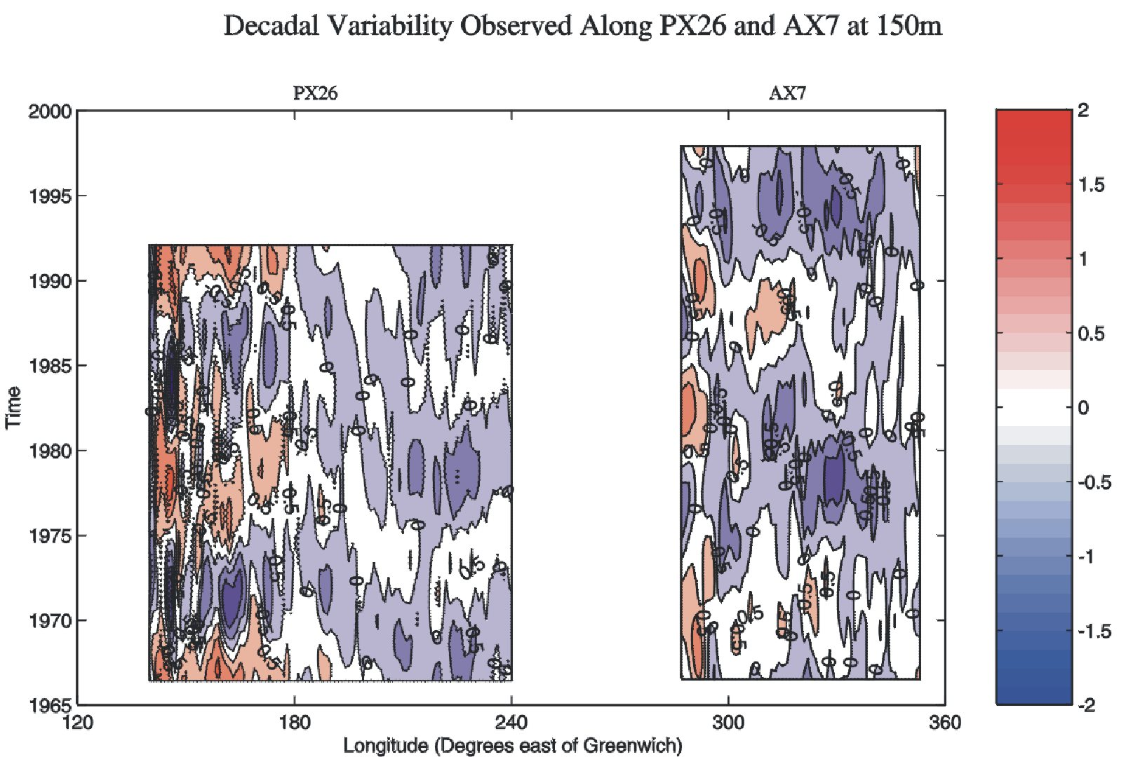
Figure 7. As part of an international evaluation of the XBT network, AOML generated time-distance plots of subsurface temperature properties for transects through the subtropical gyres of the Pacific and Atlantic Oceans. The plots show very similar decadal signals, as do similar plots from transects crossing other regions of the northern hemisphere basins (not shown). Time-longitude variability from trans-oceanic Volunteering Observing Ship/XBT transects in the Pacific (PX26) and Atlantic (AX7). Monthly temperature anomalies at the thermocline depth are binned to one degree of longitude and filtered to remove variability at periods of less than seven years. Both oceans show strong decadal variability, intensified near the western boundaries.

