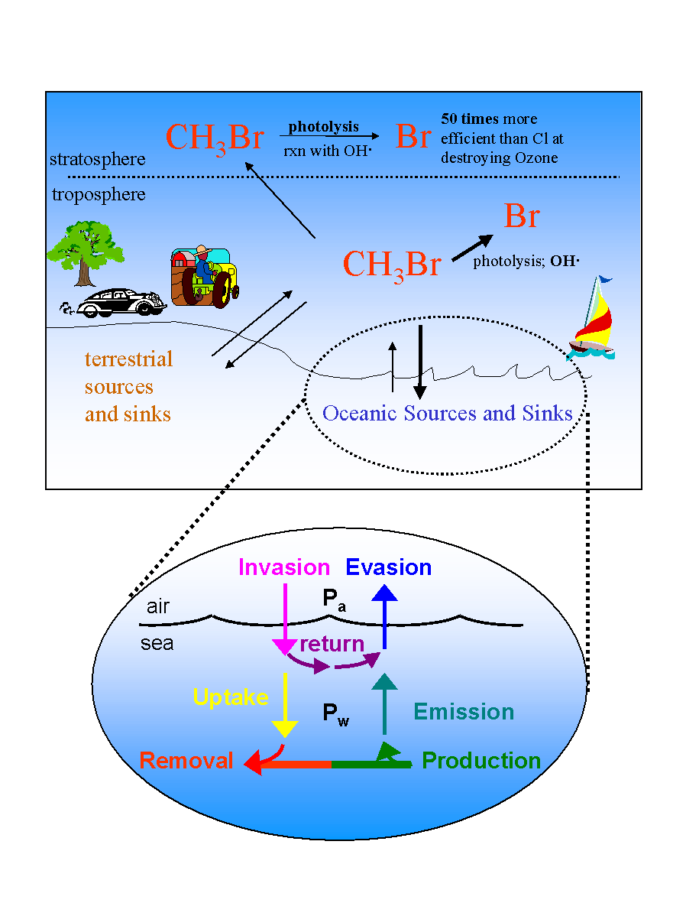
Figure 6. Upper panel: Processes involved in the biogeochemical cycling of methyl bromide (CH₃Br). This trace gas, responsible for over half of the ozone depleting bromine delivered to the stratosphere, has both anthropogenic and natural sources and sinks. Lower panel: Coupled ocean-atmosphere system in more detail. P_{a} and P_{w} are the partial pressures of the species of interest in the air and in the water. The net flux is calculated as the difference between evasion and invasion, emission and uptake, or production and removal. Investigators at AOML conduct field studies on NOAA research vessels measuring P_{a}, P_{w}, net production, and depth profiles of CH₃Br and other halocarbons. Laboratory studies are currently underway at AOML to examine the ability of bacteria to degrade CH₃Br and other halocarbons. The results from both field and laboratory studies are being used in an in-house global model of this coupled ocean-atmosphere system that calculates global uptake rates and the partial lifetime of this and other atmospheric trace gases with respect to irreversible oceanic loss. The ocean is a significant source and sink of CH₃Br and other low molecular weight halocarbons involved in ozone depletion, global warming, and marine boundary layer chemistry. Warming of the ocean, changes in ocean currents, or altered surface winds resulting from global warming are likely to alter the flux of these gases across the air-sea interface, with concommitant effects on their contributions to important atmospheric processes. At this time, however, there are insufficient data to assess or predict how climate forcing will affect or be affected by the processes controlling the oceanic saturation or net flux of these trace gases

