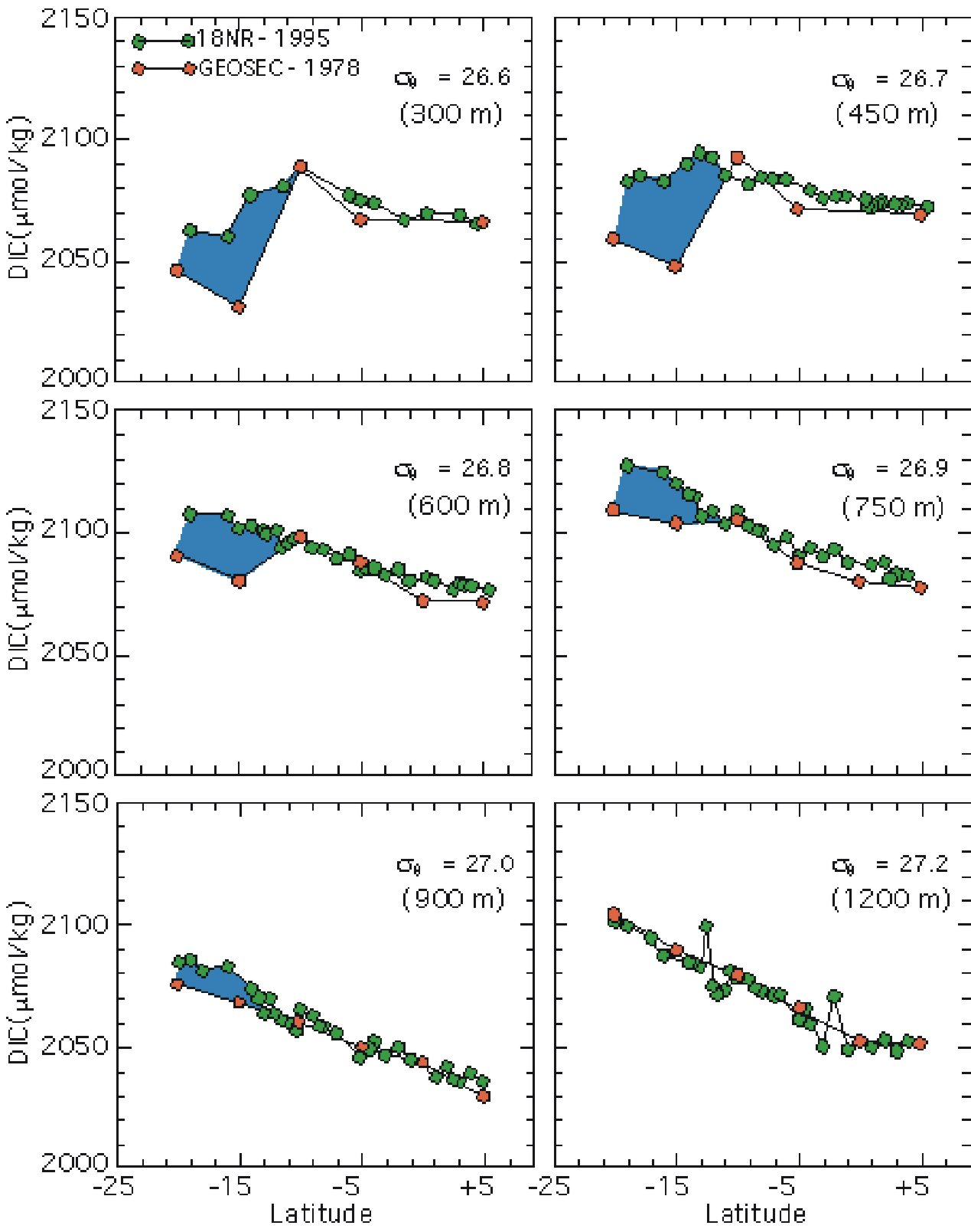
Figure 5. Anthropogenic CO₂ inventory is based on differences of dissolved inorganic carbon (DIC) over time. It is a comparison of salinity-normalized DIC, corrected for apparent oxygen utilization and alkalinity changes over time, along an isopycnal surface in the upper thermocline of the Indian Ocean along 80E longitude for a latitude zone ranging from 20S to 5N at two different times: GEOSECS in 1978 (red circles) and I8NR in 1995 (green circles). Six panels represent six density surfaces at  = 26.6, 26.7, 26.8, 26.9, 27.0, and 27.2. These surfaces correspond to a depth range of 300-1200 m. The I8NR is a CO₂ survey cruise performed by the NOAA Ocean-Atmosphere Carbon Exchange Study (OACES) program in concert with the Joint Global Ocean Flux Study (JGOFS) and the World Ocean Circulation Experiment (WOCE) repeat hydrographic survey. It shows that more anthropogenic CO₂ has been absorbed in the temperate ocean (south of about 15S) than in the equatorial ocean. It also shows higher amounts of anthropogenic CO₂ in the shallower density layers (i.e., nearer to its source in the atmosphere) than in deeper layers.

