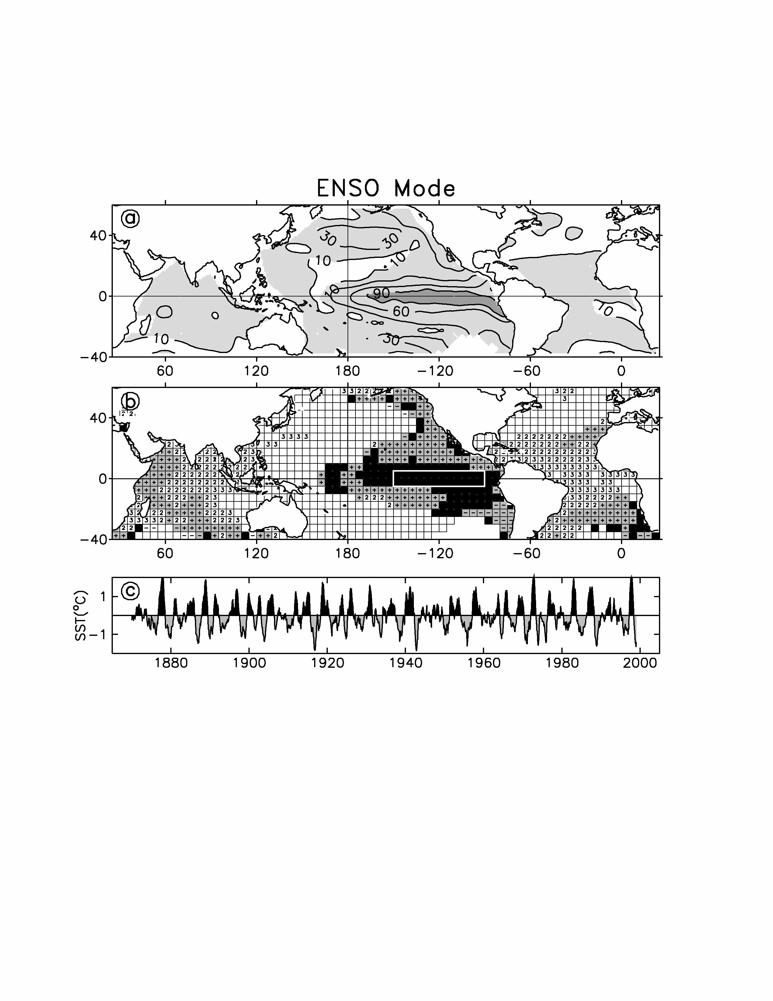
Figure 2. The global ENSO mode: Upper Panel: Relative weighting for various regions. The highest (dark gray) amplitudes are in the equatorial Pacific, but significant amplitudes (light gray) also appear in the tropical Atlantic and Indian Oceans and elsewhere in the Pacific. Middle Panel: Represents how the global mode captures the lags of the ENSO signal in various regions (+, 2, 3 = 1, 2, 3 seasons). Note the 1-3 season lags of the ENSO signal in the Atlantic and Indian Oceans and the negative numbers off Chile indicating a one-season precursor. Bottom Panel: The time series shows the global ENSO reconstruction for the NINO3 index region. Note that 1972-1973 has a higher amplitude than 1982-1983, the opposite to what a simple average of the data indicate.

