Citing Data in Science Journals – Publisher Policies
Quick Guide Chart
Gloria Averano- NHC Library May 10, 2018

Taken from Publisher website Example Additional notes
AMS  Read more about AMS Data Citation and Archiving policies | “Whenever possible, datasets should be referenced directly via a listing in the references in the following style. Note that references to papers that introduce or describe a dataset and/or mentions in the acknowledgments are no longer considered adequate, as these often fail to give a reader sufficient information to access the specific data used | Dataset authors/producers, data release year: Dataset title, version. Data archive/distributor, access date (DD Month YYYY), data locator/identifier (doi or URL).  NOAA/NCEP, 1995: NCEP/NCAR Global Reanalysis 8-day Forecast Products. NCAR Computational and Information Systems Laboratory Research Data Archive, accessed 19 February 2016, http://rda.ucar.edu/datasets/ds090.1/. | Other citation elements should be used where applicable, such as dataset editors, subsets used, and the data archive or distributor physical location. See the below examples for illustrations: | Further examples of data subsets and data that are dynamically updated daily without distinct versions:  NOAA/NCDC, 2013: VIIRS Climate Raw Data Record (C-RDR) from Suomi NPP, version 1. NOAA/National Climatic Data Center. Subset used: October 2007–September 2008, accessed 14 October 2014, https://doi.org/10.7289/V57P8W90
AGU | “AGU encourages citation of data sets according to the Force 11 and  ESIP Commons guidelines.”  http://publications.agu.org/author-resource-center/publication-policies/data-policy/  see below | Examples: https://www.force11.org/node/4771
Elsevier | Elsevier uses “Force 11”  https://www.journals.elsevier.com/earth-and-planetary-science-letters/policies/data- deposit-and-linking  see below
Nature Publishing Group
AAAS Science | The Science Journals support the efforts of databases that aggregate published data for the use of the scientific community. Therefore, before publication, large data sets (including microarray data, protein or DNA sequences, atomic coordinates or electron microscopy maps for molecular and macromolecular structures, and climate data) must be deposited in an approved database and an accession number or a specific access address must be included in the published paper. We encourage compliance with MIBBI guidelines (Minimum Information for Biological and Biomedical Investigations). | Also http://www.sciencemag.org/authors/science-journals-editorial-policies#unpublished-data-and-personal-communications  Climate Data Guide : https://fairsharing.org/FAIRsharing.4vsxkr  NetCDF CF Metadata Conventions: http://cfconventions.org/ | AAAS provides a list of approved repositories based on data type (similar to Spring Nature type 4). Not only does AAAS stipulate that data must be available, but that all materials that are necessary to understand and assess the research must be made available. This includes code, patents, and even fossils or rare specimens. Please see policies | Embargo Policy  Submitted and accepted papers must remain privileged documents and must not be released to the press or the public before publication. The Science Journals do allow posting of the submitted version of research papers on not-for-profit preprint servers, but these should not be discussed with the media. We provide embargoed press packages to reporters ahead of publication to facilitate accurate reporting on our published papers. Questions should be referred to the AAAS Office of Public Programs (202-326-6440).
Springer Nature FAQs  (formerly Springer) | “Where datasets are hosted in public repositories that provide datasets with Digital Object Identifiers (DOIs), we encourage these datasets to be formally cited in reference lists. Citations of datasets, when they appear in the reference list, should include the minimum information recommended by DataCite and follow journal style.” | Hao, Z., AghaKouchak, A., Nakhjiri, N., Farahmand, A. Global Integrated Drought Monitoring and Prediction System (GIDMaPS) Data sets. figshare. http://dx.doi.org/10.6084/m9.figshare.853801 (2014) | In general, data availability statements provide a statement about where data supporting the results reported in the article can be found including, where applicable, hyperlinks to publicly archived datasets analysed or generated during the study. The data policy types 2, 3 and 4 encourage or require the provision of data availability statements. See our data availability statement resource page for more information. | SpringerNature Data Helpdesk  https://www.springernature.com/gp/authors/research-data-policy/helpdesk
Wiley  https://authorservices.wiley.com/author-resources/Journal-Authors/licensing-open-access/open-access/data-sharing.html | Endorses FORCE 11 guidelines for citing datasets.  “The majority of Wiley’s journals enforce one of the following standardized data sharing policies:  Encourages Data Sharing – encourages authors to share the data and other artefacts supporting the results in the paper by archiving it in an appropriate public repository.  Expects Data Sharing - expects that data supporting the results in the paper will be archived in an appropriate public repository.  Mandates Data sharing - requires, as a condition for publication, that the data supporting the results in the paper will be archived in an appropriate public repository.” |  | Author Compliance Tool to check the data sharing policy of your chosen journal and/or funder before submitting your work.

Force 11 –

“PrinciPals
The Data Citation Principles cover purpose, function and attributes of citations. These principles recognize the dual necessity of creating citation practices that are both human understandable and machine-actionable.
These citation principles are not comprehensive recommendations for data stewardship. And, as practices vary across communities and technologies will evolve over time, we do not include recommendations for specific implementations, but encourage communities to develop practices and tools that embody these principles.
The principles are grouped so as to facilitate understanding, rather than according to any perceived criteria of importance.

1. Importance
Data should be considered legitimate, citable products of research. Data citations should be accorded the same importance in the scholarly record as citations of other research objects, such as publications[1].

2. Credit and Attribution
Data citations should facilitate giving scholarly credit and normative and legal attribution to all contributors to the data, recognizing that a single style or mechanism of attribution may not be applicable to all data[2].

3. Evidence
In scholarly literature, whenever and wherever a claim relies upon data, the corresponding data should be cited[3].

4. Unique Identification
A data citation should include a persistent method for identification that is machine actionable, globally unique, and widely used by a community[4].

5. Access
Data citations should facilitate access to the data themselves and to such associated metadata, documentation, code, and other materials, as are necessary for both humans and machines to make informed use of the referenced data[5].

6. Persistence
Unique identifiers, and metadata describing the data, and its disposition, should persist -- even beyond the lifespan of the data they describe[6].

7. Specificity and Verifiability
Data citations should facilitate identification of, access to, and verification of the specific data that support a claim. Citations or citation metadata should include information about provenance and fixity sufficient to facilitate verfiying that the specific timeslice, version and/or granular portion of data retrieved subsequently is the same as was originally cited[7].

8. Interoperability and Flexibility
Data citation methods should be sufficiently flexible to accommodate the variant practices among communities, but should not differ so much that they compromise interoperability of data citation practices across communities[8].
When citing this document (Force11 document) please use: Data Citation Synthesis Group: Joint Declaration of Data Citation Principles. Martone M. (ed.) San Diego CA: FORCE11; 2014 https://www.force11.org/group/joint-declaration-data-citation-principles-final

ESIP Commons - Data Citation Guidelines for Data Providers and Archives:
The core required elements of a citation are
- Author(s)--the people or organizations responsible for the intellectual work to develop the data set. The data creators.
- Release Date--when the particular version of the data set was first made available for use (and potential citation) by others.
- Title--the formal title of the data set
- Version--the precise version of the data used. Careful version tracking is critical to accurate citation.
- Archive and/or Distributor--the organization distributing or caring for the data, ideally over the long term.
- Locator/Identifier--this could be a URL but ideally it should be a persistent service, such as a DOI, Handle or ARK, that resolves to the current location of the data in question.
- Access Date and Time--because data can be dynamic and changeable in ways that are not always reflected in release dates and versions, it is important to indicate when on-line data were accessed.
Additional fields can be added as necessary to credit other people and institutions, etc. Additionally, it is important to provide a scheme for users to indicate the precise subset of data that were used. This could be the temporal and spatial range of the data, the types of files used, a specific query id, or other ways of describing how the data were subsetted.
An example citation:
Cline, D., R. Armstrong, R. Davis, K. Elder, and G. Liston. 2002, Updated 2003. CLPX-Ground: ISA snow depth transects and related measurements ver. 2.0. Edited by M. Parsons and M. J. Brodzik. National Snow and Ice Data Center. Data set accessed 2008-05-14 at http://dx.doi.org/10.5060/D4MW2F23z
.
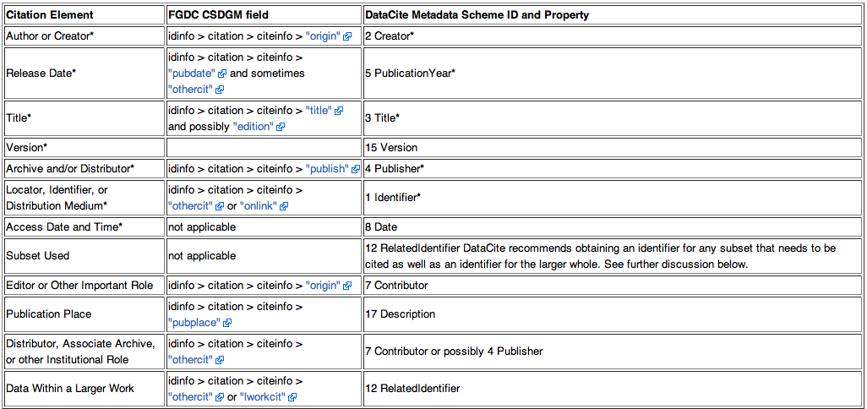

DataCite – cite your data

Books and journal articles have long benefited from an infrastructure that makes them easy to cite, a key element in the process of research and academic discourse. We believe that you should cite data in just the same way that you can cite other sources of information, such as articles and books.
DataCite DOIs help further research and assures reliable, predictable, and unambiguous access to research data in order to:
- support proper attribution and credit
- support collaboration and reuse of data
- enable reproducibility of findings
- foster faster and more efficient research progress, and
- provide the means to share data with future researchers
DataCite also looks to community practices that provide data citation guidance. The Joint Declaration of Data Citation Principles is a set of guiding principles for data within scholarly literature, another dataset, or any other research object (Data Citation Synthesis Group 2014). The FAIR Guiding Principles provide a guideline for the those that want to enhance reuse of their data (Wilkinson 2016).

Data Citation Examples
We recognize that the challenges associated with data publication vary across disciplines, and we encourage research communities to develop citation systems that work well for them. Our recommended format for data citation is as follows:
Creator (PublicationYear). Title. Publisher. Identifier
It may also be desirable to include information about two optional properties, Version and ResourceType (as appropriate). If so, the recommended form is as follows:
Creator (PublicationYear). Title. Version. Publisher. ResourceType. Identifier

References
- Data Citation Synthesis Group (2014). Joint Declaration of Data Citation Principles. Martone M. (ed.) San Diego CA: FORCE11 https://www.force11.org/group/joint-declaration-data-citation-principles-final
- Wilkinson, M. D., Dumontier, M., Aalbersberg, Ij. J., Appleton, G., Axton, M., Baak, A., … Bourne, P. E. (2016). The FAIR Guiding Principles for scientific data management and stewardship. Sci. Data, 3, 160018. https://doi.org/10.1038/sdata.2016.18

