July 25, 2015
Corresponding author: Sang-Ki Lee,
CIMAS, University of Miami and AOML, NOAA, Miami, FL 33149

E-mail) sang-ki.lee@noaa.gov

Dear Editor,

We submit a manuscript “Probability of U.S. regional tornado outbreaks and their links to the springtime ENSO phases and North Atlantic SST variability” by Sang-Ki Lee, Andrew T. Wittenberg, David B. Enfield, Scott J. Weaver, Chunzai Wang and Robert M. Atlas for possible publication in Geophysical Research Letters.

Recent studies have identified ENSO as a potential source of seasonal predictability for U.S. tornado activity. However, in spring, which is the most active U.S. tornado season, ENSO usually decays rapidly and the associated SST anomalies in the tropical Pacific become much weaker and much less coherent. Thus, there is a clear need to better characterize the springtime ENSO phase evolution and its link to U.S. tornado activity. On this issue, a recent study published in GRL [Lee et al., 2014; http://onlinelibrary.wiley.com/doi/10.1002/2014GL062484] presented a new method to objectively characterize the differences in the space-time evolution of the equatorial Pacific SST anomalies observed during El Niño and La Niña events. The study identified four main phases of springtime ENSO evolution (persistent versus early-terminating El Niño, and resurgent versus transitioning La Niña).

In this study, we show that these four main phases of springtime ENSO evolution are linked to distinctive spatial patterns of the probability of U.S. regional tornado outbreaks. Additionally, we also show in this study that the North Atlantic SST tripole is linked to the U.S. tornado outbreak probability in early spring. This is to our knowledge the first to report the impacts of different ENSO flavors and North Atlantic SST variability on U.S. tornado activity. As such, we believe that our work significantly improves our understanding of the climate signals that impact U.S. tornado activity, and also provide an important stepping stone for developing a seasonal outlook for U.S. tornado outbreaks.

Sincerely yours,
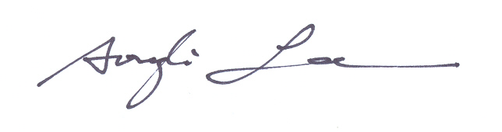
Sang-Ki Lee, Andrew T. Wittenberg, David B. Enfield, Scott J. Weaver, Chunzai Wang and Robert M. Atlas

