Table S1. Tornado-related number of fatalities and injuries and property and crop damages (in million US dollars) in the U.S. during 2004-2013, reproduced from the U.S. Natural Hazard Statistics (http://www.nws.noaa.gov/om/hazstats.shtml).
Year | Fatalities | Injuries | Property & crop damages
2004 | 35 | 396 | 549.2
2005 | 38 | 537 | 503.9
2006 | 64 | 990 | 759.0
2007 | 81 | 659 | 1,407.5
2008 | 126 | 1,714 | 1,865.6
2009 | 21 | 351 | 584.9
2010 | 45 | 699 | 1,134.6
2011 | 553 | 5,483 | 9,493.0
2012 | 70 | 822 | 1,649.7
2013 | 55 | 756 | 3,648.7
Total | 1,091 | 12,407 | 21,596.1

Table S2. List of four leading cases of ENSO variability (i.e., 8 persistent El Niño, 10 early-terminating El Niño, 11 resurgent La Niña and 8 transitioning La Niña cases) identified based on the sign and amplitude of the principal components of interevent El Niño and La Niña variability during 1949 - 2013 [Lee et al., 2014b]. These ENSO events are listed by their onset-decay years (i.e., year (0) - year (+1)). Note that the four leading cases of ENSO variability describe ENSO phase evolution in the spring (+1) following the peak of ENSO in boreal winter.
Persistent El Niño | Early-Terminating  El Niño | Resurgent La Niña | Transitioning  La Niña
1957 - 1958  1968 - 1969  1982 - 1983  1986 - 1987  1991 - 1992  1997 - 1998  2004 - 2005  2009 - 2010 | 1951 - 1952  1953 - 1954  1963 - 1964  1965 - 1966  1969 - 1970  1972 - 1973  1977 - 1978  1987 - 1988  1994 - 1995  2006 - 2007 | 1949 - 1950  1955 - 1954  1970 - 1971  1973 - 1974  1974 - 1975  1983 - 1984  1984 - 1985  1988 - 1989  1995 - 1996  1998 - 1999  2010 - 2011 | 1950 - 1951  1956 - 1957  1964 - 1965  1971 - 1972  1975 - 1976  2000 - 2001  2005 - 2006  2011 - 2012

Table S3. List of 10 most active and 10 least active U.S. tornado years based on the total number of F1-F5 tornados in the U.S. during MAM. The corresponding ENSO phase for each case is also shown. Note that the decaying phase of 2008 La Niña cannot be described using the leading mode of observed La Niña variability; thus it is simply referred to as decaying La Niña. The onset of El Niño in 1982 occurred from ENSO neural condition; thus it is referred to as developing El Niño as in cases of 1991 and 2002.
10 Most Active U.S. Tornado Years |  | 10 Least Active U.S. Tornado Years
Year (Number) | ENSO phases | Year (Number) | ENSO phases
2011 (690)  1973 (412)  1974 (390)  2008 (359)  1982 (342)  1976 (325)  1957 (317)  2003 (306)  1991 (302)  1965 (301) | Resurgent La Niña  Early-Term El Niño  Resurgent La Niña  Decaying La Niña  Developing El Niño  Transition La Niña  Transition La Niña  Persistent El Niño Developing El Niño  Transition La Niña | 1951 (67)  1987 (80)  1950 (89)  2005 (89)  1952 (93)  1992 (102)  1958 (113)  2002 (125)  1993 (129)  1969 (130) | Transition La Niña  Persistent El Niño  Resurgent La Niña  Persistent El Niño  Early-Term El Nino  Persistent El Niño  Persistent El Niño  Developing El Niño  ENSO neutral  Persistent El Niño

Table S4. List of 10 negative and 10 positive phases of North Atlantic SST tripole mode in MAM during 1949-2014, derived from the leading EOF mode of the North Atlantic SSTAs in MAM. For each case of the positive and negative phase of North Atlantic SST tripole mode, the corresponding springtime ENSO phase is also listed. Note that the onset of El Niño in 1986 occurred from ENSO neural condition; thus it is referred to as developing El Niño as in cases of 1991, 1994 and 2009.
Negative phase of North Atlantic SST tripole (MAM) |  | Positive phase of North Atlantic SST tripole (MAM)
Year | ENSO phases | Year | ENSO phases
1972  1974  1975  1976  1985  1986  1989  1991  1994  2009 | Transition La Niña  Resurgent La Niña  Resurgent La Niña  Transition La Niña  Resurgent La Niña  Developing El Niño  Resurgent La Niña  Developing El Niño  Developing El Niño  Developing El Niño | 1951  1958  1966  1969  1970  1981  1983  1998  2005  2010 | Transition La Niña  Persistent El Niño  Early-Term El Nino  Persistent El Niño  Early-Term El Nino  ENSO neutral  Persistent El Niño  Persistent El Niño  Persistent El Niño  Persistent El Niño

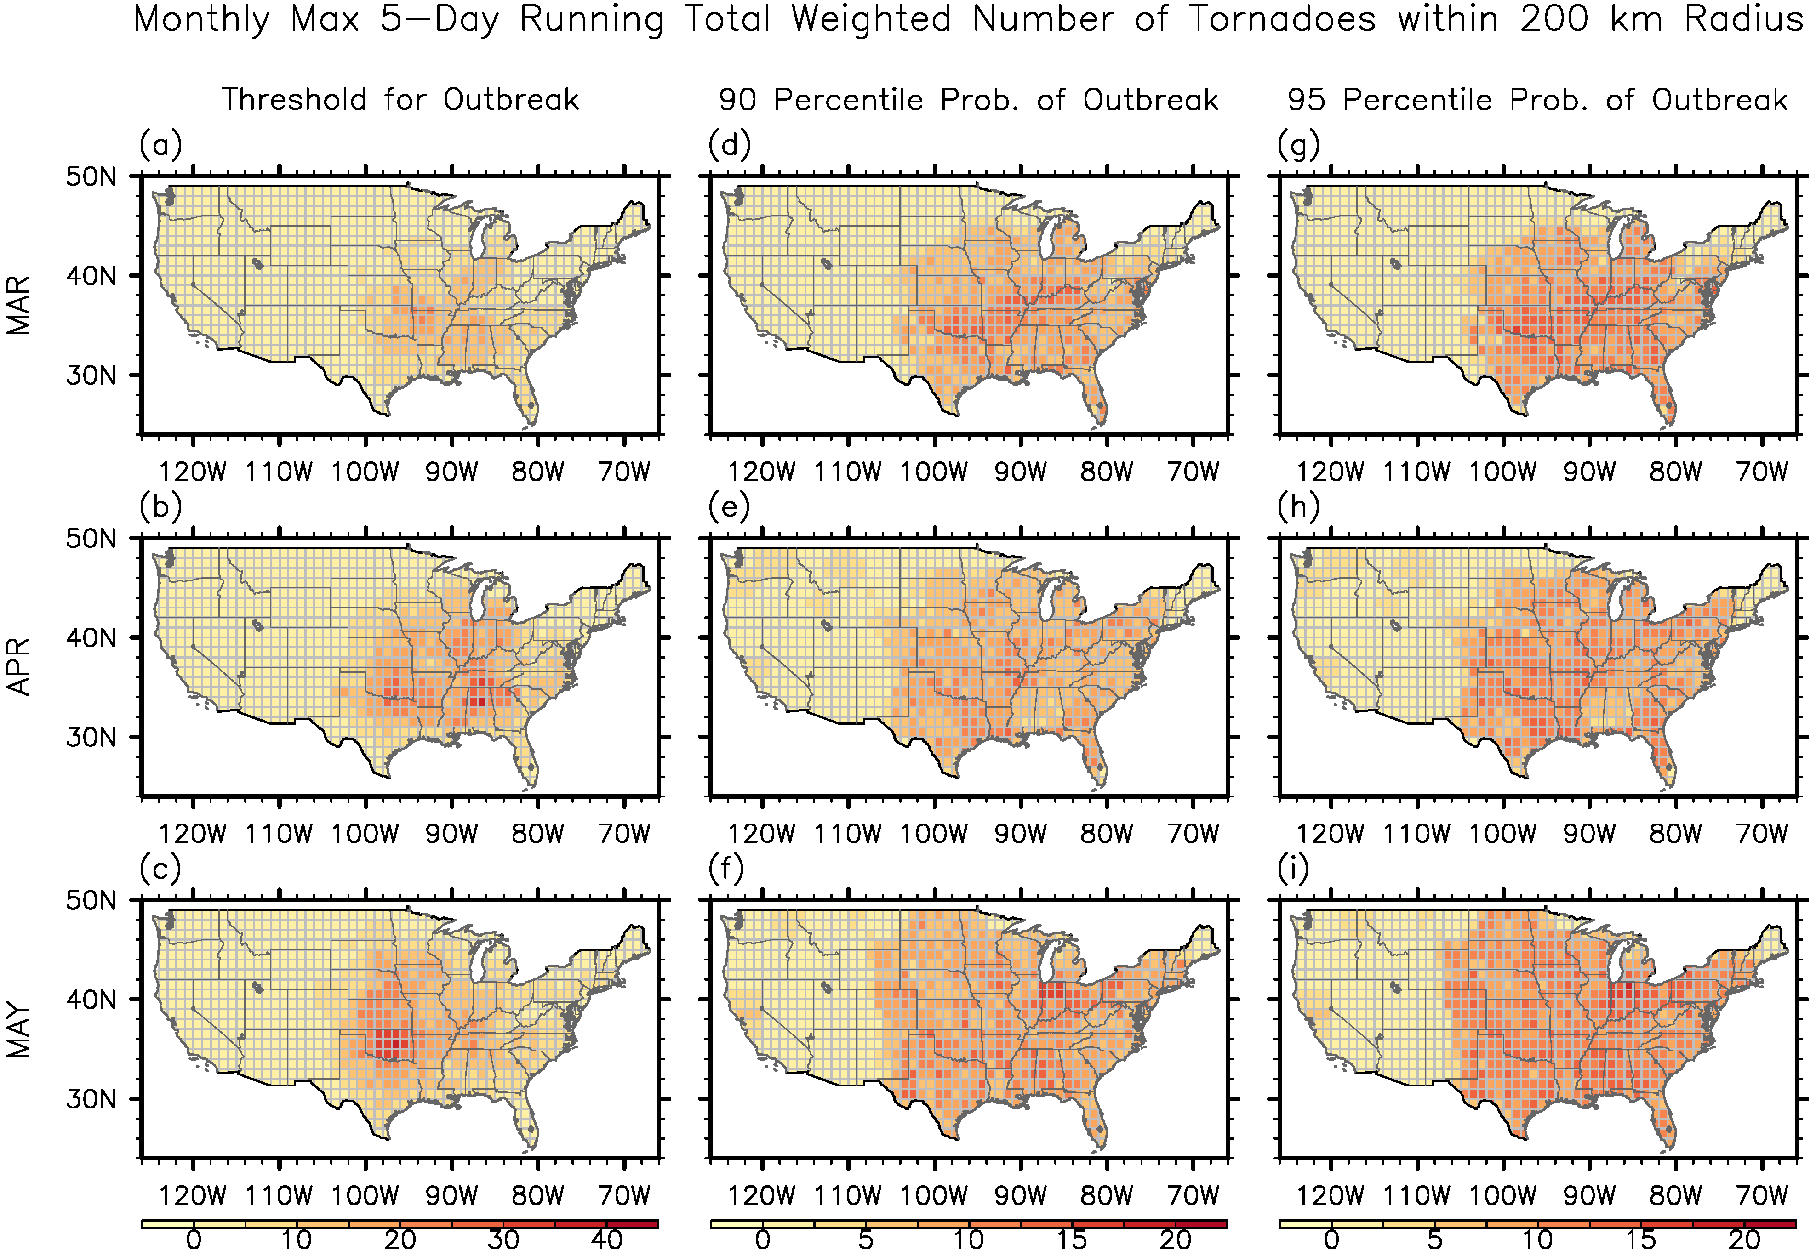
Figure S1. (a-c) Outbreak threshold of monthly maximum 5-day running total weighted number of F1 – F5 tornadoes within the 200 km radius, (d-f) the 90 percentile probability of U.S. regional outbreaks, and (g-i) the 95 percentile probability of U.S. regional tornado outbreaks for (top row) March, (middle row) April and (bottom row) May. Bootstrap method is used to determine the 90th and 95th percentile probabilities (%) of outbreak. See section 2 for more details about how these fields are derived.

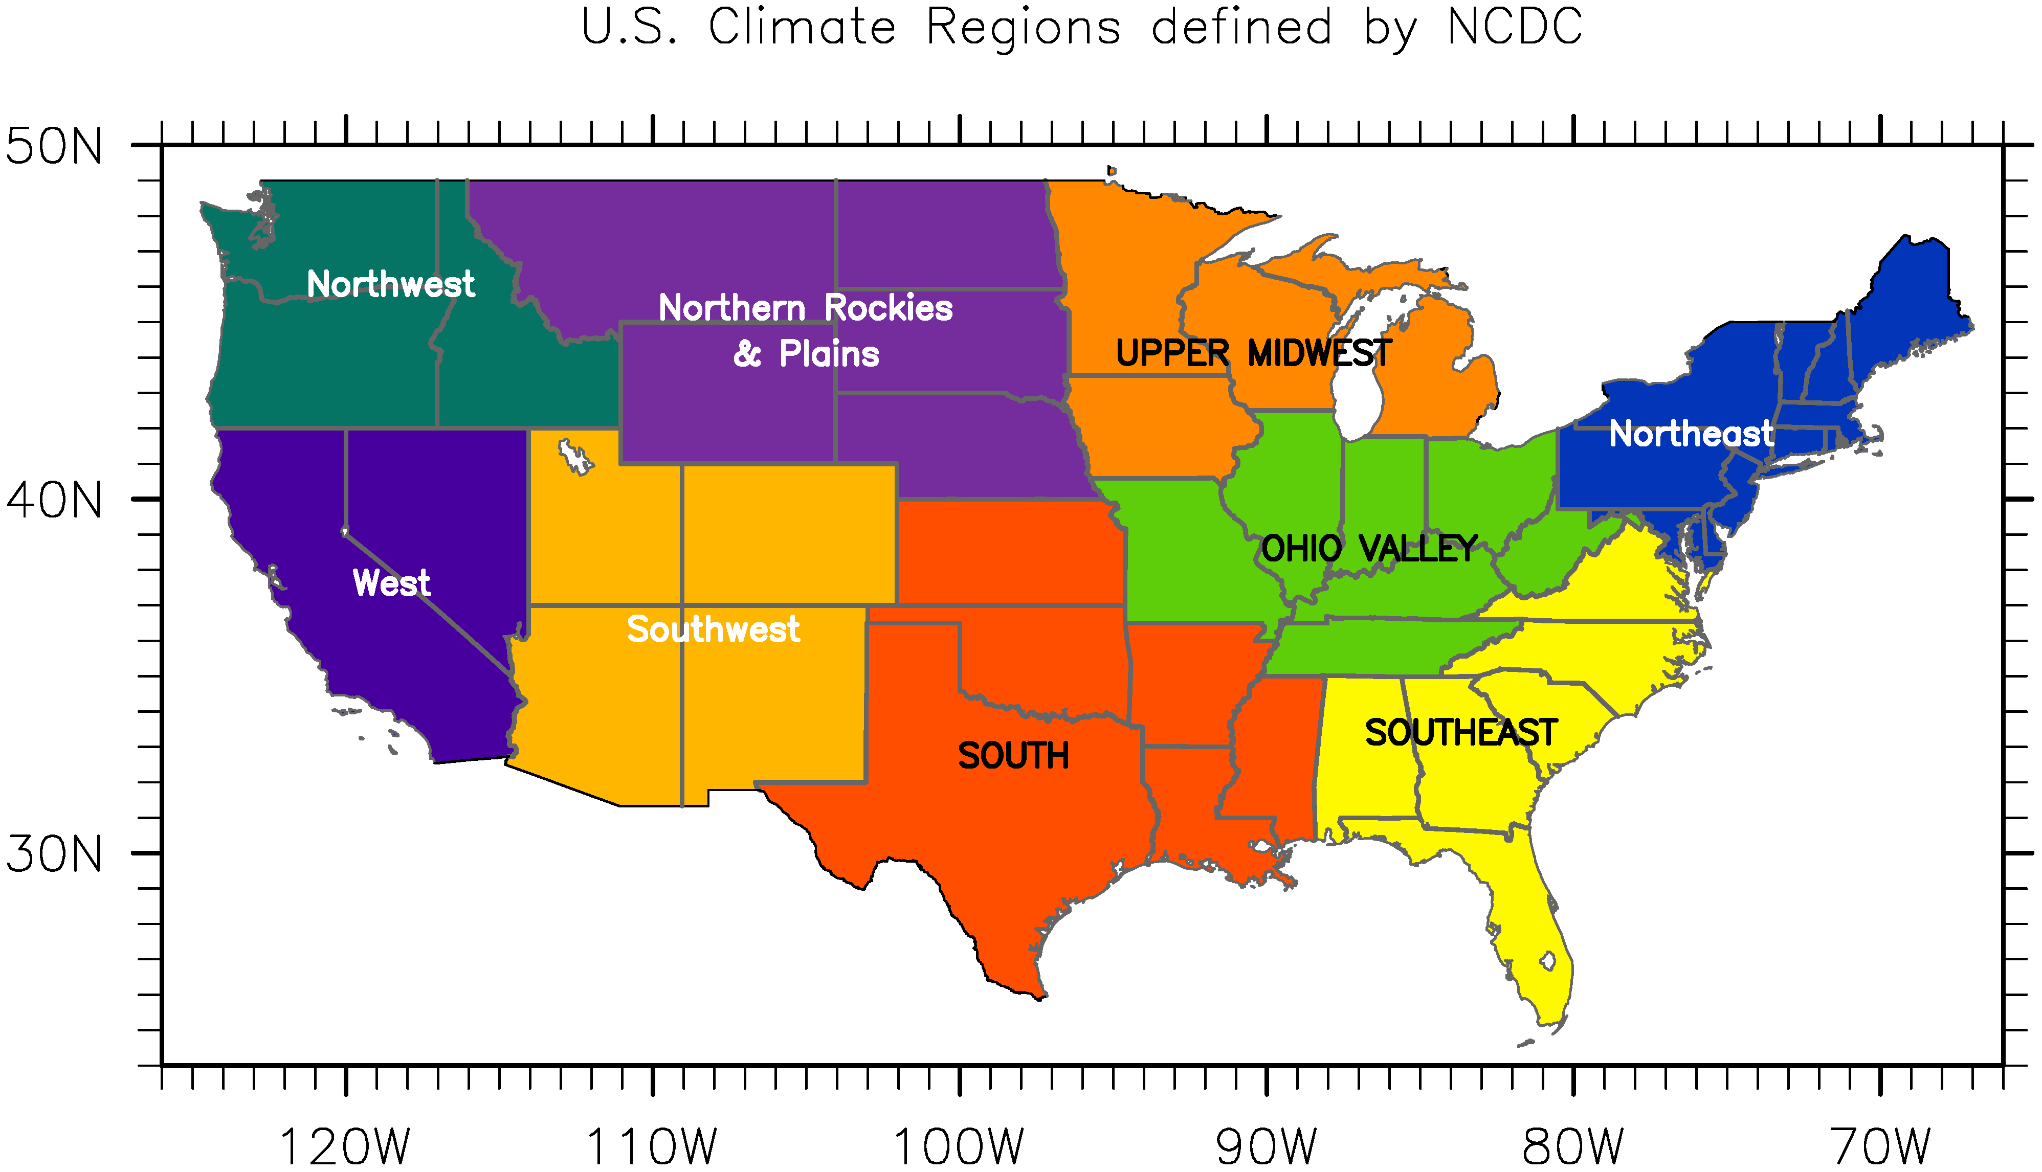
Figure S2. U.S. climate regions defined by National Climate Data Center. The four regions, namely the South, Ohio Valley, Southeast and Upper Midwest, are frequently referred in the main text to describe the probability of U.S. regional tornado outbreaks.

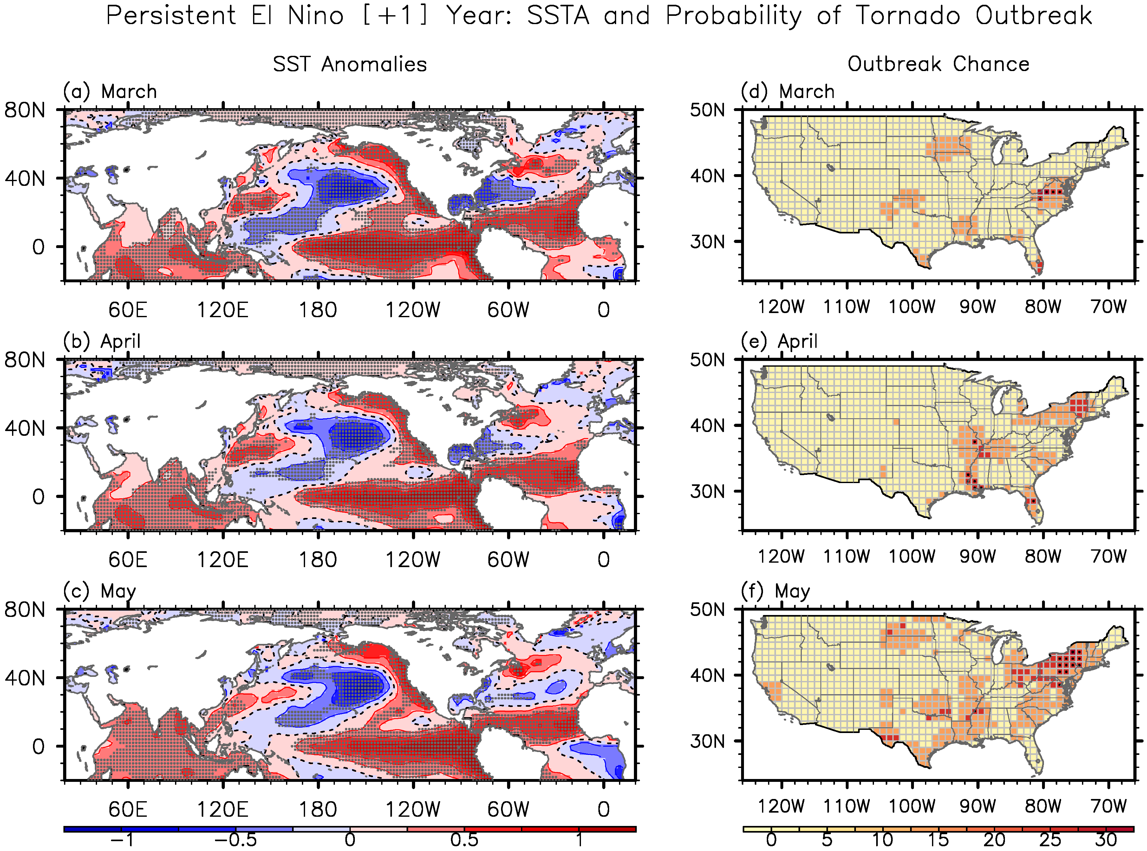
Figure S3. Composite (a-c) SSTAs for the persistent El Niño case and (d-f) the corresponding probability of U.S. regional tornado outbreaks in (top row) March (+1), (middle row) April (+1) and (bottom row) May (+1). The gray dots in panels a-c indicate that the SSTAs are statistically significant at 90% based on a Student’s t-test. The black dots in panels d-f indicate that the probability of tornado outbreaks is statistically significant at 90% based on a binomial test. The unit is in °C for the SSTAs and in % for the probability of tornado outbreaks.

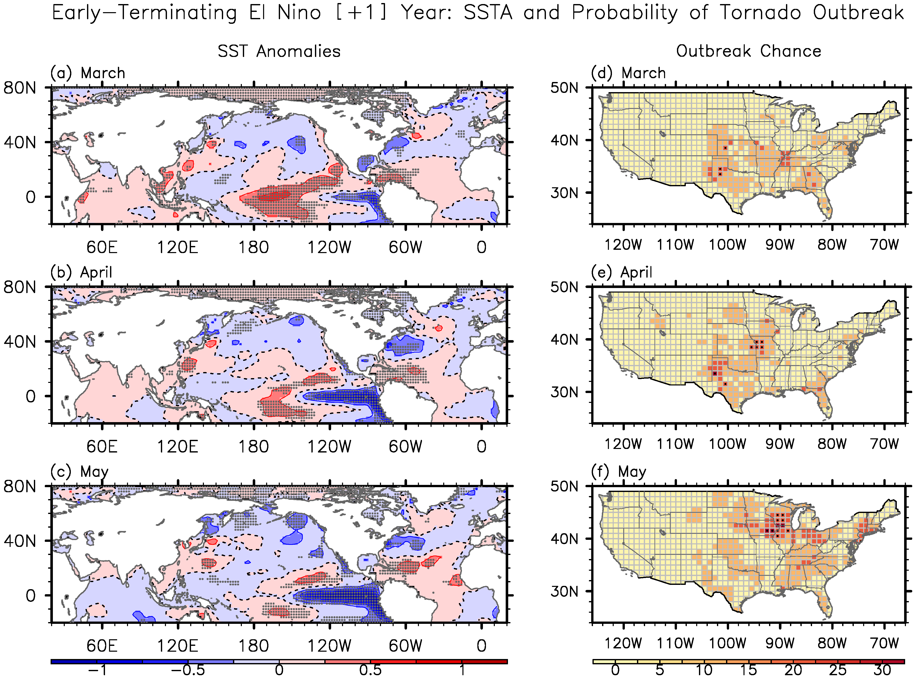
Figure S4. Composite (a-c) SSTAs for the early-terminating El Niño case and (d-f) the corresponding probability of U.S. regional tornado outbreaks in (top row) March (+1), (middle row) April (+1) and (bottom row) May (+1). The gray dots in panels a-c indicate that the SSTAs are statistically significant at 90% based on a Student’s t-test. The black dots in panels d-f indicate that the probability of tornado outbreaks is statistically significant at 90% based on a binomial test. The unit is in °C for the SSTAs and in % for the probability of tornado outbreaks.

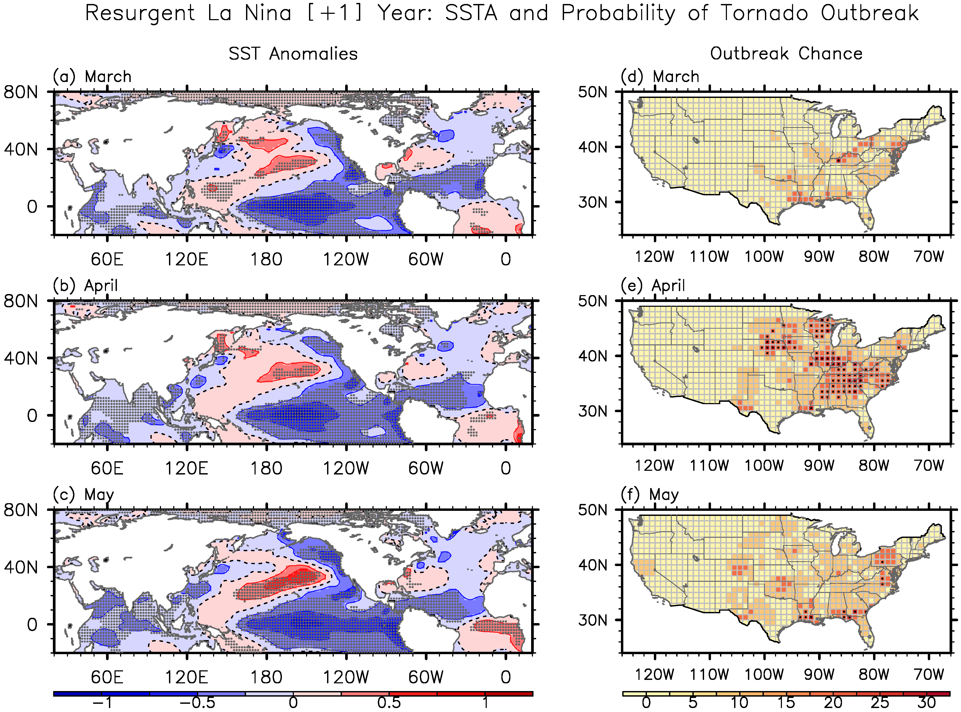
Figure S5. Composite (a-c) SSTAs for the resurgent La Niña case and (d-f) the corresponding probability of U.S. regional tornado outbreaks in (top row) March (+1), (middle row) April (+1) and (bottom row) May (+1). The gray dots in panels a-c indicate that the SSTAs are statistically significant at 90% based on a Student’s t-test. The black dots in panels d-f indicate that the probability of tornado outbreaks is statistically significant at 90% based on a binomial test. The unit is in °C for the SSTAs and in % for the probability of tornado outbreaks.

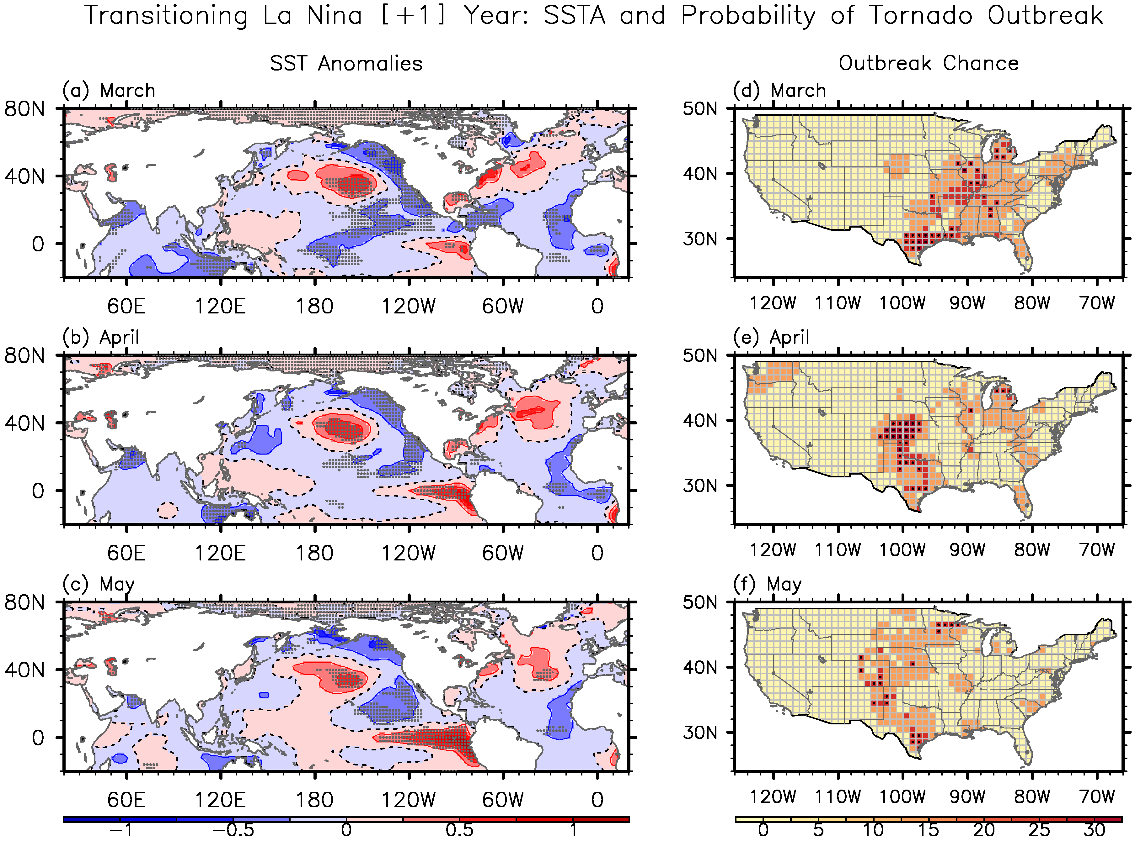
Figure S6. Composite (a-c) SSTAs for the transitioning El Niño case and (d-f) the corresponding probability of U.S. regional tornado outbreaks in (top row) March (+1), (middle row) April (+1) and (bottom row) May (+1). The gray dots in panels a-c indicate that the SSTAs are statistically significant at 90% based on a Student’s t-test. The black dots in panels d-f indicate that the probability of tornado outbreaks is statistically significant at 90% based on a binomial test. The unit is in °C for the SSTAs and in % for the probability of tornado outbreaks.

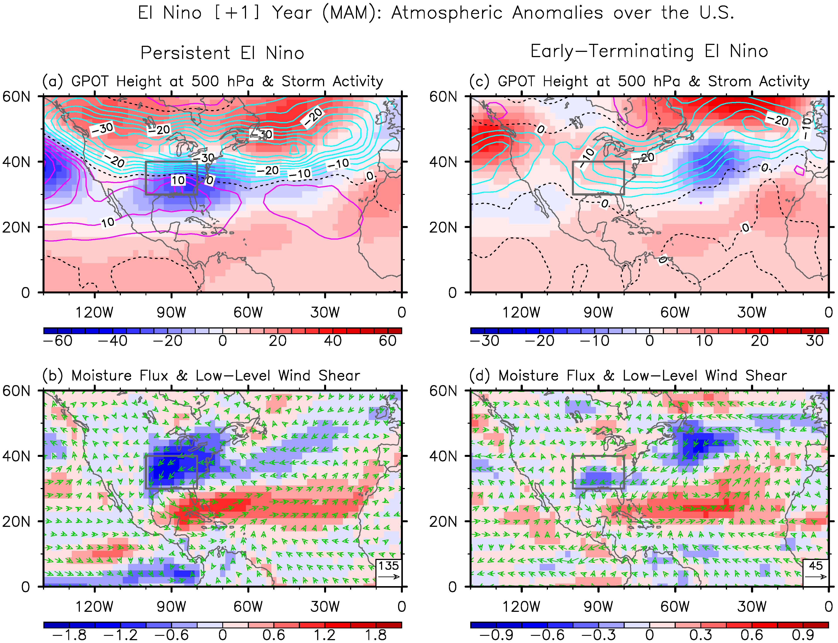
Figure S7. (upper row) Anomalous geopotential height at 500 hPa (color shades) and variance of 5day high-pass filtered meridional winds at 300 hPa (contours), and (lower row) anomalous moisture transport (vectors) and low-level vertical wind shear (850 - 1000 hPa; color shades) in MAM (+1) for (a,b) the persistent El Niño and (c,d) early-terminating El Niño cases. The units are in gpm for geopotential height, in m² s⁻² for variance of meridional winds, in kg m⁻¹ s⁻¹ for moisture transport, and in m s⁻¹ for vertical wind shear.

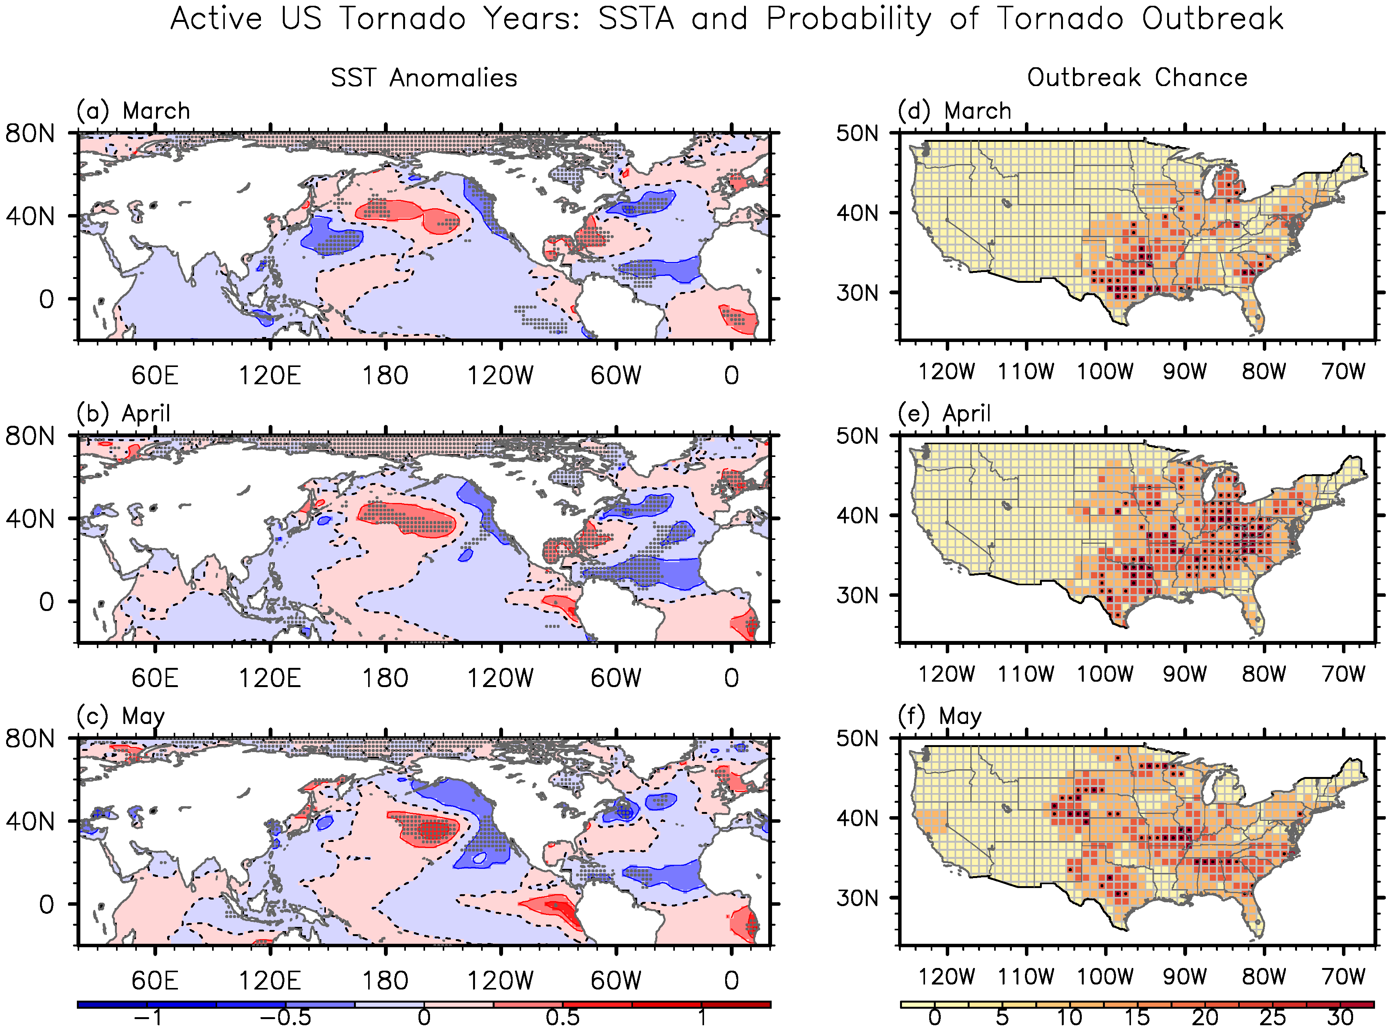
Figure S8. Composite (a-c) SSTAs for the 10 most active U.S. tornado years and (d-f) the corresponding probability of U.S. regional tornado outbreaks in (top row) March, (middle row) April and (bottom row) May. The gray dots in panels a-c indicate that the SSTAs are statistically significant at 90% based on a student-t test. The black dots in panels d-f indicate that the probability of tornado outbreaks is statistically significant at 90% based on a Chi-square test. The unit is in °C for the SSTAs and in % for the probability of tornado outbreaks.

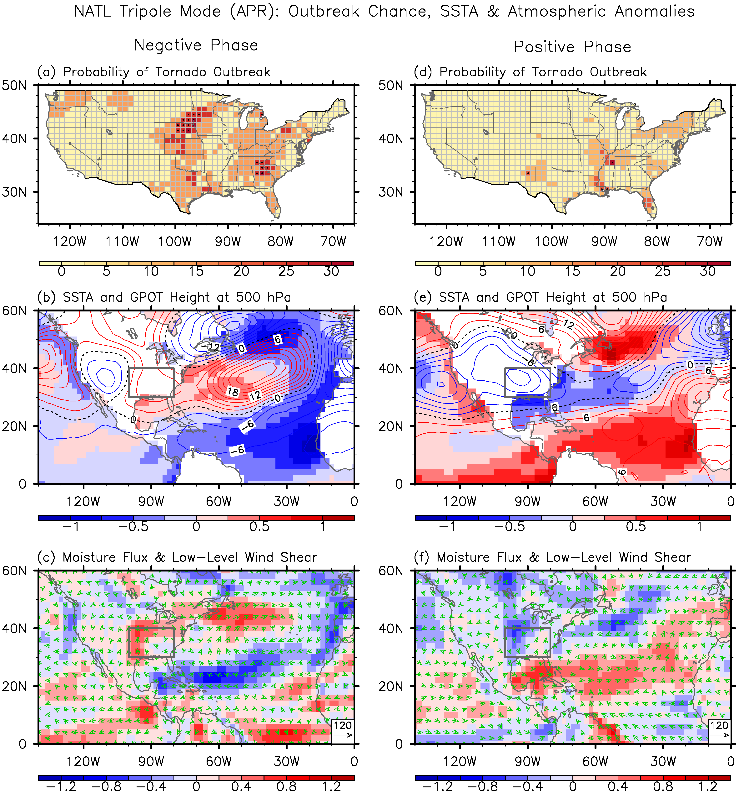
Figure S9. (top row) Probability of U.S. regional tornado, (middle row) composite SSTAs (color shades) and geopotential height anomalies at 500 hPa (contours), and (bottom row) low-level vertical wind shear anomalies (color shades) and moisture transport anomalies (vectors) in April for (a-c) the negative and (d-f) positive North Atlantic SST tripole. The unit is in % for the probability of tornado outbreaks, in °C for the SSTAs, in gpm for geopotential height, in kg m⁻¹ s⁻¹ for moisture transport, and in m s⁻¹ for vertical wind shear.

