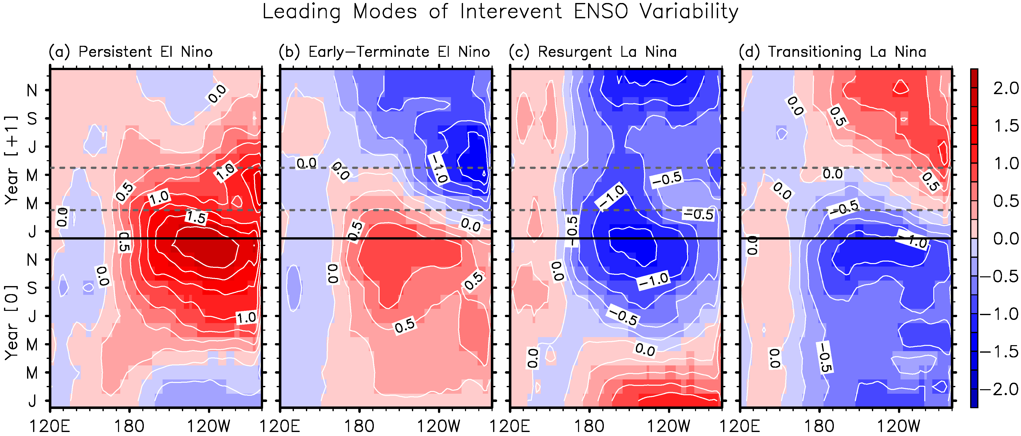
Figure 1. Time-longitude plots of the leading orthogonal modes of the tropical Pacific SSTAs averaged between 5°S and 5°N for 21 El Niño and 22 La Niña events during 1949-2013, reproduced from Lee et al. [2014b], namely (a) the persistent El Niño, (b) early-terminating El Niño, (c) resurgent La Niña and (d) transitioning La Niña. The unit is in °C.

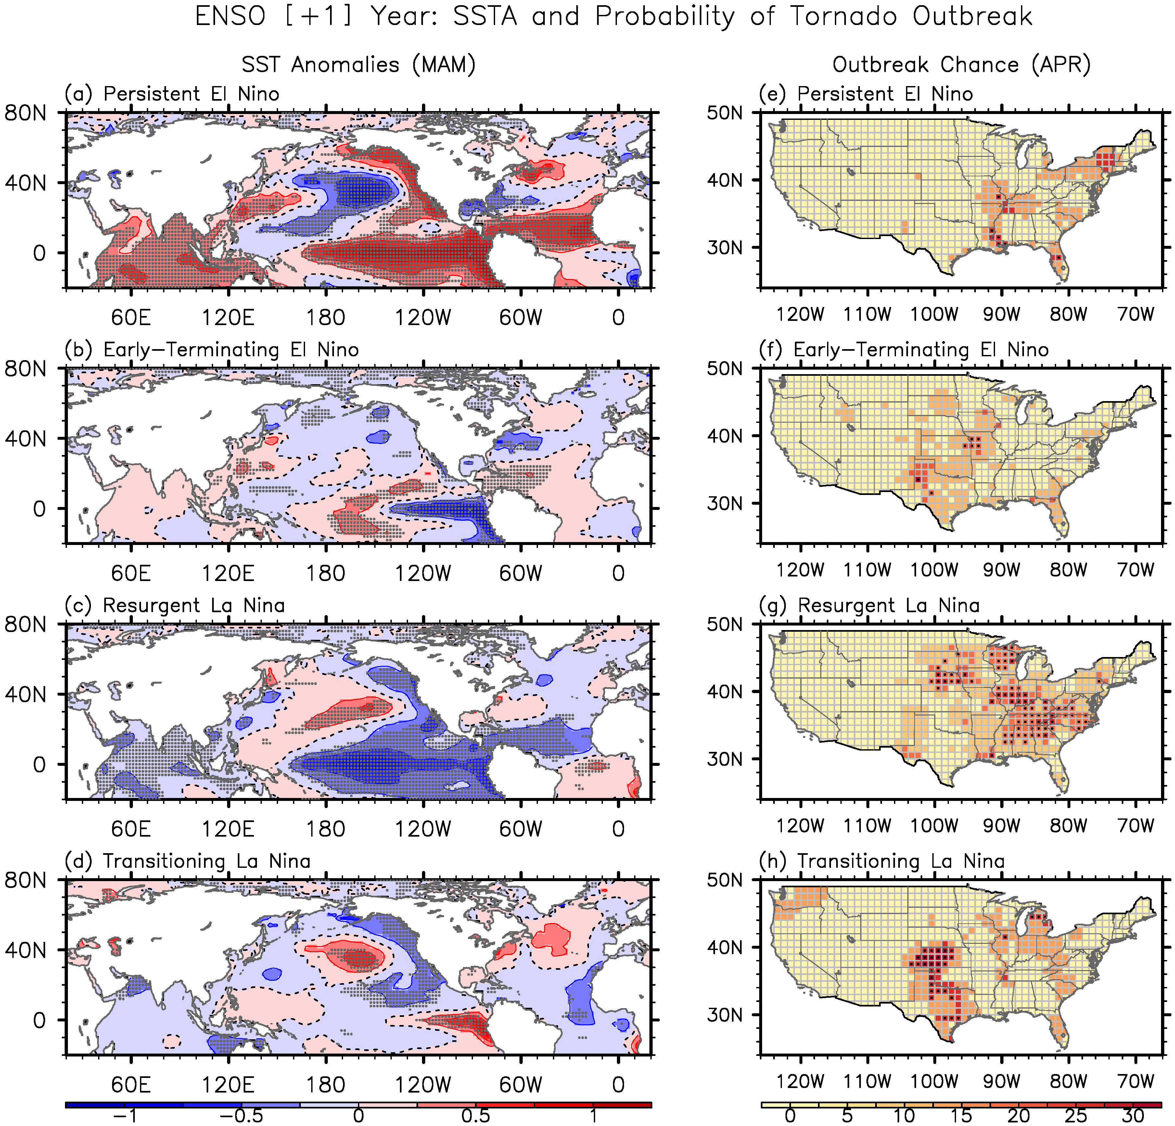
Figure 2. Composite (a-d) SSTAs for the four dominant phases of springtime ENSO evolution in MAM (+1) and (e-h) the corresponding probability of U.S. regional tornado outbreaks in April (+1). The gray dots in panels a-d indicate that the SSTAs are statistically significant at 90% based on a student-t test. The black dots in panels e-h indicate that the probability of tornado outbreaks is statistically significant at 90% based on a binomial test. The unit is in °C for the SSTAs and in % for the probability of tornado outbreaks.

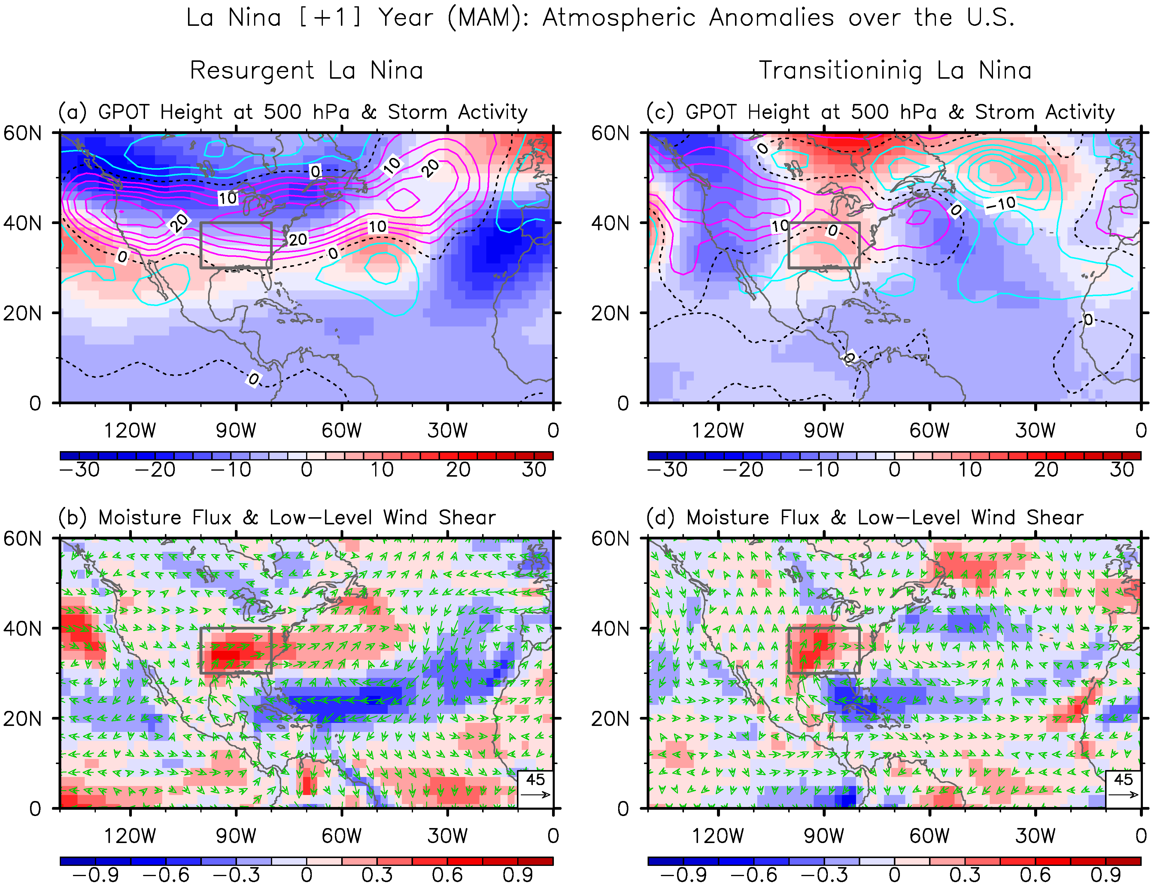
Figure 3. (upper row) Anomalous geopotential height at 500 hPa (color shades) and variance of 5day high-pass filtered meridional winds at 300 hPa (contours), and (lower row) anomalous moisture transport (vectors) and low-level vertical wind shear (850 - 1000 hPa; color shades) in MAM (+1) for (a,b) the resurgent La Niña and (c,d) transitioning La Niña cases. The units are in gpm for geopotential height, in m² s⁻² for variance of meridional winds, in kg m⁻¹ s⁻¹ for moisture transport, and in m s⁻¹ for vertical wind shear.

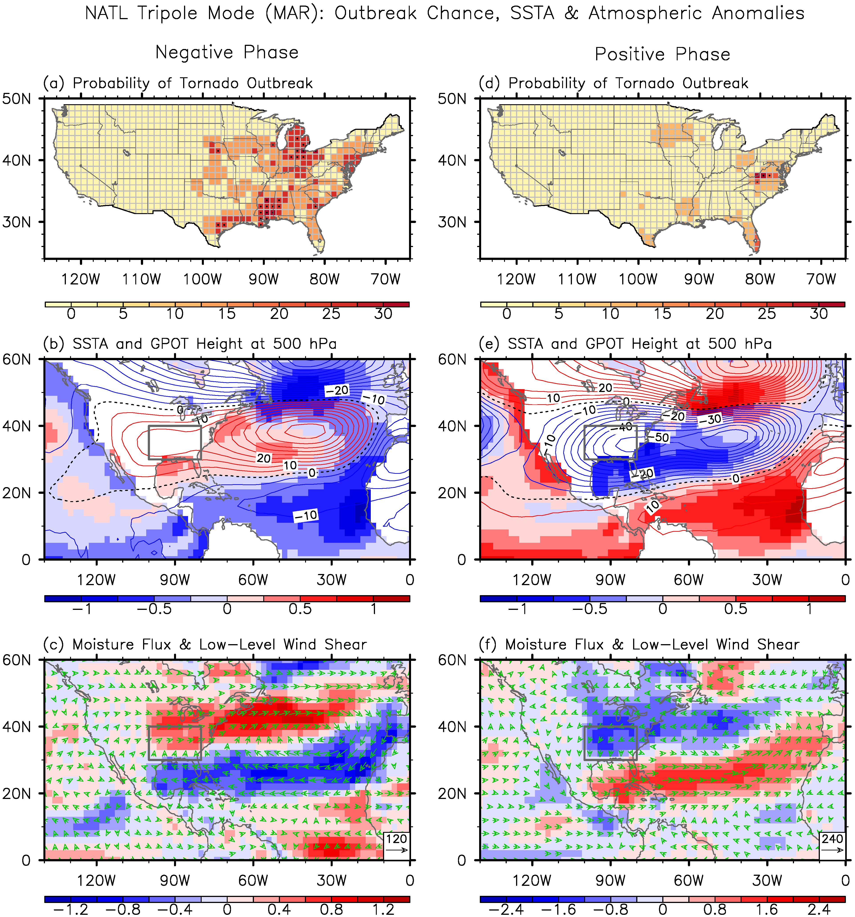
Figure 4. (top row) Probability of U.S. regional tornado, (middle row) composite SSTAs (color shades) and geopotential height anomalies at 500 hPa (contours), and (bottom row) low-level vertical wind shear anomalies (color shades) and moisture transport anomalies (vectors) in March for (a-c) the negative and (d-f) positive North Atlantic SST tripole. The unit is in % for the probability of tornado outbreaks, in °C for the SSTAs, in gpm for geopotential height, in kg m⁻¹ s⁻¹ for moisture transport, and in m s⁻¹ for vertical wind shear.

