Corresponding author: Sang-Ki Lee
CIMAS, University of Miami and AOML, NOAA, Miami, FL 33149
E-mail) sang-ki.lee@noaa.gov

Dear Editor,

We wish to submit for your kind consideration for publication in Journal of Climate the enclosed manuscript entitled “Is there an optimal ENSO pattern that enhances large-scale atmospheric processes conducive to tornado outbreaks in the U.S?” by Sang-Ki Lee, Robert Atlas, David Enfield, Chunzai Wang, and Hailong Liu. Our original manuscript was previously submitted and rejected. However, since the comments from reviewer #1 and #3 were very encouraging, we have decided to submit a substantially revised version as a new manuscript. Our replies to the comments from the three reviewers are also attached.
The record-breaking U.S. tornado outbreak in the spring of 2011 prompts the science community to identify and understand long-term climate signals that may provide seasonal predictability for intense tornado outbreaks. Currently, seasonal forecast skill for intense U.S. tornado outbreaks, such as occurred in 2011, has not been demonstrated. Our study is the first one to suggest and show that a positive phase of the Trans-Niño (TNI), which is characterized by colder than normal SSTs in the central tropical Pacific and warmer than normal SSTs in the eastern tropical Pacific, provides favorable large-scale atmospheric conditions for major tornado outbreaks over the U.S.
In our manuscript, we use a correlation study in the introduction as a preliminary test to find a potential link between the TNI and tornado activity. We then used composite analysis of the top ten most extreme tornado outbreak years and the top ten positive TNI years to show that all of the critical environmental factors for U.S. tornado activity are favorable during those positive TNI years as in the top ten most extreme tornado outbreak years. We also found that among the top ten extreme tornado outbreak years, seven years including the top three are identified with a positive phase TNI. Then, we designed and performed extensive model experiments to confirm these findings and to understand the physical mechanisms.
We have one request regarding reviewer #2. It is troubling to find that reviewer #2 is very unfair. First of all, his/her summary of our work is incorrect. For instance, he/she states throughout her/his comments as if our study relies heavily on correlation and significance, which is not a fair judgment of our work. We state in the beginning of section 3 that “the time series for the number of intense tornadoes is characterized by intense tornado outbreak years, such as 1974, 1965 and 1957, embedded amongst much weaker amplitude fluctuations”. Naturally, we decided that an effective way to explore the tornado-climate relationship is to focus on the ten most extreme tornado years ranked from 1950 to 2010 instead of relying on correlation analysis. A related point is that we are mainly interested in the extreme U.S. tornado outbreak years and the associated large-scale environments because the majority of tornado-related fatalities occur during those extreme outbreak years. Judging from his/her unfair review of our previous manuscript, we would like to request that he/she be removed from reviewing the revised manuscript. Nevertheless, we understand that the final selection of reviewers is solely decided by the editor.
During the last week, a strong positive phase TNI has emerged in the tropical Pacific (picture attached). According to our study, this may lead to another destructive tornado season over the U.S. Frankly, we are quite anxious to publish our work so that we can move on to more extensive researches that may ultimately result in a development of seasonal tornado outlook system for the U.S.

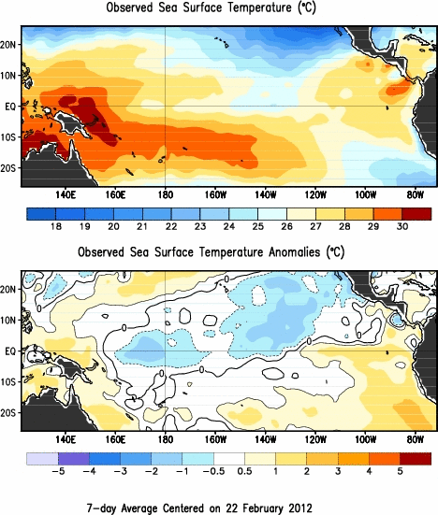
Source of the image:
http://www.cpc.ncep.noaa.gov/products/analysis_monitoring/enso_update/sstweek_c.g

Finally, we would greatly appreciate a prompt and fair review of our revised manuscript.

Sincerely yours,

Sang-Ki Lee, Robert Atlas, David Enfield, Chunzai Wang, and Hailong Liu

