Seasonal Severe Weather Outlook for the US: March-May 2016

Recent violent and widespread tornado outbreaks in the US, such as occurred in the spring of 2011, have caused devastating societal impact with significant loss of life and property. The latest U.S. Natural Hazard Statistics reported that during 2005-2014 tornadoes claimed 1,100 lives in the U.S. (second only to heat-related deaths), and caused $21.7 billion in property and crop damages (http://www.nws.noaa.gov/om/hazstats.shtml). To help emergency managers, government officials, businesses and the public better prepare the resources needed to save lives and protect critical infrastructure, a seasonal severe weather (SSW) outlook is developed to expand and compliment the current severe weather outlooks at National Oceanic Atmospheric Administration (NOAA) beyond seven days. This SSW outlook is an experimental product of NOAA Atlantic Oceanographic and Meteorological and Laboratory (AOML). It is based on a hybrid statistical-dynamical prediction model, which is currently being used at NOAA Climate Prediction Center (CPC) as one of many prediction models and decision tools for CPC’s SSW outlook (http://www.cpc.ncep.noaa.gov).

Springtime atmospheric environments and tornadogenesis in the US:
Over the central US east of the Rockies in spring, cold and dry upper-level air form the high latitudes collides with warm and moist lower-level air from the Gulf of Mexico at different altitudes. As a result, the atmosphere is unstable and the lower-level wind shear is very high providing favorable environments to form a supercell, which is known to be linked to tornadogenesis (Doswell et al. 2011).

The main goal of the SSW outlook:
Tornadogenesis is a mesoscale problem. Therefore, the SSW outlook cannot pinpoint exactly when, where and how many tornadoes may strike. Instead, the goal of the current SSW outlook is to predict in terms of probability which regions are more vulnerable to, or more likely to experience, a widespread outbreak of tornadoes.

Scientific basis of the SSW outlook:
Notable scientific advances have been made since 2011, a year of record-breaking spring tornado outbreaks in the U.S., toward expanding the severe weather outlook at NOAA beyond weather time scales. Among others, one recent study (Lee et al., 2016) showed that the dominant springtime El Niño-Southern Oscillation (ENSO) phases and the North Atlantic sea surface temperature tripole variability are linked to distinct and significant U.S. regional patterns of tornado outbreak risk. These changes in outbreak risk were shown to be largely consistent with remotely forced regional changes in the large-scale atmospheric processes conducive to tornado outbreaks.

Preparedness for severe weather events:
Damage and disasters from severe thunderstorms, tornadoes, and large hail can occur whether a season is active or relatively quiet, and it only takes one event impacting an area to cause a disaster or potentially loss of life. Residents and businesses are urged to prepare for every storm season regardless of this outlook, as numerous tornadoes and hail events occur even in relatively quiet seasons. NOAA (http://www/noaa.gov) and FEMA (http://www.fema.gov) provide important storm preparedness information on their web sites.

SSW outlook summary
The SSW outlook for March-May (MAM) 2016 for each of the nine US climate regions (see Figure 3) is shown in Table 1. A summary of the SSW for the US regions prone to severe weather (Northeast, Northern Rockies, Ohio Valley, Southeast, South, Southwest and Upper Midwest) is given below:

- Above Normal number of tornado in the Northeast
- Normal to Above Normal number of tornado in the Southeast and Upper Midwest
- Below Normal to Normal number of tornado in the Ohio Valley, South and Southwest
- Below Normal number of tornado in the Northern Rockies

Table. 1 SSW outlook for spring (March-May) 2016 is shown for the nine U.S. climate regions. The three predictors, namely the two leading modes of MAM tropical Pacific SST anomalies and the leading mode of MAM North Atlantic SST anomalies, were obtained from CFSv2 (ICs: February 2016). Two sets of predictions based on 20-member ensemble mean, and 20-member ensemble mean plus one standard deviation are shown. The predictions are indicated by “Below”, “Normal” and “Above”, which mean that the predicted value is below the lower tercile, between the lower and upper terciles and above the upper tercile, respectively. Additionally, the probabilities of “Below”, “Normal” and “Above” tornado activity, derived from the 20 member ensemble forecasts, are also shown.
US regions | Prob (%) of Below Normal | Prob (%) of Normal | Prob (%) of Above Normal | Ensemble Mean | Ensemble Mean + 1 STD
Northeast | 0 | 5 | 95 | Above | Above
Northern Rockies | 95 | 5 | 0 | Below | Below
Northwest | 50 | 50 | 0 | Normal | Normal
Ohio Valley | 60 | 40 | 0 | Below | Normal
Southeast | 30 | 30 | 40 | Normal | Above
South | 75 | 20 | 5 | Below | Normal
Southwest | 60 | 40 | 0 | Below | Normal
Upper Midwest | 50 | 35 | 15 | Normal | Above
West | 0 | 100 | 0 | Normal | Normal

SSW outlook discussion
The seasonal outlook of tornado density (EF1-EF5 tornadoes within 200 km radius) for March-May (MAM), March, April and May 2016 is shown in Figure 1. CFSv2 ensemble forecasts indicate that the current strong El Niño condition is very likely to persist throughout MAM 2016 with very high probability (Figure 2a). Strong and persistent El Niño events in spring tend to result in atmospheric conditions unfavorable for tornadogenesis across the US regions prone to severe weather. Therefore, tornado density is expected to be below normal over most of the US east of the Rockies. However, due to the southward shift of the mid-latitude jet and extratropical storm tracks, frequently occurring during strong and persistent El Niño events, the gulf coast regions and central Florida are expected to experience above normal tornado density. As observed in some of the strong and persistent El Niño events (e.g., 1982-1983 and 1997-1998), above normal condition is also expected in the Northeast.

One of the three predictors for tornado density used in the current SSW outlook is the North Atlantic SST tripole mode. A positive North Atlantic SST tripole mode (i.e., cold in the tropical North Atlantic, warm in the subtropical North Atlantic and cold in the subpolar North Atlantic) is known to be linked to a tornado outbreak in the US (Lee et al., 2016). CFSv2 ensemble forecasts indicate that a positive North Atlantic SST tripole mode is most likely with a very large spread of the ensemble members (Figure 2c). Therefore, there is some chance to have a very strongly positive North Atlantic SST tripole in MAM 2016. Mainly due to the large uncertainty in the strength of the North Atlantic SST tripole, there is some chance that Texas, Oklahoma and Kansas may experience above normal tornado density.

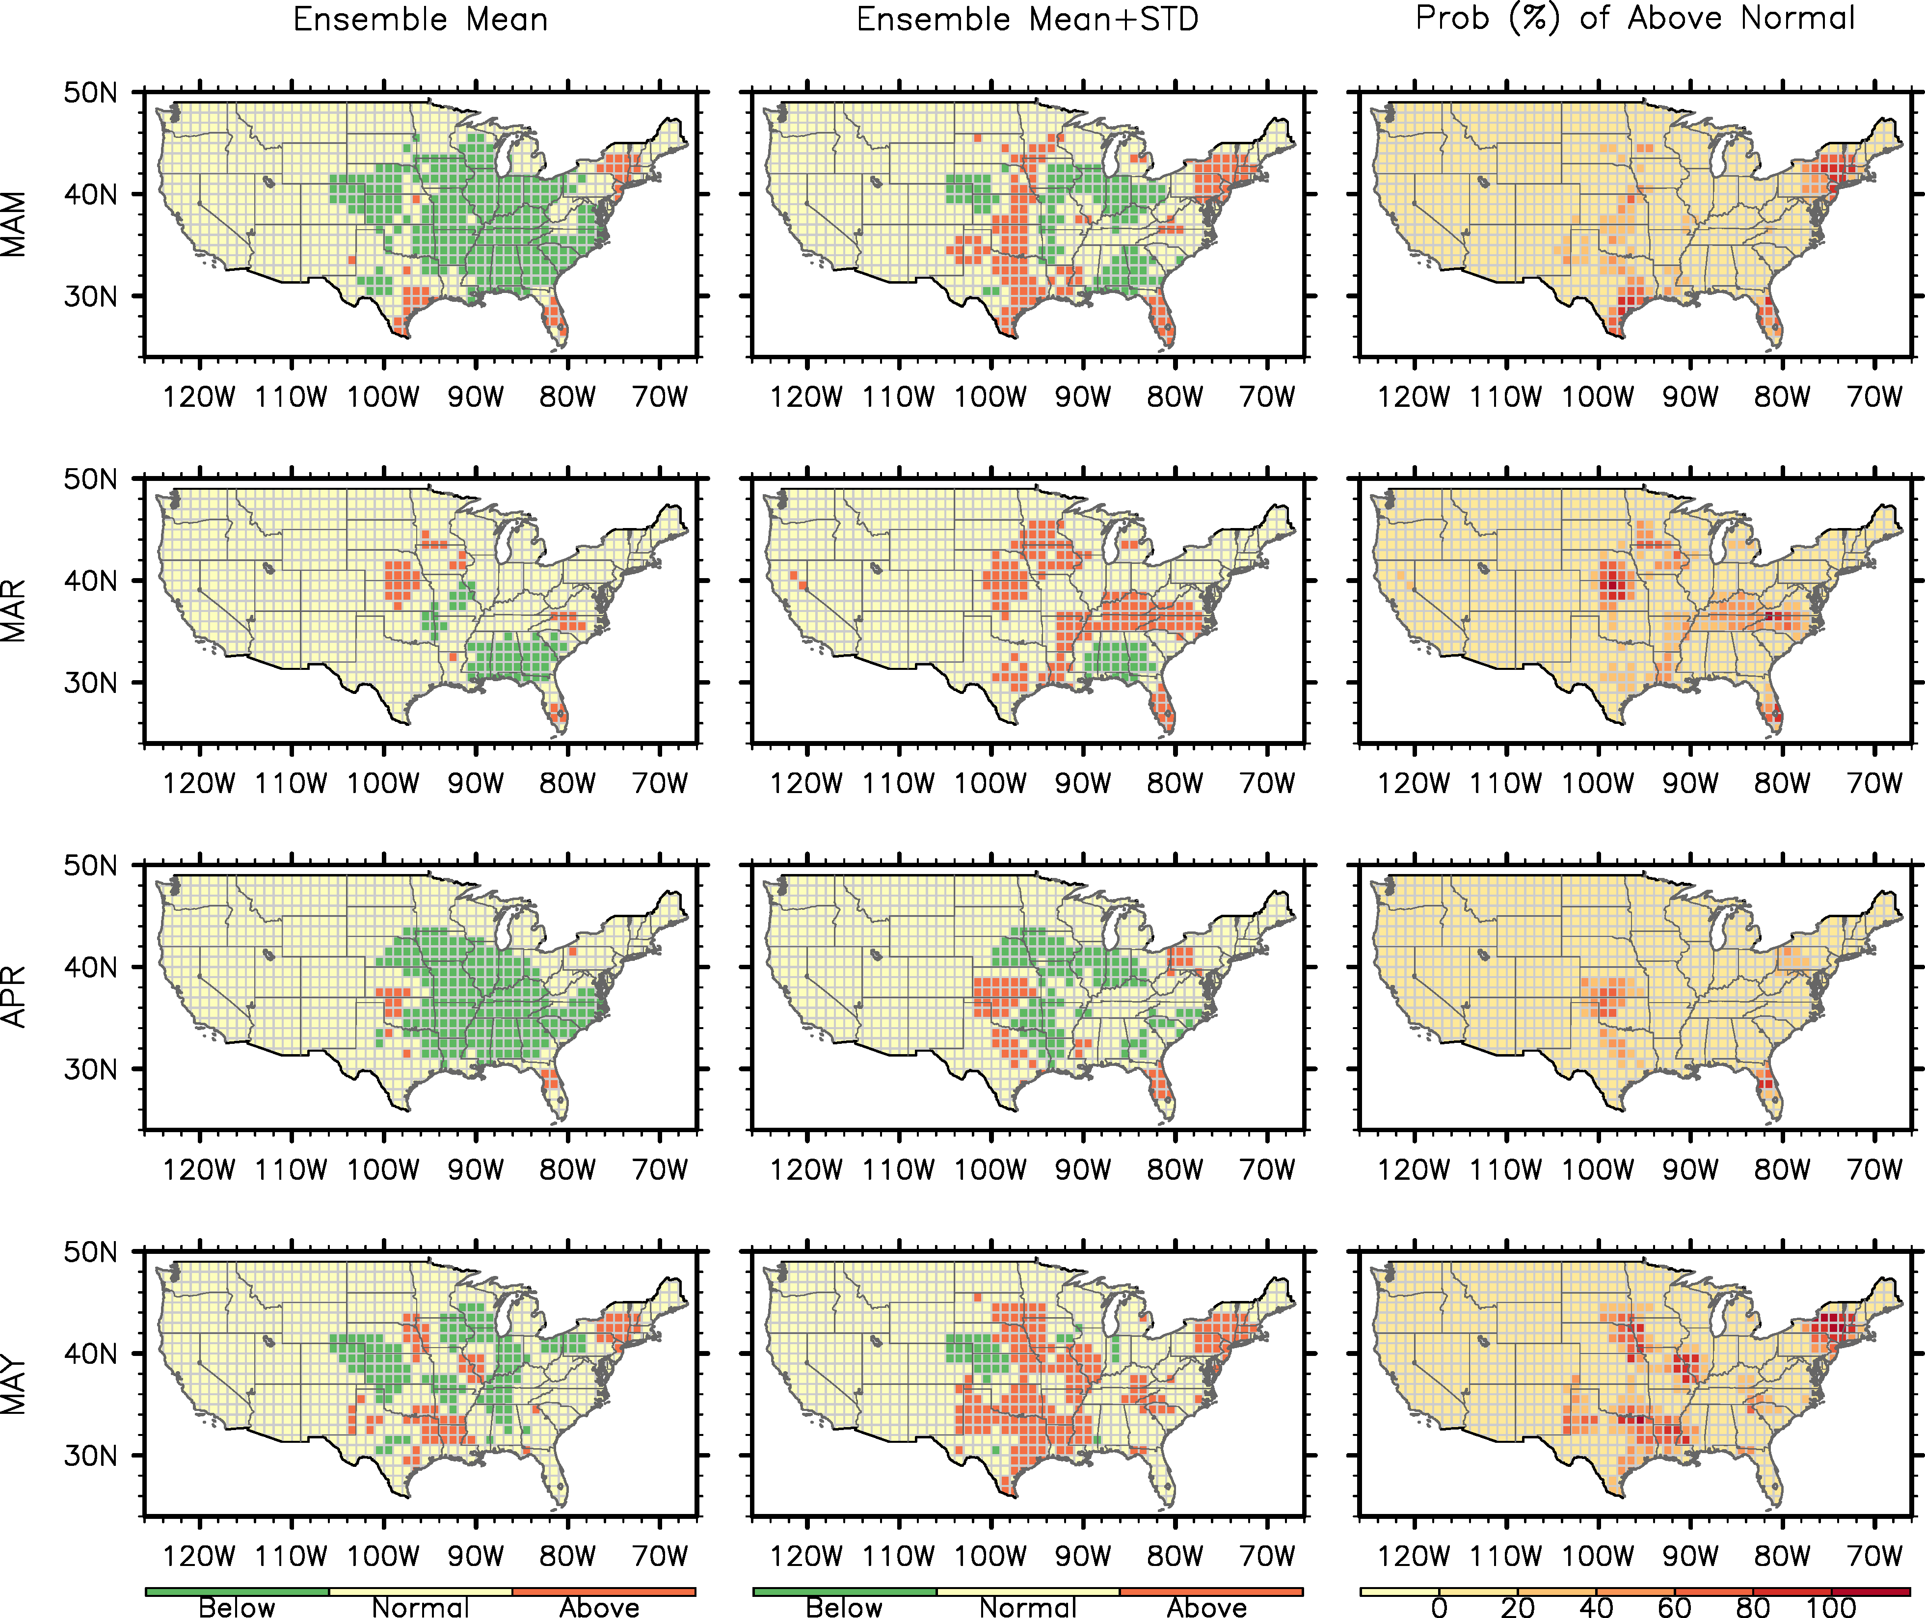

Figure 1. Hybrid statistical-dynamical prediction of tornado density (EF1-EF5 tornadoes within 200km radius) for (1st row) MAM, (2nd row) March, (3rd row) April and (4th row) May 2016. (left column) Ensemble mean, (mid column) ensemble mean + 1.0 standard deviation departure of ensemble members. A 1/3 tercile distribution is used to indicate below normal (green), normal (yellow) and above normal (dark orange) tornado density. (right column) The probability (%) of above normal tornado density derived from 20 ensemble members CFSv2 forecasts.

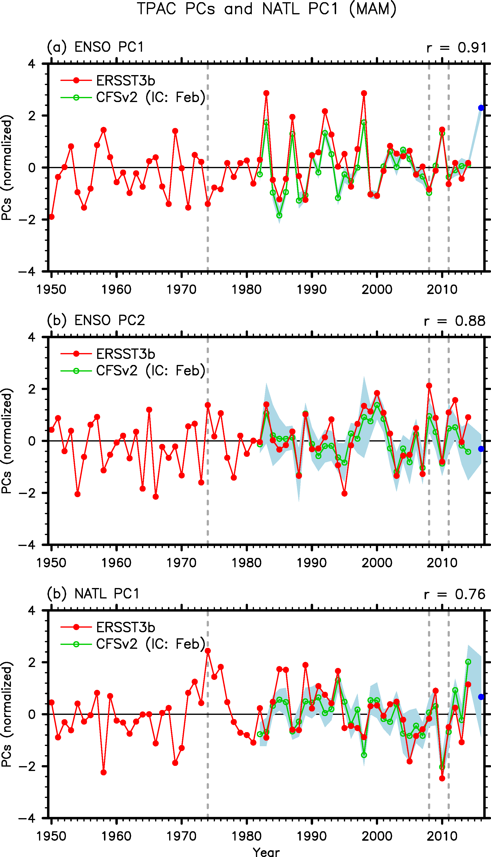

Figure 2. Three predictors derived from ERSST3b and CFSv2. (a) The 1st and (b) 2nd EOF modes of tropical pacific SST anomalies and (c) the 1st EOF modes of North Atlantic SST anomalies during March-May (Lee et al., 2014; 2016). The light blue shade indicates ensemble spread of CFSv2 forecasts (± 1 standard deviation). Partial linear regression in the context of multiple linear regression analysis is used with the three predictors to forecast tornado counts and tornado days for March-May.

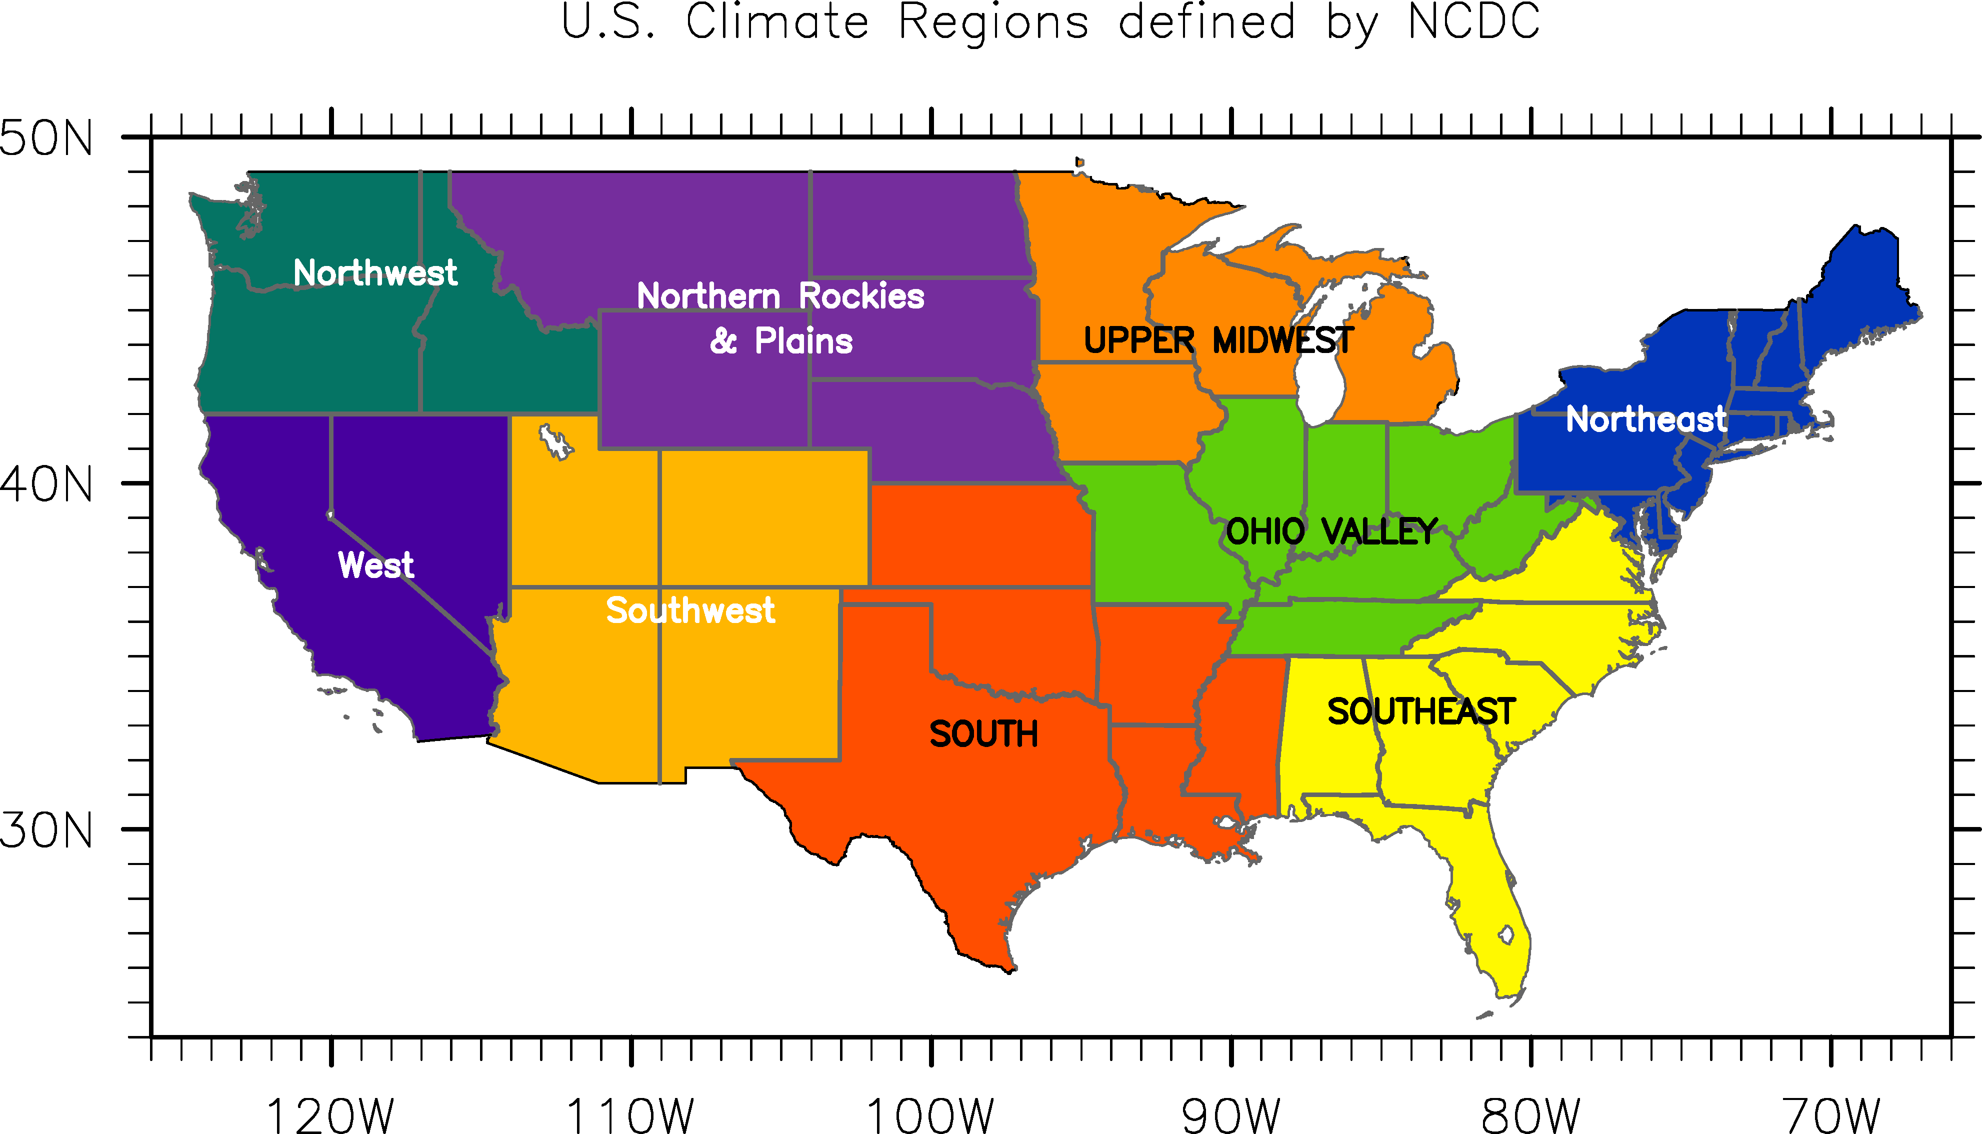

Figure 3. Nine U.S. climate regions defined by National Climate Data Center.

Prediction Tools
Seasonal tornado counts (EF1-EF5) within a 200km radius from each of 1°×1° grid points (tornado density) are predicted. The enhanced Fujita scale-0 (EF0) tornadoes are excluded in our analysis to avoid a spurious long-term trend in the severe weather database. To avoid double-counting, the location and EF-scale of each tornado are determined at the time when each tornado achieves its maximum EF-scale. The prediction is based on a hybrid statistical-dynamical model that uses CFSv2 ensemble forecasts of March-May SST anomalies. Three predictors are derived from the 1st and 2nd EOF modes of tropical pacific SST anomalies and the 1st EOF modes of North Atlantic SST anomalies (Lee et al. 2016). Partial linear regression in the context of multiple linear regression analysis is used with the three predictors to forecast tornado counts and tornado days for March-May.

References
Doswell III C A and Bosart L F 2001 Extratropical synoptic-scale processes and severe convection Severe Convective Storms ed C A Doswell III (Boston, MA: American Meteorological Society)
Lee, S.-K., P. N. DiNezio, E.-S. Chung, S.-W. Yeh, A. T. Wittenberg and C. Wang, 2014: Spring persistence, transition and resurgence of El Nino. Geophys. Res. Lett., 41, 8578-8585, doi:10.1002/2014GL062484.
Lee, S.-K., A. T. Wittenberg, D. B. Enfield, S. J. Weaver, C. Wang and R. M. Atlas, 2016: Springtime U.S. regional tornado outbreaks and their links to ENSO flavors and North Atlantic SST variability, Submitted.

Forecasters:
Dr. Sang-Ki Lee^{1,2}: sang-ki.lee@noaa.gov
Dr. Hosmay Lopez^{1,2}: hosmay.lopez@noaa.gov
Dr. Andrew Wittenberg³: andrew.wittenberg@noaa.gov

Consultants
Dr. David Enfield²: denfield@rsmas.miami.edu
Dr. Scott Weaver⁴: sweaver@edf.org
Dr. Chunzai Wang¹: chunzai.wang@noaa.gov
Dr. Robert Atlas¹: robert.atlas@noaa.gov
Dr. Gerry Bell⁵: gerry.bell@noaa.gov

¹ Atlantic Oceanographic and Meteorological Laboratory, NOAA, Miami, FL
² Cooperative Institute for Marine and Atmospheric Studies, University of Miami, Miami, FL
³ NOAA Geophysical Fluid Dynamics Laboratory, Princeton, NJ
⁴ Climate Prediction Center, NOAA, College Park, MD
⁵ Environmental Defense Fund, New York, NY

