UNIVERSITY OF MIAMI

ENSO PREDICTABILITY

By

Sarah Michelle Larson

A DISSERTATION

Submitted to the Faculty

of the University of Miami

in partial fulfillment of the requirements for

the degree of Doctor of Philosophy

Coral Gables, Florida

May 2016

©2016

Sarah M. Larson

All Rights Reserved

UNIVERSITY OF MIAMI

A dissertation submitted in partial fulfillment of

the requirements for the degree of

Doctor in Philosophy

ENSO PREDICTABILITY

Sarah Michelle Larson

Approved:

\_\_\_\_\_\_\_\_\_\_\_\_\_\_\_\_ \_\_\_\_\_\_\_\_\_\_\_\_\_\_\_\_\_

Ben P. Kirtman, Ph.D. Amy Clement, Ph.D.

Professor of Atmospheric Sciences Associate Dean and Professor of Atmospheric Sciences

\_\_\_\_\_\_\_\_\_\_\_\_\_\_\_\_ \_\_\_\_\_\_\_\_\_\_\_\_\_\_\_\_\_

Chidong Zhang, Ph.D. Dean of the Graduate School

Professor of Ocean Sciences

\_\_\_\_\_\_\_\_\_\_\_\_\_\_\_\_

Sang-Ki Lee, Ph.D.

Oceanographer,

,

NOAA/AOML, Miami, Florida

LARSON, SARAH MICHELLE (Ph.D., Meteorology and Physical Oceanography)

ENSO Predictability (May 2016)

Abstract of a dissertation at the University of Miami.

Dissertation supervised by Professor Ben P. Kirtman.

No. of pages in text. (159)

The overarching goal of this work is to explore seasonal El Niño – Southern Oscillation (ENSO) predictability. More specifically, this work investigates how intrinsic variability affects ENSO predictability using a state-of-the-art climate model. Topics related to the effects of systematic model errors and external forcing are not included in this study. Intrinsic variability encompasses a hierarchy of temporal and spatial scales, from high frequency small-scale noise-driven processes to low frequency large-scale deterministic climate modes. The former exemplifies what can be considered intrinsic “noise” in the climate system that hinders predictability by promoting rapid error growth whereas the latter often provides the slow thermal ocean inertia that supplies the coupled ENSO system with predictability. These two ends of the spectrum essentially provide the lower and upper bounds of ENSO predictability that can be attributed to internal variability.

The effects of noise-driven coupled instabilities on sea surface temperature (SST) predictability in the ENSO region is quantified by utilizing a novel coupled model methodology paired with an ensemble approach. The experimental design allows for growth of unstable intrinsic perturbations that are not prescribed; several cases exhibit sufficiently rapid growth to produce ENSO-like final states that do not require a previous ENSO event, large-scale wind trigger, or subsurface heat content precursor. Results challenge conventional ENSO theory that considers the subsurface precursor as a necessary condition for ENSO. Noise-driven SST error growth exhibits strong seasonality and dependence on the initialization month. A dynamical analysis reveals that much of the error growth behavior is linked to the seasonal strength of the Bjerknes feedback in the model, indicating that the noise-induced perturbations grow via an ENSO-like mechanism. The daily error fields reveal that persistent stochastic zonal wind stress perturbations near the equatorial dateline activate the coupled instability, first driving local SST and anomalous zonal current velocity changes that in turn induce upwelling and a clear thermocline response. Since the experimental design also isolates daily stochastic wind stress, analysis reveals that during spring when the ENSO signal is smallest and the signal-to-noise ratio is lowest, stochastic winds have the largest impact on perturbation growth that ultimately affect the development of ENSO. Ultimately, results show that the spring predictability barrier is mostly likely caused by stochastic springtime winds instigating coupled instabilities in climate models, a hypothesis supporting the notion that noise-driven errors provide an intrinsic limit to predictability.

On the other end of the spectrum, ENSO precursors, including the Pacific Meridional Mode (PMM), are thought to enhance predictability of ENSO and thus to provide potential usefulness in real-time prediction. An empirical orthogonal function (EOF) analysis identifies the dominant ENSO precursor in a coupled model as the low frequency coupled variability associated with the PMM. The robustness of the PMM/ENSO precursor relationship is verified as similar to observations and captured well by short lead-time real dynamical seasonal climate predictions. The implied usefulness of the PMM precursor as a supplemental tool for ENSO prediction is then tested by using the March PMM SST state as an independent predictor of December ENSO. In forecast mode, PMM events predict eastern Pacific El Niño events in both observations and model forecasts with somewhat useful skill, yet with much less skill for central Pacific El Niño or La Niña events.

The competition between the PMM precursor and noise-driven perturbation growth in March-initialized forecasts is tested in the context of the 2014 so-called El Niño forecast “bust.” Overall, the error growth ensemble approach implemented in the model experiment provides a more complete range of possibilities for longer lead-time forecasts and may be a better estimate of uncertainty. Moreover, applying the error ensemble approach to the 2014 El Niño forecast reveals a key insight into why PMM is a reliable precursor to ENSO, but not a reliable predictor. Since the coupled system is especially sensitive to noise-driven perturbation growth beginning in spring, much of the predictive potential of, say the PMM precursor, which peaks in terms of SST in spring, can be overshadowed by the large forecast uncertainty associated with noise-driven errors instigated by coupled instabilities. As a result, attempting to “break through” the spring predictability barrier in the coupled model may prove difficult given that noise-driven errors provide a clear intrinsic limit to ENSO predictability at longer lead-times, despite the presence of ENSO precursors.

DEDICATION

This dissertation is dedicated to meteorologist Dan Satterfield, whose enthusiasm and passion for sharing science with his audience is what inspired me to pursue a career of having my head in the clouds.

ACKNOWLEDGEMENT

I give my sincere thanks to my advisor, Dr. Ben Kirtman, for allowing me to scientifically wander through these five years and trusting that something good would result from it.

I also thank Dr. Sytske Kimball for encouraging me to pursue graduate studies and Dr. Sang-Ki Lee, who was my first research mentor and a great one at that. Special thanks to Dr. Amy Clement for her generous advice and Dr. Chidong Zhang and Dr. Bill Johns whose classes got me deeply interested in tropical interactions.

My immense appreciation goes out to Johnna Infanti for conversations on every topic imaginable and Hosmay Lopez for his help and guidance. I give special thanks to my bike buddies Sarah Bercovici and Meredith Jennings and classmates Thania Papapostolou and Yemi Adeyibi for their friendship and support. I also thank Ken, Matt, Corrye, and my brother Eric for being great distractions.

Last, I thank my parents, John and Sharon Larson, for their encouragement throughout the years and being perfectly willing to let me spend “extra” time in undergrad. I think everything worked out just fine.

TABLE OF CONTENTS

LIST OF FIGURES vii

LIST OF TABLES xii

CHAPTER 1 – Introduction 1

1.1 ENSO Predictability 1

1.2 Intrinsic Sources of Predictability 2

1.3 Intrinsic Sinks of Predictability 3

1.4 Objectives 5

1.5 Methods and Outline 6

CHAPTER 2 – The Pacific Meridional Mode as an ENSO Trigger 9

2.1 Overview 9

2.2. ENSO Precursors 9

2.3 Data and Analysis Methods 11

2.4 Composites 14

2.5 Central Pacific and the Pacific Meridional Mode 16

2.6 Western Pacific Variability and the ENSO Precursor 18

2.7 Discussion 19

CHAPTER 3 – The Pacific Meridional Mode as an ENSO Predictor in Forecast Mode 21

3.1 Overview 21

3.2 The Pacific Meridional Mode and ENSO 21

3.3 The North American Multi-Model Ensemble (NMME) 24

3.4 ENSO Precursors in Observations 25

3.5 PMM Precursors in the NMME 31

3.6 PMM as a Precursor to ENSO in the NMME 40

3.7 PMM as an ENSO Predictor 45

3.8 Extending the Observational Dataset 50

3.9 Discussion 52

CHAPTER 4 – Revisiting ENSO Coupled Instability Theory and SST Error Growth in a Fully Coupled Model 55

4.1 Overview 55

4.2 ENSO Coupled Instability Theory 56

4.3 Experimental Design 60

4.3.1 Overview 60

4.3.2 Coupled Model Framework 62

4.3.3 The Climatological Wind Experiment (CWE) 66

4.3.4 The Release Experiment (RE) 68

4.4 The March Ensemble 71

4.5 Growth Rate Seasonality 78

4.6 Implications for Predictability 84

4.7 Discussion 88

CHAPTER 5 – An Alternate Approach to Ensemble ENSO Forecast Spread: Application to the 2014 Forecast 93

5.1 Overview 93

5.2 The 2014 ENSO Forecast Challenge 93

5.3 Observations and Forecasts 95

5.4 Model Experiment and Results 97

5.5 Discussion 102

CHAPTER 6 – Drivers of ENSO Error Growth Dynamics and the Spring Predictability Barrier 105

6.1 Overview 105

6.2 Background 105

6.3 Coupled Model and Error Ensembles 107

6.4 Niño-3.4 SST Growth 109

6.5 Dynamical Processes 112

6.5.1 $Q'(TC)$ and $SST'$ 114

6.5.2 $Q'(u)$ and $τx'$ 119

6.6 Instability Trigger 121

6.6.1 Daily fields 122

6.6.2 The Role of Persistence 127

6.7 Spring Predictability Barrier 131

6.7.1 ENSO signal 131

6.7.2 Stochastic $τx'$ 133

6.8 Discussion 134

CHAPTER 7 – Conclusions 138

CHAPTER 8 – Future Work 143

8.1 Motivation 143

8.2 A Model Experiment 145

8.3 Additional Analysis 147

BIBLIOGRAPHY 150

# LIST OF FIGURES

**Figure 2.1** (a) Normalized time expansion coefficients of EOF1 of unfiltered atmospheric noise (PC1; red), low pass filtered atmospheric noise (PC1; blue) and NINO3.4 SST anomaly index (black). (b) Spatial structure of the dominant mode of tropical Pacific unfiltered atmospheric noise (dyne/cm2) in region 15°S-15°N, 160°E-80°W. (c) Cross-correlation of PC1-unfiltered and NINO3.4 index at lags 0-16 months. The negative sign indicates NINO3.4 lags PC1. Values below the blue dashed line are statistically significant at the 99% confidence level. 13

**Figure 2.2.** Composites of SST anomalies (shaded) and SSH anomalies (contours) at lag -9 months (a), lag -7 (c), and lag +0 (e) and atmospheric noise at lag -9 (b), lag -7 (d), and lag +0 (f) for significant El Niño events (NINO3.4 index ≥ 1°C in December). Lag +0 indicates the peak of an El Niño event. 15

**Figure 2.3.** (a) SST anomaly noise and (b) atmospheric noise contemporaneously regressed onto PC1. 17

**Figure 2.4**. Time expansion coefficients of EOF1 of atmospheric noise (PC1 – No filter; black) plotted with (a) TAUX-PMM, zonal wind stress anomalies averaged over the central Pacific subtropical region 180°-160°W, 10°N-15°N (black dashed) and (c) TAUX-WWB, zonal wind stress anomalies averaged over the western Pacific equatorial region 130°E-160°E, 2.5°S-2.5°N. All time series are normalized by unit standard deviation. (b) Cross-correlations of (a) at lags 0-16 months. (d) Cross-correlations of (c) at lags 0-16 months. 19

**Figure 3.1.** Right-hand column: DJF averaged SSTA in °C for the moderate-to-strong El Niño events occurring between 1982-2010. Left-hand Column: March precursors to the El Niño events. March precursors are defined as the non-ENSO SSTA (linear NINO3.4 signal removed) spatial distribution. Middle Column: March SSTA explained by the NINO3.4 signal (component removed from SSTA to obtain the precursor). 27

**Figure 3.2.** (a) Predefined PMM SSTA map as found per methods in *Larson and Kirtman* (2013). (b) Observed PMM variability, defined as the spatial correlation between the PMM map in (a) and the observed March precursor (non-ENSO SSTA). Dots indicate the PMM precursor to observed El Niño events. 29

**Figure 3.3.** PMM projection forecasts by the NMME multi-model ensemble mean (solid line), the observed PMM (dashed line), and the difference between the two (bars) for (a) 1-month, (b) 3-month, and (c) 6-month lead-times. The dashed line is the same as the PMM projection in Fig. 3.2b. 31

**Figure 3.4.** Correlation between observed and forecasted March PMM from 1982-2010 for each partner model ensemble mean and NMME multi-model ensemble mean by lead-time. Lead-times include 1-month (blue circles), 3-month (red circles), and 6-month (black circles). Values closer to one (zero) indicate higher (lower) forecast skill. Open circles indicate the NMME persistence forecasts for each lead-time. The colors for the open circles are slightly dimmed or brightened so that they can be visible whilst overlapping the filled circles. 33

**Figure 3.5.** Similar to Fig. 3.3b but for each partner model ensemble mean and the NMME multi-model ensemble mean (bottom right). 34

**Figure 3.6.** CMC1-CanCM3 January initialized forecasts for Jan-Mar SSTA (a-c), Jan-Mar precursors (non-ENSO SSTA; d-f), the observed Jan-Mar SSTA (g-i), and Jan-Mar precursors (j-l). All figures are for the year 1995. 36

**Figure 3.7.** Root-mean-squared error (RMSE; filled circles) and ensemble spread (open triangles) of each partner model and the NMME multi-model ensemble for 1-month (blue), 3-month (red), and 6-month (black) lead-time forecasts. The dashed lines indicate the NMME RMSE, provided as reference for easier comparison to the individual models. 38

**Figure 3.8.** March PMM forecast versus the following (a) December NINO-3 SSTA index and the (b) December CP-PC1 SSTA index for all March initialized forecasts between 1982-2010. (c-d) similar to (a-b) but for January initialized forecasts. Red crosses indicate model forecasts for the PMM precursor and the December NINO-3 (CP-PC1) that correspond to the observed EP (CP) El Niño events. Blue crosses are similar but for La Niña events (a,c) and black crosses are the forecasts for all other years. Bold squares are the mean forecasts for each respective category. Black filled circles indicate the NMME multi-model ensemble mean forecasts for the observed EP event years, including La Niña and El Niño events, (a,c) and CP event years (b,d) and the associated PMM precursor forecasts. Black open circles are similar but for the observed PMM and ENSO indices. Lines join the respective forecasts with the observed values for PMM and ENSO indices. 43

**Figure 4.1.** (a) Shading shows SST anomaly variance in (°C)2 and contours are SSH anomaly variance in cm2 from the CCSM4 Control simulation. (b) Similar to (a) but for CWE. (c) Ratio of variances (CWE/Control) of the zonal wind stress anomalies zonally averaged over the Dateline from 160°E-160°W. The dotted line at 1.0 indicates where CWE variance equals that of the Control. (d) NINO3 SST anomaly index for the Control (black) and CWE (orange). 65

**Figure 4.2.** Zonally-averaged temperature anomaly variance (°C)2 in the Pacific basin as a function of latitude and depth for the Control (top) and CWE (bottom). 66

**Figure 4.3.** Schematic depicting the Release Experiment (RE) modeling framework for the March ensemble. Beginning at year 30, initial conditions from CWE of each March are used to branch an additional simulation with the CWE wind stress constraints lifted. This procedure is repeated for each January, May, July, and September between years 30 and 90 of the CWE for a total of 60 cases per initialization month. 68

**Figure 4.4.** Control (dashed) and CWE (solid) mean SST (averaged over 5°S-5°N) in °C as a function of longitude for December, February, April, June, and August. These months correspond to month(0) initial conditions from which the January, March, May, July, and September RE ensembles are branched, respectively. 69

**Figure 4.5.** (a) Composite-averaged December SST error for the 10 cases that produce an El Niño event during the first year of integration. (b) Similar to (a) but for the 13 cases that produce a La Niña event. (c) Evolution of the NINO3 SST error for all 60 cases through the first calendar year of integration. Red (blue) curves indicate El Niño (La Niña) events. (d) Root-mean-squared error of (c). (e) December NINO3 error in year(0) for each case organized by the year each case is branched from CWE. Dashed lines indicate one standard deviation and black triangles indicate the cases that exceed one standard deviation and qualify as an El Niño or La Niña event. 71

**Figure 4.6.** Regression of the December NINO3 error with day(0) zonal wind stress (top row), meridional wind stress (middle), and SST (bottom) perturbations for the March ensemble. Units are dyne/cm2 per unit standard deviation of NINO3 for the wind stress and °C per unit standard deviation of NINO3 for the SST. Stippling indicates regression values significant at the 95% confidence level. 73

**Figure 4.7.** Day(0), day(2), and day(4) zonal wind stress perturbation composites for the March ensemble cases that evolve into El Niño events (top row), La Niña events( middle), and the difference (bottom). 75

**Figure 4.8.** Regression of the December NINO3 index with January – April equatorial temperature perturbations with depth of the same year (0) and December of the previous year (-1). The top row is for the Control simulation and the bottom row is for the CWE-RE experiments. In the bottom row, the right two columns are from the Release Experiment in which each case is branched in March. The left three columns correspond to the December – February from CWE preceding each March branched simulation. Units are °C per unit standard deviation of NINO3. 76

**Figure 4.9.** (a) NINO3 RMSE for the January, March, May, July, and September RE ensembles (solid lines). Dashed lines indicate month(0) from the CWE. Month(1) is the initialization month. Error bars indicate the upper and lower 5% bounds as computed using the Monte Carlo method with 10,000 iterations of 30 random samples taken from the 60 cases. The upper (lower) 5% is deemed the average of the 500 cases that are farthest from the RMSE curve in the positive (negative) direction by month. The bold dashed line indicates the annual cycle of the NINO3 anomaly standard deviation from the Control. (b) Similar to (a) but scaled by month(0). (c) The month-to-month ratio of (a). A value of 1.0 indicates no growth from month(t-1) to month(t). 79

**Figure 4.10.** (Left column) Initial error structure shown as the RMSE of the month(0) SST for each RE ensemble. (Right column) Potential growth defined as the variance of the RE SST error in December scaled by the variance of the Control. Values less than 1.0 indicate error variance that has not fully saturated the signal variance (i.e., the errors still have potential to grow) and thus, signal predictability remains. 84

**Figure 4.11.** Scatterplots of the month(0) NINO3 SST error versus the December NINO3 SST error of year(0) for the RE ensembles. Green lines indicate the month(0) NINO3 RMSE and orange lines are similarly for December. Each ensemble has 60 members. 86

**Figure 4.12.** Potential predictability curves defined as the regression coefficient of the initial state (varying from month(0) to November) and December NINO3 for NINO3 as the predictor (top) and oceanic heat content (OHC; bottom). Colors are consistent with Fig. 4.9. All predictor and predictand values are standardized separately and as a function of lead-time. 87

**Figure 4.13.** December(0) composite SST error for cases that produce (left) El Niño events and (right) La Niña events by December(0) as a function of ensemble. 89

**Figure 5.1.** a) Niño-3.4 SST error swath for the March error growth ensemble in *Larson and Kirtman* (2015b). Black bold curves indicate the 6 members whose ocean initial conditions are used in the PMM error ensemble. b) Niño-3.4 error swath, ensemble mean, spread, and uncertainty thresholds for the PMM error ensemble. Uncertainty thresholds are calculated by averaging the most extreme 3, 6, and 9 warm or cold members corresponding to 8%, 17%, and 25%, respectively. c) 2014 CCSM March initialized Niño-3.4 forecasts from the NMME, forecast spread (grey polygon), and expected spread and uncertainty thresholds from 1b. d) Same as c) but for the 2015 forecasts. 96

**Figure 5.2.** Day 1 SST errors in the 6 ocean initial conditions used for the PMM error ensemble (rows 1 and 2), the ensemble mean (bottom left), and the 2014 and 2015 0.5-lead CCSM4 forecasts of March SST anomalies from the NMME. 98

**Figure 6.1.** a) March – December Niño-3.4 SST anomaly swath for a 220-yr CCSM4 control simulation with the 10 largest El Niño (red) and La Niña (blue) events. b) Niño-3.4 error evolution for the CCSM4 March error ensemble with the 10 warmest (red) and coldest (blue) biasing members. 109

**Figure 6.2.** (Top row) The equatorially averaged March – December evolution of $SST'$ in °C (contours) and in Wm-2 (shading) for the composite El Niño and La Niña events in Fig. 6.1 and their difference. (Bottom row) Similar but for the March error ensemble. 116

**Figure 6.3.** Similar to Fig. 6.2 but for $Q'u$ (shaded) *and $τx'$*  (contours). 120

**Figure 6.4. $SST'$** , $τx'$, anomalous vertical ocean current velocities $wvel'$ (positive downward) averaged over the upper 105 meters, $Q'TC$, and $Q'u$ for an immediate activation warm case (top) and cold case (bottom). All fields are meridionally averaged over 2.5°S-2.5°N. 122

**Figure 6.5.** Similar to Fig. 6.4 but for a delayed-days cold case (top) and delayed onset warm case (bottom). 124

**Figure 6.6.** Lagged correlations between $τx'$ and the equatorially averaged $SST'$, $wvel'$, $Q'TC$, and $Q'u$ fields for the immediate activation cases in Fig. 6.5. Lag-0 indicates the contemporaneous correlation and lag(day) indicates the field lags $τx'$ by 0-6 days. 126

**Figure 6.7.** a) March monthly mean $τx'$ versus December Niño-3.4 $SST'$. b) Niño-3.4 $SST'$ histogram for all monthly $τx'>0$ in a). c) Niño-3.4 $SST'$ histogram for all monthly in a). d) persistence in days versus December Niño-3.4 . Only persistent “events” of 3+ days are included. Red (blue) signifies westerly (easterly) persistent events. e) Niño-3.4 histogram for all westerly persistent events of 3+ days. f) Niño-3.4 histogram for all easterly persistent events of 3+ days. g) All persistent events organized by the model days over which they occur versus their respective December Niño-3.4 $SST'$. Monthly mean values are used for a-c and daily for d-g. All $τx'$ are averaged over 160°E-150°W, 5°S-5°N. 129

**Figure 6.8.** The black dotted line indicates the December Niño-3.4 $SST'$ correlated with January – December Niño-4 $τx'$ in the control and represents the coherence of air-sea coupling associated with the ENSO signal in the model. Declining correlation with lead-time shows when the air-sea coupling breaks down. The solid lines show the correlation of month(1) Niño-4 with each proceeding month Niño-3.4 for the 5 error ensembles individually and indicate how long the stochastic impacts the Niño-3.4 . Declining correlation with time moving forward indicates when the is no longer tied to the month(1) Niño-4 . The black dashed line is the average stochastic over the first 15 days for the March ensemble and confirms that monthly mean (solid black) is an adequate representation of the daily stochastic mean. 132

# LIST OF TABLES

**Table 3.1.** Evaluation of PMM as a predictor of ENSO events using the % correct metric. Non-parenthesized values represent how well the forecasted PMM sign predicts the sign of the forecasted or observed ENSO index. Parenthesized values indicated similar calculations but the threshold of PMM and ENSO must fall in the upper (El Niño) or lower (La Niña) tercile. These are considered “event” predictions. The “no skill” mark is 50% for the sign predictions and 33% for the tercile, or event, predictions. The % Correct-Observed ENSO column represents how often the forecasted PMM correctly predicts the observed ENSO index for both sign and tercile ENSO index thresholds. The % Correct-ENSO Forecast is similar but for the forecasted ENSO index. 46

**Table 3.2.** Similar to Table 3.1 but for “sign” and “event” predictions from observations. The “NMME” observed record length corresponds to the hindcast period of 1982-2010. The “Extended” observed record length corresponds to 1950-2012. 49

# CHAPTER 1 – Introduction

## 1.1 ENSO Predictability

El Niño – Southern Oscillation (ENSO) is the dominant variability in the tropical Pacific, with teleconnected influences that uniquely affect weather and climate on a global scale (e.g., *Horel and Wallace*, 1981; *Rasmusson and Wallace*, 1983; *Ropelewski and Halpert*, 1987; *Trenberth et al*., 1998; *Tang and Neelin*, 2004; *Larson et al*., 2012). Despite improvements in observations (*Wallace et al*., 1998; *McPhaden et al*., 2001) and coupled models (*Bellenger et al*., 2014) in recent decades, the predictability of ENSO remains limited in real-time (*Kirtman et al*., 2002; *Jin et al*., 2008). ENSO predictability can be defined as the extent or lead-time for which boreal winter ENSO can be predicted with measurable skill.

A recent example includes the 2014 ENSO forecast. Many forecast models predicted a large 2014 El Niño, yet only weak warming was observed. The so-called 2014 El Niño forecast “bust” challenged the ENSO research and prediction communities to rethink numerous key components contributing to ENSO predictability (*Menkes et al*., 2014; *Larson and Kirtman*, 2015a; *McPhaden*, 2015; *Min et al*., 2015). This dissertation explores both intrinsic sources and sinks of ENSO predictability in fully coupled climate models, “intrinsic” meaning due to the internal variability of the climate system. To be clear, intrinsic variability does not include externally forced responses like those from greenhouse gas forcing or systematic model biases.

## 1.2 Intrinsic Sources of Predictability

In the literature, sources of potential predictability are typically referred to as ENSO precursors, which are phenomenon or tropical Pacific climate behavior that tend to occur prior to the onset of ENSO events. Precursors are found on numerous timescales, spatial scales, and components of the climate system. For instance, subsurface heat content builds up in the equatorial Pacific subsurface on the large-scale and exhibits considerable persistence that aids in predictability (*Wyrtki*, 1975; *Zebiak and Cane*, 1987; *Schneider et al*., 1995; *Jin*, 1997; *Meinen and McPhaden* 2000; *McPhaden*, 2003). Subsurface heat content can be built up locally in the tropical Pacific as in the work listed above or remotely, for instance via the “trade wind charging” (TWC; *Anderson et al*., 2013; *Anderson and Perez,* 2015) mechanism powered by sea level pressure changes in the North Pacific.

Precursors also include high frequency atmospheric noise (*Kirtman and Schopf,* 1998; *Kug et al.,* 2008, 2010), synoptic and intraseasonal westerly wind bursts (WWBs; *Harrison and Vecchi*, 1997; *McPhaden*, 1999; *Zhang and Gottschalk,* 2002; *Kug et al.,* 2008; *Lopez et al*., 2013; *Lopez and Kirtman*, 2013, 2014), Indian summer monsoons (*Kirtman and Shukla*, 2000) and mid-latitude atmospheric variability (*Anderson*, 2003; 2014; *Vimont et al.*, 2003a,b; *Chiang and Vimont*, 2004). Low frequency climate variability like the Pacific Meridional Mode (PMM; *Chiang and Vimont,* 2004*)* has also been emphasized due to its robust precursor relationship with ENSO in observations, coupled models, and dynamical climate predictions (*Chang et al.,* 2007; *Zhang et al.*, 2009a; *Larson and Kirtman*, 2013; 2014). The PMM precursor, which has the potential to enhance ENSO predictability, is highlighted in chapters 2 and 3. Note that in this dissertation, intrinsic variability can include deterministic (i.e., having spatial and temporal statistics) variability, like the subsurface precursor and the PMM, and stochastic (i.e., climate state-independent) variability, as both are internal to the climate system. The terms “noise” and “stochastic” are defined in each chapter, when applicable.

## 1.3 Intrinsic Sinks of Predictability

ENSO predictability is ultimately limited by error growth from various sources. Determining the accompanying dynamical processes that drive the growth of certain types of errors may help the ENSO community better recognize what sources of error may be intrinsic to the system. For instance, systematic model errors (*Guilyardi et al*., 2009; *Bellenger et al.*, 2014) can affect the tropical Pacific mean state and produce errors in the spatial structure and variance of ENSO. As another example, initial condition errors are common due to imperfect observations (*McPhaden*, 2003). With improved observing systems and continued model development, both types of errors can potentially be reduced over time.

On the other hand, noise-driven errors (*Xue et al*., 1997; *Samelson and Tziperman*, 2001; *Karspeck et al*., 2006; *Larson and Kirtman*, 2015a; 2015b) could be an intrinsic limit to predictability (*Samelson and Tziperman*, 2001; *Schopf and Burgman*, 2006) and may explain why longer lead-time ENSO predictions continue to fall victim to poor verification due to the so-called “spring predictability barrier” (SPB; *Webster and Yang*, 2002; *Kirtman et al*., 2002; *Jin et al*., 2008; *Duan and Wei*, 2013; *Lopez and Kirtman*, 2014; *Levine and McPhaden*, 2015). That being said, the extent to which noise-driven perturbation (or error) growth hinders ENSO predictability remains unclear in the literature, especially in the context of fully coupled models.

This topic has mostly been approached via mathematical empirical techniques, including optimal perturbations (e.g., *Penland and Sardeshmuhk*, 1995; *Moore and Kleeman*, 1996; *Kleeman and Moore*, 1997; *Xue et al*., 1997; *Mu et al*., 2007b). The lack of coupled model experimental studies attempting to address this particular ENSO predictability problem, including all possible nonlinearities, is unsurprising given that isolating specific mechanistic processes in complex climate models is challenging. Developing a model framework to tackle this issue is the aim of chapter 4. Chapter 5 includes an example of how the framework can be applied to actual ENSO predictions and chapter 6 provides a dynamical analysis of the noise-driven error growth introduced in chapter 4.

In the predictability experiments discussed throughout chapters 4-6, the initial condition “errors” are essentially stochastically introduced perturbations that have the opportunity to grow via a coupled instability mechanism (*Lau,* 1981; *McCreary*, 1983; 1985; *Philander et al*., 1984; *Anderson and McCreary*, 1985; *Gill*, 1985; *Yamagata*, 1985; *Hirst*, 1986, 1988; *Battisti*, 1988; *Battisti and Hirst*, 1989; *Wakata and Sarachik*, 1991; *Kessler and McPhaden*, 1995). The immediate excitation of the instability depends on whether the initial pertubations are conducive for growth. If the initial conditions do not include a favorable perturbation (the details of which are described in chapter 6) to excite the instability, stochastic noise has the opportunity to instigate the instability. In general, however, the season during which the favorable perturbation is introduced determines the growth rate of the instability.

The above process is essentially an aggregation of the two primary viewpoints on this topic. One side is that ENSO predictability is limited by initial condition errors that grow via the nonlinear dynamics of the system (e.g., *Zebiak and Cane*, 1987; *Tziperman et al*., 1994; 1995). In this case, the strength of the air-sea coupling varies with the annual cycle and dictates the error growth rate. The other is that the initial conditions are of secondary importance to the stochastic forcing (e.g., *Penland and Sardeshmuhk*, 1995; *Moore and Kleeman*, 1996; *Blanke et al*., 1997; *Chen et al*., 1997; *Kleeman and Moore*, 1997; *Xue et al*., 1997; *Kirtman and Schopf*, 1998; *Moore and Kleeman*, 1999). This second perspective argues that weather “noise” alters the evolution of coupled system.

The ensemble experiment illustrated in chapter 4 presents a framework that allows a combination of the two hypotheses. Errors can grow immediately upon initialization if the stochastically introduced initial perturbations are conducive to instigating a coupled instability mechanism. Otherwise the instability may be instigated when favorable atmospheric noise acts on the system. Once excited, the growth rate of the instability is determined by the seasonal dependence of air-sea feedbacks.

## 1.4 Objectives (Key questions)

The key questions (or objectives) of this research are listed below. Each question is targeted towards gaining a better understanding of ENSO predictability in state-of-the-art coupled climate models. The topics are meant to span the spectrum from potential sources of predictability (e.g., the PMM) to potential sinks (e.g., noise-driven perturbation growth).

Key Questions:

1. What role does the PMM play? Is it an ENSO precursor and predictor?
2. Does the PMM impact ENSO predictability?
3. What is the relative role of coupled instabilities versus noise-driven perturbation growth in driving ENSO predictability loss in coupled models?
4. Can noise-driven error growth explain the so-called 2014 ENSO “busted” forecast?
5. What dynamics drive intrinsic ENSO error growth in coupled models?
6. Do noise-driven errors overshadow the predictive potential of precursors like the PMM?

## 1.5 Methods and Outline

Current-day climate prediction systems, including the North American Multi-Model Ensemble (NMME; *Kirtman et al*., 2014) as well as other modeling groups (e.g., *Doblas-Reyes et al.*, 2000; *Palmer et al*., 2004), utilize state-of-the-art fully coupled climate models to provide a variety of forecasts on seasonal to intraseasonal timescales. These forecasts rely heavily on the predicted ENSO state, which can have a large impact on the predictability of, for instance, the winter and spring precipitation patterns in North America (e.g., *Ropelewski et al*., 1986; *Kumar and Hoerling*, 1997; 1998) due to the extratropical teleconnection from the Pacific via stationary Rossby waves (e.g., *Hoskins et al*., 1981; *Sardeshmukh and Hoskins*, 1988; *Trenberth et al*., 1998). Because an accurate ENSO forecast is vital to getting these teleconnected patterns correct, determining the sources and sinks of ENSO predictability in a particular model is essential to knowing when and why the forecast uncertainty may change with lead-time or initialization month. As such, coupled models are utilized in this research in an attempt to promote a better understanding of ENSO predictability in the types of models used in actual seasonal predictions.

Questions 1 and2 are first addressed via the analysis presented in chapter 2. This chapter utilizes model output from an ocean eddy-permitting version of the National Center for Atmospheric Research (NCAR) Community Climate System Model version 3.5 (CCSM3.5; *Kirtman et al*., 2012). The model output is used to pintpoint the dominant atmospheric wind stress precursor to ENSO. Then, in chapter 3, the dominant precursor pattern, found to be the PMM, is tested in the context of the NMME prediction system Phase-1 models to determine whether the PMM performs well as a predictor of ENSO in forecast mode. The NMME predictions are verified using an observational dataset. Why the PMM is found to be only a marginally useful predictor of ENSO, despite being a reliable precursor to ENSO, is revisited in chapter 5.

The experiments designed to address questions 3-6 utilize the National Center for Atmospheric Research (NCAR) Community Climate System Model version 4.0 (CCSM4), a fully coupled model used both for climate research (e.g., *Capotondi*, 2013; *Lopez and Kirtman*, 2013; *DiNezio and Deser*, 2014) and real-time climate predictions as CCSM4 is one of the Phase-2 NMME models. The phase-2 models include updated versions of the phase-1 models described in chapter 3. Chapters 4-6 employ an ensemble methodology to explore ENSO predictability in CCSM4. Specifically, chapter 4 introduces a model methodology that isolates ENSO SST error (or perturbation) growth induced by coupled instabilities. Much of the chapter is a proof of concept of the framework, which doubles as hypothesis testing of previous coupled instability work done primarily in the 1980s (e.g., *Philander et al*., 1984; *Hirst 1986*; *Battisti*, 1988; *Battisti and Hirst*, 1989; and those in chapter 4). How noise-driven error growth impacts ENSO predictability is also addressed.

Chapter 5 applies the model framework from chapter 4 to actual real-time ENSO predictions from the NMME CCSM4, specifically the 2014 and 2015 March initialized December ENSO forecasts. An ensemble approach is utilized to determine the “expected” uncertainty for ENSO forecasts with initial SST anomaly states similar to those of the 2014 and 2015. Chapter 6 presents a dynamical analysis of the error growth ensembles presented in chapter 4. This chapter reveals how rapid error growth is instigated in CCSM4 and provides a new approach to determine how the “spring predictability barrier” originates in coupled models.

Chapter 7 presents final conclusions, and chapter 8 proposes future work that expands on the methodology presented in this dissertation.

# CHAPTER 2 – The Pacific Meridional Mode as an ENSO Trigger

**In reference to *Larson and Kirtman* (2013)**

## 2.1 Overview

In this chapter, we determine the dominant wind stress precursor pattern to ENSO in a high-resolution version of the Community Climate System Model version 3.5 (*Kirtman et al*., 2012). The analysis utitilizes daily data to determine whether the preferred wind stress trigger occurs on daily or monthly timescales. Here, we focus only on wind stress variability because of its potential to excite equatorial waves dynamics, including an eastward propagating equatorial Kelvin wave packet that can set up an ENSO event. After the precursor pattern is identified, the following chapter will test the precursor pattern as an independent predictor of ENSO events to determine whether the precursor increases ENSO predictability.

## 2.2. ENSO Precursors

Precursors can be defined as any phenomenon that tends to occur prior to ENSO events, including variability on timescales of high frequency atmospheric noise (*Kirtman and Schopf,* 1998; *Kug et al.,* 2008, 2010), synoptic and intraseasonal westerly wind bursts (WWBs; *McPhaden*, 1999; *Zhang and Gottschalk,* 2002; *Kug et al.,* 2008), Indian summer monsoons (*Kirtman and Shukla*, 2000), mid-latitude atmospheric variability (*Vimont et al.*, 2003a,b), and low frequency climate variability like the Pacific Meridional Mode (PMM; *Chang et al.,* 2007; *Zhang et al.*, 2009a). WWBs, monsoonal variability, and PMM are sometimes considered ENSO triggers (*Kessler et al.*, 1995; *Zhang and Gottschalk,* 2002*; Kirtman and Shukla*, 2000, *Chang et al.,* 2007; *Zhang et al.*, 2009a). These precursors are typically classified as part of the stochastic noise forcing of ENSO because they are believed to be due to the internal variability of the system (e.g. WWBs); however, there is evidence that WWBs are in part, ENSO state-dependent (*Seiko and Takayabu,* 2007; *Tziperman and Yu*, 2007).

High frequency precursors have been extensively studied in the literature. Enhanced atmospheric noise can add to the irregularity of ENSO events and modulate the decadal signal (*Kirtman and Schopf,* 1998). Enhanced atmospheric noise variability in the western Pacific tends to lead El Niño by 7-10 months whereas variability in the central Pacific is correlated contemporaneously with ENSO, supporting the theory that atmospheric noise is ENSO state-dependent (*Kug et al.,* 2008; *Kirtman et al.* 2005). *Kug et al*. (2010) show that low frequency western Pacific zonal wind, high frequency zonal wind variance, and equatorial sea surface height (SSH) correlate highly with ENSO at a 9 month lag, contemporaneously with each other, and are part of a coupled process over the western Pacific occurring prior to ENSO events. In late boreal spring in the western Pacific, WWBs tend to be more frequent during ENSO onset years (*Seiki and Takayabu*, 2007) and the strength of Madden-Julian Oscillation induced WWBs is linked to the strength of the subsequent El Niño (*Hendon et al.* 2007). A modeling study by *Lopez et al.* (2013)shows that the slow sea surface temperature (SST) state-dependent component of WWBs potentially has a stronger impact on ENSO variability than it’s state-independent counterpart.

Precursors also include low frequency coupled variability like PMM, which is associated with peak SST anomalies (SSTA) in boreal spring coupled with anomalous westerlies in the central Pacific subtropics (*Chiang and Vimont,* 2004). Positive phase PMM tends to precede El Niño events and potentially acts as an ENSO trigger (*Chang et al.* 2007). In this study, an EOF analysis and composites are used to investigate the dominant structure of atmospheric noise, which we define as all non-ENSO variability, in the tropical Pacific and its relationship to the ENSO signal and also identify the contribution of key precursors to this relationship.

## 2.3 Data and Analysis Methods

The data used in this study are daily and monthly means of SST, zonal wind stress (τx), and SSH from an NCAR Community Climate System Model version 3.5 (CCSM3.5) current-day climate simulation named HRC06 and discussed in *Kirtman et al.* (2012). The horizontal resolution of the ocean component is eddy-resolving at 0.1° and the last 40 years of simulation output are considered here. Monthly anomalies are computed by removing the annual cycle and daily anomalies are computed by removing the annual cycle at each calendar day.

The τx anomaly noise (hereafter, atmospheric noise) is defined as linearly removing the contemporaneous ENSO signal from the full τx anomaly field. The ENSO signal is defined as the NINO3.4 index (SSTA averaged over 5°S-5°N, 170°W-120°W). Therefore, the atmospheric noise is found by,

atmospheric noise = τx(x,y)– *α(x,y) ×* NINO3.4, (2.1)

where *α* is the regression coefficient of the NINO3.4 index onto τx. It is important to note that the term “noise” may seem like a misnomer because it intuitively implies randomness. However, the way noise is defined here, it can have spatial and temporal statistics (i.e. phenomenological signatures) as well as include coupled variability (e.g. PMM) and high frequency atmospheric variability. This residual definition is similar to the procedure used by *Blanke et al.* (1997), and assumes that noise is any variability that is not linearly and contemporaneously related to NINO3.4. Previous studies, including *Kug et al.* (2008), apply a bandpass filter to the data to isolate the noise component, however no such filtering is applied here. This point is important considering that low frequency climate variability may contribute to the stochastic forcing and phase-locking of ENSO (*Zhang et al.* 2009a; *Chang et al.* 2007). This method differs from that by *Chiang and Vimont* (2004) where the authors also linearly remove the ENSO signal but instead use the cold tongue index (SSTA averaged over 6°S-6°N, 180°-90°W) and from ensemble averaging including the interactive ensemble approach by *Kirtman and Shukla* (2002).

An EOF analysis is applied to isolate the dominant structure of the so-called atmospheric noise in the tropical Pacific region of 15°S-15°N, 160°E-80°W. It is important to note that the following results are insensitive to restricting the latitudinal extent of the domain anywhere between 5°S-5°N and 15°S-15°N. There is slight sensitivity to the longitudinal extent of the domain, however the sensitivity does not change the major conclusions presented here. In fact, extending the domain to include either Atlantic or Indian Ocean variability yields very similar results. This suggests that the dominant non-ENSO variability in the tropics is in the Pacific Ocean but does not rule out the possible impact from the Atlantic or Indian Ocean (*Ham et. al.,* 2013). The normalized time expansion coefficients of the first EOF mode (PC1) and NINO3.4 (Fig. 2.1a) show a distinct lead/lag relationship with the strongest magnitude correlation occurring when NINO3.4 lags PC1 by 7 months with correlation coefficient -0.37 (Fig. 2.1c).

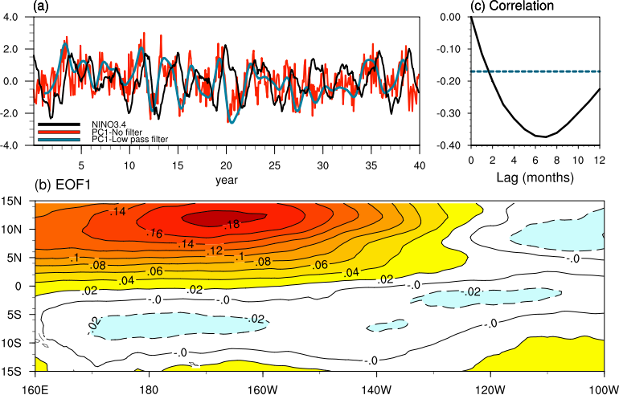

**Figure 2.1** (a) Normalized time expansion coefficients of EOF1 of unfiltered atmospheric noise (PC1; red), low pass filtered atmospheric noise (PC1; blue) and NINO3.4 SST anomaly index (black). (b) Spatial structure of the dominant mode of tropical Pacific unfiltered atmospheric noise (dyne/cm2) in region 15°S-15°N, 160°E-80°W. (c) Cross-correlation of PC1-unfiltered and NINO3.4 index at lags 0-16 months. The negative sign indicates NINO3.4 lags PC1. Values below the blue dashed line are statistically significant at the 99% confidence level.

The timescale of the lead/lag relationship is interesting considering that *Kug et al.* (2008) show that the variance of the atmospheric noise, which they define with a 2-180 day bandpass filter and averaged over the equatorial waveguide, over the equatorial Pacific tends to be stronger 7-10 months prior to an El Niño event. Despite the different definitions of atmospheric noise, both studies indicate the existence of a distinct relationship between atmosphere noise and the subsequent El Niño at a similar timescale. Interestingly, PC1 (red line) in Fig. 2.1a suggests an underlying low-frequency signal of ENSO-like timescale that would not be included in filtered noise component as in *Kug et al.* (2008). Fig. 2.1b shows enhanced off-equatorial atmospheric noise between 180-150°W and 5°N-15°N and resembles the anomalous zonal wind field associated with positive phase PMM (see *Chiang and Vimont*, 2004, their Fig. 2.1a) and the seasonal footprinting mechanism (see *Vimont, Wallace, and Battisti*, 2003, their Fig. 3).

To identify which frequencies are most important to the variability of EOF1, a low pass filter is applied to the atmospheric noise data to remove all variability with periods less than 24 months and an additional EOF analysis is computed. The spatial structure is similar (not shown) and PC1-low pass (Fig. 2.1a; blue line) resembles a smoothed version of PC1 from the unfiltered case (Fig. 2.1a; red line). The two PC1s are highly correlated (0.70). To further verify that higher frequencies are not significantly contributing to the variability of EOF1, the EOF analysis is repeated but after only allowing variability of periods less than 24 months (not shown). The lead/lag correlations between NINO3.4 and PC1-high pass are near zero and statistically insignificant for lags 0-16 months and the spatial structure does not resemble Fig. 2.1b. This filtering analysis indicates that high frequencies are not a main contributor to the spatial structure or lag-lead relationship shown in Fig. 2.1.

## 2.4 Composites

Composites are created to show the SSTA, atmospheric noise, and SSH anomalies (SSHA) structures in the tropical Pacific at lags -9, -7, and 0 months where lag-0 corresponds to the peak of a significant ENSO event. Significant ENSO events are defined as when NINO3.4 meets or exceeds 1.0°C in December. Ten El Niño years satisfy the definition. While the maximum correlation between PC1 and NINO3.4 is at lag-7 (Fig. 2.1c), composites at lag-9 are included to show the state of the tropical Pacific at the onset of the peak lead/lag relationship. Composites of the 10 El Niño events are shown in Fig. 2.2. SSTA and SSHA at lag-0 are as expected for peak El Niño conditions with strong positive anomalies extending from the equatorial eastern Pacific towards the dateline (Fig. 2.2e). The composite of τx anomalies at lag-0 (not shown), shows strong (greater than 0.3 dyne/cm2) anomalous westerlies in the western-to-central equatorial Pacific, however the anomalies are much weaker (less than 0.2 dyne/cm2) in the atmospheric noise composite at lag-0 (Fig. 2.2f) thus confirming that linearly removing the ENSO signal did, in fact, remove the robust zonal wind signatures typical during El Niño events.

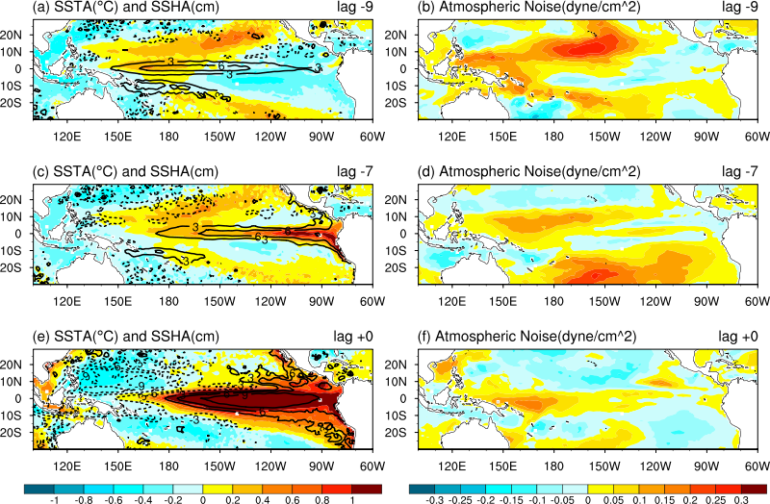

**Figure 2.2.** Composites of SST anomalies (shaded) and SSH anomalies (contours) at lag -9 months (a), lag -7 (c), and lag +0 (e) and atmospheric noise at lag -9 (b), lag -7 (d), and lag +0 (f) for significant El Niño events (NINO3.4 index ≥ 1°C in December). Lag +0 indicates the peak of an El Niño event.

## 2.5 Central Pacific and the Pacific Meridional Mode

Fig. 2.2a shows that warmest SSTA at lag-9 occur off of the equator with a structure that is consistent with positive phase PMM (see *Chiang and Vimont,* 2004, their Fig. 2.1a). Considering that lag-9 is in March, results are consistent with the timing of peak PMM SSTA in boreal spring. Anomalous westerlies in the central Pacific subtropics are consistent with previous studies that show distinct anomalous southwesterly winds in this region during PMM (Fig. 2.2b). Therefore, positive phase PMM is identified at lag-9. Also present at this time are weak cool SSTA extending from the eastern equatorial Pacific towards the dateline, a structure consistent with the decay phase of La Niña. Another key feature seen at lag-9 (Fig. 2.2a) is the positive preconditioning of the western-to-central Pacific (i.e high SSHA in the western-to-central equatorial Pacific). It is hypothesized that at this time, atmospheric noise triggers the Kelvin wave that sets up El Niño 2 months later at lag-7 (Fig. 2.2c-d), which is when the maximum correlation between NINO3.4 and PC1 occurs. These results are similar to findings from *Vimont et al*. (2003a,b), which discuss the projection of τx onto the equatorial wave via the seasonal footprinting mechanism.

A few studies (*Chang et al.*, 2007; *Zhang et al.*, 2009a; *Alexander et al.*, 2008) point out that PMM conditions tend to look like the optimal initial conditions for rapid ENSO onset described in *Penland and Sardeshmukh* (1995). To confirm that PC1 is, in fact, PMM, PC1 is regressed onto SSTA noise and atmospheric noise (Fig. 2.3a-b). The SSTA noise is defined in the same way as the atmospheric noise. Previous studies calculate PMM by computing a maximum covariance analysis between SST and horizontal winds after linearly removing the ENSO signal from each field. Therefore, our so-called noise components can easily be compared with these previous methods. The regression of SSTA noise onto PC1 (Fig. 2.3a) closely resembles the SSTA composite at lag-9 (Fig. 2.2a) in the subtropical eastern Pacific, which we identified as positive phase PMM.

*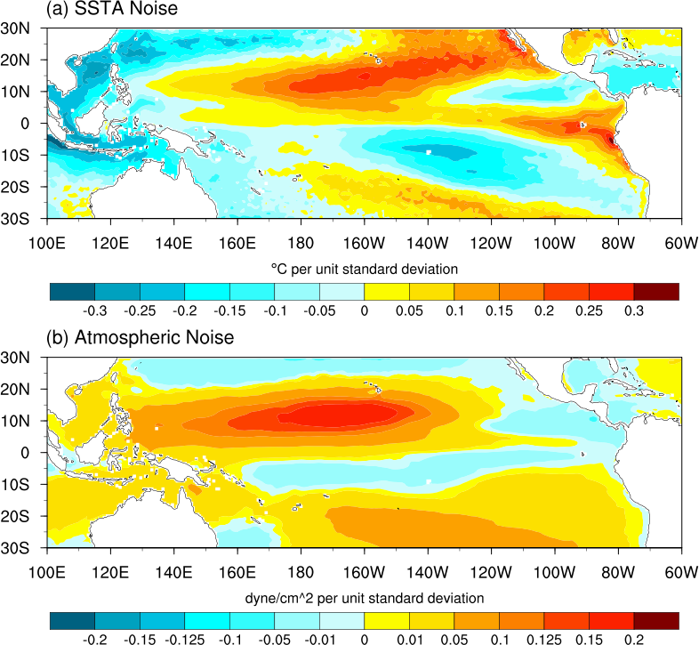*

**Figure 2.3.** (a) SST anomaly noise and (b) atmospheric noise contemporaneously regressed onto PC1.

Additionally, there is some evidence of the non-linear El Niño component in the eastern equatorial Pacific that is not removed by our linear approach. The off-equatorial, anomalous westerlies seen between 180°-120°W in the PC1 regression (Fig. 2.3b) closely resemble the atmospheric noise composite (Fig. 2.2b), which were also identified as a PMM signature. Overall, the PC1 regressions show the PMM signatures that are also identified in the composites (Figs. 2.2a-b) at lag-9. It is also worth noting that the increased atmospheric noise in the western Pacific in Fig. 2.3b may be PMM state-dependent but is also possibly an artifact of the seasonality of WWBs. Therefore, in the following section we compare the relative importance of PMM and WWBs as ENSO precursors.

## 2.6 Western Pacific Variability and the ENSO Precursor

The results thus far suggest an interesting question, namely – does western Pacific variability contribute to the ENSO precursor shown in Fig. 2.1? In other words, is the ENSO precursor dominated by low frequency coupled variability associated with PMM or does western Pacific variability primarily associated with WWBs also contribute? Since we have stated that high frequencies are not a main contributor to the EOF1 variability, we can assume that the fast SST state-independent component of WWBs, as well as other high frequency atmospheric variability, do not significantly contribute. However, since WWBs also include a slow SST state-dependent component (*Seiki and Takayabu*, 2007; *Tziperman and Yu*, 2007; *Lopez et al.,* 2013), it is possible that some variability associated with WWBs remains in the low pass filtered EOF case and may be contributing to the EOF1 variability. To show the relative importance of PMM and WWBs to the variability of ENSO precursors, τx anomalies are averaged over the regions of interest and correlated with PC1 of the unfiltered EOF at lags 0-16 months (Fig. 2.4). For PMM, τx anomalies are averaged over the central Pacific subtropics (TAUX-PMM; 180°-160°W, 10°N-15°N) and for WWBs, over the western equatorial Pacific (TAUX-WWB; 130°E-160°E, 2.5°S-2.5°N).

Fig. 2.4b shows that TAUX-PMM and PC1 are highly correlated (0.87) and the correlation is maximized at lag-0. In comparison, Fig. 2.4d shows that TAUX-WWB and PC1 are only modestly correlated at (0.34). For this reason, we can conclude that the relative importance of WWBs to the variability of ENSO precursors is less than PMM and that overall, PMM dominates over high frequency atmospheric variability as well as variability in the western Pacific in acting as a precursor to El Niño events. To be clear, we are not stating that western Pacific variability, namely WWBs, are not important to the triggering of ENSO events, only that the relative importance of WWBs is less than for PMM, according to the analysis of this model.

**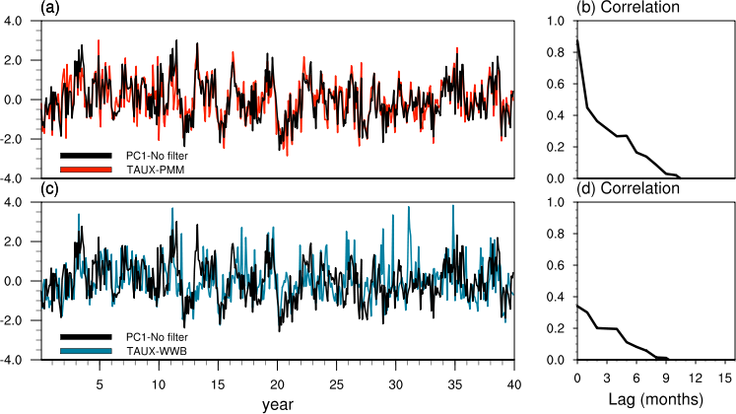**

**Figure 2.4**. Time expansion coefficients of EOF1 of atmospheric noise (PC1 – No filter; black) plotted with (a) TAUX-PMM, zonal wind stress anomalies averaged over the central Pacific subtropical region 180°-160°W, 10°N-15°N (black dashed) and (c) TAUX-WWB, zonal wind stress anomalies averaged over the western Pacific equatorial region 130°E-160°E, 2.5°S-2.5°N. All time series are normalized by unit standard deviation. (b) Cross-correlations of (a) at lags 0-16 months. (d) Cross-correlations of (c) at lags 0-16 months.

## 2.7 Discussion

First, we find that the dominant variability of tropical Pacific atmospheric noise in a high-resolution coupled model is PMM, or low frequency coupled variability, and acts as a trigger for ENSO 7-9 months prior to El Niño events. It is important to remember that the definition of atmospheric noise varies between studies and that here we include all non-ENSO variability. Because not every PMM event triggers an El Niño event, composite analysis suggests that PMM appears an effective trigger when the western-to-central equatorial Pacific is preconditioned. Second, after repeating the analysis with high pass and low pass filtered data, extending the domain to include other ocean basins, and isolating the variability in regions of interest, we are able to conclude that the relative importance of low frequency coupled variability associated with PMM dominates over other variability between 15°N and 15°S, including high frequency atmospheric variability and WWBs, in acting as a precursor to El Niño events.

The above analysis motivates an intriguing question: If the PMM is a robust precursor to ENSO, might it also be a reliable ENSO predictor? If so, the PMM may be a useful tool to enhance confidence in ENSO forecasts and potentially provide a clue as to whether the PMM positively contributes to ENSO predictability. The next chapter will test if the PMM is also a reliable predictor in forecast mode. Whether the PMM positively contributes to ENSO predictability is addressed in chapter 5.

# CHAPTER 3 – The Pacific Meridional Mode as an ENSO Predictor in Forecast Mode

**In reference to *Larson and Kirtman* (2014)**

## 3.1 Overview

Although modeling and observational studies have highlighted a robust relationship between the Pacific Meridional Mode (PMM) and El Niño – Southern Oscillation (ENSO), namely, that the PMM is often a precursor to El Niño events (e.g., chapter 2), it remains unclear if this relationship has any real predictive use. Bridging the gap between theory and practical application is essential, because the potential use of the PMM precursor as a supplemental tool for ENSO prediction has been implied but not yet implemented into a realistic forecast setting. Here, a suite of sea surface temperature hindcasts is utilized from the North American Multi-Model Ensemble (NMME) prediction experiment between 1982 and 2010. The goal is to first, assess the NMME’s ability to forecast the PMM precursor and second, examine the relationship between PMM and ENSO within a forecast framework. Ultimately, the study will determine whether the PMM is a reliable ENSO predictor in observations and dynamical forecasts.

## 3.2 The Pacific Meridional Mode and ENSO

Within the past decade, studies outlining PMM variability have become more frequent due to the strong connection between PMM and ENSO in observations and certain coupled climate models (e.g., *Chiang and Vimont*, 2004; *Chang et al*., 2007; *Zhang et al.,* 2009a; b; *Wu et al.*, 2010; *Larson and Kirtman,* 2013). The potential for utilizing PMM variability as a supplemental tool for ENSO prediction has been implied in such articles, yet a study investigating this potential within a climate prediction framework has not been performed. We present such results in this study.

PMM is low-frequency atmosphere-ocean coupled variability first discussed in *Chiang and Vimont* (2004) and found to be independent of ENSO yet of a similar interannual time scale. PMM has been linked to extratropical atmospheric variability, which tends to project onto the tropical Pacific SST via alterations of the trade wind easterlies that, in turn, affect latent heat fluxes at the air-sea interface (*Vimont et al*., 2003a; b). Physical characteristics of PMM include an anomalous SST gradient across the mean latitude of the ITCZ in the tropical eastern Pacific coupled with anomalous southwesterly winds extending from the equatorial dateline to the Baja Peninsula. Anomalies are maximized in boreal spring with SST anomalies lagging wind anomalies by approximately one month due to the slower response of SST to peak mid-latitude atmospheric variability in boreal winter (*Chiang and Vimont*, 2004; *Chang et al*., 2007). Both positive and negative phases of PMM have been documented in observational studies (*Chiang and Vimont, 2004; Chang et al.* 2007); however, the positive phase receives more attention because it often precedes and is hypothesized to trigger to El Niño events (*Chang et al.* 2007; *Larson and Kirtman,* 2013). Positive phase PMM refers to the positive meridional SSTA gradient (cool-to-warm moving northward) in the eastern tropical Pacific. Through coupled model simulations, *Wu et al.* (2010) suggests that such warming in the northeastern Pacific is due to a wind-evaporation-SST feedback originally generated by trade easterly variations induced by extratropical variability while the cooling in the eastern equatorial Pacific is attributed to enhanced upwelling.

The robust relationship between PMM and ENSO in observations was first reported in *Chang et al.* (2007) in which the authors find that over 70% of El Niño events occurring between 1958 and 2000 were preceded by positive phase PMM. *Zhang et al.* (2009a) find a similar robust relationship (66%) in NCAR-CCSM version 3 (CCSM3). *Larson and Kirtman* (2013) show that not only does this relationship hold in a high-resolution, eddy-permitting version of CCSM4 (0.1° horizontal resolution), but also that the atmospheric variability associated with PMM dominates over all other non-ENSO tropical variability globally in acting as a precursor to ENSO events. The version of CCSM used in *Larson and Kirtman* (2013) is a precursor release of the official version CCSM4. The authors also confirm that CCSM4 captures typical PMM characteristics, including SST and horizontal wind coupling and boreal spring phase locking. Therefore, PMM has been consistently found as a significant mode of variability in the tropical Pacific and as an ENSO precursor that is present in both observations and some coupled climate models and thus we hypothesize, also present in the North American Multi-Model Ensemble (NMME) system forecasts.

The NNME system is a multi-institutional multi-model system designed to provide and improve upon Intra-seasonal to Interannual predictions (*Kirtman et al.,* 2014). Further details are provided in the next section. The utility of the NMME system is widely diverse, ranging from real-time operational U.S. drought predictions to climate research, including ENSO diversity (*Kirtman et al.,* 2013) and the prediction skill of multi-model precipitation forecasts over the southeastern U.S. (*Infanti and Kirtman*, 2014). In this study, we utilize the suite of SST hindcasts from phase-1 of the NMME prediction experiment to assess the relationship between PMM and ENSO within the NMME climate prediction framework. This chapter is organized as follows: First, the NMME prediction experiment is introduced. Second, we examine the March precursors to all moderate-to-strong El Niño events in observations and identify those with PMM signatures. Third, we assess the NMME forecast skill of said March PMM precursors at varying lead-times. Next, we examine the role of PMM as an ENSO precursor and predictor in the NMME system and observations and last, we test the robustness and sensitivity of the results.

## 3.3 The North American Multi-Model Ensemble (NMME)

The NMME system is a newly formed multi-institutional collaborative effort to provide and improve upon Intra-seasonal to Interannual (ISI) predictions. A full outline of the project and further details can be found in *Kirtman et al.* (2014). The effort is hinged upon the concept that multi-model ensemble mean forecasts are on average better than even the most skilled individual model alone. Large multi-model ensemble forecasts also allow for better quantification of uncertainty due to model formulation as well as minimize systematic model biases by providing ensemble mean forecasts from a large (in this case, over 100 members) group of ensemble members. This chapter utilizes Phase-1 of the NMME models. Phase-1 is comprised of 9 institutional partners, all of which provide 9-month forecasts or longer. The data is readily available online (e.g., http://iridl.ldeo.columbia.edu/SOURCES/.Models/.NMME/) and includes approximately 30 years of hindcasts for the period 1982-2010. Fields provided in the Phase-1 NMME hindcast database are limited to global SST, 2-meter temperature, and precipitation rate. As a result, the analysis methods in this study are carefully chosen to overcome this limitation.

## 3.4 ENSO Precursors in Observations

As previously mentioned, *Chang et al*. (2007) show that more than 70% of ENSO events occurring between 1958-2000 were preceded by PMM events based on a Maximum Covariance Analysis (MCA) between tropical Pacific wind stress and SST observations that are not directly following ENSO events. The authors find that the lag-correlation of the temporal variation of the wind stress and SST is maximized (0.7 correlation) when the wind stress leads the SST by one month. Although PMM is typically characterized by this anomalous co-variability of the atmosphere (wind stress) and ocean (SST), because the two are highly correlated, we use SST variability alone in this study to capture PMM variability.

It should also be noted that we are emphasizing what is arguably the more deterministic component of PMM, particularly that although PMM can have a stochastic component that originates in the extra-tropics (*Vimont et al.,* 2003a; b), PMM is traditionally defined by a distinct SST anomaly pattern in the tropical Pacific that may prove to be predictable. As such, we focus on this SST pattern, particularly so that we can exhaust its potential persistence and as follows, its predictability. It is worth noting that not all PMM events exhibit this persistence characteristic and that the predictability of PMM events can be limited by the stochastic atmospheric component. For instance, one way this pattern can emerge is via the seasonal footprinting mechanism developed in *Vimont et al*. (2001; 2003a; 2003b), also shown in *Anderson* (2003; 2004), and tested in *Alexander et al*. (2010). Therefore, although we discuss poor PMM forecasts in the context that the models are not appropriately persisting the SST pattern, it is also possible that the predictability of these particular events are ultimately limited by the inherent lack of predictability of stochastically forced coupled responses.

For the verification of NMME hindcasts we use observationally-based estimates of SST from the NOAA Extended Reconstructed SST version 3b (ERSSTv3b) dataset, which provides monthly global SST at 2° horizontal resolution. ERSSTv3b data is provided by the NOAA/OAR/ESRL PSD, Boulder, Colorado, USA, from their website (http://www.esrl.noaa.gov/psd/). In this study we consider the period from 1982-2010, which is the common period for all but one NMME partner model. The DJF-averaged SSTA for all moderate-to-strong El Niño events throughout this period are shown in the right-hand column in Fig. 3.1. Included are the 1982-83, 1987-88, and 1997-98 Eastern Pacific (EP) El Niño events and the 1990-91, 1994-95, 2002-03, and 2004-05 Central Pacific (CP) El Niño events; however, we do not discriminate between CP and EP events in the first part of this study and classify both types as “El Niño events.” The left-hand column in Fig. 3.1 shows the ENSO precursor present during the previous boreal spring from observations. For example, in the top row of Fig. 3.1, the 1982-83 El Niño event is shown on the right and the 1982 precursor for said event is shown on the left. The ENSO precursor is defined as the non-ENSO SSTA (see below for definition) spatial distribution present during the March prior to El Niño events. March is chosen because, as previously mentioned, peak PMM SSTA signatures occur in boreal spring.

The non-ENSO SSTA is defined as linearly removing the contemporaneous NINO3.4 signal (SSTA averaged over 5°S-5°N, 170°W-120°W) from the full SSTA field. The calculation is as follows,

SSTA(non-ENSO) = SSTA(x,y) – α(x,y) × NINO3.4 (3.1)

where α is the regression coefficient of the NINO3.4 index onto SSTA. This residual definition is necessary because the cool (warm) eastern Pacific SSTA associated with La Niña (El Niño) projects onto positive (negative) phase PMM (*Chiang and Vimont*, 2004), which as previously mentioned, is a common ENSO precursor (see also *Larson and Kirtman,* 2013 for non-ENSO SSTA).

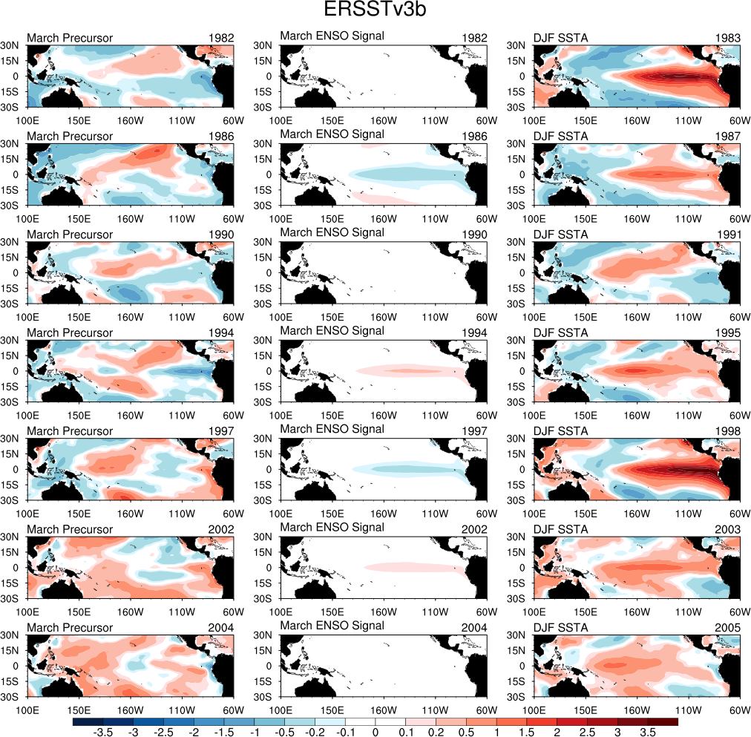

**Figure 3.1.** Right-hand column: DJF averaged SSTA in °C for the moderate-to-strong El Niño events occurring between 1982-2010. Left-hand Column: March precursors to the El Niño events. March precursors are defined as the non-ENSO SSTA (linear NINO3.4 signal removed) spatial distribution. Middle Column: March SSTA explained by the NINO3.4 signal (component removed from SSTA to obtain the precursor).

As shown in the middle column of Fig. 3.1, the NINO3.4 signal component removed from the SSTA during these particular years is small or near zero, suggesting that the likelihood of this component having a significant impact on the results presented here had it not been removed is very small. Additionally, because the NINO3.4 component is so weak or negative, the signal of the oncoming El Niño warming is practically undetectable in the full SSTA field (left column + middle column) at this time, thus further motivating the utilization of precursors. One caveat of this definition is that the nonlinear ENSO component is not removed; how this affects the results will be highlighted and discussed.

Figure 3.1 shows that the 1982, 1986, 1990, 1994, and 1997 March precursors all display PMM signatures. This verifies that slightly over 70% of observed El Niño events are preceded by PMM events, as shown in *Chang et al.* (2007). The time window in this study differs from the previous observational study yet the results remain consistent, thus confirming the robustness of the PMM/ENSO relationship in observations. The 2004 non-ENSO SSTA shows no evidence of PMM signatures and the 2002 non-ENSO SSTA shows a weak projection of negative PMM. Although we only discuss PMM precursors to positive phase ENSO in this section, our results, as well as those in *Zhang et al.* (2009a; b), do suggest that the PMM/ENSO relationship is regime-specific, meaning that positive PMM typically precedes El Niño events and negative phase PMM precedes La Niña. This point will be revisited in a later section.

For verification purposes, it is of interest to quantify the phase and magnitude of PMM for all years to obtain a single-value representation of PMM for each year and represent PMM temporal variability in observations. Although an MCA computation between wind stress and SST method is ideal for defining PMM (see *Chiang and Vimont* 2004; *Chang et al*. 2007), as previously mentioned, we are limited to only SST. As a result, here we define PMM variability strictly from SST as the PMM projection onto the March precursor (non-ENSO SSTA). The PMM projection is defined as the spatial correlation between each March non-ENSO SSTA (e.g., left column in Fig. 3.1) and a previously defined indicator of PMM SSTA signatures found in *Larson and Kirtman* (2013). The *Larson and Kirtman* (2013) study shows that the composite of the March SSTA preceding large El Niño events (10 total) in a high-resolution version of CCSM4 shows robust PMM signatures as reproduced in Fig. 3.2a.

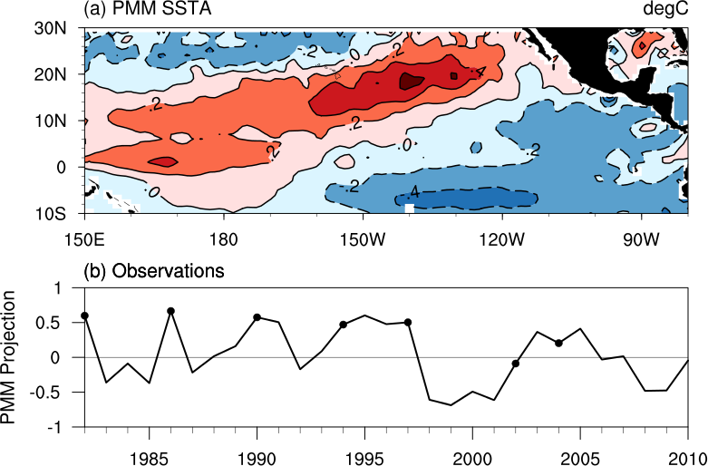

**Figure 3.2.** (a) Predefined PMM SSTA map as found per methods in *Larson and Kirtman* (2013). (b) Observed PMM variability, defined as the spatial correlation between the PMM map in (a) and the observed March precursor (non-ENSO SSTA). Dots indicate the PMM precursor to observed El Niño events.

The SSTA pattern is coupled with anomalous westerlies in the central Pacific subtropics consistent with PMM (not shown). Therefore, this PMM pattern is chosen because it is found to be representative of the SSTA signatures associated with coupled (wind stress and SST) PMM variability as well as it is derived from a model independent of the NMME suite. It should be noted that CCSM3 is part of the NMME forecasts, but the model (CCSM3.5) used for the base PMM pattern in *Larson and Kirtman* (2013) has substantially different parameterized physics and resolution, and very different ENSO behavior. This helps reduce model biases with this particular part of the analysis.

The predefined map is also chosen instead of one constructed from observations because it provides an independent “baseline” for PMM amplitude as opposed to handpicking the “best representative” PMM year from observations, which could be considered subjective. As a result, all PMM projections calculated will be less than 1.0 because the predefined map is independent of all datasets analyzed in this study. There is slight sensitivity to the results when using an observed PMM composite map instead of the model-based map chosen here, however, the overall conclusions presented here remain unchanged. A discussion of the sensitivity of results is provided in section 3.7.

The time series of PMM variability based on observations from 1982-2010 is shown in Fig. 3.2b and will be used quantify NMME PMM forecast skill in the following section. The observed PMM variability is defined as the spatial correlation between the observed non-SSTA in March and the PMM pattern from *Larson and Kirtman* (2013). Note that the general variability in Fig. 3.2b closely resembles Fig. 1 in *Chang et al.* (2007), which shows the temporal variation of horizontal winds associated with PMM as found via the MCA approach. The characteristic lower-frequency variability associated with PMM is particularly evident from the 1990s to the present. It is evident that the 1982, 1986, 1990, 1994, and 1997 March precursors, all of which showed PMM signatures in Fig. 3.1, do correspond to the strong positive PMM projections in Fig. 3.2b and the *Chang et al.* (2007) approach, indicating that this method for quantifying PMM and PMM variability captures such characteristics.

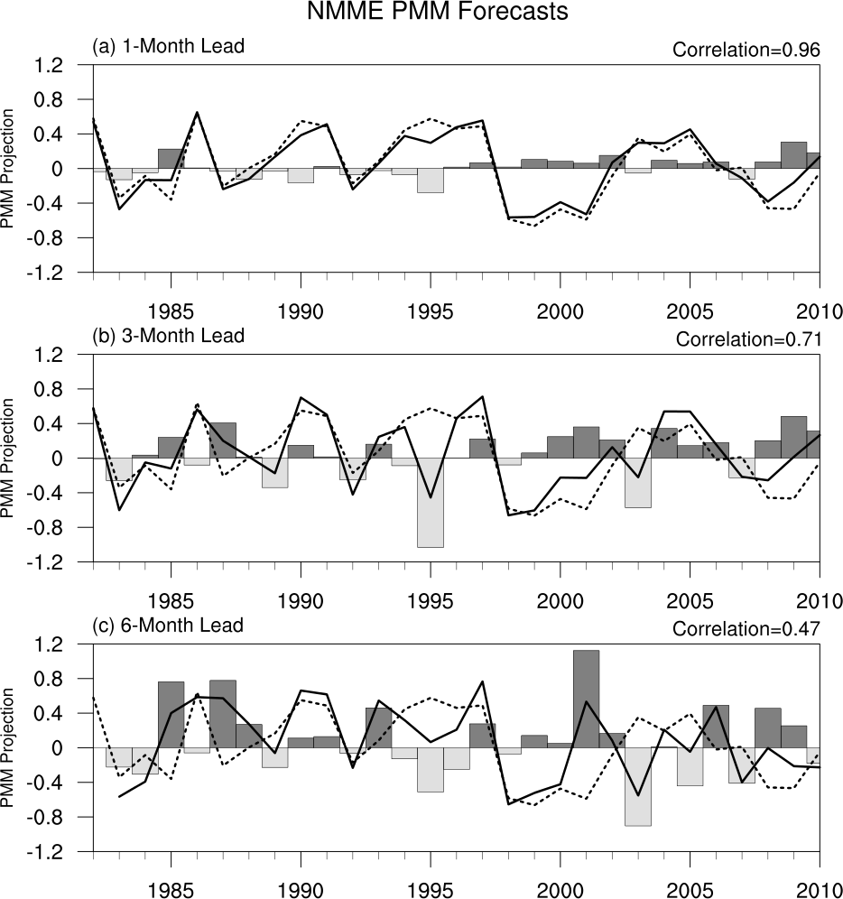

**Figure 3.3.** PMM projection forecasts by the NMME multi-model ensemble mean (solid line), the observed PMM (dashed line), and the difference between the two (bars) for (a) 1-month, (b) 3-month, and (c) 6-month lead-times. The dashed line is the same as the PMM projection in Fig. 3.2b.

## 3.5 PMM Precursors in the NMME

The emphasis of this chapter is to assess whether PMM is actually useful in forecast mode, so in principle we need only have PMM signatures in the initial condition or very short lead forecasts. On the other hand, if PMM is a useful precursor and if it is predictable at longer leads then there is potential for even longer lead ENSO forecast skill. As such, in this section, 1-month, 3-month, and 6-month lead-time forecasts are considered to assess the NMME’s forecast skill for March PMM. It is important to remember that in this study, the term “projection” is a spatial projection and not a temporal projection. It is, however, inherently a predictive quantity because the NMME PMM projections are calculated from the forecasted SST.

First, consider the NMME multi-model ensemble forecasts, which are calculated as the equally weighted average of all ensemble members. This is distinctly different from equally weighting each partner model, which in this case would refer to an average of the 9 partner models’ individual ensemble averages. Here, all 109 individual ensemble members have equal weight so that the plume of forecasts better resolves the probability distribution. Figure 3.3 shows the NMME multi-model ensemble PMM forecasts (solid line), the observed PMM (dashed line; same as Fig. 3.2b), and their difference (bars) for 1-month, 3-month, and 6-month lead-times. Since March PMM is the forecast of interest, a 1-month lead-time refers to March monthly averaged forecasts that are initialized in March. Since the 1-month lead March forecast is initialized in early March, we view this short lead forecast as a proxy for the initial condition. The 3-month lead-time forecasts are initialized in January and 6-month lead-time forecasts are initialized in October. The high forecast skill for the 1-month lead-time NMME forecast is expected, with a correlation between the NMME forecast and the observed of 0.96. The NMME performs very well in capturing the low-frequency variability from the 1990s to the present as well as the rapid onset and decay of the 1986 event.

Figure 3.4 shows a breakdown of the forecast skill (correlation between the model forecast and observed) for each lead-time, individual partner model ensemble mean, and the NMME multi-model ensemble mean. All partner models perform well at 1-month lead-time (blue circles in Fig. 3.4), with high correlations ranging from 0.81 (GFDL) to 0.96 (CMC1-CanCM3) and it can be concluded that all models considered in this study capture the PMM state well at very short lead-times.

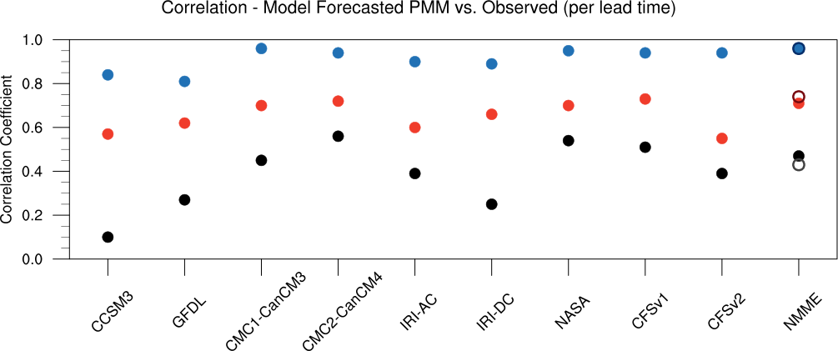

**Figure 3.4.** Correlation between observed and forecasted March PMM from 1982-2010 for each partner model ensemble mean and NMME multi-model ensemble mean by lead-time. Lead-times include 1-month (blue circles), 3-month (red circles), and 6-month (black circles). Values closer to one (zero) indicate higher (lower) forecast skill. Open circles indicate the NMME persistence forecasts for each lead-time. The colors for the open circles are slightly dimmed or brightened so that they can be visible whilst overlapping the filled circles.

Figure 3.3b and the red circles in Fig. 3.4 show that 3-month lead-time forecasts also have relatively high correlation (0.71) between the NMME multi-model ensemble mean forecasts and the observed estimates. Furthermore, all partner models have correlations over 0.5 with the observed, ranging from 0.55 (CFSv2) to 0.73 (CFSv1). In particular, the CCSM3, IRI-AC, and CFSv2 models are the least skilled at the 3-month lead-time. Similar to Fig. 3.3b, Fig. 3.5 shows each partner model’s ensemble mean 3-month lead-time forecast and suggests that this is due to under-forecasting the amplitude of events, which at some but not all times, can be linked to the discrepancy in the phase forecasted by the individual ensemble members.

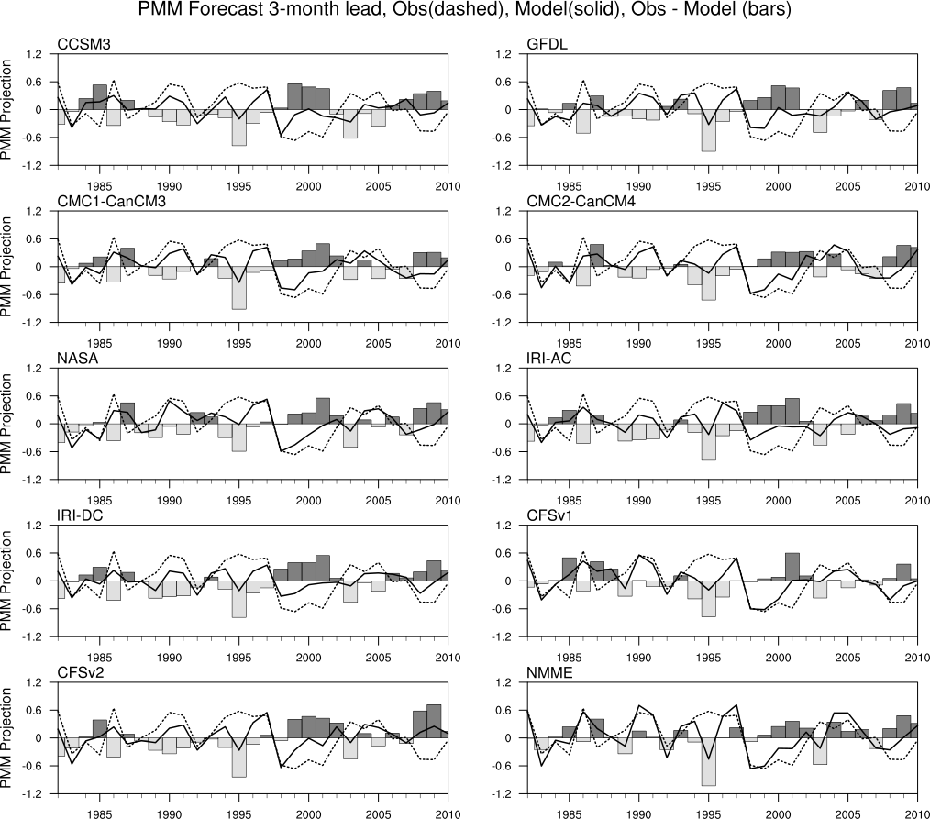

**Figure 3.5.** Similar to Fig. 3.3b but for each partner model ensemble mean and the NMME multi-model ensemble mean (bottom right).

As also seen in Fig. 3.5, the models have difficultly forecasting the amplitude and persistence of the negative PMM event observed from the late 1990s through the early 2000s. Nevertheless, a few models (e.g., CMC2-CanCM4 and CFSv1) and the NMME multi-model ensemble perform fairly well during this period. Only the NMME correctly forecasts the amplitude of the rapid-onset 1986 positive PMM event, although all models forecast the correct phase. All models also capture the sharp transition from positive to negative phase PMM between 1997 and 1998. Such a result is not surprising because the 1997-98 El Niño event was very strong, thus producing a large non-linear positive ENSO component that would not be removed via the linear regression methods presented here in defining the ENSO precursor. Since the forecasts are initialized in January during peak El Niño, the models, as they have a tendency to do in such a circumstance, persist the warm SSTA signal well through boreal spring, resulting in strong projection onto the negative PMM phase in March and PMM projection forecasts that verify closely with the observed.

In addition, all models, including the NMME multi-model ensemble mean, perform poorly on a few occasions with a 3-month lead, in particular, the 1995 event, and to a lesser extent, the 2003 event. In fact, the 1995 forecast is the most poorly forecasted PMM event during the 1982-2010 period for all models. For example, CMC1-CanCM3, as well as others, forecasts a PMM event for March 1995 but of the incorrect negative phase, despite being one of the better performing models in this study. This is more easily viewed in Figs. 3.6 d-f, which shows the CMC1-CanCM3 January-March precursor SSTA from the January initialized forecasts. As is evident, this particular model ensemble forecasts a warm-to-cool meridional SSTA gradient in the tropical eastern Pacific, indicative of weak negative phase PMM, whereas Figs. 3.6 j-l show that the observed precursor is a steadily amplifying positive phase PMM event from January through March.

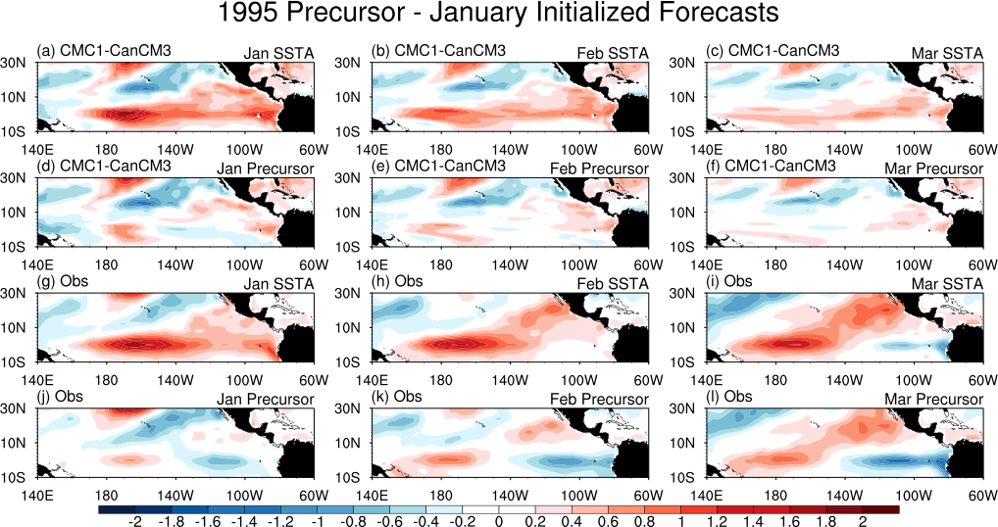

**Figure 3.6.** CMC1-CanCM3 January initialized forecasts for Jan-Mar SSTA (a-c), Jan-Mar precursors (non-ENSO SSTA; d-f), the observed Jan-Mar SSTA (g-i), and Jan-Mar precursors (j-l). All figures are for the year 1995.

The poor forecast skill for the 1995 event can likely be explained by model biases as noted in *Kirtman et al.* (2013). January 1995 is a strong CP El Niño event; therefore, the 1995 January initialized forecasts have initial states that look very similar to the January 1995 SSTA as shown in Fig. 3.6g. The warm SSTA perturbation in the central Pacific quickly induces persistent eastern Pacific warming in most of the models and extends well through March (Figs. 3.6a-c), while in reality, the warming remains and persists only in the central Pacific (Figs. 3.6g-i). *Kirtman et al.* (2013) shows that this type of behavior is typical for the NMME models, specifically, that the models have difficulty forecasting CP El Niño events because they tend to propagate the central Pacific warming to the eastern Pacific fairly quickly, thus resulting in an incorrectly forecasted EP El Niño event. Accordingly, the persistent eastern Pacific warming in the models produces an eastern Pacific SSTA gradient of incorrect sign, thus projecting onto negative phase PMM and resulting in the large discrepancy between the 1995 March PMM model forecasts and the observed positive PMM event shown in Fig. 3.5. A similar response occurs for the 2003 PMM event, but to lesser extent because the 2003 CP event is weaker.

The forecast skill quickly declines between the 3-month and 6-month lead-time forecasts. The 6-month NMME multi-model ensemble PMM forecasts correlate modestly with the observed at 0.47 (Figs. 3.3c and black circles in Fig. 3.4) and many of the forecasts are of either incorrect phase or falsely neutral. Some models, in particular, CCSM3, GFDL, and IRI-DC, lose most forecast skill by the 6-month lead while others, including CMC2-CanCM4 and NASA, remain fairly skilled at 6-months with correlations greater than 0.5 with the observed. Notably, the 6-month forecasts are considerably better than the 3-month forecasts for the 1995 PMM event, although, such a result is expected because the October initialized forecasts are not initialized with the strong central Pacific SSTA perturbation as discussed above with the 3-month forecasts.

Also shown in Figure 3.4 are the NMME multi-model mean persistence forecasts for the various lead-times. The persistence forecast assumes that the March PMM projection forecast is the same as the PMM projection during the initialization month, or more simply, the initialized PMM projection persists through March. The persistence forecast skill for all lead-times is very similar to the dynamical forecasts. For the 1-month lead-time, the skill is the same because the initialization month is also the forecast month. This result is hopeful in that the dynamical forecast skill is at least as good as the persistence forecasts, although ideally, the dynamical forecast skill would surpass that of the persistence forecasts.

As typical with ensemble forecasts, a few models tend to slightly outperform the ensemble mean in terms of correlation to observations. Such is the case with the CMC2-CanCM4 and NASA models as shown in Fig. 3.4, particularly at the 6-month lead (black circles). In addition to correlation with observed, however, we also consider the skill metric root-mean-squared error (RMSE). RMSE is a useful skill metric to quantify the “correctness” of a forecast because it is unconstrained by linear fitting, unlike correlation, and also presents the error in the same units as the forecast of interest. Figure 3.7 shows the RMSE (filled circles) and ensemble spread (open triangles) for each partner model and the NMME multi-model ensemble mean for 1-month (blue), 3-month (red), and 6-month (black) lead-time forecasts.

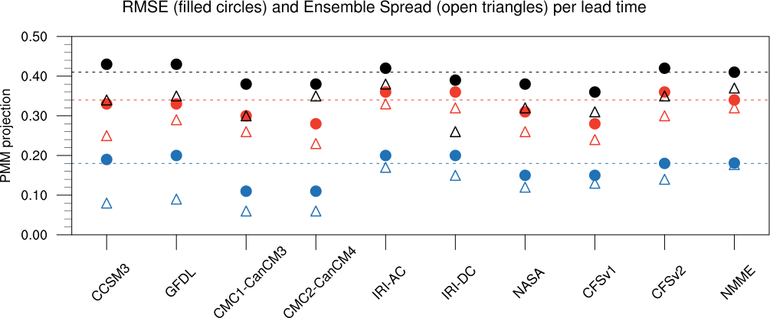

**Figure 3.7.** Root-mean-squared error (RMSE; filled circles) and ensemble spread (open triangles) of each partner model and the NMME multi-model ensemble for 1-month (blue), 3-month (red), and 6-month (black) lead-time forecasts. The dashed lines indicate the NMME RMSE, provided as reference for easier comparison to the individual models.

Ensemble spread is defined as the root-mean-squared difference between all possible combinations of ensemble forecasts at a given lead-time. The dashed lines indicate the NMME ensemble mean RMSE and are provided solely as a reference line for easier comparison to the individual models. For all lead-times, the NMME multi-model ensemble forecast sits around the middle in terms of RMSE, which is not surprising because both lesser and higher skilled individual ensemble members contribute equally in the calculation. The skill separation between the 3 different lead times for some models, in particular, CCSM3 and GFDL is fairly evenly spaced, indicating that skill is consistently gained (lost) by shortening (extending) the forecast lead-time. On the other hand, most models, including the NMME ensemble mean, lose more skill between the 1-month and 3-month forecasts than the 3-month to the 6-month. In particular, IRI-DC has similar skill for both the 3-month and 6-month forecasts, which was not evident in the correlations seen in Fig. 3.4; therefore, little skill is gained until shortening the lead to 1-month.

Although a few of the partner models are more skilled than the NMME ensemble mean in terms of RMSE, one important factor to consider is how well the forecast system is calibrated. In this regard, the ensemble spread (open triangles in Fig. 3.7) is a useful forecast metric in that if the system is well calibrated, the RMSE and the spread compare closely. Having a well calibrated system is beneficial because then the spread can be used to estimate the RMSE; however, if the spread is considerably smaller than the RMSE, for instance, the CCSM3 and GFDL 1-month lead time forecasts, the spread significantly underestimates the uncertainty in the forecast. *Kirtman et al.* (2014) show that the NMME system is particularly beneficial for this reason in that the NMME ensemble spread captures the uncertainty in ENSO forecasts fairly well. Similar results are seen with the PMM forecasts. For the most part, the partner models considered here are not well calibrated in this particular field and tend to be overconfident in their forecasts, however, the full NMME system does appear to be fairly well calibrated at 1- and 3-month lead times.

Overall, from Figs. 3.4 and 3.7 we conclude that the 1-month and 3-month forecasts are reasonable PMM predictions for March but that the skill of the 6-month forecasts is insufficient for further discussion. Since the full NMME ensemble is the best-calibrated system for PMM considered here and, therefore, is arguably the best suited for prediction purposes, individual partner models will no longer be discussed separately but instead, all individuals are considered “ensemble members.” There will, however, be a distinction between eastern Pacific (EP) and central Pacific (CP) El Niño events and the associated precursors in the following section.

## 3.6 PMM as a Precursor to ENSO in the NMME

To investigate the PMM/ENSO relationship in the NMME system, longer forecast periods are necessary to (1) assess the PMM forecast in March and (2) assess the ENSO forecast the following December. Therefore, only partner models that provide 12-month forecasts are considered in this section so that we can utilize the 1-month (March initialized) and 3-month (January initialized) lead-time PMM forecasts as well as the subsequent December ENSO forecasts. Four partner models satisfy this criterion, namely, CCSM3, GFDL, CMC1-CanCM3, and CMC2-CanCM4, and the ensemble size is reduced accordingly to 36 ensemble members. While including all models is preferable, this subset, which includes two of the higher skilled models and two of the lesser skilled models, is a fair representation of the average forecast skill of the full ensemble.

EP and CP El Niño events are analyzed separately to allow for comparison between the PMM precursor relationship and both types of events in observations and model forecasts. La Niña events, namely, the 1988-89, 1999-2000, 2000-01, and 2007-08 events, are also included to examine the previously suggested regime-specific relationship between PMM and EP ENSO events. To differentiate between EP and CP events, indices are computed. The amplitude of EP events is quantified by the NINO-3 index (SSTA averaged over 5°S-5°N, 150°W-90°W), where negative values identify La Niña events and positive values identify El Niño events. CP events are defined by an alternative index proposed in *Lopez and Kirtman* (2013). The idea is that the EMI, or El Niño Modoki Index (see *Ashok et al*., 2007), which is often used as an index for CP El Niño events, is derived from empirical orthogonal function (EOF) analysis of observed SSTA and that similar EOFs calculated from model SSTA may differ considerably in structure. Considering that SST forecasts from four different models are analyzed the section, accounting for variations in CP structure is important in attempting to capture this particular SST mode specific to each model. In short, the CP index is based on partial regression – EOF analysis. Prior to EOF analysis, all SSTA variability correlated to the NINO-3 index but not the EMI is removed because often, anomalies associated with EP and CP events overlap and this method prevents events from being categorized as both. Then the EOF analysis is performed and the first principal component (hereafter, CP-PC1) represents the CP index. EP and CP ENSO forecasts for the month of December are considered because it allows for the longest-term forecast for boreal winter SST common to both initialization times. As before, PMM is quantified by the PMM projection onto the March precursor SSTA. Such relationships between PMM and ENSO events are shown in Fig. 3.8.

Figures 3.8a,c show the relationship between PMM and EP events for the January and March initialized forecasts. Red crosses show the model forecasts for the PMM precursor and the 1982, 1987, 1997 December NINO-3, which correspond to the observed 1982-83, 1987-88, and 1997-98 EP El Niño events highlighted in the previous sections. Blue crosses are similar but for the 1988-89, 1999-2000, 2000-01, and 2007-08 La Niña events and black crosses are the forecasts for all other years. Therefore, all December NINO-3 and March PMM forecasts from all 36 members from 1982-2010 are shown. Bold squares indicate the mean forecasts for each respective category and black filled circles show the NMME multi-model mean forecasts for the observed La Niña and El Niño years. Black open circles indicate the observed NINO-3 and PMM for the observed La Niña and El Niño years.

A regime-specific precursor relationship between PMM and EP ENSO is evident in both the March initialized forecasts (1-month lead for PMM and 10-month lead for NINO-3) and January initialized forecasts (3-month lead for PMM and 12-month lead for NINO-3). The relationship is less pronounced in the January initialized forecasts due to increased forecast uncertainty that can be attributed to increased spread associated with the longer lead-time forecasts. The observed EP El Niño years tend to have forecasts in the upper right quadrant, meaning that the models typically forecast both positive PMM and EP El Niño events for years in which strong El Niño events are observed (red square).

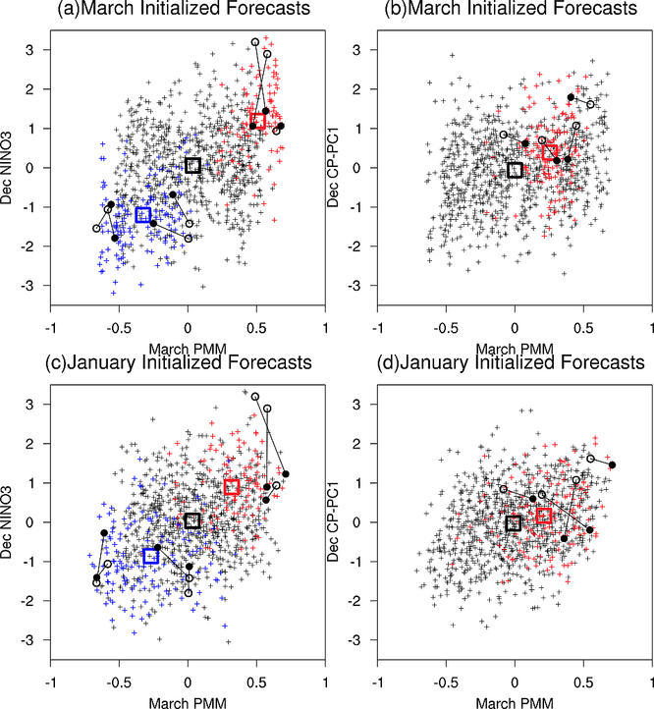

**Figure 3.8.** March PMM forecast versus the following (a) December NINO-3 SSTA index and the (b) December CP-PC1 SSTA index for all March initialized forecasts between 1982-2010. (c-d) similar to (a-b) but for January initialized forecasts. Red crosses indicate model forecasts for the PMM precursor and the December NINO-3 (CP-PC1) that correspond to the observed EP (CP) El Niño events. Blue crosses are similar but for La Niña events (a,c) and black crosses are the forecasts for all other years. Bold squares are the mean forecasts for each respective category. Black filled circles indicate the NMME multi-model ensemble mean forecasts for the observed EP event years, including La Niña and El Niño events, (a,c) and CP event years (b,d) and the associated PMM precursor forecasts. Black open circles are similar but for the observed PMM and ENSO indices. Lines join the respective forecasts with the observed values for PMM and ENSO indices.

Analogously, observed La Niña years, on average, have forecasts in the bottom left quadrant, meaning that the models tend to forecast both negative PMM and La Niña events for years in which La Niña events are observed (blue square). All other years (black square) show no clear relationship with PMM. The NMME multi-model ensemble mean forecasts (black filled circles) capture this fairly relationship well, particularly in the March-initialized forecasts for EP El Niño years; however, the ensemble mean NINO-3 forecasts underestimate the intensity of the high amplitude 1982-83 and 1997-98 events. For the observed La Niña years, it appears that only two La Niña events considered here are preceded with negative PMM in observations and the ensemble mean appears to forecast these events well. On the other hand, PMM and ENSO forecasts for the other La Nina years are less skilled. Overall, PMM appears to be a potentially useful tool to enhance confidence in EP ENSO forecasts due to the regime-specific precursor relationship found between PMM and NINO-3.

A less robust relationship is seen between positive PMM and CP El Niño years (Figs. 3.8b,d). Although there appears a slight relationship between PMM and CP years, the separation between CP years and non-CP years is fairly small compared to the pronounced relationship seen with the EP years. This is possibly, in part, due to the previously mentioned model caveat discussed in *Kirtman et al*. (2013) in which the models tend to favor EP events over CP events; however, such an unclear relationship is seen in observations as well (open circles), considering that two of the four observed CP years show weak PMM projection during the previous March. The NMME multi-model ensemble forecasts for the four CP years demonstrate that PMM may not be a useful precursor for CP El Niño forecasts, especially considering that there also appears no clear relationship between PMM and CP phase in observations.

It should be pointed out that these results rely on the approach that we look for precursors prior to the verified events of interest. In this regard, PMM precursors are identified with a “hindsight approach” in that we look for PMM based on the prior knowledge that an ENSO event did, in fact, occur. In this sense, the PMM precursor can be considered a dependent variable. This is distinctly different from the “forecast mode approach” presented in the next section in that PMM is considered an independent predictor and the reliability of the predictor is assessed. In this sense, a reliable precursor need not and should not also be assumed a reliable predictor.

## 3.7 PMM as an ENSO Predictor

To quantify the robustness of using PMM to predict ENSO events within the NMME system and observations, we calculate a “percent correct” metric (hereafter, % correct). Essentially, the % correct metric quantifies how well the forecasted or observed PMM predicts the forecasted or observed ENSO index. For example, for all ensemble members that forecast positive sign PMM in March, we calculate the percentage of those ensemble members that also forecast positive NINO-3 in December and separately, the percent of those members that correctly predict the observed NINO-3 sign. The procedure is repeated for negative phases, CP events, and observations. Model results are presented as the non-parenthesized values in Table 3.1 and results from observations for the NMME hindcast period are in Table 3.2 with the identifier “NMME.” The NINO3.4 predictions shown in Table 3.1 and Table 3.2 as well as the results in Table 3.2 for the “Extended” observed record length are discussed in a following section. The “no skill” mark for these values is 50% assuming that PMM and ENSO are independent of each other. For instance, given a particular PMM forecast, random chance dictates that the probability of the ENSO forecast being positive or negative is 50% and 50%, respectively. Note that we are assuming that positive (negative) phase PMM predicts positive (negative) phase ENSO.

|  |  |  |  |  |
| --- | --- | --- | --- | --- |
| **Model Init. Month** | **PMM Phase** | **ENSO Index Threshold** | **% Correct** *Observed ENSO* | **% Correct**  *ENSO Forecast* |
| January | + Forecast | + NINO-3 | 52%  (52%) | 59%  (47%) |
| March | (Upper tercile forecast) | (Upper tercile NINO-3) | 53%  (56%) | 63%  (48%) |
| January | − Forecast | − NINO-3 | 77%  (34%) | 58%  (48%) |
| March | (Lower tercile forecast) | (Lower tercile NINO-3) | 79%  (34%) | 61%  (52%) |
| January | + Forecast | + CP Index | 70%  (49%) | 59%  (45%) |
| March | (Upper tercile forecast) | (Upper tercile CP index) | 78%  (44%) | 57%  (43%) |
| January | + Forecast | + NINO-3.4 | 65%  (55%) | 60%  (47%) |
| March | (Upper tercile forecast) | (Upper tercile NINO-3.4) | 65%  (57%) | 64%  (49%) |
| January | − Forecast | − NINO-3.4 | 70%  (43%) | 59%  (49%) |
| March | (Lower tercile forecast) | (Lower tercile NINO-3.4) | 71%  (45%) | 62%  (51%) |

**Table 3.1.** Evaluation of PMM as a predictor of ENSO events using the % correct metric. Non-parenthesized values represent how well the forecasted PMM sign predicts the sign of the forecasted or observed ENSO index. Parenthesized values indicated similar calculations but the threshold of PMM and ENSO must fall in the upper (El Niño) or lower (La Niña) tercile. These are considered “event” predictions. The “no skill” mark is 50% for the sign predictions and 33% for the tercile, or event, predictions. The % Correct-Observed ENSO column represents how often the forecasted PMM correctly predicts the observed ENSO index for both sign and tercile ENSO index thresholds. The % Correct-ENSO Forecast is similar but for the forecasted ENSO index.

To remove both weak and neutral PMM projections and ENSO events, the analysis is repeated for events that fall within the upper (for El Niño events) or lower (for La Niña events) terciles only and correspond to the parenthesized values in Table 3.1 and Table 3.2. Terciles are defined as ranking the data and then partitioning the data into thirds. The % correct is calculated as the percentage of PMM projections that fall within the upper (lower) tercile that correctly predict an ENSO event that also falls within the upper (lower) tercile. Therefore, we are considering the skill of strong PMM projections predicting strong ENSO events. The “no skill” mark for these values is 33% given that random chance dictates a 33% probability that the forecasted ENSO event will fall within the respective tercile, given an independent predictor, in this case PMM. Therefore, % correct values greater (lesser) than 33% indicate that skill is acquired (lost) when utilizing the PMM predictor compared with random chance. These values can be considered “event” predictions while the values from the method in the previous paragraph can be considered “sign” predictions.

The robust precursor relationship between PMM and EP ENSO in the model forecasts is not necessarily grounds for use as a forecast tool unless all events in which PMM is in the upper or lower tercile are considered and the forecast skill is significantly greater than the 33% “no skill” threshold. In observations (Table 3.2) for the NMME hindcast period, although positive sign PMM does not predict positive sign NINO-3 with any skill (47%), positive PMM events (i.e., upper tercile PMM projection) correctly predict EP El Niño events (i.e., upper tercile NINO-3 index) 60% of the time. January and March initialized forecasts of positive PMM events verify similarly with observed EP El Niño, 52% and 56%, respectively (Table 3.1). On the other hand, less skill is seen with the model forecasts in that the forecasted PMM events correctly predict the forecasted EP El Niño events slightly less than 50% of the time for both sets of initialized forecasts. Therefore, the model forecasts do not capture the full predictive potential of PMM for EP El Niño events that is seen in observations and so there is room to improve this relationship in the forecast models to better utilize the predictive potential of PMM for EP El Niño events.

In observations (Table 3.2), although negative sign PMM predicts negative sign NINO-3 well (71%), negative PMM events predict La Niña events with less skill (25%) than random chance alone and negative PMM event forecasts predict observed La Niña events with practically no skill (Table 3.1; 34% for both initialization times). Considering the model ENSO forecasts, however, negative PMM event forecasts correctly predict La Niña event forecasts with skill comparable to that of El Niño (48% and 52% for January and March initialized forecasts, respectively). Unfortunately, this shows that the weak relationship between PMM events and La Niña events found in observations is not captured well by model forecasts and too often, the models forecast La Niña events following negative PMM events. Therefore, there is also opportunity to improve this representation in the models despite the fact that negative PMM events are not a useful predictor of La Niña events based on the analysis methods presented here.

Observed positive sign PMM predicts observed positive sign CP index well (73%); however, observed positive PMM events show only slight skill in predicting observed CP El Niño events (40%) and this measure is reproduced fairly well by the model forecasts. It follows that in a hindsight or precursor view, where we first identify ENSO years and then look for the precursors, PMM appears to correctly predict particular types of ENSO events quite well. In forecast mode, however, using PMM as a predictor for EP El Niño events shows some promise whereas for La Niña events and CP El Niño events, little-to-no skill is gained.

|  |  |  |  |
| --- | --- | --- | --- |
| **Observed Record Length** | **PMM Phase** | **ENSO Index Threshold** | **% Correct** *Observed ENSO* |
| NMME | + Observed | + NINO-3 | 47%  (60%) |
| Extended | (Upper tercile observed) | (Upper tercile NINO-3) | 53%  (48%) |
| NMME | − Observed | − NINO-3 | 71%  (25%) |
| Extended | (Lower tercile observed) | (Lower tercile NINO-3) | 68%  (30%) |
| NMME | + Observed | + CP Index | 73%  (40%) |
| Extended | (Upper tercile observed) | (Upper tercile CP index) | 61%  (57%) |
| NMME | + Observed | + NINO-3.4 | 60%  (50%) |
| Extended | (Upper tercile observed) | (Upper tercile NINO-3.4) | 53%  (48%) |
| NMME | − Observed | − NINO-3.4 | 64%  (38%) |
| Extended | (Lower tercile observed) | (Lower tercile NINO-3.4) | 65%  (35%) |

**Table 3.2.** Similar to Table 3.1 but for “sign” and “event” predictions from observations. The “NMME” observed record length corresponds to the hindcast period of 1982-2010. The “Extended” observed record length corresponds to 1950-2012.

It should be noted that the % correct for observed positive PMM events predicting observed positive ENSO events (both EP and CP type) are somewhat sensitive to the PMM base map chosen in the analysis. The sign predictions remain consistent. For instance, when using the model-based PMM map, observed positive PMM events predict EP El Niño events 60% of the time, however, when using the observationally-based map, the % correct is reduced to 50%. For CP events, the model-based PMM map yields a 40% value whereas the observationally-based map yields a 50% value. The % correct for observed negative PMM predicting observed La Nina is changed by no more than 2% for both “sign” and “event” predictions. Results regarding forecasted PMM predicting the forecasted and observed ENSO fall within a 5% window compared to using the model-based PMM map. Therefore, the overall conclusions and assessment of how well the model PMM forecasts predict forecasted and observed ENSO events remain unchanged. This discrepancy for the observed warm events is likely due to the small sample size. In the following section we attempt to strengthen the results by testing their robustness.

## 3.8 Extending the Observational Dataset

Two methods are employed to increase the robustness and test the sensitivity of the observed predictions – 1) calculations are repeated for PMM predicting the NINO3.4 SST anomaly index and 2) the observed % correct calculations are repeated with an extended record from 1950 – 2012. First, NINO3.4 is added to Tables 3.1 and 3.2 in attempt to capture both EP and CP events into one index, thus allowing for a single predictand for the one predictor, PMM. The number of PMM events considered remains the same but the predictand is less discriminatory, thus potentially allowing for more ENSO events to meet the particular thresholds. Only the “event” predictions are discussed below.

For the model forecasts, results for positive PMM events predicting positive NINO3.4 events are fairly similar to the NINO3 results. This is unsurprising considering that the models tend to favor EP over CP El Niño events and in the observed, higher amplitude positive ENSO events tend to be of the EP type. Both factors likely bias the upper tercile NINO3.4 values towards EP events. For La Nina events, the % correct is larger by nearly 10% for both March and January initialized forecasts when considering negative PMM events predicting negative observed NINO3.4 events compared to NINO3. Therefore, results are sensitive to the SST anomaly index considered when defining negative ENSO.

For the observed predictions in Table 3.2, positive PMM events predict EP El Niño events 60% of the time, whereas only 40% for CP events and 50% for NINO3.4. In this case, a less discriminatory predictand does not necessarily increase the skill of the predictor, possibly because the number of PMM events remains the same. For La Nina events, the skill increases moderately from 25% to 38% when using NINO3.4 instead of NINO3; however, the skill is only slightly above the no skill threshold.

Second, the observed record is extended beyond the NMME hindcast period to 1950-2012 and the observed metrics are recalculated. Results are in Table 3.2 with the identifier “Extended.” Extending the record length has little effect on negative PMM predicting negative ENSO and event predictions using both the NINO3 and NINO3.4 predictand show little skill above random chance alone. The predictability for EP El Niño events is reduced from 60% to 48% when extending the record, whereas CP events show an increase from 40% to 57%. The reduction in EP El Niño skill is consistent with findings from *Wang et al*. (2013) in which the authors find that during more recent decades, the PMM precursor relationship with El Niño is stronger. Therefore, the NMME hindcast years encompass decades where PMM is arguably expected to be a better EP El Niño predictor compared to prior decades. As such, when extending the record to 1950, the skill is reduced.

Results for NINO3.4 events, both positive and negative phase, are consistent when extending the record length, suggesting that considering nondiscriminatory ENSO events provides less sensitive results. Comparing the 48% for positive NINO3.4 events from the extended observed dataset with the model forecasts for NINO3.4, there is a fair amount of consistency between the two. In contrast, the models do not accurately capture the weak PMM/ENSO relationship for La Niña events as was previously discussed. Overall, however, for positive ENSO events, our analyses suggest that even when extending the observational record and not discriminating between CP and EP events, PMM has some skill as an ENSO predictor in observations.

## 3.9 Discussion

The motivational factor behind this work is that several ENSO precursors are routinely discussed in the literature and many are used to make statistical ENSO forecasts. In theory, all precursors should be in the dynamical prediction systems however the utility of precursors in dynamical forecasts is ultimately limited by how well the models represent these precursors and the associated physical interactions. If a particular precursor is important, it is of practical importance that we are examining how well the current state-of-the-art forecast systems capture them and work to improve this representation. The ultimate goal being that we can identify the precursors that are more useful as predictors of ENSO events and utilize them to enhance confidence to forecasts. Currently, most precursor research takes on a more hindsight approach, in that an ENSO event is first observed in nature or identified in a model simulation and then precursors are identified. Instead, in a prediction or forecast mode approach as shown here, the precursor is viewed as an independent predictor and the reliability of the precursor is assessed.

The present study shows that PMM variability is captured well by the NMME system at both 1- and 3-month lead times and that PMM often is a precursor to ENSO events in the models. Perhaps most interestingly, we find that observed positive PMM events show promise as a predictor of observed EP El Niño events but less skill as a predictor of CP El Niño events, whereas observed negative PMM events show no skill at predicting La Niña events. In addition, utilizing a less discriminatory ENSO index like NINO3.4 produces similar results that are also less sensitive to the time period examined. Nevertheless, the observed relationships are not necessarily reproduced well by the models. We should also stress that the results presented here are quite limited by the observational dataset and that similar analyses should be repeated as more observational data as well as NMME forecasts become available.

One way to possibly enhance PMM’s skill as an ENSO predictor is to consider only “preconditioned” PMM events, considering that several studies show that the effectiveness of PMM-like precursors may depend on whether the equatorial Pacific is also primed with anomalous heat content buildup (*Anderson*, 2007; *Deser et al.,* 2012*; Larson and Kirtman*, 2013). In terms of the models themselves, there is a notion that climate models are not “noisy” enough. Sub-grid kinetic energy is lost throughout the model integration but this energy can be added via nonlinear sub-grid dynamical schemes that project the energy onto resolved scales. To better represent sub-grid stochastic processes, *Berner et al*. (2008) applies this method in the European Centre for Medium Range Weather Forecasts (ECMWF) coupled model and finds marked improvements in tropical Pacific seasonal forecasts. As such, we speculate that the models are underestimating the noisiness in the climate system and that increasing the noisiness in the models could improve the models’ representation of PMM.

This work exemplifies the common misconception that a reliable precursor is also a reliable predictor in that PMM does not predict La Niña with any skill. Therefore, the most important conclusion here is that when using a forecast framework, even though a precursor, in this case, PMM, is shown to be reliable using the “hindsight” or precursor approach, it is not necessarily also always useful as a predictor in forecast mode. Nevertheless, we find the results concerning EP El Niño events optimistic in that with better representation of the observed PMM/ENSO relationship in the models, PMM could serve as a confidence-enhancing tool for this type of ENSO forecasts. Furthermore, the results suggest that a strong positive PMM event in March increases the probability that a strong El Niño will occur the following December. This point is revisited in the context of the 2014 and 2015 March-initialized ENSO forecasts in chapter 5.

# CHAPTER 4 – Revisiting ENSO Coupled Instability Theory and SST Error Growth in a Fully Coupled Model

**In reference to *Larson and Kirtman* (2015b)**

## 4.1 Overview

Although precursors like the PMM have the potential to enhance ENSO predictability (i.e., increase the probability that El Niño will occur) as seen in chapter 3, other sources of intrinsic variability may overshadow that predictive potential. This may explain why we have difficulty in “breaking through” the spring predictability barrier in real-time ENSO prediction (*Webster and Yang*, 2002; *Kirtman et al*., 2002; *Jin et al*., 2008; *Duan and Wei*, 2013; *Lopez and Kirtman*, 2014; *Levine and McPhaden*, 2015), despite the presence of precursors. Next, we shift to the opposite end of the spectrum and quantify how much noise-driven processes hinder ENSO predictability. Following this chapter, chapter 5 will present an application of the proposed model framework to determine whether noise-driven coupled instabilities overshadow the PMM’s predictive capabilities, potentially explaining why the PMM is not an excellent predictor despite being a reliable precursor to ENSO as discussed in chapter 3.

In this chapter, a coupled model framework is presented to isolate coupled instability induced SST error growth in the ENSO region. The model framework using CCSM4 allows for seasonal ensembles of initialized simulations that are utilized to quantify the spatial and temporal behavior of coupled instabilities and the associated implications for ENSO predictability. The experimental design allows for unstable growth of initial perturbations that are not prescribed and several cases exhibit sufficiently rapid growth to produce ENSO events that do not require a previous ENSO event, large-scale wind trigger, or subsurface heat content precursor. The results pose real implications for predictability because the final error structure is ENSO-like and occurs without a subsurface precursor, which studies have shown to be essential to ENSO predictability. Despite the large error growth induced by coupled instabilities, analysis reveals that ENSO predictability is retained for most seasonal ensembles.

## 4.2 ENSO Coupled Instability Theory

Unlocking the primary mechanism responsible for the initiation of ENSO events and the associated uncertainty has proven exceptionally challenging, especially from the dynamical and prediction standpoints. Often, the inherent complexities of the coupled system prove a substantial hurdle in determining why, on a mechanistic level, certain ENSO events are initiated. This is true for both observations and dynamical forecasts, the latter of which is subject to potentially large uncertainty due to errors in the initial conditions.

Since the development of general circulation models (GCMs) and enhanced observational methods (*McPhaden et al*., 2001), many studies examining ENSO initiation have turned towards identifying deterministic “trigger patterns” in the atmospheric winds and many patterns have proven effective in triggering certain ENSO events in observations and models (e.g., *Kessler et al*., 1995; *Kirtman and Shukla*, 2000; *Clarke and Van Gorder*, 2001; *Zhang and Gottschalk*, 2002; *Chang et al*., 2007; *Zhang et al*., 2009a; *Larson and Kirtman*, 2013). That being said, attempting to identify specific deterministic trigger patterns to solely explain ENSO initiation may be underestimating the role that coupled instabilities play in the initiation process. This point is raised because the possibility exists that an event may be initiated in the absence of a clear wind stress trigger like climate state-dependent westerly wind bursts (WWBs), without which can reduce ENSO predictability in certain coupled models (*Lopez and Kirtman*, 2014). Another possibility is that an event may be initiated in the absence of a “subsurface precursor”, often described as the slow buildup of upper ocean heat content along the equatorial Pacific prior to ENSO events (*Jin*, 1997) that is essential to the predictability of ENSO (*Meinen and McPhaden*, 2000; *McPhaden*, 2003). As such, quantifying the error growth induced by coupled instabilities, assumed to be a leading mechanism capable of explaining the physics of ENSO initiation that does not require a subsurface precursor or large-scale deterministic wind stress trigger (*Lau,* 1981; *McCreary*, 1983; 1985; *Philander et al*., 1984; *Anderson and McCreary*, 1985; *Gill*, 1985; *Yamagata*, 1985; *Hirst*, 1986, 1988; *Battisti*, 1988; *Battisti and Hirst*, 1989; *Wakata and Sarachik*, 1991), is essential to understanding the fidelity of models and their forecasts.

Because some ENSO events appear to spontaneously arise in the absence of a subsurface precursor (*Philander*, 1983), the notion that ENSO events can been triggered without the presence of a subsurface precursor seems plausible (*Penland and Sardeshmukh*, 1995; *Kleeman and Moore*, 1997; *Moore and Kleeman*, 1999; *Kessler*, 2002; *Moore et al*., 2006). That is not to say that coupled modes (*Anderson*, 2007; *Deser et al*., 2012; *Larson and Kirtman*, 2013) and heat content precursors (*Wyrtki*, 1975, 1985; *Cane et al*., 1986; *Zebiak*, 1989; *Jin*, 1997; *Guilyardi et al*., 2003; *McPhaden*, 2003; *Zebiak and Cane*, 1987; *Meinen and McPhaden*, 2000) do not prime the coupled system for an event and that the presence of triggers do not enhance confidence in forecasts (*Larson and Kirtman*, 2014) or augment ENSO predictability in models (*Lopez and Kirtman*, 2014).

Many ENSO studies determine how one component of the climate system responds to alterations in another; however, the assumption that one component “forces” the other is not necessarily ideal along the equatorial region where the atmosphere-ocean coupling is strong (*Bjerknes*, 1969; *Neelin and Dijkstra*, 1995; *Wu and Kirtman*, 2005). This is important because coupled feedbacks are considered necessary to catalyze SST growth characteristic to ENSO (*Bjerknes*, 1969; *Lau,* 1981; *McCreary*, 1983; 1985; *Philander et al*., 1984; *Anderson and McCreary*, 1985; *Gill*, 1985; *Yamagata*, 1985; *Hirst*, 1986, 1988; *Battisti*, 1988; *Battisti and Hirst*, 1989; *Wakata and Sarachik*, 1991). *Philander et al.* (1984) argue that while many studies reveal how the atmosphere responds to a particular ocean state (*Bjerknes*, 1969; *Shukla and Wallace*, 1983; *Neelin et al*., 1994; *Trenberth et al*., 1998) or vice versa (*Wyrtki*, 1975; *McCreary*, 1976; *Philander*, 1981), neither of these pathways ultimately can explain why small initial perturbations exhibit unstable growth and result in ENSO events. For this reason, and the particularly unexpected 1982-83 El Niño event that exhibited rapid growth much later in the seasonal cycle than traditional theory would predict (*Gill and Rasmusson*, 1983; *Philander*, 1983), the popularity of coupled instability theory increased rapidly, much like the basis of the theory itself. Coupled instability theory flourished out of pioneering work in the 1980s with the implementation of simple and intermediate coupled models and what would now be considered fairly crude representation of coupling processes compared to current-day, complex coupled models (*Lau,* 1981; *Anderson and McCreary*, 1985; *Battisti*, 1988; *Battisti and Hirst*, 1989; *Gill*, 1985; *Hirst*, 1986, 1988; McCreary, 1983, 1985; *Philander et al*., 1984; *Yamagata*, 1985; *Wakata and Sarachik*, 1991). The central idea is the incorporation of air-sea coupling into the model equations. The resulting behavior includes the potential destabilization of equatorial ocean waves, given that the coupling is sufficiently strong to induce the instability.

Coupled instability theory was initially introduced and applied to coupled models of simple and intermediate complexities, however there has yet to be rigorous current-day application using state-of-the-art coupled GCMs that resolve more complex coupled processes and include the full nonlinear system of equations. It is necessary that we reintroduce coupled instability theory in fully coupled models to better understand mechanisms that promote rapid perturbation growth in the types of models that are used in current-day dynamical prediction systems. The goal being that we can create a framework to confront the hypotheses of previous coupled instability work and gain insight into the relative role of the subsurface precursor in the initiation process. Hereafter, the terms “anomaly” and “error” can be considered synonymous because we are discussing initial perturbations (or errors in the initial conditions) in the context that they have the capacity to grow into anomalously warm or cold ENSO events.

The overarching goal of this chapter is to identify the temporal and spatial behavior of coupled instabilities and how they contribute to SST error growth that may affect the predictability of ENSO in CCSM4. This chapter is organized as follows: First, a two-step coupled model framework is proposed to isolate coupled instability growth. Second, each step of the framework is discussed individually, including model behavior and key results. Third, the main conclusions are discussed in the context of error growth and ENSO predictability. Last, a summary and discussion conclude the presented work.

## 4.3 Experimental Design

### 4.3.1 Overview

The type of initial conditions necessary to isolate coupled instability growth in a fully coupled model is outlined in this section. The objective is to not add variability to the system by prescribing a heat flux or wind stress (hereafter, τx,y refers to both zonal and meridional wind stresses discussed in tandem) perturbation to induce coupled instabilities but instead, allow intrinsic atmospheric and oceanic perturbations the opportunity to interact and grow with time. By not prescribing the perturbations, the coupled system presents the opportunity for warm, cold, and neutral ENSO events as determined solely by the initialized state. We hypothesize that initial ocean conditions that are close to climatology, particularly along the equatorial waveguide are essential to minimize large state-dependent responses by the atmosphere that can, in turn, affect the interannual evolution of the ocean (*Eisenman et al*., 2005; *Gebbie et al*., 2007; *Lopez et al*., 2013) as well as remove the subsurface preconditioning often seen with ENSO precursors (*Anderson*, 2007; *Deser et al*., 2012; *Larson and Kirtman*, 2013). The motivation against using climatological ocean initial conditions is to allow intrinsic variability to always be present, thus ensuring the presence of random perturbations and the associated uncertainty in the initial state.

Removing subsurface precursors and minimizing large-scale τx,y triggers from the tropical Pacific is essential to isolate coupled instability growth for several reasons. First, low frequency coupled modes can precondition the coupled state by inducing the buildup of anomalous heat content in the equatorial region and bias the system towards the initiation of an event (*Anderson*, 2007; *Deser et al*., 2012; *Larson and Kirtman*, 2013). Westerly wind bursts perhaps generated by the Madden – Julian Oscillation can produce similar effects (*McPhaden*, 2004) as well as a previous ENSO event can provide the slow ocean thermal inertia that allows for much of the predictability of ENSO (*Wyrtki*, 1975; 1985; *Philander*, 1983; *Cane et al*., 1986; *Neelin et al.*, 1994; *Rosati et al*., 1997; *Latif et al.*, 1998; *McPhaden*, 2003). Second, τx,y triggers tend to be seasonally dependent, thus potentially affecting the seasonality of ENSO (*Lau and Chan*, 1988; *Clarke and Shu*, 2000; *Kirtman and Shukla*, 2000; *Zhang and Gottschalk*, 2002; *Hendon et al*., 2007). The amplitude or frequency of the trigger can also depend on the climate state (*Eisenman et al*., 2005; *Gebbie et al*., 2007; *Jin et al*., 2007; *Kug et al*., 2008; *Lopez et al*., 2013). If certain precursors or triggers are solely responsible for initiation of events, then the observed false alarms would be markedly less (*Larson and Kirtman*, 2014). As such, in the present study we eliminate the influence of the subsurface precursor, demonstrate that large-scale atmospheric variability is not playing a dominant role in the initiation of events, and show that coupled instabilities alone can be responsible for large error growth.

As outlined below, the coupled model framework allows for initial perturbations determined solely by the model’s atmospheric intrinsic variability to interact with a minimally biased equatorial ocean state that also exhibits intrinsic variability of its own. In the end, we can quantify the error produced by coupled instabilities without manually adding anomalous forcing (i.e., triggering) and determine how coupled instabilities affect ENSO predictability.

### 4.3.2 Coupled Model Framework

The experimental design is implemented using the National Center for Atmospheric Research (NCAR) Community Climate System Model version 4 (CCSM4).ENSO in CCSM4 exhibits a spatial structure and 3-6-yr period that compares well with observations but overestimates SST variability in the ENSO region by roughly 30%, exhibits too much regularity, and the cold tongue extends too far west (*Deser et al*., 2012). The asymmetry between El Niño and La Niña events is generally consistent with observations as is ENSO diversity (*Capotondi*, 2013). The thermocline feedback plays a dominant role in the eastern equatorial Pacific heat budget in CCSM4 whereas the zonal advective feedback dominates in the central Pacific. CCSM4 also simulates a realistic “seasonal footprinting mechanism” (SFM; *Vimont et al*., 2001, 2003a,b; *Anderson*, 2003, 2004; *Alexander et al*., 2010) albeit with a weaker than observed linkage between the extra-tropics and tropics (*Deser et al.*, 2012). Furthermore, the SST anomaly spatial structure and seasonal phase-locking of the Pacific Meridional Mode in a precursor release of CCSM4 also compares well with observations (*Larson and Kirtman*, 2013).

The Control simulation is a fully coupled, pre-industrial configuration at 1°x1° horizontal resolution. The experimental design is of a similar configuration and consists of a two-step methodology. The first step is to produce the proper initial atmosphere and ocean states that will allow for the isolation of coupled instability growth for an ensemble of experiments. This step consists of removing ENSO itself, as well as subsurface precursors and large-scale atmospheric triggers that may bias the initial state towards a specific ENSO phase. As much of the aforementioned variability is characterized by anomalous winds or generated via dynamical air-sea feedbacks, the most direct way to dampen such types of variability is to disengage the mechanical coupling between the atmosphere and ocean. Doing so hinders the amplification of such types of variability and dampens its possible influence on the ocean surface.

In the coupled model framework, mechanical coupling is the anomalous wind-driven forcing that generates momentum transfers between the atmosphere and ocean. Mechanically decoupling the ocean is achieved here by forcing the ocean with the model’s daily climatological (determined from a free running control simulation) τx,y while allowing the atmosphere to respond freely to the ocean state without constraint. This way, the ocean component does not respond to the atmosphere interactively in terms of anomalous momentum transfer but the components remain thermally coupled via heat and fresh water fluxes. As we show here allowing the buoyancy coupling to remain interactive does not produce substantial equatorial SST variability in the model.

In the model code, the atmosphere and ocean components exchange fields via the flux coupler once per model day. Accordingly, the atmospheric τx,y is passed through the coupler to the ocean and at this time, we override the τx,y with daily climatological values determined from the unconstrained control simulation. CCSM4 model climatological τx,y are used to achieve a dynamically consistent ocean at the model’s approximate mean state. Otherwise, if forced with observed winds, the model’s initial response when the constrained forcing is released (discussed below) is dominated by drift due to the differences in τx,y climatologies (*Jin et al*., 2008). The simulation is integrated for 90 years and named the “Climatological Wind Experiment” or “CWE” for short.

Step two of the methodology includes a “releasing” of the constraints to allow perturbations to grow under the fully coupled configuration. In CWE, coupled instabilities are essentially prohibited because coupled feedbacks instigated by atmospheric perturbations are unsupported by a complementary ocean response, and vice versa, although ocean dynamics are technically unconstrained. Unlike in the CWE, when the atmosphere and ocean are dynamically coupled and τx and zonal ocean current perturbations are in phase, the atmosphere can transfer momentum to the ocean, reinforcing unstable growth by increasing the local ocean kinetic energy (*Hirst*, 1986). This type of momentum transfer is unsupported in the CWE.

It should be noted that subtropical SST variability produced by the “seasonal footprinting mechanism” (SFM; *Vimont et al*., 2001, 2003a,b) is not necessarily removed in CWE. However, the CWE methodology prohibits 1) SST variability produced by the SFM to induce coupled instabilities and 2) sufficient dynamical support for the buildup of a subsurface heat content precursor often accompanying the Pacific Meridional Mode (*Chiang and Vimont*, 2004; *Anderson*, 2007; *Deser et al*., 2012; *Larson and Kirtman*, 2013) SST pattern, a pattern generated by several processes including the SFM. As a result, effects from extra-tropical variability on the equatorial region are possible, albeit they are likely confined to earlier calendar months when the SFM peaks. In a later section we demonstrate that large-scale atmospheric variability that is often linked to off-equatorial SST patterns is likely not the dominant initiator of error growth in the simulations. That being said, chapter 5 suggests that large-scale SST patterns may increase the probability that an event biases warm or cold, but does not guarantee it.

Before introducing step two of the experimental design, we must first verify the hypothesis that disengaging the mechanical coupling eliminates ENSO and minimizes other SST and τx,y variability. Note that the CWE is distinctly different from studies that show ENSO-like variability without a dynamical ocean (*Dommenget and Latif*, 2008; *Clement et al*., 2011). The CWE has an unconstrained dynamical ocean but does not allow for anomalous τx,y to act on the sea surface, thus prohibiting variability of equatorial trade wind strength that can support large SST variability via thermal fluxes (e.g., *Drushka et al.*,2014). Accordingly, ENSO-like variability that can arise in the absence of dynamical coupling like the thermally coupled Walker mode found in *Clement et al*. (2011) is unsupported by the imposed τx,y constraint in the CWE.

**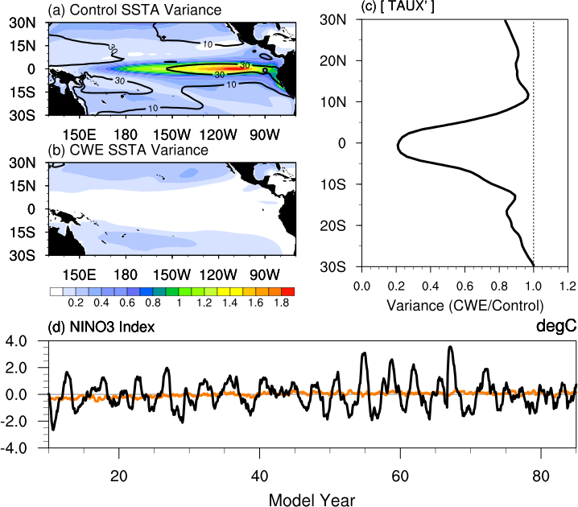**

**Figure 4.1.** (a) Shading shows SST anomaly variance in (°C)2 and contours are SSH anomaly variance in cm2 from the CCSM4 Control simulation. (b) Similar to (a) but for CWE. (c) Ratio of variances (CWE/Control) of the zonal wind stress anomalies zonally averaged over the Dateline from 160°E-160°W. The dotted line at 1.0 indicates where CWE variance equals that of the Control. (d) NINO3 SST anomaly index for the Control (black) and CWE (orange).

### 4.3.3 The Climatological Wind Experiment (CWE)

In the tropics where wind-driven forcing largely influences interannual SST variability, the CWE substantially dampens SST variability. Essentially all interannual SST variability in the tropics (10°S-10°N) is removed in CWE (Fig. 4.1b), particularly that in the eastern Pacific associated with ENSO as seen in the Control (Fig. 4.1a). Although this response is anticipated, it is striking how comprehensively the SST damping is throughout the equatorial Pacific. Similar results are seen in sea surface height (SSH) variance (contours in Figs. 4.1a,b) indicating that variations in ocean heat content are also substantially damped in CWE.

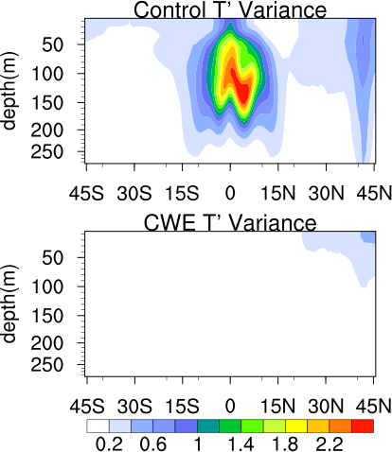

**Figure 4.2.** Zonally-averaged temperature anomaly variance (°C)2 in the Pacific basin as a function of latitude and depth for the Control (top) and CWE (bottom).

Figure 4.2 reveals that the zonally-averaged temperature anomaly variance in the Pacific basin as a function of latitude and depth shows no clear subsurface precursor signatures or interannual equatorial thermocline variability as well, confirming that all aspects of ENSO and the subsurface precursor are minimized in CWE. Figure 4.1d confirms that the CWE NINO3 index (SST anomalies averaged over 150°W-90°W, 5°S-5°N) shows no clear ENSO characteristics compared to the large interannual variability in the Control. Although the domain shown is restricted to the tropical Pacific, overall, less variable SST anomalies are seen globally; however, more variability is maintained in the extra-tropics where thermal fluxes are an important driver of SST variability (*Alexander et al*., 1992; *Neelin et al.*, 1994; *Kushnir et al*., 2002).

In theory, because the tropical atmosphere-ocean system is strongly coupled (*Bjerknes*, 1969; *Neelin and Dijkstra*, 1995; *Wu and Kirtman*, 2005), reduction in SST variability should reduce the overlying atmospheric wind variability. This effect is desirable such that only small wind perturbations are present when the τx,y constraint is “released”. Figure 4.1c shows the variance ratio of the zonal wind stress (τx) anomalies zonally averaged over the Dateline (160°E – 160°W) of CWE and the Control. A ratio of 1.0 (dotted line) indicates that 100% of the variance in the Control is reproduced in CWE and a ratio less than 1.0 indicates that CWE variability is reduced. For CWE, τx used in the calculation is that which the ocean would have felt had the field not been overwritten with climatology. Since the atmospheric component responds freely to the ocean, this particular τx is obtained from the atmospheric component output. In the tropical atmosphere, less variable SST has an anticipated “back interaction” on zonal surface winds in the central Pacific, causing substantial damping of surface winds by as much as 80% (ratio of 0.2) as seen between 5°S and 5°N. Generally, poleward from the equatorial region, the damping of zonal surface winds varies between 0-20%. The only substantial exception is in the North Pacific where τx variability is damped by nearly 50%.

### 4.3.4 The Release Experiment (RE)

Now that tropical SST, subsurface temperature, and τx variability are dampened, we have essentially generated a suite of initial conditions from which to branch ensembles of coupled instability experiments. The first 30 years of the CWE are discounted to reduce effects from model spin-up. Note that during integration, CWE initial conditions are archived every-other month. Beginning at year 30, for every set of archived January, March, May, July, and September initial conditions, an additional simulation is branched with the τx,y constraint lifted (i.e., integrated under the fully coupled configuration). Since the wind constraint is “released”, the simulations are referred to as the “Release Experiment” or “RE” hereafter.

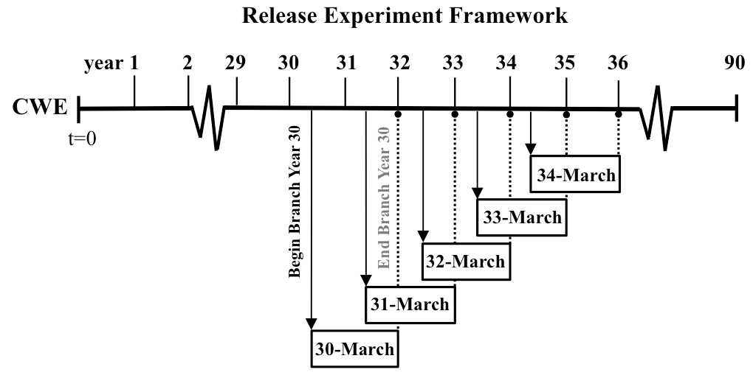

**Figure 4.3.** Schematic depicting the Release Experiment (RE) modeling framework for the March ensemble. Beginning at year 30, initial conditions from CWE of each March are used to branch an additional simulation with the CWE wind stress constraints lifted. This procedure is repeated for each January, May, July, and September between years 30 and 90 of the CWE for a total of 60 cases per initialization month.

Figure 4.3 depicts a schematic of the March ensemble model framework. A total of 60 cases comprise the March ensemble, one case for each set of March initial conditions spanning CWE years 30 to 90. All cases are integrated through the first December of year(0) but only cases branched from CWE years 60 to 90 are integrated an additional year through December of year(1). The process is repeated for the January, May, July, and September for a total of 300 members that comprise the RE.

Note that the Control mean state and seasonality in the equatorial Pacific is reproduced fairly well by the CWE, indicating that minimal biases in the region of interest are produced in the CWE framework. Figure 4.4 shows the December, February, April, June, and August mean SST (averaged over 5°S-5°N) as a function of longitude for the Control and CWE. These are considered the month(0) for each of the RE ensembles as the initial conditions originate from the previous month of CWE integration.

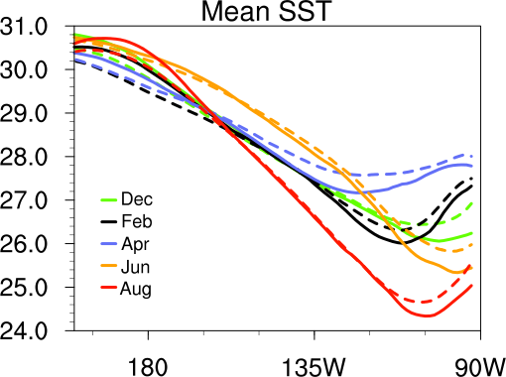

**Figure 4.4.** Control (dashed) and CWE (solid) mean SST (averaged over 5°S-5°N) in °C as a function of longitude for December, February, April, June, and August. These months correspond to month(0) initial conditions from which the January, March, May, July, and September RE ensembles are branched, respectively.

There is a slight cold (warm) bias in the eastern (central) Pacific of no more than 0.5°C for any months shown here, although small biases can have a large atmospheric response in the warm pool region. The average bias in the Pacific basin of the zonal average mean temperature from the surface to 250 meters between 20°S-20°N is -0.39°C. The bias is most likely a result of model spin-up in CWE, although the effects from lacking higher frequency atmospheric variability that may contribute to the mean state SST cannot be fully ruled out. Error calculations for each ensemble are computed separately and by integration month; therefore all errors shown hereafter are calculated from the specific reference cycle of the ensemble, not the Control. As a result, small biases in the mean state do not affect the main conclusions presented here.

We are aware that the month(0) monthly mean SST fields treated here as the initial condition are not necessarily representative of the instantaneous field at initialization. However, the month(0) SST gives a good indication of any prevalent sign biases likely present in the initial conditions. SST anomalies exhibit reasonable persistence, for instance, SST persistence in March – May is 1-2 months, which is the season with the least SST persistence in the tropical Pacific (*McPhaden*, 2003) and well within the range for application here. Visual comparison of the day(0) initialized and month(0) SST confirms that distinct perturbations in month(0) are similarly present at day(0) (not shown). This is not a fair assumption for, say, atmospheric winds that can have much shorter decorrelation timescales (*Blanke et al*., 1997). To address the τx,y structures at initialization, the first five days of daily mean τx,y are obtained from the March ensemble only. An analysis of the day(0), which corresponds to March 1st, τx,y is included in the following section. Note that daily fields are further analyzed and discussed in chapter 6.

## 4.4 The March Ensemble

To exemplify the performance of the RE without being overly exhaustive, the March ensemble is chosen to highlight the general ENSO behavior and confirm the coupled instability growth of ENSO events produced within the model framework. Figure 4.5 provides a summary of the March ensemble.

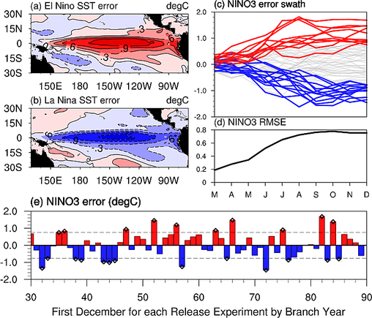

**Figure 4.5.** (a) Composite-averaged December SST error for the 10 cases that produce an El Niño event during the first year of integration. (b) Similar to (a) but for the 13 cases that produce a La Niña event. (c) Evolution of the NINO3 SST error for all 60 cases through the first calendar year of integration. Red (blue) curves indicate El Niño (La Niña) events. (d) Root-mean-squared error of (c). (e) December NINO3 error in year(0) for each case organized by the year each case is branched from CWE. Dashed lines indicate one standard deviation and black triangles indicate the cases that exceed one standard deviation and qualify as an El Niño or La Niña event.

March is chosen because the equatorial Pacific is often saturated with subsurface precursors and triggers during the spring (*Webster and Yang*, 2002; *McPhaden*, 2003; *Chiang and Vimont,* 2004; *Anderson*, 2007; *Larson and Kirtman,* 2013), thus masking the effects of coupled instability growth. The spring season is also when much of the predictability of ENSO is lost (i.e., the spring predictability barrier; *Webster and Yang*, 1992; *Kirtman et al*., 2002; *Mu et al*., 2007a) and is a prominent source of uncertainty in ENSO forecasts (*Goswami and Shukla*, 1991; *Samelson and Tziperman*, 2001).

Figure 4.5e shows the NINO3 error for the first December of each case, organized by the year of the CWE initial conditions from which the case is branched. El Niño and La Niña events are defined as any event that exceeds one standard deviation (0.75°C) in December of the respective sign and both types as well as neutral events all occur. This is a good indication that the climatological winds used in CWE are an accurate representation of the actual mean state winds of the model. Otherwise, a bias towards one phase of ENSO events could occur due to the systematic adjustment of the ocean towards the proper mean state and possible effects on the stability of the background state. The frequency of events also falls in line with the 3-6 yr ENSO period of a multicentury CCSM4 control simulation that exhibits multidecadal modulation of ENSO (*Deser et al*., 2012). Figure 4.5a shows the December SST error composite of the 10 El Niño events and Fig. 4.5b shows similar but for the 13 La Niña events. Both exhibit the expected spatial distribution of SST anomalies for ENSO in CCSM4 (*Deser et al*., 2012).

Although it is difficult to completely rule out the possibility that deterministic atmospheric variability is playing a role in initiating ENSO events in the RE, we will demonstrate that coherent trigger patterns cannot be assumed a dominant factor in the initiation of events. The regressions of December NINO3 error with day(0) τx,y and SST perturbations are shown in Fig. 4.6.

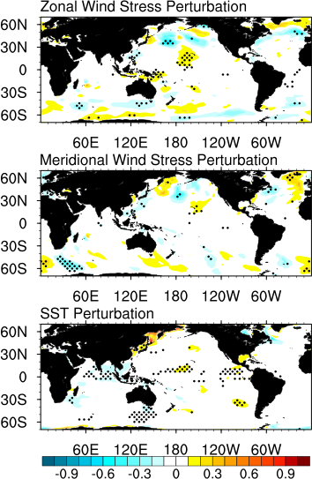

**Figure 4.6.** Regression of the December NINO3 error with day(0) zonal wind stress (top row), meridional wind stress (middle), and SST (bottom) perturbations for the March ensemble. Units are dyne/cm2 per unit standard deviation of NINO3 for the wind stress and °C per unit standard deviation of NINO3 for the SST. Stippling indicates regression values significant at the 95% confidence level.

At first glance, there appears weak evidence of a small day(0) Northern Hemisphere τx signal in the central Pacific in the τx regression. However, the day(0), day(2), and day(4) τx perturbation composites for El Niño and La Niña events and their difference (Fig. 4.7) clearly demonstrate that there is no discernable trigger pattern in the initial conditions that dictates whether an event will evolve into an El Niño or La Niña event. Furthermore, there appears no discernable pattern in the meridional wind stress or SST perturbation regressions as well. We can also confirm that daily τx variability, in addition to monthly means shown in Fig. 4.1c, is also limited in the equatorial region. Overall, Figs. 4.6 and 4.7 demonstrate that large-scale wind patterns in the initial conditions are likely not playing a primary role in the triggering of events in the RE, thus suggesting that coupled instabilities are the dominant mechanism for the initiation of events in the simulations. Note that tropical instability waves (TIWs) are present in the CWE; thus, we cannot rule out the possibility that TIWs are influencing the initiation in some way, although we have found no clear link between the TIWs and the evolution of the events (not shown).

Figure 4.5c shows a fairly symmetric spread (skewness of 0.21 in December) of the NINO3 error evolution for each case through the first December, with red (blue) curves indicating El Niño (La Niña) events and neutral in gray. The NINO3 root-mean-squared error (RMSE) in March is 0.19°C and saturates at about 0.75°C in September (Fig. 4.5d). The most striking aspect of Fig. 4.5d is how closely the error curve mimics ENSO forecast skill for typical boreal winter and spring initialized forecasts (*Jin et al*., 2008), which implies that coupled instability growth from initial perturbations may be a large contributor to the limit of ENSO predictability in this model. Typically, idealized predictability studies boast a longer period, often over one year, of error growth prior to error saturation (i.e., forecast skill) as in *Cane et al.* (1986). However, here the skill saturates around 6 months, similar to the e-folding timescale of the fast error growth in the Zebiak-Cane model that is suspected to be associated with coupled instabilities (*Goswami and Shukla*, 1991). Error growth of all RE ensembles is discussed in a later section.

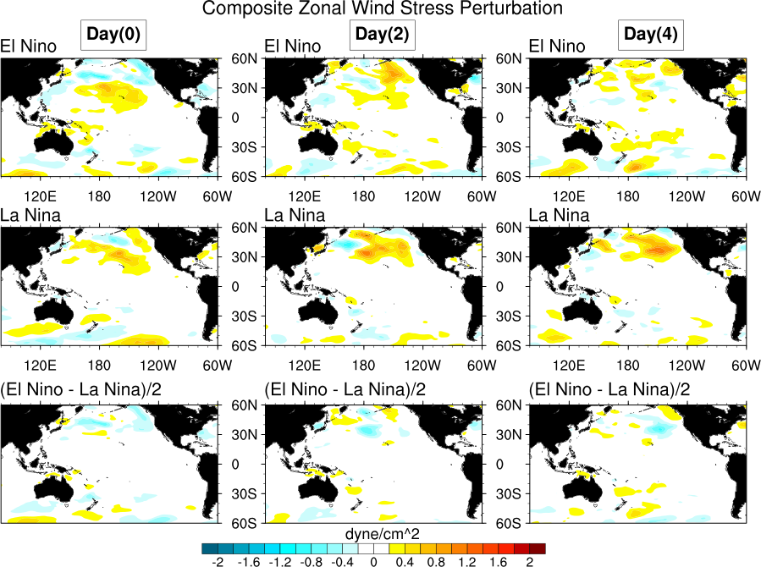

**Figure 4.7.** Day(0), day(2), and day(4) zonal wind stress perturbation composites for the March ensemble cases that evolve into El Niño events (top row), La Niña events( middle), and the difference (bottom).

So far, the geographical location of the perturbation growth has not been discussed. *Suarez and Schopf* (1988) argue that coupled feedbacks along the equatorial Pacific are strongest in the central Pacific. In fact, the relative ease for the destabilization of oceanic waves in this region is the basis of the wave delay term in delayed-oscillator theory (*Suarez and Schopf*, 1988; *Battisti and Hirst*, 1989). Figure 4.8 shows the regression of December NINO3 error with the previous December – April equatorial temperature perturbations with depth. For the Control, 60 years of continuous data are analyzed to compare with the 60 cases from the CWE-RE framework. For the March ensemble, December NINO3 error is regressed onto March and April from the RE and the preceding December – February from the CWE.

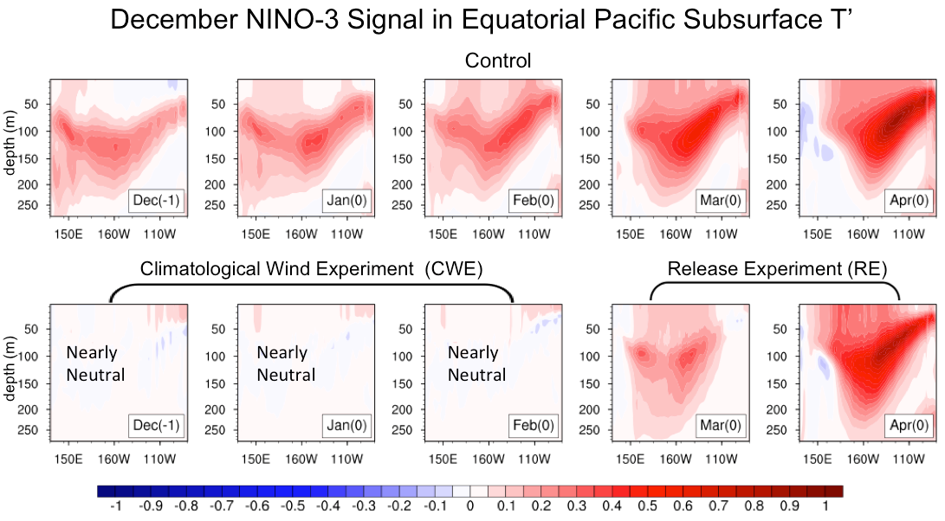

**Figure 4.8.** Regression of the December NINO3 index with January – April equatorial temperature perturbations with depth of the same year (0) and December of the previous year (-1). The top row is for the Control simulation and the bottom row is for the CWE-RE experiments. In the bottom row, the right two columns are from the Release Experiment in which each case is branched in March. The left three columns correspond to the December – February from CWE preceding each March branched simulation. Units are °C per unit standard deviation of NINO3.

Essentially, Figure 4.8 shows where the ENSO signal originates and how it evolves by month. For the Control, heat content buildup in the western Pacific during the previous December shows mainly subsurface signals. The signal propagates eastward with time via an equatorial Kelvin wave packet, amplifies, and eventually produces eastern Pacific SST anomalies. For the March ensemble, the signal is not visible in the CWE from December-February, verifying that events are not initiated until dynamical coupling is permitted in the RE. The perturbation grows rapidly throughout March, with both surface and subsurface signals in the central Pacific in agreement with theory from *Suarez and Schopf* (1988), although the cold tongue bias may shift the region of strongest coupling slightly towards the west. The perturbation continues rapid growth and eastward propagation and the Control and RE subsurface structure are remarkably similar by April. *Wyrtki* (1975) proposes that western Pacific preconditioning is a necessary condition for ENSO whereas *Zebiak and Cane* (1987), *Schneider et al*. (1995), and *Kirtman* (1997) show that basin-wide preconditioning is a necessary condition. The March ensemble is intriguing because neither condition is necessarily realized and subsurface heat content buildup is zonally confined to the central Pacific where coupled feedbacks are strongest.

A point that must be emphasized is that generally ENSO theory, including the recharge oscillator paradigm (*Jin*, 1997), argues that ENSO events are connected and that the turnabout plays a key role in the initiation of subsequent events. However, the RE shows that rapid SST growth in the ENSO region can occur in the absence of a previous ENSO event or subsurface precursor. *Kessler* (2002) points out that observed weak El Niño events have occurred without a recharge and in the present work, not only weak El Niño events but also El Niño and La Niña events of magnitudes greater than 1.0°C yet less than the ~3.0°C peak events produced in the multicentury CCSM4 control simulation (*Deser et al*., 2012) are initiated without a recharge/discharge. This may suggest that the recharge is merely remnant of the previous event and may serve to prime or amplify the oncoming event similar to preconditioning, thus enhancing predictability, but is not fundamentally essential for ENSO initiation.

An alternative interpretation includes that without the subsurface precursor, the predictability of ENSO is essentially lost (e.g., the symmetric spread in Fig. 4.5c). Hence, the RE shows that without a largely biased initial state, initial perturbations can induce rapid growth that appears unpredictable and may result in large errors in a prediction setting. The results are consistent with the idea that the presence of an ENSO cycle reduces the tropical system’s sensitivity to perturbations (*Chen et al*., 1997). As shown here, the absence of an ENSO cycle in the initial conditions results in a tropical system that is very sensitive to initial perturbations and teasing out any predictability may prove a difficult task.

## 4.5 Growth Rate Seasonality

Previous studies utilizing simple and intermediate coupled models argue that unstable air-sea interactions are seasonally dependent (*Philander et al*., 1984; *Tziperman et al*. 1997) and that SST anomaly growth rates in the ENSO region are largest during July – August (*Battisti and Hirst*, 1989; *Zebiak and Cane*, 1987). Growth rates of SST in the ENSO region are also sensitive to the initialization month as discussed in the context of intermediate models (*Battisti and Hirst*, 1989; *Xue et al*. 1997) and similarly with forecast errors in coupled GCMs (*Jin et al*., 2008). The model framework presented in the previous section provides a sound platform to confront earlier findings given that CCSM4 incorporates complex coupled processes similar to models in the *Jin et al*. (2008) study but with fewer simplifications in the model physics compared to intermediate models.

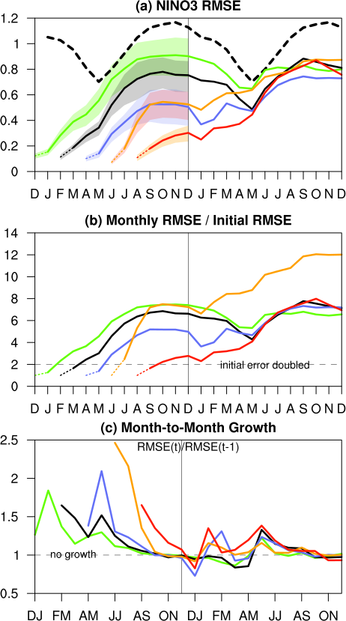

**Figure 4.9.** (a) NINO3 RMSE for the January, March, May, July, and September RE ensembles (solid lines). Dashed lines indicate month(0) from the CWE. Month(1) is the initialization month. Error bars indicate the upper and lower 5% bounds as computed using the Monte Carlo method with 10,000 iterations of 30 random samples taken from the 60 cases. The upper (lower) 5% is deemed the average of the 500 cases that are farthest from the RMSE curve in the positive (negative) direction by month. The bold dashed line indicates the annual cycle of the NINO3 anomaly standard deviation from the Control. (b) Similar to (a) but scaled by month(0). (c) The month-to-month ratio of (a). A value of 1.0 indicates no growth from month(t-1) to month(t).

First we consider the NINO3 SST root-mean-squared error (RMSE), or equivalently the standard deviation of the error since the reference case is climatology, as a function of integration month, specific to each RE ensemble. We first focus on the dynamically-driven initial error growth during year(0). Since the initial equatorial oceanic conditions are close to climatology, the magnitude of the error in the ENSO region greatly depends on the length of time that coupled interactions and feedbacks have been engaged in the model. For this reason, considering the March ensemble, the reference cycle from which errors are computed consists of the full 22-month cycle calculated as the ensemble mean of all 60 March cases.

Figure 4.9a shows the NINO3 RMSE for the five RE ensembles (solid lines). Month(1) is defined as the initialization month. The dotted lines show the month(0) RMSE that is defined from the prior month CWE SST. The error bars indicate the upper and lower 5% bounds as computed using the Monte Carlo method with 10,000 iterations of 30 random samples taken from the 60 cases. The upper (lower) 5% is deemed the average of the 500 cases that are farthest from the RMSE curve in the positive (negative) direction by month, thus showing maximum (minimum) error possible due to the relatively small sample size. The bold dashed line indicates the annual cycle of the NINO3 anomaly standard deviation from the Control. It follows that if the error is equal to or surpasses the Control annual cycle, the error has saturated the NINO3 signal and predictability is lost. The December(0) RMSE in °C is 0.90, 0.75, 0.51, 0.53, and 0.30 for the January, March, May, July, and September ensembles, respectively compared to the Control that surpasses 1.0°C. The error for each ensemble does not fully saturate the NINO3 signal during September – December, although the January ensemble error upper bound closely approaches the signal from May – August. Predictability during the peak ENSO months is retained for most initialization months, yet minimal for the January ensemble. The error saturation for January initialized cases could be linked to the “spring predictability barrier” (*Webster and Yang*, 1992; *Kirtman et al*., 2002; *Mu et al*., 2007a).

The month(0) initial error is small for all ensembles, although once mechanical coupling is engaged in month(1), the error grows quickly for all ensembles yet the growth rate shows dependence on the initialization month. For instance, initial error for July is the smallest of all ensembles but the July ensemble month-to-month growth from month(0) to month(1) shown in Fig. 4.9c is clearly the largest of all ensembles. This means that initial errors in the July cases grow the fastest and have doubled by month(1) as shown in Fig. 4.9b. In contrast, the error doubling time for the remaining ensembles is closer to two months. Results show that in this model, initial error growth in the ENSO region largely depends on the initialization month and error can grow rapidly for all initialization months, especially for summer initializations. The fast month-to-month growth for the July ensemble continues from month(1) to month(2) as error doubles between these months as well. This may, in part, be due to the fact that initial errors in July are a minimum, however, the July ensemble grows rapidly enough to overtake the May ensemble error by September along with attaining the largest month(1) error of all five ensembles (Fig. 4.9a). These findings follow the work of *Battisti and Hirst* (1989) and *Chen et al*. (1997) in which the authors argue that the tropical Pacific background state is most unstable to coupled instabilities in boreal summer, thus promoting fast growth of small perturbations similar to those shown above. Specific to CCSM4, the Bjerknes feedback is strongest in boreal summer (*DiNezio and Deser*, 2014), lending a possible mechanism by which the initial error growth is dynamically accelerated for the July cases.

In addition to dependence on initialization month, initial error growth also exhibits strong seasonality. Consistent with seasonal background stability studies (e.g., *Chen et al*., 1997; *Xue et al*., 1997), initial error growth is largest in spring and summer months during year(0). *Tziperman et al*. (1997) argue that background wind divergence, largely influenced by the ITCZ seasonal migration, is a likely candidate to explain why the background instability is seasonal. For instance, wind convergence is strongest in spring when the ITCZ approaches the equator, which acts to enhance the air-sea coupling by reinforcing atmospheric heating. Based on findings in *Tziperman et al*. (1997), *Xue et al*. (1997) suggest that initializations that start prior to fall include the months with the most unstable background states that can support rapid perturbation growth. This includes spring as mentioned above and summer when the mean zonal SST gradient along the equator is large and mean upwelling plays a more dominant role in enhancing coupling.

Furthermore, Fig. 4.9 shows a well-defined seasonal limit to initial error growth in CCSM4. In particular, growth saturates around September – October for all ensembles that are initialized prior to September. All ensembles except September show a month-to-month error growth rate of around 1.0 at this time, indicating no growth (Fig. 4.9c). The plateau in NINO3 error beginning in September (Fig. 4.9a) is also indicative of a halt in growth and error saturation. *Goswami and Shukla* (1991) show similar characteristics in a prediction error study. The waning of growth is consistent with work by *Tziperman et al*. (1997) and *Xue et al*. (1997) in which the authors find a lack of instability in the background state during the fall season due primarily to the placement of the ITCZ and subsequent lack of moisture convergence as well as secondary effects including the background SST and ocean upwelling.

A seasonal limit to growth implies that events in CCSM4 with later onset cannot grow as large in the absence of subsurface precursors and since growth terminates in September – October, peak growth does not necessarily coincide with the peak event, typically from November – January for ENSO. In reality, El Niño events have been initiated later in the calendar year and still exhibit large amplitude by December (e.g., 1982-83; *Gill and Rasmusson*, 1983; *Philander*, 1983), thus suggesting that subsurface precursors can have an impact on the amplitude of events as well as previously mentioned, enhance predictability. Here we are showing that initial errors induced by coupled instabilities alone can also grow upwards of 1.0°C, but not large enough that they completely saturate the NINO3 signal such that all ENSO predictability is lost.

Once the initial error growth saturates and the RMSE curves begin to converge in year(1), the error becomes less of a function of initialization month and lead-time. This period is no longer considered part of the initial error growth but seasonal modulation of the error. Seasonal characteristics including a decrease in springtime error and increase of error in winter become more pronounced. These results mirror those in *Karspeck et al*. (2006) in which strong dependence of spread on the verification month in a version of the Zebiak-Cane model is discussed. The smaller springtime error may be attributed to maximum negative feedbacks from net air-sea fluxes and the delayed thermocline feedback during boreal spring in CCSM4 (*DiNezio and Deser*, 2014). This is also reflected in the slowest initial error growth found with the March initialized cases (Fig. 4.9a). Note that although the rapid initial error growth is dynamically driven, after the error saturates, the seasonal modulation of the error by uncoupled atmospheric variability and heat fluxes is entirely possible (*Sun et al*., 2006; 2009; *Lloyd et al.,* 2011; 2012; *DiNezio and Deser*, 2014). During the initial error growth, the net effect from thermal fluxes acts primarily as a damping term (not shown); therefore, thermal fluxes are important to the initial growth as a means to prevent runaway heating or cooling.

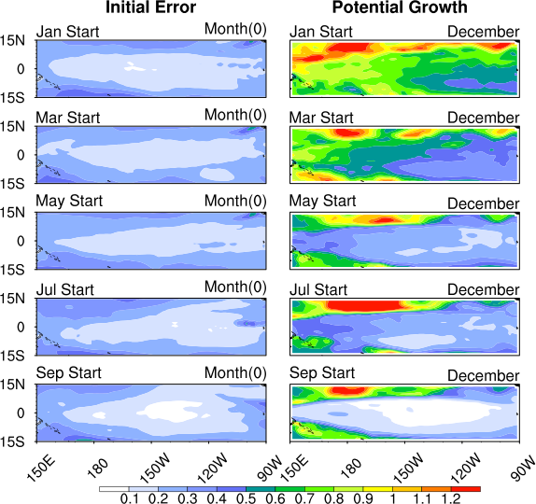

**Figure 4.10.** (Left column) Initial error structure shown as the RMSE of the month(0) SST for each RE ensemble. (Right column) Potential growth defined as the variance of the RE SST error in December scaled by the variance of the Control. Values less than 1.0 indicate error variance that has not fully saturated the signal variance (i.e., the errors still have potential to grow) and thus, signal predictability remains.

## 4.6 Implications for Predictability

The spatial structure of the initial error is shown by the RMSE of the month(0) SST field in Fig. 4.10 (left column). The initial error structure is similar for all ensembles, with smallest error in the equatorial Pacific interior and larger errors moving poleward. The right column shows the “potential growth” calculated as the variance of the RE SST error in December scaled by the December SST anomaly variance of the Control. Values less than 1.0 indicate error variance that has not fully saturated the signal variance, signifying that predictability is retained. The results in Fig. 4.10 are analogous to those found in Fig. 4.9a, although by observing the spatial distribution one can see that predictability remains all along the equatorial Pacific and that even though the January initialized cases integrate fully coupled for a entire year, much of the eastern and central Pacific still has the potential to grow 20-50% of the Control variance. It follows that although coupled instability induced errors can be large, the errors do not fully saturate the equatorial Pacific signal and by extension, do not completely exhaust the predictability of ENSO for the initialization months considered here.

As discussed in a previous section, subsurface precursors are practically nonexistent in the RE initial conditions, thus SST errors are assumed to originate at the sea surface and then evolve spatially following the dynamics of coupled instability theory. Figure 4.11 displays scatterplots of the month(0) NINO3 SST error versus the December NINO3 SST error of year(0) for the RE ensembles. The September ensemble shows hint of a positive linear relationship between the initial and final sign, although the other ensembles show only a slight indication of a bias for the cases that exceed the RMSE in December. The slope of the best-fit regression line can reveal if a bias in the initial condition sign is present that may predict the final state sign. In other words, a positive regression coefficient suggests that a positive (negative) sign predictor variable yields a positive (negative) sign predictand.

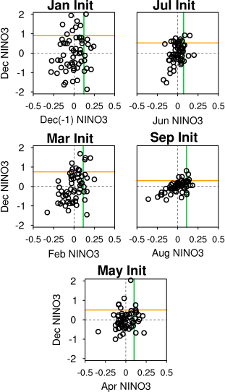

**Figure 4.11.** Scatterplots of the month(0) NINO3 SST error versus the December NINO3 SST error of year(0) for the RE ensembles. Green lines indicate the month(0) NINO3 RMSE and orange lines are similarly for December. Each ensemble has 60 members.

As shown in Fig. 4.12 (top panel), calculation of the regression line slope (predictor and predictand variables are standardized separately and by lead-time) confirms that month(0) is not a good predictor of the final state for all ensembles (i.e., leftmost point of each ensemble curve), excluding September. The exception of September is because the error exhibits only 4 months of growth by December and without the faster growth seasons of spring and summer, resulting in initial and final states that are similar and a slope that is closer to 1.0. Most importantly, while the month(0) regression coefficients are small, they are all positive, indicating a general agreement in the initial and final error sign that is otherwise undetectable in the scatterplots.

If we allow the initial state (e.g., x-axis in Fig. 4.11) to evolve with the RE integration and recalculate the regression slope, “potential predictability” curves can be drawn as in Fig. 4.12.

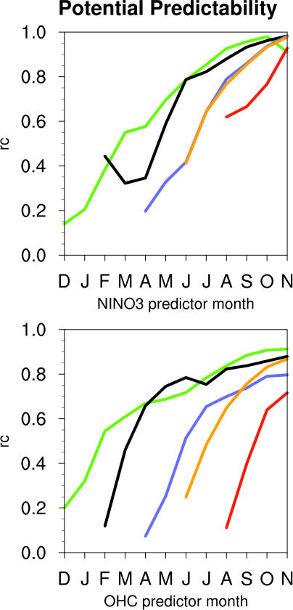

**Figure 4.12.** Potential predictability curves defined as the regression coefficient of the initial state (varying from month(0) to November) and December NINO3 for NINO3 as the predictor (top) and oceanic heat content (OHC; bottom). Colors are consistent with Fig. 4.9. All predictor and predictand values are standardized separately and as a function of lead-time.

As the RE ensembles integrate with time, the NINO3 error grows and better predicts the final state such that by month(3), even the longer lead-time predictions of the final state show some predictability of December error. Again, all regression coefficients are positive indicating that same sign initial and final states often occur. The ocean heat content (OHC; defined as depth averaged temperature perturbations between 0-250 meters along the equatorial Pacific) shown in the bottom panel reveals that smaller standardized errors are found in the initial state subsurface but potential predictability grows more quickly than at the surface, consistent with growing thermocline perturbations associated with the wave dynamics central to coupled instability theory. This is a good indication that the air-sea coupling is allowing for the destabilization of equatorial ocean waves (i.e., initiation). The NINO3 error peaks later once the thermocline effects of the equatorial Kelvin wave manifest at the surface.

Composites of the resulting El Niño and La Niña events for each ensemble shown in Fig. 4.13 confirm that coupled instability error growth is indeed ENSO-like in spatial structure for all initialization months. The final growth structure presents a real challenge for forecasters because the large growth is not accompanied by a subsurface precursor.

## 4.7 Discussion

This chapter focuses on SST error alone, specifically to emphasize the error growth itself and focus on seasonality. Other dynamical factors, like small τx,y perturbations and high frequency forcing, may be playing a role in the initiation and evolution of the different cases. In fact, this is the very discussion of chapter 6. So far, we have ruled out that large-scale atmospheric variability is initiating the events although the possibility that the small-scale variability is playing a role remains. There is, however, some indication that a slight initial SST bias may also be important for coupled instabilities and determination of the future error sign. What cannot be concluded from the results is whether the atmosphere, ocean, or coupled state perturbation is most important for instigating unstable growth. In other words, what is the relative importance of the atmosphere versus the ocean perturbation or are they both essential? The error growth dynamics, including the instigator of the instability, are discussed in detail in chapter 6.

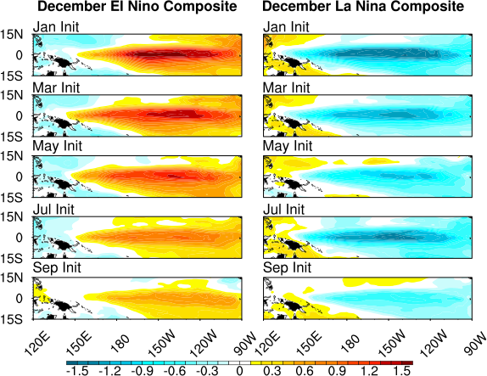

**Figure 4.13.** December(0) composite SST error for cases that produce (left) El Niño events and (right) La Niña events by December(0) as a function of ensemble.

In this chapter, a coupled model framework is developed to isolate coupled instability error growth. The framework allows for coupled instabilities to grow under a fully coupled configuration, which modernizes earlier simplified model approaches and allows us to apply results in a current-day dynamical forecast and ENSO predictability sense. Seasonal ensembles of initialized CCSM4 simulations are performed and results show that the experimental design successfully captures the unstable growth of errors in the ENSO region from perturbations that are not prescribed. One of the main conclusions of this work is that initial condition errors that grow into ENSO events do not require a previous ENSO event, subsurface precursor, or large-scale τx,y trigger, albeit without these features much of the predictability is lost. We quantify the error growth in the ENSO region for different initialization months and find that strong seasonal characteristics are prevalent in CCSM4 and are consistent with previous work that shows faster initial error growth in spring and summer seasons. The error growth rate seasonality is consistent with the seasonal stability of the background state and once the initial error growth saturates, the seasonal modulation of the error is consistent with the seasonality of air-sea feedbacks in CCSM4 (*DiNezio and Deser*, 2014).

Apart from the seasonality, we also find that the initial error growth induced by coupled instabilities is dependent on the initialization month, with July initialized cases displaying the most rapid initial growth. Another important finding is that coupled instability error growth has a well-defined seasonal limit in CCSM4. In particular, the January, March, May, and July ensembles all show a clear seasonal halt in error growth in September likely due to the increased background stability that occurs during the fall season. Furthermore, we find that some predictability in the ENSO region is retained for all initialization months despite the large error induced by coupled instabilities. A combination of strong seasonality, dependence on the initialization month, and nonlinearity best characterize coupled instability SST error growth in this model.

A point that should be emphasized is that nearly 70% of the interannual SST variability in the ENSO region in December is reproduced in the absence of a subsurface precursor in CCSM4 for long lead-times (Fig. 4.10, January ensemble). This is particularly important for the prediction community, because it shows that coupled instabilities can instigate seemingly unpredictable ENSO events and the subsequent growth is a dominant component of nonlinear SST growth in the model. This may prove problematic because the final error structure can be large and ENSO-like, potential predictability of these events is low, and subsurface temperatures fail to provide any additional predictability at month(0). Overall, there appears no clear mechanistic precursor common to the initialization months that aids in the predictability of the oncoming ENSO event, although this could be model specific considering that CCSM4 has a weak “seasonal footprinting mechanism” (*Deser et al*., 2012). We stress that the results in the present study are based on the initiation of events via coupled instabilities, however, this does not mean that air-sea feedbacks and uncoupled atmospheric variability are not playing a role in seasonally modulating the error after the initial error growth saturates. Furthermore, the fact that the growth is seasonally modulated may aid in the predictability once the event is initiated.

Finally, the lower amplitude of events in the January ensemble compared to the peak amplitude of ~3.0°C in a multicentury CCSM4 control run (*Deser et al*., 2012) demonstrates that the subsurface precursor is an important contributor to ENSO amplitude. One may infer from Fig. 4.10 that nearly 30% of ENSO variability in CCSM4 can be attributed to the subsurface precursor but more in depth exploration of this topic is necessary. The topic of the subsurface precursor is specifically emphasized in chapter 8 Future Work.

The motivation behind developing the above methodology with this particular climate model is that CCSM4 is also used in real-time NMME seasonal climate predictions. Now that the framework is developed, it can be used as a tool to model ENSO forecast error growth that can be supplemented with actual ENSO forecasts. In the following chapter, cases with initial SST perturbation structures similar to the March 2014 and 2015 observed anomaly fields are combined to test their sensitivity to noise-driven processes similarly to that shown in this chapter. The difference being that only cases with certain SST initial structures are selected from the 60 March Release Experiment ensemble members. The experimental design allows for the generation of a plume of possibilities that can result from noise-driven coupled instabilities. We then determine whether an initialized SST pattern can impact ENSO predictability. The ultimate goal being that we can now estimate an “expected” forecast spread from ENSO-independent intrinsic variability and provide insight as to why the observed December 2014 ENSO state was contrary to that predicted by the CCSM4 ensemble from the NMME.

# CHAPTER 5 – An Alternate Approach to Ensemble ENSO Forecast Spread: Application to the 2014 Forecast

**In reference to *Larson and Kirtman* (2015a)**

## 5.1 Overview

Evaluating the 2014 El Niño forecast as a “bust” may be tapping into a bigger issue, namely that forecast “overconfidence” from single model ensembles could affect the retrospective assessment of ENSO predictions. The present chapter proposes a new approach to quantifying an “expected” spread and uncertainty from noise-driven processes and supplementing these measures with actual ENSO forecasts. Expanding on a previously developed coupled model framework that isolates noise-driven ENSO-like errors (chapter 4), an experimental design is implemented to generate an expected December Niño-3.4 spread from March initial condition SST errors that have similar structure to the 2014 and 2015 observed. In addition, since the initial SST anomaly structure for both March 2014 and 2015 observed is PMM-like, the experiment design and accompanying analyses allows for the quantification of PMM’s effect on ENSO predictability.

## 5.2 The 2014 ENSO Forecast Challenge

Many dynamical forecast models predicted a 2014 El Niño event. Yet, despite the moderate SST warming that was observed, the 2014 forecast is often described as a “busted” forecast. The question that arises is of practical importance – was 2014 actually a bust or is the usual method of calculating ensemble spread (defined below) underestimating forecast uncertainty and by extension, affecting the retrospective evaluation of ENSO predictions?

A continuing challenge in ENSO prediction is determining how the range of possibilities for a forecast can be better represented without requiring increasingly more ensemble members (*Kumar and Hoerling*, 2000; *Kumar et al*., 2001). In particular, single model ensembles often produce too small of spread or “over confidence” (e.g., *Buizza and Palmer*, 1998; *Richardson*, 2001). One method of tackling this issue is the implementation of multi-model ensemble prediction systems, including the North American Multi-model Ensemble (NMME; *Kirtman et al*., 2014) and other modeling groups (e.g., *Doblas-Reyes et al.*, 2000; *Palmer et al*., 2004). Ensemble predictions combined from multiple models increase forecast diversity and provide a better estimate of uncertainty owing to model formulation (*Kharin and Zwiers*, 2002; *Palmer et al*., 2004; *Kirtman et al*., 2014). Nevertheless, there persists a need to develop alternative approaches to represent uncertainty for single model ensembles as well, because individual models provide the basis for the multi-model ensemble forecast spread and the number of ensemble members provided is often financially limited.

The present study proposes a new approach to assigning ensemble spread to single model ensembles in an attempt to better represent an “expected” uncertainty generated by noise-driven errors. Error growth behavior is often model-dependent and requires a model-by-model approach to diagnosing not only systematic biases that are studied extensively in the literature (e.g., *Guilyardi et al*., 2009; *Bellenger et al.*, 2014), but also dynamically driven errors that are difficult to isolate in complex coupled models. The present effort is based on the quantification of dynamically driven error growth for seasonal ensembles using a recently developed National Center for Atmospheric Research (NCAR) Community Climate System Model, version 4 (CCSM4) approach (*Larson and Kirtman*, 2015b; hereafter LK15). The experimental design isolates noise-driven coupled instability error growth that is independent of the ENSO cycle. Expanding on the LK15 methodology, we examine the question – how much forecast spread is expected from noise-driven error growth for the 2014 and 2015 CCSM4 NMME forecasts?

The fundamental assumption is that we are considering error growth independent of the ENSO cycle, which includes both the classical equatorial SST structure and the subsurface heat content precursor (*Cane et al*., 1986; *Meinen and McPhaden*, 2000; *McPhaden*, 2003). The introduction of errors to the system is due to intrinsic ENSO-independent perturbations, either present in the initial conditions or occurring stochastically later in the evolution. Note that all measures of spread are defined as the average deviation about the ensemble mean. How this framework can be extended to initial conditions containing the ENSO subsurface precursor are discussed in chapter 8 future work.

## 5.3 Observations and Forecasts

Motivated by the LK15 framework, an “expected” spread is added to the 2014 and 2015 March initialized CCSM4 ENSO forecasts from the NMME. March initializations are chosen for their temporal proximity to the spring predictability barrier (*Webster and Yang*, 1992; *Kirtman et al*., 2002; *Mu et al*., 2007a) and because the spring background state is particularly well suited for coupled feedbacks to amplify errors and produce large ensemble spread in CCSM4 (LK15). Additionally, both 2014 and 2015 March initial conditions have robust Pacific Meridional Mode (PMM; *Chiang and Vimont*, 2004) SST anomaly signatures, an ENSO-independent intrinsic mode of variability also present in the LK15 ensembles and a potential source of ENSO forecast error due to PMM’s robust precursor relationship with ENSO. The relationship is highlighted in model, observational, and dynamical forecast studies (*Chiang and Vimont*, 2004; *Chang et al*., 2007; *Zhang et al*., 2009a; *Larson and Kirtman*, 2013, 2014). Last, both forecasts predict December El Niño larger than 1.5°C from PMM initial conditions.

Figures 5.1c,d show the CCSM4 March initialized Niño-3.4 anomaly forecasts with 10 ensemble members (gold), ensemble mean (black solid), forecast spread (grey polygon), and the observed Niño-3.4 index from the National Center for Environmental Prediction (NCEP) Climate Prediction Center (CPC; black dashed).

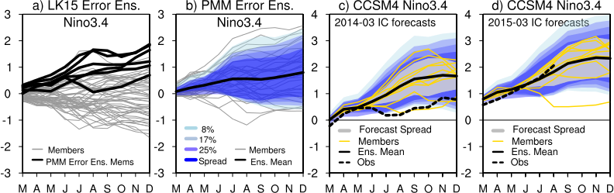

**Figure 5.1.** a) Niño-3.4 SST error swath for the March error growth ensemble in *Larson and Kirtman* (2015b). Black bold curves indicate the 6 members whose ocean initial conditions are used in the PMM error ensemble. b) Niño-3.4 error swath, ensemble mean, spread, and uncertainty thresholds for the PMM error ensemble. Uncertainty thresholds are calculated by averaging the most extreme 3, 6, and 9 warm or cold members corresponding to 8%, 17%, and 25%, respectively. c) 2014 CCSM March initialized Niño-3.4 forecasts from the NMME, forecast spread (grey polygon), and expected spread and uncertainty thresholds from 1b. d) Same as c) but for the 2015 forecasts.

To be clear, “forecast spread” is computed from the actual CCSM4 initialized forecasts, whereas “expected spread” is the proposed supplemental spread discussed below. The 2015 observed Niño-3.4 evolution falls within the forecast spread and thus far, is on track to verify, albeit the final amplitude may vary from that predicted by this particular model (2.33°C in December). On the other hand, observed 2014 Niño-3.4 sits well below the forecast spread and verifies at 0.78°C as compared to the ensemble mean forecast of 1.67°C. So was 2014 a “bust” or does 0.78°C fall within the expected spread generated via noise-driven processes in CCSM4, despite the December forecast spread spanning only 1.16-2.17°C?

The 2014 and 2015 forecasts both predict El Niño from PMM-like initial conditions (Fig. 5.2). Depicted are the 0.5-lead CCSM4 ensemble mean March SST anomaly forecasts and are considered close proxies for the initial condition. In earlier versions of the NMME models (i.e., phase-1 models), strong positive projections of PMM in the 0.5-lead March initialized forecasts correctly predict a Niño-3.4 forecast that falls within the upper tercile 49% of the time, which is moderately larger than the 33% expected from randomness (*Larson and Kirtman*, 2014); therefore, the 2014 and 2015 El Niño forecasts are not particularly surprising. Since PMM predicts El Niño with some skill in the dynamical forecasts, then PMM-like initial errors could have an impact on ENSO forecast error.

## 5.4 Model Experiment and Results

As previously mentioned, we expand upon the LK15 model framework, specifically utilizing their March initialized error growth ensemble. The ensemble consists of 60 members each branched from different March initial conditions originating from the same base simulation named the Climatological Wind Experiment (CWE; see LK15 or chapter 4 for more details). CWE is a mechanically decoupled CCSM4 simulation. Mechanical decoupling is achieved by forcing the ocean component with CCSM4 daily climatological wind stresses while allowing the atmosphere to respond freely without constraint.

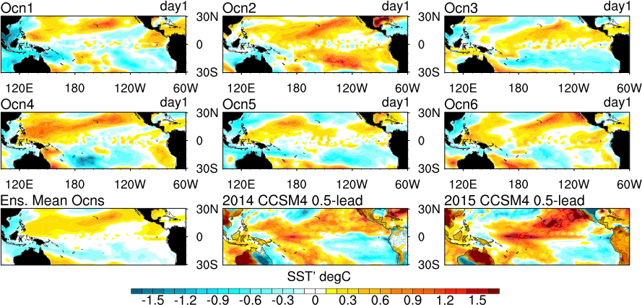

**Figure 5.2.** Day 1 SST errors in the 6 ocean initial conditions used for the PMM error ensemble (rows 1 and 2), the ensemble mean (bottom left), and the 2014 and 2015 0.5-lead CCSM4 forecasts of March SST anomalies from the NMME.

Since tropical interannual SST variability is largely wind-driven whereas extra-tropical variability is influenced more by thermal fluxes (*Neelin et al*., 1994), mechanically decoupling the atmosphere and ocean considerably reduces SST variability in the tropics only. The extra-tropics are less impacted. Without dynamic wind stress support, the ENSO cycle, large subsurface heat content precursors, and coupled instabilities along the equatorial Pacific are all unsupported in the CWE; therefore, there is no ENSO cycle or subsurface precursors in the initial conditions of the 60 ensemble members. The only perturbations are intrinsic to the system and are dynamically decoupled as per the experimental design. There is practically no interannual SST variability in the ENSO region in the CWE. As a result, overlying atmospheric wind variability is damped by 80% throughout the tropical Pacific compared to a CCSM4 control simulation. Essentially, equatorial Pacific wind perturbations are small and ENSO-independent in CWE. The 60 cases are initialized in March by essentially “turning the coupling back on” (i.e., no longer overriding the atmospheric wind stresses with climatology) to allow for the activation of coupled instabilities via interaction between the perturbations at the air-sea interface, which are treated as errors in the initial condition. Figure 5.1a shows that several members generate largely warm or cold biased Niño-3.4 SST error growth whereas others remain fairly neutral.

CWE is a free-running simulation, so each member is branched from sequential March initial conditions occurring one year apart. In LK15, 10 cases bias noticeably warmer than the other 50, exceeding one standard deviation of Nino-3 in December. To discount possible decadal variability that previously went undetected and allow for the maximum amount of model spinup, only the subset of the 10 cases branched from the last 30-yr period of the CWE are selected. This results in the selection of the 6 warm biasing cases as shown in Fig. 5.1a (black bold). We use only the ocean initial conditions from these 6 cases, referred to as Ocn1-6. The day 1 SST errors from Ocn1-6 and the ensemble mean are shown in Fig. 5.2. All members show some extent of a PMM-like projection, thus each member is considered having PMM-like errors in the initial condition. This type of structure is desirable to test how errors may grow if error exists say, in PMM amplitude or structure. The 6-member subset is well representative of the 10 warm biasing cases because 9/10 of the day 1 SST errors have PMM-like errors in the initial condition. The fact that the PMM is active in the CWE provides strong confirmation that PMM is ENSO-independent as originally argued in *Chiang and Vimont* (2004).

To test the sensitivity of the ocean perturbations to atmospheric noise, (i.e., errors in the atmospheric initial conditions) the 6 initial ocean conditions are each paired with 6 different atmosphere initial conditions from LK15 members that bias cold. These atmospheres are chosen to ensure that the atmospheric noise is entirely decoupled in terms of both buoyancy and momentum fluxes because initial SST error structures can be similar (Fig. 5.2). A total of 36 combinations comprise the PMM error ensemble.

How much scatter can be expected from PMM-like errors in the initial condition SST? Figure 5.1b shows the Niño-3.4 error swath for the PMM error ensemble. The range of possibilities of December Niño-3.4 error from PMM-like initial errors is large, spanning -0.65 – 2.57°C with little clustering around a particular final error value. Despite the large spread, the errors are clearly biased warm. This suggests that PMM-like perturbations in the initial condition can shift the distribution warm, implying an increased probability of El Niño. Nevertheless, the noise-driven scatter demonstrates how sensitive March is to noise-driven perturbation growth that affects December ENSO verification (i.e., large expected spread) thus suggesting large forecast uncertainty for these longer lead times.

The PMM error ensemble produces a noticeably larger spread (-0.11-1.72°C) than the forecast spread computed from the CCSM4 forecasts (grey polygons in Figs. 5.1c,d). Other thresholds are computed, including averaging the most extreme 3, 6, and 9 ensemble members that bias warm or cold, respectively the 8%, 17%, and 25% levels (Fig. 5.1b). Note that this method may still be underestimating the expected spread as we selected only members that originally bias warm in LK15. A few members have PMM-like initial errors but bias cold instead. The chosen members begin a warm biased trajectory that continues through December, apart from seasonal waxing and waning of the growth rate. Nevertheless, the present method of choosing only 6 ocean base cases proves to produce a large range of possibilities including members that bias slightly cold. Most importantly, the PMM error ensemble clearly generates a larger expected spread than the actual forecast spread for either 2014 or 2015.

Since the noise-driven scatter from PMM-like errors is large, does this measure of ENSO-independent expected spread change our evaluation of the 2014 forecast? The expected spread and uncertainty thresholds in Fig. 5.1b are added to the 2014 and 2015 ensemble mean forecasts (Figs. 5.1c,d). For 2014, observed Niño-3.4 still sits below all uncertainty thresholds during summer but the final amplitude (0.78°C) falls within the 25% expected threshold (0.51-2.87°C) and is within the lower bounds of the expected spread (0.75-2.58°C), meaning that even though the observed amplitude sits below the forecast spread (1.16-2.17°C), it is an unsurprising outcome when considering the expected noise-driven scatter. This shows that ENSO-independent, noise-driven processes alone can produce large spread and perhaps, the expected spread is a better representation of the uncertainty.

We emphasize that noise-driven scatter is present in the forecast spread but because of the small ensemble size, the forecast spread does not adequately represent the forecast uncertainty at longer lead times. We also stress that we are not suggesting the removal of the forecast spread polygon, but the addition of an expected spread or uncertainty threshold from noise-driven processes that can serve as a benchmark for expected uncertainty from the stochastic component of coupled system. The benefit being that this approach does not require an increase of forecast ensemble size, but a diagnostic assessment of the noise-driven error behavior away from the forecast setting. Expected spread and uncertainty thresholds can be applied to each forecast, thus providing a measure of spread that is independent of the forecast itself. This way, even if single model ensemble “overconfidence” is evident in the forecast spread, a reality check of the potential spread from noise-driven errors is available to supplement the “expert assessment” of the model forecast.

## 5.5 Discussion

Ensemble spread is an important estimate of forecast uncertainty and assigning confidence in ENSO predictions requires an expert assessment that may benefit from measures of uncertainty besides forecast spread alone, which can be affected by ensemble size. Quantifying the expected noise-driven spread in fully coupled models that are used in real-time seasonal predictions is essential to providing a forecast-independent measure of the possible uncertainty that can occur. LK15 present a coupled model framework to isolate such error growth for single model ensembles.

The present study expands on the LK15 experimental design to produce an expected noise-driven spread for the March initialized 2014 and 2015 CCSM4 NMME predictions of December Niño-3.4. The initial conditions of both forecasts contain PMM SST signatures and predict December El Niño. A PMM error growth ensemble is constructed from 6 ensemble members that originally bias warm in the LK15 March error ensemble, each also having PMM-like errors in the initial conditions. The constructed ensemble is essentially a sensitivity test, pairing each base ocean with 6 different atmospheric noise initial conditions.

In reality, the 2015 prediction, so far, appears realistic, whereas the 2014 prediction is often discussed as a “bust.” Based on the expected spread produced by the PMM error ensemble, we argue that the observed 2014 December Niño-3.4 warming falls well within the expected uncertainty for noise-driven error growth originating from the interaction of atmospheric noise with PMM-like errors in the initial condition SST.

We are not suggesting that a new error ensemble must be constructed for each actual forecast, but merely demonstrating that the expected spread from initial SST errors with similar structures as the March 2014 and 2015 initial conditions used in the real-time CCSM4 NMME forecasts is large for longer lead times. In fact, the spread in the PMM error ensemble (Fig 5.1b) is similar to that in the original LK15 March error ensemble (Fig 5.1a), suggesting that the expected spread is similar for differently constructed noise-driven error ensembles, as long as the initial conditions are ENSO-independent. Thus, the spread of the LK15 ensembles suffice as a benchmark for expected spread from noise-driven processes alone in CCSM4. In this case, more information is gained by using ocean base members with PMM-like initial errors, including that the presence of PMM-like perturbations in March can increase the probability that El Niño will occur (i.e., the warm bias), but does not guarantee it due to the large sensitivity of the coupled system to perturbations in March (i.e., large expected spread).

The present study is only looking at error growth that is independent of the ENSO cycle. The expected spread may change if an ENSO cycle is present in the initial condition and is a topic worth investigating as it has potentially large practical benefits for the assessment of forecast uncertainty.

An outstanding question remains from chapers 4 and 5: What is driving the error growth? More specifically, what noise is instigating the instability and what processes are modulating the strong seasonality of the growth rate as highlighted in chapter 4? As is shown in this chapter, the initialized SST state can increase the probability that perturbations or errors will grow into warm ENSO-like final structures, but whether the growth takes that pathway ultimately relies on whether the successful instigation of the instability occurs or not. Therefore, the missing link is determining exactly what excites the instability and what mechanisms allow or hinder its continued growth. Understanding this process will give better indication of whether the errors undergo similar or different mechanistic growth processes compared to ENSO events themselves. In other words, are the errors distinguishable from the ENSO signal?

# CHAPTER 6 – Drivers of ENSO Error Growth Dynamics and the Spring Predictability Barrier

**In reference to *Larson and Kirtman* (submitted)**

## 6.1 Overview

Despite improvements in ENSO simulations throughout recent decades, model ENSO predictions ultimately remain limited by error growth. Determining the accompanying dynamical processes that drive the growth of certain types of errors may help the community better recognize what sources of error may be intrinsic to the system. This chapter applies a dynamical analysis to a previously developed CCSM4 error growth ensemble that has been used to assess noise-driven coupled instability induced error growth that affects ENSO predictability (chapters 4 and 5). Anomalous heat flux convergence terms related to positive feedback mechanisms are computed to compare error growth mechanisms with those associated with typical model ENSO behavior. Daily fields are utilized to determine the instigator of the instability and a new approach to identifying sources of the spring predictability barrier in coupled models is presented. Overall results are in line with the hypothesis that noise-driven errors can provide an intrinsic limit to ENSO predictability.

## 6.2 Background

El Niño – Southern Oscillation (ENSO) is the dominant variability in the tropical Pacific, with teleconnected influences that uniquely affect weather and climate on a global scale (e.g., *Ropelewski and Halpert*, 1986, 1987; *Trenberth et al.,* 1998; *Tang and Neelin*, 2004; *Lee et al*., 2014b; *Infanti and Kirtman*, 2015). Understanding the sources of ENSO forecast errors and the dynamical processes that accompany their growth (when applicable) can help us better distinguish what kinds of error can potentially be improved upon and what sources of error may be intrinsic and thus set the limit to predictability of the system.

Model predictions of ENSO are ultimately limited by error growth, including initial condition errors (*McPhaden*, 2003), systematic model errors (*Guilyardi et al*., 2009; *Bellenger et al.*, 2014), and noise-driven errors (*Xue et al*., 1997; *Samelson and Tziperman*, 2001; *Karspeck et al*., 2006; *Larson and Kirtman*, 2015a; 2015b). Initial condition and systematic model errors are active areas of research that have the potential to reduce errors, whereas noise-driven errors could be an intrinsic limit to predictability (*Samelson and Tziperman*, 2001; *Schopf and Burgman*, 2006). Despite improvements over the past decades in tropical Pacific observations (*Wallace et al*., 1998; *McPhaden et al*., 2001) and model simulated ENSO (*Bellenger et al*., 2014), longer lead time ENSO predictions continue to fall victim to poor verification due to the so-called “spring predictability barrier” (SPB; *Webster and Yang*, 2002; *Kirtman et al*., 2002; *Jin et al*., 2008; *Duan and Wei*, 2013; *Lopez and Kirtman*, 2014; *Levine and McPhaden*, 2015), suggesting the problem could be related (although not exclusively) to noise-driven errors.

Isolating noise-driven error growth in fully coupled models is complicated due to the hierarchy of spatiotemporal scales of variability resolved by the model. Mathematical empirical techniques, including optimal perturbations (e.g., *Penland and Sardeshmuhk*, 1995; *Kleeman and Moore*, 1997) are often applied to coupled model data to isolate the fastest growing (optimal) modes of a dynamical system. These modes are found to produce final state error structures that are ENSO-like, thus potentially impacting ENSO predictability. In a different approach, *Larson and Kirtman* (2015b) develop a methodology to isolate and model noise-driven error growth in a fully coupled model. An ensemble approach was used to produce a noise-driven spread to assess implications for ENSO predictability. In comparison to empirical techniques, the benefit to modeling error growth itself is that no implicit assumptions about the climate state or the internal dynamics are necessary and the statistics are not required to be stationary.

The error ensembles are utilized to quantify the spatiotemporal behavior of coupled instabilities in *Larson and Kirtman* (2015b) and to supplement an expected noise-driven spread to actual real-time predictions in *Larson and Kirtman* (2015a). Here a dynamical approach is taken to understand what drives the error growth and how it is related to previous ideas about the SPB. The chapter is organized as follows. First, the coupled model and error ensembles are described in detail. The study next focuses on – 1) anomalous heat flux convergence terms to compare error growth with typical ENSO growth mechanisms, 2) physical mechanisms that trigger the instability, and 3) providing new insight on the SPB in coupled models. Finally, a summary and discussion conclude the presented work.

## 6.3 Coupled Model and Error Ensembles

*Larson and Kirtman* (2015b) establish a coupled model framework to isolate coupled instability induced SST error growth in the ENSO region. The necessary details of the experimental design are discussed below. The model used is the National Center for Atmospheric Research (NCAR) Community Climate System Model, version 4 (CCSM4) with nominal 1° horizontal resolution and pre-industrial forcing (*Gent et al*., 2011). The model is compromised of an atmosphere, ocean, land, and sea-ice models, all connected through a flux coupler. CCSM4 is also part of the North American Multimodel Ensemble (NMME) prediction system (*Kirtman et al*., 2014); therefore, diagnosing error growth behavior in this model is of particular interest because of its use in real-time seasonal climate prediction. CCSM4 simulates a realistic ENSO with a 3-6-yr period and seasonal phase-locking, yet overestimates the SST variability by about 30% (*Deser et al*., 2012). ENSO characteristics, including El Niño/La Niña asymmetry and diversity of spatial patterns are also generally realistic (*Capotondi*, 2013) despite having a cold tongue bias typical of coupled models (*Deser et al*., 2012).

The methodology consists of: i) a free-running, mechanically decoupled CCSM4 simulation integrated for 100 model years named the Climatological Wind Experiment (CWE) and ii) using i) as a suite of initial conditions from which to branch error growth ensemble experiments. Mechanically decoupling the air-sea interface is implemented by forcing the ocean with the model’s daily climatological wind stresses, while leaving the atmosphere and buoyancy fluxes unconstrained. Due to the lack of dynamic wind support, the CWE does not support coupled instabilities, an ENSO cycle, or large subsurface heat content precursors. Furthermore, practically there is no interannual tropical Pacific SST variability in the CWE. Consistently, the overlying zonal wind stress variability is redcued by nearly 80%. The remaining equatorial variability, characterized by ENSO-independent noise-driven perturbations, can be treated as errors in the initial conditions of the branched error ensemble experiments.

Every two months, a simulation is branched from the CWE initial conditions with the wind constraint released, giving perturbations in the atmosphere and ocean the opportunity to generate coupled instabilities (e.g., *Philander et al*., 1984; *Anderson and McCreary*, 1985; *Hirst,* 1986; *Battisti*, 1988; *Battisti and Hirst*, 1989; *Kessler and McPhaden*, 1995). More specifically, simulations are branched every January, March, May, July, and September for 60 model years, creating 5 ensembles for each of 60 members. The March error ensemble is chosen for much of the analysis here due to its proximity to the SPB. Any reference to the “error ensemble” hereafter is strictly for the 60 March initialized cases, although all ensembles are discussed in a later section.

## 6.4 Niño-3.4 SST Growth

Since error growth that affects ENSO predictability is of interest, Fig. 6.1 shows the Niño-3.4 sea surface temperature (SST) anomaly/error swath for both the March error ensemble and a 220-yr CCSM4 control simulation with the same configuration. The control is included to compare the typical ENSO “signal” in CCSM4 with error growth that can interfere with the predictability of the signal.

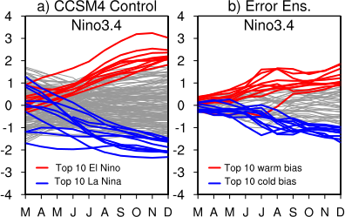

**Figure 6.1.** a) March – December Niño-3.4 SST anomaly swath for a 220-yr CCSM4 control simulation with the 10 largest El Niño (red) and La Niña (blue) events. b) Niño-3.4 error evolution for the CCSM4 March error ensemble with the 10 warmest (red) and coldest (blue) biasing members.

The March – December Niño-3.4 anomaly evolution for each of the 220 control years are shown along with the 10 largest amplitude El Niño/La Niña events highlighted. ENSO amplitude is defined from the December Niño-3.4 value. For the error ensemble, the Niño-3.4 error evolution, defined as the deviation about the ensemble mean, along with the 10 warmest/coldest biasing members are displayed.

First, the control Niño-3.4 (i.e., ENSO signal) evolution shown in Fig. 6.1a is explored. In March, the Niño-3.4 anomaly for the strongest 10 impending (i.e., December) El Niño events falls within the range of -0.33 to 0.91°C and 60% are positive in sign. The range for La Niña is -1.70 to 1.29°C in March, with 50% negative. The larger range for La Niña reflects two well-documented aspects of La Niña onset that evidence nonlinear ENSO dynamics in CCSM4 (*Deser et al*., 2012; *Capotondi* 2013; *DiNezio and Deser*, 2014). One is that La Niña often occurs after El Niño, thus the decaying El Niño anomalies linger through March prior to La Niña. This phase transition is often referred to as the turnabout in recharge oscillator dynamics (*Jin,* 1997). The other is that sometimes “double dip” La Niña events occur, also referred to as 2-yr La Niña in *DiNezio and Deser* (2014) or resurgent La Niña in *Lee et al*. (2014a), characterized by cool anomalies that persist for two years instead of one. Both El Niño/La Niña show a clear warming/cooling throughout the evolution and end with a plateau of peak amplitude in October – December. The range for the final amplitude of the 10 warmest El Niño is 1.82 to 3.02°C and -2.32 to -1.48°C for the 10 coldest La Nina, consistent with ENSO amplitude asymmetry found in a multicentury CCSM4 simulation (*Deser et al*., 2012).

Next, the error ensemble shown in Fig. 6.1b is investigated. The largest 10 warm/cold biasing members of the error ensemble evolve differently in many aspects from El Niño/La Niña. Since the initial conditions contain no ENSO cycle, the March initial errors are much smaller than the ENSO anomalies, ranging from -0.25 to 0.38°C for the warm case and -0.31 to 0.11°C for the cold case. Furthermore, 80% of the warm cases are positive in Marchand 70% of the cold cases are negative. This implies that 75% of the extremes choose their trajectory within the first month (hereafter, month(1)) and indicates that analysis of daily fields is necessary to determine the trigger that excites the rapid growth. The remaining 25% cases either change sign from the initial trajectory or do not choose a trajectory until months later and are discussed in more detail later on.

The warm/cold errors exhibit rapid growth in late spring-summer and plateau in September – October (*Larson and Kirtman*, 2015b), whereas ENSO growth plateaus in October – December. One warm case begins a cold trajectory, exhibits unusually rapid growth beginning July – August, and ends with a final warm error, although this evolution appears exceptional. Two cold cases do not begin a cold trajectory until after May. The warm cases tend to show a more marked peak in July – August than the cold cases, likely attributed to nonlinear SST-wind feedbacks in CCSM4 (*DiNezio and Deser*, 2014). Ultimately, December warm/cold errors are smaller than El Niño/La Niña peak amplitude in nearly all cases, indicating that ENSO predictability for March initialized ensembles is possible. Obviously, this is because the ENSO signal is typically larger than the maximum error expected from noise-driven processes (*Larson and Kirtman*, 2015b). The December error range of the warm case is 0.90 to 1.87°C and -1.67 to -0.96 °C for the cold case.

## 6.5 Dynamical Processes

Comparison of the Niño-3.4 swaths prompts the consideration of dynamical processes that may contribute to the error evolution. For instance, the different timing of the growth plateau may be explained by differences in the amplitude or timing of positive feedback mechanisms. We next quantify key heat budget terms linked to ENSO dynamics and positive feedback mechanisms (*Jin and An*, 1999; *An et al*., 1999; *An and Jin*, 2001; *Zhang et al*., 2007) to determine if the error dynamics operate via similar dynamical processes. The terms are derived from the surface layer ocean heat budget equation for a constant depth H:

$ρ_{o}c_{p}H\frac{∂T}{∂t}= Q_{ocn}+Q_{atm}$ (6.1)

where $ρ_{o}$ is the density of seawater, $c_{p}$ is the ocean heat capacity, H is set constant at 105 meters, $Q_{ocn}$ represents heat flux convergence over the layer H, and $Q_{atm}$ is the net surface heat flux. *DiNezio et al.* (2012) and *DiNezio and Deser* (2014) perform heat budget decompositions on multiple models including CCSM4 over the upper 100m and show considerable success in approximating the surface mixed layer heat budget. As such, depth H = 105m, corresponding to the upper 10 levels, is selected here.

Following the lead of previous recharge oscillator work (*Jin and An*, 1999; *An et al.,* 1999; *An and Jin,* 2001; *Zhang et al*., 2007) and heat budget decompositions of CCSM4 (*DiNezio et al*., 2012; *Capotondi*, 2013; *DiNezio and Deser*, 2014), we quantify two anomalous $Q_{ocn}$ terms described as being essential for ENSO growth and phase transition,

${Q'}_{TC}=-ρ_{o}c_{p}\int_{-H}^{0}{\left(\overline{w}\frac{∂T'}{∂z}\right)}dz$, (6.2)

${Q'}_{u}=-ρ_{o}c_{p}\int_{-H}^{0}{\left(u'\frac{∂\overline{T}}{∂x}\right)}dz$. (6.3)

The ${Q'}_{TC}$ term represents the anomalous heat flux convergence due to the mean upwelling $\overline{w}$ of anomalous thermocline temperatures $∂T'/∂z$. The ${Q'}_{u}$ term represents the anomalous heat flux convergence due to anomalous zonal current velocities $u'$ acting on mean zonal temperature gradients $∂\overline{T}/∂x$. ${Q'}_{TC}$ and ${Q'}_{u}$ are closely tied to the two dominant positive feedback mechanisms for ENSO, the so-called thermocline and zonal advective feedbacks, respectively (*Jin and An*, 1999). Both terms are computed for CCSM4 in *Capotondi* (2013), *DiNezio and Deser* (2014), and *Lopez and Kirtman* (2013), however with different methodology than what is ideal for the purposes of the present study.

Previous CCSM4 work involving the two key feedback terms (6.2) and (6.3) attempt to either decompose the ENSO heat budget (*DiNezio and Deser*, 2014) or explore ENSO diversity in the context of different feedback mechanisms (*Capotondi*, 2013; *Lopez and Kirtman*, 2013). Note that that ${Q'}_{TC}$ and ${Q'}_{u}$ are not technically feedbacks. However, these heat flux convergence terms are closely tied to the respective mechanistic feedbacks. In the above CCSM4 literature, ${Q'}_{TC}$ and ${Q'}_{u}$ are calculated for specific ENSO regions. For instance, *Capotondi* (2013) averages over both Niño-3 and Niño-4 to study ENSO diversity and *DiNezio and Deser* (2014) average over Niño-3.4 to study the dynamics of La Niña. These studies also isolate interannual variability associated with each $Q_{ocn}$ term using various filtering techniques. This makes for difficulty in straightforward comparisons with the present study.

First, since model ENSO events are compared with error growth, all resolved timescales of variability are desirable such that the most realistic representation of a forecast setting is possible. Additionally, the error ensemble members are each integrated for only 10 months; thus interannual filtering cannot be used. Second, it is not reasonable to assume that the error dynamics are active in zonally similar locations as ENSO dynamics. Thus, spatial averaging is applied only meridionally over the equatorial region of 2.5°S-2.5°N. As such, results are displayed as equatorial time-longitude sections. We also assume that the error growth $Q'$ terms may exhibit warm/cold asymmetries similar to El Niño/La Niña; thus linear approximations like a lead-lag regression approach in *Zhang et al*. (2007) are also undesirable. As a test, we apply similar Fourier filtering and regional averaging to the ${Q'}_{TC}$ and ${Q'}_{u}$ terms as in *Capotondi* (2013) using the 220-yr control CCSM4 simulation to obtain similar results (not shown). The only quantitative differences are in amplitude, which is understandable given that we average only the largest 10 events.

### 6.5.1 ${Q'}_{TC}$ and $SST'$

Figure 6.2 (top row) shows the equatorially averaged March-December SST anomaly/error (contours; hereafter, $SST'$) and ${Q'}_{TC}$ evolution (shaded) for the control ENSO events and their difference. The $Q'$ terms considered here are maximized along the equator (*Zhang et al*., 2007), thus we focus on the narrow latitudinal band of 2.5°S – 2.5°N. The composite El Niño shows ${Q'}_{TC}>0$ in March, extending from 160°E-110°W. Although not shown, ${Q'}_{TC}$ can begin converging heat in the equatorial region 12 months prior to peak El Niño (*Zhang et al*., 2007) evidenced by $∂T'/∂z$ in the subsurface as early as the January prior in CCSM4 (*Capotondi*, 2013). The heat content builds up (i.e., the “recharge”) often forced by the anomalous easterlies associated with a previous La Niña event. The wide zonal extent of ${Q'}_{TC}>0$ persists in the eastern Pacific until June, with the first of two pulses of maximum ${Q'}_{TC}$ values of 80-100 Wm-2 occurring in April – May near 130°-140°W. This “spring pulse” of ${Q'}_{TC}$ precedes faster $SST'$ growth in the late spring, during which $SST'$ warms from 0.5°C in April to 1.5°C in June. The “spring pulse” may be attributed to the subsurface heat content precursor propagating to the eastern Pacific with the relaxation of trade easterlies (Fig. 6.3).

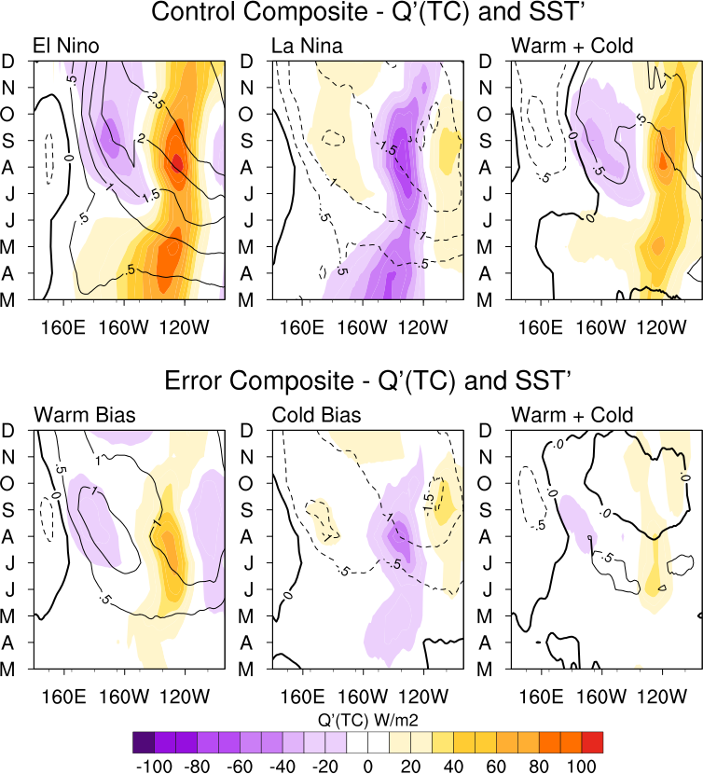

**Figure 6.2.** (Top row) The equatorially averaged March – December evolution of $SST^{'}$ in °C (contours) and in Wm-2 (shading) for the composite El Niño and La Niña events in Fig. 6.1 and their difference. (Bottom row) Similar but for the March error ensemble.

The positive SST anomlaies ($SST^{'}>0$) amplify to greater than 2.5°C in the extreme eastern Pacific in August and gradually expand westward to 160°W by December. The expansion of the maximum $SST^{'}$ coincides with the “summer pulse” of ${Q'}_{TC}>0$ in July – October, preceding peak ENSO in October – December. The beginning of the “summer pulse” coincides with the timing of the maximum Bjerknes feedback in CCSM4 (*DiNezio and Deser*, 2014) and is consistent with the interannual maximum of ${Q'}_{TC}$ leading El Niño by 4-5 months in *Capotondi* (2013). In CCSM4, ${Q'}_{atm}$ damping is also minimized in September – October when the climatological cold tongue is stronger, providing another mechanism for $SST^{'}$ growth. Rapid $SST^{'}$ growth quickly slows after the summer pulse. The zonal confinement of ${Q'}_{TC}>0$ to the eastern Pacific is consistent with thermocline feedback showing the maximization of the thermocline feedback in the eastern Pacific where the thermocline is shallow (*Jin and An*, 1999).

Beginning in July, the equatorial “discharge” (*Jin*, 1997) or “delayed thermocline feedback” (*DiNezio and Deser*, 2014) is evidenced by the ${Q'}_{TC}<0$ positioned near the dateline and persists through the peak event. Once El Niño enters its peak phase, the zonally integrated Sverdrup transport discharges heat poleward to alleviate the anomalously flat zonal thermocline slope forced by the overlying zonal wind stress anomalies (*Jin*, 1997; *Jin and An*, 1999). Hence, before the peak event, the ${Q'}_{TC}>0$ is large and acting as a positive feedback in the eastern Pacific (*Jin and An*, 1999) at the same time the discharge mechanism is activated to the west.

Generally, similar behavior is seen for La Niña, albeit with weaker amplitude. The negative SST anomalies ($SST^{'}<0$) amplify from -0.5°C in April to -1.0°C in June. The amplitude reaches over -1.5°C in July in the far eastern Pacific, with a slow westward expansion of peak anomalies reaching the central Pacific by December. La Niña amplitude is about 1.0°C weaker than El Niño. The “spring pulse” occurs slightly earlier for La Niña, likely an effect of 2-year (or resurgent) La Nina in composite averaging, whereas the “summer pulse” is temporally consistent with El Niño. The difference plot shows that the ${Q'}_{TC}$ amplitude for El Niño is consistently larger in the eastern Pacific throughout the evolution, with ${Q'}_{TC}$ larger by 40-60 Wm-2 near 120°W for the full evolution and even larger during the spring and fall maxima. Similar nonlinear behavior is noted in *DiNezio and Deser* (2014). In the central Pacific, the zonal $SST^{'}$ asymmetry between El Niño and La Niña is apparent and is also evidenced by the higher amplitude cold anomalies in the central Pacific by over 1.0°C west of the dateline.

The ${Q'}_{TC}$ and $SST^{'}$ evolution for the warm/cold error composites (Fig. 6.2 bottom row) display marked differences from the ENSO composites. First, the $SST^{'}$ do not reach 0.5°C in amplitude until May for the warm composite and June for the cold composite since the errors are growing from a neutral March initial state. Within 1-2 months and in the absence of a subsurface precursor, $SST^{'}$ along the equatorial eastern Pacific doubles to 1.0°C. The higher amplitude $SST^{'}$ quickly expands westward. Both warm and cold biases show two zonal maxima in $SST^{'}$ during late spring. One maximum is positioned east of 160°W in the eastern Pacific, linked to the ${Q'}_{TC}$ maximum peaking in July – August for both composites. In the warm composite, a secondary maximum is located to the west along the dateline during July – October. The maximum is locally forced by anomalous westerlies collocated with the $SST^{'}$ that appears one month prior (Fig. 6.3). In the cold composite, a similar yet weaker secondary maximum is seen along the dateline in August – September, locally forced by anomalous easterlies that precede the $SST^{'}$ cooling by one month. The warm/cold asymmetry evidences the nonlinear SST-wind feedback. It is possible that a similarly forced local $SST^{'}$ response occurs in the ENSO composites, but these smaller amplitude signatures are likely indistinguishable from the ENSO signal.

Another salient feature in the error composites is the single pulse of ${Q'}_{TC}$ in July – August as compared to the two pulses in the ENSO composites. The single pulse is analogous to the “summer pulse” seen in the ENSO composite, occurring contemporaneously with the maximum Bjerknes feedback in the model. This supports the notion that the “spring pulse” in the ENSO composites is tied to the subsurface precursor, a feature not present in the error ensemble thus absent in the error composite ${Q'}_{TC}$.

Moreover, neither the warm nor cold error composite ${Q'}_{TC}$ reach over 50 Wm-2 until the peak pulse in summer. That said, the trajectory towards heat convergence/divergence via ${Q'}_{TC}$ is established during the first month (i.e., month(1)), consistent with the 75% of the largest warm/cold errors beginning a clear warm/cold Niño-3.4 trajectory in month(1). The singular ${Q'}_{TC}$ peak and rapid decay is also consistent with the Niño-3.4 growth behavior, exhibiting a clear seasonal halt in SST growth during September – October (*Larson and Kirtman*, 2015b). Despite the lower amplitude ${Q'}_{TC}$ pulse, there appears to be temporary activation of a recharge/discharge-like mechanism, albeit it is weak and quickly decays with the ${Q'}_{TC}$ term. Weak ${Q'}_{TC}$ asymmetry tied to the nonlinear SST-wind feedback is seen in the eastern Pacific during June – August.

### 6.5.2 ${Q'}_{u}$ and $τ_{x}'$

Much of the ${Q'}_{u}$ behavior can be linked to either the overlying zonal wind stress anomaly $τ_{x}'$ or to its dynamical linkage to ${Q'}_{TC}$ through the geostrophic balance between the zonal geostrophic current and the meridional gradient of the thermocline depth (*Jin and An*, 1999; *An and Jin*, 2001). Anomalous zonal advection is more dominant in the central Pacific where $∂\overline{T}/∂x$ is large near the eastern edge of the warm pool. The ${Q'}_{u}$ term is large during the phase transition of ENSO as well, thus peaks many months prior to peak ENSO (*Zhang et al*., 2007).

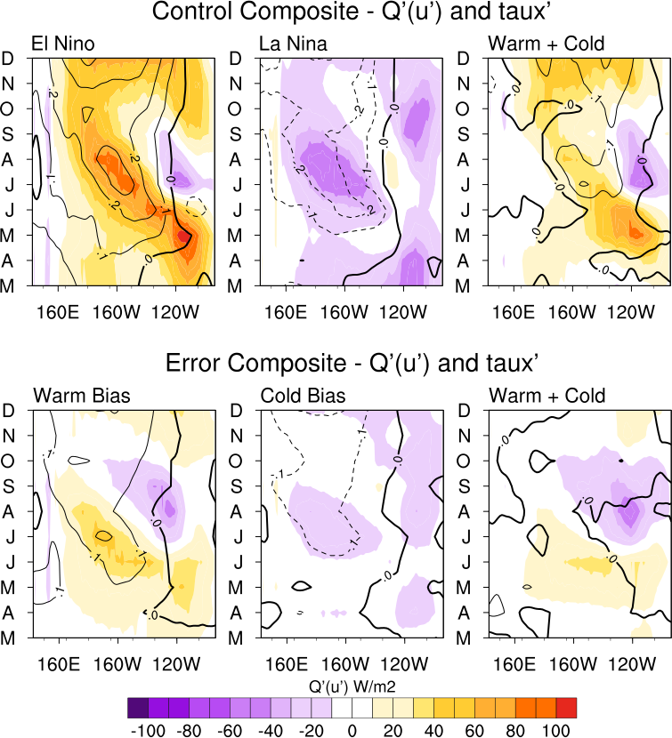

**Figure 6.3.** Similar to Fig. 6.2 but for ${Q'}_{u}$ (shaded) *and $τ_{x}'$*  (contours).

The $τ_{x}'$ (contours) and ${Q'}_{u}$ (shaded) terms are shown in Fig. 6.3 (top row). Two main features of the ${Q'}_{u}$ term stand out, the zonal propagation and the timing of the maximum amplitude. The zonal propagation is linked to $τ_{x}'$. For El Niño, ${Q'}_{u}>0$ is collocated with $τ_{x}^{'}>0$. As $SST^{'}>0$ expands westward, $τ_{x}^{'}>0$ strengthens and propagates westward accordingly. As a result, ${Q'}_{u}>0$ propagates westward, following the local wind-forced $u^{'}$. By November, maximum $SST^{'}$ and $τ_{x}^{'}>0$ spread along the equatorial central-eastern Pacific. The timing of the maximum ${Q'}_{u}>0$ follows closely with the timing of the pulses of ${Q'}_{TC}$ due to the dynamical linkage mentioned above. In April – June, maximum ${Q'}_{u}$ over 80-100 Wm-2 are present from 140°W – 110°W, the same time as the ${Q'}_{TC}$ spring pulse. In July – September, another ${Q'}_{u}$ maximum near 160°W occurs with similar timing as the summer pulse of ${Q'}_{TC}$, linked to the Bjerknes feedback. Similar features are seen for La Niña, including timing with the ${Q'}_{TC}<0$ pulses shown in Fig. 6.2.

In terms of asymmetry, ${Q'}_{u}$ amplitude is larger for El Niño by nearly 80 Wm-2 during April – June. Following the westward propagation in summer-fall and the winter equatorial expansion, El Niño is larger by 40-60 Wm-2. amplitude is 0.1 dyne/cm2 larger for El Niño beginning in July, generally persists through fall, and the asymmetry becomes more pronounced during the peak event. Much of the ${Q'}_{u}$ behavior is discussed in *DiNezio and Deser* (2014), however they analyze a ${(Q'}_{u}+{Q'}_{v})$ term that includes anomalous advection driven by anomalous meridional currents as well. Much of the nonlinearity in their study is verified here, along with confirmation that stronger $τ_{x}^{'}$ for El Niño drives a larger advective term compared to La Niña.

The error composites (Fig. 6.3 bottom row) show much weaker amplitude ${Q'}_{u}$ than the composite ENSO, with peak amplitude for warm (cold) errors near 40-50 Wm-2 (-30 to -10 Wm-2). The amplitudes are also much weaker, rarely becoming larger than 0.15 dyne/cm2. The warm errors show similar westward propagation of maximum $τ_{x}^{'}>0$ and ${Q'}_{u}>0$ as El Niño, however ${Q'}_{u}$ quickly decays to less than 10 Wm-2 beginning in August. A similar rapid decay of ${Q'}_{TC}$ is seen beginning in August. Analogous behavior is seen in the cold bias and La Niña composites.

Comparing the ENSO and error composites gives new insight into what details of the coupled system are necessary for the continuation of $SST^{'}$ through the fall. Neither the cold nor warm biasing composite shows clear persistence of the $Q'$ terms past September – October, precisely when the seasonal halt to $SST^{'}$ error growth occurs. Based on the $Q'$ pulses peaking in summer in the error composites, the main mechanism driving the heat flux convergence/divergence is the Bjerknes feedback. However, the lack of persistence of the $Q'$ terms through fall-winter implies that the heat content supplied by the subsurface precursor preceding the onset of ENSO is paramount to maintaining the instability through the fall. As a result, the growth of ENSO-independent errors is stunted in fall.

## 6.6 Instability Trigger

The monthly $Q'$ terms confirm that the warm/cold trajectory of the error growth is established in month(1). Of course, this is in a composite sense and a few cases do not show a clear trajectory until months later (hereafter, delayed onset). Next, daily fields are utilized to determine the triggering mechanism of the error growth. Only the first 15 days of daily mean data are archived for the March ensemble, thus we can only specify why the cases that exhibit rapid growth beginning at initialization (hereafter, immediate activation) or within the first 15 days but after day-1 (hereafter, delayed-days) are instigated. We cannot be certain that the delayed onset cases exactly follow the proposed paradigm, although the extended delay further emphasizes the complicated role that the stochastic component plays in influencing error evolution.

### 6.6.1 Daily fields

Five daily fields averaged over 2.5°S-2.5°N are presented: $SST^{'}$, $τ_{x}^{'}$, anomalous vertical ocean current velocities ${wvel}^{'}$ (positive downward) averaged over the upper 105 meters, ${Q'}_{TC}$, and ${Q'}_{u}$. Figure 6.4 shows examples of immediate activation warm and cold types. Both have perturbations upon initialization that instigate coupled feedbacks almost immediately.

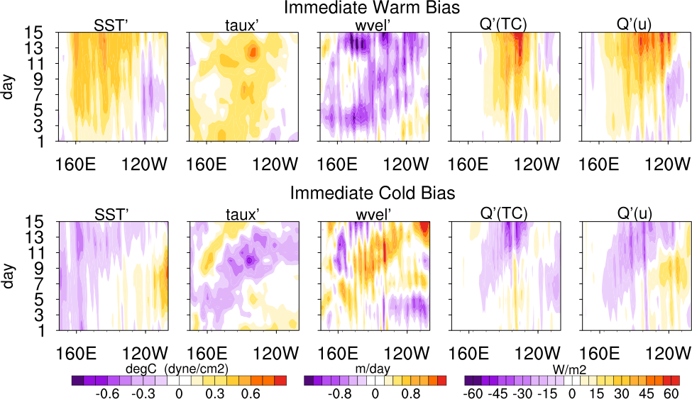

**Figure 6.4. $SST^{'}$** , $τ_{x}^{'}$, anomalous vertical ocean current velocities ${wvel}^{'}$ (positive downward) averaged over the upper 105 meters, ${Q'}_{TC}$, and ${Q'}_{u}$ for an immediate activation warm case (top) and cold case (bottom). All fields are meridionally averaged over 2.5°S-2.5°N.

Much of the noisiness in the daily fields is caused by tropical instability waves (TIWs), although no link between TIWs and the error evolution is evident. This is unsurprising considering that TIW intensity largely depends on the climate state and seasonal cycle (*Willett et al*., 2006), both of which are essentially held fixed due to the experimental design. TIWs are, however, sensitive to the ENSO state (*Philander*, 1990).

For the immediate activation warm case, $τ_{x}^{'}>0$ in the eastern Pacific and weak warm $SST^{'}$ are present at day-1. Downwelling velocities in the wind-driven layer ( ${wvel}^{'}<0)$ are quickly activated within the next 1-2 days. Sufficient $τ_{x}^{'}>0$ can perturb the upper ocean down to the thermocline via a downwelling equatorial Kelvin wave and eventually invoke a warm $SST^{'}$ response that reinforces the $τ_{x}^{'}$ trigger (*McPhaden et al*., 1988; *Picaut and Delcroix*, 1995; *Lengaigne et al*., 2002). Activation of the $Q^{'}$ terms occurs within 2-3 days and amplify from 5 Wm-2 to over 20 Wm-2 by day 5 after the $τ_{x}^{'}>0$ persists in the central Pacific for several days.

For the cold case, $τ_{x}^{'}<0$ is present near 160°E at day-1, as well as weak cool $SST^{'}$. Upwelling velocities ( ${wvel}^{'}>0)$ occur 1-2 days later, however the $Q^{'}$ terms take several days to become clearly negative. The initial ${wvel}^{'}$ in the western Pacific is unable to produce a substantial upper ocean response since the thermocline is especially deep in the western Pacific warm pool region, whereas the central Pacific is well suited for a large coupled response because the air-sea coupling is strong (*Suarez and Schopf*, 1988). The $Q^{'}$ terms are not clearly activated until day-5, after the $τ_{x}^{'}<0$ propagates eastward across the equatorial dateline and persists for a few days. These examples of immediate activation cases are well representative of other cases with similar timing of error growth activation. The mechanism for the activation of the coupled instability is consistent with the wind-induced intraseasonal Kelvin wave forcing discussed in *Kessler and McPhaden* (1995).

To confirm the necessity of persistent $τ_{x}^{'}$ positioned along or slightly east of the dateline to activate the $Q^{'}$ terms, Fig. 6.5 (top row) displays an example of a delayed-days cold biasing case. This type of case is characterized by triggering within the first 15 days but away from the initial condition.

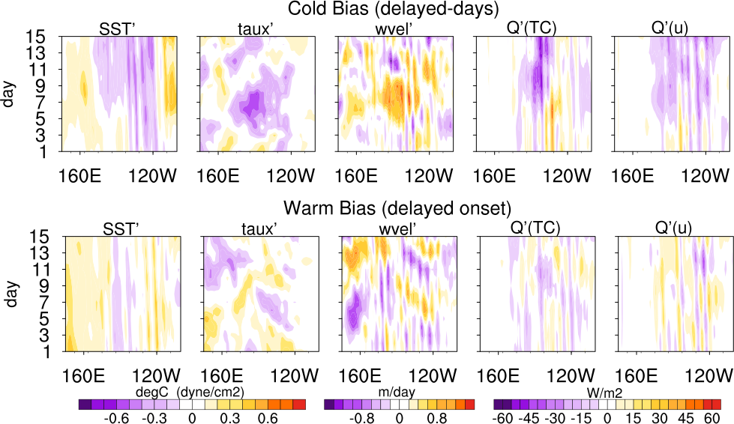

**Figure 6.5.** Similar to Fig. 6.4 but for a delayed-days cold case (top) and delayed onset warm case (bottom).

The day-1-3 equatorial $SST^{'}$ field consists of warm anomalies in the west-central Pacific and cool anomalies in the east. The $Q^{'}$ terms and ${wvel}^{'}$ are also not definitively biased one way or the other, leaving the future evolution uncertain at this time. Beginning on day-3, seemingly organized easterly $τ_{x}^{'}$ develop between 170°E and 120°W and persist with through day-9. After a few days of persistence, the $τ_{x}^{'}<0$ force local SST cooling and upwelling in the central Pacific, as well as ${Q'}_{TC}<0$ and ${Q'}_{u}<0$ soon after. The instability continues to amplify as evidenced by the monthly mean (not shown), the $SST^{'}$ continues to cool, and eventually the growth is sufficient to be classified as of one of the 10 coldest biasing cases.

A few of the rapid error growth cases are not initiated within the first 15 days. Figure 6.5 also depicts a delayed onset case that eventually biases warm. Despite warm $SST^{'}$ in the western Pacific, the $τ_{x}^{'}$ is disorganized and lacks sufficient persistence and zonal extent to activate the other terms. This particular case begins a warm trajectory the following month. It should be noted that although $τ_{x}^{'}$ is described as being organized or disorganized, this is in reference to the persistence and zonal extent. The $τ_{x}^{'}$ is not necessarily organized in the sense that it is part of a large-scale trigger pattern (see *Larson and Kirtman*, 2015b), although large-scale patterns may play some role in triggering delayed onset cases once the air-sea coupling is engaged for several weeks. The daily $τ_{x}^{'}$ is stochastic and mechanically decoupled until the instability occurs, as per the experimental design.

Further evidence is necessary to confirm that persistent $τ_{x}^{'}$ is indeed the instigator of the instability, especially because small SST perturbations are also present. Lagged correlations between $τ_{x}^{'}$ and the four other fields – $SST^{'}$, ${wvel}^{'}$, ${Q'}_{TC}$, and ${Q'}_{u}$– are shown in Fig. 6.6. Lag-0 corresponds to a contemporaneous correlation and lag(day) indicates the particular field lags $τ_{x}^{'}$ by *N*-days. For example, if $SST^{'}$ lags $τ_{x}^{'}$ by 5-days this indicates that the SST response occurs 5-days after the wind stress anomaly. If $SST^{'}$ and $τ_{x}^{'}$ are instantaneously coupled then the correlation would be maximized at lag-0. To determine when the four fields are activated, we look for when the correlation markedly increases with lag. The warm/cold examples in Fig. 6.6 are the immediate activation examples in Fig. 6.4. These cases have less noisy structures, thus have a more pronounced (i.e., easier to distinguish) increase in correlation when the different fields are activated.

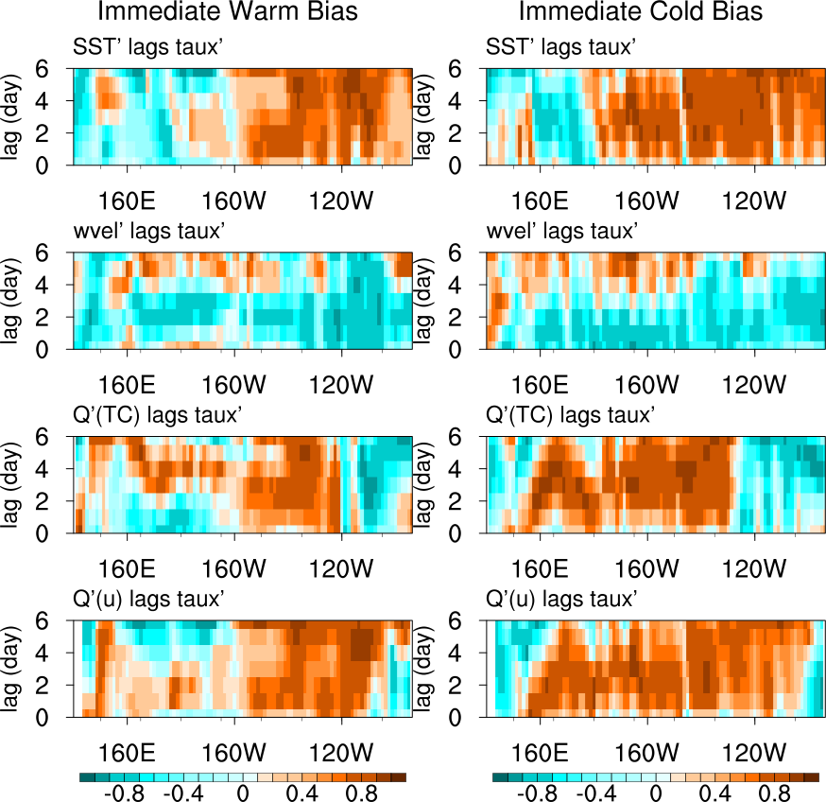

**Figure 6.6.** Lagged correlations between $τ_{x}^{'}$ and the equatorially averaged $SST^{'}$, ${wvel}^{'}$, ${Q'}_{TC}$, and ${Q'}_{u}$ fields for the immediate activation cases in Fig. 6.5. Lag-0 indicates the contemporaneous correlation and lag(day) indicates the field lags $τ_{x}^{'}$ by 0-6 days.

In the eastern Pacific, the marked increase of correlation to 0.8 between $SST^{'}$ and $τ_{x}^{'}$ occurs when $τ_{x}^{'}$ leads $SST^{'}$ by one day. The relationship breaks down in the western Pacific where the $τ_{x}^{'}$ structure is noisier and less persistent. The lagged relationship indicates that $τ_{x}^{'}$ drives the changes in SST. The relationship between ${wvel}^{'}$ and $τ_{x}^{'}$ is not as clear because of the presence of TIWs. Averaging ${wvel}^{'}$ over the top 105m alleviates some of the noisiness but because TIWs have a large barotropic component, considerable variability in the zonal dimension remains. ${Wvel}^{'}$ and $τ_{x}^{'}$ are out-of-phase ( ${wvel}^{'}$ is positive downward), so the largest negative correlation is of interest. For the warm (cold) case, the largest common increase in correlation occurs when ${wvel}^{'}$ lags by 2 days (1 day). Both have a correlation around 0.8. The ${Q'}_{u}$ terms are clearly activated at a 1-day lag from $τ_{x}^{'}$ and support the notion that $u^{'}$ is largely wind driven. Last, ${Q'}_{TC}$ is activated at a 2-day lag once ${wvel}^{'}$ begins influencing thermocline temperatures.

In summary, $τ_{x}^{'}$ first drives local SST warming/cooling and ${Q'}_{u}$. Downwelling/upwelling velocities quickly follow, activating the ${Q'}_{TC}$. As long as the $τ_{x}^{'}$ persists in the equatorial central Pacific for a minimum of 3 days, the heat flux convergence terms have the potential to become sufficiently large to promote rapid $SST^{'}$ growth. The terms are activated on the order of days, not months. Clearly persistent $τ_{x}^{'}$ is the key to instigating the instability but how important is the role of $τ_{x}^{'}$ persistence in predicting the error evolution?

### 6.6.2 The Role of Persistence

The next section investigates whether a link exists between $τ_{x}^{'}$ persistence and the final error amplitude. The analysis follows the lead of the *Harrison and Vecchi* (1997) classification of westerly wind events (WWEs), but is also extended to persistent easterlies. WWEs can be considered analogous to the westerly wind bursts (WWBs) discussed in chapter 2. Based on the zonal location of the previously described $τ_{x}^{'}$ triggers, a domain of 160°E-150°W, 5°S-5°N is chosen to average $τ_{x}^{'}$. The latitudinal boundaries are extended to 5°S-5°N to more closely follow *Harrison and Vecchi* (1997) area-averaged regions. The domain chosen here is similar to combining their equatorial east and central regions, together encompassing 160°E-160°W.

A persistence algorithm is applied to the 60 cases to identify any persistence $τ_{x}^{'}$ events that occur within the first 15 days. An amplitude threshold of ±0.08 dyne/cm2 is first applied to remove weak $τ_{x}^{'}$. The threshold is chosen to be slightly larger than the standard deviation of the average $τ_{x}^{'}$ over the first 15 days for all 60 cases (0.07 dyne/cm2). The overall conclusions are not impacted when using a threshold of 0.08-0.09 dyne/cm2. Next, the algorithm searches for any remaining $τ_{x}^{'}$ that meets the amplitude threshold and persists for 3 consecutive days or more.

If more than one $τ_{x}^{'}$“event” occurs, the selection of the one event per case follows a set of conditionals described below. The conditionals are necessary since there are no strong $SST^{'}$ controls on $τ_{x}^{'}$ within the first 15 days. The persistent $τ_{x}^{'}$ occurring within the first 15 days are considered analogous to the stochastic component of WWEs (*Zavala-Garay et al*., 2003, 2004; *Lopez and Kirtman*, 2013, 2014), because they are essentially climate-state independent. This is distinctly different from the climate-state dependent component that is closely tied to SST (*McPhaden*, 1999; *Yu et al*., 2003; *Tziperman and Yu*, 2007). As a result, the $τ_{x}^{'}$ is often noisy during the first 15 days and multiple $τ_{x}^{'}$“events” can occur.

First, if more than one westerly (easterly) $τ_{x}^{'}$ event occurs, the one with the longest persistence is chosen. Next, if a westerly and easterly $τ_{x}^{'}$ event both occur, the event with the longest persistence is chosen. Finally, if a westerly and easterly $τ_{x}^{'}$ event both occur and with equal persistence, the event occurring first is chosen. In total, a persistent $τ_{x}^{'}$ event is selected for 52/60 cases, revealing that only 8 do not pass the amplitude threshold and persistence requirements. For all 60 cases, the algorithm provides average $τ_{x}^{'}$ over days 1-15. If a persistent $τ_{x}^{'}$ event occurs, the average $τ_{x}^{'}$ over the event, the model day it begins (range, day 1-13), and its duration (range, 3-15 days) are provided. Figure 6.7 provides a summary of the results.

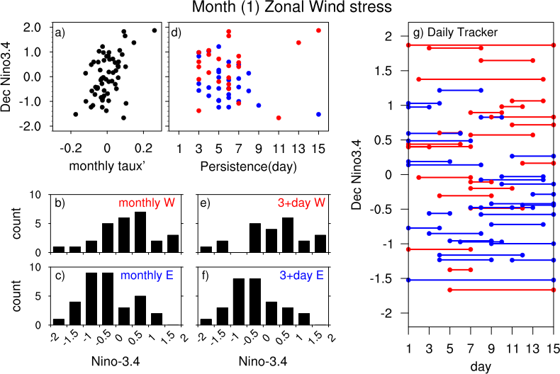

**Figure 6.7.** a) March monthly mean $τ_{x}^{'}$ versus December Niño-3.4 $SST^{'}$. b) Niño-3.4 $SST^{'}$ histogram for all monthly $τ_{x}^{'}>0$ in a). c) Niño-3.4 $SST^{'}$ histogram for all monthly in a). d) persistence in days versus December Niño-3.4 . Only persistent “events” of 3+ days are included. Red (blue) signifies westerly (easterly) persistent events. e) Niño-3.4 histogram for all westerly persistent events of 3+ days. f) Niño-3.4 histogram for all easterly persistent events of 3+ days. g) All persistent events organized by the model days over which they occur versus their respective December Niño-3.4 $SST^{'}$. Monthly mean values are used for a-c and daily for d-g. All $τ_{x}^{'}$ are averaged over 160°E-150°W, 5°S-5°N.

The majority of $τ_{x}^{'}$ events exhibit 3-7 days persistence (Fig. 6.7d). Based on European Centre for Medium-Range Weather Forecasts analysis data from 1986-1995, *Harrison and Vecchi* (1997) find WWE persistence in similar regions as considered here to range from 4.5-5.5 days, although they include all months and calculate WWEs from 10-m winds. Here we focus on March $τ_{x}^{'}$ only. Nevertheless, the CCSM4 results here seem reasonable. Generally, westerly (easterly) $τ_{x}^{'}$ events precede warm (cold) December Niño-3.4 (hereafter, Niño-3.4(Dec)) errors. Figure 6.7e (6.7f) shows the Niño-3.4(Dec) error histogram corresponding to all cases with a persistent westerly (easterly) $τ_{x}^{'}$ event. A westerly event shifts the mean Niño-3.4(Dec) value to 0.46°C and increases to 0.60°C when considering 5+ days persistence although the sample size is reduced. For easterlies of 3+ days of persistence, the mean Niño-3.4(Dec) value is -0.33°C and increases in amplitude to -0.47°C when considering 5+ days persistence.

If a westerly $τ_{x}^{'}$ event occurs within the first 15 days, there is a 15/23 or 65% chance of Niño-3.4(Dec) > 0.0°C and an 11/23 or 48% chance of Niño-3.4(Dec) > 0.5°C. If an easterly event occurs, there is a 20/29 or 69% chance of Niño-3.4(Dec) < 0.0°C and 12/29 or 41% chance Niño-3.4(Dec) < -0.5°C. To determine whether there is any preference to when the $τ_{x}^{'}$ events begin, Fig. 6.7g shows each $τ_{x}^{'}$ event organized by the model days over which the event occurs versus the respective Niño-3.4(Dec) value. A preference for westerly (easterly) events preceding warm (cold) error growth is evident, although there is no clear preference for length of persistence or the start day in predicting the amplitude. Overall, persistent $τ_{x}^{'}$ is a good indication of future error sign, but not amplitude. Of course, there are some exceptions mostly due to the delayed onset cases and cases with neutral final Niño-3.4(Dec) errors.

Although daily data is preferable in such an analysis, only monthly mean data is available for the aforementioned January, May, July, and September error ensembles. Therefore, it is advantageous to find a meaningful connection between the daily persistent $τ_{x}^{'}$ and the monthly mean. Assuming that all other $τ_{x}^{'}$ apart from the persistent $τ_{x}^{'}$ are highly variable or weak, the persistent $τ_{x}^{'}$ should bias the monthly mean sufficiently to reproduce the shifted (away from zero) distributions in Figs 6.7e-f. Figures 6.7b-c show the Niño-3.4(Dec) histograms for all cases that have March monthly mean $τ_{x}^{'}>0$ or $τ_{x}^{'}<0$. Monthly mean westerly (easterly) $τ_{x}^{'}$ in March shifts the mean to 0.34°C (-0.28°C), analogous to the 3+ day persistence distributions. The March monthly mean $τ_{x}^{'}$ versus Niño-3.4(Dec) is shown in Fig. 6.7a. Overall, monthly mean March $τ_{x}^{'}$ is sufficient to reproduce the preference of $τ_{x}^{'}>0$ ${(τ}_{x}^{'}<0)$ preceding warm (cold) Niño-3.4 error found using the daily data. An additional sensitivity test is included below.

## 6.7 Spring Predictability Barrier

### 6.7.1 ENSO signal

ENSO prediction skill markedly declines as the forecast lead-time is extended to boreal spring or earlier, an issue referred to as the spring predictability barrier (*Webster and Yang*, 2002; *Kirtman et al*., 2002; *Jin et al*., 2008; *Lopez and Kirtman*, 2014; *Levine and McPhaden*, 2015). Since wind stress and SST are strongly coupled throughout the ENSO cycle, lagged correlations of the control December Niño-3.4 $SST^{'}$ with previous January – December monthly mean Niño-4 $τ_{x}^{'}$ can divulge when the air-sea coupling associated with the ENSO signal breaks down with lead time (Fig. 6.8 black dotted). The December Niño-4 $τ_{x}^{'}$ correlates highly with December Niño-3.4 $SST^{'}$ (0.94) and gradually reduces to 0.78 for June $τ_{x}^{'}$, indicating that the ENSO signal is large and dominant from June – December. As the lead-time increases, a rapid reduction in correlation is evident. May $τ_{x}^{'}$ shows a marked decline in correlation of 0.55 and is preceded by a plateau in correlation of 0.41 for March $τ_{x}^{'}$ and 0.44 for April. This plateau is evidence of the spring predictability barrier, when the ENSO signal is weak and the equatorial $τ_{x}^{'}$ does not predict the impending event with much skill. The correlation further drops in January – February equatorial Pacific $τ_{x}^{'}$, although $τ_{x}^{'}$ during this time is closely linked to the contemporaneous ENSO state rather than the triggering of the following.

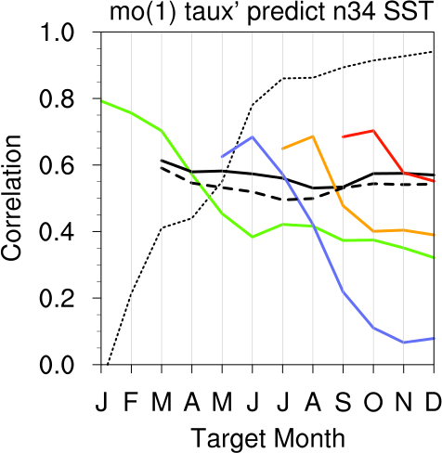

**Figure 6.8.** The black dotted line indicates the December Niño-3.4 $SST^{'}$ correlated with January – December Niño-4 $τ_{x}^{'}$ in the control and represents the coherence of air-sea coupling associated with the ENSO signal in the model. Declining correlation with lead-time shows when the air-sea coupling breaks down. The solid lines show the correlation of month(1) Niño-4 with each proceeding month Niño-3.4 for the 5 error ensembles individually and indicate how long the stochastic impacts the Niño-3.4 . Declining correlation with time moving forward indicates when the is no longer tied to the month(1) Niño-4 . The black dashed line is the average stochastic over the first 15 days for the March ensemble and confirms that monthly mean (solid black) is an adequate representation of the daily stochastic mean.

### 6.7.2 Stochastic $τ_{x}^{'}$

Now that the error growth trigger ${(τ}_{x}^{'})$ is identified, we can determine how long $τ_{x}^{'}$ noise occurring in month(1) can impact Niño-3.4 $SST^{'}$. In other words, how long does stochastic forcing affect SST error growth in the ENSO region? For all 5 error ensembles, Fig. 6.8 shows the correlation of the month(1) Niño-4 $τ_{x}^{'}$ with each proceeding month of Niño-3.4 $SST^{'}$. Correlation declining with time moving forward indicates that the $SST^{'}$ is no longer responding to the initial $τ_{x}^{'}$. Gradual decline in correlation as opposed to an abrupt drop reflects typical SST persistence (*McPhaden*, 2003).

The main exception is the March ensemble (black solid). March $τ_{x}^{'}$ shows a steady influence on $SST^{'}$ through December with correlations between 0.5-0.6 throughout. Similar is seen with the stochastic $τ_{x}^{'}$ averaged over the first 15 days (black dashed), confirming that monthly $τ_{x}^{'}$ is suffice for our purposes here. This also confirms that month(1) $τ_{x}^{'}$ for each ensemble can be used as a proxy for the stochastic $τ_{x}^{'}$. Results show that persistent stochastic winds in March are closely tied to ENSO-like SST errors in December, thus can be deemed an important contributor to errors that affect ENSO predictability. Therefore, spring, when the ENSO signal is smallest, is also the same time that the tropical Pacific is most sensitive to stochastic winds exciting coupled instabilities that affect December ENSO verification. This is distinctly different from June – December, when the ENSO signal is seasonally strong and the tropical Pacific is much less sensitive to stochastic wind perturbations that can impact December verification. To better understand this point, consider the January ensemble.

Month(1) $τ_{x}^{'}$ (i.e., January $τ_{x}^{'}$) has a large impact on $SST^{'}$ from January – March with correlations greater than 0.7, followed by a rapid drop off in correlation ending in June. Overall, stochastic $τ_{x}^{'}$ in January only has a lasting impact on $SST^{'}$ for about 3 months. May $τ_{x}^{'}$ influences $SST^{'}$ for only 2 months before the skill rapidly declines to a plateau in correlation of 0.1 in November. This suggests that stochastic $τ_{x}^{'}$ in May has very little influence on ENSO verification. Similar behavior is seen for the July and September ensembles, although both plateau with correlations greater than 0.3. Ultimately, persistent stochastic $τ_{x}^{'}$ occurring in March has the largest impact on December verification, thus is hypothesized to be the primary source of the spring predictability barrier in CCSM4. Results complement a CCSM3 study by *Lopez and Kirtman* (2014) showing that the coupled system is most sensitive to noise in spring when the $τ_{x}^{'}$ signal-to-noise ratio is low. Recall that the present analysis does not take into account state-dependent $τ_{x}^{'}$, only stochastic $τ_{x}^{'}$ is considered.

## 6.8 Discussion

To summarize, a dynamical analysis is applied to the CCSM4 error growth ensembles first presented in *Larson and Kirtman* (2015b). The error ensembles consist of noise-driven coupled instability induced SST error growth that is ENSO-independent and has a large impact on ENSO predictability at longer lead times. The present study focuses on: 1) ENSO and error growth dynamics using analyses of heat flux convergence terms related to positive feedback mechanisms, 2) pinpointing the instigator of the instability, and 3) providing a new method to understand the SPB in coupled models. The March ensemble is emphasized here.

Overall, analysis of anomalous heat budget terms ${Q'}_{TC}$ and ${Q'}_{u}$ reveals that much of the Niño-3.4 error growth can be attributed to a “summer pulse” of $Q'$ terms associated with the Bjerknes feedback, including the rapid growth in late spring-summer and the seasonal plateau in fall noted in *Larson and Kirtman* (2015b). After the decay of the “summer pulse” in the error composites, SST error growth is stunted. El Niño/La Niña composites also exhibit an additional “spring pulse” of ${Q'}_{TC}$ tied to the subsurface heat content precursor that is lacking in the error ensemble. Similar warm/cold asymmetries are seen in the error composites as the ENSO composites, but the overall amplitudes are reduced.

In the error composites, anomalous zonal wind stresses in the central Pacific force a maximum ${Q'}_{u}$ term, thus generating a secondary zonal maximum of $SST'$ in summer-fall via horizontal advection. This is in contrast to the zonal maximum of $SST'$ in the eastern Pacific that is driven by ${Q'}_{TC}$. This feature is likely in the ENSO composites but masked by the large ENSO $SST'$ signal. Ultimately, ${Q'}_{u}$ follows the local $τ_{x}^{'}$ and the maximum zonal $SST'$ gradient for El Niño/La Niña and the warm/cold biasing errors. Overall, the lack of persistence of the $Q^{'}$ terms in the error composites is consistent with the seasonal halt of $SST'$ error growth in fall. The subsurface precursor in the model ENSO, however, appears to provide the maintenance of $SST'$ growth through the fall, a feature that does not occur in the error ensemble.

The daily error fields reveal that persistent stochastic $τ_{x}^{'}$ instigates the instability. The $τ_{x}^{'}$ first drives the local $SST^{'}$ and ${Q'}_{u}$, with ${wvel}^{'}$ and ${Q'}_{TC}$ quickly following suit, given sufficient $τ_{x}^{'}$ persistence, similar to the wind-induced instability discussed in *Kessler and McPhaden* (1995). The coupled model error growth behavior here complements the overall hypothesis posed in *Samelson and Tziperman* (2001). Using a linear singular vector approach, the authors find that optimal disturbances in the Zebiak-Cane model (*Zebiak and Cane*, 1987) follow a similar mechanism as ENSO itself during the growth phase. Results here show that the growth of coupled instabilities activated by stochastic $τ_{x}^{'}$ are modulated by the seasonal strength the Bjerknes feedback, similar to the model ENSO. One difference being that the error ensembles lack the springtime influence of the subsurface precursor.

Why March is particularly well suited for perturbation growth that drives the spring predictability barrier has been addressed in previous studies involving air-sea coupling strength (*Webster*, 1995) and the low signal-to-noise ratio during spring (*Webster and Yang*, 1992). The March error ensemble reveals that persistent stochastic $τ_{x}^{'}$ is the likely cause of the SPB in CCSM4. During spring when the ENSO signal is small and the signal-to-noise ratio is low, stochastic $τ_{x}^{'}$ is shown to have the largest impact on perturbation growth that ultimately affects December ENSO verification. Although spring is when the ENSO surface signal is weakest, it is also the time when subsurface heat content precursors (*Meinen and McPhaden*, 2000; *McPhaden*, 2003; *Anderson*, 2007; *Anderson et al*., 2013; *Larson and Kirtman*, 2013; *Anderson and Perez*, 2015) are important for predictability, as well as when the Pacific Meridional mode (PMM) tropical SST signatures, an ENSO-independent mode of variability that is a robust precursor to ENSO (*Chiang and Vimont*, 2004; *Chang et al*., 2007; *Zhang et al*., 2009a), are large. However, since the coupled system is especially sensitive to noise-driven perturbation growth beginning in spring, much of the predictive potential of, say the PMM precursor, can be overshadowed by the large forecast uncertainty associated with noise-driven errors (*Larson and Kirtman*, 2014, 2015a).

Overall, attempting to “break through” the spring predictability may prove difficult in CCSM4 based on the presented evidence. Results here support the hypothesis that noise-driven errors provide an intrinsic limit to ENSO predictability for longer lead times. One point of optimism includes that error growth may be less impactful when the initial condition contains an ENSO cycle (*Chen et al*., 1997). This is the topic of chapter 8 future work.

# CHAPTER 7 – Conclusions

Despite decades of research on the dynamics, predictability, and evolution of ENSO, predicting El Niño and La Niña events at longer lead-times than 3-month remains a challenge. For this reason, ENSO precursors are intriguing, particularly those that are composed of an ocean variable (e.g., the PMM, subsurface heat content). These types of precursors have an ocean temperature component either at the surface or subsurface, tapping into the high heat capacity and slow ocean thermal inertia that aids in predictability. Such traceable signatures are suspected to be an integral part of our ability to predict ENSO events and may also provide a means to “break through” the spring predictability barrier.

Numerous such precursors have been proposed in the literature, yet just how skillful they are at enhancing predictability is often left unanswered. This comes at little surprise, however, because free access to dynamical forecasts of seasonal climate has only recently become available (e.g., the NMME). A flurry of activity is anticipated on the predictability side of ENSO research. Chapters 2 and 3 provide a first account of how such types of precursor assessments can be conducted using actual dynamical climate predictions from a large ensemble of models.

In chapter 2, the low-frequency coupled variability associated with the PMM is found to be the dominant wind stress precursor to ENSO in a coupled model. It is argued that the PMM appears to be most efficient at triggering El Niño when the subsurface is preconditioned with the buildup of heat content, and speculated that the PMM may be a useful predictor for ENSO events. In chapter 3, we test this distinction. If a certain precursor is important during the onset phase of ENSO, we should be examining how well forecast systems capture these precursors. If the precursor is captured well by the dynamical forecasts, the precursor and predictor relationships must also be confronted with observations. Furthermore, testing these relationships in the context of forecast mode is distinctly different than studying them in free-running climate model simulations.

The precursor and predictor relationships between the PMM and ENSO are tested in chapter 3. We utilize the NMME dynamical forecast models and specifically the hindcasts from 1982-2010. The first conclusion is that the NMME multi-model averaged 1- and 3-month lead-time forecasts of March PMM are sufficiently skilled, whereas 6-month lead-time forecasts are unreliable. The dynamical forecasts also well represent the observed regime-specific relationship signifying the PMM/ENSO precursor relationship. In other words, positive PMM often precedes El Niño and negative PMM often precedes La Niña.

On the other hand, when PMM is treated as an independent predictor of ENSO, its reliability comes into question. Observed positive PMM events show promise as a predictor of observed eastern Pacific El Niño events but less skill as a predictor of central Pacific El Niño events, whereas observed negative PMM events show no skill at predicting La Niña events. These observed relationships are not necessary reproduced well by the NMME forecast models and steps should be made to improve the model representation of the PMM and ENSO relationships.

Utilizing an ensemble methodology technique developed in chapter 4, chapter 5 introduces a hypothesis as to why the PMM is only a marginally useful predictor of ENSO, despite being an excellent precursor. The predictability experiment shows that positive PMM-like SST in the initial condition may bias the ENSO forecast toward El Niño, but the spread does not necessary decrease (i.e., predictability does not increase). We hypothesize that PMM may not be an excellent predictor of ENSO because PMM SST signatures peak at spring-summer when the coupled system is most sensitive to stochastically induced coupled instabilities, which frequently result in ENSO-like errors in December. Therefore, perturbation growth may mask the predictive potential of precursors that peak in the spring-summer seasons. The proposed experiments in the chapter 8 (Future Work) will determine whether this conclusion also holds for the subsurface heat content precursor, which peaks in the western Pacific in spring.

Chapters 4-6 focus less on precursors and more on how internal variability of the climate system can result in ENSO forecast degredation. In chapter 4, a coupled model methodology is developed to isolate noise-driven processes that may impact ENSO predictability. Chapter 4 and a subsequent dynamical analysis in chapter 6 shows that for longer lead-time forecasts using CCSM4, much of ENSO predictability is likely lost due to stochastic winds instigating coupled instabilities. The stochastic winds are westerly wind burst-like and are not strongly tied to the climate state. A modified version of the methodology is utilized in an application study as an alternate approach to generating an “expected” forecast spread in actual real-time ENSO predictions (chapter 5). For instance, the application study shows that the observed ENSO evolution for the 2014 so-called El Niño forecast “bust” falls in line with what one would expect from forecast-independent, ENSO-independent, noise-driven error growth.

The error growth rate discussed in chapter 4 is modulated by the Bjerknes feedback, an ENSO-like mechanism, and does not require a large-scale wind stress trigger pattern, subsurface heat content precursor, or a previous ENSO event. Temporal growth behavior is best characterized by nonlinearity, strong seasonality, and dependence on the initialization month. Overall, results support the view that intrinsic variability ultimately limits ENSO predictability.

Based on the error growth dynamics, seasonal halt to growth of errors in boreal fall, and comparison to the model ENSO, we can deduce that the lack of a subsurface precursor hinders the maintenance of the instability through fall. In other words, despite the seasonal drop off of the strength the Bjerknes feedback, model ENSO events maintain amplitude through the fall aided by the subsurface precursor.

The model framework also provides a new approach to understanding the spring predictability barrier in coupled models as shown in chapter 6. The daily error fields indicate that stochastic zonal wind stress perturbations near the equatorial dateline that persist for at least three days activate the coupled instability, first driving local SST and anomalous zonal current changes that in turn induce upwelling and a clear thermocline response. The lasting influence of the wind trigger on ENSO-like error growth is largest when the wind trigger occurs in March, suggesting that the spring predictability barrier in CCSM4 is most likely caused by stochastic springtime winds instigating coupled instabilities. Stochastic winds in other months, particularly January, May, July, and September only affect the SST in the ENSO region for 2-3 months, whereas for March, the influence lasts through peak ENSO in December. Overall results in this dissertation support the argument that variability intrinsic to the climate system, not model deficiencies, is hindering the predictability of ENSO.

There is, however, reason for optimism. There is the possibility that the presence of an ENSO cycle in the initial condition will result in increased ENSO predictability (*Chen et al*. 1997). Strong El Niño or La Niña ocean anomalies may decrease the sensitivity of the coupled system to stochastically induced instabilities. The framework developed in this dissertation is well suited for adaptation to confront this important point. Details for a proposed model experiment are presented in the following chapter.

# CHAPTER 8 – Future Work

## 8.1 Motivation

The model framework presented in this dissertation, particularly chapter 4, provides a sound platform to construct other important ENSO predictability studies. The natural progression of this work is to determine whether predictability is altered when the subsurface heat content is sufficiently built up in the initialized subsurface equatorial Pacific. Another potential spinoff of this work is to repeat a similar ensemble predictability experiment with a different model to investigate the sensitivity of the error growth rate to models with a more stable or less stable ENSO cycle. Both topics are discussed in this chapter. We begin with further discussion of the so-called 2014 El Niño forecast “bust.”

Why the 2014 El Niño amplitude was verified much weaker than predicted is discussed mostly in terms of intrinsic processes (i.e., not model deficiencies) in the literature (*McPhaden*, 2015) as well as in chapter 5 here. For instance, *Menkes et al*. (2014) argue that the lack of westerly wind bursts (WWBs) during summer hindered the development of a large event, whereas others argue that easterly wind surges (*Min et al*., 2015) or an exceptional easterly wind burst (*Hu and Fedorov*, 2016) accounted for El Niño’s demise. Along those lines, *Larson and Kirtman* (2015a) show through a coupled model ensemble experiment that the 2014 event falls within the expected uncertainty generated from ENSO-independent, forecast-independent, noise-driven perturbation growth.

These studies, however, neglect one key aspect that is particularly puzzling about the 2014 and 2015 forecasts - both years exhibited clear buildup of subsurface heat content in the western Pacific. While equatorial winds have been stressed in recent analyses, the subsurface heat content precursor (*Meinen and McPhaden*, 2000; *McPhaden,* 2003) requires more attention. Both 2014 and 2015 March initialized forecasts contained a buildup of heat content in the western Pacific subsurface, yet only 2015 resulted in a large El Niño event. Thus, the sensitivity of the precursor behavior to other intrinsic sources of atmosphere and ocean variability needs to be properly addressed. Previous knowledge considers the subsurface precursor a necessary condition for ENSO (e.g., *Wyrtki*, 1975; *Zebiak and Cane*, 1987; *Schneider et al*., 1995), although recent years have shown a less coherent relationship between the warm water volume (WWV) and ENSO SST (*McPhaden*, 2015). Furthermore, *Larson and Kirtman* (2015b) reveal that certain coupled models, for instance CCSM4, do not need the WWV precursor to excite ENSO-like growth via a coupled instability mechanism (e.g., *Philander et al*., 1984; *Hirst* 1986; *Battisti*, 1988; *Battisti and Hirst*, 1989; *Kessler and McPhaden*, 1995). Ultimately, these different conclusions suggest the need for a better understanding of the role of the subsurface heat content precursor in determining the evolution of ENSO and ENSO predictability.

There exists only a limited number of ENSO events that are sufficiently well-observed; thus coupled model experiments provide a helpful supplemental tool to mechanistically study the contribution of the precursor to ENSO predictability. A large sample of preconditioned equatorial Pacific states is necessary to explore the precursor’s role in ENSO evolution, especially because false alarms are equally as important in understanding why certain preconditioned states evolve into large El Niño events while others do not. The goal of the future work is to quantify how much the precursor biases the mean ENSO evolution or forecast (warm or cold) and how much noise-driven processes, including WWBs, contribute to the spread about the mean bias. A complementary analysis using all observed preconditioned equatorial Pacific states and the subsequent ENSO evolutions will supplement the model conclusions.

## 8.2 A Model Experiment

Overall, the goal of the future work is to quantify how much a preconditioned ocean state impacts the predictability of ENSO. The influence of the precursor on ENSO evolution will be determined using a modified version of a model framework developed in *Larson and Kirtman* (2015b; chapter 4 in this dissertation). Perturbation growth ensembles are created from a nearly neutral tropical Pacific Ocean state to isolate SST perturbation growth induced by instabilities of the coupled system using CCSM4. The initial conditions are produced by first running CCSM4 in a configuration that prohibits ENSO variability in the coupled model, thus removing any influence from previous ENSO events. A nearly neutral equatorial state (i.e., neutral ENSO) is achieved by forcing the ocean component with CCSM4 daily climatological wind stresses, while leaving buoyancy fluxes, ocean dynamics, and the full atmospheric unconstrained. Such a framework does not support ENSO variability, equatorial subsurface precursors, or coupled instabilities in the tropical Pacific due to the lack of dynamic wind coupling. As a result, for instance, every March 1st contains ENSO-independent perturbations. The initial conditions from each March 1st are then gathered into a “March ensemble” and each run fully coupled. As such, the ENSO-independent perturbations in the ocean and atmosphere are given the opportunity to interact and grow in time via coupled instabilities. ENSO-like growth occurs in many of the cases without any influence from a subsurface ENSO precursor.

The idea is to generate ocean initial conditions that are preconditioned with a subsurface precursor and to use them instead of a nearly neutral ocean state as in *Larson and Kirtman* (2015b). The easiest way to generate numerous precursors, both for El Niño and La Niña, is to produce a coupled model configuration that induces a continual ENSO cycle. To facilitate a continual ENSO cycle, wind stresses from a full (i.e., composite) CCSM4 ENSO cycle will be repeated instead of the climatological winds as in *Larson and Kirtman* (2015b). In CCSM4, the typical El Niño onset through La Niña decay occurs over approximately 4 years. Therefore, every 4 years, a preconditioned El Niño occurs, thus the initial conditions of every 4th March 1st contains a preconditioned subsurface El Niño state forced by the decaying La Niña winds. Similar to the original methodology, these different March 1st initial conditions will be combined to form a March ensemble and then run fully coupled. An analogous methodology will be repeated for a La Niña ensemble.

By only constraining the wind stresses felt by the ocean, other intrinsic sources of variability or “noise” in the atmosphere and ocean are permitted to interact and respond to the continual ENSO cycle. Thus, each precursor, although identically wind forced, will be slightly different. The preconditioned El Niño and La Niña ensembles will be compared with their non-preconditioned counterparts in *Larson and Kirtman* (2015b). The proposed methodology will allow the calculation of the fractional contribution of the preconditioned subsurface state on El Niño and La Niña final amplitude. Furthermore, the spread of the final ENSO state in December for the respective ensembles will reveal whether a preconditioned state reduces or increases the predictability of ENSO, an important distinction *Larson and Kirtman* (2015b) could not address given their experimental design. Other start months, for instance January, can be also be utilized to construct additional ensembles to determine during what initialization month the precursor contributes the most to predictability.

## 8.3 Additional Analysis

Based on the large spread of current real-time March initialized forecasts, a plume of possibilities for the preconditioned ENSO ensembles is anticipated. The warmest and coldest extremes for the preconditioned El Niño and La Niña ensembles will be further analyzed to determine what factors contribute to the enhancement or hindrance of the ENSO event evolution. The El Niño and La Niña ensemble extremes will also be directly compared to identify potential nonlinearities. Additionally, La Niña growth behavior is somewhat different from El Niño, often described as “flat” when compared to the more rapid growth of El Niño during summer. These nonlinear growth characteristics are captured in CCSM4 (*DiNezio and Deser*, 2014). Whether the preconditioned experiments exhibit similar nonlinear characteristics will be addressed. The spring predictability barrier (SPB) will also be investigated in the context of the proposed experiment, as (*Larson and Kirtman*, submitted) show that the error ensembles provide a unique approach to understanding the SPB in coupled models.

Another interesting question to address is whether the observed preconditioned cases bias the final ENSO state as in the model experiments. Addressing this question may tell us whether the model properly simulates the observed precursor/ENSO relationship. However, finding sources of potential model deficiencies is the first step to improve the simulation of ENSO. The spread of the observed cases versus the models will also reveal whether the models are tapping into the predictive power of the precursor found in nature or whether the model is overestimating the relationship. It should be noted that the growth behavior is likely depending on whether the model exhibits a damped or unstable ENSO cycle. A worthwhile comparison of the model results with that from a simpler model, for instance the Zebiak-Cane intermediate model (*Zebiak and Can*e, 1987), is also planned to gauge this sensitivity in a cost-effective way.

Overall, the future work will focus on the role of the subsurface precursor in ENSO evolution and emphasizes the utilization of a novel model framework to address a topic that may require new approaches to understand its full predictive potential. More specifically, this work will provide a new supplemental tool in understanding to what extent the subsurface precursor provides ENSO predictability in coupled models and also to highlight potential model deficiencies in simulating observed ENSO behavior. The results will provide new insight as to how much we can “trust” the precursor as an ENSO predictor as well as potentially reveal additional or alternative reasons as to why the 2014 El Niño did not fully mature.

The so-called 2014 ENSO forecast “bust” is a clear example of why more effort needs to be expended on fundamental research of ENSO predictability. Knowing the key ingredients for ENSO extremes, as well as the various contributors to forecast degradation, are equally important to assess how much potential we have at getting the forecast correct. In the end, the effects of ENSO are felt worldwide and on various levels of the climate system. As such, determining at what lead-time ENSO predictions are reliable is a necessary step to assessing the fidelity of our forecast models.

# BIBLIOGRAPHY

Alexander, M. A., 1992. Midlatitude atmosphere-ocean interaction during El Nino. Part I: the North Pacific. *J. Clim.,* **5**: 944-958.

Alexander, M. A., and Co-authors, 2008: Forecasting Paciﬁc SSTs: Linear inverse model predictions of the PDO, Journal of Climate, **21**(2), 385-402.

Alexander, M. A., D. J. Vimont, P. Chang, and J. D. Scott, 2010: The Impact of Extratropical Atmospheric Variability on ENSO: Testing the Seasonal Footprinting Mechanism Using Coupled Model Experiments. *J. Clim.*, **23**, 2885–2901.

An, S. I., and F. F. Jin, 2001: Collective Role of Thermocline and Zonal Advective Feedbacks in the ENSO Mode. *J. Climate*, **14**, 3421–3432.

An, S. I., F. F. Jin, and I. S. Kang, 1999: The Role of Zonal Advection Feedback in Phase Transition. *J. Meteor. Soc. Japan*, **77**, 1151-1160.

Anderson, B. T., 2003: Tropical Pacific sea-surface temperatures and preceding sea-level pressure anomalies in the subtropical North Pacific, *J. Geophys. Res*. **108**, 4732.

Anderson, B. T., 2004: Investigation of a large-scale mode of ocean/atmosphere variability and its relation to tropical Pacific sea-surface temperature anomalies, *J. Clim.*, **17**, 4089-4098.

Anderson, B. T., 2007: On the Joint Role of Subtropical Atmospheric Variability and Equatorial Subsurface Heat Content Anomalies in Initiating the Onset of ENSO Events. *J. Clim.*, **20**, 1593–1599.

Anderson, B. T., and R. C. Perez, 2015: ENSO and non-ENSO induced charging and discharging of the equatorial Pacific. *Climate Dynamics*, **45** (9), 2309-2327.

Anderson, B.T., R.C. Perez, and A. Karspeck, 2013: Triggering of El Niño onset through trade wind-induced charging of the equatorial Pacific. *Geophys. Res. Lett.*, **40**, 1212-1216.

Anderson, D. L. T., and J. P. McCreary, 1985: Slowly Propagating Disturbances in a Coupled Ocean-Atmosphere Model. *J. Atmos. Sci.*, **42**, 615–630.

Ashok, K., S. Behera, A. S. Rao, H. Y. Weng, and T. Yamagata, 2007: El Niño Modoki and its possible teleconnection, *J. Geophys. Res*., 112, C11007, doi:10.1029/2006JC003798.

Battisti, D. S., 1988: Dynamics and Thermodynamics of a Warming Event in a Coupled Tropical Atmosphere–Ocean Model. *J. Atmos. Sci.*, **45**, 2889–2919.

Battisti, D. S., and A. C. Hirst, 1989: Interannual Variability in a Tropical Atmosphere–Ocean Model: Influence of the Basic State, Ocean Geometry and Nonlinearity. *J. Atmos. Sci.*, **46**, 1687–1712.

Bellenger, H., E. Guilyardi, J. Leloup, M. Lengaigne, and J. Vialard, 2014: ENSO representation in climate models: from CMIP3 to CMIP5. *Climate Dynamics*, **42**(7-8), 1999-2018.

Berner, J., Doblas-Reyes, F. J., Palmer, T. N., Shutts, G., and Weisheimer, A., 2008: Impact of a quasi-stochastic cellular automaton backscatter scheme on the systematic error and seasonal prediction skill of a global climate model. *Phil. Trans. R. Soc. A*, **366**, 2561–2579.

Bjerknes, J., 1969: Atmospheric teleconnections from the equatorial Pacific. *Mon. Wea. Rev*., **97**, 163-172.

Blanke, B., J. D. Neelin, and D. Gutzler, 1997: Estimating the effect of stochastic wind stress forcing on ENSO irregularity. *J. Clim.,* **10,** 1473–1486.

Buizza, R., and T. N. Palmer, 1998: Impact of Ensemble Size on Ensemble Prediction. *Mon. Wea. Rev.*, **126**, 2503–2518.

Cane, M. A., S. E. Zebiak, and S. C. Dolan, 1986: Experimental forecasts of El Nino. *Nature*, **321**, 827 – 832.

Capotondi, A., 2013: ENSO diversity in the NCAR CCSM4 climate model, *J. Geophys. Res. Oceans*, **118**, 4755–4770, doi:10.1002/jgrc.20335.

Carton, J. A. and J. Shukla, 1991:  Predictability of the tropical Atlantic Ocean.  *J. of Marine* Systems, **1**, 299‑313.

Chang, P., L. Zhang, R. Saravanan, D. J. Vimont, J. C. H. Chiang, L. Ji, H. Seidel, and M. K. Tippett, 2007: Pacific meridional mode and El Niño—Southern oscillation. *Geophys. Res. Lett*., **34**, L16608.

Chen, Y.-Q., D. S. Battisti, T. N. Palmer, J. Barsugli, and E. S. Sarachik, 1997: A Study of the Predictability of Tropical Pacific SST in a Coupled Atmosphere–Ocean Model Using Singular Vector Analysis: The Role of the Annual Cycle and the ENSO Cycle. *Mon. Wea. Rev.*, **125**, 831–845.

Chiang, J. C. H., and D. J. Vimont, 2004: Analogous Pacific and Atlantic meridional modes of tropical atmosphere–ocean variability. *J. Clim*., **17**, 4143–4158, doi:10.1175/JCLI4953.1.

Clarke, A.J., and L. Shu, 2000: Biennial winds in the far western equatorial Pacific phase-locking El Nino to the seasonal cycle. *Geophys. Res. Lett*., **27**, 771-774.

Clarke, A. J., and S. Van Gorder, 2001: ENSO prediction using an ENSO trigger and a proxy for western equatorial Pacific warm pool movement, *Geophys. Res. Lett.*, **28**, 579–582.

Clement, A., P. DiNezio, and C. Deser, 2011: Rethinking the Ocean's Role in the Southern Oscillation. *J. Clim*., **24**, 4056-4072, doi: 10.1175/2011JCLI3973.1.

Deser, C., and Co-authors, 2012: ENSO and Pacific Decadal Variability in the Community Climate System Model Version 4. *J. Clim.*, **25**, 2622–2651.

DiNezio, P. N., and C. Deser, 2014: Nonlinear Controls on the Persistence of La Niña. *J. Clim*., **27**, 7335-7355.

DiNezio, P. N., B. P. Kirtman, A. C. Clement, S.-K. Lee, G. A. Vecchi, and A. Wittenberg, 2012: Mean Climate Controls on the Simulated Response of ENSO to Increasing Greenhouse Gases. *J. Climate*, **25**, 7399–7420.

Doblas-Reyes, F. J., M. Déqué, and J.-P. Piedelievre, 2000: Multi-model spread and probabilistic seasonal forecasts in PROVOST. *Q.J.R. Meteorol. Soc*., 126: 2069–2087.

Dommenget, D., and M. Latif, 2008: Generation of hyper climate modes. *Geophys. Res. Lett*., **35**, L02706, doi:10.1029/2007GL031087.

Drushka, K., H. Bellenger, E. Guilyardi, M. Lengaigne, J. Vialard, and G. Madec, 2014: Processes driving intraseasonal displacements of the eastern edge of the warm pool: The contribution of westerly wind events. *Clim. Dyn*., doi: 10.1007/s00382-014-2297-z.

Duan, W. and C. Wei, 2013: The ‘spring predictability barrier’ for ENSO predictions and its possible mechanism: results from a fully coupled model. *Int. J. Climatol*., **33**: 1280–1292. doi: 10.1002/joc.3513.

Eisenman, I., L. Yu, and E. Tziperman, 2005: Westerly wind bursts: ENSO's tail rather than the dog? *J. Clim.*, **18**, 5224-5238.

Fedorov, A. V., S. L. Harper, B. Winter, and A. Wittenberg, 2003: How predictable is El Niño? *Bull. Amer. Meteorol. Soc*., **84**, 911-919.

Gebbie, G., I. Eisenman, A. Wittenberg, and E. Tziperman, 2007: Modulation of westerly wind burst by sea surface temperature: A semi-stochastic feedback for ENSO. *J. Atmos. Sci*., **64**, 3281–3295.

Gent, P. R., and co-authors, 2011: The community climate system model version 4. *J. Climate*, ***24***, 4973-4991.

Gill, A. E., 1985: Elements of coupled ocean-atmosphere models for the tropics, *Coupled Ocean-Atmosphere Models, Elsevier Oceanogr. Ser*., **40**, 303–328.

Gill, A. E., and E. M. Rasmusson, 1983: The 1982-83 climate anomaly in the equatorial Pacific. *Nature (London)*, **306**, 229 – 234.

Goswami, B. N., and J. Shukla, 1991: Predictability of a Coupled Ocean-Atmosphere Model. *J. Clim.,* **4**, 3–22.

Guilyardi, E., P. Delecluse, S. Gualdi, and A. Navarra, 2003: Mechanisms for ENSO Phase Change in a Coupled GCM. *J. Climate*, **16**, 1141–1158.

Guilyardi, E., A. Wittenberg, A. Fedorov, M. Collins, C. Wang, A. Capotondi, G. J. van Oldenborgh, and T. Stockdale, 2009: Understanding El Niño in Ocean–Atmosphere General Circulation Models: Progress and Challenges. *Bull. Amer. Meteor. Soc.*, **90**, 325–340.

Ham, Y.-G., J.-S. Kug, and J.-Y. Park, 2013: Sea surface temperature in the north tropical Atlantic as a trigger for El-Niño — Southern oscillation events. *Nat. Geosci.*, 6, 112-116, doi:10.1038/NGEO1686.

Harrison, D. E., and G. A. Vecchi, 1997: Westerly Wind Events in the Tropical Pacific, 1986-95\*. *J. Climate*, **10**, 3131-3156.

Hendon, H. H., M. C. Wheeler, and C. Zhang, 2007: Seasonal dependence of the MJO–ENSO relationship. *J. Clim.*, **20**, 531–543.

Hirst, A. C., 1986: Unstable and Damped Equatorial Modes in Simple Coupled Ocean-Atmosphere Models. *J. Atmos. Sci.*, **43**, 606–632.

Hirst, A. C., 1988: Slow Instabilities in Tropical Ocean Basin–Global Atmosphere Models. *J. Atmos. Sci.*, **45**, 830–852.

Horel, J. D., and J. M. Wallace, 1981: Planetary-scale atmospheric phenomena associated with the Southern Oscillation. *Monthly Weather Review* **109** (4), 813-829.

Hu, S., and A. V. Fedorov, 2016: An exceptional easterly wind burst stalling El Niño of 2014. *PNAS, in press.*

Infanti, J. M., and B. P. Kirtman, 2014: Southeastern U.S. Rainfall Prediction in the North American Multi-Model Ensemble. *J. Hydrometeor.*,**15**, 529–550.

Infanti, J., and B. P. Kirtman, 2015: North American rainfall and temperature prediction response to the diversity of ENSO. *Climate Dynamics*, 1–17. doi: 10.1007/s00382-015-2749-0.

Jin, F. F., 1997: An equatorial recharge paradigm for ENSO. Part I: Conceptual model. *J. Atmos. Sci*., **54**, 811–829.

Jin, F. F., and S. I., An, 1999: Thermocline and Zonal Advective Feedbacks Within the Equatorial Ocean Recharge Oscillator Model for ENSO. *Geophys. Res. Lett.*, **26**, 2989-2992.

Jin, F.-F., L. Lin, A. Timmermann, and J. Zhao, 2007: Ensemble-mean dynamics of the ENSO recharge oscillator under state-dependent stochastic forcing, *Geophys. Res. Lett*., **34**, L03807.

Jin, E. K. and Co-authors, 2008: Current status of ENSO prediction skill in coupled ocean-atmosphere models. *Climate Dynamics,* **31**: 647-664.

Karspeck, A. R., A. Kaplan, and M. A. Cane, 2006: Predictability Loss in an Intermediate ENSO Model due to Initial Error and Atmospheric Noise\*. *J. Clim*., **19**, 3572-3588.

Kessler, W. S., 2002: Is ENSO a cycle or a series of events*?, Geophys. Res. Lett*., **29**, 2125 – 2128.

Kessler, W. S., and M. J. McPhaden, 1995: Oceanic equatorial waves and the 1991-93 El Niño. *J. Climate*, **8**, 1757-1774.

Kessler, W. S., M. J. McPhaden, and K. M. Weickmann, 1995: Forcing of intraseasonal Kelvin waves in the equatorial Pacific. *J. Geophys. Res*., **100**, 10613–10631.

Kharin, V. V., and F. W. Zwiers, 2002: Climate predictions with multimodel ensembles, *J. Clim*., **15**(7), 793-799.

Kirtman, B. P., and P. S. Schopf, 1998: Decadal variability in ENSO predictability and prediction, *J. Clim*., 11, 2804–2822.

Kirtman, B. P., and J. Shukla, 2000: Influence of the Indian summer monsoon on ENSO. *Quart. J. Roy. Meteor. Soc.,* 126, 1623–1646.

Kirtman, B. P., and J. Shukla, 2002: Interactive coupled ensemble: A new coupling strategy for CGCMs. *Geophys. Res. Lett.*, 29, 1367, doi:10.1029/2002GLO14834.

Kirtman, B. P., K. Pegion, and S. Kinter, 2005: Internal atmospheric dynamics and climate variability, *J. Atmos. Sci.,* 62, 2220-2233.

Kirtman, B. P., J. M. Infanti, S. M. Larson, 2013: The diversity of El Niño in the North American multi-model prediction system. In: US CLIVAR Var. vol 1, issue 2. http://www.usclivar.org/sites/default/files/USCLIVAR\_VARIATIONS\_11\_2\_Summer2013.pdf.

Kirtman, B. P., J. Shukla, M. Balmaseda, N. Graham, C. Penland, Y. Xue, and S. Zebiak, 2002: Current status of ENSO forecast skill: *A report to the Climate Variability and Predictability (CLIVAR) Numerical Experimentation Group (NEG), CLIVAR Working Group on Seasonal to Interannual Prediction*.

Kirtman, B. P., and Co-authors, 2012: Impact of ocean model resolution on CCSM climate simulations, *Clim. Dyn*., **39**, 1303–1328.

Kirtman, B. P., and Co-authors, 2014: The North American Multi-1 Model Ensemble (NMME): Phase-1 Seasonal to Interannual Prediction, Phase-2 Toward Developing Intra-Seasonal Prediction. *Bull. Am. Meteor. Soc.*, **95**, 585–601.

Kleeman, R., and A. M. Moore, 1997: A Theory for the Limitation of ENSO Predictability Due to Stochastic Atmospheric Transients. *J. Atmos. Sci.*, **54**, 753–767.

Kug, J.-S., F.-F. Jin, K. P. Sooraj, and I.-S. Kang, 2008: State-dependent atmospheric noise associated with ENSO, *Geophys. Res. Lett.*, 35, L05701, doi:10.1029/2007GL032017.

Kug, J.‐S., K.‐P. Sooraj, T. Li, and F.‐F. Jin, 2010: Precursors of the El Niño/La Niña onset and their interrelationship, *J. Geophys. Res*., 115, D05106, doi:10.1029/2009JD012861.

Kumar, A. and M. P. Hoerling, 1997. Interpretation and implications of the observed inter-El Nino variability. *J. Clim.*, **10**(1), pp.83-91.

Kumar, A., and M. P. Hoerling, 2000: Analysis of a conceptual model of seasonal climate variability and implications for seasonal prediction. *Bull. Am. Meteor. Soc*., **81**, 255–264.

Kumar, A., A. G. Barnston, and M. P. Hoerling, 2001: Seasonal predictions, probabilistic verifications, and ensemble size. *J. Climate*, **14**, 1671–1676.

Kushnir, Y., W. A. Robinson, I. Blade, N. M. J. Hall, S. Peng, and R. Sutton, 2002: Atmospheric GCM response to extratropical SST anomalies: Synthesis and evaluation. *J. Clim*., **15**, 2233–2256.

Larson, S. M., and B. P. Kirtman, 2013: The Paciﬁc Meridional Mode as a trigger for ENSO in a high resolution coupled model. *Geophys. Res. Lett*., **40**, 3189–3194.

Larson, S. M, and B. P. Kirtman, 2014: The Pacific Meridional Mode as an ENSO Precursor and Predictor in the North American Multi-Model Ensemble. *J. Climate*, **27**, 7018-7032.

Larson, S. M., and B. P. Kirtman, 2015a: An alternate approach to ensemble ENSO forecast spread: Application to the 2014 forecast. *Geophys. Res. Lett*., **42**, doi:10.1002/2015GL066173.

Larson, S. M., and B. P. Kirtman, 2015b: Revisiting ENSO Coupled Instability Theory and SST Error growth in a fully coupled model. *J. Climate*, **28**, 4724–4742.

Larson, S. M., and B. P. Kirtman, 2016: Drivers of coupled model ENSO error growth dynamics and the spring predictability barrier, *Climate Dynamics* (submitted).

Larson, S. M., S.-K. Lee, C. Wang, E.-S. Chung, and D. Enfield, 2012: Impacts of non-canonical El Niño patterns on Atlantic hurricane activity. *Geophys. Res. Lett*., **39**, L14706.

Latif, M., 1998: Dynamics of Interdecadal Variability in Coupled Ocean–Atmosphere Models. *J. Clim.*, **11**, 602–624.

Lau, K. – M., 1981: Oscillations in a Simple Equatorial Climate System. *J. Atmos. Sci.*, **38**, 248–261.

Lau, K.-M., and P. H. Chan, 1988: Intraseasonal and Interannual Variations of Tropical Convection: A Possible Link between the 40–50 Day Oscillation and ENSO? *J. Atmos. Sci.*, **45**, 506–521.

Lee, S.-K., P. N. DiNezio, E.-S. Chung, S.-W. Yeh, A. T. Wittenberg and C. Wang, 2014a: Spring persistence, transition and resurgence of El Nino. Geophys. Res. Lett., 41, 8578-8585, doi:10.1002/2014GL062484.

Lee, S.-K., B. E. Mapes, C. Wang, D. B. Enfield, and S. J. Weaver, 2014b: Springtime ENSO phase evolution and its relation to rainfall in the continental U.S., *Geophys. Res. Lett.*, **41**, 1673–1680, doi:[10.1002/2013GL059137](http://dx.doi.org/10.1002/2013GL059137" \o "Link to external resource: 10.1002/2013GL059137" \t "_blank).

Lengaigne, M., J. P. Boulanger, C. Menkes, S. Masson, G. Madec, and P. Delecluse, 2002: Ocean response to the March 1997 westerly wind event. *Journal of Geophys. Res.: Oceans (1978–2012)*, *107*(C12), SRF-16.

Levine, A. F., and F. F. Jin, 2015: A simple approach to quantifying the noise–ENSO interaction. Part I: deducing the state-dependency of the windstress forcing using monthly mean data. *Climate Dynamics*, 1-18.

Lloyd J., E. Guilyardi, H. Weller, 2011: The Role of Atmosphere Feedbacks During ENSO in the CMIP3 Models. Part II: Using AMIP Runs to Understand the Heat Flux Feedback Mechanisms. *Clim. Dyn*., **37**:1271-1292

Lloyd J., E. Guilyardi, H. Weller, 2012: The Role of Atmosphere Feedbacks During ENSO in the CMIP3 Models. Part III: The Shortwave Flux Feedback. *J. Clim*., **25**, 4275-4293

Lopez, H., and B. P. Kirtman, 2013: Westerly wind bursts and the diversity of ENSO in CCSM3 and CCSM4. *Geophys. Res. Lett.*, **40**, 4722-4727.

Lopez, H., and B. P. Kirtman, 2014: WWBs, ENSO predictability, the spring barrier and extreme events**,***J. Geophys. Res. Atmos*., **119**, 10,114–10,138, doi:[10.1002/2014JD021908](http://dx.doi.org/10.1002/2014JD021908" \o "Link to external resource: 10.1002/2014JD021908).

Lopez, H., B. P. Kirtman, E. Tziperman, and G. Gebbie, 2013: Impact of interactive westerly wind bursts on CCSM3, *Dyn. Atmos. Oceans*, **59**, 24 – 51.

McCreary, J. P., 1976: Eastern Tropical Ocean Response to Changing Wind Systems: with Application to El Niño. *J. Phys. Oceanogr.*, **6**, 632–645.

McCreary, J. P., 1983: A model of tropical ocean–atmosphere interaction. *Mon. Wea. Rev.*, **111**, 370–387.

McCreary, J. P., 1985: Modeling equatorial ocean circulation. *Annu. Rev. Fluid Mech.,* **17**, 359-409.

McPhaden, M. J., 1999: Genesis and evolution of the 1997-98 El Niño. *Science*, *283*(5404), 950-954.

McPhaden, M. J., 2003: Tropical Pacific Ocean heat content variations and ENSO persistence barriers. *Geophys. Res. Lett*., **30**, 1480, doi:10.1029/2003GL016872.

McPhaden, M. J., 2004: Evolution of the 2002/03 El Niño\*. *Bull. Amer. Meteor. Soc.*, **85**, 677–695.

McPhaden, M. J., 2015: Playing Hide and Seek with El Niño. *Nature Climate Change* **5** (9), 791–95.

McPhaden, M. J., H. P. Freitag, S. P. Hayes, B. A. Taft, Z. Chen, and K. Wyrtki, 1988: The response of the equatorial Pacific Ocean to a westerly wind burst in May 1986. *J. Geophys. Res*., **93**, 10 589–839 10 603.

McPhaden, M. J., T. Delcroix, K. Hanawa, Y. Kuroda, G. Meyers, J. Picaut, and M. Swenson, 2001: The El Nino/Southern Oscillation (ENSO) Observing System. *Observing the Ocean in the 21st Century. Australian Bureau of Met., Melbourne, Australia*, 231-246.

Meinen, C. S., and M. J. McPhaden, 2000: Observations of warm water volume changes in the equatorial Pacific and their relationship to El Niño and La Niña. *J. Climate*, **13**, 3551–3559.

Menkes, C. E., M. Lengaigne, J. Vialard, M. Puy, P. Marchesiello, S. Cravatte, and G. Cambon, 2014: About the role of Westerly Wind Events in the possible development of an El Niño in 2014. *Geophys. Res. Lett*., **41**, 6476–6483.

Min, Q., J. Su, R. Zhang, and X. Rong, 2015: What hindered the El Niño pattern in 2014? *Geophys. Res. Lett*., **42**, 6762–6770.

Moore, A.M., and R. Kleeman, 1996: The dynamics of error growth and predictability in a coupled model of ENSO. *Quarterly J. of the Royal Met. Society*, 122(534), pp.1405-1446.

Moore, A. M., and R. Kleeman, 1999: Stochastic Forcing of ENSO by the Intraseasonal Oscillation. *J. Clim.*, 12, 1199–1220.

Moore, A. M., and Coauthors, 2006: Optimal Forcing Patterns for Coupled Models of ENSO. *J. Clim.,* **19**, 4683–4699.

Mu, M., H. Xu, and W. Duan, 2007a: A kind of initial errors related to “spring predictability barrier” for El Niño events in Zebiak-Cane model, *Geophys. Res. Lett*., 34, L03709.

Mu, M., W. Duan, and B. Wang, 2007b: Season‐dependent dynamics of nonlinear optimal error growth and El Niño‐Southern Oscillation predictability in a theoretical model. *J. Geophys. Res.: Atmospheres (1984–2012)*, *112*(D10).

Neelin, J. D., and H. A. Dijkstra, 1995: Ocean-Atmosphere Interaction and the Tropical Climatology. Part I: The Dangers of Flux Correction. *J. Clim.*, **8**, 1325–1342.

Neelin, J. D., M. Latif, and F. F. Jin, 1994: Dynamics of coupled ocean-atmosphere models: The tropical problem. *Annual review of fluid mechanics*, ***26***, 617-659.

Palmer, T. N., and Co-authors, 2004: Development of a European Multimodel Ensemble System for Seasonal-to-Interannual Prediction (DEMETER). *Bull. Amer. Meteor. Soc*., 85, 853–872.

Penland, C., and P. D. Sardeshmukh, 1995: The Optimal Growth of Tropical Sea Surface Temperature Anomalies. *J. Climate*, **8**, 1999–2024.

Philander, S. G. H., 1981: The Response of Equatorial Oceans to the Relaxation of the Trade Winds. *J. Phys. Oceanogr*., **11**, 176 – 189.

Philander, S. G. H., 1983: El Nino Southern Oscillation Phenomena, *Nature*, **302**, 295 – 301.

Philander, S. G. H., 1990: El Niño, La Niña, and the Southern Oscillation. *Academic Press,* 293 pp.

Philander, S. G. H., T. Yamagata, and R. C. Pacanowski, 1984: Unstable Air-Sea Interactions in the Tropics. *J. Atmos. Sci.*, **41**, 604–613.

Picaut, J., and T. Delcroix, 1995: Equatorial wave sequence associated with warm pool displacements during the 1986–1989 El Niño-La Niña, *J. Geophys. Res*., 100(C9), 18393–18408, doi:[10.1029/95JC01358](http://dx.doi.org/10.1029/95JC01358" \o "Link to external resource: 10.1029/95JC01358" \t "_blank).

Rasmusson, E. M., and J. M. Wallace, 1983: Meteorological aspects of the El Nino/southern oscillation. *Science,* **222** (4629), 1195-1202.

Richardson, D. S., 2001: *Measures of skill and value of ensemble prediction systems, their interrelationship and the effect of ensemble size*. ECMWF.

Ropelewski C. F., and M. S. Halpert, 1986: North American precipitation and temperature patterns associated with the El Niño/Southern Oscillation (ENSO). *Mon. Weather. Rev.,* 114:2352–2362. doi:10.1175/1520-0493(1986)1142.0.CO;2.

Ropelewski C. F., and M. S. Halpert, 1987: Global and regional scale precipitation patterns associated with the El Niño/Southern Oscillation. *Mon. Weather Rev.,* 115:1606–1626. doi:10.1175/1520-0493 (1987)1152.0.CO;2.

Rosati, A., K. Miyakoda, and R. Gudgel, 1997: The impact of ocean initial conditions on ENSO forecasting with a coupled model. *Mon. Wea. Rev*., **125**, 754–772.

Samelson, R. M., and E. Tziperman, 2001: Instability of the Chaotic ENSO: The Growth-Phase Predictability Barrier. *J. Atmos. Sci.*, **58**, 3613–3625.

Schneider, E. K., B. Huang, and J. Shukla, 1995: Ocean wave dynamics and El Niño. *J. Clim.*, **8**, 2415-2439.

Schopf, P. S., and R. J. Burgman, 2006: A Simple Mechanism for ENSO Residuals and Asymmetry. *J. Climate*, **19**, 3167–3179.

Seiki, A., and Y. N. Takayabu, 2007: Westerly wind bursts and their relationship with intraseasonal variations and ENSO. Part I: Statistics, *Mon. Wea. Rev*., **135**, 3325–3345.

Shukla, J., and J. M. Wallace, 1983: Numerical Simulation of the Atmospheric Response to Equatorial Pacific Sea Surface Temperature Anomalies. *J. Atmos. Sci.*, **40**, 1613–1630.

Suarez, M. J., and P. S. Schopf, 1988: A delayed action oscillator for ENSO. *J. Atmos. Sci*., **45**: 3283-87.

Sun, D.-Z., Yu, Y., & Zhang, T., 2009: Tropical Water Vapor and Cloud Feedbacks in Climate Models: A Further Assessment Using Coupled Simulations. *J. Clim*., **22**(5), 1287-1304.

Sun, D.-Z., Zhang, T., Covey, C., Klein, S. A., Collins, W. D., Hack, J. J., and Co-authors, 2006: Radiative and Dynamical Feedbacks over the Equatorial Cold Tongue: Results from Nine Atmospheric GCMs. *J. Clim*., **19**, 4059-4074.

Tang, B. H., and J. D. Neelin, 2004: ENSO influence on Atlantic hurricanes via tropospheric warming, *Geophys. Res. Lett*., **31**, L24204, doi:10.1029/2004GL021072.

Trenberth, K. E., G. W. Branstator, D. Karoly, A. Kumar, N-C. Lau, and C. Ropelewski, 1998: Progress during TOGA in understanding and modeling global teleconnections associated with tropical sea surface temperatures. *J. Geophys. Res.*, **103** (special TOGA issue), 14291-14324.

Tziperman, E., and L. Yu, 2007: Quantifying the Dependence of Westerly Wind Bursts on the Large-Scale Tropical Pacific SST, *J. Climate*, **20**(12), 2760–2768.

Tziperman, E., L. Stone, M. Cane, and H. Jarosh, 1994: El Niño chaos: Overlapping of resonances between the seasonal cycle and the Pacific ocean–atmosphere oscillator. Science,264, 72–74.

Tziperman, E., M. A. Cane, and S. E. Zebiak, 1995: Irregularity and locking to the seasonal cycle in an ENSO prediction model as explained by the quasi-periodicity route to chaos. J. Atmos. Sci., 52, 293–306.

Tziperman, E., S. E. Zebiak, and M. A. Cane, 1997: Mechanisms of Seasonal – ENSO Interaction. *J. Atmos. Sci.*, **54**, 61–71.

Vimont, D. J., D. S. Battisti, and A. C. Hirst, 2001:  Footprinting: a seasonal link between the mid-latitudes and tropics. *Geophys. Res. Lett*., **28**, 3923–3926.

Vimont, D. J., D. S. Battisti, and A. C. Hirst, 2003a: The seasonal footprinting mechanism in the CSIRO general circulation models. *J. Clim.,* **16,** 2653–2667.

Vimont, D. J., J. M. Wallace, and D. S. Battisti, 2003b: The Seasonal Footprinting Mechanism in the Pacific: Implications for ENSO. *J. Clim*. **16**, 2668–2675.

Wakata, Y., and E. S. Sarachik, 1991: On the Role of Equatorial Ocean Modes in the ENSO Cycle. *J. Phys. Oceanogr.*, **21**, 434–443.

Wallace, J. M., E. M. Rasmusson, T. P. Mitchell, V. E. Kousky, E. S. Sarachik, and H. Von Storch, 1998: Variability in the tropical Pacific: Lessons from TOGA. *Journal of Geophysical Research* **103** (C7), 14-241.

Wang, S.-Y., M. L'Heureux, and J.-H. Yoon, 2013: Are Greenhouse Gases Changing ENSO Precursors in the Western North Pacific? *J. Clim.*, **26**, 6309–6322.

Webster, P. J., 1995: The annual cycle and the predictability of the tropical coupled ocean-atmosphere system. *Meteor. Atmos. Phys*., **56**, 33-55.

Webster, P. J., and S. Yang, 1992: Monsoon and ENSO: Selectively Interactive Systems. *Quart. J. Roy. Meteor. Soc*., **118**, 877-926.

Willett, S.C., Leben, R.R., Lavın, M.F., 2006. Eddies and tropical instability waves in the eastern tropical Pacific: a review. *Progress in Oceanography,* **69**, 218–238.

Wu, R., and B. P. Kirtman, 2005: Roles of Indian and Pacific Ocean air –sea coupling in tropical atmospheric variability. *Climate dynamics*, **25**, 155-170.

Wu, S., L. X. Wu, Q. Y. Liu, and S.-P. Xie, 2010: Development processes of the Tropical Paciﬁc Meridional Mode. *Adv. Atmos. Sci.*, **27**, 95 –99.

Wyrtki, K., 1975: El Ni ño—The Dynamic Response of the Equatorial Pacific Ocean to Atmospheric Forcing.  *J. Phys. Oceanogr.*, **5**, 572–584.

Wyrtki, K., 1985: Water displacements in the Pacific and the genesis of El Nino cycles, *J. Geophys. Res*., **90**, 7129–7132.

Xue, Y., M. A. Cane, and S. E. Zebiak, 1997: Predictability of a Coupled Model of ENSO Using Singular Vector Analysis. Part I: Optimal Growth in Seasonal Background and ENSO Cycles.  *Mon. Wea. Rev.*, **125**, 2043–2056.

Yamagata, T., 1985: Stability of a simple air-sea coupled model in the tropics. *Coupled Ocean-Atmosphere Models. J. C. J. Nihoul, Ed., Elsevier Oceanogr. Ser*., **40**, 637-657.

Yu, J. -Y. and S. T. Kim, 2011: Relationships between Extratropical Sea Level Pressure Variations and the Central Pacific and Eastern Pacific Types of ENSO.  *J. Climate*, **24**, 708–720.

Yu, L., R. A. Weller, and W. T. Liu, 2003: Case analysis of a role of ENSO in regulating the generation of westerly wind bursts in the western equatorial Pacific.  *J. Geophys. Res.: Oceans (1978–2012)*, *108*(C4).

Zavala‐Garay, J., A. M. Moore, & R. Kleeman, 2004: Influence of stochastic forcing on ENSO prediction. *J. Geophys. Res.: Oceans (1978 –2012)*, *109*(C11).

Zavala-Garay, J., A. M, Moore, C. L. Perez, and R. Kleeman, 2003: The response of a coupled model of ENSO to observed estimates of stochastic forcing.  *J. Climate*, **16**, 2827-2842.

Zebiak, S. E., 1989: Oceanic Heat Content Variability and El Ni ño Cycles. *J. Phys. Oceanogr.*, **19**, 475–486.

Zebiak, S. E., and M. A. Cane, 1987: A Model El Niño–Southern Oscillation. *Mon. Wea. Rev.*, **115**, 2262–2278.

Zhang, Q., and J. Gottschalk, 2002: SST anomalies of ENSO and the Madden-Julian Oscillation in the Equatorial Pacific, *J. Clim*., **15**, 2429–2445.

Zhang, L., P. Chang, and L. Ji, 2009a: Linking the Pacific meridional mode to ENSO: Coupled model analysis. *J. Clim.*, **22**, 3488–3505, doi:[10.1175/2008JCLI2473.1](http://dx.doi.org/10.1175/2008JCLI2473.1).

Zhang, Q., A. Kumar, Y. Xue, W. Wang, and F. F. Jin, 2007: Analysis of the ENSO cycle in the NCEP coupled forecast model.  *J. Climate*, **20**, 1265-1284.

Zhang, L., P. Chang, and M. K. Tippett, 2009b: Linking the Pacific meridional mode to ENSO: Utilization of a noise filter. *J. Clim.*, **22,**905–922.