The Record-breaking Cold Temperatures in the Northern Hemisphere during the Winter of 2009/10

Chunzai Wang¹
Hailong Liu^{2, 1}
Sang-Ki Lee^{2, 1}

¹ NOAA Atlantic Oceanographic and Meteorological Laboratory
Miami, Florida

² Cooperative Institute for Marine and Atmospheric Studies
University of Miami
Miami, Florida

Submitted to GRL

February 2010

Corresponding author address: Dr. Chunzai Wang, NOAA/Atlantic Oceanographic and Meteorological Laboratory, 4301 Rickenbacker Causeway, Miami, FL 33149, USA.
E-mail: Chunzai.Wang@noaa.gov.
Abstract
The winter of 2009/10 is an unusual one because it is extremely cold and the snowiest in many regions over the Northern Hemisphere. In particular, the weeks of December 28, 2009 to January 13, 2010 are the coldest from North America to Europe as well as in Asia, during which record-breaking cold air temperature are measured in many cities. (Please think about combining these sentences into one sentence because this introduction seems to be too long and repetitive). The coldest air temperatures are associated with the extremely negative values of the North Atlantic Oscillation (NAO) index, which is referred to the fluctuation of the Icelandic low and the Azores high. During these weeks, strongly positive (negative) sea level pressure anomalies circle global high- (mid-) latitude, producing northerly surface wind anomalies in the mid-latitude Northern Hemisphere. These northerly winds advect the cold arctic airs to the mid-latitude Northern Hemisphere and thus result in the cold temperatures in North America, Europe and Asia.
In association with the longer-term (decadal-to-multidecadal) variations of Pacific and Atlantic sea surface temperatures, the downward trend of the NAO are persistent since the early 1990s. Due to the on-going downward trend of the NAO, more frequent cold outbreaks in the Northern Hemisphere are likely in the coming years.

1. Introduction
The weather and climate in the Northern Hemisphere winter are greatly influenced by atmospheric pressure difference patterns between northern mid- and high latitudes. The Arctic Oscillation (AO), also known as the North Atlantic Oscillation (NAO), is referred to the fluctuation of the low in high latitude and the high in middle latitude [Hurrell, 1995; Thompson and Wallace, 2001]. The NAO and AO are synonyms – they are different names for the same variability, not different patterns of variability [Wallace, 2000]. The difference between the terms is in whether the variability is interpreted as a regional pattern controlled by Atlantic sector processes or as an annular mode whose strongest teleconnections lie in the Atlantic sector. The NAO was discovered in the 1920s/1930s by Sir Gilbert Walker [Walker and Bliss, 1932]. Unlike the ENSO phenomenon in thePacific Ocean, the NAO is a largely atmospheric mode arising form climate noise [Feldstein, 2000]. It is one of the most important manifestations of climate fluctuations in the North Atlantic and its surrounding continents.
The winter of 2009/10 is an unusual winter because it is extremely cold in many places and is the snowiest on record for many major cities (Washington, D. C. has received 72 inches of snow this winter so far – February 10, 2010). Some media even reported that “the mini ice age starts here”. In particular, the weeks of December 28, 2009 to January 13, 2010 are the coldest from North America to Europe as well as in Asia, during which record-breaking cold air temperatures are measured in many cities. For example, the National Weather Service reported 36°F at the Miami airport on January 11, 2010, beating an 82-year-old record of 37°F. The purpose of this article is to (1) describe and report that a strongly negative phase of North Atlantic Oscillation (NAO) in the winter of 2009/10 is responsible for the recent cold outbreak in the Northern hemisphere., and (2) investigate possible factors that may be responsible for the persistent downward trend of NAO since the early 1990s.

2. Data sets and indices
The NCEP/NCAR reanalysis field [Kalnay et al., 1996] from January 1950 to January 2010 is used in this study. Both daily and monthly data of surface air temperature (SAT), sea level pressure (SLP), and surface wind fields are downloaded from http://www.esrl.noaa.gov/psd/data/gridded/data.ncep.reanalysis.surface.html. The data is on a grid of 2.5° latitude by 2.5° longitude. The observed daily temperatures in Miami, Florida and St. Louis, Missouri are downloaded from NOAA/NODC at http://lwf.ncdc.noaa.gov/oa/climate/climatedata.html#monthly. Monthly extended reconstruction sea surface temperature (ERSST.v3b) on a grid of 2° latitude by 2° longitude [Smith et al., 2008] is from NOAA/NODC at http://www.ncdc.noaa.gov/oa/climate/research/sst/ersstv3.php.
Both monthly and daily NAO/AO indices are from NOAA/CPC (http://www.cpc.noaa.gov/products/precip/CWlink/pna/nao_index.html). Monthly NAO index is defined as principal component (PC) time series of the first leading mode of rotated empirical orthogonal function analysis of monthly mean 500-mb height during 1950-2000 (comment: The data ends in 2000?) over the Northern Hemisphere. The daily NAO index is constructed by projecting the daily 500-mb height anomalies over the Northern Hemisphere onto the loading pattern of the NAO. The temporal coverage of both daily and monthly NAO indices is from January 1950 to January 2010. Monthly AO index at NOAA/CPC from January 1950 to December 2009 is defined as PC time series of the leading mode of empirical orthogonal function analysis of monthly mean 1000-mb height during 1979-2000. Monthly Pacific decadal oscillation (PDO) index is from the Joint Institute for the Study of Atmosphere and Oceans at University of Washington, derived as the leading PC of monthly SST anomalies in the North Pacific Ocean poleward of 20°N [Mantua et al., 1997]. The temporal coverage of the PDO index is from January 1900 to December 2009. The unsmoothed monthly Atlantic multidecadal oscillation (AMO) index from January 1948 to December 2009 provided by NOAA/ESRL is calculated from the area weighted SST average over the North Atlantic of 0°-70°N [Enfield et al., 2001] based on Kaplan SST dataset.

3. NAO-related air temperature in the Northern Hemisphere
As stated in the introduction, the NAO and the AO represent the same variability – the fluctuations of the high-latitude low and the mid-latitude high in the Northern Hemisphere. It is thus expected that the NAO index be highly correlated with the AO index, but difference remains [e.g., Wang et al., 2005]. The calculations show that correlations of two time series for the winter (December to February), monthly, 1-year running mean, and 7-year running mean indices are 0.76, 0.60, 0.71, and 0.83, respectively. In this paper, the NAO index is used for all calculations. Figure 1a shows the monthly NAO index since 1950 and its associated 7-year running mean time series. An obvious feature is its longer-term variation. The NAO has increased from 1950 to 1990, and since the early 1990s, it has then decreasing
Previous studies have documented the influence of the NAO or the AO on climate and weather in the Northern Hemisphere [e.g., Hurrel, 1995; Thompson and Wallace, 2001]. Regressed map of monthly SAT anomalies onto the monthly NAO index is shown in Fig. 1b. A quadri-pole pattern of SAT is dominated in the Northern Hemisphere. The negative regressed SAT anomalies are located in Greenland/eastern Canada and the Middle East/North Africa, whereas the positive SAT anomalies are in the United States and Europe as well as Asia. This indicates that a positive (negative) phase of the NAO is associated with warm (cold) SAT in the United States and Europe as well as Asia, and cold (warm) SAT in Greenland/eastern Canada and the Middle East/North Africa. As the NAO index varies, the relative strengths and positions of the Icelandic low and the Azores high are changed leading to the changes of wind speed and wind direction and thus to change in SAT. [Note that the regressed pattern of winter SAT anomalies onto the winter NAO index is similar to that of Fig. 1b, but with the larger amplitude (not shown). This indicates that the NAO can induce a larger air temperature change in the winter than other seasons.]: I don’t understand this part. Figure 1b does show the regressed pattern of winter SAT anomalies onto the winter NAO index.

4. Cold air outbreak during the weeks of December 28, 2009 to January 13, 2010
The daily time series of temperatures at Miami, Florida and St. Louis, Missouri along with the daily NAO index are shown in Fig. 2a. (I think that it is better to show in table as in Thompson and Wallace, 2001. It is also better to include more cities, not only in US, but also in European and Asian countries) As the season progresses from the fall to the winter, air temperatures decrease and so does the NAO. In addition to the seasonal transition, Figure 2a also shows the relatively long period of December 28, 2009 to January 13, 2010 with the cold temperatures in both Miami and St. Louis. The cold temperatures last more than two weeks, which is extremely unusual in South Florida. Associated with the drop of air temperatures is a decrease of the NAO index. The lowest value of the NAO index leads the coldest air temperatures, indicating that the NAO is responsible for the decrease of air temperatures. Interestingly, the cold air temperatures in Miami and St. Louis still persist even after the NAO index starts to recover on January 3, 2010.
To see the spatial distribution of air temperature during the cold period, we calculate the SAT difference between the period of December 28, 2009 to January 13, 2010 and the same time period of previous 60 years (Fig. 2b). Basically, the air temperature pattern is similar to the regressed SAT pattern in Fig. 1b (with signs reversed). In particular, air temperature shows cold SAT anomalies in the southeastern United States, Europe and even in Asia. This suggests that the more than two week cold temperature during December 28, 2009 to January 13, 2010 is due to the NAO. Indeed, these cold air temperatures are consistent with the distribution of SLP anomalies (Fig. 2c). The SLP pattern shows a band of positive SLP anomalies circled in high latitude of the globe and a band of negative SLP anomalies in the middle Northern Hemisphere (Fig. 2c). In the North Atlantic sector, the SLP anomalies display a pattern similar to that of the negative NAO phase [Hurrel, 1995; Hoerling et al., 2001]. Again, it shows that the extremely negative phase of the NAO is responsible for the cold air temperatures occurred during December 28, 2009 to January 13, 2010 in the middle Northern Hemisphere.
In association with the extremely negative phase of the NAO during December 28, 2009 to January 13, 2010, how do the cold air temperatures occur in middle latitude? We calculate the surface wind and meridional temperature advection differences between the period of December 28, 2009 to January 13, 2010 and the same time period of previous 60 years (Fig. 3). During these two weeks, the surface wind anomalies are northerly in middle latitude from the eastern United States to Asia (Fig. 3a). These northerly winds can bring the cold air of high latitude to middle latitude. Indeed, the meridional temperature advection (i.e., -) anomalies do show the negative values in the eastern United States, Europe and Asia, explaining the cold air temperature pattern in Fig. 2b. It is noticed that the zonal temperature advection anomalies are not important for the cold air temperature during these two weeks (not shown).

5. Persistent downward trend of NAO’ since the 1990s
In the previous section, we showed that the extremely negative value of the NAO index is responsible for the cold air temperature occurred during December 28, 2009 to January 13, 2010. In addition to atmospheric internally-induced NAO variation, do the oceans play a role in the NAO? Here we focus on lower- and higher-frequency variability by separating the NAO, PDO and AMO into decadal and interannual timescales (Fig. 4). Both the PDO and AMO seem to relate to the NAO on lower-frequency variations. On lower-frequency (lower than decadal timescales), Figure 4a shows that the downward trend of the PDO index from the late mid-1980s to the present is associated with the downward trend of the NAO from the early 1990s to the present. Similarly, the upward trend of the AMO since the 1990s corresponds to the downward trend of the NAO from the early 1990s. The calculations show that the maximum correlation of 0.71 occurs when the PDO leads the NAO about 1.5 years. The negative correlation of -0.51 also exists, with the AMO leading the NAO by 8 years. (Lead-lag correlations create more questions than answers. I suggest deleting this part) All of these suggest that the longer-term variations of the NAO may be forced by the lower-frequency SST in the Pacific and Atlantic [e.g., Rodwell et al., 1999; Hoerling et al., 2001]. This is controversial issue. Basugri and Battisti (1998) showed using a simple coupled model that this is not the case. I think that we need to separate Hoerling et al., 2001 who suggested tropical SST influence on NAO from Rodwell et al., 1999. . In other words, the extremely negative value of the NAO index during December 28, 2009 to January 13, 2010 is also attributable to longer-term SST variability such as the PDO and AMO. On interannual timescale, both the PDO and AMO are negatively related to the AMO (Fig. 4b). The correlations of the interannual NAO index with the interannual PDO and AMO indices are -0.26 and -0.24, both of which are above the 95% significant level. But the interannual PDO index leads the interannual NAO by 2 months, whereas the AMO lags the NAO by 2 months.
Regressed map of SST anomalies onto the lower-frequency NAO index is shown in Fig. 4c. The regressed SST pattern in the Pacific is PDO-like, whereas it resembles the AMO in the Atlantic. This again suggests that on longer-term timescales the NAO is forced by the lower-frequency SST variations. We also calculate the regressed pattern of SST anomalies onto the interannual NAO index as shown in Fig. 4d. The tropical Pacific SST is very weak and the North Pacific shows a positive SST pattern. The Atlantic SST distribution is the conventional SST tri-pole pattern, with negative SST anomalies in the North Atlantic and tropical North Atlantic and positive SST anomalies in the middle North Atlantic. This tri-pole SST pattern is consistent with the NAO-forced SST distribution through latent heat flux [e.g., Xie and Tanimoto, 1998], supported by the lagged correlation between the interannual AMO and NAO indices.

Comment-1) In general, there are many cases where you describe things that are already well established, especially about NAO. We can just use references instead of describing using long text and figures.

Comment-2) Discussions about Pacific and Atlantic SST forcing the NAO is very controversial. We should be very careful with this. To avoid any problem, I would describe in the following way:
1) NAO is largely atmospheric noise.
2) However, recent trend in NAO during the past 40 years can not be described using atmospheric internal variability as shown by Feldstein (2002, The recent trend and variance increase of the annular mode, JCL).
3) PDO and AMO seems to be related to decadal-to-multidecadal variations of NAO. Among many other hypotheses, we want to focus on tropical SST influence. Hoerling et al., (2001) suggest that central equatorial Pacific SST is positive correlated with NAO, whereas Xie and Tanimoto (1998) suggested that a cold TNA could induce a positive NAO phase. Figure 4c is consistent with these two hypotheses.
4) Then, we need to show if this tropical SST regression is consistent with the downward trend of NAO in 1990s and 2000s. If so, we need to discuss why the SST changes.

Two more things to do:1) We need to define extreme positive and negative NAO years. Then we need to show that there is more chance to have extremely negative NAO events during the 1950s, 1960s and 2000s, than in comparison to 1970s, 1980s and 1990s. This can be added as table. This table is needed to backup our prediction that more extreme cold outbreak is expected in the coming years.
2) We need to focus on the downward trend since 1990s. For instance, we can compare SST before and after the 1990s. Or perhaps, we need to look at the SST trend after the 1990s shift.
It is quite possible that this pattern may be different from the SST regression to NAO shown in Figure 4c.

Acknowledgments. We thank two reviewers’ comments and suggestions. This work was supported by National Oceanic and Atmospheric Administration (NOAA) Climate Program Office and the base funding of NOAA Atlantic Oceanographic and Meteorological Laboratory (AOML). The findings and conclusions in this report are those of the author(s) and do not necessarily represent the views of the funding agency.

References
Enfield, D. B., A. M. Mestas-Nunez, and P. J. Trimble (2001), The Atlantic multidecadal oscillation and its relationship to rainfall and river flows in the continental US, Geophys. Res. Lett., 28, 2077-2080.
Feldstein, S.B., 2000: Is interannual zonal mean flow variability simply climate noise? J. Climate, 13, 2356–2362.
Kalnay, E., et al. (1996), The NCEP/NCAR 40-year reanalysis project, Bull. Am. Meteorol. Soc., 77, 437-471.
Hoerling, M. P., J. W. Hurrell, and T. Xu (2001), Tropical origins for recent North Atlantic climate change, Science, 292, 90-92.
Hurrel, J. M. (1995), Decadal trends in the North Atlantic Oscillation: Regional temperature and precipitation, Science, 269, 676-679.
Mantua, N. J., S. R. Hare, Y. Zhang, J. M. Wallace, and R. C. Francis (1997), A Pacific interdecadal climate oscillation with impacts on salmon production, Bull. Amer. Met. Soc., 78, 1069-1079.
Rodwell, M. J., D. P. Rodwell, and C. K. Folland (1999), Oceanic forcing of the wintertime North Atlantic oscillation and European climate, Nature, 398, 320-323.
Smith, T. M., R. W. Reynolds, T. C. Peterson, and J. Lawrimore (2008), Improvements to NOAA's Historical Merged Land-Ocean Surface Temperature Analysis (1880-2006), J. Clim., 21, 2283-2296.
Thompson, D. W., and J. M. Wallace (2001), regional impacts of the Northern Hemisphere annular mode, Science, 293, 85-89.
Walker, G. T., and E. W. Bliss (1932), World weather V, Memoirs of the Royal Meteorological Society, 4, 53-83.
Wallace,M (2000) North Atlantic Oscillation / Annular Mode: Two Paradigms - One Phenomeno, Q. J. Roy. Meteor. Soc. 126, 791-805.
Wang, D., C. Wang, X. Yang, and J. Lu (2005), Winter Northern Hemisphere surface air temperature variability associated the Arctic Oscillation and North Atlantic Oscillation, Geophy. Res. Lett., 32, L16706, doi:10.1029/2005GL022952.
Xie, S.-P., and Y. Tanimoto (1998), A pan-Atlantic decadal climate oscillation, Geophys. Res. Lett., 25, 2185-2188.

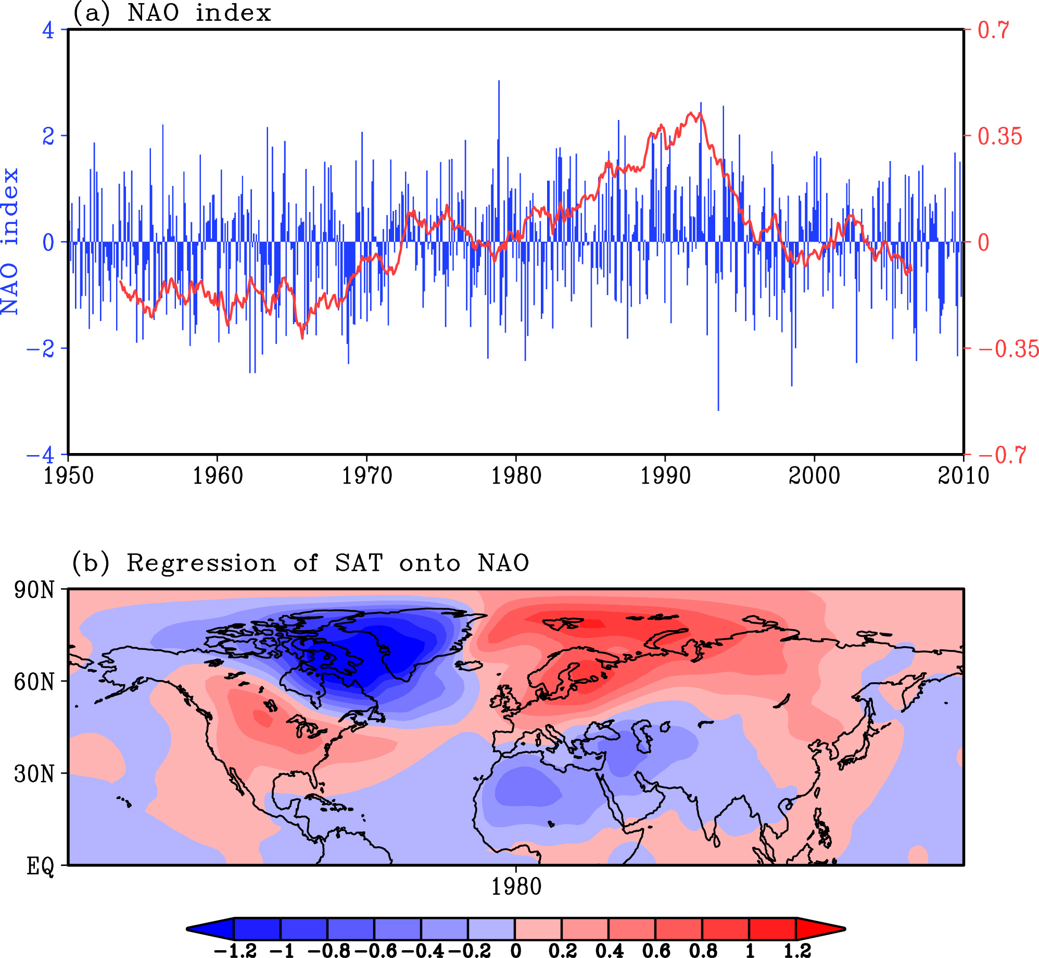

Figure 1. (a) Monthly NAO index from 1950 to 2009. (b) Regression (°C per NAO) of monthly surface air temperature onto monthly NAO index. The red line in (a) is the 7-year running mean NAO index.
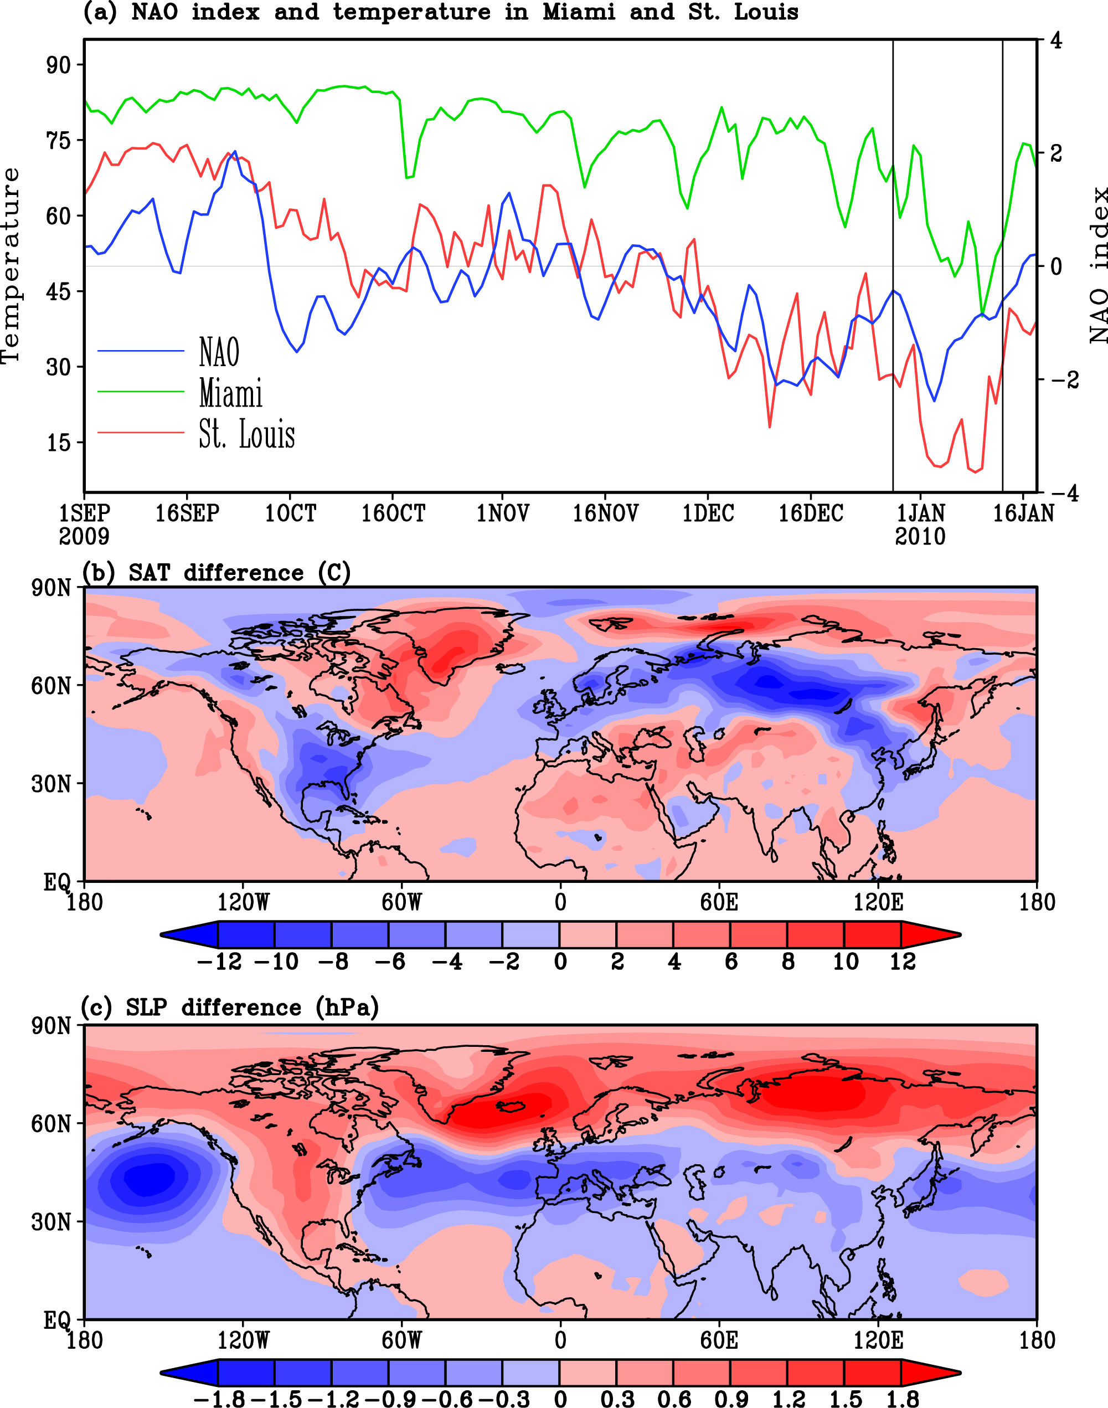

Figure 2. (a) Daily temperatures (°F) at Miami and St. Louis and daily NAO index from September 1, 2009 to January 18, 2010. (b) Surface air temperature (SAT) difference (°C) between the period of December 28, 2009 and January 13, 2010 and the same time period of previous 60 years. (c) Sea level pressure (SLP) difference (hPa) between the period of December 28, 2009 and January 13, 2010 and the same time period of previous 60 years. Two vertical lines in (a) represent the weeks of December 28, 2009 and January 13, 2010.

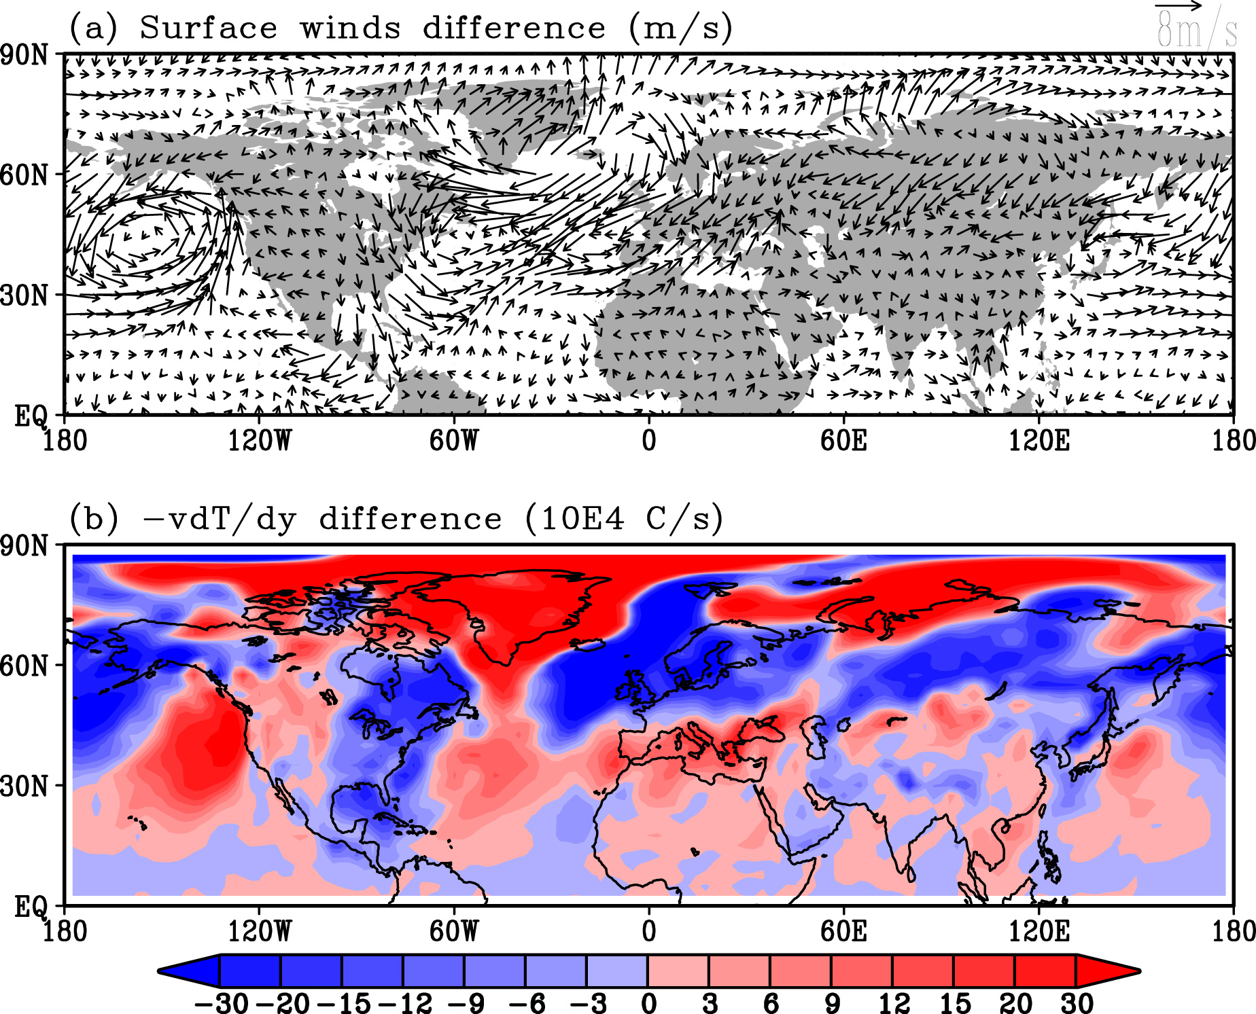

Figure 3. (a) Surface wind difference (m/s) between the period of December 28, 2009 and January 13, 2010 and the same time period of previous 60 years. (b) Meridional temperature advection term () difference (10⁴ °C/s) between the period of December 28, 2009 and January 13, 2010 and the same time period of previous 60 years.

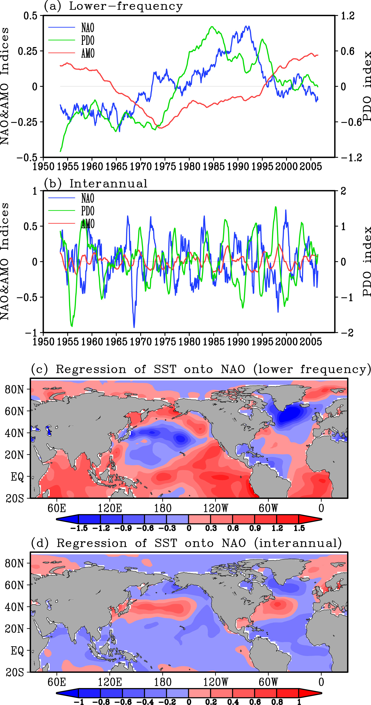

Figure 4. (a) The lower-frequency (7-year running mean) NAO, PDO and AMO (°C) indices. (b) The interannual NAO, PDO and AMO indices. (c) Regression (°C per NAO) of monthly SST onto the lower-frequency NAO index. (d) Regression (°C per NAO) of monthly SST onto the interannual NAO index. The interannual index is calculated as the difference between the 1-year running mean index and the 7-year running mean index.

