Inter-hemispheric Influence of the Northern Hemisphere Summer Monsoon

Sang-Ki Lee^{1,2}, Carlos R. Mechoso³ and Chunzai Wang²
¹Cooperative Institute for Marine and Atmospheric Studies, University of Miami, Miami FL
²Atlantic Oceanographic and Meteorological Laboratory, NOAA, Miami FL
³Department of Atmospheric Sciences, University of California, Los Angeles, Los Angeles, CA

To be submitted to Journal of Climate
August 2012

Corresponding author address: Dr. Sang-Ki Lee, NOAA/AOML, 4301 Rickenbacker Causeway, Miami, FL 33149, USA. E-mail: Sang-Ki.Lee@noaa.gov.
Abstract
Regression analysis of major atmospheric reanalysis products indicates that the northern hemisphere (NH) summer monsoons, especially the South Asian monsoon is linked to a significant strengthening the subtropical anticyclones over the South Pacific and South Atlantic. To understand the underlying mechanism and to clearly isolate the interhemispheric influence of the NH summer monsoon, a suit of specially designed experiments is performed using the Community Atmospheric Model version 3 (CAM3). The strengthening of the South Pacific subtropical cyclone associated with NH summer monsoon is reasonably well simulated in the CAM3. However, the CAM3 failed to reproduce the observed strengthening of the South Atlantic subtropical anticyclone associated with NH summer monsoon. An important implication of this finding is that the failure in simulating the strengthening of the South Atlantic subtropical anticyclone during NH summer in CAM3.1 may be a source of tropical Atlantic SST bias in the Community Climate System Model version 3 (CCSM3).

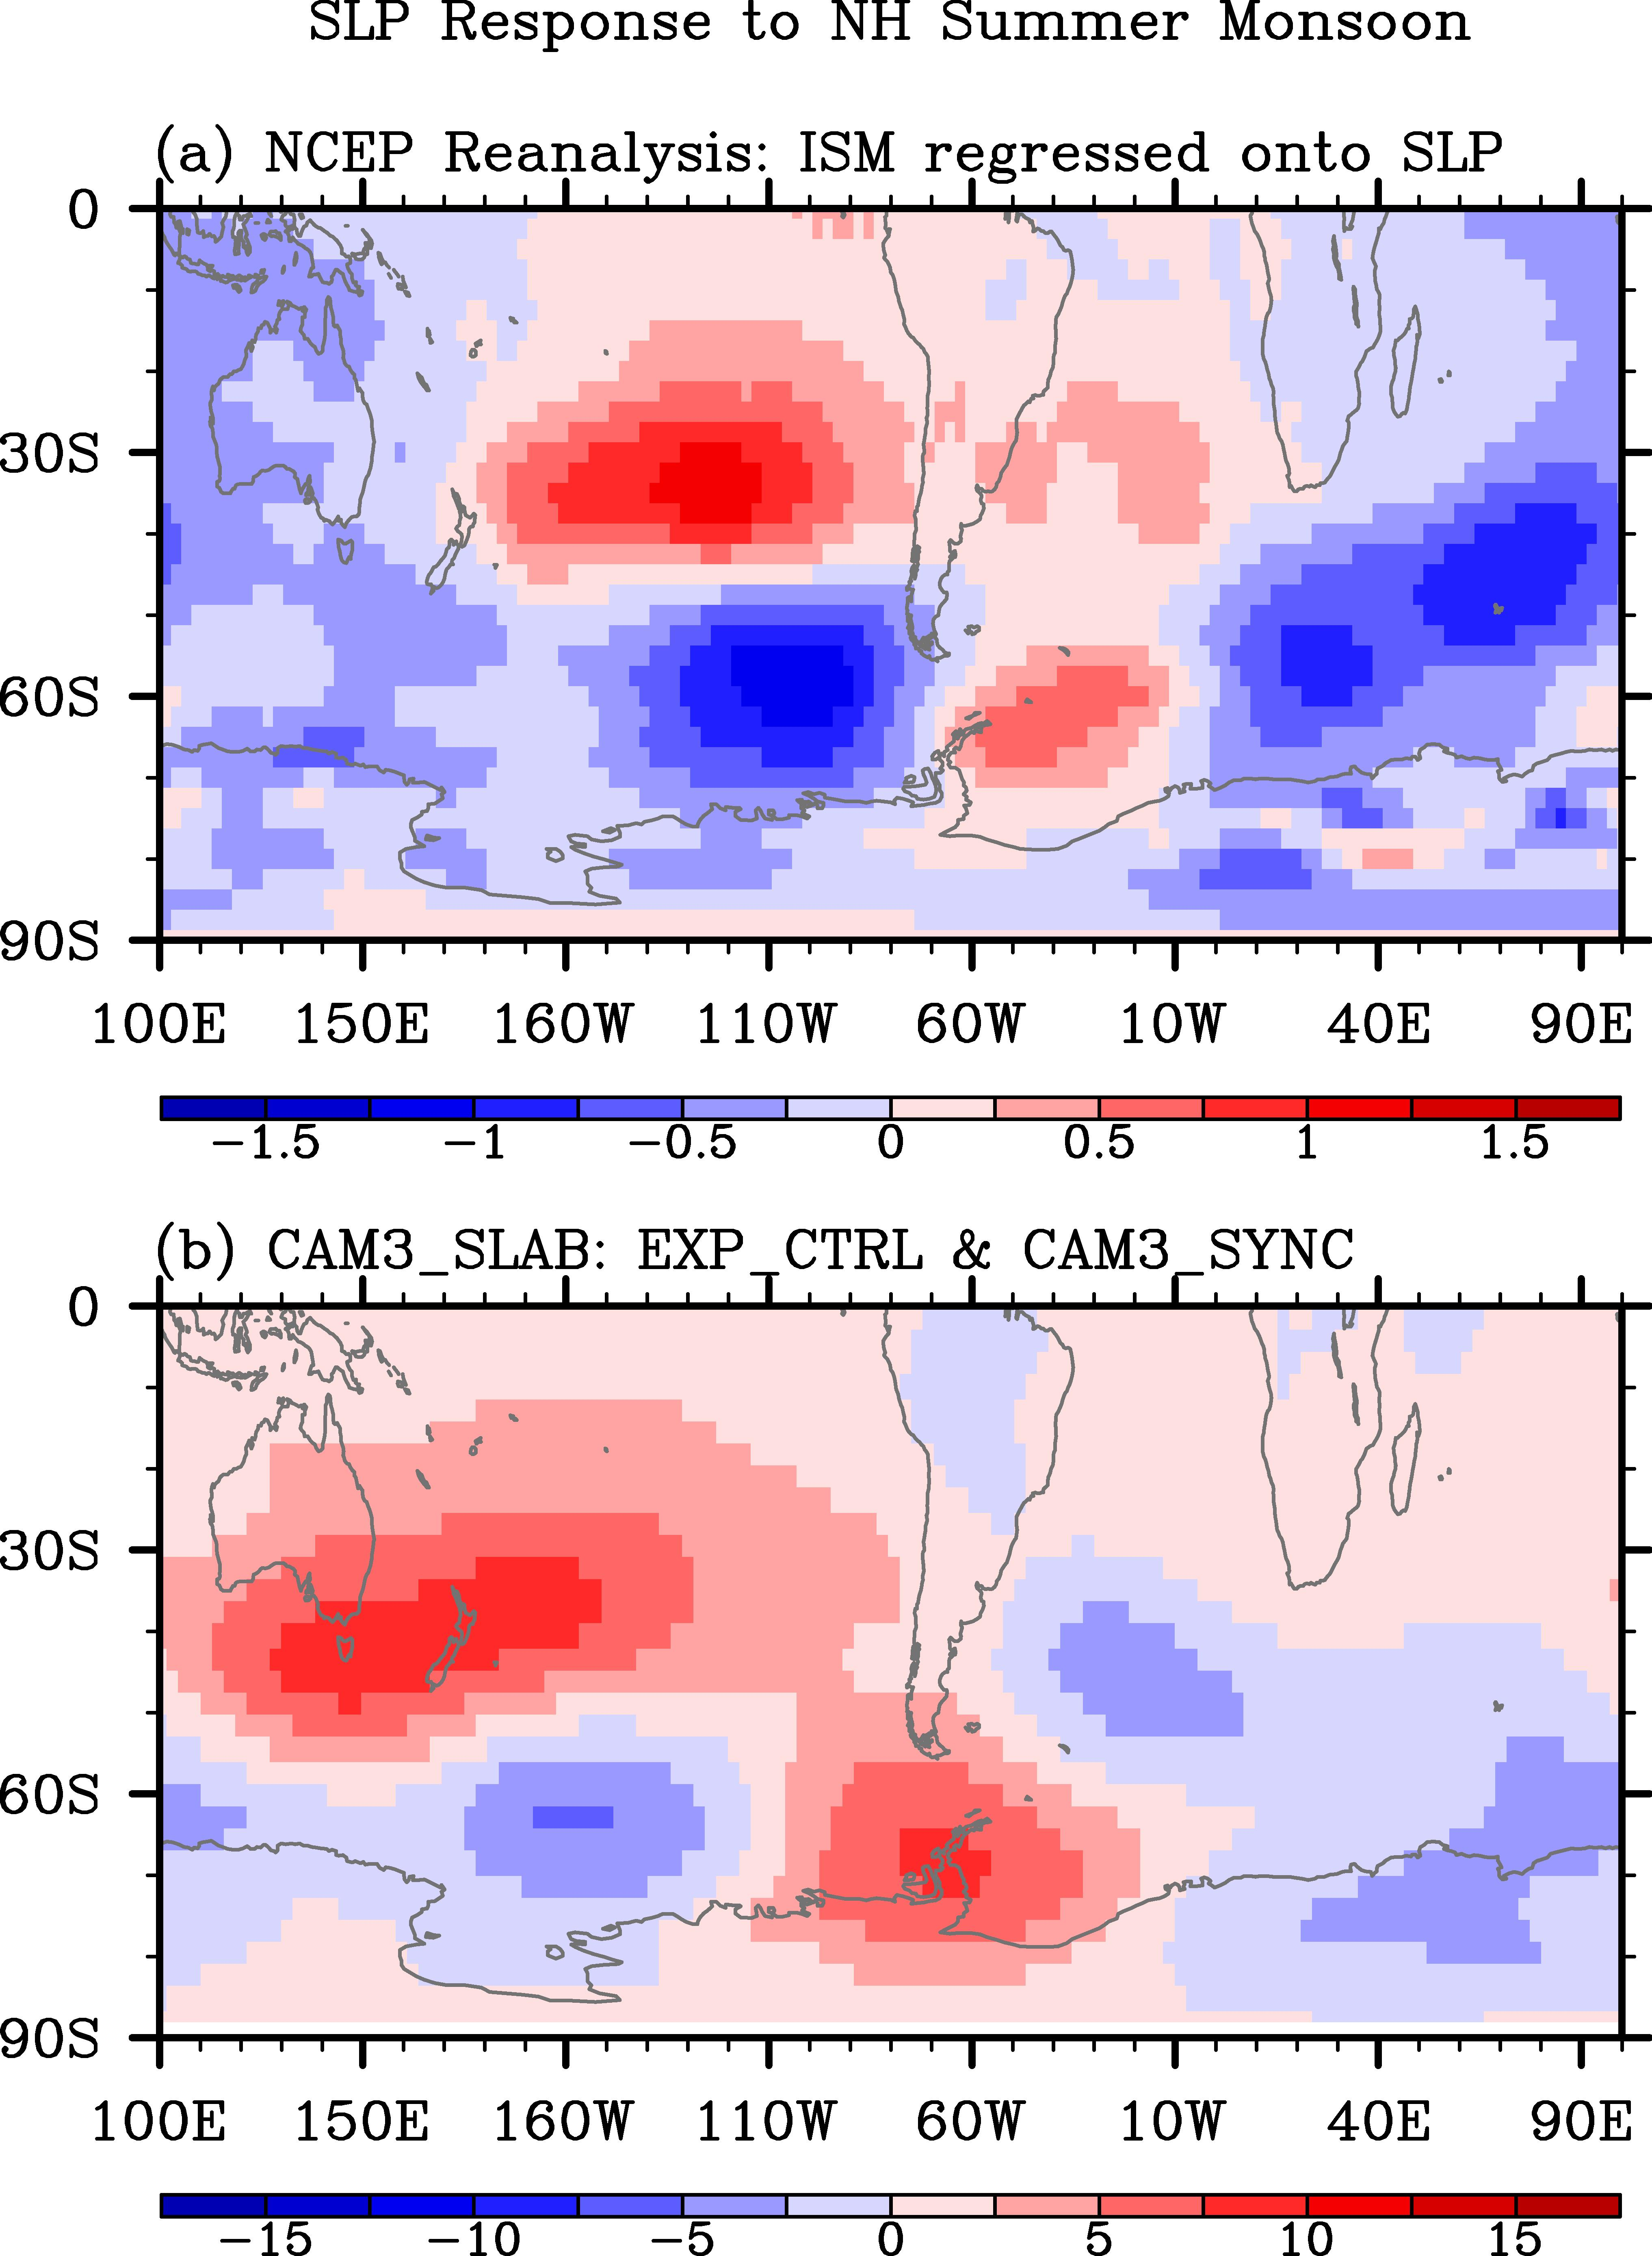
Figure 1. (a) Regression coefficient that measures the sea level pressure variability linked to the Indian Summer Monsoon (ISM) during June-September. NCEP reanalysis during 1950-2010 is used to compute the regression coefficient. The ISM is obtained by computing the difference of the 850 hPa zonal winds between a southern region of 5-15N, 40-80E and a northern region of 20-30N, 70-90E following Wang et al. [2001]. (b) Sea level pressure difference between the control simulation (EXP_CTRL) and the synchronized interhemispheric model experiment (EXP_SYNC) during July-September

Tentative plan for this paper:
We need to further use various reanalysis products to find the potential link between NH summer monsoons and SH subtropical anticyclones. For instance, we can explore to see how much of the total variance of the SH subtropical anticyclones can be explained by the interhemispheric influence. We should also explore the mechanisms of course. Once we are done with the observation analysis, we can use the CAM3 experiments (already finished) to show that the CAM3 has some difficulties in simulating the strengthening of the South Atlantic subtropical anticyclones in SH winter (JJA) associated with the NH summer monsoon. Of course, we should also think about performing CCSM3 experiments to see if this failure in CAM3 is a source of tropical Atlantic SST bias in CCSM3. Perhaps, we should do the CCSM3 simulations for the next paper.

