Corresponding author: Sang-Ki Lee
CIMAS, University of Miami and AOML, NOAA, Miami, FL 33149
E-mail) sang-ki.lee@noaa.gov

Dear Editor,

We wish to submit for your kind consideration for publication in Geophysical Research Letters the enclosed manuscript entitled “Spring persistence, transition and resurgence of El Niño” by Sang-Ki Lee, Pedro DiNezio, Eui-Seok Chung, Sang-Wook Yeh, Andrew Wittenberg and Chunzai Wang. In this manuscript, we present a systematic exploration of the spatio-temporal SST evolution associated with inter-event El Niño variability. Our analysis shows that two leading modes capture more than 60% of the inter-El Niño variance, delineating spring persistence, transition and resurgence aspects of El Nino. We also analyzed atmosphere and ocean reanalysis products to explain the potential mechanisms associated with these aspects of inter-event El Niño variability.

As far as we know, this is the first attempt to objectively identify and explain the spatio-temporal evolution of inter-event El Niño variability in the tropical Pacific for the entire lifespan of El Niño from onset to decay.

Sincerely yours,
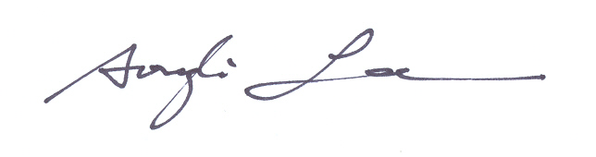
S.-K. Lee, P. DiNezio, E.-S. Chung, S.-W. Yeh, A. Wittenberg and C. Wang

