Annual Project Report to NSF

Collaborative Research: The Southern Subtropical Anticyclones
Carlos R Mechoso¹, Sang-Ki Lee^{2,3} and Chunzai Wang³
¹Department of Atmospheric Sciences, University of California - Los Angeles, Westwood, CA
²Cooperative Institute for Marine and Atmospheric Studies, University of Miami, Miami FL
³Atlantic Oceanographic and Meteorological Laboratory, NOAA, Miami FL
Research Period: January 1 2011 – December 31 2011
Award Number: 1041145
Program Officer Name: Eric T. DeWeaver
Program Officer Email Address: edeweave@nsf.gov
Program Officer Phone Number: (703) 292-8527

1. Goals, objectives and progress
The present proposal aims to reconcile different ideas on the generation and maintenance of the southern Atlantic and Pacific highs, gain a better understanding of these important climate features and their variability, and contribute to improve their simulation by CGCMs through identification of reasons for systematic model errors in the tropics. With these goals in mind, we propose to concentrate on four questions in the framework of the coupled atmosphere-ocean system:
- How is the South Atlantic anticyclone during the southern winter connected with the West African and Asian monsoons?
- How significant are the interhemispheric influences of the Atlantic Warm Pool on the southeastern Pacific?
- In the Southern Hemisphere, do atmospheric-ocean interactions contribute significantly to the links between monsoons and subtropical highs?
- Has the recently reported change in the relationship between Atlantic and Pacific Niños affected the variability of the southern subtropical highs?

In the first year of this project (January 1 2011 – December 31 2011), to tackle the first two questions, we have performed several ensemble experiments using the NCAR community climate system model (CCSM) and UCLA CGCM, as summarized in Table 1. We are currently analyzing these model results. Preliminary results from our on-going analysis are briefly described below.

Table 1. Ensemble model experiments performed during the year-1. All AMIP (e.g., AGCM experiments with prescribed SSTs) simulations, except AMIP_SYNC, are performed using both CCSM and UCLA model. AGCM-SLAB (e.g., AGCM is thermally coupled to a slab mixed layer ocean model) coupled model experiments are carried out with CCSM, while two partially coupled experiments are performed only with UCLA model. In the year-2 of the project, all of the model experiments listed here will be completed with both CCSM and UCLA model.
Experiments | Models | Descriptions
AMIP_CTRL | CCSM UCLA | The model’s monthly SSTs are prescribed using the climatological global SSTs obtained from Hadley Center SST for 1971-2000.
AMIP_SYNC | CCSM | The model run is designed to remove interhemispheric influence from the NH to the South Atlantic and South Pacific anticyclones during Southern winter. This experiment is identical to CCSM_AMIP_CTRL except that the downward solar radiation at the top of the atmosphere (TOA) and the SSTs are time-shifted by 6 months only in the NH.
AMIP_NAWP | CCSM UCLA | This experiment is identical to CCSM_AMIP_CTRL except that the seasonal onset of the Atlantic warm pool (AWP) is removed by keeping the AWP SST in the Atlantic region of 5ºN-30ºN and 100ºW-40ºW below 26ºC in all months.
AMIP_LAWP | CCSM UCLA | This experiment is identical to CCSM_AMIP_CTRL except that UCLA model is used.
AMIP_SAWP | CCSM UCLA | This experiment is identical to CCSM_AMIP_CTRL except that UCLA model is used.
SLAB_CTRL | CCSM | This experiment is identical to CCSM_AMIP_CTRL except that the atmospheric model is thermally coupled to a slab ocean model outside of the Atlantic warm pool region (5ºN-30ºN and 100ºW-40ºW).
SLAB_NAWP | CCSM | This experiment is identical to CCSM_SLAB_CTRL except that the seasonal onset of the Atlantic warm pool (AWP) is removed by keeping the AWP SST in the Atlantic region of 5ºN-30ºN and 100ºW-40ºW below 26ºC in all months.
PCPL_CTRL | UCLA | This is a partially coupled UCLA model simulation. The model is fully coupled (atmosphere-land-ocean) except in the Atlantic basin where the climatological SST is prescribed to force the atmospheric model component.
PCPL_LAWP | UCLA | This is identical to UCLA_PCPL_CTRL except that the AWP SSTs in the Atlantic region of 5ºN-30ºN and 100ºW-40ºW are obtained from the composite SST of large AWP years following Wang et al. [2008].

2. Synchronized Interhemipsheric Seasonal Cycle Model Experiment
Richter et al. [2008] used an AGCM to study the dynamics of the South Atlantic anticyclone by means of control simulations and experiments to investigate sensitivity to various known factors that affect the Northern anticyclones. Their results suggest the existence of links between intensity and structure of the wintertime South Atlantic anticyclone and the major summer monsoons in the Northern Hemisphere. Here, we revisit this hypothesis by means of control simulations and sensitivity experiments as in Richter et al. [2008], but with a different AGCM and a different model design.
The main goal is to design a series of AGCM model experiments to clearly isolate and quantify the interhemispheric influence on the South Atlantic anticyclone from other known mechanisms, especially the role of orography [Seager et al. 2003], monsoon heating-induced circulations [Rodwell and Hoskins 2001; Chen 2003]. To achieve this goal, we attempt to cut off interhemispheric exchanges of mass, heat and moisture on seasonal time scale by synchronizing the seasonal cycles of the external and boundary forcing in the NH to those of the SH. This is achieved by shifting the top of the atmosphere (TOA) downward solar radiation and the global SSTs in the NH by 6 months. Figure 1 shows the TOA clearsky net solar radiation in the control experiment (AMIP_CTRL), the synchronized interhemispheric seasonal cycle model experiment (AMIP_SYNC) and the difference between the two experiments. As shown, the TOA external forcing in the NH is synchronized to that of the SH in AMIP_SYNC. It is important to note that the TOA external forcing and the boundary forcing at the sea surface in the SH are unchanged form the control model experiment, thus the difference in the SH between the two model experiment (AMIP_CTRL - AMIP_SYNC) represents the net effect of interhemipsheric influence on the SH.

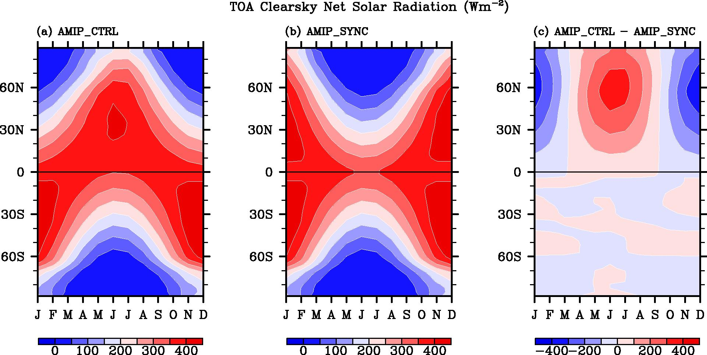

Figure 1. TOA clearsky net solar radiation in (a) the control experiment (AMIP_CTRL), (b) synchronized interhemispheric model experiment (AMIP_SYNC) and (c) the difference between the two experiments.

Figure 2 shows the velocity potential and divergent winds at 200mb obtained from AMIP_CTRL, AMIP_SYNC and AMIP_CTRL – AMIP_SYNC averaged for JJA and ASO. In AMIP_CTRL, the rising motion is centered over the India and over the Caribbean Sea. The sinking motion splits into one centered over the South Atlantic and the other over the Southeastern Pacific. The geographic segregation of the two sinking centers is much more clear in ASO compared to that in JJA.

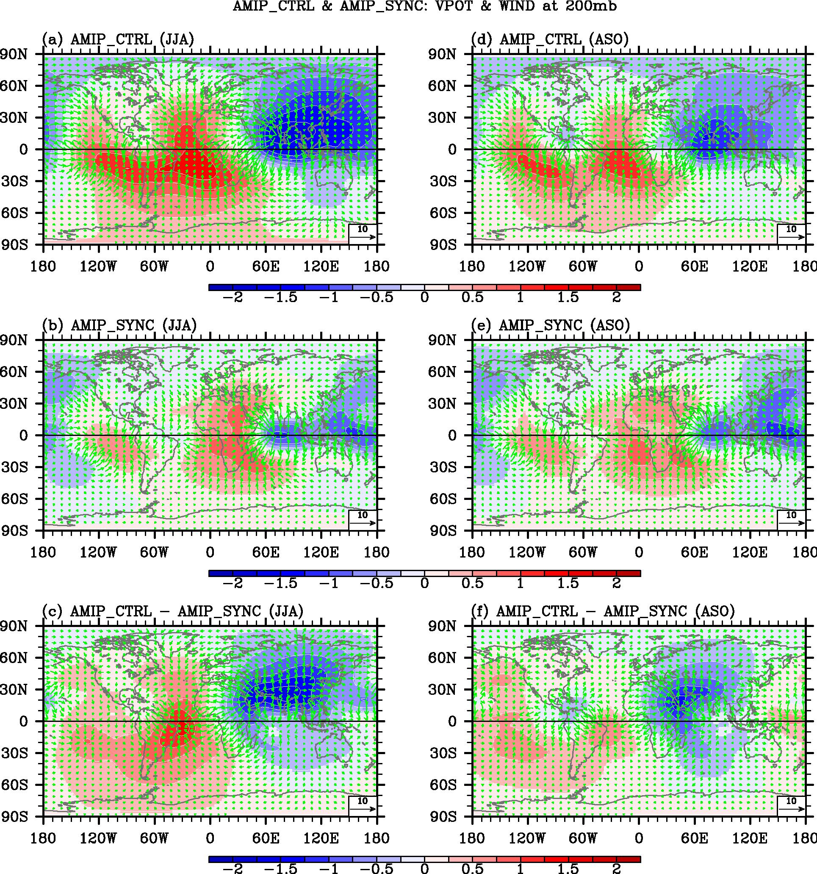

Figure 2. Velocity potential and divergent winds at 200mb obtained from AMIP_CTRL, AMIP_SYNC and AMIP_CTRL – AMIP_SYNC for JJA and ASO.

In AMIP_SYNC, the rising motion is much weaker and confined to the equatorial Indian and west Pacific Ocean where seasonal cycle of the underlying SST is relatively weak. The sinking motions over the Southeastern Pacific and South Atlantic are also much weaker. Interestingly, the center of the sinking motion over the South Atlantic is shifted to the east. The difference in velocity potential between the two experiments further shows that the sinking motion over the Southwestern Atlantic region is strongly influenced by the rising motion over the Caribbean Sea. Therefore, it appears that the lack of diabatic heating the Caribbean Sea in AMIP_SYNC greatly reduces the sinking motion over the Southwestern Atlantic and thus pushes the center of the South Atlantic sinking motion to the east in AMIP_SYNC.

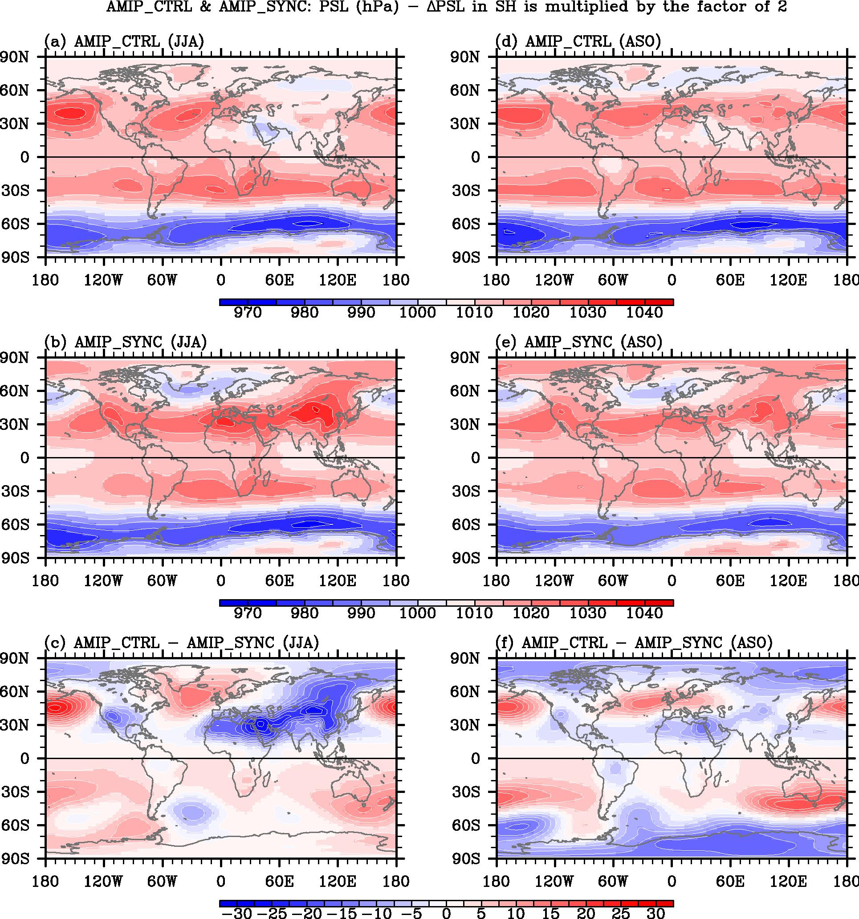

Figure 3. Sea level pressure obtained from AMIP_CTRL, AMIP_SYNC and AMIP_CTRL – AMIP_SYNC for JJA and ASO.
Consistent with the reduced subsidence over the Southwest Atlantic, the South Atlantic sea level pressure is generally weakened in AMIP_SYNC during JJA (Figure 3). In other words, the interhemispheric influence associated with the monsoon in the NH increases the subsidence over the Southwest Atlantic and thus contributes to the South Atlantic anticyclone.

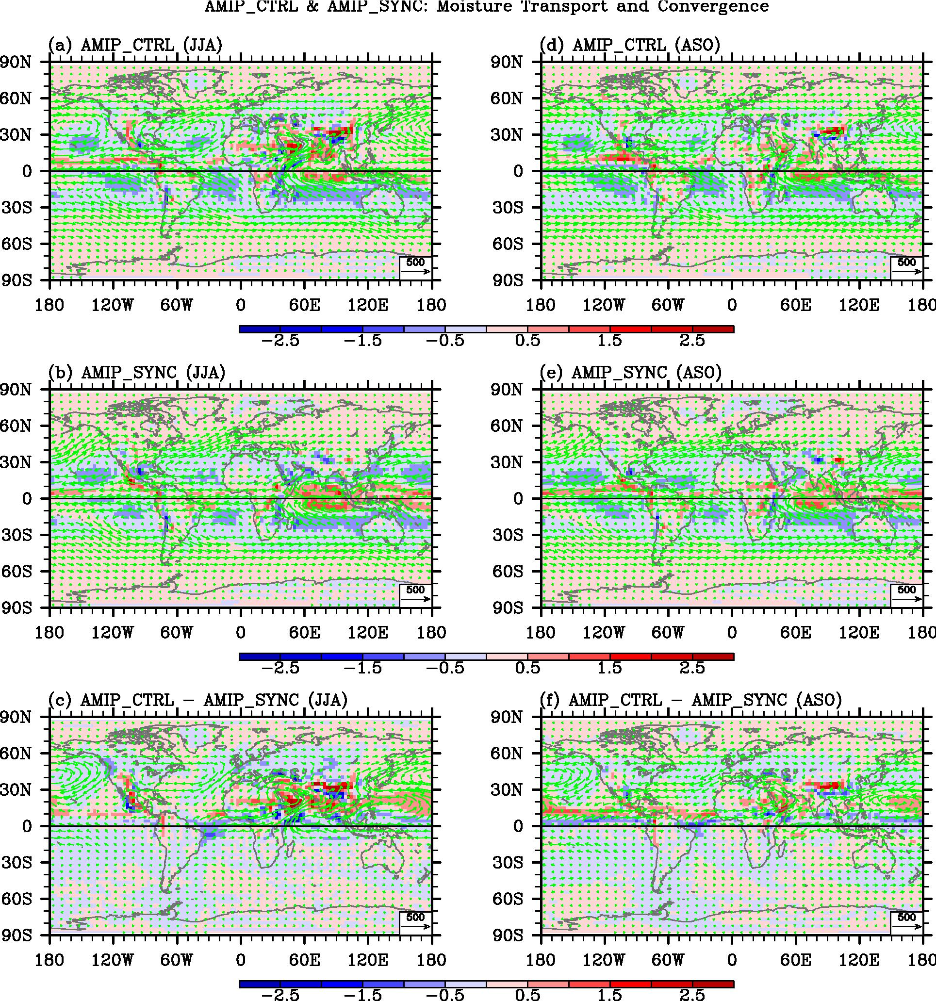

Figure 4. Vertically integrated moisture transport and convergence obtained from AMIP_CTRL, AMIP_SYNC and AMIP_CTRL – AMIP_SYNC for JJA and ASO.

Obviously, an important question is why the African-Asian monsoon enhances subsidence over the Southwest Atlantic. A preliminary analysis suggests that the seasonal onset of the West African monsoon help reduce the moisture transport and convergence onto the Southwest Atlantic, thus reduce deep tropical convection there (Figure 4). Further diagnosis of the CCSM model experiments and similar experiments with UCLA model are planned in the year-2 of the project.

3. How significant are the interhemispheric influences of the seasonal Atlantic Warm Pool onset on the southeastern Pacific?
A recent work by Wang et al. [2010] emphasized connections between the South Pacific subtropical high and convection over the AWP (AWP; warm surface water in regions comprising the Gulf of Mexico, Caribbean Sea, and the western tropical North Atlantic). This paper demonstrated the establishment of interhemispheric connections through a regional Hadley circulation emanating from the AWP and sinking over the subtropical southeastern Pacific. Such Hadley circulation is strengthened (weakened) by anomalously large (small) AWPs. The interhemispheric connection helps explain why stratus clouds in the southeastern Pacific peak in the southern spring and not in the summer, when the South American monsoon system is in full strength.
We plan to further investigate the AWP-Southeastern Pacific connection, proposed in Wang et al. [2010], for seasonal, interannual and multidecadal times scales by using thermally coupled and fully coupled GCMs. Here, we will briefly summarize our findings on the seasonal AWP-Southeastern Pacific connection in a thermally coupled GCM. As summarized in Table 1, we performed two experiments using CCSM coupled to a slab mixed layer ocean model. In the control simulation (SLAB_CTRL), the atmospheric model is thermally coupled to a slab ocean model outside of the AWP region (5ºN-30ºN and 100ºW-40ºW), whereas SSTs over the AWP region are prescribed using the climatological global SSTs obtained from Hadley Center SST during 1971-2000. The second experiment is identical to SLAB_CTRL except that the seasonal onset of the AWP is removed by keeping the AWP SST in the Atlantic region of 5ºN-30ºN and 100ºW-40ºW below 26ºC in all months (SLAB_NAWP).
Figure 5 clearly shows that the sea level pressure in the Southeastern Pacific is reduced in SLAB_NAWP, consistent with Wang et al. [2010]. As shown in Figure 6c, the seasonal onset of the AWP induces rising motions over the Caribbean Sea and sinking motions in the tropical Pacific. It is clear that the AWP-induced increased sinking motion over the South Pacific causes the increased sea level pressure in the Southeastern Pacific as concluded in Wang et al. [2010]. Therefore, it appears that the AWP-Southeastern Pacific connection exists in seasonal time scale. We also find that SST is reduced and the low-level cloud fraction is increased in response to the AWP-Southeastern Pacific connection (not shown). This suggests that the AWP-Southeastern Pacific connection is strengthened by SST-low-level cloud positive feedback on seasonal time scale. Further diagnosis and comparison with AMIP_CTRL and AMIP_NAWP simulations are planned in the year-2 of the project to further explore the importance of the local feedback.

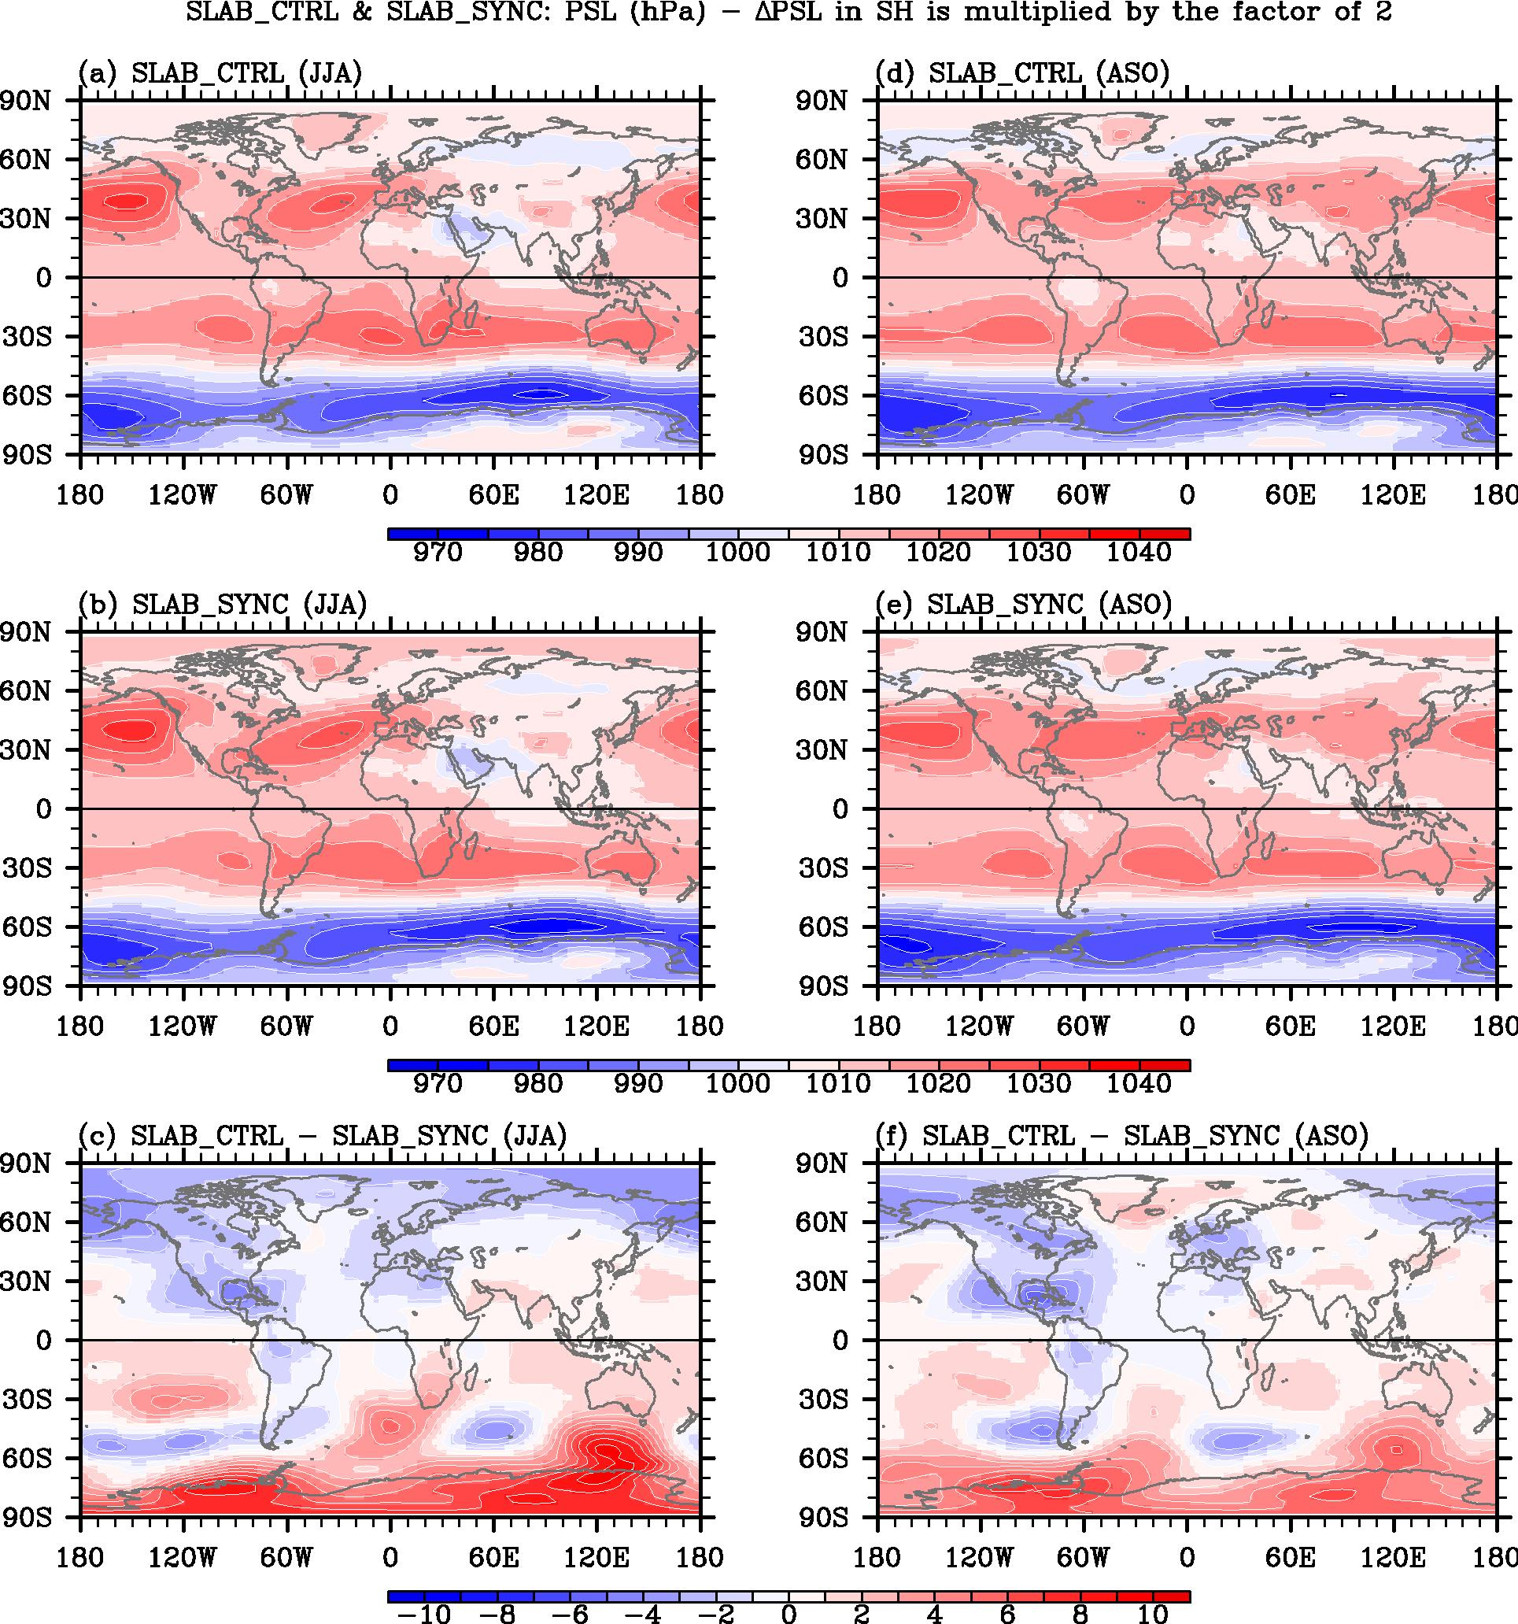

Figure 5. Sea level pressure obtained from SLAB_CTRL, SLAB_NAWP and SLAB_CTRL – SLAB_NAWP for JJA and ASO.

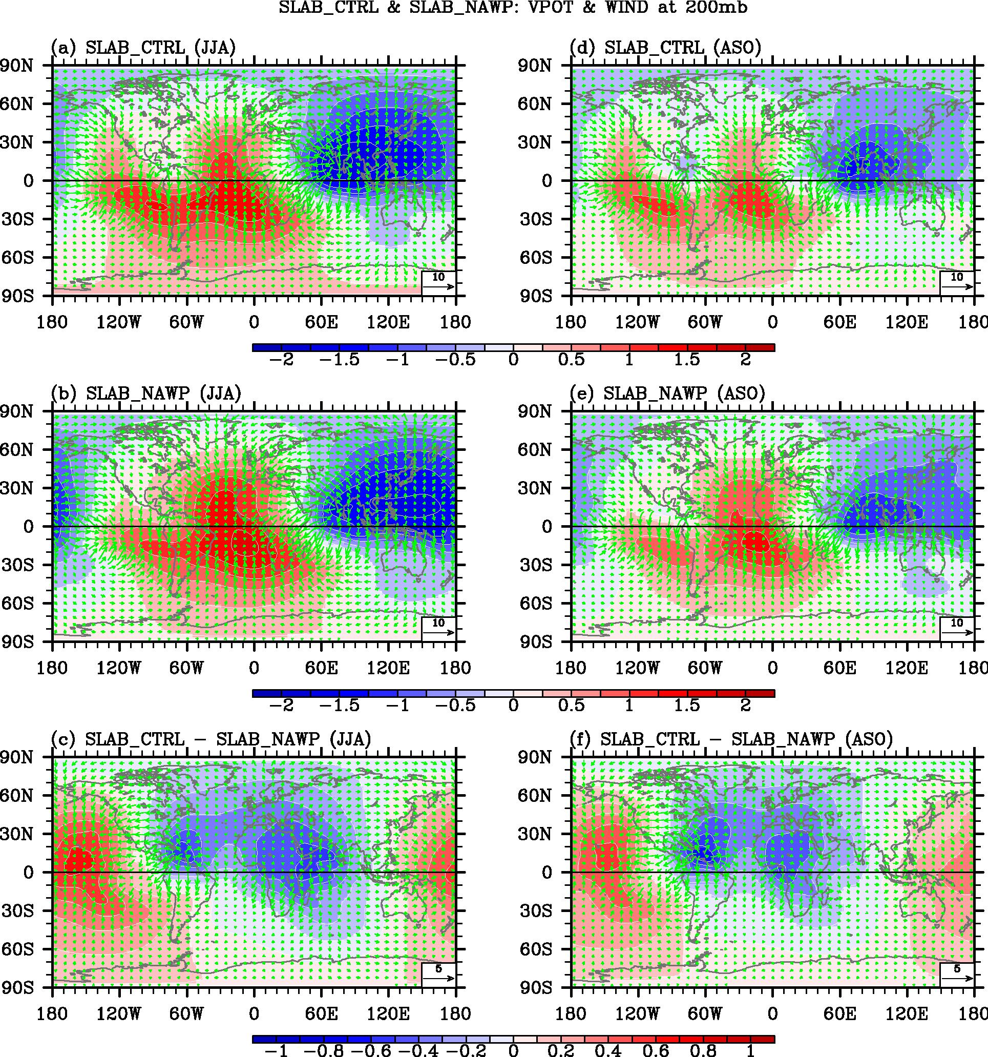

Figure 6. Velocity potential and divergent winds at 200mb obtained from SLAB_CTRL, SLAB_NAWP and SLAB_CTRL – SLAB_NAWP for JJA and ASO.

4. Interhemipsheric influence of large and small Atlantic Warm Pool in two AGCMs

Teresa can prepare this section.

5. What is the role of atmospheric-ocean interactions in the interhemipsheric influence of Atlantic Warm Pool on the Southeastern Pacific?

Teresa and Heng can prepare this section.

6. Summary and future plan

We need to discuss.

7. Publications
We were quite productive in term of publication in 2011. The following is the list of 17 publications by the PIs of the project (R. Mechoso, S.-K. Lee, and C. Wang) on the subject of Pacific and Atlantic climate and modeling during 2011.

Published or In Press in 2011:
1) Lee S.-K., W. Park, E. van Sebille, M. O. Baringer, C. Wang, D. B. Enfield, S. Yeager, and B. P. Kirtman, 2011. What Caused the Significant Increase in Atlantic Ocean Heat Content Since the mid-20th Century? Geophysical Research Letters, doi:10.1029/2011GL048856. [highlighted in Oct. 6, 2011 issue of Nature as Community Choice]
2) Lee, S.-K., D. B. Enfield and C. Wang, 2011. Future Impact of Differential Inter-Basin Ocean Warming on Atlantic Hurricanes. Journal of Climate, 24, 1264-1275.
3) Liebmann, B., and C.R. Mechoso, 2011: The South American Monsoon System. The Global Monsoon System: Research and Forecast, 2nd Edition. Chang, C. -P., Y. Ding, N.-C. Lau, R. H. Johnson, B. Wang, and T. Yasunari, Eds., World Scientific Series on Asia-Pacific Weather and Climate, Vol. 5, World Scientific Publication Company, 608 pp.
4) Ling, Z., G. Wang, C. Wang, and Z.-S. Fan, 2011: Different effects of tropical cyclones generated in the South China Sea and the northwest Pacific on the summer South China Sea circulation. Journal of Oceanography, 67:347-355.
5) Ma, H.-Y., X. Ji, J. D. Neelin, and C. R. Mechoso, 2011: Mechanisms for Precipitation Variability of the Eastern Brazil/SACZ Convective Margin. J. Climate, doi: 10.1175/2011JCLI4070.1.
6) Mohino, E., B. Rodriguez-Fonseca, C.R. Mechoso, S. Gervois, P. Ruti, and F. Chauvin, 2011: Impacts of the Tropical Pacific/Indian Oceans on the Seasonal Cycle of the West African Monsoon. J. Climate doi: 10.1175/2011JCLI3988.1.
7) Shu, Q., F. Qiao, Z. Song, and C. Wang, 2011: Sea ice trends in the Antarctic and their relationship to surface air temperature during 1979 to 2009. Climate Dynamics, in press.
8) Song, Z., F. Qiao, and C. Wang, 2011: The correctness to the spuriously simulated semi-annual cycle of the sea surface temperature in the equatorial eastern Pacific. Science China Earth Sciences, 54:438-444, doi:10.1007/s11430-011-4176-3.
9) Stammer, D., N. Agarwal, P. Hermann, A. Kohl, and C. R. Mechoso, 2011 Response of a Coupled Ocean-Atmosphere Model to Greenland Ice Melting. Surveys of Geophysics. In Press.
10) Teixeira, J., S. Cardoso, M. Bonazzola, J. Cole, A. DelGenio, C. DeMott, C. Franklin, C. Hannay, C. Jakob, Y. Jiao, J. Karlsson, H. Kitagawa, M. Kohler, A. Kuwano-Yoshida, C. LeDrian, J. Li, A. Lock, M. J. Miller, P. Marquet, J. Martins, C. R. Mechoso, E. v. Meijgaard, I. Meinke, P. M. A. Miranda, D. Mironov, R. Neggers, H. L. Pan, D. A. Randall, P. J. Rasch, B. Rockel, W. B. Rossow, B. Ritter, A. P. Siebesma, P. M. M. Soares, F. J. Turk, P. A. Vaillancourt, A. Von Engeln, and M. Zhao, 2011: Tropical and sub-tropical cloud transitions in weather and climate prediction models: the GCSS/WGNE Pacific Cross-section Intercomparison (GPCI). J. Climate. doi: 10.1175/2011JCLI3672.1.
11) Toniazzo, T., S. J. Abel, R. Wood, C. R. Mechoso, G. Allen, and L. C. Shaffrey, 2011: Large-scale and synoptic meteorology in the south-east Pacific during the observations campaign VOCALS-REx in austral Spring 2008. Atmos. Chem. Phys., 11, 4977-5009.
12) Turner, A., K. Sperber, J. Slingo, G. Meehl, C.R. Mechoso, M. Kimoto, and A. Giannini, 2011: Modeling Monsoons: Understanding and predicting current and future behavior. The Global Monsoon System: Research and Forecast, 2nd Edition. . Chang, C. -P., Y. Ding, N.-C. Lau, R. H. Johnson, B. Wang, and T. Yasunari, Eds., World Scientific Series on Asia-Pacific Weather and Climate, Vol. 5, World Scientific Publication Company, 608 pp. April 2011.
13) Wang, C., 2011: Atlantic multidecadal oscillation (AMO). In "State of the Climate in 2010". Bulletin of the American Meteorological Society, 92(6):S137-S138.
14) Wang, C., H. Liu, S.-K. Lee and R. Atlas, 2011. Impact of the Atlantic Warm Pool on United States Landfalling Hurricanes. Geophysical Research Letters, doi:10.1029/2011GL049265. [highlighted in Oct. 21, 2011 issue of Science as Editor's Choice]
15) Wang, X., C. Wang, W. Zhou, D. Wang, and J. Song, 2011: Teleconnected influence of North Atlantic sea surface temperature on the El Niño onset. Climate Dynamics,37:663-676, doi:10.1007/s00382-010-0833-z.
16) Wood, R., C. R. Mechoso, C. S. Bretherton, R. A. Weller, B. Huebert, F. Straneo, B. A. Albrecht, H. Coe, G. Allen, G. Vaughan, P. Daum, C. Fairall, D. Chand, L. Gallardo Klenner, R. Garreaud, C. Grados, D. S. Covert, T. S. Bates, R. Krejci, L. M. Russell, S. de Szoeke, A. Brewer, S. E. Yuter, S. R. Springston, A. Chaigneau, T. Toniazzo, P. Minnis, R. Palikonda, S. J. Abel, W. O. J. Brown, S. Williams, J. Fochesatto, J. Brioude, and K. N. Bower, 2011: The VAMOS Ocean-Cloud-Atmosphere-Land Study Regional Experiment (VOCALS-REx): Goals, platforms, and field operations. Atmos. Chem. Phys.,11, 627-654.
17) Zamboni, L., F. Kucharski, and C. Mechoso, 2011: Seasonal variations of the links between the interannual variability over South America and the South Pacific. Clim. Dyn., Published online, 22 June 2011.

