**NF1704: summary of activities conducted May 7th – June 2nd, 2017 aboard NOAA Ship Nancy Foster**

* 514 Tunas (359 BFT) collected, 568 specimens measured
* 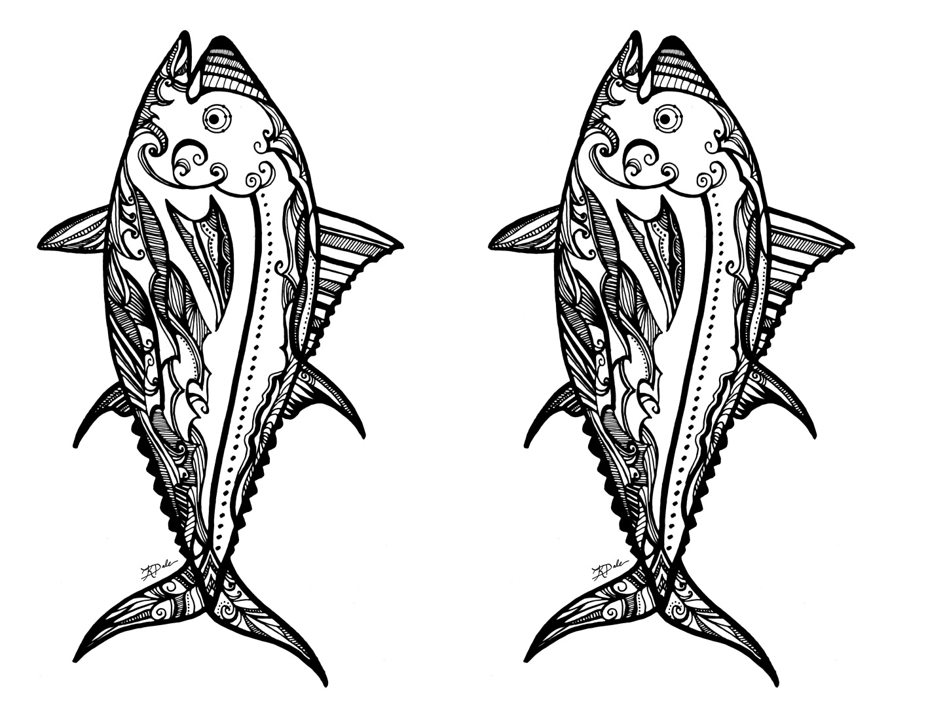90 CTD casts: Depths were (300m, 500, 1500, and 2500m). Double sensors on the CTD were temperature, oxygen, salinity, chlorophyll-a and CDOM, conductivity, PAR.
* Continuous measurements of currents (ADCP) from Key West to Progresso and to Miami
* Continuous measurement of flow through (TSG) from Key West to Progresso and to Miami
* 7 SVP Drifters were deployed
* 546 Flow cytometry samples (phytoplankton, bacteria, water column abundance)
* 72 Elemental Nitrogen (N2)-fixing organism samples
* 6 casts with PAR (Photosynthetically-Active Radiation) sensor
* 207 Microbial Abundances and Biomass samples
* 95 Sediment Trap Flux samples
* 78 Thorium concentration profiles (dissolved + particulate)
* 354 Primary Production and Nitrate Uptake
* 226 Deckboard Incubations for nitrogen utilization rates
* 120 Shipboard Nitrate Concentrations
* 57 Deckboard Incubations for δ15N.
* 130 Nutrient Profiles for NO3- + NO2,-PO43- and isotope analyses (δ15N and δ18O)
* 95 Mesozooplankton Biomass and Grazing
* 48 Growth and Grazing Rate Profiles (8 experiments x 6 depths)
* 279 Phytoplankton Pigments fluorometric Chla,
* 210 High-performance liquid chromatography  samples
* 19 ring net tows (100m)
* 136 net tows (25m): 120 Bongo-90 (240 jars) & 16 Mini-bongo net tows
* 16 Mesozooplankton and 16 microzooplankton samples
* Live sorted 120 plankton samples
* 95 specimens selected for genetic analysis