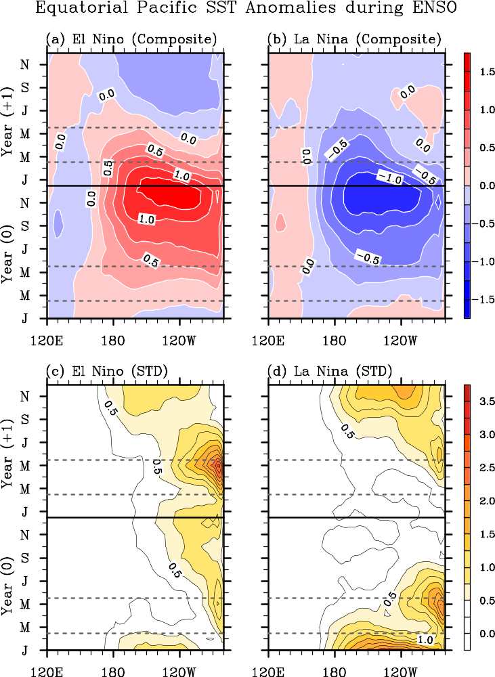
Figure 1. Time-longitude plots of composite (a and b) means and (c and d) standard deviations of the tropical Pacific SST anomalies averaged between 5°S and 5°N for (a and c) 21 El Niños and (b and d) 22 La Niñas during 1949-2012, derived from ERSST3. The composite standard deviation of El Niño (La Niña) measures the spread of the 21 El Niños (22 La Niñas) from their composite mean. The horizontal black line marks the last day of Year (0). The horizontal gray lines indicate the start (March 1) and end (May 30) dates of boreal spring. The unit is °C.
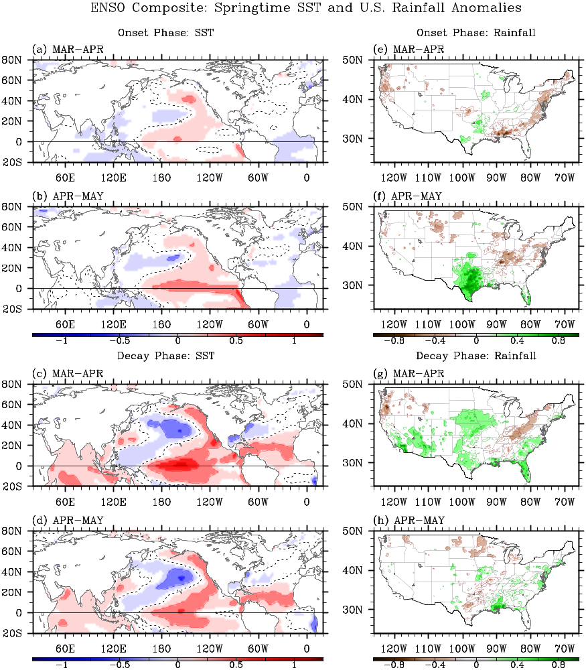
Figure 2. Composite mean differences of (a - d) SST and (e - h) U.S. rainfall anomalies between the onset phase of El Niño and La Niña in (a, e) early spring and (b, f) late spring; and between the decay phase of El Niño and La Niña in (c, g) early spring and (d, h) late spring derived from ERSST3 and CPC unified gauge-based analysis of U.S. daily precipitation. In (a – c), negative and positive contours are in blue and red, respectively, whereas the zero-contour is in dashed black. In (d - f), negative and positive contours are in brown and green, respectively. Significant values at 90% or above based on a student-t test (two-tailed) are shaded. The unit is °C for the SST anomalies and mm⋅day⁻¹ for the rainfall anomalies.

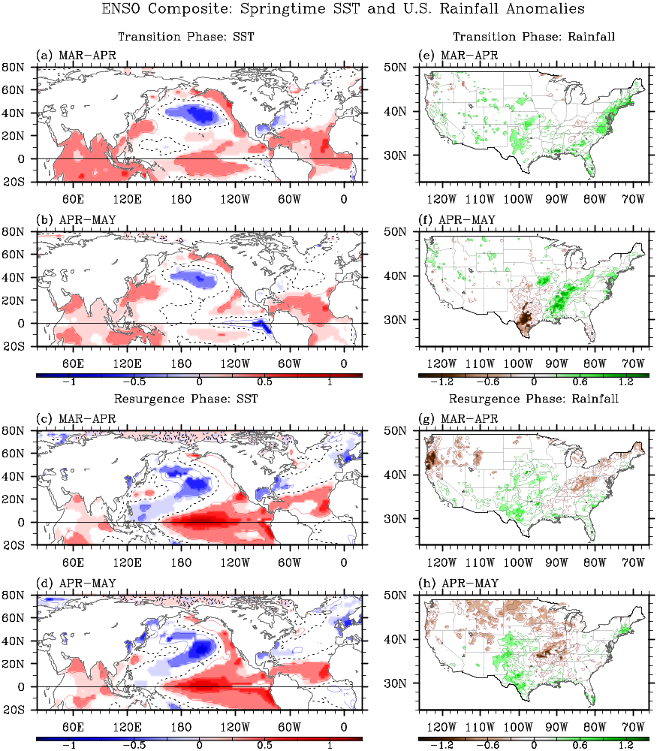
Figure 3. Composite mean differences of (a - d) SST and (e - h) U.S. rainfall anomalies between the El Niño-to-La Niña transition phase and the La Niña-to-El Niño transition phase in (a, e) early spring and (b, f) late spring; and between the resurgence phase of El Niño and the resurgence phase of La Niña in (c, g) early spring and (d, h) late spring derived from ERSST3 and CPC unified gauge-based analysis of U.S. daily precipitation. In (a – c), negative and positive contours are in blue and red, respectively, whereas the zero-contour is in dashed black. In (d - f), negative and positive contours are in brown and green, respectively. Significant values at 90% or above based on a student-t test (two-tailed) are shaded. The unit is °C for the SST anomalies and mm⋅day⁻¹for the rainfall anomalies.

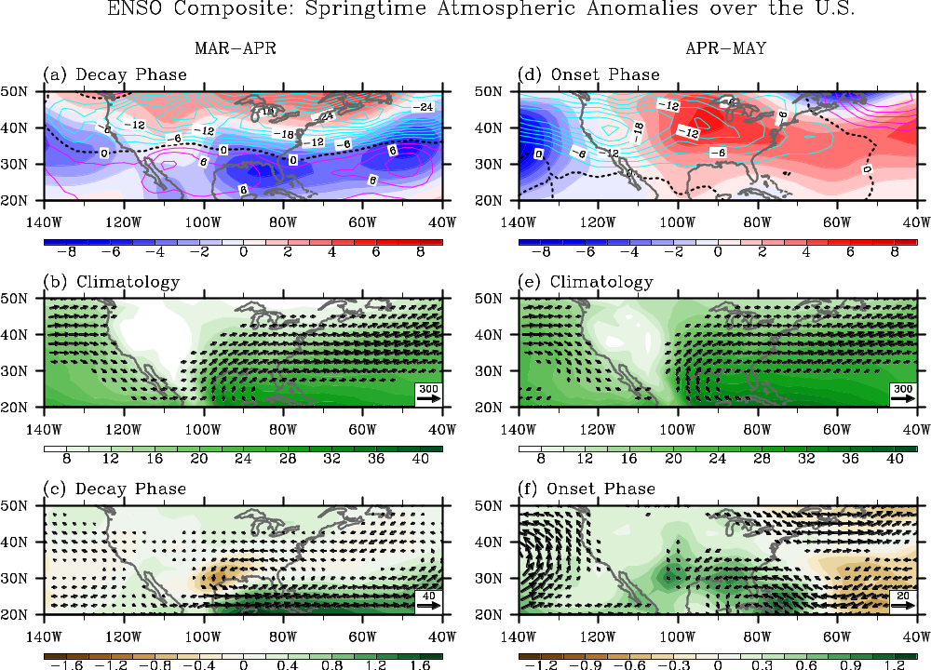
Figure 4. Upper-panel: anomalous geopotential height at 850 hPa (color shades) and variance of 5-day high-pass filtered meridional winds at 300 hPa (contours) for (a) early spring of ENSO decay phase and (d) late spring of ENSO onset phase. Mid-panel: climatological moisture transport (vectors) and precipitable water (color shades) in (b) early and (e) late spring. Bottom-panel: anomalous moisture transport (vectors) and precipitable water (color shades) for (c) early spring of ENSO decay phase and (f) late spring of ENSO onset phase. The units are kg·m⁻¹·s⁻¹ for moisture transport, kg·m⁻² for precipitable water, gpm for geopotential height and m²·s⁻² for variance of meridional winds.

