Cruise Instructions

Date Submitted: | 1 March 2015
Platform: | NATO Ship Alliance
Cruise Number:
Project Title: | PIRATA Northeast Extension / AEROSE
Cruise dates: | 15 November — 15 December 2015

Prepared by: ________________________ Dated: __________________
Dr. Claudia Schmid
Chief Scientist
NOAA/AOML/PhOD

Approved by: ________________________ Dated: __________________
Dr. Robert Atlas
Director
NOAA/AOML

Approved by: ________________________ Dated: ________________
XXXXXXXXXXXXX
I. Overview
A. Cruise Period

15 November — 15 December 2015
staging: November 13 & 14, 2015
destaging: December 15 (rest of) & 16 2015.]

B. Operating Area

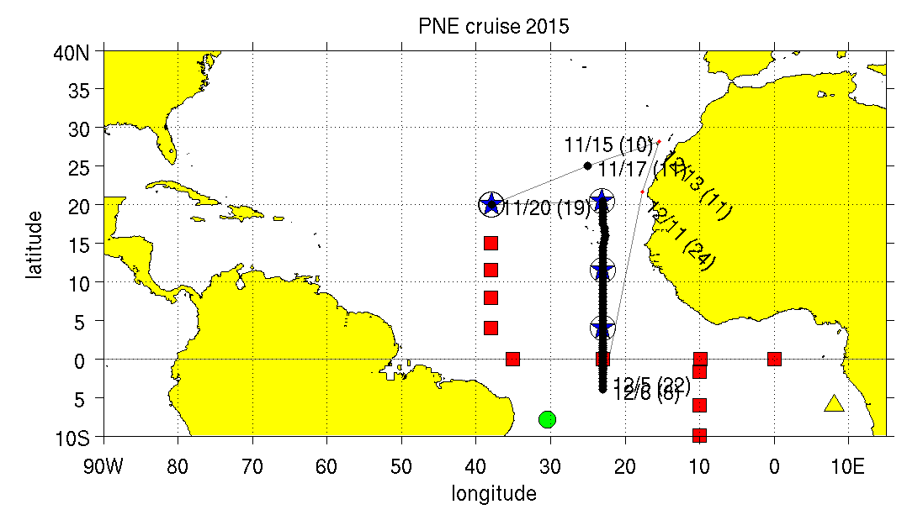
Fig. 1: cruise track (black line) and locations of Tropical Atlantic moorings. Symbols indicate the PIRATA backbone (red squares), the PIRATA SW extension (green dot), the PIRATA SE extension (yellow triangle). Blue stars indicate the PIRATA Northeast Extension. Black dots show CTD stations (test site and 23 W section). AEROSE satellite-dedicated radiosondes will be launched along all legs. No reserve time is contained in this cruise plan. The duration has been calculated as 29.5 days. The CTD section south of the equator can be shortened as needed to return to port on time.

The operating area is the eastern tropical Atlantic primarily along 23°W. ATLAS moorings will be recovered and new ones deployed at the PNE sites near 20°N, 38°W, as well as near 20.5°N, 11.5°N, and 4°N along 23°W. In addition, a TFlex mooring will be recovered and a new one deployed near 4°N, 23°W. The equatorial Atlas mooring at 23°W maintained by France maybe serviced (tube and/or sensor swap) if necessary. At all PNE mooring sites a Seabeam survey is requested and a hydropgraphic cast will be performed.

A CTD test cast to about 1500 m will be performed near 25ºN, 25ºW along the way to the first PNE mooring site. From the second mooring site near 20.5°N, 23°W a hydrographic line will be conducted along 23°W to 5ºS, detouring slightly eastward around the Cape Verde plateau. The southern end point of this CTD section depends on delays caused by weather or other events, the time needed to complete the work at each mooring site, and the time needed to return to Las Palmas. There also is the possibility to adjust the station plan north of the equator if this becomes necessary to allow reaching the equator. Most casts will end at about 1500 m. The only one to the bottom is the equatorial station, which will allow capturing the equatorial deep jets (4000m wire will be sufficient for this). Atmospheric measurements, sonde launches and XBT casts will be performed throughout the cruise. In addition, float and drifter deployments are planned.

D. Summary of Objectives

The PIRATA Northeast Extension

The Pilot Research Moored Array in the Tropical Atlantic (PIRATA) is a three-party project between Brazil, France and the United States that seeks to monitor the upper ocean and near surface atmosphere of the Tropical Atlantic via the deployment and maintenance of an array of moored buoys and automatic meteorological stations. This array is the Atlantic’s analogue of the Pacific Ocean’s TAO array. The PIRATA array consists of a backbone of ten moorings that run along the equator and extends southward along 10ºW to 10ºS, and northward along 38ºW to 15ºN (Fig. 1).

The northeastern and north central Tropical Atlantic is a region of strong climate variations from intraseasonal to decadal scales, with impacts upon rainfall rates and storm strikes for the surrounding regions of Africa and the Americas. The northeastern Tropical Atlantic includes the southern edge of the North Atlantic subtropical gyre, defined by the westward North Equatorial Current (NEC), and the northern edge of the clockwise tropical/equatorial gyre defined by the North Equatorial Countercurrent (NECC) (Fig. 2). This area is the location of the North Atlantic’s oxygen minimum zone at a depth of 400—600m. The size and intensity of this zone is a potential integrator of long-term North Atlantic circulation changes (Zheng et al., 2000), and the extremely low oxygen values have significant impacts on the biota of the region (Childress and Seibel, 1998). The cyclonic Guinea Dome (c.f., Siedler et al., 1992) is centered near 10ºN, 24ºW (Stramma et al., 2005), between the NECC and NEC in the eastern TA. It is driven by trade wind-driven upwelling, and may play an active role in modulating air-sea fluxes in this region (Yamagata and Iizuka, 1995).
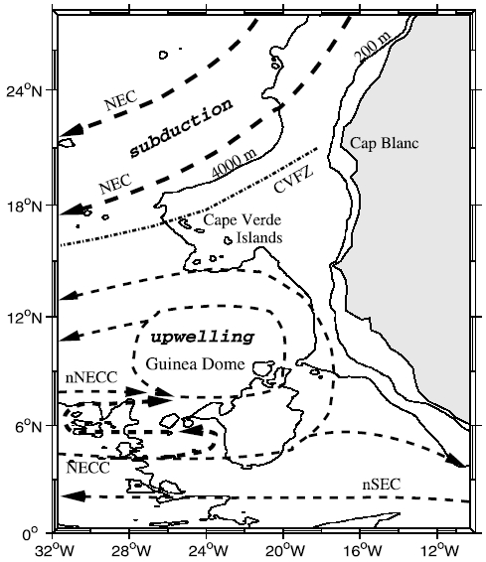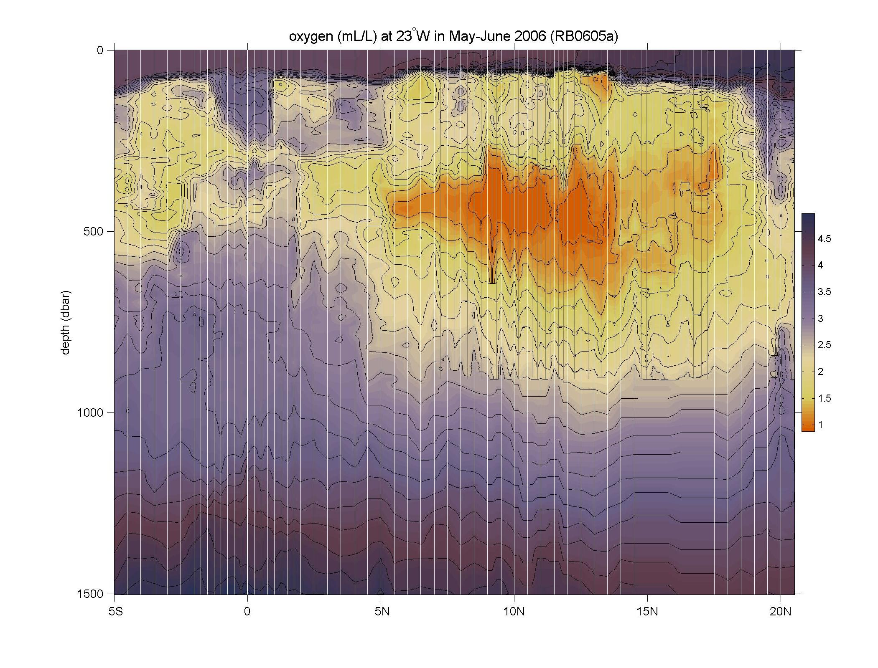

Fig. 2: Left: schematic of surface currents and features in the northeastern TA, from Stramma et al. (2005). Right: oxygen (mL/L) measured during the 2006 PNE cruise aboard Ronald H. Brown, showing the pronounced oxygen minimum.

The Tropical North Atlantic is the Main Development Region (MDR) of tropical cyclones. Many major hurricanes that ultimately threaten the eastern United States begin as atmospheric easterly waves that propagate off the African continent. Once over the MDR in the band 10-20ºN, these waves are exposed to convective instability driven by the upper ocean’s heat content. The resulting infusion of energy can result in closed cyclonic circulation and development from tropical depression to tropical storm and hurricane. These hurricanes are known as Cape Verde-type hurricanes, to distinguish them from storms forming further west, and they are often the most powerful storms to strike the US east coast. Prominent examples include Andrew (1992), Floyd (1999) and Ivan (2004). An average season has two Cape Verde hurricanes, but some years have up to five while others have none. There is profound uncertainty regarding the specific atmospheric/oceanic conditions that determine which of the atmospheric waves will develop into tropical cyclones and then hurricanes (on average, one of ten; J. Dunion, personal communication). Specifically, the quantitative effects of the Saharan Aerosol Layer (SAL), anomalous sea surface temperatures (SST), upper layer oceanic heat content and atmospheric wind shear on the formation of tropical cyclones are poorly known.

Seasonal tropical storm and hurricane forecasts are generated annually and based primarily on statistical analyses of historical data and the formulation of empirical predictors (e.g., ENSO index, Atlantic SST, Sahel rainfall, etc.). Recent empirical studies have demonstrated that tropical storm and hurricane activity in the Atlantic Ocean varies on decadal and multi-decadal time-scales and that this variability is correlated with sea-surface temperature anomalies in the MDR (e.g., Shapiro and Goldenberg, 1998). The SST signal in the MDR has been correlated with the North Atlantic Oscillation (NAO) on decadal time-scales. The multi-decadal signal indicates that an extended period of increased hurricane activity is to be expected. Other historical studies have also demonstrated spatial variability in storm formation areas and landfall locations on longer timescales.

Despite the climate and weather significance of the Tropical North Atlantic region, it was not sampled by the PIRATA backbone array apart from the 38W line of moorings extending north to 15N (Fig. 1). In 2005, a formal Northeast Extension of PIRATA was proposed as a joint project between NOAA/AOML and PMEL (Rick Lumpkin, Mike McPhaden and Bob Molinari, co-principal investigators). This PIRATA Northeast Extension (PNE) was proposed to consist of four moorings, three creating a northward arm up 23°W (building upon the equatorial backbone mooring there), and a fourth extending the 38°W arm to 20°N.

In June 2006, the first two moorings of this extension were deployed during RB-06-05a. The mooring at 11.5°N, 23°W was deployed on June 7, and the mooring at 4°N, 23°W was deployed on June 11. Both moorings were replaced in May 2007, during RB-07-03, and two more moorings were added at 20.5°N, 23°W and 20°N, 38°W. The four moorings, which report meteorological and oceanographic data onto the Global Telecommunications System for weather and climate forecasting need to be serviced annually. In the Memorandum of Understanding from the PIRATA-12 meeting (November 2006), the United States agreed that

[I]t is recognized that the Parties are dependent upon year-to-year funding allocations from their governments, and thus commitments for future funding and logistical support cannot be guaranteed. Given this proviso, the Parties affirm that PIRATA is a high priority for Brazil, France, and the United States, and that the institutions are making plans for continued support … NOAA will provide ship time for maintenance of four moorings in the North East Extension.

The fall 2015 cruise, this time on a charter ship, serves to honor this commitment.

Aerosols and Ocean Science Expeditions (AEROSE)

The African continent is one of the world’s major source regions of mineral dust and biomass burning aerosols. Saharan dust storms are estimated to inject over three billion metric tons of mineral aerosols into the troposphere annually, with large quantities advecting over the tropical North Atlantic within outflows caused by tropical easterly winds and waves. These aerosols impact phenomena ranging from cloud seeding and precipitation, to ocean fertilization, and to downstream air quality and ecosystem impacts in the Caribbean and U.S. eastern seaboard. Red tides, increasing rates of asthma, and precipitation variability in the eastern Atlantic and Caribbean have been linked to increases in the quantities of Saharan dust transported across the Atlantic. The contribution of the Saharan air layer (SAL) to the development of the West African Monsoon (WAM) and its role in tropical cyclogenesis are just beginning to be understood. The interplay between thermodynamics, microphysics, and aerosol chemistry are currently unknown and these field measurements represent a unique data set for unraveling these complex interactions. These issues make the need for understanding the mobilization, transport, and impacts of aerosols originating from natural and anthropogenic processes in Africa a high priority. Unfortunately, large uncertainties remain in our full understanding of the impact of Saharan mineral dust and sub-Saharan biomass burning aerosols on the weather and climate of the tropical Atlantic. It is thus important that we address these gaps in our understanding of regional and trans-boundary aerosol issues. ..

The NOAA Aerosols and Ocean Science Expeditions (AEROSE) constitute a comprehensive measurement-based approach for gaining understanding of the impacts of long-range transport of mineral dust and smoke aerosols over the tropical Atlantic (Morris et al., 2006; Nalli et al., 2011). The project, involving international coordination of monitoring in Puerto Rico, Mali, the Canary Islands, and Senegal, hinges on multi-year, trans-Atlantic field campaigns conducted in extended collaboration with PNE project over the tropical Atlantic. AEROSE is supported through collaborative efforts with NOAA’s National Environmental Satellite Data and Information Service, Center for Satellite Applications and Research (NESDIS/STAR) and the National Weather Service (NWS), as well as NASA and several academic institutions linked through the NOAA Center for Atmospheric Sciences at Howard University.

The AEROSE campaigns (to date, comprised of nine separate trans-Atlantic Project legs) have thus provided a set of in situ measurements to characterize the impacts and microphysical evolution of continental African aerosol outflows (including both Saharan dust and sub-Saharan and biomass burning) across the Atlantic Ocean (Nalli et al., 2011). AEROSE has sought to address three central scientific questions (Morris et al., 2006):

- How do Saharan mineral dust aerosols, biomass burning aerosols, and/or the SAL affect atmospheric and oceanographic parameters during trans-Atlantic transport?
- How do the aerosol distributions evolve physically and chemically during transport?
- What is the capability of satellite remote sensing and numerical models for resolving and studying the above processes?

Specific objectives of the cruise

The objectives of this project address NOAA’s Climate Goal and Weather and Water Goal, and are an explicit NOAA contribution to the PIRATA and AEROSE programs. Specific goals are in the areas of oceanography, marine meteorology, atmospheric chemistry and satellite validation.

Oceanography: Numerical models that are used to simulate the coupled air-sea system and to forecast atmospheric climate are notoriously inaccurate in the eastern tropical Atlantic. For example, the majority of the models cannot simulate the sign of the equatorial sea surface temperature (SST) gradient. They show cold water in the west and warm water in the east, exactly out of phase with observed conditions. The main objective of the oceanographic component of this cruise is to collect the data needed to evaluate the terms in the heat budget of the upper ocean and to compare the observed results with model results. The comparison should identify areas/processes of model deficiencies. Four ATLAS moorings and one TFlex mooring will be recovered and redeployed. The purpose of these moorings is to provide time series of the upper ocean temperature, salinity, current structure and heat fluxes between the ocean and atmosphere. The data collected by these moorings, which are located in the main development region of tropical cyclones, are also useful for monitoring and studying the formation of these storms. Shipboard observations will include upper ocean and surface heat flux data along 23°W, from 5°S to 20.5°N. These observations will be supplemented by data from surface drifters and profiling floats to be deployed during this and other cruises to the area. Combining the various data will allow estimation of the terms in the heat budget. Data to be collected provide an improved picture of seasonal-to-interannual variability.

Marine Meteorology: Atmospheric data will be collected to characterize the vertical structure of the Saharan air layer (SAL) (e.g., Nalli et al., 2005; 2011), including mineral dust aerosol over the Atlantic Ocean. The atmospheric data will also be used to investigate the effect of the SAL on the marine boundary layer, clouds, precipitation, and surface radiation balance.

Recent work by Min et al 2009 indicates that ice particles are abundant in the dusty sectors of deep tropical convective systems that have entrained Saharan mineral dust. This is particularly evident at altitudes at which heterogeneous ice nucleation is a dominant process. Other studies suggest that mineral dust may be of critical importance in precipitation processes but studies are inconclusive regarding whether it suppresses or enhances rainfall in tropical systems. The AEROSE team will take advantage of opportunistic events where dust storms are ingested into deep convective systems via soundings, ship-based lidar, optical and chemical determination of the dust load composition, Suomi NPP, A-train and/or other relevant satellite observational overpasses.

Atmospheric Chemistry: Profile measurements of the atmosphere will be conducted to investigate the linkages between the vertical distributions of tropospheric ozone with dust and biomass burning outflows (e.g., Nalli et al., 2011). Historical data show a seasonal variation in tropospheric ozone that peaks during June-August. The origins of this peak remain uncertain and may be due to anthropogenic sources (e.g., transport from biomass burning in the Congo Basin) or natural sources (e.g., lightning over West Africa, stratospheric injections).

Current atmospheric chemistry models are challenged by the need to account for a variety of processes in dense aerosol outflows. Very few in-situ measurements have been reported for tropical air masses that are rich in mineral dust aerosols, biomass burning aerosols, West African megacity urban aerosols, and/or mixtures of these aerosol types that characterize the trade wind and SAL outflow regimes. AEROSE will extend its record of key measurements of trace gases that will allow for better constraints on the chemistry within these outflows. The measurements include ozone, carbon monoxide, sulfur dioxide, NOx (nitric oxide and nitrogen dioxide), methane, and aggregate non-methane volatile organic carbon species (VOC).

A comprehensive suite of aerosol measurements and in situ sampling will also be performed in order to quantify the microphysical and chemical evolution of the Saharan dust during trans-Atlantic transport, to characterize aerosol mixing, to identify microbial distributions and microbial load on the aerosols, to determine evidence for heterogeneous chemistry within dusty air mass outflows. Offline microbiological and chemical composition as a function of size and source region will be performed so sample collection and processing will be conducted prior to freezing filter samples collected during the cruise. Number distributions will be measured continuously for Aitken, accumulation mode, and fine aerosols using mobility analyzers and optical particle counters. Mass density and gravimetric aerosol analysis will be performed using a suite of tandem quartz crystal cascade impactors, cyclone impactors, and high volume gravimetric sequential samplers.

Satellite validation: Visible, microwave, infrared and in situ measurements will be collected to support the calibration/validation and improvement of advanced satellite retrievals and data products (Nalli et al., 2011) including the NOAA R-Series Geostationary Operational Environmental Satellite (GOES-R) (e.g., Xie et al., 2013), and especially the Suomi National Polar-orbiting Partnership (S-NPP) satellite NOAA-Unique CrIS/ATMS Processing System (NUCAPS) (Nalli et al., 2013).

E. Participating Institutions

a) Atlantic Oceanographic and Meteorological Laboratory (NOAA/AOML)
4301 Rickenbacker Causeway
Miami, FL 33149 USA
Telephone: 001 305 361 4313
Facsimile: 001 305 361 4412

b) Pacific Marine Environmental Laboratory (NOAA/PMEL)
7600 Sand Point Way NE
Seattle, Washington 98115
Telephone: 001 206 526 6239
Facsimile: 001 206 526 6815

c) Earth System Research Laboratory (NOAA/ESRL)
Physical Sciences Division (PSD)
325 Broadway
Boulder, CO 80305-3337

d) NOAA/NESDIS Center for Satellite Applications and Research (STAR)
NOAA Center for Weather and Climate Prediction (NCWCP) Bldg
5830 University Research Court
College Park, MD 20740-3818
Telephone: 001 301 683 3608

e) NOAA Center for Atmospheric Sciences (NCAS)
Howard University Research Building 1
840 7th Street NW Washington, DC 20001
Telephone: 001 202 864 8678
Facsimile: 001 202 865 8294

F. Personnel (Science Party)

Name
- Claudia Schmid
- Pedro Pena or Andy Rawson
- Zach Barton(?)
- Shaun Dolk(?)
- Eric Ulhorn(?)
- Nicholas Nalli
- Vernon Morris
- XXXXXXXXXXXXX TBD
- ... will update list once I have the names, up to 25 participants

G. Administrative
1. Points of Contacts:

PNE Project Lead: Dr. Rick Lumpkin
Atlantic Oceanographic and Meteorological Laboratory
4301 Rickenbacker Causeway Miami, FL 33149 USA
Telephone: 305-361-4513 Fax: 305-361-4412
Rick.Lumpkin@noaa.gov
Chief Scientist: Dr. Claudia Schmid
Atlantic Oceanographic and Meteorological Laboratory
4301 Rickenbacker Causeway Miami, FL 33149 USA
Telephone: 305-361-4313 Fax: 305-361-4412
Claudia.Schmid@noaa.gov
watch leader: Dr. Rick Lumpkin (contact above)
Alternate Point of Contact: LCDR Stephen Meador
Atlantic Oceanographic and Meteorological Laboratory
4301 Rickenbacker Causeway Miami, FL 33149 USA
Telephone: 305-361-4544 Fax: 305-361-4449
aoml.associate.director@noaa.gov

Agent in Las Palmas: TBD XXXXXXXXXXXXX

2. Diplomatic Clearances

Research clearance is needed for Cape Verde, Canary Islands, Guinea, Guinea-Bissau, Senegal, The Gambia, Mauritania, Western Sahara.

Clearance has been initiated 22 April 15 by CMRE of the R/V Alliance through Germany.

3. Licenses and Permits

not applicable

II. Operations
A. Staging and Destaging

Staging for the cruise will be conducted in Las Palmas. Equipment characteristics are given in Appendix B. What to expect:

AOML Equipment for the collection of hydrographic data.

Drifters and floats.

AOML will require the assistance [Yves Perron: We are investigating possibility to have our own computer technician remain on board for a few extra days (from previous cruise) to help set up lab computers. We will need to figure out the network configuration that is requested by NOAA. Claudia: We can discuss what information about the computers we are bringing will need to be provided prior to the cruise via email or phone call.] to help install computer systems. [Yves Perron: We will need to ascertain if the network for NOAA will be interfacing with ship science net or will be independent. Special IT security provision may have to be put in place. Extraction of data from ship system will also need to be clarified in terms of computer security. Claudia: some of this can maybe be taken care off before we arrive at the ship (e.g.: antivirus scans, ...)?]

Everything needed for recovery/deployment of three ATLAS moorings and one TFlex mooring and the recovery of one TFlex mooring. Most of this equipment needs to be stored near the fantail.

RSMAS M-AERI: installation requires a crane lift. The most recent image with the suggested installation location is in Appendix D.

NCAS van: 20 ft van [Yves Perron: This can be accommodated forward. Shore crane to load on board will be required. Need to identify power requirement. Loading of 20 ft container forward will necessitate juggling the use of data and oceanographic winches. Once we have more information on the equipment, we can sort out location with a load plan that everyone can agree to well in advance.]with standard fitting. The plan is to load the van with a rented crane if necessary (expected weight more than 15,000 lb). NCAS requires engineering help on connecting van to ship's power supply before departure. A NCAS team will work on sensor installation while in port.

NCAS requires help unloading and securing gas cylinders (30 about 4.5 ft tall), secured on near the site where the launching is done (see Appendix D for proposed location). Note that adequate deck clearance is necessary for launching balloons from the port and starboard quarter rails. The ESRL sounding system must be set up in a nearby lab.

Small items loading needs to be coordinated with the OPS if not included in the NCAS van. NCAS will take care of them.

De-staging of all equipment will occur in Las Palmas.

B. Operations to be Conducted

The primary goal of the cruise is to recover and redeploy the Atlas moorings of the PIRATA Northeast extension and to continuously sample oceanic and atmospheric variables along the cruise track. A CTD section will be taken along 23°W from 20.5°N across the equator. This section will extend to 5°S, if enough time is available. CTD station locations are given in Appendix H. The actual hydrographic stations sampling plan may deviate from this proposed plan in both number of stations and their locations. Some CTD station locations are in Cape Verde’s EEZ.

The ship will depart from Las Palmas and proceed to the first PNE mooring near 20ºN, 38°W. A hydrographic test cast will be performed along the way (near 25ºN, 25ºW). At the first PNE mooring station at 20ºN, 38°W to recover and deploy the ATLAS mooring. At all mooring sites a the bottom topography needs to be monitored prior to dropping the anchor, small boat operations may be required and a hydrographic cast will be performed. We intend to use the ships boat for the small boat operations, manned by the ship crew and one or two scientists needed to do the work on a mooring buoy. The ship will then proceed to the second mooring site near 20.5°N, 23°W to recover and deploy an ATLAS mooring. From there on a hydrographic line will be conducted along 23°W to 5ºS if time allows, detouring slightly eastward around the Cape Verde plateau. Station locations, which are subject to small changes, are listed in Appendix F. The southern end point of this section depends on the time needed to return to Las Palmas. Along this line, two more moorings will be replaced at 11.5ºN and 4ºN. The Tropical Flex (TFlex) mooring near 4ºN will also be recovered. In addition, the equatorial Atlas mooring at 23°W may be serviced (tube and or sensor swap) if necessary. Once the work has been completed, the ship will head back to Las Palmas.

Atmospheric data will be collected throughout the cruise. Changes in speed may be required for radiosonde launches which will be done at positions determined by the atmospheric scientists and based on satellite overpass predictions determined on the ship while underway (i.e., pre-cruise positions cannot be provided). Small changes in heading may also be required for large-balloon ozonesonde launches, depending on wind conditions. XBT casts will be performed throughout the cruise. Satellite tracked surface drifters and Argo floats will be deployed along the trackline at locations determined by the Chief Scientist. Pre-cruise deployment locations cannot be provided as final deployment sites will be determined by the locations of floats and drifters previously deployed.

Data to be collected and operations
- Recovery and redeployment of ATLAS moorings at 4°N, 23°W and 20.5°N, 23°W and 20°N, 38°W. Recovery of one TFlex mooring at 4°N, 23°W. Deployment of one TFlex mooring at 11.5°N, 23°W. Recovery of one ATLAS mooring at 11.5°N, 23°W.
- Repair Atlas mooring at equator, 23W if necessary.
- We presently have 2 moorings near 4°N 23°W, an ATLAS mooring and a T-Flex mooring which has 11 Aquadopp current meters in the upper 85m. The velocity data from these 11 current meters on TFLex are coherent with each other but not coherent with the current meter data at 10m on the ATLAS mooring. We are trying to determine which of the two moorings is providing the more accurate data. Record shipboard ADCP data for approximately 2 hours as the ship stands near these 4°N 23°W moorings before the moorings are recovered. The shipboard velocity profiles would provide helpful information for our analysis of the mooring data.
- CTD profiles along 23°W and at the Atlas mooring locations. CTD casts will include the CTD unit and a Rosette sampler with 12 bottles. The maximum depth of most casts will be 1500 m, a cast to about 3500 m is planned near the equatorial mooring site. The ships data winch will be used for the CTD casts. The cast rate is about 60m/min. We will need a package tracking system and display for the CTD operations (Knudsen/Bathy2000).
- Salinity of the water samples collected with the bottles on the CTD rosette. (analyzed on board)
- Dissolved oxygen concentration in the water samples collected with the bottles. (analyzed on board)
- Continuous recording of ship mounted ADCP data. (see section "Disposition of Data and Reports" for more information)
- Continuous recording of heading data from both the gyro compass system and the GPS system for comparison of heading quality for the gyro compass system. (see section "Disposition of Data and Reports" for more information)
- Continuous recording of Thermosalinograph (TSG). (see section "Disposition of Data and Reports" for more information)
- Launching of about to 200 XBTs. (using the ship's XBT system with our XBTs).
- Deployment of Argo floats along the trackline as specified by the Chief Scientist. No slow-down or stop is required.
- Deployment of surface drifters along the trackline as specified by the Chief Scientist. No slow-down or stop is required.
- Lidar aerosol and wind observations (NCAS)
- Sun photometer measurements (NCAS)
- Tropospheric profiles of pressure, temperature, humidity and wind from launching of approximately 60 Vaisala RS92 radiosondes during Suomi NPP and A-Train overpasses. They will be launched with small (200 g) balloons at locations along the trackline specified by the Chief Scientist. (STAR/NCAS)
- Ozone profiles from launching of 20 ozonesondes during Suomi NPP and A-Train overpasses. They will be launched with large (1200 g) balloons at locations along the trackline specified by the Chief Scientist. (NCAS/STAR)
- Laser particle counters (NCAS)
- Ceilometer (ESRL)
- Marine Atmospheric Emitted Radiance Interferometer (M-AERI) (an infrared Fourier transform spectrometer (FTS)) to measure uplooking and downlooking spectral radiances, marine boundary layer profiles of temperature and water vapor, and skin SST (UM)
- Broadband pyranometers and pyrgeometers to measure downwelling solar (visible) and terrestrial (infrared) radiation (NCAS)
- Ambient trace gas (O₃, CO, SO₂, NO_{x}, VOC, CH₄) measurements (NCAS)
- Aerobiological sampling (NCAS)
- Partiosol 2025 Sequential high-volume aerosol sampler (NCAS)
- Low-volume bulk sampler for fungi and chemical analysis (NCAS)
- Scanning Mobility Particle Sizer (NCAS)
- Aerosol Particle Sizer (NCAS)

III. Equipment
A. Equipment and Capabilities Provided by the Ship

Scientific Equipment requested from the Ship
- 24/7 Internet capabilities (both for email and scientific transfer of data/images).
- CTD deck unit (SBE11) for SBE9
- Data Winch system and readouts (ideally using 322 conducting cable for CTD operations, specs of the cable were provided already).
- Echo Sounder (Ocean Data Equipment Corporation (ODEC) Bathy 2000 or the Knudsen system) used in 12 kHz mode (to track CTD package to within 10 meters of the bottom) to be used while on CTD station.
- 12 kHz echosounder to monitor bottom topography at mooring sites and CTD stations.
- Barometer
- WOCE IMET sensors (see section "Disposition of Data and Reports" for more information on what data AEROSE needs)

- Hull mounted acoustic Doppler current profiler (RD Instruments (RDI), 75 kHz Ocean Surveyor acoustic Doppler current profiler) with gyro compass input.
- gyro compass system for acquisition of heading data used by acoustic Doppler current profiler.
- GPS system for acquisition of heading data.
- thermosalinograph (TSG)
- Winch and A-frame for ATLAS/TFlex deployment and recovery.
- XBT system
- A Guildline 8400B Autosal for processing salinity bottle samples.
- Need a room where we can keep the temperature stable to within one degree C with a portable AC unit. The programmer's room is probably the best one for this purpose.

B. Equipment and Capabilities Provided by the Scientists

In addition to the suite of oceanographic and meteorological instruments on board the Alliance, the science party will bring the following instruments and materials on board (see Appendix B for full specifications):

AOML equipment
see Appendix B

NCAS equipment
see Appendix B

NOAA/NESDIS equipment:
see Appendix B

NOAA/ESRL equipment:
see Appendix D

PMEL equipment
see Appendix E

IV. Hazardous Materials
see appendix A
MSDS for all chemicals on PNE will be available.

V. Additional Projects
No additional projects are expected to participate from the USA. Just in case this changes (i.e., some experiment from the previous cruise is to be continued): Any additional work will be subordinate to the primary project and will be accomplished only with the concurrence of the Commanding Officer and the Chief Scientist.

VI. Disposition of Data and Reports
A. Data Responsibilities

The Chief Scientist will be responsible for the disposition, feedback on data quality, and archiving of data and specimens collected on board the ship for the primary project. As representative of the program manager (Director, AOML), the Chief Scientist will also be responsible for the dissemination of copies of these data to participants in the cruise, to any other requesters, and to NESDIS in accordance with NDM 16-11 (ROSCOP within 3 months of cruise completion). The ship may assist in copying data and reports insofar as facilities allow.

Individuals in charge of piggyback projects conducted during the cruise have the same responsibilities for their project's data as the Chief Scientist has for primary project data.

DATA REQUIREMENTS (updated lists)
real-time display:
air pressure (hPa)
air temperature (Celsius)
relative humidity (RH)
true wind speed (m/s)
true wind direction
relative wind speed
relative wind direction
water surface variables (TSG, temperature, salinity)
ship ADCP data with primary and secondary heading (mechanical Gyro compass; mulch-antenna GPS or accelometer assisted gyro compass or POS/MV)
Course Over Ground (COG)
Speed Over Ground (SOG)
ship latitude/longitude coordinates (GPS and navigation system)
ship pitch, roll
time (UTC)
bottom depth
Data we need for research (i.e., archived on a DVD or other storage medium after the cruise):
air pressure (hPa)
air temperature
IR radiometer
relative humidity (RH)
true wind speed
true wind direction
water surface variables (TSG, temperature, salinity)
ship ADCP data with primary and secondary heading (mechanical Gyro compass; mulch-antenna GPS or accelometer assisted gyro compass or POS/MV)
Course Over Ground (COG)
Speed Over Ground (SOG)
ship latitude/longitude coordinates (GPS and navigation system)
ship pitch, roll
time (UTC)
bottom depth

Ideally, the temporal resolution of these data is 2 minutes and they will be continually recorded throughout the cruise. If we receive instructions on how to collect the data and can ask questions via email if problems arise, we should be able to archive the records necessary for our research ourselves.

We will need copies of the navigational log sheets. Format: paper copy or electronic copy of the ship logs, no specific format required, should contain date/time/position/work done/other notes of interest recorded by a ship officer.

APPENDICES

Appendix A. List of Hazardous Materials XXXXXXXXXXXXX

NCAS
Person Responsible | chemical/compressed gas | quantity | unit | neutralizer
Vernon Morris | Helium | 30 | cylinders | none
Vernon Morris | UHP Nitrogen | 2 | cylinders | none
Vernon Morris | Air | 3 | cylinders | none
Vernon Morris | Hydrogen | 1 | cylinder | none
Vernon Morris | ethanol | 1 | 1-L | spill kit
Vernon Morris | toluene | 1 | 1-L | spill kit
Vernon Morris | Sodium Phosphate | 1 | 200-g | spill kit
Vernon Morris | Hydrogen peroxide | 1 | 0.5-L | spill kit
Vernon Morris | Drierite | 16 (1 case) | 0.5-L bottles | spill kit
Vernon Morris | hexane | 1 | 1-L | spill kit
OXYGEN
Person Responsible | chemical/compressed gas | quantity | unit | neutralizer
Pedro or Andy? | sodium iodide & alkaline Iodide | 3 | Liter | spill kit
Pedro or Andy? | Manganese Chloride | 3 | Liter | spill kit
Pedro or Andy? | Dilute H₂SO₄ (Sulfuric Acid) | 3 | Liter | spill kit
Pedro or Andy? | Sodium Thiosulfate | 10 | 17.5g | spill kit
Pedro or Andy? | potassium iodate | 3 | 3 Liter | spill kit

Appendix B. Equipment/Van List
1) AOML
one 20 foot container, about 9,000 lbs [Any suggestion for best location is welcome - one thing to consider is: most of the gear is needed for CTD work; in addition there will be surface drifters (light) and maybe a few Argo floats (bulky and heavy - 1 to 2 people can carry a float)].
List: see Appendix C

2) ATLAS/TFLEX MOORINGS (NOAA/PMEL)
a container will be used for shipping the gear. It will be offloaded in the port
List: see Appendix E

3) NCAS (see Appendix D for installation locations for not hand-held equipment)
- Van , 10,000 lbs, 20ft
- 30 He cylinders including rack
- radiometers
- Partisol sequential sampler
- bio-samplers
- Microwave radiometer on van
- Microtops sun photometers
- EN-SCI ECC ozone sondes
- QCM Cascade Impactors and control units
- Climet laser particle counter
- Partisol sequential aerosol sampler
- Staplex cyclone impactor
- Respicon 3-stage impactors
- Single-stage impactors
- Ceilometer
- MPL lidar
- MFRSR
- Broadband pyranometer
- Pyrgeometer
- TSI SMPS
- TSI APS
- Thermo Ozone monitor
- Thermo Carbon Monoxide monitor
- Thermo Sulfur Dioxide monitor
- Thermo VOC monitor
- Thermo NOx monitor
- Assorted pumps
- uas quadcopter
- small refrigerator for samples
- optical microscopes
- autoclave
- desiccant chamber
- CRDS system
- lightning detector

4) NESDIS/NCAS equipment
- Vaisala RS92 rawinsondes
- 200 g balloons

5) NCAS general laboratory requirements
Site: Main Laboratory: 24-30 feet of contiguous lab space (tables), storage cabinets, and benchtop – roughly 5-6 tables and seating for 9-10 persons
Bio-Lab: 6-ft of benchtop space and storage
Hazmat locker: Modest chemical stores
sonde launches from fantail and hangar

6) PMEL / Mooring Group Laboratory Space:
Interior lab space is required for mooring instrument testing and setup. A small amount of bench space (~2m) is necessary for instrument checkout and a satellite-uplink monitoring station used to receive transmissions from the buoy. A cable is run from the laboratory space to an outside antenna in an area that would allow an unobstructed view of the surface mooring during deployment operations. This “line of sight” path to the buoy allows for the reception of Argos transmissions while monitoring the instrumentation. _

7) NOAA/ESRL/NCAS equipment
see Appendix D

Appendix C: AOML equipment

one van with ~9,000 lbs:

DESCRIPTION | QTY
SBE 11 deck units | 1 or more
SBE43 DISSOLVE OXYGEN sensors | 6
SBE4 CONDUCTIVITY sensors | 6
SBE3 TEMPERATURE sensors | 6
SBE5 PUMP | 6
SBE 32 (PYLON) | 2
SBE9 CTD | 3
XSG type connectors | 3 or more
WHS300 | 3
ADCP BATTERY PACK | 2
CTD FRAME [Yves Perron: Any lifting appliances brought on board will need to have a valid safety certificate to be provided to the Master of the ship. Claudia: Working on it.] | 2
ALTIMETER | 2
STANDARD SEAWATER (CASE of 10) | 3
NIKSIN BOTTLES | 36
OXYGEN BOTTLES (CASE of 26) | 10
SALINITY BOTTLES (CASE of 24) | 12
OXYGEN TITRATION SYSTEM | 2
PORTABLE AC UNITS | 1
NIKSIN BOTTLES SUPPLIES BOX | 1
TOOL BOX | 1
OXYGEN SUPPLIES BOX | 1
LADCP SUPPLIES BOX | 1
SEABIRD SUPPLIES BOX | 1
FRAME HARDWARE BOX | 1
OFFICE SUPPLIES BOX | 2
LAPTOPS/DESKTOPS (CTDacq, CTDproc, LADCP, XBT, O2, Autosal) | 6
DRIFTERS | 15
XBT Hand Launchers | 2
XBT Probes (CASE of 12) | 13
Argo floats | <=10
Autosal | 1 or 2?
AC unit for autosal room | 1 or 2?
power strips | 6
Schuko Type E/F adapters | 6
Chemicals:
Alkaline Iodine Solution (320 grams/Liter) | 3 Liters
Manganese Chloride Solution (600 grams/Liter) | 3 Liters
Potassium Iodate Solution, Diluted (.3567 grams/Liter) | 3 Liters
Sodium Thiosulfate Crystals (17.5 grams/Vial) | 10 Vials
Sulfurica Acid, Diluted Solution (280 milliLiter/Liter) | 3 Liters

Complete CTD package weight: about 1,200 lbs

The autosal will be set up in the programmers room together with the portable AC unit.

CTD/rosette will be set up on fore deck. AOML technicians will be trained on how to do the termination. We are using XSG type connectors.
For the SEABIRD 9 system, no issues with compatibility between CTD and deck unit on the Alliance.
Appendix D: NOAA/ESRL/NCAS Equipment (PNE/AEROSE)

Background on Measurement Systems
The Physical Science Division (PSD) air-sea flux and cloud group conducts measurements of fluxes and near-surface bulk meteorology during field programs.
The air-sea flux system consists of six components:
(1) A fast turbulence system with ship motion corrections. The sensors are: GILL Sonic anemometer, Fast Ozone Sensor’s inlet, LiCor LI-7500 fast CO₂/hygrometer, and a Systron-Donner motion-pak.
(2) A mean T/RH sensor in an aspirator.
(3) Solar and IR radiometers (Eppley pyranometers and pyrgeometers).
(4) A near surface sea surface temperature sensor consisting of a floating thermistor deployed with outrigger (Sea Snake).
(5) A Riegl laser rangefinder wave gauge.
(6) An optical rain gauge. Slow mean data (T/RH, PIR/PSP, etc) are digitized on a Campbell 23x datalogger and transmitted via a combination of RS-232 and wireless as 1-minute averages. A central data acquisition computer logs all sources of data via RS-232 digital transmission:

PSD/Flux also operates two remote systems:
- Vaisala CL31 cloud base ceilometer
- Tera Scan Satellite receiver (Sea Space)

The ceilometer is a vertically pointing lidar that determines the height of cloud bottoms from time-of-flight of the backscatter return from the cloud. The time resolution is 30 seconds and the vertical resolution is 15 m.
A Tera Scan (SeaSpace) satellite receiver collects High Resolution Picture Transmission (HRPT) data from NOAA’s polar orbiting satellites (12, 14, 15, 17, 18). This system is permanently mounted on the Alliance and is available on all cruises to visiting scientists or for ship operations.

PSD is also the mentor for the weather balloon operations on board RHB. A Vaisala MW31 system is maintained by PSD and available to visiting scientists upon request. Expendables (balloons, radiosondes, helium, etc) are the responsibility of the person(s) requesting use of this system. This system can handle RS92 digital GPS radiosondes and ozondesondes.

Instrumentation Set-up
The primary flux sensors are already mounted on the forward jackstaff. [Yves Perron: ALLIANCE jackstay is relatively small and sensor equipment fitment will have to be analyzed for fitment in ALLIANCE. We will need to know by early June if ship mods are required as ship won’t be available alongside post mid July. Claudia: AEROSE will work on this.] Data cables run from the mast into the main lab. Three data loggers are mounted on the forward starboard side of the main lab. From these data-loggers cables are run into the Science Office forward of the main computer room. Two computers are setup in this lab and connected to the ship’s internet. Power to the instruments is supplied by the AC connections at the bottom of the jackstaff. [Yves Perron: Dependent on ship’s design. ALLIANCE jackstay may not be appropriate for the sensor to be mounted. Claudia: AEROSE will work on this.] A water hose is run from the O2 deck fresh water connection to the top of the jackstaff for rinsing the LiCor [Yves Perron: Need more detail on how it is viewed for ALLIANCE. Claudia: AEROSE will work on this.] sensor window. The sea surface temperature sensor (sea snake) is attached to a mounting arm located port-side O1 Deck.

The Vaisala radiosonde balloon sounding system stored in Boulder must also be deployed to the ship and set up aft nearby helium cylinders with space for filling balloons and access to the fantail for launches.

Should we keep any of the pictures below? [Yves Perron: Pictures are good but need to be relevant to ALLIANCE. Claudia: AEROSE will work on this.]

Attached are some photos of the M-AERI on a recent deployment. It is not on the mast, but on the railing on the deck above the bridge of the Italian R/V Minerva Uno. A similar position above the bridge on the Alliance will probably be our best option. The instrument needs a clear view of the sea surface ahead of the bow wave, and of the sky, to zenith, in the same direction.
We also install a set of met sensors, as you have seen on the RHB, and we think we can install these on the instrument platform on the foremast. I can send pictures of the RHB deployments, if needed, but not before next Monday - I am traveling and do not have them on my small laptop.
The all-sky camera that we also deploy with the M-AERI can be put on a railing on an upper deck where it has a clear view of the sky.
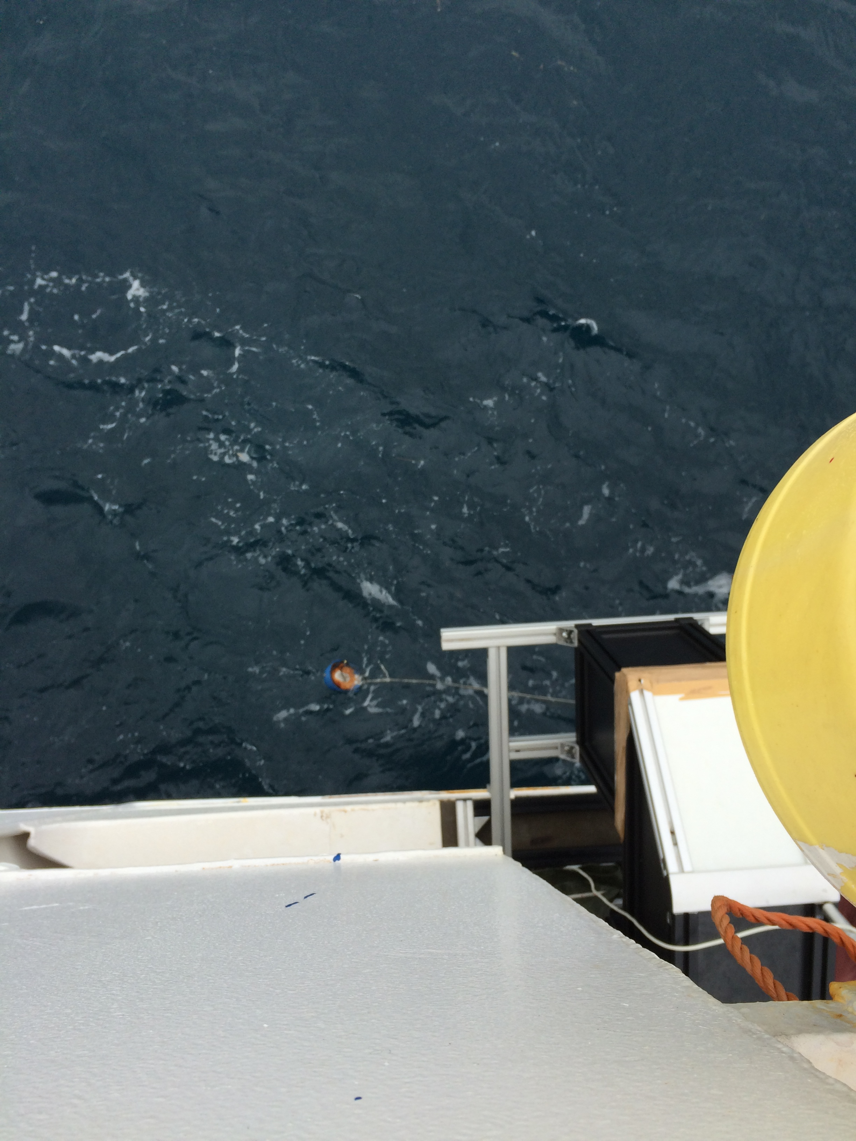
The hard hat (here viewed from above) for measuring skin sea surface temperature is usually deploys near the field of view of the M-AERI. We need to run the cable of the probe from the location into a dry area (lab) where the cable is connected to a multimeter and a computer.

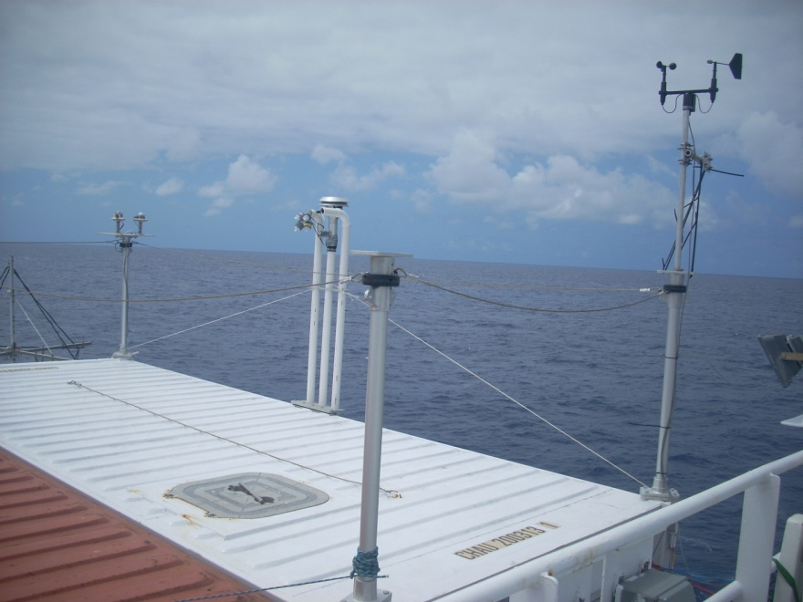
Howard University van (white) on 01 Level viewed from 02 Level showing meteorological instrumentation (right corner starboard), the aerosol and trace gas intakes (center starboard, and radiometers (left starboard corner). On the Alliance, the van will be in one of the container slots on the bow, so these sensors will need to be mounted on the mast or at some other location.
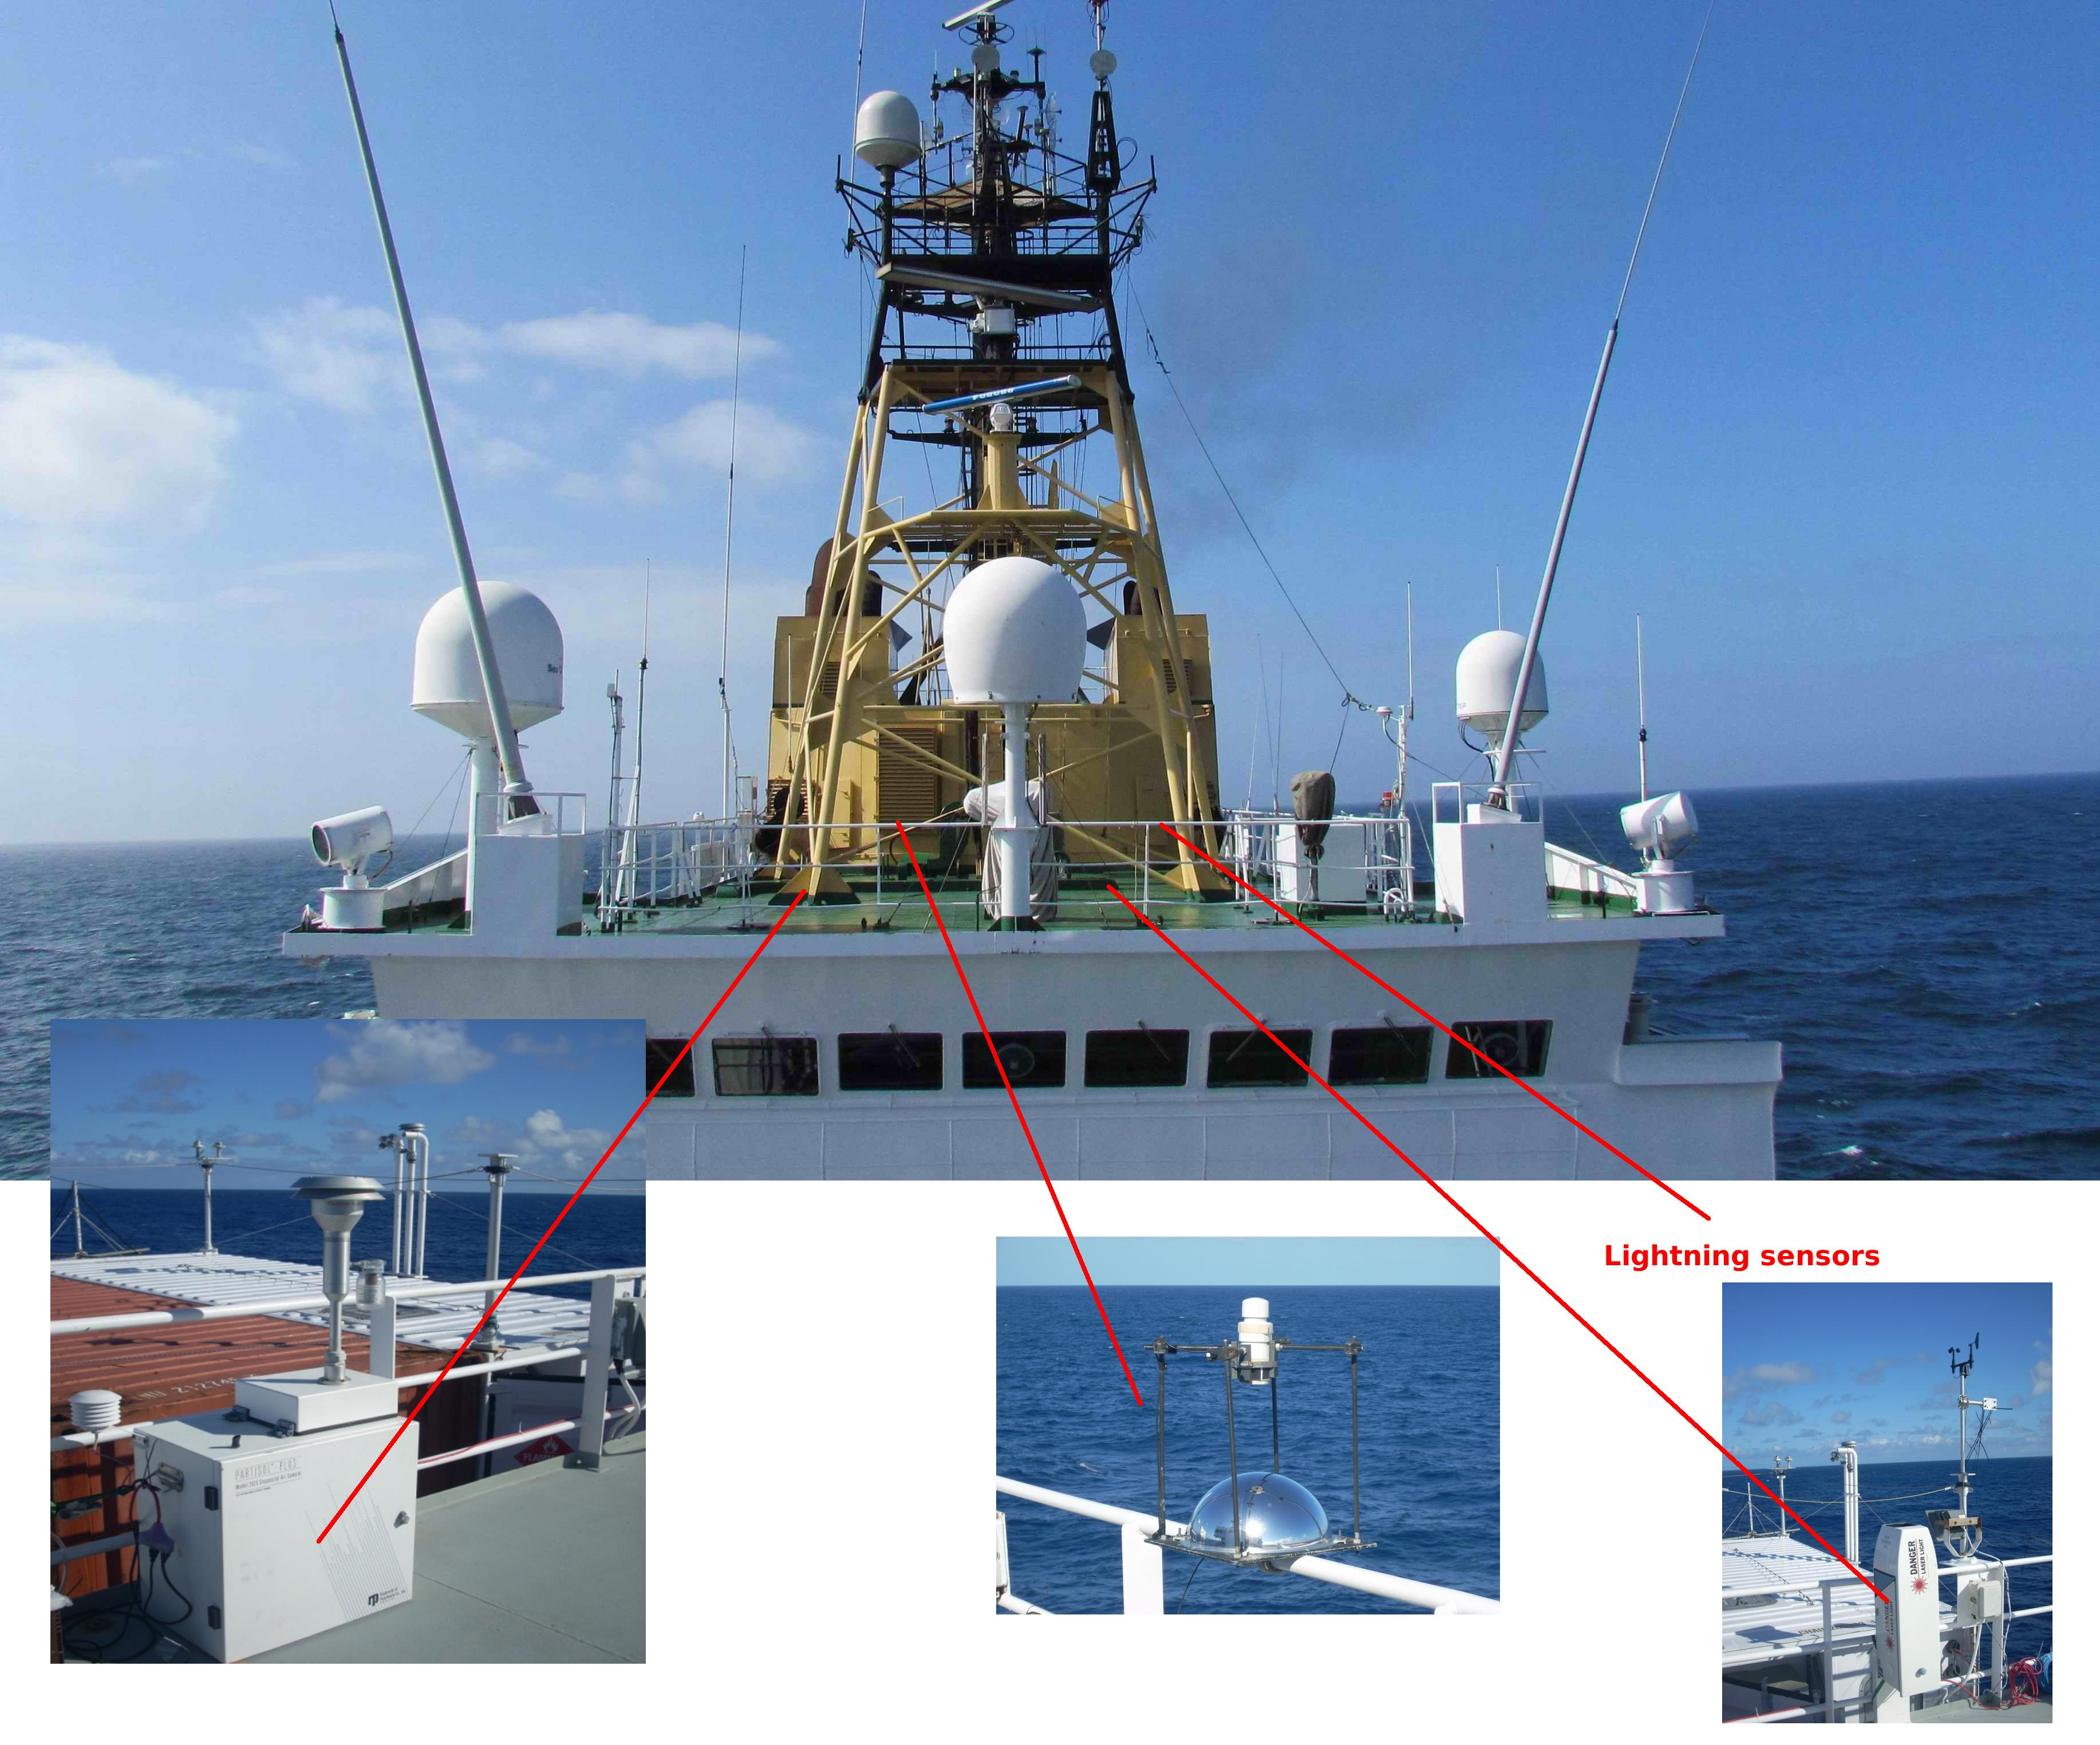
From left to right: Howard University Sequential Aerosol Sampler (PARTISOL)
UM/RSMAS all-sky imager needs to be far enough away from ship superstructure
NOAA/NCAS ceilometer (low-power lidar)
Lightning sensors (have no picture yet)

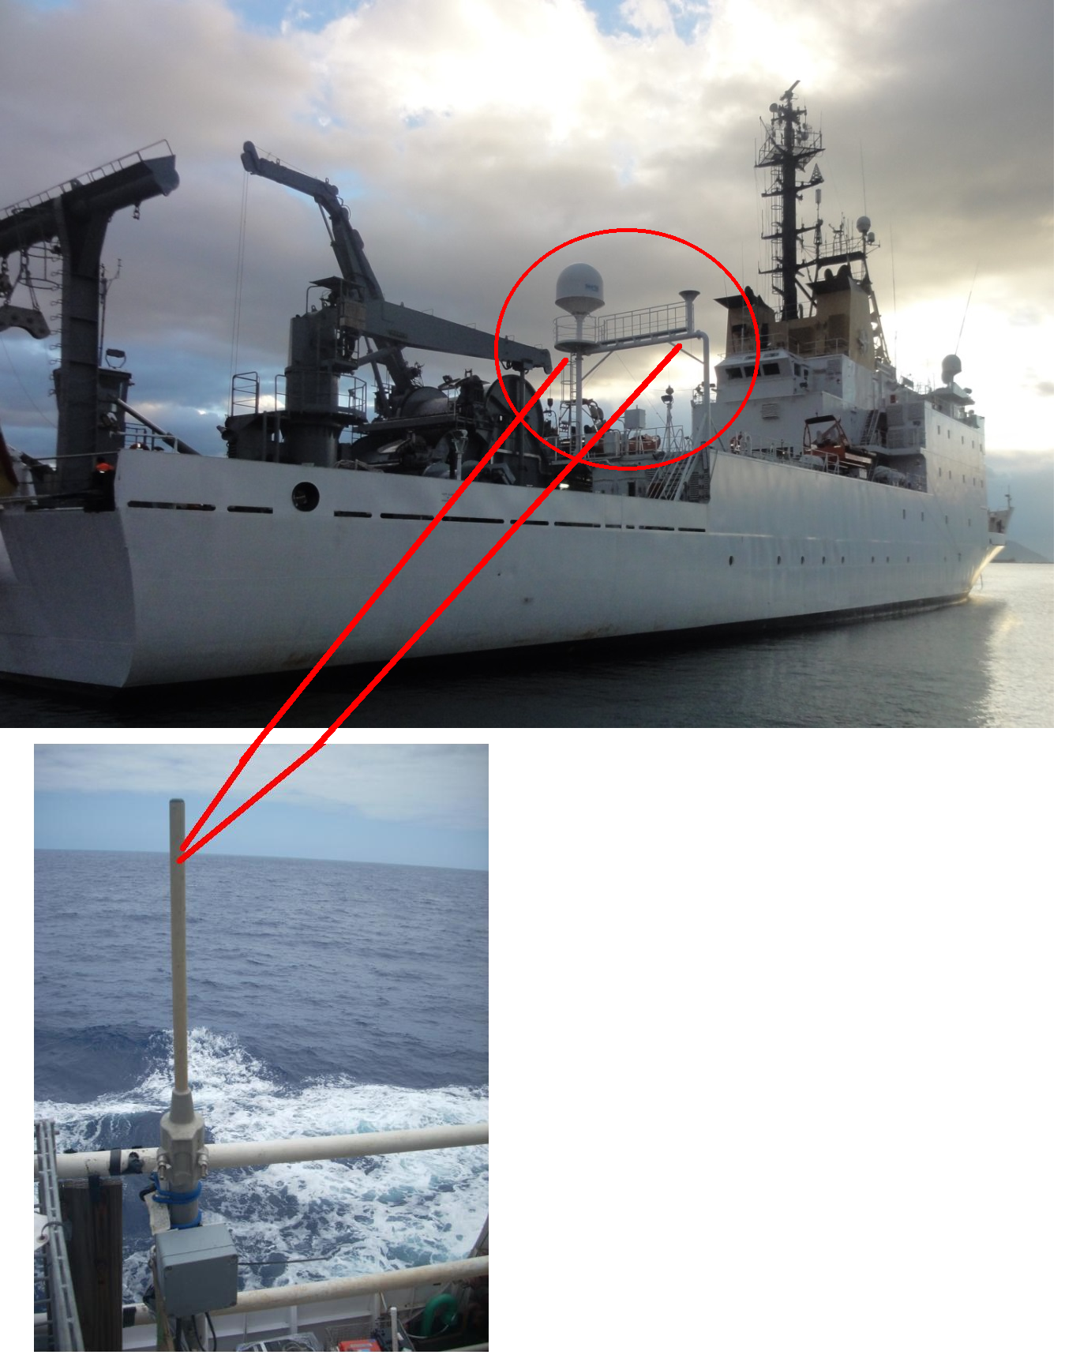
NOAA/NCAS sounding system antennas (telemetry and GPS), need cable access to the interior lab aft. They can be placed somewhere on the goalpost structure

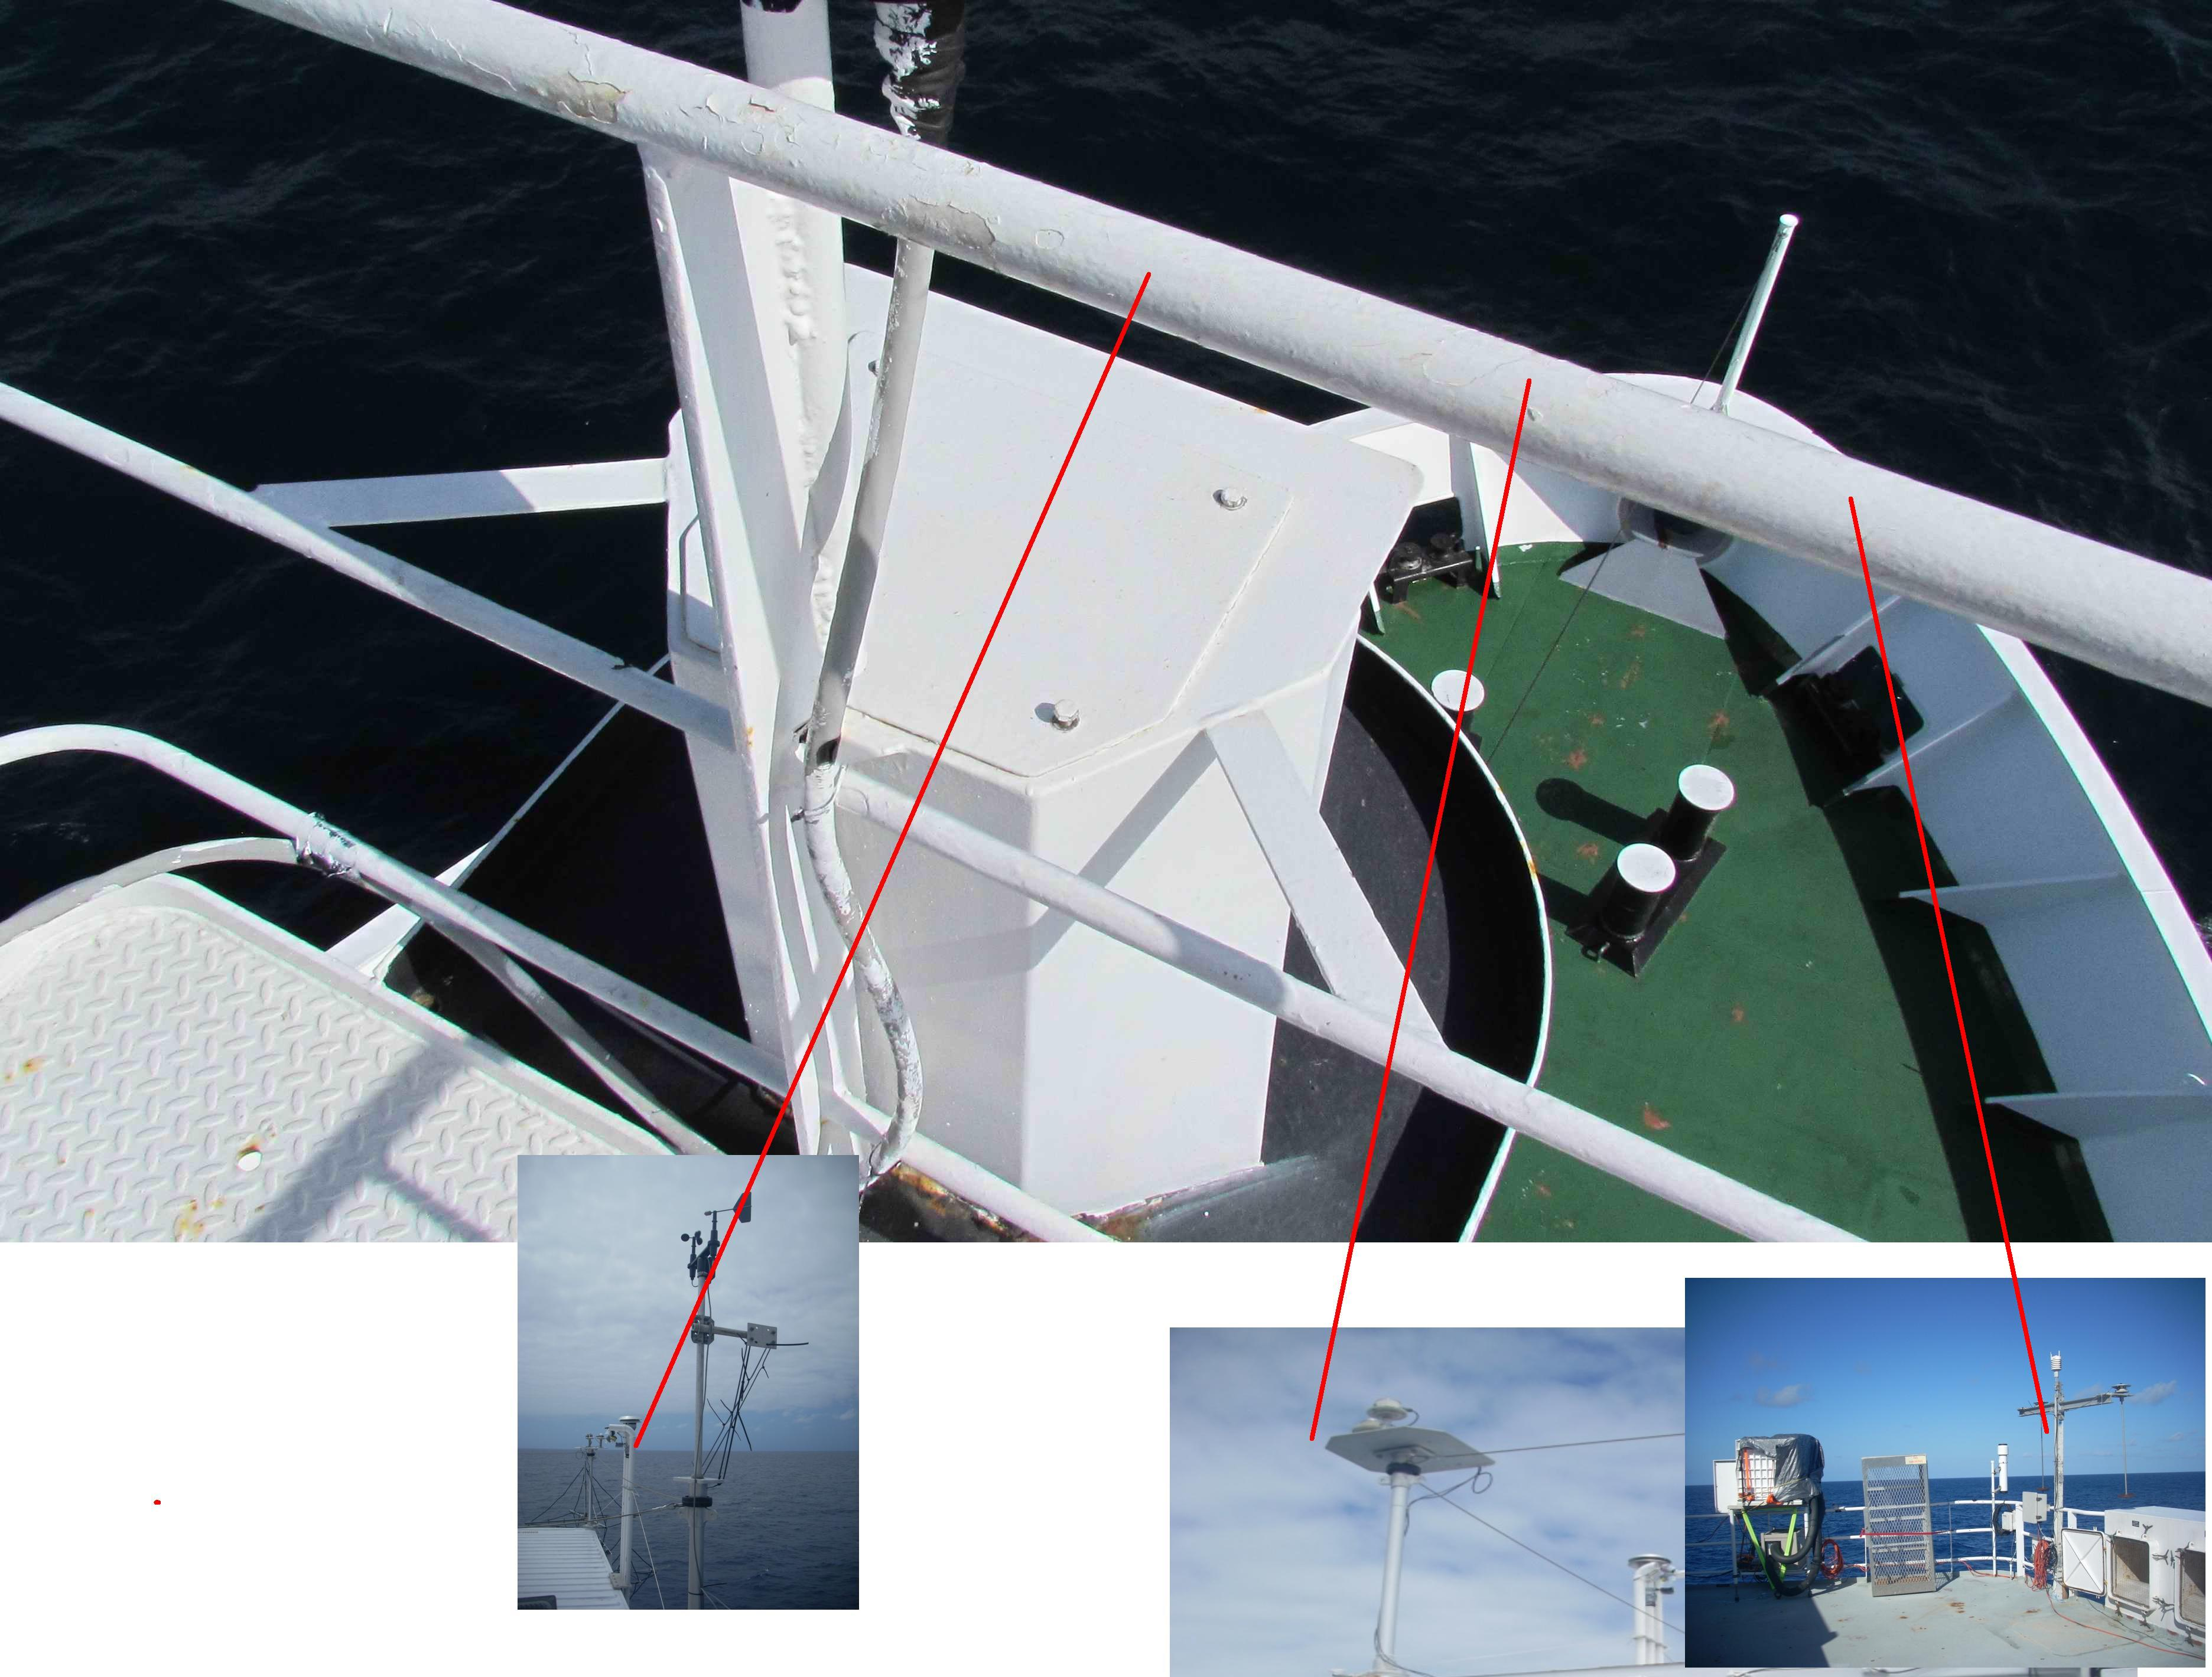From left to right:
Sampling manifold for aerosol and trace gases
NCAS radiometer and MFRSR
UM/RSMAS MAERI and broadband flux setup.

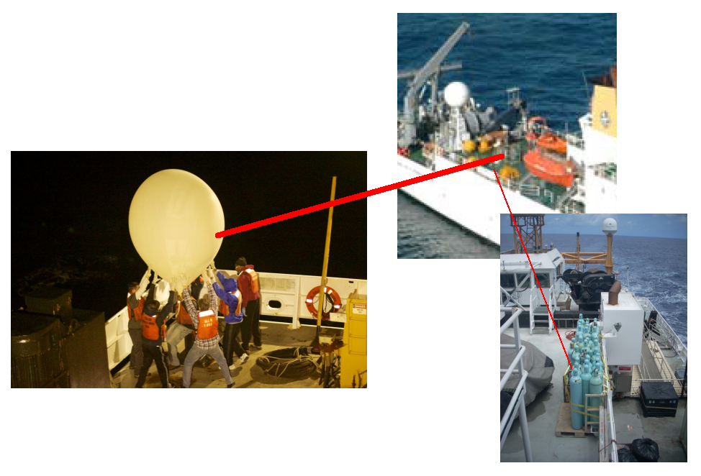
Balloon launch and helium tanks.
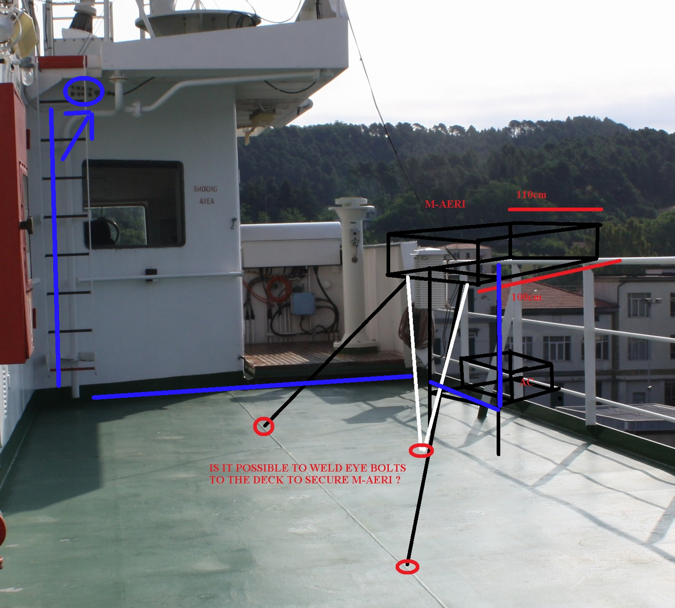
Proposed location of the UM/RSMAS M-AERI. It needs to be located forward with clearance to view sea surface beyond ship wake, but also somewhat near amidships to reduce sea spray and motion from ship pitch/roll.
Appendix E: NOAA/PMEL Equipment (PNE) [Yves Perron: The moorings and ballast can be loaded on aft deck and on boat deck. Claudia: there will be interaction with PMEL on the load plan]
Total weight ~ 23 tons
2X buoy/tower/bridle sets – 2345 lbs
3X 4400 lb. Anchors – 13,200 lbs
2X 5980 lb Anchors – 11,960
Misc. mooring supplies – 12,000 lbs:
- 8 spools Nilspin wire
- 5 tube boxes with meteorological equipment
- 8 temperature module boxes
- 1 box wind sensors
- 2 electronics support boxes (laptops, receivers, meters, cables, office supplies etc.)
- 1 hardware box
- 1 electronics toolbox
- 17 spools nylon
- 1 box of current meters
- 5 boxes of acoustic releases; 2 acoustic release deck sets.
- 1 box of mooring cables
- 1 box paint supplies
- 2 current meter stands
- 1 rolling tool cart, tools
- 1 pressure washer
- 1 reel 6 x 50m nylon
- 9 empty reels
- 1 reel 300m working line
- 1 Nylon cutter
- 1 box German O2 loggers, Module mounts, straps [The O2 loggers will be shipped directly between Germany and Las Palmas]
- 6 buoy leads
- 2 aluminum reel stands
- 1 box with turnaround kits for acoustic releases
- 3 815 lbs hydrophone anchors
- 8 boxes TFLEX buoy instruments, cables, and supplies
- 1 aluminum ladder
- 2 tube cages

Appendix F: Station Locations

CTD station | Latitude |  |  | Longitude |  |  | Notes
 | deg | min |  | deg | min
1 | 26 | 18 | N | 60 | 0 | W
 | 20 | 1 | N | 37 | 52 | W | ATLAS recovery/redeployment
2 | 20 | 1 | N | 37 | 52 | W
3 | 20 | 30 | N | 23 | 0 | W
 | 20 | 28 | N | 23 | 4 | W | ATLAS recovery/deployment
4 | 20 | 0 | N | 23 | 0 | W | First in Cape Verde EEZ
5 | 19 | 30 | N | 23 | 0 | W
6 | 19 | 0 | N | 23 | 0 | W
7 | 18 | 30 | N | 23 | 0 | W
8 | 18 | 0 | N | 23 | 0 | W
9 | 17 | 30 | N | 23 | 0 | W
10 | 17 | 0 | N | 22 | 49 | W
11 | 16 | 30 | N | 22 | 44 | W
12 | 16 | 0 | N | 22 | 36 | W
13 | 15 | 30 | N | 22 | 44 | W
14 | 15 | 0 | N | 22 | 52 | W
15 | 14 | 30 | N | 23 | 0 | W
16 | 14 | 0 | N | 23 | 0 | W
17 | 13 | 30 | N | 23 | 0 | W
18 | 13 | 0 | N | 23 | 0 | W
19 | 12 | 30 | N | 23 | 0 | W
20 | 12 | 0 | N | 23 | 0 | W | Last in Cape Verde EEZ
21 | 11 | 30 | N | 23 | 0 | W
 | 11 | 29 | N | 22 | 59 | W | ATLAS recovery/TFlex deployment
22 | 11 | 0 | N | 23 | 0 | W
23 | 10 | 30 | N | 23 | 0 | W
24 | 10 | 0 | N | 23 | 0 | W
25 | 9 | 30 | N | 23 | 0 | W
26 | 9 | 0 | N | 23 | 0 | W
27 | 8 | 30 | N | 23 | 0 | W
28 | 8 | 0 | N | 23 | 0 | W
29 | 7 | 30 | N | 23 | 0 | W
30 | 7 | 0 | N | 23 | 0 | W
31 | 6 | 30 | N | 23 | 0 | W
32 | 6 | 0 | N | 23 | 0 | W
33 | 5 | 30 | N | 23 | 0 | W
34 | 5 | 0 | N | 23 | 0 | W
35 | 4 | 30 | N | 23 | 0 | W
 | 4 | 3 | N | 22 | 57 | W | ATLAS recovery/redeployment
 | 4 | 0 | N | 23 | 0 | W | TFlex recovery
36 | 4 | 0 | N | 23 | 0 | W
37 | 3 | 30 | N | 23 | 0 | W
38 | 3 | 0 | N | 23 | 0 | W
39 | 2 | 30 | N | 23 | 0 | W
40 | 2 | 0 | N | 23 | 0 | W
41 | 1 | 45 | N | 23 | 0 | W
42 | 1 | 30 | N | 23 | 0 | W
43 | 1 | 15 | N | 23 | 0 | W
44 | 1 | 0 | N | 23 | 0 | W
45 | 0 | 45 | N | 23 | 0 | W
46 | 0 | 30 | N | 23 | 0 | W
47 | 0 | 15 | N | 23 | 0 | W
48 | 0 | 0 | N | 23 | 0 | W
 | 0 | 1 | S | 23 | 0 | W | ATLAS repair if necessary
49 | 0 | 15 | S | 23 | 0 | W
50 | 0 | 30 | S | 23 | 0 | W
51 | 0 | 45 | S | 23 | 0 | W
52 | 1 | 0 | S | 23 | 0 | W
53 | 1 | 15 | S | 23 | 0 | W
54 | 1 | 30 | S | 23 | 0 | W
55 | 1 | 45 | S | 23 | 0 | W
56 | 2 | 0 | S | 23 | 0 | W
57 | 2 | 30 | S | 23 | 0 | W
58 | 3 | 0 | S | 23 | 0 | W
59 | 3 | 30 | S | 23 | 0 | W
60 | 4 | 0 | S | 23 | 0 | W
61 | 4 | 30 | S | 23 | 0 | W
62 | 5 | 0 | S | 23 | 0 | W

