AOML GTSPP National Report 2014
Atlantic Oceanographic and Meteorological Laboratories (AOML)
Annual Report – 2013
Version 1.0
Date of update : May 29, 2014
Status
The global XBT network (Figure 1), formed by repeat transects recommended by the scientific community is a multi-national (US, France, Australia, South Africa, Brazil, Germany, Japan, Argentina, and Canada), multi institutional effort. There are 27 XBT transects that are maintained exclusively by AOML or by its US or international partners and in which AOML plays an active and continuous role in the deployment of XBTs, or transmission, data quality control, or data distribution of XBT observations (Table I).

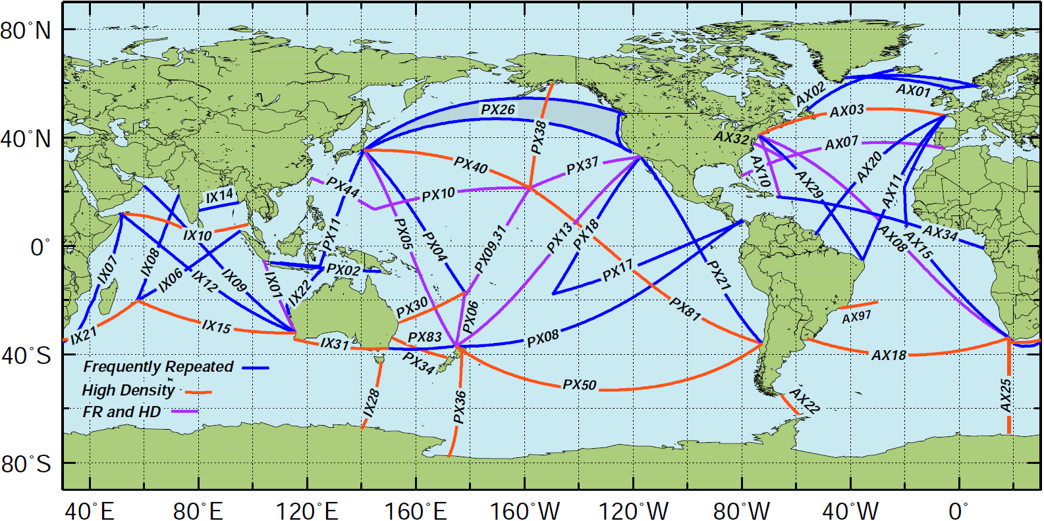

Figure 1. Location of the High Density and Frequently Repeated XBT transects recommended by OceanObs 2009. The countries leading the efforts to carry out each transect are indicated in Table 1.
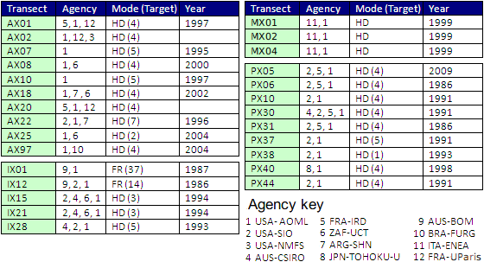
Table 1. XBT transects performed by the international community during FY2013, including their current status and the year in which operations on these transects started.
During FY2013, AOML continued with its XBT operations in High Density (HD) mode, where XBT deployments are done every 20-25 km and transects are repeated 2 to 10 times per year, depending on scientific requirements and logistics. A few transects, carried out in collaboration with international partners were carried out in Frequently Repeated (FR) mode. During FY2013, NOAA/AOML collaborated with its partners by providing probes, equipment, logistics, and/or data processing and transmission capabilities. Approximately 8,000 XBT deployments were done with AOML involvement during FY2013 (Table 2, Figure 2).

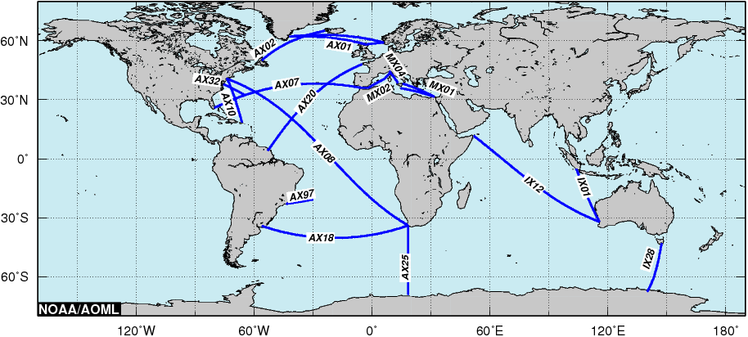
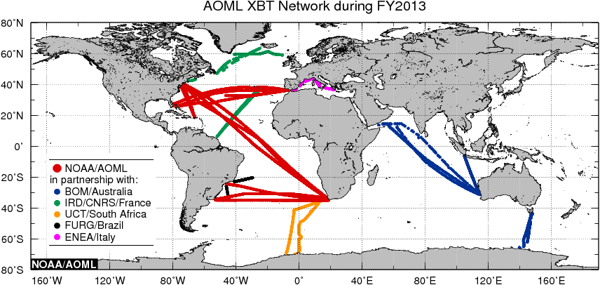

Figure 2. (top) Location of the 4 High Density XBT transects (AX07, AX08, AX10, and AX18) maintained solely by NOAA/AOML, and the 7 transects (AX01, AX02, AX20, AX25, AX32, AX97, IX01, IX12, IX28, MX01, MX02, and MX04) maintained by NOAA/AOML in collaboration with the University of Paris, IRD/France, NOAA/NEFSC, University of Cape Town, Federal University of Rio Grande, Australia’s Bureau of Meteorology and CSIRO, and ENEA/Italy. (bottom) Location of the AOML XBT deployments and AOML-supported XBT deployments/transmissions during FY2013 carried out by AOML or in partnership with national and international collaborators.
International Collaboration
The collaboration between AOML and its international partners include the sharing of resources, such as XBT probes, ship recruiting and logistics, equipment, and scientific riders. AOML provides probes to oceanographic institutions that have demonstrated reliability in logistics and operations. These probes are used to carry out recommended transects in HD mode. During FY2013 AOML provided the following number of probes to its international collaborators:
- IRD, Brest, 2 pallets (648 probes for AX01 and AX20), collaborators: Diverres and Gilles Reverdin
- FURG, Brazil, 1 pallet (324 probes for AX97), collaborator: Mauricio Mata
- CSIRO and Bureau of Meteorology, Australia, 2 pallets (648 probes for IX01, IX12, and IX28), collaborators: Susan Wijffels and Graeme Ball
- ENEA/Italy, 1 pallet (324 probes for MX01 and MX04), collaborator: Franco Reseghetti
- University of Cape Town, 4 pallets (1296 probes for AX25), collaborators: Isabelle Ansorge and Sebastiaan Swart.

Transect | Realizations | No. of XBTs | Avg. No. | Argo Floats Deployed | Drifters Deployed | XBT Fast Deep Probes
 |  |  | of XBT per
 |  |  | Transect
AX01 | 5 | 248 | 50 | 0 | 0 | 0
AX02 | 3 | 197 | 66 | 0 | 0 | 0
AX07 | 4 | 964 | 241 | 6 | 24 | 110
AX08 | 6 | 3055 | 509 | 14 | 34 | 0
AX10 | 4 | 438 | 110 | 0 | 0 | 0
AX18 | 4 | 885 | 221 | 0 | 0 | 0
AX20 | 3 | 476 | 159 | 0 | 0 | 0
AX25 | 2* | 305 | 153 | 0 | 0 | 0
AX97 | 6 | 268 | 45 | 0 | 0 | 0
IX01, 12, 28 |  | 648 |  | 0 | 0 | 0
MX01 | 2 | 56 | 28 | 0 | 0 | 0
MX02 | 2 | 79 | 40 | 0 | 0 | 0
MX04 | 3 | 116 | 39 | 0 | 0 | 0
Other | 2** | 307
Total | 46 | 7,735 |  | 20 | 58 | 110

* There were XBTs deployed as a collaboration to allow for extra data along with CTD casts aboard the AX25 ship. They were not deployed along the normal AX25 cruise track.
** These two cruises were SAMOC (43 deployments) and PNE (264 deployments).
Table 2. Summary of the number of XBTs, Argo and drifters deployed on the XBT transects operated by AOML or with direct AOML participation during FY2013. * Indicates partial contribution to the full sampling.

Data issued to GTS
All AOML and Scripps data are transmitted into the GTS 100%. Starting in Jan 2013 we have been transmitting more than 15K XBT profiles in BUFR to the GTS. This process is independent of the transmission in BATHY format and includes: 1) Get the XBT Data; 2) Access the associated metadata; 3) Encode into BUFR; 4) Decode it to ensure the previous process succeeded; 5) Add bulletin header; 6) Send it to the GTS. Additionally we are retrieving the bulletins from the GTS to compare with the original ones and ensure the data flow is correct and traceable.
Status of switch to BUFF data delivery to the GTS
BUFR and BATHY data delivery to the GTS run in parallel. AOML is ready to stop TAC (Traditional Alphanumeric Codes) transmissions of XBT data once migration is considered finished and user requirements adapt to new regulations and formats.
Data issued to US-NODC after real-time QC
AOML and Scripps XBT profiles undergo near-real time automatic quality control (AQC) procedures at AOML. The profiles that fail the AQC are submitted to visual quality control (VQC) using a MATLAB based code developed at AOML, in which a trained operator decides whether or not to send the data to the GTS. Probe failure (as measured by the AQC) remains consistently between 5% and 10% with greater higher failure rates at higher latitudes during winter months. Approximately 85% of the profiles that fail the AQC were approved during the VQC. Typically about 95% of all profiles are approved during the quality control process and submitted to the GTS. In addition, all the XBT data obtained are submitted to NODC for archival and distribution.
Data issued to US-NODC after delayed node QC
All Atlantic Ocean High Density XBT data collect by AOML or AOML partners undergo delayed mode quality control. For this quality control, bad profiles are identified, spikes are removed and profiles are evaluated for representativeness of the surrounding physical oceanography issues known for the region. For example, subsurface temperature inversions found near the high salinity/higher temperature Mediterranean outflow might fail automatic quality control procedures, but are perfectly acceptable, expected oceanographic profiles. Occasionally, some data are filtered to remove the small-scale unphysical electrical noise that can occur in the profiles. All modifications to the XBT profiles are logged and available via the AOML web site. Final quality controlled profiles are delivered to NODC for archival and replacement into the “Best Quality” GTSPP data set, typically with one-two months of the data being collected.

Web pages
AOML currently hosts and maintains three web pages:
- HD web page (http://www.aoml.noaa.gov/phod/hdenxbt/) and users can access the raw or qc’ed XBT data from this web page.
- XBT science web page (http://www.aoml.noaa.gov/phod/goos/xbtscience)
- XBT networking page (http://www.aoml.noaa.gov/phod/goos/xb_network)

Statistics of GTSPP data usage
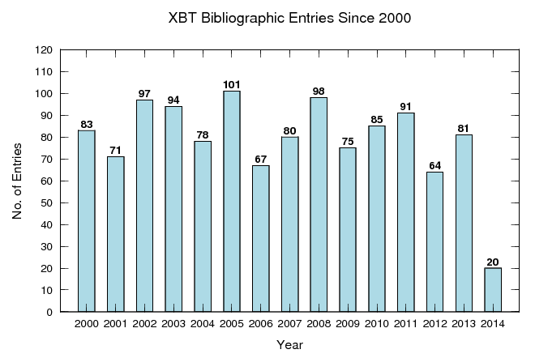Please refer to http://www.aoml.noaa.gov/phod/goos/xbtscience/bibliography.php.
Products generated from GTSPP data
- Meridional Heat Transport
HD transects AX07 and AX18 XBT observations in the Atlantic Ocean are used to monitor the Meridional Heat Transport in the Atlantic basin on a quarterly basis. Time series of theses estimates can be found at: http://www.aoml.noaa.gov/phod/goos/xbtscience/mht_products.php
- Ocean Currents Monitoring

Current | Area | XBT line
Florida Current | 27°N | AX-WBTS
Tropical Current |  | AX08
Brazil Current | 22°S | AX97
Brazil Current | 34°S | AX18
Agulhas Current | 28°S | IX21
Agulhas Current | 34°S | IX21
Leeuwin Current |  | IX15
Indonesian Throughflow |  | IX01
East Australian Current | 30°S | PX30
East Australian Current | 34°S | PX34
Kuroshio Current | 34°N | PX05
Kuroshio Current | 22°N | PX44
California Current System |  | PX37

- Global Ocean Heat Content
Please refer to http://www.aoml.noaa.gov/phod/goos/xbtscience/ghc_products.php.
Research operations
- XBT Fall Rate Experiments
In an effort to improve XBT data quality and to investigate possible issues in the XBT data related to uncertainties in the XBT fall rate equation (FRE), data from three XBT fall rate experiments are currently being analyzed. These experiments were carried out at the AOML water tank, the University of Miami swimming pool, and the Stennis Space Center test tank (Figure 3).

Two of these experiments were designed to study the effect of the deployment height in the fall rate of XBT probes at the beginning of its descent on the water. A different initial velocity of the probe below (above) the terminal velocity considered in the manufacturers FRE is expected to cause a acceleration (deceleration) of the probe until the terminal velocity is reached. During this time the actual depth of the probe will be different than that described by the FRE. During these two experiments, XBT probes were deployed in a 5m deep swimming pool and in a 11.12m deep water tank from different initial eights and in the straight vertical direction with the objective to determine the deviation of the actual fall rate from the FRE estimates as well as the maximum depth at which these probes could reach terminal velocity. Results show the dependence of the actual fall rate of the probes with the initial velocity (Figure 4). Probes deployed from initial heights above the water of 0 and 2m move slower than predicted by the FRE while those deployed from heights of 9, 14, 20, and 25m move faster. XBTs deployed from an initial height of 4m start their movement in the water at a velocity that is very close to their terminal velocity and in this case the FRE provides a better estimate of their trajectory.
The experiment conducted at the NOAA/Southeast Fisheries Science Center test tank within the Stennis Space Center facility in Mississippi in July 2012 was designed to study the fall rate and terminal velocity of XBTs during the first meters of their fall. The analysis of the data obtained from the approximately 300 deployments done as part of this experiment is underway. The results from this experiment will allow scientists to better understand the dynamic of an XBT on the first meters after the probe hits the water, and to reduce the errors of observations taken with XBTs.
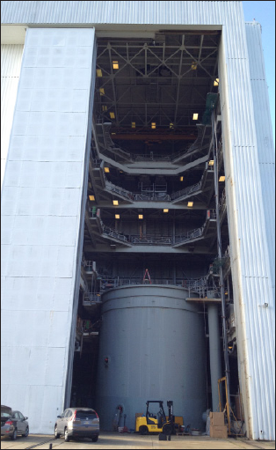
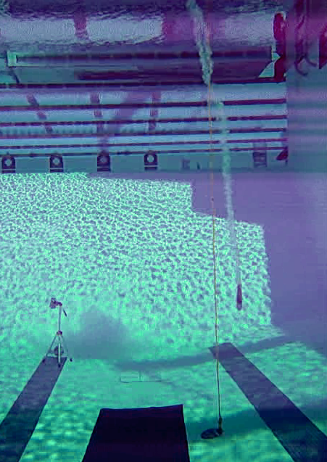
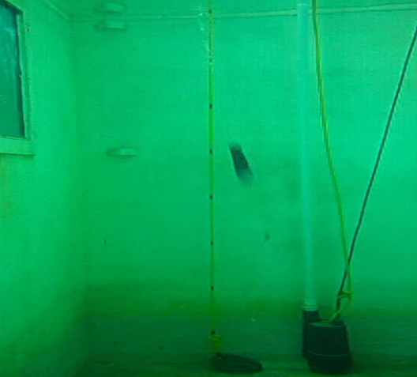

Figure 3. Three locations were FRE experiments were carried out: (left) Test tank at Stennis Space Center. (center) University of Miami swimming pool (right) AOML water tank.

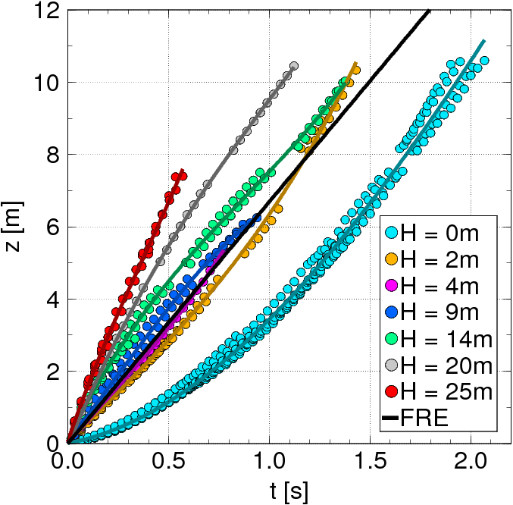

Figure 4. Preliminary results obtained to determine the effect of XBT launch height (H, colors) with descent time (t) and depth (z).
- Prototype of new XBT probes
NOAA/AOML has been collaborating with Lockheed Martin/Sippican (LCS) in the development of the Climate Quality XBT probe (CQXBT). The CQXBT system will feature improvements in the probe, acquisition system, and software. NOAA/AOML is leading the efforts to study and recommend the necessary changes in the probe. The probe improvements will consist of including additional thermistor calibrations and pressure switch(es). An initial sensitivity study of the utility of the pressure switches measurements has been performed. Results from this study have been published in Goes et al., (2013). In addition, sea trials where experimental XBT probes with improved weight and thermistor calibrations were deployed and compared to standard probe deployments. Two sea trials were performed in NOAA/AOML cruises aboard the R/V Ron Brown, one during the Western Boundary Time Series (WBTS2012 cruise) and the other during the PIRATA Northeast Extension (PNE2013 cruise). In those cruises, standard and experimental probes were deployed along with co-located CTD casts. The goal of these sea trials is to detect improvements in the pure temperature biases and depth accuracy. he analysis of the cruise data consisted in using the temperature gradient method (Hanawa, 1995) to separate the depth biases from the pure temperature biases for different probe types, and compare the biases estimated for the standard and experimental probes. Preliminary results were presented during the SOOP meeting in Victoria, Canada. Three additional corrections to the XBT thermistor resistance data have been performed to evaluate which correction is able to reduce temperature biases. These corrections account for: i) wire imbalance, ii) thermistor calibration and iii) thermal time constant. Analysis of the temperature offset changes for each probe using separately each of these three corrections show that the wire imbalance has the highest potential to reduce temperature offset. The temperature offset is less sensitive to the other corrections. A temperature offset reduction compared to the original XBT temperature profile is only achieved in half of the analyzed cases. This variability is still a question of debate, and a new sea trial is necessary. A prototype of a probe with an integrated pressure switch is now under construction by LCS. This pressure switch will be used to improve the depth accuracy of individual XBT drops. The target depth for the proposed pressure switch is 400 meters, which is approximately the middle depth of a XBT profile (Goes et al., 2013). Further analysis of another sea trial is expected to be performed in the following months. New deployments of standard and experimental XBT probes, which would possibly contain pressure switches, will take place on the next PNE cruise, which will be conducted aboard the RV Ronald Brown in November 2013.

Difficulties encountered
Major challenges and difficulties are:
- Budget constrains in the US.
- Limited budget available to contribute with probes and equipment to international collaborators.
- Transect AX18 (Buenos Aires to Cape Town) continues to be a challenge as it is difficult to find and recruit ships doing this route.
- Communicate to the scientific and operational communities the new goals of the XBT network given the full implementation of Argo.
- Training people is also another issue that AOML encounters.
- Delivering of the XBT pallets are also challenging task for a certain country.
Feedback

Work Plan 2014-2016
- Performance Measures (FY2013-2016)
Measure of Performance | 2013 Actual | 2014 planned assuming flat budget | 2015-flat budget | 2015-maintain capabilities | 2016-flat budget | 2016-maintain capabilities
Number of XBT transects | 15 | 12-15 | 12-14 | 15 | 12-14 | 15
Number of XBTs deployed | 7872 | 7500-8000 | 7200-7800 | 7500-8000 | 7200-7800 | 7500-8000
Reduce the time QC data is made available | 1-2 months | 1-2 months | 1-2 months | 1-2 months | 1-2 months | 1-2 months
Number of partnerships established for operations | 11 | 11 | 11 | 11 | 11 | 11
Number of publications by PIs and Co-PIs in this project | 4 | 4 | 4 | 4 | 4 | 4

