Cruise Instructions

Date Submitted:
Platform: | NOAA Ship Ronald H. Brown
Cruise Number: | RB-14-02
Project Title: | PIRATA Northeast Extension / AEROSE
Cruise dates: | 29 October — 25 November 2013

Prepared by: ________________________ Dated: __________________
Dr. Gregory Foltz
Chief Scientist
NOAA/AOML/PhOD

Approved by: ________________________ Dated: __________________
Dr. Rick Lumpkin
PNE Project Lead
NOAA/AOML/PhOD

Approved by: ________________________ Dated: __________________
Dr. Robert Atlas
Director
NOAA/AOML

Approved by: ________________________ Dated: __________________
Captain Anita L. Lopez, NOAA
Commanding Officer
Marine Operations Center - Atlantic
I. Overview
A. Cruise Period

29 October — 25 November 2013

B. Service Level Agreements

Of the 28 DAS scheduled for this project, 28 DAS are base funded days. This project is estimated to exhibit a Medium Operational Tempo.

C. Operating Area

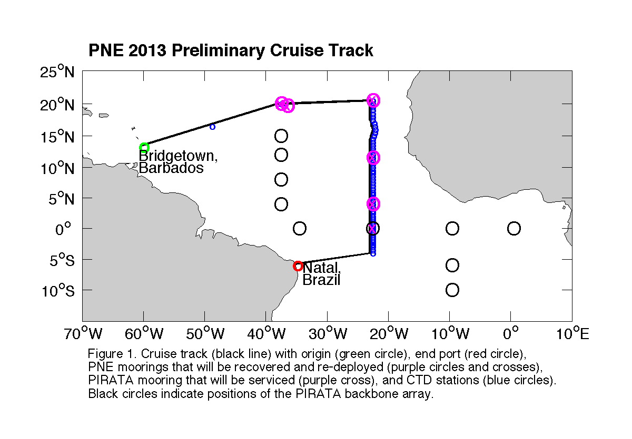
The operating area is the eastern tropical North Atlantic, primarily along 23°W. The ship will depart from Bridgetown, Barbados, and proceed to the first PNE mooring station at 20ºN, 38°W to recover and re-deploy an ATLAS mooring and a Tropical Flex (TFlex) mooring that are located approximately 5nm apart. A hydrographic test cast will be performed on the way to the first mooring station (at about 16º30’N, 49ºW). A hydrographic line will be conducted along 23°W, from 20.5°N to 4°S, detouring slightly eastward around the Cape Verde plateau. Along this line, ATLAS moorings will be serviced at 20.5ºN, 11.5ºN and 4ºN (recovery/redeployment for these three), and the equatorial ATLAS mooring will be serviced if needed and if time permits. The ship will then proceed to Natal, Brazil. Atmospheric measurements and sonde launches will be performed throughout the cruise. A tethered sonde will be tested during the transit to the 23°W line. Twenty surface drifting buoys will be deployed, primarily along 23°W.

D. Summary of Objectives

The PIRATA Northeast Extension

The Pilot Research Moored Array in the Tropical Atlantic (PIRATA) is a three-party project between Brazil, France and the United States that seeks to monitor the upper ocean and near surface atmosphere of the Tropical Atlantic via the deployment and maintenance of an array of moored buoys and automatic meteorological stations. This array is the Atlantic’s analogue of the Pacific Ocean’s Tropical Atmosphere Ocean (TAO) array. The PIRATA array consists of a backbone of ten moorings that runs along the equator and extends southward along 10ºW to 10ºS, and northward along 38ºW to 15ºN (Fig. 1).

The northeastern and north central Tropical Atlantic is a region of strong climate variations from intraseasonal to decadal scales, with impacts on rainfall rates and storm strikes for the surrounding regions of Africa and the Americas. The northeastern Tropical Atlantic includes the southern edge of the North Atlantic subtropical gyre, defined by the westward North Equatorial Current (NEC), and the northern edge of the clockwise tropical/equatorial gyre defined by the North Equatorial Countercurrent (NECC) (Fig. 2). This area is home to the North Atlantic’s oxygen minimum zone at a depth of 400—600m. The size and intensity of this zone is a potential integrator of long-term North Atlantic circulation changes (Zheng et al., 2000), and the extremely low oxygen values have significant impacts on the biota of the region (Childress and Seibel, 1998). The cyclonic Guinea Dome (c.f., Siedler et al., 1992) is centered near 10ºN, 24ºW (Stramma et al., 2005), between the NECC and NEC in the eastern TA. It is driven by trade wind-driven upwelling, and may play an active role in modulating air-sea fluxes in this region (Yamagata and Lizuka, 1995).

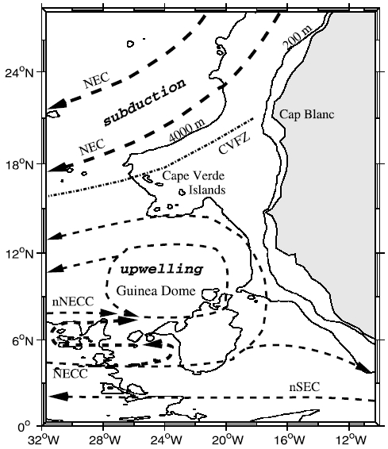
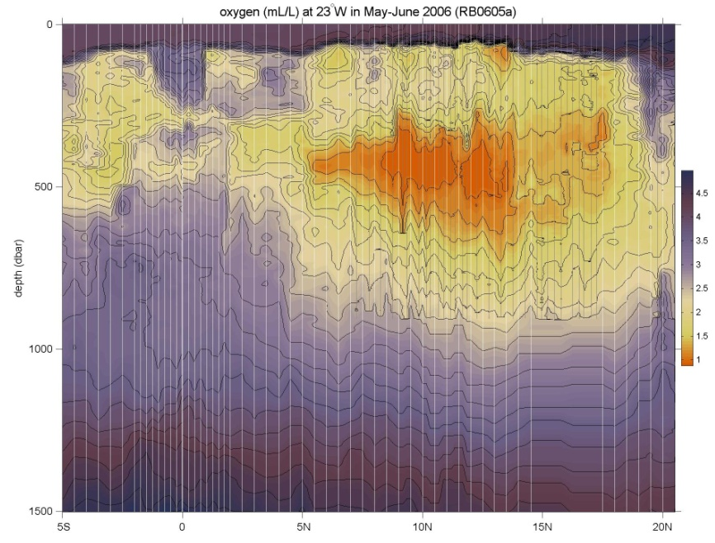

Fig. 2: Left: schematic of surface currents and features in the northeastern TA, from Stramma et al. (2005). Right: oxygen (ml/l) measured during the 2006 PNE cruise aboard Ronald H. Brown, showing the pronounced oxygen minimum.

The tropical North Atlantic is the Main Development Region (MDR) of tropical cyclones. Many major hurricanes that ultimately threaten the eastern United States begin as atmospheric easterly waves that propagate off the African continent. Once over the MDR in the latitude band of 10-20ºN, these waves are exposed to convective instability driven by the upper ocean’s heat content. The resulting infusion of energy can result in closed cyclonic circulation and development from tropical depression to tropical storm and hurricane. These hurricanes are known as Cape Verde-type hurricanes, to distinguish them from storms forming further west, and they are often the most powerful storms to strike the US east coast. Prominent examples include Andrew (1992), Floyd (1999) and Ivan (2004). An average season has two Cape Verde hurricanes, but some years have up to five while others have none. There is uncertainty regarding the specific atmospheric/oceanic conditions that determine which atmospheric waves will develop into tropical cyclones and then hurricanes (on average, one of ten; J. Dunion, personal communication). Specifically, the quantitative effects of the Saharan Air Layer (SAL), anomalous sea surface temperatures (SST), upper layer oceanic heat content and atmospheric wind shear on the formation of tropical cyclones are poorly known.

Seasonal tropical storm and hurricane forecasts are generated annually and based primarily on statistical analyses of historical data and the formulation of empirical predictors (e.g., ENSO index, Atlantic SST, Sahel rainfall, etc.). Recent empirical studies have demonstrated that tropical storm and hurricane activity in the Atlantic Ocean varies on decadal and multi-decadal time-scales and that this variability is correlated with sea-surface temperature anomalies in the MDR (e.g., Shapiro and Goldenberg, 1998). The SST signal in the MDR has been correlated with the North Atlantic Oscillation (NAO) on decadal time-scales. The multi-decadal signal indicates that an extended period of increased hurricane activity is to be expected. Other historical studies have also demonstrated spatial variability in storm formation areas and landfall locations on longer timescales.

Despite the climate and weather significance of the tropical North Atlantic region, it was not sampled by the PIRATA backbone array except for the 38ºW line of moorings extending north to 15ºN (Fig. 1). In 2005, a formal Northeast Extension of PIRATA was proposed as a joint project between NOAA/AOML and PMEL (Rick Lumpkin, Mike McPhaden and Bob Molinari, co-principal investigators). This PIRATA Northeast Extension (PNE) was proposed to consist of four moorings, three creating a northward arm up 23°W (building on the equatorial backbone mooring there), and a fourth extending the 38°W arm up to 20°N.

In June 2006, the first two moorings of this extension were deployed during RB-06-05a. The mooring at 11.5°N, 23°W was deployed on June 7, and the mooring at 4°N, 23°W was deployed on June 11. Both moorings were replaced in May 2007, during RB-07-03, and two moorings were added at 20.5°N, 23°W and 20°N, 38°W. The four buoys were planned for servicing during the April 2008 cruise RB-08-03. Due to the cancellation of this cruise, the buoys failed and a data gap was introduced in mid to late 2008. All four sites were subsequently serviced in November 2008 by NOAA charter of the French R/V Antea. In 2009, the four moorings were serviced during RB-09-04. Cancellation of the cruise RB-12-05 led to another gap in the record. After the make-up cruise in January-February 2013, all four buoys, which need to be serviced annually, were once again be reporting meteorological and oceanographic data onto the Global Telecommunications System for weather and climate forecasting. In the Memorandum of Understanding from the PIRATA-12 meeting (November 2006), the United States agreed that

[I]t is recognized that the Parties are dependent upon year-to-year funding allocations from their governments, and thus commitments for future funding and logistical support cannot be guaranteed. Given this proviso, the Parties affirm that PIRATA is a high priority for Brazil, France, and the United States, and that the institutions are making plans for continued support … NOAA will provide ship time for maintenance of four moorings in the North East Extension.

Ronald H. Brown’s cruise RB-14-02 serves to honor this commitment for the year 2013.

Aerosols and Ocean Science Expeditions (AEROSE)

Large uncertainties remain in our understanding of the impact of mineral dust and biomass burning aerosols on the weather and climate of the tropical Atlantic. In order to advance knowledge and improve predictive models, it is important that we address gaps in our understanding of regional and trans-boundary aerosol issues. The African continent is one of the world’s major source regions of mineral dust and biomass burning aerosols. This makes the need for understanding the mobilization, transport, and impacts of aerosols originating from natural and anthropogenic processes in Africa a high priority. Saharan dust storms are estimated to inject over three billion metric tons of mineral aerosols into the troposphere annually, with large quantities of these advecting out over the tropical North Atlantic within tropical easterly winds and waves. These aerosols impact phenomena ranging from cloud seeding and precipitation, to ocean fertilization, and to downstream air quality and ecosystem impacts in the Caribbean and U.S. eastern seaboard. Red tides, increasing rates of asthma, and precipitation variability in the eastern Atlantic and Caribbean have been linked to increases in the quantities of Saharan dust transported across the Atlantic. The contribution of the Saharan air layer (SAL) to the development of the West African Monsoon (WAM) and its role in tropical cyclogenesis are just beginning to be understood. The interplay between thermodynamics, microphysics, and aerosol chemistry are currently unknown and these field measurements represent a unique data set for unraveling these complex interactions.

The NOAA Aerosols and Ocean Science Expeditions (AEROSE) constitute a comprehensive measurement-based approach for gaining understanding of the impacts of long-range transport of mineral dust and smoke aerosols over the tropical Atlantic (Morris et al., 2006; Nalli et al., 2011). The project, involving international coordination of monitoring in Puerto Rico, Mali, the Canary Islands, and Senegal, hinges on multi-year, trans-Atlantic field campaigns conducted in collaboration with PNE project over the tropical Atlantic. AEROSE is supported through collaborative efforts with NOAA’s National Environmental Satellite Data and Information Service, Center for Satellite Applications and Research (NESDIS/STAR) and the National Weather Service (NWS), as well as NASA and several academic institutions linked through the NOAA Center for Atmospheric Sciences at Howard University.

The AEROSE campaigns (to date, comprised of eight separate trans-Atlantic Project legs) have thus provided a set of in situ measurements to characterize the impacts and microphysical evolution of continental African aerosol outflows (including both Saharan dust and sub-Saharan and biomass burning) across the Atlantic Ocean (Nalli et al., 2011). AEROSE has sought to address three central scientific questions (Morris et al., 2006):
- How do Saharan mineral dust aerosols, biomass burning aerosols, and/or the SAL affect atmospheric and oceanographic parameters during trans-Atlantic transport?
- How do the aerosol distributions evolve physically and chemically during transport?
- What is the capability of satellite remote sensing and numerical models for resolving and studying the above processes?

Specific objectives of RB-14-02

The objectives of this Ronald H. Brown project address NOAA’s Climate Goal and Weather and Water Goal, and are an explicit NOAA contribution to the PIRATA and AEROSE programs. Specific goals are in the areas of oceanography, marine meteorology, atmospheric chemistry and satellite validation.

Oceanography: Numerical models that are used to simulate the coupled air-sea system and to forecast atmospheric climate are notoriously inaccurate in the eastern tropical Atlantic. For example, the majority of the models cannot simulate the sign of the equatorial sea surface temperature (SST) gradient. They show cold water in the west and warm water in the east, exactly out of phase with observed conditions. The main objective of the oceanographic component of RB-14-02 is to collect the data needed to evaluate the terms in the heat budget of the upper ocean and to compare the observed results with model results. The comparison should identify areas/processes of model deficiencies. Four ATLAS moorings will be recovered and redeployed and one TFlex mooring will be recovered. The purpose of these moorings is to provide time series of the upper ocean temperature, salinity, current structure and heat fluxes between the ocean and atmosphere. Shipboard observations will include upper-ocean and surface heat flux data along 23°W, from 5°S to 20.5°N. These observations will be supplemented by data from surface drifters and profiling floats to be deployed during this and other cruises to the area. Combining the various data will allow estimation of the terms in the heat budget. Data to be collected provide an improved picture of seasonal-to-interannual variability.

Marine Meteorology: Atmospheric data will be collected to characterize the vertical structure of the Saharan air layer (SAL) (e.g., Nalli et al., 2005; 2011), including mineral dust aerosol over the Atlantic Ocean. The atmospheric data will also be used to investigate the effect of the SAL on the marine boundary layer, clouds, precipitation, and surface radiation balance.

Recent work by Min et al (2009) indicates that ice particles are abundant in the dusty sectors of deep tropical convective systems that have entrained Saharan mineral dust. This is particularly evident at altitudes at which heterogeneous ice nucleation is a dominant process. Other studies suggest that mineral dust may be of critical importance in precipitation processes but studies are inconclusive regarding whether it suppresses or enhances rainfall in tropical systems. The AEROSE team will take advantage of opportunistic events where dust storms are ingested into deep convective systems via soundings, ship-based lidar, optical and chemical determination of the dust load composition, Suomi NPP, A-train and/or other relevant satellite observational overpasses.

Atmospheric Chemistry: Profile measurements of the atmosphere will be conducted to investigate the linkages between the vertical distributions of tropospheric ozone with dust and biomass burning outflows (e.g., Nalli et al., 2011). Historical data show a seasonal variation in tropospheric ozone that peaks during June-August. The origins of this peak remain uncertain and may be due to anthropogenic sources (e.g., transport from biomass burning in the Congo Basin) or natural sources (e.g., lightning over West Africa, stratospheric injections).

Current atmospheric chemistry models are challenged by the need to account for a variety of processes in dense aerosol outflows. Very few in-situ measurements have been reported for tropical air masses that are rich in mineral dust aerosols, biomass burning aerosols, West African mega city urban aerosols, and/or mixtures of these aerosol types that characterize the trade wind and SAL outflow regimes. AEROSE will extend its record of key measurements of trace gases that will allow for better constraints on the chemistry within these outflows. The measurements include ozone, carbon monoxide, sulfur dioxide, NOx (nitric oxide and nitrogen dioxide), methane, and aggregate non-methane volatile organic carbon species (VOC).

A comprehensive suite of aerosol measurements and in situ sampling will also be performed in order to quantify the microphysical and chemical evolution of the Saharan dust during trans-Atlantic transport, to characterize aerosol mixing, to identify microbial distributions and microbial load on the aerosols, to determine evidence for heterogeneous chemistry within dusty air mass outflows. Offline microbiological and chemical composition analysis will be performed as a function of size and source region. The filter samples collected during the cruise will be frozen following sample collection and processing. Number distributions will be measured continuously for Aitken, accumulation mode, and fine aerosols using mobility analyzers and optical particle counters. Mass density and gravimetric aerosol analysis will be performed using a suite of tandem quartz crystal cascade impactors, cyclone impactors, and high volume gravimetric sequential samplers.

Satellite validation: Visible, microwave, infrared and in situ measurements will be collected to support the calibration/validation and improvement of advanced satellite retrievals and data products (Nalli et al., 2011) including the NOAA R-Series Geostationary Operational Environmental Satellite (GOES-R) , and especially the new Suomi National Polar-orbiting Partnership (NPP) Cross-track Infrared Microwave Sounding Suite (CrIMSS) (Nalli et al., 2012), and Visible Infrared Imaging Radiometer Suite (VIIRS).

E. Participating Institutions

a) Atlantic Oceanographic and Meteorological Laboratory (NOAA/AOML)
4301 Rickenbacker Causeway
Miami, FL 33149 USA
Telephone: 001 305 361 4313
Facsimile: 001 305 361 4412

b) Pacific Marine Environmental Laboratory (NOAA/PMEL)
7600 Sand Point Way NE
Seattle, Washington 98115
Telephone: 001 206 526 6239
Facsimile: 001 206 526 6815

c) Earth System Research Laboratory (NOAA/ESRL)
Physical Sciences Division (PSD)
325 Broadway
Boulder, CO 80305-3337

d) NOAA/NESDIS Center for Satellite Applications and Research (STAR)
NOAA Center for Weather and Climate Prediction Bldg
5830 University Research Court
College Park, MD 20740-3818
Telephone: 001 301 683 3608

e) NOAA Center for Atmospheric Sciences (NCAS)
Howard University Research Building 1
840 7th Street NW Washington, DC 20001
Telephone: 001 202 864 8678
Facsimile: 001 202 865 8294

f) Rosenstiel School of Marine and Atmospheric Science
University of Miami
4600 Rickenbacker Causeway
Miami, FL 33149-1098
Telephone: 305 421 4104
Facsimile: 305 421 4696

F. Personnel (Science Party)

Name Title Gend. Nat. Affiliation Med. Clear

- Gregory Foltz Chief Sci. M USA NOAA/AOML n
- Renellys Perez Res. Sci. F USA CIMAS/UM n
- Grant Rawson Engineer M USA CIMAS/UM n
- Shaun Dolk Engineer M USA CIMAS/UM n
- J. Michael Strick Mooring Tech. M USA NOAA/PMEL n
- Linda Stratton Mooring Tech. F USA NOAA/PMEL n
- Vernon Morris Prof., Atm. Sci. M USA NCAS/Howard n
- Everette Joseph Prof., Atm. Sci. M USA NCAS/Howard n
- Nicholas Nalli Res. Sci. M USA NOAA/NESDIS n
- AEROSE, TBD n
- AEROSE, TBD n
- AEROSE, TBD n
- AEROSE, TBD n
- AEROSE, TBD n
- AEROSE, TBD n
- RSMAS group M UM/RSMAS n
- RSMAS group F UM/RSMAS n
- TBD observer
- TBD observer
- TBD observer
- TBD observer

All participants will board in Bridgetown, Barbados on October 28, 2013 and disembark in Natal, Brazil on November 26, 2013.

G. Administrative
1. Points of Contact:

PNE Project Lead: Dr. Rick Lumpkin
Atlantic Oceanographic and Meteorological Laboratory
4301 Rickenbacker Causeway Miami, FL 33149 USA
Telephone: 305-361-4513 Fax: 305-361-4412
Rick.Lumpkin@noaa.gov
Chief Scientist: Dr. Gregory Foltz
Atlantic Oceanographic and Meteorological Laboratory
4301 Rickenbacker Causeway Miami, FL 33149 USA
Telephone: 305-361-4430 Fax: 305-361-4412
Gregory.foltz@noaa.gov
watch leader: Dr. Rick Lumpkin (contact above)
Alternate Point of Contact: LCDR Stephen Meador
Atlantic Oceanographic and Meteorological Laboratory
4301 Rickenbacker Causeway Miami, FL 33149 USA
Telephone: 305-361-4544 Fax: 305-361-4449
aoml.associate.director@noaa.gov
Agent in Bridgetown: None
Agent in Natal: None

2. Diplomatic Clearances

Research clearance has been requested for Barbados, Cape Verde, and Brazil.
The requests were submitted to the State Department by Wendy Bradfield-Smith
(Wendy.Bradfield-Smith@noaa.gov).

3. Licenses and Permits

not applicable

II. Operations
A. Cruise Plan/Itinerary

The primary goal of the cruise is to recover and redeploy the ATLAS moorings of the PIRATA Northeast extension and to continuously sample oceanic and atmospheric variables along the cruise track. A CTD section will be taken along 23°W from 20.5°N to 4°S. CTD station locations are given in Appendix H. The actual hydrographic stations sampling plan may deviate from this proposed plan in both number of stations and their locations. Some CTD station locations are in Cape Verde’s EEZ.

ATLAS moorings will be recovered and new moorings deployed at 20°N, 38°W, as well as at 20.5°N, 11.5°N, and 4°N along 23°W. In addition, a TFlex mooring will be recovered and a new one deployed at 20°N, 38°W. An instrument repair on the equatorial ATLAS mooring at 23°W may be necessary and will be done if the time allows.

Atmospheric data will be collected throughout the cruise; such data are not subject to restrictions in foreign EEZs. Changes in speed may be required for radiosonde launches, which will be done at positions determined by the atmospheric scientists and based on satellite overpass predictions determined on the ship while underway (i.e., pre-cruise positions cannot be provided). Changes in heading will be required for large-balloon ozonesonde launches, depending on wind conditions. A tethered sonde will be tested at some point during the cruise (exact location to be determined by the AEROSE group) using either the ship’s winch or a winch provided by AEROSE. Satellite tracked surface drifters will be deployed along the track line at locations determined by the Chief Scientist. Pre-cruise deployment locations cannot be provided as final deployment sites will be determined by the locations of drifters previously deployed.

NOAA Ship Ronald H. Brown (RHB) will depart Bridgetown October 29 and transit to the test CTD cast site (at about 16°30’N, 49°W). RHB will then proceed to the site of the first ATLAS mooring (20ºN, 39°W). A CTD cast will be conducted, an ATLAS mooring will be recovered and redeployed, and a TFlex mooring will be recovered and re-deployed. The RHB will continue to 20.5°N, 23°W for the next CTD cast and ATLAS mooring recovery and deployment. The RHB will continue southward nominally along 23°W (staying east of the Cape Verde Islands) to the 11.5°N mooring and take CTD stations along the way. At 11.5°N, the next ATLAS mooring will be recovered and redeployed, and the RHB will continue the CTD section while heading southward along 23°W to the next ATLAS mooring recovery and deployment at 4°N, 23°W. From there the RHB will continue to the last ATLAS mooring site for a visit (or repair if necessary and the available time allows). Then the RHB will head for Natal to arrive on November 25.

B. Staging and Destaging

Staging for the cruise will be conducted in Charleston and Bridgetown. Equipment characteristics are given in Appendix B.

AOML Equipment for the collection of hydrographic data was loaded in Charleston in July (for A16N, PNE, and A16S). All equipment will remain on the ship between A16N and A16S.

Drifters for PNE: loaded in Charleston.

Equipment for recovery/deployment of four ATLAS moorings and one TFlex mooring will be loaded in Bridgetown following the NTAS cruise and immediately prior to the PNE cruise. A large part of this equipment needs to be stored near the fantail (typically on the port side).

NCAS van: 20 ft van with standard fitting, to be loaded in Bridgetown, ideally prior to the NTAS cruise, but possibly after. The plan is to load the van on the forward 02 Level with a rented crane, since it is too heavy for the ship’s crane (expected more than 15,000 lb).

NCAS requires engineering help on connecting the van to ship's power supply before departure from Bridgetown. A NCAS team will work on sensor deployment during the port of call in Bridgetown.

NCAS requires help unloading and securing gas cylinders (30, each about 4.5 ft tall), secured on the O1 deck aft of the winch house.

RSMAS requires assistance with loading in Barbados and off-loading in Natal of equipment crates to and from 02 deck forward.

Loading of small items needs to be coordinated with the OPS if not included in the NCAS van. NCAS will take care of them.

AOML will require the assistance of the shipboard ET to help install computer systems. The science party will stay on board the ship the night of October 28 to allow for maximum time for setup of the scientific gear prior to sailing. We understand that the galley may not be available for meals on October 28. We request that scientists be allowed to stay on board RHB the night of arrival in Natal.

Destaging will occur in Valparaiso following the A16S cruise.

C. Operations to be Conducted

RHB will steam from Charleston to the test cast near 16°30’N, 49°W. RHB will proceed to the ATLAS and TFlex moorings near 20°N, 38°W (both moorings will be recovered and redeployed). RHB will continue to the ATLAS mooring at 20.5ºN, 23°W for another recovery/deployment, and begin CTD stations while heading southward to the equator along 23°W. Along the way the ATLAS moorings at 11.5ºN, 23°W and 4ºN, 23°W will be recovered and redeployed. Repairs of the equatorial ATLAS mooring at 23°W will require small boat operations for sensor replacements. RHB will then head southwest to Natal (on this transect a detour around the EEZ of Brazil may be necessary if clearance is not obtained). Drifter deployments will be performed along the cruise track.

During each CTD downcast, the package will be soaked at a depth of approximately 30 m for a duration of about five minutes in order to measure velocity in the upper 30 m from an upward-looking ADCP mounted on the CTD frame. It is possible that the package will need to be recovered after the soak so that the ADCP settings can be changed for the full cast. We anticipate that this may add as much as 15 minutes to the duration of each cast. We will have a better estimate of the additional time needed (if any) after test casts are performed in early August.

Approximate Station Locations are listed in Appendix G. These are subject to small changes.

The AEROSE group will deploy approximately 20 ozonesondes, spaced approximately evenly in time throughout the cruise. Each deployment may require the ship to stop and reposition, depending on the meteorological conditions. It is estimated that approximately half an hour will be required for each deployment. Radiosonde deployments will be conducted without the need to decrease ship speed.

Sometime during the first half of the cruise (probably between the first mooring at 20°N, 38°W and the mooring at 20.5°N, 23°W) the AEROSE group will test a thethered-sonde. The test deployment will require stopping the ship for approximately 6 hours.

The ship shall continuously collect ADCP, meteorological, thermosalinograph (TSG), and bathymetric (Kongsberg EM122) data while underway. The ship shall also collect heading information from both the gyro compass and GPS system for comparison and testing.

Small boat operations will be required during the servicing of the ATLAS moorings at 4°N, 23°W; 11.5°N, 23°W; 20.5°N, 23°W and 20°N, 38°W. Small boat operations may also be needed at the ATLAS mooring at the equator, 23W if it requires repairs. Small boat operations will be conducted at the discretion of the Commanding Officer.

Kongsberg EM122 monitoring at the recovery/redeployment sites is requested for the ATLAS and TFlex mooring sites. The Chief Scientist will provide areas and coverage parameters for the surveys relative to time available as the cruise progresses. The Chief Survey Technician will generate contoured plots of the mooring site survey. No systematic survey (typical full surveys cover 5 nm x 5 nm around the sites) is necessary since the previous year’s surveys should be sufficient for mooring ops for most mooring sites. A single 5nm pass should be quite sufficient at these mooring sites.

Data to be collected and operations
- Recovery and re-deployment of ATLAS moorings along 23°W at 4°N, 11.5°N and 20.5°N, 23°W and 20°N, 38°W. Recovery and re-deployment of one TFlex mooring at 20°N 38°W.
- Repair ATLAS mooring at 0°, 23°W if necessary and time allows.
- CTD profiles at the test cast location, along 23°W, and at the ATLAS mooring locations. CTD casts will include the CTD unit and a Rosette sampler with 12 bottles. The casts at the 48 station locations will extend to 1500 m (possibly shallower in the vicinity of Cape Verde) and are listed in Appendix G. The cast rate is about 60m/min. We will require a package tracking system and display for the CTD operations (Knudsen/Bathy2000). Each cast may require as much as an additional 15 minutes for near-surface ADCP measurements during the soak at 30 m, followed by recovery and re-deployment for the full cast.
- Salinity of the water samples collected with the bottles on the CTD rosette.
- Dissolved oxygen concentration in the water samples collected with the bottles.
- Continuous recording of ship mounted ADCP data.
- Heading data from both the gyro compass system and the GPS system for comparison of heading quality for the gyro compass system.
- Continuous recording of Thermosalinograph (TSG).
- Continuous recording of Kongsberg EM122 bathymetry requested (with help from ship science technician)
- Lidar aerosol and wind observations (NCAS)
- Sun photometer measurements (NCAS)
- Tropospheric profiles of pressure, temperature, humidity and wind from launching of approximately 12 Vaisala RS92 radiosondes during Suomi NPP CrIMSS and MetOp IASI overpasses. They will be launched with small (200 g) balloons at locations along the trackline specified by the Chief Scientist. (NCAS)
- Ozone profiles from launching of 20 ozonesondes during Suomi NPP and MetOp overpasses. They will be launched with large (1200 g) balloons at locations along the trackline specified by the Chief Scientist. (NCAS)
- Laser particle counters (NCAS)
- Ceilometer (ESRL)
- Deployment of 20 surface drifters along the trackline specified by the Chief Scientist. No slow-down or stop is required.
- Broadband pyranometers and pyrgeometers to measure downwelling solar (visible) and terrestrial (infrared) radiation (NCAS)
- Ambient trace gas (O₃, CO, SO₂, NO_{x}, VOC, CH₄) measurements (NCAS)
- Aerobiological sampling (NCAS)
- Partiosol 2025 Sequential high-volume aerosol sampler (NCAS)
- Low-volume bulk sampler for fungi and chemical analysis (NCAS)
- Scanning Mobility Particle Sizer (NCAS)
- Aerosol Particle Sizer (NCAS)
- Spectra of infrared radiation emitted by the ocean surface and atmosphere (RSMAS)
- Subsurface thermometer in tethered surface-following float deployed at some stations (RSMAS)
- Atmospheric water vapor and liquid water content by microwave radiometer (RSMAS)
- All-sky camera images of clouds (RSMAS)
- Standard meteorological variables (RSMAS)
- Incident short-wave and long-wave radiation (RSMAS)

D. Dive Plan

N/A

E. Applicable Restrictions

Conditions which preclude normal operations: (list restrictions such as poor weather conditions, equipment failure, safety concerns, unforeseen circumstances, as well as mitigation strategies that might be used).

III. Equipment
A. Equipment and Capabilities Provided by the Ship

The following communications devices are currently on board Ronald H. Brown.
- Hull-mounted transducer for release deckset use
- A VSAT for 24/7 Internet capabilities. There will no longer be a charge for e-mail. All scientists will be provided an email address from the ship, but will not have to pay for large messages, etc. A usage policy is being crafted by the ship and will be posted on the RHB web site once complete.
Scientific Equipment requested from the Ship
1. Echo Sounder (Ocean Data Equipment Corporation (ODEC) Bathy 2000 or the Knudsen system) used in 12 kHz mode (to track CTD package to within 10 meters of the bottom) to be used while on CTD station.
2. Continuous Kongsberg EM12 (12 kHz) swath bathymetric sonar system sampling while underway between stations.
3. Barometer
4. WOCE IMET sensors
5. Hydrographic Winch system and readouts (using 322 conducting cable for CTD operations).
- Hull mounted acoustic Doppler current profiler (RD Instruments (RDI), 75 kHz Ocean Surveyor acoustic Doppler current profiler) with gyro compass input.
- gyro compass system for acquisition of heading data used by acoustic Doppler current profiler.
- GPS system for acquisition of heading data.
- Winch and A-frame for ATLAS deployment and recovery.
- Two Guildline 8400B Autosals for processing salinity bottle samples. Also need a temperature controlled room stable to within one degree C.
- CTD package as backup for the package provided by the science party

The above listed scientific equipment provided by the ship is all critical for meeting the objectives of this cruise. However, the hull-mounted transducer, Kongsberg EM122, IMET, sADCP and TSG are particularly important for satisfying the objectives of this cruise.

B. Equipment and Capabilities Provided by the Scientists

In addition to the suite of oceanographic and meteorological instruments on board Ronald H. Brown, the science party will bring the following instruments and materials on board (see Appendix B for full specifications):

AOML equipment
see Appendix B

NCAS equipment
see Appendix B

NOAA/NESDIS equipment:
see Appendix B

NOAA/ESRL equipment:
see Appendix D

PMEL equipment
see Appendix E

RSMAS equipment
see Appendix F

IV. Hazardous Materials
A. Policy and Compliance

The Chief Scientist is responsible for complying with FEC 07 Hazardous Materials and Hazardous Waste Management Requirements for Visiting Scientific Parties (or the OMAO procedure that supersedes it). By Federal regulations and NOAA Marine and Aviation Operations policy, the ship may not sail without a complete inventory of all hazardous materials by name and the anticipated quantity brought aboard, MSDS and appropriate neutralizing agents, buffers, or absorbents in amounts adequate to address spills of a size equal to the amount of chemical brought aboard, and a chemical hygiene plan. Documentation regarding those requirements will be provided by the Chief of Operations, Marine Operations Center, upon request.
Per FEC 07, the scientific party will include with their project instructions and provide to the CO of the respective ship 60 to 90 days before departure:
- A list of hazardous materials by name and anticipated quantity
- A list of neutralizing agents, buffers, and/or absorbents required for these hazardous materials, if they are spilled
- A chemical hygiene plan.
A chemical hygiene plan is a written document establishing procedures, equipment, personal protective equipment and work practices to protect employees from the health hazards from chemicals used in that particular workplace. This document is usually managed by the laboratory or science center personnel. On most projects, the program doesn’t bring the entire hygiene plan, just the relevant portions about PPE; spills, etc for underway operations. For reference: http://www.osha.gov/pls/oshaweb/owadisp.show_document?p_table=STANDARDS&p_id=10106
Upon embarkation and prior to loading hazardous materials aboard the vessel, the scientific party will provide to the CO or their designee:
- An inventory list showing actual amount of hazardous material brought aboard
- An MSDS for each material
- Confirmation that neutralizing agents and spill equipment were brought aboard
Upon departure from the ship, scientific parties will provide the CO or their designee an inventory of hazardous material indicating all materials have been used or removed from the vessel. The CO’s designee will maintain a log to track scientific party hazardous materials. MSDS will be made available to the ship’s complement, in compliance with Hazard Communication Laws.
Scientific parties are expected to manage and respond to spills of scientific hazardous materials. Overboard discharge of scientific chemicals is not permitted during projects aboard NOAA ships.

B. Radioactive Isotopes
N/A.

C. Inventory

See appendix A.
The required MSDS for all chemicals loaded before to the start of PNE will be provided by the chief scientists of PNE and WBTS.

V. Additional Projects
A. Supplementary (“Piggyback”) Projects
B. NOAA Fleet Ancillary Projects

Any additional work will be subordinate to the primary project and will be accomplished only with the concurrence of the Commanding Officer and the Chief Scientist.

The following projects will be conducted by ship's personnel in accordance with the general instructions contained in the MOC Directives, and conducted on a not-to-interfere basis with the primary project:

a. SEAS Data Collection and Transmission
b. Marine Mammal Reporting
c. Bathymetric Trackline
d. Weather Forecast Monitoring
e. Sea Turtle Observations
f. Automated Sounding Aerological Program

The underway sensors on RHB will be used in support of the objectives of the Global Carbon Cycle Research (GCC) to quantify the uptake of carbon by the world's ocean and to understand the bio-geochemical mechanisms responsible for variations of partial pressure of CO2 in surface water (pCO2). This work is a collaborative effort between the CO2 groups at AOML and PMEL.

Principal investigators:
Dr Rik Wanninkhof, AOML 305-361-4379 wanninkhof@aoml.noaa.gov
Dr Richard Feely, PMEL 206-526-6214 feely@pmel.noaa.gov

The semi-automated instruments are installed on a permanent basis in the hydrolab of RHB. All work is performed on a not-to-interfere basis and does not introduce any added ship logistic requirements other than the continuous operation of the bow water pump and thermosalinograph. The chief scientist assumes responsibility for the hazardous materials aboard RHB for this project. A list of the HAZMAT associated with this project is provided in Appendix A.

VI. Disposition of Data and Reports
A. Data Responsibilities

The Chief Scientist will be responsible for the disposition, feedback on data quality, and archiving of data and specimens collected on board the ship for the primary project. As representative of the program manager (Director, AOML), the Chief Scientist will also be responsible for the dissemination of copies of these data to participants in the cruise, to any other requesters, and to NESDIS in accordance with NDM 16-11 (ROSCOP within 3 months of cruise completion). The ship may assist in copying data and reports insofar as facilities allow.

The Chief Scientist will receive all original data gathered by the ship for the primary project, and this data transfer will be documented on NOAA Form 61-29 "Letter Transmitting Data". The Chief Scientist in turn will furnish the ship a complete inventory listing all data gathered by the scientific party detailing types and quantities of data.

Individuals in charge of piggyback projects conducted during the cruise have the same responsibilities for their project's data as the Chief Scientist has for primary project data. All requests for data should be made through the Chief Scientist.

The Commanding Officer is responsible for all data collected for ancillary projects until those data have been transferred to the project's principal investigators or their designees. Data transfers will be documented on NOAA Form 61-29. Copies of ancillary project data will be provided to the Chief Scientist when requested. Reporting and sending copies of ancillary project data to NESDIS (ROSCOP) is the responsibility of the program office sponsoring those projects.

DATA REQUIREMENTS
The ship's SCS system should log the following parameters:
Gyro compass (Degrees)
GPS positions from Northstar 941 and Furuno GP-90 systems
TSG_Unit_Temp (Degrees_C)
TSG_Conductivity (Mega_Mhos)
TSG_Salinity (PPT)
Barometer (MB)
Precip9-trwlhs (mm/hr)
Imet-Rain (mm)
Imet-Rel_Hum (Percent)
Imet-Temp (Degrees_C)
Fluoro-Value (PPM)
Imet-TWind1-Speed-MSEC (M/SEC)
Imet-Twind1-Dir (Degrees)
Imet-Rwind2-Spd-Knts (Knots)
Imet-TWind2-Speed-KNTS (Knots)
Imet-TWind2-Dir (Degrees)
Bottom Depth (meters)

The Chief Survey Technician (CST) will provide an event file logging of all the above variables as two-minute averages. The CST will also provide an additional event file with the parameters needed for LADCP and SADCP processing as will be requested at the time of sailing.

The Chief Survey Technician (CST) will translate the data from thermosalinograph to ASCII and plot the data on a daily basis.

The ship shall record ADCP raw data continuously during the cruise.

The following data products will be produced by the ship and, if requested, will be given to the Chief Scientist at the end of each leg:

a. navigational log sheets (MOAs);
b. salinity determinations;
c. calibration data for Autosals;
d. copy of SEAS data diskettes;
e. CDs of Sea Beam EM122 and navigational data, including location and depths of acoustic profile locations;
f. SCS tapes;
g. ADCP raw data on CD
h. CD of two event files: summary data above, and LADCP-SADCP event files

B. Pre and Post Cruise Meeting

A pre-cruise meeting between the Commanding Officer and the Chief Scientist will be conducted either the day before or the day of departure, with the express purpose of identifying day-to-day project requirements, in order to best use shipboard resources and identify overtime needs. A brief post-cruise meeting will be held when convenient.

If need be, upon completion of the cruise, a post-cruise meeting will be held and attended by the ship’s officers, the Chief Scientist and members of the scientific party, the Vessel Coordinator and the Port Captain to review the cruise. Concerns regarding safety, efficiency, and suggestions for improvements for future cruises should be discussed. Minutes of the post-cruise meeting will be distributed to all participants with email to the CO.MOC.Atlantic@noaa.gov and ChiefOps.MOA@noaa.gov.

C. Ship Operation Evaluation Report

Within seven days of the completion of the cruise, a Ship Operation Evaluation form is to be completed by the Chief Scientist. The preferred method of transmittal of this form is via email to OMAO.Customer.Satisfation@noaa.gov . If email is not an option, a hard copy may be forwarded to:
Director, NOAA Marine and Aviation Operations
NOAA Office of Marine and Aviation Operations
8403 Colesville Road, Suite 500
Silver Spring, MD 20910

VII. Miscellaneous
A. Meals and Berthing

Meals and berthing are required for up to 26 scientists. Meals will be served 3 times daily beginning one hour before scheduled departure, extending throughout the cruise, and ending two hours after the termination of the cruise. Since the watch schedule is split between day and night, the night watch may often miss daytime meals and will require adequate food and beverages (for example a variety of sandwich items, cheeses, fruit, milk, juices) during what are not typically meal hours. Special dietary requirements for scientific participants will be made available to the ship’s command at least seven days prior to the survey.

Berthing requirements, including number and gender of the scientific party, will be provided to the ship by the Chief Scientist. The Chief Scientist and Commanding Officer will work together on a detailed berthing plan to accommodate the gender mix of the scientific party taking into consideration the current make-up of the ship’s complement. The Chief Scientist is responsible for ensuring the scientific berthing spaces are left in the condition in which they were received; for stripping bedding and linen return; and for the return of any room keys which were issued. The Chief Scientist is also responsible for the cleanliness of the laboratory spaces and the storage areas utilized by the scientific party, both during the cruise and at its conclusion prior to departing the ship.

All NOAA scientists will have proper travel orders when assigned to any NOAA ship. The Chief Scientist will ensure that all non NOAA or non Federal scientists aboard also have proper orders. It is the responsibility of the Chief Scientist to ensure that the entire scientific party has a mechanism in place to provide lodging and food and to be reimbursed for these costs in the event that the ship becomes uninhabitable and/or the galley is closed during any part of the scheduled project.

All persons boarding NOAA vessels give implied consent to comply with all safety and security policies and regulations which are administered by the Commanding Officer. All spaces and equipment on the vessel are subject to inspection or search at any time. All personnel must comply with OMAO's Drug and Alcohol Policy dated May 7, 1999 which forbids the possession and/or use of illegal drugs and alcohol aboard NOAA Vessels.

B. Medical Forms and Emergency Contacts

The NOAA Health Services Questionnaire (NHSQ, Revised: 02 JAN 2012) must be completed in advance by each participating scientist. The NHSQ can be obtained from the Chief Scientist or the NOAA website at http://www.corporateservices.noaa.gov/~noaaforms/eforms/nf57-10-01.pdf. The completed form should be sent to the Regional Director of Health Services at Marine Operations Center. The participant can mail, fax, or scan the form into an email using the contact information below. The NHSQ should reach the Health Services Office no later than 4 weeks prior to the cruise to allow time for the participant to obtain and submit additional information that health services might require before clearance to sail can be granted. Please contact MOC Health Services with any questions regarding eligibility or completion of the NHSQ. Be sure to include proof of tuberculosis (TB) testing, sign and date the form, and indicate the ship or ships the participant will be sailing on. The participant will receive an email notice when medically cleared to sail if a legible email address is provided on the NHSQ.

Contact information:
Regional Director of Health Services
Marine Operations Center – Atlantic
439 W. York Street
Norfolk, VA 23510
Telephone 757.441.6320
Fax 757.441.3760
E-mail MOA.Health.Services@noaa.gov

Prior to departure, the Chief Scientist must provide a listing of emergency contacts to the Executive Officer for all members of the scientific party, with the following information: name, address, relationship to member, and telephone number.

C. Shipboard Safety

Wearing open-toed footwear or shoes that do not completely enclose the foot (such as sandals or clogs) outside of private berthing areas is not permitted. Steel-toed shoes are required to participate in any work dealing with suspended loads, including CTD deployments and recovery. The ship does not provide steel-toed boots. Hard hats are also required when working with suspended loads. Work vests are required when working near open railings and during small boat launch and recovery operations. Hard hats and work vests will be provided by the ship when required.

D. Communications

A progress report on operations prepared by the Chief Scientist may be relayed to the program office. Sometimes it is necessary for the Chief Scientist to communicate with another vessel, aircraft, or shore facility. Through various modes of communication, the ship is able to maintain contact with the Marine Operations Center on an as needed basis. These methods will be made available to the Chief Scientist upon request, in order to conduct official business. The ship’s primary means of communication with the Marine Operations Center is via e-mail and the Very Small Aperture Terminal (VSAT) link. Standard VSAT bandwidth at 128kbs is shared by all vessels staff and the science team at no charge. Increased bandwidth in 30 day increments is available on the VSAT systems at increased cost to the scientific party. If increased bandwidth is being considered, program accounting is required it must be arranged at least 30 days in advance.

Program contacts
Claude (Rick) Lumpkin Rick.Lumpkin@noaa.gov 305-361-4513
Gregory Foltz Gregory.foltz@noaa.gov 305-361-4430

E-mail addresses:
MOP radio room: Radio.Room@noaa.gov
Commanding Officer, RHB CO.Ronald.Brown@noaa.gov
Executive Officer, RHB XO.Ronald.Brown@noaa.gov
Field Operations Officer, RHB OPS.Ronald.Brown@noaa.gov
Medical Officer, RHB Medical.Ronald.Brown@noaa.gov

E. IT Security

Any computer that will be hooked into the ship's network must comply with the NMAO Fleet IT Security Policy prior to establishing a direct connection to the NOAA WAN. Requirements include, but are not limited to:
(1) Installation of the latest virus definition (.DAT) file on all systems and performance of a virus scan on each system.
(2) Installation of the latest critical operating system security patches.
(3) No external public Internet Service Provider (ISP) connections.

Completion of these requirements prior to boarding the ship is required.
Non-NOAA personnel using the ship's computers or connecting their own computers to the ship's network must complete NOAA’s IT Security Awareness Course within 3 days of embarking.

F. Foreign National Guests Access to OMAO Facilities and Platforms

All foreign national access to the vessel shall be in accordance with NAO 207-12 and RADM De Bow’s March 16, 2006 memo (http://deemedexports.noaa.gov). National Marine Fisheries Service personnel will use the Foreign National Registration System (FRNS) to submit requests for access to NOAA facilities and ships. The Departmental Sponsor/NOAA (DSN) is responsible for obtaining clearances and export licenses and for providing escorts required by the NAO. DSNs should consult with their designated NMFS Deemed Exports point of contact to assist with the process.
The following are basic requirements. Full compliance with NAO 207-12 is required.
Responsibilities of the Chief Scientist:
- Provide the Commanding Officer with the e-mail generated by the FRNS granting approval for the foreign national guest’s visit. This e-mail will identify the guest’s DSN and will serve as evidence that the requirements of NAO 207-12 have been complied with.
- Escorts – The Chief Scientist is responsible to provide escorts to comply with NAO 207-12 Section 5.10, or as required by the vessel’s DOC/OSY Regional Security Officer.
- Ensure all non-foreign national members of the scientific party receive the briefing on Espionage Indicators (NAO 207-12 Appendix A) at least annually or as required by the servicing Regional Security Officer.
- Export Control - The NEFSC currently neither possesses nor utilizes technologies that are subject to Export Administration Regulations (EAR).

The Commanding Officer and the Chief Scientist will work together to implement any access controls necessary to ensure no unlicensed export occurs of any controlled technology on board regardless of ownership.
Responsibilities of the Commanding Officer:
- Ensure only those foreign nationals with DOC/OSY clearance are granted access.
- Deny access to OMAO platforms and facilities by foreign nationals from countries controlled for anti-terrorism (AT) reasons and individuals from Cuba or Iran without written NMAO approval and compliance with export and sanction regulations.
- Ensure foreign national access is permitted only if unlicensed deemed export is not likely to occur.
- Ensure receipt from the Chief Scientist or the DSN of the FRNS e-mail granting approval for the foreign national guest’s visit.
- Ensure Foreign Port Officials, e.g., Pilots, immigration officials, receive escorted access in accordance with maritime custom to facilitate the vessel’s visit to foreign ports.
- Export Control - 8 weeks in advance of the cruise, provide the Chief Scientist with a current inventory of OMAO controlled technology on board the vessel and a copy of the vessel Technology Access Control Plan (TACP). Also notify the Chief Scientist of any OMAO-sponsored foreign nationals that will be on board while program equipment is aboard so that the Chief Scientist can take steps to prevent unlicensed export of Program controlled technology. The Commanding Officer and the Chief Scientist will work together to implement any access controls necessary to ensure no unlicensed export occurs of any controlled technology on board regardless of ownership.
- Ensure all OMAO personnel on board receive the briefing on Espionage Indicators (NAO 207-12 Appendix A) at least annually or as required by the servicing Regional Security Officer.

Responsibilities of the Foreign National Sponsor:
- Export Control - The foreign national’s sponsor is responsible for obtaining any required export licenses and complying with any conditions of those licenses prior to the foreign national being provided access to the controlled technology on board regardless of the technology’s ownership.
- The DSN of the foreign national shall assign an on-board Program individual, who will be responsible for the foreign national while on board. The identified individual must be a U.S. citizen, NOAA (or DOC) employee. According to DOC/OSY, this requirement cannot be altered.
- Ensure completion and submission of Appendix C (Certification of Conditions and Responsibilities for a Foreign National Guest) as required by NAO 207-12 Section 5.03.h.

APPENDICES

Appendix A. List of Hazardous Materials

NCAS
Person Responsible | chemical/compressed gas | quantity | unit | neutralizer
Vernon Morris | Helium | 30 | cylinders | none
Vernon Morris | UHP Nitrogen | 2 | cylinders | none
Vernon Morris | Air | 3 | cylinders | none
Vernon Morris | Hydrogen | 1 | cylinder | none
Vernon Morris | ethanol | 1 | 1-L | spill kit
Vernon Morris | toluene | 1 | 1-L | spill kit
Vernon Morris | Sodium Phosphate | 1 | 200-g | spill kit
Vernon Morris | Hydrogen peroxide | 1 | 0.5-L | spill kit
Vernon Morris | Drierite | 16 | 0.5-L | spill kit
Vernon Morris | hexane | 1 | 1-L | spill kit
OXYGEN
Person Responsible | chemical/compressed gas | quantity | unit | neutralizer
Grant Rawson | sodium iodide & alkaline Iodide | 10 | l | spill kit
Grant Rawson | Manganese Chloride | 10 | l | spill kit
Grant Rawson | Dilute H₂SO₄ (Sulfuric Acid) | 10 | l | spill kit
Grant Rawson | Sodium Thiosulfate | 10 | 35g | spill kit
Grant Rawson | potassium iodate | 10 | l | spill kit

Appendix B. Equipment/Van List
1) AOML
One 16 foot container with: about 8,000 lbs, typically on fantail starboard side.
See Appendix C.

2) ATLAS/TFLEX MOORINGS (NOAA/PMEL)
See Appendix E.

3) NCAS
- Van on 01 deck, 10,000 lbs
- 30 He cylinders including rack (behind winch 02 deck)
- radiometers – mounted atop van on O2 deck
- Partisol sequential sampler – 02 deck railing
- bio-samplers 02 deck railing
- Microwave radiometer 01 starboard railing
- Microtops sun photometers
- EN-SCI ECC ozone sondes
- QCM Cascade Impactors and control units
- Climet laser particle counter
- Partisol sequential aerosol sampler
- Staplex cyclone impactor
- Respicon 3-stage impactors
- Single-stage impactors
- Ceilometer
- MFRSR
- Broadband pyranometer
- Pyrgeometer
- TSI SMPS
- TSI APS
- Thermo Ozone monitor
- Thermo Carbon Monoxide monitor
- Thermo Sulfur Dioxide monitor
- Thermo VOC monitor
- Thermo NOx monitor
- Assorted pumps
- Tethered sonde

5) NESDIS/NCAS equipment
- Vaisala RS92 rawinsondes
- 200 g balloons

6) NCAS general laboratory requirements
Site: Main Laboratory: 24-30 feet of contiguous lab space (tables), storage cabinets, and bench top – roughly 5-6 tables and seating for 9-10 persons
Bio-Lab: 6-ft of bench top space and storage
Hazmat locker: Modest chemical stores
sonde launches from fantail and hangar

7) NOAA/ESRL equipment
see Appendix D

8) RSMAS equipment
see Appendix F

Appendix C: AOML equipment

CTD packages 1 1,500 lb
CTD sensors 6 sets about 60 lb
CTD tool chests 2 about 150 lb
laptops 4 about 40 lb
LADCP 2 about 100 lb
altimeter 2 about 100 lb

Oxygen equipment:

sample bottles 10 boxes about 50 lb
analysis system 1 about 50 lb
reagents see Appendix A about 100 lb

Salinity equipment:

sample bottles 10 boxes about 50 lbs
standard water 30 about 30 lbs
autosal interface 1 about 10 lbs

Surface drifters 20 about 700 lbs
(often staged in forward science storage; can be removed from boxes)

Appendix D: NOAA/ESRL Equipment (PNE/AEROSE 2013)

Earth Systems Research Laboratory
Physical Science Division
Weather and Climate Physics Branch

Daniel E. Wolfe, Chris Fairall, Sergio Pezoa, and Ludovic Bariteau
NOAA Earth System Research Laboratory
Boulder, CO USA

Background on Measurement Systems
The Physical Science Division (PSD) air-sea flux and cloud group conducts measurements of fluxes and near-surface bulk meteorology during field programs on Ronald H. Brown (RHB) .
The air-sea flux system consists of six components:
(1) A fast turbulence system with ship motion corrections mounted on the jack staff. The jack staff sensors are: GILL Sonic anemometer, Fast Ozone Sensor’s inlet, LiCor LI-7500 fast CO₂/hygrometer, and a Systron-Donner motion-pak.
(2) A mean T/RH sensor in an aspirator on the jack staff.
(3) Solar and IR radiometers (Eppley pyranometers and pyrgeometers) mounted on the railing on the 03 deck starboard side.
(4) A near surface sea surface temperature sensor consisting of a floating thermistor deployed off port side with outrigger (Sea Snake).
(5) A Riegl laser rangefinder wave gauge mounted on the jack staff.
(6) An optical rain gauge mounted on the jack staff. Slow mean data (T/RH, PIR/PSP, etc) are digitized on a Campbell 23x data logger and transmitted via a combination of RS-232 and wireless as 1-minute averages. A central data acquisition computer logs all sources of data via RS-232 digital transmission:

PSD/Flux also operates two remote systems:
- Vaisala CL31 cloud base ceilometer
- Tera Scan Satellite receiver (Sea Space)

The ceilometer is a vertically pointing lidar that determines the height of cloud bottoms from time-of-flight of the backscatter return from the cloud. The time resolution is 30 seconds and the vertical resolution is 15 m.
A Tera Scan (SeaSpace) satellite receiver collects High Resolution Picture Transmission (HRPT) data from NOAA’s polar orbiting satellites (12, 14, 15, 17, 18). This system is permanently mounted on the RHB and is available on all cruises to visiting scientists or for ship operations.

PSD is also the mentor for the weather balloon operations on board RHB. A Vaisala MW31 system is maintained by PSD and available to visiting scientists upon request. Expendables (balloons, radiosondes, helium, etc) are the responsibility of the person(s) requesting use of this system. This system can handle RS92 digital GPS radiosondes and ozonesondes.

Instrumentation Set-up
The primary flux sensors are already mounted on the forward jack staff. Data cables run from the mast into the main lab. Three data loggers are mounted on the forward starboard side of the main lab. From these data-loggers cables are run into the Science Office forward of the main computer room. Two computers are setup in this lab and connected to the ship’s internet. Power to the instruments is supplied by the AC connections at the bottom of the jack staff. A water hose is run from the O2 deck fresh water connection to the top of the jack staff for rinsing the LiCor sensor window. The sea surface temperature sensor (sea snake) is attached to a mounting arm located port-side O1 Deck.

The balloon sounding system stored in Boulder is already deployed on the ship and has been tested.
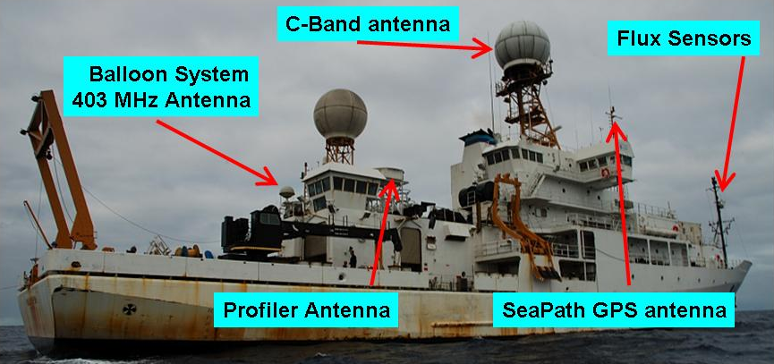
Stratus 2006
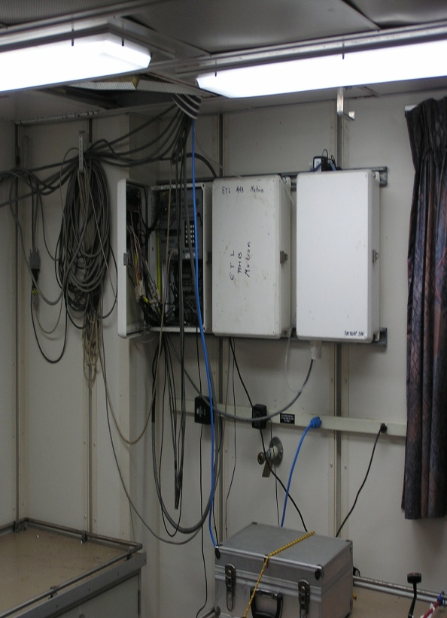
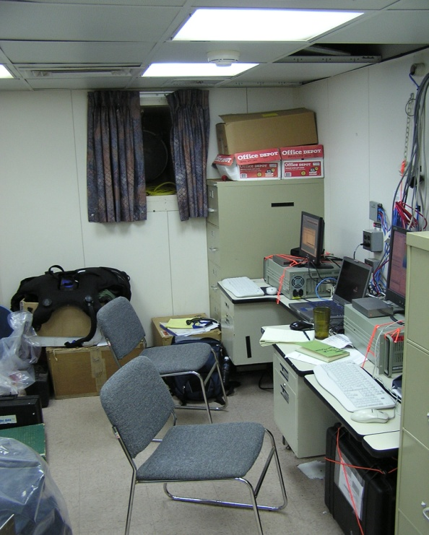

Data loggers in main computer room Flux computers in forward science office
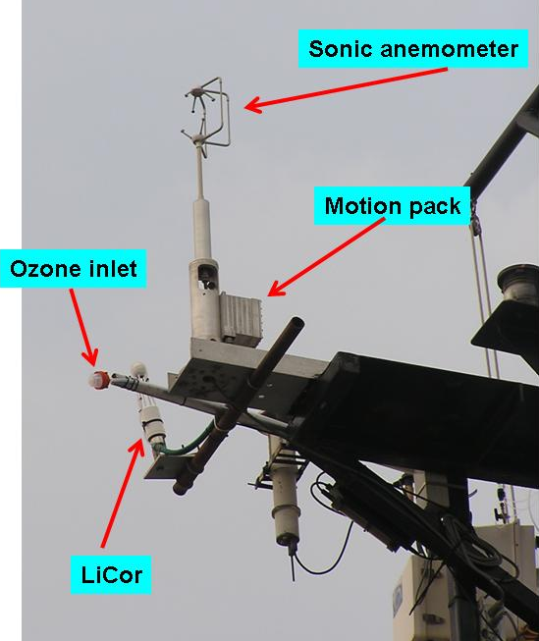
Fast sensor platform configuration
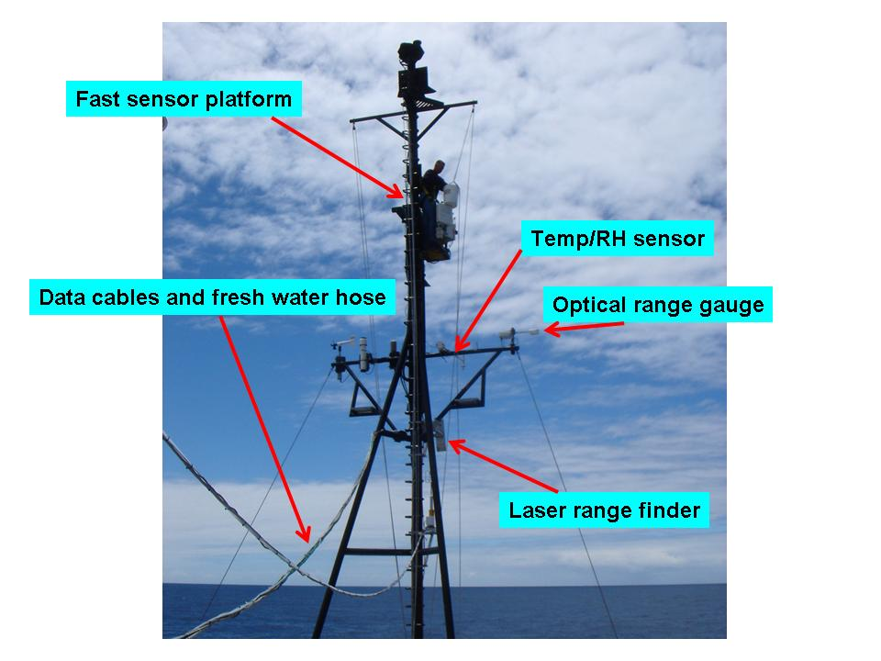
Forward Jack staff with PSD Flux sensors

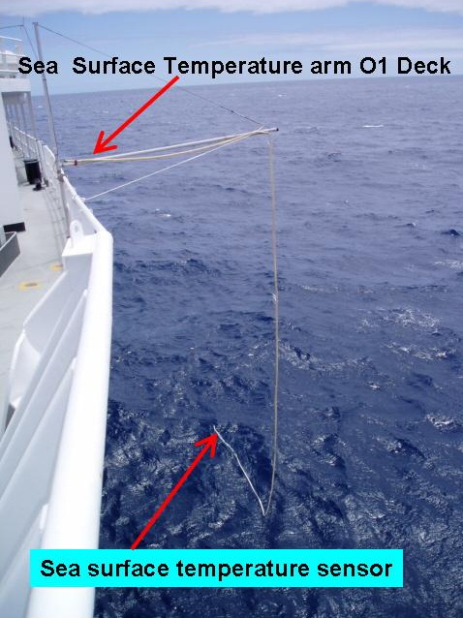
Sea Surface Temperature sensor port-side O1 Deck
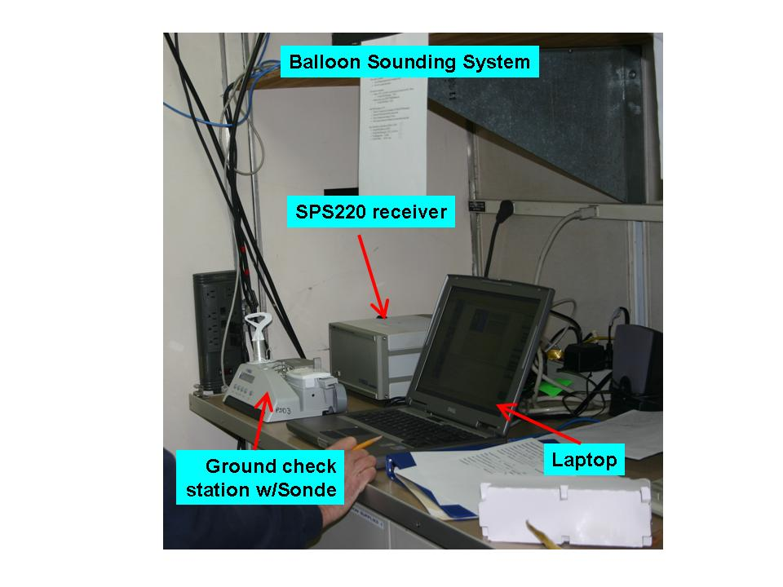
PSD Vaisala sounding system in Hydro-Lab (receiving station)
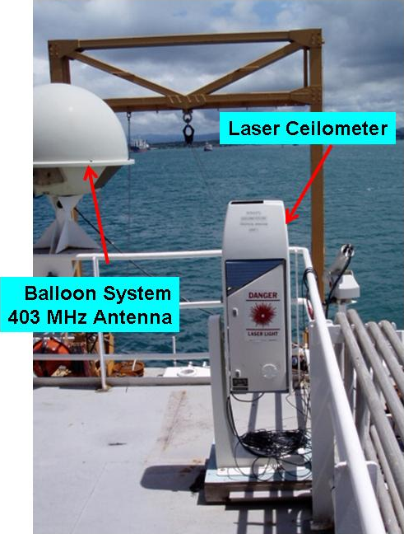
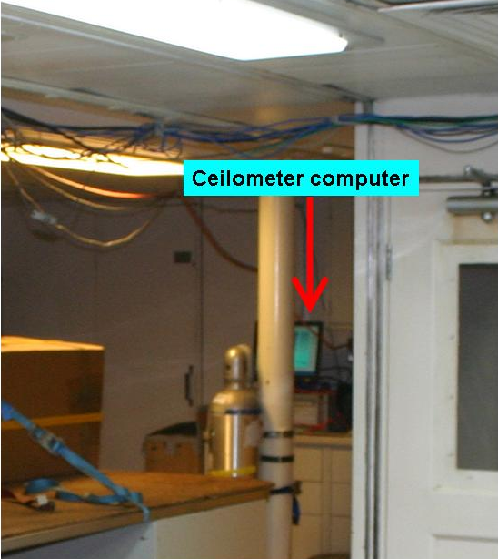
Ceilometer on O2 Deck Ceilometer PC in Hydro-Lab
Example of Tera Scan satellite visible image NOAA-18 2043 UTC October 19, 2006. Red circle is the location of the STRATUS buoy (20 S, 85W)

Appendix E: NOAA/PMEL Equipment (PNE 2013)
Total weight: 55,630 lb

Anchors - 4400# 5 22,000 lb
Anchors - 5980# 2 11,960 lb
Buoy Toroids 3 5100 lb
Metal Buoy Towers 3 900 lb
Buoy Bridles 3 900 lb
Reels of Nylon Line – Unmarked 15 3000 lb
Reels of Nylon Line - Marked Every 50m 1 200 lb
Reels of Nylon Line - 50m Pieces 3 600 lb
Nilspin wire rope 6 4200 lb
Nilspin wire rope, 3 x 300 meter lengths 2 800 lb
Empty Reels 8 400 lb
Reels of Nylon Line - Working Line 1 200 lb
Reel Stand (52"x48"x38") 2 40 lb
Anti- theft cages 2 40 lb
6 Lead weights 1 330 lb
Current meter stands 2 30 lb
Rolling Toolcart, tools 1 120 lb
Topsections cables 5 45 lb
Grey Hardware Tote (4'x4'x3') 1 1150 lb
Module Mounts 1 25 lb
Orange Electronics Toolbox (22"x18"x10") 1 65 lb
Nylon cutter 1 50 lb
White Plastic Box (36"x27"x17") 1 99 lb
4 Sontek current meters
power supply
comm. cable
spiral wrap
Sontek tool kit
TV cables
manual
fins
White Plastic Box (35"x27"x17") 1 133 lb
SBE37 Water Sensor
SBE39 Water Sensor
Aquadopp Water Current Meter
Test loop cable and ground lug cable
White Plastic Box (35"x27"x17") 1 101 lb
SBE37 Water Sensor
SBE39 Water Sensor
Aquadopp Water Current Meter
Short Wave Radiation Sensor
Long Wave Radiation Sensor
Wind Sensor
Air Temperature Sensor
Baromater
IM Test cable and ground lug cable
Wooden Box (31"x14"x15") 1 80 lb
Paint (white, orange, black, antifouling)
Acoustic Release Model 8242N 6 690 lb
Acoustic Release Deck Set Model 8011M 2 110 lb
Wooden Box 1 160 lb
Electronic Tube
Humidity/Temperature Sensor
Short Wave Radiation Sensor
Long Wave Radiation Sensor
Rain Gauge
Rad Post
Wooden Box 1 160 lb
Electronic Tube
Humidity/Temperature Sensor
Short Wave Radiation Sensor
Rain Gauges
Rad Post
Wooden Box 1 160 lb
Electronic Tube
Humidity/Temperature Sensor
Short Wave Radiation Sensor
Long Wave Radiation Sensor
Rain Gauges
Barometers
2 double rad mount
8 Micarta plates
6 Rain Screens
Wooden Box 1 160 lb
Electronic Tube
Humidity/Temperature Sensors
Short Wave Radiation Sensors
Rain Gauge
Rad Post
Wooden Box 1 160 lb
Electronic Tube
Humidity/Temperature Sensor
Short Wave Radiation Sensor
Long Wave Radiation Sensor
Rain Gauge
Barometers
1 Rad Post
Black plastic box (52"x22"14") 1 108 lb
Rain Sensors
5 wind sensor aluminum masts
6 Bird Spike covers
ATLAS Temp, Conductivity Modules 6 330 lb
Grey Plastic Box (White Box) (32"x18"x16") 1 115 lb
Panasonic Laptop CF-29
Dell laptop
Alegro hand held
HP Printer
Telonics uplink receiver
Fluke Multimeterc
Fluke Mega ohm meter
Cables, antennas, cables
manuals, office supplies
Cardboard Tube Box (64"x3.5"x3.5") 1 6 lb
TFLEX RF modem antennae
Black plastic box (53"x22"x14") 1 100 lb
2 Gill Wind Sensor masts, 2 Rad masts
2 Rain gauges SN
2 Bird wire tops, SW Rad
2 Micarta mast bases
Black plastic box (44"x16"14") 2 174 lb
TFLEX Electronics Tube
Sensor Cables
Black plastic box (44"x16"14") 1 99 lb
TFLEX Battery #1
Battery Cables
Black plastic box (44"x16"14") 1 99 lb
TFLEX Battery #2
Battery Cables
Orange plastic box (32"x21"16") 1 71 lb
2 Seabird Inductive Modem boxes with test loops
1 Seabird Inductive modem (not in box)
2 SBE37SMP Com cables
2 SBE37IM Internal Com cables
2 SBE39 Internal Com cables
2 TFLEX Com cables
1 Spare Long IM test loop with clips
9-pin Serial cable
SBE Manuals & Sofware CD
3 Digi RF modems (2 Serial & 1 USB)
2 RF modemserial com cables & 1 USB cable
2 power supplies
2 small antennas
Digi Software CD
50' & 30' RF modem antenna cable
Base antenna
Bag of TFLEX dummy plugs
Organizer box of spare TFLEX hardware
USB to Serial Converter
Canvas bag of TFLEX tools
2 of each: 3/8", 3/16", 7/16" nut drivers
1-13/16" SBE39 wrench
Nortek tool box & spares
Box of Kimwipes
Spare AA batteries (28) packed separately
9volt batteries (3)
Nortek com cable & DC power supply
ScotchKote, Silicone grease, Maglite flashlight.
Appendix F: RSMAS Equipment
Total weight: 2900 lb

Box 1 (48”x32”x46”) Weight: 450 lb
MAERI (optics, calibration units, and electronics).
MAERI( networking switches; cables, and KVM).
Vaisala Weather Transmitter.
Laptops
N2 regulator and valve
Spare hardware for MAERI table
Power strip (3)
DVDs and office supplies
Velcro
Linksys switch (2)
External hard disk (2)
DB25 cable (2 of 50ft each)

Box 2 (48”x32”x46”) Weight: 200 lb.
MAERI enclosure
Enclosure table and hardware
MAERI AC hose

Box 3 (48”x40”x39”) Weight: 600 lb.
MAERI AC unit and enclosure
WVR table and railing clamps
Weather Pack aluminum T and electronics box
Weather Pack gimbals and weights
Tools box
150 ft power cords
Hard Hat and signal cable
Red toolbox with tubing
Sky camera base and arms
150ft Ethernet cables

Box 4 (42”x32”x27”) Weight: 190 lb.
WVR with signal and power cables
WVR box with spare parts; screws and manual
Laptops (4) (Dell; Gateway and Acer (2))
Level
UPS
Hard Hat Multimeter

Box 5 (30”x22”x23”) Weight: 180 lb
Sky camera mirrors, cameras and USB extenders
Cordless drill
MAERI rinse bottles
MAERI Transformer
Eppley radiometers (2 PSP and 2 PIR)
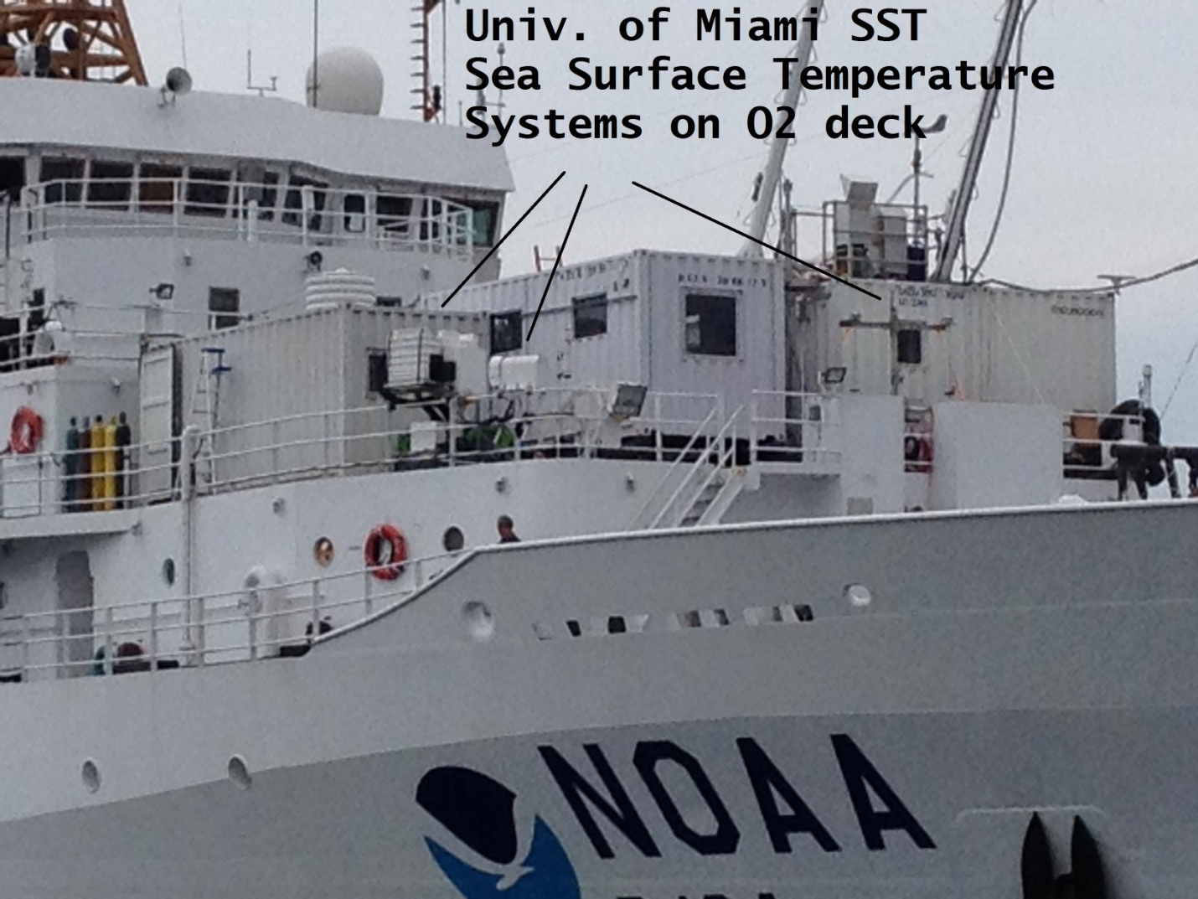
Locations of RSMAS equipment on the 02 deck.
Appendix G: Station Locations

CTD Latitude Longitude Description

13°06’N 59°37’W Bridgetown, Barbados
1 16°43’N 49°18’W CTD test cast
2 20°01’N 37°54’W CTD
20°01’N 37°54’W ATLAS recovery/deployment
3 20°01’N 37°47’W CTD
20°01’N 37°47’W TFlex recovery/deployment
4 20°27’N 23°10’W CTD
20°27’N 23°10’W ATLAS recovery/deployment
5 20°00’N 23°00’W CTD
6 19°30’N 23°00’W CTD
7 19°00’N 23°00’W CTD
8 18°30’N 23°00’W CTD
9 18°00’N 23°00’W CTD
10 17°30’N 23°00’W CTD
11 17°00’N 22°49’W CTD
12 16°30’N 22°44’W CTD
13 16°00’N 22°36’W CTD
14 15°30’N 22°44’W CTD
15 15°00’N 22°52’W CTD
16 14°30’N 23°00’W CTD
17 14°00’N 23°00’W CTD
18 13°30’N 23°00’W CTD
19 13°00’N 23°00’W CTD
20 12°30’N 23°00’W CTD
21 12°00’N 23°00’W CTD
22 11°30’N 23°00’W CTD
11°30’N 23°00’W ATLAS recovery/deployment
23 11°00’N 23°00’W CTD
24 10°30’N 23°00’W CTD
25 10°00’N 23°00’W CTD
26 09°30’N 23°00’W CTD
27 09°00’N 23°00’W CTD
28 08°30’N 23°00’W CTD
29 08°00’N 23°00’W CTD
30 07°30’N 23°00’W CTD
31 07°00’N 23°00’W CTD
32 06°30’N 23°00’W CTD
33 06°00’N 23°00’W CTD
34 05°30’N 23°00’W CTD
35 05°00’N 23°00’W CTD
36 04°30’N 23°00’W CTD
37 04°00’N 23°00’W CTD
04°00’N 23°00’W ATLAS recovery/deployment
38 03°30’N 23°00’W CTD
39 03°00’N 23°00’W CTD
40 02°30’N 23°00’W CTD
41 02°00’N 23°00’W CTD
42 01°45’N 23°00’W CTD
43 01°30’N 23°00’W CTD
44 01°15’N 23°00’W CTD
45 01°00’N 23°00’W CTD
46 00°45’N 23°00’W CTD
47 00°30’N 23°00’W CTD
48 00°15’N 23°00’W CTD
49 00°00’N 23°00’W CTD
00°00’N 23°00’W ATLAS repair
50 00°15’S 23°00’W CTD
51 00°30’S 23°00’W CTD
52 00°45’S 23°00’W CTD
53 01°00’S 23°00’W CTD
54 01°15’S 23°00’W CTD
55 01°30’S 23°00’W CTD
56 01°45’S 23°00’W CTD
57 02°00’S 23°00’W CTD
58 02°15’S 23°00’W CTD
59 02°30’S 23°00’W CTD
60 02°45’S 23°00’W CTD
61 03°00’S 23°00’W CTD
62 03°30’S 23°00’W CTD
63 04°00’S 23°00’W CTD
05°35’S 35°12’W Natal, Brazil

