GTSPP CTD National Report 2014
Atlantic Oceanographic and Meteorological Laboratories (AOML)
Annual Report – 2013
Version 1.0
Date of update : June 09, 2014
Status
There are two projects in AOML which collects the CTD data and they are PIRATA Northeast Extension (PNE) figure 1 and Western Boundary Time Series (WBTS) figure 2. The WBTS project is composed of two sub projects which are 1) big cruise and 2) small cruise. The PNE project’s deployment for 2013 is 50 CTD’s per year and the WBTS project’s big cruise deployment is about 41 CTD’s per year and the samll cruise deplyment is about 36 CTD’s per year.
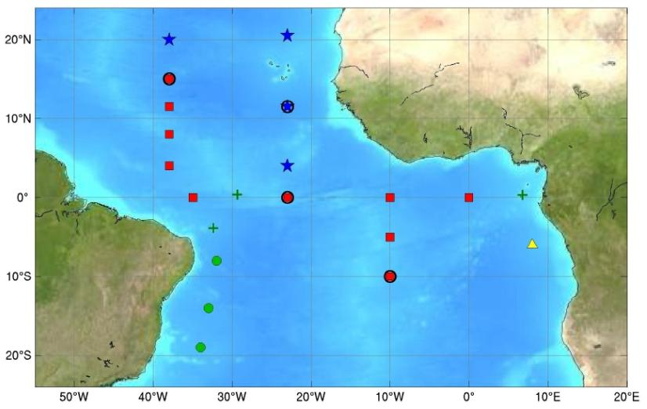
Figure 1: This image shows the PIRATA backbone of buoys (red squares), the Northeast Extension (blue stars) led by the United States, the Southwest Extension (green circles) led by Brazil, the Southeast Extension pilot site (yellow triangle), and island-based observation sites (green crosses). Buoys with barometers and long wave radiometers are indicated with black circles.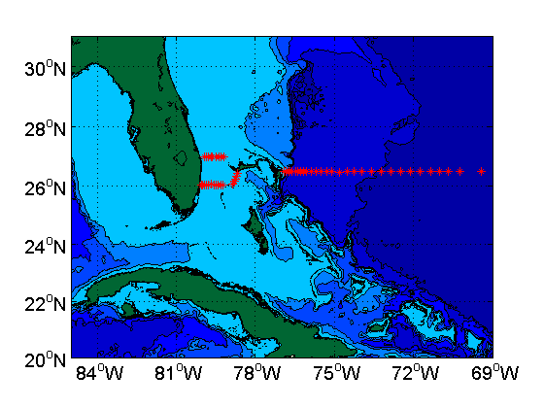
Figure 2 : Stations frequently visited during the Deep Western Boundary Current Hydrography cruise.
Data issued to GTS
The PNE ctd data are transmitted to the GTS as un-calibrated data, but the WBTS ctd data are not transmitted to the GTS.
Data issued to US-NODC after real-time QC
The PNE ctd data as real-time are not quality controlled.
Data issued to US-NODC after delayed QC
The PNE and WBTS CTD both data have been quality controlled in AOML as delayed mode data and stored in the AOML FTP site for NODC to pick them up.
The PNE ctd data has been collected once a year and the WBTS ctd data has been collected every 9 months.
Web pages
AOML currently hosts and maintains two web pages:
- PNE web page (http://www.aoml.noaa.gov/phod/pne/pirata.php)
Data are available from AOML’s FTP site:
/phod/pub/lumkin/pne13a/ctd
- WBTS web page (http://www.aoml.noaa.gov/phod/wbts/hydro/index.php)
Data are available from the AOML’s FTP site:
/phod/pub/WBTS/IES
/phod/pub/WBTS/Global_class
/phod/pub/WBTS/SmallBoat
/phod/pub/WBTS/WaltonSmith

Products generated from GTSPP data
WBTS data related publication can be found in (http://www.aoml.noaaa.gov/phod/wbts/public.php)
PNE data related publication can be found in (http://www.aoml.noaaa.gov/phod/pne/publications.php)

Research operations
The PNE related projects are:
- AEROSE
The Trans-Atlantic Saharan Dust AERosols and Oceanographic Science Expedition (AEROSE) is a project that aims to characterize the impacts and microphysical evolution of Sahara dust aerosol transport across the Atlantic Ocean. AEROSE observations are collected during PNE cruises aboard the R/V Ronald H. Brown.
- TACE
The Tropical Atlantic Climate Experiment (TACE), endorsed by the CLimate Variability and Predictability (CLIVAR) project, is a program of enhanced observation and modeling studies in the tropical Atlantic spanning the period 2006-2011. One goal of TACE is to contribute to the final design of a sustained observing system for the region, including the PIRATA Northeast Extension.
- AMMA
The African Monsoon Multidisciplinary Analysis (AMMA) project, is an international effort to improve our knowledge and understanding of the West African Monsoon (WAM) and its variability. PNE contributes to AMMA by helping us better understand the role of the ocean in seasonal to interannual fluctuations in the WAM with observations at the new PIRATA mooring sites.

The WBTS related projects are:
- Florida Current
- Deep Western Boundary Current
- Meridional Overturning Circulation – MOC
- Meridional Overturning Circulation and Heatflux Array - MOCHA
Difficulties encountered
AOML scientists collect conductivity-temperature-depth (CTD) profiles for several projects, including the Western Boundary Time Series and the PIRATA Northeast Extension projects. This CTD work involves lowering a 1000+ lb instrument package from the surface down to 10-20 meters above the bottom of the ocean on a conducting cable and then retrieving it. Because this is somewhat mechanically complicated, these CTD operations are subject to a variety of challenges. The CTD winches are subject to mechanical failures that can result in very low operating speeds, extended delays when the CTD is at depth, and even the loss of the CTD package if the winch wire breaks (as sadly happened during one of our GO-SHIP cruises in 2013). Because the deep ocean is a physically tough environment, CTD work can also be subject to electronic sensor failures and communication failures. Furthermore, as the sea is rarely calm, the actual process of putting the CTD package into the water and removing it from the sea can b perilous, and at times the package will hit the ship, damaging the electronic sensors and/or the Niskin bottles.

Feedback
Work Plan 2014-2016
The WBTS project has four cruises per year with 9 CTD’s for each cruise for the small cruise. The big cruise will have one (about 9months) per year with approximately 40 CTD’s. The PNE project will have about 50 CTD’s per year.

