## *Global ocean phytoplankton*—B. A. Franz1, I. Cetinić1,2, J.P. Scott1,3, D. A. Siegel4, and T.K. Westberry5

1NASA Goddard Space Flight Center, Greenbelt, MD, USA; 2Universities Space Research Association, Columbia, MD, USA; 3Science Application International Corporation, Beltsville, MD, USA; 4University of California, Santa Barbara, California, USA; 5Oregon State University, Corvallis, Oregon, USA;

Photosynthetic production of carbon by marine phytoplankton fuels oceanic ecosystems and drives biogeochemical cycles (e.g. Falkowski et al. 1998; Field et al. 1998), contributing roughly 50% to global net primary production (NPP). Phytoplankton distribution, growth, and diversity is governed by light and nutrient availability, successively controlled by physical forces (e.g. Behrenfeld et al. 2006). Spaceborne radiometers such as SeaWiFS (McClain 2009) and MODIS (Esaias et al. 1998) allow us to detect spatio-temporal changes in the distribution of phytoplankton, either through near-surface concentration of the phytoplankton pigment chlorophyll-*a* (Chl*a*; mg m-3) or phytoplankton carbon (Cphy, mg m-3). Both parameters are useful tools to quantity variability of phytoplankton biomass in the ocean; however, discrepancies between their distributions (shifts in Chl*a*:Cphy ratios) are indicators of physiological variability within the cell (due to the changes in light and nutrient conditions) or changes in species composition (Westberry et al. 2016; Dierssen 2010; Geider et al. 1997). The combination of these two measurements thus provide a synoptic view of phytoplankton biomass in the ocean, as well as its response to climate-associated variability in the environment.

In this report, we evaluate global Chl*a* and Cphy distributions for the one year period from October 2018 through September 2019, within the context of the continuous 22-year record provided through the combined observations of SeaWiFS (1997–2010) and MODIS on Aqua (MODISA, 2002–present). The MODISA daytime sea surface temperature (SST; °C) is also assessed for the same period, to provide context on the physical state of the oceans. The Chl*a* product was derived using the OCI algorithm of Hu et al. (2012), while Cphy was derived from the particle backscattering coefficient, bbp, at 443nm (GIOP algorithm, Werdell et al. 2013) and a linear relationship between bbp and Cphy as described in Graff et al. (2015). In combining the ocean color records, the overlapping period from 2003 through 2010 was used to assess and correct for residual bias between the two mission datasets.

Changes in phytoplankton distribution over the year were evaluated by subtracting the mean values for MODISA Chl*a* and Cphy in each month of the year from monthly climatological means for MODISA (Oct 2002 – Sept 2018). These monthly fields were then averaged to produce the global Chl*a* and Cphy anomaly maps for 2019 (Fig. 3.23a,b). Similar calculations were performed on MODISA sea surface temperature data to produce an equivalent SST annual mean anomaly (Fig. 3.23c). The permanently stratified ocean (PSO) is defined as the region, spanning the tropical and subtropical oceans, where annual average SST is greater than 15C and surface mixed layers are typically low in nutrients and shallower than the nutricline (black lines near 40N and 40S in Fig. 3.23; Behrenfeld et al. 2006).

Chl*a* concentrations for 2019 (Fig. 3.23a) were suppressed 10%-30% relative to the climatological mean in the western Pacific warm pool, northern region of the tropical Pacific, western North Pacific, and central Indian Ocean. These locations correspond to regions of strongly elevated SSTs (Fig. 3.23c). Positive SST anomalies in these permanently stratified ocean regions generally coincide with shallower surface mixed layer depths (MLD), which increases light exposure within the mixed layer. Response of the phytoplankton to this increased insolation manifests as a decrease in cellular chlorophyll concentrations (Behrenfeld et al. 2015). This effect, in combination with the physiological response to nutrient replete conditions, leads to decreased cellular chlorophyll to carbon ratios (Westberry et al. 2016) and thus a decoupling of the Chl*a* and Cphy anomalies. Like Chl*a*, concentrations of Cphy within the tropical Pacific show similar but weaker patterns of negative anomalies in the east (-5%), but contrasting neutral to positive anomalies (+5%) in the west, with Cphy anomalies generally more homogeneous across the Atlantic and Pacific oceans (Fig. 3.23b), consistent with prior-year observations (Franz et al. 2019). Notably, a region of strongly elevated SST in the South Atlantic, extending from the east coast of South America to the horn of Africa (Fig. 3.23c), shows neutral to positive Chl*a* anomalies and neutral to negative Cphy anomalies. Elevated phytoplankton biomass, evident from both Chl*a* and Cphy anomalies, were visible in the Mediterranean Sea, Arabian Sea and Bay of Bengal, the Southern Pacific Subtropical gyre, and the eastern Equatorial and subtropical Atlantic. Outside of the PSO, a much weaker correlation is generally observed between phytoplankton biomass anomalies and SST anomalies, consistent with past reports (e.g., Franz et al. 2019), with patches of high biomass visible throughout the southern ocean and northern subpolar Atlantic (negative SST anomaly), and northeastern subpolar Pacific (positive SST anomaly).

Seasonal changes in phytoplankton biomass in the PSO typically display two pronounced peaks, reflecting vernal increases in biomass in northern and southern hemispheres (Fig. 3.24). Peaks in monthly climatological Cphy tend to trail behind peaks in Chl*a* with a 2-month delay, likely due to a reduction in phytoplankton chlorophyll to carbon ratios as the seasonal bloom progresses (e.g., Westberry et al. 2016). During 2019, primary and secondary peaks in Chl*a* (Fig. 3.24a) occurred in March and July, followed by Cphy maxima in June and September (Fig. 3.24b), corresponding with the associated seasonal cycles of the northern and southern hemispheres respectively (Figs. 3.24c-h), and with timing consistent with prior-year observations (Franz et al. 2019). Monthly mean values of Chl*a* and Cphy for 2019 fell generally within the range of climatological norms, with the notable exception of highly elevated concentrations observed in the southern hemisphere in May-July 2019.

Over the 22-year time series of spatially integrated monthly mean Chl*a* within the PSO (Fig. 3.25a), concentrations varied by ~15% (±0.02 mg m-3) around a long-term average of 0.142 mg m-3 . This variability includes significant seasonal cycles in Chl*a* distributions and responses to climatic events, as has been observed previously (e.g., Behrenfeld et al. 2006, Franz et al. 2019). Cphy over the same 22-yr period varied by ~7% (±1.5 mg m-3) around an average of *23.7* mg m-3 (Fig. 3.25c). Seasonal cycles in Cphy are more clearly defined than those of Chl*a*, consistent with the assertion that Cphy represents true variability in phytoplankton biomass that is insensitive to local and global environmental conditions that alter cell pigmentation through physiological processes.

Chl*a* monthly anomalies within the PSO (Fig. 3.25b) show variations of ±10% (± 0.015 mg m-3) over the multi-mission time series, with largest deviations generally associated with El Niño/La Niña events. This link between ENSO variability and mean Chl*a* response in the PSO is demonstrated by the correspondence of anomaly trends with the Multivariate ENSO Index (MEI; Wolter and Timlin (1998); presented in the inverse to illustrate the covariation). For 2019, variability in monthly Chl*a* anomalies was modest (±6%) and centered around zero, consistent with neutral to weak ENSO conditions during this year (Fig 3.1b). Similar observations can be made of the Cphy anomalies (±2%), which also track well with the MEI over the 22-year timeseries.

Observed trends and variability in Cphy reflect changes in phytoplankton biomass, while Chl*a* variability reflects changes in both biomass and physiology (or health). These two properties are mechanistically linked to physical conditions of the upper ocean, as well as to ecological interactions between phytoplankton and their zooplankton predators. Our ability to track subtle variations in the distribution of Chl*a* and Cphy on the global scale thus contributes to our understanding of climate driven changes in the functionality of the ocean. Unraveling the diversity and covariation of factors that influence Chl*a* concentrations, however, is essential for correctly interpreting the implications of Chl*a* anomalies on ocean biogeochemistry and food webs. An additional complication is that measured changes in ocean color often contain a contribution from colored dissolved organic matter (Siegel et al. 2005), or from the changing phytoplankton population (with its type-specific optical characteristics, Dierssen (2010)), that can be mistakenly attributed to changes in Chl*a* (Siegel et al. 2013). Cphy provides a more direct measurement of phytoplankton biomass and thus offers complementary information on the state of the oceans. Future satellite missions, such as the upcoming hyperspectral Plankton, Aerosol, Cloud, ocean Ecosystem mission (PACE), will enable the rigorous separation of phytoplankton absorption features from non-algal features, as well as the assessment of changes in phytoplankton species or functional group distributions (Werdell et al. 2019). Such data will provide a major step forward in our ability to disentangle the impacts of climate forcing on global phytoplankton communities.

**References:**

Behrenfeld, M. J., K. H. Halsey, and A. J. Milligan, 2008: Evolved physiological responses of phytoplankton to their integrated growth environment. *Philosophical Transactions of the Royal Society B: Biological Sciences*, **363,** 2687-2703.

Behrenfeld, M. J., and Coauthors, 2015: Revaluating ocean warming impacts on global phytoplankton. *Nature Climate Change*, **6,** 323.

Behrenfeld, M. J., and Coauthors, 2006: Climate-driven trends in contemporary ocean productivity. *Nature*, **444,** 752-755.

Dierssen, H. M., 2010: Perspectives on empirical approaches for ocean color remote sensing of chlorophyll in a changing climate. *Proceedings of the National Academy of Sciences*, **107,** 17073-17078.

Esaias, W. E., and Coauthors, 1998: An overview of MODIS capabilities for ocean science observations. *IEEE Transactions on Geoscience and Remote Sensing*, **36,** 1250-1265.

Falkowski, P. G., R. T. Barber, and V. Smetacek, 1998: Biogeochemical controls and feedbacks on ocean primary production. *Science*, **281,** 200-206.

Field, C. B., M. J. Behrenfeld, J. T. Randerson, and P. Falkowski, 1998: Primary Production of the Biosphere: Integrating Terrestrial and Oceanic Components. *Science*, **281,** 237-240.

Franz, B.A., I. Cetinić, E.M. Karaköylü, D.A. Siegel, and T.K. Westberry, 2019: Global ocean phytoplankton [in "State of the Climate in 2018"]. Bulletin of the American Meteorological Society, 100(9):S92-S94, doi: 10.1175/2019BAMSStateoftheClimate.1

Geider, R. J., H.L. MacIntyre, and T. M. Kana, 1997: Dynamic model of phytoplankton growth and acclimation: responses of the bablnced growth rate and the chlorophyll a:carbon ratio to light, nutrient limitation and temperature. *Mar. Ecol. Prog. Ser.*, **148,** 187-200.

Graff, J. R., and Coauthors, 2015: Analytical phytoplankton carbon measurements spanning diverse ecosystems. *Deep Sea Res Part 1 Oceanogr Res Pap.*, **102,** 16-25.

Hu, C., Z. Lee, and B.A. Franz, 2012: Chlorophyll a algorithms for oligotrophic oceans: A novel approach based on three‐band reflectance difference. *J. Geophys. Res.*, 117, C01011, doi:10.1029/2011JC007395.

McClain, C. R., 2009: A Decade of Satellite Ocean Color Observations. *Annual Review of Marine Science*, **1,** 19-42.

Siegel, D. A., S. Maritorena, N. B. Nelson, M. J. Behrenfeld, and C. R. McClain, 2005: Colored dissolved organic matter and its influence on the satellite-based characterization of the ocean biosphere. *Geophys. Res. Lett.*, **32**.

Siegel, D. A., and Coauthors, 2013: Regional to global assessments of phytoplankton dynamics from the SeaWiFS mission. *Remote Sens. Environ.*, **135,** 77-91.

Werdell, P. J., and Coauthors, 2013: Generalized ocean color inversion model for retrieving marine inherent optical properties. *Appl. Opt.*, **52,** 2019-2037.

Werdell, P.J., M. Behrenfeld, P. Bontempi, E. Boss, B. Cairns, G. Davis, B. Franz, U. Gliese, E. Gorman, O. Hasekamp, K. Knobelspiesse, A. Mannino, V. Martins, C. McClain, G. Meister, L. Remer, 2019: The Plankton, Aerosol, Cloud, ocean Ecosystem (PACE) mission: Status, Science, Advances. *Bull. Amer. Meteor. Soc.,* 100 (9), 1775-1794, doi:10.1175/BAMS-D-18-0056.1

Westberry, T. K., and Coauthors, 2016: Annual cycles of phytoplankton biomass in the subarctic Atlantic and Pacific Ocean. *Global Biogeochem. Cycles*, **30,** 175-190.

Wolter, K., and M. S. Timlin, 1998: Measuring the strength of ENSO events: How does 1997/98 rank?, *Weather*, **53,** 315-324.

**Datasets Used:**

|  |  |  |
| --- | --- | --- |
| Variable | Dataset | Source |
| Phytoplankton Chlorophyll  Particle Backscattering Coefficient | SeaWiFS v 2018.0 | https://oceancolor.gsfc.nasa.gov/reprocessing/ |
| MODIS-Aqua v 2018.0 and v 2018.1 | https://oceancolor.gsfc.nasa.gov/reprocessing/ |
| Sea Surface Temperature | MODIS-Aqua v 2019.0 | https://oceancolor.gsfc.nasa.gov/reprocessing/ |

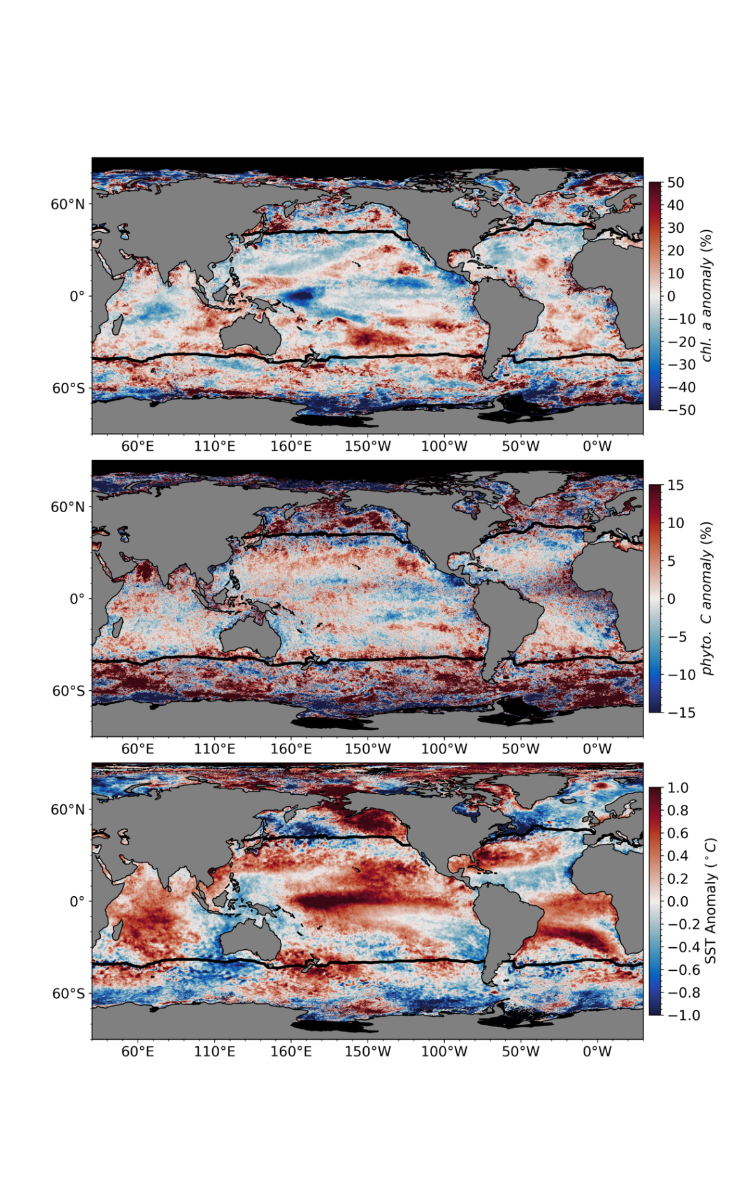

**Fig. 3.23**: Spatial distribution of average monthly (a) MODISA Chl*a* anomalies, (b) MODISA Cphy anomalies, and (c) MODISA SST anomalies, where monthly differences were derived relative to a MODISA 16-year climatological record (October 2002-September 2018). Chl*a* and Cphy are stated as % difference from climatology, while SST is shown as an absolute difference. Also shown in each panel is the location of the mean 15oC SST isotherm (black lines) delineating the permanently stratified ocean (PSO).



**Fig. 3.24:** Distribution of October 2018 – September 2019 monthly means (red circles) for (a) MODISA Chl*a* and (b) MODISA Cphy for the permanently stratified ocean (PSO) region, superimposed on the climatological values as derived from the combined time-series of SeaWIFS and MODISA over the 20-year period from 1998 through 2017. The gray boxes show the interquartile range of the climatology, with black line for the median value and whiskers extending to the 5th and 95th percentiles. Subsequent panels show latitudinally segregated subsets of the PSO for the northern hemisphere (c,d), tropical +/-23.5-deg latitude subregion (e,f), and southern hemisphere (g,h).



**Fig. 3.25**: 22-year, multi-mission record of Chl*a* and Cphy averaged over the PSO for SeaWiFS (blue), MODISA (red), and combined (black). Panel (a) shows Chl*a* from each mission, with horizontal line indicating the multi-mission mean Chl*a* concentration for the region. Panel (b) shows the monthly Chl*a* anomaly from SeaWiFS and MODISA after subtraction of the 20-year multi-mission climatological mean (Fig. 3). Panel (c) and (d) show the same as (a) and (b) respectively, but for Cphy. Green diamonds show the Multivariate ENSO Index (MEI), inverted and scaled to match the range of the Chl*a* and Cphy anomalies.