j. Global ocean carbon cycle—R. A. Feely1, R. Wanninkhof2, P. Landschützer3, B. R. Carter4, and
J. A. Triñanes5

1 Pacific Marine Environmental Laboratory, 7600 Sand Point Way NE, Seattle, WA, 98115

2 Atlantic Oceanographic and Meteorological Laboratory, 4301 Rickenbacker Causeway, Miami, FL, 33149
3 Max Planck Institute for Meteorology, Hamburg, Germany

4 University of Washington Joint Institute for the Study of Atmosphere and Oceans, 3737 Brooklyn Avenue NE, Seattle, WA 19195, USA
5 Laboratory of Systems, Technological Research Institute, Universidad de Santiago de Compostela, Campus Universitario Sur, Santiago de Compostela, Spain; NOAA/OAR Atlantic Oceanographic and Meteorological Laboratory (AOML), Miami, Florida, and Cooperative Institute for Marine and Atmospheric Studies, Rosenstiel School of Marine and Atmospheric Science, University of Miami, Miami, Florida

- Introduction.

The oceans play a major role in the global carbon cycle by taking up a significant fraction of the excess carbon dioxide that humans release into the atmosphere. As a consequence of humankind’s collective release of CO2 emissions into the atmosphere from fossil fuel burning, cement production, and land use changes over the last two-and-a-half centuries, commonly referred to as “anthropogenic CO2 (Canth)” emissions, the atmospheric CO2 concentration has risen from pre- industrial levels of about 278 ppm (parts per million) to 411 ppm in 2019. The atmospheric concentration of CO2 is now 47% higher than preindustrial levels (Friedlingstein et al. 2019). As discussed in previous State of the Climate reports, marine Canth is the major cause of anthropogenic ocean acidification. Here the discussion is updated to include recent estimates of the ocean Canth
sink. Over the last decade the global ocean has continued to take up a substantial fraction of the

Canth emissions and therefore is a major mediator of global climate change. Of the 11 (±0.9) Pg C yr−1 Canth released during the period 2009−2018, about 2.5 (±0.6) Pg C yr−1 (23%) accumulated in the ocean, 3.2 (±0.6) Pg C yr⁻¹ (29%) accumulated on land, and 4.9 (±0.1) Pg C yr⁻¹ (44%) remained in the atmosphere with an imbalance of 0.4 Pg C yr⁻¹ (4 %) (Figure 2 of Friedlingstein et al., 2019). This decadal ocean carbon uptake estimate is a consensus view from a combination of measured decadal CO2 inventory changes, models, and global air–sea CO2 flux estimates based on surface ocean partial pressure of CO2 (pCO2) measurements from ships and moorings. Using ocean circulation models that include biogeochemical parameterizations (OBGCMs) and inverse models that are validated against or fit to observed air–sea exchange fluxes and basin- scale ocean inventories, Friedlingstein et al. (2019) showed that the oceanic anthropogenic carbon sink has grown from 1.0 (±0.6) Pg C yr⁻¹ in the decade of the 1960s to 2.6 (±0.6) Pg C yr⁻¹ in 2018. Riverine contributions supply an additional -0.45 to -0.78 Pg C yr⁻¹ to the ocean.

- Air–sea carbon dioxide fluxes

Ocean uptake of CO2 is estimated from the net air–sea CO2 flux derived from the bulk flux formula with air–sea differences in CO2 partial pressure (ΔpCO2) and gas transfer coefficients as input. Gas transfer is parameterized with wind described in Wanninkhof (2014). A steady contribution of carbon from riverine runoff, originating from organic and inorganic detritus from land, revised upward from 0.45 to 0.78 Pg C yr−1 (Resplandy et al, 2018) is included. The inferred air-sea pCO2 imbalance is due to riverine contributions, Canth fluxes into the ocean, natural carbon deposition into/onto the sea floor and margins, and natural variations in that balance of CO2 between the atmosphere and ocean. If the latter two are assumed to be small or small on long timescales, then the Canth can be inferred from these flux estimates. The data sources for pCO2 are annual updates of
surface water pCO2 observations from the Surface Ocean CO2 Atlas (SOCAT) composed of
mooring and ship-based observations (Bakker et al. 2016) and the LDEO database with ship- based observations (Takahashi et al. 2019). The increased observations and improved mapping techniques including the neural network methods (Rödenbeck et al. 2015) provide annual global pCO2 fields on a 1° latitude by 1° longitude grid at monthly time scales. This allows investigation of variability on sub-annual to decadal time scales.

The monthly 2019 ΔpCO2 maps are based on the observation-trained neural network approach of Landschützer et al. (2013, 2014). The 2019 values are projections based on observed sea surface temperature, sea surface salinity for 2019; climatological mixed-layer depth; satellite chlorophyll-a, atmospheric CO2; and a neural network approach for pCO2w developed from the data from 1982- through January 2019. The 2019 estimate uses the monthly wind fields from 2018 but changes in winds over time have a small effect on annual global air–sea CO2 fluxes (Wanninkhof and Triñanes, 2017). The Canth fluxes from 1982 to 2019 suggest a decreasing ocean sink in the first part of the record and a strong increase from 2001 onward that continued unabated into 2019 with an 0.2 Pg C yr₋1 increase from 2018 to the 2019 estimate (Fig. 3.j1). The amplitude of seasonal variability is large (≈ 1 Pg C yr₋1) compared to the long-term trend with minimum uptake in the June–September timeframe. The Canth air–sea flux of 3.2 Pg C yr−1 in 2019 is 33% above the revised 1997–2017 average of 2.40 (±0.46) Pg C yr⁻¹.

The average fluxes in 2019 (Fig. 3.j2a) show the characteristic pattern of effluxes in the tropical regions, in coastal upwelling zones, and in the high latitude Southern Ocean around 60˚S. Coastal upwelling regions include the Arabian Sea, off the west coasts of North and South America, and the coast of Mauritania. The western Bering Sea in the northwest Pacific is a strong CO2 source as well in 2019, particularly in the March to April timeframe. The region with largest efflux is the
upwelling region of the eastern Equatorial Pacific. The regions of effluxes are significant CO2
sources to the atmosphere. The primary uptake regions are in the subtropical and subpolar regions. The largest sinks are observed poleward of the sub-tropical fronts. The frontal positions determine the location of the maximum uptake. This position is farther south and weaker in the Pacific sector of the Southern Ocean compared to the other basins.

In the Northern Hemisphere, there is a significant asymmetry in fluxes in the sub-Arctic gyre with the North Atlantic being a large sink while the North Pacific is a significant source of CO2. This is, in part, due to the position of the western boundary currents that are known CO2 sinks at high latitudes. The Gulfstream/North Atlantic Drift in the Atlantic extends further north than the Kuroshio in the Pacific.

Ocean carbon uptake anomalies (Fig. 3.j2b) in 2019 relative to the 1997–2017 average are attributed to the increasing ocean CO2 uptake with time (Fig. 3.j1) and to variations in large-scale climate modes. The long-term air–sea flux trend since the minimum uptake in 2000 is -0.75 Pg C decade⁻¹ (or -0.17 mol m₂ yr₋₁ decade⁻¹), which leads to predominantly negative flux anomalies, or, in other words, greater ocean CO2 uptake (blue colors in Fig. 3.j2a). Despite this trend there are several large regions showing positive anomalies for 2019, notably the eastern Equatorial Pacific, the sub-polar Northwest Pacific (centered at ≈ 40°N), and the high latitude Southern Ocean. The increased effluxes in the eastern Equatorial Pacific are related to a predominant negative sign of the Oceanic Niño Index (ONI) that followed an extensive period of predominantly positive ONI (i.e., more El Niño-like) conditions in the preceding 20 years. The neutral sea surface temperature anomalies (SSTA) (Fig. 3.1a) indicate normal upwelling of waters with high CO2 content has returned after a period of lower than normal upwelling. Positive anomalies in the Northwest Pacific regions are related to the positive SSTA over the past year compared to the long-term
average (Fig. 3.j2b).

The differences between the air–sea CO2 fluxes in 2019 compared to 2018 (Fig. 3.j2c) are relatively small compared to previous years with anomalies roughly in the same regions as the difference of 2019 from to the 20-year average. This indicates that conditions in 2019 resemble conditions in 2018. The increase in CO2 effluxes in Northwest Pacific from 2018 to 2019 are associated with the return of the marine heatwave in this area. The Southern Ocean (south of 40°S) shows a decreasing sink in the polar front region (≈ 50°S) and increasing source to the south for the Atlantic sector of the Southern Ocean compared to 2018. The correlations with SSTA (2019-2018) are more nuanced. The large positive SSTA in Northwest Pacific from 30°N to 60°N are indicative of the warm water anomaly and associated positive CO2 flux anomaly (Fig. 3.j2b). The large negative CO2 flux anomaly in the southeastern Pacific has a positive SSTA associated with it, and the positive flux anomaly around 45°S in the South Atlantic is associated with a negative SSTA. These flux differences are not readily explained in terms of SSTA and suggest that in this band SSTA and flux anomalies are decoupled. The North Atlantic near Greenland shows a large increase in sink strength with a positive SSTA which again cannot be readily explained in terms of local SSTA. Rather it appears that changes in the ocean currents and biological productivity changes between 2019 and 2018 are the cause of the greater uptake.

Some of the pCO2 and CO2 flux anomalies can be attributed to variations in large-scale climate modes and associated physical anomalies, notably temperature, but the causality is often complex. For example, the behavior of pCO2 with respect to temperature includes competing processes: thermodynamics dictate decreasing pCO2 with decreasing SST, but waters originating from the deep with a cold temperature signal will have a high pCO2. As the exchange of CO2 is an order of
magnitude slower than inert gases, CO2 and CO2 flux anomalies can be propagated by ocean currents. Moreover, the drawdown of pCO2 due to biology is often associated with increasing temperature, but this depends on region and season. The strong trend of increasing CO2 uptake since 2000-2002 has continued through 2019 with an increase in 2019 of 0.2 Pg C yr-1 above the 2018 estimate. This increase meets the overall expectation that the ocean will remain an increasing sink if atmospheric CO2 levels continue to rise. The sequestration of CO2 by the ocean partially mitigates the atmospheric CO2 rise but it comes at a cost of increased acidification of surface and subsurface waters (Feely et al., 2016; Carter et al., 2017; Lauvset et al., 2020).

- Large-scale carbon and pH changes in the ocean interior

Global-scale carbon dioxide emissions from human activities are causing ocean interior Canth increases and acidification. These large-scale changes can affect marine organisms and impacting fisheries with implications for food security (Gattuso et al 2015). Delineating how the biogeochemical processes in the ocean interior will be affected by the changing heat content and Canth uptake is essential for developing future mitigation and adaptation responses to climate change. A major aim of the international Global Oceans Ship-based Investigations Program (GO- SHIP) is to determine the Canth input to the ocean interior and the changing patterns of oceanic CO2 over time (Talley et al., 2016; Sloyan et al. 2019). Field observations and inverse models have provided estimates of the uptake of Canth into the ocean both over the last 250 years and over the last two decades. Simulations of Canth inventories with models suggest that the ocean accumulated 24 - 34 Pg C of Canth between 1994 and 2007 (Gruber et al., 2019; Fig. 3.j3), accounting for about 25% of the total anthropogenic CO2 emissions over that time period. This uptake has increased the total inventory of Canth since 1750 from 118 ± 20 Pg C in 1994 to 170 ± 20 Pg C in 2018 (Sabine et al., 2004; Friedlingstein et al., 2019). Change in Canth storage is determined by the change in Canth
between repeat surveys. This approach utilizes several newly developed methods and procedures for determining Canth from the often much larger changes in the natural carbon content due to changes in transport ventilation and remineralization (e.g. Woosley et al. 2016; Clement and Gruber, 2018; Carter et al., 2017, 2019). The approaches have been extended to allow for estimation of global ocean Canth as well as extrapolation into coastal regions (Feely et al., 2016). These approaches have indicated that significant variability at interannual and decadal time scales occurs in some regions, particularly in the tropics due to ENSO forcing, and in the subtropics and high-latitude regions due to changing ventilation processes that can alter the globally integrated sink (Carter et al., 2017, 2019; Rödenbeck et al., 2015; Landschützer et al., 2016; DeVries et al., 2017; Friedlingstein et al., 2019).

The GO-SHIP surveys have also been used to determine the long-term biogeochemical changes in carbonate chemistry including pH and calcium carbonate saturation state in the global oceans (Carter et al., 2017, 2019; Lauvset et al., 2015, 2020). Since 1750, surface ocean pH has declined by 0.018 ± 0.004 units decade₋1 in 70% of the ocean basins (Fig. 3.j4), and the surface aragonite saturation state has fallen by an average rate of 0.34% per year, causing more stress on carbonate mineral-forming organisms. The sensitivity of pH to changing atmospheric CO2 concentration increases as temperature decreases. Hence the magnitude of ΔpH is largest in cold high-latitude waters. Anthropogenic changes in pH are amplified at depth where pH is naturally lower and dissolved inorganic carbon (DIC) is naturally higher, implying a larger change in pCO2 and pH for a given change in DIC. As atmospheric CO2 concentration increases, changes in the carbonate system, and the individual carbonate system species, will be directly affected with changing buffer capacity of seawater. Continued observations and modeling studies are needed to determine how oceans keep pace with the atmospheric CO2 increase.

- References:

Bakker, D.C.E. and Coauthors ( 2016): A multi-decade record of high-quality fCO2 data in version the Surface Ocean CO2 Atlas (SOCAT). Earth Syst. Sci. Data, 8, 383–413, http://dx.doi.org/10.5194/essd-8-383-2016.
Carter, B.R., R.A. Feely, S. Mecking, J.N. Cross, A.M. Macdonald, S.A. Siedlecki, L.D. Talley,

C.L. Sabine, F.J. Millero, J.H. Swift, and A.G. Dickson (2017): Two decades of Pacific anthropogenic carbon storage and ocean acidification along GO-SHIP Sections P16 and P02. Global Biogeochem. Cycles, 31, doi: 10.1002/2016GB005485
Carter, B.R., R.A. Feely, R. Wanninkhof, S. Kouketsu, R.E. Sonnerup, P.C. Pardo, C.L. Sabine,

G.C. Johnson, B.M. Sloyan, A. Murata, S. Mecking, B. Tillbrook, K. Speer, L.D. Talley,

F.J. Millero, S.E. Wijffels, A.M. Macdonald, N. Gruber, and J.L. Bullister (2019): Pacific anthropogenic carbon between 1991 and 2017. Global Biogeochem. Cycles, 33(5), 597– 617, doi: 10.1029/2018GB006154,
Clement, D., and N. Gruber (2018): The eMLR(C*) method to determine decadal changes in the global ocean storage of anthropogenic CO2. Global Biogeochem. Cycles, doi:10.1002/2017GB005819.
DeVries, T., M. Holzer, and F. Primeau (2017): Recent increase in oceanic carbon uptake driven by weaker upper-ocean overturning. Nature, 542, 215–218, doi:10.1038/nature21068.
Feely, R.A., S. Alin, B. Carter, N. Bednaršek, B. Hales, F. Chan, T.M. Hill, B. Gaylord, E. Sanford, R.H. Byrne, C.L. Sabine, D. Greeley, and L. Juranek (2016): Chemical and biological impacts of ocean acidification along the west coast of North America. Estuar. Coast. Shelf Sci., 183(A), 260–270, doi: 10.1016/j.ecss.2016.08.043.
Friedlingstein, P., M.W. Jones, M. O’Sullivan, R.M. Andrew, J. Hauck, G.P. Peters, W. Peters, J.
Pongratz, S. Sitch, C. Le Quéré, D.C.E. Bakker, J.G. Canadell, P. Ciais, R. Jackson, P. Anthoni, L. Barbero, A. Bastos, V. Bastrikov, M. Becker, L. Bopp, E. Buitenhuis, F. Chevallier, L.P. Chini, K.I. Currie, R.A. Feely, M. Gehlen, D. Gilfillan, T. Gkritzalis, D.S. Goll, N. Gruber, S. Gutekunst, I. Harris, V. Haverd, R.A. Houghton, G. Hurtt, T. Ilyina,
A.K. Jain, E. Joetzjer, J.O. Kaplan, E. Kato, K. Klein Goldewijk, J.I. Korsbakken, P. Landschützer,

S.K. Lauvset, N. Lefèvre, A. Lenton, S. Lienert, D. Lombardozzi, G. Marland, P.C. McGuire, J.R. Melton, N. Metzl, D.R. Munro, J.E.M.S. Nabel, S.-I. Nakaoka,
N. Negi, C. Neill, A.M. Omar, T. Ono, D. Pierrot, B. Poulter, G. Rehder, L. Resplandy, E. Robertson, C. Rödenbeck, R. Séférian, J. Schwinger, N. Smith, P.P. Tans, H. Tian, B. Tilbrook, F.N. Tubiello, G.R. van der Werf, A.J. Wiltshire, and S. Zaehle (2019): Global
Carbon Budget 2019. Earth Sys. Sci. Data, 11, 1783–1838, doi: 10.5194/essd-11-1783-

2019.

Gattuso, J.-P., Magnan, A., Bille, R., Cheung, W.W.L., Howes, E.L., Joos, F., Allemand, D.,Bopp,

L., Cooley, S.R., Eakin, C.M., Hoegh-Guldberg, O., Kelly, R.P., Pörtner, H.-O., Rogers,

A.D., Baxter, J.M., Laffoley, D., Osborn, D., Rankovic, A., Rochette, J., Sumaila, U.R., Treyer, S., Turley, C., 2015. Contrasting futures for ocean and society from different anthropogenic CO2 emission scenarios. Science 349(6243), aac4722, doi:10.1126/science.aac4722.
Gruber, N., D. Clement, B.R. Carter, R.A. Feely, S. van Heuven, M. Hoppema, M. Ishii, R.M. Key,

A. Kozyr, S. Lauvset, C. Le Monaco, J.T. Mathis, A. Murata, A. Olsen, F.F. Perez,

C.L. Sabine, T. Tanhua, and R. Wanninkhof (2019): The oceanic sink for anthropogenic CO2 from 1994 to 2007. Science, 363(6432), 1193−1199, doi: 10.1126/science.aau5153,
Landschützer, P., and Coauthors, 2013: A neural network-based estimate of the seasonal to inter- annual variability of the Atlantic Ocean carbon sink. Biogeosciences, 10, 7793-7815,
doi:10.5194/bg-10-7793-2013.

Landschützer, P., N. Gruber, D. C. E. Bakker, and U. Schuster, 2014: Recent variability of the global ocean carbon sink. Global Biogeochemical Cycles, 28, 927-949, doi: 10.1002/2014gb004853.
Landschützer, P., N. Gruber, and D. C. E. Bakker (2016), Decadal variations and trends of the global ocean carbon sink, Global Biogeochem. Cycles, 30, 1396–1417, doi:10.1002/2015GB005359.
Lauvset, S. K., Gruber, N., Landschützer, P., Olsen, A., & Tjiputra, J. (2015). Trends and drivers in global surface ocean pH over the past 3 decades. Biogeosciences, 12(5), 1285–1298.
Lauvset, S.K., B.R. Carter, F.F. Perez, L.-Q. Jiang, R.A. Feely, A. Velo, and A. Olsen (2020): Processes driving global interior ocean pH distribution. Global Biogeochem. Cycles, 34(1), doi: 10.1029/2019GB006229.
Resplandy, L., and Coauthors, 2018: Revision of global carbon fluxes based on a reassessment of oceanic and riverine carbon transport. Nature Geoscience, 11, 504-509, doi:10.1038/s41561- 018-0151-3
Rödenbeck, C., D.C.E. Bakker, N. Gruber, Y. Iida, A.R. Jacobson, S. Jones, P. Landschützer, N. Metzl, S. Nakaoka, A. Olsen, G.-H. Park, P. Peylin, K.B. Rodgers, T.P. Sasse, U. Schuster,
J.D. Shutler, V. Valsala, R. Wanninkhof, and J. Zeng. Data-based estimates of the ocean carbon sink variability—First results of the surface ocean pCO2 mapping intercomparison (SOCOM). Biogeosciences, 12(23):7251-7278, doi:10.5194/bg-12-7251-2015
Sabine, C.L., R.A. Feely, N. Gruber, R.M. Key, K. Lee, J.L. Bullister, R. Wanninkhof, C.S. Wong,

D.W.R. Wallace, B. Tilbrook, F.J. Millero, T.-H. Peng, A. Kozyr, T. Ono, and A.F. Rios (2004): The oceanic sink for anthropogenic CO2. Science, 305(5682), 367–371, doi: 10.1126/science.1097403.
Slovan, B.M., R. Wanninkhof, M. Krump, et al. (2019). The Global-Ocean Ship-based Hydrographic Investigations Program (GO-SHIP): A P for integrated Multidisciplinary Ocean Science. Frontiers in Marine Science 6(445). Doi: 10.3389/fmars.2019.00455.
Talley, L.D., R.A. Feely, B.M. Sloyan, R. Wanninkhof, M.O. Baringer, J.L. Bullister, C.A. Carlson, S.C. Doney, R.A. Fine, E. Firing, N. Gruber, D.A. Hansell, M. Ishii, G.C. Johnson,
K. Katsumata, R.M. Key, M. Kramp, C. Langdon, A.M. Macdonald, J.T. Mathis, E.L. McDonagh,

S. Mecking, F.J. Millero, C.W. Mordy, T. Nakano, C.L. Sabine, W.M. Smethie,

J.H. Swift, T. Tanhua, A.M. Thurnherr, M.J. Warner, and J.-Z. Zhang (2016): Changes in ocean heat, carbon content, and ventilation: A review of the first decade of GO-SHIP global repeat hydrography. Annu. Rev. Mar. Sci., 8(1), 185–215, doi: 10.1146/annurev-marine- 052915-100829.
Takahashi, T., Sutherland, S. C., Kozyr, A. (2019). Global Ocean Surface Water Partial Pressure of CO2 Database: Measurements Performed During 1957-2018 (LDEO Database Version 2018) (NCEI Accession 0160492). Version 7.7. NOAA National Centers for Environmental Information. Dataset. https://doi.org/10.3334/CDIAC/OTG.NDP088(V2015).
Wanninkhof, R., G.-H. Park, T. Takahashi, C. Sweeney, R. Feely, Y. Nojiri, N. Gruber, S.C. Doney, G.A. McKinley, A. Lenton, C. Le Quéré, C. Heinze, J. Schwinger, H. Graven, and
S. Khatiwala (2013): Global ocean carbon uptake: Magnitude, variability, and trends.

Biogeosciences, 10, 1983–2000, doi: 10.5194/bg-10-1983-2013.

Wanninkhof, R. (2014): Relationship between wind speed and gas exchange over the ocean revisited. Limnol and Oceanogr: Methods, 12, 351-362, doi:10.4319/lom.2014.12.351.
Wanninkhof, R., and J. A. Triñanes (2017), The impact of changing wind speeds on gas transfer and its effect on global air-sea CO2 fluxes, Global Biogeochem Cycles, doi:10.1002/2016GB005592.
Woosley, R.J.W., F.J. Millero, and R. Wanninkhof (2016). Rapid anthropogenic changes in CO2 and pH in the Atlantic: 2003-2014. Global Biogeochem. Cycles, 30(70). DOI: 10.1002/215GB005248.

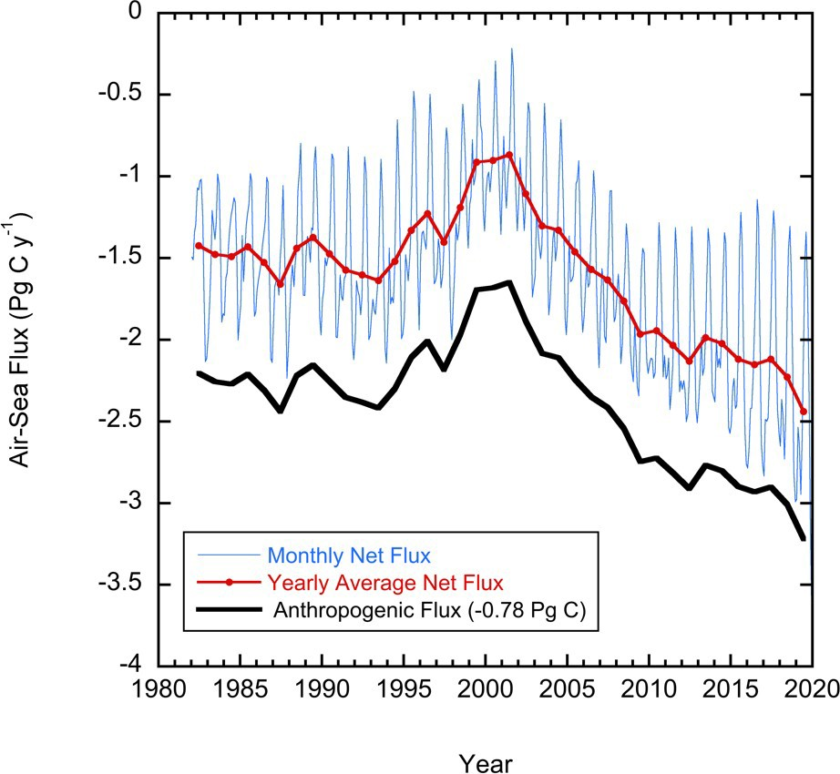

Fig. 3.j1. Global annual (red line) and monthly (blue line) net CO2 fluxes (Pg C yr−1) for 1982 to 2019. The black line is the anthropogenic CO2 flux which is the net flux minus the riverine component of 0.78 Pg C yr−1. Negative values indicate CO2 uptake by the ocean.
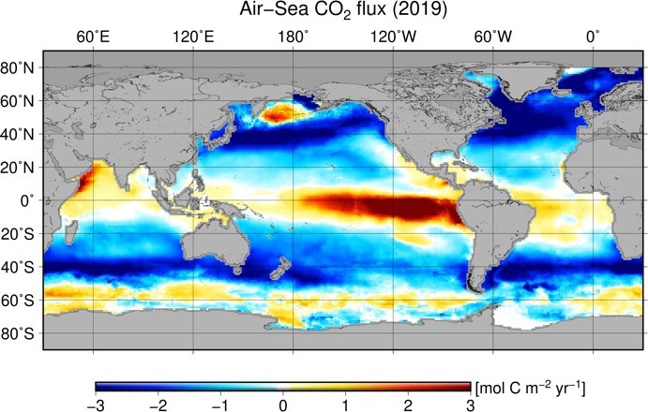
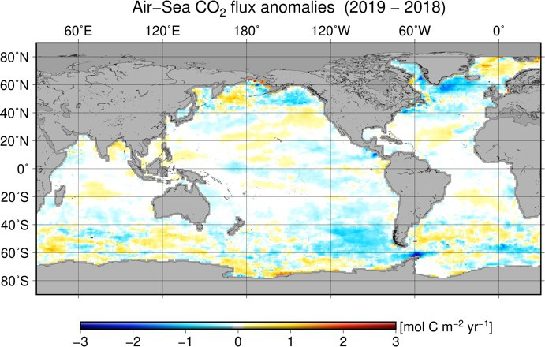

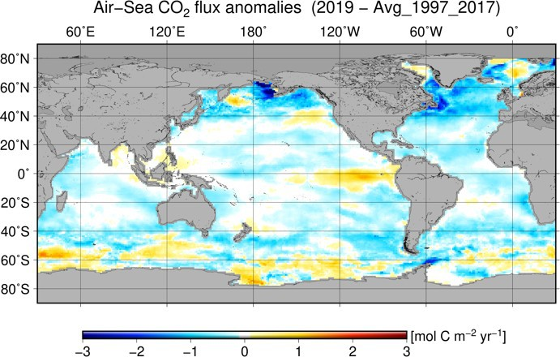

Fig. 3.j2. Global map of (a) net air–sea CO2 fluxes for 2019, (b) net air–sea CO2 flux anomalies for

2019 relative to a 1997–2017 average, and (c) net air–sea CO2 flux anomalies for 2019 minus 2018 values following the method of Landschützer et al. (2013). All maps have units of mol C m₋₂ yr₋₁.

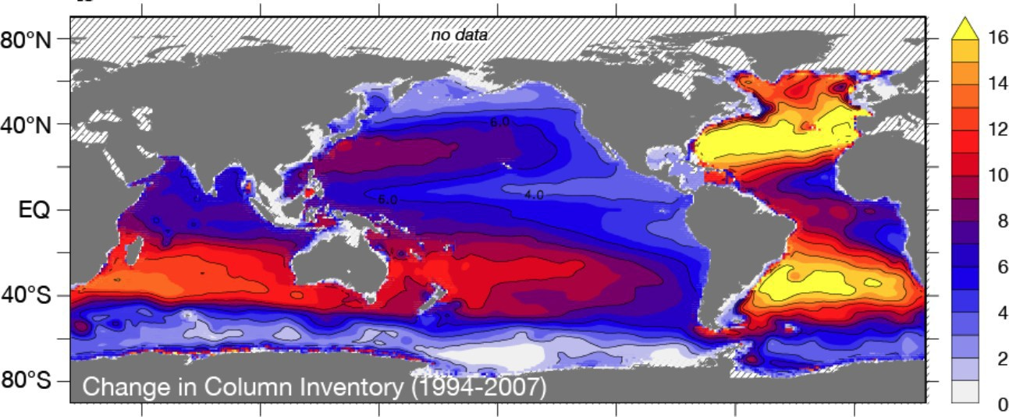

Fig. 3.j3. Change in full water column inventory of anthropogenic CO2 in mol m-2 from 1994 to 2007, based largely on WOCE and GO-SHIP BGC data in the GLODAPv2 data product (modified from Gruber et al., 2019).
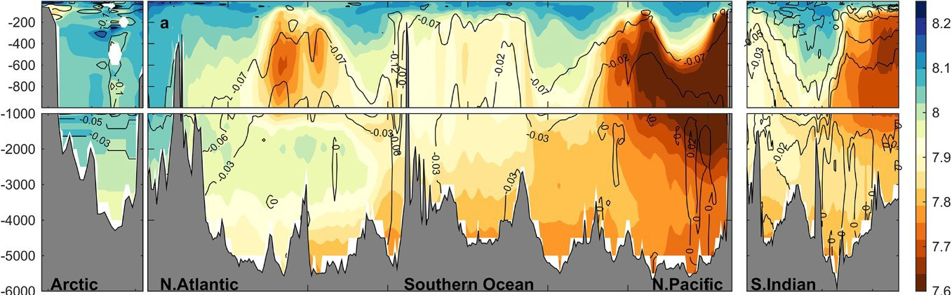
Fig. 3.j4. Vertical cross sections of pH (color) in the major ocean basins, from GO-SHIP. The pH (total scale) is reported for in situ temperature and pressure and are normalized to year 2002 as in the GLODAPv2 data product (Lauvset et al., 2015). Anthropogenic change in pH from preindustrial to year 2002 is contoured (after Lauvset et al., 2020).

