Tropical Cyclone Heat Potential – G. J. Goni and J. Knaff

Tropical cyclones (TC) occur in seven regions in all ocean basins: tropical Atlantic, northeast Pacific, northwest Pacific, southwest Indian, north Indian, southeast Indian, and south Pacific. While sea surface temperature (SST) plays a role in the genesis of TCs, the ocean heat content contained between the sea surface and the depth of the 26°C isotherm, also referred as Tropical Cyclone Heat Potential (TCHP), has been shown to play a more important role in TC intensity changes (Shay et al., 2000), provided that atmospheric conditions are also favorable. The TCHP shows high spatial and temporal variability associated with oceanic mesoscale features. Sea surface height observations derived from satellite altimetry can be used to compute the TCHP (Goni et al, 1996; Shay et al, 2000). In general, the real-time forecast of TC intensity is highly dependant on track forecasts and many of the errors introduced in the track forecast are translated into the intensity forecast. Clearly, areas with high values of TCHP may be important only when TCs travel over them.

To examine the interannual variability of TCHP with respect to tropical cyclones, TCHP anomalies are computed during the months of TC activity in each hemisphere: June through November in the Northern Hemisphere and November through April in the Southern Hemisphere. Anomalies are defined as departures from the mean TCHP calculated during the same months for the period 1993 to 2008. These anomalies show large variability within and among the tropical cyclone basins (Figure 1)

The west Pacific basin exhibits the anomalies from the signature of the negative phase of the 2007 ENSO event (La Nina). The South Pacific basin showed mostly positive anomalies. The North Indian basin exhibited positive values in the Bay of Bengal and in the eastern Arabian Sea and negative values in the western Arabian Sea. The Gulf of Mexico (insert) showed an alternation of regions with positive and negative values. The tropical Atlantic exhibited positive values to the north of 30ºN and south of 15ºN. The most evident changes that happened between 2008 and 2007 are the increase of values in the southern region of the western Pacific basin.
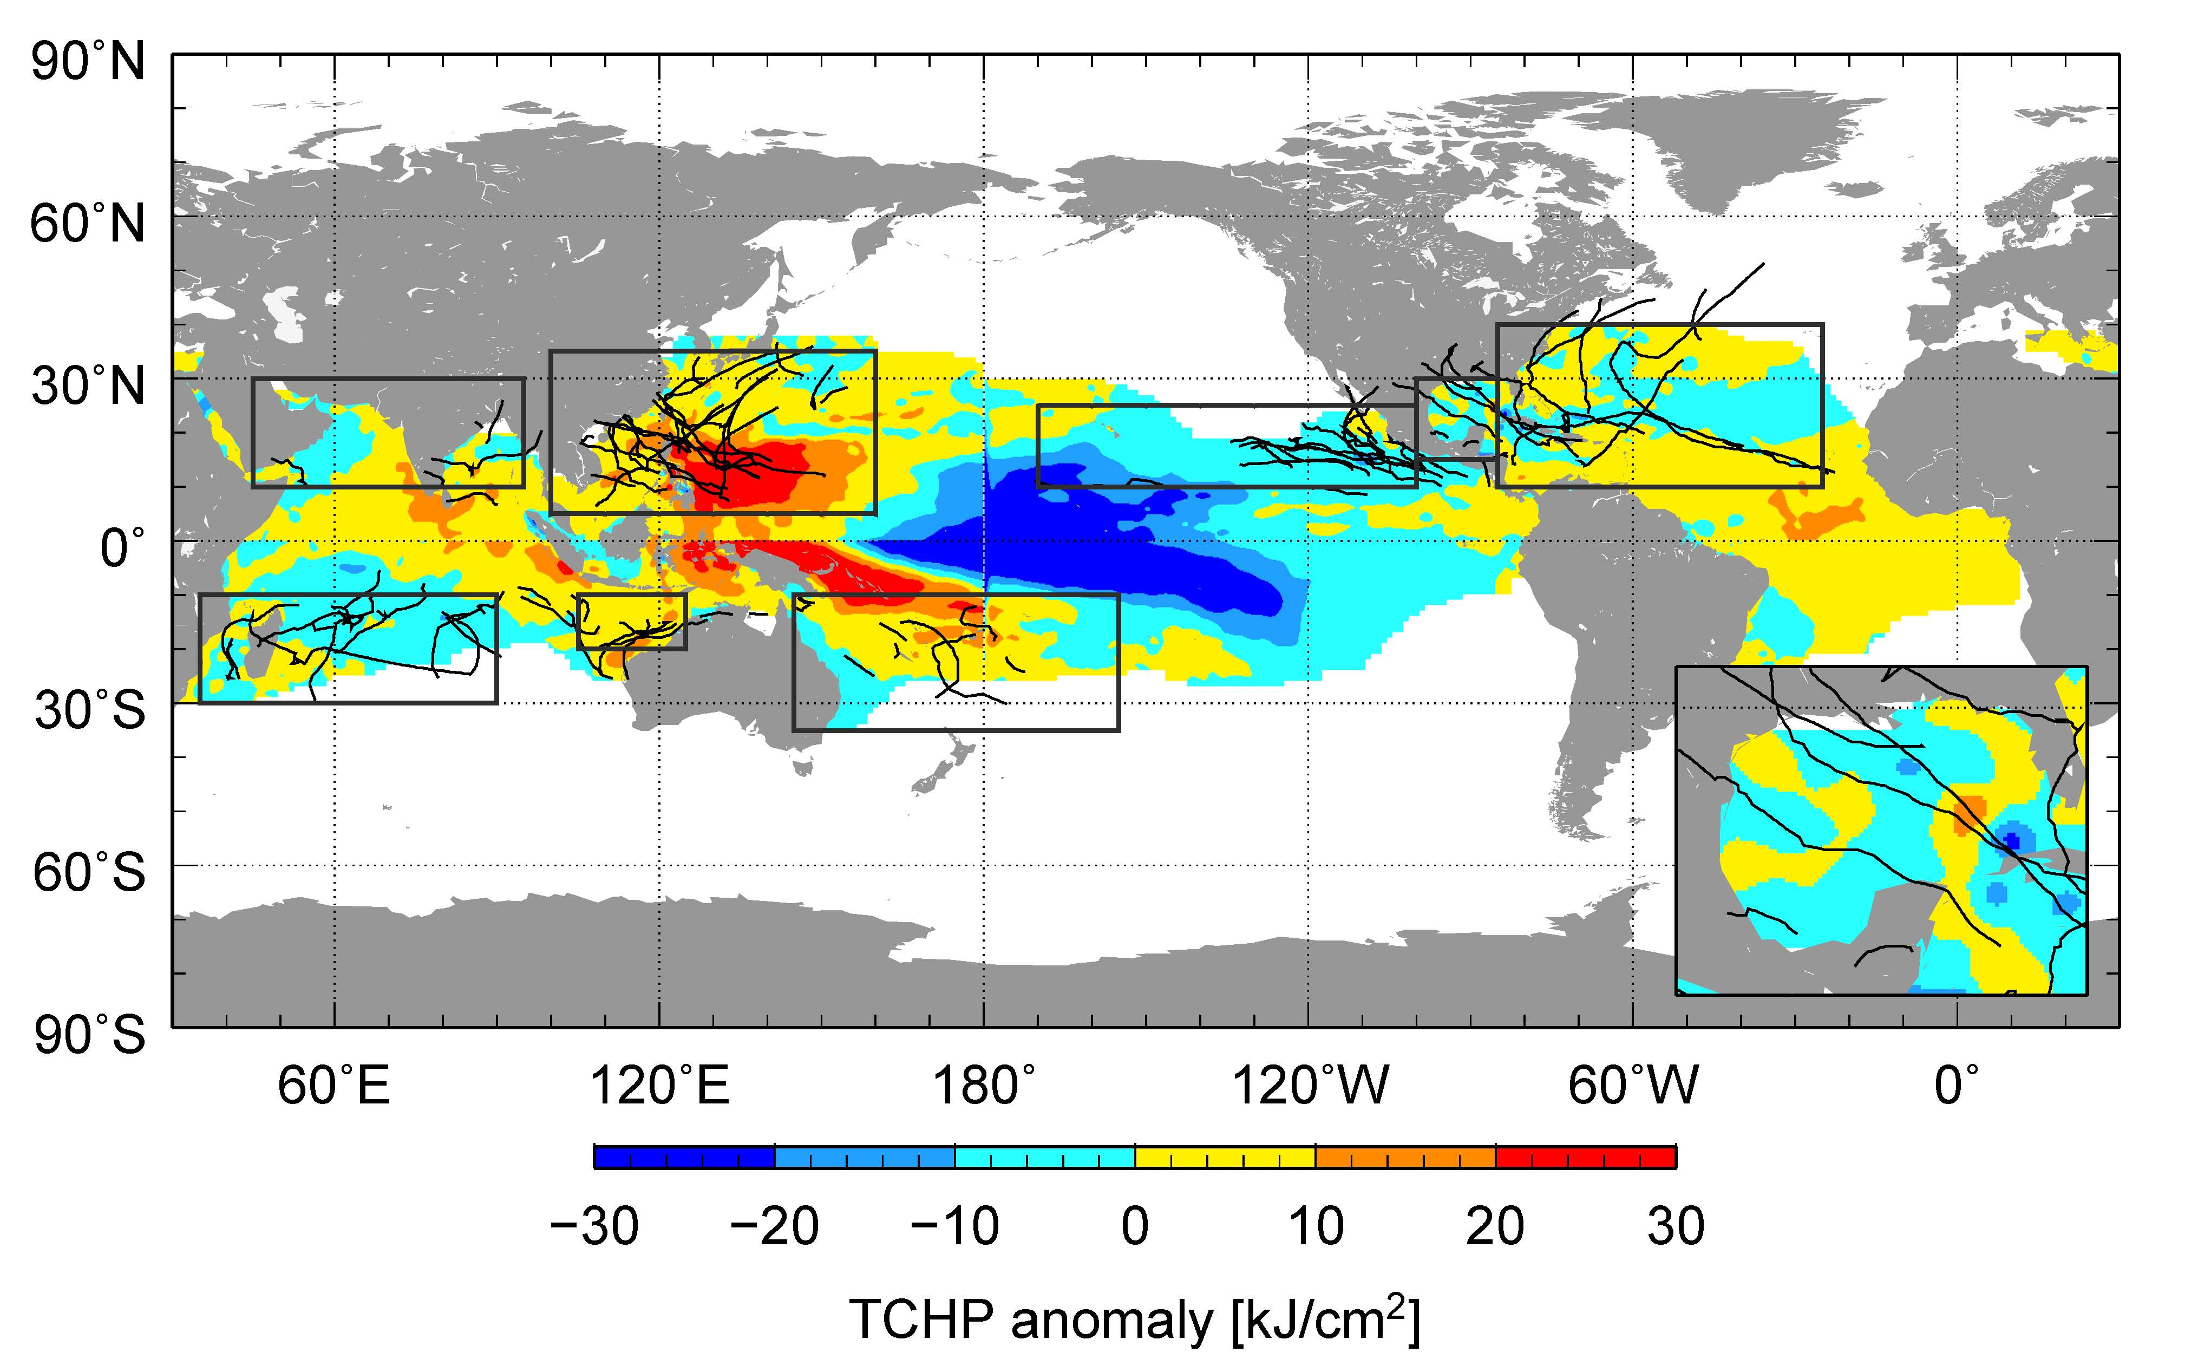

Figure 1. Global anomalies of TCHP corresponding to 2008 computed as described in the text. The boxes indicate the seven regions where TCs occur: from left to right, Southwest Indian, North Indian, West Pacific, Southeast Indian, South Pacific, East Pacific, and North Atlantic (shown as Gulf of Mexico and tropical Atlantic separately). The black lines indicate the trajectories of all tropical cyclones category 1 and above during November 2007-December 2008 in the Southern Hemisphere and 2008 in the Northern Hemisphere. The Gulf of Mexico conditions during June-November 2008 are shown in detail in the insert shown in the lower right corner.

During 2008 Several TCs were identified to have gained strength when traveling into regions of very high or higher values of TCHP. Some examples of these intensification events are shown in Figure 2. The results presented here correspond to five intense (category 4 and 5) TCs, where the location of their intensification coincided with an increase of the values of TCHP along their tracks. Additionally, the cooling associated with the wake of the TCs, which can reach values of 30 kJcm⁻² in tropical cyclone heat potential and 3°C in sea surface temperature, is important since it influences the upper ocean thermal structure on regional scales within weeks to months after the passage the cyclones. These TCs were Gustav in the Gulf of Mexico, Ike in the Caribbean Sea, Sinlaku in the western Pacific, Nargis in the northern Indian, and Ivan in the southwest Indian region. A brief description of each of these storms is now presented.

In the Atlantic basin, Hurricanes Gustav and Ike are good examples of major hurricanes that interacted with TCHP features. Hurricane Gustav (Aug 25 – 2 Sept), reached its maximum estimated intensity of 125 kt prior to making landfall in Cuba on 30 Aug. and at a time when its track was traversing some of the highest values of TCHP west of Jamaica. The storm’s impact was felt throughout the Northern Caribbean in Hispanola, Jamaica, the Cayman Islands and Cuba. On the other hand, Hurricane Ike (Sept 1 – Sept 14) experienced three separate peak intensities. The first and maximum peak intensity, 125 kt, was obtained in the central Atlantic, northwest of the Leeward Islands. In the next day or so the storm weakened and moved southwest. The second peak shown in Figure 2, occurred in a region of elevated TCHP. The third peak intensity occurred in the Gulf of Mexico before making landfall in Texas (not shown in Figure 2). This storm resulted in major impacts throughout the Northern Caribbean, making landfall twice in Cuba (110, 115 kt) and once in Texas (95 kt).

Typhoon Sinlaku (Sept 8 – Sept 22), in the western North Pacific, obtained its maximum intensity (125kt) following an encounter with a warm ocean eddy. Following its peak intensity the storm weakened slightly as it turned toward Taiwan and moved over lower values of TCHP. Following this weakening Sinlaku showed a slight intensification as it tracked to the Northwest and moved over larger TCHP values. The storm eventually brushed the northeast coast of Taiwan on 13 Sept. with an estimated intensity between 90 and 95 kt.

In the North Indian Ocean, Tropical Cyclone Nargis (Apr 27 – May 3) made landfall in Myanmar on 2 May with an estimated intensity of 115 kt. The storm resulted in a devastating storm surge that killed an estimated 146,000 people. The storm intensified over the high TCHP waters of the Bay of Bengal. One aspect of the storm’s forecast is that for the 48 hours prior to landfall the storm was forecasted to have a more northward track that was observed, which not only allowed the storm to tack over higher TCHP values, but to make landfall in the low-lying Irrawaddy river delta. This storm occurred in early May and likely contributed to the negative anomalies in Figure 1 in the northern part of the Bay of Bengal.

Tropical Cyclone Ivan (Feb 7 – Feb 22) is a good example of a very strong and rather large Southern Hemisphere tropical cyclone, which reached its maximum intensity of 115 kt just as it made landfall in Madagascar. Ivan also tracked across the warmest TCHP during the day or so prior to landfall on 17 February intensification was occurring. Initial reports indicated that 26 deaths occurred and more than 300,000 persons were affected, particular by the heavy general rainfall and subsequent floods in the north and east of the island of Madagascar.

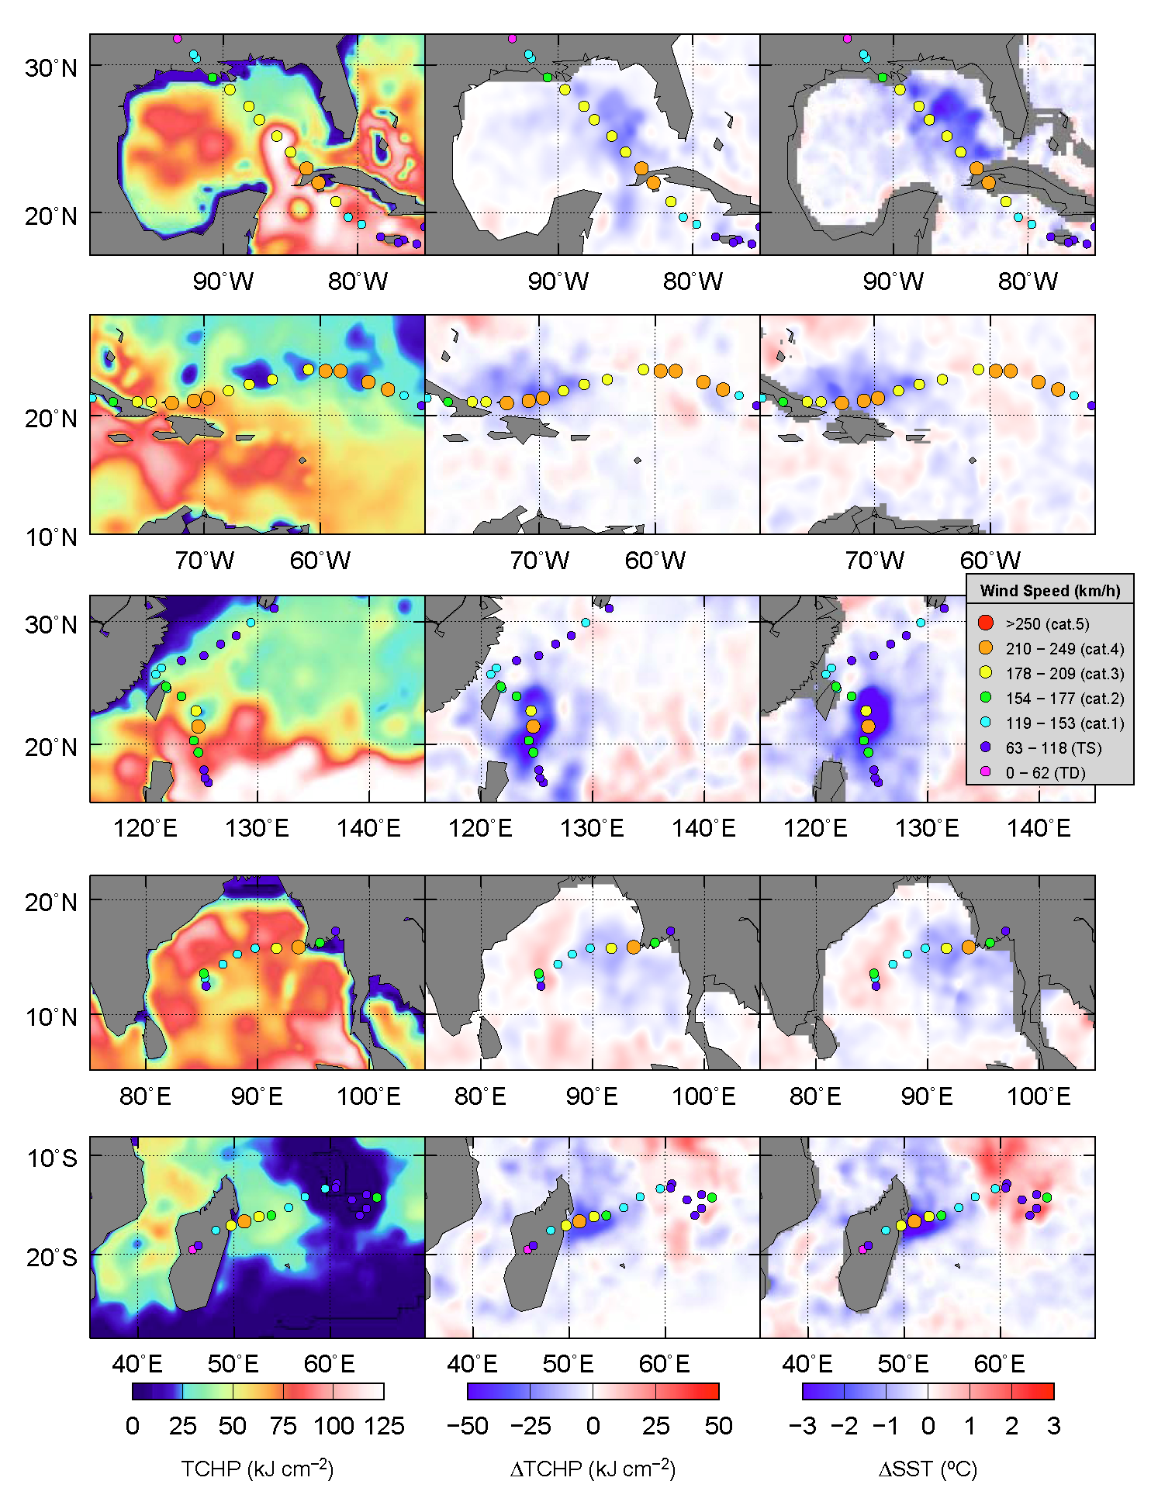

Figure 2. (left) Tropical cyclone heat potential, and surface cooling given by the difference between post and pre storm values of (center) tropical cyclone heat potential and (right) sea surface temperature, for (from top to bottom) Hurricane Gustav, Hurricane Ike, Typhoon Sinlaku, Tropical Cyclone Nargis, and Tropical Cyclone Ivan.

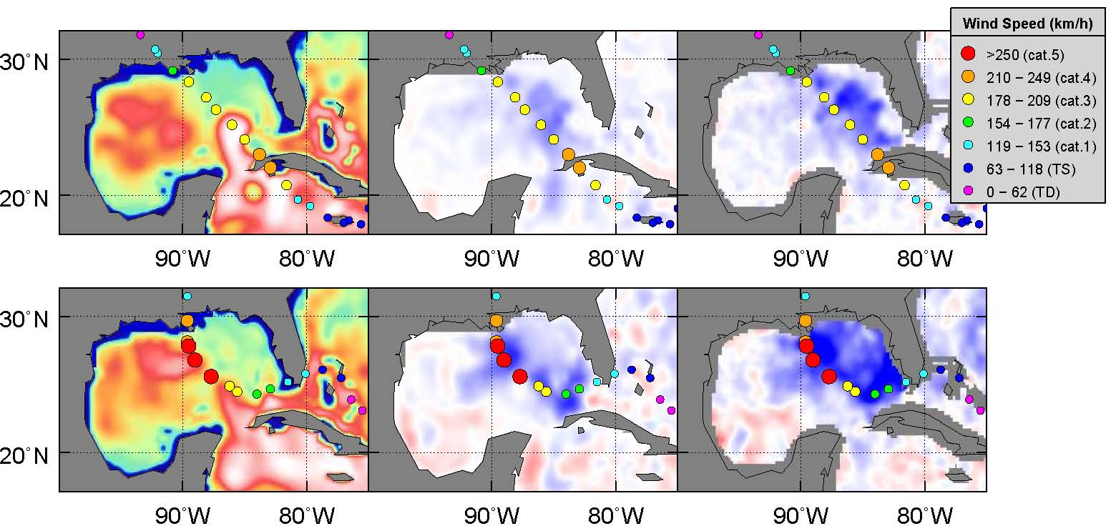
Figure 3. (left) Tropical cyclone heat potential, and surface cooling given by the difference between post and pre storm values of (center) tropical cyclone heat potential and (right) sea surface temperature, for hurricanes (bottom) Katrina in 2005 and (top) Gustav in 2008. The scales are the same as in Figure 2.

Hurricane Gustav (2008) is now contrasted with hurricane Katrina (2005) (Figure 3). Both hurricanes made landfall in a region in the Gulf of Mexico. There are some similarities as they both travelled directly over the loop current. Katrina was energized by its passage over the Loop Current and continued to intensify as it moved from the loop current region into a region occupied by a warm ring shed by the Loop Current. The storm also became larger as it went through an eyewall replacement cycle (Maclay et al (2009)). Gustav in contrast tried to reorganize over the loop current region following a landfall in western Cuba, but instead of moving over a warm eddy as Katrina did, Gustav moved into a region of relatively low TCHP, and did not re-intensify despite being in favorable environmental conditions (200-850–hPa vertical wind shear < 15 kt and SST >29 C). As a likely consequence Gustav did not become nearly as large or as intense as Katrina. And while both storms weakened as they approached the Louisiana Coast, Katrina with its larger and more intense wind field and landfall in a more populated area produced more property damage. The difference of intensity of these two hurricanes is also translated in the sea surface cooling, where maximum cooling by Katrina is approximately 30 kJcm⁻² and 4°C, in tropical cyclone heat potential and sea surface temperature, respectively, almost double than for hurricane Gustav.

References:

Goni, G., S. Kamholz, S. Garzoli and D. Olson (1996) Dynamics of the Brazil-Malvinas Confluence Based on Inverted Echo Sounders and Altimetry, J. Geophys. Res., 101, 16273-16289.
Maclay, K.S., M. DeMaria and T.H. Vonder Haar (2008) Tropical cyclone inner core kinetic energy evolution. Mon. Wea. Rev., 136, 4882-4898.
Shay, L. K., G. J. Goni, and P. G. Black (2000) Effects of a warm oceanic feature on Hurricane Opal. Mon. Wea. Rev., 128: 1366-1383.

