Ocean observations and analysis suggest potential MH370 crash site
Joaquin A. Trinanes^{a,b,c} M. Josefina. Olascoaga^{d}, and Gustavo. J. Goniª*
ªPhysical Oceanography Division, Atlantic Oceanographic and Meteorological Laboratory, National Oceanic and Atmospheric Administration, Miami, FL 33149, USA; ^{b}Cooperative Institute for Marine and Atmospheric Studies, Rosenstiel School of Marine and Atmospheric Sciences, University of Miami, Miami, FL 33149, USA; ^{c}Instituto de Investigaciones Tecnoloxicas, Universidade de Santiago de Compostela, Santiago, 15782, Spain; ^{d}Department of Ocean Sciences, Rosenstiel School of Marine and Atmospheric Sciences, University of Miami, Miami, FL 33149, USA.
*Correspondence to: Gustavo.Goni@noaa.gov

Ocean observations and analysis suggest potential MH370 crash site
Analyses of trajectories obtained from surface drifters and from synthetic drifter analysis confirm the pathway of debris found from the Malaysia Airlines Flight 370 (MH370) and suggest that the potential crash site may lie to the north of the present search region or even further to the north and potentially in vast areas of the southern Indian Ocean.
Keywords: drifters, OSCAR, ocean currents, debris, Indian Ocean, MH370
On 8 March 2014 flight MH370 disappeared after departing from Kuala Lumpur for Beijing with 239 people on board. Based on the last transmitted signal from the plane to the Inmarsat satellite network, a potential location site of the plane entering the water could have been the area west of Australia, where extensive search efforts coordinated by the Joint Agency Coordination Centre (jacc.gov.au) have been concentrated to date (red arc in Figure 1). No debris from the missing airplane has been found in the search area. However, on 31 July 2015, a plane flaperon was found washing up on the shores of Reunion Island, located in the western side of the southern Indian Ocean (SIO).
This discovery led to the analysis of the complex Lagrangian (i.e., of material) circulation capable of connecting distant locations in the SIO. This circulation is sustained by a system of major surface ocean currents, with high seasonal variability, that form the anticyclonic Indian Ocean subtropical gyre (Schott et al. 2009). The main currents of this gyre are the West Australian Current on the east, and the westward flowing South Equatorial Current (SEC) on the north, which forms the northern limb of the gyre. This current bifurcates off Madagascar, forming a northern and southern branch of the East Madagascar Current (EMC). The gyre is completed by the shallow eastward flowing South Indian Counter-Current, which expands in latitude to the east allowing a connection from south of Madagascar to off the northwest of Australia. A highly complex field of eddies, vortices that have smaller spatial scales than the currents described above and that can travel long distances before dissipating, is superimposed upon this complex system of currents.
Ocean observations, in particular those that are part of the sustained ocean observing system, together with wind field observations, are key to monitor and assess ocean currents and their spatial and temporal variability that control the transport of particles. Examples on how ocean observations are used for this type of application include studies related to transport of contaminants, such as during the Deepwater Horizon and other oil spill incidents (Goni et al. 2015), the Fukushima cooling water release to the ocean (Rypina et al. 2013), the motion of surface drifters (Olascoaga et al. 2013), the monitoring of marine debris trajectories (Moore et al. 2001; Duhec et al. 2015), and the transport of fish larvae (Cowen et al. 2000).
We present here results from a study that provides key information on the potential crash site of flight MH370 in the SIO. This study uses two main data sets that are frequently used to investigate the location and variability of global ocean currents. The first data set corresponds to trajectories of surface drifters (Niiler 2001). Surface drifters are buoys that have a subsurface drogue (sea anchor) centered at 15 m water depth attached to the buoy. They are tracked by satellites and have an average lifetime of approximately 1 year, although some individual drifters lives can even extend beyond 24 months. Annually, nearly 1100 surface drifters are deployed globally in a rather inhomogeneous fashion in time and space. At any time there are about 400 drifters in the Indian Ocean. Undrogued drifter data are used here, as the debris ,are probably at or very close to the surface and this dataset better describes the surface dynamics. The second data set corresponds to synthetic (hypothetical) drifter trajectories derived from surface ocean velocity fields obtained from SCUD-Surface Currents from Diagnostic Model (Maximenko&Hafner 2010). These velocities incorporate hydrographic, satellite altimetry, and wind data. The spatial resolution of these velocity fields is of one quarter of a degree and fields are provided on a daily basis. The trajectories of surface and synthetic drifters are used in this study to simulate the displacement in the surface of the SIO of debris that could have potentially belonged to flight MH370.
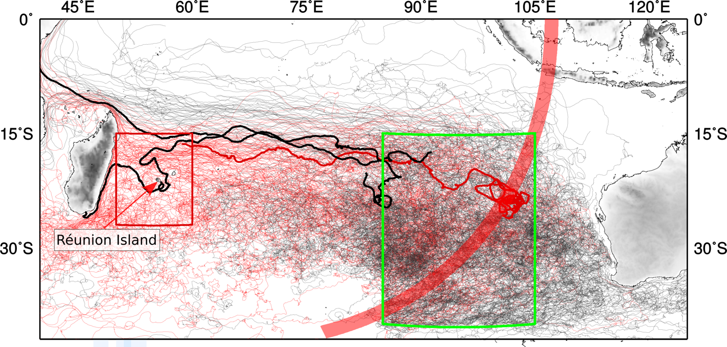
Figure 1. Trajectories of 509 surface drifters that were deployed or travelled near the search area (green box) during 1991-2015 (black and red trajectories) and a subset of 118 drifters from that group (red trajectories) that eventually reached the red box, which surrounds Reunion Island. Three of these drifters (thick trajectories in black and red) travelled within the green box during March-April 2014 and eventually reached the red box. The red trajectory corresponds to the drifter that reached the red box on July 2015. The red arc shows the possible position of the plane when its last signal to the Inmarsat satellite network was transmitted.

In this work, we first trace the surface and synthetic drifters that were at one time located in the search region, an area of the eastern Indian Ocean off Australia, indicated by the green box in each figure. Of especial interest are the trajectories of those drifters that were in the green box during the period March-April 2014 (Figure 1). Secondly, we determine the positions of the drifters prior to reaching an area in the western Indian Ocean close to Reunion Island, indicated by the red box in every figure, where airplane debris was found. Of particular interest are the trajectories of the drifters that ultimately arrived in this area during July-August 2015.
Of the approximately 3083 observed surface drifters that have historically travelled in the Indian Ocean from October 1985 to August 2015 (Figure 1A), 509 (16.5 %) of them travelled (or were deployed) inside the green box (black and red trajectories in Figure 1). Depending on their location in this large area, their trajectories generally follow the general circulation of the South Indian Ocean subtropical gyre as given by the historical record of surface drifters that travelled inside the green box. Of these drifters, 31% reached 75°E between 15°S and 30°S, mostly carried by the South Equatorial Current, even reaching longitudes west of Madagascar, with the rest remaining in the gyre, or travelling east towards Australia or south of Australia. It was also found that 23% of the drifters coming from the green box eventually reached the red box (red trajectories in Figure 1). During the period March-April 2014, there were 17 drifters that travelled or were deployed in the green box, of which three (or 18%, a number close to the historical average) reached the red box, around Reunion Island. Two of them (thick black trajectories in Figure 1) reached the red box in July and November of 2014. Remarkably, one of them (red trajectory in Figure 1) reached the red box in July 2015, precisely in the same month that the MH370 debris were found washing up on the shores of Reunion Island.

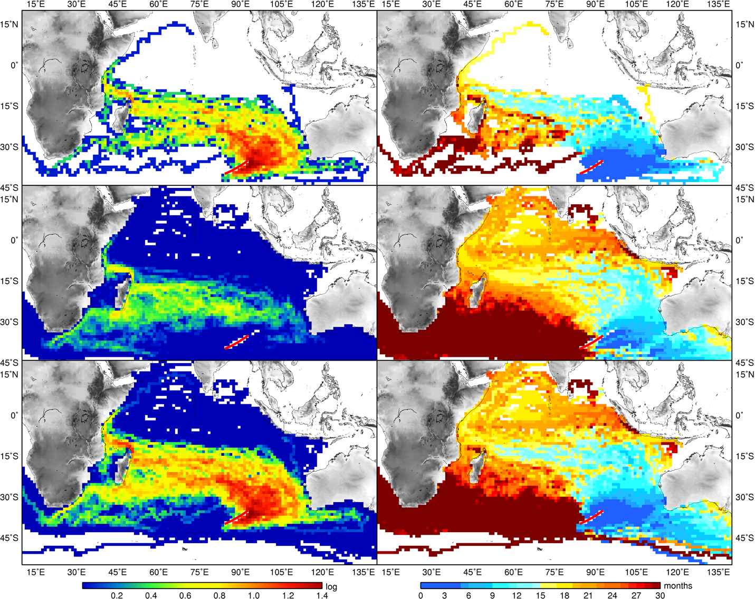
Figure 2. Probability (left) and travel time (right) maps estimated using the 2-iteration approach (Rypina et al 2013). The 3 rows refer to the direct (top), one-stop (middle) and total trajectories (bottom).
The trajectories of the 509 drifters that travelled within the green box and beyond indicate that there are several areas in the SIO with high probability that debris linked to the missing flight could have travelled through them. Using the data from the undrogued drifters passing through the search area (indicated by the red segment in Figure 2), we estimate the probabilities of finding any of those drifters in other regions as well as the mean time taken to reach them. The direct trajectories follow a general pattern that includes part of the West Australian Current, and a westward flow on the South Equatorial Current. The coverage greatly increases using indirect one-step trajectories, which at some point crossed with the direct trajectories and increment the number of drifters used in our analysis. The average lifespan of the undrogued drifters in the Indian Ocean is of 1 year and 10 months. The indirect trajectories, besides contributing to improve the coverage, also permit to expand the temporal coverage over periods larger than the lifespan of the average drifter.
The total probability map (Figure 3 bottom) indicates high values in the neighbourhood of the search area, almost reaching the west coast of Australia, and an evident westward pattern between 10S-30S, that bifurcates near Madagascar following the 2 branches of the East Madagascar Current. The northern branch can reach the east coast of the African Continent, and follows the East African Coastal Current. Drifters in the southern branch of the EMC can turn east but many other drifters propagate southwestwards, reaching the Agulhas Retroflection system and possibly even entering the Atlantic Ocean. The analysis of the mean travel times shows that the range to reach the major coastal areas in the Indian Ocean varies between 0.5-1 years for West Australia and the 1.5-2 years for East Africa, with increasing values for the southern parts of the continent. It is interesting to indicate that there is a noticeable meridional gradient in the travel times in a wide region along the east coast of Madagascar. Drifters from the search area could arrive within 1 year to the north of the region while it could take up to 2.5 years for the south of the island. These results are consistent with the finding of the plane debris in Reunion Island, almost 17 months after the plane disappeared.
The probability and travel time maps (Figure 2) may help define rational initial ad-hoc spatio-temporal constraints. These areas correspond to the northern limb of the subtropical gyre, the vast regions that include Madagascar and extend farther east, and the waters west and south of Australia. The westward trajectories, that leave the search area, take two main pathways that correspond to the South Equatorial Current. Trajectories located south of Australia mostly correspond to drifters that first travelled through the southern part of the search region.
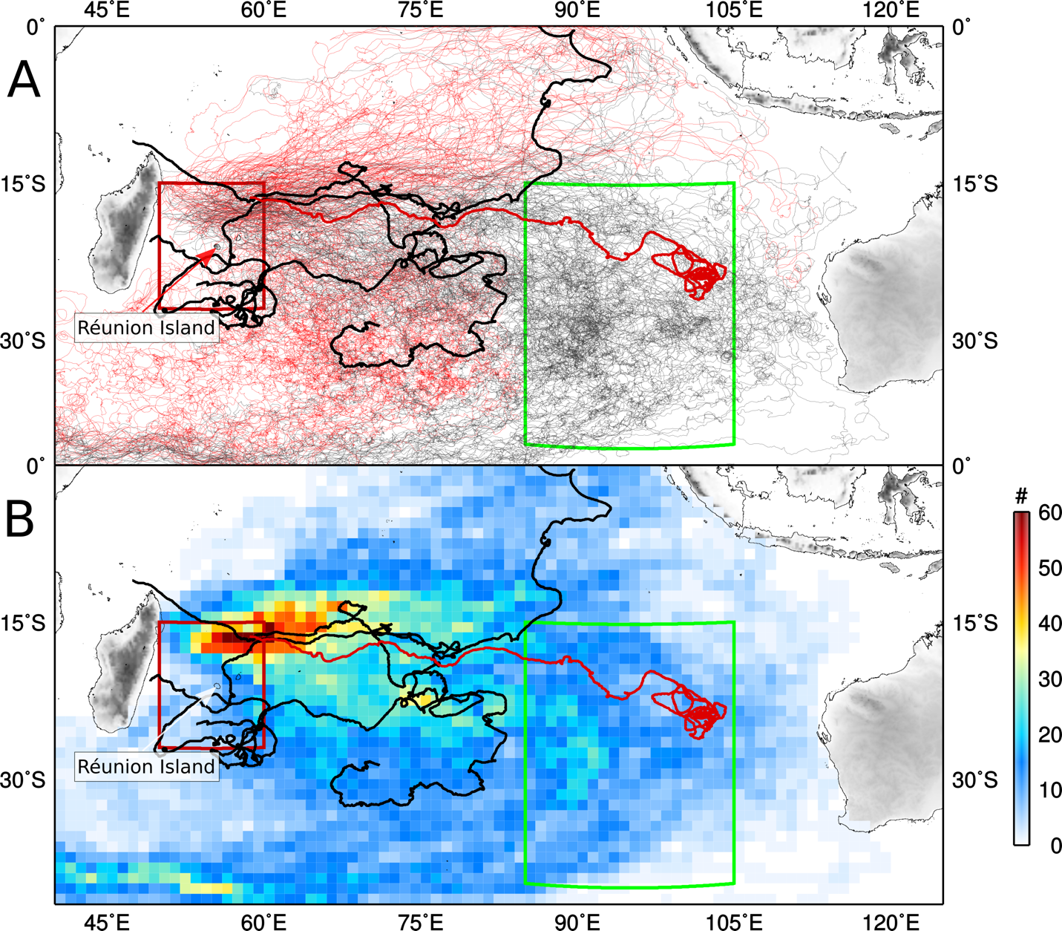
Figure 3. (A) Trajectories (black and red; drawn from their source) of the 375 surface drifters that reached the red box during 1985-2015. From these 375 trajectories, 118 correspond to drifters that first travelled in the green box before arriving in the red box (black trajectories). Four trajectories (shown in thick black and red) entered into the red box between June-July 2015. Of these four trajectories, one corresponds to a drifter that was present in the green box in March 2014, in a region close to the Inmarsat arc but farther north from the current search area. (B) The background colors represent the number of drifters in a square boxes of 1-degree side that later travelled within the red box.
Since some of the airplane debris was found in Reunion Island, backtracking the positions of the 375 surface drifters that travelled within the red box during the last 25 years may help identify the possible initial location of the debris. The trajectories of these drifters (Figure 3A) indicate that their source location could have been vast areas of the South Indian Ocean. Remarkably, there were four drifters that arrived in the red box during June-July 2015 (Figure 3, thick trajectories). Of the total of 375 surface drifters that travelled within the red box, 118 (30 %) were in the green box before arriving in the red box (Figure 3A, black trajectories). Of these 375 surface drifters, the number of drifters with trajectories in boxes of 1-degree side indicates that potential airplane debris may have travelled from areas that belong to the green box, and areas of the center of the South Indian Ocean subtropical gyre, and north of 15°S. The area within the green box with the highest probability of being the source of plane debris is centered at 90E 30S (red and green colors in Figure 3B), a location reasonably close to the search area (just a few hundreds km to the north). On the other hand, the southeast and northeast areas of the green box are less likely to have been the source of plane debris (light blue and white colors in Figure 3B).
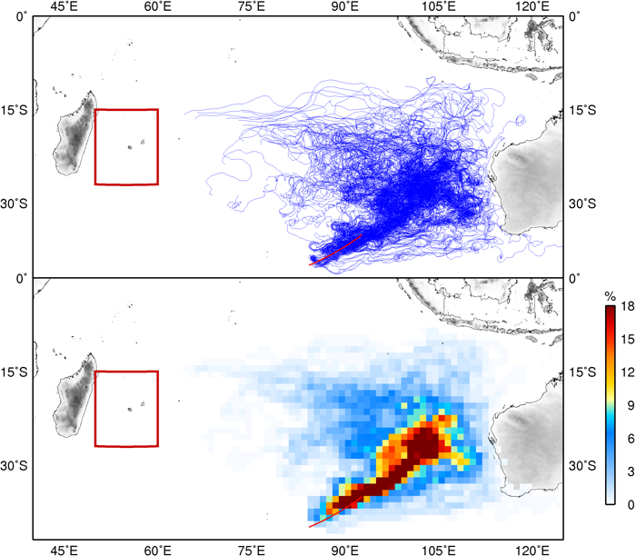
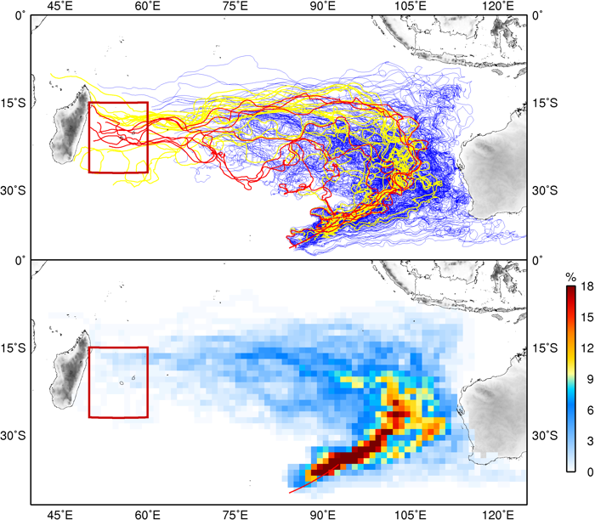
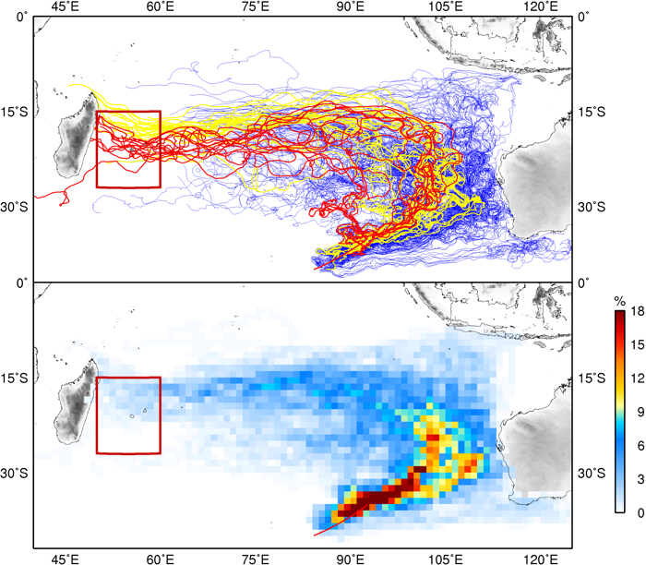
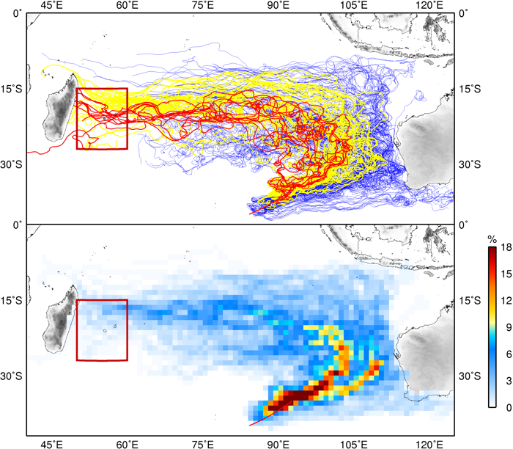

Figure 4. Trajectories of synthetic drifters that were deployed in the search area during March 2014 obtained from SCUD analysis with the trajectories of the synthetic drifters that arrived in the red box highlighted in yellow. The trajectories in red correspond to drifters with locations within a radius of 150km centered in Reunion Island. The background colors indicate the percentage of synthetic drifters initially deployed within the search area that travelled in each square box of 1degree side. Each panel represents a different windage coeffient (from top to bottom and from left to right: 0%, 0.6%, 0.8% and 1%).

A similar analysis as above was carried out using synthetic drifters that were deployed in the SCUD current fields during the period March 2014 to August 2015. Thousands of synthetic drifters were deployed in a region that encompass the search area on March 8th, 2014. The figures focus on the 246 drifters which were deployed within a distance of 100km from the arc and cover the temporal period from release to Jul 29th, 2015, when the debris was found in Reunion Island. The simulated trajectories closely match the trajectories of the real drifters shown in Figure 2. Many move along the South Equatorial Current of the Indian Ocean subtropical gyre, (approximately 0%, 11%, 16% and 23% for each windage coefficient) reaching the red box. Other drifters don’t reach the red box within the specified period but the westward trajectories bring them close to it. This is especially relevant when wind friction with the debris is not taken into account (i.e. windage=0%). Under this assumption, most of the synthetic drifters would be far away from the eastern side of the Indian Ocean. This scenario could represent the case of underwater low-floating debris that, in the case of the MH370, could represent a significant percentage, specially after the temporal decay of the buoyancy.
Results obtained from this experiment show that debris could wash up in various regions. In the Western Indian Ocean, some locations in the coast of Australia are good candidates, especially north and south of Perth and the Gascoyne coast. On the other side of the Indian Ocean, Madagascar is an obvious option, as well as some of the islands along the pathway. These results are confirmed by the analysis of the historical dataset (Figure 5). The distribution of the landings by country is shown in Table1. Australia shows a large number of indirect hits (mostly in the south) as a result of iterations between the direct trajectories and drifters entering the Great Australian Bight.

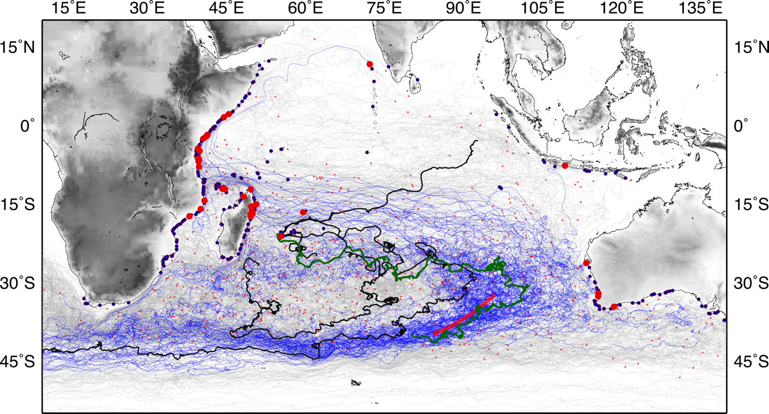
Figure 5. Trajectories of SVP drifters from the historical dataset. The small red dots represent the locations of the latest transmission. The larger circles refer to drifters reaching land (in red, for the drifters passing at some point through the search area; in blue, for indirect trajectories).

Country | Direct Trajectories | Indirect Trajectories
MADAGASCAR | 8 | 59
TANZANIA | 4 | 27
KENYA | 4 | 11
AUSTRALIA | 4 | 92
MOZAMBIQUE | 3 | 54
SOMALIA | 2 | 43
COMOROS | 2 | 22
REUNION | 1 | 5
MAURITIUS | 1 | 13
INDIA | 1 | 4
INDONESIA | 1 | 12
OTHER |  | 47

Table 1. Number of SVP drifters washed up per country. Only drifters passing through the search area and corresponding one-stop trajectories are reflected in the statistics.

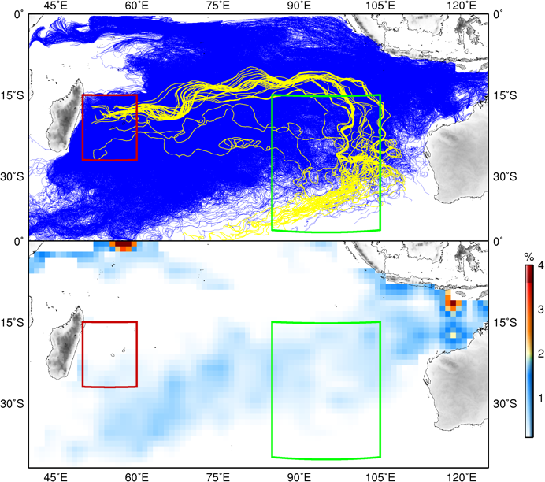
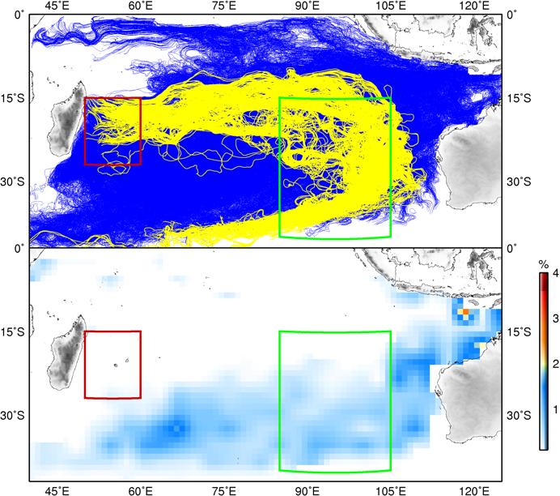
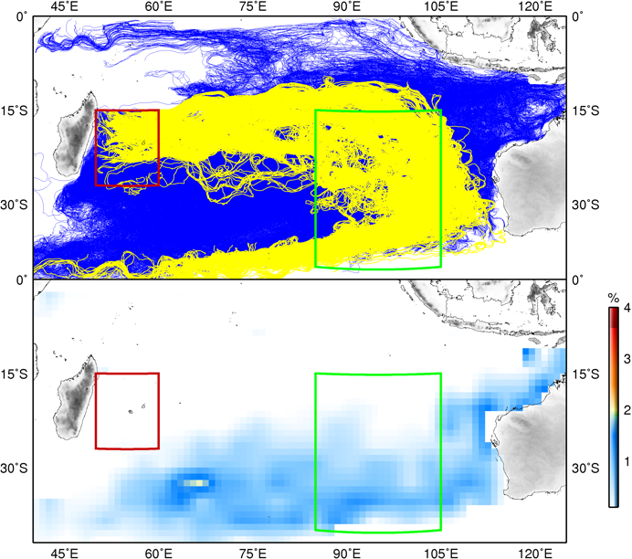
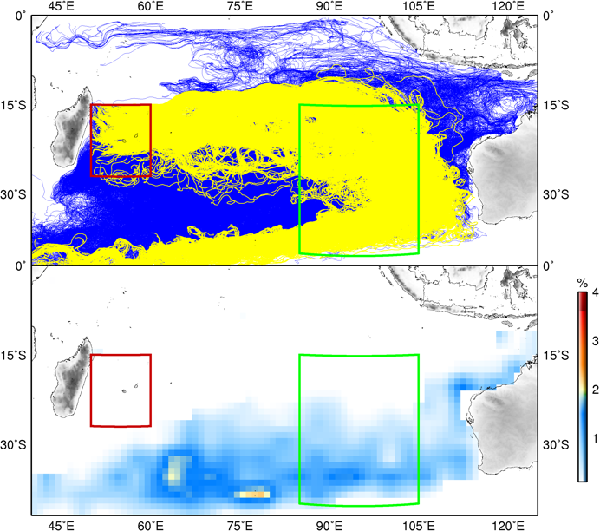
Figure 6. Backtrack trajectories of synthetic drifters that reached the region around Reunion Island represented by the red box, at the end of July 2014. Simulation used SCUD analysis and applies the same windage coefficients of Figure 2. The yellow trajectories correspond to the synthetic drifters that at some point approached within 100 km to the arc that defines the search area. The background colors represent (in percentage) the location of the synthetic drifters at the time that MH370 disappeared.
Thousands of synthetic drifters were backtracked from the red box at the end of July 2015 to their position in March of 2014 (Figure 6). Potential sources of debris are found in several regions of the SIO, including areas west of Australia, and larger regions outside the search area. Besides the case of no windage, the other panels show a reasonably probability that the drifters entering the red box at the time the flaperon was found, could originate near the search area. Confining the analysis to a smaller subset (Figure 7), we can better delineate the possible sources of debris arriving to Reunion Island in July 2015. As in Figure 4, there are no drifters connecting the search area in Reunion Island when windage is not considered. In the other cases, there are drifters (represented in yellow in Figure 7) that comply with these requirements. The probability maps show that more regions in the Indian Ocean could account for the bulk of synthetic drifters washed up in Reunion Island, but the intersection of these maps with the Inmarsat arc clearly defines the search area as a high probability source region.

Results presented here indicate the complexity of the circulation and debris trajectories, which are largely affected by the eddy field. Combined results of the two methodologies used here indicate that there is a clear pathway for surface and synthetic drifters, initially located within the search region, to travel westward and arrive at longitudes as far west as Reunion Island, Madagascar and East Africa. As debris was found in the area of Reunion Island, our analysis suggests that the origin of the debris could be reasonably linked to the search area.
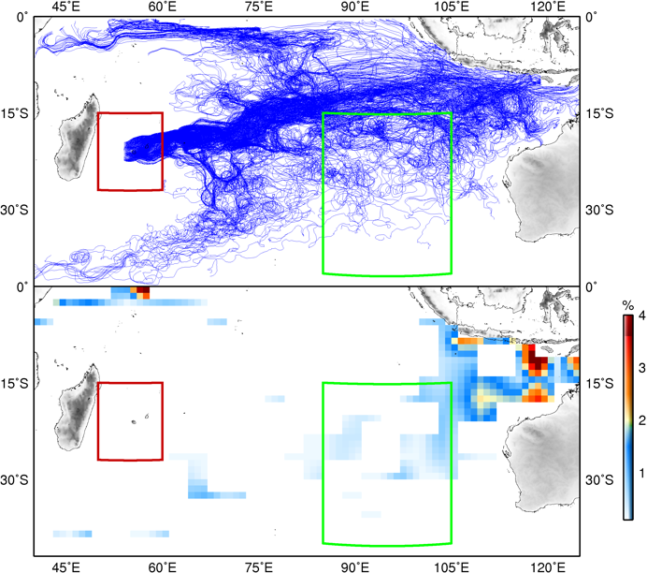
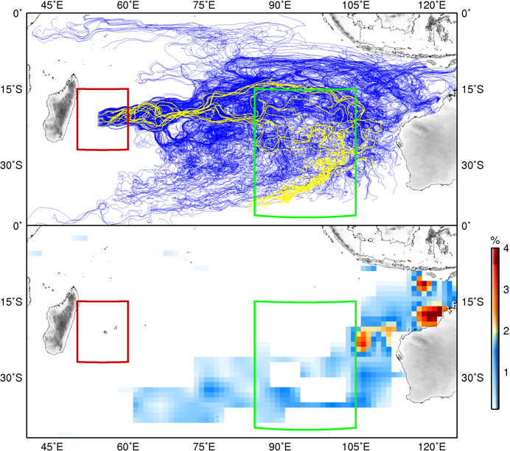
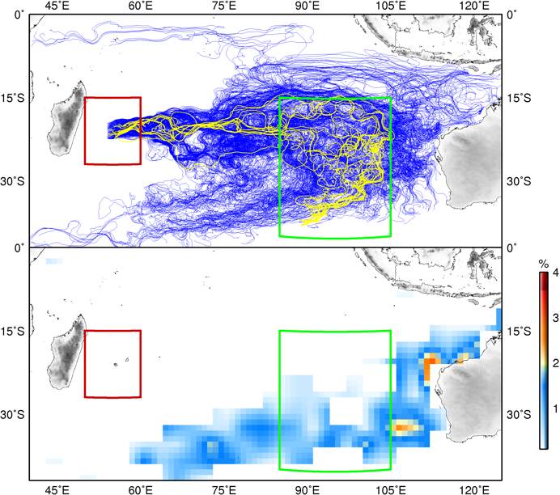
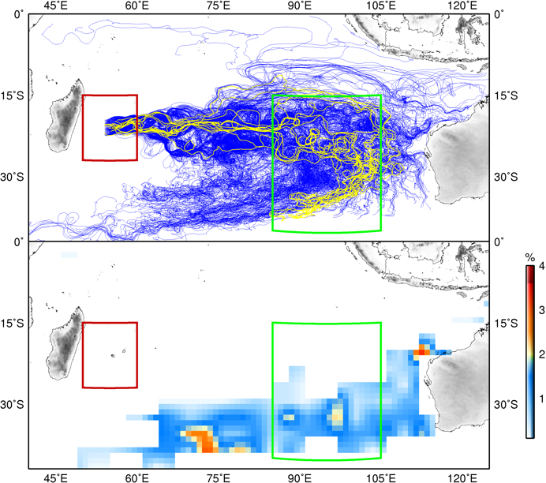
Figure 7. Backtrack trajectories of synthetic drifters that reached a small region surrounding Reunion Island at the end of July 2014 obtained from SCUD analysis using the same windage coefficients of Figure 2. The yellow trajectories correspond to the synthetic drifters that at the time of the disappearance of MH370 were within 100 km to the arc that defines the search area. The background colors represent (in percentage) the location of the synthetic drifters at that time.
This analysis did not consider the debris size and buoyancy (although the use of a windage coefficient somehow refers to positive buoyant debris), possibly affected by weathering and bio fouling (Ryan 2015), which may influence the debris trajectories (Beron-Vera et al. 2015). This work and analysis on the surface transport characteristics between the eastern and western areas of the subtropical South Indian Ocean during 2014 and 2015 could potentially serve for future search strategies. This study highlights the importance of sustained ocean observations to monitor ocean conditions, that may serve a suite of applications and studies.
References
Beron-Vera FJ, Olascoaga MJ, Haller G, Farazmand M, Trinanes J, Wang Y. 2015. Dissipative inertial transport patterns near coherent Lagrangian eddies in the ocean. Chaos, 25: 087412.
Bonjean F, Lagerloef GSE. 2002. Diagnostic model and analysis of the surface currents in the tropical Pacific Ocean, J Phys Oceanogr. 32:2938-2954.
Cowen R, Lwuiza K, Sponaugle S, Paris C, Olson D. 2000. Connectivity of marine populations: open or closed. Science 287:857-859.
Duhec AV, Jeanne RF, Maximenko N, Hafner J. 2015. Composition and potential origin of marine debris stranded in the Western Indian Ocean on remote Alphonse Island, Seychelles. Mar Pollut Bull. 96:76-86.
Goni, G, Trinanes JA, MacFadyen A, Streett D, Olascoaga MJ, Imhoff ML, Muller-Karger F, Roffer MA. 2015.Variability of the Deepwater Horizon surface oil spill extent and its relationship to varying ocean currents and extreme weather conditions. In: Ehrhardt M, editor. Mathematical Modelling and Numerical Simulation of Oil Pollution Problems New York: Springer-Verlag; pp 1-22.
Maximenko, N.A., and J. Hafner, 2010: SCUD: Surface Currents from Diagnostic model, IPRC Tech. Note 5, 17pp.

Moore C, Moore S, Leecaster M, Weisberg S. 2001. A comparison of plastic and plankton in the north Pacific central gyre. Mar Pollut Bull. 42:1297–1300.
Niiler P. 2001. The world ocean surface circulation. In: Siedler G, Church J, Gould J, editors. Ocean circulation and climate, Volume 77 of International Geophysics Series. London: Academic Press; pp. 193–204.
Olascoaga, ML, Beron-Vera FJ, Haller G, Trinanes JA, Iskandarani M, Coelho F, Haus B, Huntley HS, Jacobs G, Kirwan AD, Lipphardt BL, Ozgokmen T, Reniers AJHM, Valle-Levinson H. 2013. Drifter motion in the Gulf of Mexico constrained by altimetric lagrangian coherent structures. Geophys. Res. Lett., 40:6171-6175.
Ryan PG. 2015. Does size and buoyancy affect the long-distance transport of floating debris? Environ Res Lett. 10:084019. doi:10.1088/1748-9326/10/8/084019.
Rypina II, Jayne SR, Yoshida S, Macdonald AM, Douglas E, Buesseler K . 2013. Dispersal of Fukushima-derived radionuclides off Japan: modeling efforts and model data intercomparison. Biogeosciences 10:4973–4990.
Schott FA, Xie SP, McCreary JP. 2009. Indian Ocean circulation and climate variability. Rev Geophys 47:RG1002. doi:10.1029/2007RG000245.

Acknowledgments: The trajectories of the surface drifters were obtained from the Global Drifter Program Data Acquisition Center and the Global Telecommunication System. This work was led by G. Goni, who was funded by NOAA/AOML. J. Trinanes was funded by NOAA/OceanWatch and NOAA/AOML, and M. J. Olascoaga was funded by a British Petroleum/The Gulf of Mexico Research Initiative grant.

