Ocean Observations in Support of Studies and Forecasts of Tropical and Extratropical Cyclones

Ricardo Domingues^{1,2,*}, Akira Kuwano-Yoshida³, Patricia Chardon-Maldonado^{4,5}, Robert E. Todd⁶, George Halliwell², Hyun-Sook Kim^{2,7}, I-I Lin⁸, Katsufumi Sato⁹, Tomoko Narazaki⁹, Lynn K. Shay¹⁰, Travis Miles¹¹, Scott Glenn¹¹, Jun A. Zhang^{1,2}, Steven R Jayne⁶, Luca Centurioni¹¹, Matthieu Le Hénaff^{1,2}, Gregory R. Foltz², Francis Bringas², MM Ali¹³, Steven F. DiMarco¹⁴, Shigeki Hosoda¹⁵, Takuya Fukuoka⁹, Benjamin LaCour², Avichal Mehra², Elizabeth R. Sanabia¹⁶, John R. Gyakum¹⁷, Jili Dong², John A. Knaff², Gustavo Goni²

¹ Cooperative Institute for Marine and Atmospheric Studies, University of Miami, USA
² National Oceanic and Atmospheric Administration, USA
³ Kyoto University, Japan
⁴ Caribbean Coastal Ocean Observing System, Puerto Rico
⁵ University of Puerto Rico, Puerto Rico
⁶ Woods Hole Oceanographic Institution, USA
⁷ I. M. Systems Group, Inc., Maryland, USA
⁸ National Taiwan University, Taiwan
⁹ University of Tokyo, Tokyo, Japan
¹⁰ Rosenstiel School of Marine and Atmospheric Science, University of Miami, USA
¹¹ Rutgers University, USA
¹² Scripps Institution of Oceanography, USA
¹³ International CLIVAR Global Project Office
¹⁴ Texas A&M University, USA
¹⁵ Japan Agency for Marine-Earth Science and Technology, Japan
¹⁶ United States Naval Academy, USA
¹⁷ McGill University, Canada
* corresponding author: Ricardo.Domingues@noaa.gov

Abstract: Over the past decade, the climate-oriented ocean observing system has provided datasets crucial for advancing our understanding of extreme weather events that originate and intensify over the ocean, such as tropical cyclones (TCs) and extratropical bomb cyclones (EBCs). Despite these advances, a component of the ocean observing system dedicated specifically in support of studies and forecasts of TCs and EBCs is yet to be implemented. New technologies, pilot networks, targeted deployments of instruments, and state-of-the art coupled numerical forecast models have enabled advances in research and forecast capabilities and illustrate a potential framework for the future. In this community white paper, we discuss the applications and key results made possible by the different ocean observing efforts in support of studies and forecasts of TCs and EBCs. The paper describes the recent advances in observing technologies and strategies in light of previous recommendations from the scientific community during OceanObs’ 09, and provides a vision and specific recommendations for the next decade. The need for a sustained component within the ocean observing system dedicated specifically to help improve TCs and EBCs forecasts was identified by the community as a key recommendation to be addressed during the upcoming decade.

Keywords: Weather Extremes, Global Ocean Observing system, Coupled Ocean-Atmosphere Weather Forecasts, Ocean Heat Content, Barrier Layer, Western Boundary Currents, Mesoscale Ocean Features.
1. Introduction
Extreme weather events are natural hazards that affect marine and land areas around the world and are associated with different temporal and spatial scales (Elsner et al. 2008; Menkes et al. 2016; Zhou et al. 2018). Tropical cyclones (TCs), and their extratropical counterpart, often referred as extratropical “bomb” cyclones (EBCs), are deep low pressure systems that produce and sustain high intensity winds generated over the ocean (TCs) or predominantly over the ocean (EBCs). TCs and EBCs are among the deadliest and costliest types of extreme weather that often cause widespread damage due to their strong winds, storm surge, and heavy precipitation, posing risks to human lives and infrastructure. Understanding their dynamical mechanisms and having the ability to accurately forecast them is, therefore, a critical societal need, and remains a challenge. Some topics that will be addressed here relate to the impact of ocean observations on the forecasting of TC and EBC intensity. One of the main purposes of this article is to discuss and recommend potential observation strategies for future TC and EBCs forecasting and research.
The understanding of upper-ocean processes leading to extreme weather events, such as TCs and EBCs, has largely benefited from the climate-oriented sustained ocean observing system and observational process studies. Clearly, ocean observations are vital in EBCs and TCs research, especially with the more and more occurrences of record-breaking “Cat-6” types of TCs (e.g. Lin et al. 2014; Rogers et al. 2017; Huang et al. 2017). In addition, recent advances in research and ocean observing efforts have largely addressed specific recommendations identified by the scientific community during OceanObs’ 09 (e.g., Goni et al., 2010) about key areas to be addressed in the upcoming decade in support of TCs studies and forecasts. Since then, new technologies, pilot networks, and targeted deployments have further expanded the reach of the global observing system and have been used in weather analyses, outlooks, and improved ocean-atmosphere numerical forecasts models. For instance, (i) extensive synergies between the scientific and operational communities continue facilitating transitions of research results into operations (e.g., Shay et al., 2014); (ii) networks specifically designed in support of TC studies and forecasts have been implemented (e.g., Domingues et al., 2015; Miles et al., 2015) (iii) targeted airborne profiling observations ahead of forecasted TCs have since then been extensively implemented (e.g., D’Asaro et al., 2014; Jaimes et al., 2016; Meyers et al., 2015; Zhang et al., 2018); (iv) substantial progress has been accomplished on understanding the role of upper ocean salinity (e.g., Balaguru et al. 2012a, b; Domingues et al. 2015) and temperature stratification (Price 2009; Lin et al. 2013b, a; Balaguru et al. 2015, 2018; Glenn et al. 2016) for sustaining TC intensity and changes; (v) real-time assimilation of ocean observations into coupled weather forecast systems continues providing critical information for improved ocean representation (e.g., Dong et al., 2017), and (vi) new state-of- the-art coupled numerical forecast weather models have evolved and are now being used in experimental and operational modes (e.g., Kim et al., 2014).
In this community white paper, we describe some of the most important advances in the observational efforts in support of studies and forecasts of TCs and EBCs since OceanObs’ 09, and present and discuss some potential enhancements to ocean observing strategies for the upcoming future, as well as provide specific recommendations.

1.1 Tropical Cyclones
A TC is a fast-rotating storm system that is characterized by a low pressure center that forms in the tropics. TCs are observed in seven ocean basins worldwide (Figure 1), namely the: tropical Atlantic, northeast Pacific, northwest Pacific, southwest Indian, north Indian, southeast Indian, and south Pacific. In the North Atlantic Ocean basin, for example, 11 named TCs, 6 hurricanes, and 2-3 major hurricanes are generally observed to develop from June to November in a typical year (Landsea, 1993). In general, sea surface temperatures (SSTs) above 26°C are needed for Atlantic hurricane generation (e.g., Leipper and Volgenau 1972). With respect to the intensity changes of TCs, the vertical thermal structure (e.g., Leipper and Volgenau, 1972; Shay et al., 2000; Mainelli et al., 2008; Goni et al., 2009; Shay and Brewster, 2010) and the stratification of the upper ocean (e.g., Lin et al., 2008; Price, 2009; Balaguru et al., 2012a, 2012b, 2015; Domingues et al., 2015; Emanuel, 2015; Huang et al., 2015; Seroka et al., 2016; Rudzin et al., 2017, 2018) have been shown to be important factors that may contribute with intensification and weakening of TCs, provided that the atmospheric conditions are also favorable. Intense upper ocean mixing events caused by the strong hurricane winds can quickly erode the thermal signature of subsurface warm or cold features (Pickard and Emery, 1990), leading to SST misrepresenting the ocean thermal energy. Several studies (e.g., Mao et al., 2000; Shay et al., 2000; Ali et al., 2007, 2013; Mainelli et al., 2008; Lin et al., 2013b) demonstrated the importance of ocean thermal energy, represented by warm ocean features. In addition, the stratification of the upper ocean, including the waters below the mixed layer, and the storm maximum wind and translation speed have been also shown to be linked to hurricane intensification (Balaguru et al., 2018).
The intensification of TCs includes the interaction of very complex mechanisms at multi-scales, such as internal TC dynamics, upper ocean interaction, and atmosphere circulation. Rapid intensification is often associated with TCs moving over warm ocean features (i.e. SSTs larger than 26º C, Figure 2), which maintain warmer sea surface temperatures (due to suppression of TC-induced sea surface cooling) near the convective center of the TC (Shay et al., 2000; Goni and Trinanes, 2003; Lin et al., 2005, 2009); thermal energy across the sea surface is central to the enthalpy fluxes that transport heat and moisture from the ocean to the atmosphere, fueling the TC. For this reason, ocean heat content (OHC) estimates from a variety of datasets and methodologies are routinely used to provide operational guidance for intensity change and rapid intensification (e.g., Goni and Trinanes, 2003; DeMaria et al., 2005; Kaplan et al., 2010; Shay and Brewster, 2010; Meyers et al., 2014; Rogers et al., 2017; Knaff et al., 2018; Yamaguchi et al., 2018). Despite these advances in understanding the role that the upper ocean plays in TC intensification, short-term intensity forecast errors have not been significantly reduced over the past two decades in any basin (DeMaria et al., 2007, 2014), particularly in the Atlantic basin (Figure 3). One of the factors contributing to the lag in improvement of TC intensity forecasts relative to TC track forecasts may be the lack of a dedicated ocean observing system with sustained and targeted ocean observations to correctly represent the ocean component in ocean-atmosphere coupled intensity forecast models.

1.2. Extratropical Bomb Cyclones
An EBC is an extratropical cyclone that undergoes rapid deepening of its low pressure by 24 mbar or more in a period of 24 hours or less. This process is predominantly maritime, taking place in winter, with seldom occurrences over continental land masses. Atmospheric baroclinic instabilities, upper levels vorticity coupling and diabatic processes have been acknowledged as the main mechanisms causing EBCs genesis (Shapiro et al. 1999; Yoshida and Asuma 2004; Kuwano-Yoshida and Asuma 2008). Even though their genesis involves processes completely different from that of TCs, EBCs still produce winds as strong as hurricanes and are often associated with large rain events. The strength, intensification and trajectory of the EBCs are known for being influenced by upper ocean conditions (Kuwano-Yoshida and Minobe, 2017). For example, genesis of EBCs is often associated with upper ocean conditions at frontal systems, such as at the Kuroshio or the Gulf Stream, which enables large heat fluxes from the ocean into the storm (Sanders and Gyakum, 1980; Ulbrich et al. 2009; Hirata et al. 2015, 2016, 2018; Kuwano-Yoshida and Minobe 2017). Future projections suggest that strong EBCs will tend to increase, while the total number of extratropical cyclones is expected to decrease (Colle et al. 2015; Chang 2017). Some of these climate models projections, however, cannot fully resolve sharp gradients linked with the Kuroshio and the Gulf Stream currents (Haarsma et al., 2016), and therefore further studies are still required to confirm these trends.
The intensity of EBCs developing over warmer ocean are underestimated when compared to those over cooler ocean (Kuwano-Yoshida and Enomoto, 2013), because latent heat release associated with cloud condensation process is more important for rapid development than upper vorticity forcing (Catto et al., 2010). Recent analysis using satellite based high-resolution SST data suggest that EBCs are affected by SST fluctuations associated with fronts and mesoscale eddies around western boundary currents (Booth et al., 2012; Kuwano-Yoshida and Minobe, 2017; Hirata et al., 2015; 2016; 2018). Considering that the western boundary currents such as the Gulf Stream and the Kuroshio are warming more rapidly than global mean (Wu et al., 2012), ocean effect on EBCs forecasts will increase in the future. With respect to ocean response to EBCs winds, recent ocean simulations suggest that EBCs can induce surface horizontal divergence and upwelling reaching depths of 6,000 m, which can impact the deep ocean circulation and ecosystems through mixing and bio-geochemical transport (Kuwano-Yoshida et al., 2017).

2. Ocean Observations and Parameters in Support of Extreme Weather Studies and Forecasts
The Global Ocean Observing System (GOOS) provides valuable and unique datasets derived from a diverse suite of observing platforms that enables us to partly address the challenges of understanding the complex physical mechanisms associated with extreme weather, their internal dynamics, and also to help improve the overall skill of extreme weather forecast models. Accurate TC forecasts based on coupled models, for example, require a correct representation of the upper-ocean heat content, vertical density structure, and the mesoscale field. Similarly, the correct representation of upper ocean processes under ECBs require returning observations with high spatial and temporal resolution.
Ocean observations of TCs and EBCs have enabled improved understanding about their development and intensification, which occur over distinct geographic domains and on different seasons. The GOOS includes several ocean observing efforts led by the international community that are serving to support studies and forecasts of both TCs and EBCs. While the observational requirements and needs for TCs and EBCs are different, some of these platforms are used in support of studies on both events, and some are particularly used for TCs or EBCs.
We discuss here the importance of the integrated ocean observing system and of targeted observations, focusing on its application to TCs and EBCs. We also provide an overview of these components based on several successful examples of a suite of technologies and improved capabilities that are helping accomplish the above objectives. Some of these platforms are being used for targeted TC sampling and process studies, while others are components of the sustained ocean observing system (Legler et al., 2015). Preferably, the data transmission from the observing platforms requires to be carried out in near real-time, to be available to forecasters in a timely manner (e.g. the Global Telecommunication System, GTS), and to use in operational forecasts.

2.1. Ocean Observations
Satellites: Satellite-derived fields of SST and of sea surface height (SSH) are used to estimate the upper ocean heat content (OHC, Leiper and Volgenau, 1972), which is sometimes also referred to as Tropical Cyclone Heat Potential (TCHP; Goni and Trinanes, 2003). The TCHP/OHC is defined as the excess heat content in the water column between the sea surface and the depth of the 26°C isotherm. These TCHP/OHC fields can provide key qualitative and quantitative spatial information of areas where TCs may intensify, mainly by identifying the location and thermal characteristics of warm eddies and current frontal regions (Meyers et al., 2014). For example, high values of TCHP (larger than approximately 50 kJ/cm²) have been shown to be linked to intensification of Atlantic TCs (e.g., Mainelli et al., 2008). Fields of SST and TCHP/OHC are now used by the National Oceanic and Atmospheric Administration (NOAA) National Hurricane Center (NHC) and the Joint Typhoon Warning Center for their subjective TC intensity forecasts and quantitatively in the Statistical Hurricane Intensity Prediction Scheme (SHIPS) (DeMaria and Kaplan, 1994; DeMaria et al., 2005) and rapid intensification aids (Kaplan et al., 2010; Knaff et al., 2018). Notable examples of use of satellite fields to assess links between the ocean and hurricane intensification include Hurricane Opal (Shay et al., 2000), super-typhoon Maemi (Lin et al., 2005), Hurricane Katrina (Figure 2; Goni et al., 2009), and “killer cyclone” Nargis (Lin et al., 2009).
Underwater gliders: Autonomous underwater gliders (Rudnick, 2016) provide measurements of temperature and salinity in the upper several hundred meters and are becoming key components of the ocean observing system (Liblik et al., 2016; Testor et al., this issue). In addition to the standard measurements of temperature, salinity, and depth-average currents, gliders can be equipped to measure current profiles (e.g., Todd et al., 2017), bio-optical properties, dissolved oxygen, and turbulent microstructure. Because of their adaptability and versatility, gliders can, and are helping fill important observational gaps in the ocean observing system (Liblik et al., 2016), particularly with respect to TC intensity forecasts. Glider observations are, for example, frequently assimilated into ocean-atmosphere coupled models and used for intensity hurricane forecasts. Sustained glider deployments are currently monitoring upper ocean conditions in areas frequently impacted by TCs (e.g., Domingues et al., 2015; Miles et al., 2015; Todd et al. 2018). In addition, gliders have particular utility measuring ocean processes on continental shelves before and during landfalling of TCs, where alternative datasets are scarce (e.g., Glenn et al., 2016; Miles et al., 2017). Since gliders move slowly (about 25 km/day) compared to most atmospheric cyclones (100 km/day), actively piloting them into the paths of storms is generally not feasible due to the short lead times of forecasts. Thus, sustained deployment of gliders at locations prone to tropical or extratropical cyclones (e.g., Domingues et al., 2015, Glenn et al., 2016; Perry et al., 2017) or along oceanic boundaries as part of boundary current observing systems (Todd et al., 2018; Testor et al., this issue; Todd et al., this issue) is preferable.
Compared to rapid response deployments (e.g., Miles et al., 2015; Goni et al., 2017), sustained glider surveillance has the distinct advantage of providing critical high resolution observations in the open ocean and continental shelf break prior to storm arrival, which have been shown to improve the representation of the ocean in operational coupled forecasts models of hurricane intensity (e.g., Dong et al., 2017). Most underwater glider data are transmitted in real-time into the GTS and U.S. Integrated Ocean Observing System (IOOS) underwater glider data assembly center.
Surface Drifters: Different types of drifters provide mostly sustained observations of ocean current velocities, SST, and sea level pressure (SLP) that are also used in support of weather forecasts, including TCs and EBCs. Sustained global observations from drifters are used for constraining satellite SST errors and biases (e.g., Zhang et al., 2009) and have enabled a positive impact on global weather forecast throughout the troposphere thanks to assimilation of in-situ SLP observations (Centurioni et al. 2017; Horányi et al. 2017; Ingleby and Isaksen, 2018). The Forecast Sensitivity to Observations Impact study results described by Horányi et al. (2017) have also shown that, in case of intense cyclogenesis, SLP observations from drifters made possible for large reduction in forecast errors, sometimes the largest among all the other assimilated observations. Furthermore, targeted deployments of drifters are sometimes carried out in front of TCs to measure surface currents, SSTs, sea level pressure, and surface winds. During the Atlantic hurricane season, for example, Surface Velocity Program (SVP), Surface Velocity Program Barometer (SVPB), and Autonomous Drifting Ocean Station drifters (Centurioni, 2010; see also Centurioni et al., 2018, for a complete description of the drifter technology) are often air-deployed in front of TCs that may impact the US mainland. New drifters capable of measuring the directional wave spectra of surface gravity waves, termed the Directional Wave Spectra Drifters (Centurioni et. al, 2016; Centurioni et al., this issue) have also been deployed ahead of TCs. Successful deployments of various drifters have been carried out in the Atlantic Ocean during the following TCs: Fabian (2003), Frances (2004), Rita (2005), Dean (2007), Gustav (2008), Ike (2008), Isaac (2012) and Michael (2018), and in the western Pacific Ocean during Hagupit (2008), Jangmi (2008), Fanapi (2010), and Malakas (2010). In addition, drifters that are part of the Global Drifter Program array, often come close to tropical cyclones and provide valuable SST and SLP observations. In the 2013-2018 period a total of 116 SVP and SVPB drifters were located within 30 nm of the tracks of systems that eventually developed into hurricanes (Centurioni et al., this issue). The effect of SLP drifter observation in improving TC track forecast is, however, yet to be studied.
Air deployed profiling instruments: Airborne profiling instruments are often deployed in targeted sampling mode in front of TCs in the Atlantic and Pacific basins. In the Atlantic, deployments of Airborne eXpendables Bathythermographs (AXBTs), Airborne eXpendable Conductivity Temperature and Depth (AXCTDs) and Current Profilers (AXCPs) are generally conducted to sample ocean conditions ahead and under TCs as part of the NOAA Hurricane Field Program (Meyers et al., 2015; Jaimes et al., 2016; Zhang et al., 2018). Paired deployments of AXBTs and dropsondes, for example, provide collocated measurements of SST, air temperature, humidity and TC wind speed that allow for the estimation of bulk air-sea fluxes. Exchange coefficients used in such computations are based on direct flux data (Zhang et al. 2008). These data provide valuable information that is used to evaluate and improve TC model physics such as boundary-layer parameterizations (e.g., Zhang et al., 2015). In recent years, the following Atlantic TCs were sampled: Edouard (2014), Harvey (2017), Irma (2017), Maria (2017), Nate (2017), and Michael (2018). In the Pacific, paired deployments of AXBTs and dropsondes were also carried out during the 2010 Impact of Typhoon on Pacific (ITOP) international field experiment (D’Asaro et al., 2014, see Section 3.6).
The more recent Air-Launched Autonomous Micro-Observer (ALAMO) (Jayne and Bogue, 2017) profiling float was also developed to be deployed from an aircraft Sonobuoy-A size tube similarly to AXBTs (Sanabia et al., 2013). A key distinction between ALAMO floats and other airborne expendable profiling instruments is that these floats are capable of sampling hundreds of profiles continuously before, during, and after the passage of TCs for up to 6 months, depending on instrument configurations. During the 2014-2018 period, a total of 60 ALAMO floats were deployed in support of the NOAA Hurricane Field Program, in both the Atlantic and eastern North Pacific basins.
Profiling Floats: Profiling floats (e.g., Riser et al., 2016) offer the advantage of providing a sustained long-term and large-scale record of most of global oceans. Temperature and salinity observations from Argo floats are routinely assimilated into operational ocean models (e.g., Chassignet et al., 2009) that are used to initialize the ocean component of hurricane forecast models. In addition, operational Argo floats have been found to be very important in regions where routine and/or opportunistic airborne AXBTs observations are lacking, e.g., in the case of “Cat-6” supertyphoon Haiyan which devastated the Philippines in 2013 (Lin et al., 2014).
Profiling floats also offer valuable information of upper ocean processes contributing to EBCs formation and intensification. Usual observation interval for Argo floats, however, is 10 days, which is generally too long to capture the rapid air-sea interactions processes. High-frequency and adaptive fine scale profiling float sampling are generally needed in order to fully capture mesoscale ocean features usually associated with storm intensification, and also to characterize the storm-induced upper ocean response in detail. Experimental high-frequency observations of the upper 700 m with 6-hour interval were conducted using six Argo floats obtaining 73 profiles under EBCs developed during the 2015/16 and 2016/17 winters. These data provided critical information of ocean changes under EBCs in the Northwestern Pacific (Kuwano-Yoshida et al., 2018), and emphasize the advantage of adaptive profiling float sampling using two-way communication systems over the traditional infrequent observations. In addition, new and expanding coverage of Biogeochemical Argo float observations can also offer opportunities for evaluating phytoplankton blooming in response to mixing forced by TCs and EBCs (e.g., Chacko et al., 2017).
EM-APEX (Electromagnetic Autonomous Profiling Explorer) floats were developed to measure the ocean temperature, salinity and current (and shear) during both weak and strong wind events. The method was first developed in expendable current profilers deployed in hurricanes (Sanford et al., 1987; Shay et al., 1992), in which the velocity measurements are based on motional induction in that sea water moving through a magnetic field induces an electromagnetic force that provides the two dimensional current field with depth (Sanford et al., 2007; 2011). EM-APEX floats have been successfully air-deployed in front of hurricane Frances (2004), during the ITOP missions in the western Pacific (2010) and more recently in Hurricane Michael (2018). This type of float can profile to depths of 2000 m or over a specific depth region such as the mixed layer through the seasonal thermocline. Mission profiles can be changed using iridium remote sensing allowing for significant flexibility in an adaptive sample mode between the pre, during and post missions for model initialization, air-sea interactions, and the oceanic response for several weeks following passage. For example, during Hurricane Michael (2018), the profiler sampled between 30-300 m during the storm at one hour intervals to assess the role of current shear in vertical mixing processes to evaluate model parameterizations. That is, with the high resolution measurements, the evolution of the Richardson numbers can be determined at vertical resolution of 2-4 m in an active entrainment zone. In addition, the momentum flux from the surface wind stress into the surface mixed layer provides a method to back out the surface drag coefficient that are needed in examining the complex air-sea interactions that occur during tropical cyclone passage (e.g., Shay and Brewster, 2010).
Bio-logging has also been used to collect in-situ meteorological and physical oceanographic observations. Marine mammals (Campagna et al., 2000; Boehlert et al., 2001; Boyd et al., 2001), seabirds (Koudil et al., 2000; Watanuki et al., 2001; Charrassin et al., 2002; Wilson et al., 2002), sea turtles (Narazaki et al. 2009; Fukuoka et al., 2015) and fish (Block et al., 2001) have been adopted as autonomous samplers of oceanographic parameters such as temperature, conductivity and depth (Charrassin et al., 2002; Koudil et al., 2000; Watanuki et al., 2001; Wilson et al., 2002; Block et al., 2001; Fedak, 2013). These animals often live around western boundary currents and frontal systems where TCs and EBCs are often observed (Figure 4). In addition, Bio-logging by sea turtles observed daily temperature profiles in surface layers in the northwestern Pacific (Narazaki et al. 2009; Fukuoka et al. 2015). The profiles were collected during 77 EBCs events in 6 consecutive winters. Both Argo floats and Bio-logging captured rapid temperature changes under EBCs due to high-frequency observations. These ocean observations are crucial to identify near-surface baroclinic zones and ocean-atmosphere fluxes of heat and moisture. Such processes are crucial to the successful predictions and simulations of EBCs.

2.2 Ocean Parameters

Some parameters estimated from both in situ and satellite observations have been employed in TC and EBCs studies and forecasts, such as the TCHP/ OHC. The OHC, however, has dimensional inequality with SST, it cannot be used in place of SST in the numerical models. Besides, Price (2009), using an ocean model, argued that a depth-averaged temperature is a more robust metric of hurricane-ocean interaction than is OHC. Hence, Ali et al. (2015) used the satellite-derived OHC and D26 (depth of the 26 ºC isotherm) to estimate ocean mean temperature (OMT) using a few assumptions. This OMT is proved to have better predictability for Indian monsoon rainfall compared to SST (Ali et al. 2015; Venugopal et al., 2018). Hence, it is worthwhile to use OMT in place of SST in the numerical models and to assess the improvement in forecasting the cyclones.
Thermodynamically, the subsurface ocean affects TCs through its control of TC-induced cold SST wakes. When the cold wake is small (less than about 0.5ºC), TCHP is a very good predictor of TC intensification, exceeding the skill of other predictors such as SST and vertically-averaged temperature (Figure 5; Balaguru et al., 2018). However, when the cold wake is large, as can occur when SST is very warm and temperature stratification is shallow, ocean dynamic temperature (Tdy) performs significantly better (Figure 5; Balaguru et al., 2018). Tdy is defined as ocean temperature averaged from the surface to the post-storm mixed layer depth, which depends on the upper-ocean stratification as well as the TC intensity and translation speed (Balaguru et al., 2015). Furthermore, a serious limitation of temperature-based metrics such as TCHP and OMT is that they do not account for salinity, which has shown to be important in all TC basins (Wang et al., 2011; Balaguru et al., 2012b; Grodsky et al., 2012; Neetu et al., 2012; Domingues et al., 2016; Foltz and Balaguru, 2016; Balaguru et al., 2016). The incorporation of satellite-based sea surface salinity into Tdy, which explicitly includes salinity stratification, may result in further improvements to statistical TC prediction schemes and enable more meaningful validation of operational ocean analyses and forecasts.

3. Highlighted Applications and Results

In this section, key results, sampling strategies, and applications of ocean observations in support of studies and forecasts of TCs and EBCs are described. These case studies provide additional information on some of the successful examples of employing data derived from the GOOS, new pilot networks, and targeted deployments to enhance our understanding of the ocean-atmosphere interaction processes that can lead to TC and EBC intensification.

3.1. The 2011 and 2012 Atlantic Hurricane Seasons: hurricanes Irene (2011) and Sandy (2012).
Over the broad continental shelf of the Middle Atlantic Bight along the US East Coast, research carried out with gliders observations has identified and determined that a key ocean feature characterized by cool subsurface waters (the “Cold Pool”; e.g., Houghton et al., 1982) can be mixed with the surface waters under intense wind conditions, therefore impacting storm intensity. Since this “Cold Pool” is not observable by satellites, in-situ observations, such as those obtained by gliders are needed to capture its properties and impact on cyclone intensity (Glenn et al., 2016; Seroka et al., 2016). For example, one glider deployed ahead of Hurricane Irene (2011) observed larger than usual ahead-of-eye-center cooling of over 6°C (Seroka et al., 2016) caused by intense mixing of surface waters with cold subsurface waters forced by the hurricane winds. Subsequent ocean and atmosphere model sensitivity studies identified this process as the missing component necessary to capture Irene rapid weakening just prior to landfall. In contrast, glider observations collected during Hurricane Sandy (2012) showed that the storm winds were downwelling favorable and led to offshore advection of the lower Cold Pool waters, which prevented the upper ocean to cool, and likely favored the sustained intensity of Sandy (Miles et al., 2015, 2017).

3.2. The 2014 Atlantic Hurricane Season: Hurricanes Gonzalo (2014) and Fay (2014)
Studies carried out using all ocean observations, including those from underwater gliders, in the western tropical Atlantic and Caribbean Sea, were used to assess the pre and post ocean conditions during hurricanes Fay and Gonzalo (2014). When Hurricane Gonzalo traveled north of Puerto Rico, the general background ocean conditions were provided by Argo floats and satellite-derived SST and SSH fields. In addition, there was one glider surveilling the upper ocean temperature and salinity structure in the vicinity of the projected path of Gonzalo (Figure 6a). This glider provided the only observations that capture the presence of a 20 m thick barrier layer (Domingues et al., 2015), a salinity stratified layer (e.g., Sprintall and Tomczak, 1992) within the deeper isothermal layer. This layer inhibited vertical mixing and limited surface cooling forced by Gonzalo’s winds to only 0.4°C, allowing the storm to intensify to Cat-4 (Domingues et al., 2015). When Gonzalo subsequently crossed the path of Fay near Bermuda (Figure 6a), it weakened from Cat-3 to Cat-2 due to the upper ocean cooling of approximately 4ºC observed in the wake of Fay (Goni et al., 2017).

3.3. The 2017 Hurricane Season: Hurricanes Harvey, Irma, Jose, Maria, and Nate

During the 2017 Atlantic hurricane season, underwater gliders, profiling floats, XBTs, airborne observations, and other observing platforms collected crucial ocean data that served to assess the upper ocean conditions and changes before, during, and after the passage of all hurricanes. The 2017 Atlantic hurricane season was one of the most active in recent history with 17 named storms, and six major hurricanes. Here we describe ocean observations and key results from hurricanes: Harvey, Irma, Maria, Jose, and Nate. Data from the ocean observing system were used in support of operational hurricane intensity forecasts.
In August, Hurricane Harvey developed in the tropical Atlantic and travelled in the Caribbean Sea south of Puerto Rico. In this area, observations from one underwater glider showed that a relative shallow mixed layer favored cooling of the upper ocean, which together with the moderate wind shear contributed to its lack of intensification in that region. Once it reached the Gulf of Mexico, where Argo floats derived OHC were at a record level and SSTs higher than 30 ºC (Trenberth et al., 2018), Hurricane Harvey intensified from a tropical depression (16 m s⁻¹ / 56 km/h sustained winds) into a Cat-4 hurricane (59 m s⁻¹ / 212 km/h sustained winds) in less than 48 hours before making landfall.
In September, SST values of ~30°C were observed across the western Atlantic and Caribbean (Figure 7), which along with low wind shear, helped sustain the development and intensification of hurricanes Irma, Maria and Jose (Camp et al., 2018). Hurricane Irma, the strongest TC globally in 2017, reached its maximum intensity (Cat-5) on September 6, while traveling over waters north of Puerto Rico and Hispaniola. Underwater glider data showed that the upper ocean conditions exhibited low salinity values at the surface, partially preventing the upper ocean from mixing with the colder underlying waters, similar to Hurricane Gonzalo (2014; Domingues et al., 2015, Dong et al., 2017). These observations also revealed that the upper 50 m of the ocean cooled by approximately 1°C as a result of storm-induced mixing. Few days following Irma, Hurricane Jose travelled off Puerto Rico, between 2-3 degrees in latitude to the north of where Irma traveled. Its trajectory coincided at time with the cold wake left by Hurricane Irma, experiencing, therefore, a relatively cooler and well mixed upper-ocean as observed by underwater glider data. These cooler ocean conditions may have partly contributed to its weakening from Cat-4 to 3. Later in the month, Hurricane Maria travelled in the Caribbean Sea and later through the same approximate area as Irma in the tropical North Atlantic. On September 20 and after entering the Caribbean Sea following a landfall in Dominica, Maria peaked in intensity with maximum sustained winds of 78 m s⁻¹(280 km/h). Underwater glider observations revealed the existence of a very stable barrier layer of approximately 30 m depth along the path of Maria (Figure 8a), providing favorable ocean conditions for intensification. On September 20, Maria made landfall in Puerto Rico as an intense Cat-4 hurricane. By the end of September, positive SST anomalies recorded before the passage of these hurricanes had dissipated due to the intense mixing caused by these major storms, and SSTs closer to neutral conditions were observed. Farther north, Todd et al. (2018) used glider observations and volume transport measurements in the Florida Straits to show that the Gulf Stream exhibited a large freshwater anomaly that was attributable to rains from Irma and also a transient reduction in volume transport that was attributable to winds forcing associated with the passing storms; further studies with numerical simulations are needed to better understand the dynamics of the storm impacts on the western boundary current.
In October, Hurricane Nate developed and steadily gained strength as travelling over warm waters of the northwestern Caribbean Sea. Once Nate reached the Gulf of Mexico, EM-APEX floats located in the proximity of the projected track (Figure 9) were reprogrammed to sample rapidly every 2 to 4 hours intervals, and continuously measured vertical profiles of temperature, salinity, current (including vertical shear), dissolved oxygen, chlorophyll fluorescence, backscatter as proxy of particle concentration, and CDOM. In addition, one hundred and forty AXCPs, and AXCTDs were deployed from the NOAA WP-3D aircraft prior, during and after Nate (Figure 9). These observations showed the development of a velocity response with magnitude of 0.5 to 0.75 m s⁻¹, with clear rotation of the current vector in the upper ocean leading to strong current shear between 40 to 60 m depth. The development of strong shear favored the deepening of the oceanic mixed layer under Nate by 10 to 15 m, and a cooling of this layer of 1.5 to 2 °C. The observed response was predominantly near-inertial in character, and likely impacted the air-sea fluxes and the intensity and structure of the storm (e.g. Jaimes et al., 2016).

3.4. Impact of Riverine Outflows on Atlantic Hurricanes

Areas in the Caribbean Sea and Tropical North Atlantic, where hurricanes commonly intensify, are sensitive to different freshwater sources, including major rivers such as the Amazon and Orinoco (e.g., Kelly et al., 2000; Balaguru et al., 2012a; Johns et al., 2014) that can contribute to barrier layer formations. These upper-ocean low salinity layers with enhanced vertical density stratification close to the surface act as physical barriers to storm-induced turbulent mixing, which may favor hurricane intensification by reducing the storm-induced SST cooling, enabling continuous fluxes from the ocean into the hurricane. Barrier layers can be tens of meters thick, and have been indicated as a potential contributor to the rapid intensification of several TCs worldwide (e.g., Balaguru et al., 2012b).
Underwater glider observations revealed that major Atlantic hurricanes in 2017 experienced pre-existing barrier layer conditions along their trajectories (Figure 8a). Analysis of satellite-derived chlorophyll data for August 2017 (Figure 8b) indicates that freshwater plumes from the Amazon and Orinoco rivers were largely entrained by the circulation to areas where these hurricanes travelled. In fact, historical chlorophyll data for the tropical North Atlantic Ocean and Caribbean Sea (Figure 8c,d) indicates that entrainment of freshwater plumes from these rivers in 2017 may have caused one of the largest freshwater transport events on record. While investigation is still ongoing to assess the potential impact of these freshwater conditions on the 2017 hurricanes, these results emphasize that the correct representation of salinity conditions within coupled TC forecast models can be key to produce accurate hurricane predictions. This may be especially true for areas that are particularly sensitive to large freshwater sources, such as the Caribbean Sea, Gulf of Mexico, and tropical North Atlantic Ocean.

3.5. Development of Bio-Logging as an ocean observation platform for EBCs

Flight and drift paths and of sea birds soaring and floating over the ocean surface enable measurement of fine-scale winds and currents. Yonehara et al. (2016) and Goto et al. (2017) found out that fine-scale flight trajectories by recording one position per second provide 5-min to 1-hour interval surface wind direction and speed along the trajectories. The bird-estimated wind directions showed good agreement with those from satellite, although wind speeds were slower than satellite winds because sea birds flew at lower altitudes than 10 m at which satellite winds were calibrated. Only the wind estimates from three birds had meaningful impact on data assimilation when severe rainfall occurred in Japan associated with two typhoons using regional numerical forecast system (Wada et al., 2017). Yoda et al. (2014) developed a new method for obtaining in-situ ocean current measurements by using sea birds with GPS/GNSS loggers floating at the surface as Lagrangian current sensors akin to drifting buoys. The sea birds forage boundary areas between two oceanic mesoscale eddies and their edges where primary productivity and prey density are thought to be high. The current data from sea birds improved reproducibility of eddies through data assimilation into an operational ocean nowcast/forecast system (Miyazawa et al., 2015).

3.6. The 2010 ITOP field campaign

The ITOP international field campaign in the western North Pacific Ocean is an important example for future field observation strategy and planning (Figure 10; D’Asaro et al., 2014). The western North Pacific was chosen because this basin is where the largest number and the most intense TCs are usually recorded (Figure 1). In the summer of 2010, the ITOP field campaign used targeted aircraft AXBT observations to collect the pre-storm temperature profiles ahead of 3 TCs of distinct intensity: Megi, Fanapi, and Malakas. Supertyphoon Megi (with peak intensity 82 m s⁻¹/ 296 km/h, Cat-5) was the most intense TC recorded globally until 2010, while Fanapi was a Cat-3 moderate TC and Malakas was a Cat-2 TC. The pre-TC ocean conditions were different among these three TCs (Figure 11a). Among the three, Megi intensified over warm ocean conditions temperatures, characterized by TCHP values larger than 140 kJ cm⁻², and D26 of 120 m. In contrast, both Fanapi and Malakas travelled over waters with shallower D26, with TCHP values lower than 100 kJ cm⁻². Analysis of the available ocean observations revealed that these large differences in upper ocean heat content may have played a key role in the intensification of these TCs (Lin et al., 2013a; D’Asaro et al., 2014).
In addition to assessing the pre-TC ocean conditions using AXBT profile observations, the collection of ocean-atmosphere paired observations during TC intensification were also carried out. These observations were collected to evaluate actual air-sea sensible and latent heat fluxes. The correct representation of these fluxes is needed in order to obtain accurate TC intensification forecasts, since air-sea fluxes are the actual energy that will lead to TC intensification. Direct observations of air-sea fluxes were obtained employing co-incident/co-located pair atmospheric dropsonde and ocean AXBT in TC-penetration flights (see Figure 11c). With these unique observations obtained during ITOP, accurate air-sea sensible and latent fluxes were obtained (Lin et al., 2013a; D’Asaro et al., 2014), and revealed that enthalpy fluxes were substantially larger during Supertyphoon Megi as it reached Cat-2 (Figure 11c), enabling Megi to continue intensifying until it became a Cat-5 Supertyphoon. These results obtained during ITOP emphasize the value of paired, co-located, ocean-atmosphere observations to improve model prediction performance, and for improving our understanding on the role that different types of ocean conditions can play in the TC intensification processes.

4. Impact of Ocean Data in Tropical Cyclone Intensity Forecasts
A variety of observations collected near TCs in recent years have had demonstrated impacts on the fidelity of TCs forecasts, typically by reducing errors and biases in analyses used to initialize the ocean component of coupled prediction models. For example, Halliwell et al. (2011) analyzed the impact of multiple factors toward reducing errors in ocean analyses in the Gulf of Mexico prior to Hurricane Isaac (2005) produced by the HYbrid-Coordinate Ocean Model (HYCOM). They determined that assimilation of ocean observations is a leading-order factor in reducing initialization errors in comparison to ocean model attributes such as vertical mixing and surface flux parameterizations, along with model resolution.
More recently, Dong et al. (2017) conducted observing system experiments (OSE) focused on the influence of conventional ocean observing systems plus underwater glider data on prediction of Gonzalo’s intensity. A twin experiment was performed comparing an analysis that assimilated underwater glider data from July 15 to October 13 along with other in-situ and satellite observations to an analysis produced by an unconstrained model simulation. These two analyses were then used to initialize the high-resolution Hurricane Weather Research and Forecasting (HWRF)-HYCOM coupled forecast system (Dong et al., 2017). Assimilation of subsurface observations from gliders improved the representation of pre-storm vertical structure of both temperature (Figure 6b) and salinity, capturing the barrier layer previously observed in the region (Domingues et al, 2016). Consequently, forecast intensity errors (e.g., Figure 6c) were reduced by approximately 50% as a result of assimilating all available observations, enabling a substantially improved forecast for Hurricane Gonzalo.
OSEs are now being conducted for the 2017 North Atlantic hurricane season. The fields of mean TCHP and D26 presented in Figure 12 demonstrate the impact of assimilating all ocean profilers (Argo and Alamo floats plus underwater gliders). Comparing fields produced by an unconstrained model simulation (Figures 12c and 12d) to observation-based estimates provided by the AOML/PhOD TCHP analysis product (Figures 12a and 12b), the unconstrained model produces TCHP that is too small and an upper-ocean warm layer that is too thin across the entire North Atlantic hurricane development region. Assimilation of all ocean profilers (Figures 12e and 12f) substantially corrects these large-scale biases. The planned next step in this analysis will be to assess the impact on intensity prediction by using these fields to initialize the HYCOM-HWRF prediction model.
Observing System Simulation Experiments (OSSEs) have also been performed over the North Atlantic hurricane region. Given that the Nature Run, a validated, unconstrained, and realistic ocean simulation by a state-of-the-art ocean model, is known, it is possible to evaluate new observing systems and alternate deployment strategies for existing systems. Previous OSSEs have quantitatively assessed the positive impacts of existing observing systems and different deployment strategies for systems, such as underwater gliders and picket-fence deployments of thermistor chains (Halliwell et al., 2017a), and also for pre-storm airborne ocean profiler surveys (Halliwell et al., 2017b). More recently, OSSEs were performed to demonstrate the advantages of collecting ocean profiles from moving platforms such as gliders compared to collecting profiles from stationary platforms. These results are summarized in another OceanObs White Paper (Fujii et al., this issue). Moving forward, OSSEs will continue to be an important tool for the design and implementation of optimized ocean sampling strategies in support of both TCs and EBCs forecasts, while OSEs will also continue providing further quantitative information on the impacts of different components of the ocean observing system.

5. Data Management

Efficient data management, including data transmission is critical for ensuring observations are available in real-time or near-real-time for assimilation into forecast models. Latency in data availability can have unwanted downstream effects on the use of observations within operational models.

For weather forecast purposes, it is critical that Data Assembly Centers (DACs) and operators transmit the data in real time to systems such as the Global Telecommunications System (GTS) for assimilation into numerical forecast models to ensure increased data availability for forecasters and to validate models. In order to make the data available for assimilation into forecast numerical models, most of the data obtained by the different observational platforms considered here need to be transmitted in real-time or near-real time through different satellite networks. After its reception on land the data is submitted in most cases to quality analysis (QA) and quality control (QC) procedures which are typically platform dependent and are designed to identify possible inaccuracies in the observations. For most platforms these QC procedures include test designed to identify data gaps or missing values, spikes or unrealistic gradients in the data, invalid dates or locations, among other error sources. As a result, the data is normally not modified at this step, but individual records are flagged according to the results of the tests applied, or the data from a malfunctioning platform may be blacklisted and removed altogether from GTS distribution. The data is then encoded into different traditional alphanumeric formats (for example, FM 63-XI Ext. BATHY for XBTs and AXBTs, FM 64-XI Ext. TESAC for Argo floats and underwater gliders; World Meteorological Organization, 2015a - Part A), or into binary universal form for the representation of meteorological data (FM 94–XIV BUFR, World Meteorological Organization, 2015a - Part B). For example, the drifting buoys format TM315009 is used by the data processing Center of the Lagrangian Drifter Laboratory at the Scripps Institution of Oceanography, by MeteoFrance and the UK Met Office for the ESURFMAR contribution to the Global Surface Drifter Array and submitted into the GTS (World Meteorological Organization, 2015b) for near real-time distribution and numerical model assimilation. Additionally, these data are submitted into data centers such as the Global Temperature and Salinity Profile Programme (GTSPP; XBT, Argo floats, underwater glider), the U.S. IOOS underwater gliders Data Assembly Center (DAC), NOAA/NCEI (XBT, Argo, underwater glider) as part of long term archival and for distribution for other delayed-mode scientific applications. At this step the data may be submitted to delayed-mode QC that may result in flags for individual records or in modifications to the data set, in order to ensure the highest possible data quality for all applications.

For research and retrospective analysis, data management is important to ensuring collected observations from various platforms, operated by diverse organizations, is easily available, QA/QCed, and compatible with relevant standards. DACs can be leveraged to provide a diverse observation platform community a single place to store, share, archive, and quality control their data. In addition to providing standardized, easy to access, QA/QCed ocean observations critical for extreme weather events.

6. The vision for the next 10 years
6.1 Ocean observations in support of tropical cyclones studies and forecasts
A dedicated integrated multiplatform ocean observing system in support of studies and forecasts of TCs is not currently in place. Analysis of ocean observations from the largely climate-focused ocean observing system may often provide valuable information on the mechanisms and processes associated with these extreme weather conditions. Ocean data in support of extreme weather events need to focus on resolving mesoscale features, barrier layers, spatial variability of warm current jets, mesoscale ocean heat content changes, surface waves (Centurioni et al., this issue), etc. prior and during the season in each basin where TC occur, with distribution of data in real-time. However, the scientific and operational requirements of observing platforms, such as profiling floats, moorings (Foltz et al., this issue; Masumoto et al. this issue; Smith et al., this issue), expandable probes (Goni et al, this issue), etc. do not support these requirements. Sustained and targeted, high resolution ocean observations provide a means to better understand the processes responsible for the rapid evolution of the ocean and its feedback on the atmosphere during these extreme weather conditions. These concerns have been presented and discussed in workshops on TCs from a global perspective, as for example where WMO Recommendations focused on structure and intensity of TCs (Shay et al., 2014).
Pilot networks of sustained multi-platform observations and targeted observations in the tropical Atlantic during hurricane season, which allow proper representation of the upper ocean density field in areas where TC intensification and weakening may occur, have proven to provide key upper ocean observations to initialize numerical ocean-atmosphere coupled forecast models. Assimilation of oceanic observations on intensity forecast errors has been quantitatively assessed for Hurricane Gonzalo (2014), where glider data improved the representation of the ocean component of the ocean-atmosphere coupled forecast model and, together with standard ocean observations (SSH from altimetry, SST from satellite radiometers, temperature and salinity from profiling floats), reduced intensity forecast errors for Hurricane Gonzalo by almost 50% in the HYCOM-HWRF numerical model. OSEs similar to the work by Dong et al. (2017), studying the impact of the assimilation of ocean observations on hurricane prediction, need to be extended to more storms in order to provide a more robust estimate of the benefit of various types of observations. These experiments should ideally be performed using operational models, in order to quantify the benefit of ocean observations in operational conditions. Furthermore, the OSSE approach dedicated to hurricanes should continue to be followed in order to optimize the deployment of dedicated TC ocean observations, typically gliders and airborne profilers.
For the next decade, coupled model system will extend to multi-way dynamic coupling. In recent years, EMC has demonstrated 3-way dynamic coupling with HYCOM-WaveWatchIII-HWRF model. This poses not only revisiting air-sea interaction dynamics but also exploring observational measurements to support research and simulations. The importance of air-sea flux exchanges to the TC development is widely known, and yet simulations are still based on the bulk parameterizations. In order to support the evolving modeling efforts, observational effort should accordingly extend to collecting data on waves, sea sprays, roughness, turbulence, and relative humidity over the ocean.
Sustained and targeted observations carried out in locations where TCs often intensify in the warm tropics or boundary currents and rapidly weaken on mid latitude continental shelves provide one of the best strategies in support of hurricane studies and forecasts. Underwater gliders and other autonomous vehicles offer one option for carrying out sustained surveillance in support of TCs studies and forecasts, given that these vehicles can be remotely operated along predetermined routes, provide observations in real-time continuously for several months, and can withstand hurricane-force winds. Targeted and rapid response observations also provide critical information that instruments surveying on sustained mode cannot. For instance, air-deployed instrumentation are particularly useful since they are deployed from aircrafts already tasked with storm surveillance, they are logistically easier to position along the forecast track ahead of a TC. Flexible deployments of in-situ marine and airborne platforms allow for co-located measurements with other air/ocean observing systems which are key for advancing science of understanding air-sea flux interactions across the oceanic surface. These can also help provide precious data points for future coupled data assimilation methods under active consideration for balanced initialization of next generation coupled hurricane models.
With respect to satellite observations, with the advent of wide swath, high resolution altimetry (e.g., Fu and Ubelmann, 2014), it is expected that the ocean background information, in particular the surface characteristics of features that can intensify or weaken cyclones, will be able to provide more detailed information for analysis and data for assimilation into forecast models. High-resolution swath altimetry data will also enable the evaluation of air-sea interaction processes during high-wind events in detail, such as, for example, the generation of internal waves in the wake of TCs. Satellite measurements of surface salinity have potential for improving our understanding of the oceanic factors and processes that lead to TC intensification, especially in the western Atlantic and Bay of Bengal, where there is persistent shallow salinity stratification. It is important that these measurements continue, along with satellite SST, sea level, and winds. Temperature and salinity profiles from Argo are also crucial for relating satellite surface measurements to subsurface conditions.
Considering the positive impacts of upper-ocean observations from pilot networks, and targeted deployments, the following key recommendations have been identified to continue and enhance ocean observations in support of TCs:
- Maintain the elements of the observing system that have proven to valuable for Tropical Cyclone ocean research and operational intensity forecast.
- Utilize numerical Observing System Experiments to quantify the impact of the current ocean observing platforms in Tropical Cyclone forecasts.
- Evaluate optimal observational strategies in support of Tropical Cyclone studies and forecasts using numerical Observing System Simulation Experiments.
- Implement sustained and targeted pilot observations (gliders, profiling floats, drifters, etc) dedicated to improve Tropical Cyclone intensity forecasts; and foster co-incident, co-located paired air-deployed profile observations (AXBTs, AXCTDs, floats, thermistor chains, etc.) of ocean temperature, salinity, and currents.
- Foster additional sustained measurements of sea level pressure (e.g., from drifters and moorings), and of waves, sea spray, and mixed-layer turbulence to help develop, evaluate, and validate boundary layer parameterizations (e.g., from gliders).
- Use upper ocean metrics (e.g. Tropical Cyclone Heat Potential, ocean mean temperature, barrier layer thickness, etc) derived from profile and satellite ocean observations in the operational evaluation and validation of numerical forecast models.
- Continue with efforts focused on improving coupled ocean-atmospheric numerical weather models, especially those relating to enhancing ocean data assimilation techniques and mixed layer parametrizations.
- Create an ocean database easily accessible to the scientific community to facilitate research in support of assessments of the role of the ocean in Tropical Cyclones studies.
- Enhance data management efforts to transmit and QA/QC data in real-time for assimilation in operational forecast models.

6.2 Ocean observations in support of extratropical bomb cyclones studies
The recommended observations to improve the understanding of ocean-atmosphere interactions during EBC events are:
- Increase efforts to implement and improve coverage of high-frequency and high-resolution observations using profiling instruments and Bio-logging to detect oceanic fronts associated with western boundary currents in winter in support of Extratropical Bomb Cyclones studies.
- Enhance efforts dedicated to observing surface wind, and waves, using surface drifters, and floating seabirds equipped with weather and motion sensors, respectively, to estimate air-sea flux exchanges under Extratropical Bomb Cyclones.
- Foster additional efforts aimed at observing ocean turbulent mixing induced by Extratropical Bomb Cyclones using, profiling floats and other platforms (e.g. gliders, moorings, etc).
- Incorporate real-time meteo-ocean observations, including ocean bottom pressure, in moorings from the Tsunami monitoring network in support of Extratropical Bomb Cyclones studies and forecasts.
The loggerhead turtles favor over 15ºC, which is corresponded to northern edges of the Kuroshio and its extension near the surface in winter. A feasibility study for data assimilation of temperature measurements by the turtles suggests that the turtle measurements captured the warm core rings separating from the Kuroshio Extension better than the Oyashio intrusion branches (Miyazawa et al., in review). Observation interval and depth of modern Argo floats can be controlled using two-way satellite communication. Interactive operation of the floats with satellite and assimilated data will enable high-frequency and high-resolution observation at fronts, i.e. the floats observe short interval if satellite and assimilated data suggest that the floats are located near the SST fronts. The in-situ observations will complement satellite observations, increase temporal sampling, and enable resolving the fine structure associated with SST fronts.
Air-sea interaction under EBCs is one of the most unclear processes because of few in-situ observations and lack of satellite observations by thick clouds and heavy rain. Seabirds are often observed to fly and float under EBCs to forage (Yoda et al., 2014; Yonehara et al., 2016; Goto et al., 2017), providing an additional potential source of environmental data. Estimation of surface winds and waves using Bio-logging GNSS and motion sensor can provide useful information about air-sea interaction processes under EBCs as well as their temperature and pressure measurements. In addition, the development of profiling floats equipped with motion sensors can also help to provide metrics to evaluate ocean mixing near the sea surface.
To monitor Tsunami, several real-time observation networks of ocean bottom pressure have been established (Kaneda, 2010; Bernard and Meinig, 2011; Lawson et al., 2011; Mochizuki et al., 2017). Most of sites in the networks are located under the area where EBCs frequently develop. Recently, seismic stations on land can catch microseisms induced by EBCs (Nishida and Takagi, 2016). The real-time monitoring networks will provide oceanic responses to EBCs and information of winds and waves which may contribute to forecast improvement of EBCs.

7. Summary
In this community white paper, a summary of current ocean observing efforts, and recent research findings in support of studies and forecasts of TCs and EBCs is provided. Substantial progress has been accomplished over the past decade in terms of ocean observations, of improving the knowledge that the ocean plays on TCs and EBCs, and of implementing state-of-the art coupled forecast models into operational mode. These advances have largely addressed previous recommendations raised by the scientific community during OceanObs’ 09 (e.g. Goni et al., 2010), and emphasize the critical value of sustained and targeted ocean observations, real-time data transmission, and of multi-platform efforts.
With recent advances in ocean modelling, and on coupling atmospheric-ocean models, operational forecasts increasingly rely more on assimilating real-time data of ocean conditions to produce accurate ocean, weather and extreme weather forecasts. Assimilation of ocean observations can largely help improve hurricane intensity forecasts (e.g. Dong et al., 2017), for example, and in all regions, OSEs can assist in quantifying the impact of upper ocean observations on TC and EBCs forecasts. Similarly, OSSEs can also be applied to various regions to design optimal and most cost-effective deployment strategies for both targeted and sustained observations in support of EBCs and TCs.
Given the large benefits provided by the ocean observing system in support of extreme weather studies and forecasts, it is expected that current components are maintained and possibly expanded over the next decade. In addition, new technologies, pilot networks, and targeted deployments are greatly expanding the observation capabilities of the current ocean observing system, and incorporating these components into a sustained mode of observation could likely considerably improve current capabilities. Finally, considering the large number of countries whose coastal areas are often impacted by TCs and EBCs, results and advances presented here emphasize the critical value of carrying out a coordinated international effort in the design, implementation, maintenance, and data management of key aspects of ocean observations that will ensure the feasibility of logistical, operational, and research activities.

Author Contributions Statement
RD, AKY, PCM, and GG elaborated the initial outline, and wrote the first draft of the manuscript. All 29 authors of this community white paper have provided input in the form of language, figures, and recommendations for the future of the ocean observing system in support of studies and forecasts of Tropical and Extratropical Cyclones.

Conflict of Interest Statement
Author Hyun-Sook Kim was employed by company I.M. Systems Inc. All other authors declare no competing interests.

References
Ali, M. M., Jagadeesh, P. S. V., and Jain, S. (2007). Effects of eddies on Bay of Bengal cyclone intensity. Eos Trans. Am. Geophys. Union 88, 93–95. doi:10.1029/2007EO080001.
Ali, M. M., Kashyap, T., and Nagamani, P. V. (2013). Use of sea surface temperature for cyclone intensity prediction needs a relook. Eos Trans. Am. Geophys. Union 94, 177–177. doi:10.1002/2013EO190005.
Ali, M. M., Nagamani, P. V., Sharma, N., Gopal, R. T. V., Rajeevan, M., Goni, G. J., et al. (2015). Relationship between ocean mean temperatures and Indian summer monsoon rainfall. Atmospheric Sci. Lett. 16, 408–413. doi:10.1002/asl2.576.
Balaguru, K., Chang, P., Saravanan, R., and Jang, C. J. (2012a). The barrier layer of the Atlantic warm pool: formation mechanism and influence on the mean climate. Tellus Dyn. Meteorol. Oceanogr. 64, 18162.
Balaguru, K., Chang, P., Saravanan, R., Leung, L. R., Xu, Z., Li, M., et al. (2012b). Ocean barrier layers’ effect on tropical cyclone intensification. Proc. Natl. Acad. Sci. 109, 14343–14347. doi:10.1073/pnas.1201364109.
Balaguru, K., Foltz, G. R., Leung, L. R., Asaro, E. D., Emanuel, K. A., Liu, H., et al. (2015). Dynamic potential intensity: An improved representation of the ocean’s impact on tropical cyclones. Geophys. Res. Lett. 42, 6739–6746. doi:10.1002/2015GL064822.
Balaguru, K., Foltz, G. R., Leung, L. R., and Emanuel, K. A. (2016). Global warming-induced upper-ocean freshening and the intensification of super typhoons. Nat. Commun. 7, 13670. doi:10.1038/ncomms13670.
Balaguru, K., Foltz, G. R., Leung, L. R., Hagos, S. M., and Judi, D. R. (2018). On the use of ocean dynamic temperature for hurricane intensity forecasting. Weather Forecast. 33, 411–418. doi:10.1175/WAF-D-17-0143.1.
Bernard, E. N., and Meinig, C. (2011). “History and future of deep-ocean tsunami measurements,” in OCEANS’ 11 MTS/IEEE, Kona, Japan. doi:10.23919/OCEANS.2011.6106894.
Block, B. A., Dewar, H., Blackwell, S. B., Williams, T. D., Prince, E. D., Farwell, C. J., et al. (2001). Migratory movements, depth preferences, and thermal biology of Atlantic bluefin tuna. Science 293, 1310–1314. doi:10.1126/science.1061197.
Boehlert, G. W., Costa, D. P., Crocker, D. E., Green, P., O’Brien, T., Levitus, S., et al. (2001). Autonomous pinniped environmental samplers: using instrumented animals as oceanographic data collectors. J. Atmospheric Ocean. Technol. 18, 1882–1893. doi:10.1175/1520-0426(2001)018<1882:APESUI>2.0.CO;2.
Booth, J. F., Thompson, L., Patoux, J., and Kelly, K. A. (2012). Sensitivity of midlatitude storm intensification to perturbations in the sea surface temperature near the Gulf Stream. Mon. Weather Rev. 140, 1241–1256. doi:10.1175/MWR-D-11-00195.1.
Boyd, I. L., Hawker, E. J., Brandon, M. A., and Staniland, I. J. (2001). Measurement of ocean temperatures using instruments carried by Antarctic fur seals. J. Mar. Syst. 27, 277–288. doi:10.1016/S0924-7963(00)00073-7.
Camp, J., Scaife, A. A., and Heming, J. (2018). Predictability of the 2017 North Atlantic hurricane season. Atmospheric Sci. Lett. 19, e813. doi:10.1002/asl.813.
Campagna, C., Rivas, A. L., and Marin, M. R. (2000). Temperature and depth profiles recorded during dives of elephant seals reflect distinct ocean environments. J. Mar. Syst. 24, 299–312. doi:10.1016/S0924-7963(99)00091-3.
Catto, J. L., Shaffrey, L. C., and Hodges, K. I. (2010). Can climate models capture the structure of extratropical cyclones? J. Clim. 23, 1621–1635. doi:10.1175/2009JCLI3318.1.
Centurioni, L., Braasch, L., Lauro, E. D., Contestabile, P., Leo, F. D., Casotti, R., et al. (2016). “A new strategic wave measurement station off Naples port main breakwater,” in Coastal Engineering Proceedings, 36. doi:10.9753/icce.v35.waves.36.
Centurioni, L., Horányi, A., Cardinali, C., Charpentier, E., and Lumpkin, R. (2017). A global ocean observing system for measuring sea level atmospheric pressure: Effects and impacts on numerical weather prediction. Bull. Am. Meteorol. Soc. 98, 231–238.
Centurioni, L. R. (2010). Observations of large-amplitude nonlinear internal waves from a drifting array: Instruments and methods. J. Atmospheric Ocean. Technol. 27, 1711–1731.
Centurioni, L. R., Turton, J., Lumpkin, R., Braasch, L. J., Brassington, G., Chao, Y., et al. (this issue). Multidisciplinary Global In-Situ Observations of Essential Climate and Ocean Variables at the Air-Sea Interface in Support of Climate Variability and Change Studies and to Improve Weather Forecasting, Pollution, Hazard and Maritime Safety Assessments. Front. Mar. Sci.
Chacko, N. (2017). Chlorophyll bloom in response to tropical cyclone Hudhud in the Bay of Bengal: Bio-Argo subsurface observations. Deep Sea Res. Part Oceanogr. Res. Pap. 124, 66–72. doi:10.1016/j.dsr.2017.04.010.
Chang, E. K. (2017). Projected significant increase in the number of extreme extratropical cyclones in the Southern Hemisphere. J. Clim. 30, 4915–4935.
Charrassin, J.-B., Park, Y.-H., Maho, Y. L., and Bost, C.-A. (2002). Penguins as oceanographers unravel hidden mechanisms of marine productivity. Ecol. Lett. 5, 317–319. doi:10.1046/j.1461-0248.2002.00341.x.
Chassignet, E. P., Hurlburt, H. E., Metzger, E. J., Smedstad, O. M., Cummings, J. A., Halliwell, G. R., et al. (2009). US GODAE: global ocean prediction with the HYbrid Coordinate Ocean Model (HYCOM). Oceanography 22, 64–75.
Colle, B. A., Booth, J. F., and Chang, E. K. (2015). A review of historical and future changes of extratropical cyclones and associated impacts along the US East Coast. Curr. Clim. Change Rep. 1, 125–143.
D’Asaro, E. A., Black, P. G., Centurioni, L. R., Chang, Y.-T., Chen, S. S., Foster, R. C., et al. (2014). Impact of typhoons on the ocean in the Pacific. Bull. Am. Meteorol. Soc. 95, 1405–1418.
DeMaria, M., and Kaplan, J. (1994). A statistical hurricane intensity prediction scheme (SHIPS) for the Atlantic basin. Weather Forecast. 9, 209–220.
DeMaria, M., Knaff, J. A., and Sampson, C. (2007). Evaluation of long-term trends in tropical cyclone intensity forecasts. Meteorol. Atmospheric Phys. 97, 19–28.
DeMaria, M., Mainelli, M., Shay, L. K., Knaff, J. A., and Kaplan, J. (2005). Further improvements to the statistical hurricane intensity prediction scheme (SHIPS). Weather Forecast. 20, 531–543.
DeMaria, M., Sampson, C. R., Knaff, J. A., and Musgrave, K. D. (2014). Is tropical cyclone intensity guidance improving? Bull. Am. Meteorol. Soc. 95, 387–398.
Domingues, R., Goni, G., Bringas, F., Lee, S.-K., Kim, H.-S., Halliwell, G., et al. (2015). Upper ocean response to Hurricane Gonzalo (2014): Salinity effects revealed by targeted and sustained underwater glider observations. Geophys. Res. Lett. 42, 7131–7138.
Dong, J., Domingues, R., Goni, G., Halliwell, G., Kim, H.-S., Lee, S.-K., et al. (2017). Impact of assimilating underwater glider data on Hurricane Gonzalo (2014) forecasts. Weather Forecast. 32, 1143–1159.
Elsner, J. B., Kossin, J. P., and Jagger, T. H. (2008). The increasing intensity of the strongest tropical cyclones. Nature 455, 92–95. doi:10.1038/nature07234.
Emanuel, K. (2015). Effect of upper-ocean evolution on projected trends in tropical cyclone activity. J. Clim. 28, 8165–8170.
Fedak, M. A. (2013). The impact of animal platforms on polar ocean observation. Deep Sea Res. Part II Top. Stud. Oceanogr. 88–89, 7–13. doi:10.1016/j.dsr2.2012.07.007.
Foltz, G. R., Brandt, P., Rodriguez-Fonseca, M., Hernandez, F., Dengler, M., Rodrigues, R., et al. (this issue). The Tropical Atlantic Observing System. Front. Mar. Sci.
Foltz, G. R., and Balaguru, K. (2016). Prolonged El Niño conditions in 2014-2015 and the rapid intensification of Hurricane Patricia in the eastern Pacific: El Niño and Hurricane Patricia. Geophys. Res. Lett. 43, 10,347-10,355. doi:10.1002/2016GL070274.
Fu, L.-L., and Ubelmann, C. (2014). On the transition from profile altimeter to swath altimeter for Observing Global Ocean Surface Topography. J. Atmospheric Ocean. Technol. 31, 560–568. doi:10.1175/JTECH-D-13-00109.1.
Fujii, Y., Remy, E., Zuo, H., Oke, P., Halliwell, G., Garparin, F., et al. (this issue). Observing system evaluation based on ocean data assimilation and prediction systems: On-going challenges and future vision for designing/supporting ocean observational networks. Front. Mar. Sci.
Fukuoka, T., Narazaki, T., and Sato, K. (2015). Summer-restricted migration of green turtles Chelonia mydas to a temperate habitat of the northwest Pacific Ocean. Endanger. Species Res. 28, 1–10.
Glenn, S. M., Miles, T. N., Seroka, G. N., Xu, Y., Forney, R. K., Yu, F., et al. (2016). Stratified coastal ocean interactions with tropical cyclones. Nat. Commun. 7. doi:10.1038/ncomms10887.
Goni, G., Sprintall, J., Bringas, F., Cheng, L., Cirano, M., Dong, S., et al. (this issue). More than 50 years of successful continuous temperature section measurements by the Global Expendable Bathythermograph Network, its integrability, societal benefits, and future. Front. Mar. Sci.
Goni, G., DeMaria, M., Knaff, J., Sampson, C., Ginis, I., Bringas, F., et al. (2009). Applications of satellite-derived ocean measurements to tropical cyclone intensity forecasting. Oceanography 22, 190–197.
Goni, G., DeMaria, M., Knaff, J., Sampson, C., Price, J., Mehra, A., et al. (2010). “The ocean observing system for tropical cyclone intensification forecasts and studies,” in OceanObs’ 09 Conference, Venice, Italy.
Goni, G. J., Todd, R. E., Jayne, S. R., Halliwell, G., Glenn, S., Dong, J., et al. (2017). Autonomous and Lagrangian ocean observations for Atlantic tropical cyclone studies and forecasts. Oceanography 30, 92–103.
Goni, G. J., and Trinanes, J. A. (2003). Ocean thermal structure monitoring could aid in the intensity forecast of tropical cyclones. Eos Trans. Am. Geophys. Union 84, 573–578.
Goto, Y., Yoda, K., and Sato, K. (2017). Asymmetry hidden in birds’ tracks reveals wind, heading, and orientation ability over the ocean. Sci. Adv. 3, e1700097. doi:10.1126/sciadv.1700097.
Grodsky, S. A., Reul, N., Lagerloef, G., Reverdin, G., Carton, J. A., Chapron, B., et al. (2012). Haline hurricane wake in the Amazon/Orinoco plume: AQUARIUS/SACD and SMOS observations. Geophys. Res. Lett. 39. doi:10.1029/2012GL053335.
Haarsma, R. J., Roberts, M. J., Vidale, P. L., Senior, C. A., Bellucci, A., Bao, Q., et al. (2016). High Resolution Model Intercomparison Project (HighResMIP v1.0) for CMIP6. Geosci. Model Dev. 9, 4185–4208. doi:https://doi.org/10.5194/gmd-9-4185-2016.
Halliwell, G. R. H., Mehari, M. F., Hénaff, M. L., Kourafalou, V. H., Androulidakis, I. S., Kang, H. S., et al. (2017a). North Atlantic Ocean OSSE system: Evaluation of operational ocean observing system components and supplemental seasonal observations for potentially improving tropical cyclone prediction in coupled systems. J. Oper. Oceanogr. 10, 154–175. doi:10.1080/1755876X.2017.1322770.
Halliwell, G. R., Mehari, M., Shay, L. K., Kourafalou, V. H., Kang, H., Kim, H.-S., et al. (2017b). OSSE quantitative assessment of rapid-response prestorm ocean surveys to improve coupled tropical cyclone prediction. J. Geophys. Res. Oceans 122, 5729–5748. doi:10.1002/2017JC012760.
Halliwell, G. R., Shay, L. K., Brewster, J. K., and Teague, W. J. (2011). Evaluation and sensitivity analysis of an ocean model response to Hurricane Ivan. Mon. Weather Rev. 139, 921–945. doi:10.1175/2010MWR3104.1.
Hirata, H., Kawamura, R., Kato, M., and Shinoda, T. (2015). Influential role of moisture supply from the Kuroshio/Kuroshio extension in the rapid development of an extratropical cyclone. Mon. Weather Rev. 143, 4126–4144. doi:10.1175/MWR-D-15-0016.1.
Hirata, H., Kawamura, R., Kato, M., and Shinoda, T. (2016). Response of rapidly developing extratropical cyclones to sea surface temperature variations over the western Kuroshio–Oyashio confluence region. J. Geophys. Res. Atmospheres 121, 3843–3858. doi:10.1002/2015JD024391.
Hirata, H., Kawamura, R., Kato, M., and Shinoda, T. (2018). A positive feedback process related to the rapid development of an extratropical cyclone over the Kuroshio/Kuroshio extension. Mon. Weather Rev. 146, 417–433. doi:10.1175/MWR-D-17-0063.1.
Horányi, A., Cardinali, C., and Centurioni, L. (2017). The global numerical weather prediction impact of mean-sea-level pressure observations from drifting buoys. Q. J. R. Meteorol. Soc. 143, 974–985. doi:10.1002/qj.2981.
Houghton, R. W., Schlitz, R., Beardsley, R. C., Butman, B., and Chamberlin, J. L. (1982). The middle Atlantic Bight Cold Pool: Evolution of the temperature structure during summer 1979. J. Phys. Oceanogr. 12, 1019–1029. doi:10.1175/1520-0485(1982)012<1019:TMABCP>2.0.CO;2.
Huang, B., Thorne, P. W., Banzon, V. F., Boyer, T., Chepurin, G., Lawrimore, J. H., et al. (2017). Extended reconstructed sea surface temperature, Version 5 (ERSSTv5): Upgrades, validations, and intercomparisons. J. Clim. 30, 8179–8205. doi:10.1175/JCLI-D-16-0836.1.
Huang, P., Lin, I.-I., Chou, C., and Huang, R.-H. (2015). Change in ocean subsurface environment to suppress tropical cyclone intensification under global warming. Nat. Commun. 6, 7188. doi:10.1038/ncomms8188.
Ingleby, B., and Isaksen, L. (2018). Drifting buoy pressures: Impact on NWP. Atmospheric Sci. Lett. 19, e822. doi:10.1002/asl.822.
Jaimes, B., Shay, L. K., and Brewster, J. K. (2016). Observed air-sea interactions in tropical cyclone Isaac over Loop Current mesoscale eddy features. Dyn. Atmospheres Oceans 76, 306–324. doi:10.1016/j.dynatmoce.2016.03.001.
Jayne, S. R., and Bogue, N. M. (2017). Air-Deployable profiling floats. Oceanography 30, 29–31. Available at: https://www.jstor.org/stable/26201841 [Accessed October 27, 2018].
Johns, E. M., Muhling, B. A., Perez, R. C., Müller‐Karger, F. E., Melo, N., Smith, R. H., et al. (2014). Amazon River water in the northeastern Caribbean Sea and its effect on larval reef fish assemblages during April 2009. Fish. Oceanogr. 23, 472–494. doi:10.1111/fog.12082.
Kaneda, Y. (2010). “The advanced ocean floor real time monitoring system for megathrust earthquakes and tsunamis-application of DONET and DONET2 data to seismological research and disaster mitigation,” in OCEANS 2010 MTS/IEEE, Seattle, 1–6. doi:10.1109/OCEANS.2010.5664309.
Kaplan, J., DeMaria, M., and Knaff, J. A. (2010). A revised tropical cyclone rapid intensification index for the Atlantic and eastern North Pacific basins. Weather Forecast. 25, 220–241. doi:10.1175/2009WAF2222280.1.
Kelly, P. S., Lwiza, K. M. M., Cowen, R. K., and Goni, G. J. (2000). Low-salinity pools at Barbados, West Indies: Their origin, frequency, and variability. J. Geophys. Res. Oceans 105, 19699–19708. doi:10.1029/1999JC900328.
Kim, H.-S., Lozano, C., Tallapragada, V., Iredell, D., Sheinin, D., Tolman, H. L., et al. (2014). Performance of Ocean coupled HWRF–HYCOM model. J. Atmospheric Ocean. Technol. 31, 545–559. doi:10.1175/JTECH-D-13-00013.1.
Knaff, J. A., Sampson, C. R., and Musgrave, K. D. (2018). An operational rapid intensification prediction aid for the western North Pacific. Weather Forecast. 33, 799–811. doi:10.1175/WAF-D-18-0012.1.
Koudil, M., Charrassin, J.-B., Le Maho, Y., and Bost, C.-A. (2000). Seabirds as monitors of upper-ocean thermal structure. King penguins at the Antarctic polar front, east of Kerguelen sector. Comptes Rendus Académie Sci. - Ser. III - Sci. Vie 323, 377–384. doi:10.1016/S0764-4469(00)00144-X.
Kuwano-Yoshida, A., and Asuma, Y. (2008). Numerical study of explosively developing extratropical cyclones in the northwestern Pacific region. Mon. Weather Rev. 136, 712–740. doi:10.1175/2007MWR2111.1.
Kuwano-Yoshida, A., and Enomoto, T. (2013). Predictability of explosive cyclogenesis over the northwestern Pacific region using ensemble reanalysis. Mon. Weather Rev. 141, 3769–3785. doi:10.1175/MWR-D-12-00161.1.
Kuwano-Yoshida, A., and Minobe, S. (2017). Storm-track response to SST fronts in the northwestern Pacific region in an AGCM. J. Clim. 30, 1081–1102. doi:10.1175/JCLI-D-16-0331.1.
Kuwano‐Yoshida, A., Sasaki, H., and Sasai, Y. (2017). Impact of explosive cyclones on the deep ocean in the North Pacific using an eddy-resolving ocean general circulation model. Geophys. Res. Lett. 44, 320–329. doi:10.1002/2016GL071367.
Kuwano-Yoshida, A., Sasaki, H., Sasai, Y., and Hosoda, S. (2018). “Impact of explosive cyclones on the deep ocean in the North Pacific: Simulations and observations,” in OCEANS’ 18 MTS/IEE Kobe/Techno-Ocean 2018, Kobe, Japan.
Landsea, C. W. (1993). A climatology of intense (or major) Atlantic hurricanes. Mon. Weather Rev. 121, 1703–1713. doi:10.1175/1520-0493(1993)121<1703:ACOIMA>2.0.CO;2.
Lawson, R. A., Graham, D., Stalin, S., Meinig, C., Tagawa, D., Lawrence-Slavas, N., et al. (2011). “From research to commercial operations: The next generation Easy-to-Deploy (ETD) tsunami assessment buoy,” in OCEANS 2011 IEEE, Spain. doi:10.1109/Oceans-Spain.2011.6003520.
Legler, D. M., Freeland, H. J., Lumpkin, R., Ball, G., McPhaden, M. J., North, S., et al. (2015). The current status of the real-time in-situ Global Ocean Observing System for operational oceanography. J. Oper. Oceanogr. 8, s189–s200. doi:10.1080/1755876X.2015.1049883.
Leipper, D. F., and Volgenau, D. (1972). Hurricane heat potential of the Gulf of Mexico. J. Phys. Oceanogr. 2, 218–224. doi:10.1175/1520-0485(1972)002<0218:HHPOTG>2.0.CO;2.
Liblik, T., Karstensen, J., Testor, P., Alenius, P., Hayes, D., Ruiz, S., et al. (2016). Potential for an underwater glider component as part of the Global Ocean Observing System. Methods Oceanogr. 17, 50–82. doi:10.1016/j.mio.2016.05.001.
Lin, I.-I., Black, P., Price, J. F., Yang, C.-Y., Chen, S. S., Lien, C.-C., et al. (2013a). An ocean coupling potential intensity index for tropical cyclones. Geophys. Res. Lett. 40, 1878–1882. doi:10.1002/grl.50091.
Lin, I.-I., Chen, C.-H., Pun, I.-F., Liu, W. T., and Wu, C.-C. (2009). Warm ocean anomaly, air sea fluxes, and the rapid intensification of tropical cyclone Nargis (2008). Geophys. Res. Lett. 36. doi:10.1029/2008GL035815.
Lin, I.-I., Goni, G. J., Knaff, J. A., Forbes, C., and Ali, M. M. (2013b). Ocean heat content for tropical cyclone intensity forecasting and its impact on storm surge. Nat. Hazards 66, 1481–1500. doi:10.1007/s11069-012-0214-5.
Lin, I.-I., Pun, I.-F., and Lien, C.-C. (2014). “Category-6” supertyphoon Haiyan in global warming hiatus: Contribution from subsurface ocean warming. Geophys. Res. Lett. 41, 8547–8553. doi:10.1002/2014GL061281.
Lin, I.-I., Wu, C.-C., Emanuel, K. A., Lee, I.-H., Wu, C.-R., and Pun, I.-F. (2005). The interaction of supertyphoon Maemi (2003) with a warm ocean eddy. Mon. Weather Rev. 133, 2635–2649. doi:10.1175/MWR3005.1.
Lin, I.-I., Wu, C.-C., Pun, I.-F., and Ko, D.-S. (2008). Upper-ocean thermal structure and the western North Pacific category 5 typhoons. Part I: Ocean features and the category 5 typhoons’ Intensification. Mon. Weather Rev. 136, 3288–3306. doi:10.1175/2008MWR2277.1.
Mainelli, M., DeMaria, M., Shay, L. K., and Goni, G. (2008). Application of oceanic heat content estimation to operational forecasting of recent Atlantic category 5 hurricanes. Weather Forecast. 23, 3–16. doi:10.1175/2007WAF2006111.1.
Mao, Q., Chang, S. W., and Pfeffer, R. L. (2000). Influence of large-scale initial oceanic mixed layer depth on tropical cyclones. Mon. Weather Rev. 128, 4058–4070. doi:10.1175/1520-0493(2000)129<4058:IOLSIO>2.0.CO;2.
Masumoto, Y., Hermes, Beal, Roxy, Vialard, J., Andres, et al. (this issue). Sustained Indian Ocean Observing System. Front. Mar. Sci.
Menkes, C. E., Lengaigne, M., Lévy, M., Ethé, C., Bopp, L., Aumont, O., et al. (2016). Global impact of tropical cyclones on primary production. Glob. Biogeochem. Cycles 30, 767–786. doi:10.1002/2015GB005214.
Meyers, P. C., Shay, L. K., and Brewster, J. K. (2014). Development and analysis of the systematically merged Atlantic regional temperature and salinity climatology for oceanic heat content estimates. J. Atmospheric Ocean. Technol. 31, 131–149. doi:10.1175/JTECH-D-13-00100.1.
Meyers, P. C., Shay, L. K., Brewster, J. K., and Jaimes, B. (2015). Observed ocean thermal response to Hurricanes Gustav and Ike. J. Geophys. Res. Oceans 121, 162–179. doi:10.1002/2015JC010912.
Miles, T., Seroka, G., and Glenn, S. (2017). Coastal ocean circulation during Hurricane Sandy. J. Geophys. Res. Oceans 122, 7095–7114. doi:10.1002/2017JC013031.
Miles, T., Seroka, G., Kohut, J., Schofield, O., and Glenn, S. (2015). Glider observations and modeling of sediment transport in Hurricane Sandy. J. Geophys. Res. Oceans 120, 1771–1791. doi:10.1002/2014JC010474.
Miyazawa, Y., Guo, X., Varlamov, S. M., Miyama, T., Yoda, K., Sato, K., et al. (2015). Assimilation of the seabird and ship drift data in the north-eastern sea of Japan into an operational ocean nowcast/forecast system. Sci. Rep. 5, 17672. doi:10.1038/srep17672.
Mochizuki, M., Kanazawa, T., Uehira, K., Shimbo, T., Shiomi, K., Kunugi, T., et al. (2017). “S-net project: Construction of large scale seafloor observatory network for tsunamis and earthquakes in Japan,” in AGU Fall Meeting 2017, New Orleans, Lousiana.
Narazaki, T., Sato, K., Abernathy, K. J., Marshall, G. J., and Miyazaki, N. (2009). Sea turtles compensate deflection of heading at the sea surface during directional travel. J. Exp. Biol. 212, 4019–4026. doi:10.1242/jeb.034637.
Neetu, S., Lengaigne, M., Vincent, E. M., Vialard, J., Madec, G., Samson, G., et al. (2012). Influence of upper-ocean stratification on tropical cyclone-induced surface cooling in the Bay of Bengal. J. Geophys. Res. Oceans 117. doi:10.1029/2012JC008433.
Nishida, K., and Takagi, R. (2016). Teleseismic S wave microseisms. Science 353, 919–921. doi:10.1126/science.aaf7573.
Perry, R. L., Leung, P. T., Bouchard, R., Petraitis, D., Smith, W. C., Sharma, N., et al. (2017). “The continuation of an ocean observing collaboration to improve hurricane and loop current forecasting and modeling in the Gulf of Mexico,” in OCEANS 2017, Anchorage, 1–7.
Pickard, G. L., and Emery, W. J. (1990). Descriptive Physical Oceanography. Pergamon, New York.
Price, J. F. (2009). Metrics of hurricane-ocean interaction: vertically-integrated or vertically-averaged ocean temperature? Ocean Sci 5, 351–368. doi:10.5194/os-5-351-2009.
Riser, S. C., Freeland, H. J., Roemmich, D., Wijffels, S., Troisi, A., Belbéoch, M., et al. (2016). Fifteen years of ocean observations with the global Argo array. Nat. Clim. Change 6, 145–153. doi:10.1038/nclimate2872.
Rogers, R. F., Aberson, S., Bell, M. M., Cecil, D. J., Doyle, J. D., Kimberlain, T. B., et al. (2017). Rewriting the tropical record books: The extraordinary intensification of Hurricane Patricia (2015). Bull. Am. Meteorol. Soc. 98, 2091–2112. doi:10.1175/BAMS-D-16-0039.1.
Rudnick, D. L. (2016). Ocean Research Enabled by Underwater Gliders. Annu. Rev. Mar. Sci. 8, 519–541. doi:10.1146/annurev-marine-122414-033913.
Rudzin, J. E., Shay, L. K., Jaimes, B., and Brewster, J. K. (2017). Upper ocean observations in eastern Caribbean Sea reveal barrier layer within a warm core eddy. J. Geophys. Res. Oceans 122, 1057–1071. doi:10.1002/2016JC012339.
Rudzin, J. E., Shay, L. K., and Johns, W. E. (2018). The influence of the barrier layer on SST response during tropical cyclone wind forcing using idealized experiments. J. Phys. Oceanogr. 48, 1471–1478. doi:10.1175/JPO-D-17-0279.1.
Sanabia, E. R., Barrett, B. S., Black, P. G., Chen, S., and Cummings, J. A. (2013). Real-time upper-ocean temperature observations from aircraft during operational hurricane reconnaissance missions: AXBT demonstration project year one results. Weather Forecast. 28, 1404–1422. doi:10.1175/WAF-D-12-00107.1.
Sanders, F., and Gyakum, J. R. (1980). Synoptic-Dynamic climatology of the “Bomb.” Mon. Weather Rev. 108, 1589–1606. doi:10.1175/1520-0493(1980)108<1589:SDCOT>2.0.CO;2.
Sanford, T. B., Black, P. G., Haustein, J. R., Feeney, J. W., Forristall, G. Z., and Price, J. F. (1987). Ocean response to a hurricane. Part I: Observations. J. Phys. Oceanogr. 17, 2065–2083. doi:10.1175/1520-0485(1987)017<2065:ORTAHP>2.0.CO;2.
Sanford, T. B., Price, J. F., and Girton, J. B. (2011). Upper-ocean response to Hurricane Frances (2004) observed by profiling EM-APEX floats. J. Phys. Oceanogr. 41, 1041–1056. doi:10.1175/2010JPO4313.1.
Sanford, T. B., Price, J. F., Girton, J. B., and Webb, D. C. (2007). Highly resolved observations and simulations of the ocean response to a hurricane. Geophys. Res. Lett. 34. doi:10.1029/2007GL029679.
Seroka, G., Miles, T., Xu, Y., Kohut, J., Schofield, O., and Glenn, S. (2016). Hurricane Irene sensitivity to stratified coastal ocean cooling. Mon. Weather Rev. 144, 3507–3530. doi:10.1175/MWR-D-15-0452.1.
Shapiro, M., Wernli, H., Bao, J.-W., Methven, J., Zou, X., Doyle, J., et al. (1999). “A Planetary-Scale to Mesoscale Perspective of the Life Cycles of Extratropical Cyclones: The Bridge between Theory and Observations,” in The Life Cycles of Extratropical Cyclones, eds. M. A. Shapiro and S. Grønås (Boston, MA: American Meteorological Society), 139–185. doi:10.1007/978-1-935704-09-6_14.
Shay, L. K., Ali, M. M., Chen, S., Ginis, I., Halliwell, G., Kim, H., et al. (2014). “Air-sea Interface and Oceanic Influences (Topic 4.4)”, Jeju, Republic of Korea: World Meteorological Organization (WMO).
Shay, L. K., Black, P. G., Mariano, A. J., Hawkins, J. D., and Elsberry, R. L. (1992). Upper ocean response to Hurricane Gilbert. J. Geophys. Res. Oceans 97, 20227–20248. doi:10.1029/92JC01586.
Shay, L. K., and Brewster, J. K. (2010). Oceanic heat content variability in the eastern Pacific Ocean for hurricane intensity forecasting. Mon. Weather Rev. 138, 2110–2131. doi:10.1175/2010MWR3189.1.
Shay, L. K., Goni, G. J., and Black, P. G. (2000). Effects of a warm oceanic feature on Hurricane Opal. Mon. Weather Rev. 128, 1366–1383. doi:10.1175/1520-0493(2000)128<1366:EOAWOF>2.0.CO;2.
Smith, E. R., Kessel, W., Cravatte, S., Sprintall, S., Cronin, S., Sutton, M., et al. (this issue). Tropical Pacific Observing System. Front. Mar. Sci.
Sprintall, J., and Tomczak, M. (1992). Evidence of the barrier layer in the surface layer of the tropics. J. Geophys. Res. Oceans 97, 7305–7316. doi:10.1029/92JC00407.
Testor, P., Rudnick, D. L., Pattiaratchi, C., Pallas, E., and Rehm, E. (this issue). Ocean Gliders: a component of the integrated GOOS. Front. Mar. Sci.
Todd, R. E., Chavez, F., Clayton, S., Cravatte, S., Pereira, M., Graco, M., et al. (this issue). Global perspectives on observing ocean boundary current systems. Front. Mar. Sci.
Todd, R. E., Asher, T. G., Heiderich, J., Bane, J. M., and Luettich, R. A. (2018). Transient response of the Gulf Stream to multiple hurricanes in 2017. Geophys. Res. Lett. 45, 10,509-10,519. doi:10.1029/2018GL079180.
Todd, R. E., Rudnick, D. L., Sherman, J. T., Owens, W. B., and George, L. (2017). Absolute velocity estimates from autonomous underwater gliders equipped with Doppler current profilers. J. Atmospheric Ocean. Technol. 34, 309–333. doi:10.1175/JTECH-D-16-0156.1.
Trenberth, K. E., Cheng, L., Jacobs, P., Zhang, Y., and Fasullo, J. (2018). Hurricane Harvey Links to Ocean Heat Content and Climate Change Adaptation. Earths Future 6, 730–744. doi:10.1029/2018EF000825.
Ulbrich, U., Leckebusch, G. C., and Pinto, J. G. (2009). Extra-tropical cyclones in the present and future climate: a review. Theor. Appl. Climatol. 96, 117–131. doi:10.1007/s00704-008-0083-8.
Venugopal, T., Ali, M. M., Bourassa, M. A., Zheng, Y., Goni, G. J., Foltz, G. R., et al. (2018). Statistical evidence for the role of southwestern Indian Ocean heat content in the Indian summer monsoon rainfall. Sci. Rep. 8, 12092. doi:10.1038/s41598-018-30552-0.
Wada, A., Kunii, M., Yonehara, Y., and Sato, K. (2017). “Impacts on local heavy rainfalls of surface winds measurement by seabirds,” in CAS/JSC WGNE Res. Activities in Atm. And. Oceanic Modelling, 25.
Wang, X., Han, G., Qi, Y., and Li, W. (2011). Impact of barrier layer on typhoon-induced sea surface cooling. Dyn. Atmospheres Oceans 52, 367–385. doi:10.1016/j.dynatmoce.2011.05.002.
Watanuki, Y., Mehlum, F., and Takahashi, A. (2001). Water temperature sampling by foraging Brünnich’s Guillemots with bird-borne data loggers. J. Avian Biol. 32, 189–193. doi:10.1034/j.1600-048X.2001.320214.x.
Wilson, R. P., Grémillet, D., Syder, J., Kierspel, M. A. M., Garthe, S., Weimerskirch, H., et al. (2002). Remote-sensing systems and seabirds: their use, abuse and potential for measuring marine environmental variables. Mar. Ecol. Prog. Ser. 228, 241–261. doi:10.3354/meps228241.
World Meteorological Organization (WMO) (2015a). Manual on Codes (WMO 306). Geneva: World Meteorological Organization.
World Meteorological Organization (WMO) (2015b). Manual on the Global Telecommunication System (WMO 386). Geneva: World Meteorological Organization.
Wu, L., Cai, W., Zhang, L., Nakamura, H., Timmermann, A., Joyce, T., et al. (2012). Enhanced warming over the global subtropical western boundary currents. Nat. Clim. Change 2, 161–166. doi:10.1038/nclimate1353.
Yamaguchi, M., Owada, H., Shimada, U., Sawada, M., Iriguchi, T., Musgrave, K. D., et al. (2018). Tropical cyclone intensity prediction in the western North Pacific basin using SHIPS and JMA/GSM. SOLA 14, 138–143. doi:10.2151/sola.2018-024.
Yoda, K., Shiomi, K., and Sato, K. (2014). Foraging spots of streaked shearwaters in relation to ocean surface currents as identified using their drift movements. Prog. Oceanogr. 122, 54–64. doi:10.1016/j.pocean.2013.12.002.
Yonehara, Y., Goto, Y., Yoda, K., Watanuki, Y., Young, L. C., Weimerskirch, H., et al. (2016). Flight paths of seabirds soaring over the ocean surface enable measurement of fine-scale wind speed and direction. Proc. Natl. Acad. Sci. 113, 9039–9044. doi:10.1073/pnas.1523853113.
Yoshida, A., and Asuma, Y. (2004). Structures and environment of explosively developing extratropical cyclones in the northwestern Pacific region. Mon. Weather Rev. 132, 1121–1142. doi:10.1175/1520-0493(2004)132<1121:SAEOED>2.0.CO;2.
Zhang, H.-M., Reynolds, R. W., Lumpkin, R., Molinari, R., Arzayus, K., Johnson, M., et al. (2009). An integrated global observing system for sea surface temperature using satellites and in-situ data: Research to operations. Bull. Am. Meteorol. Soc. 90, 31–38. doi:10.1175/2008BAMS2577.1.
Zhang, J. A., Atlas, R., Emmitt, G. D., Bucci, L., and Ryan, K. (2018). Airborne Doppler wind lidar observations of the tropical cyclone boundary layer. Remote Sens. 10, 825. doi:10.3390/rs10060825.
Zhang, J. A., Black, P. G., French, J. R., and Drennan, W. M. (2008). First direct measurements of enthalpy flux in the hurricane boundary layer: The CBLAST results. Geophys. Res. Lett. 35. doi:10.1029/2008GL034374.
Zhang, J. A., Nolan, D. S., Rogers, R. F., and Tallapragada, V. (2015). Evaluating the impact of improvements in the boundary layer parameterization on hurricane intensity and structure forecasts in HWRF. Mon. Weather Rev. 143, 3136–3155. doi:10.1175/MWR-D-14-00339.1.
Zhou, L., Chen, D., Karnauskas, K. B., Wang, C., Lei, X., Wang, W., et al. (2018). Introduction to special section on oceanic responses and feedbacks to tropical cyclones. J. Geophys. Res. Oceans 123, 742–745. doi:10.1002/2018JC013809.

Figure Captions

Figure 1. Global TC tracks during the time period of 1993-2011, overlaid on the average hurricane season satellite-derived Tropical Cyclone Heat Potential (upper ocean heat content above 26 °C isotherm) for each hemisphere computed for the same period. Thin white lines show the tracks of TCs with Cat-2 and below, and red lines show tracks of major TCs with Cat-3 and above.

Figure 2. Track of Hurricane Katrina (2005) overlaid on tropical cyclone heat potential (TCHP, upper ocean heat content) conditions in the Gulf of Mexico on 08/20/2005 (prior to the passage of Katrina). Gray contours are displayed every 5 kJ cm⁻² units.

Figure 3. Official Atlantic hurricane intensity forecast error for the Atlantic basin reported by NOAA’s National Hurricane Center.

Figure 4. (a) Satellite tracks of 15 loggerhead turtles released from Sanriku coast, Japan (open circle) between 2010 and 2014. (b) Tracks of 33 Streaked shearwaters from a breeding colony in Funakoshi-Ohshima Island, Japan (open circle) between August and September in 2013 and 2014.

Figure 5. Scatter between 36-hour intensity changes of Atlantic TCs and SST (red), TCHP (blue), and Tdy (magenta) for the 10-yr period 2005–14. (a)–(c) All storm locations, (d)–(f) cases where the magnitude of the hurricane-induced SST cooling is below 0.5 °C, and (g)–(i) cases where the cold wake magnitude is greater than 0.5 °C. Correlation coefficients are also indicated in each panel. Reproduced from Balaguru et al., (2018).

Figure 6. (a) Tracks of Hurricanes Gonzalo (2014) and Fay (2014) superimposed on the altimetry-derived upper ocean heat content (tropical cyclone heat potential) during October 2014. (b) Impact of glider temperature profiles on the initialization of HYCOM-HWRF. (c) Impact of glider and other ocean data to reduce errors in TC intensity (maximum wind speed) during the forecast of Gonzalo tested on October 13, 2014. Figure adapted from Goni et al. (2017).

Figure 7. North Atlantic sea surface temperature forecasts: (a) observed and (b) forecast mean Atlantic SST anomalies during September 2017. Solid and dotted black line shows location of the 26.5 °C isotherm during September 2017 relative to September 1993–2015. (c) Observed and (d) forecast mean Atlantic SSTs during September 2017. Anomalies relative to September 1993–2015. Adapted from Camp et al., (2018).

Figure 8. (a) Barrier layer thickness (BLT) calculated using underwater glider observations collected in areas off Puerto Rico under major 2017 TCs. (b) Average surface chlorophyll concentration for August 2017 derived from MODIS-Aqua data. Major rivers contributing to elevated chlorophyll concentrations are indicated. (c) Chlorophyll anomalies during hurricane season in the Tropical North Atlantic (TNA) Ocean for areas off Puerto Rico. (d) Same as (c), but for areas in the Caribbean Sea (CAR) off Puerto Rico.

Figure 9. The separation of a LC WCE during the passage of Hurricane Nate of 2017. The color scale is for ocean heat content (OHC) relative to the 26 °C isotherm, from the satellite fields (Meyers et al., 2014). APEX-EM floats (purple, white, red, and yellow dots) that were active during Nate’s passage of Nate over the Gulf. (a) Pre-storm OHC structure on 5 October 2017. (b) Post-storm OHC structure on 10 October 2017. Black dots in (a) and (b) depict airborne ocean profilers deployed from NOAA WP-3D research aircraft; green, blue, and red stars in (b) represent in-storm oceanographic and atmospheric airborne profilers.

Figure 10. Background color map of average temperature for the upper 100 m (T100) from the East Asia Seas Nowcast/Forecast System on 23 September 2010. Overlaid are graphical representations of the ITOP operations area, experimental tools, and strategy. Locations of the three major ITOP storms at the time of maximum sampling are shown by storm symbols. Figure originally from D’Asaro et al. (2014), ©American Meteorological Society. Used with permission.

Figure 11. Evolution of temperature and air–sea fluxes for three ITOP TCs (Megi, Fanapi, and Malakas). (a) Pre-TC temperature profiles from ARGO floats. (b) Symbols: SST and air temperature at the core of each TC as measured by dropsonde/AXBT pairs. Lines: results of an ocean model (Price et al., 1994) driven by the observed TC (solid) and extrapolated to higher wind speeds (dashed). (c) As in (b), but for estimated total enthalpy flux (After Lin et al. GRL, 2013).

Figure 12. Mean fields of TCHP (a, c, and e) and H₂₆ (b, d, and f) averaged over the time interval 21 August through 8 October 2017. Observation-based estimates are provided by the NOAA/AOML TCHP product (a and b). Model fields are from an unconstrained simulation (c and d) and from an analysis that assimilated all ocean profilers (Argo floats, underwater gliders, and Alamo floats).

Figures
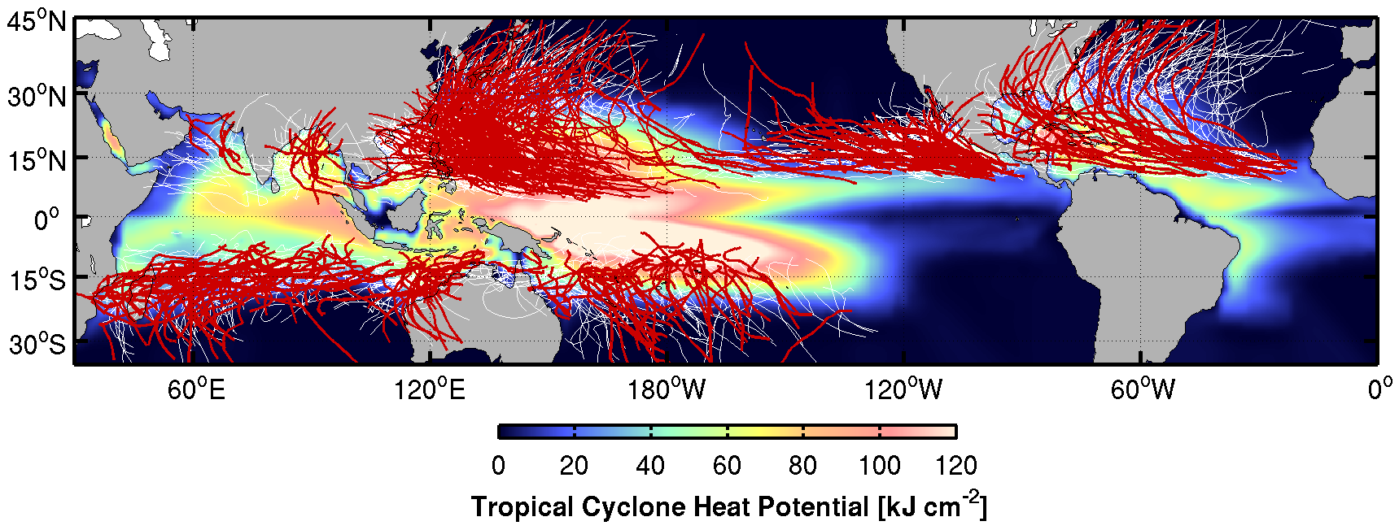
Figure 1. Global TC tracks during the time period of 1993-2011, overlaid on the average hurricane season satellite-derived Tropical Cyclone Heat Potential (upper ocean heat content above 26 °C isotherm) for each hemisphere computed for the same period. Thin white lines show the tracks of TCs with Cat-2 and below, and red lines show tracks of major TCs with Cat-3 and above.

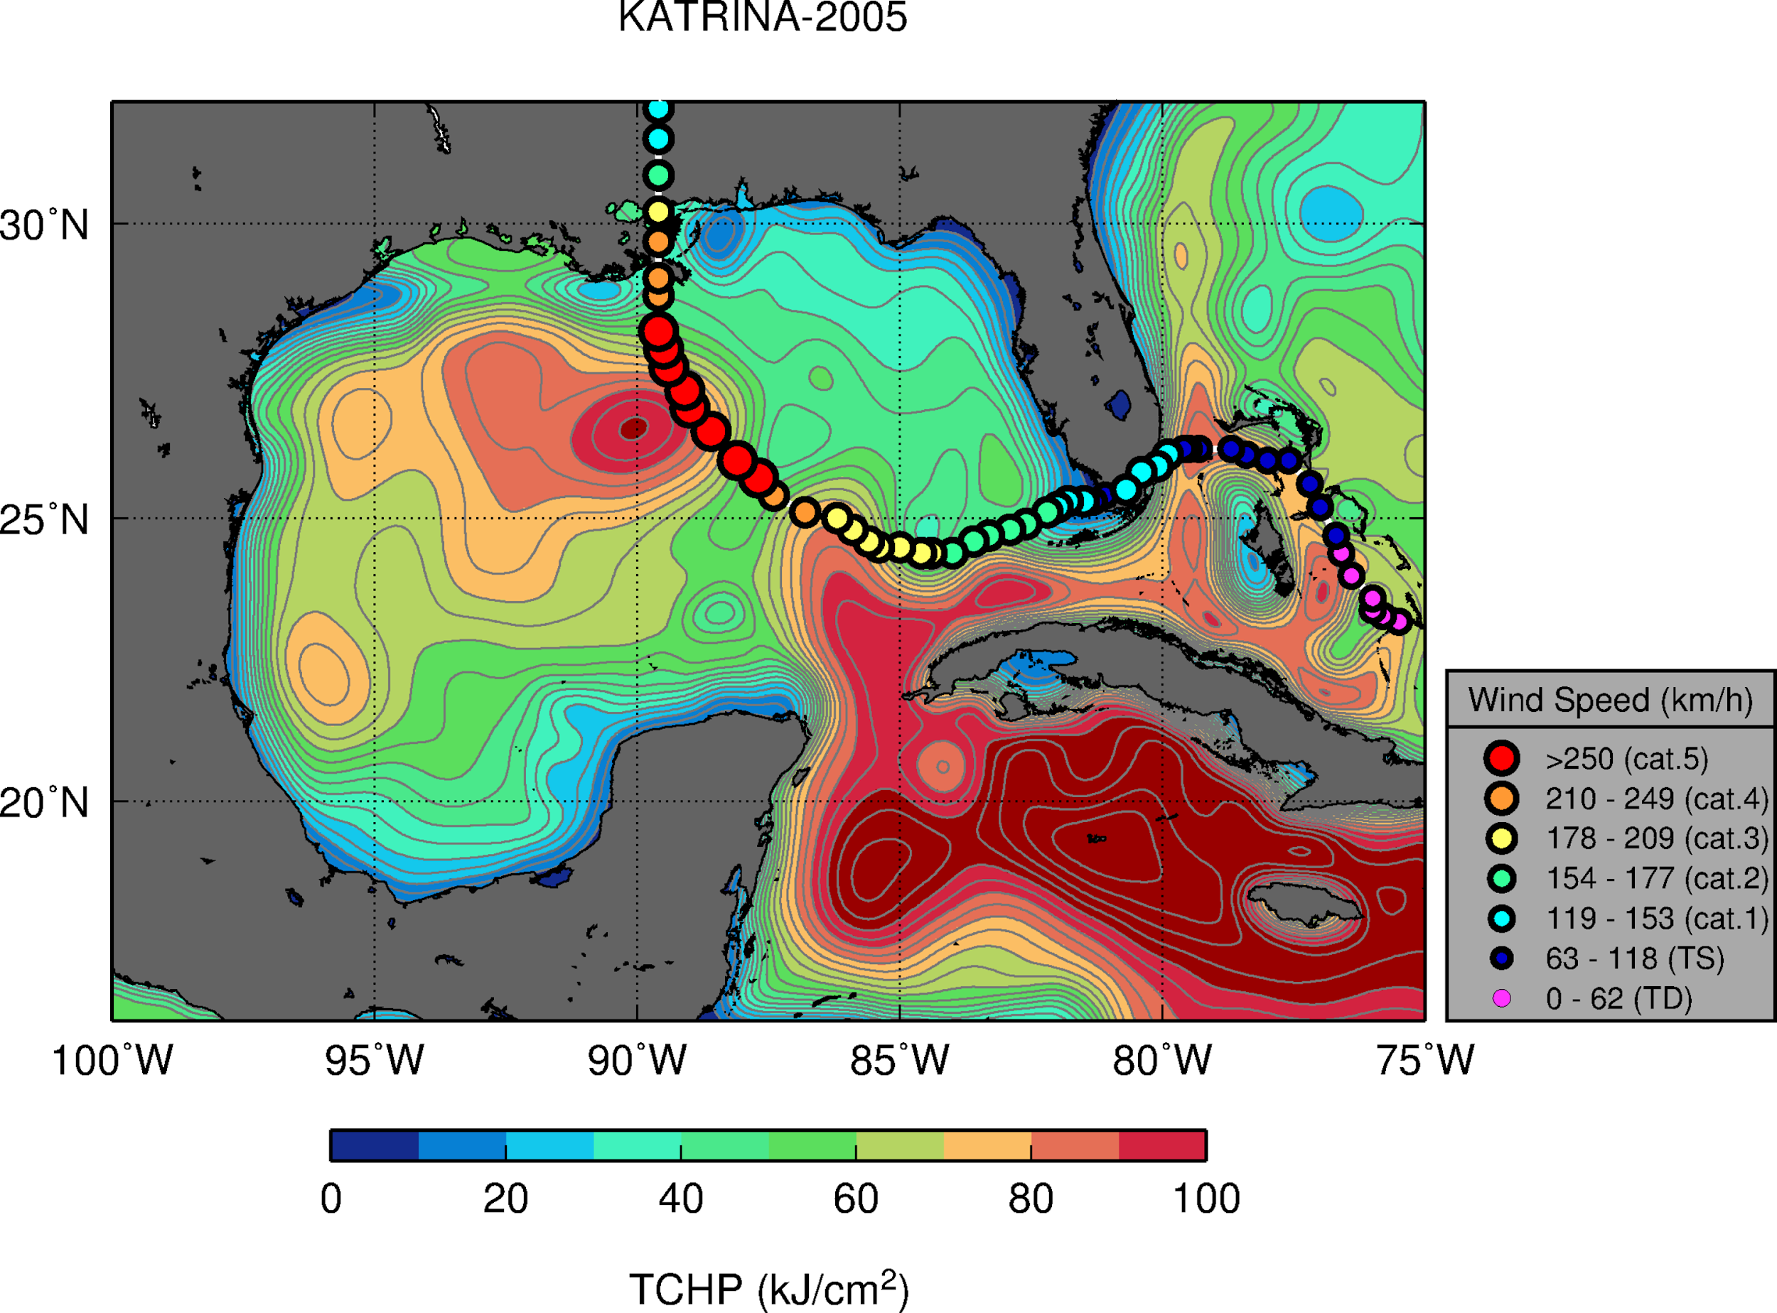
Figure 2. Track of Hurricane Katrina (2005) overlaid on tropical cyclone heat potential (TCHP, upper ocean heat content) conditions in the Gulf of Mexico on 08/20/2005 (prior to the passage of Katrina). Gray contours are displayed every 5 kJ cm⁻² units.

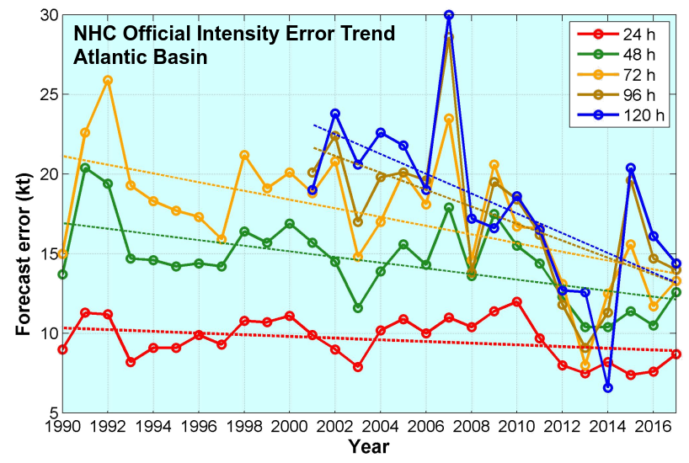
Figure 3. Official Atlantic hurricane intensity forecast error for the Atlantic basin reported by NOAA’s National Hurricane Center.

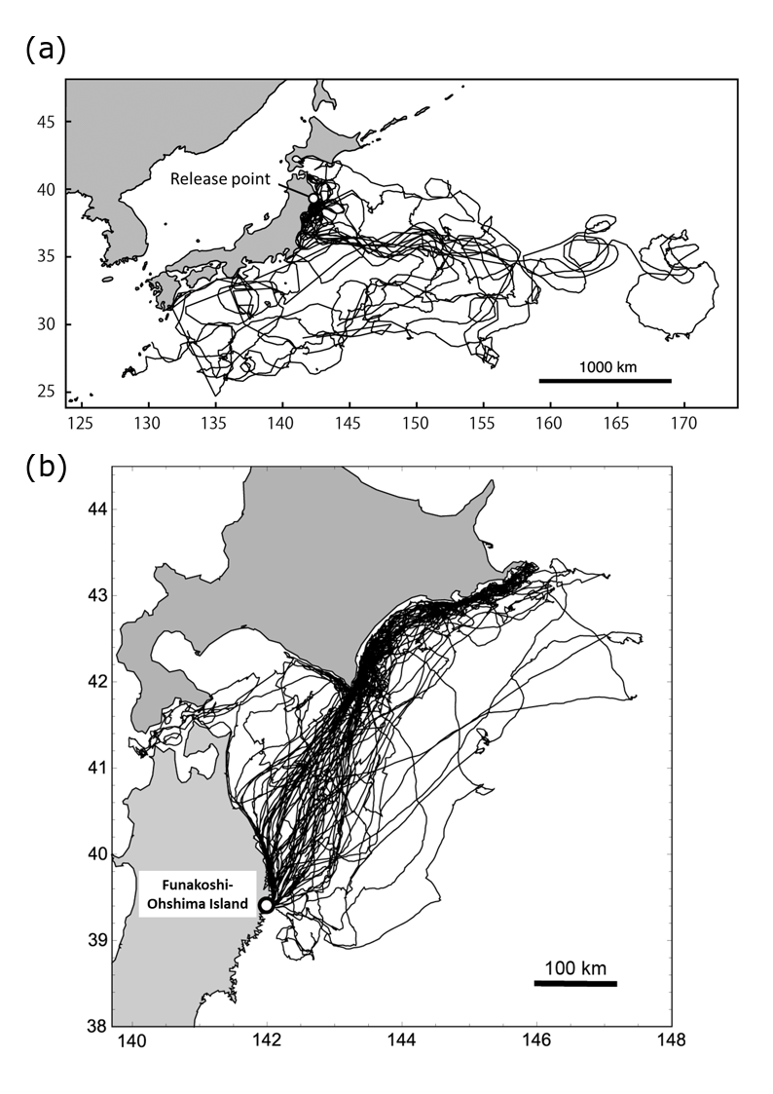
Figure 4. (a) Satellite tracks of 15 loggerhead turtles released from Sanriku coast, Japan (open circle) between 2010 and 2014. (b) Tracks of 33 Streaked shearwaters from a breeding colony in Funakoshi-Ohshima Island, Japan (open circle) between August and September in 2013 and 2014.

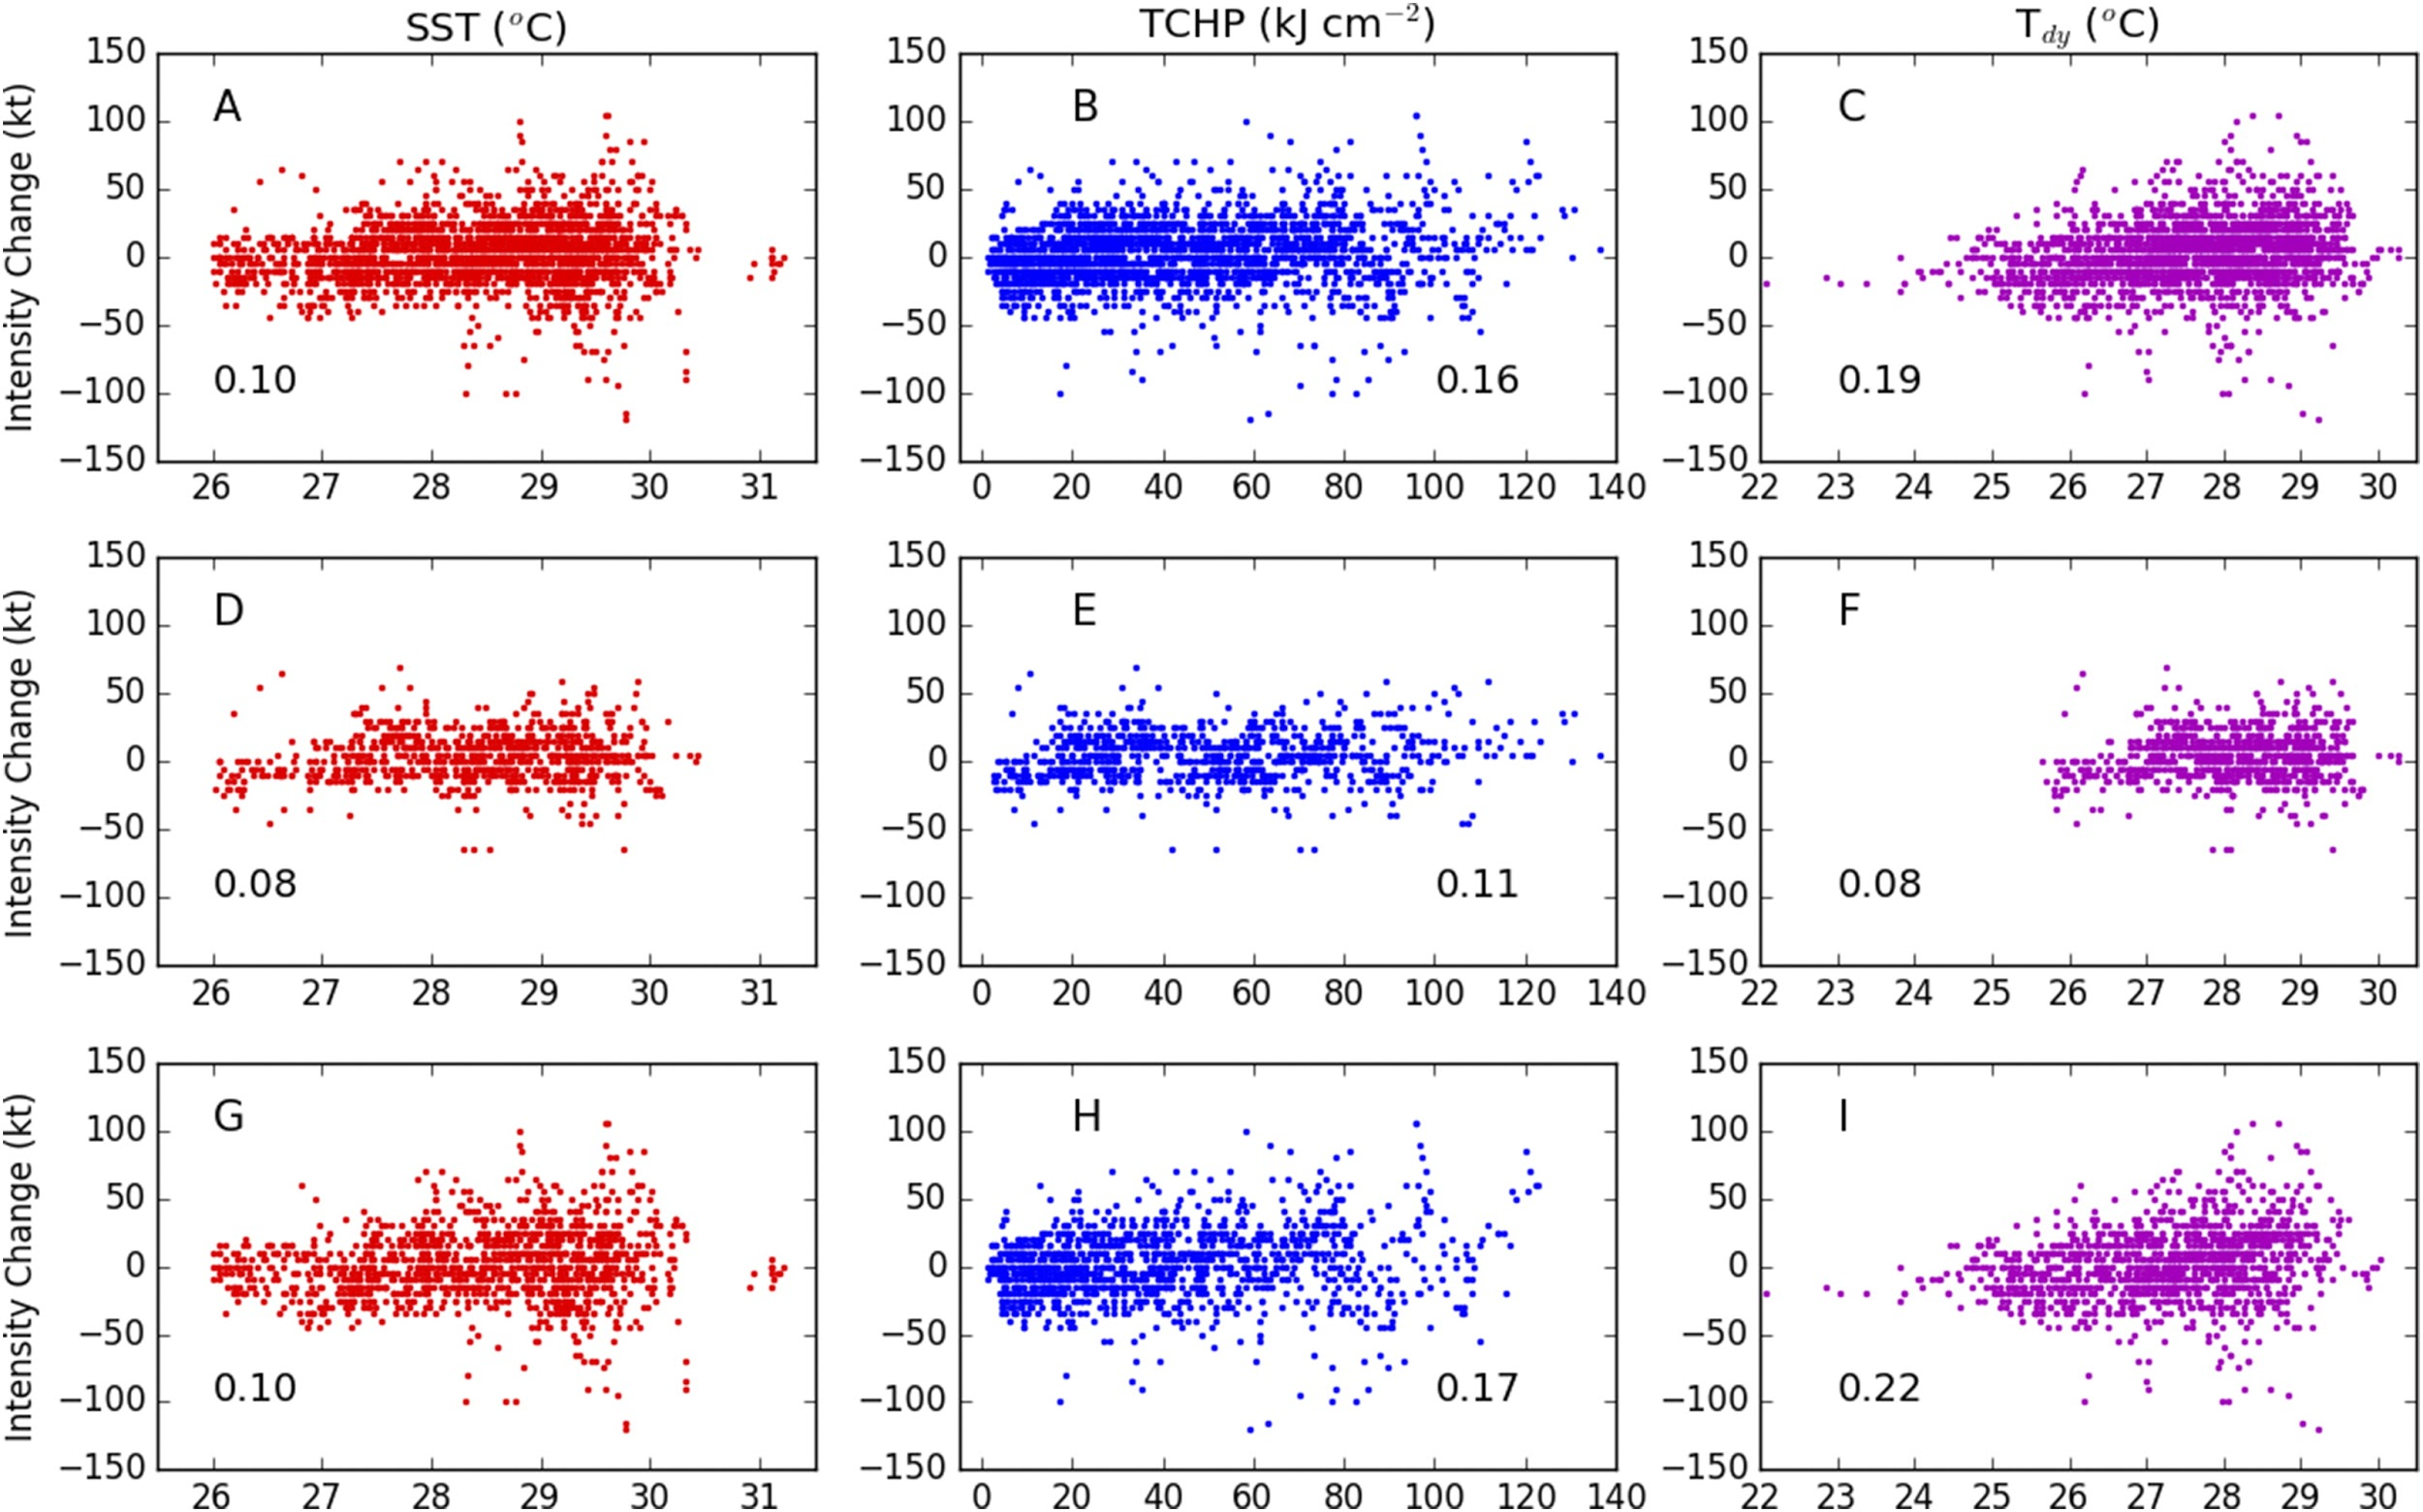

Figure 5. Scatter between 36-hour intensity changes of Atlantic TCs and SST (red), TCHP (blue), and Tdy (magenta) for the 10-yr period 2005–14. (a)–(c) All storm locations, (d)–(f) cases where the magnitude of the hurricane-induced SST cooling is below 0.5 °C, and (g)–(i) cases where the cold wake magnitude is greater than 0.5 °C. Correlation coefficients are also indicated in each panel. Reproduced from Balaguru et al., (2018)

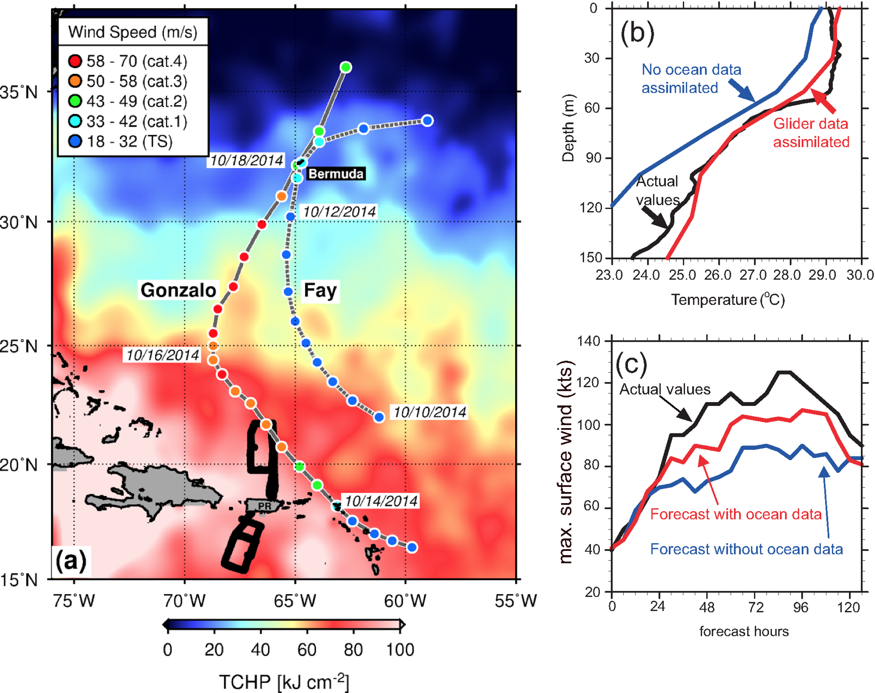

Figure 6. (a) Tracks of Hurricanes Gonzalo (2014) and Fay (2014) superimposed on the altimetry-derived upper ocean heat content (tropical cyclone heat potential) during October 2014. (b) Impact of glider temperature profiles on the initialization of HYCOM-HWRF. (c) Impact of glider and other ocean data to reduce errors in TC intensity (maximum wind speed) during the forecast of Gonzalo tested on October 13, 2014. Figure adapted from Goni et al. (2017).

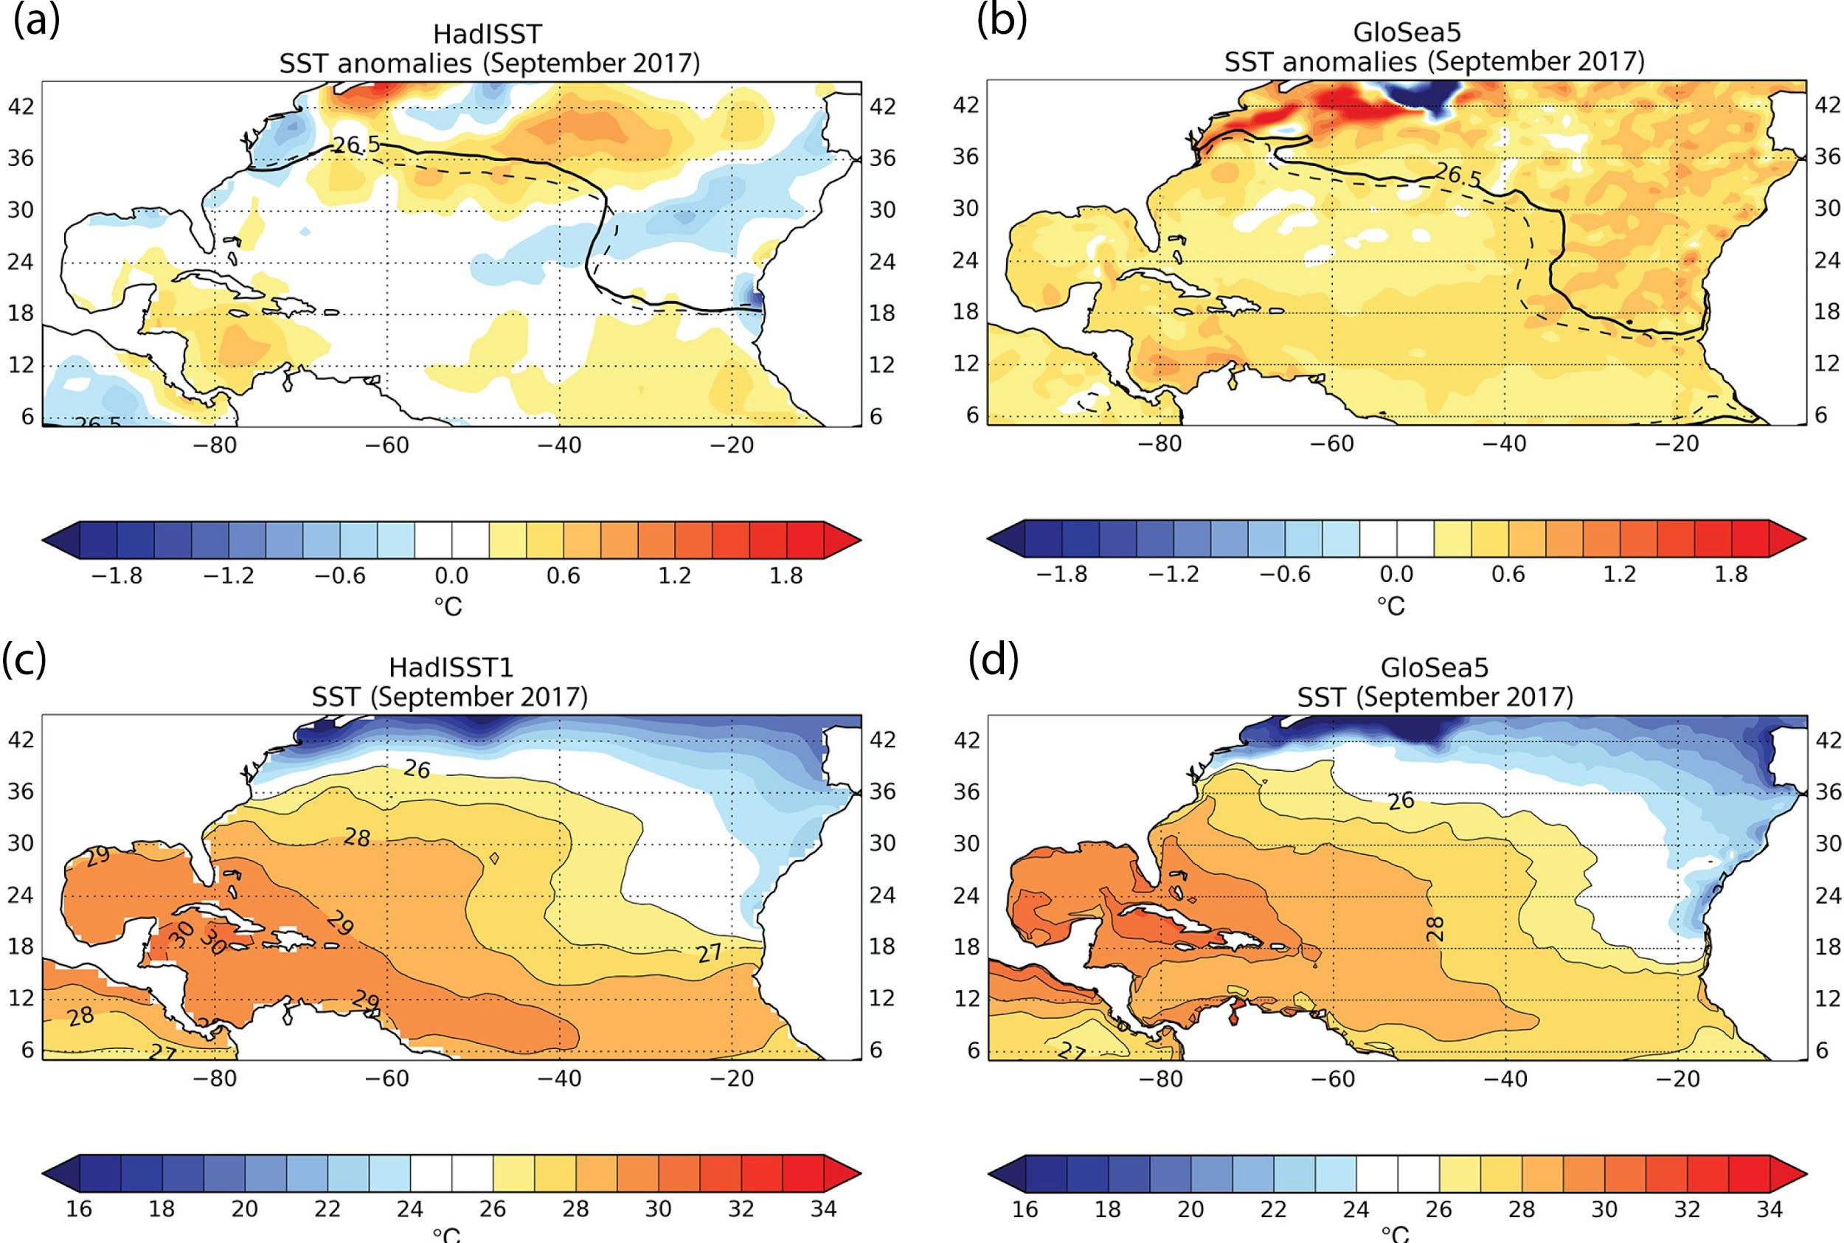

Figure 7. North Atlantic sea surface temperature forecasts: (a) observed and (b) forecast mean Atlantic SST anomalies during September 2017. Solid and dotted black line shows location of the 26.5 °C isotherm during September 2017 relative to September 1993–2015. (c) Observed and (d) forecast mean Atlantic SSTs during September 2017. Anomalies relative to September 1993–2015. Adapted from Camp et al., (2018).

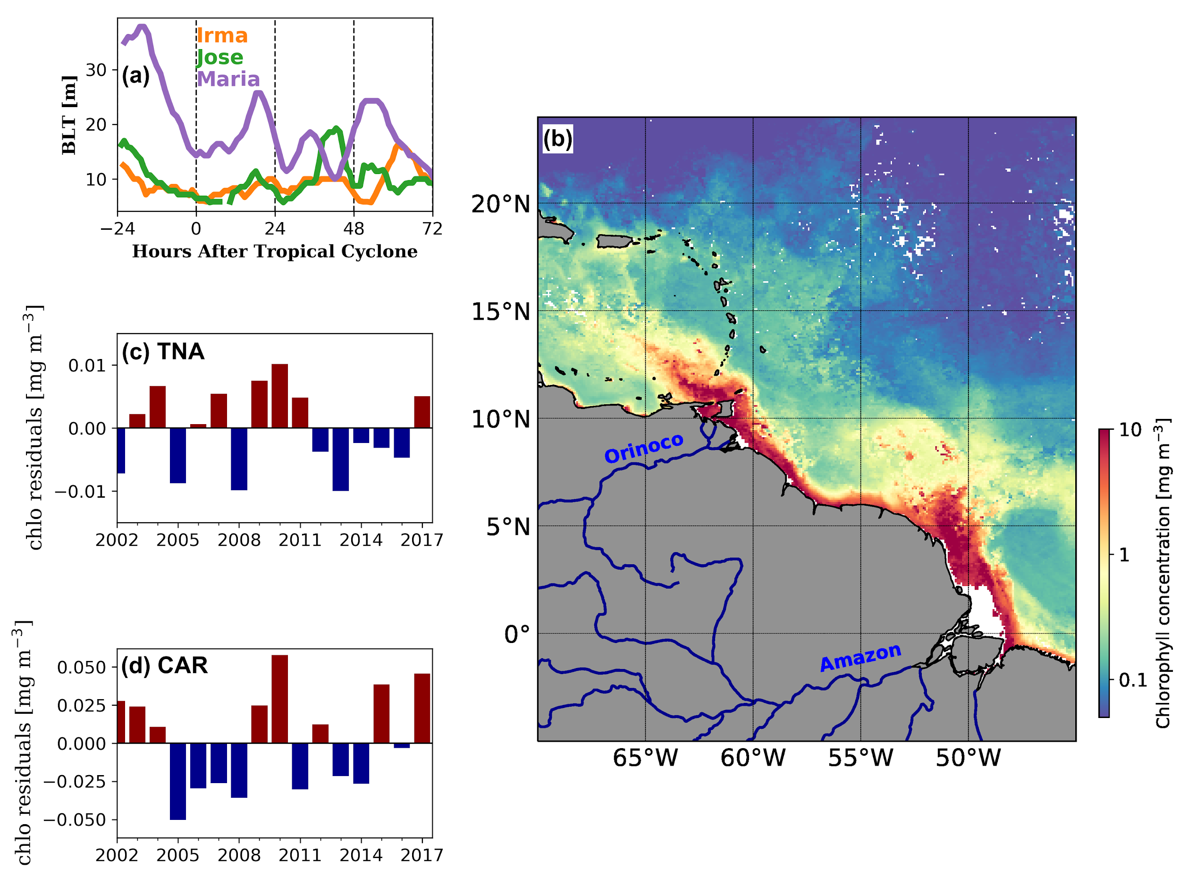

Figure 8. (a) Barrier layer thickness (BLT) calculated using underwater glider observations collected in areas off Puerto Rico under major 2017 TCs. (b) Average surface chlorophyll concentration for August 2017 derived from MODIS-Aqua data. Major rivers contributing to elevated chlorophyll concentrations are indicated. (c) Chlorophyll anomalies during hurricane season in the Tropical North Atlantic (TNA) Ocean for areas off Puerto Rico. (d) Same as (c), but for areas in the Caribbean Sea (CAR) off Puerto Rico.

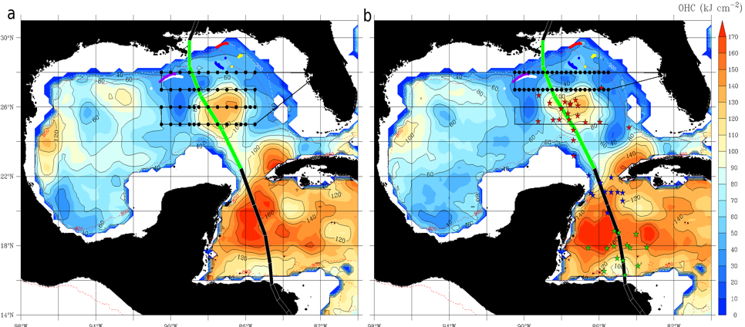

Figure 9. The separation of a LC WCE during the passage of Hurricane Nate of 2017. The color scale is for ocean heat content (OHC) relative to the 26 °C isotherm, from the satellite fields (Meyers et al., 2014). APEX-EM floats (purple, white, red, and yellow dots) that were active during Nate’s passage of Nate over the Gulf. (a) Pre-storm OHC structure on 5 October 2017. (b) Post-storm OHC structure on 10 October 2017. Black dots in (a) and (b) depict airborne ocean profilers deployed from NOAA WP-3D research aircraft; green, blue, and red stars in (b) represent in-storm oceanographic and atmospheric airborne profilers.

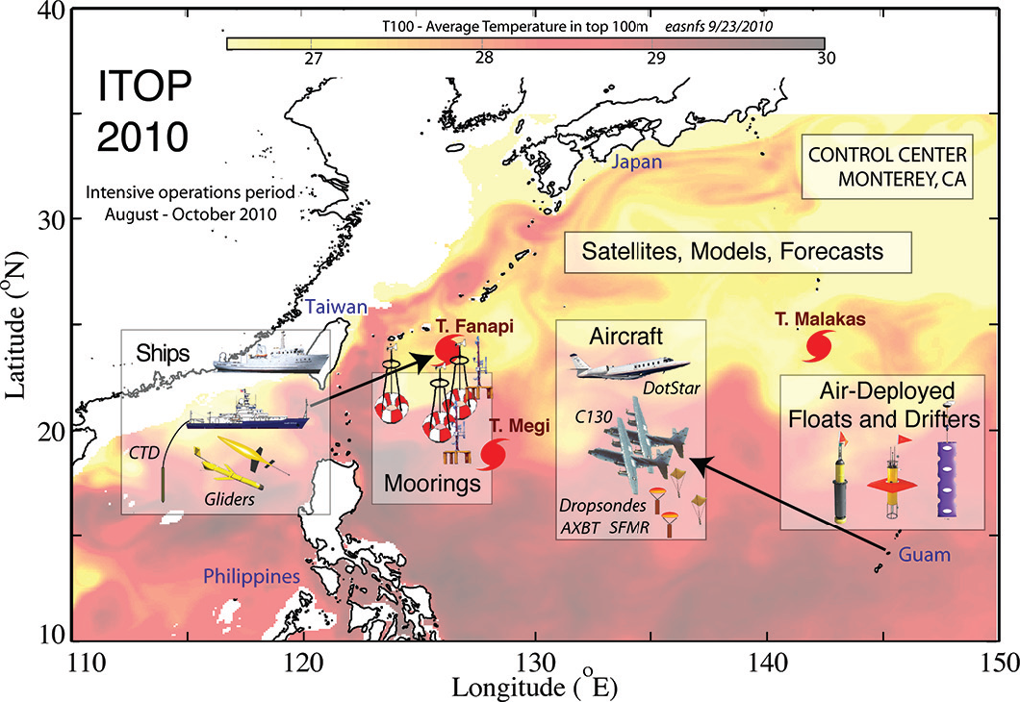
Figure 10. Background color map of average temperature for the upper 100 m (T100) from the East Asia Seas Nowcast/Forecast System on 23 September 2010. Overlaid are graphical representations of the ITOP operations area, experimental tools, and strategy. Locations of the three major ITOP storms at the time of maximum sampling are shown by storm symbols. Figure originally from D’Asaro et al. (2014), ©American Meteorological Society. Used with permission.

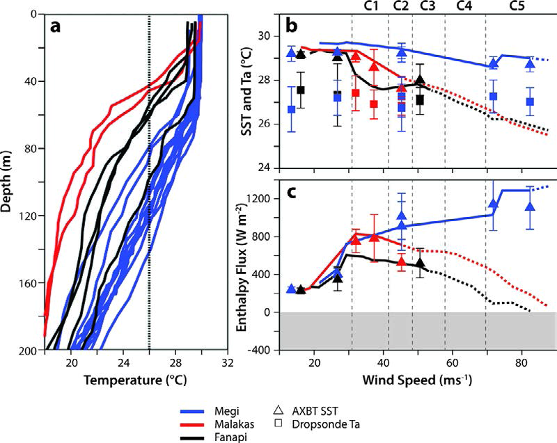

Figure 11. Evolution of temperature and air–sea fluxes for three ITOP TCs (Megi, Fanapi, and Malakas). (a) Pre-TC temperature profiles from ARGO floats. (b) Symbols: SST and air temperature at the core of each TC as measured by dropsonde/AXBT pairs. Lines: results of an ocean model (Price et al., 1994) driven by the observed TC (solid) and extrapolated to higher wind speeds (dashed). (c) As in (b), but for estimated total enthalpy flux. Reproduced from Lin et al., (2013).

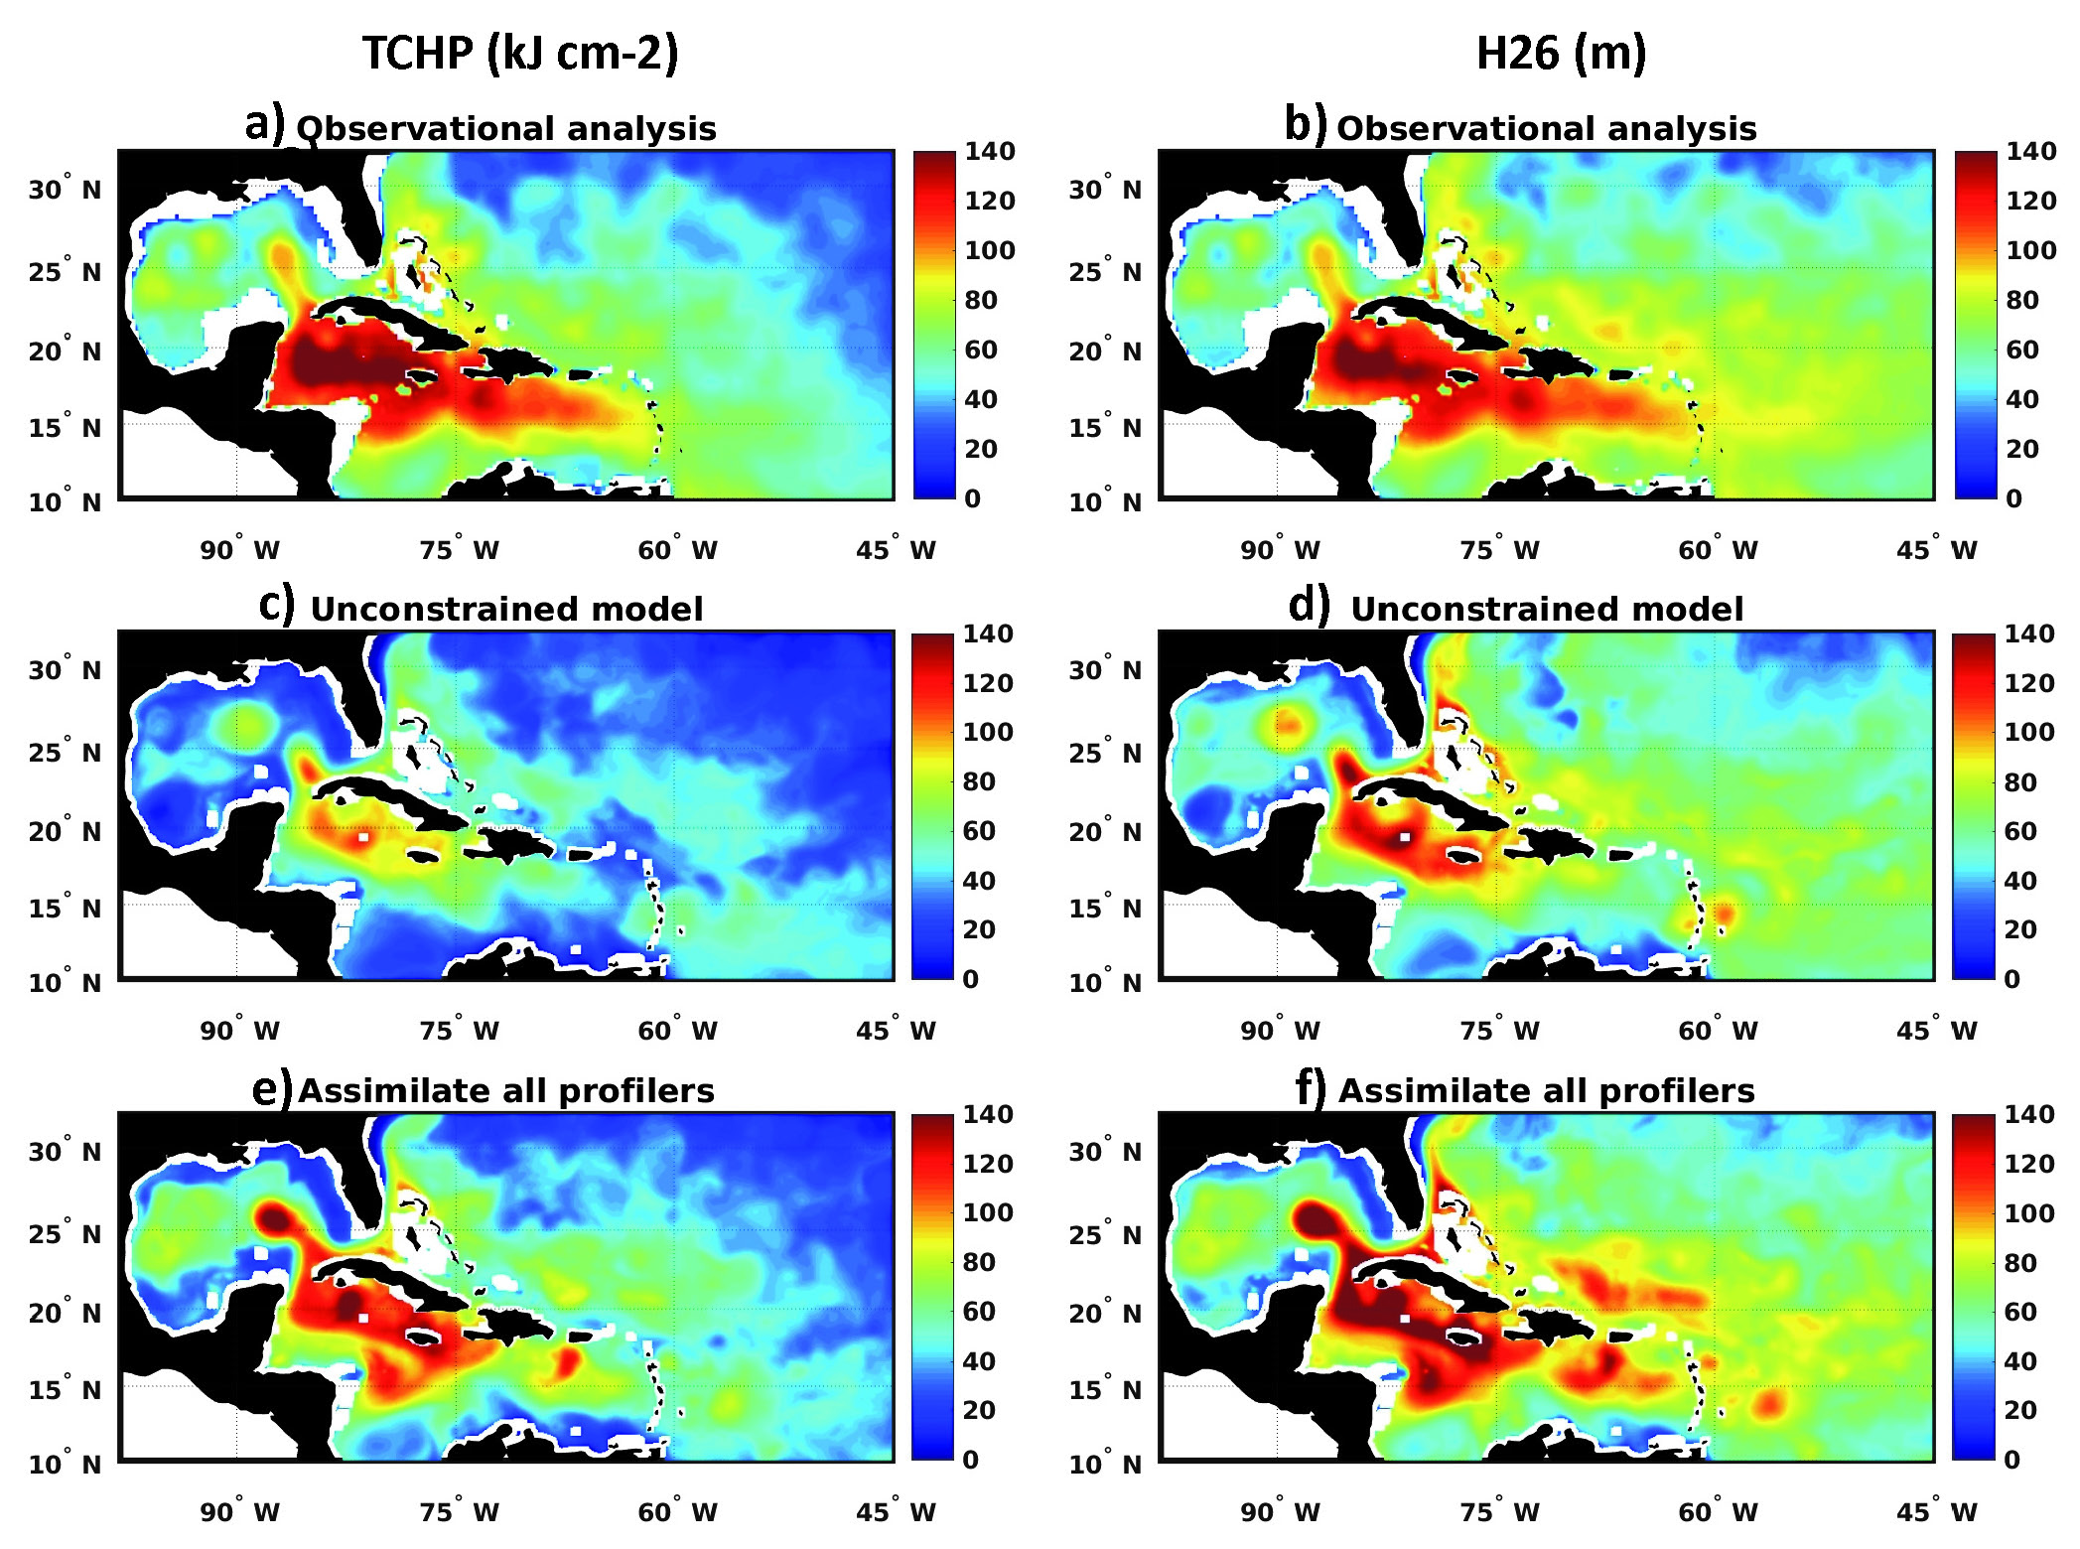

Figure 12. Mean fields of TCHP (a, c, and e) and H₂₆ (b, d, and f) averaged over the time interval 21 August through 8 October 2017. Observation-based estimates are provided by the NOAA/AOML TCHP product (a and b). Model fields are from an unconstrained simulation (c and d) and from an analysis that assimilated all ocean profilers (Argo floats, underwater gliders, and Alamo floats).

NOAA High-resolution Blended Analysis of Daily SST available at : https://www.esrl.noaa.gov/psd/data/gridded/data.noaa.oisst.v2.highres.html
Satellite altimetry products made available by the Copernicus Marine Environment Monitoring Service: http://marine.copernicus.eu/
TCHP fields made available by the NOAA Atlantic Oceanographic and Meteorological Laboratory at: http://www.aoml.noaa.gov/phod/cyclone/data/
U.S. Glider Data Assembly Center: https://gliders.ioos.us/data/
The Global Drifter Program: http://www.aoml.noaa.gov/phod/gdp/index.php and http//gdp.ucsd.edu
Argo Global Data Assembly Center at: http://www.usgodae.org/argo/argo.html
NASA Ocean Color website: https://oceancolor.gsfc.nasa.gov/
source: https://www.nhc.noaa.gov/verification/verify5.shtml
source: https://www.nhc.noaa.gov/verification/verify5.shtml

