REPORT: TECHNICAL COORDINATOR

ISABP

RIO DE JANEIRO

JR van der Merwe

- BACKGROUND: JR becomes TC for ISABP.

- The South African Weather Bureau had its first look at drifting weather buoys in September 1969. SOEKOR, drilling for oil around our coastline needed improved weather forecasting for their oil rigs. The SAWB was not ready for buoys yet, and a 600 ton whaling boat was chartered in stead and equipped to do weather observations half way between Cape Town and Gough Island. In September 1969 I had no knowledge of buoys – I was then participating in a field expedition in Antarctica…..

- My first involvement with drifting weather buoys was in 1978 when we retrieved two TOGAS on an SA Agulhas voyage to Marion Island.

- During the next 20 years or so, I became involved with all aspects of our buoy deployment programme under the guidance of that old dragon – Piet le Roux. In this period I participated in about 25-30 relief voyages to Antarctica, Gough- and Marion Islands and deployed about 250 drifting buoys. I represented the SAWS at the IBPIO and IPAB and we hosted three international meetings in SA. Amongst other things I also compiled and circulated a monthly report to about 50 local and international destinations.

- When Piet le Roux retired, Louis Vermaak took his place and he took charge of almost the complete buoy program. My contribution to the buoy program was reduced to mainly deployments during voyages, and doing all the footwork in preparation or international meetings. For those who still remember Piet – he is now happily retired and living in a small coastal town ‘Kleinmond’ not far from Cape Town and he is doing mostly nothing.

- When Louis passed away about 5 years later the SAWS discovered that I was the only person who knew anything about buoys and Antarctica & Island management and I was formally put in charge of our buoy program by SAWS management. After being out of circulation of the buoy family for about 5 years I was a bit rusted but with the friendly assistance of overseas participants I made contact again easily enough. I represented the SAWS at the DBCP in Buenos Aires straight off the ship after a six week voyage to Gough Island – almost three days without sleep….. As Louis had been TC for ISABP, I volunteered to be TC for ISABP. Fools rush in where wise men fear to tread……….

(End of History lesson)

2. ACTIVITIES AS TC FOR ISABP
I spent many hours, days, weeks reading through Louis, files and reports to try to find out what he had done as TC, but at the next ISABP I had no choice but to say: Sorry, he did not share his activities with me. I could not compile a report on his behalf. The Chairman and I compiled a list of tasks for the TC. To be TC without guidance from anyone in SA, was uhm, not easy.

As I have retired end of December 2007, I am writing this report strictly from memory and without access to my monthly reports and data files. I do not even have the list of my tasks as TC with me…….

  - IMPROVED BUOY DEPLOYMENT NETWORK.

To begin with, the main mission I tasked myself with was to improve the buoy distribution network in the South Atlantic Ocean.

The well known problem with our previous deployment pattern was that the SA Agulhas could not reach far enough west in the South Atlantic during voyages to Gough and Antarctica. Buoys deployed during the voyage to Gough in September~October would converge with buoys deployed between Cape Town and Antarctica in December~January, and the whole lot would rapidly drift eastwards. This would leave the South Atlantic Ocean devoid of data – especially during winter when we needed it most.

I then embarked on an initiative to find additional deployment opportunities to counter the situation. Several possibilities were investigated and three have so far proved to be very successful:

- The Island Community of Tristan da Cunha has joined the ISABP. Four drifters were put on the island during the annual visit in October last year. These drifters can be deployed from their fishing patrol boat whenever we ask them to do so, any time during the year – weather permitting of course.

- The Fisheries Department on the Falkland Islands has also agreed to deploy buoys for us. They did not join the ISABP, but they are a very active and willing participant. Six buoys were hurriedly provided to us in November 2006 by NOAA/AOML (Thanks guys!) and they were put on a destroyer from the UK which by lucky coincidence happened to be in Cape Town en route to the Falklands. The Falklands Fisheries Department can deploy drifters for us during monthly voyages between the Falklands and South Georgia. They also patrol into an area about 45S 45W twice a year. Buoys can now be deployed in this area which has always been devoid of data. As the Royal Navy cannot put one of HMS war ships conveniently at our disposal to transport buoys to the Falklands every year, we had to make alternative arrangements. During the annual buoy deployment voyage to Antarctica the SA Agulhas will now deliver buoys to the Fisheries Department at South Georgia who will deploy when we request them to do so.

Note: Deployments from Tristan da Cunha and from the Falklands have the advantage that buoys can be deployed almost any time during the year.

- The German icebreaker – The Polarstern – has agreed to deploy buoys for us during her voyages between Cape Town and Antarctica. Deployments from the Polarstern has three advantages:

- She can deploy in the Drake Passage where we would LOVE to have buoys.

- Her voyages between Cape Town and Antarctica are usually very early and very late in the summer season. So she can deploy at times when the SA Agulhas is not in the area.

- The Polarstern is using Cape Town as base for voyages down south. This makes access to the ship and communication with the on board scientists very easy.

- Our dear chairman did a few deployments for us on the AX-18 line between Cape Town and BA. But we found that buoys deployed from Tristan tend to drift anti clock wise and end up in the area between Gough and South America anyway.
- I also looked at deployments by tour operators form South America. Some of them were quite willing, but I would prefer to stay with official organisations.
- We investigated deployments from Gough island with the main purpose of getting buoys south of Cape Town – especially in winter. Our meteorological team would be in a position to deploy buoys any day. Even if we could get the buoys safely down the 20 meter cliffs, away from the rocks and through the kelp, the buoys would still tend to drift up north, and not eastwards towards Australia where we need them.
- BAS have ships commuting between England and Antarctica but they never responded to my queries.
- Six drifters were sent to Argentina for deployment between Buenos Aires and Antarctica, but their ship caught fire and I don’t know what the situation is now.
- I found the website with deployment opportunities very much outdated and lacking information of contact persons.

  - GHANA JOINS ISABP.

The Fisheries Department of Ghana has very recently joined the ISABP. This opens the possibility of deployments in the Bay of Guinea which has always been a very empty data area.

  - THE LAMBERTS BAY MOORED BUOY EXPERIMENT.

More pressure and wind information was needed off shore from the SA and Namibian west coast. It would have been fairly easy to deploy SVP-BW’s but they would have drifted out of the area of interest fairly quickly.

One SVP-B was moored at Lamberts Bay about 300 km North of Cape Town along our west coast in April 2006. This project was executed in collaboration with the University of Cape Town (UCT) and Marine and Coastal Management (MCM) who provided the mooring facilities and logistic support. The SVP-B was attached to the mooring of a scientific buoy of UCT but it stopped transmitting after about six months. We speculated that it could have been damaged by a passing boat, or - more likely - that it had sunk due to marine growth on the buoy. A few transmissions were received again at about 7 March 2007 during an exceptionally severe spring tide, but nothing was heard from it since. This project was to be our first step towards developing a moored buoy program, and we learned a lot from it – especially that we do not yet have the resources for a moored buoy program.

I’m sure the buoy is still there, and it will be interesting to retrieve it one day.

My visit to Lamberts Bay when we installed our buoy took place just a few days after I had retuned from a voyage to Marion Island. I arranged that my wife could accompany me and we spent a few wonderful days at this small fishing village.

  - PARTICIPATION BY NEIGHBOURING COUNTRIES.

- Tanzania: A meteorologist from Tanzania met service was invited to join the SA Agulhas voyage to Gough in September 2005. This visitor was a well educated and dignified gentleman. But life on board a ship was not for him. He just didn’t want to be there.

- Namibia: Another meteorologist from Namibia joined the voyage to Antarctica in the 2005/2006 summer season. He participated fully in all activities. He has recommended that Namibia met service should:

Participate in the activities of the ISABP
Put together a program to deploy buoys.
Host the ISABP in 2008 !

Nothing has come of any of these initiatives.

My next mission as TC would have been to try to improve the buoy network up the west coast of Africa (a daunting task) and to improve communication between ISABP participants in the inter session periods.

3. SAWS RESTRUCTURE.

Since the passing away of Louis Vermaak, the function of managing Antarctica, Islands and buoys was done by one person only. Additional staff (Shine) was appointed from outside the SAWS in January 2007. SAWS management put her in charge of the buoy deployment programme about three months after she was appointed.

The function of managing our stations in Antarctica and of Gough and Marion was transferred to our Cape Town regional office.

I chose to retire from the SAWS at the end of December 2007

FINAL WORDS.

How does one say goodbye after so many years? One of our Afrikaans writers had some free advice – he said saying goodbye is a sad thing, so keep it short.

I had wonderful times with Antarctic & Islands and with our buoy deployment programme. Visited some of the most remote places on earth and attended meetings as far away as pretty Fairbanks, Alaska.

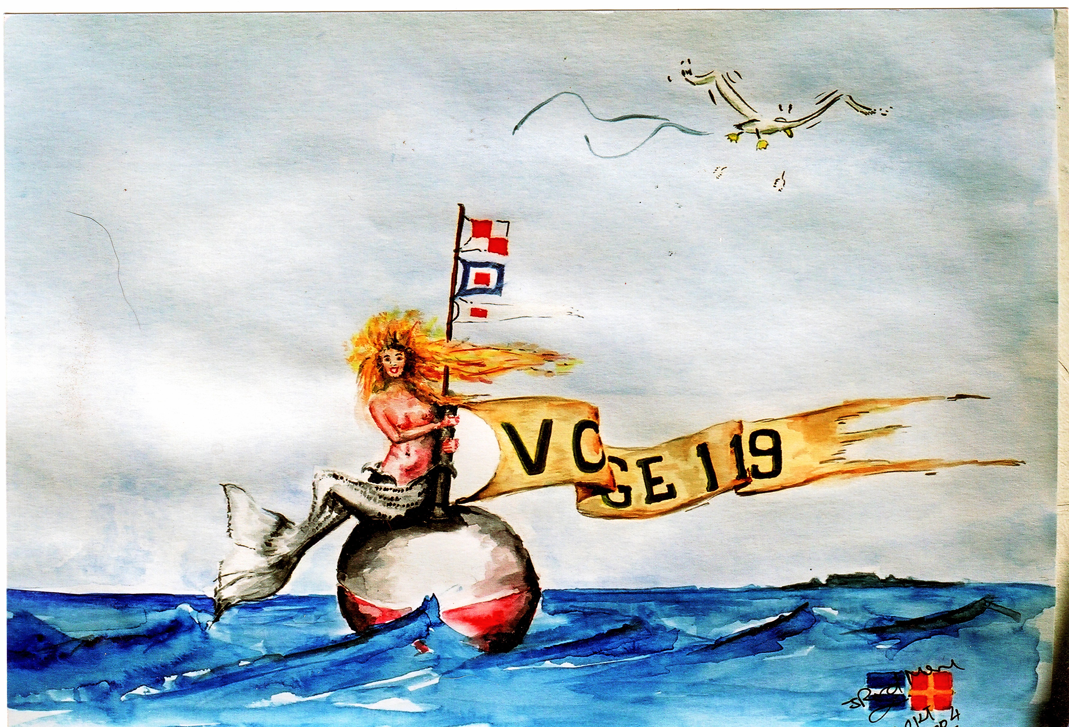
There's a mesage in the flags: Thanks for your support. Have a good trip home.

Thanks to our buoy friends for their friendship and support.

Go Well.

Johan van der Merwe
Antarctica, Islands & Weather Buoys.
Now Retired from: South African Weather Service.
May 2008.

