Global Drifter Programme

Barometer Drifter Design Reference

by

A. L. Sybrandy (Pacific Gyre Inc.)
P. P. Niiler, C. Martin, and W. Scuba (Scripps Institution of Oceanography)
E. Charpentier (Data Buoy Co-operation Panel)
D. T. Meldrum (Dunstaffnage Marine Laboratory)

DBCP Report No. 4

REVISION 2

May 2005

Published by the Data Buoy Co-operation Panel
Global Drifter Design Center Data Buoy Co-operation Panel
Scripps Institution of Oceanography World Meteorological Organization
La Jolla, CA 92093 CH-1211, Geneva
USA Switzerland

Global Drifter Programme

Barometer Drifter Design Reference

by

A. L. Sybrandy (Pacific Gyre Inc.)
P. P. Niiler, C. Martin, and W. Scuba (Scripps Institution of Oceanography)
E. Charpentier (Data Buoy Co-operation Panel)
D. T. Meldrum (Dunstaffnage Marine Laboratory)

DBCP Report No. 4

REVISION 2

May 2005

Published by the Data Buoy Co-operation Panel
NOTE

The designations employed and the presentation of materials in this publication do not imply the expression of any opinion whatsoever on the part of the Secretariats of the Intergovernmental Oceanographic Commission (of UNESCO), and of the World Meteorological Organization concerning the legal status of any country, territory, city or area, or of its authorities, or concerning the delimitation of its frontiers or boundaries.

FOREWORD

Drifting buoys are now well established as platforms for gathering both meteorological and oceanographic data from the world’s oceans. Hitherto the diverse requirements of the two scientific communities have led to varying designs, with quite distinct characteristics suiting the particular specialised requirements.

The Global Drifter Design Center at Scripps Institution of Oceanography, recognised the potential of a combined meteorological and oceanographic buoy, based on their Lagrangian drifter. Their buoy was developed for the Surface Velocity Project (SVP) of the World Ocean Circulation Experiment (WOCE).

The outcome of this initiative, supported by the Data Buoy Co-operation Panel, is the development of the SVP-Barometer (SVP-B) drifter, which design is detailed in this manual.

On behalf of the Data Buoy Co-operation Panel, I congratulate the staff at Scripps Institution of Oceanography, Pacific Gyre, Inc., and those panel members, who assisted in the development of the SVP-B drifter. I also commend those involved in the production of this design manual, which I recommend to potential users and buoy manufacturers who wish to take advantage of the proven operational characteristics of the buoy and its low cost potential.

Graeme Brough
Chairman
Data Buoy Co-operation Panel
December 2001

CONTENTS

FOREWORD 4
CONTENTS 5
FIGURES 6
TABLES 6
REVISIONS 7
I. INTRODUCTION 9
1. General Information 9
2. The Original SVP Oceanographic Drifter 10
3. The Barometer Version 11
4. The smaller size drifter 11
II. DRIFTER DESIGN 15
1. The Surface Float 15
2. The barometer port 16
3. The thermistor fitting 18
4. Recommendations for installing the electronics into the surface float 20
5. Sealing the surface float 22
6. The tether assembly 23
7. Connecting the surface float and radial hub to the tether 24
8. Radial hub 26
9. Designing the 5-section Ø61 cm holey sock 27
The Drag Area Ratio 28
Sphere 28
10. Preparing the drogue rings 29
11. Connecting the tether to the drogue 30
12. Applying biofouling protection 30
APPENDIX 1 - Materials 31
Surface Float 31
Tether Pieces 31
Drogue Pieces 32
Antifouling Paints and Primers 32
APPENDIX 2 - Address list 33
Complete drifters 33
Global Drifter Design Center 34
Global Drifter Center 34
Data Buoy Co-operation Panel 34
APPENDIX 3 - Sensor sampling and an example Argos message format 35
Sensor Sampling and duty cycle 35
Atmospheric pressure 35
Argos Message Format (example): 36
APPENDIX 4 - The SVP-B drifter: development, trials and possibilities for collaboration 39
1. Design of the barometer drifter 39
2. Field tests 41
3. Opportunities for co-operation between oceanographers and meteorologists. 42
APPENDIX 5 - Comparison of this design with the design described in revision 1.3 of this manual 43
REFERENCES 44
ACKNOWLEDGEMENTS 44
TECHNICAL DOCUMENTS ISSUED WITHIN THE DBCP SERIES 45

FIGURES

Figure 1. SVP-B drifter - general arrangement. 13
Figure 2. The Barometer drifter - surface float layout. 14
Figure 3. The barometer port 17
Figure 4. Installing the thermistor fitting 18
Figure 5. Submergence switch detail. 19
Figure 6. Inside the bottom half of surface hull (left) and outside (right). 20
Figure 7. Connecting surface float to tether (top). Cap (bottom left), and eye-bolt (bottom right). 25
Figure 8. Radial hub top (left) and bottom (right), and bottom close up (bottom). 26

TABLES

Table 1. The SVP barometer drifter - description of components 12
Table 2. Computing the drag area ratio of the drifter (example). 28

REVISIONS

Version 1.0, September 1995

Original version of the document (09/1995) was called the “WOCE Surface Velocity Programme Barometer Drifter Construction Manual”. It has been published as DBCP Technical Document No. 4, WOCE Report No. 134/95, SIO Report No. 95/27.

Revision 1, December 2001

Revised to reflect the latest improvements with the design of the barometer drifter. As of revision 1, manual is made available via the web. Latest version can be found at http://www.dbcp.noaa.gov/dbcp/SVPB-design-manual.pdf. The new version of the manual is less specific regarding construction details and leaves more latitude for adapting designs to specific manufacturing processes provided requirements expressed in the document are followed. Important modifications to the drifter design since the 1995 version are:

- Subsurface float removed: This allows reduction of the drogue size while still maintaining a drag area ratio (DAR) of 40 since elimination of sub-surface float reduces tether drag. In order to maintain a low mean tension between the surface float and the drogue, the drogue is also more buoyant than in the previous design.
- The Surface float is now made of ABS plastic instead of fiberglass.
- Three air pressure sensors are now suggested although other sensors meeting the requirements (i.e. 1 hPa accuracy, less than 1hPa/year drift) could be chosen:
- Vaisala (e.g. PTB 101C)
- Honeywell (PPT/HPB family)
- Two options are now proposed for installing the saltwater switch:
- 6 cm above the equator of the surface float separated by 5 cm
- separated by 60 degrees centred from the top of the sphere
- Barometer port has been redesigned leaving outside dimensions unchanged.
- Argos message format changed.
- Antenna installation detailed.
- List of contacts updated.

Revision 1.1, August 2002

Correction with regard to drag area ratio computation in Section 9, “Designing the 5-section Ø92 cm holey sock.”

Revision 1.2, December 2002-12-17

Barometer AIR SB-2A is not available any more. Vaisala added to the list of suppliers.

Revision 1.3, December 2003

Appendix V had been added to describe the difference between the design described in the document and a newer design with reduced size hull and drogue. This was done before a new revised edition of the manual describing completely the reduced size design could be made available.

Revision 2, May 2005

New design with reduced size hull and drogue is now completely described in this version of the manual. Appendix V now compares this new design with the one that was described in revision 1.3 of the manual. The two designs are accepted in terms of meteorological and oceanographic requirements. New design is simply more cost effective, lighter, less expensive to ship, and easier to handle & deploy.

I. INTRODUCTION

1. General Information

For several years, oceanographers and meteorologists have deployed satellite-tracked drifting buoys in support of their research and operational programmes. These two bodies of users have, however, sought different capabilities from their drifters: the oceanographers have mainly looked for designs which accurately follow water parcels at a given depth, whereas the meteorologists have equipped their drifters with barometer ports and air-pressure sensors to collect real-time observations for weather forecasting. Despite efforts by both user groups to develop combined programmes, these two main requirements have been largely incompatible, particularly in respect to the size and above-surface exposure of the drifter.

The success of the low-cost WOCE Surface Velocity Programme (SVP) oceanographic drifter, with its accurately quantified water following characteristics and proven longevity, prompted renewed interest in the development of a low cost met-ocean drifter capable of satisfying the needs of both user communities. The result is the SVP Barometer (SVP-B) drifter, whose design and use is described in this manual. This design, refined over several years and after extensive testing, further develops the original SVP drifter by inclusion of a novel barometer port. This inexpensive but stable pressure sensor combined with a data filtering algorithm removes pressure spikes resulting from the repeated immersion of the drifter by waves.

The information given in this manual follows the design methods developed by the Global Drifter Design Center (SIO/GDEC) at the Scripps Institution of Oceanography (SIO), in collaboration with manufacturers and users. Of necessity, much of the constructional detail relates to parts and materials available in the USA: however it has been our intention to give sufficient information to allow the substitution of locally available products. Note that the use of specific materials may affect the buoyancy of the completed drifter, and prototypes should always be tested and ballasting adjusted as necessary so that the drifter floats correctly.

Similarly, some parts of the description relate to specific Argos transmitter/controllers. Other transmitter/controller configurations may be used, provided that the pressure de-spiking algorithm (see Appendix 3) can be implemented correctly. Consult your preferred transmitter supplier for confirmation of this vital capability.

Currently, a preferred format exists for the data message sent by the drifter to the Argos processing centres for transmission of meteorological data to the Global Telecommunication System (GTS). Information about this format, and other recommendations regarding the use of the Argos system, are given in Appendix 3. Other data formats are allowable, but may not be compatible with the GTS processing software presently in use by Argos. Users are strongly advised to check that their proposed data format can be handled by Argos before any irreversible steps are taken. The technical co-ordinator of the Data Buoy Co-operation Panel (for contact information see Appendix 2) is specifically tasked to give detailed advice and assistance in these matters, and should be consulted by all potential deployers of SVP-B drifters.

2. The Original SVP Oceanographic Drifter

The original WOCE Surface Velocity Program (SVP) satellite-tracked drifter, whose construction is described in detail in Sybrandy and Niiler (1991), was designed to track the mean current at 15 m depth using a 7 m holey-sock drogue. It uses the Argos satellite tracking system for location and retrieval of data (see the Argos Users Manual for full information). The drifter consists of three main components:

• A surface float, housing the Argos transmitter, batteries, sea surface temperature probe and drogue-loss (immersion) sensor. Drogue loss is detected by a change in the immersion behaviour of the surface float. A magnetic reed switch, mounted on the inside wall of the surface float, allows the electronics to be switched on and off without opening the hull.

• A tether assembly, which connects the surface float to the sub-surface drogue. The tether incorporates components designed to reduce the damaging effects of heavy weather.

• A dimensionally-stable drogue, designed to perform well under adverse conditions and to be easy to deploy.

The two principal objectives pursued in this design were to make a drifter with known water-following characteristics, and with a lifetime of many months under severe open-ocean conditions. Low cost and ease of deployment were also seen as essential design goals.

Accurate and predictable drift characteristics imply that the design must attempt to minimise the effects of wind and waves on the surface float, the contamination of the current signal by aliasing of wave-induced and tether forces, and slippage of the drogue. These goals were realised in the SVP drifter by using:

• A spherical surface float, which minimises rectification of surface waves into net horizontal forces.

• A low mean tension between the surface and sub-surface elements in order to reduce aliasing of vertical forces into slip-producing horizontal forces. This was achieved with initial SVP drifter design by using a sub-surface float. The sub-surface float is eliminated in the new design and drogue buoyancy reduced (a drag area ratio of 40 preserved because elimination of sub-surface float reduces surface element drag).

• Thin, stiff wire tethers to minimise drag-induced slip, and to reduce looping and kinking caused by wind waves.

• A dimensionally stable drogue of a design resistant to kiting under normal horizontal load conditions. The SVP drifter uses the holey-sock drogue, with dimensions chosen to give a drag-area ratio (drogue:(tether + floats)) of about 40 (see Table 2 for a calculation of the drag area ratio). The holey sock is also relatively easy to construct and to handle during deployment.

Long drifter lifetimes are achieved by taking steps to reduce excessive flexing and shock loadings in the tether assembly, and by selecting materials and finishes which are resistant to corrosion, degradation and fouling. Flexing at attachment points is controlled by in-situ moulding of bend restrictors ('carrots').

Completed drifter assemblies were calibrated in the sea under a variety of operating conditions by using vector-measuring current meters to measure drogue slip. Values of less than 1 cm s⁻¹ were obtained in wind speeds of 10 m s⁻¹ (Niiler et al, 1987, Bitterman et al, 1990). Studies have also shown slip in the presence of current shear is influenced by drogue length, the performance of drogues longer than 7 m begin to deviate from the ideal vertical average due to non-linearities in the upper-ocean shear profile (Chereskin et al, 1989).

Since the start of the programme, several hundred SVP drifters have been deployed and monitored. Drifters recovered, both by accident and as a result of planned trials, are carefully examined. As a result, the SVP design is continually refined with a view to improving the durability of the tether assembly. Median lifetimes now exceed 400 days.

3. The Barometer Version

The tether and drogue assemblies are identical to those employed for the standard SVP drifter described above (see figure 1). The surface float has, however, been enlarged to accommodate the additional batteries needed for the air pressure sensor, and strengthened to accept a short mast containing the barometer port (see figure 2). Development efforts are devoted to developing a pressure measurement system (port + sensor + signal conditioning) that is reliable in terms of its durability, resistance to flooding, and ability to determine accurate surface pressures when the drifter is repeatedly submerged by waves.

As with the conventional SVP drifter, the design is improved in response to user feedback and as a result of extensive trials (see Appendix 4 and, for example, Sombardier, 1993). Currently, hundreds of SVP-B drifters, built as described in this manual or its previous version, are deployed in support of operational met-ocean programmes such as the International South Atlantic Buoy Programme (ISABP). These drifters continue to report accurate surface pressure data after many months exposure to severe open-ocean conditions. The design will continue to evolve in the light of experience, and intending SVP-B constructors are advised to contact the GDEC or the Technical Co-ordinator of the Data Buoy Co-operation Panel for the latest update information.

4. The smaller size drifter

A smaller size drifter was introduced in 2003 to reduce cost (manufacturing, storage, shipping), and to facilitate handling and deployment. Main differences between the new smaller design and the older design are summarized in Appendix V. Drag Area Ratio (DAR) remains greater than 40. Basic differences include the following:

- Surface hull size reduced from 40 cm to 32 cm;
- Drogue diameter reduced from 100 cm to 61cm;
- Drogue is now comprised of 4 sections instead of 5 for a total length of 4.9 m instead of 7 m;
- Total weight has been reduced from 30 kg to 15 kg;
- Radial hub comprised of cables had been replaced by a formed plastic radial hub.

Table 1. The SVP barometer drifter - description of components

Component | Description
Surface Float | 32 cm diameter, ABS plastic 4 mm (0.16") thick surface float. Outer gel coat applied to protect against UV.
Tether | (a) 3/32" (2.4 mm) x 1/8" (3.2 mm) diameter plastic impregnated wire rope between surface float and drogue.
 | (b) 1/4" x 1.5" (thread) eye-bolt to attach cable to centre of radial hub & to the surface float.
 | (c) 16 cm long polyurethane carrots moulded below surface float and above radial hub.
Drogue | (a) Holey sock made from non-fray synthetic cloth; diameter 61 cm, length 490 cm. Construction consists of 4 cylindrical sections, each 122 cm long. Two pairs of 30.5 cm holes are cut in each section. In a pair, holes are cut opposite each other. Axis joining holes is rotated by 90° between successive sections. Holes are evenly spaced throughout the drogue. Drogue is centred at 15 m. See Figure 1.
 | (b) Approx. 1.5 kg lead weight sewn into base of sock inside a 25.4 mm (1") 'schedule 40' (wall thickness 3.6 mm (0.14") PVC-pipe ring, partly filled with epoxy to prevent movement of lead inside pipe.
 | (c) 19 mm (3/4") ID, 1.6 mm (1/16") wall polypropylene 'irrigation' pipe ring between each 122 cm segment for support. Rings are drilled to allow flooding.
 | (d) 25.4 mm (1") 'schedule 80' (wall thickness 4.8 mm (0.19")) PVC-pipe top ring, filled with closed cell polyurethane foam.
 | (e) Formed plastic radial hub with four radial arms to the outside. Radial hub is used to attach top of drogue.
Transmitter | (a) Argos-approved transmitter..
& Power | (b) Antenna mounted above electronics.
 | (c) Duty Cycle: typically full on
 | (d) Batteries configured for an expected endurance of 24 months
 | (e) Power Supply: typically 1 pack of 32 alkaline D-cells. For example, total capacity can vary between 75Ah (24 months) and 112 Ah (3 years) depending upon actual electrical current consumption and expected life time. Average power consumption using 12V electronics can vary from 0.035W (e.g. 56 bits) to 0.084W (248 bits) depending upon usable Argos message length.
Anti-fouling | Anti-fouling coating on bottom half of surface float. Inflatable boat anti-fouling paint polyurethane carrot.
Sensors | (a) Air-pressure sensor, Vaisala (e.g. PTB 101C), Honeywell (PPT/HPB family, e.g. HPB 2000W TTA-H020).
 | (b) Linear thermistor sensor (YSI type 44018 or equivalent) embedded in a capped 316 SS Swagelok™ through-hull fitting or equivalent at base of surface float. The complete assembly is available as Betatherm part no XP36K53D93.
 | (c) Surface float submergence (drogue-loss) sensor.
Packaging | Individually packaged for free-fall deployment from a moving cargo ship from 10 m height above the ocean, or for air deployment.

Figure 1. SVP-B drifter - general arrangement.

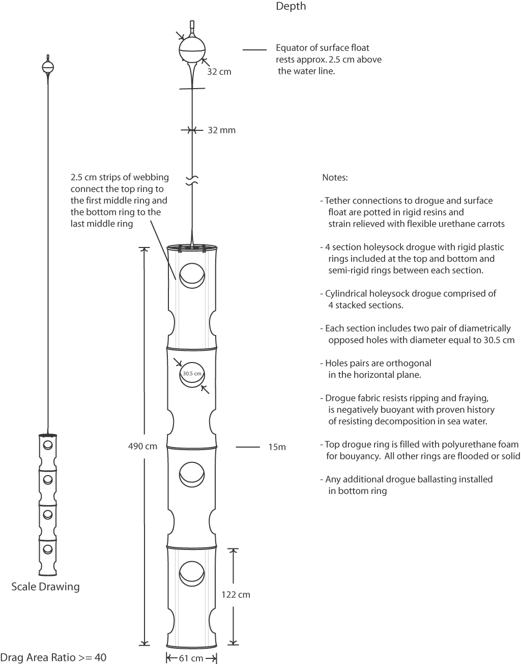

Figure 2. The Barometer drifter - surface float layout.

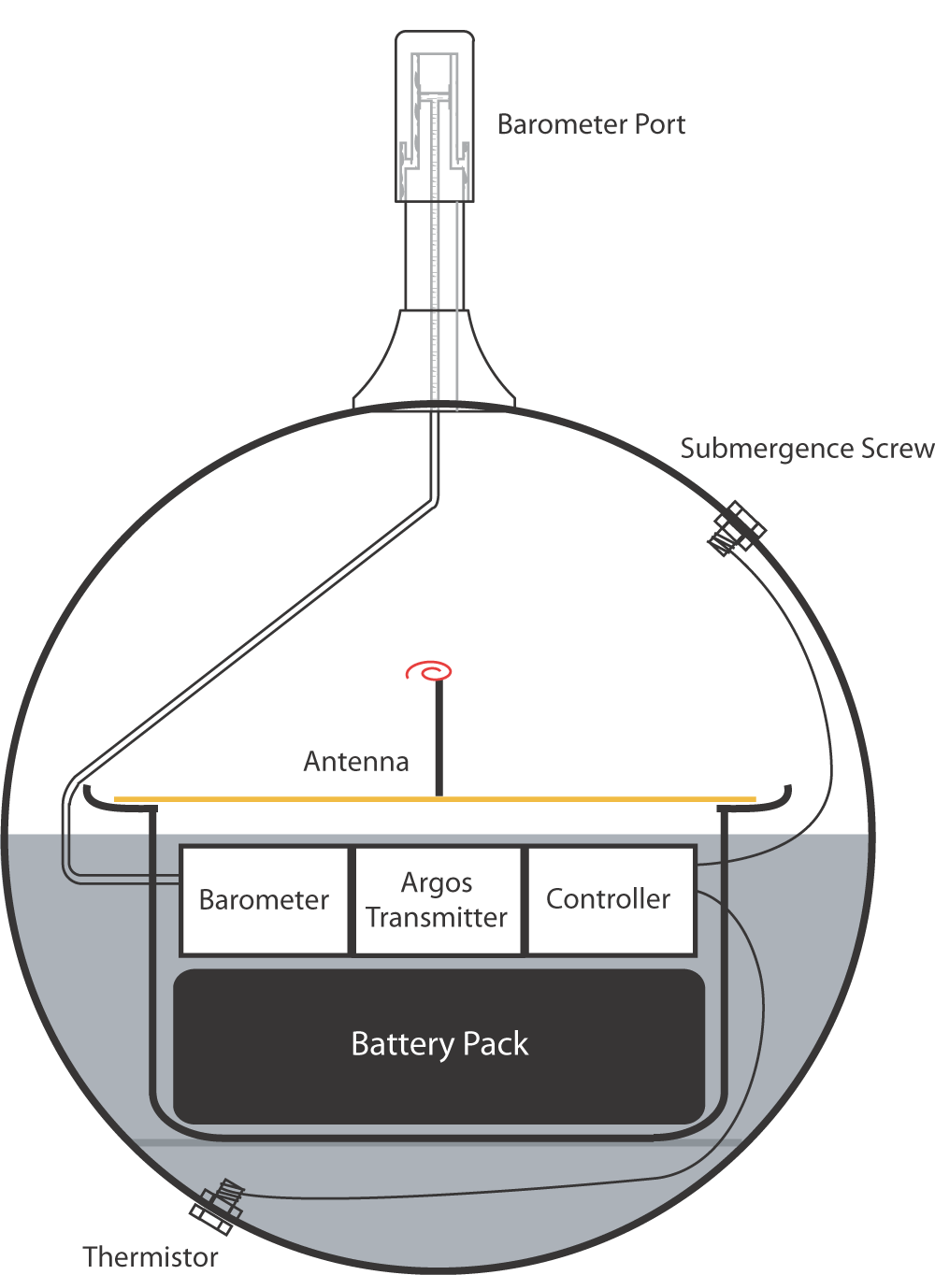

II. DRIFTER DESIGN

1. The Surface Float

The surface float is a crucial part of the drifter. In addition to providing buoyancy, it carries all the electronics and sensors. ABS plastic is a good choice for the float (upper and lower halves use separate moulds). It can be vacuum moulded and is easily glued using industry standard adhesives. Additionally ABS plastic is not brittle at cold temperatures. The outermost layer of material is a gray, filled, polyester resin (gel coat) formulated to protect against UV and water absorption. We recommend that an experienced plastic craftsperson fabricates the surface float.

The following features should be moulded into the float.

- Indexing marks for the saltwater screws, barometer port, and temperature sensor to facilitate drilling

- A flat spot indicating the location of the magnet used to turn the drifter on and off (bottom of lower half).

- A lip in the lower hemisphere to provide additional strength to the surface float glue joint.

- An additional knob at the bottom of the lower hemisphere for a circular piece to plastic to be glued into place providing a cavity for the tether connection.

- Indexed locations to glue electronic mounting blocks inside the sphere.

- Drill a hole near the tope out of the way of other components (port, submergence switch, etc.). This hole will be used to create a vacuum upon sealing of then two hemispheres. Hole will eventually be sealed.

Remark: surface float size is related to its total weight including electronics, batteries, sensors etc... It can therefore be adapted to reflect differences with weights expressed here. Surface float size or buoyancy is adapted so that its equator is located about 2.5 cm above water level when the whole drifter, including drogue is deployed in still water. Similarly, drogue size may be adapted to reflect changes in surface size in order to keep a drag area ratio > 40. See table 2 for an example of computation of the drag area ratio.

2. The barometer port

The barometer port is designed to reduce wind induced Bernouilli effect pressure offsets in the pressure signal (Osmund and Painting, 1984). The port also prevents water from entering and therefore damaging the internal pressure sensor with a baffle, backing volume and micropourous filter. It is recommended to place filter vertically to avoid condensed water to block air flow. The port is also machined from ABS or similar plastic. Do not use PVC for the port as this material become very brittle when cold. An additional water trap located between the port and the sensor is recommended to catch condensing water vapor. The example port on figure 3 is an acceptable design.

Note that the baffle assembly is a relatively complicated shape to machine. The assembly details are not given here but design must meet following requirements:

- Port must be submergible
- Leave sufficient backup volume
- Outside dimensions of the port must follow Osmund and Painting’s design (see figure 3)
- Prevent water from blocking the filter.

Figure 3. The barometer port

Remark: inside design below is an approximation which is given as an example. Outside design must be followed.

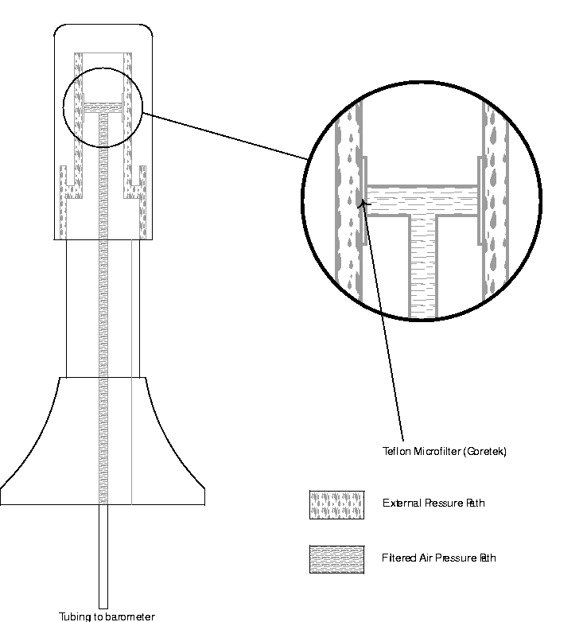

3. The thermistor fitting

The thermistor fitting, thermally isolated from the inside of the float, is designed to react quickly to changes in sea surface temperature (SST). Thermal isolation prevents solar heating of the top of the surface float from influencing the SST measurement. The sensor should be accurate to better than 0.1°C when the inside of the float is 1°C warmer than the sea surface. A thermistor fitting that reacts quickly to temperature changes also speeds up temperature sensor calibration in the lab. We use a Betatherm assembly (part no XP36K53D93) which incorporates a linearised thermistor composite within a stainless steel fitting. Alternatively, an assembly can be made by potting a linearised thermistor composite within a suitable tubing connector.

Figure 4. Installing the thermistor fitting

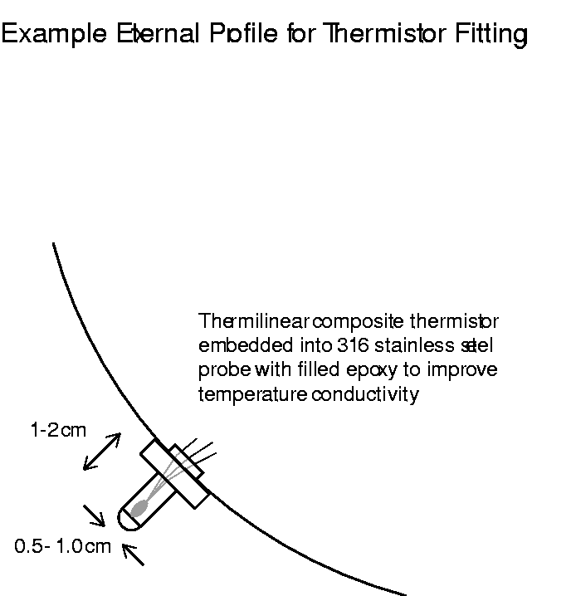

Figure 5. Submergence switch detail.

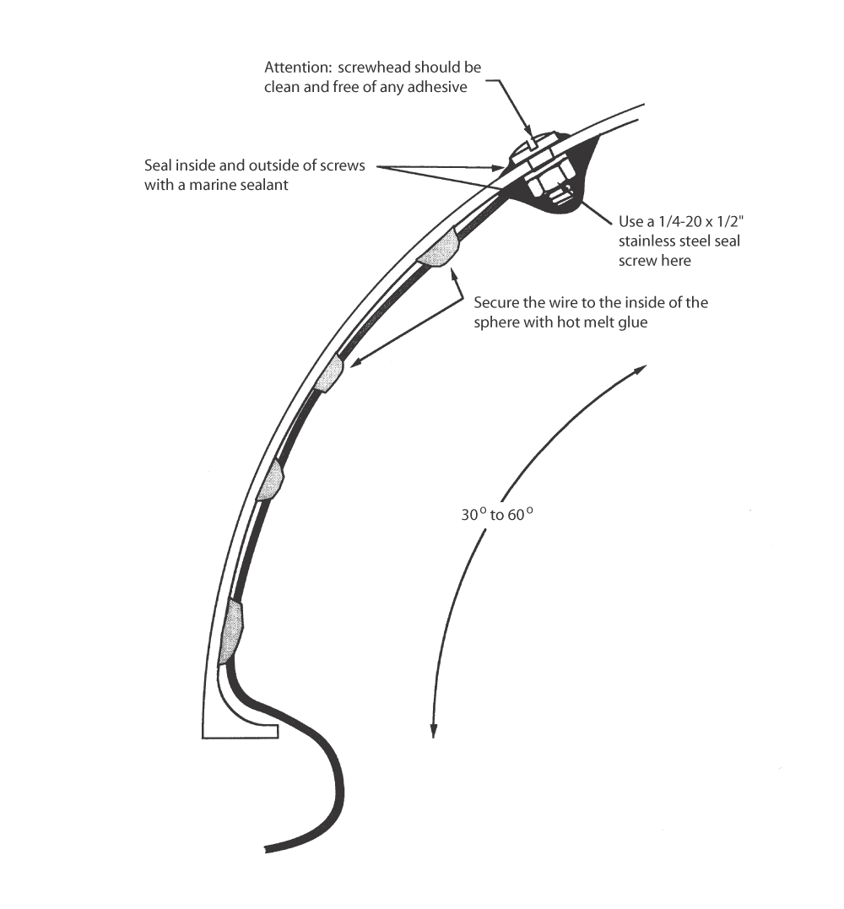

4. Recommendations for installing the electronics into the surface float

- Reduce interference between antenna and electronics by providing appropriate electromagnetic shielding;
- Electronic mounting should provide shock proofing to allow deployment by air and 10 m ship decks;
- To secure battery and electronics in place as well as provide additional water proofing polyurethane foam can be used.
- A magnetic reed switch, mounted on the inside of the surface float bottom part of the hull, starts and stops drifter transmissions via a magnet placed on the outside of the hull.
- Install electronics, batteries, sensors etc. so that centre of gravity of surface float is as low as practicable.

Electronics, batteries, and antenna are placed in a moulded hexagonal box of approximately 24 cm diameter. The bottom part of the box includes the batteries, and the electronics on top of them. The top part of the box that includes the antenna is slightly larger than the bottom part; its diameter is about 28 cm (11").

Mounting, and shock-proofing of the electronics box within the lower hemisphere of the surface float is achieved simply by use of polyurethane foam. The foam is formed by pouring pre-mixed liquid ingredients into the surface float. The liquid quickly expands into a foam and hardens into place. The delicate thermistor composite leads, the air-pressure sensor and the magnetic reed switch must be secured in place carefully before pouring the foam to avoid damage and displacement during expansion of the foam. Similarly, the transmitter, the air-pressure sensor and the battery packs must be sealed to keep the liquid foam from leaking into and damaging them.

The bottom half of the surface hull is designed in such a way to facilitate installation of the electronics box: a shelf (1.3 cm (0.5") large, and about 24 cm (9.4") outside diameter) is moulded to provide support for electronics box and to keep from interfering with the tether mounting hardware, thermistor, and magnetic switch. The electronics box sits on the shelf.

Figure 6. Inside the bottom half of surface hull (left) and outside (right).

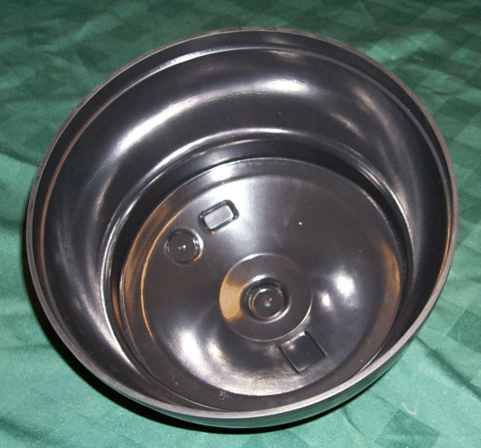 | 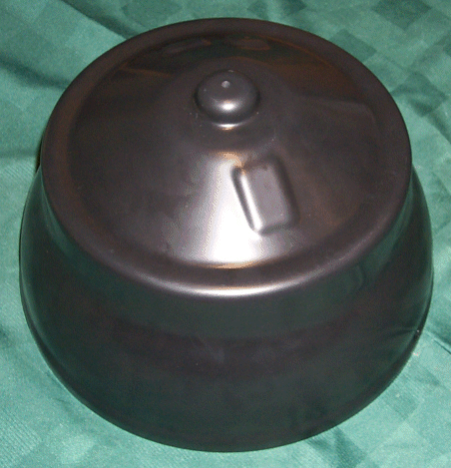

5. Sealing the surface float

It is important to seal the surface float carefully. Float hemispheres are sealed with acrylic adhesive. Use the following 5 part procedure, to ensure a good seal.

1. Sand lightly before applying any adhesive. Clean surfaces thoroughly with solvent.

2. Warm the upper and lower hemispheres slightly before closing the surface float. This will create a slight vacuum inside the surface float upon cooling and helps pull the two halves together.

3. Secure a sachet of desiccant within the hull to minimise the risk of water condensation.

4. Place a bead of acrylic adhesive on the sealing edge of both top and bottom parts of surface sphere for initial closure of the surface float. Smooth to even consistency with finger. Put the two pieces together. Then put additional bead of glue around sealing join and smooth with finger.

5. When the glue has dried, attach a vacuum pump to small hole in top part of the float. Pull a vacuum and monitor to see that the pressure remains relatively constant at a period of several minutes. Once one is satisfied that there are not leaks the hole is sealed using a plastic rivet and marine sealant.

6. The tether assembly

The tether assembly consists of plastic impregnated wire rope. It is 2.4 mm (3/32") x 3.2 mm (1/8"), where 2.4 mm (3/32") is the outside diameter (OD) of the wire rope and 3.2 mm (1/8") is the OD of the final product after impregnation. In order for the drogue to be centred at 15 m below sea surface, the length of the cable from the surface float to the radial hub is about 12.4 m.

The radial hub connects the tether to the drogue. Radial hub is now made of moulded plastic. A cable configuration of the radial hub also works and is described in revision 1.3 of this manual (sizes would have to be adapted to this smaller size drogue in that case).

In this design we have used plastic impregnated Space-Lay wire rope manufactured by MacWhyte (see Appendix 1). Other manufacturers produce similar wire.

7. Connecting the surface float and radial hub to the tether

The connection of the tether to the surface float on one end and to the radial hub on the other end is a 6 step operation described below (figure 7).

Parts needed include:

- Two eye-bolts 1/4" with 1.5" of thread
- Two ABS pipes 3.8 mm (1.5") diameter, 8.9 mm (3.5") long, 0.4 mm (0.16") thick
- Two ABS caps suitable for pipe
- Four metal screws, 1" long
- Four 1/4" ID washers
- Two Nylock nuts 1/4" - 20
- Two 4/32" Swaged oval sleeves, tin-plated

- Drill 3 mm (1/8") hole in caps centre. Screw two sheet metal screws in cap at 1.3 cm (0.5") from centre of cap; one on either side.
- Feed 40 cm (16") of wire through hole and centre of cap.
- Feed cable through eye-bolt and attach with Swaged oval sleeve
- Slide ABS pipe along cable to cap
- Put washer on eye-bold and insert into hole in bottom of surface float (or radial hub). Secure on the other side with a washer and Nylock nut.
- Pour epoxy in bottom of hull to cover screw and thermistor. This will keep the Nylock nut in place and provide extra leak protection. Follow the manufacturer's instructions to mix a ratio of catalyst to resin that leaves the least flexibility.

Strain relief carrots (conical) are then moulded on both ends of the tether using a PVC plastic mold. A two part urethane with a hardness of 65 Shore A is used. Carrots are placed on top of ABS cap (hence the two screws) and are about 16 cm (6.3") long.

Figure 7. Connecting surface float to tether (top). Cap (bottom left), and eye-bolt (bottom right).

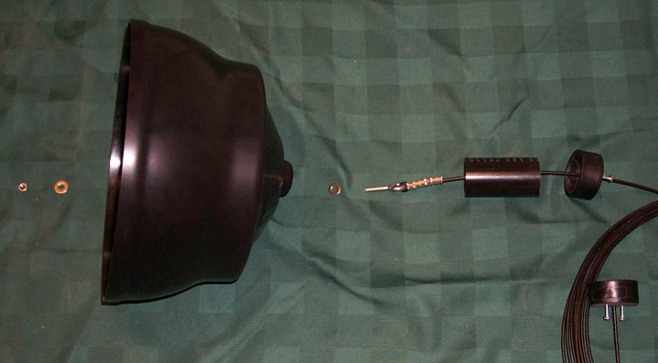
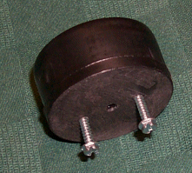 | 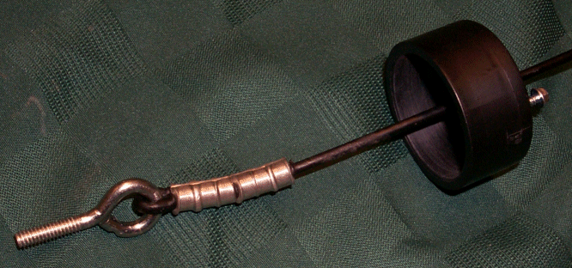

8. Radial hub

The 61 cm diameter radial hub is now made of one single piece of moulded plastic (figure 8). It is about 1.4 cm (0.55") thick. It includes 4 radial arms which begin 7.6 cm (3") from the centre of the hub and extend to 28 cm (11") from the centre. There is a 2.5 cm (1") ring around the outside to attach the drogue. Each radial arm is 7.6 cm (3") large at its base (centre side) and 5.6 cm (2.2") large at the top (ring side). The drogue can therefore be attached on the ring through four 40.6 cm (16") long sections. That also leaves room for a 15.2 cm (6") diameter area at the centre of the hub to attach the tether. A 3.8 cm (1.5") knob is moulded at the centre of that central area with a hole in its centre in order to attach the pipe and cable.

Figure 8. Radial hub top (left) and bottom (right), and bottom close up (bottom).

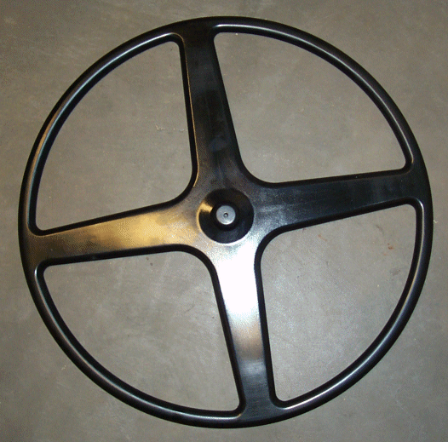 | 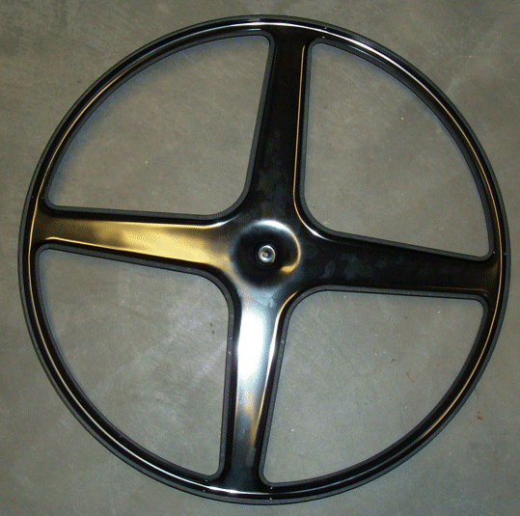
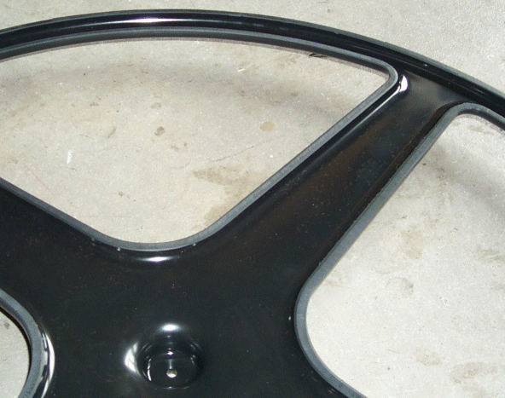

9. Designing the 5-section Ø61 cm holey sock

The holey sock is a long cylindrical cloth tube supported in five places by plastic rings. Two parameters define the holey sock dimensions: the number of sections and the section diameter. Two pairs of 30.5 cm (1') holes are cut in each section. In a pair, holes are cut opposite each other. Axis joining holes is rotated by 90° between successive sections. The holes are evenly spaced throughout the drogue.

The drifter is based on a 4-section, Ø61 cm (2') drogue (see Figure 1). This design gives a drogue to tether drag area ratio of greater than 40. Table 2 shows the drag area ratio computation based on the dimensions of the elements specified in this design.

The drogue is made of fray resistant canvas. We recommend using 11 oz (370 g m⁻²) 1000 denier Cordura nylon cloth to construct the holey sock. This material is extremely durable, is coated to prevent fraying, and requires no additional reinforcing, even along the cut edges of the holes. An alternative material is 6 oz (200 g m⁻²) stabilised Dacron sailcloth, which does, however, require the holes to be cut thermally to prevent fraying.

Construct the drogue using the following 5 part procedure, sewing with a strong, durable thread such as #92 Dacron.

1. Make the cylindrical cloth tube that forms the body of the drogue from a suitably sized piece of material, with 30.5 cm (1') diameter holes cut as described above.

2. Using a zigzag stitch, sew strips of material along their top and bottom edges inside the drogue to form pockets for the middle rings.

3. Make the top and bottom pockets by folding the end of the drogue over twice. Sew two lines of zigzag stitches through four layers of material to close the pockets.

4. Cut 4 small windows out of the top pocket to allow for the connection of the radial arms to the top ring. These windows are about 7.6 cm (3") wide, and extend no more than 3 cm below the top ring.

5. Spread the excess loading at the top and bottom of the drogue by sewing strips of nylon webbing (seatbelt type material) along the drogue. Sew six strips vertically into the drogue around the top ring to the bottom of the first section. Sew four strips around the bottom ring to the top of the last section.

The Drag Area Ratio

The drag area ratio of a drifter is defined as the ratio of the drag area of the drogue over the drag of the non-drogue elements. In order for SVP Lagrangian drifters with holey sock drogues to follow water parcels to an accuracy of better than 1 cm/sec, the drag area ratio (DAR) must be greater than 40.

$$\text{DragAreaRatio}=\frac{\text{DrogueDragArea}}{\sum{\text{DragArea}\left(\text{NonDrogueElements}\right)}}≥\text{40}$$

$$\text{DragArea}=\text{CompleteHorizontalCrossSection}×\text{DragCoefficient}$$

Drag Coefficients:
Sphere | 0.47
Holeysock type drogue | 1.40
Other elements except Urethane and pipe on top of radial hub | 1.40
Urethane and pipe on top of radial hup | 1

Table 2. Computing the drag area ratio of the drifter (example).

10. Preparing the drogue rings

The top ring is made from 2.54 cm (1") schedule 80 PVC pipe, which has a wall thickness of 4.82 mm (0.19"). Use the following 3 part procedure to construct the ring.

1. Heat the pipe section to allow it to be formed into a circle.

2. Fill the top ring with two part, 2 lb/ft³ (32 kg/m³) closed cell polyurethane foam. This makes the top ring slightly buoyant, and helps keep the top of the drogue from executing concertina-type motions when the tether becomes slack.

3. Insert the pipe into the drogue pocket along with the radial hub and connect the ends of the pipe using a 2.54 (1") schedule 40 pipe coupling, cemented into place.

The bottom ring is made from 2.54 (1") schedule 40 PVC pipe, which has a wall thickness of 3.6 mm (0.14"). Use the following 4 part procedure to assemble the ring.

1. Heat the pipe section to allow it to be formed into a circle.

2. Fill the pipe with enough lead (i.e. about 1.5 kg) to produce a net 2.5 kg to 4 kg tension (in the water) on the wire tether below the surface float. The amount of lead varies depending on the types of materials used throughout the drogue. To ballast any drogue correctly conduct a float test on the drifter.

3. Epoxy the lead into the pipe to prevent it from moving around.

4. Insert the pipe into the drogue pocket and connect the ends using a 2.54 (1") schedule 40 PVC coupling; cemented into place.

Make the middle rings of lighter Ø19.1 mm (3/4") , 1.8 mm (0.07") wall thickness polypropylene irrigation pipe. This pipe, shipped in rolls, requires no special treatment before bending. Use the following 2 part procedure.

1. Drill four Ø0.25 cm (0.1") holes in each pipe section to allow flooding on immersion.

2. Insert each pipe section into its drogue pocket and connect the ends using standard irrigation pipe insert couplings.

11. Connecting the tether to the drogue

Use procedure as described in paragraph 7.

12. Applying biofouling protection

During the period 1985-1990, we recovered 26 drifters from the eastern North Pacific that had been at sea for between 40 and 250 days. We found the most severe fouling, usually consisting of a variety of gooseneck barnacles, on the lower half of the surface float, the hydraulic hose and subsurface float (original SVP drifters had hydraulic hose and sub-surface floats). Floats and tethers that were still protected with copper-filled ship bottom paint upon recovery showed a much lesser degree of bio-fouling. Unprotected drogues tended to have a few barnacles at the bottom, and neutrally buoyant algae and sea grass growth on the drogue material.

We recommend applying antifouling protection as follows.

1. Bottom of the surface float - non-sloughing cuprous oxide bottom paint on cleaned and primed surfaces.

2. Polyurethane carrots below the surface float - two part antifouling system used for inflatable boats.

APPENDIX 1 - Materials

The parts used by SIO is drawn from US suppliers whose material has worked well in 200 days of open ocean testing. Changes were made after an evaluation of problems we noted amongst the 12 drifters that were recovered from the North Pacific in the WOCE Heavy Weather Tests of 1989-90. Use parts and materials only after careful, prolonged at-sea tests and evaluations.

Surface Float

Electronics and Power

1. Transmitter: We have used the Seimac, Telonics, Toyocom, and Metocean platform transmitters. Some provide options such as for linear thermistor temperature, submergence sensor, atmospheric pressure, magnetic reed switch, 25-pin male D connector, and thermistor composite. Check for characteristics of antenna. We recommend to contact transmitter manufacturers for details.

2. Battery Packs: the battery packs consist of one pack of 32 D-cell alkaline batteries with a diode for protection. We recommend the use of date-stamped batteries as a guarantee of freshness.

3. Thermistor fitting: We have used a Swagelok™ 3/16" (4.8 mm) bulkhead male tube fitting connector (P/N SS-100-1-OR) terminated with a 3/16" plug (P/N SS-100-P). More recently we have used a custom Betatherm part (P/N XP36K53D93) which consists of a linear thermistor composite potted within a probe assembly.

Adhesives and Foam

1. Pot the thermistor into the thermistor fitting with a thermally conductive epoxy.

2. Use a marine adhesive sealant to seal the submergence sensor screws. Many companies manufacture these thru-hull adhesives and they are available at local boat shops. We use 3M 5200 Marine Adhesive Sealant.

3. Embed the electronics box into the surface float with a two-part, 2 lb/ft³ closed cell polyurethane foam. The electronics and construction industries use this material to insulate hard to reach places. A two-part foam is sufficient for this purpose and is often available in local hardware stores.

3. Use a polyester laminating resin to seal the sphere. A good laminating resin is available at most boat shops.

4. For the strain relief, use urethane with a hardness of “65 shore A”.

Tether Pieces

1. Use wire rope made from plow-share steel and impregnated (not simply coated) with plastic.

2. Tether is attached to surface float and radial hub using a threaded 3.8 cm (1.5") schedule 40 PVC pipe end cap, available at many local plastic and plumbing suppliers.

3. We use the same epoxy to encapsulate the surface float connection, and encapsulate the connection in the radial hub. The epoxy is a general purpose filled epoxy that bonds well to many surfaces and holds up well in seawater.

4. We make the strain relief carrots throughout the tether with a two-part fast curing urethane.

5. The 3/32" (2.4 mm) (51-G-887 tool) and 1/8" (3.2 mm) (51-M-850 tool) swaged oval sleeves and 5/32" (4 mm) (51-MJ tool) swaged stoppers and tools are available at most rigging shops. Use a 3/32" (2.4 mm) oval sleeve at the surface float, and the radial hub. The outer diameter of the wire rope is 1/8" (3.2 mm), but when the outer jacket is stripped this figure reduces to 3/32" (2.4 mm). Use 1/8" (3.2 mm) oval sleeves at the connections from the radials to the top ring of the drogue. The outer diameter of the wire rope is 5/32" (4 mm), but when the outer jacket is stripped this figure reduces to 1/8" (3.2 mm).

Drogue Pieces

1. Make the drogue with 11 oz 1000 denier Cordura nylon cloth. This is a nylon cloth with an anti-fraying material on one side. This layer stays on and continues to prevent fraying in the arduous conditions of the ocean.

2. The top ring is a 2.54 cm (1") schedule 80 PVC pipe.

3. The bottom ring is a 2.54 cm (1") schedule 40 PVC pipe.

4. The middle rings are 19.1 mm (3/4") OD polypropylene irrigation pipes with a wall thickness of 0.07" (1.8 mm).

5. We suggest using a lead rod as a ballast material in the bottom ring.

Antifouling Paints and Primers

Use a non-sloughing anti-fouling paint on the surface float.

APPENDIX 2 - Address list

Complete drifters

Pacific Gyre Inc.
7460 Capstan Drive
Carlsbad, CA 92009
Ph: (+1) 760 918 9798
Fx: (+1) 413 375 0914
Email: info@pacificgyre.com
Web: www.pacificgyre.com

Clearwater Instrumentation
304 Pleasant Street
Watertown, MA 02472
USA
Tel: (+1) 617 924-2708
Fax: (+1) 617 924-2724
Contact: Gary Williams
E-mail: wgwill@clearwater-inst.com
Web: http://www.clearwater-inst.com/

Technocean, Inc.
820 NE 24th Lane
Unit 112
Cape Coral, FL 33909
USA
Tel: + 1 239 772 9067
Fax: + 1 239 574 5613
Contact: Mr Jeff Wingenroth
Email: jw@technocean.com
Web: http://www.technocean.com/
Marlin-Yug Ltd.
2, Kapitanskay, St.
Sevastopol
99011, Ukraine
Tel/Fax: +380 692 540450
Contact: Dr.Sergey Motyzhev
E-mail: marlin@stel.sebastopol.ua
Web: http://marlin.stel.sebastopol.ua/

Metocean Data Systems, Ltd.
VP Sales & Marketing
METOCEAN Data Systems
247 S.W. 8th Street
#226 Miami, Florida 33130
USA
Email: tony@metocean.ns.ca
Web: http://www.metocean.com/

Interested parties are recommended to contact the GDDC or the Technical Co-ordinator of the Data Buoy Co-operation Panel for the latest update to this list.

Global Drifter Design Center

Bill Scuba
Scripps Institution of Oceanography (SIO)
La Jolla, CA 92093-0213
USA
Tel: (+1) 858 534 0378
E-mail: wscuba@ucsd.edu

Global Drifter Center

Craig Engler
NOAA, Atlantic Oceanographic and Meteorological Laboratory
4301 Rickenbacker Causeway
Miami, FL 33149
Tel: (+1) 305 361-4439
Fax: (+1) 305 361-4412
E-mail: Craig.Engler@noaa.gov

Data Buoy Co-operation Panel

Etienne Charpentier
DBCP Technical Co-ordinator
JCOMMOPS
8-10 rue Hermes
Parc Technologique du Canal
31526 Ramonville St. Agne
France
Tel: (+33) 5 61 39 47 82
Fax: (+33) 5 61 75 10 14
Email: charpentier@jcommops.org
Web: http://dbcp.nos.noaa.gov/dbcp/

APPENDIX 3 - Sensor sampling and an example Argos message format

Sensor Sampling and duty cycle

Atmospheric pressure

160 pressure samples (taking approximately 160s) are collected each hour. Counts 1 to 4 are error flags as specified by drifter manufacturer. The de-spiking algorithm is as follows:

- Take the median of the lowest 10 points of 160.

- Calculate the median of the points within the entire set of 160 points that are within 1 hPa of the 10 point median.

- Store as 12 bit count: 0 => 800.0 hPa and 4095 => 1209.5 hPa, with 0.1 hPa resolution.

- If 15 or more of the 160 samples include communication errors, the sampled set is deemed corrupt, and the transmitter count is set to zero.

Historical pressure data are also stored for 12 hours. In the information that follows, time in hours elapsed relative to most recent pressure sample (Pl_{i}) is denoted by a subscript. For example a Pl_{i-8} pressure sample is the pressure sample that is 8 hours older than the current pressure Pl_{i}.

Sea Surface Temperature

SST is sampled continuously with a 15-minute repeat cycle.

- Interval between samples = 60 s
- Number of samples averaged = 15
- SST updated every 15 minutes
- Number of thermistors monitored = 1 (YSI 44018 or equivalent)

Salt water switch

The salt water switch is sampled continuously with a 30-minutes repeat cycle.

- Length of salt water switch data collection = 30 minutes
- Store as 8 bit count = (immersion time in seconds) / 10

Duty cycle

Normally full on. Cycles like 1 day on, 2 days off may be allowed depending upon drifter experiment.

Argos Message Format (example):

This so called DBCP-M2 Argos message format is for platforms transmitting their Argos ID number using 28 bits through Argos. For information on other possible formats, see at http://dbcp.nos.noaa.gov/dbcp/1ramf.html.

With 28 bit Argos IDs, first block of data is comprised of 24 bits; following blocks of data have 32 bits. DBCP-M2 contains a minimum of two blocks, i.e. 24+32 bits = 56 bits.

Data are stored in the buoy memory in blocks of observations. Each block contains one single observation. Blocks are Block_Period minutes apart (e.g. every 30 minutes, every hour)). Normally, buoys are turned on at a round hour (e.g. 03h00) so that observations are made exactly at a round hour. However, this may not be the case and the on-board clock may drift in time. Transmitting the age of the observation at the time the message is transmitted to the satellite permits to recover the exact time of observation even in case the buoy real time clock has drifted.

One block (one observation) is transmitted in one Argos message. One Argos message contains only one block.

Hence, consecutive blocks can be transmitted using consecutive Argos messages using a transmission cycle. For example, if we pick a block_period of one hour, we could transmit the observations in a cycle of 3 Argos messages like this:

Block | Rank
…
Block H | 0
Block H-1 | 1
Block H-2 | 2
Block H | 0
Block H-1 | 1
Block H-2 | 2
…

Rank is encoded in the Argos message. Rank of the most recent observation transmitted is 0. The rank of a given observation is incremented each time a new observation is carried out.
Age of the observation at the time of the next block update (AGEB) in the buoy memory is encoded in the Argos message. Age of the observation at the time of the Argos message transmission is therefore:

• Age = Rank x Block_Period + AGEB

And observation time can therefore be computed as following:

• Observation time = Acquisition time by the satellite - Age

If hourly observations are needed (Block_Period=60), the buoy must be activated so that a new observation is available on the hour. If synoptic observations are requested (Block_Period=180), the buoy must be activated accordingly.

Message format:

In white are the first mandatory two blocks of data, i.e. 56 bits (24+32).
In yellow is the following optional block of data, i.e. 32 bits
In green are the following optional blocks of data, i.e. 32 bits or more.
Total message length cannot exceed 248 bits.

 | Item | Bits | Pos | Min | Max | Formula / Comments (n = word value) | Fixed bits in block (o)
CHK | Checksum | 8 | 0 | 0 | 255 | Checksum = Lower 8 bits of the sum of other bytes | Y
Rank | Rank of observation | 4 | 8 | 0 | 15 | Rank = n (see § 3) | Y
AGEB | Age of observation at the time of next block update | 6 | 12 | 0 | 63 | Age (minutes). This timer starts at 0 when the sensor data is updated in the transmission and in incremented in minutes until the next data update (block). | Y
BP | Barometric Pressure | 11 | 18 | 850.0 | 1054.7 | Press(hPa) = 0.1 n + 850 | Y
SST | Sea Surface Temp. | 9 | 29 | -5.0 | 35.88 | SST(°C) = 0.08 n - 5 | Y
APT | Air Pressure tendency | 9 | 38 | -25.5 | 25.6 | APT(hPa) = 0.1 n - 25.5 | Y
SubM | Submergence Count | 6 | 47 | 0 | 100 | Percent of time submerged = 100 n / 63 | Y
VBat | Battery Voltage | 3 | 53 | free | free | free (e.g. voltage, % of charge, or table) | Y
WD | Wind Direction | 7 | 56 | 0.0 | 360.0 | WD(deg) = 3 n  n=127 indicates no Wind Direction sensor present | Y
WS | Wind Speed | 6 | 63 | 0.0 | 63 | WS(m/s) = n | Y
AT | Air Temperature | 8 | 69 | -20.0 | 43.75 | AT(°C) = 0.25 N - 20 | N
Cond | Conductivity | 11 | 77 | 25.0 | 55.705 | Cond(mmho/cm) = 0.015 n + 25 | N
Tz | Subsurface Temp. | 10 | 88 | -5 | 35.92 | Tz(°C) = 0.04 n - 5 | N
Depth | Depth (pressure) | 8 | 98 | 0 | 255 | Depth(m) = N | N
Extra | Extra sensor #1 | ? | 106 | ? | ? | ? | N
… | … | … | ... | … | … | … | N

(o) Where "Fixed bits in blocks" is marked as "Y", it means that when a block is actually coded, the exact number of bits are reserved for the considered sensor or information if available. If there is no such sensor in the buoy, then those bits shall be considered as free and can be used for one or more other variables provided that this does not affect the bits used by the surrounding sensors. These bits can also be coded with all bits set to 1 in case they are completely useless. This permits some flexibility in the format.

Offsets and resolutions are given here as examples and can be modified. The number of bits for each sensor must be changed only if it is not possible to do otherwise (see remark under (o) above).

We chose to report the barometric tendency in one single word instead of two (one for the absolute value of pressure tendency, the other for the characteristic). Automatic stations are permitted to do so. On the GTS, the characteristic is coded as 2, 4 or 7, according to the sign of the tendency (positive, zero or negative, respectively). This solution is debatable.

Examples:

- Basic format (e.g. SVPB, FGGE)

Checksum  8 bits | Rank  4 bits | AgeB  6 bits | Barometric Pressure  11 bits

Barometric pressure (cont.) | Sea Surface Temperature  9 bits | Barometric Tendency  9 bits | Submergence count  6 bits | Battery Voltage  3 bits

The message length is 56 bits.

- Wind and/or salinity buoys (e.g. SVPBW, Wind FGGE)

This format concerns SVP-BW drifters and Wind FGGE buoys, possibly equipped for Air Temperature and/or Sea Surface Salinity measurements. The message length is 88 bits. The parameters are :

Checksum  8 bits | Rank  4 bits | AgeB  6 bits | Barometric Pressure  11 bits

Barometric pressure (cont.) | Sea Surface Temperature  9 bits | Barometric Tendency  9 bits | Submergence count  6 bits | Battery Voltage  3 bits

Wind Direction  7 bits | Wind Speed  6 bits | Air Temperature  8 bits | Conductivity  11 bits

Air temperature and Conductivity rooms can be used by technological data such as Weather Classification and/or Wind speed from specific frequency bands in the case of SVP-BW drifters.

APPENDIX 4 - The SVP-B drifter: development, trials and possibilities for collaboration

[This is largely extracted from a paper entitled 'The Low-cost Barometer Drifter', which was submitted to the DBCP session in November 1993 by its Technical Co-ordinator.]

1. Design of the barometer drifter

1.1 Background

The low cost barometer drifter is basically a standard SVP drifter to which an air pressure port has been added. The standard SVP drifter is now a proven and reliable design and it has been deployed at sea in large quantities for oceanographic research programs as part of the World Ocean Circulation Experiment (WOCE) and the Tropical Ocean and Global Atmosphere programme (TOGA). For the period 1 July 1991 to 31 January 1993, the WOCE Surface Drifter Data Assembly Centre has processed data from 1315 drifters (WOCE Report No. 104/93) deployed in the Pacific and north Atlantic oceans. The drifter is capable of accurately measuring sea surface currents (± 1 cm/s) in 10 m/s winds and sea surface temperature (± 0.1°C). Nominal life time is 18 months. It has, however, been shown that half life time of standard SVP drifters is of the order of 440 days.

1.2 Surface current measurement

For measuring surface velocity, standard SVP buoys have been designed to be good Lagrangian drifters (buoys which follow the water motion well) and very specific requirements of drogue and surface float design have been developed (large holey sock drogue, spherical floats and thin wire tethers). Laboratory and at-sea tests have been conducted to guarantee the reliability of SVP drifter measurements.

The slip (i.e. the motion of the centre of the drogue relative to the moving water parcel) has been minimised. Many phenomena can induce slip: the main ones being wind stress, surface gravity wave effects and vertical shear of currents. Therefore tests have been conducted on various shapes of floats and drogues (Bitterman et al, 1990). These tests show that the most efficient shapes are small, spherically-symmetric surface and subsurface floats, thin-wire tethers and a large semi-rigid drogue. The drogues which have a high drag coefficient and stable water following characteristics are the Tristar (Niiler et al, 1987) and the Holey Sock (Nath et al, 1979). The drag area ratio is the drag coefficient of the drogue times the frontal area divided by the sum of the products of the drag coefficient and the largest projected frontal areas of floats and tethers. A drag area ratio for the drifter greater than 40 will give the instrument the capability to make current measurements accurate to within 2 cm/s. Using a correction formula, a wind correction can then improve this accuracy to 1 cm/s if the wind is known to within 4 m/s. In extra-tropical areas, if an optimised network of low-cost barometer drifters is maintained, the air pressure field and consequently the wind field will be known to a better accuracy.

The same general design as for the standard SVP Lagrangian drifter has been chosen for the low-cost barometer drifter.

1.3 Drogue detector (submersion switch)

A drogue detector is necessary for ascertaining if the drogue is still attached. A drifter without a drogue is of little value for surface velocity measurements. Since the surface float goes under the water more often when the drogue is attached, one principle is to install a submersion detector (switch) on the surface float and to analyse the time series in order to deduce if the drogue is still attached.

1.4 Sea surface temperature measurement

The low cost 'barometer' drifter is also equipped with a sea surface temperature sensor that is designed to make measurements accurate to 0.1°C. Once again, experience gained with the standard SVP drifter has been used. To obtain this accuracy, tests show that one must install the temperature sensor outside the hull of the drifter float. Also, calibrations of a number of thermistors while connected to the electronics circuitry in a test tank in various range of temperatures must be done. Only these kind of tests and calibrations can provide accurate coefficients to be used to convert raw data (resistance) into physical values (Celsius) within ± 0.1°C. The life time of the sensor is expected to exceed that of the transmitter batteries.

1.5 Atmospheric pressure measurement

The air pressure port has been designed to withstand frequent immersion with no loss of accuracy. The port is elevated to some height above the float itself to avoid Venturi effects caused by air flow over the curved float surface. The total surface of the mast is lower than 10% of the total frontal area so that wind stress does not induce a substantial slip effect compared to the one induced by the hull itself. The design is based on a port used on moored buoys by the United Kingdom Meteorological Office, and has been extensively tested in a wind tunnel. Internal baffling is provided against submergence surges and sufficient back up volume of air assures that water does not enter the barometer duct.

The barometer port design is based on the following rationale (WOCE/TOGA Lagrangian Drifter with barometer port, May 1991):

(i) Field observations indicate that the surface float of the SVP Lagrangian drifter is pulled under the water to a depth of 1-2 m at the crests of wind-waves, therefore an overpressure of 200 hPa can be expected on the barometer. Data from the submergence switch on drifters in WOCE Heavy Weather Drifter Test indicate that they spend about 20-30% of the time under the water in winds in excess of 15 m/s. Upon resurfacing, the port has to clear from sea-water quickly and completely. Flaps and valves to close a port will fail or become encrusted. An inverted port, with sufficient backup volume of air which can be compressed upon submergence so that the water is kept out of the barometer air duct, was incorporated in the design.

(ii) A long air pressure duct to the barometer can collect condensation in the extreme changes of moisture and temperature which occur in synoptic weather systems. This problem was solved by placing the barometer very close to and above the air intake. Specially configured barometers were made for this application for SIO/GDEC by several manufacturers. [later versions have reverted to placing the barometer within the buoy hull and using water traps and desiccant.]

(iii) In a wind stream, the spherical surface float produces a lowering of air pressure due to the Bernouilli effect. In a 10 m/s wind, this effect produces less than 0.1 hPa pressure lowering at a distance of one sphere radius. The barometer port air intake is therefore placed on a mast 24 cm above the top of the sphere. A second Bernouilli effect is produced by the airflow around the mast. This problem has been studied extensively, and a tabular wind shield, with air intake holes inside a second internal sleeve is adopted (Osmund and Painting, 1984).

(iv) The sampling and averaging scheme for the air pressure has to take account of when the port is under the water. Tests have run at sea under 15 m/s wind conditions off San Diego (WOCE/TOGA Lagrangian Drifter with barometer port, May 1991) where pressure was sampled at 2 Hz inside the surface float. A laboratory standard barometer of identical construction was used to obtain data at identical rates about 3 m above sea level in a semi-enclosed laboratory on a ship. No significant wind effect, or delay times, were observed on the barometer port response of the surface float in the water.

For the sensor itself, now we leave choice of using Vaisala (e.g. PTB 101C), Honeywell (PPT/HPB family), or any other suitable sensor providing required accuracy, resolution, and long-term drift. This is a ceramic diaphragm capacitance sensor equipped with a built-in temperature compensating circuit. AIR sensors have been carefully tested for WOCE and finally proved reliable (Payne et al, IMET) but AIR SB-2A is not manufactured anymore. Accuracy is ±1 hPa with a stability of ±1 hPa over a one year period. Sensor output is digital in tenths of hPa.

In the latest scheme (proposed at the joint DBCP-SVP workshop, 4-6 May 1993), data are sampled at 1 Hz, and averaged over 80 seconds [now 160 seconds]. A dedicated de-spiking algorithm was designed to remove from the average these air pressure measurements made while the barometer port is submerged:

"The algorithm will first average the lowest 20 of 80 measurements; it will then throw away all measurements within the entire 80 measurement set with values greater than 1 hPa over that average, and transmit the median point of the remaining values."

[Note that this algorithm has since been revised – see Appendix 3 for the latest version.]

The latest average of every hour is stored on board. The last 24 hourly [now 12 hourly] measurements are memorised and transmitted through Argos using multiplexing techniques. It is expected that the full series of 24 hourly [now 12 hourly] measurements will be recovered every day. Hence the latest available air pressure and tendency measurements (real time), as well as the synoptic air pressure measurements will be distributed on GTS (deferred time).

2. Field tests

A total of 25 prototype barometer drifters (MOD-1) were purchased and deployed by the GDC and the national weather services of Australia, Canada, France, and the United Kingdom. A joint DBCP-SVP workshop was help on 4-6 May 1993 in San Diego in order to evaluate the quality of the prototypes and to propose design changes (SIO report No. 93/28, WOCE report No. 108/93). At the time of the meeting, 16 prototypes had been deployed at sea. In general, despite limited success with some of the buoys, the test participants were pleased with the performance of the new SVP barometer drifter. In particular it was demonstrated that the quality of the pressure data was in general as good as for regular FGGE-type meteorological buoys.

The meeting agreed that the main problems detected with the first 16 prototypes deployed at sea were through-hull connector failure, upper hemisphere failure (due to insufficient fiberglass [hull was made of fiberglass initially]) and the de-spiking algorithm. These problems are believed to have caused the premature failure of six of the prototypes. The meeting therefore proposed some design modifications, which were incorporated in a new version (MOD-2).

The modifications included replacing the existing lithium batteries with alkaline batteries and increasing the hull diameter, reinforcing the new hull, removing the through-hull serial connector, improving the hemisphere sealing increasing the diameter of the barometer port attachment, strengthening of the SST probe, and implementing changes to the Argos message format and the de-spiking algorithm.

[Another evaluation workshop was held in New Orleans, 9-10 May 1995, and proposed further improvements such as adding a water trap and desiccant and improving packaging.]

[Since the compilation of this report, many further deployments have been made (e.g. in the South Atlantic Ocean under the auspices of the International South Atlantic Buoy Programme (ISABP)), and the design is now believed to be demonstrably reliable and mature. Nonetheless, modifications of the basic design will continue to be introduced in the light of further experience.]

3. Opportunities for co-operation between oceanographers and meteorologists.

For the reasons detailed below, the low-cost barometer drifter is a device which can be shared by both oceanographic (research) and meteorological (operational) communities:

Advantages for oceanographers:

- Accurate and well-quantified water following characteristics, resulting from a high drag area ratio (~40) and low wind stress:
- Long life time (half life = 440 days)
- Accurate measurement of sea surface temperature
- Accurate measurement of air pressure, leading to accurate estimates of the wind field and the surface wind stress.
- Ability to transmit quasi-continuous data-sets by the use of an on board data-stacking.

Advantages for meteorologists:

- Longer persistence in a given area (the drifter is drogued at 15 meters)
- Long life time
- Accurate measurement of air pressure
- Accurate measurement of sea surface temperature
- Data distributed on GTS in near real time
- Availability of data measured at synoptic hours

The cost of the SVP-B drifter is about US$3000 (2005) is well below the cost of a regular FGGE type meteorological buoy (in the order of US$15000). The lifetime and quality of measurements of both devices are now shown to be very similar.

APPENDIX 5 - Comparison of this design with the design described in revision 1.3 of this manual

Design described in revision 1.3 of this manual | This design
40 cm float diameter. | 32 cm float diameter. Lower half of surface hull moulded in such a way to receive magnet, electronics and battery pack.
Electronics package described in literature | New electronics package
14 V transmitter | 3 - 4 V transmitter
Transmits using 1 W power every 60 seconds | Transmits using 1/2 W power every 90 seconds
3/32" (2.4 mm) x 1/8" (3.2 mm) diameter plastic impregnated wire rope connecting buoy to drogue | Identical
Radial hub on top of drogue made of tethers | Moulded plastic radial hub
5 sections 1 m diameter drogue with total 7 m length | 4 sections 61 cm diameter drogue with total 4.9 m length
Buoy hull and top made of fiberglass | Buoy hull and top made from moulded ABS plastic
Drogue attachment wheel of wire spoke design | Drogue attachment wheel made from stamped plastic
Drogue sewed around outside ring of radial hub | Identical
Large strain relief | Strain relief uses 1/4 the Urethane
Lithium Battery | D-cell batteries
Different attachments on drogue and buoy ends of tether | Identical attachments on both ends of the tether
Drogue made of Cordura Nylon | Drogue made of lighter weight sports bag material - 1/2 the previous weight
Protective hose over wire tether from buoy to subsurface float | No protective hose
Total weight ~ 30 kg | Total weight ~ 15 kg
Total cost $5400 (in 2003 US dollars) | Total cost $2900 (in 2005 US dollars)
 | ~ 60% less work needed to assemble

REFERENCES

Argos Users Manual, 1988. CLS Argos, Toulouse.

Bitterman, D S, P P Niiler, Y Aoustin and A du Chaffaut, 1990. Drift buoy intercomparison test results. NOAA Data Report ERL AOML-17.

Chereskin, T, P P Niiler and P M Poulain, 1989. A numerical study of the effects of upper ocean shear on flexible drogue drifters. J. ATM and OC. Tech., 6 (2), 243-253.

Nath J et al, 1979. Hydrodynamic coefficients for flexible drogues. In: Proceedings of the Specialty Conference: Civil Engineering in the Oceans IV, vol II, San Francisco, September 10-12 1979. American Society of Civil Engineers.

Niiler, P P, R E Davis and H J White, 1987. Water-following characteristics of a mixed layer
drifter. Deep-Sea Res., 34, 1867-1881.

Osmund, A and D J Painting (1984). Static pressure heads for meteorological use. UK Meteorological Office, Tecemo/Reference III.15. UK Meteorological Office, Bracknell.

Payne, R E, G H Crescenti and R A Weller, 1989. Improved meteorological measurements from buoys and ships (IMET) : Preliminary Report on Barometric Pressure Sensors. WHOI Ref No 89-49. Woods Hole Oceanographic Institution.

Sombardier, L (ed), 1993. SVP/DBCP workshop on evaluation of low cost barometer drifters. WOCE Report No 109/93; SIO Report No 93/28. Scripps Institution of Oceanography, La Jolla.

Sybrandy, A L and P P Niiler, 1991. WOCE/ TOGA Lagrangian drifter construction manual. WOCE Report No 63; SIO Report No 91/6. Scripps Institution of Oceanography, La Jolla.

WMO-IOC DBCP-IX session report, October 1993, Athens, Greece. WMO, Geneva.

WOCE Data Management, Data Sharing Policy and Practices, Data Assembly and Analysis Centres, Satellite Data Availability and Data Information Unit. WOCE Report No 104/93, April 1993. WOCE International Project Office: Wormley, UK.

WOCE Surface Velocity Program / Drifting Buoy Co-operation Panel Workshop on evaluation of low cost barometer drifters, 1993. WOCE Report No 108/93; SIO Report No 93/28. Scripps Institution of Oceanography, La Jolla.

Surface Velocity Programme, Joint Workshop on SVP Barometer Drifter Evaluation, New Orleans, USA, May 1995, DBCP Technical Document No. 5.

WOCE Surface Velocity Programme Barometer Drifter Construction Manual, A.L. Sybrandy, et al.; WOCE Report No. 134/95, SIO Report No. 95/27, DBCP Technical Document No. 4. Version 1, September 1995.

WOCE Surface Velocity Programme Barometer Drifter Construction Manual, A.L. Sybrandy, et al.; WOCE Report No. 134/95, SIO Report No. 95/27, DBCP Technical Document No. 4. Version 1, September 1995.

Barometer Drifter Design Reference, A. L. Sybrandy, et al.; DBCP Technical Document No. 4, Revision 1.3, December 2003.

ACKNOWLEDGEMENTS

The authors of this report gratefully acknowledge the generous support of the US National Science Foundation, the NOAA Office of Global Programs and the NASA NSCAT project.

TECHNICAL DOCUMENTS ISSUED WITHIN THE DBCP SERIES

No. | Title | Year of first issue | Last revision and year
1 | DBCP Annual Report for 1994 | 1995
2 | Reference Guide to the GTS Sub-system of the Argos Processing System | 1995 | Rev. 1.4, 2004
3 | Guide to Data collection and Location Services Using Service Argos | 1995
4 | WOCE Surface Velocity Programme Barometer Drifter Construction Manual | 1995 | Rev. 2, 2005
5 | Surface Velocity Programme Joint Workshop on SVPB drifter evaluation | 1995
6 | DBCP Annual Report for 1995 | 1996
7 | Developments in buoy technology and enabling methods (DBCP workshop, Pretoria, Oct. 1996) | 1996
8 | Guide to moored buoys and other ocean data acquisition systems | 1997
9 | DBCP Annual report for 1996 | 1997
10 | Development in buoy and communications technologies (DBCP workshop, Henley on Thames, Oct. 1996) | 1997
11 | DBCP Annual report for 1997 | 1998
12 | Developments in buoy technology and data applications (DBCP workshop, La Réunion, Oct. 97) | 1998
13 | DBCP Annual report for 1998 | 1999
14 | Variety in buoy technology and data applications (DBCP workshop, Marathon, Florida, Oct. 98) | 1999
15 | Global drifting buoy observations, A DBCP Implementation Strategy | 1999
16 | DBCP Annual Report for 1999 | 2000
17 | Developments in Moored and Drifting Buoy Design, Programmes, Sensors, and Communications (DBCP Workshop, Wellington, Oct. 1999 | 2000
18 | DBCP Annual report for 2000 | 2001
19 | Developments in buoy technology, communications, and data applications (DBCP Workshop, Victoria, Oct. 2000 | 2001
20 | DBCP Annual report for 2001 | 2002
21 | Dev. in buoy technology, communications, science and data applications(DBCP Workshop, Perth, Oct. 2001) | 2002
22 | Research, applications and developments involving data buoys(DBCP Workshop, Martinique, Oct. 2002) | 2003
23 | DBCP Annual report for 2002 | 2003
24 | Research, Applications and Developments involving data buoys (DBCP Workshop, Angra Dos Reis, Brazil, October 2003) | 2004
25 | DBCP Annual report for 2003 | 2004
26 | DBCP Annual report for 2004 | 2005

The publications can be ordered from the Technical Co-ordinator of the DBCP.

