Project Title: Surface Drifter Program
Progress Report FY08

Report Date: 15 October 2008
Project Managers: Rick Lumpkin,
Silvia Garzoli

4301 Rickenbacker Causeway
Miami, FL 33149-1097
(305) 361- 4513
Rick.Lumpkin@noaa.gov
Silvia.Garzoli@noaa.gov

Project Summary

The Surface Drifter Program is AOML’s contribution to the Global Drifter Program (GDP), a branch of NOAA’s Integrated Ocean Observing System, Global Ocean Observing System (IOOS/GOOS) and a scientific project of the Data Buoy Cooperation Panel (DBCP). The primary goals of this project are to maintain a global 5ºx5º array of Argos-tracked Lagrangian surface drifting buoys to meet the need for an accurate and globally dense set of in-situ observations transmitting in real time for weather forecast, and to provide a data processing system for the scientific use of these data that support short-term (seasonal-to-interannual, “SI”) climate predictions as well as climate research. AOML’s GDP responsibilities are to: (1) recruit ships and manage drifting buoy deployments around the world using research ships, Volunteer Observation Ships (VOS) and aircraft; (2) insure the data is placed on the Global Telecommunications System (GTS) for distribution to meteorological services everywhere; (3) maintain META files describing each drifter deployed, (4) process the data and archive it at AOML and at Canada’s Integrated Science Data Management (formerly MEDS); (5) develop and distribute data-based products; (6) maintain the GDP website; and (7) maintain liaisons with individual research programs that deploy drifters.

The drifters provide sea surface temperature (SST) and near surface (mixed layer) currents. A subset of the drifters also measures air pressure, winds, subsurface temperatures and salinities. These observations are needed to (a) calibrate SST observations from satellites; (b) initialize global SI forecast models to improve prediction skill; and (c) provide nowcasts of the structure of global surface currents. Secondary objectives of this project are to use the resulting data to increase our understanding of the dynamics of SI variability, and to perform model validation studies, in particular in the Atlantic Ocean. Thus, this project addresses both operational and scientific goals of NOAA’s program for building a sustained ocean observing system for climate.

Accomplishments

The global drifter array became the first component of the IOOS that reached completion, with 1250 active drifters in September 2005. This number has since been maintained. During FY08, the drifter array averaged 1232 drifters, with a standard deviation of 48. The maximum size was 1312 (7 April); the minimum was 1152 (11 August). During the fiscal year, the Surface Drifter Program coordinated worldwide deployments of 1001 drifters (1023 in FY07), 880 (FY07: 859) funded by NOAA/OCO; 147 drifters were deployed in the Atlantic between 30ºN and 40ºS. AOML managed observations from 2113 unique drifters during FY08 (this is significantly greater than 1250, as some died while new ones were deployed to maintain ~1250).

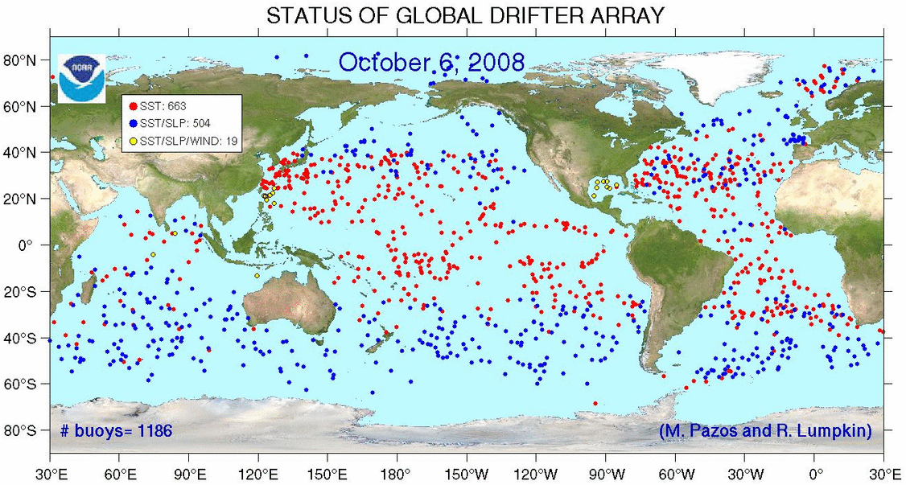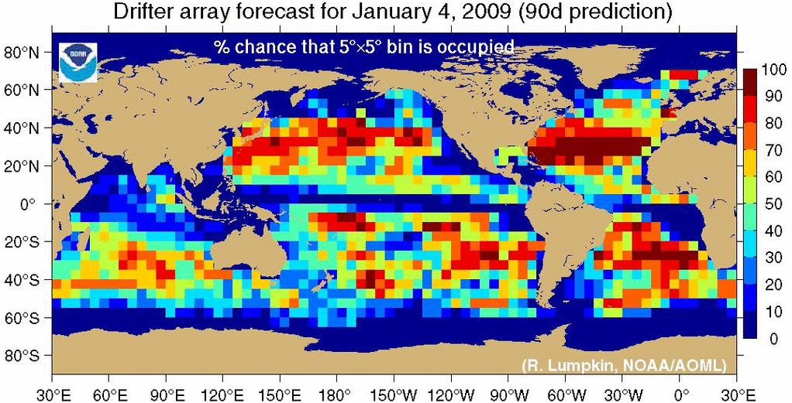

Fig. 1: Global population of drifters on 6 October 2008 (array size 1186 drifters), and 90 day prediction of coverage (% chance that a 5ºx5º bin will have a drifter if no additional drifters are deployed in the interim).

The main challenge is now to increase the spatial coverage of the array while maintaining its size at 1250 drifters on average.

FY08 Deployment highlight: African Partnership Station (APS) Training

In March 2008, 28 participants from Ghana, Cameroon, and Nigeria boarded the U.S. Navy vessel HSV-2 Swift, where three days of training ensued from the port of Tema, Ghana. The ability of the US Navy to host the training aboard one of its vessels allowed for a novel “hands-on” experience which enabled participants to become familiar with the instruments, from which the data they are studying. The session was conducted as part of the US Naval Forces Africa Partnership Station (APS), which is an initiative in support of NOAA’s climate research and ocean-observing efforts. During the three-day session, one Argo Float, three global drifting buoys, and 12 expendable bathythermographs (XBTs) were deployed from the HSV-2 Swift to gather temperature, salinity, and current measurements. The deployment of these instruments was an important step in understanding how to incorporate the data access training previously taught in Ghana and Belgium.

FY08 Deployment highlight: 2008 Hurricane drifters

On August 31 and September 11, the 53rd Air Force Reserve Squadron “Hurricane Hunters” deployed 21 GDP hurricane drifters in the paths of hurricanes Gustav and Ike in the Gulf of Mexico. These drifters, funded by OCO via JIMO, measured winds, air pressure, surface temperatures and subsurface temperatures to a depth of 150m. R. Lumpkin coordinated the deployments, in collaboration with P. Niiler (JIMO), E. D’Asaro (U. Washington), AOML’s Hurricane Research Division (HRD), and NOAA’s National Hurricane Center (NWS). The hurricanes moved over the drifters 24 hours after deployments. All drifters survived deployment to transmit data, and many of the Gustav drifters were subsequently hit by Ike. While the hurricanes passed over the arrays, R. Lumpkin interacted with AOML’s HRD to coordinate WP-3D flights that measured the properties of the storms at drifter locations with dropwindsondes.
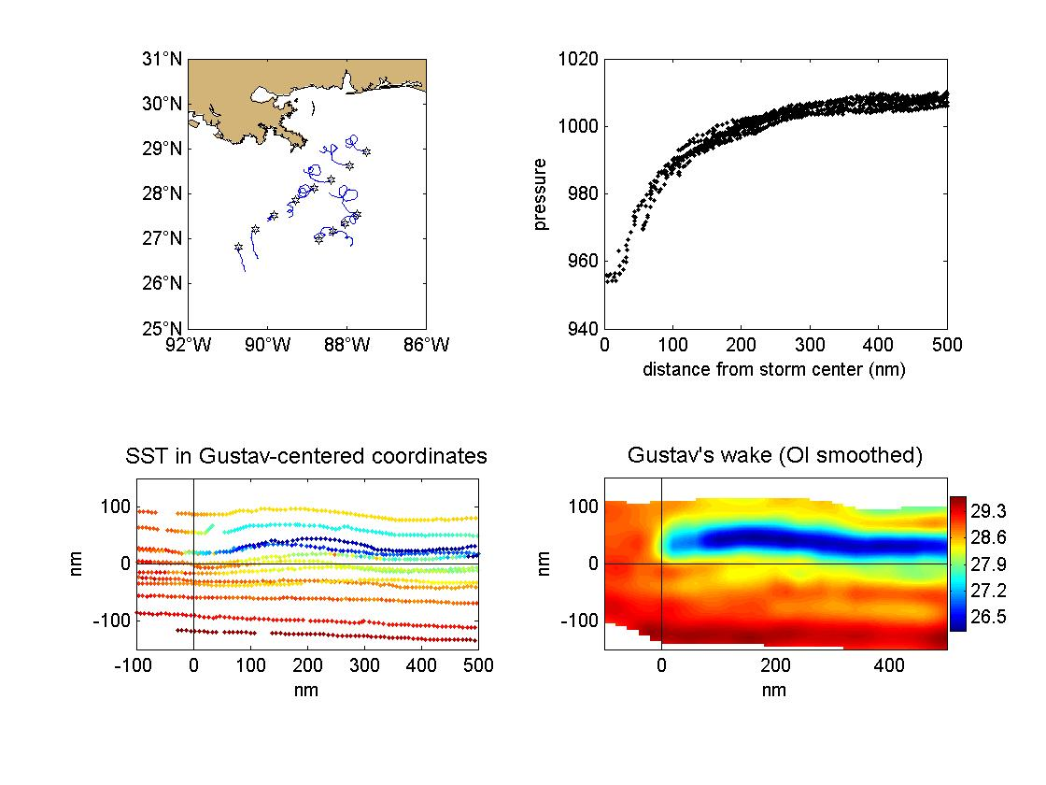
Fig. 2: drifter observations in hurricane Gustav. Upper left: deployment locations on 31 August 2008 (stars) and subsequent trajectories through 8 September. Upper right: measured air pressure as a function of distance from the storm’s center. Bottom: surface temperature measurements in a frame of reference moving with Gustav (centered at 0,0), in which the array streaks from left to right.

Analysis of the drifter array

The number of drifters in the global array as a function of time is shown below. Since September 2005, the array size has fluctuated around 1250. Those fluctuations reveal a distinct seasonality, with peaks of 1300—1350 drifters in Boreal winter—spring and troughs of ~1150—1200 drifters in summer—fall. This pattern reflects seasonal variations in deployment opportunities, e.g., Southern Ocean deployments in February—March.

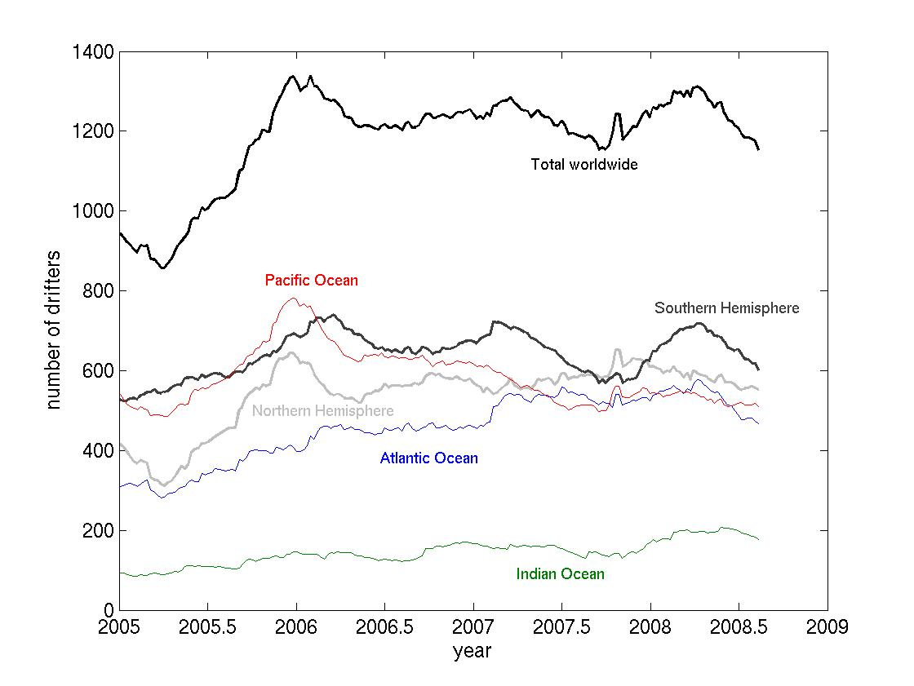

Fig. 3: Size of global drifter array in regions. Atlantic/Indian divided at 25°E in the Southern Ocean, Atlantic/Pacific at 70°W in the Southern Ocean, Indian/Pacific at 125°E south of Timor.

The number of drifter deaths per month, per 1250 drifters, is shown in Fig. 4. This is the number of drifters that must be deployed each month in order to maintain the array at 1250. In addition to short-term ups and downs, the death rate has generally increased over the last few years. Approximately 70 deployments were needed per month in September 2005 to maintain the array at 1250 drifters, while 90—100 deployments are now needed each month.

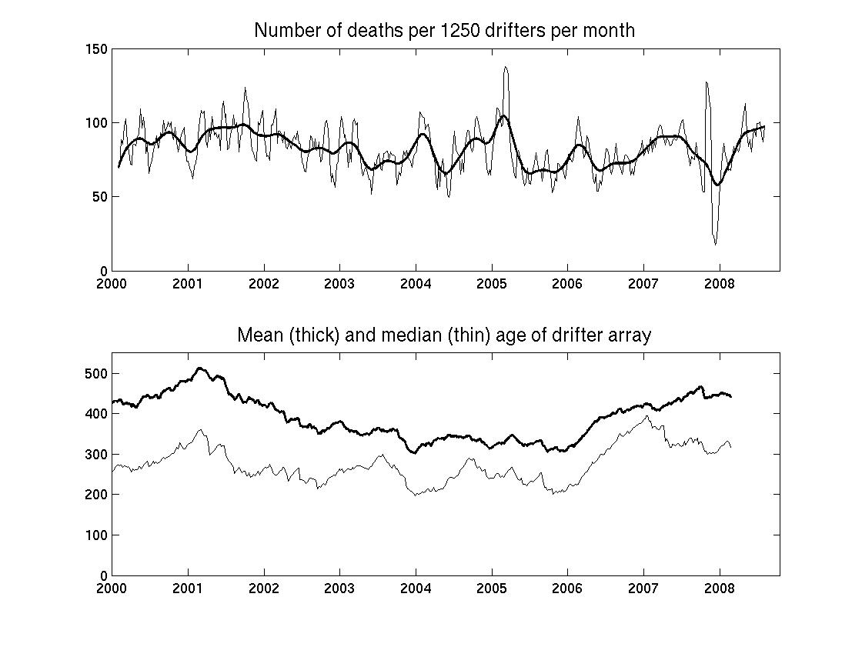

Fig. 4: Number of drifter deaths per 1250 drifters per month (top) and the age of the global drifter array (bottom).

Why has the death rate increased? One major factor in setting the high death rate is the mean age of the array, also shown in Fig. 4. During 2005, the size of the array increased dramatically as deployments were ramped up to meet the goal of 1250 drifters by September. This large influx of new drifters drove down the average age of the array to its lowest level in years. At the beginning of 2006, the median age of a drifter in the array was 200 days, far less than the operational lifetime of 450 days. After reaching the goal of 1250 drifters, fewer needed to be deployed to maintain that number. Thus, the mean age of the array began increasing after January 2006. The mean age is now near 450 days, e.g., the mean lifetime of a drifter, suggesting that the increase in death rate and array age should level off unless systematic engineering problems develop to reduce the mean age of the array while increasing the death rate.

What has been the impact of the increasing death rate? We have been responding to the increased death rate by a moderate increase in the number of deployments in the last few months. Thus, the number of drifters in the array has not substantially declined below the late Boreal summer minimum (c.f. Fig. 3). However, our FY08 average deployment rate of 83 drifters per month is insufficient to maintain the array in the long term, in the face of 90—100 deaths per month per 1250 drifters.

What will be the impact of this increased death rate in the future? If we do nothing differently to address this, we can anticipate that there will be a shortfall of ~10 drifters per month to maintain the array. The array will grow to a peak of ~1245 drifters in mid-March 2009, then shrink to a minimum of ~1040 drifters by September 2009. The FY09 average size will be ~1165. Several strategies can be adopted to address this problem:
- NOAA can fund an additional 10 drifters per month, at an additional cost of $160k per year (basic SVP drifters with SST and surface currents; operational partners will be invited to add barometers via the upgrade program). This strategy is offered in the FY09 Work Statement and Budget.
- The Global Drifter Program can increase the pressure upon its international partners to share more of the load in their regions of interest. This strategy has been attempted in the past, for example to populate the tropical Atlantic with drifters, without major success. In many cases, a regional partner is a meteorological organization that is willing to fund barometer upgrades, but not the complete drifter. This strategy will certainly lead to regional gaps in the array in the short term.
- The Surface Drifter Program can adjust deployment plans to place more focus on lowering the death rate. In short, we can trade off the 5°x5° resolution goal with the goal of maintaining 1250 drifters. There are ocean regions where drifters do not tend to live as long, due to a historically higher rate of running aground or being picked up. Examples include the western Indian Ocean and the northern Gulf of Guinea. (Other examples, such as the coast of Brazil, cannot be avoided due to ocean advection patterns.) By strictly avoiding any deployments in these regions, we will be less successful at reducing the potential satellite bias error in SST and surface current measurements (fewer 5°x5° bins sampled), but will be more successful at maintaining 1250 drifters with the present deployment rate.

Fig. 5 shows the recent growth of the array as a function of the four major drifter manufacturers from which NOAA purchases drifters: Clearwater, Metocean, Pacific Gyre and Technocean. Technocean and Clearwater drifters dominate the global array. Death rates (second subplot) have remained relatively low and steady for Technocean drifters. Clearwater drifter deaths spiked to larger values in early to mid 2007, an issue which the Surface Drifter Program identified in mid-2007 and communicated to the manufacturer. Since mid-2008, the death rates of three of the four manufacturers (all but Technocean) have risen, perhaps reflecting the increasing age of the drifters. For the period September 2007 to the present, the mean death rate, per 1250 drifters, per month have been 108 (Clearwater), 89 (Metocean), 84 (Pacific Gyre) and 52 (Technocean). Some of these variations reflect various deployment regions, which are not uniform for drifters from the manufacturers, deployment techniques from individual platforms, storage times for some batches of drifters, etc.; these variations motivated the ADB study described below. Regardless, these results suggest that the longer operational lifetime of the Technocean drifters helps compensate for their higher price (~$450 more per drifter than the other three manufacturers).

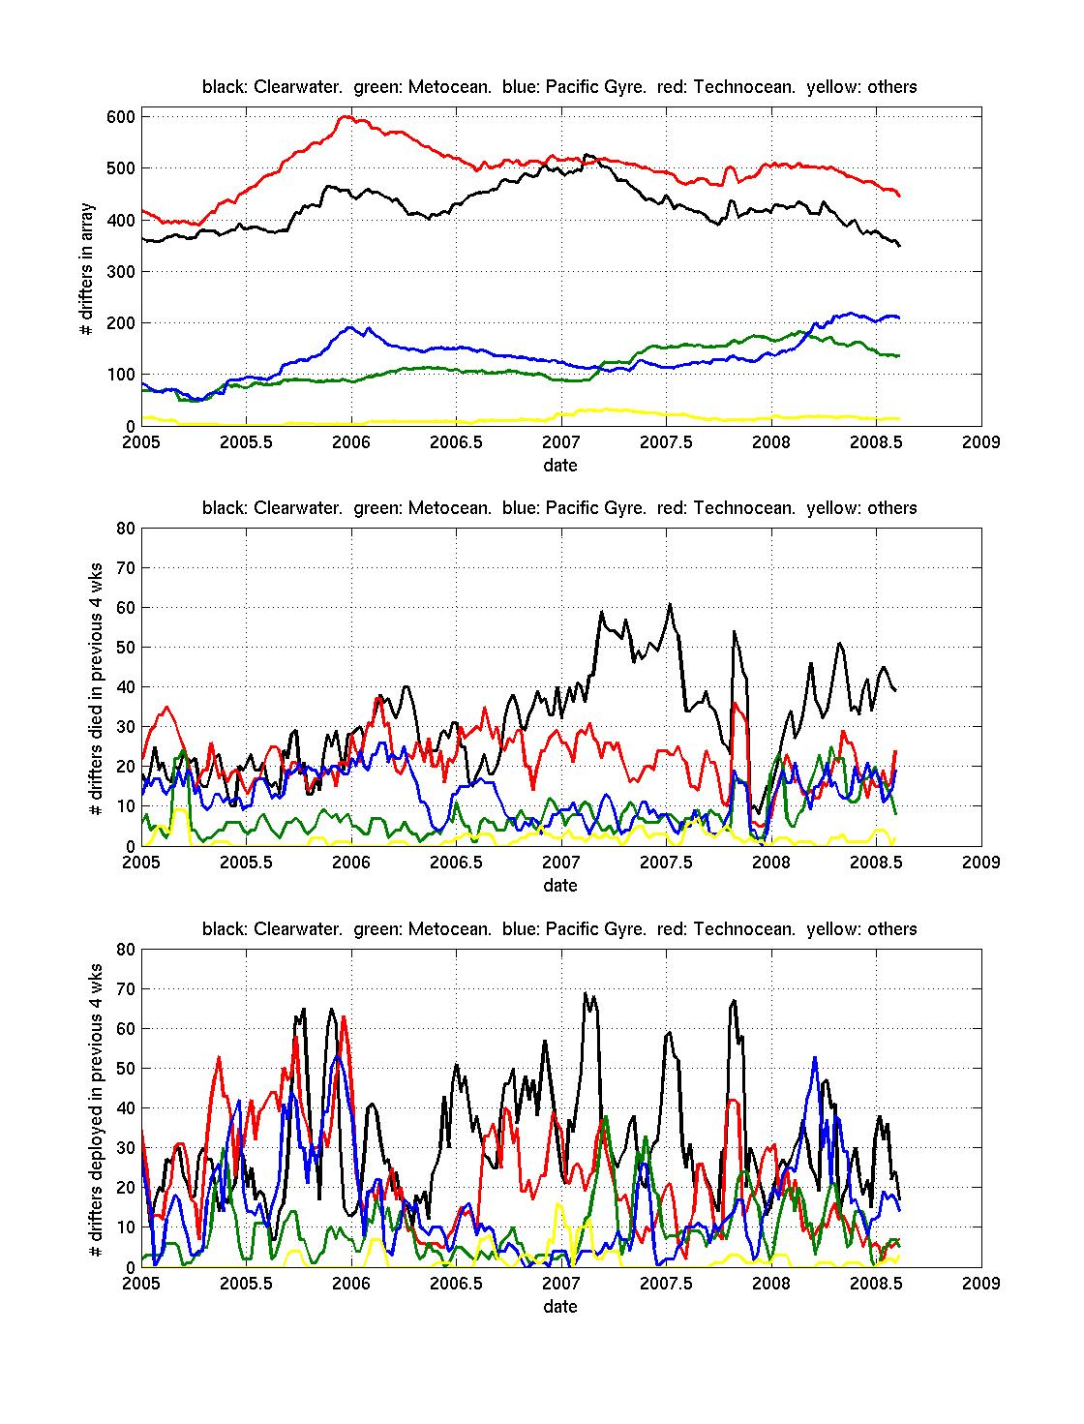

Fig. 5: Size of the array divided into the four major manufacturers (top), the number of drifters that died each month (middle) and the number of drifters deployed each month (bottom).

AOML Data Buoy (ADB) Comparison Study

In FY08—09, as in FY05—06, the Surface Drifter Program is conducting an AOML Data Buoy (ADB) comparison study to evaluate the performance of the manufacturers. During this study, drifters from Clearwater, Metocean, Pacific Gyre and Technocean are deployed in clusters in various regions throughout the world. The clusters are initially only a few meters apart, allowing us to cross-compare for SST quality and wind-driven slip. It is the goal of the Surface Drifter Program to evaluate the performance of each product independently, and use these findings to determine the strengths and weaknesses (if any) that exist. Preliminary results show that after 5 months of data collected, a total of 4 drifters out of 20 have already ceased transmitting, one from Technocean after 50 days, two from Metocean after 34 and 64 days and one from Pacific Gyre after 91 days. We are concerned about the rapid death of the Metocean drifters, with 2 out of 5 dead already dead, and will continue to monitor the lifetimes of the remaining drifters. Five ADB drifters have already lost their drogues: one Clearwater drifter lost its drogue after 99 days, three Technocean drifters lost their drogues after 101, 99 and 75 days, and one Pacific Gyre showed drogue lost after only 12 days in the water. We are concerned with the rapid loss of Technocean drifters, and will monitor this issue more closely in the Bay of Biscay study (see below). With respect to SST, we found two problems with Pacific Gyre drifters: one had an offset of 0.45⁰C with respect to its neighbors (confirmed not to be an error with the SST coefficients) … this offset was added to the GTS distribution to correct and avoid wrongful data dissemination; another drifter from Pacific Gyre had SST sensor failure after 30 days in the water. Also one Metocean drifter’s SST failed five days after deployment.

As a subset of the 2008 ADB Comparison Study, fifteen SVPB drifters, five each from three manufacturers (Clearwater, Pacific Gyre, and Technocean), were developed to evaluate the addition of strain gauge for drogue detection. DBCP colleagues at Méteo-France recently deployed these drifters in tight clusters in the Bay of Biscay. As well as testing the tether strain sensors, we are taking this opportunity to examine other aspects of these drifters such as barometer port sensors, SST values, battery life, signal strength, etc. Preliminary results indicate that three of the five Technocean drifters lost their drogues within an extremely short time in the water, a result confirmed by the recovery of one drifter by Méteo-France, and that this drogue loss was successfully evaluated from tether strain.

Collaborations

The Global Drifter Program would not be able to maintain the drifter array without contributions from national and international partners who deploy the drifters worldwide. Drifters are deployed from many research cruises, several (such as PIRATA Northeast Extension, Western Boundary Time Series and NTAS) funded by NOAA/OCO. Many drifters are deployed from vessels cooperating in NOAA’s Ship Of Opportunity Program (SOOP); SOOP personnel (J. Trinanes) also supports AOML’s efforts to collect the hurricane drifter data for subsequent quality control and redistribution.

Research efforts

Since the introduction of multisatellite processing in January 2005, the mean temporal resolution of drifter data has decreased dramatically from its earlier values, now averaging slightly over one fix per hour. This increase in temporal resolution allowed AOML-funded postdoctoral fellow S. Elipot, with his advisor R. Lumpkin, to conduct a global census of high-frequency (inertial and superinertial) motion (Elipot and Lumpkin, 2008). The rotary (clockwise and counterclockwise) energy spectrum of hourly drifter velocity (Fig. 6) reveals the energy content in the anticyclonic inertial band and in semidiurnal and diurnal motion. The energy content in the inertial band is much higher here than in analyses of kriged data at high latitudes, where kriging to ¼ day values removes much of the inertial variance. Resolving these high-frequency motions has significant climate implications as wind energy input as near-inertial waves is one of the primary energy inputs to drive the observed stratification of the ocean via interior ocean mixing.

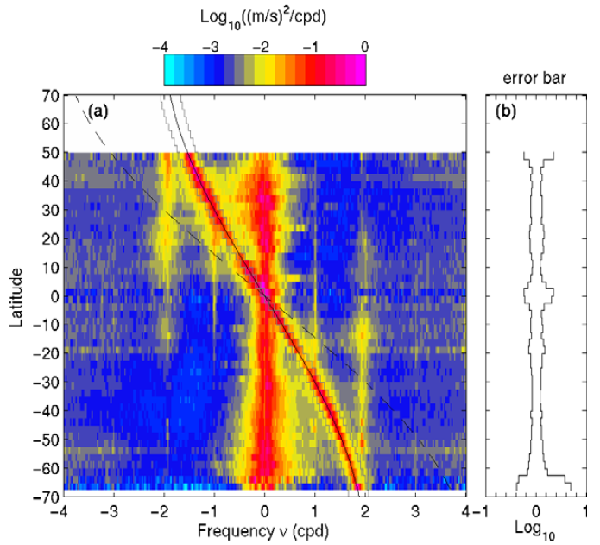

Fig. 6: Clockwise (negative frequency) and counterclockwise (positive frequency) energy content in drifter velocities as a function of latitude, in the Pacific Ocean (from Elipot and Lumpkin, 2008). The local inertial frequency is indicated by the solid curve, twice the inertial frequency by a dashed curve. Diurnal and semidiurnal ridges of enhanced energy are seen at frequencies of ±1 and ±2 cycles per day.

With collaborators A. Griffa and M. Veneziani, R. Lumpkin has mapped the global distribution of “spin” from the drifter trajectories. Spin is calculated from the lagged correlation between zonal and meridional velocity, and indicates where looping trajectories dominate oceanic surface motion. In addition to the known dominance of anticyclonic spin at high latitudes, the investigators found a band of dominant cyclonic spin at 15-20°N and S in all ocean basins (Fig. 7). This new feature may be related to submesoscale vortices generated at the equatorward edges of the subtropical gyres (Griffa, Lumpkin and Veneziani, 2008).
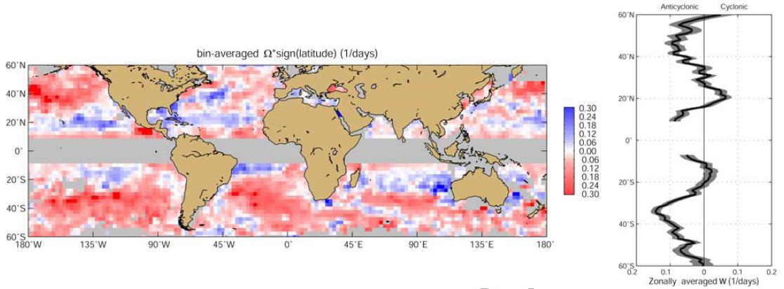
Fig. 7: mean distribution of spin (left) showing where anticyclonic (red) and cyclonic (blue) loopers are common. Zonal average (right) indicates the presence of cyclonic bands at the equatorial side of the subtropical gyres, a feature seen for the first time in these data. From Griffa et al. (2008).

A subcomponent of the Global Drifter Program, the Atlantic Drifters, was funded with the objectives to fill gaps in the observational network, in order to accurately describe the basin-scale Atlantic current and SST seasonal-to-interannual variations. This program was started to address the data coverage deficiency in the tropical and subtropical south Atlantic (20°N to 40°S). Lumpkin and Garzoli (2005) analyzed the time mean and seasonal variability of the equatorial currents using the resulting drifter data, and shed new light on different branches of the equatorial system and its variability. The PIs are currently completing an analysis of the data collected in the South Atlantic to characterize the near-surface circulation of the sub-tropical Atlantic. Two different data sets were derived for this study: a climatology for sea surface velocities derived from the period October 1992 to March 2007 and a product derived from sea surface currents observed with the drifters and altimeter covering the same time period. The study encompasses the whole basin as well as individual studies of the time-mean pathways of the boundary currents (Confluence of Brazil and Malvinas in the west; the Agulhas/Benguela system in the east) and the variations of the upper ocean exchanges associated with the bifurcation of the South Equatorial Current at the coast of Brazil. R. Lumpkin presented a highlight of the results of this study at the 2008 Office of Climate Observations annual review. In summary, the 1993—2008 southward migration of the Brazil/Malvinas current confluence (see Fig. 8) was mostly likely driven by a southward migration of the wind stress pattern, as is known to happen at the seasonal time scale. Looking back for longer times, using the wind patterns as a proxy for the ocean at pre-altimetry and drifter times, we suggest that this decadal migration may be part of a multidecadal oscillation related to basin-scale SST anomalies in the subtropical South Atlantic Ocean.
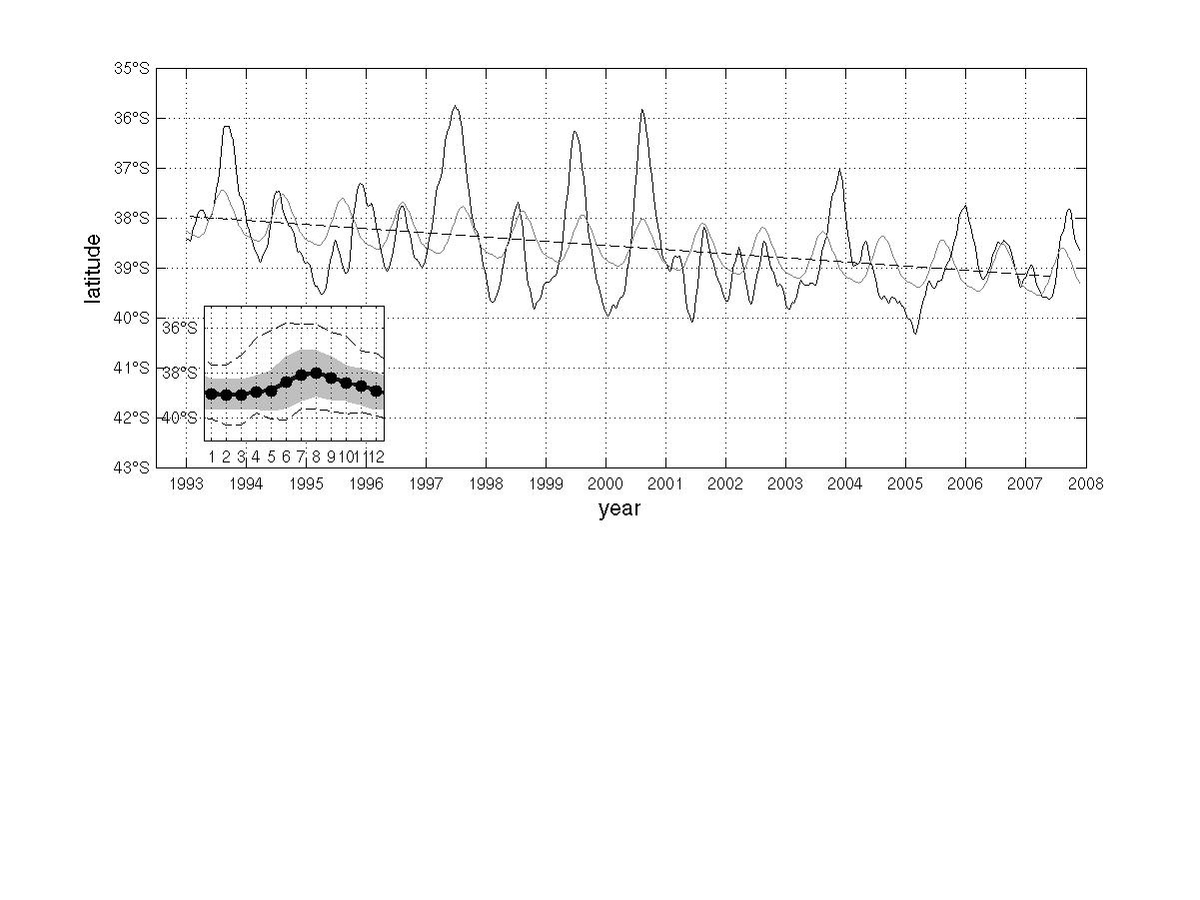
Fig. 8: Location of the Confluence of the southward Brazil Current and northward Malvinas Current as a function of time (from Lumpkin and Garzoli, manuscript in revision). Subpanel shows the seasonal cycle, standard deviation (shading) and monthly extrema (dashed line).

Meetings:
S. Dolk and M. Pazos (AOML) attended the 23nd Data Buoy Cooperation Panel (DBCP) meeting (15-19 October 2007, Jeju, South Korea). There, they presented the results of the 2007 drifter comparison study, attended numerous subpanel meetings such as regional planning panels, and attended the “First Panel Meeting of Coastal and Ocean Observations”, a joint observation project between MOMAF/NORI (Korea) and NOAA. M. Pazos attended the Argos Users Meeting (30 Sept—2 Oct 2008, Annapolis, MD) and the ISABP-12 meeting (29-30 May 2008, Rio de Janeiro, Brazil), and was appointed technical coordinator of the ISABP. J. Redman attended a tether strain implementation meeting between three manufacturers and JIMO (13-14 December 2007, La Jolla, CA). S. Dolk attended the African Partnership Station meeting in Ghana, Africa (March 2008; see earlier in this report for more). R. Lumpkin presented drifter-based analysis at the Office of Climate Observations Annual Review (3—5 September 2008, Silver Spring, MD), the Ocean Sciences meeting (3—7 March 2008, Orlando, FL) and the CLIMODE PI meeting (6—7 August 2008, Woods Hole MD). R. Lumpkin and B. King organized the CLIVAR/GSOP Special Workshop on Velocity Observations (5—7 December 2007, La Jolla, CA).

Outreach:
R. Lumpkin worked with Anand Gnanadesikan for the “Ocean Currents” display in the newly opened Ocean Hall of the National Museum of Natural History. He also authored a chapter of the National Geographic and Smithsonian Institution’s “Hidden Depths: Atlas of the Ocean by NOAA” in concert with the Ocean Hall opening.

Our cooperation with the African Partnership Station program, noted earlier in this report, represents NOAA’s contribution to this effort.

Surface Drifter Program Publications and Reports FY08:

Elipot, S. and R. Lumpkin, 2008: Spectral description of oceanic near-surface variability. Geophys. Res. Letters, 35, L05605, doi:10.1029/2007GL032874.
Griffa, A., R. Lumpkin and M. Veneziani, 2007: Cyclonic and anticyclonic motion in the upper ocean. Geophys. Res. Letters, 35, L01608, doi:10.1029/2007GL032100.
Lumpkin, R. and B. King, 2008: First CLIVAR Global Synthesis and Observation Panel Workshop on Ocean Velocity Measurements and their Application. Meeting report.
Lumpkin, R. and G. Goni, 2008: State of the Ocean in 2007: Surface Currents. In “State of the Climate in 2007”, Bulletin of the American Meteorological Society, 89 (in press).
Marshall, J., W. Dewar, J. Edson, R. Ferrari, D. Fratantoni, M. Gregg, T. Joyce, K. Kelly, R. Lumpkin, R. Samelson, E. Skyllingstad, F. Straneo, L. Talley, J. Toole and R. Weller, 2008: CLIMODE: a mode water dynamics experiment in support of CLIVAR. Bulletin of the American Meteorological Society, submitted.
Sallée, J-B., K. Speer, R. Morrow and R. Lumpkin, 2008: An estimate of Lagrangian eddy statistics and diffusion in the mixed layer of the Southern Ocean. J. Marine Res., accepted July 2008.
Zhang, H.-M., R.W. Reynolds, R. Lumpkin, R. Molinari, K. Arzayus, M. Johnson, and T.M. Smith, 2008: An Integrated Global Ocean Observing System for Sea Surface Temperature Using Satellites and In situ Data: Research-to-Operations. Bulletin of the American Meteorological Society, accepted June 2008.

