CTDO2 Calibration Toolbox

Carlos A. Fonseca
Cooperative Institute for Marine and Atmospheric Sciences (CIMAS)

Derrick Snowden
Atlantic Oceanographic and Meteorological Laboratory (AOML)

This document describes a Matlab® toolbox, which allows CTDO₂ data, collected with a Sea-Bird© SBE 911 Plus CTD to be calibrated against independent analyses of seawater samples.

Introduction 3
Credits 3
Feedback 3
Obtaining and Installing the CTDCAL Toolbox 4
The Matlab® Environment 4
Installation 4
Getting Help 5
Preparing to Calibrate a New Cruise 6
Sea-Bird© files and formats 6
Cruise Data Directory Structure 6
Cruise Metadata Management 7
Alternative methods to manage the Matlab® search path 9
Loading the Calibration Database 10
Loading the Sea-Bird© files 10
Loading the Salinity Samples 12
Loading the Oxygen Samples 14

Introduction

Provide a good overview and anything else you may think is needed in this area. Looking at other HOWTOs may assist in providing ideas

Credits
Most of the software described in this document was written by Carlos Fonseca. Derrick Snowden has contributed to the software development to a lesser extent. Scientific inputs to the software development was given by Molly Baringer, Libby Johns, Bill Johns and Bob Molinari. Many of the ideas and algorithms are taken from other packages in use by PMEL. In particular, Greg Johnson and Kristy McTaggart were the primary authors.

Feedback
Feedback is most certainly welcome for this document and for the software it describes. Send your additions, comments and criticisms to the following email address : carlos.fonseca@noaa.gov and derrick.snowden@noaa.gov .

Obtaining and Installing the CTDCAL Toolbox

The CTDCAL Toolbox is intended to be used at sea, to calibrate CTD profiles as they are collected. It is platform independent and has been tested on Linux and MS Windows PCs. Prior to the cruise, download the CTDCAL Toolbox from the AOML intranet home page (http://doris/matlab/ctdcal/). The file ctdcal.tar.gz contains both the programs and the documentation.

The Matlab® Environment
Though the CTDCAL Toolbox, is platform independent, the following examples will assume the operating system is Linux (or some other Unix variant). As time allows, the documentation will be updated to include analogous examples on MS Windows computers.
There are several default directories which are automatically visible to the Matlab® interpreter. Upon startup, the Matlab® interpreter searches the current user's home directory, HOME (e.g. /home/user/) for a matlab/ subdirectory which is automatically appended to the Matlab® path. In this document, MATALABPATH, is used to specify the Matlab® search path.

NOTE: Environment Variables - The enviroment variable notation (e.g. MATALABPATH) does not imply a strict association between the Matlab® search path and the Unix environment path.

Installation
To install the CTDCAL Toolbox, simply unzip the ctdcal.tar.gz file somewhere in the MATLABPATH.

Example 1: Installing the CTDCAL Toolbox on a linux/unix computer

cp ctdcal.tar.gz ~/matlab/

cd ~/matlab/

tar xvfz ctdcal.tar.gz

There should be a ctdcal/ directory beneath the HOME/matlab/ directory, containing the program files and documentation for the CTDCAL Toolbox. This directory will be referred to as CTDCALDIR for the remainder of this document. In order to add the CTDCAL Toolbox to the default Matlab® path, add the following line to the user's startup.m file which usually exists in HOME/matlab/.

path(fullfile('home','user','matlab','ctdcal'),path) % CTDCAL Toolbox

For Windows PC users we recommend to put the CTDCAL folder under ~\MATLAB\toolbox\local\ for example: C:\MATLAB6p5\toolbox\local\ctdcal.

path(fullfile('C:','MATLAB6p5','toolbox','local','ctdcal'),path) % CTDCAL Toolbox
NOTE - Notice that the path in the above example matches the HOME/matlab/ctdcal/ directory described in the installation section. This is logical and convenient but not required. The exact form of this statement will be specific to the user's computer.

To test the installation, start the Matlab® interpreter and type

help ctdcal

A long description of the m-files contained in the toolbox should scroll across the screen. If the Matlab® returns the message below, see the troubleshooting tips in section XX.

help ctdcal
ctdcal.m not found

Getting Help

The documentation for the CTDCAL Toolbox is contained in CTDCALDIR/doc/. There is a postscript version of this User's Guide at CTDCALDIR/doc/HOWTO-ctd-calibration.ps and an html version beginning at CTDCALDIR/doc/howto/index.html. Finally, the demo and example files, referenced throughout this document can be found in CTDCALDIR/demo/.
From within Matlab®, the help documentation for each function in the CTDCAL Toolbox can be accessed using the standard help syntax described above. In addition to the online text based help for each individual function, an html version has been created and is located at CTDCALDIR/doc/ctdcal.html. In addition to the standard help the html presentation shows the interdependencies of the Matlab® functions and the code itself.

Preparing to Calibrate a New Cruise

Sea-Bird© files and formats

During the process of acquisition and processing of the CTDO₂ data a set of files is created for each cast. In some of these files, the parameters to be saved are defined by the user. That way, there are parameters that are not included in our package and the inclusion of these in the Sea-Bird© files may require changes in one or more Matlab® functions within CTDCAL Toolbox.

This toolbox is setup for the standard configuration used here at the Atlantic Oceanographic and Meteorological Laboratory (AOML) that consists of two temperature sensors (SBE 3F), two conductivity sensors (SBE 4) and two dissolved oxygen sensors (SBE 43). Consequently this represents the minimum information that the Matlab® functions will require. A description with the minimum parameters necessary to use this toolbox can be found in the Appendix A

A brief description about the Sea-Bird© proprietary file formats can be found in the Appendix B.

Cruise Data Directory Structure

Before calibrating a cruise, the CTDO2 data files must be placed in a cruise calibration directory, which has a predefined layout. There are Matlab® functions within CTDCAL Toolbox, which will help in creating the correct directory structure. The root of the cruise directory CRUISEDIR from now on can be anywhere.

Warning
We strongly discourage using the CTDCALDIR as the CRUISEDIR. If they are chosen to be the same location, then each subsequent cruise will require a new installation of CTDCAL Toolbox and there is an increased risk of path conflicts with multiple versions of the same software.

From within the Matlab® interpreter, follow the steps outlined in example 2 to create the cruise calibration directory tree described above.

Example 1: Installing the CTDCAL Toolbox on a linux/unix computer

cd /Data

cruisedir=make_cruise_dir (‘ab0505’)

cd /Data/ab0505

ls

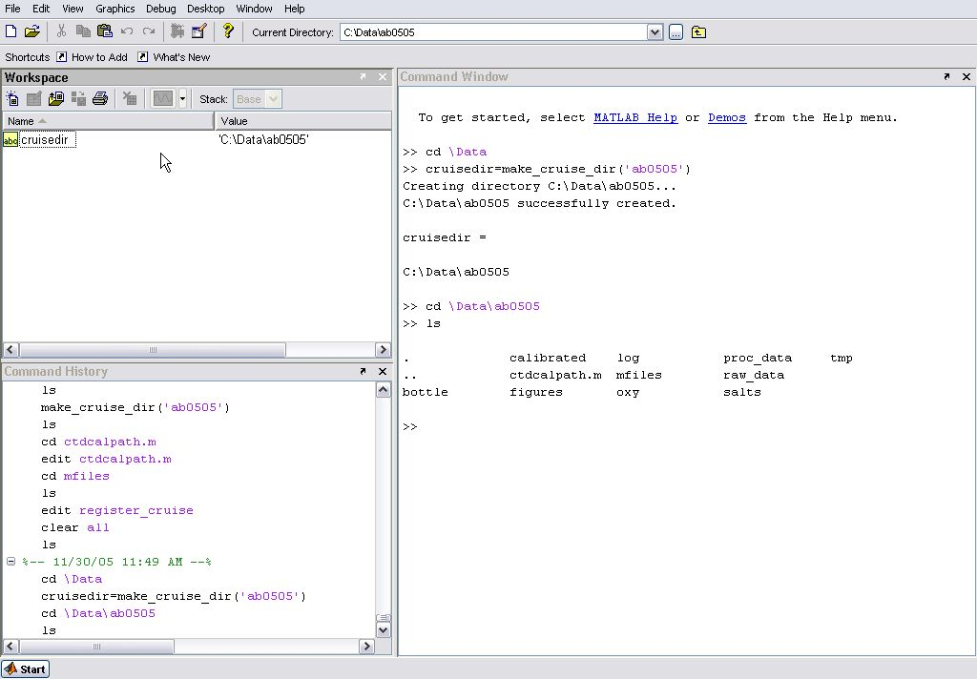

This directory tree is a duplicate of the standard cruise directory set up on the CTD acquisition and CTD processing computers.

Cruise Metadata Management

There is a large amount of metadata associated with acquiring and calibrating CTDO₂ data on a research cruise. In the CTDCAL Toolbox the metadata of interest describes the locations on the disk of the various Sea-Bird© data files described in the Appendix B as well as the information describing the space-time domain of the research cruise. The function register_cruise.m is the means by which this metadata is made available to the CTDCAL Toolbox.

Once a new cruise calibration directory tree has been created as described in Cruise Data Directory Structure a new register_cruise.m will be created in CRUISEDIR/mfiles. This file should be edited by the user to contain the metadata relevant to the current cruise calibration project. The important elements of this file are described below as well the places where do you need to edit for your cruise

% The cruiseid is the case sensitive character mneumonic which
% will be used to reference the current cruise calibration project.

cruiseid = 'ab0505';
group = group_name(cruiseid);
setpref(group,'cruiseid',cruiseid);

% How are the Seabird ctd files named? This is also case sensitive on %linux computers.We recommend that you use lower case for everything to %minimize the %chance for conflicts.e.g. stc2001.cnv, stc2001.hdr, %stc2001.btl etc. Notice that the filestub variable below doesn't have %to be the same as the cruiseid above.

file_name_prefix = 'ab0505';
setpref(group,'file_name_prefix',file_name_prefix)

% The number of digits used in creating the file names from the %file_name_prefix and a variable station number.
% TODO: This does not allow for multiple casts at the same station as %per WOCE specs.

nDigits = 3;
setpref(group,'n_digits_station_num',nDigits)

% Are the extensions to the Seabird Data files written in upper case or %lower case? e.g. stc2001.CNV or stc2001.cnv. This must be true for %all or none of the relevant file types. (cnv, bl, btl)

sbe_is_upper_case_extensions = false;
setpref(group,'sbe_is_upper_case_extensions',sbe_is_upper_case_extensions)

% Where is the main cruise calibration working directory?
% This directory is the top level root directory which contains a copy %of the cruise data, the calibration reports, figures, and all the
% user editable m-files copied from the ctdcal/demos directory. See %the User's Guide
% for more explanation.

calibration_dir = fullfile('C:','Data','ab0505');
setpref(group,'calibration_dir',calibration_dir);

%calibration_dir=fullfile(filesep,'doris','snowden','CTD','test','stc02%');
% NOTE: pseudo platform independent representation of %directories. On %Windows you must add
% 'C:' or '\\computername' as the first argument to fullfile. %(fullfile('C:','doris',etc...))

These are the critical parameters that need to be modified to represent your cruise. You can modify the parameters inside this function but they are not fully implemented in CTDCAL Toolbox at this moment.
Once the register_cruise.m file is current, we recommend to save with another name (attaching the cruiseid for example e.g. register_cruise_ab0505.m) and execute it at the Matlab® prompt.

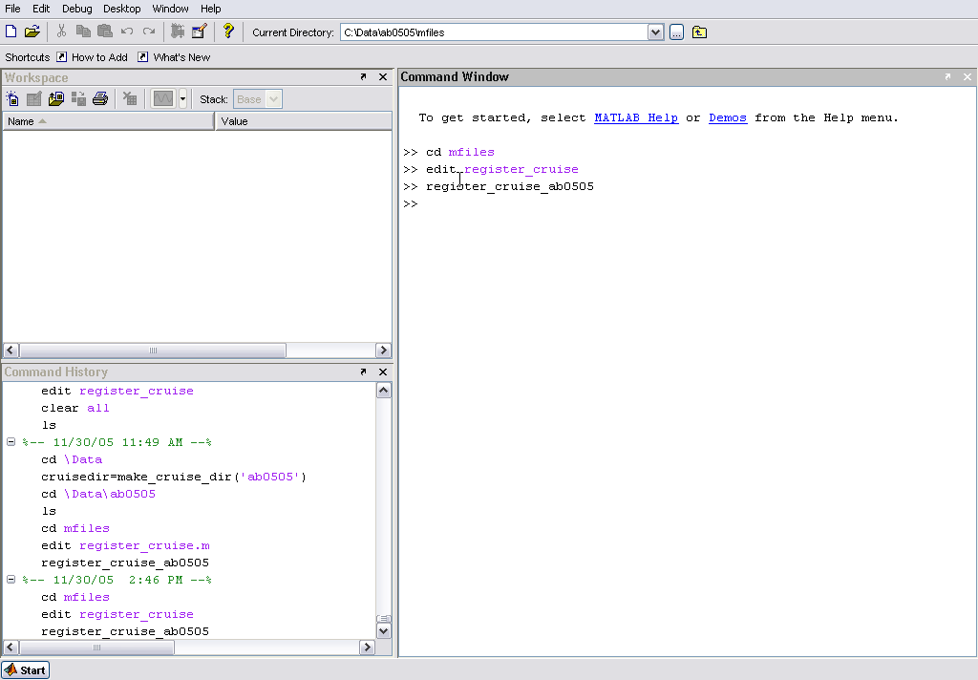

Alternative methods to manage the Matlab® search path

In addition to editing the global startup.m file to include the CTDCAL Toolbox path, the user has another option to include the necessary functions in the Matlab® path. The file CRUISEDIR/ctdcalpath.m should have been created at the same time as the CRUISEDIR by the make_cruise_dir.m function. This function, when executed from the command line, should place the relevant toolbox and cruise specific functions into the Matlab® search path. The user must issue the ctdcalpath command at the beginning of each new Matlab® session.

Loading the Calibration Database

Loading the Sea-Bird© files

Once the cruise directory is created and the cruise has been registered by typing the register_cruise command, the relevant Sea-Bird© files must be manually copied in the correct locations in the directory tree. The table below shows the Sea-Bird© files and the corresponding folders where these files supposed to be.

Sea-Bird© file | Folder on CRUISEDIR
*.BL | raw_data
*.CNV | proc_data
*.BTL | bottle

NOTE – The Matlab® functions inside CTDCAL are set to work with *.CNV files that have only the downcast information. Case you have *.CNV files with both casts information you can split easy and fast using the “SPLIT” function in the SBEDataProcessing® software.

Provided the set up has been down correctly and all files have been copied into the cruise directory tree, loading the cruise database with the information in the Sea-Bird© data files is a simple procedure. The following commands will load the Sea-Bird© data files into the cruise database.

Example 2: Loading Sea-Bird© files into the database

bl=load_bl(‘ab0505’);

btl=load_btl(‘ab0505’);

cnv=load_cnv(‘ab0505’);

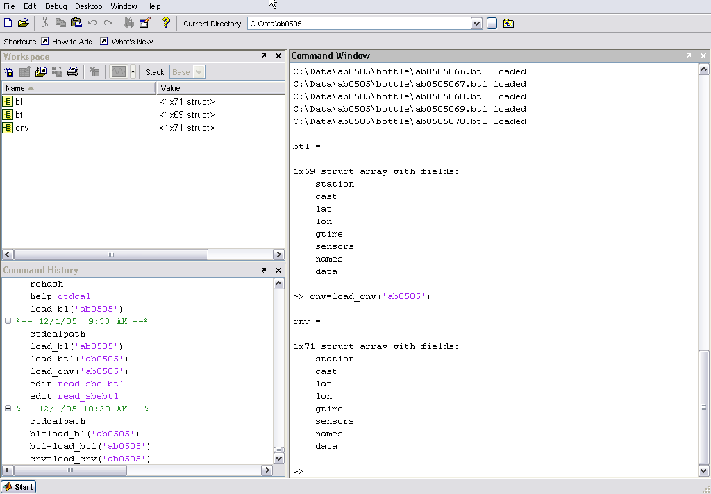

Automatically, after you load the first set of Sea-Bird© files you will receive on the screen the information about the number of stations that were loaded and a database is created in you CRUISEDIR. The database will be named CRUISEDIR_db.mat. These database is the backbone CTDCAL Toolbox. It consists of a series Matlab® structures that are added accordingly with the steps that you reached inside the toolbox. All the relevant information that can be further used in CTDCAL Toolbox will be stored in this file. You can check this database using the following commands.

Example 2: Checking the database for you cruise

ls *.mat;

load ab0505_db.mat;

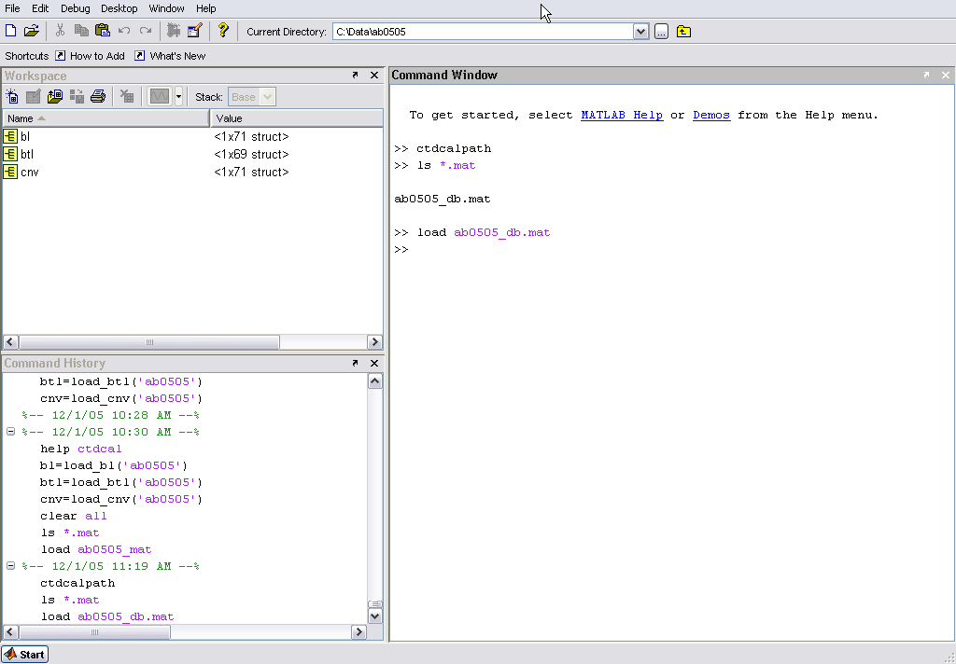

Loading the Salinity Samples

Due the variety of salinometer interfaces that we have available it’s very difficult to create a Matlab® function that addresses all the formats. What we did, so far, was to create a function that reads a file in a specific format, that way; it is up for the user do the editions and/or corrections necessary to have a final ascii file in the format described below.

station | niskin bottle number | sample bottle number | conductivity ratio * 2 | Salinity
1 | 1 | 795 | 1.99299 | 34.86218
1 | 2 | 796 | 1.99415 | 34.88496
1 | 3 | 797 | 1.99474 | 34.8966
1 | 4 | 798 | 1.99505 | 34.90257
1 | 5 | 799 | 1.99567 | 34.9148
1 | 6 | 800 | 1.99673 | 34.93569
1 | 7 | 801 | 1.99738 | 34.94848
1 | 8 | 802 | 1.99805 | 34.96157
1 | 9 | 803 | 1.99841 | 34.96869
1 | 10 | 804 | 1.99878 | 34.97593

Once you have a file formatted with these columns and on this order, copy/move to the your CRUISEDIR/salts folder. To load the salinity sample in your cruise database you just need now use the following function.

Example 3: Loading the salinity samples into the database for you cruise

salts=load_salts(‘ab0505’);

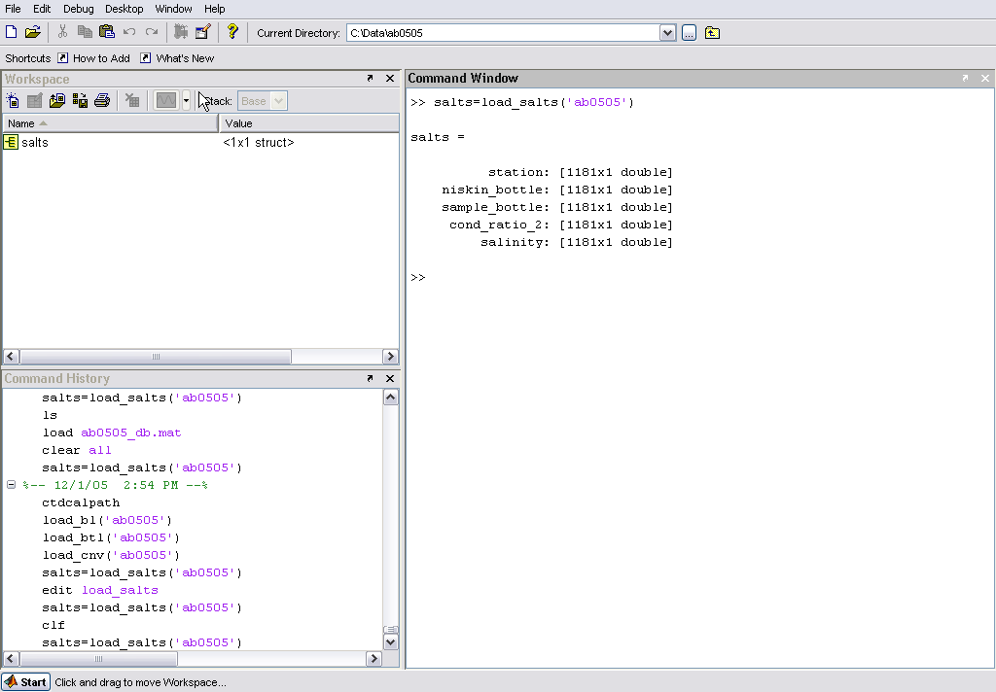

Same as in the functions that load Sea-Bird© files, you will receive the information about the number of stations loaded on the screen and the cruise database will be updated.

NOTE – Nowadays we have been using the Ocean Scientific International© salinometer interface called Salinometer Data Logger (version 1.2). Additional information about the editions and corrections that need to be made can be found in the Appendix C

Loading the Oxygen Samples

As for the salinity samples the files containing the oxygen samples results are required in a specific format. This format corresponds to the format that the information is saved by our oxygen titration system interface. An example of these files can be found below.

MnCl2 volume : 1
NaOH/NaI volume : 1
Factor : 24.909
Blank : 0.0001
Comment :
Comment :
Operator :BJK

Date Time Station Depth Bottle Thio. uM O2.
5/4/2005 6:32 0 1 1 3.9385 274.4
5/4/2005 6:36 0 3 3 4.062 274.7
5/4/2005 6:43 0 4 4 3.891 274.4
5/4/2005 6:46 0 5 5 3.705 271.1
5/4/2005 6:48 0 6 6 3.8875 271.1
5/4/2005 6:50 0 7 7 3.886 271.1
5/4/2005 6:53 0 8 8 4.084 271
5/4/2005 6:56 0 9 9 3.8805 269.6
5/4/2005 6:58 0 10 10 3.86 268.8
5/4/2005 7:01 0 11 177 3.8065 268.6
5/4/2005 7:04 0 12 166 3.7445 268.4
5/4/2005 7:07 0 13 13 3.711 264.6
5/4/2005 7:10 0 14 14 3.7895 264.7
5/4/2005 7:13 0 15 178 3.779 264.4
5/4/2005 7:15 0 16 16 3.8055 264.6
5/4/2005 7:18 0 17 17 3.733 260
5/4/2005 7:20 0 18 18 3.7155 260.4
5/4/2005 7:29 0 19 19 3.6565 259.6
5/4/2005 7:32 0 20 168 3.73 259.8

The field named as “Depth” actually corresponds to the niskin bottle number and the results of the oxygen titration are given in micromoles per litter (μmol/l). These files are saved in the CRUISEDIR/oxy folder and can be loaded using the following command.

Example 3: Loading the oxygen samples into the database for you cruise

oxy=load_oxy(‘ab0505’);

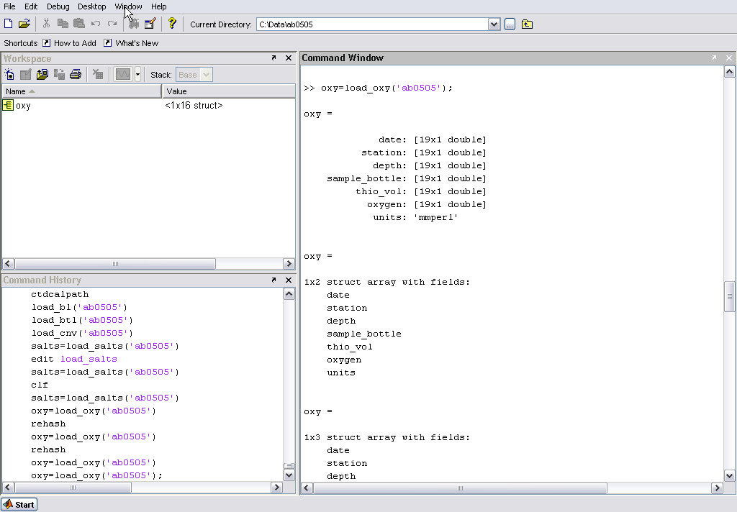
At this point the CTDCAL Toolbox have the minimum information to start the functions that will do the comparisons, the quality control and the calibration of the CTD data. We should emphasize that is not necessary wait for the end of the cruise to start use this toolbox. There are Matlab® functions inside this package that allows you to make diagnostics plots that can help the quality control of the CTD data as well the salinity and oxygen samples throughout the entire cruise. The cruise database now will have the following structures.
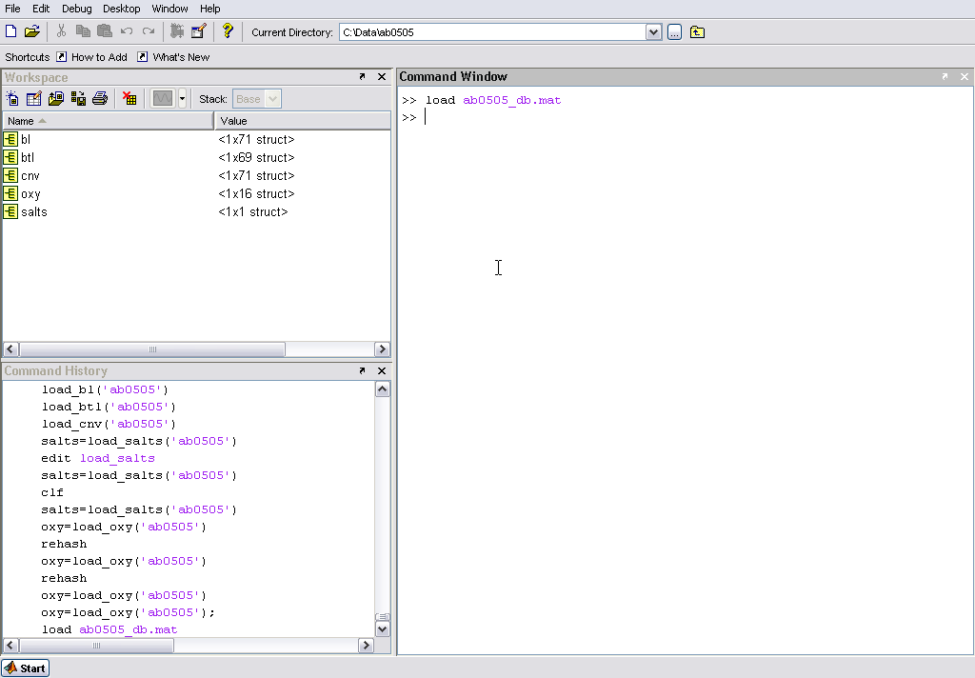

Preliminary Comparisons

CTD Data
As mentioned before, the standard configuration used here at AOML consists of pairs of sensors for three different variables: temperature, conductivity and dissolved oxygen. So a first comparison would be check the behavior of the sensors that are measuring the same property. The function compare_ctd_sensors inside the CTDCAL toolbox allows you to compare the performance of the sensors. You can select the stations and the property that you want to check. For better visualization, the maximum number of the stations allowed per plot is 10 (ten), that means if your station selections is bigger than 10, you will have more than one plot as your output.

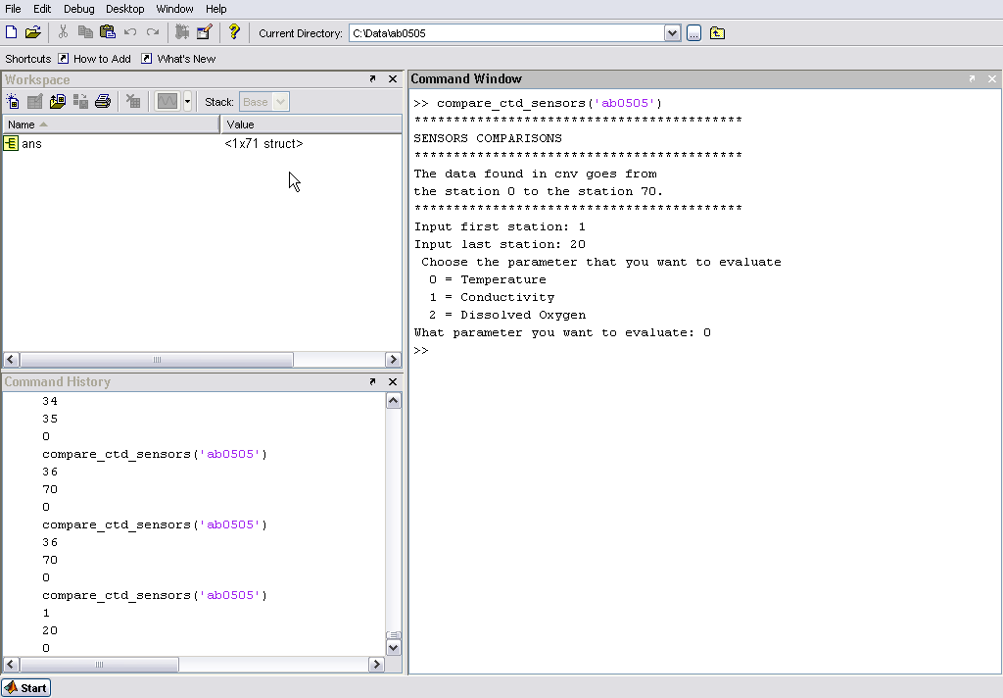

The figure above illustrates the usage and the options of the function compare_ctd_sensors , the next figure is an example of the one of the outputs of this function.
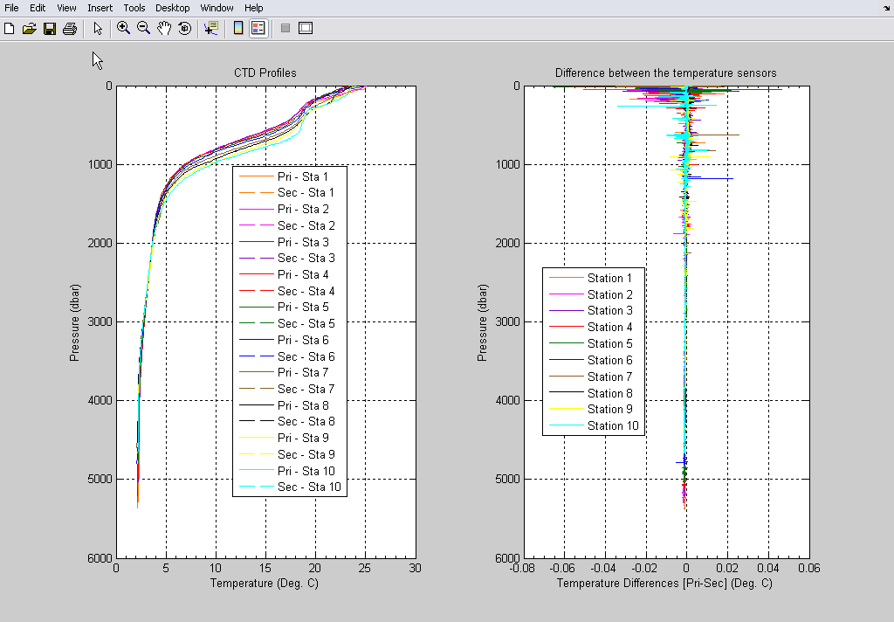

Merging CTD Data with the Bottle Samples

Procedures for Autosal Files

- Folder structure

Under the "cruiseid" folder we recommend, at least, the following folders:
-raw_data : copies of the files generated by the Seasave (acquisition program);
-bottle: destination for the .btl files generated by the CTD processing batch;
-proc_data: destination for the .cnv files generated by the CTD processing batch;
-oxy : copies of the .oxy files created by the oxygen titration program
-salts: copies of the files associated with salinity samples.

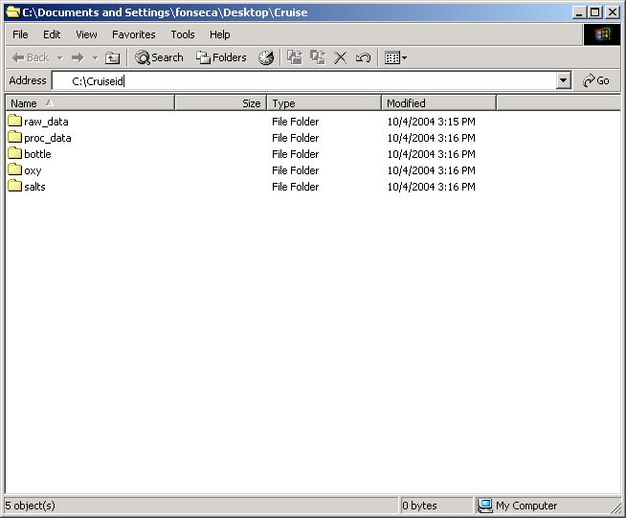

Inside the salts folder we recommend two other folders:
- drift_correction: destination for the files created by the autosal correction m-files;
- original: copies of the files created by the autosal interface.

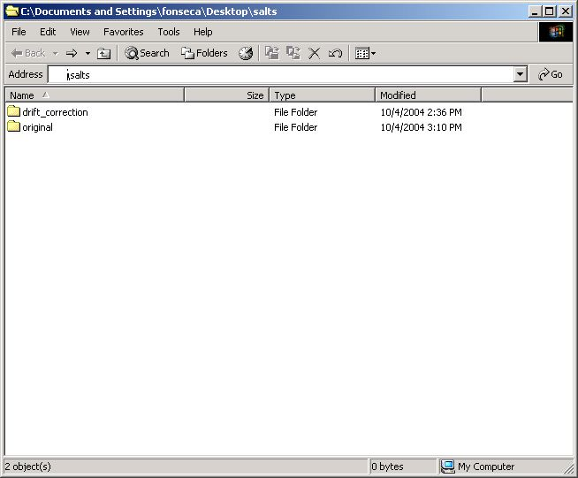

- Autosal files
The survey technician will give you four files (.xls, .dat, .raw and .hdr). usually the files are named like "XXYYZZ" (where XX is the month; YY is the day; and ZZ is the GMT hour). These files should be copied into the original folder inside the salts folder

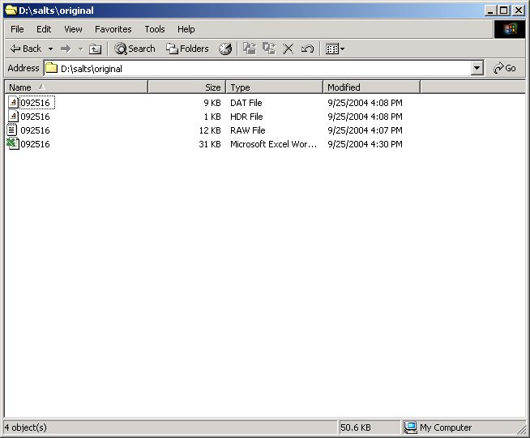

At this point we copy and rename ( if the user thinks it is necessary) the .dat and the .raw files to the drift correction folder. Make sure that the in the "Bottle number" field inside the .dat files you have only numbers (the program is not set to handle alphanumeric bottle numbers). The drift correction folder will have the copies of the .raw and the .dat files as well the m-files necessary to read these files and apply the drift correction for the autosal.

- Reading the autosal files
Start the MATLAB® and go to the drift correction folder.

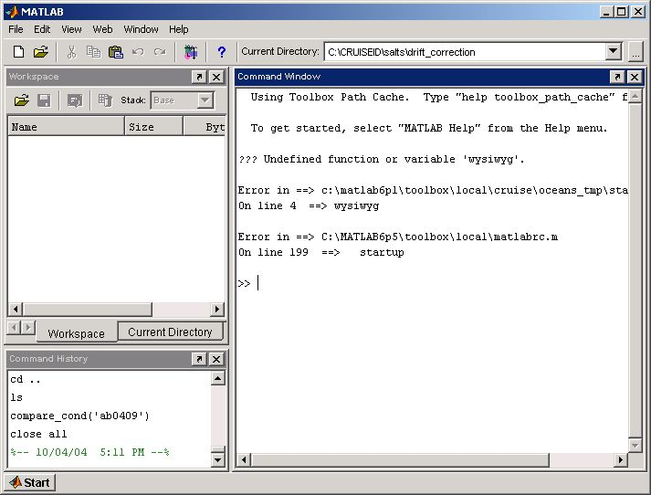

Read the .dat files, in order to do that a m-file was created named read_autosal_dat. The only input argument is the full name of the file (that means file name plus extension, the complete path of the file can be used as well).
Read the .raw files, calling the m-file named read_autosal_raw. The only input argument is the full name of the file (that means file name plus extension, the complete path of the file can be used as well).

- bla bla bla

