Hurricane Intensity Forecasting at NOAA using Envisat Altimetry
John Lillibridge ⁽¹⁾, Nick Shay ⁽²⁾, Mark DeMaria ⁽³⁾, Gustavo Goni ⁽⁴⁾, Michelle Mainelli ⁽⁵⁾, Remko Scharroo ⁽⁶⁾ and Lamar Russell ⁽⁷⁾

⁽¹⁾ NOAA Lab. for Satellite Altimetry, 1335 East-West Hwy. E/RA31, Silver Spring, MD, 20910, USA
⁽²⁾ University of Miami, Rosenstiel School of Marine and Atmospheric Sciences, Miami, FL 33149, USA
⁽³⁾ NOAA Regional and Mesoscale Meteorology Branch, Fort Collins, CO 80523, USA
⁽⁴⁾ NOAA Atlantic Oceanographic and Meteorological Laboratory, Miami, FL 33149, USA
⁽⁵⁾ NOAA National Hurricane Center, Tropical Prediction Center, Miami, FL 33165, USA
⁽⁶⁾ Altimetrics LLC, Cornish, NH 03745, USA
⁽⁷⁾ U.S. Naval Oceanographic Office, Stennis Space Center, MS 39529, USA

ABSTRACT
NOAA's National Hurricane Center (NHC) has operational forecast responsibility for tropical cyclones in the Atlantic and the eastern North Pacific to 140°W. They provide track, intensity and wind structure forecasts out to 5 days, which are updated every 6 hours. NHC has a number of skillful track guidance models, but only a limited number of intensity prediction schemes, and those provide only marginally skillful forecasts. The relatively low skill of the intensity forecasts is due to the complexity of the problem, which involves a very wide range of scales, and interaction with the underlying ocean.
Because of this complexity, the empirical Statistical Hurricane Intensity Prediction Scheme (SHIPS) provides intensity predictions with accuracy comparable to those from the much more complex coupled three-dimensional GFDL hurricane model [1]. The SHIPS model was implemented at the NHC in 1996, and upgraded in 2004 to include upper ocean heat content (OHC) estimated from satellite altimetry as a predictor. OHC is defined as the vertically integrated heat content between the sea surface and the depth of the 26°C isotherm, expressed in kJ/cm². It is believed that hurricane intensification can occur over regions where OHC values exceed 50 kJ/cm², not just in regions of high sea surface temperature [2].
Sea surface height anomalies from altimetry, in combination with SST, are used to estimate OHC via a 2-layer upper ocean model. The OHC analysis is also used subjectively by the NHC forecasters for their official intensity forecast, and is being tested in an experimental mode to improve the ocean initialization of the GFDL hurricane model. The OHC analysis presently incorporates sea surface height anomalies from Jason-1 and Geosat Follow-On. Envisat altimetry is expected to be used routinely in the NHC ocean heat content analysis for the 2007 hurricane season, and testing is now being done to examine the positive impact of adding a third altimetry data set to the model.
Envisat data have been provided to the NHC routinely since 2006, via a Category-1 proposal by NOAA, in collaboration with the U.S. Naval Oceanography Office. Efforts are underway to reduce the latency of the Envisat data being used at the NHC, by switching from the IMAR to the FDMAR products. If successful, the near real-time altimetry from Envisat may also be used by the U.S. Defense Department's Joint Typhoon Warning Center (JTWC), which forecasts tropical cyclones in the western North Pacific, Indian Ocean and the southern hemisphere. The JTWC currently uses an experimental altimetry-based ocean heat content product developed by AOML as input to their typhoon intensity forecasts.

1. OCEAN HEAT CONTENT FROM ALTIMETRY
Early work on the development of tropical cyclones led to the concept of upper ocean heat content as an important quantity in storm intensification. Ocean heat content (OHC) is defined as the anomaly in heat storage between the depth of the 26°C isotherm and the sea surface, Equation 1:
(1)

OHC is estimated using a combination of sea surface height anomalies (SSHA) from altimetry and sea surface temperature (SST) from radiometric measurements provided by AVHRR and TRMM. A two-dimensional baroclinic ocean model is used to estimate the depth of the 20°C isotherm (within the main thermocline) from the SSHA measurements, . This is based on hurricane-season climatologies of the mean depth of the 20°C isotherm and of the mean density difference between the two ocean layers. The depth of the 26°C isotherm is then calculated from the depth of the 20°C isotherm using the climatological relationship between these two depths. Finally, the OHC is computed from the 26C isotherm depth and measured SST values using bulk vertical temperature gradients in the upper layer, from the same hurricane-season climatologies. Further details of this methodology are described in [2].
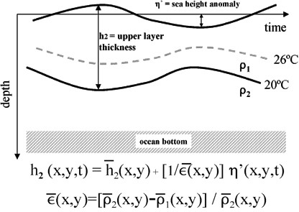

Figure 1. Two-layer model used to calculate depth of 20°C isotherm, h2, from SSH anomaly, . Assuming no motion in the lower layer, variations in h2 about it's mean are scaled by the density difference between layers, 
It has been demonstrated in previous studies [2], [3], that OHC is a more useful quantity than SST alone for predicting hurricane intensification. Of course there are many other factors, such as favorable upper-level wind shear, that will influence the development of a tropical cyclone. But OHC provides a better estimate of the store of heat available to fuel the storm than SST, and is more useful as a forecasting tool since altimetry can ‘see’ regions of high heat content even when SST is nearly uniform in regions such as the Gulf of Mexico, . In this figure the intensification of Hurricane Katrina is observed after crossing regions of high heat content in the Loop Current and a warm core eddy in the Gulf of Mexico, where SST shows no significant warm features.
2. ENVISAT ALTIMETRY FOR OHC
Presently Jason-1 and Geosat Follow-On (GFO) altimetry data are used operationally to create maps of OHC for intensity forecast by the NHC. The Joint Typhoon Warning Center (JTWC), which forecasts tropical cyclones in the Western Pacific, is currently using OHC data based on Jason-1, GFO AND Envisat, but only in an experimental mode. We plan to include Envisat in the blend of altimetry data used by the NHC for the 2007 hurricane season, and are working to get OHC into operations by the JTWC.
The Univ. of Miami group has made an assessment of the benefit of including Envisat data by comparing altimetric OHC to in situ observations based on XBT and CTD temperature profiles in the Gulf of Mexico, . The in situ measurement of OHC, D20, and D26 are shown by the color filled background, compared to the altimetry estimates shown by the black contours. The upper panels, based on Jason-1 and GFO, are then compared to the potential improvement by the addition of Envisat altimetry in the lower panels.
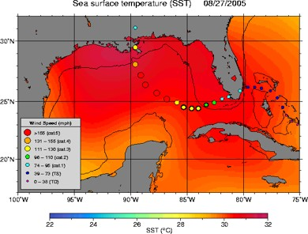
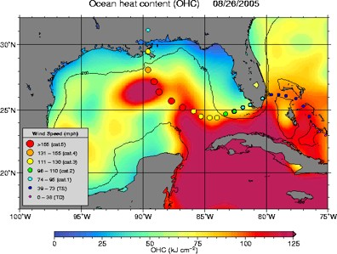
Figure 2. Comparison of fields of SST (top) vs. OHC (bottom) on 26/27-Aug-2005 during the passage of Hurricane Katrina. The SST field is nearly uniform in late summer, and doesn't reveal the Loop Current and warm core eddy features seen in OHC. These features were associated with Katrina’s growth to a Category-5 storm.
Although there are some areas where the combination of three altimeters improves the agreement with in situ data, the incremental gain is generally not large. We believe this is due to using a 1-cyle 35-day averaging window for the Envisat data. More careful study is required, for example with 10-day or ½-cycle 17-day averaging windows, to maximize the additional sampling provided by Envisat.
However, the present situation of using only GFO and Jason-1 data has already degraded greatly. The batteries on GFO, launched in 1998, have essentially reached their end-of-life and can no longer sustain the radar altimeter when the satellite is in the eclipse portion of each orbit. Thus we are now in a “1-1/2” vs. 2-satellite situation and should therefore be relying more heavily on Envisat data to augment the reduced GFO operations.
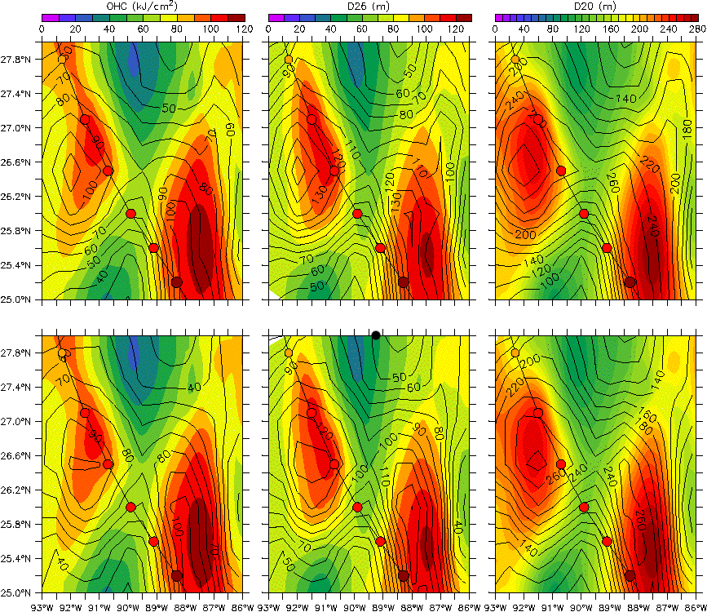

Figure 3. Fields of OHC (left), 20°C isotherm depth (middle) and 26°C isotherm depth (right) based on in situ XBT and CTD surveys (in color) compared to altimetry (black contours) from a survey in the Gulf of Mexico prior to Hurricane Rita. The upper panels are based on Jason and GFO, while the lower panels use Jason, GFO, and Envisat. There is a slight improvement from the addition of Envisat altimetry to the fields.

3. OHC AND INTENSITY FORECASTING
At the NHC, hurricane forecasters avail themselves of a variety of information to help predict the evolution of both the track and intensity changes in hurricanes. Here we illustrate three primary uses that benefit from the inclusion of the altimetric OHC fields: a statistical intensity model; a coupled hurricane/ocean dynamical model; and qualitative use of the OHC maps themselves by the forecasters.

3.1 The SHIPS & STIPS models
The Statistical Hurricane Intensity Prediction Scheme (SHIPS) model [1], uses several input “predictors” to forecast intensification. Notably the predictors include SST, as well as many relevant meteorological parameters. In 2004 altimetric OHC was added as a predictor in the operational model at the NHC, and there was an improvement in the forecast skill. The performance improvement in SHIPS is expressed as a percentage reduction of error in the maximum surface wind speed observed in a large sample of storms. For example, if the observed wind speed was 100 knots, and the SHIPS forecast was for 50 knots before, and 60 knots after, the addition of OHC the error would be reduced from 50 knots to 40 knots representing an improvement of 20% (10 knots out of the 50 knot error).
In Figure 4 the improvement to the statistical model, after including OHC, is shown as a function of forecast lead time. This is based on a sample of 3072 Atlantic tropical cyclone forecasts, as well as a smaller sample of 311 tropical cyclone forecasts in the W. Pacific from experimental runs of the JTWC STIPS model. The improvement is on the order of a few percent, but generally increases for longer lead times. It appears that the model is more effective for the Pacific storms, but a larger sample of forecasts is needed to confirm this.
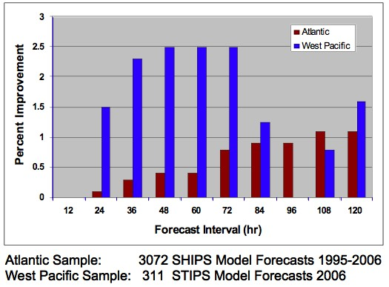
Figure 4. Increase in skill of SHIPS with the inclusion of OHC, expressed as a percent decrease in maximum wind speed error, as a function of forecast interval lead time. The N. Atlantic samples, from 3072 storms, show a small but significant improvement of about 1%, with more improvement at longer lead times. A smaller sample of 311 storms in the W. Pacific shows a larger improvement at short forecast intervals from the STIPS model.
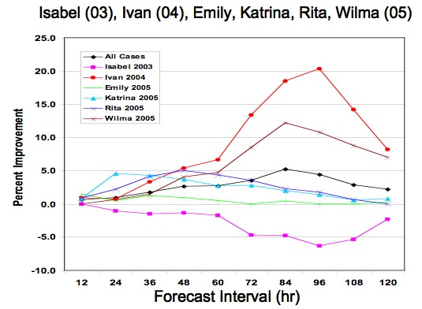

Figure 5 Improvement in SHIPS forecast for individual Category-5 hurricanes from 2003-2005, as a function of forecast interval. For these large hurricanes, the role of OHC has a much larger impact of 5-20% for several storms. Wilma was the only storm where SHIPS performed worse when OHC was included. Hurricane Ivan showed the greatest improvement, reaching 20% for the 96-hour forecast.
Although the improvement from the addition of OHC to SHIPS appears small, percentage-wise, the gains are much greater for Category-5 hurricanes during the 2003-2006 hurricane seasons, . The only Category 5 storm whose intensity forecast wasn’t improved was Isabel. The remaining Category-5 storms showed improvements of several percent, as great as 20% increase in skill for Ivan’s 96-hour forecast.
Tropical cyclones in the W. Pacific are forecast by the Joint Typhoon Warning Center (JTWC). The JTWC is running an experimental version of its Statistical Typhoon Intensity Prediction Scheme (STIPS), which includes OHC input, in parallel to its operational model running without the altimetric predictor [4].
In a recent, preliminary, study by the Naval Research Laboratory, the skill of STIPS forecast was assessed for cases where typhoons tracked crossed the ‘cold wake’ formed by the passage of a previous typhoon (B. Sampson, 2007, personal communication). The air-sea interaction and mixing associated with tropical cyclones creates these cold wakes, but in many cases the wake’s SST signature quickly disappears. The loss of OHC from the passage of an earlier typhoon, however, impacts subsequent typhoons which pass over the wake, where they are robbed of heat energy to fuel them. In fact, the intensity forecasts for these ‘cold-wake’ typhoons is appreciably better when OHC is used in STIPS, Figure 6. The improvement in the STIPS intensity forecasts is in the range of 6-8%, vs. a typical rate of 1-2% for all the W. Pacific storms analyzed. Although this analysis is based on a small sample size (N=39) it shows a promising and potentially important benefit of the inclusion of OHC.
3.2 The Coupled GFDL/Princeton Hurricane Model
An independent intensity prediction model that is run by NCEP for NHC is based on the coupled GFDL atmospheric and Princeton ocean models. This is a purely dynamical (vs. statistical/dynamical) coupled model whose ocean state is initialized with climatological conditions. Recent work my Isaac Ginis, Univ. of Rhode Island, has demonstrated that OHC fields can be used to initialize the ocean model, resulting in much more realistic mesoscale features, such as the Gulf of Mexico Loop Current and associated warm core eddies, .
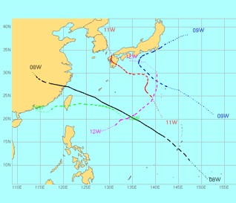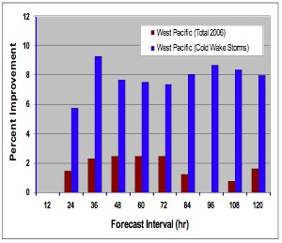
Figure 6. Analysis of "Cold Wake" typhoons from the W. Pacific 2006 season. The tracks of typhoons 8W-12W (top) show the storms crossing the tracks of earlier typhoons. The improvement in the STIPS model intensity forecasts (bottom) illustrate that the inclusion of OHC which retain cold wake features is significantly greater than the averages over all 2006 typhoons.
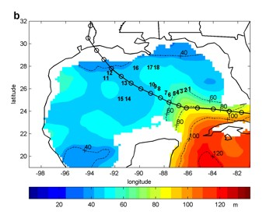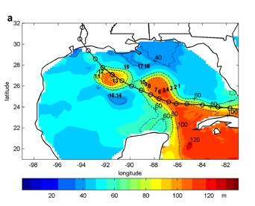
Figure 7. Depth of the 26°C isotherm from the GFDL coupled model before assimilation (top) and after assimilation (bottom) of OHC from altimetry. The overlaid track of hurricane Rita shows that the storm passed over regions of high OHC, that were not reflected in the present operational ocean model, which is initialized with climatological OHC values.
This example, from Hurricane Rita in 2005, shows that the climatological initialization doesn’t capture the mesoscale OHC features that fueled the intensification of Rita. The model initialized with OHC fields will properly drive the coupled atmospheric hurricane model, resulting in improved performance.
The improvement from assimilating OHC is shown in , in terms of the time series of minimum atmospheric pressure observed during hurricane Katrina. The observed values dropped to nearly 900 mbar on Aug. 15th, 2005, while the standard coupled model predicted a minimum pressure of only 930 mbar a day later. By assimilating OHC into the coupled model, the proper timing of minimum pressure was predicted, with a minimum value of 915 mbar, closer to the observed value.
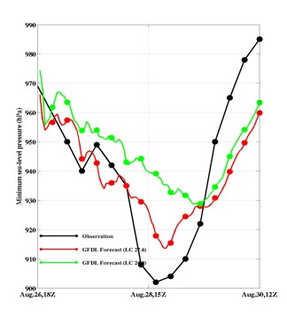
Figure 8. Time history of minimum surface pressure along the track of Hurricane Katrina. Observed values are in black, GFDL model predictions without OHC assimilation are in green, and GFDL model with OHC assimilation are in red. The addition of realistic OHC structure as seen in results in better timing as well as minimum pressure in the forecast with OHC assimilated.

3.3 Qualitative use by Hurricane Forecasters
Hurricane forecasters at the NHC rely on a variety of information to help guide their intensity predictions. When 10’s or 100’s of thousands of lives may be impacted, for example by a call to evacuate, it is imperative that they receive the best available information in a timely fashion. The same fields of OHC that are used as predictors in SHIPS, and which can be assimilated to improve the dynamical hurricane models, are utilized by forecasters [5] in their original mapped form (e.g. ).
This usage, though subjective by nature, should not be underestimated in it’s benefit to intensity forecasting. The following quotes from forecasters demonstrate how the OHC fields help guide them:
Katrina - “Katrina is expected to be moving over the Gulf of Mexico Loop Current after 36 hours, which when combined with decreasing vertical shear, should allow the hurricane to reach category four status before landfall”.
“This pattern in combination with the high oceanic heat content … along the path of Katrina calls for additional strengthening”.
Rita - “The environment is conducive for strengthening and Rita, as Katrina did, will be crossing the Loop Current or an area of high heat content within the next 12 hour or so. This would aid the intensification process”.
“The intensity forecast is based on the premise that the shear and reduced outflow will cause a gradual weakening, especially after Rita moves west of the Loop Current.”
Ivan - “Thereafter the hurricane will be over the northwestern Caribbean Sea where there is high oceanic heat content and lower shear. So, Ivan is expected to intensify before reaching Cuba”.
4. REDUCING THE LATENCY OF ENVISAT OHC
Presently, the blended fields being used to compute heat content at the NHC and JTWC are based on Envisat IMAR data, which has a typical latency of 3-4 days. Having the most up to date information on the ocean’s mesoscale structure will benefit intensity forecasts, so we are attempting to include the Envisat FDMAR data, with a latency of several hours to a day, into the SSHA analysis. This study is based on three recent, complete cycles of FDMAR data, Cycles 54-56: 18-Dec-2006 to 02-Apr-2007.
Recent improvements to the Envisat ground segment‘s processing software eliminated issues that previously hampered the use of FDMAR data:
- USO anomaly correction files were routinely made available to users on 28-Jul-2006. It is essential to correct the ~5.5 m bias, and tens of cm of around-orbit variation in height, associated with the anomaly.
- Instrument Processing Facility (IPF) Version 5.03, released 18-Sep-2006, finally implemented the ‘peakiness’ parameter in the FDMAR data, providing a desirable edit criteria for height data affected by sea ice or rain.
- Also in IPF 5.03, a status flag to indicate the quality of the real-time orbits in each 1-Hz FDMAR data record was added: bit #27 of the Measurement Confidence Data (MCD).
This last point, regarding orbit quality, represents the final major hurdle to overcome. The FDMAR includes orbits from the on-board DORIS system’s real-time DIODE processor [6]. When DIODE orbit data are unavailable, due either to instrument or ground segment processing difficulties, a crude state-vector propagator orbit is used as a fall-back. In this case bit #27 of the MCD is set to zero; when the DORIS/DIODE orbits are available bit #27 is set to one.
Our initial analysis of Cycles 54-56 shows an unexpectedly large amount of degraded data, where the propagator orbit is present rather than the higher accuracy DIODE orbit, . Here the ascending and descending passes are plotted separately, illustrating that there are persistent ‘patches’ where the DIODE data are missing, as well as a large number of full passes based on the degraded propagator orbits. The indicated percentages of good data are in the range of only 60-65 percent for cycles 55-56, and even lower in cycle 54 (presumably due to other data availability issues in the ground segment).
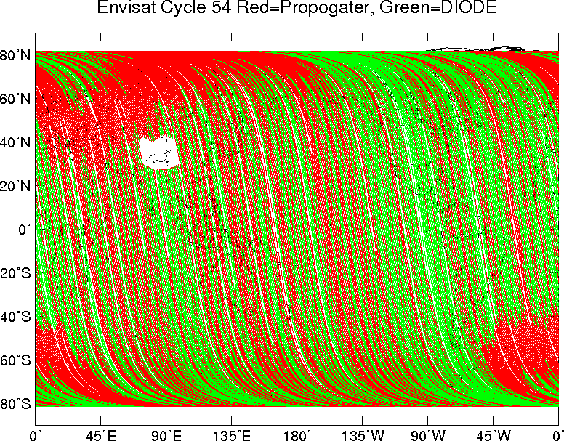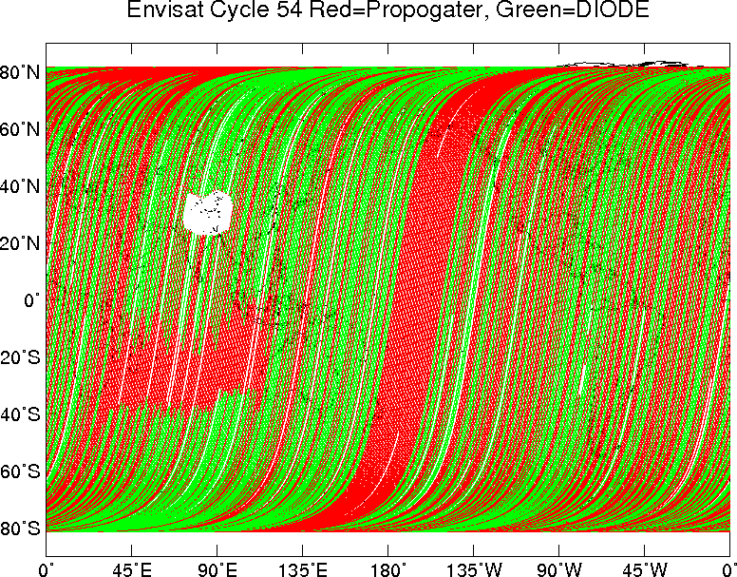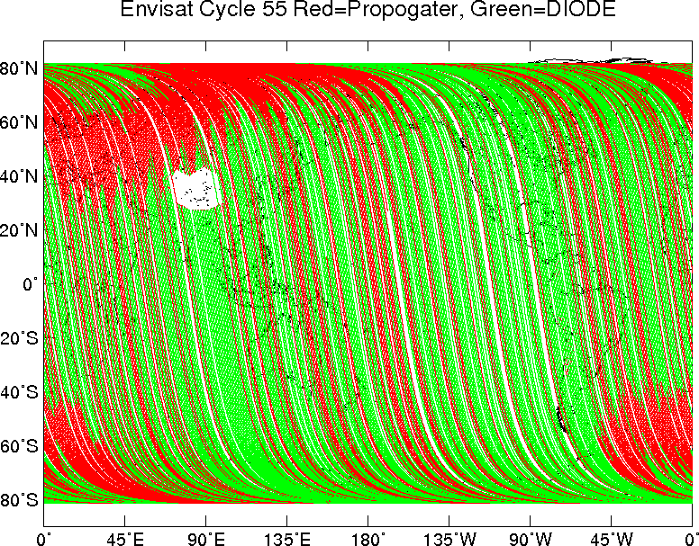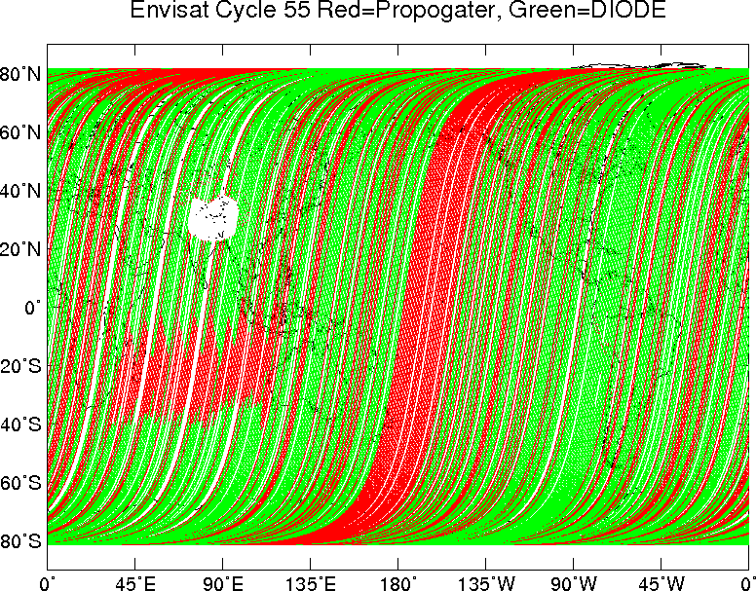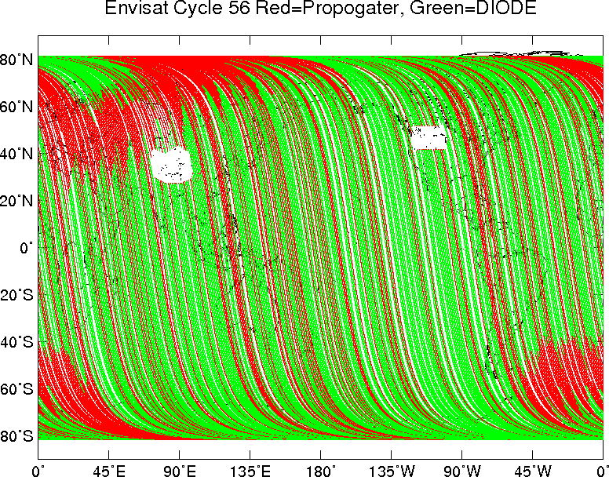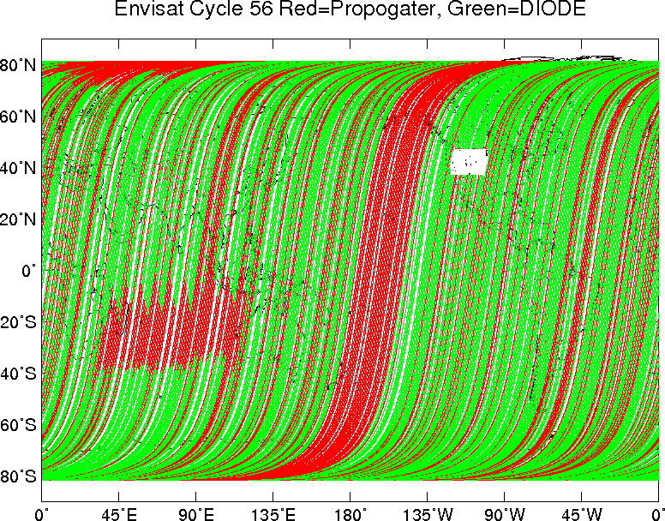

Figure 9. Distribution of real-time orbits for Envisat Cycles 54 (top), 55 (middle), and 56 (bottom) for ascending passes (left) and descending passes (right). The red points have orbits from the crude state vector propagator, while the green points are those based on the DORIS/DIODE onboard system. The white areas are where the RA-2 performs a calibration mode.
It is hoped that the full passes of missing DIODE data, at least, can be rectified in the next upgrade to the IPF. The ‘patches’, however, are apparently due to an inherent, single-source-packet delay between the altimetry and DIODE data within the telemetry, and this will not be easy to solve. (P. Femenias, personal communication).
To assess the level of radial orbit error present in the FDMAR data, we have differenced the orbital heights found on the IMAR data (based on DORIS Medium-precision orbits) with the orbits found in the FDMAR data, from DIODE, Figure 10. As expected from the technical specifications for the DIODE system, the orbit differences have an amplitude of roughly 30 cm and are dominated by once and twice-per-revolution variations. This level of orbit error does NOT present a problem for the routine processing of the SSHA fields done at the Naval Oceanographic Office (NAVO) who supply the SSHA fields to the NHC. The data based on propagator orbits, with typical error on the scale of meters, are very problematic and likely won’t be used.
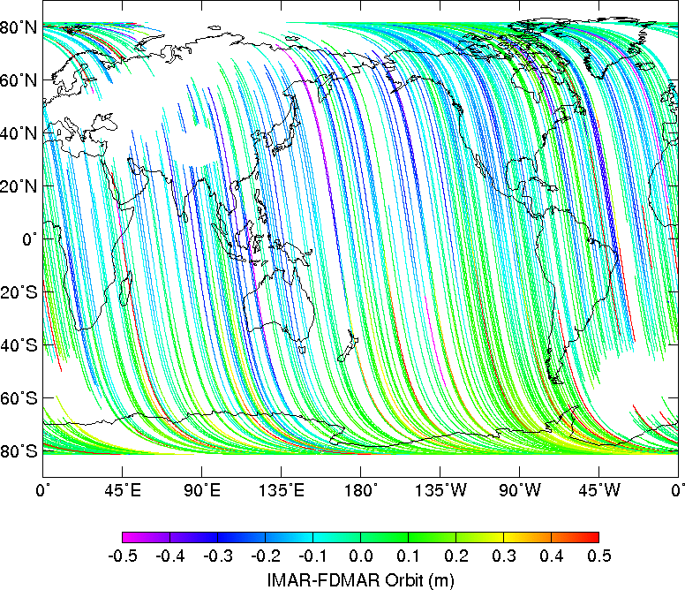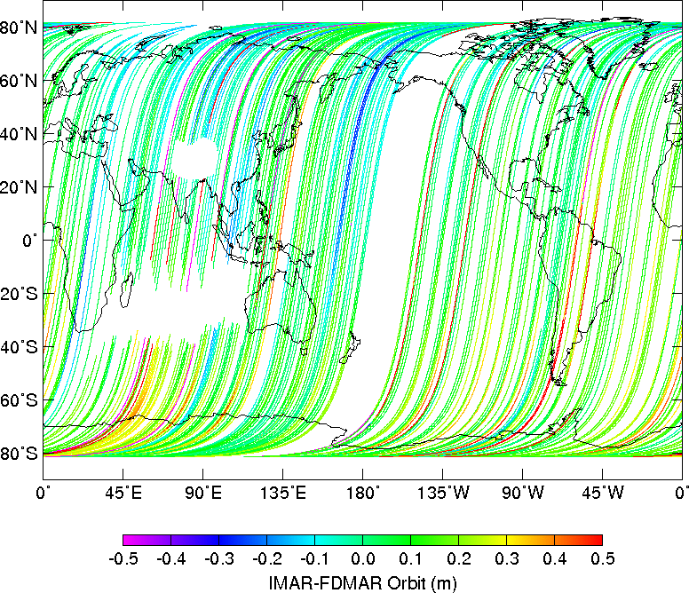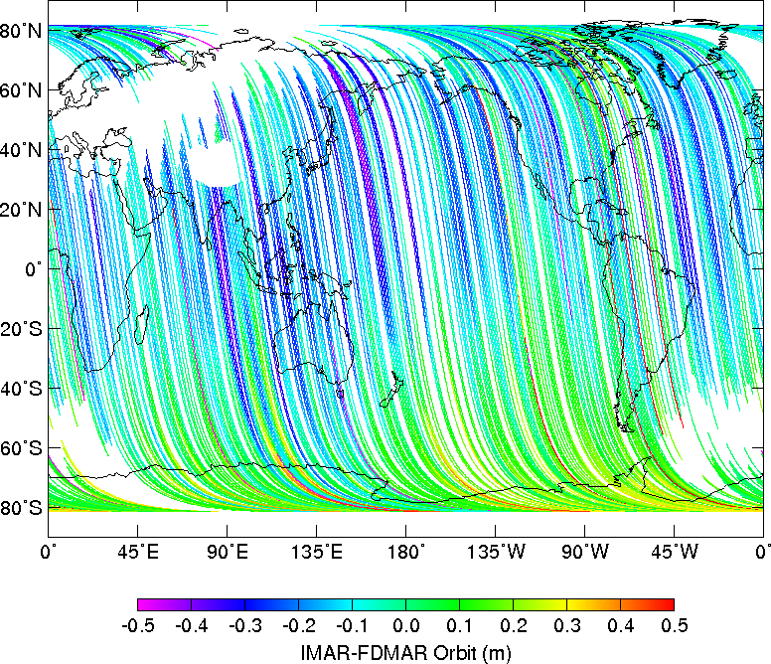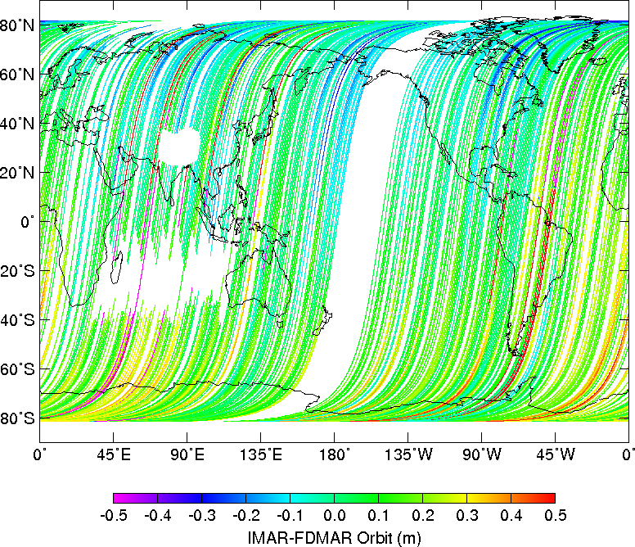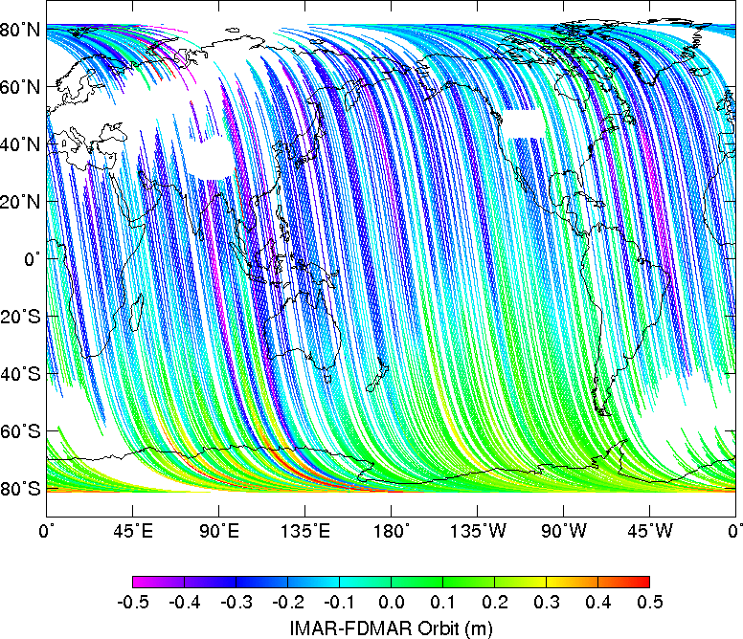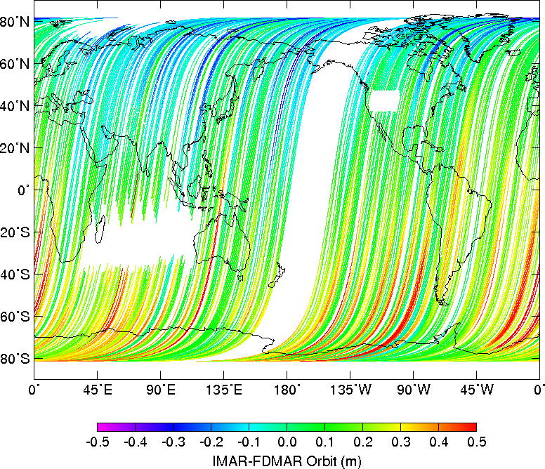
Figure 10. Differences in orbital altitude between the IMAR MOE orbits and FDMAR DIODE orbits. Points based on the propagator orbits in the FDMAR are excluded. The differences are attributed to radial orbit error in the DIODE orbits with a level of 20-30 cm, and have the expected once-per-revolution structure in each pass.

5. CONCLUSIONS
Altimetry provides a valuable tool to produce global maps of upper ocean heat content. Fields of OHC improve the forecast skill of both statistical models, such as SHIPS, and coupled dynamical models that are used operationally for tropical cyclone intensity forecasts. OHC seems to be particularly effective when forecasting large storms over regions of OHC in excess of 50-60 kJ/cm². And ‘cold-wake’ cyclones, which cross regions of low OHC due to previous storms, appear to benefit even more from the inclusion of OHC in the statistical models.

Reducing the latency of Envisat altimetry data would benefit from improved processing of the Fast Delivery products. Specifically by applying the USO corrections in the ground segment and most importantly by increasing the percentage of passes based on DIODE orbits. In the next several months we plan to include FDMAR data in the routine altimetry processing at NAVO, which will become part of the data flow to the NHC. Although slight improvement in the OHC fields results from the addition of Envisat data, it is particularly important that it be included as Geosat Follow-On continues to deteriorate.

6. REFERENCES
[1] DeMaria, M., M. Mainelli, L.K. Shay, J.A. Knaff and J. Kaplan, 2005: Further Improvements in the Statistical Hurricane Intensity Prediction Scheme (SHIPS). Weath. Forecasting, 20, 531-543.

[2] Shay, L. K., G. J. Goni, and P. G. Black, 2000: Effects of a Warm Oceanic Feature on Hurricane Opal. Mon. Weath. Rev., 128, 1366-1383.

[3] Scharroo, R., W. H. F. Smith, and J. Lillibridge, 2004: Satellite Altimetry and the Intensification of Hurricane Katrina. EOS Trans. AGU, 86(40), 366-367.

[4] Knaff, J.A., C.R. Sampson, and M. DeMaria, 2005: An Operational Statistical Typhoon Intensity Prediction Scheme for the Western North Pacific. Weath. Forecasting, 20, 688-699.

[5] Mainelli, M., M. DeMaria, L.K. Shay, and G. Goni, 2007: Application of oceanic heat content estimation to operational forecasting of recent Atlantic category 5 hurricanes. Accepted, Weath. Forecasting.

[6] Willis, P., C. Jayles, and Y. Bar-Sever, 2006: DORIS: From orbit determination for altimeter missions to geodesy. C.R. Geoscience, 338, 968-979.

7. DISCLAIMER
The views, opinions, and findings contained in this report are those of the authors and should not be construed as an official National Oceanic and Atmospheric Administration or U.S. Government position, policy, or decision.

