In section 7.

For uses of multiple platforms:

For climate studies, TSG observations are important along fixed transects, as they allow investigating long term variability. TSG instrumentation is usually installed in support of studies of pCO2 inventories, where sometimes XBTs are also deployed to better identify the depth of the mixed layer. Within this context, TSG transects should be recommended where (usually meridional) pCO2 transects are carried out. In addition, TSG observations are usually carried across regions where surface temperature observations alone may not exclusively help identify current fronts or eddies. This type of observations is commonly done in support of fish stock assessment studies. Additionally, TSG observations will be beneficial at high latitudes for validation of data from upcoming satellite surface salinity missions.

Figure

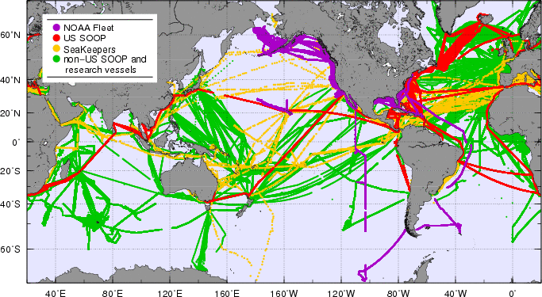
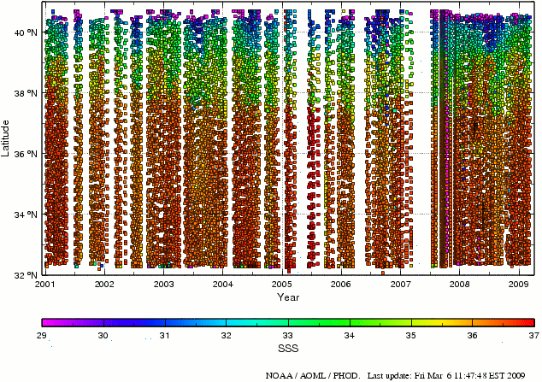
Fig. 1: (left) TSG observations transmitted into the GTS and to the Coriolis data center (http://www.coriolis.eu.org/) during the period 2003-2009. (right) Sea surface salinity obtained from the TSG installed in the M/V Oleander from 2001-2009, across the transect New Jersey-Bermudas.[I promise better pictures for after the revision].

