Tropical Cyclone Heat Potential – G. J. Goni and J. Knaff

Tropical cyclones (TC) occur in seven regions in all ocean basins: tropical Atlantic, northeast Pacific, northwest Pacific, southwest Indian, north Indian, southeast Indian, and south Pacific. The intensification of TCs includes the interaction of very complex mechanisms that include TC dynamics, upper ocean interaction and atmosphere circulation. The influence of the upper ocean thermal structure on TC intensification, the focus of recent studies, is one of these physical processes. While sea surface temperature (SST) plays a role in the genesis of TCs, the ocean heat content contained between the sea surface and the depth of the 26°C isotherm, also referred as Tropical Cyclone Heat Potential (TCHP), has been shown to play a more important role in TC intensity changes (Shay et al., 2000). The TCHP shows high spatial and temporal variability associated with oceanic mesoscale features. TC intensification has been linked with high values of TCHP contained in these mesoscale features, particularly warm ocean eddies, provided that atmospheric conditions are also favorable. Therefore, resolving the upper ocean mesoscale field is critical to monitor the TCHP. Since sustained in situ ocean observations cannot resolve global mesoscale features and their vertical thermal structure, different indirect approaches and techniques are used to estimate the TCHP. Sea surface height observations derived from satellite altimetry, a parameter that provides information on the upper ocean dynamics and vertical thermal structure, can resolve these features. In general, the real-time forecast of TC intensity is highly dependant on track forecast and many of the errors introduced in the track forecast are translated into the intensity forecast. Clearly, areas with high values of TCHP may be important only when TCs travel over them.

The TCHP anomalies are computed during the months of TC activity in each hemisphere: June through November in the northern hemisphere and November through April in the southern hemisphere. Anomalies are defined as departures from the mean TCHP obtained for the same months from 1993 to 2008. These anomalies show large variability within and among the basins (Fig. 1)

In the Pacific Ocean the largest anomalies showed the signature of the negative phase of the 2007 ENSO event (La Nina). The West Pacific and South Pacific basins showed positive anomalies only. The North Indian basin exhibited positive values in the Arabian Sea and negative values in the Bay of Bengal. In the mean, the Gulf of Mexico and the tropical Atlantic exhibited small positive anomalies. Nevertheless, within the tropical Atlantic the anomalies were positive (negative) to the south (north) of approximately 25ºN.
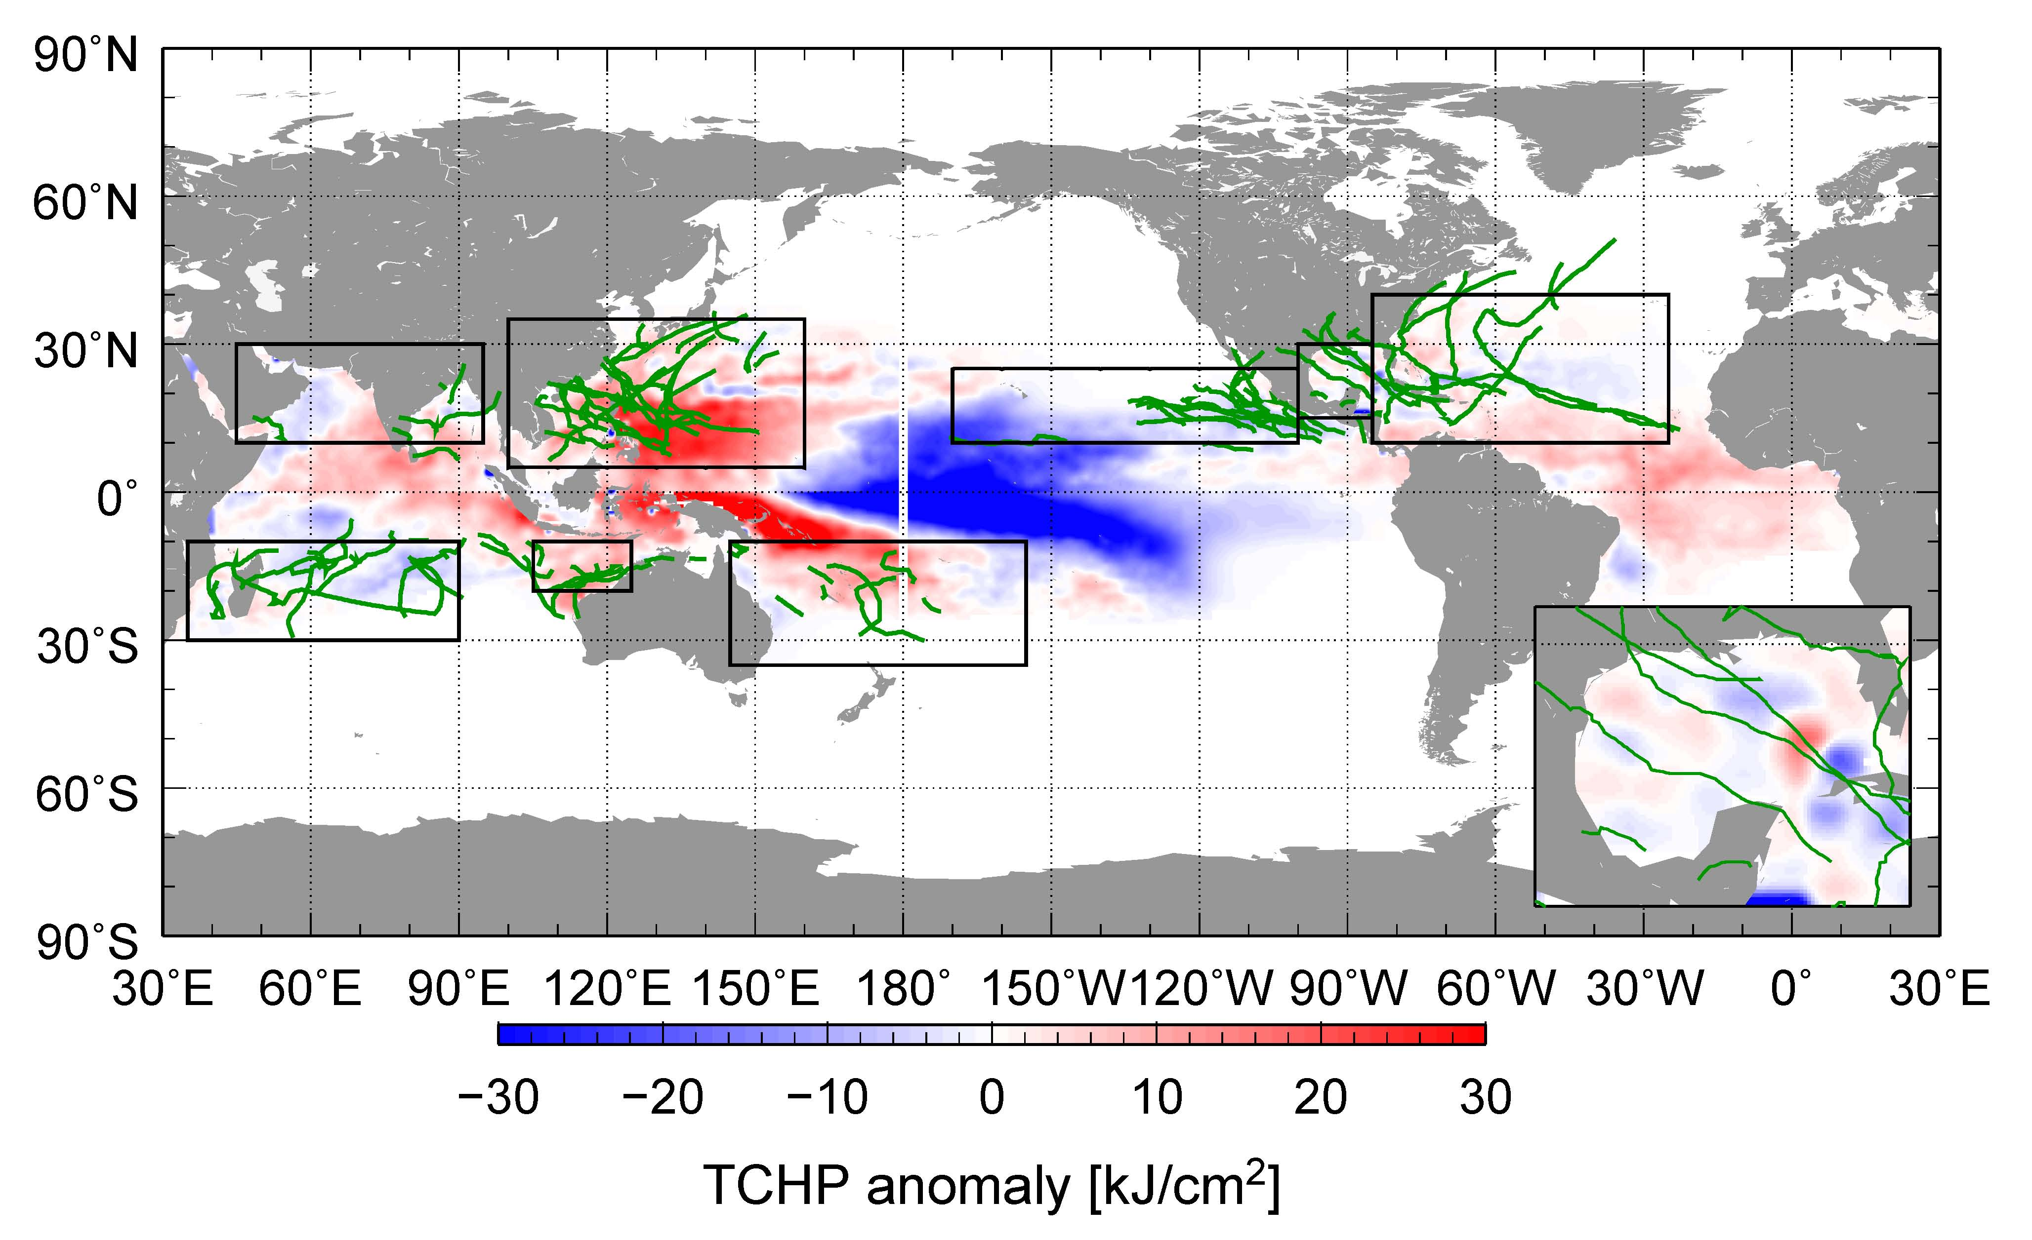
Fig. 1. Global anomalies of TCHP corresponding to 2008 computed as described in the text. The boxes indicate the seven regions where TCs occur: from left to right, Southwest Indian (SWIND), North Indian (NIND), West Pacific (WPAC), Southeast Indian (SEIND), South Pacific (SPAC), East Pacific (EPAC), and North Atlantic (shown as Gulf of Mexico (GOM) and tropical Atlantic (TATL) separately). The green lines indicate the trajectories of all tropical cyclones category 1 and above during November 2007-April 2008 in the southern hemisphere and June-November 2008 in the northern hemisphere. The Gulf of Mexico is shown in detail in the insert shown in the lower right corner.

Several TCs were identified to have gained strength when traveling into regions of very high values of TCHP. Some examples of these intensification events are shown in Fig. 3.10. The results presented here correspond to three intense (category 4 and 5) TCs, where the location of their intensification coincided with an increase of the values of TCHP along their tracks. Additionally, the cooling associated with the wake of the TCs is important since it influences the upper ocean thermal structure on regional time scales within weeks to months after the passage the cyclones. These TCs were Gustav in the Gulf of Mexico, Ike in the Caribbean Sea, Sinlaku in the western Pacific, Nargis in the northern Indian, and Ivan in the southwest Indian region.

Hurricane Gustav, AL072008, 125 kt, hit Cuba, went over some of the highest values of TCHP west of Jamaica.

Hurrican Ike,

Typhoon Sinlaku, WP152008, 125 kt, hit Taiwan, has a peak over high TCHP, weakens over a cold eddy and re-intensifies. (best case).
Tropical Cyclone Nargis, IO012008, 115 kt (probably will stronger in the final best track), hit Myanmar (Burma), went over a very warm region, while forecast over a much cooler region. Big storm surge.

Tropical Cyclone Ivan, SH182008, 115 kt, hit Madagascar, tracked across the warmest TCHP on its way to landfall.

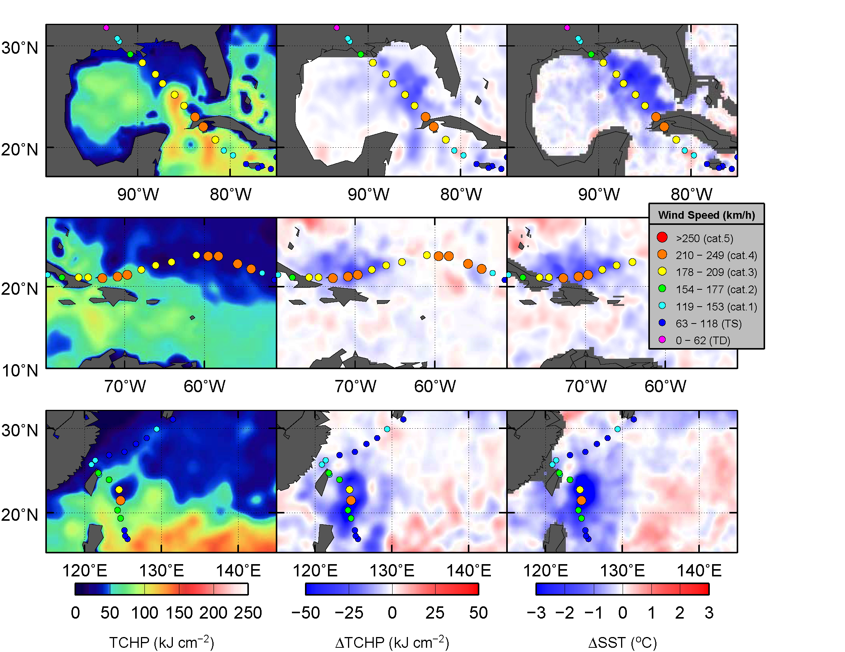

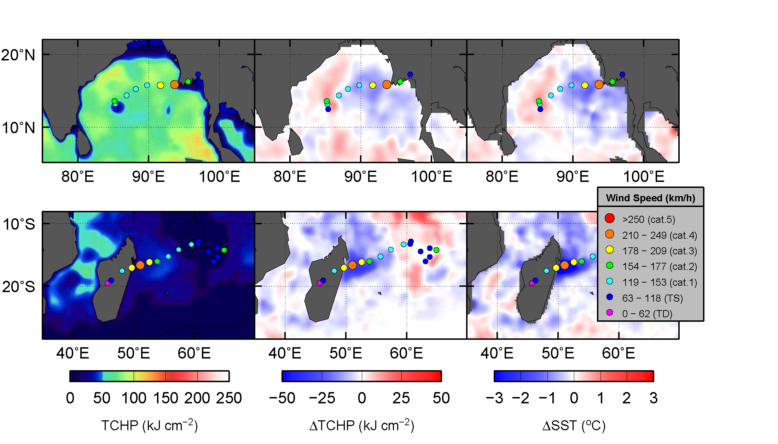

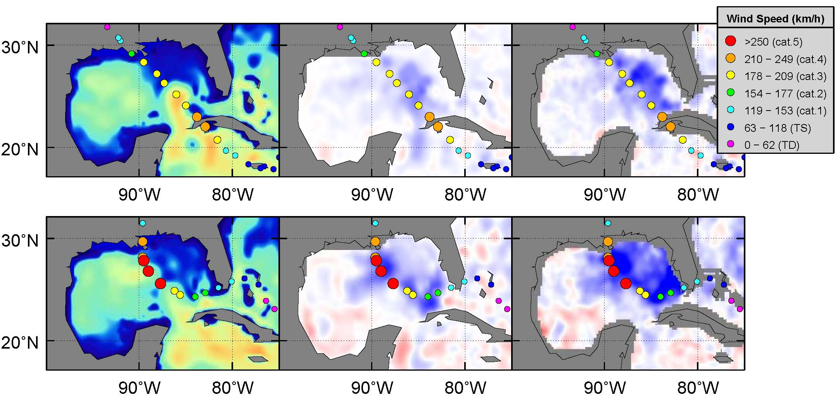
Would we like to include a comparison between Katrina and Gustav ? (figures above)

