The AOML Physical Oceanography Division (PhOD) Ship of Opportunity Program (SOOP) successfully completed four High Density (HD) AX10 XBT cruises during 2008, deploying almost 450 Expendable Bathythermograph (XBT) probes. This XBT transect runs from Newark, NJ, to Puerto Rico and collects information about the thermal structure in the North Atlantic Ocean, of great importance in the study and monitoring of the Gulf Stream. During the October and December transects, Pedro DiNezio and Francis Bringas of PhOD tested a new system for real-time data transmission based on the Iridium satellite network. The AOML SOOP is exploring a transition from the Inmarsat transmission system, currently in use, to Iridium, which could potentially translate into large savings for NOAA. The Iridium software was developed by Janet Roseli and Paul Chinn, and the hardware by Pedro Pena and Andrew Stefanick all of PhOD.

In December, Francis tested a new auto-launcher and a new version of the SEAS program designed to operate with different types of XBTs, with the goal of carrying out additional tests during upcoming 2009 transects. The new auto-launcher allows the deployment of XBT probes capable of collecting temperature profiles to a depth of 1800 meters, and will ultimately be used in the zonal transects across the North and South Atlantic. This new autolauncher was designed by Ulises Rivero and David Bitterman of PhOD.

Sommyr Pochan of PhOD recently travelled the AX07 transect from Barcelona, Spain, to Fort Lauderdale, FL, deploying 195 XBTs, 3 sea surface drifters and 4 ARGO floats during her 15 day voyage on the Hapag-Lloyd Veracruz Express. The Veracruz Express is a longstanding SOOP partner, welcoming HD riders for trans-Atlantic observations since 2005. This was the 53rd realization of AX07. Sommyr is the first AOML female to perform a solo HD XBT Atlantic crossing and joins the ranks of solo female riders already performing HD transects in other ocean basins.

XBT data obtained during these cruises and other SOOP projects are transmitted in real-time and received by AOML staff in Silver Spring, MD, transmitted to AOML to be quality controlled, and finally disseminated through the Global Telecommunication System (GTS) in Silver Spring. More than 3000 XBTs were deployed in the Atlantic during 2008, together with 30 drifters and 12 profiling floats.

SOOP is supported by both the World Meteorological Organization and the Intergovernmental Oceanographic Commission. NOAA/AOML is its main contributor and plays a role in the acquisition, deployment, and data transmission of 90% of the approximate 25,000 XBTs deployed annually to obtain temperature profiles from the sea surface down to various depths starting at 800m. Information about SOOP can be found at www.aoml.noaa.gov/phod/goos/.

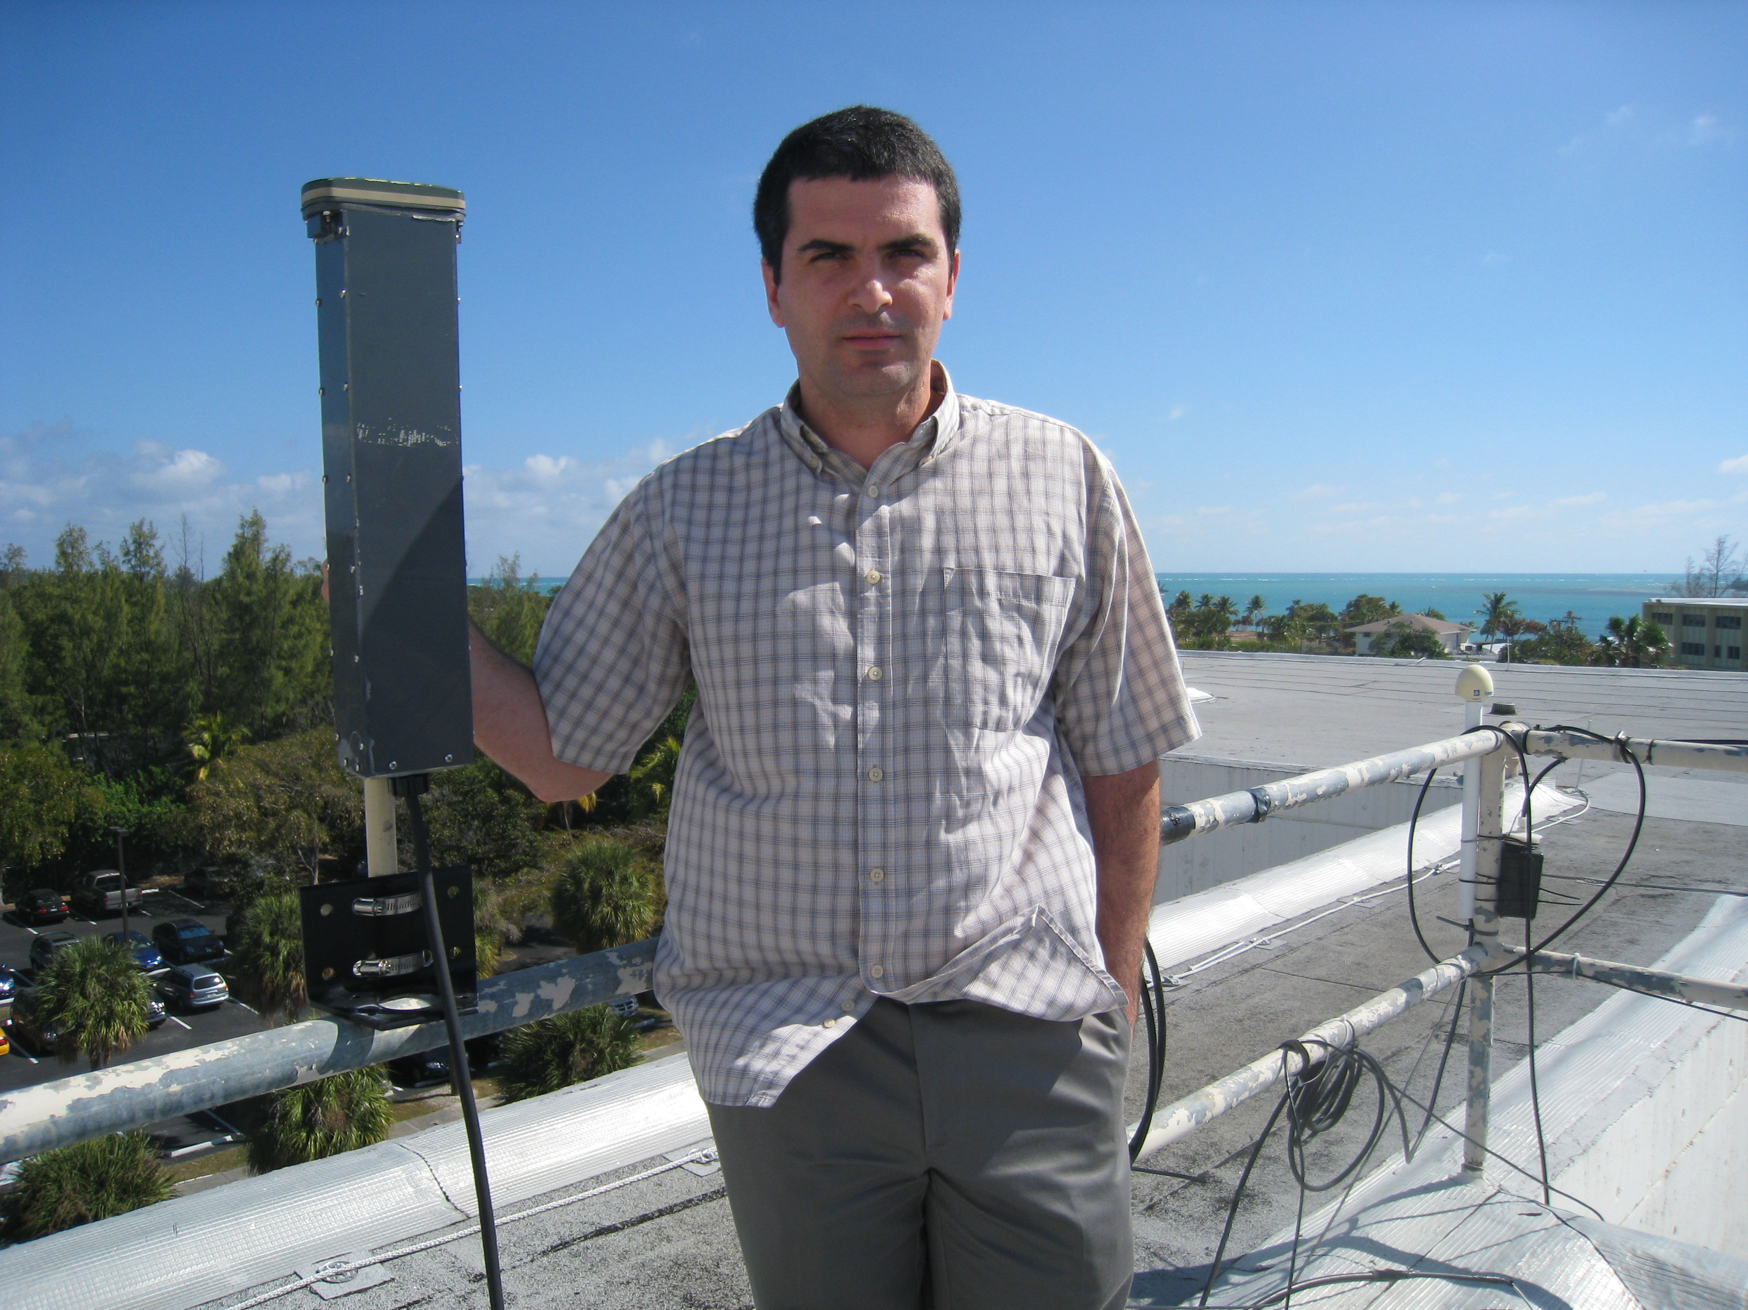
Francis Bringas with the Iridium antenna and modem package, built at AOML.

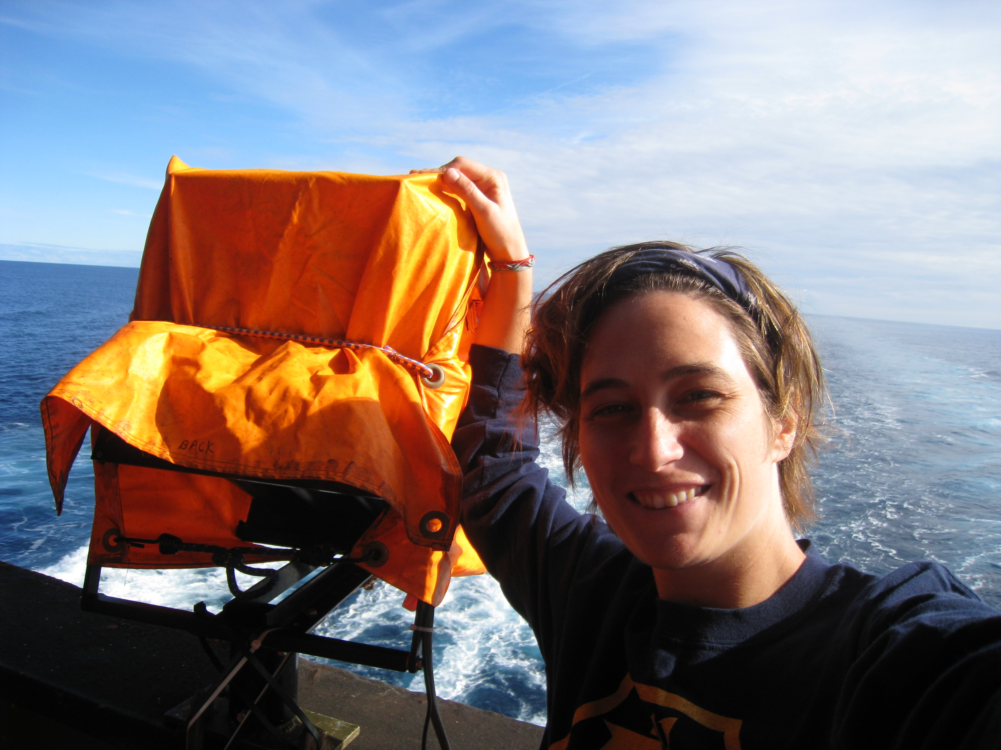
High Density Autolauncher with Sommyr Pochan

