IV-4.2 Observing Other Ocean Variables

Ships of the Ship Of Opportunity Program are not used only as a platform for XBT deployments, but also for the deployment of surface drifters and profiling floats, and to install pCO2 instrumentation, Acoustic Doppler Current Profiler (ADCP), and ThermoSalinoGraphs (TSGs).

Thermosalinographs (TSGs) are instruments mounted close to the water intake of ships to continuously measure the sea surface salinity (SSS) and temperature (SST) along the track of the ship. Data obtained from TSGs have demonstrated to be important in the studies of water mass formation, ocean front variability, pCO₂ dissolved in sea water, and ENSO forecast studies, and fisheries. For climate studies, TSG observations are important along fixed transects, as they allow investigating long term variability. TSG instrumentation is usually installed in support of studies of pCO2 inventories, where sometimes XBTs are also deployed to better identify the depth of the mixed layer. Within this context, TSG transects should be recommended where (usually meridional) pCO2 transects are carried out. In addition, TSG observations are usually carried across regions where surface temperature observations alone may not exclusively help identify current fronts or eddies. This type of observations is commonly done in support of fish stock assessment studies. Additionally, TSG observations will be beneficial at high latitudes for validation of data from upcoming satellite surface salinity missions.

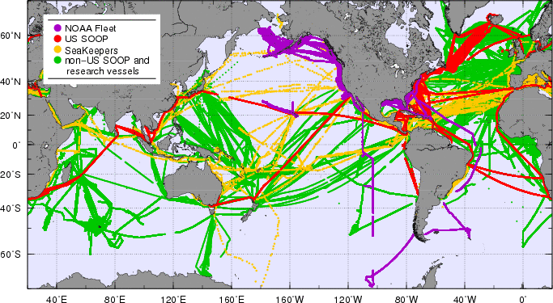

Figure 1. Location of TSG observations transmitted into the GTS and to the Coriolis data center (http://www.coriolis.eu.org/) during the period 2003-2009, for the NOAA fleet (purple), US SOOP (red), Seakeepers (yellow), and non-US ships (green).

The M/V Oleander is perhaps the most notable example of ship cooperation within the SOOP. This is a joint Program between the University of Rhode Island, NOAA, the State University of New York at Stony Brook, and NOAA. This ship carries out 2 transects per week, 51 weeks per year, along XBT transect AX32. This ship has a Continuous Plankton Recorder (CPR) since 1975, deploys XBTs since 1981, has a TSG since 1992, has a ADCP since 1993 and a pCO2 system since 2006, and the crew performs water sampling.

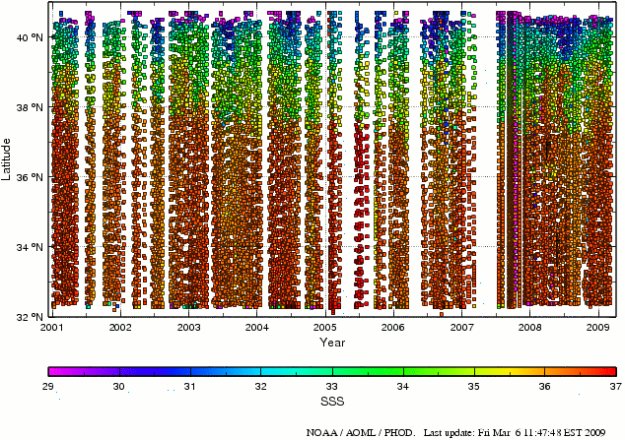
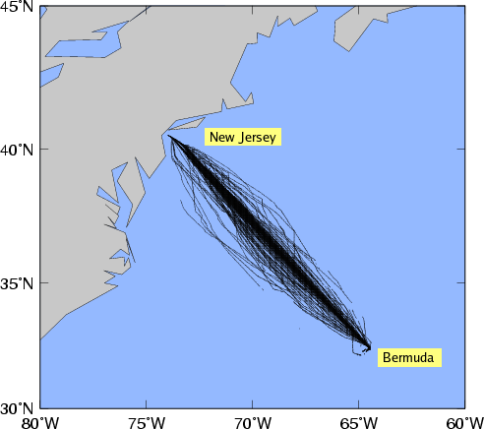

Figure 2. (left) Ship tracks of the M/V Oleander during the period 2001-2009, and (right) Sea surface salinity obtained from the TSG installed in this across the transect New Jersey-Bermudas.

