March 1, 2013
Dr. Peter Ortner
Director
Cooperative Institute for Marine and Atmospheric Studies
Rosenstiel School of Marine and Atmospheric Science
University of Miami
4600 Rickenbacker Causeway
Miami, FL 33149
U.S. DEPARTMENT OF COMMERCE

National Oceanic and Atmospheric Administration Atlantic Oceanographic and Meteorological Laboratory

4301 Rickenbacker Causeway Miami FL 33149

Re: Recommendation to promote Mr. Ricardo Domingues to Research Associate II

Dear Dr. Ortner,

I would like to recommend Mr. Ricardo Domingues for a promotion to Research Associate II.

Mr Domingues has worked at AOML as a Research Associate I since July 2011. His work is mostly to support scientific and operational activities related to NOAA’s XBT Network.

After a short period of training and transition, Mr Domingues has performed with excellent quality the tasks that were assigned to him, some of which had been previously assigned to a RA-III employee in the division.

During the last 2 years Mr Domingues has maintained and excellent record of efficiency and productivity in the execution of his assignments, most of which include tasks normally performed by a RA-II or RA-III employees. In addition to his regular assignments, Mr. Domingues participated in research cruises, gave scientific presentations and worked in scientific papers. In one of these scientific manuscripts, he has taken the lead to perform the research and has submitted a paper as a first author.

Mr. Domingues has demonstrated many abilities and qualities in the execution of his work with minimum supervision. For his willingness to take up more responsibilities and the already demonstrated quality with which he has performed his currents tasks that correspond to a RA-II employee, I highly recommend Mr Domingues for this promotion.

Sincerely,

Dr. Francis Bringas,
National Oceanic and Atmospheric Administration
Atlantic Oceanographic and Meteorological Laboratory
Physical Oceanography Research Division
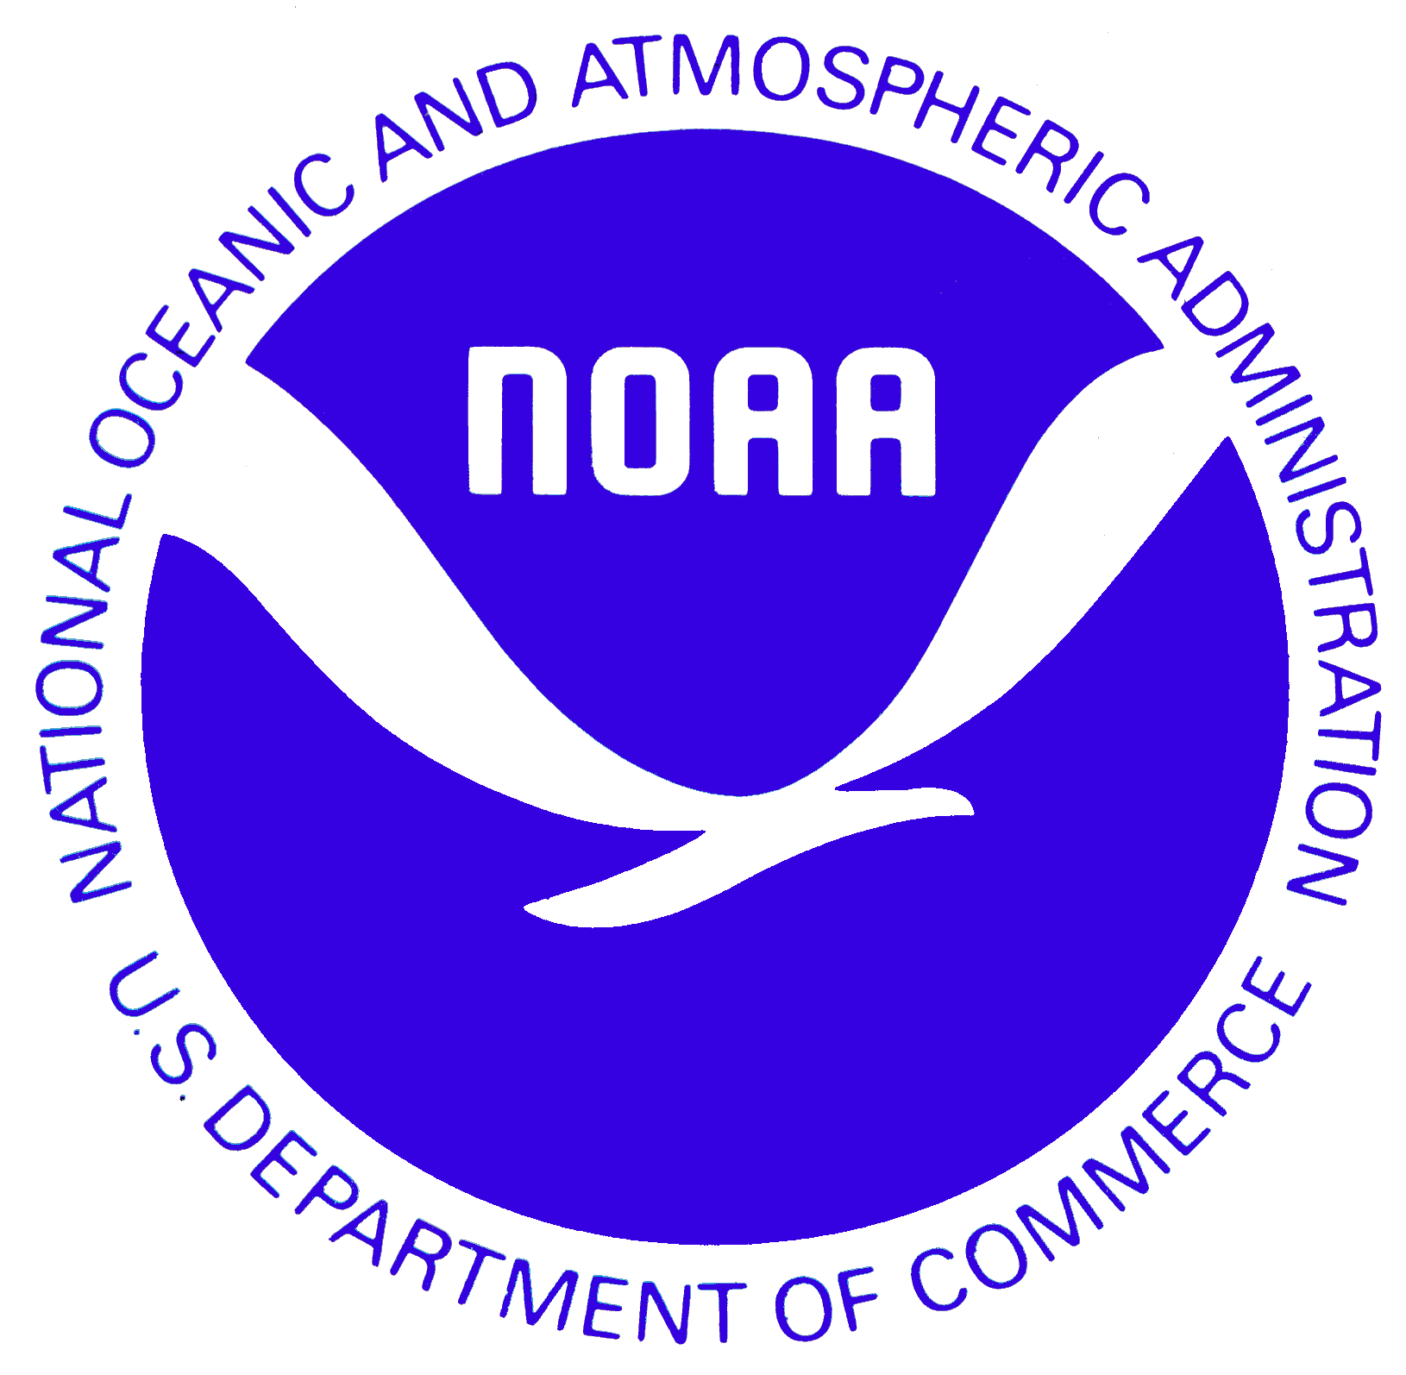
4301 Rickenbacker Causeway
Miami, FL 33149
305-361-4338

