Progress Report
The XBT Network
G. Goni¹, M. Baringer¹, and S. Garzoli²
¹ NOAA/AOML, Miami, FL
²UM/CIMAS, Miami, FL

Table of Contents

1. Project Summary 1
2. Scientific and Observing System Accomplishments 3
2.1. Contribution to Climate Program Deliverables 3
2.2. Contribution to Societal Challenges 4
2.3. Project Goals 4
2.4. SEAS System 5
2.5. XBT Operations 5
2.6. XBT Data Management 13
2.7. XBT Project Collaborations and Partnerships with other Projects 14
2.8. Panel Memberships 16
2.9. XBT Meetings and Workshops organized or attended by XBT PIs 17
3. Outreach and Educations 17
4. Publications and Reports 18
4.1. XBT-related Publications by Principal Investigators 18
4.2. XBT Relevant Publications 18
Appendix I 19

1. Project Summary

The XBT Network is an international effort that supports the implementation of a network of cargo vessels, cruise ships, and research vessels to deploy Expandable Bathythermographs (XBTs). XBTs are deployed along fixed pre-established transects, which are repeated at least 4 times per year, to measure the water temperature from the sea surface to a maximum depth of usually 850m. The XBT network currently in place has been recommended by the international scientific community during the OceanObs99 and OceanObs09 meetings. The countries that provide the largest contributions to this program are the United States, Australia, France, South Africa, Brazil, Germany, Italy, and Japan. In average, approximately 20,000 are deployed per year, of which AOML is involved in some aspect of the logistics, operations, data processing, etc, of about 80% of them. AOML leads or co-leads with its international partners the implementation and operations of 10 Atlantic Ocean transects.

XBT temperature measurements are used to monitor changes of key surface and subsurface currents, to study meridional heat transport in all ocean basins, and to supplement other observational platforms to assess the variability of the upper ocean heat content. All XBT transects have been justified because of their impact of our understanding of how the upper ocean dynamics and thermal structure may be linked to long-term climate signals, extreme weather events, ecosystem assessments, etc. Scientists using XBT data produce more than 50 publications annually in peer review scientific publications, in addition to presentations in scientific meetings, and a large number of other applications in which several products for ocean condition monitoring are created.

Some of the XBT transects have been maintained for many years, such as AX32, which runs from Newark to Bermuda. This transect is geared towards investigating the variability of the Gulf Stream, and has been carried out for 32 consecutive years since 1981. These measurements represent the longest time series available of the Gulf Stream. Other transects, such as AX07 (from Miami to Gibraltar) and AX18 (From Cape Town to Buenos Aires), are geared towards monitoring the Meridional Heat Transport in the South and North Atlantic Ocean, respectively. In fact, the AX18 transect that is currently maintained by AOML is the only observational platform that can provide estimates of this parameter. In addition to the 10 Atlantic XBT transects on which NOAA/AOML maintain a lead or co-lead role, the AOML SOOP project collaborates by providing probes, equipment, and/or data transmission support for 9 transects in the Pacific Ocean,5 transects in the Indian Ocean, and three in the Mediterranean Sea.

Most of the data obtained though this project are distributed into the GTS within 24 hours of its acquisition, providing critical input for weather and climate forecasts models and scientific applications. Additional scientific quality control is carried out at AOML to provide data with quality for climate studies. These data are distributed to NOAA/NODC and to other data distribution centers.

This project is also involved in activities aimed to the continuous development of new technologies in support of the operations carried out as part of the XBT network. During recent years the engineering group at AOML has developed new equipment for the automatic deployment of several models of XBTs during cruises with high rate of deployments, for the transmission of data in real-time using different satellite networks, and for the substitution of several components saving money to the project. In addition, AOML scientists continue working on XBT fall rate studies and collaborating with Lockheed Martin Sippican to develop a new, upgraded, XBT probe that will be able to provide climate quality observations.

To facilitate the data collection effort, this project has developed and currently maintains the Shipboard Environmental Data Acquisition System (SEAS), a software to collect and transmit observations from XBTs, ThermoSalinoGraphs (TSGs), and meteorological observations, which contribute to the largest source of marine meteorological observations used by the NOAA National Weather Service for Marine forecast. In addition, this software provides regular reports to the US Coast Guard’s Automated Mutual-Assistance Vessel Rescue System (Amver), which aids in finding ships in the vicinity of vessels in distress, in order to save lives and property.

This project is also partly responsible for the installation and operation of TSGs, which are instruments that continuously measure the values of sea surface temperature and salinity along the ship path. In addition this project supports to other observational networks, such as the global drifter array, and Argo profiling floats. TSG observations are used in conjunction with pCO2 observations and provide critical information to determine frontal regions and mixed layer depths for ocean acidification assessments.

2. Scientific and Observing System Accomplishments

2.1. Contribution to Climate Program Deliverables

The XBT Network project, through its analysis of temperature profile data and ocean circulation observations, contributes to the following NOAA/Climate Observation Division Program Deliverables (in rough order of impact and relevance):
- Ocean Heat Content and Transport, to better understand the extent to which the ocean sequesters heat; to identify where heat enters the ocean and where it emerges to interact with the atmosphere; and to identify changes in thermohaline circulation and monitor for indications of possible abrupt climate change.
This project specifically addresses this NOAA climate goal by providing long-term integrated indicators of the global thermohaline (overturning) circulation and heat transport that directly addresses the program deliverable on “ocean heat content and transport”. This project is designed to deliver quarterly estimates of the state of the thermohaline circulation and heat transport.
- Sea Surface Temperature and Surface Currents, to identify significant patterns of climate variability and change.
Analyses carried out using data of this project provides an estimates of the location and strength of key surface and boundary currents, some associated with the net meridional overturning circulation.
- Air-Sea Exchanges of Heat, Momentum, and Fresh Water, to identify changes in forcing functions driving ocean conditions and atmospheric conditions; and to elucidate oceanic influences on the global water cycle
This project provides data used in the analysis of ocean heat and mass transport time series that can be used as a constraint on air-sea flux estimates and numerical model validation. This type of direct oceanic-transport-based flux estimate helps to reduce errors in surface products and assess numerical models.
- Sea Level, to identify changes resulting from trends and variability in climate
Data from this project provides indirect indicators that can influence sea-level variability through estimates of the Meridional Overturning Circulation and heat transport. Changes in heat content (e.g. induced by changes in the divergence of heat transports) and the meridional overturning circulation can affect sea level.

- Ocean Carbon Uptake and Content, to better understand the extent to which the ocean sequesters CO2 and how cycling among ocean-land-atmosphere carbon reservoirs varies on seasonal-to-decadal time scales
As noted above, the transport of boundary currents and the overturning circulation are central to determining Carbon uptake, but without direct carbon estimates these can only provide context with mean and variability of currents. Analysis carried out with data obtained from the XBT network provides, for example, a boundary current estimate of the Florida Current, Brazil Current, Benguela Current and MOC that can be used to place Carbon flux estimates in context (e.g. at 24N Macdonald et al, 2003; Hansell et al, 2004).

2.2. Contribution to Societal Challenges

NOAA’s Climate Goal is focusing on an initial set of societal challenges:
- Reduce vulnerability to extreme weather (extremes);
- Prepare for drought and water resource challenges (drought);
- Manage risks to coastlines and coastal infrastructure (coastal inundation); and
- Sustainably manage marine ecosystems (marine ecosystems)

Observations from the XBT network and the analysis carried out with its data provides an indirect contribution to these societal challenges. XBT observations represent approximately 15% of all ocean temperature profile data and, consequently, they are key for assessments of upper ocean heat content and sea level variability studies. In addition, this project provides direct estimates of the boundary current transports that could affect coastal sea level. Similarly, changes in the net meridional overturning circulation can influence long-term sea level. Extreme weather (e.g. hurricanes) and drought (e.g. rainfall) have been linked to the strength of the meridional overturning circulation. Continued analysis of boundary currents and the meridional overturning circulation and heat transport may improve forecasts of coastal inundation, seasonal forecasts of hurricanes, etc.

2.3. Project Goals

Currently, the main focus of the XBT network is to maintain the High Density transects. The strength of the XBT data set currently lies on its length and on its ability to estimate transports across entire ocean sections and key choke points, such as Drake Passage, Indonesian Throughflow, ACC south of Africa, etc. The scientific objectives for this mode of deployment are summarized below:
- Measure the seasonal and interannual fluctuations in the transport of mass, heat, and freshwater across transects which define large enclosed ocean areas and investigate their links to climate indexes.
- Determine the long-term mean, annual cycle and interannual fluctuations of temperature, geostrophic velocity and large-scale ocean circulation in the top 800 m of the ocean. In some regions, XBTs reaching 800 m cannot depict the complete vertical structures of fine but intense oceanic jets and a combined approach in terms of high density and deeper profiling float measurements is necessary.
- Obtain long time-series of temperature profiles at approximately repeated locations in order to unambiguously separate temporal from spatial variability.
- Determine the space-time statistics of variability of the temperature and geostrophic shear fields.
- Provide appropriate in situ data (together with Argo profiling floats, tropical moorings, air-sea flux measurements, sea level etc.) for testing ocean and ocean-atmosphere models.
- Determine the synergy between XBT transects, satellite altimetry, Argo, and models of the general circulation.
- Identify permanent boundary currents and fronts, describe their persistence and recurrence and their relation to large-scale transports.
- Estimate the significance of baroclinic eddy heat fluxes.

2.4. The SEAS System

The Shipboard Environmental data Acquisition System (SEAS) is a real time application developed and maintained at NOAA/AOML, which combines acquisition and transmission of environmental data collected over several platforms. The system acquires atmospheric and oceanographic data, such as meteorological parameters, sea surface salinity and temperature. It operates on cargo ships, NOAA vessels, University-National Oceanographic Laboratory System (UNOLS) ships, and Coast Guard vessels, to produce high quality marine weather and oceanographic observations. NOAA and Scripps Institution of Oceanography (SIO) are the main users of the software. SEAS is installed in more than 50 ships of the SOOP, which participate with NOAA/AOML in acquiring and transmitting data from approximately 10,000 XBTs per year. The data acquired by the SEAS system are transmitted in real-time to the Global Telecommunication System (GTS) and to global data distribution centers (NODC, Coriolis) to be used by scientists and operational centers.

2.5. XBT Operations

The XBT operations address both operational and scientific goals of the NOAA program for building a sustained ocean observing system for climate. The global XBT network (Figure 1), formed by repeat transects recommended by the scientific community is a multi national (US, France, Australia, South Africa, Brazil, Germany, Japan, Argentina, and Canada), multi institutional effort. There are 27 XBT transects that are maintained exclusively by AOML or by its US or international partners and in which AOML plays an active and continuous role in the deployment of XBTs, or transmission, data quality control, or data distribution of XBT observations (Table I).

During FY2013, AOML continued with its XBT operations in High Density (HD) mode, where XBT deployments are done every 20-25 km and transects are repeated 2 to 10 times per year, depending on scientific requirements and logistics. A few transects, carried out in collaboration with international partners were carried out in Frequently Repeated (FR) mode. During FY2013, NOAA/AOML collaborated with its partners by providing probes, equipment, logistics, and/or data processing and transmission capabilities. Approximately 8,000 XBT deployments were done with AOML involvement during FY2013 (Table II, Figure 2).

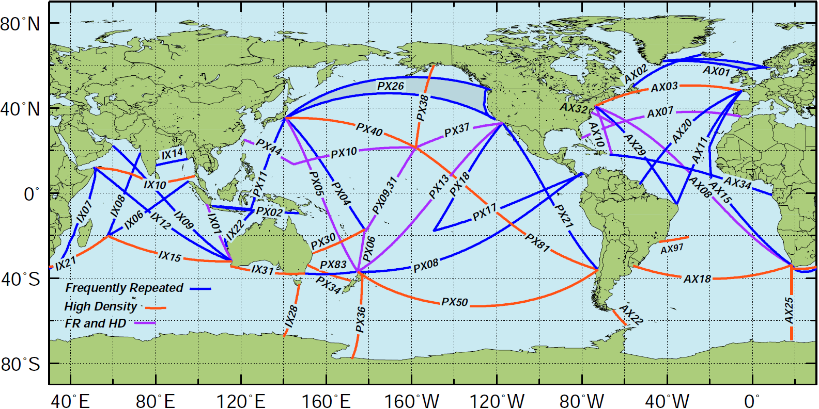

Figure 1. Location of the High Density and Frequently Repeated XBT transects recommended by OceanObs 2009. The countries leading the efforts to carry out each transect are indicated in Table 1.

Scientific and Operational Accomplishments

The main accomplishments of work carried out by the AOML XBT network during FY13 were:
- Maintenance of all AOML XBT transects that includes the deployment of approximately 8,000 XBTs;
- Transmission of almost 100% of all XBT data acquired in the deployments;
- Automatic quality control of all AOML and Scripps XBTs;
- Insertion of all AOML and Scripps XBT data in near-real time into the GTS;
- Scientific quality control of all Atlantic XBTs and submission of data to NODC;
- Strong scientific use of XBT data for studies of surface, subsurface, and boundary currents; meridional heat transport; and XBT fall rate experiments;
- Collaboration with NASA in the SPURS (Salinity Processes in the Upper ocean Regional Studies) Project; and
- Collaboration with Sippican to design a climate quality XBT probe.

Several scientific research projects are currently taken place at AOML using the data within the XBT Network Project. These projects include:
- Variability of the Atlantic equatorial currents
- Variability of the Southern Ocean current system
- North and South Atlantic Meridional Fluxes
- Brazil Current variability
- Fall rate studies

Specifically, the AOML XBT observations are geared towards the measurement of the variability of:
- Meridional Heat Transport South Atlantic (AX18)
- Meridional Heat Transport North Atlantic (AX07)
- Gulf Stream (AX32, AX10, AX07)
- Agulhas Currents and rings(AX08, AX18, AX25, IX21)
- Brazil Current (AX18, AX97)
- Tropical Atlantic zonal equatorial currents (AX08, AX20)
- Kuroshio Current (PX44, PX40, PX05, PX04)
- Antarctic Circumpolar Current (AX25, AX22, IX28)
- Indonesian Throughflow (PX05, IX01)
- Mediterranean Sea (MX01, MX02, MX04)
- South Atlantic Subtropical gyre (AX08, AX18)
- North Atlantic Subtropical gyre (AX08, AX10, AX07, AX20, AX04)
- North Atlantic Subpolar gyre (AX02, AX01)

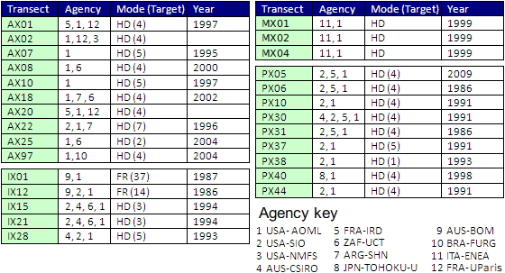

Table I. XBT transects performed by the international community during FY2012, including their current status and the year in which operations on these transects started.

High Density XBT transects
This operation is designed to measure the upper ocean thermal structure in key regions of the Atlantic Ocean with the objective of investigating the temporal variability of key surface and subsurface currents and of meridional heat transport in the Atlantic Ocean. XBT transects in HD mode are repeated every approximately 3 months with XBTs deployed 20 to 25 km apart in order to measure the mesoscale structure of the ocean to diagnose the ocean circulation responsible for redistributing heat and other water properties globally. HD XBT transects are carried out globally (Figure 1) with AOML taking the lead in most of the operations in the Atlantic Ocean. In addition AOML contributes with the HD data transmission and distribution of SIO HD XBT operations and has current international collaboration efforts with Australia, France, Brazil, Argentina, and Italy. For example, during the last three years AOML implemented 6 new HD transects (AX20, AX01, AX02, MX01, MX02, and MX04) as part of its international collaboration efforts, and increased the number of cruises per year in two transects in the North Atlantic.

AOML is currently carrying out 10 XBT transects in HD mode in the Atlantic Ocean. The continuation of AX07 and AX10 and the implementation of AX08 and AX18 were recommended by the Upper Ocean Thermal Review Panel in St. Raphael in 1999, and supported by OceanObs09 recommendations. The HD transects AX07 and AX10 have been maintained since 1994 and 1996, respectively, providing a homogeneous data set for more than a decade. In addition, HD observations in AX08, AX01, AX02, AX18, AX25, AX20, and AX97 provide observations in poorly surveyed regions. The XBT transect AX32 is maintained in support of the M/V Oleander operations.

The locations of XBT deployments in HD mode along each transect during FY2013 are shown on the AOML HD XBT web page (http://www.aoml.noaa.gov/phod/hdenxbt/). Data can be also obtained from these web pages or from NOAA/NODC GTSPP. A summary of all the observations conducted in FY2013 can be found in Table 2. All HD transects were operated normally.

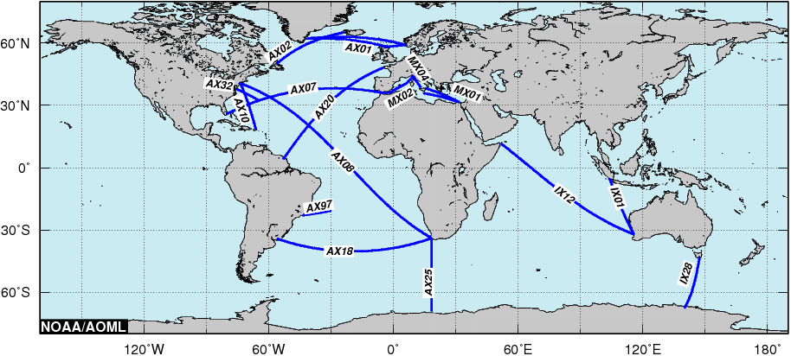
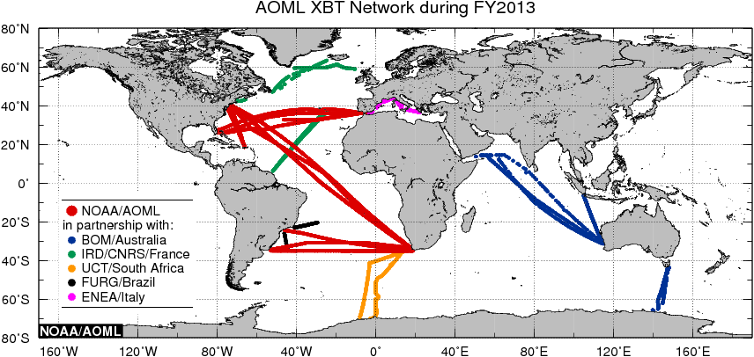

Figure 2. (top) Location of the 4 High Density XBT transects (AX07, AX08, AX10, and AX18) maintained solely by NOAA/AOML, and the 7 transects (AX01, AX02, AX20, AX25, AX32, AX97, IX01, IX12, IX28, MX01, MX02, and MX04) maintained by NOAA/AOML in collaboration with the University of Paris, IRD/France, NOAA/NEFSC, University of Cape Town, Federal University of Rio Grande, Australia’s Bureau of Meteorology and CSIRO, and ENEA/Italy. (bottom) Location of the AOML XBT deployments and AOML-supported XBT deployments/transmissions during FY2013 carried out by AOML or in partnership with national and international collaborators.

International Collaboration
The collaboration between AOML and its international partners include the sharing of resources, such as XBT probes, ship recruiting and logistics, equipment, and scientific riders. AOML Provides probes to oceanographic institutions that have demonstrated reliability in logistics and operations. These probes are used to carry out recommended transects in HD mode. During FY2013 AOML provided the following number of probes to its international collaborators:

- IRD, Brest, 2 pallets (648 probes for AX01 and AX20), collaborators: Diverres and Gilles Reverdin
- FURG, Brazil, 1 pallet (324 probes for AX97), collaborator: Mauricio Mata
- CSIRO and Bureau of Meteorology, Australia, 2 pallets (648 probes for IX01, IX12, and IX28), collaborators: Susan Wijffels and Graeme Ball
- ENEA/Italy, 1 pallet (324 probes for MX01 and MX04), collaborator: Franco Reseghetti
- University of Cape Town, 4 pallets (1296 probes for AX25), collaborators: Isabelle Ansorge and Sebastiaan Swart.

Transect | Realizations | No. of XBTs | Avg. No. | % successful deployments | Argo Floats Deployed | Drifters Deployed | XBT Fast Deep Probes
Transect | Realizations | No. of XBTs | of XBT per
Transect | Realizations | No. of XBTs | Transect
AX01 | 4 | 202 | 50 | 83.6 | 0 | 0 | 0
AX02 | 3 | 197 | 66 | 89.85 | 0 | 0 | 0
AX07 | 5 | 1178 | 229 | 95.59 | 6 | 52 | 133
AX08 | 5 | 2545 | 509 | 96.7 | 14 | 29 | 0
AX10 | 5 | 542 | 109 | 93.55 | 0 | 0 | 0
AX18 | 4 | 885 | 221 | 94.81 | 0 | 0 | 0
AX20 | 3 | 476 | 159 | 94.96 | 0 | 0 | 0
AX25 | 2* | 403 | 153 | 86.89 | 0 | 0 | 0
AX97 | 6 | 268 | 45 | 97 | 0 | 0 | 0
IX01, 12, 28 |  | 648 |  |  | 0 | 0 | 0
MX01 | 2 | 56 | 28 | 98.26 | 0 | 0 | 0
MX02 | 2 | 79 | 40 | 98.7 | 0 | 0 | 0
MX04 | 3 | 86 | 29 | 98.3 | 0 | 0 | 0
Other | 2** | 307
Total | 41 | 7,872 |  |  | 20 | 81 | 133

* There were XBTs deployed as a collaboration to allow for extra data along with CTD casts aboard the AX25 ship. They were not deployed along the normal AX25 cruise track.
** These two cruises were SAMOC (43 deployments) and PNE (264 deployments).

Table II. Summary of the number of XBTs, Argo and drifters deployed on the XBT transects operated by AOML or with direct AOML participation during FY2012. * Indicates partial contribution to the full sampling.

The probes provided to IRD/France were deployed along transects in the North Atlantic Ocean (AX01 and AX20). The probes provided to Australia are used in a basin wide transect in the Indian Ocean that crosses the equator and to partly support a High Density transect between Tasmania and Antarctica. The XBTs provided to Brazil are used along the AX97 transect in the subtropical South Atlantic that monitors the Brazil Current. The XBTs provided to Italy are deployed in important regions of the Mediterranean Sea. The probes provided to South Africa are deployed along AX25 to study and monitor the Antarctic Circumpolar Current and associated fronts. AOML provided a total of 10 pallets (3240 XBTs) to these partners. Additionally, several agencies are currently collaborating with this project. The Argentine Hydrographic Naval Office (SHN) provides personnel to deploy the XBTs on AX18; the University of Cape Town provides the riders for the deployments along AX08 and AX25. The South African Weather Service is our contact in Cape Town and Durban to store the equipment in between transects and to provide ship riders. Deployments along AX97 are carried out in collaboration with the Federal University of Rio Grande, Brazil. AOML has been in continuous communication with the Brazilian Navy and has provided the technical expertise needed for transmitting XBT data during the realization of the AX97 transects. Drs. Gustavo Goni and Molly Baringer are involved in data analysis and scientific collaboration activities with scientists from University of Cape Town, South Africa, and University of Rio Grande, Brazil. Most of the data obtained from these XBTs were placed into the GTS in real-time. For those ships that are not currently transmitting the data in real-time, we are exploring the possibility of installing computers and transmitting antennas for real-time data distribution. Most of the data collected from these deployments were submitted to NODC. Figure 2 (bottom) shows the location of all the XBTs deployed by AOML and its partners during FY2013.

XBT Fall Rate Experiments
In an effort to improve XBT data quality and to investigate possible issues in the XBT data related to uncertainties in the XBT fall rate equation (FRE), data from three XBT fall rate experiments are currently being analyzed. These experiments were curried out at the AOML water tank, the University of Miami swimming pool, and the Stennis Space Center test tank (Figure 3).

Two of these experiments were designed to study the effect of the deployment height in the fall rate of XBT probes at the beginning of its descent on the water. A different initial velocity of the probe below (above) the terminal velocity considered in the manufacturers FRE is expected to cause an acceleration (deceleration) of the probe until the terminal velocity is reached. During this time the actual depth of the probe will be different than that described by the FRE. During these two experiments, XBT probes were deployed in a 5m deep swimming pool and in a 11.12m deep water tank from different initial eights and in the straight vertical direction with the objective to determine the deviation of the actual fall rate from the FRE estimates as well as the maximum depth at which these probes could reach terminal velocity. Results show the dependence of the actual fall rate of the probes with the initial velocity (Figure 4). Probes deployed from initial heights above the water of 0 and 2m move slower than predicted by the FRE while those deployed from heights of 9, 14, 20, and 25m move faster. XBTs deployed from an initial height of 4m start their movement in the water at a velocity that is very close to their terminal velocity and in this case the FRE provides a better estimate of their trajectory.

The experiment conducted at the NOAA/Southeast Fisheries Science Center test tank within the Stennis Space Center facility in Mississippi in July 2012 was designed to study the fall rate and terminal velocity of XBTs during the first meters of their fall. The analysis of the data obtained from the approximately 300 deployments done as part of this experiment is underway. The results from this experiment will allow scientists to better understand the dynamic of an XBT on the first meters after the probe hits the water, and to reduce the errors of observations taken with XBTs.
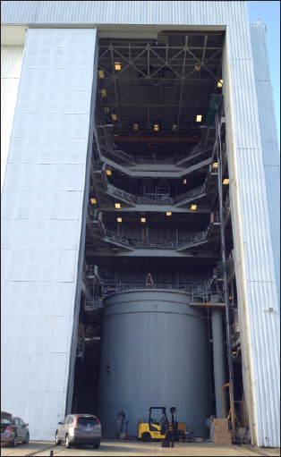
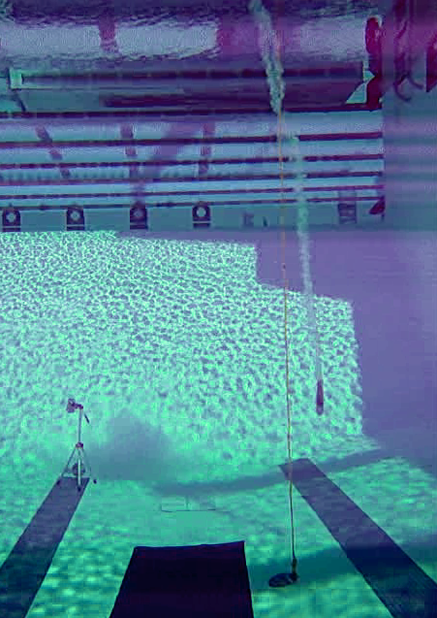
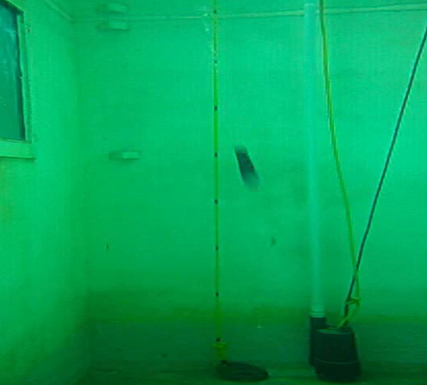

Figure 3. Three locations were FRE experiments were carried out: (left) Test tank at Stennis Space Center. (center) University of Miami swimming pool (right) AOML water tank.

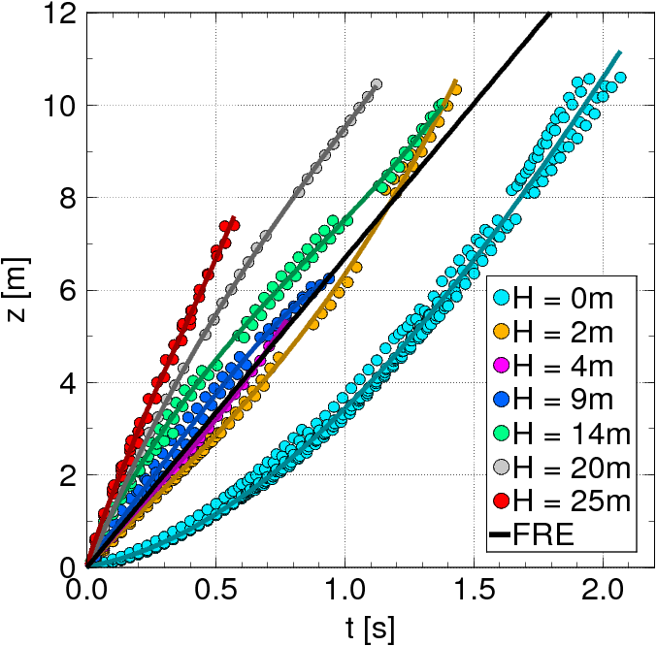

Figure 4. Preliminary results obtained to determine the effect of XBT launch height (H, colors) with descent time (t) and depth (z).

Prototype of new XBT probes
NOAA/AOML has been collaborating with Lockheed Martin/Sippican (LCS) in the development of the Climate Quality XBT probe (CQXBT). The CQXBT system will feature improvements in the probe, acquisition system, and software. NOAA/AOML is leading the efforts to study and recommend the necessary changes in the probe. The probe improvements will consist of including additional thermistor calibrations and pressure switch(es). An initial sensitivity study of the utility of the pressure switches measurements has been performed. Results from this study have been published in Goes et al., (2013). In addition, sea trials where experimental XBT probes with improved weight and thermistor calibrations were deployed and compared to standard probe deployments. Two sea trials were performed in NOAA/AOML cruises aboard the R/V Ron Brown, one during the Western Boundary Time Series (WBTS2012 cruise) and the other during the PIRATA Northeast Extension (PNE2013 cruise). In those cruises, standard and experimental probes were deployed along with co-located CTD casts. The goal of these sea trials is to detect improvements in the pure temperature biases and depth accuracy. he analysis of the cruise data consisted in using the temperature gradient method (Hanawa, 1995) to separate the depth biases from the pure temperature biases for different probe types, and compare the biases estimated for the standard and experimental probes. Preliminary results were presented during the SOOP meeting in Victoria, Canada. Three additional corrections to the XBT thermistor resistance data have been performed to evaluate which correction is able to reduce temperature biases. These corrections account for: i) wire imbalance, ii) thermistor calibration and iii) thermal time constant. Analysis of the temperature offset changes for each probe using separately each of these three corrections show that the wire imbalance has the highest potential to reduce temperature offset. The temperature offset is less sensitive to the other corrections. A temperature offset reduction compared to the original XBT temperature profile is only achieved in half of the analyzed cases. This variability is still a question of debate, and a new sea trial is necessary. A prototype of a probe with an integrated pressure switch is now under construction by LCS. This pressure switch will be used to improve the depth accuracy of individual XBT drops. The target depth for the proposed pressure switch is 400 meters, which is approximately the middle depth of a XBT profile (Goes et al., 2013). Further analysis of another sea trial is expected to be performed in the following months. New deployments of standard and experimental XBT probes, which would possibly contain pressure switches, will take place on the next PNE cruise, which will be conducted aboard the RV Ronald Brown in November 2013.

XBT Science Team
Members of the SOOP are active participants of the XBT Science Team, which was formally established and held its first meeting in 2010. The second Science Team meeting was held during the

XBT Science Web Page
AOML currently hosts and maintains the XBT Science web page, which is located at:
http://www.aoml.noaa.gov/phod/goos/xbtscience

2.6. XBT Data Management

Data flow
XBT profiles are acquired and transmitted in real-time through the Thrane Standard C units. AOML also uses Iridium transmission on some XBT realizations and on all TSG operations. The ratio of XBTs deployed to real time data transmitted is essentially 100% in ships with XBT transects directly implemented and maintained by AOML.

AOML and Scripps XBT profiles undergo near-real time automatic quality control (AQC) procedures at AOML. The profiles that fail the AQC are submitted to visual quality control (VQC) using a MATLAB based code developed at AOML, in which a trained operator decides whether or not to send the data to the GTS. Probe failure (as measured by the AQC) remains consistently between 5% and 10% with greater higher failure rates at higher latitudes during winter months. Approximately 85% of the profiles that fail the QWC were approved during the VQC. Typically about 95% of all profiles are approved during the quality control process and submitted to the GTS. In addition, all the XBT data obtained are submitted to NODC for archival and distribution.

Details of this project, such as logistics, equipment, software, and data distribution, are provided through links that can be accessed through the main NOAA/AOML Global Ocean Observing System (GOOS) web page www.aoml.noaa.gov/phod/goos, or directly through the NOAA/AOML Ship Of Opportunity Program (SOOP) web page www.aoml.noaa.gov/phod/soop.

- XBT Network: www.aoml.noaa.gov/phod/goos/xbt_network/
- XBT HD: www.aoml.noaa.gov/phod/hdenxbt
- SEAS: www.aoml.noaa.gov/phod/trinanes/SEAS/

The XBT Network website features the latest information on operational XBT transects along with specific web pages showing the latest XBT, Meteorological, and TSG observations, available online at: www.aoml.noaa.gov/phod/goos/seas/latest/. The GOOS website also features a Google Earth layer displaying Global Marine and Meteorological Observations available online at www.aoml.noaa.gov/phod/VOS/GE/GE_AOML_DT.kmz. This application is a powerful tool to visualize the global extent of ocean and meteorological observations interactively. Other web sites were also developed for more specific aspects of the SOOP operation, including the display of real-time TSG data from the MV Explorer (www.aoml.noaa.gov/phod/tsg/sas/), the Explorer of the Seas (www.aoml.noaa.gov/phod/tsg/xpls/), and for the Oleander Project displaying XBT products and data obtained from this ship (www.aoml.noaa.gov/phod/goos/oleander).

Data quality control and distribution to NODC
All Atlantic Ocean High Density XBT data collect by AOML or AOML partners undergo delayed mode quality control. For this quality control, bad profiles are identified, spikes are removed and profiles are evaluated for representativeness of the surrounding physical oceanography issues known for the region. Similar procedures are employed as other delayed mode quality control such as Scripps and CSIRO. For example, subsurface temperature inversions found near the high salinity/higher temperature Mediterranean outflow might fail automatic quality control procedures, but are perfectly acceptable, expected oceanographic profiles. Occasionally, some data are filtered to remove the small-scale unphysical electrical noise that can occur in the profiles. All modifications to the XBT profiles are logged and available via the AOML web site. Final quality controlled profiles are delivered to NOAA NODC for archival and replacement into the “Best Quality” GTSPP data set, typically within one-two months of the data being collected.

2.7. XBT Project Collaborations and Partnerships with other Projects

Meridional Heat Transport
XBT observations in the Atlantic Ocean obtained from HD transects AX07 and AX19 are used to monitor the Meridional Heat Transport in the Atlantic basin on a quarterly basis. Time series of these estimates can be found at:
http://www.aoml.noaa.gov/phod/goos/xbtscience/mht_products.php

Marine Meteorological Observations.
The SEAS software, which is supported by this project, is also installed on more than 1,200 ships of the VOS (Voluntary Observing Ships) program to transmit over three million meteorological messages (Figure 5), constituting the largest source of marine meteorological observations, which are used in weather forecast prediction models and analysis by university and government laboratories, such as the NOAA National Weather Service.

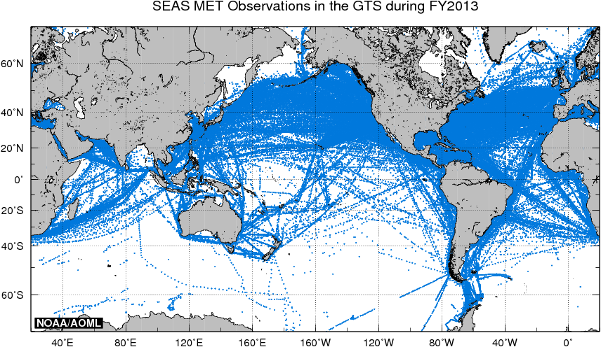

Figure 5. Locations of the more than 3M marine weather observations obtained from 1,200 ships of the VOS using XBT SEAS software during FY2013.

TSG Operations
During FY2012 the TSG operations at AOML were carry out in support of the pCO₂ operations. AOML is currently receiving, processing and distributing TSG data from 7 ships of the SOOP (Semester at Sea’s MV Explorer, MV Oleander, MV Barcelona Express, MV Reykjafoss, Las Cuevas, and Royal Caribbean’s Explorer of the Seas and Allure of the Seas) and 10 ships of the NOAA fleet. More than 25 million TSG records were processed at AOML during FY2012, and distributed through several data centers. The operation of TSG equipment is performed with the SEAS software. Data from TSG observations are crucial for the calibration of the upcoming NASA Aquarius satellite mission.

NASA SPURS (Salinity Processes in the Upper Ocean Regional Studies)
AOML enhanced its AX08 and AX10 expendable bathythermograph (XBT) transects from Cape Town, South Africa to New York and from Spain to Miami, respectively, in support of SPURS. In addition, AOML is also collaborating with researchers at the University of Paris to gather data along the AX20 XBT transect, which runs between France and French Guyana. These XBT transects provide temperature sections five times during 2012 and 2013 across the region of salinity maximum in the tropical Atlantic, which will be key to assessing the tropical ocean current system partly responsible for the fresh water budget. Key to the SPURS experiment and to understanding and assessing the value of the salinity satellite missions will be the deployment of surface drifters in the regions containing salinity sensors, of which AOML will be leading the data processing efforts.

Global Drifter Program
The XBT network helps at no cost the Surface Drifter Program to maintain its drifter array by having the XBT ship riders to deploy surface drifters. During FY213, 60 drifters were deployed from XBT ships, totaling 731 deployments since 2000 (Figure A1).

Argo Program
Riders from ships performing XBT deployments also deploy Argo floats at no cost to the Argo Program. During FY2013, a total of 20 Argo floats were deployed by AOML XBT ship riders, totaling 578 deployments since 2002 (Figure A2).

Other domestic collaboration in which the AOML XBT Project is also actively involved includes:

- Support of the NOAA-funded “Surface pCO₂ Measurements from Ships” (Drs. Rik Wanninkhof, Richard Feely, and G. Goni, PIs), AOML provided 1.5 pallets (486 XBTs) to NOAA/NEFSC in Rhode Island to be deployed along the pCO₂ transects AX32 and AX02. During FY2011 the XBT operation along AX02 was transitioned to a HD XBT transect.
- AOML provides equipment support to one ship of SIO HD XBT operations.
- AOML provides the software to SIO for data acquisition and transmission and carries out the real-time quality control of all SIO HD XBT data.
- AOML collaborates with the National Weather Service to provide maintenance of SEAS software to transmit marine meteorological observations.
- Through an agreement with the U.S. Coast Guard, NOAA/AOML provide real-time information about the location of ships with the SEAS software installed, which is used for search and rescue operations.
- AOML provides hardware equipment (computer for data acquisition and transmission antenna) for the Oleander operation, a joint project between NOAA/AOML, NOAA/NEFSC, University of Rhode Island, and SUNY/Stony Brook. Approximately 350 XBTs are deployed by this ship between New York and Bermuda. A web page displaying the data obtained from this project has been created at www.aoml.noaa.gov/phod/goos/oleander. The TSG data obtained from this ship can be seen on the TSG web page at AOML: www.aoml.noaa.gov/phod/tsg

2.8. Panel Memberships

Ship Of Opportunity Programme Implementation Panel (SOOPIP)
The NOAA/AOML SOOP Program is a participating member of JCOMM and JCOMMOPS. The AOML SOOP XBT program is represented bi-annually at the WMO/IOC Ship Observations Team (SOT) meeting. Participation on these international panels provides an important mechanism for integrating and coordinating with other national or regional programs which, in the long run, improves our national climate mission by making more efficient and effective use of available resources. Dr. Gustavo Goni continues being the Chairman of the WMO/IOC Ship Of Opportunity Program Implementation Panel (SOOPIP), Dr. Joaquin Trinanes is a member of the Meta-T panel and the JCOMM Data Management Programme Area (DMPA) Task Team on Table Driven Code Forms, and Dr. Francis Bringas is a member of the JCOMM DMPA Task Team on Table Driven Code Forms and the SOT Task Team on Instrument Standards.

XBT Science Steering Team
Drs. Goni and Baringer and active members of the XBT Science Steering Team. Dr. Goni is the co-chair for operations of this team, together with Dr. Janet Sprintall (for science), and Dr. Thresher (CSIRO, for data management).

SPURS
Dr. Gustavo Goni is an active member of the NASA SPURS (Salinity Processes in the Upper Ocean Regional Studies) Science Steering Team and lead of the Sustained Ocean Observations Working Group. The SOOP is closing collaborating with NASA maintaining the XBT observations in the tropical North Atlantic that are of interest for this project.

2.9. XBT Meetings and Workshops organized or attended by XBT PIs

AOML Annual XBT Meeting
An annual meeting was held at NOAA/AOML on April 3, 2012. The main goal of this meeting was to bring together the main players of the NOAA/AOML XBT network, SEAS, and TSG project. This workshop was attended by more than 30 participants from AOML, CIMAS, NOAA/SEFSC, NOAA/NESFC, and NOAA/NWS. A total of 27 short presentations were given during this meeting, with most of the time reserved for discussions and planning.

Ship of Opportunity Team
Drs. G. Goni, M. Baringer, F. Bringas, and J. Trinanes, participated at the SOT-7 Meeting in Victoria, Canada, April 22-26, 2013.

XBT Science Team
Drs. G. Goni, M. Baringer, S. Dong, F. Bringas, and M. Goes, participated at the Second XBT Science Workshop in Victoria, Canada, April 22, 2013.

Global Synthesis and Observations Panel (GSOP)
Dr. G. Goni participated at the GSOP Meeting in Hobart, Australia, June 12-14, 2013. The objective of this meeting was to established a coordinated system for quality-control of global subsurface ocean climate observations.

3. Outreach and Education

M. Baringer served as a contributing author for Chapter 3: Observations: Oceans for Climate Change 2013: The Physical Science Basis, Contribution of Working Group I to the Intergovernmental Panel on Climate Change Fifth Assessment Report.

The following is a link to a news story reported in FY2013 regarding on various publications co authored by principle investigators of this project
Abraham, John (28 August 2013). Global warming and oceans: what are the known unknowns?. Climate Consensus - the 97%, hosted by The Guardian.

S. Garzoli was interviewed on MOC topics for an article that was being prepared for the climate.gov web site. S. Garzoli was also interviewed for a news article in Nature. An article relating to the December 2012 “Southwest Atlantic MOC – SAM” project cruise was prepared for the AOML Keynotes publication by S. Garzoli. Several of the PIs also participated in public education activities in Miami, including discussions with school children and the public during the AOML Open House in May 2013, and working with women scientists to increase retention in the field (MPOWIR). Finally, several presentations were given by the PIs at national and international science conferences including the US AMOC/RAPID meeting and the IAHS-IAPSO-IASPEI joint assembly.

4. Publications and Reports

4.1. XBT-related Publications by Principal Investigators

- Abraham J. P., M. O. Baringer , N.L. Bindoff, T. Boyer, L.J. Cheng, J.A. Church, J.L. Conroy, C.M. Domingues, J.T. Fasullo, J. Gilson, G. Goni , S.A. Good, J. M. Gorman, V. Gouretski, M. Ishii, G.C. Johnson, S. Kizu, J.M. Lyman, A. M. Macdonald, W.J. Minkowycz, S.E. Moffitt, M.D. Palmer, A. Piola, F. Reseghetti, K. Schuckmann, K.E. Trenberth, I. Velicogna, J.K. Willis (2013). Monitoring systems of global ocean heat content and the implications for climate change, a review. Rev Geophy, doi: 10.1002/rog.20022 in press.
- Domingues R., G. Goni, S. Swart and S. Dong. Atmospheric forced variability on the Antarctic Circumpolar Current south of Africa during 1993-2010, J. Geophys. Res., under review.
- Goes, M., G. Goni, K. Keller, 2013: Reducing biases in XBT measurements by including discrete information from pressure switches, J. Atmos. Ocean. Tech., 30, 810-824, doi:10.1175/JTECH-D-12-00126.1.
- Goes, M., G.J. Goni, V. Hormann, and R.C. Perez, 2013: Variability of eastward currents in the equatorial Atlantic during 1993-2010. J. Geophys. Res., doi:10.1002/jgrc.20186, 118, 1-20.
- Goni, G ., J. Sprintall, D. Roemmich, A. Gronell Thresher, R. Couley, and M. Baringer, 2013: The global network of XBT temperature sections in support of Oceanographic and climate studies. Chapter 5: Oceans and Society: Blue Planet, ed. Samuel Djavidnie, Cambridge Scholars Publishing, in press.
- Hutchinson K., S. Swart, I. J. Ansorge, and G. J. Goni, 2013: Exposing XBT bias in the Atlantic sector of the Southern Ocean. Deep-Sea Res., doi:10.1016/j.dsr.2013.06.001, 80, p. 11-22.

4.2. XBT Relevant Publications

XBT publications in refereed journals since 2000 total approximately 1,000. There were 65 peer-reviewed XBT publications during FY 2013. For a complete list of XBT-related publications please visit our XBT bibliography page at: http://www.aoml.noaa.gov/phod/goos/xbtscience/bibliography.php

Appendix 1

Surface drifters and Argo floats deployed from XBT transects since 2000.

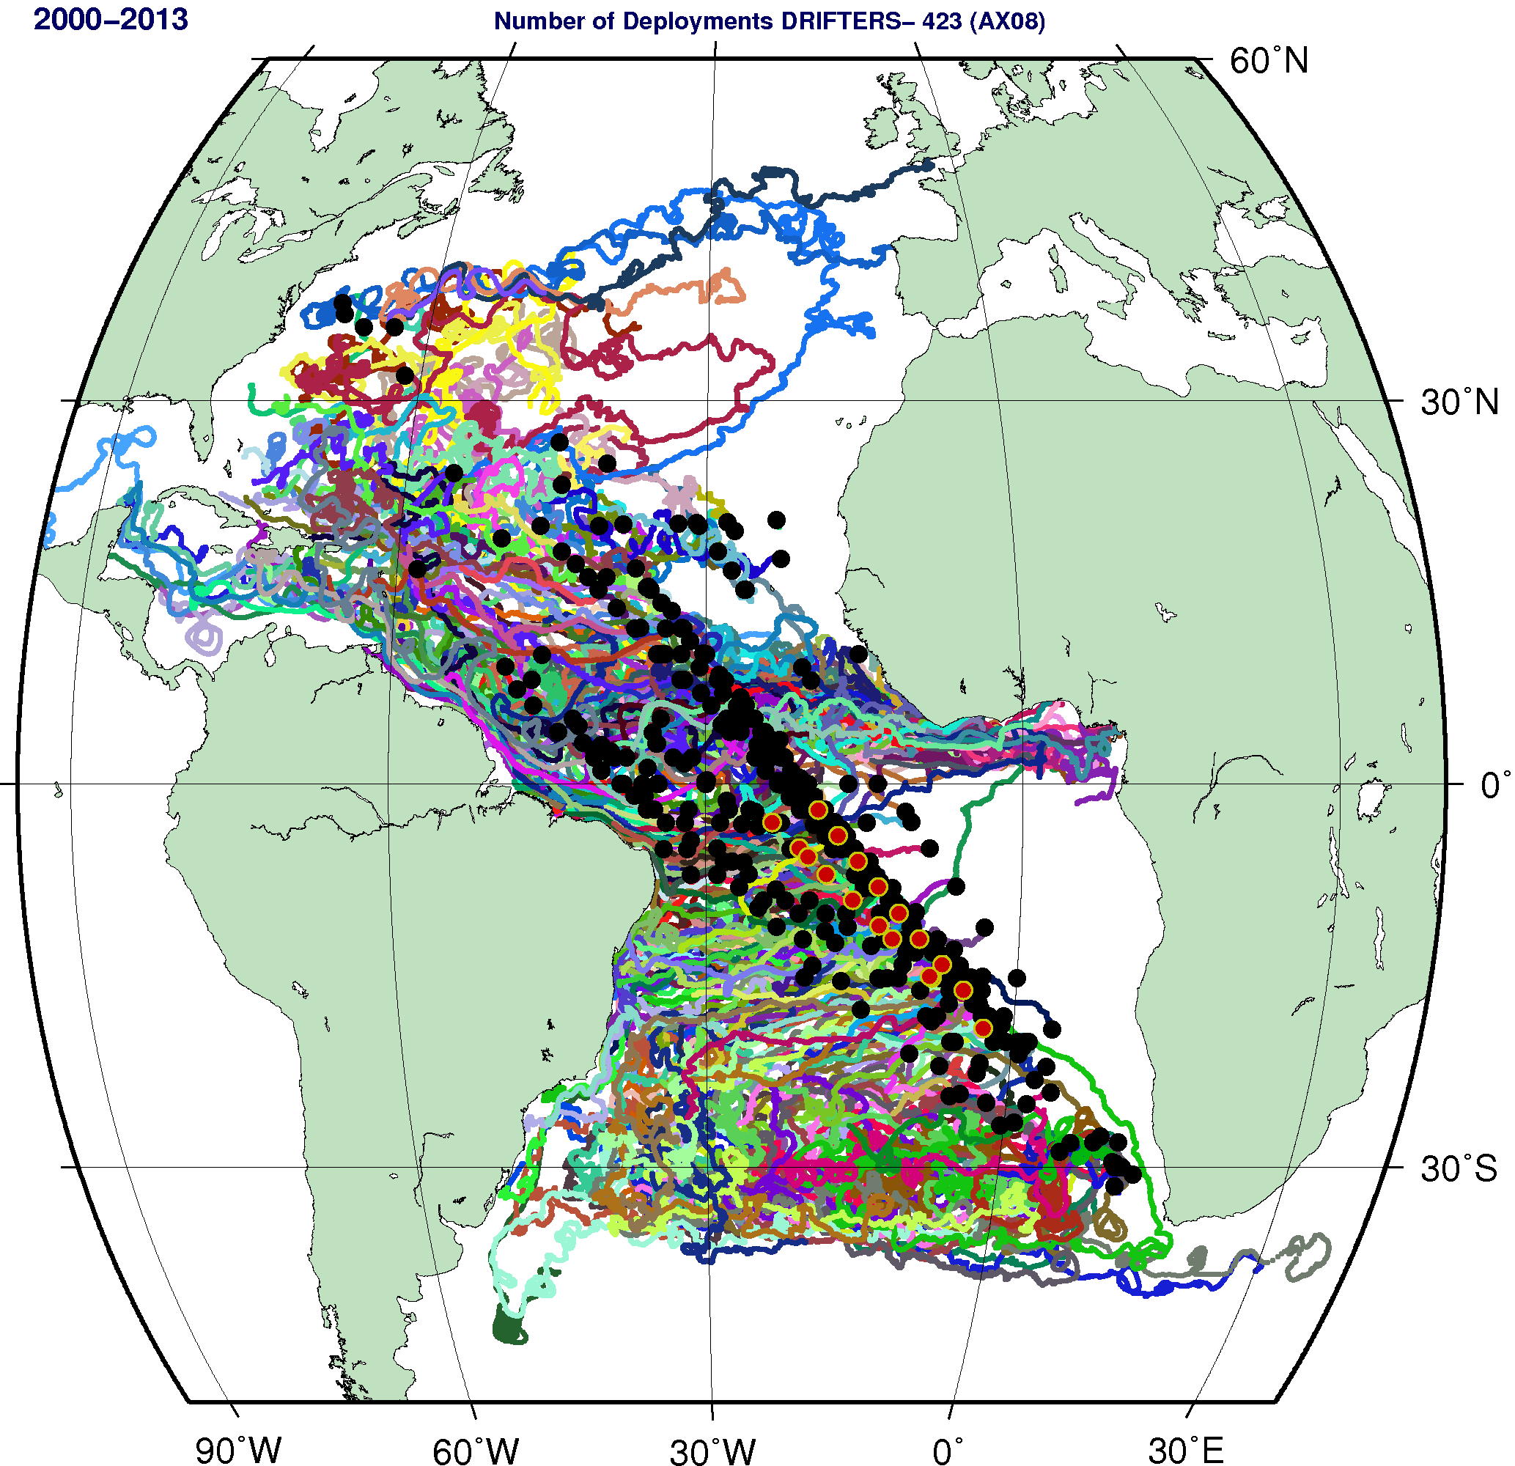
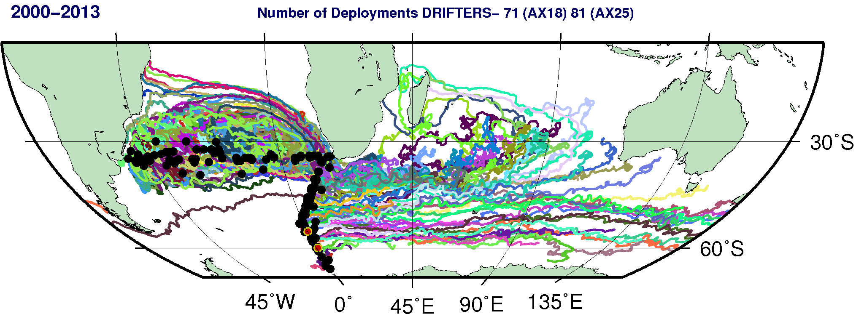
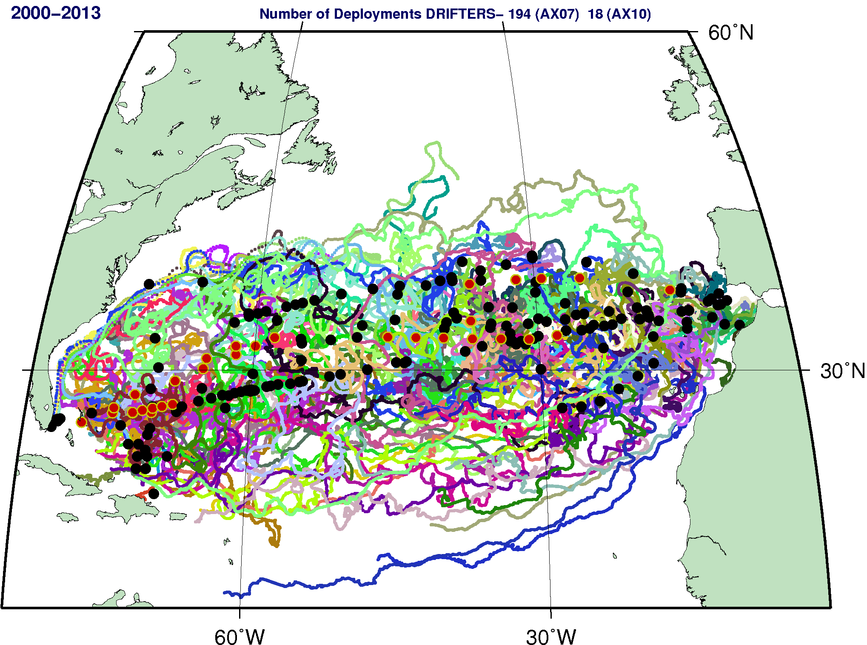

Figure A1. Location of deployments (black circles) of surface drifters carried out from XBT ship riders (FY2013 deployments in red circles) since 2000. Trajectories of these drifters are color lines.

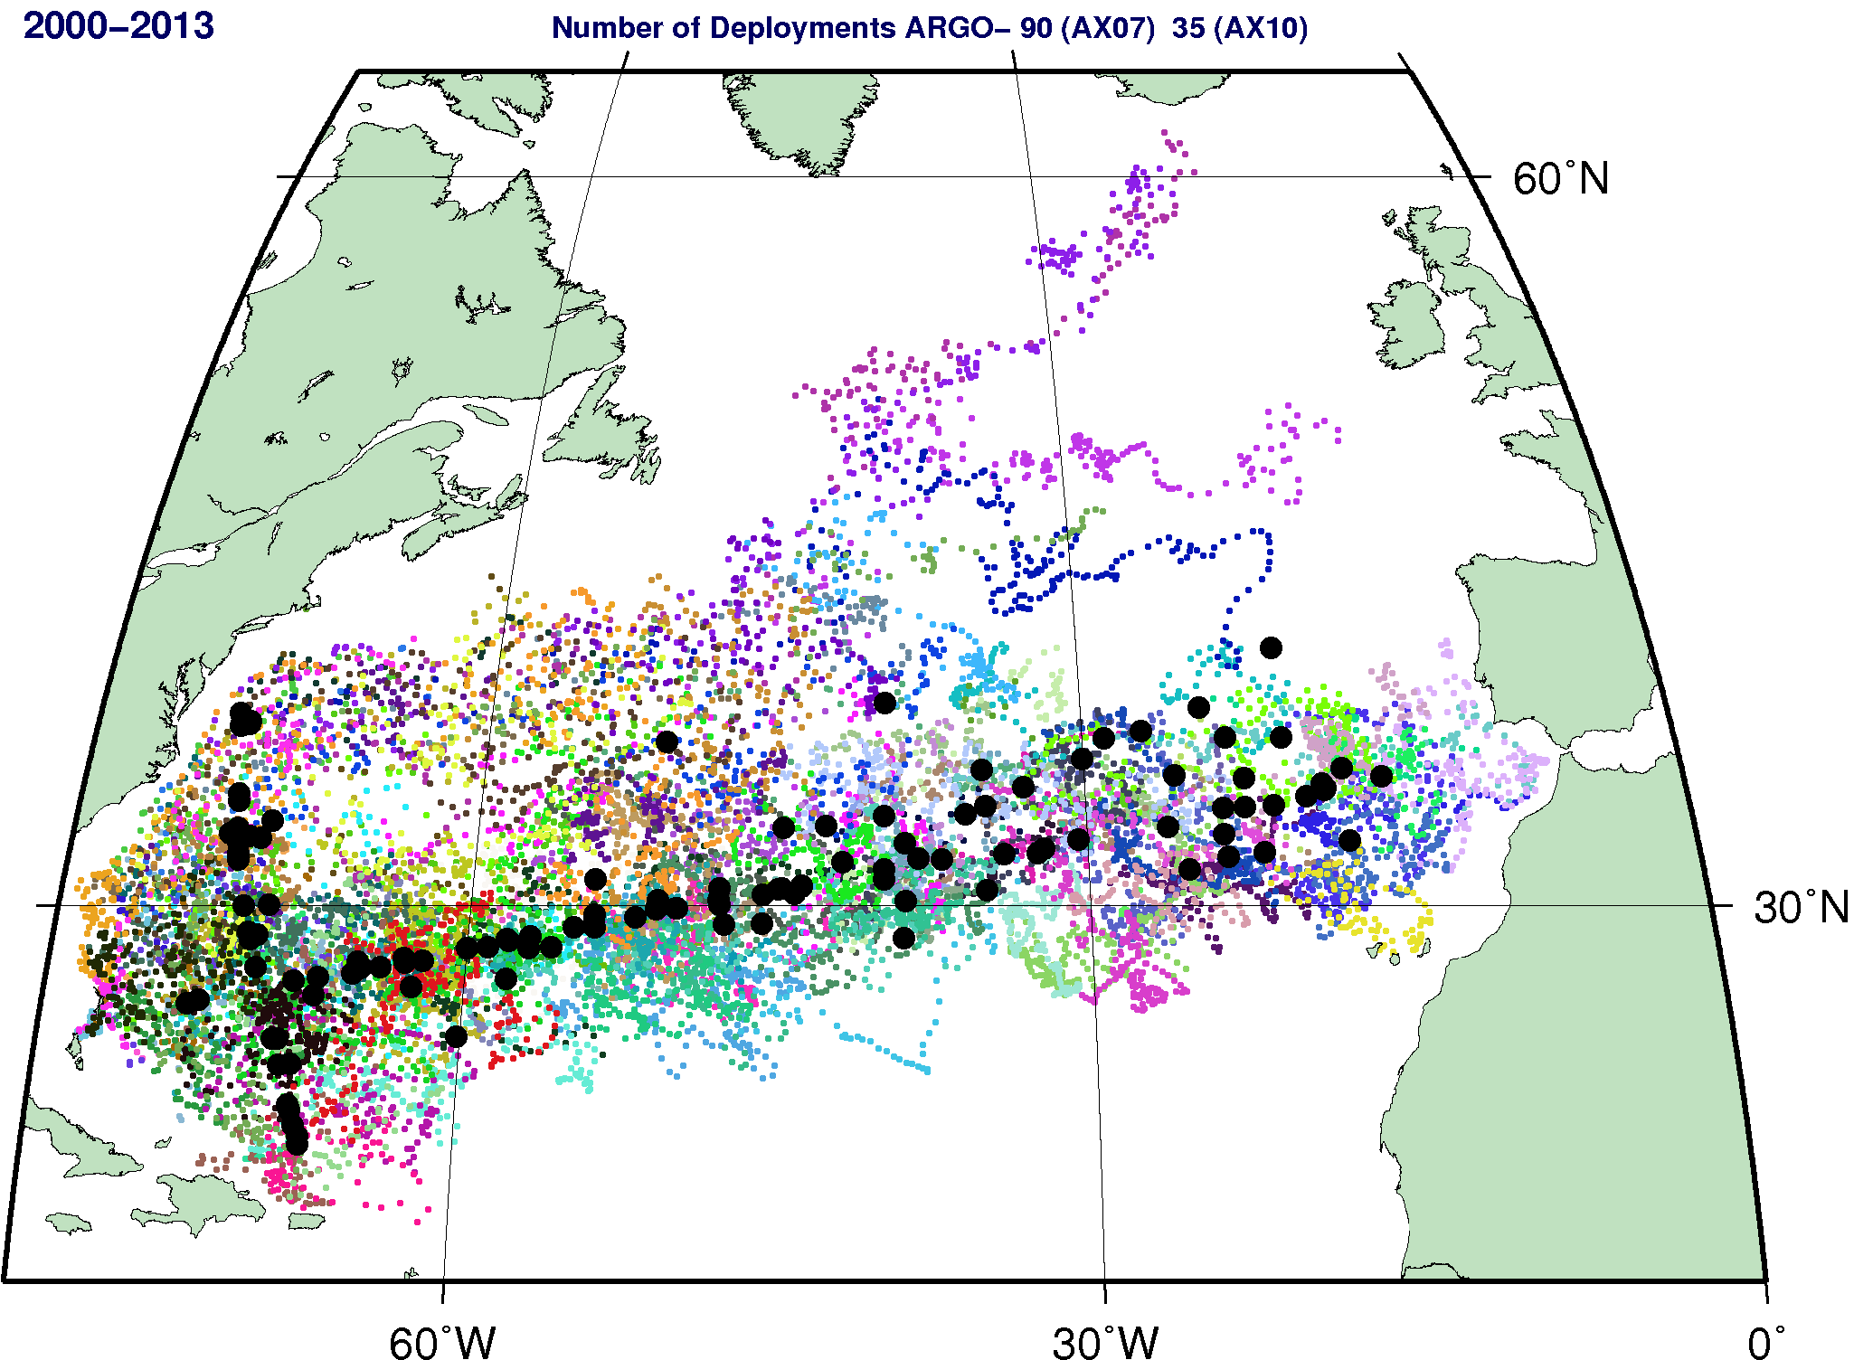
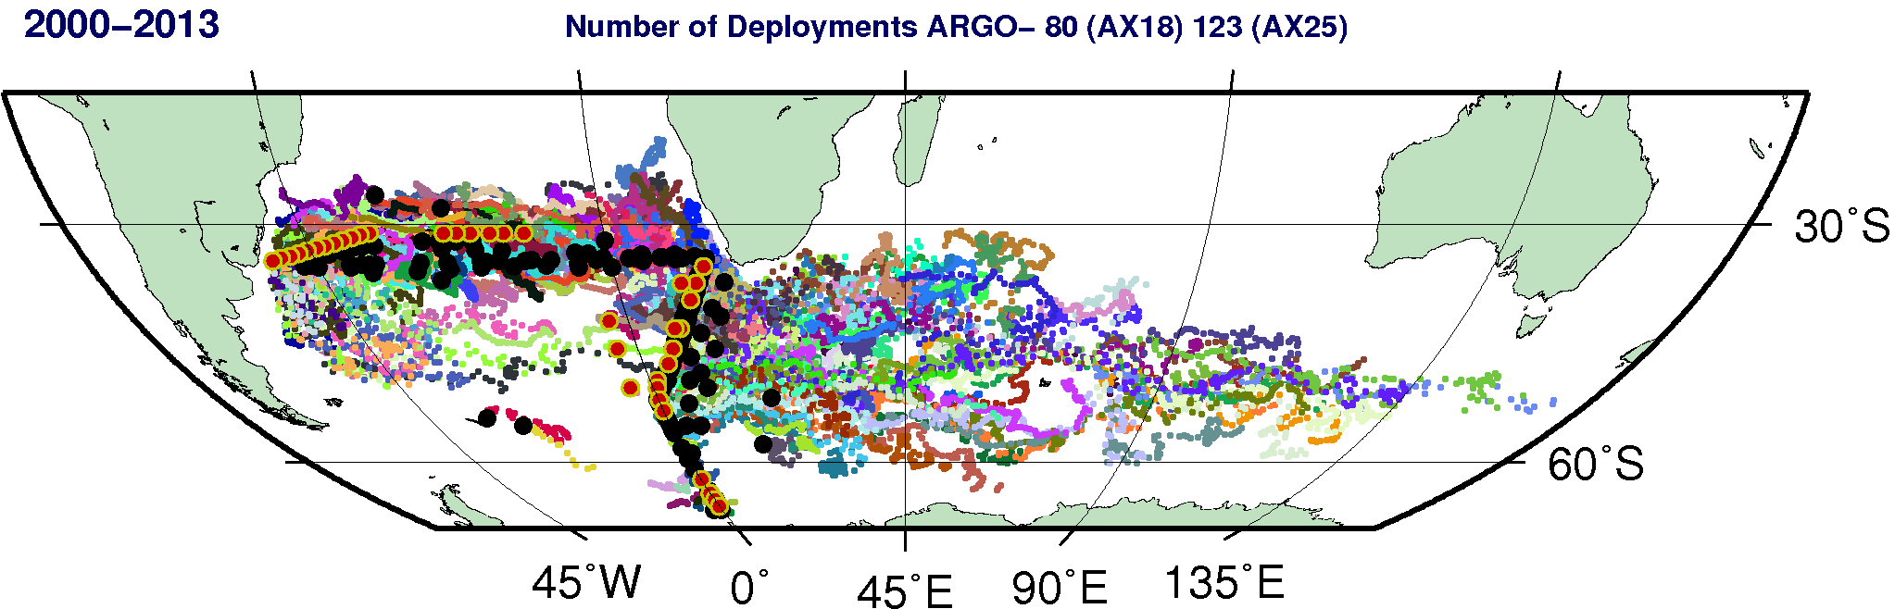
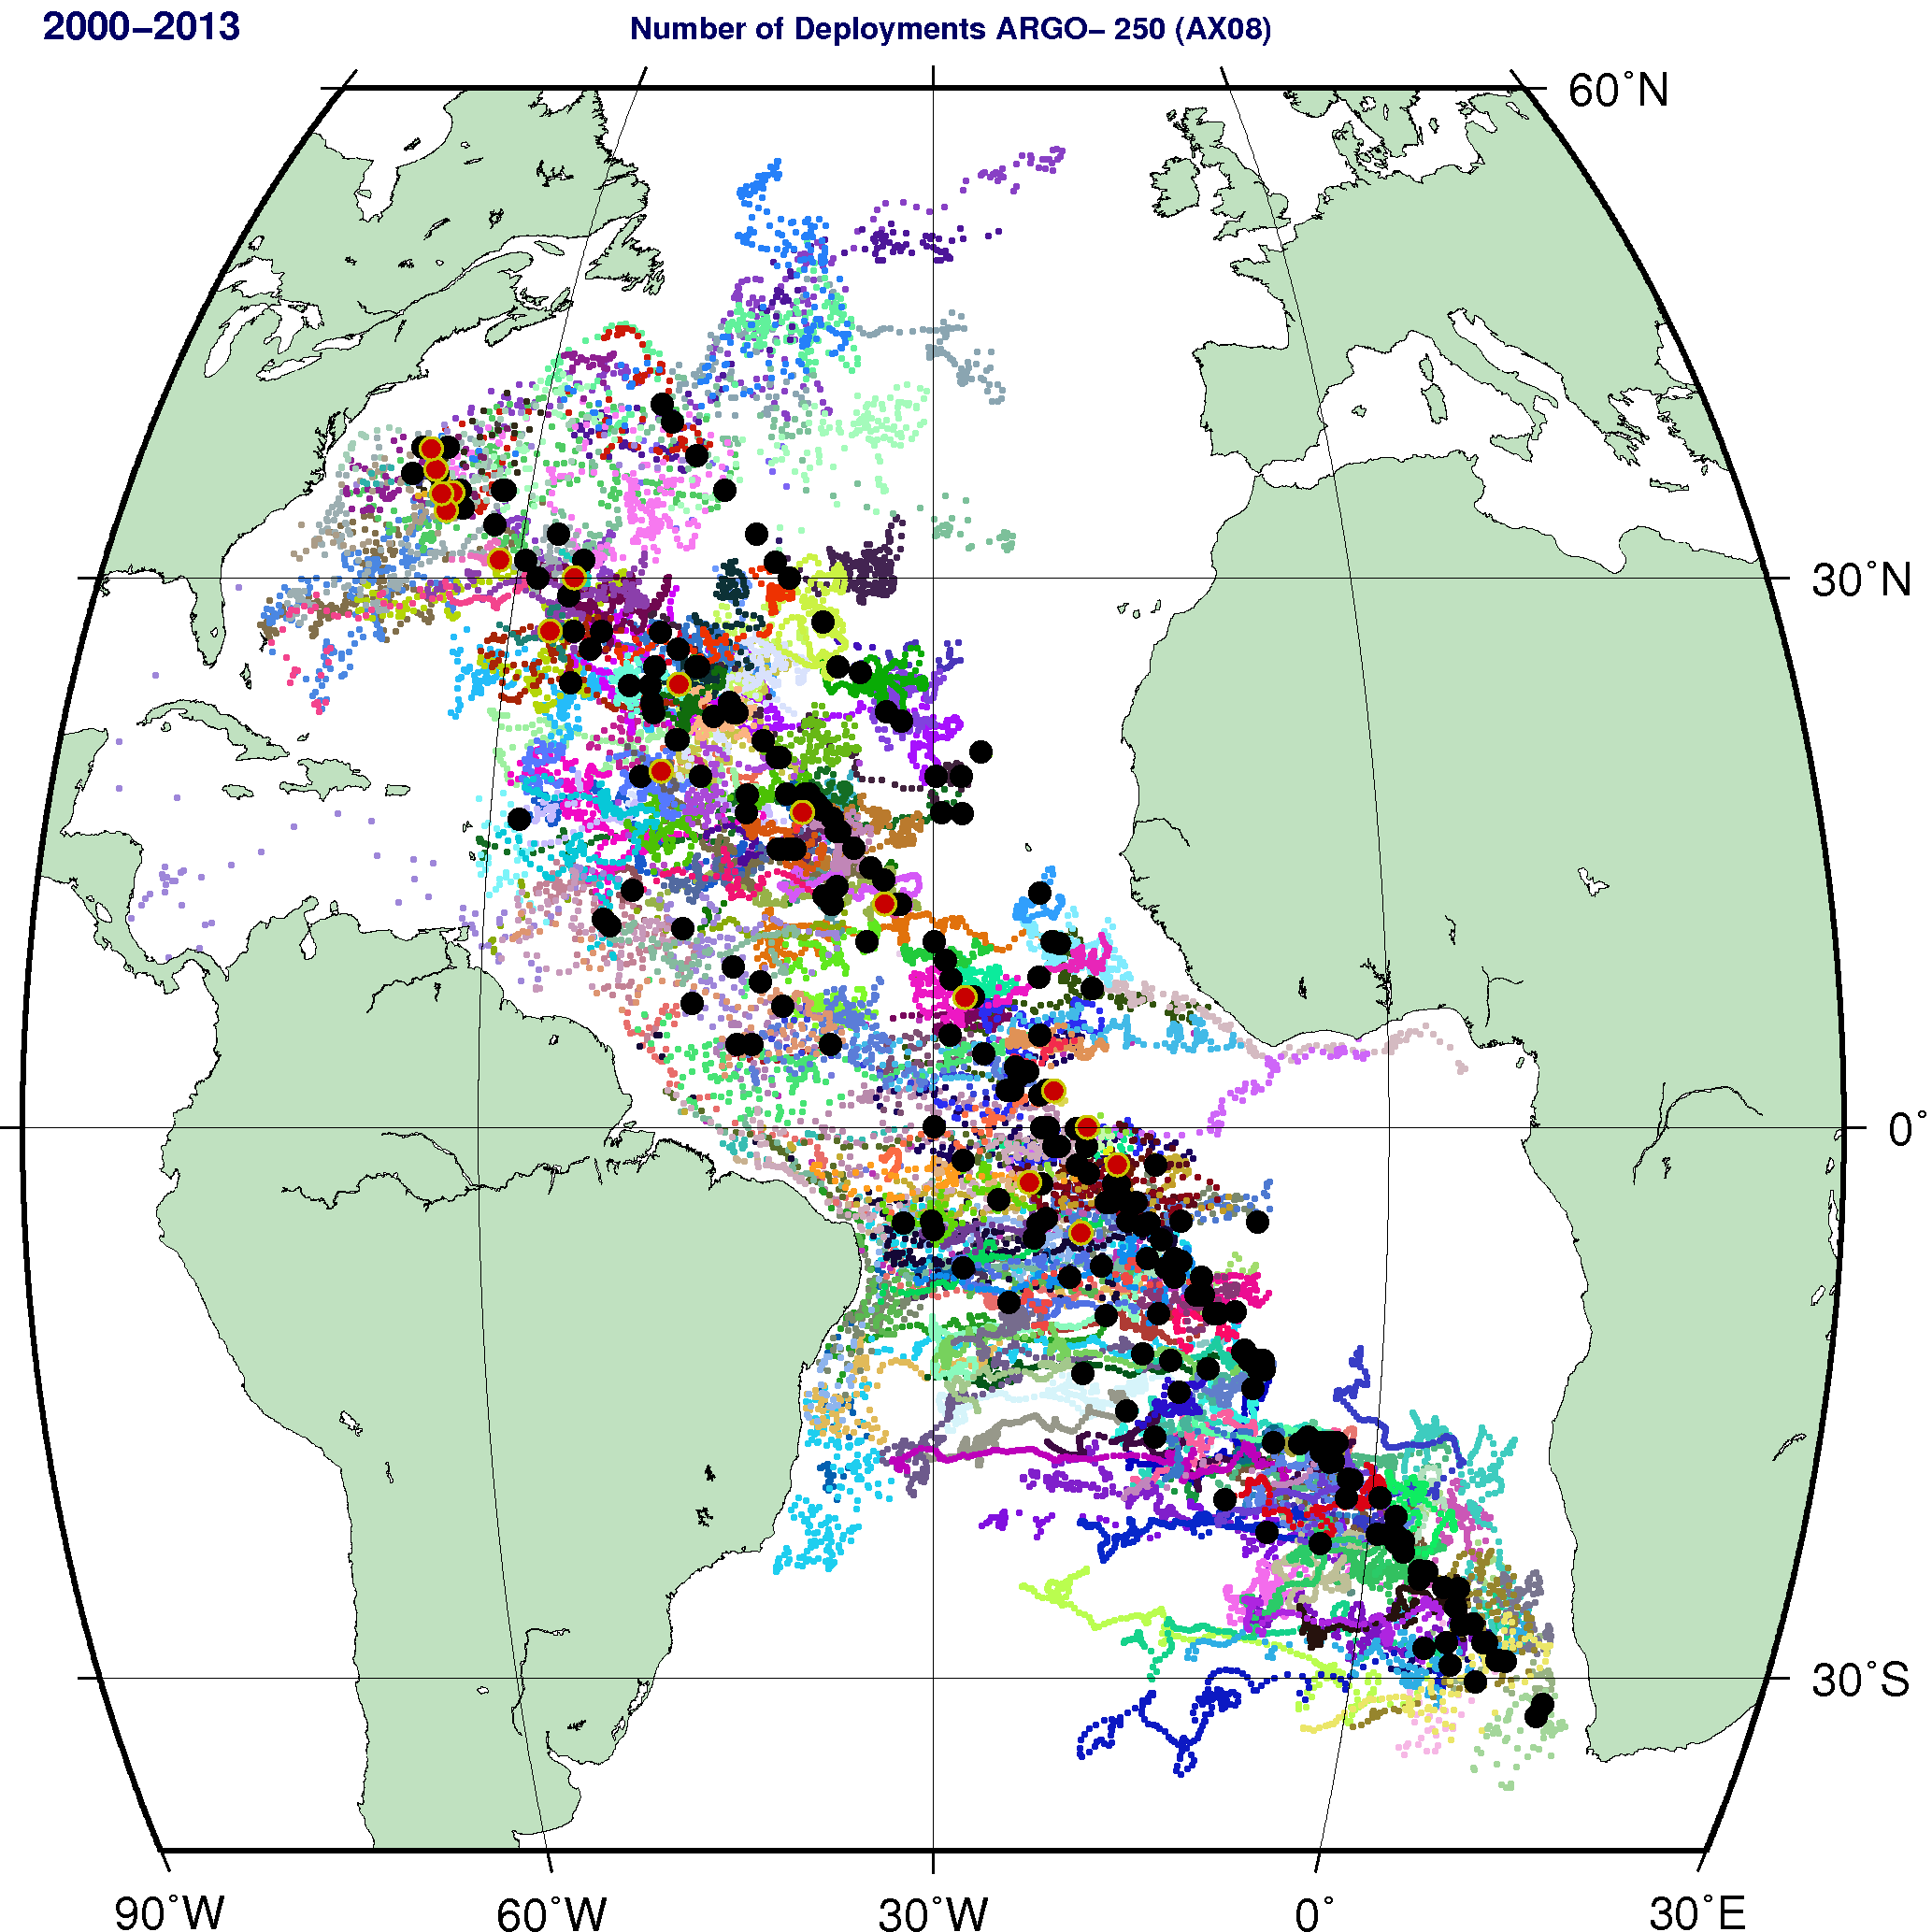

Figure A2. Location of deployments (black circles) of profiling float carried out by XBT ship riders (FY2013 deployments in red circles) since 2000. Locations of observations from these floats are indicated by color dots.

