Manuscript to be submitted to the International Journal of Remote Sensing - PORSEC special issue (deadline on January 15th, 2013)
Understanding the Influence of the Upper Ocean Heat Content on Tropical Cyclones
Gustavo Goni¹, Francis Bringas¹, Ricardo Domingues^{1,2} , M. M. Ali³, and potential co-authors
(Note: authors list still to be defined)
¹ NOAA Atlantic Oceanographic and Meteorological Laboratory, Miami, FL, USA
² University of Miami, Cooperative Institute for Marine and Atmospheric Studies, Miami, FL, USA
³ Oceanography Division, National Remote Sensing Centre, Hyderabad, India
Gustavo Goni – 4301 Rickenbacker Causeway, Miami, FL 33149, USA. E-mail: Gustavo.Goni@noaa.gov.
Provide short biographical notes on all contributors here if the journal requires them.

Understanding the Influence of the Upper Ocean Heat Content on Tropical Cyclones
(Note: abstract still to be defined)
High values of upper ocean heat content (UOHC) have been shown to be more closely linked to intensity changes of tropical cyclones (TC) than sea surface temperature (SST), provided that atmospheric conditions are also favorable. Although SST data provide a measure of the surface ocean conditions, the data give no information about the subsurface (first tens of meters) ocean thermal structure. It is known that the ocean skin temperature cools when the sea surface is affected by strong winds, creating a well-mixed layer that can reach depths of several tens of meters. As the TC progresses, it travels above waters with mixed layer temperatures similar to their skin temperatures. The UOHC can be estimated using a combination of satellite observations, including sea height derived from altimetry and sea surface temperature derived from a suit of remote sensors. We present here the year-to-year variability of the upper ocean heat content in each of the seven tropical cyclone basins, and several cases of TCs which intensification have been linked to the upper ocean thermal conditions.
Keywords: word; another word; lower case except names
Subject classification codes: include these here if the journal requires them

1. Introduction
Tropical Cyclones are devastating natural phenomena that can cause great destruction and significant economic loses. An example of such destruction was hurricane Katrina (2005), which caused over 1,800 fatalities and damage estimated in 108 billion dollars (Blake et al. 2007). Therefore, it is a sensitive matter to understand the mechanisms that drive such destructive storms as well as the real-time monitoring of the environmental conditions that may be favourable for their development and intensification.
Tropical cyclones (TCs) occur in seven ocean basins: the North Atlantic, Northeast Pacific, Northwest Pacific, Southwest Indian, North Indian, Southeast Indian, and South Pacific (Goni et al. 2009) (Figure 1). TCs genesis and intensification are highly complex processes, which may be influenced by the internal TC dynamics, by the upper ocean heat content (UOHC), and by the atmospheric circulation (Gray, 1979; Emmanuel, 1986). UOHC parameters are often considered to have a significant role on these processes, provided favourable atmospheric conditions. Therefore, while threshold values of sea surface temperature (SST) are usually associated with the genesis of TCs, the subsurface thermal structure of the upper ocean is often considered an important factor for TC intensification (Leipper and Volgenau 1972, Shay et al. 2000).
Sudden or Rapid TC intensification (>30 kt.day⁻¹, Kaplan et al. 2009) has been linked with high values UOHC contained in mesoscale features, particularly warm ocean eddies. Several TCs have been identified to have gained strength while travelling over regions of positive UOHC anomalies. For example, this has been reported for hurricanes OPAL (1995, Shay et al., 2000) and Katrina (2005, Scharroo et al., 2005) in the Atlantic, for the TC Nargis (2008, Lin et al., 2009) in the North Indian ocean, and for super-typhoon Maemi (2003, Lin et al., 2005) in the Northwest Pacific. A similar interaction have also been observed between a warm ocean eddy and hurricane Catarina (2004) in the South Atlantic (Vianna et al, 2010), where Subtropical/Tropical Cyclones are not common. Another study (Lin et al., 2008, hereafter refereed as LIN08) analysed 30 category 5 typhoons in the Northwest Pacific, concluding that passing over warm ocean features is generally critical for TC intensification because the deeper warm layer can effectively restrain the typhoon’s self-induced ocean cooling. Therefore, resolving, understanding, and monitoring the upper ocean mesoscale field and its vertical thermal structure appear to be critical elements for TC intensification studies and forecasts.
In most basins, the available hydrographic and in situ observations cannot resolve mesoscale features and their vertical thermal structure have spatial and temporal resolution that is insufficient for TC intensification research or forecast. Therefore, a variety of indirect approaches and techniques are needed to estimate the upper ocean heat content. In the last decades, the availability altimetry data has marked a major advance in oceanographic studies. The altimetry data provides information of the upper ocean dynamics as well as of the vertical thermal structure at a spatial and temporal resolution that resolves ocean mesoscale features (Le Traon et al., 1999). The availability of the altimetry data enabled the development of one technique (Goni et al., 2009) that combines sea height anomaly (SHA) with historical hydrographic observations to determine the Tropical Cyclone Heat Potential (TCHP). The altimetry-derived TCHP fields are a good approximation of the in situ UOHC (Nagamani et al. 2012), providing with a tool for further investigation of the TC intensification processes.
A possible approach to explore the relation between UOHC parameters (TCHP and SST) and the intensification of TCs is by analysing a large number of storms, which may provide with quantitative information of the influence of these oceanographic parameters in the storm evolution and intensification. In particular, storms that undergo rapid intensification (RI), defined as an increase in the TC maximum sustained wind speed of 30 kt within a 24-h period (Kaplan and DeMaria 2003), may provide important information about the correlation between ocean conditions (TCHP or SST) and TC intensification.
Following LIN08, this study aims to evaluate the relationship of UOHC parameters with TC intensification globally and for all TC categories. To accomplish this, a comprehensive analysis based on global datasets of TCs, of TCHP and of SST is developed. This manuscript is organized as follows: in section 2 the dataset employed in this work is described; in section 3 the methodology is detailed, in section 4 the results and discussion are assessed, and in section 5 the conclusions are drawn.

2. Data

2.1 Unisys Weather Hurricane database
The TC ‘‘best-track’’ data is obtained from the Unisys database (Unisys 2012), for the period of 1993-2010. The data consists of along track (AT) values of wind-speed and atmospheric pressure, which are provided in various temporal resolutions (every 3 hrs, every 6 hrs, and etc.). The AT data was linearly interpolated at hourly intervals to enable the calculation of intensification rates. A total of 1630 TCs are evaluated in this study (Table 1).

3. Methods

3.1 The TCHP calculation
The TCHP is defined as the vertically integrated upper ocean heat content between the sea surface and the depth of the 26°C isotherm (D26) (Goni et al. 2009, 2010, 2011):
TCHP_{x,y}= ∫Cp*ρ*T_{x,y,z}*dz (1)
where x and y are the horizontal coordinates, Cp = 3990 J.kg⁻¹.K⁻¹ is the heat capacity of the water, ρ = 1025 kg.m⁻³ is the water density, and T_{x,y,z} is the temperature profile. The approach to determine the D26 combines altimetry-derived sea height anomaly (SHA, available at http://www.aviso.oceanobs.com/) with historical hydrographic observations in a statistical analysis to determine the depth of the main thermocline, usually the 20°C in tropical regions (Goni et al. 1996). Climatological relationships are then used to estimate the D26 (Shay et al. 2000).

4. Results and Discussions
In this section, the relationship between UOHC parameters (TCHP and SST) and the TCs is investigated. In section 4.1, this is investigated for two TCs in the Atlantic, Gustav (2008) and Katrina (2005), and two TCs in the Northwest Pacific, Nida (2009) and Megi (2010). This four case analysis is important to define some generic criteria for a global analysis. In section 4.2, the a global analysis focuses on the influence of UOHC anomalies for TC intensification. In section 4.3, a characterization of the UOHC parameters during periods of TC RI is performed.

4.1 A four case analysis
The influence of the TCHP in the Atlantic TCs can be illustrated by the analysis of hurricanes Gustav (2008) and Katrina (2005) (Figure 2). Both hurricanes had similar tracks, which travelled directly over the Loop Current and made landfall in the same region in the Gulf of Mexico. Katrina was energized by its passage over the Loop Current (~80 kJ/cm²) and continued to intensify as it moved from the Loop Current region into a region occupied by a warm ring (~90 kJ/cm²) shed by the Loop Current. The maximum intensification rate of Katrina (~50 kt.day⁻¹) occurred approximately 14 hours after it reached the warm ring. The storm also became larger as it went through an eyewall replacement cycle (Maclay et al. 2008). Despite the similarities with the track followed by Katrina, Gustav did not become nearly as large or as intense as Katrina. This is possibly because Gustav travelled over the Loop Current (~110 kJ/cm²) region following a landfall in western Cuba and instead of moving over a warm eddy as Katrina did, it moved into a region of relatively low TCHP (~45 kJ/cm²). This potentially prevented its re-intensification, despite being in favorable environmental conditions (200–850 hPa vertical wind shear < 15 kt and SST > 29°C). The difference in the intensity and size of these two hurricanes translates into a difference in sea surface cooling. Maximum cooling by Katrina was approximately 30 kJ/cm² in TCHP and 4°C in SST, almost double that observed for Hurricane Gustav (Figure 2).
In the Northwest Pacific Ocean, Nida (2009), the most intense storm of 2009, and Megi (2010), one of the most intense TCs on record, provide also good examples of the relation between TCHP and storm intensification(Goni et al. 2010, Goni et al. 2011, D’Asaro et al. 2011). Typhoon Nida (2009) was a Category-1 storm on 24 November and intensified into a Category-5 super-typhoon on 25 November, reaching peak winds of 155 kt. This typhoon travelled from a region of moderate (~60 kJ/cm²) TCHP values to a region of high (~100 kJ/cm²) values (Figure 3) during the same period of its RI. Its maximum intensification rate (~80kt.day⁻¹) occurred approximately 6 hours after it reached the warm ocean feature. The strength of this storm is also independently revealed by its large 10-minute sustained winds of 115 kt (Dvorak 1984, Koba et al. 1991). However, the cooling produced by this storm was small (~1°C), which may be due to the deep warm and stable surface layer in the region (Figure 3).
Super-typhoon Megi (2010) (Figure 3) formed to the west of Guam on 12 October 2010, and strengthened to a Category-5 super-typhoon by 17 October with winds of 160 kt and central pressure at 885 hPa, which is among the lowest TC pressures ever observed. Megi formation and intensification was favoured by the unusually high TCHP availability in 2010 (up to 50 kJ/cm² higher than 2009). Megi formed in the region that is known as the gyre center (LIN08) that is characterized by very high TCHP values (normally > 100 kJ/cm²). From 14 to 17 October, Megi intensified from a tropical storm stage to a Category-5 TC, subsequently making landfall in the Philippines (D’Asaro et al. 2011, Pun et al. 2012, Goni et al. 2012). Its maximum intensification rate (~50 kt.day⁻¹) occurred immediately after crossing a warm ocean feature. The self-induced cooling by this storm reached values of 50 kJ/cm² and of 3ºC to the west of the Philipines.
The four cases emphasized here exemplify the influence of the UOHC on TC intensification. The TCs Katrina (2005), Nida (2009) and Megi (2010), developed a RI (>30 kt.day⁻¹, Kaplan et al. 2009) shortly (within 24 hours) after reaching a warm ocean feature.

4.2 UOHC anomalies and TC intensification
This section investigates the importance of positive UOHC anomalies for TC intensification globally. To accomplish this, the analysis focuses on the along track TCHP and SST during periods of TC intensification (> 0kt.day⁻¹).
The along track TCHP values during periods of TC intensification is averaged in bins of 1ºX1º (AT-TCHP, Figure 4a) to investigate the characteristics of the TCHP (SST) field associated with intensification. The AT-TCHP exhibits a wide range between 0 and 120 kJ/cm², which indicates that storm intensification can occur under different oceanographic conditions. The lower values of the AT-TCHP (~0 kJ/cm²) are observed in the higher latitudes of each basin, while the higher values (≥ 80 kJ/cm²) are observed in the Caribbean and in the Northwest/Southwest Pacific. The AT-TCHP also exhibits a distribution that is zonally dependent, in which the higher values occur near the western boundary. An exception to this general pattern is the Indian ocean, where higher values are observed in the eastern side of the basin. The global AT-TCHP pattern is consistent with the geographic distribution of the averaged hurricane season TCHP during 1993-2010 (HURR-TCHP, Figure 4b). This suggests that the intensification of TCs may not depend on specific values of TCHP. For example, the east side of the North Atlantic is an active site of storm formation and intensification, although the relatively low values of TCHP (<50 kJ/cm²).
The difference between AT-TCHP and HURR-TCHP is calculated (ANOM-TCHP, Figure 4c) to study the importance of the TCHP anomalies during TC intensification. Positive ANOM-TCHP indicates that TC intensification is usually associated with positive TCHP anomalies, while negative ANOM-TCHP indicates the contrary. Regions with the predominance of positive ANOM-TCHP are on the (i) Atlantic, (ii) North Indian, (iii) South Indian south of 10ºS, (iv) Northwest Pacific north of 20ºN, (v) South Pacific south of 15ºS, and (vi) East Pacific. In these regions, TC intensification may be usually associated with warm ocean features, which agrees with the analysis of specific TCs (Shay et al., 2000, Scharroo et al., 2005, Lin et al., 2005, LIN08, Lin et al., 2009). The negative ANOM-TCHP values occur within the latitude band of 20ºS–20ºN of the (i) west Pacific and in (ii) the Indian Ocean. Negative ANOM-TCHP suggests that TC intensification may not require for warm ocean features in these regions. The region in the Northwest Pacific between 5ºN–20ºN encompasses the center of the subtropical gyre, where the background climatological warm layer is deep, and passing over positive upper ocean heat content anomalies is not critical for intensification of TCs (LIN08). The high values of the HURR-TCHP in these regions indicates that the energy for TC intensification may be available independently of warm ocean features. Similar results are observed for the SST (not shown here).
The predominance of positive ANOM-TCHP indicates that TC intensification is usually related with the presence of warm ocean features. The maximum rate of wind speed intensification is compared here with the maximum rate of change in the along track SST and TCHP to provide a detailed analysis of the influence of warm ocean features on the TCs. This comparison is discussed for the Atlantic (Figure 5) and Northwest Pacific (Figure 6). Positive (Negative) rates of change in the SST and TCHP indicates that the TC track crossed a warm (cold) ocean feature. The maximum rate of wind speed intensification ranges between 5 kt.day⁻¹ and 90 kt.day⁻¹ for the Atlantic and Northwest Pacific. For both basins, over 80% of all TCs experienced its maximum intensification within ~18 ± 13 hours after crossing a warm ocean feature (Figure 5 and 6). However, the flat slope between the rate of wind speed intensification and the rate of change in the SST (Figures 5a and 6a) suggests that these parameters are not associated. This may be due because the SST is restricted to the very thin ocean “skin” that does not fully represents the presence of warm ocean features. An example is that the TC-induced SST cooling is dependent on the subsurface thermal structure (Lin et al. 2009). The TCHP, on the other hand, can provide a good representation of the UOHC (Nagamani et al. 2012). The positive slope in the relationship between the rate of wind speed intensification and the rate of change in the TCHP (Figures 5b and 6b) further suggests that higher UOHC anomalies are associated with higher TC intensification. For example, in the Atlantic (Northwest Pacific) an increase of 30 kJ/cm² (20 kJ/cm²) in the along track TCHP during a day is linked with a TC intensification of ~60 kt. The results confirm the hypothesis suggested by the evaluation of specific cases (Shay et al., 2000, Scharroo et al., 2005, Lin et al., 2005, Lin et al., 2009, Vianna et al, 2010) that maximum TC intensification occurs shortly after travelling over a positive anomaly in the UOHC, such as a warm eddy.

4.3 UOHC and TC RI
The discussion above emphasized the importance of warm ocean features for TC intensification globally. Here, the analysis focuses on the characterization of the oceanic conditions during periods of RI (> 30kt.day-1, Kaplan et al. 2009) of TCs.
The classification of all Category 1-5 TCs as a function of the average along track SST (TCHP) reveals that the TCs follow a quasi-normal (single tailed) distribution (Figure 7a,d). More than 60% of the Category 1-5 TCs occur in regions with SST (TCHP) between 27ºC and 30ºC (< 50 kJ/cm²). The mode of the along track SST (TCHP) is centred at 28.5ºC (~17 kJ/cm²). A higher range of values is observed when only TCs that experienced RI are considered (Figure 7b,e). Over 80% of the RI TCs travelled on regions with average SST (TCHP) higher than 28.5ºC (42 kJ/cm²). Some TCs undergo RI while traveling over regions with SST < 26ºC, indicating the influence of other factors (e.g. the atmospheric conditions). The number of RI TCs relative to the total number TCs storms increases with the increase in SST and TCHP (Figure 7c,f), reaching maximum values for storms travelling over regions with SST and TCHP higher than 31ºC and 100 kJ/cm², respectively. This result can be thought as a probability of RI for high values of UOHC. Therefore, these observations indicate that higher values of SST and TCHP are associated with higher chances of RI. The fact that the maximum relative number of RI storms is not observed for TCHP higher than 150 kJ/cm² (Figure 7f) may be due to the small number of storms that travelled over regions of very high TCHP.
Finally, the along track SST and TCHP are also analysed according to the TC category. The analysis focuses on the Atlantic and Northwest Pacific (Figure 8). The SST and TCHP exhibits a large standard deviation for all storm categories during non-rapid intensification periods, which indicates that the TCs may transit over areas of high SST and TCHP without intensifying rapidly. For example, the SST (TCHP) averages during in the Atlantic are ~27 ± 3.5ºC (30 ± 20 kJ/cm²). Rapid intensification periods are always associated with a higher and less variable range of SST and TCHP values, which is consistent with the discussion above. For each TC category, the statistics indicates that the maximum storm intensity may be linked with the availability of higher UOHC values (Figure 8b,d). Results exhibit an increase in the TCHP averages with the increase in the storm category. This pattern is more evident for TCs in the Northwest Pacific (Figure 8d). Therefore, these results provide some observational evidence linking RI and TC intensity with the availability of high UOHC values.

5. Final Remarks
(Note: Conclusions are still to be defined)
Results presented here show that TCHP is related to future TC intensity change. Values greater than 50 kJ cm-2 are best related to positive 24-h intensity change in a large sample of cases. However, the ocean role in TC intensification still needs to be adequately investigated and quantified. Future work will include detailed analysis of other upper ocean parameters, such as heat content and mean temperature in the mixed layer to different depths or isotherms, including isotherms below 26°C. Additionally, considering the atmospheric variability is crucial to investigate the phenomenon of TC intensification: while the ocean appears to provide the potential for the intensification, the atmosphere determines if that potential can be realized. It is clear that improved estimates of TCHP in ocean and ocean-atmosphere coupled models are critical for improvement in TC intensity forecasting. The results presented here highlight the importance of continuous support for altimetric missions able to resolve mesoscale features.

References
Blake, Eric S., Christopher W. Landsea, Ethan J. Gibney, and N. C. D. C. Asheville (2007). The deadliest, costliest, and most intense United States tropical cyclones from 1851 to 2006 (and other frequently requested hurricane facts). NOAA/National Weather Service, National Centers for Environmental Prediction, National Hurricane Center,.
D'Asaro, E., P. Black, L. Centurioni, P. Harr, S. Jayne, I-I Lin, C. Lee, J. Morzel, R. Mrvaljevic, P. Niiler, L. Rainville, T. Sanford, and T-Y D. Tang, (2011). Typhoon-Ocean Interaction in the Western North Pacific, Part 1, Oceanography, 24, 4, 24-31. doi: 10.5670/oceanog.2011.91.
Dvorak, D. F., (1984): Tropical cyclone intensity analysis using satellite data. NOAA Tech. Rep. 11, 45 pp. [Available from NOAA/NESDIS, 5200 Auth Rd., Washington, DC 20333.]
Emanuel, Kerry A. (1986), "An air-sea interaction theory for tropical cyclones. Part I: Steady-state maintenance." Journal of the Atmospheric Sciences 43, no. 6: 585-605.
Gray, William M. (1979). "Hurricanes: Their formation, structure and likely role in the tropical circulation." Meteorology over the tropical oceans 19, no. 9: 155-218.
Goni, G., S. Kamholz, S. Garzoli and D. Olson (1996). Dynamics of the Brazil-Malvinas Confluence Based on Inverted Echo Sounders and Altimetry. J. Geophys. Res., 101, 16273-16289.
Goni G. J., M. DeMaria, J. Knaff, C. Sampson, I. Ginis, F. Bringas, A. Mavume, C. Lauer, I-I Lin, M. M. Ali, P. Sandery, S. Ramos-Buarque, K. Kang , A. Mehra, E. Chassignet, and G. Halliwell (2009). Applications of satellite-derived ocean measurements to tropical cyclone intensity forecasting. Oceanography, 22, 176-183.
Goni, G. J., J. A. Knaff, and I-I Lin, (2010). TC heat potential (TCHP). In State of the Climate in 2009, Special Supplement of the Bulletin of the American Meteorological Society, 91, 7, S99-S100.
Goni, G. J., J. A. Knaff, and I-I Lin, (2011). Tropical Cyclone Heat Potential. In State of the Climate in 2010, Special Supplement of the Bulletin of the American Meteorological Society, 92, 6, S132-S134.
Goni, G. J., J. A. Knaff, and I-I Lin, (2012). Tropical Cyclone Heat Potential. In State of the Climate in 2011, Special Supplement of the Bulletin of the American Meteorological Society, 93, 7, S114-S116.
Gray, W. M., (1979): Hurricanes: Their formation, structure and likely role in the tropical circulation. Meteorology over the Tropical Oceans, D. B. Shaw, Ed., Royal Meteorological Society, 155–218.
Leipper, D., and D. Volgenau, (1972): Hurricane heat potential of the Gulf of Mexico. J. Phys. Oceanogr., 2, 218–224.
Le Traon, P., & Dibarboure, G. (1999). Mesoscale mapping capabilities of multiple-satellite altimeter missions. Journal of Atmospheric and Oceanic Technology, 16(9), 1208-1223.
Lin, I. I., Chen, C. H., Pun, I. F., Liu, W. T., & Wu, C. C. (2009). Warm ocean anomaly, air sea fluxes, and the rapid intensification of tropical cyclone Nargis (2008). Geophysical Research Letters, 36(3), L03817.
Lin, I.-I., C.-C. Wu, K. A. Emanuel, I.-H. Lee, C.-R. Wu, and I.-F. Pun (2005), The interaction of supertyphoon Maemi (2003) with a warm ocean eddy, Mon. Weather Rev., 133, 2635 – 2649.
Lin, I. I., Wu, C. C., Pun, I. F., & Ko, D. S. (2008). Upper-ocean thermal structure and the western North Pacific category 5 typhoons. Part I: ocean features and the category 5 typhoons' intensification. Monthly Weather Review, 136(9), 3288-3306.
Kaplan, J. and M. DeMaria (2003). Large-Scale Characteristics of Rapidly Intensifying Tropical Cyclones in the North Atlantic Basin. Wea. Forecasting, 18, 1093-1108.
Kaplan, J., M. DeMaria, J. A. Knaff, (2009): A Revised Tropical Cyclone Rapid Intensification Index for the Atlantic and East Pacific Basins, Wea. Forecasting, doi:10.1175/2009WAF2222280.1.
Koba, H., S. Osano, T. Hagiwara, S. Akashi, and T. Kikuchi, (1991): Relationship between the CI-number and central pressure and maximum wind speed in typhoons (English translation). Geophys. Mag., 44, 15–25.
Leipper, D. and D. Volgenau (1972). Hurricane heat potential in the Gulf of Mexico. J. Phys. Ocean., 2: 218-224.
Maclay, K. S., M. DeMaria, T. H. Vonder Haar, (2008). Tropical Cyclone Inner-Core Kinetic Energy Evolution. Mon. Wea. Rev., 136, 4882–4898.
Nagamani, P. V., Ali, M. M., Goni, G. J., Pedro, D. N., Pezzullo, J. C., Bhaskar, T. V. U., & Kurian, N. (2012). Validation of satellite-derived tropical cyclone heat potential with in situ observations in the North Indian Ocean. Remote Sensing Letters, 3(7), 615-620.
Pun, I-F, Y-T Chang, I-I Lin, T-Y Tang, and R-C Lien, (2012). Typhoon-Ocean Interaction in the Western North Pacific, Part 2, Oceanography, 24, 4, 32-41. doi: 10.5670/oceanog.2011.92.
Scharroo, Remko, Walter HF Smith, and John L. Lillibridge (2005). "Satellite altimetry and the intensification of Hurricane Katrina." Eos, Transactions American Geophysical Union 86, no. 40: 366.
Shay, L. K., G. J. Goni, and P. G. Black (2000). Effects of a warm oceanic feature on Hurricane Opal. Mon. Wea. Rev., 128: 1366-1383.
Unisys, cited 2012: Unisys weather hurricane tropical data. [Available online at http://weather.unisys.com/hurricane/.]
Vianna, M. L., Menezes, V. V., Pezza, A. B., & Simmonds, I. (2010). Interactions between Hurricane Catarina (2004) and warm core rings in the South Atlantic Ocean. Journal of Geophysical Research, 115(C7), C07002.

Table 1. Number of Tropical Cyclones analysed in this work per basin and storm category.
 | TS | CAT-1 | CAT2 | CAT-3 | CAT-4 | CAT-5 | subtotal
Atlantic | 119 | 48 | 22 | 24 | 30 | 8 | 251
West Pacific | 187 | 80 | 55 | 30 | 88 | 51 | 491
East Pacific | 134 | 42 | 27 | 19 | 34 | 12 | 268
South Pacific | 54 | 15 | 4 | 10 | 9 | 7 | 99
North Indian | 56 | 19 | 2 | 3 | 10 | 2 | 92
South Indian | 199 | 79 | 31 | 41 | 66 | 13 | 429
Total |  |  |  |  |  |  | 1630

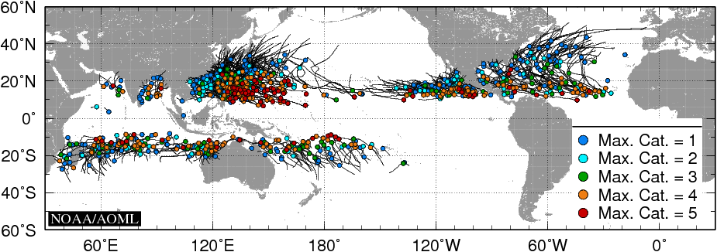
Figure 1. Trajectories of TCs that reached Cat.1 strength (i.e., maximum sustained winds above 33 m s-1) during 1993-2010, with circles indicating the location where the storm first became Cat.1 and the colors indicating the maximum category reached by these storms.

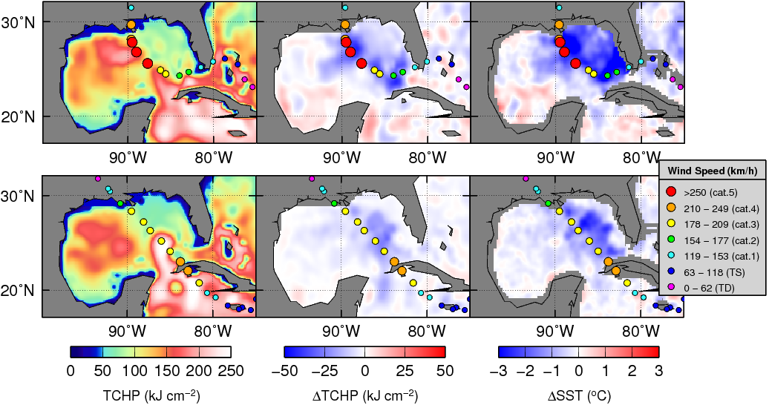
Figure 2. (left) TCHP and surface cooling given by the difference between post- and pre-storm values of (center) TCHP and (right) SST, for Hurricanes (top) Katrina in 2005 and (bottom) Gustav in 2008.

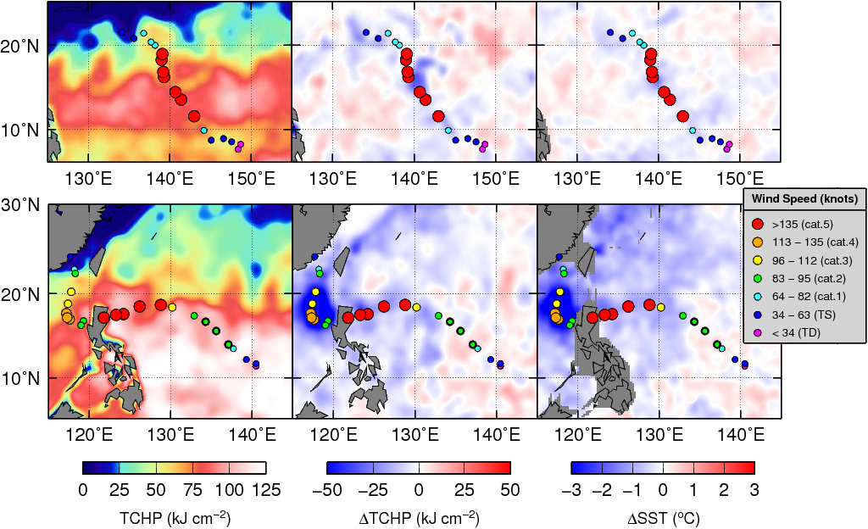
Figure 3. (left) TCHP and surface cooling given by the difference between post- and pre-storms values of (center) TCHP and (right) SST for Super Typhoons (top) Nida in 2009 and (bottom) Megi in 2010.

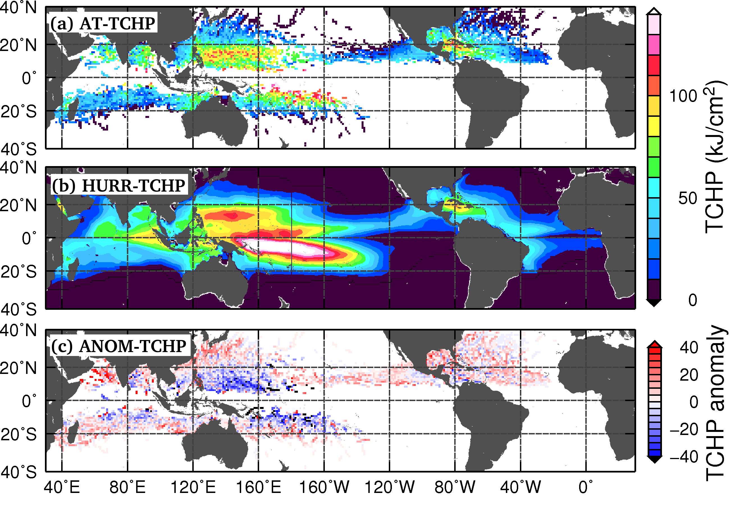
Figure 4. (a) Averaged along track TCHP for each 1ºX1º box during storm intensification (AT-TCHP). (b) Average hurricane season TCHP during 1993-2010. (c) Difference between the averaged along track TCHP during storm intensification and the average hurricane season TCHP (ANOM-TCHP).

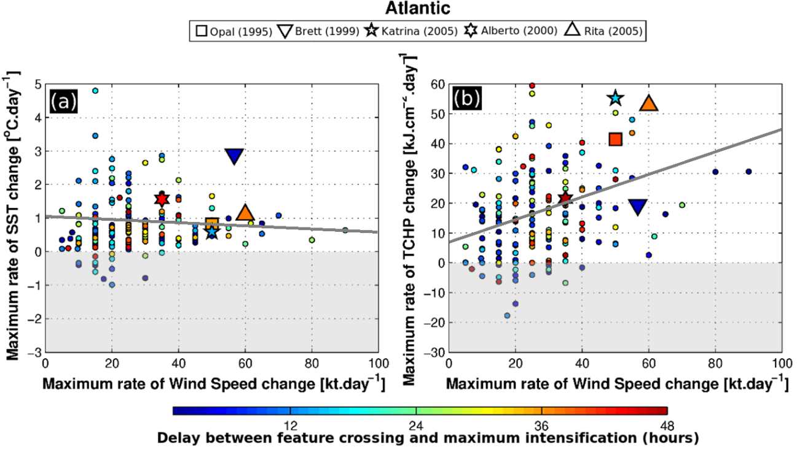
Figure 5. Atlantic (a) maximum rate of wind speed change [kt.day-1] per storm vs. maximum rate of SST change [ºC.day⁻¹] along the storm track, and (b) maximum rate of wind speed change [kt.day⁻¹] per storm vs. maximum rate of TCHP change [kJ.cm⁻².day⁻¹] along the storm track. The color scale indicates the delay in hours between the change in the upper ocean heat conditions and the maximum intensification.
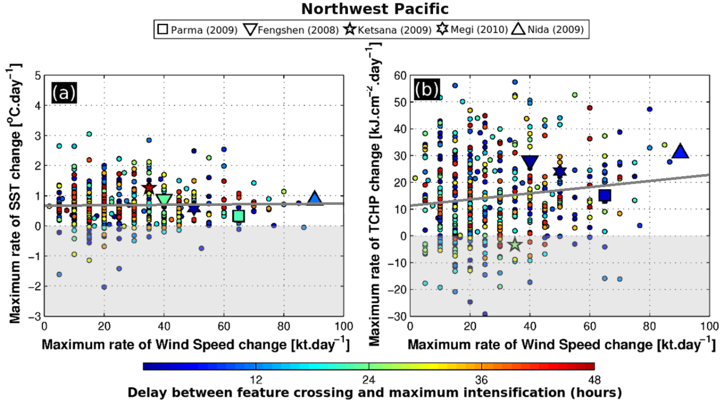
Figure 6. Same as Figure 5, but for the West Pacific basin.
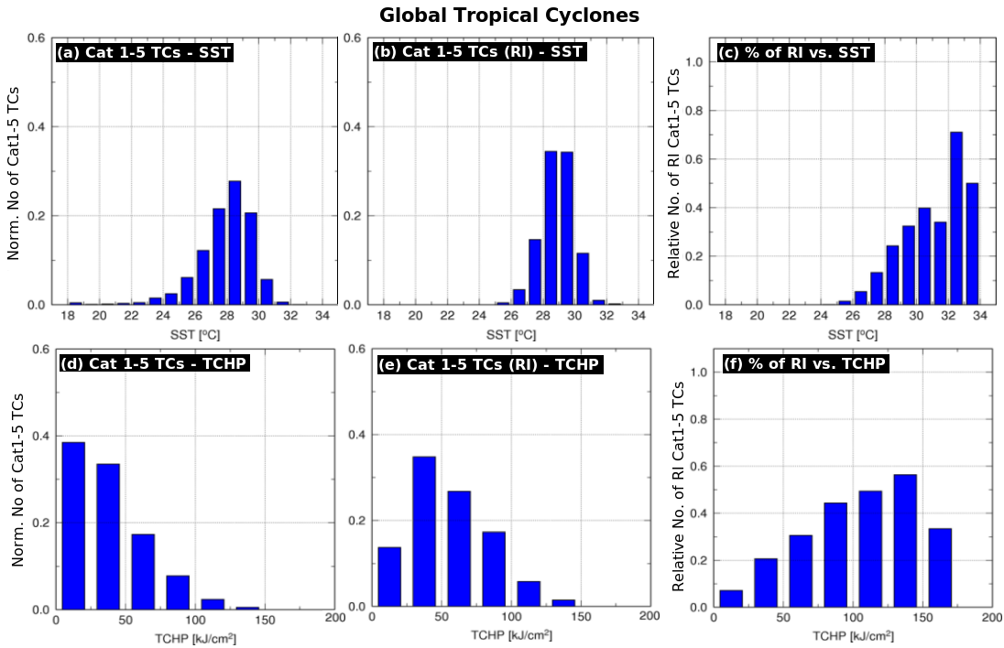
Figure 7. (left) Total (normalized) number of Cat.1-5 TCs, (center) total (normalized) number of rapidly intensified (RI) Cat.1-5 TCs, and (right) total number of RI Cat.1-5 Storms divided by the total number of Cat.1-5 storms, as a function of (top) SST and (bottom) TCHP.

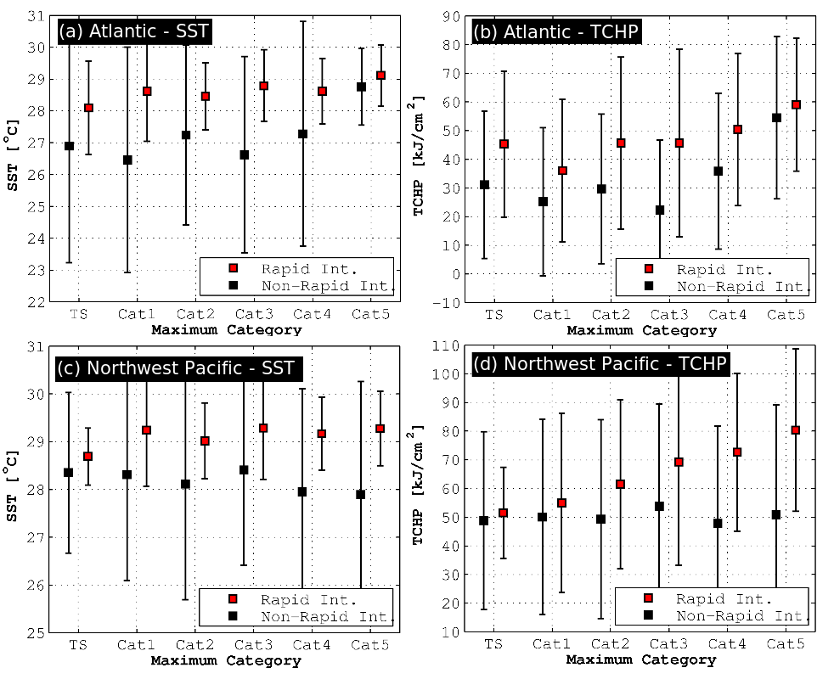
Figure 8. Along track (AT) statistics per storm category during rapid intensification periods (red square) and during non-rapid intensification periods (black square) for the (a) Atlantic AT SST, (b) Atlantic AT TCHP, (c) Northwest Pacific AT SST, and (d) Northwest Pacific AT TCHP.

