SOOP Report 2013 – Ricardo Domingues highlights
Paragraph
In a scientific paper led by Ricardo Domingues (CIMAS/UM), the role of local wind stress changes in forcing variations in the structure of the Antarctic Circumpolar Current (ACC) is investigated. The main finding of this work is that changes in the structure and intensity of the westerlies force an immediate and integrated response in the upper layer of the ACC, and in the transports by the Subantarctic Front and by the Antarctic Polar Front (APF). This response occurs as follows: during positive phases of the Southern Annular Mode, easterly anomalies develop between 35ºS-45ºS, forcing the poleward advection of warmer waters through anomalous Ekman transport, and changes in the dynamic height structure, which ultimately causes the deacrease (increase) of the SAF (APF) geostrophic transport. The dynamical link between the wind stress changes and the dynamic height adjustments occurs as a combination of (i) thermosteric sea level rise due to warm anomalies in the Ekman layer, and of (ii) Ekman pumping driven sea level rise (Figure 1a). Therefore, the long term variability of the sea height anomaly (Figure 1b) is largely due to the sea surface temperature variability (Figure 1c), and to the Ekman pumping (not shown). This mechanism may have implications for the Atlantic-Indian heat and mass exchanges. The manuscript entitled “Atmospherically forced variability of the Antarctic Circumpolar Current south of Africa between 1993-2010” is currently under review at the Journal of Geophysical Research – Oceans.
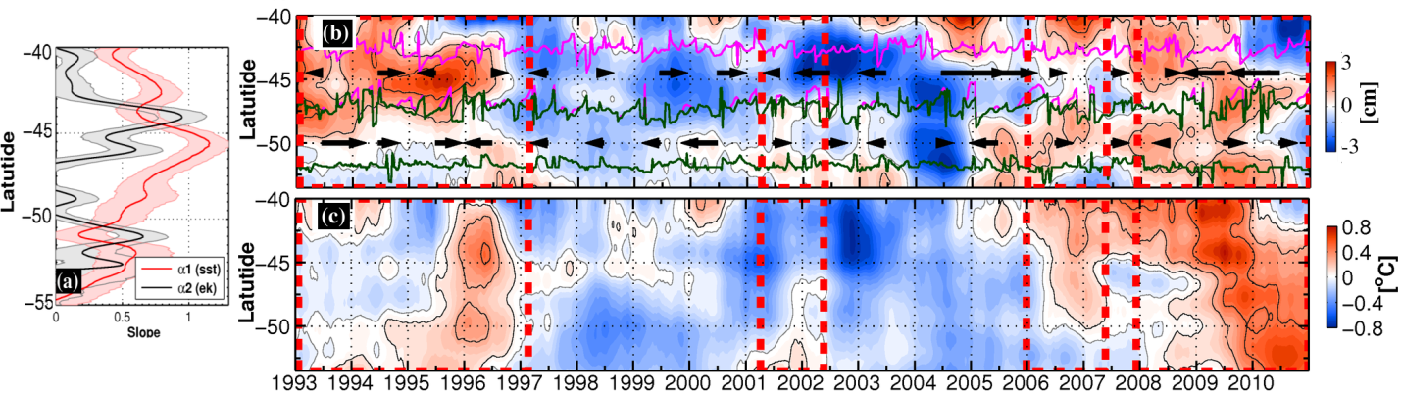
Figure 1 – (a) Contribution of the thermosteric component (red line) and of the Ekman pumping component (black line) for the sea height anomaly variability as a function of latitude. (b) Observed sea height anomaly variability for time scales longer than the annual. Highlighted are the SAF (magenta lines) and APF (dark green) frontal domains, and the annual mean geostrophic velocity signal (arrows). (c) Sea surface temperature residuals (annual cycle removed) for time scales longer than the annual.

Highlight
The Ship Of Oportunities Program currently maintains 4 thermosalinographs (TSGs) installed on merchant vessels. During the SOOP operational meeting of 2012, the following question has been posted: How much bias is introduced in the TSG data due to calibration? The concept is that changes in the calibration coefficients may introduce biases between measurements made before and after the calibration. Quantifying such quantity is of great relevance for the decision making process involved in the SOOP management. An investigation conducted by Ricardo Domingues (CIMAS/UM) and Dr. Francis Bringas (AOML/NOAA) has addressed this question using data collected by the SBE45 Micro TSG for the period of 02/10/2011-04/21/2011 aboard the M/V Reykjafoss. The approach consisted of (1) determining the synthetic instrument output using a convergence numerical method on the geophysical functions of the instrument, (2) applying two consecutive set of calibration coefficents on the synthetic instrument output, and (3) evaluating the residuals introduced by the use of two sets of calibration coefficients. The residuals obtained were of the order of 10^{-3 o}C (10⁻³ PSU) for temperature (salinity), which is a value smaller than the nominal accuracy of the instrument. Similar results have also been obtained for data collected by the instrument SBE21 Seacat aboard the M/V Oleander. As a conclusion, the current calibration practices adopted by the SOOP management are suited for maintaining the quality of the data collected.

