Tutorial: setting up the personal CV websites (05/24/2013)
By Ricardo Domingues

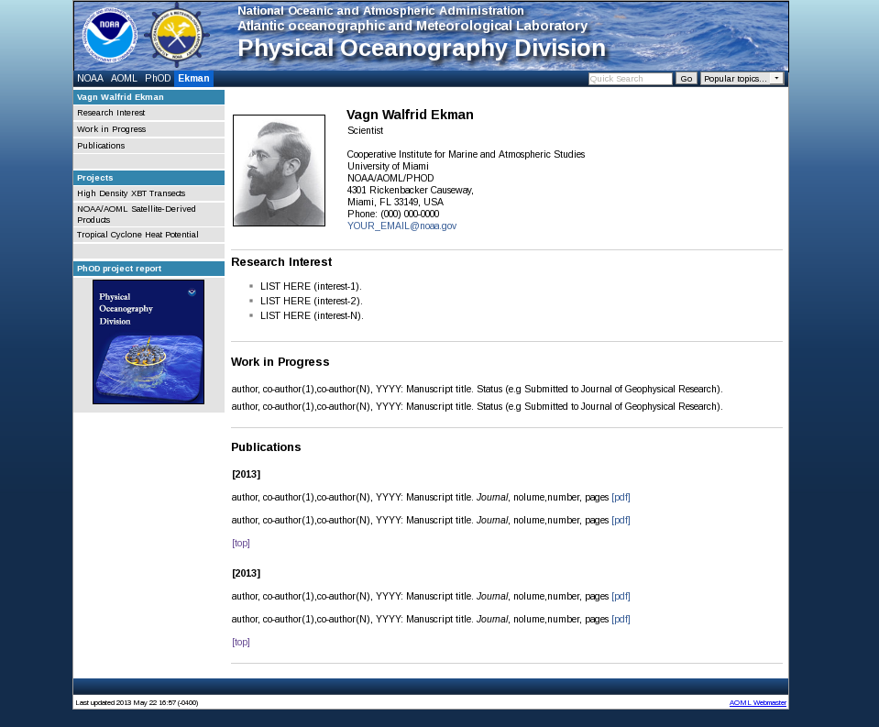

Location of the files: /WSmounts/phoddat/share/phod/people/CV_template
Step 1: Copy the template directory to your personal directory.
linux command line:
cp -rf /WSmounts/phoddat/share/phod/people/CV_template /WSmounts/phoddat/share/phod/people/yourlastname (lower case)
Note: before proceeding with this step check if you already have your personal directory at: /WSmounts/phoddat/share/phod/people/
Step 2: Edit the file “link_db.txt” inside your directory
Note: This file contains information about the websites under this level (under your CV)
Procedures:
- Open the file “link_db.txt” with any text editor.
- Search “CV_template” & Replace for “yourlastname”
- Search “Vagn Walfrid Ekman” & Replace for “Your Full Name”
- Search “Ekman” & Replace for “Your Last Name”
Step 3: Open a web browser and navigate to:
http://phodnet.aoml.noaa.gov/phod/people/yourlastname/index.php
Note: This is the test version of the website. From now on you may start testing the changes by refreshing (F5) the website after making any changes to the files
Step 4: Edit the file “menu_db.txt” inside your directory
Note: This file contains information about the menus on the side bar on the left side.
Procedures:
- Open the file “menu_db.txt” with any text editor.
- Search “CV_template” & Replace for “yourlastname”
- Search “Vagn Walfrid Ekman” & Replace for “YOUR FULL NAME”
Step 5: Edit the file “index.php” inside your directory
Note: Here is where you will edit enter your professional information. Please follow the structure of the file.
Procedures:
- Search “Vagn Walfrid Ekman” & Replace for “YOUR FULL NAME”
- Place your picture file in this directory, search “PHOTO.jpg” and replace for your picture file. If you don’t want to have your picture on the website, just remove this line.
- Edit this file according to your information, always testing it (F5) on the web browser.
Step 6: Once you’re finished, contact Ricardo Domingues (Ricardo.Domingues@noaa.gov) to have your page published on the live PHOD website.

