

Physical Oceanography Division Phone: 305/361-4345
4301 Rickenbacker Cswy Fax: 305/361-4412
Miami, Florida 33149-1097
June 2011

Cruise Plan – AX10

Ship Name: M/V HORIZON NAVIGATOR

Project Title: Atlantic Climate Change Program
Volunteer Observing Ship High Resolution XBT Line AX10

Beginning date: Departing Newark, NJ, June 10, 2011.

Ending date: Arriving San Juan, Puerto Rico, estimated June 14, 2011.

Sections taken four times per year. Next section scheduled for Sep, 2011.

Scientific Ship Riders: Dr. Francis Bringas - NOAA AOML

Description of the Scientific Program

The volunteer ship, M/V HORIZON NAVIGATOR, will be involved in a study of the upper ocean thermal structure of the subtropical North Atlantic Ocean within the context of the Atlantic Volunteer Observing Ship Program. Repeat crossings through the center of the subtropical gyre, every 3 months, will be conducted with the intent of determining and monitoring the seasonal-to-interannual variability of the upper ocean. The upper ocean thermal structure obtained by the ship using the expendable temperature probes (XBTs) will be used to correlate the subtropical gyre intensity with atmospheric forcing as well as determining the heat transport. This particular line along nominally 75⁰ W, designated as AX10, will be used in conjunction with the high resolution line AX7 that transits from Miami, Florida through the Straits of Gibraltar (Figure 1). Together, these two lines form a closed box off the eastern United States, which should allow us to make stronger statements about the effect of heat flux variability on atmospheric weather patterns.
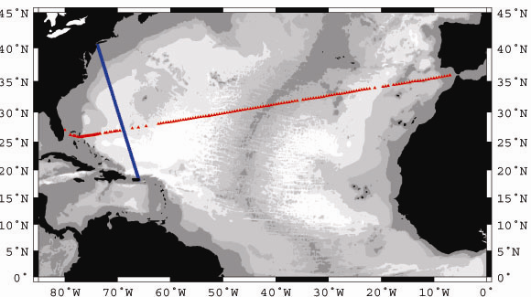

Figure 1. Projected station locations for the VOS/XBT line AX10 (blue circles) and the station locations from a sample track along AX7 (red triangles) taken aboard the M/V MITLA during Feb, 1995. Shading represents progressively deeper bottom contours: 3000, 4000, 5000, and 5500 m.

Implementation

Sampling along this section (designated AX10) began in 1996 (figure 2) and meets the WOCE (World Ocean Circulation Experiment) criterion for high resolution deployment providing temperature profiles every 40 km in the open ocean and between 10-30 km near boundary currents down to a depth of about 760 m.

Sampling on this section should be of consistent horizontal spacing of XBT probes (see below) and a nearly repeating track line for each of the crossing in order to minimize the differences between sections and the possible aliasing of horizontal gradients in temperature into time changes of temperature.

The overall plan for the sampling assuming previous ship tracks and speeds is as follows:

PLEASE NOTE: IT IS THE RESPONSIBILITY OF THE RIDER TO ENTER THE SHIP’S LLOYDS NUMBER AND CALLSIGN INTO THE SEAS METADATA SETUP.

- From Port of departure to Ambrose Tower, 40°27' N, 73°49' W: Set up and test XBT launcher as desired. No planned sampling.
- From Ambrose Tower near 40°27' N, 73°49' W to near 39°25' N, 73°24' W : Low resolution sampling every 40 km (every 21.6 nm): i.e., 4 probes over 120 km deployed approximately every 58 minutes.
- From near 39°25' N, 73°24' W to near 35°17' N, 71°49' W: High resolution sampling every 20 km (10.8 nm): i.e., 24 probes over 480 km deployed approximately every 29 minutes.
  - Note this sampling should continue until you first see the Gulf Stream. The northern edge of the Gulf Stream can be estimated by looking at the 15°C isotherm at 150-200m. As soon as you see this Temperature at this depth, start shooting every 15 minutes until the Gulf Stream is completely crossed. The southern edge of the Gulf Stream is completely crossed after the 15°C isotherm deeper than 600m).
- From near 35°17'N, 71°49'W to near 19°30'N, 66°1'W: Sampling every 40 km (21.6 nm): i.e., 47 probes over about 1880 km deployed every 58 minutes.
- From near 19°30' N, 66°14' W to 18°40' N, 66°1' W: Sampling every 20 km (10.8 nm): i.e., 3 probes over 60 km deployed every 29 minutes.
- After 18°40' N XBT locations will be as follows: 18°40'N, 18°35'N, 18°30'N, 18°29.4'N and 18°28.8'N.

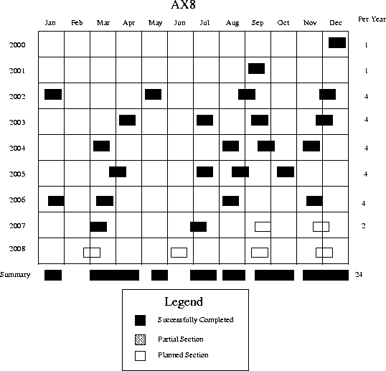

Figure 2: Table of times of all section occupations since the program began in 1994.

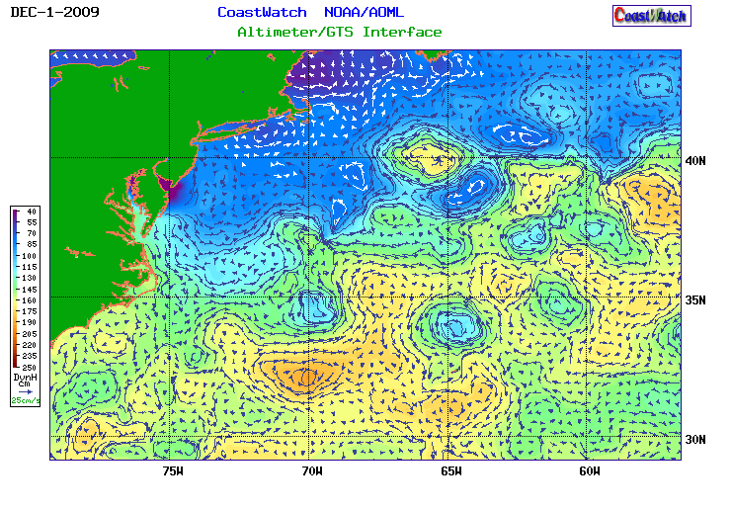
Figure 3. Satellite altimetry-derived surface currents and dynamic height in the North Atlantic for 30 November 2009.

The time interval between XBT deployments is a function of ship speed. The above time interval estimates are based on a ship traveling at 22 knots. If the ship is traveling at a different speed it will be necessary to adjust the launch times (see table 1 as a quick guide). If the planned cruise track deviates significantly from the outline above please notify Molly Baringer at 305/361-4345 or 305/710-9240.

If the planned sampling is interrupted for any reason (such as an autolauncher failure) the procedure will be to drop another probe as close as possible to the planned drop and continue with the desired spacing of the XBTs for that section of the cruise track (according to the above guide). If a serious malfunction of the autolauncher occurs then manually deploy the XBTs from the stern of the ship using the hand launcher.

The ship-rider will work as needed around the clock to:

1) check and load the auto-launcher;
2) check that the system is logging data correctly;
3) keep a log of problems, repeated casts due to suspected XBT errors and
weather conditions;
4) inform NOAA personnel of any difficulties; and,
5) deploy ARGO profiling floats and surface drifting buoys as necessary.

No drifters or floats will be deployed during this cruise.

Summary

This high resolution XBT line will require 84 probes plus an anticipated 10% failure rate of 8 probes for each Atlantic crossing. This typically requires a total of 92 probes per crossing and about 368 probes per year.

What features we are expecting:

Numerous XBT sections have been taken in areas similar to the ones to be taken on this AX10 cruise. Several of the previously taken sections provide guidance in determining where the XBTs will be dropped. Figure 3 shows the expected currents in the region during the cruise.

Figures 4, 5 and 6 show some of the typical sections that show features we will be attempting to sample. The most prominent feature is the deepening of temperature contours (isotherms) marking the Gulf Stream (figure 4). The northern edge or ‘wall’ of the Gulf Stream (or front) is often demarked by the northernmost position that the 15°C isotherm occurs deeper than 150-200m. Further south of the Gulf Stream this isotherm is typically about 600m (or more) deep. Some investigators use the position that the 15°C isotherm goes deeper than 500m to denote the southern edge of the Gulf Stream.

The Gulf Steam is an unstable jet (or front) that wiggles or meanders considerably as the current proceeds farther into the Atlantic Ocean. We will attempt to approximate the exact position of the Gulf Stream from satellite sea-surface temperature (SST) imagery. Near 70-74°W the Gulf Stream is thought to meander over a 300 km distance between about 35°N to 38°N. Occasionally these meanders in the Gulf Stream will pinch off and form rings of anomalously warm (or cold) water that appear to the north (or south) of the Gulf Stream.

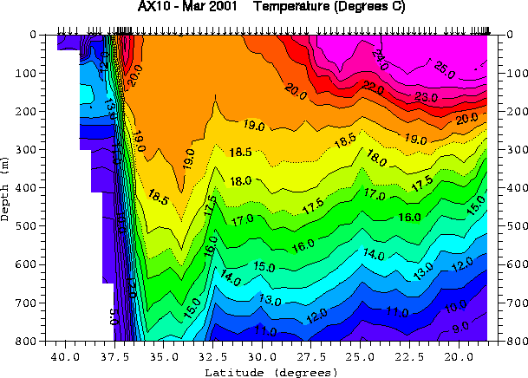

Figure 4. Temperature section of a typical crossing along AX10 (temperature contours as marked
are in ⁰C). This section was taken aboard the M/V CSX HAWAII in March of 2001.
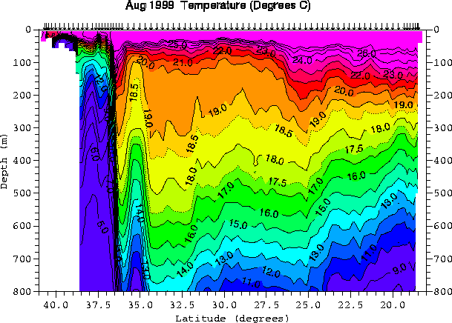

Figure 5. Temperature section along AX10 showing a cold core ring (temperature contours as marked
are in ⁰C). This section was taken aboard the M/V SEALAND CRUSADER in August ’99.

One example of a cold ring is shown in figure 5. In this figure starting at the left hand side that is closest to the coast, the cold water off the NE United States is seen (blue contours at depth). The abrupt deepening of many isotherms (constant temperature surfaces) of the Gulf Stream occurs near 36-37°N. Further south, the isotherms rise and fall again briefly marking the presence of a cold ‘core’ ring (centered at about 35°N). A warm core ring can be seen in figure 5 located approximately 300 km offshore near 38°N. Warm core rings are characterized by isolated regions of relatively warm water usually at depth. Often these are “capped” over by water consistent with the local environment. Optimally we would like to sample the Gulf Stream and any rings with fine horizontal sampling (15-20 km) while the rest of the ocean is sampled more coarsely (40 km).
Some other features we are looking for include:
- The pocket of warm water typically found along the axis of the Gulf Stream.
Note this is marked by waters warmer than 23°C in figure 4 and greater than 25°C in figure 5. This is primarily an advective feature that marks a long filament of warm waters from the Florida Straits and is seen clearly in SST maps. This feature is occasionally obscured during summer when surface heat creates fairly uniformed warm surface temperatures.

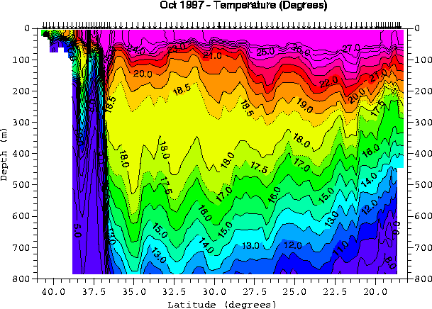
Figure 6. Temperature section along AX10 showing a warm core ring (temperature contours as
marked are in ⁰C). This section was taken aboard the M/V SEALAND CRUSADER
in October ’97.

- The large volume of "18°C" water south of the Gulf Stream. This water is formed through surface cooling during winter and can form very deep layers of homogeneous properties (over 400m thick). Figure 4 shows isotherms extending vertically to the surface with uniform (or near uniform) water properties from the surface to more than 300 m depths. The presence of this water type (we call it a water mass) can still be seen in the summer section, figure 5, when the surface is warmer by noting the large distance between the 17°C and 19°C isotherms. Note that the volume and specific temperature of this "18°C" water mass varies substantially as a function of time. For example the October 1997 section contains a large volume of water between 18 to 18.5°C, while the August 1999 section contains more water in the 19 to 20°C range.
- The shelf-slope front. Very near the coast, surface cooling and advection of cold waters from the north produce very cold water that typically follows the edge of the continental shelf where it meets the continental slope (where the bottom topography deepens from less than 100m to over 500m). An example of this is shown in figure 4. In figure 4, the shelf slope front is evident by the cluster of closely spaced isotherms 39°N that slope downwards towards the coast and bottom topography. The slope front is generally coincident with the abrupt change in the bottom topography about 200 km from Ambrose Tower. Note that this feature and its offshore extension will include vertical temperature inversions of as much as 5°C (in 100m) with colder water on top of warmer water (figure 4). This is due to the low salinity of the coastal waters compensating for the lower temperatures. At present we are not measuring the salinity along AXl0. We hope that some arguments about the correspondence between temperature and salinity from historical coastal data can be used to estimate the actual density from temperature alone.
Typical Temperature Profile Examples

Below are examples of typical temperature profiles expected on this transect.
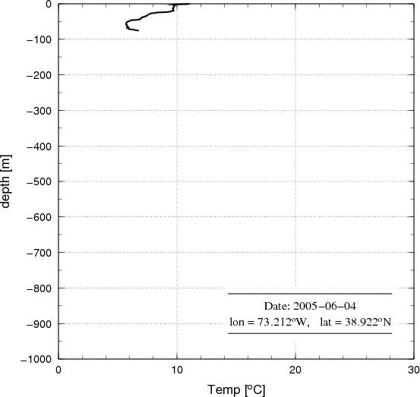
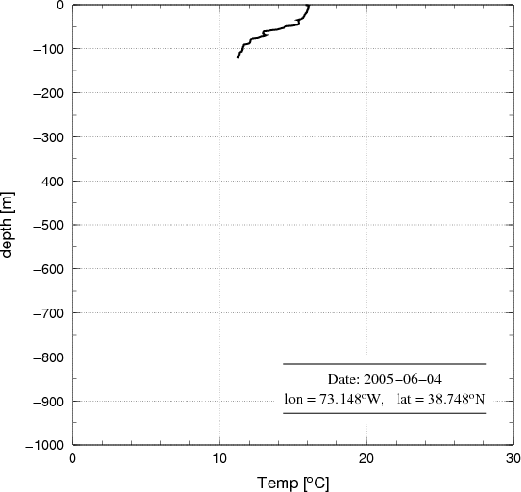
Figure 7a and 7b. Temperature Profiles, Hitting Bottom on Shelf out of NY (left). Sitting on Bottom (right)

Figure 7a shows cold shelf water with a small temperature increase at the bottom of the profile just before the probe hits the bottom (near 100 m depth). No obvious “hit bottom” spike is distinguishable from the increased (noisy) temperature near the bottom, but the profile in Figure 7b shows a classic signature of the probe sitting on the bottom (perhaps some wire stretch). The shelf out of New York is quite broad and the slope is not encountered until around 38.8 N.
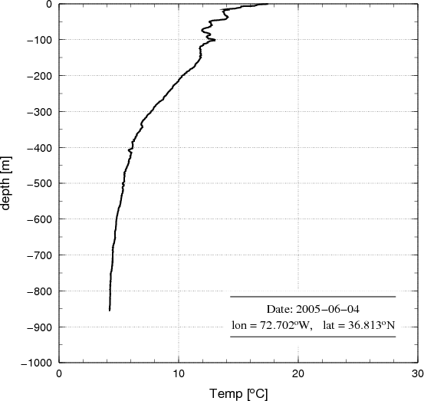

Figure 8. Typical Temperature Profile, North of Gulf Stream. Example of Electrical Noise

Upper 200 m temperature inversions are common north of the Gulf Stream. Note the large-scale, relatively smooth temperature variations in Figure 8. Note that profile exhibits regularly spaced in depth (time) fine scale “noise”. This is not natural and is likely electrical interference or grounding issues. These very small scale “wiggles” can be filtered out, but are not ideal.

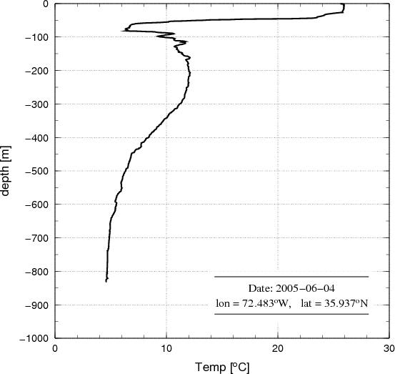

Figure 9. Typical Temperature Profile, Crossing the Gulf Stream. Temperature Inversion above 200m

Figure 9 signals the crossing of the Gulf Stream. Near the northern part of the Gulf Stream temperature inversions can be seen well below 200 m; here two occur up to 350 m. This particular profile shows water near 75 m to be warmer than water on the shelf (see Figure 7) but colder than the water in between (see Figure 8). The cold inversion in Figure 9 is likely from the shelf and is a filament or pinched off ring.
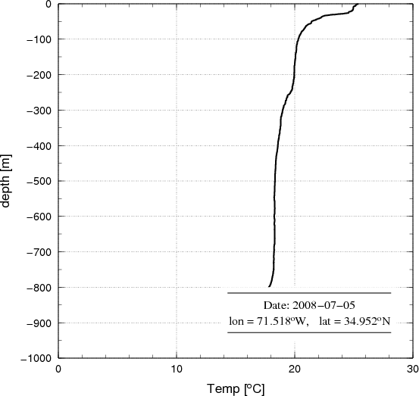

Figure 10. Typical Temperature Profile, South of the Gulf Stream – Uniform Temperature to Deep Water

South of the Gulf Stream, temperature profiles are usually smoothly decreasing with increasing depth but very uniform water (near 18 C) can be found quite deep (e.g. Figure 10 to 800 m). Sometimes there will appear one or more subsurface nearly uniform temperature layers. These are thought to be “capped over” mixed layers from previous winters.

High Density Check-in list for the Ship Rider Date Completed

Equipment testing: ____________
- Verify that all equipment to be sent from AOML has been thoroughly tested before shipping.
- Comment if not testing was performed:
______________________________________________________________________________________________________________________________________________________________________________________________________

Check equipment shipping to Newark: ____________
- Contact Robert Roddy (Robert.J.Roddy@noaa.gov, 305 361-4434) to confirm that the equipment is shipped to the Fedex depot at Newark Airport.

Check ship route ____________
- Contact Robert Roddy (Robert.J.Roddy@noaa.gov, 305 361-4434) to confirm that the ship is on the scheduled route to Newark two days in advance of the cruise’s planned date

Contact support at Newark ____________
- Contact James Farrington (James.W.Farrington@noaa.gov, 757 651-3794) to coordinate airport pick up.

Useful information:

Address of the entrance of the APM terminal at Port Elizabeth is:

1100 McLester St
Elizabeth, New Jersey 07201

Address of FedEx depot at Newark Airport:

FedEx Metroplex
Building 155
Newark IAP, New Jersey 07114
(757) 441-3062 (Jim Farrington)

High Density Check-out list for the Ship Rider Date Completed

Data to be copied to CD or other means of transportable memory __________________
1. All XBT data in .BIN, .NDC and electronic XBT drop log sheet.
2. HistoryAllAttempts.txt – found at c:\ProgramFiles\AMVERSEAS\XBT\ARCHIVE
3. Cruise webpage summary, cruise report, drifting buoy log sheet and ARGO float log sheet

XBT data and HistoryAllAttempts.txt CD to each of the following:
Robert Roddy __________________
Yeun-Ho Daneshzadeh __________________
Francis Bringas __________________

Argo deployment information while underway:
e-mailed to: aoml.argo@noaa.gov and deploymentinfo@whoi.edu _____________________

Drifting buoy deployment information while underway:
shaun.dolk@noaa.gov __________________

Cruise webpage summary. This information goes on the webpage including number XBTs dropped, drifters/floats deployed, any data affecting issues. Send an email to each of the following:
Gustavo Goni gustavo.goni@noaa.gov __________________
Molly Baringer molly.baringer@noaa.gov __________________
Yeun-Ho Daneshzadeh (XBTs) yeun-ho.chong@noaa.gov __________________
Silvia Garzoli silvia.garzoli@noaa.gov __________________

Please email a Cruise Report to Molly Baringer, Silvia Garzoli and Gustavo Goni stating the following:
  - XBTs deployed
  - Drifters deployed (ID, date, time, latitude, longitude)
  - Profiling floats deployed (start time, deployment time, latitude, longitude)
  - GTS transmission (Real-time, twice a day, problems)
  - Additional equipment, tools, supplies needed
  - Problems
  - Recommendations
  - Other narrative

