CRUISE REPORT

R/V Seward Johnson Cruise No. SJ-14-06

RAPID/MOCHA Program
September 25 – October 12, 2006
Ft. Pierce to Ft. PIerce, Florida, USA

1. Introduction and Objectives

The RAPID/MOCHA program is a joint research effort between the National Oceanography Centre (Southampton, U.K.), the University of Miami’s Rosenstiel School of Marine and Atmospheric Science (RSMAS), and NOAA’s Atlantic Oceanographic and Meteorological Laboratory (AOML). The objective of this program is to establish a pre-operational prototype system to continuously observe the strength and structure of the Atlantic meridional overturning circulation across the basin at 26º N. The U.K. program is referred to as “RAPID-MOC” and is a part of the U.K. Rapid Climate Change Program (RAPID) funded by the National Environmental Research Council (NERC). The U.S. program is referred to as “MOCHA” (Meridional Overturning Circulation and Heat-flux Array) and is funded by the National Science Foundation (NSF). NOAA provides significant support for the overall effort through its Western Boundary Time Series Program.

The purpose of cruise SJ-14-06 was fourfold:
- to service 4 mooring sites that constitute part of the “western boundary array” of the RAPID/MOCHA transbasin moored array
- to conduct hydrographic (CTDO₂) and direct current profiling (lowered-ADCP, “LADCP”) stations along the 26.5 º N mooring section off Abaco, Bahamas; and along sections in the Northwest Providence Channel and Florida Current at 27º N,
- to service 3 inverted echo sounder (IES) sites, deploy 4 new IESs, and recover data (via acoustic telemetry) from two IESs that had been deployed previously along the Abaco 26.5ºN line, and
- to deploy a number of satellite-tracked surface drifters and ARGO profiling floats at locations in the Florida Current and the region offshore of Abaco.

The cruise began with occupation of the Florida Current CTDO₂/LADCP section at 27ºN enroute to Freeport, Bahamas to clear in for research in Bahamian waters. This section measures the outflow through the Straits of Florida where AOML monitors the Florida Current volume transport via submarine electromagnetic cable.

After departing Freeport, the ship proceeded to deep water offshore of Abaco where the 26.5º N section was occupied, consisting of 23 CTDO₂/LADCP stations extending from Abaco to 72º W. This section sampled the Deep Western Boundary Current and Antilles Current region east of the Bahamas and is part of an ongoing time series of these currents collected since 1984 by the AOML group. The CTDO₂/LADCP stations collected on this section are also important for calibration and cross-checking of results from the western boundary moored array.

Following completion of the Abaco section, mooring servicing operations were commenced from east to west across the RAPID/MOCHA array. Servicing of the IES sites, including acoustic telemetry, was also accomplished during this period, except for three IESs which were deployed during the Abaco CTD section. After the mooring operations were completed, the planned CTDO₂/LADCP section across Northwest Providence Channel had to be cancelled due to insufficient remaining time (owing to difficulties with some of the mooring deployments, see section 3.a). The ship cleared out via Freeport and finally steamed across the 27º N Florida Current section while sampling the current with shipboard ADCP and XBT profiles on the return to Harbor Branch for cruise disembarkation.

2. Scientific Personnel

1. William Johns RSMAS, U. Miami Chief Scientist
2. Jonathan Molina RSMAS, U. Miami Scientist
3. Mark Graham RSMAS, U. Miami Technician
4. Robert Jones RSMAS, U. Miami Technician
5. Cedric Guigand RSMAS, U. Miami Technician
6. Guilherme Castelao RSMAS, U. Miami Student
7. Simona Simoncelli RSMAS, U. Miami Student
8. Chris Meinen NOAA/AOML Scientist
9. Carlos Fonseca NOAA/AOML Scientist
10. Pedro Pena NOAA/AOML Technician
11. Andrew Stefanick NOAA/AOML Technician
12. Jeffrey Benson NOC, Southampton Technician

3. Cruise Operations

3.a) Mooring Operations

Mooring Recoveries

Four taut-line subsurface moorings were successfully recovered from the locations listed in Table 1 and shown in Figure 1a. These moorings contained a mixture of current meters, Acoustic Doppler Current Profilers (ADCPs), and temperature/salinity recorders. The University of Miami moorings (sites A, B, and E in Table 1) had been deployed previously in May 2005 aboard the R/V Knorr, while the NOC mooring (site WB2) had been deployed previously on the NOAA R/V Ronald Brown in March 2006. All mooring recoveries went smoothly and without incident.

Table 1. Mooring Recoveries
Mooring Site | Mooring Number | Latitude (N) | Longitude (W) | Depth (m) | Date of Recovery
A | M366 | 26 30.55' | 76° 50.52' | 1015 | 10/09/2006
WB2 | 2006/06 | 26° 30.82' | 76° 44.23' | 3898 | 10/08/2006
B | M367 | 26° 29.73' | 76° 29.98' | 4840 | 10//06/2006
E | M368 | 26° 30.10' | 71° 58.28' | 5298 | 10/02/2006

Mooring Deployments

A total of 6 moorings were deployed at the locations listed in Table 2 and shown in Figure 1b. The moorings denoted A, WB2, B, and E were replacement moorings for the ones recovered at those same sites. Moorings B-L and E-L were short “bottom-lander” type moorings containing high-precision bottom pressure sensors deployed near the base of moorings B and E.

Mooring E contained an experimental surface telemetry buoy intended to provide near-real time data from all of the instruments on the mooring. The instrument data is relayed via inductive up-wire telemetry to a subsurface controller/logger in the main subsurface flotation unit at 50 m depth, which then relays the data via conducting S-tether cable to a surface telemetry buoy. The other moorings contain only internally recording instruments whose data is recovered after the moorings are retrieved.

Mooring E was deployed in relatively rough sea conditions (winds 25-30 kts, seas 7-8 ft.) after waiting on-site for 24 hours for weather conditions to improve, as had been forecast, but did not materialize. Conditions were too rough to do an acoustic survey of the on-bottom position of the mooring after deployment, as the continuous thrusting and maneuvering required to maintain a stable ship heading caused too much noise for good acoustic reception. However, both mooring E and mooring E-L were successfully confirmed on bottom before leaving the area. Unfortunately, the surface telemetry buoy was apparently damaged during deployment, since no data telemetry messages were successfully received from the unit after deployment. The cause of the failure is unknown but it is likely a broken Iridium antenna on the surface buoy. If the umbilical cable or any of the subsurface inductive components were damaged the surface buoy would still deliver messages containing its GPS position but without any subsurface data. The fact that no messages are being sent indicates it is a problem with the surface telemetry buoy itself.

The rest of the moorings were deployed in much better sea conditions. Deployment of moorings B/B-L and A went smoothly and without any incident. However, mooring WB2, which was initially deployed on October 9 GMT, resurfaced shortly after its anchor was launched due to a failed termination. The problem was first indicated when the acoustic releases reached the bottom sooner than expected (based on continuous acoustic ranging), and was confirmed when the mooring strobe light was finally sighted on the surface about an hour after launch. Recovery operations immediately followed so that the mooring cable would not pose any danger to other ships in the area that night, and were completed the following morning, October 10 GMT, with all instruments on the mooring accounted for. The cause of the mooring failure was a failed termination in the ‘parafil’ cable segment closest to the anchor, which had pulled out of its termination socket. Fortunately, a length of spare ¼ inch steel-jacketed cable from the earlier recovery of Miami mooring ‘B’ was available that was used to replace the damaged parafil cable. Instruments were allowed to continue logging data and on October 11 GMT, mooring WB2 was successfully redeployed and its anchor was confirmed on bottom.

Surveying of the on-bottom position of all moorings (except E/E-L) were done using a new interactive Matlab script written by Jon Molina (RSMAS) that considerably streamlined the survey operations and provided more accurate bottom fixes.

Table 2. Mooring Deployments

Mooring Site | Mooring Number | Latitude (N) | Longitude (W) | Depth (m) | Date of Deployment
A | M366 | 26 30.52' | 76° 50.51' | 1015 m | 10/10/2006
WB2 | 2005/28 | 26° 30.62' | 76° 44.63' | 3893 m | 10/10/2006
B | M367 | 26° 29.45' | 76° 29.90' | 4840 m | 10/07/2006
B-L | M369 | 26° 29.45' | 76° 29.90' | 4840 m | 10/07/2006
E | M368 | 26° 30.00' | 71° 58.30' | 5297 m | 10/05/2006
E-L | M370 | 26° 29.96' | 71° 58.28' | 5300 m | 10/05/2006

3.b). Inverted Echo Sounders

NOAA maintains a line of inverted echo sounders (IES) along 26° 30’ N as part of its Western Boundary Time Series project. Some of the instruments are also equipped with bottom pressure sensors (PIES), and one has both a bottom pressure sensor and a single point current meter 50 m above the bottom (C-PIES). The activities involving inverted echo sounders are summarized in Table 3 and described below.

Deployment: Instruments were deployed at the following sites:
Site A2: PIES
Site B: PIES
Site C: PIES
Site D2: IES
Site D3: PIES
Site D4: IES
Site E: PIES

Recovery: Instruments were recovered at the following sites:
Site C: PIES
Site E: PIES

Failed Recovery: The PIES at Site B failed to leave the bottom and was not recovered.

Telemetry: Data was recovered at the following sites via acoustic telemetry
Site A: PIES
Site B: PIES
Site D: C-PIES

All operations with the IES/PIES/C-PIES instruments were successful except for the recovery at Site B. The instrument responded correctly to the release command but did not leave the bottom. Several attempts to release it again also failed. The instrument remained on the bottom in sampling mode upon departing the site.

Table 3
IES site | Instr. Type | Latitude | Longitude | Depth (m) | Activity
A | IES | 26° 31.0’ N | 76° 50.0’ W | 1065 |  | Telemetry
A2 | IES | 26° 30.0’ N | 76° 44.6’ W | 1065 |  | Deploy
B | PIES | 26° 29.5’ N | 76° 28.2’ W | 4843 |  | Telemetry/Deploy
C | PIES | 26° 30.1’ N | 76° 05.2’ W | 4843 |  | Recover/Deploy
D | C-PIES | 26° 30.2’ N | 75° 42.3’ W | 4690 |  | Telemetry
D2 | IES | 26° 30.0’ N | 74° 48.0’ W | 4534 |  | Deploy
D3 | PIES | 26° 30.0’ N | 73° 52.0’ W | 4717 |  | Deploy
D4 | IES | 26° 29.9’ N | 72° 46.0’ W | 5118 |  | Deploy
E | PIES | 26° 29.9’ N | 72° 00.3’ W | 5294 |  | Recover/Deploy

4. CTDO₂/LADCP Stations

A total of 42 CTDO₂/LADCP stations were conducted during the cruise (Table 4, Figure 2). At each station, profiles of temperature, salinity (conductivity), and dissolved oxygen concentration were collected from the surface to within approximately 20 m of the bottom, using a Sea-Bird SBE-911plus CTD system. Water samples for calibration of the salinity and dissolved oxygen profiles were collected using a 24-bottle Rosette system containing 10 liter Niskin bottles. Current profiles were also measured using a paired downward-looking 150 kHz Broadband and upward-looking 300 kHz Workhorse Acoustic Doppler Current Profiling ‘hybrid” system (LADCP). First pass processing of LADCP data was done using Visbeck version 8a software with navigation data only. Version IX_2, which is supposedly a better version, was also utilized but only after clipping off on-deck data using RDI’s WINADCP (as it has been observed that IX_2 does not automatically clip off on-deck data).

Some of the CTDO₂ casts were used to perform calibration checks on the temperature, salinity, and pressure measurements obtained from various types of moored instruments (including SBE Microcats, Interocean S4 and Aanderaa RCM current meters) after their recovery or prior to deployment. During these casts, the outer rack of Niskin bottles was removed from the Rosette to accommodate the moored instruments and the CTD package was lowered to typically 3000 m with 5 minute bottle stops during the package retrieval. These casts were not part of the regular CTDO₂ /LADCP hydrographic sampling performed on the cruise and are indicated by a * in Table 4.

Table 4. CTDO₂ Station Locations
Station No. | Date | Time (UTC) | Latitude (N) | Longitude (W) | Depth (m)
1 | 09/25/06 | 2336 | 27º 0.17 | 79º 56.024 | 123
2 | 09/26/06 | 1137 | 27º 0.617 | 79º 51.968 | 244
3 | 09/26/06 | 0238 | 27º 0.337 | 79º 47.088 | 369
4 | 09/26/06 | 0442 | 27º 0.008 | 79º 40.909 | 517
5 | 09/26/06 | 0623 | 27º 0.347 | 79º 37.021 | 631
6 | 09/26/06 | 0809 | 27º 0.43 | 79º 29.990 | 722
7 | 09/26/06 | 1005 | 27º 0.238 | 79º 23.035 | 673
8 | 09/26/06 | 1141 | 27º 0.251 | 79º 16.885 | 598
9 | 09/26/06 | 1312 | 26º 59.995 | 79º 12.013 | 469
10* | 09/27/06 | 0736 | 25º 57.216 | 76º 53.264 | 3504
11* | 09/27/06 | 1153 | 25º 57.000 | 76º 53.609 | 3500
12* | 09/27/06 | 1607 | 25º 57.377 | 76º 53.797 | 3512
13* | 09/28/06 | 0046 | 26º 27.272 | 76º 52.646 | 1001
14 | 09/28/06 | 0328 | 26º 31.506 | 76º 53.495 | 290
15 | 09/28/06 | 0448 | 26º 30.964 | 76º 49.888 | 1087
16 | 09/28/06 | 0701 | 26º 30.15 | 76º 44.761 | 3919
17 | 09/28/06 | 1111 | 26º 30.034 | 76º 39.919 | 4604
18 | 09/28/06 | 1540 | 26º 29.898 | 76º 33.833 | 4897
19 | 09/28/06 | 2048 | 26º 30.136 | 76º 28.363 | 4922
20 | 09/29/06 | 0122 | 26º 29.800 | 76º 20.688 | 4932
21 | 09/29/06 | 0622 | 26º 29.974 | 76º 12.986 | 4879
22 | 09/29/06 | 1056 | 26º 29.994 | 76º 5.243 | 4864
23 | 09/29/06 | 1528 | 26º 29.664 | 75º 53.705 | 4810
24 | 09/29/06 | 2017 | 26º 29.996 | 75º 42.318 | 4674
25 | 09/30/06 | 0056 | 26º 30.019 | 75º 29.962 | 4667
26 | 09/30/06 | 0552 | 26º 29.977 | 75º 17.999 | 4699
27 | 09/30/06 | 1032 | 26º 30.049 | 75º 5.104 | 4593
28 | 09/30/06 | 1652 | 26º 30.102 | 74º 48.106 | 4507
29 | 09/30/06 | 2140 | 26º 29.994 | 74º 31.565 | 4475
30 | 10/01/06 | 0214 | 26º 30.002 | 74º 14.363 | 4520
31 | 10/01/06 | 0806 | 26º 30.029 | 73º 52.102 | 4710
32 | 10/01/06 | 1312 | 26º 30.012 | 73º 30.646 | 4929
33 | 10/01/06 | 1822 | 26º 30.022 | 73º 10.468 | 5024
34 | 10/01/06 | 2357 | 26º 29.872 | 72º 45.984 | 5115
35 | 10/02/06 | 0530 | 26º 29.962 | 72º 23.648 | 5175
36 | 10/02/06 | 1808 | 26º 30.084 | 71º 58.046 | 5271
37* | 10/03/06 | 0148 | 26º 29.800 | 72º 0.370 | 3500
38 | 10/03/06 | 0526 | 26º 30.251 | 71º 59.879 | 5272
39 | 10/06/06 | 1824 | 26º 30.12 | 76º 5.287 | 4785
40* | 10/06/06 | 2334 | 26º 30.09 | 76º 27.863 | 3500
41 | 10/08/06 | 0120 | 26º 30.403 | 76º 28.865 | 4814
42* | 10/08/06 | 2320 | 26º 29.993 | 76º 44.624 | 3500

* Instrument calibration casts

5. Drifter Deployments

A total of 13 surface drifters were deployed during the cruise at the locations listed in Table 5. The drifters were of the “WOCE Standard” type including holey sock drogues at 15 m depth. The drifters are tracked by NOAA/AOML’s Global Drifter Center in Miami via ARGOS. The drifter data includes drifter position and local sea surface temperature.

Table 5. Drifter Launches

Drifter ID | Launch Date | Time (UTC) | Latitude (N) | Longitude (W)
62225 | 09/26/2006 | 0320 | 27º 02.19 | 79º 47.06
62229 | 09/26/2006 | 0716 | 27º 02.18 | 79º 36.00
62233 | 09/26/2006 | 1051 | 27º 01.40 | 79º 22.60
62228 | 09/26/2006 | 1351 | 27º 00.27 | 79º 11.57
62234 | 09/29/2006 | 0021 | 26º 30.33 | 76º 26.20
62230 | 09/29/2006 | 1414 | 26º 30.04 | 76º 05.49
62226 | 09/30/2006 | 1349 | 26º 29.89 | 75º 05.48
621/64111 | 09/30/2006 | 1351 | 26º 29.91 | 75º 05.34
62227 | 10/01/2006 | 0146 | 26º 30.58 | 74º 14.34
62232 | 10/01/2006 | 2231 | 26º 30.04 | 73º 01.97
62231 | 10/02/2006 | 0516 | 26º 30.24 | 72º 22.36
631/64121 | 10/02/2006 | 0916 | 26º 29.90 | 72º 22.36
634/64124 | 10/05/2006 | 1112 | 26º 31.38 | 73º 33.29

6. Underway Measurements

Thermosalinograph

Values of surface temperature and salinity were continuously monitored and logged on the ship’s computer using a Sea-Bird temperature-conductivity recorder installed in the ship’s seawater intake line.

Shipboard Acoustic Doppler Current Profiler

Upper ocean currents were continuously measured with two different Acoustic Doppler Current Profilers (ADCPs) mounted in the ship’s transducer well. One was a 150 kHz Ocean Surveyor ADCP and the other was a 38 kHz Ocean Surveyor ADCP. The depth range of good velocity data typically extended to 250 m below the vessel for the 150 kHz ADCP, and 1000 m for the 38 kHz ADCP, depending on sea state conditions.

7. Preliminary Results

The LADCP data acquired during the hydrographic section east of Abaco show typical flow features found close to the western boundary (Fig. 3): (1) a subsurface intensified northward flow on the upper continental slope with a core near 400 m (often referred to as the “Antilles” current), and (2) a southward deep flow below 1000 m, the Deep Western Boundary Current (DWBC). A thin layer of southward flow was found at the surface overlying the northward Antilles current.

An interesting feature of the DWBC seen during the cruise is the lateral offset of the upper and lower cores of the current, with the core of the upper DWBC (1000-3000 m) found at ~40 km offshore and the lower DWBC core at ~75 km offshore. This suggests that a meander or eddy has deflected the lower DWBC away from the boundary. Both cores were characterized by high speeds in excess of 40 cm/s. Offshore of the western boundary layer (>100 km), the flow consisted of alternating bands of northward and southward flow with a scale of ~100 km, which is also fairly typical of previous observations in the region.

8. Release of Project Data

In accordance with the provisions specified in the cruise prospectus and application for foreign clearances, the full data results from this experiment will be provided to the Commonwealth of the Bahamas according to the following schedule:

Shipboard Measurements

All shipboard measurements, including underway data records and CTDO₂/LADCP station data, will be provided within 1 year of the termination of the cruise (November, 2007).

Moored Instrumentation

Time series data records from the moored instruments will be provided within 2 years of recovery of the instruments (nominally November, 2008).

9. Acknowledgements

The support and able assistance provided by the Captain and crew of the R/V Seward Johnson, operated by the Harbor Branch Oceanographic Institution, is gratefully acknowledged. Support for the scientific research was provided by the U.S. National Science Foundation, the NOAA Office of Global Programs, and the U.K. National Environmental Research Council. The Commonwealth of the Bahamas graciously granted privileges to conduct scientific research in their territorial waters.

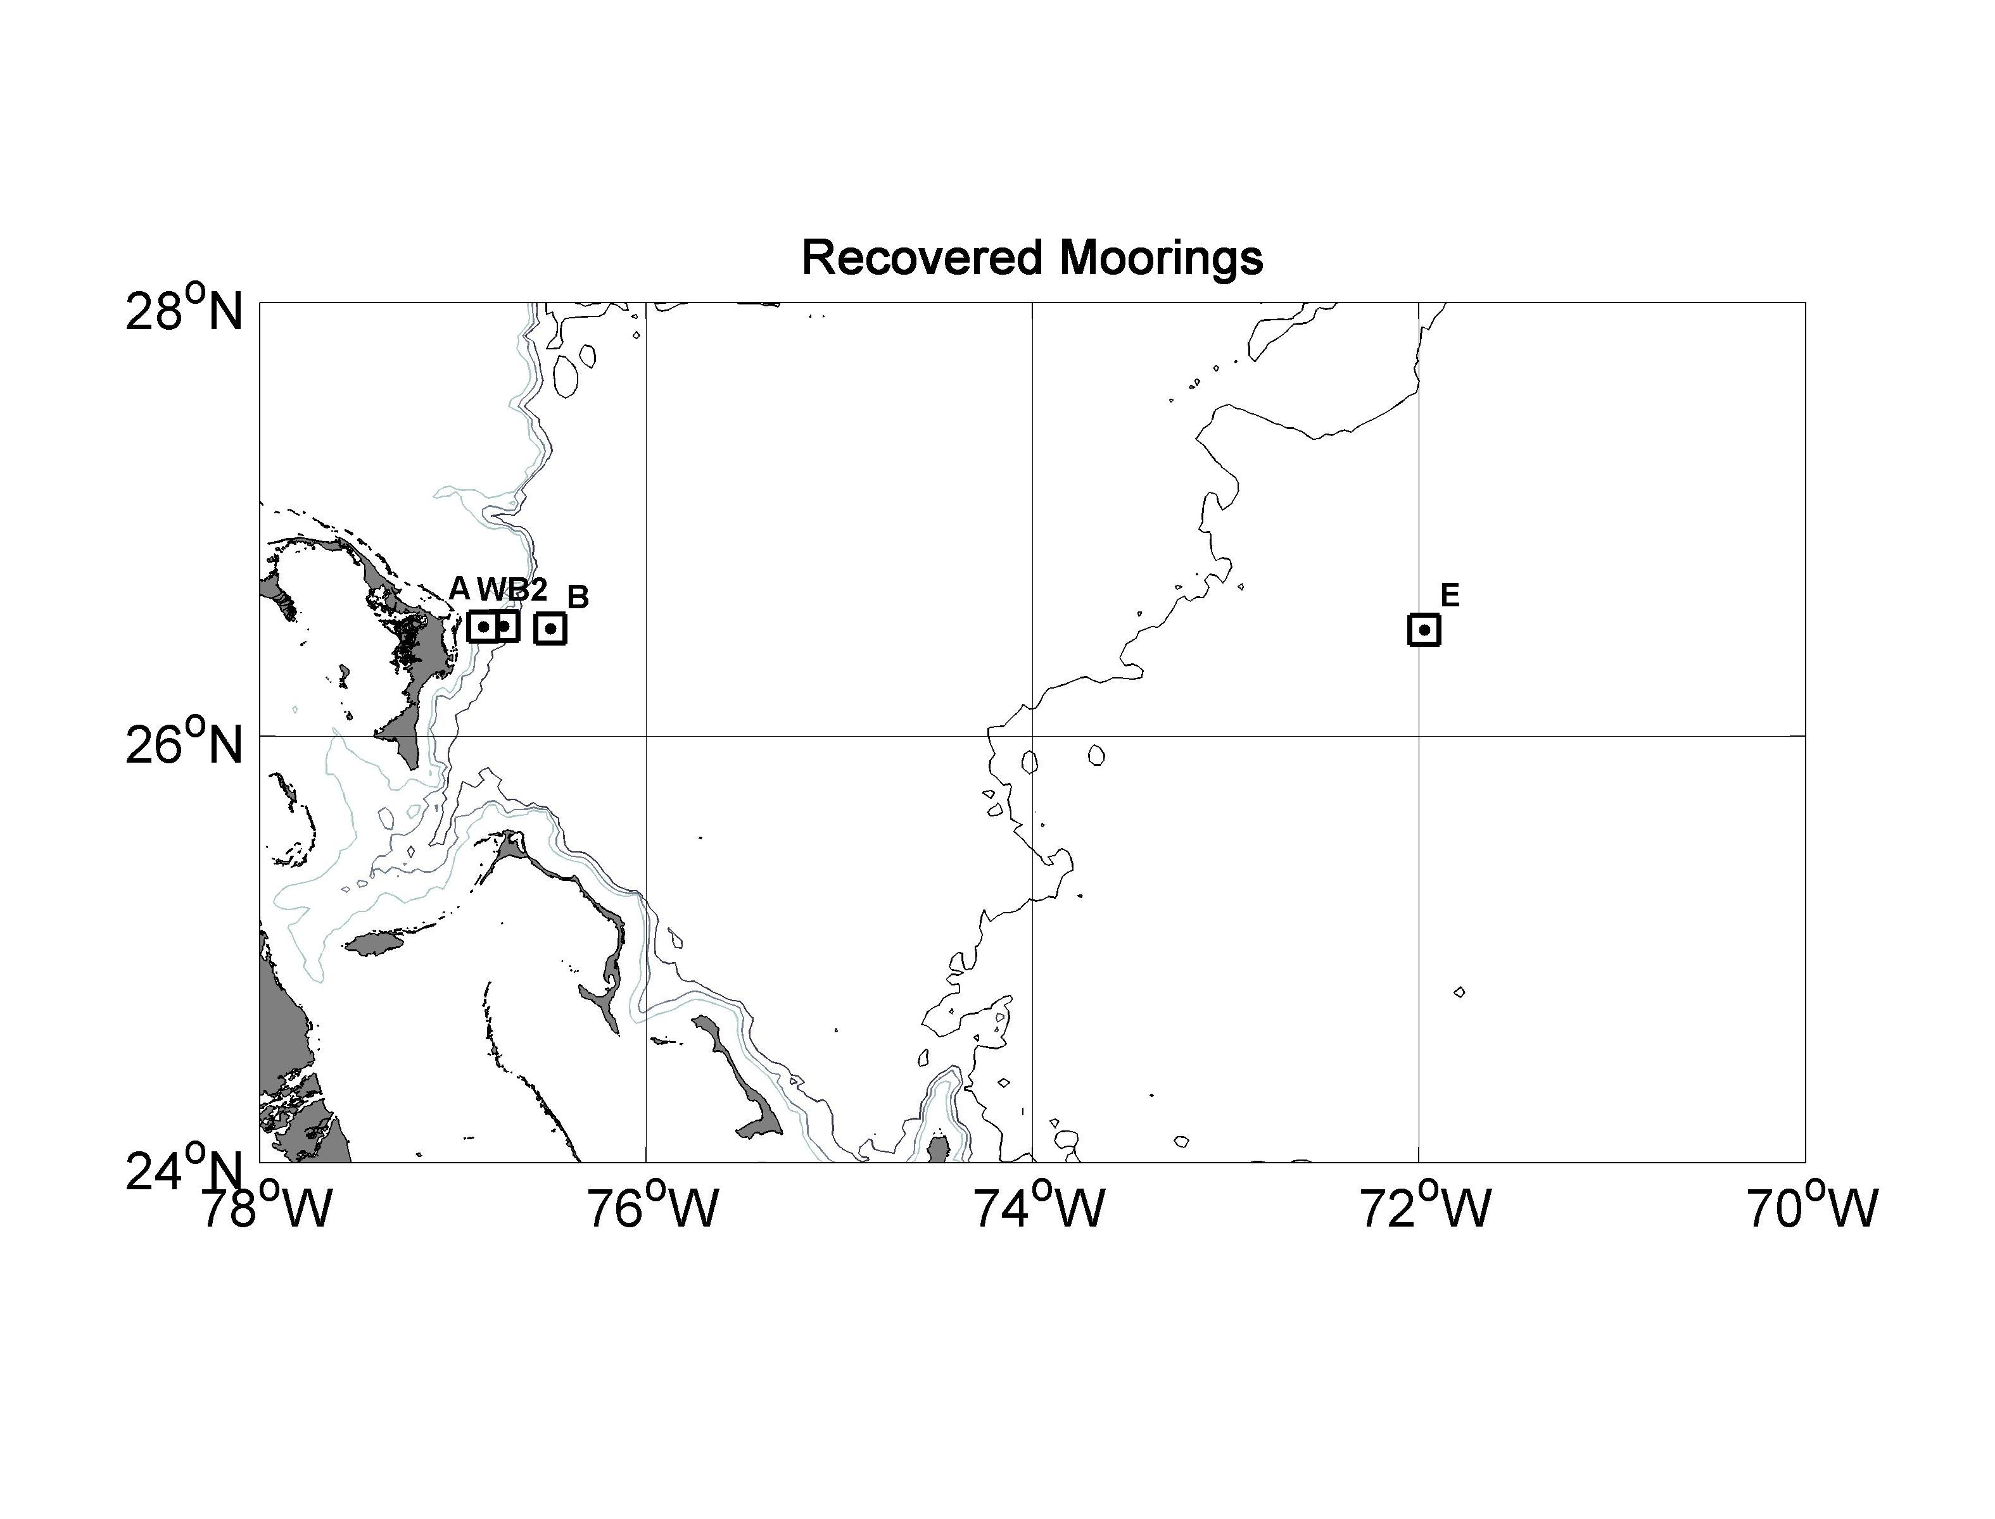

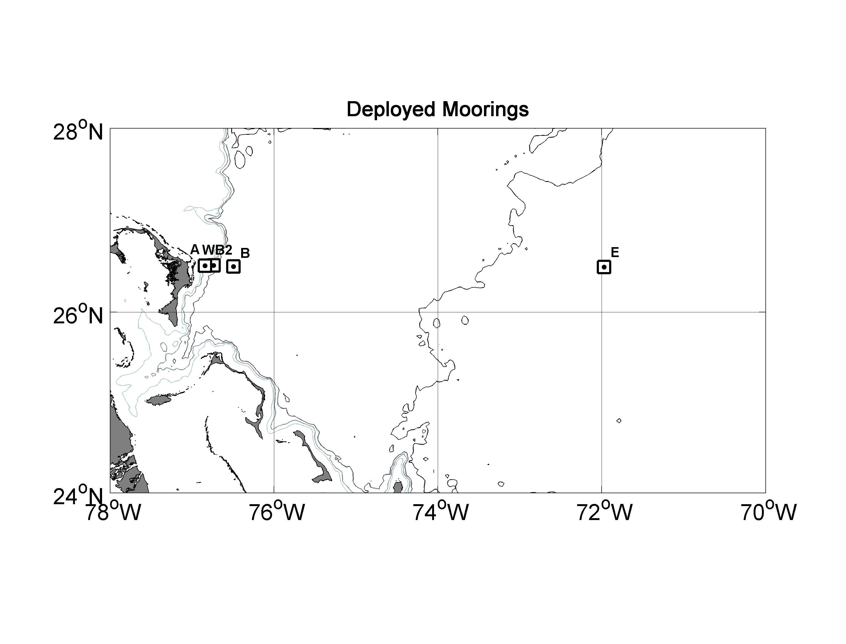
Figure 1a. Moorings recovered on cruise SJ-14-06.

Figure 1b. Moorings deployed on cruise SJ-14-06. Additional "bottom lander" moorings were deployed at sites B and E (not shown).

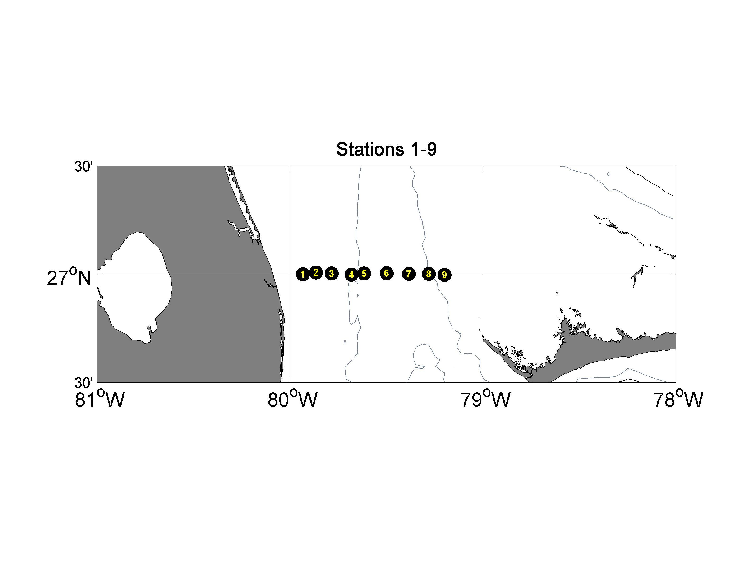

Figure 2a. CTDO2/LADCP stations 1-9, occupied on September 25-26, 2006.
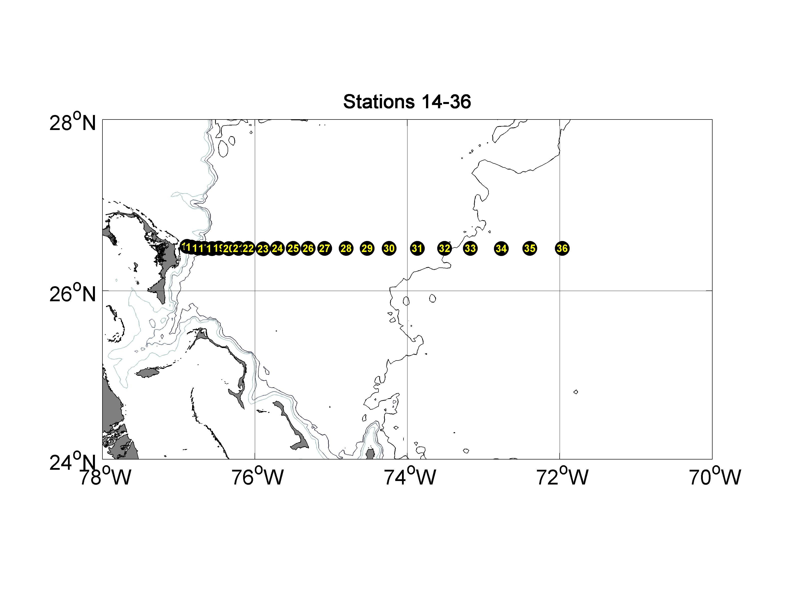

Figure 2b. CTDO2/LADCP stations 14-36, occupied on September 28 - October 2, 2006.

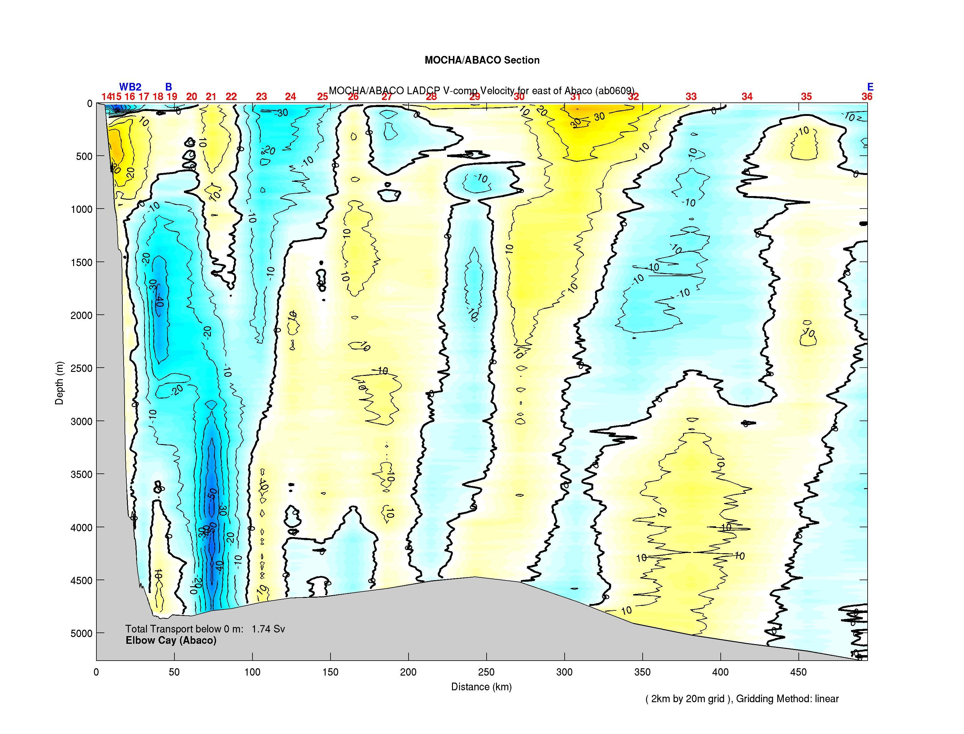

Figure 3. Meridional velocity section offshore of Abaco, contoured from LADCP velocity profiles at stations 14-36, September 28 - October 2. 2006.

