CRUISE REPORT

R/V Knorr Cruise No. KN182-2

RAPID/MOCHA Program
May 2-26, 2005
St. George, Bermuda - Miami, Florida, USA

1. Introduction and Objectives

The RAPID/MOCHA program is a joint research effort between the National Oceanography Centre (Southampton, U.K.), the University of Miami’s Rosenstiel School of Marine and Atmospheric Science (RSMAS), and NOAA’s Atlantic Oceanographic and Meteorological Laboratory (AOML). The objective of this program is to establish a pre-operational prototype system to continuously observe the strength and structure of the Atlantic meridional overturning circulation across the basin at 26º N. The U.K. program is referred to as “RAPID-MOC” and is a part of the U.K. Rapid Climate Change Program (RAPID) funded by the National Environmental Research Council (NERC). The U.S. program is referred to as “MOCHA” (Meridional Overturning Circulation and Heat-flux Array) and is funded by the National Science Foundation (NSF).

The purpose of KN182-2 was threefold:
- to service a set of moorings that constitute the “western boundary array” of the RAPID/MOCHA transbasin moored array
- to conduct hydrographic (CTDO₂) and direct current profiling (lowered-ADCP, “LADCP”) stations along the 26.5 º N mooring section off Abaco, Bahamas; and along sections in the Northwest Providence Channel and Florida Current at 27º N, and
- to deploy an inverted echo sounder (IES ) and recover data (via acoustic telemetry) from three IESs deployed previously along the Abaco 26.5ºN line.

The cruise operations fell naturally into 3 segments. First, a CTDO₂/LADCP section was completed from east-to-west across the width of the western boundary array, then mooring servicing operations were conducted from west-to-east across the array, and then a final CTDO₂/LADCP section was competed again from east-to west across the newly deployed array. The CTDO₂/LADCP sections are important for calibration and cross-checking of results from the western boundary moored array and therefore two complete sections were performed, one before recovery of the “old” array and one after deployment of the “new” array. These sections sampled the Deep Western Boundary Current and Antilles Current region east of the Bahamas and are part of an ongoing time series of these currents collected since 1984 by the AOML group. On the return to Miami, time permitting, it was planned to complete a CTDO₂/LADCP section across the Northwest Providence Channel (NWP) and across the Florida Current (FC). These sections were to measure the inflow to the Florida Current system through the NWP and the outflow of the FC through the Straits of Florida at 27º N where the FC transport is monitored by submarine electromagnetic cable. The NWP section was completed, however the FC section had to be aborted to carry out an emergency mooring recovery offshore of Abaco (see section 3a).

2. Scientific Personnel

1. William Johns RSMAS, U. Miami Chief Scientist
2. Lisa Beal RSMAS, U. Mami Scientist
3. Jonathan Molina RSMAS, U. Miami Scientist
4. Mark Graham RSMAS, U. Miami Technician
5. Robert Jones RSMAS, U. Miami Technician
6. Tania Casal RSMAS, U. Miami Student
7. Chris Meinen NOAA,/AOML Scientist
8. Humberto Guarin NOAA,/AOML Scientist
9. Carlos Fonseca NOAA,/AOML Scientist
10. Benjamin Kates NOAA,/AOML Scientist
11. Stuart Cunningham NOC, Southampton Scientist
12. Darren Rayner NOC, Southampton Scientist
13. Ian Waddington NOC, Southampton Technician
14. Stephen Whittle NOC, Southampton Technician
15. Christian Crowe NOC, Southampton Technician
16. David Childs NOC, Southampton Technician
17. Aazani Mujahid NOC, Southampton Student
18. Julie Collins BODC Scientist

3. Cruise Operations

3.a) Mooring Operations

Mooring Recoveries

Eight moorings were successfully recovered from the locations listed in Table 1 and shown in Figure 1a. These moorings contained a mixture of current meters, Acoustic Doppler Current Profilers (ADCPs), and temperature/salinity recorders, including 4 short “bottom lander” moorings containing high-resolution bottom pressure sensors. These moorings were initially deployed in March 2004 aboard the RSS Discovery as part of the first deployment of the RAPID/MOCHA Array.

Table 1. Mooring Recoveries
Mooring Site | Mooring Number | Latitude (N) | Longitude (W) | Depth (m) | Date of Recovery
A | M360 | 26 30.61' | 76° 50.53' | 1005 | 05/09/2005
WB1 | 2004/20 | 26° 30.16' | 76° 48.83' | 1382 | 05/09/2005
WBH1 | 2004/18 | 26º 30.018 | 76º 41.90' | 4287 | 05/10/2005
WBH2 | 2004/17 | 26 30.018 | 76 35.95' | 4800 | 05/10/2005
WB2 | 2004/19 | 26° 30.82' | 76° 44.23' | 3898 | 05/11/2005
B | M361 | 26° 29.70' | 76° 30.00' | 4840 | 05/11/2005
WB4 | 2004/16 | 26° 30.21' | 76° 02.70' | 4794 | 05/14/2005
E | M362 | 26° 29.95' | 71° 58.52' | 5296 | 05/16/2005

Mooring Deployments

A total of eleven moorings were deployed at the locations listed in Table 2 and shown in Figure 1b. The moorings denoted A, WB1, WB2, B, WB4, and E were replacement moorings for the ones recovered at those same sites. Mooring WBADCP was a replacement for a similar mooring deployed in March 2004 which had broken free in November 2004 and was recovered off Abaco with local assistance. Moorings WB2-L, B-L, WB4-L, and E-L were new “bottom-lander” type moorings that replaced the “drop- off” bottom pressure sensors previously deployed at the base of tall moorings WB2, B, WB4, and E.

On May 23, 2005, within 10 days of its deployment, the top buoyancy sphere on mooring WB4 broke free of its mooring and began drifting northward, tracked by an ARGOS beacon on the sphere. The ongoing CTD transect across the Straits of Florida was immediately abandoned and the ship tracked down and recovered the top float, which had been severed from the rest of the mooring about 100 m below the float by an unknown cause. The McClane Moored Profiler (MMP) on this section of the wire was lost. The remainder of WB4 was then recovered from the original anchor drop site, and a second WB4 was constructed from the recovered instruments and spare mooring line and redeployed.

Moorings WB2 and E contained surface telemetry buoys, of different designs developed by NOC and RSMAS, respectively, that are intended to provide near-real time data from the instruments on those moorings. The instrument data is relayed via inductive telemetry either directly to the surface buoy (NOC mooring WB2), or to a subsurface controller/logger that then relays the data via conducting cable to the surface buoy (RSMAS mooring E). If successful, these moorings will provide near real-time estimates of the time varying, spatially-averaged baroclinic flow structure between WB4 and E spanning the western boundary region. As of the end of the cruise, both units were successfully transmitting the instrument data from the moorings.

Table 2. Mooring Deployments

Mooring Site | Mooring Number | Latitude (N) | Longitude (W) | Depth (m) | Date of Deployment
WBADCP | 2005/26 | 26° 31.50' | 76° 52.13' | 609 m | 05/10/2005
A | M366 | 26 30.52' | 76° 50.51' | 1015 m | 05/10/2005
WB1 | 2005/27 | 26° 29.84' | 76° 48.90' | 1405 m | 05/10/2005
WB2 | 2005/28 | 26° 30.62' | 76° 44.63' | 3893 m | 05/14/2005
WB2-L | 2005/29 | 26° 30.42' | 76° 44.60' | 3880 m | 05/14/2005
B | M367 | 26° 29.45' | 76° 29.90' | 4840 m | 05/13/2005
B-L | M369 | 26° 29.45' | 76° 29.90' | 4840 m | 05/13/2005
WB4 | 2005/32 | 26° 30.21' | 76° 02.70' | 4794 m | 05/14/2005
WB4-L | 2205/31 | 26° 30.01 | 76° 02.86' | 4794 m | 05/22/2005
E | M368 | 26° 29.96' | 71° 58.28' | 5302 m | 05/17/2005
E-L | M370 | 26° 29.96' | 71° 58.28' | 5302 m | 05/17/2005

`

3.b). Inverted Echo Sounders

One inverted echo sounder mooring was deployed near the top of the continental shelf during the cruise (Table 3). Acoustic telemetry was used to download data from three other inverted echo sounder moorings that were deployed in September-October 2004 (Table 3). Two of the telemetry moorings were ‘PIES’, inverted echo sounders additionally equipped with a bottom pressure gauge, and one was a ‘C-PIES’, an inverted echo sounder additionally equipped with both a bottom pressure gauge and an acoustic current meter. The telemetry moorings will be visited once or twice a year to download travel time, pressure, and velocity data that can be combined with hydrographic data to estimate the variability of the transports of the Deep Western Boundary Current and the Antilles Current.

Table 3
IES site | Ser. # | Moor. Type | Latitude | Longitude | Depth (m) | Activity
A | 24 | IES | 26° 30.67'N | 76° 50.39' W | 1065 | Deploy
B | 169 | PIES | 26° 30.04'N | 76° 28.06' W | 4843 | Telemeter
D | 139 | C-PIES | 26° 29.97'N | 75° 42.19' W | 4690 | Telemeter
E | 140 | PIES | 26° 29.93' N | 72° 00.26' W | 5294 | Telemeter

4. CTDO₂/LADCP Stations

A total of 70 CTDO₂/LADCP stations were conducted during the cruise (Table 4, Figure 2). At each station, profiles of temperature, salinity (conductivity), and dissolved oxygen concentration were collected from the surface to within approximately 20 m of the bottom, using a Sea-Bird SBE-911plus CTD system. Water samples for calibration of the salinity and dissolved oxygen profiles were collected using a 24-bottle Rosette system containing 10 liter Niskin bottles. Current profiles were also measured using a paired downward-looking 150 kHz Broadband and upward-looking 300 kHz Workhorse Acoustic Doppler Current Profiling ‘hybrid” system (LADCP).

Some of the CTDO₂ casts were used to perform calibration checks on the temperature, salinity, and pressure measurements obtained from various types of moored instruments (including SBE Microcats, Interocean S4 and Aanderaa RCM current meters) after their recovery or prior to deployment. During these casts, the outer rack of Niskin bottles was removed from the Rosette to accommodate the moored instruments and the CTD package was lowered to typically 3000 m with 3-5 minute bottle stops on the package retrieval. These casts were not part of the regular CTDO₂ /LADCP hydrographic sampling performed on the cruise and are indicated by a * in Table 4.

Table 4. CTDO₂ Station Locations
Station No. | Date | Time (UTC) | Latitude (N) | Longitude (W) | Depth (m)
000 | 05/03/2005 | 2050 | 26º 14.13 | 69º 47.18 | 3583
001 | 05/04/2005 | 1214 | 26º 30.02 | 71º 59.46 | 5285
002 | 05/04/2005 | 1835 | 26º 30.27 | 72º 22.28 | 5218
003 | 05/05/2005 | 0022 | 26º 30.00 | 72º 46.07 | 5135
004 | 05/05/2005 | 0624 | 26º 29.99 | 73º 07.98 | 5049
005 | 05/05/2005 | 1212 | 26º 29.99 | 73º 29.94 | 4962
006 | 05/05/2005 | 1743 | 26º 29.99 | 73º 51.99 | 4743
007 | 05/05/2005 | 0235 | 26º 30.00 | 74º 13.99 | 4542
008 | 05/06/2005 | 0355 | 26º 29.94 | 74º 31.09 | 4488
009 | 05/06/2005 | 0852 | 26º 29.95 | 74º 48.01 | 4534
010 | 05/06/2005 | 1334 | 26º 30.01 | 75º 04.99 | 4610
011 | 05/06/2005 | 1749 | 26º 30.09 | 75º 18.04 | 4637
012 | 05/06/2005 | 2159 | 26º 30.06 | 75º 30.19 | 4687
013 | 05/07/2005 | 0028 | 26º 29.99 | 75º 42.20 | 4693
014 | 05/07/2005 | 0614 | 26º 30.00 | 75º 52.03 | 4733
015 | 05/07/2005 | 1017 | 26º 30.01 | 76º 01.77 | 4792
016 | 05/07/2005 | 1422 | 26º 29.99 | 76º 10.73 | 4810
017 | 05/07/2005 | 1832 | 26º 30.09 | 76º 19.76 | 4838
018 | 05/07/2005 | 2247 | 26º 30.11 | 76º 28.64 | 4867
019 | 05/08/2005 | 0258 | 26º 30.09 | 76º 34.27 | 4826
020 | 05/08/2005 | 0708 | 26º 29.92 | 76º 39.58 | 4559
021 | 05/08/2005 | 1058 | 26º 30.11 | 76º 45.57 | 3814
022 | 05/08/2005 | 1416 | 26º 30.95 | 76º 49.96 | 1105
023 | 05/08/2005 | 1547 | 26º 31.46 | 76º 53.47 | 370
024* | 05/08/2005 | 2055 | 26º 31.14 | 76º 42.43 | 2983
025* | 05/09/2005 | 0044 | 26º 32.26 | 76º 43.74 | 3575
026* | 05/09/2005 | 2313 | 26º 30.68 | 76º 42.24 | 420
027* | 05/10/2005 | 0201 | 26º 30.96 | 76º 42.69 | 2981
028* | 05/10/2005 | 2229 | 26º 30.64 | 76º 50.41 | 995
029* | 05/11/2005 | 0131 | 26º 30.01 | 76º 28.62 | 2979
030* | 05/11/2005 | 2112 | 26º 29.84 | 76º 29.98 | 2984
031* | 05/12/2005 | 1511 | 26º 30.03 | 76º 28.08 | 2981
032* | 05/12/2005 | 1909 | 26º 31.90 | 76º 30.13 | 2981
033* | 05/13/2005 | 0211 | 26º 32.74 | 76º 31.07 | 2981
034* | 05/14/2005 | 0713 | 26º 30.28 | 76º 06.02 | 4811
035* | 05/15/2005 | 2059 | 26º 32.02 | 72º 58.49 | 2980
036* | 05/17/2005 | 0404 | 26º 29.81 | 71º 58.54 | 2985
037 | 05/18/2005 | 0616 | 26º 30.10 | 69º 59.89 | 5491
038 | 05/18/2005 | 1243 | 26º 30.02 | 70º 29.99 | 5491
039 | 05/18/2005 | 1902 | 26º 30.10 | 71º 00.00 | 5485
040 | 05/19/2005 | 0110 | 26º 30.11 | 71º 30.06 | 5417
041 | 05/19/2005 | 0801 | 26º 30.05 | 71º 59.59 | 5286
042 | 05/19/2005 | 1406 | 26º 30.03 | 72º 23.17 | 5178
043 | 05/19/2005 | 1941 | 26º 30.21 | 72º 46.14 | 5124
044 | 05/20/2005 | 0054 | 26º 30.12 | 73º 08.02 | 5050
045 | 05/20/2005 | 0614 | 26º 30.01 | 73º 30.03 | 4960
046 | 05/20/2005 | 1122 | 26º 30.01 | 73º 52.06 | 4731
047 | 05/20/2005 | 1617 | 26º 29.90 | 74º 14.07 | 4538
048 | 05/20/2005 | 2058 | 26º 29.89 | 74º 30.84 | 4490
049 | 05/21/2005 | 0136 | 26º 30.01 | 74º 47.92 | 4536
050 | 05/21/2005 | 0618 | 26º 29.98 | 75º 05.01 | 4609
051 | 05/21/2005 | 1028 | 26º 30.02 | 75º 18.08 | 4636
052 | 05/21/2005 | 1440 | 26º 29.90 | 75º 30.08 | 4680
053 | 05/21/2005 | 1908 | 26º 30.02 | 75º 42.53 | 4687
054 | 05/21/2005 | 2318 | 26º 30.04 | 75º 52.06 | 4732
055 | 05/22/2005 | 0623 | 26º 30.15 | 76º 04.26 | 4802
056 | 05/22/2005 | 1053 | 26º 30.18 | 76º 10.84 | 4818
057 | 05/22/2005 | 1501 | 26º 30.13 | 76º 19.61 | 4825
058 | 05/22/2005 | 1928 | 26º 30.12 | 76º 28.69 | 4855
059 | 05/22/2005 | 2345 | 26º 30.00 | 76º 34.25 | 4823
060 | 05/23/2005 | 0355 | 26º 30.06 | 76º 39.86 | 4460
061 | 05/23/2005 | 0747 | 26º 30.02 | 76º 45.39 | 3876
062 | 05/23/2005 | 1202 | 26º 30.88 | 76º 50.11 | 1057
063 | 05/23/2005 | 1333 | 26º 31.53 | 76º 53.14 | 424
064 | 05/24/2005 | 0311 | 26º 04.06 | 78º 51.02 | 304
065 | 05/24/2005 | 0425 | 26º 09.92 | 78º 47.88 | 460
066 | 05/24/2005 | 0537 | 26º 15.00 | 78º 45.95 | 522
067 | 05/24/2005 | 0652 | 26º 19.98 | 78º 43.00 | 686
068 | 05/24/2005 | 0820 | 26º 25.95 | 78º 40.10 | 764
069 | 05/24/2005 | 1316 | 26º 59.99 | 79º 11.98 | 484
070 | 05/24/2005 | 1428 | 27º 00.04 | 79º 16.94 | 614

* Instrument calibration casts

5. Drifter Deployments

A total of 20 surface drifters were deployed during the cruise at the locations listed in Table 5. The drifters were of the “WOCE Standard” type including holey sock drogues at 15 m depth. The drifters are tracked by NOAA/AOML’s Global Drifter Center in Miami via ARGOS. The drifter data includes drifter position and local sea surface temperature.

Table 5. Drifter Launches

Drifter ID | Launch Date | Time (UTC) | Latitude (N) | Longitude (W)
55115 | 05/02/2005 | 1452 | 32º 09.51 | 64º 51.47
55109 | 05/02/2005 | 2232 | 31º 05.00 | 66º 06.13
55123 | 05/03/2005 | 0650 | 29º 57.00 | 67º 35.50
55119 | 05/03/2005 | 1459 | 28º 50.00 | 69º 01.18
55114 | 05/04/2005 | 0323 | 27º 43.00 | 70º 26.53
55134 | 05/04/2005 | 1114 | 26º 36.20 | 71º 50.88
55122 | 05/04/2005 | 1622 | 26º 30.10 | 72º 00.02
55163 | 05/05/2005 | 0521 | 26º 30.10 | 73º 00.01
55138 | 05/05/2005 | 2149 | 26º 29.56 | 74º 00.00
55147 | 05/06/2005 | 1256 | 26º 29.90 | 74º 59.60
55143 | 05/07/2005 | 0955 | 26º 30.10 | 76º 00.57
55130 | 05/18/2005 | 0951 | 26º 30.03 | 69º 59.89
55135 | 05/18/2005 | 2240 | 26º 30.81 | 71º 00.00
55118 | 05/19/2005 | 1214 | 26º 30.33 | 72º 00.45
55125 | 05/20/2005 | 0010 | 26º 30.20 | 73º 00.00
55117 | 05/20/2005 | 1458 | 26º 30.31 | 74º 00.00
55127 | 05/21/2005 | 0542 | 26º 30.03 | 75º 00.00
55144 | 05/26/2005 | 1457 | 26º 01.13 | 79º 30.00
55111 | 05/26/2005 | 1527 | 25º 58.86 | 79º 36.00
55136 | 05/26/2005 | 1555 | 25º 56.45 | 79º 42.03

6. Underway Measurements

Thermosalinograph

Values of surface temperature and salinity were continuously monitored and logged on the ship’s computer using a Sea-Bird temperature-conductivity recorder installed in the ship’s seawater intake line.

Shipboard Acoustic Doppler Current Profiler

Upper ocean currents were continuously measured with two different Acoustic Doppler Current Profilers (ADCPs) mounted in the ship’s transducer well. One was a 150 kHz Narrowband ADCP and the other was a 75 kHz Ocean Surveyor ADCP. The depth range of good velocity data typically extended to 200 m below the vessel for the 150 kHz ADCP, and 700 m for the 75 kHz ADCP, depending on sea state conditions. During the cruise (on May ?, 2005) transducer beam 2 on the 150 kHz ADCP failed for unknown reasons and data collection from that unit was limited to the 3 remaining beams.
A newly installed UHDAS shipboard ADCP data acquisition system on the R/V Knorr was used to log the data from this cruise, including display of the processed velocity data on the ships internal website

7. Preliminary Results

The CTDO₂/LADCP and shipboard ADCP measurements collected during the cruise indicate that a strong anticyclonic eddy was present in the western part of the Abaco section. This feature extended from the surface to about 1000 m with maximum velocities of up to 1.7 m/s. It appeared to be centered slightly north of the 26.5º N line, such that the sections cut through its southern half (Fig 3). This feature was also revealed by the drifters launched during the cruise and it appeared to propagate slowly westward during the course of the cruise.

The LADCP data indicates that during the first hydrographic section along the line east of Abaco (May 4-8), the Deep Western Boundary Current (DWBC) was found in the 1200 m to 2200 m layer with a peak southward speed of 20 cms⁻¹ (Fig. 4). The core was located farther to the east than usual. Interestingly, in the deeper layer, between 3000 to 4500 m no discernible DWBC structure was found.

The total transport for the Abaco section was calculated to be 16 Sv southward. From the coast to about 150 km offshore, the transport is northward (possibly associated with the Antilles Current as well as the anticyclonic eddy) and is southward from 150 km to about 500 km east of Abaco. The shipboard ADCP transport along the same transect indicate a similar north/south structure. In the upper 425 m, the net transport across the whole section was 0.43 Sv. This indicates that the northward and southward transports nearly cancel each other in this upper layer, both being around 25 Sv.

.
8. Release of Project Data

In accordance with the provisions specified in the cruise prospectus and application for foreign clearances, the full data results from this experiment will be provided to the Commonwealth of the Bahamas according to the following schedule:

Shipboard Measurements

All shipboard measurements, including underway data records and CTDO₂/LADCP station data, will be provided within 1 year of the termination of the cruise (June, 2006).

Moored Instrumentation

Time series data records from the moored instruments will be provided within 2 years of recovery of the instruments (nominally June, 2007).

9. Acknowledgements

The support and able assistance provided by the Captain and crew of the R/V Knorr, operated by the Woods Hole Oceanographic Institution, is gratefully acknowledged.
Support for the scientific research was provided by the U.S. National Science Foundation, the NOAA Office of Global Programs, and the U.K. National Environmental Research Council. The Commonwealth of the Bahamas graciously granted privileges to conduct scientific research in their territorial waters.

Figure 1a. Moorings recovered on cruise KN-182-2.

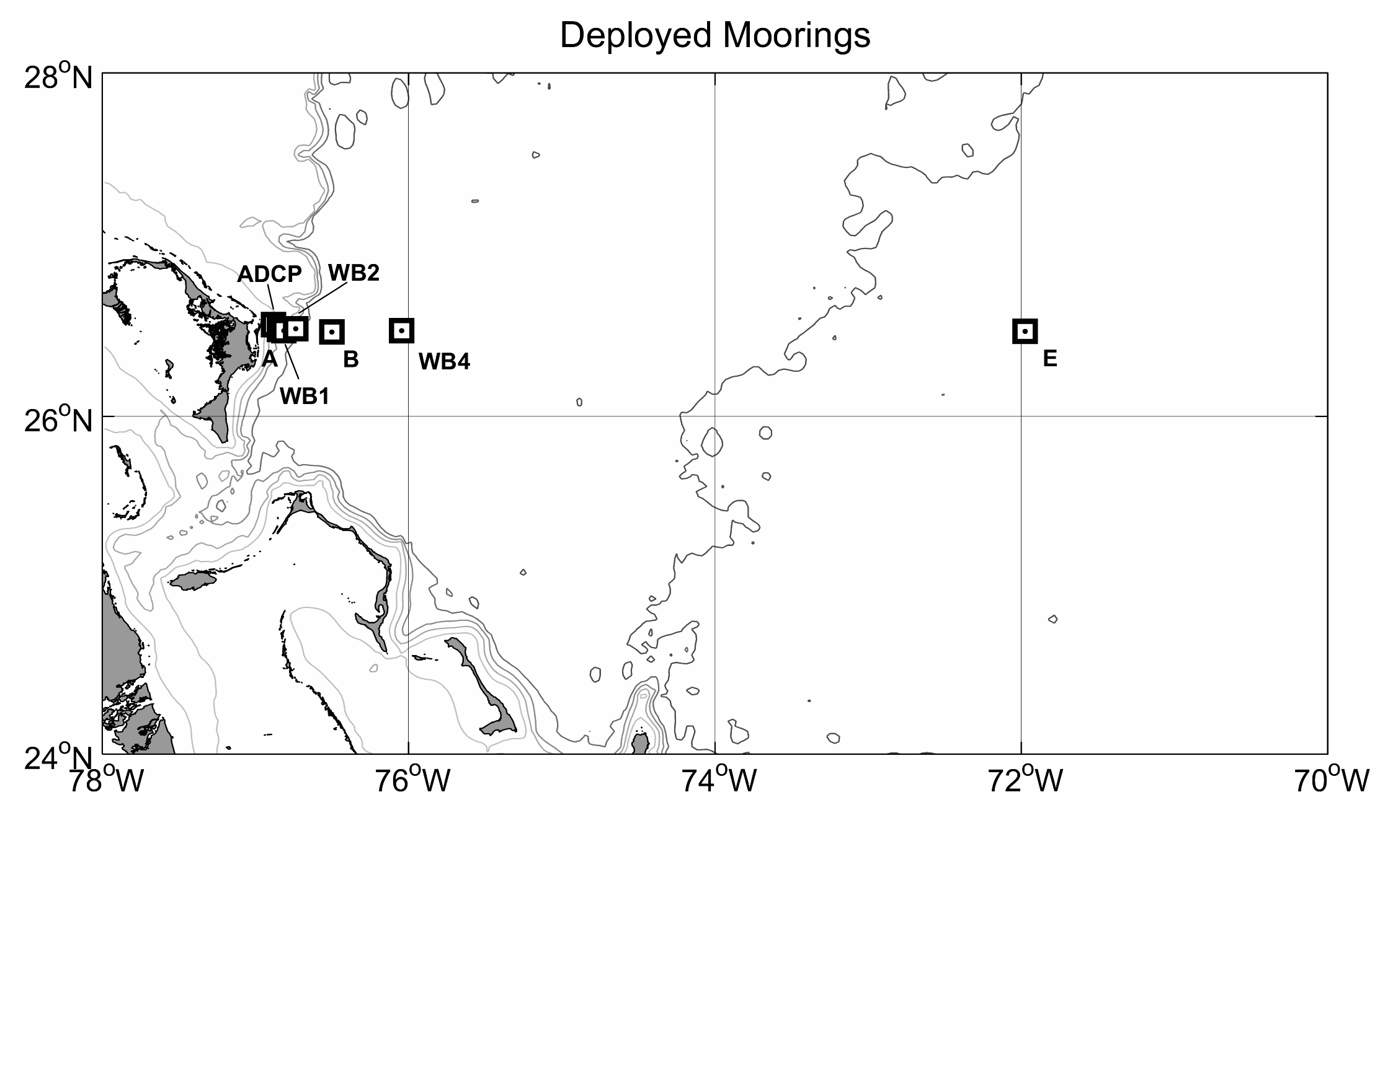
Figure 1b. Moorings deployed on KN182-2. Additional "bottom lander" moorings were deployed at sites WB2, B, WB4, and E (not shown).

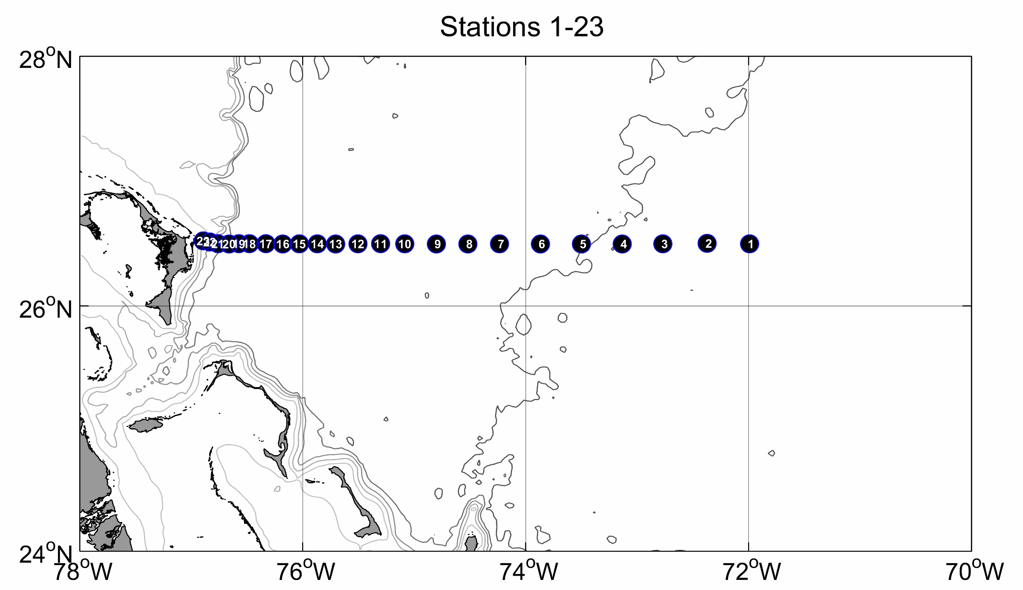
Figure 2a. CTDO2/LADCP stations 1-23, occupied on May 4-8, 2005.

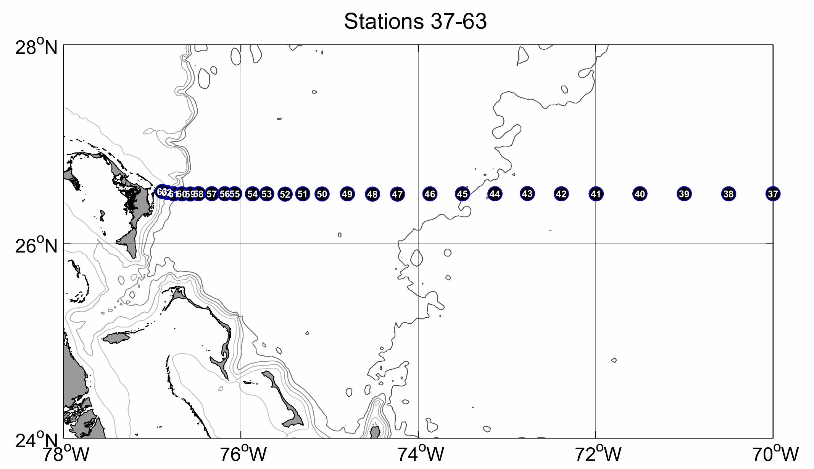
Figure 2b. CTDO2/LADCP stations 37-63, occupied on May 18-23, 2005.

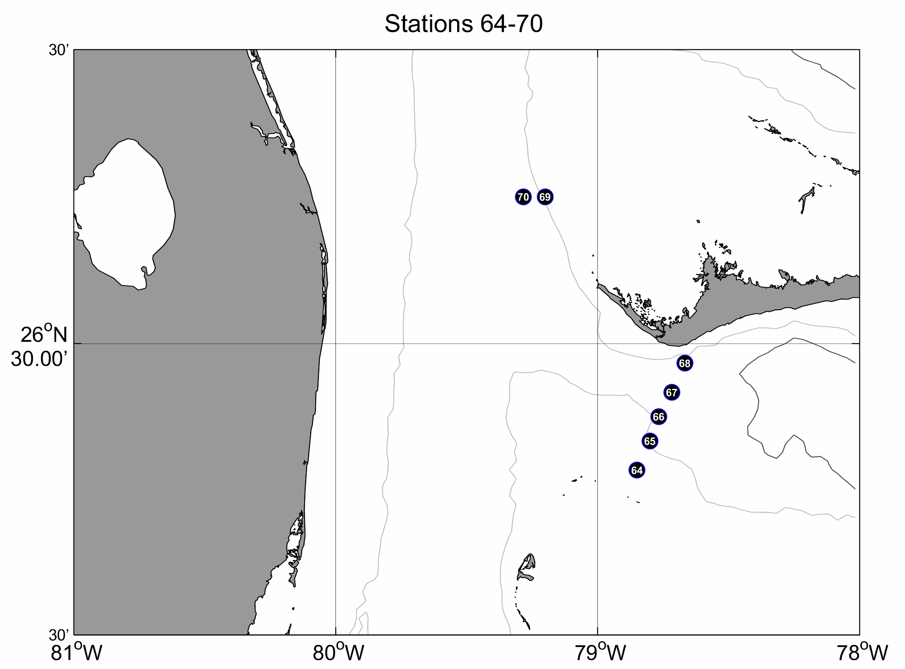
Figure 2c. CTDO2/LADCP stations 64-70, occupied on May 24, 2005.

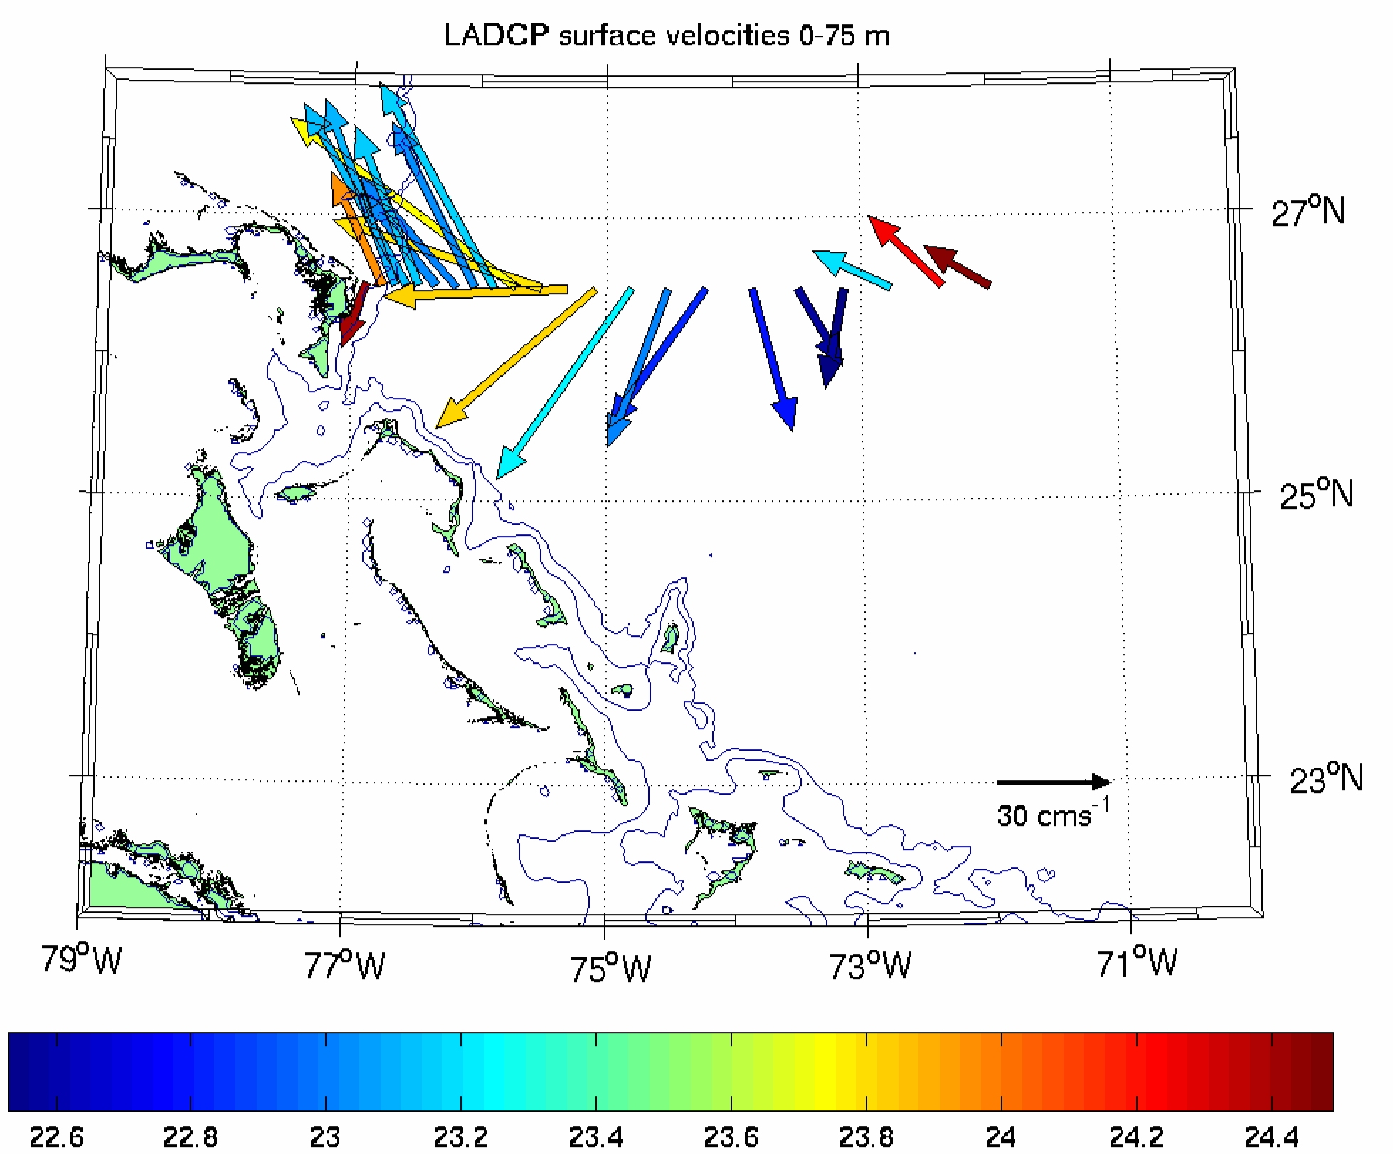
Figure 3. Velocity vectors averaged from the surface to 75 m depth, from LADCP stations offshore of Abaco occupied on May 4-8, 2005.

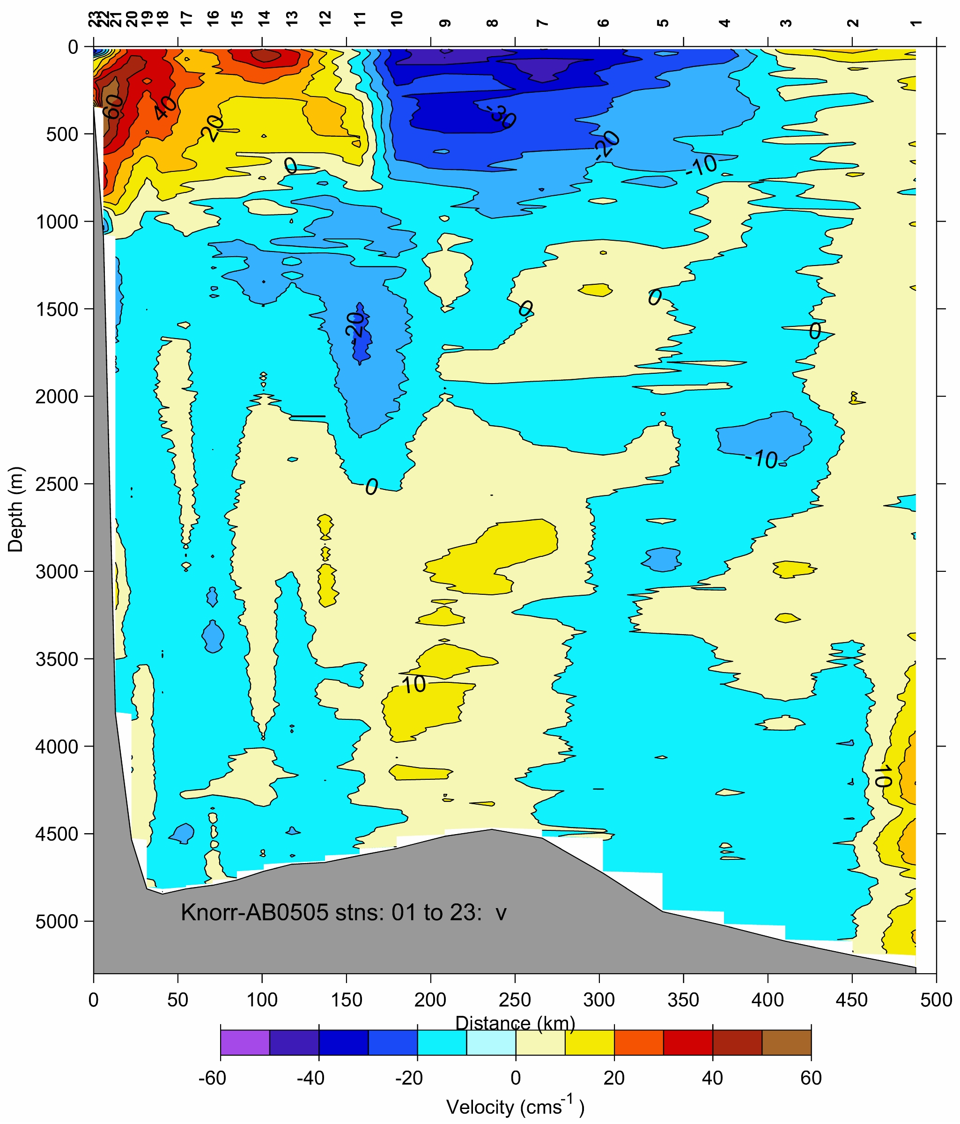
Figure 4. Meridional velocity section offshore of Abaco, contoured from LADCP velocity profiles at stations 1-23, May 4-8, 2005.

