The United States Surface Ocean - Lower Atmosphere Study
(US SOLAS)
Workshop Report and Recommendations

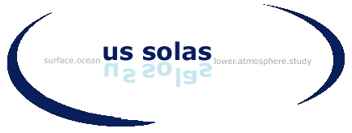

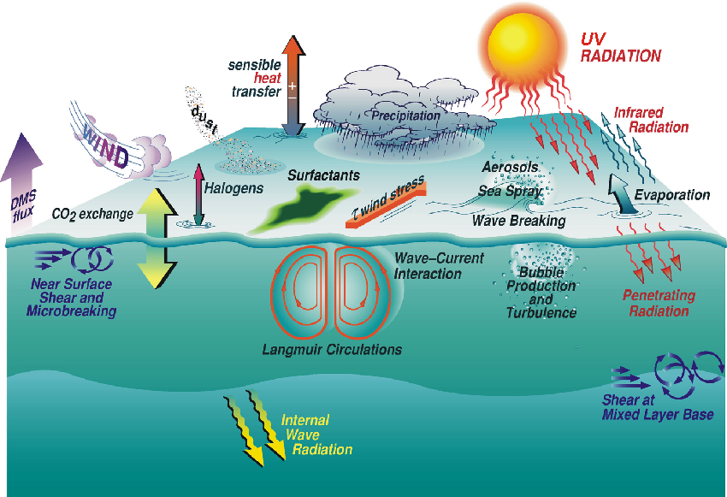

The United States Surface Ocean - Lower Atmosphere Study
(US SOLAS)
Workshop Report and Recommendations

Acknowledgment

The first US SOLAS workshop and production of this report were made possible through generous financial contributions from the National Science Foundation (NSF), the National Oceanic and Atmospheric Administration (NOAA), the Office of Naval Research (ONR), and the National Aeronautics and Space Administration) (NASA). In particular we wish to acknowledge the encouragement and support of the following program managers: Dr. Don Rice (NSF), Dr. Lisa Dilling (NOAA), Dr. John Marra (NASA), and Dr. Ron Ferek (ONR).

Summary

This report summarizes the deliberations during the US SOLAS workshop held at the Bolger Center in Potomac MD, May 16 -18, 2001. The goal of this open meeting was to lay the groundwork for the SOLAS program in the United States. The workshop consisted of plenary sessions in which the needs were highlighted for interdisciplinary study of the surface ocean-lower atmosphere realm for a variety of relevant biogeochemical issues. Four working groups discussed science issues and priority projects that would benefit from a multi-disciplinary approach as advocated in SOLAS.

US SOLAS is a component of an international program endorsed by the IGBP and SCOR with as overall goal:

“To achieve a quantitative understanding of the key biogeochemical-physical interactions between the ocean and atmosphere, and of how this coupled system affects and is affected by climate and environmental change”

The international goal and science plan were adopted as a framework for the US planning effort. The international science plan is broad and the working groups focused on those components that of most interest to the US research community.

Each working group produced a chapter of a report that will form the basis of the US SOLAS science plan. The report describes the research issues and suggested research projects to further SOLAS science in the US. The partitioning into working groups was largely an issue of manageability and created some artificial barriers in the continuum of research interests. The synopses provided here give a summary of the report and points to connectivity and overlap of many of the research topics. The recommended pilot projects exemplify the synergism between the topics.

The highlights and issues that came out of the working groups are as follows:

I. Boundary-layer Physics: Physical processes at the interface play a controlling role in transfer and transformations of Climate Relevant Compounds (CRCs). Quantifying fluxes of CRCs, and understanding and quantifying the physical controls of transfer are critical research areas where major advances can be achieved. Wet and dry deposition processes are poorly constrained hampering the connection between atmospheric input and surface ocean biological responses. Research projects of long duration to capture episodic events and studies in coastal regions were advocated as high priority issues.

II. Dynamics of long-lived climate relevant compounds: By definition, these compounds have slow reaction rates in the lower atmosphere and the proposed research efforts were focused on constraining large scale fluxes of CO₂, N₂O and CH₄. Upscaling process studies through opportunistic research cruises and fully integrating remote sensing into upscaling procedures were proposed. There is also a strong need to get basic physical and biological information on transformation rates for many of the halogenated compounds that fall in the long-lived CRC category.

III. Dynamics of short-lived compounds: Tropospheric ozone, particulate matter and clouds are among the most powerful, but least understood elements of climate forcing. The SOLAS region is a major sink for ozone and both a source and sink of particulate material containing organic matter, sulfur compounds and sea salt. Photochemical and multi-phase processes in both the upper ocean and lower atmosphere control the concentrations and distributions of these CRCs. The closely interlinked nature of their processing calls for a coordinated, multidisciplinary approach.

IV. Atmospheric effects on marine biogeochemical processes: Recent evidence that atmospheric deposition of trace constituents to the surface ocean can have a significant effect on upper ocean biological processes has fundamentally changed our understanding of biogeochemical cycling, nutrient limitations, and atmospheric versus sub-surface control. In particular, the strong interest in atmospheric deposition of iron and its possible effect on nitrogen fixation and enhanced biological productivity in the surface ocean as well as its possible effect on the air/sea exchange of CRCs made it a natural recommendation as a high priority US SOLAS project.

An important goal of SOLAS is to provide observational, theoretical and modeling information for global scale climate modeling with an emphasis on how air-sea exchange of heat, momentum and chemical species may influence atmospheric chemistry and climate. The air-sea exchange of CO₂ is but one example of the many different processes and feedbacks in the climate system that are intimately involved in surface ocean – lower atmosphere interactive dynamics. Several of the researchers involved in the development of SOLAS are also closely tied to the Community Climate System Model (CCSM) development effort, which is a multi-agency, multi-institutional effort to create state of the art Earth system model, facilitating this connection.

The US SOLAS effort will continue along two pathways. First, a steering committee will be formed to act as a clearinghouse for related information and an avenue to support and augment projects that focus on the lower marine atmosphere and surface ocean mixed layer. A particular focus will be to implement bilateral integrated studies of both the atmospheric and oceanic boundary layers. Second, the steering committee will interact with the community at large to advocate multi-agency endorsement and funding of dedicated projects. Since the efforts will be focused on multi-investigator process studies we anticipate that the National Science Foundation will play a major, but not exclusive, role in supporting the effort. Within this context, the steering committee will foster interactions and cross-disciplinary announcements of opportunity between various funding organizations.

Recommended Scientific Objectives and Activities

The following sections of the report summarize the science for the US SOLAS effort proposed by the breakout groups at the meeting. More comprehensive reports from each group can be downloaded from www.aoml.noaa.gov/ocd/solas. The international science plan, which served as overall guidance for the US component, can be found at www.ifm.uni-kiel.de/ch/solas/main.html. Several field studies are singled out as examples of high priority US SOLAS studies and are proposed as strawmen for dedicated US process studies. The final section of the report provides recommendations for steering group functions and logistic issues.

There is increasing evidence that the biogeochemical cycles for building blocks of life such as carbon, nitrogen, and sulfur have been perturbed by mankind. These changes result in appreciable impacts and feedbacks in the surface ocean-lower atmosphere (SOLAS) region. The exact nature of the impacts and feedbacks are poorly constrained because of sparse observations, in particular relating to the interconnections between the major biogeochemical cycles and associated physical forcings. It is in these areas that the research and the interdisciplinary research approaches advocated in US SOLAS will provide high returns. The research in US SOLAS will be heavily focused on process studies of the natural variability of key processes, anthropogenic perturbation of the processes, and the (positive and negative) feedbacks on biogeochemical cycles in the SOLAS region. (e.g. Figure 1). A major objective is to integrate results from the process studies, large-scale observations and small and large-scale modeling and remote sensing efforts to improve our mechanistic understanding of biogeochemical and physical phenomena and feedbacks.

Figure 1. The hypothesized link between atmospheric CO₂ levels and dust deposition is one example of the tight connectivity between lower atmosphere and surface ocean (courtesy of T. Michaels, USC).

To test the SOLAS hypotheses and advance our knowledge of chemistry and climate, experiment and theory must proceed hand in hand. Theories can be tested with numerical models, but models must be evaluated with measurements. In situ observations can provide specific properties, concentrations, and fluxes with known uncertainty, but only for limited areas and times. Recent advances in satellite-based remote sensing make it possible to measure atmospheric and oceanic properties such as temperature, radiation, ocean color, and sea state, as well as atmospheric column concentrations of O₃, CO, CO₂, NO₂, H₂CO, BrO, H₂O, and aerosols. Instruments useful to studies in the SOLAS region include MOPITT, MODIS, MISR on TERRA, TESS and OMI on AURA, and SeaWiFs. European colleagues have complementary projects including GOME1 and radar altimeters on ERS2, IASI and GOME2 on MeTOP, and SCIAMACHY, MERIS, ATSR and AATSR, on ENVISAT scheduled for launch in spring 2002. Geostationary satellites may be particularly powerful for studying SOLAS processes, especially diurnal variations; these include NASA’s GIFTS and the European GEOTROPE (GeoSCIA/GeoFIS) proposed to cover the Atlantic and Indian Oceans. These satellite measurements, especially when calibrated with “ground truth,” can test the transport and spatial extent of CRCs calculated in models. In this way, results from SOLAS studies will be expanded from specific measurements to general principles.

Air-Sea Interaction and Transport Processes in the Atmospheric and Oceanic Boundary Layers

Elucidating chemical and biological processes in the surface ocean and lower atmosphere requires a firm underpinning of physical processes that take place in this realm. Such processes are often parameterized with rudimentary physical forcing algorithms. Understanding the small-scale physical controls is critical to model their effects on larger scales. Processes that are of paramount importance to improve interpretation of observations and modeling of the SOLAS region include:

- The physical processes that control air-water gas fluxes.
- Wet deposition via precipitation and dry deposition of particles onto the sea surface.
- Production of particulate material at the ocean surface.
- Mixing processes in the ocean mixed layer and atmospheric boundary layer.

Significant advances in instrumental and modeling capabilities in the last decade make observation and verification of many of these processes tractable. The work includes laboratory investigations, Lagrangian field studies and modeling.

Physical processes that control air-water gas fluxes

Transfer of gases is regulated by molecular and turbulent processes near and in the molecular sublayers. For slightly soluble gases the aqueous sublayer controls gas transfer processes; for soluble or reactive gases the gaseous sublayer is important.

Small-scale processes such as short wind waves, microscale breaking and near-surface shear are believed to control the air-sea gas transfer. Any processes that affect the small-scale turbulence, such as microlayer surfactants or that short-circuit the diffusive sublayer, such as bubble entrainment, can have an effect on air-sea gas transfer of climate relevant gases. Significant advances have been made in probing the interface by optical and thermal methods that can be deployed in laboratory environments and in the field. Besides quantification of processes, improvements in direct-flux measurement techniques that require both highly accurate analyzers and micrometeorological instruments make it possible to determine fluxes concurrently with interfacial processes which will greatly enhance understanding of the causal nature of the variation in gas transfer.

Wet and dry deposition onto the sea surface

Aside from gases, particles play an important role on the earth’s radiation balance and as a vehicle to transport chemical and biological species into and out of the surface ocean. Two primary pathways of particulate material delivery to the surface ocean are direct deposition onto the sea surface (dry deposition) or by scavenging, along with soluble gases, into water droplets and subsequent rainout (wet deposition). The mechanisms and effectiveness by which both processes occur is poorly constrained. Observations at process scale and modeling of the processes will constrain the deposition fluxes. This will improve our knowledge of atmospheric lifetimes of particulate constituents and related influences on multiphase chemical processes, direct and indirect climate forcing, and biogeochemical cycles in the surface ocean. Iron input through atmospheric dust deposition (Fig. 2) and subsequent biological response is a clear example of the importance of deposition processes on biogeochemical cycling. The process study information along with remotely sensed information such as aerosol optical depth and ocean color from satellite sensors such as MODIS can constrain regional deposition effects (Fig. 3).

Production of particulate material at the ocean surface

Aerosols produced at the ocean surface play a critical role in the radiation balance and multiphase chemical processes over the ocean. The mechanisms by which particles form at the interface are varied and poorly constrained. Reliable information on particle number, size, optical and chemical characteristics as a function of altitude is essential to properly model many processes in the SOLAS regime.

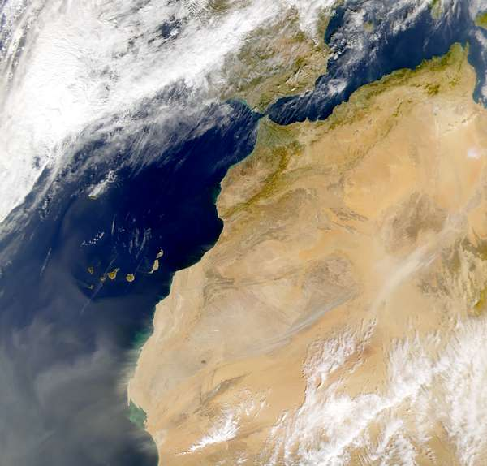

Figure 2. The influence of dust storms such as the one shown emanating from the Western Sahara at lower left have a global reach. The impacts of the dust particles on surface ocean biology, heterogeneous (atmospheric) chemistry and radiation are poorly known. (Figure from http://www.visibleearth.nasa.gov/data)

Mixed layer physics

Physical processes control, to large extent, the supply of nutrients into the euphotic zone through dynamics at the bottom of the mixed layer. Internal waves, Langmuir cells and eddies all have a significant, but poorly quantified impact on thermocline – mixed layer interaction. Inputs of trace species often can occur from the atmosphere or from below the mixed layer and the origin is of fundamental importance to understand feedback processes and to forecast future changes in delivery and resulting changes in productivity.

Similarly, dynamics at the top of the atmospheric boundary layer exert a fundamental control on boundary layer composition. Episodic exchanges between the marine boundary layer (MBL) and free troposphere are sources and sinks of reactive species to the boundary layer. Breaking waves and busting bubbles can eject significant amounts of particulate material of marine origin into the lower atmosphere. Transformations of gases and particles in the marine boundary layer lead to changes in cloud droplet size distributions and effect albedo if transported to sufficient height.

Studies to improve quantification of mixed layer dynamics range from utilizing probes to estimate turbulence and shear, to tracer studies in which the cumulative effect of the processes can be estimated. The key is to use methods and appropriate tracers that can separate the physical processes from the chemical and biological transformations. Incorporating the basic physical information into models, which then in turn can be used to predict the larger scale effects, will be a particularly powerful approach.

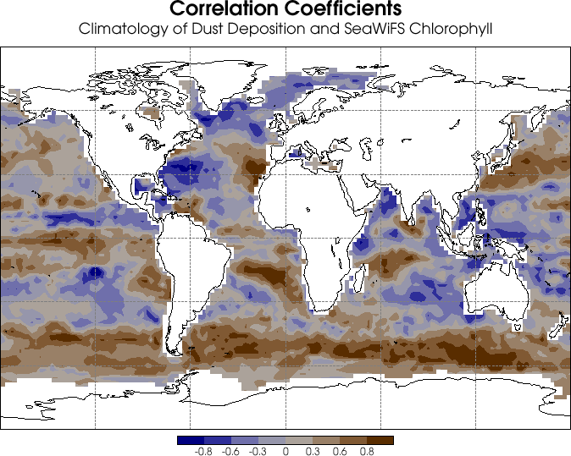

Figure 3. The correlation between remotely sensed chlorophyll and modeled dust deposition is an example of creative use of multiple approaches to assess the global effect of dust deposition on the open ocean and possible feedbacks as illustrated in figure 1 (courtesy of David Erickson III, ORNL)

The greatest advances in boundary layer dynamics can be obtained by studies that cover a range of environmental forcing. This argues for sustained observations of key variables from fixed platforms interspersed with more intense field campaigns to capture a wider range of dynamic responses.

Long-Lived Climate Relevant Compounds in the Surface Ocean-Lower Atmosphere Region

Fluxes of long-lived CRCs are strongly affected by boundary layer physics. Quantifying fluxes and inventories of these compounds will rely in large part on advances in the realm of boundary layer physics and modeling. One of the most important long-lived CRC is CO₂, and it is a focal point in the SOLAS science plan because of its climatic and societal relevance. Comprehensive plans to study the oceanic and atmospheric CO₂ cycle are currently being developed as part of the NASA, NSF, and NOAA carbon cycle initiatives. Rather than duplicating these efforts, US SOLAS will augment plans under development to create an integrated multi-species program. Since the compounds in question such as CO₂, CO, COS, N₂O, and CH₃Br have relatively long atmospheric lifetimes, SOLAS will focus on air-sea fluxes, transformations in the surface mixed layer and modeling.

US SOLAS can enhance the current plans focusing exclusively on CO₂ in several ways:

- Including the dynamics of radiatively important trace species in general circulation
models to improve the forecasting skills of the models in determining radiative
balance.
- Obtaining basic physical and chemical characteristics of the compounds.
- Augmenting surface observations of partial pressure of CO₂ on ships of opportunity
with other CRCs.
- Providing a value-added product to surface CO₂ observations in near real-time by supplying key environmental information obtained from other sources such as remote sensing and climatologies.

Global numerical models of the climate system are rapidly moving toward full biogeochemical coupling. That is, the atmospheric concentrations of CO₂ and other CRCs are carried explicitly in the atmospheric flow, interacting with atmospheric radiation, and are directly influenced by surface source-sink processes such as air-sea exchange and material transfers with the terrestrial biosphere (e.g., Fig 4). This allows detailed feedbacks between the biogeochemical and physical systems to influence climate prediction. For example, should any future shift in ocean circulation result in alterations to the air-sea exchange of trace gases (and aerosols), this would feedback into the system due to changes in the radiative balance of the atmosphere. Including other CRCs such as N₂O, CH₄ and aerosols in models of radiative forcing requires a better understanding of the basic biogeochemical cycles and air-sea exchange of these trace species.

To model the biogeochemical cycles of more "exotic" long-lived CRCs, such as new man-produced halocarbons, requires consideration of the basic physical and chemical characteristics of these compounds. These include determination of solubility and diffusivity of gases as well as hydrolysis rates of the compounds in seawater. Such studies are best performed in controlled laboratory environments.

Several of the planning efforts focusing on CO₂ advocate monitoring programs on ships of opportunity including research vessels. This work should be augmented at low cost with other long and also short-lived CRCs such as dimethylsulfide (DMS), halogenated and oxygenated organic compounds whose oceanic sources and sinks are poorly constrained. Many of these compounds are produced or consumed by microbes but the specific functional groups involved in the transformations are unknown. Surface observations in opportunistic mode on research ships also offer the possibility for shipboard incubation studies to determine production and degradation rates of relevant CRCs for different biogeochemical provinces.

To provide a product useful to the larger observational and modeling community, data products should be comprehensive packages of in situ data, remotely sensed products and climatologies. Although the auxiliary information can mostly be obtained from public sources, the efforts involved to merge relevant remotely sensed or climatological data, such as wind speed, mixed layer depth, or sea surface height anomalies into the data sets is beyond the capabilities or time constraints of most researchers. Providing such data packages to the scientific community at large will facilitate interpretation of the data. It will aid in projects such as interpolating measured quantities over larger space scale and provide large-scale process information on the factors that control surface water concentrations.

Figure 4. Schematic of the major processes affecting boundary layer concentrations of halocarbons (courtesy of S. Yvon-Lewis, AOML)

Short Lived Climate Relevant Compounds in the Surface Ocean-Lower Atmosphere Region.

The composition of the atmosphere also impacts climate change through ozone and particulate matter – short-lived species whose concentration vary greatly in time and space. Ozone, a greenhouse gas itself, is involved in the biogeochemical cycles of many, perhaps most, other CRCs. Aerosols produce climate forcing directly, as well as indirectly through a number of cloud-mediated processes.

Gases and particles with short atmospheric life times, less than or equal to the residence time of atmospheric water, or about a week, generally show coherence on spatial scales smaller than 1000 km and reflect local or regional sources and sinks. However, the impact of these species, however, on Earth systems such as climate can be global in scale. For example, removal in the SOLAS region limits transport of pollutants from one continent to another. Many short-lived atmospheric CRCs that originate from the surface ocean together with their reaction products play a major role in the chemistry and radiative properties of the lower atmosphere. Among these are sea-salt aerosols, halogen radicals (Cl, Br, and I), organic halogen compounds, nitric oxide (NO), DMS, ammonia (NH₃), condensed organic compounds and volatile organic compounds (VOCs).

Four broad but interrelated hypotheses or themes emerged in this focus as important to improving our understanding of the impact of SOLAS processes on climate and chemistry.

- Sea salt aerosols impact the cycling of trace gases and particles between the atmosphere and ocean.
- Marine sulfur and other elements appear to play a quantitatively significant role in regulating Earth’s climate.
- Fluxes of organic matter across the air/sea interface could play an important role in trace gas and aerosol cycling, photochemistry, and marine biogeochemistry.
- The photochemistry of the lower atmosphere and surface ocean are linked.

Impact of sea salt aerosols on the cycling of trace gases and particles between the atmosphere and ocean

Interactions among sea-salt aerosols, multiphase processes, and the fast photochemistry in the MBL are some of the most exciting climate-chemistry topics to arise recently. The factors controlling the concentration of sea-salt aerosol themselves are not easily simulated. Winds play a role, but wind speed alone is inadequate to predict sea-salt particle concentrations. The physics of the surface ocean and concentrations of dissolved organic matter (DOM) and surfactants are probably involved.

The rate of ozone destruction in the remote MBL sometimes exceeds that attributable to ozone photolysis and “standard” ROx chemistry, and bromine and/or chlorine atoms are implicated (see Fig. 5). The suspected mechanism involves acidification of sea-salt aerosol, formation and release of sparingly soluble Br_{2,} BrCl, and perhaps Cl₂. Recent studies suggest that iodine chemistry may likewise consume ozone. Iodine originates from photolysis of biogenic alkyl iodides, destroys ozone in a cycle using marine aerosols, may be involved in new particle production, and accumulates as particulate iodate. The high rate of ozone removal observed, if widespread, would constitute a major global sink. The relative loss of hydrocarbons has been used to infer a substantive role for Cl atom attack. If halogens play a major role in tropospheric O₃ and VOC chemistry, then they may also oxidize elemental mercury to make it more biologically active.

Nitric oxide, the limiting reactant in tropospheric ozone formation over most of the Earth, appears to be emitted by the ocean. If model simulations of heterogeneous oxidation of NOx to nitrate are correct, then cycling of NOx in the MBL is rapid and the marine source may be strong.

Figure 5. Schematic diagram of multiphase Br chemistry in the MBL

Evidence for rapid halogen chemistry in the Arctic is particularly strong. Photochemical reactions on snow and ice may be a sink for O₃, but also a source of halogens, H₂CO, and NOx. These processes may also impact the flux of trace species between the atmosphere and frozen surface and thus affect the reactivity of Hg and the long-term glacial record of atmospheric composition.

Detailed studies of OH and HOx often indicate reasonable (factor of two or better) agreement between measurements and theory. Homogeneous gas-phase models cannot, however, account for the observed rate of loss of ozone (as discussed above) or for concentrations of oxygenated organic compounds such as formaldehyde, H₂CO, acetaldehyde, methanol, and acetone. In the SOLAS region, these oxygenates are often found in much greater concentrations than nonmethane hydrocarbons and should exert a profound influence on the oxidizing capacity of the atmosphere. Understanding the interactions of multiphase processes, the oxidizing capacity of the atmosphere and the photochemistry of the MBL and surface ocean demands a deliberate, multidisciplinary approach.

The role of marine sulfur and related elements in regulating the Earth’s climate

The direct and indirect influences of aerosol on Earth’s radiative balance are currently the single largest source of uncertainty in anthropogenic climate forcing prediction. Particles enhance scattering and absorption of terrestrial and solar radiation. In addition to this direct effect, they can impact the thermodynamic stability of the atmosphere and the rates of photochemical processes in both the atmosphere and ocean. Anthropogenic aerosols further increase cloud brightness and connect to the hydrological cycle by inhibiting precipitation. In the SOLAS region there are three main classes of particles, sea salt, natural, marine-derived sulfates, and aerosols transported from the continents. Particulate organic compounds from both marine and continental sources are associated with each class. The processes controlling the concentrations, radiative properties, and climate forcing of these aerosols are currently not well constrained.

Most DMS emitted from the surface ocean is oxidized to SO₂ and then, by both aqueous- and gas-phase pathways, to H₂SO₄. Gaseous sulfuric acid condenses onto existing particles or can form (perhaps in concert with marine NH₃) new aerosols that act as CCN and influence strongly the size-number distribution of cloud droplets. This mechanism represents an impact of ocean emissions on precipitation and the radiative properties of the atmosphere, but the processes controlling DMS emission are poorly understood. If cloud cover impacts the phytoplankton and the foodweb involved in DMS production, then a natural feedback cycle may be in play. If on the other hand atmospheric inputs of nutrients such as iron or reactive nitrogen affect phytoplankton populations and their foodweb and resulting emissions, then a nonlinear feedback cycle involving continentally derived substances may be in play.

The factors controlling the concentrations and fluxes of sulfur compounds in the SOLAS region remain uncertain. Major unanswered questions include the magnitude and distribution of significant atmospheric deposition of dust and nitrogen and the relative role of oceanic upwelling vs. atmospheric input in the marine nutrient concentrations. These questions, also central to the boundary layer physics and biogeochemical foci, cut across disciplines. Several existing programs are actively investigating these processes, but SOLAS-related initiatives will complement ongoing efforts and help provide an integrated framework for future experiments. Because of the complex web of interactions, a coordinated approach is needed with simultaneous measurements and models of atmospheric and oceanic biology, chemistry, and physics.

The role of fluxes of organic matter across the air/sea interface in trace gas and aerosol cycling, photochemistry, and marine biogeochemistry
Organic compounds are produced in large quantities by the oceanic biosphere and reside in the ocean as dissolved and particulate matter and in the atmosphere as VOCs and in association with marine aerosols. The cycles of organic compounds are poorly understood, but may play major roles in controlling radiative properties, nutrient cycling, and in cloud-aerosol interactions. The oceanic and atmospheric reservoirs are intrinsically coupled by air-sea and gas-particle exchange.

The ocean is a source of both primary condensed organic material and VOCs; see above. Additional material is transported to the SOLAS region from continents. Both gas-phase and multiphase reactions are involved in chemical transformations and phase transitions. In seawater, organic matter helps control the aquatic light field and photochemical production of a variety of trace gases, nutrients, and reactive intermediates. Ocean opacity and color also play an important role in the Earth’s radiative balance, and they are coupled to climate change in non-linear and difficult-to-predict ways. SOLAS objectives include studying the factors controlling the concentrations of organic constituents in the lower atmosphere and surface ocean and determining whether cycling through the atmosphere can impact organic matter sufficiently to change marine productivity. Key requirements to understand the air/sea fluxes of organic matter include chemical and physical structure, thermodynamic properties, photochemistry, and distribution in the surface ocean.

The photochemistry of the lower atmosphere and surface ocean are linked

If the photochemistry of the lower atmosphere and surface ocean are intimately linked, then air-sea interactions may respond nonlinearly to climate changes. The trace gas and aerosol composition of the atmosphere controls (both directly and through changing cloud properties) the flux of solar UV and PAR reaching the ocean surface. Initial studies show strong surface ocean photochemical response to changes in UVB radiation resulting from changes in column ozone content, indicating that other climate-related geophysical changes may also alter SOLAS photochemistry. Deep convective clouds over the tropical ocean might transport organic compounds across the tropopause where they impact stratospheric ozone and aerosols. The organic composition of the upper ocean controls to a large extent the penetration of radiation and depth of the photic zone. Major unanswered questions include the spectra and quantum yields of dissolved organic compounds, the impact of changes in ozone, aerosols and clouds on actinic radiation reaching the ocean surface and the response of the surface ocean to changes in radiation.

Atmospheric Impacts on Marine Biogeochemical Processes.

The need for an integrated atmospheric and oceanic program is particularly pertinent for the study of atmospheric impacts on marine biogeochemical processes. The hypothesis of aeolian dust deposition enhancing biological productivity, perhaps even in oligotrophic regions through a nitrogen fixation mechanism, is well documented. Several other broader aspects are now being addressed under SOLAS and related planning efforts. Of fundamental importance are the following two questions:

- How is the ratio of phosphorous and nitrogen in surface water related to atmospheric fluxes of trace compounds?
- How do biogeochemical processes affect the air-sea exchange of CRCs and what are the possible feedbacks to radiative forcing?

The relationship of the ratio of phosphorous and nitrogen in surface water to atmospheric fluxes of trace compounds

Inorganic nutrients are found in the deep ocean in fixed stoichiometric ratios and many of our inferences on biogeochemical cycling are based on these so-called Redfield ratios (with current widely used stoichiometry of P:N:C: -O = 1:16:117:170). Some organisms exhibit these ratios some of the time, but several functional groups have nutrient requirements that deviate significantly from the Redfield ratio. For instance, it appears that during episodic events Redfield ratio constraints are particularly violated. Particles sinking from blooms often exhibit non-Redfield ratios and nitrogen fixing organisms in the open ocean that might be iron limited show enrichment in nitrogen with respect to phosphorous. Interestingly, although this increases the N: P ratio, the C:N ratio does not appear to change making this pathway a possible natural CO₂ sequestration mechanism. Coastal regimes, in particular, are environments where there is riverine and aeolian input of fixed nitrogen and dust. Phytoplankton responses to these inputs often have unique nutrient ratios. The issue of which (micro) nutrients control biological growth and the origin of the nutrients (aeolian, terrestrial, or from below) in different environments is a quintessential SOLAS question.

Just how important is the atmosphere as a transport path for these nutrients? In determining the possible implications of atmospheric input, there are a number of important issues that must be addressed. For example, we do not know what controls the temporal and spatial patterns of the atmospheric fluxes and what chemical processes control the bio-availability of the atmospherically supplied nutrients and bioactive elements that enter the surface ocean. This is particularly important for the nutrient iron, where the atmospheric input is related to the transport of iron-containing minerals from the continent, and where important chemical processes in the atmosphere during transport may affect the bio-availability of the iron in the ocean. Perhaps even more fundamentally, we do not understand how the nutrients derived from atmospheric input really affect marine biogeochemical processes and the relative availability of key limiting nutrients.

The effect of biogeochemical processes on the air-sea exchange of CRCs and the possible feedbacks to radiative forcing

Aside from the importance of physical forcing of the air-water interface and chemical transformations, there is increasing evidence of biological processes exerting a fundamental influence on concentrations of CRCs in the SOLAS region. The functional groups that are responsible for production of many CRCs are not known. Even more fundamental is the issue of whether the CRCs are formed during production, respiration, or by bacterial processes. Biological processes can also directly affect the sea surface rheology through biological exudates that can concentrate at the sea surface. At high concentrations these manifest themselves as surfactant layers. Biological production will also affect the optical depth of the water and penetration of sensible heat. Therefore such processes must be included in models of surface forcing. In these cases, the biogeochemical cycles can act as feedbacks to the climate system. An optimal way of determining if such feedback mechanisms have operated in the past is by using paleo-proxies.

Perturbation and controlled-volume studies are particularly useful for investigating atmospheric impacts on the marine biogeochemical. The best-known perturbation studies are those of iron fertilization in HNLC (high nutrient, low chlorophyll) regions. Such studies to date have unequivocally shown an increased productivity following deliberate iron fertilization (Fig. 6) but they have not been of sufficient duration to determine the full response, particularly the export production of carbon. Moreover, there are other responses that bear study such as the possible response to dust deposition onto the oligotrophic gyres. It is suggested that the warm oligotrophic ocean could have a productivity response through nitrogen fixation. Perturbation studies should not be limited to deliberate additions but should also include study of responses to natural perturbations, such as nutrient delivery from below the mixed layer during storms. Performing the work as a controlled volume study will facilitate obtaining quantitative information.

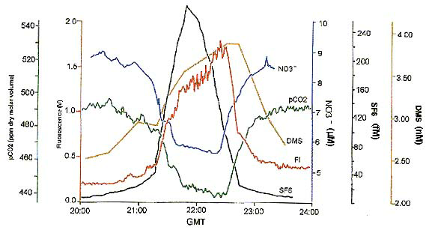

Figure 6. Traverse across iron enriched patch for a deliberate addition of iron and inert tracer SF₆, IronEX II (from the SOLAS science plan, compilation of results from various authors)

Suggested Studies

It is envisioned that US SOLAS will proceed on two parallel tracks. The US SOLAS community, through its steering committee, will advocate and coordinate select augmentation of established oceanographic and atmospheric research efforts with focus on connecting the two realms. However, full implementation of the SOLAS principles is best facilitated by planning projects from the ground up. Several of these conceptual "golden nuggets " are listed below. Others can be found in the working group reports. There are also some generic research issues (“housekeeping issues”) that must be addressed to see the program off to a successful start. SOLAS type activities will be greatly aided by:

- Obtaining basic physical and biogeochemical information on a suite of CRCs in controlled environments.
- Inclusion of a wide suite of CRCs into models will improve their predictive skill as well as provide critical information on the possible positive or negative feedbacks of the CRCs on the climate system.
- Infrastructure and field support for time series facilities in a variety of biogeochemical provinces. Such support is also advocated in many oceanic and atmospheric planning efforts. It is critical that there is a strong connection between both observational realms such that the forcing and feedbacks between upper ocean and lower atmosphere are clearly established.

Augmentation of Established or Planned Efforts.

Several projects of direct relevance to the objectives of SOLAS have recently been undertaken or are scheduled in the future. For future studies, augmentation with key measurements will greatly enhance their relevance as SOLAS-type projects and for studies that have recently completed, support for multi-disciplinary interpretation is suggested. Examples of recently completed projects include the joint NSF/NOAA Gas-Ex-2001 study, the multi-agency INDOEX study, the NSF/NOAA ACE-Asia study and the near concurrent PEM-West campaign funded by NASA. Synthesis projects that incorporate findings such as from the largely ship based ACE-Asia study and aircraft-based PEM-West along with smaller studies such as the MBARI Western Flyer Monterey-Hawaii transect and remote sensing could elucidate the oceanic response of large desert dust deposition. The Gas Ex-2001 (Fig. 6) study is well suited for higher order ground truthing and for upscaling results to estimate regional fluxes and factors controlling these fluxes. The three iron fertilization studies in the Southern ocean should be interpreted in a holistic manner with focus on modeling and paleoclimatic interpretation of increased productivity events and the origin thereof. Most of these projects mentioned had significant international components and collaborations

Several field efforts are being planned that will take place prior to full implementation of SOLAS. For example, the cruise under auspices of the International Oceanic Commission (IOC) in the Western Pacific planned for 2002 focuses on the role of Asian dust deposition and the effect of delivery of trace metals to upper ocean biota. Remote sensing efforts would be beneficial to obtain regional information. Establishing a quantitative link between atmospheric dust levels and upper ocean biological response studies of wet and dry deposition would be of merit.

On larger scale, US SOLAS hopes to collaborate with the largely continental programs of the North American Carbon Program (NACP) and the Intercontinental Chemical Transport Experiment- A North American Mission (INTEX). Both studies aim to constrain fluxes of carbon dioxide and trace gases, respectively, on regional scale over the continental US. The oceans surrounding the continental US will be studied to deconvolve oceanic and terrestrial signals. In particular, residence times and transformation rates in the oceans differ dramatically from those in the atmosphere, and different cycles dominate each side of the interface. Severe knowledge gaps exist for photochemical oxidation of organic compounds in the surface ocean while the origin of high concentrations of oxygenated trace gases over the ocean remains a mystery. Multiphase processes such as oxidation involving sea salt aerosols, and even the processes maintaining the aerosol itself, stand as major unanswered questions in atmospheric chemistry. The interaction of continentally derived atmospheric species with marine aerosols also has the potential for major environmental consequences. Air quality programs that focus on coastal regions (e.g., Atmospheric Investigation, Regional Modeling and Prediction, AIRMAP) are addressing some aspects of this issue but not in a comprehensive fashion. Oceanic fluxes, in particular along the coast, must be constrained as boundary condition for (transport) models that are an important tool for quantification and interpretation of the continental signal.

The significant (platform) resources that will be available for NACP and INTEX can greatly aid US SOLAS projects with focus on the coastal US. US SOLAS aims to closely interact with the organizers of the projects to incorporate multi-disciplinary coastal boundary layer projects focused on CRCs.

A regional project that embodies the SOLAS objectives is the Sargasso Sea Ocean/Atmosphere Observatory (S2O2) that is being formed to coordinate and enhance the contributions of the many marine biological, biogeochemical, hydrographic and atmospheric studies that are conducted in time series mode in and above the western North Atlantic. The S2O2 comprises several ongoing ocean and atmospheric observation and modeling programs, which are in turn managed by several institutions. Primary objectives of S2O2 will be to maintain the vigor of the local time series programs and to provide a fluid and timely data stream to the international community of ocean and climate scientists.

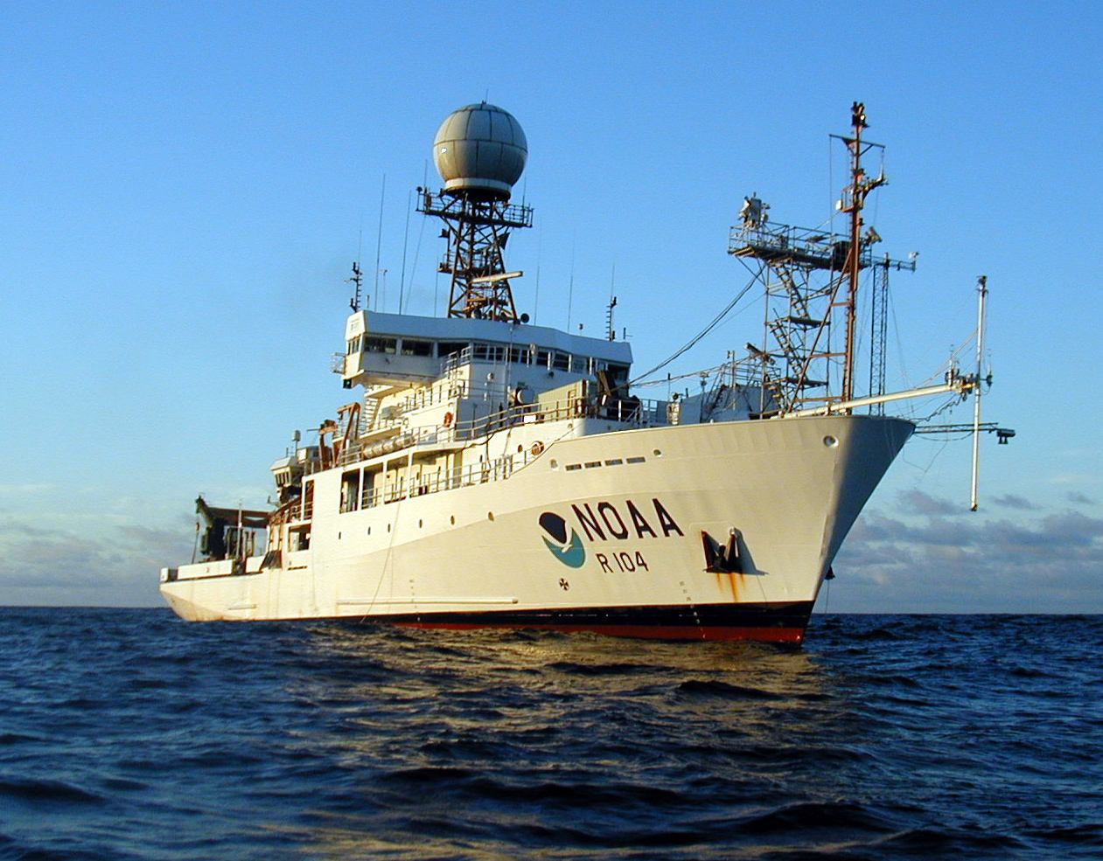

Figure 7. The NOAA Research Vessel Ronald H. Brown used for several studies of the SOLAS region including INDOEX and Gas Ex. For these cruises specialized sampling infrastructure was put in place like a bow tower and sampling booms to sample uncontaminated air and water.

The US SOLAS steering committee will act as a source of information exchange to facilitate that key measurements and interpretations connecting the lower atmosphere to the upper ocean for relevant field studies are performed. It will facilitate larger scale interpretation of such studies through optimal use of remote sensing and modeling

Golden Nugget Projects

Many of the SOLAS objectives can be facilitated by augmentation of planned efforts or efforts in place. However, to fully explore the interdisciplinary approach and to foster interactions between the atmospheric and oceanic communities, dedicated projects should be implemented. The projects listed should at this point be construed as examples of the critical interconnectivity of atmospheric, interfacial, and upper ocean processes to study phenomena of critical importance in understanding the earth's system.

Barbados Dust Deposition Experiment: BarDEx

A project that covers many of the SOLAS objectives is one that was formulated several years ago to study the deposition mechanisms of African dust in the Western Atlantic and the upper ocean response. Deposition is not the sole requirement for an upper ocean biological response but bio-availability of trace nutrients is critical as well. Indeed, recent studies in the Pacific do not unequivocally show a biological response to dust deposition even in HNLC regions. A high priority within US SOLAS is to characterize wet and dry removal processes in regions where dust concentrations are known to be high. An experiment is proposed to take place in the tropical North Atlantic in the region of Barbados where trade winds carry high concentrations of dust during late Spring, Summer and early Fall. This experiment would have three overriding goals that encompass many SOLAS objectives:

- To characterize the removal rates of mineral dust and related aerosol particles via wet and dry deposition.
- To measure the deposition rate of dust to the ocean surface in individual rain events to follow the subsequent changes in the concentration of Fe and other species in the surface waters compared to dry deposition
- To document biological and biogeochemical responses to these inputs.

The proposed project would both have a longer duration, land based phase quantifying dust transport, mineral aerosol composition and size distribution, and (wet)-deposition fluxes along with shorter duration oceanographic process studies focusing on the deposition mechanism and the bio-availability of the trace constituents in the mineral aerosols. The effort would rely heavily on remote sensing products from sensors such as TOMS, MODIS, and SeaWiFS to characterize dust transport and upper ocean response. Established and new modeling activities would be entrained to focus on the effort. A synopsis of the study along with descriptions of other related candidate projects can be found in Chapter 4 of the web based report.

Long term air-sea exchange studies

Another example of a gold nugget project is long-term estimates of air-surface exchange of trace constituents over a broad range of environmental conditions for incorporation in regional and global scale models. A multi-year deployment at a fixed site to capture seasonal and interannual variability is recommended. The site would include intensive and continuous measurements of air-sea transfer of constituents with a range of solubilities, mass diffusivity, and controls on concentration in the atmosphere and ocean (e.g. chemical enhancement, surface reactive gases, catalytic reactions, and biological processes). To capture a large range of environmental forcing, including extreme events and biogeochemical response, a mid to high latitude observational post would be desired. In addition to the central facility, arrays of moored and mobile instrument platforms would be deployed. The following studies are envisioned:

- Budget-based Lagrangian studies.
- Multiple tracer releases.
- Direct flux measurements.
- Near-surface processes.

Chapter 1 of the full report provides more information on such a project and other related projects of high relevance to US SOLAS

Regional high latitude studies
In addition to S2O2 mentioned previously, a large Arctic regional program with strong SOLAS emphasis has been proposed on “Changing Environmental Controls on Coupled Chemical Exchange Between the Ocean, Ice, and Atmosphere in the Arctic ”

The Arctic Ocean and its marginal seas play a fundamental role in the global ocean/climate system, due to bottom water formation and its influence in thermohaline circulation, as well as its permanent sea-ice cover affecting Earth’s albedo and associated radiation balance, and the distribution of freshwater. An important question is how the recently documented change in glacial and sea ice extent and thickness may impact on the lower atmosphere and its composition, and how that may in turn feed back into changes in surface temperatures and Arctic biological processes.

Therefore simultaneous examination of processes that regulate the concentrations of gases in cold, Arctic seawater, ice and snow leading to sea-air flux as well as ice- and snow-air fluxes is necessary. The broader scale impacts and ties to climate and transport and fate of toxic pollutants will require a sophisticated approach to the relevant Arctic-scale meteorology. The central role of a modeling component from the outset will be essential, the ultimate goal of which will be the refinement of an Arctic ocean-atmosphere sub-model (including physical transport as well as biogeochemical transformations) that can be included in comprehensive and predictive global climate-system models.

The following list addresses some of the issues:

- Does halogen activation occur above/near open water/leads/polynyas, or is a frozen surface required? How would we go about testing this?
- How will changing sea-ice cover impact on arctic boundary layer chemistry and the processing of pollutants, such as Hg?
- What is the role of the biota (phytoplankton; macrophytes; ice algae) in releasing photochemically active species such as organo-halogens and DMS, and how do we best pursue this question?
- How will changing meteorology in response to changing sea-ice cover and the AO impact on the transport and processing of pollutants in/out of the Arctic?
- How should we treat the ice/snow surface so that chemistry on frozen surfaces can be treated quantitatively in models? What laboratory work is needed in this area?

Interaction of US SOLAS with other Programs

There is significant synergism between US SOLAS and other budding environmental programs in the U. S. and the challenge will be to optimize interaction and coordination both at international and national levels. US SOLAS will be closely aligned with the international SOLAS effort that has recently appointed a steering committee. Canada, Japan and Germany have already funded SOLAS efforts that will involve or offer opportunities for US participants.

Nationally, continued interactions with the different agencies involved in planning of global carbon cycle programs will occur. In particular, we hope to develop strong interactions with the NASA carbon program which focuses on remote sensing and coastal processes, and the Ocean Carbon Cycle Research group at NSF which is focusing on the oceanic biogeochemical cycles of carbon and related parameters. Large-scale observational programs as planned in NOAA’s sustained observations efforts including those with emphasis on the carbon cycle, trace gases and aerosols are good venues to extrapolate findings to larger scales and for hypothesis development. SOLAS issues such as dust delivery, marine boundary layer transformations, and physics of the air-sea interface will be of direct benefit for the marine carbon oriented programs. The carbon-based projects envisioned in these programs can serve as a springboard for SOLAS efforts such as the study of halogenated trace compounds, wet and dry deposition, and photochemical processes in the SOLAS region.

Aside from ocean-oriented programs, there are several continental and atmospheric efforts for which coordination would be of mutual benefit. The NACP focusing on constraining regional sources and sinks in North America will benefit from better knowledge of oceanic CO₂ fluxes including regional interpolation mechanisms using remote sensing. (Coastal) towers and aircraft which will include oceanic transects could be utilized for measurement of boundary layer dynamics and CRCs. The INTEX program, focusing on reactive trace compounds in the continental atmosphere, should provide many opportunities for both joint studies and use of data to expand the scale of observations from continental to oceanic and vice versa. As mentioned above, the marine source of many of the reactive halo- and hydrocarbons is either poorly constrained or completely unknown which causes significant uncertainty in interpretation of large scale atmospheric chemistry models.

US SOLAS aims to work with the different programs under development. Several of the objectives brought forth in the international SOLAS plan have been adopted by other US planning efforts but often not in a fully integrative fashion spanning both the ocean and atmosphere. In such instances US SOLAS aims to facilitate the connectivity between the oceanic and atmospheric reservoirs and research communities.
Organizational Structure of US SOLAS

As manifested at the community workshop and many other interactions, the concept of a surface ocean lower atmosphere study is well embraced in the oceanic and atmospheric research communities. In its current planning phase US SOLAS is volunteer based. The organizational efforts required to implement the effort as outlined above which includes augmentation of established efforts, coordination of generic research issues ("housekeeping items"), implementation of dedicated projects, and coordination with other efforts, requires dedicated efforts in addition to continued active scientific input from the research community.

It is envisioned that, initially, these efforts would be coordinated on a part-time basis by a senior scientist with a 3 to 4-month per year commitment working in coordination with the International and US SOLAS Science Steering Committees. With input from agency representatives, and consultation with the community at large, the SOLAS planning group, with agency and community input, will select a US SOLAS science steering committee that will direct the implementation phase of the program. To assure continuity some of the current planning group members will likely be part of the new science steering committee. Much of the committee work would be performed by e-mail and teleconferences with one meeting per year held in conjunction with a national meeting such as AGU and AMS. The request for funding to sustain the initial organizational component of US SOLAS efforts is estimated at the $100 K level. Funding would be sought through proposal submission to funding agencies.

Appendix A:

Narrative of the US SOLAS open science meeting
The meeting summary is abridged from the note in US JGOFS New (Vol 11, #2, June 2001).

Some 70 scientists representing a wide variety of oceanic and atmospheric disciplines attended the first community science workshop for the proposed U.S. Surface Ocean Lower Atmosphere Study (US SOLAS) at the Bolger Center in Potomac MD, May 16 -18, 2001. The workshop attracted researchers in paleo oceanography, boundary-layer physics, ocean biogeochemistry, atmospheric chemistry and cloud physics. US SOLAS is a component of a larger international program, which was recently adopted as a so-called interface program of the International Geosphere-Biosphere Programme (IGBP). The purposes of the workshop were to familiarize participants with the goals of SOLAS, to formulate relevant science questions for the U.S. component of the study and to discuss implementation strategies for the U.S. program.

The meeting started with presentations on international and national research programs that US SOLAS would be likely to interact with. International SOLAS is forming a scientific steering committee led by Peter Liss of the University of East Anglia, United Kingdom. Close ties are likely with the International Global Atmospheric Chemistry (IGAC) program, which has included studies of the marine atmospheric boundary layer as part of the Aerosol Characterization Program (ACE) and the Marine Aerosol and Gas Exchange Experiment (MAGE).

Short presentations were made on the fledging carbon-cycle science programs of the U.S. National Science Foundation (NSF), the National Atmospheric and Oceanic Administration (NOAA) and the National Aeronautics and Space Administration (NASA). The research of quantifying the exchange of carbon dioxide (CO₂) across the air-sea interface is a major focus of these planning efforts as well as of SOLAS. Two continental field experiments, which includes the coastal regions, planned for North America in 2004, one focusing on atmospheric chemistry and one on the terrestrial carbon sink, offer possibilities for collaboration. A representative from Canadian SOLAS, the first national SOLAS program that has gotten underway, invited collaborations with studies planned in the sub-polar North Pacific and North Atlantic.

Four plenary talks offered context for the working groups, which convened to discuss science ideas and formulate priorities. Several overarching themes emerged from their efforts. For example, we need to quantify basic physical constants for a variety of compounds that have an important effect on climate. Issues include the solubility and diffusivities of halogenated trace gases; the characterization of organic compounds in the gas phase, in aerosol solutions, and in the surface ocean ; biological consumption and production estimates for various compounds, and rates of photolysis.

Coastal margins, including the large arctic shelves, were singled out as requiring more attention. The high biological productivity, sedimentary processes, modified atmospheric chemistry of these regions contribute disproportionately to the fluxes of many compounds that affect climate, and critical interactions between continental runoff and the marine domain occur there.

The boundary-layer physics working group homed in on problems of quantifying the physical factors controlling fluxes and deposition of compounds, including gas-transfer velocity and wet and dry deposition mechanisms. Sustained coastal time-series measurements of fluxes of compounds that affect climate were suggested as one way to improve our understanding of the factors controlling gas transfer and deposition processes. The group also advocated studying the effects of high wind speeds on these processes.

The working group on the dynamics of long-lived compounds emphasized the need for regional flux information, particularly in the coastal regions. A lively discussion revolved around the question of US SOLAS participation in a survey of the partial pressure of CO₂ (pCO₂) in global surface water that is recommended in the large-scale oceanic and atmospheric carbon observing plan. The final recommendation was to support this effort and to strive for augmentation of pCO₂ surveys with near real-time flux estimates utilizing remote sensing and measurements of other compounds that affect climate. The group also noted a need for controlled studies of biological production and degradation rates of halogenated, nitrogen and sulfur bearing compounds.

The working group on dynamics of short-lived compounds had the daunting task of setting science goals with regard to a myriad of compounds that are reactive on both sides of the air-sea interface. Specific priority issues were identified and classified under 4 major, interrelated research foci: 1) Influences of multiphase processes involving sea-salt aerosols on the cycling of gases and condensed material between the atmosphere and ocean; 2) climatic effects of marine-derived S and other compounds; 3) the air-sea exchange of organic matter and related biogeochemical implications on both sides of the interface; and 4) linkages between photochemistry in the atmosphere and ocean.

The fourth working group focused on atmospheric effects on marine biogeochemical processes, including the cycling of iron and nitrogen. Highlighted issues were dust transport and deposition on the ocean and subsequent transformation of iron in dust into bioavailable form. Participants noted that questions about wet and dry deposition and chemical transformation in the air phase were not fully addressed in other programs. They also discussed nitrogen fixation and deposition in different forms and noted the importance of coastal regions for studies of deposition. This group put forth two overarching themes for SOLAS research on upper-ocean biogeochemistry: How do atmospheric fluxes affect the nitrogen-to-phosphorus ratios of inorganic nutrients in the upper ocean? How do changes in biogeochemical processes in the surface ocean affect the air/sea exchange of compounds important to climate and thereby have a feedback effect on radiative forcing? These themes were broken down into more specific research objectives and field experiments that would address these issues.

All groups highlighted the importance of using information gathered by remote-sensing instruments to assess regional variability, to understand the effects of physical forces on biogeochemical processes and to extrapolate the results in time and space. The critical importance of maintaining and fostering long-term time-series observations was pointed out. Modeling priorities included coupling ocean biogeochemical process models with models describing the atmospheric marine boundary layer for both long- and short-lived compounds. Participants urged the incorporation of both modeling and remote-sensing efforts into the initial stages of experimental design and their use in site selection and the generation of hypotheses.

Appendix B. Participants at the US SOLAS meeting in Bolger, MD

Jeff Amthor
Department of Energy
19901 Germantown Road
SC-74 Germantown, MD 20874-1290
USA
Ph: (1) 301-903-2507
Fax: (1) 301-903-8519
jeff.amthor@science.doe.gov

Robert Anderson
Columbia University
Route 9W
Palisades, NY 10964
USA
(1) 845-365-8508
(1) 845-365-8155
boba@lamont.ldeo.columbia.edu

Krisa Arzayus
NOAA Office of Global Programs
1100 Wayne Ave, Ste. 1225
Silver Spring, MD 20910-5603
USA
krisa.arzayus@noaa.gov

Richard Barber
Duke University
135 Duke Marine Lab Rd.
Beaufort, NC 28516-9721
USA
(1) 919-504-7578 or 7641
(1) 919 504-7648
rbarber@duke.edu

Leonard A. Barrie
Pacific Northwest National Laboratory
P.O. Box 999
Richland, WA 99352
USA
(1) 509-375-3998
(1) 509-372-6153
leonard.barrie@pnl.gov

Timothy S. Bates
NOAA Pacific Marine Environmental Laboratory
7600 Sand Point Wy., NE, Bldg. 3
Seattle, WA 98115-0070
USA
(1) 206-526-6248
(1) 206-526-6744
bates@pmel.noaa.gov

Nick Bates
Bermuda Biological Station for Research
17 Biological Station Lane
Ferry's Reach
St. George's GE 01
BERMUDA
(1) 441-297-1880 x303
(1) 441-297-8143
nick@bbsr.edu

Neil Blough
University of Maryland
Building 91
College Park, MD 20742
USA
(1) 301-405-0051
(1) 301-311-9121
nb41@umail.umd.edu

Edward Boyle
Massachusetts Institute of Technology (MIT)77 Massachusetts Ave.
Cambridge, MA 02139
USA
(1) 617-253-3388
(1) 617-253-8630
eaboyle@mit.edu

Douglas G. Capone
University of Southern California
3616 Trousdale Parkway
AHF First Floor
Los Angeles, CA 90089
USA
(1) 213-740-2772
(1) 213-740-6720
capone@usc.edu

Mary-Elena Carr
Jet Propulsion Lab
4800 Oak Grove Dr
MS 300-323
Pasadena, CA 91109
USA
(1) 818-354-5097
(1) 818-393-6720
mec@pacific.jpl.nasa.gov

Fei Chai
University of Maine
5741 Libby Hall
Orono, ME 04469-5741
USA
(1) 207-581-4317
(1) 207-581-4388
fchai@maine.edu

Robert Chatfield
NASA Ames Research Center
Mail Stop 245-5
Moffett Field, CA 94035
USA
(1) 415-604-5490
(1) 415-604-3625
chatfield@clio.arc.nasa.gov

Francisco P. Chavez
Monterey Bay Aquarium Research Institute
7700 Sandholdt Road
P.O. Box 628
Moss Landing, CA 95039
USA
(1) 831-775-1709
(1) 831-775-1645
chfr@mbari.org

James Christian
University of Maryland
2201 Computer & Space Science Building
College Park, MD 20742
USA
(1) 301-405-1532
(1) 301-405-8468
jrc@essic.umd.edu

Patrick Y. Chuang
National Center for Atmospheric Research
P.O. Box 3000 - FL3
Boulder, CO 80307-3000
USA
(1) 303-497-8905
(1) 303-497-8171
chuang@ucar.edu

Tom Church
University of Delaware
Newark, DE 19716-3501
USA
(1) 302-831-2558
(1) 302-831-4575
tchurch@udel.edu

Donald Collins
Texas A&M University
1204 Eller O&M Bldg. / TAMU 3150
College Station, TX 77843-3150
USA
(1) 979-862-4401
dcollins@tamu.edu

Greg Cutter
Old Dominion University
4600 Elkhorn Ave.
Norfolk, VA 23529-0276
USA
(1) 757-683-4929
(1) 757-683-5303
gcutter@odu.edu

John Dacey
Woods Hole Oceanographic InstitutionWoods Hole, MA
USA
(1) 508-289-2327
(1) 508-457-2169
jdacey@whoi.edu

Russel R. Dickerson
University of Maryland
College Park, MD 20742
USA
(1) 301-405-5364
(1) 301-314-9482
russ@atmos.umd.edu

Andrew Dickson
University of California, San Diego
9500 Gilman Drive
La Jolla, CA 92093-0902
USA
(1) 619-534-2582
(1) 619-456-9079
adickson@ucsd.edu

Lisa Dilling
NOAA Office of Global Programs
1100 Wayne Ave., Ste. 1225
Silver Spring, MD 20910-5603
USA
(1) 301-427-2089
(1) 301-427-2073
dilling@ogp.noaa.gov

Scott Doney
National Center for Atmospheric Research
P.O. Box 3000-ML
Boulder, CO 80307-3000
USA
(1) 303-497-1639
(1) 303-497-1700
doney@ucar.edu

Robert Duce
Texas A & M University
TAMU-3146
College Station, TX 77843-3146
USA
(1) 979-845-5756
(1) 979-862-8978
rduce@ocean.tamu.edu

David Erickson, III
Oak Ridge National Laboratory
P.O. Box 2008
Oak Ridge, TN 37831-6367
USA
(1) 865-574-3136
(1) 865-574-0680
ericksond@ornl.gov

Paul Falkowski
Rutgers University
71 Dudley Road
New Brunswick, NJ 08901-8521
USA
(1) 732-932-6555 x370
(1) 732-932-8578
falko@imcs.rutgers.edu

Song Miao Fan
Princeton University, Forrestal Campus
Sayre Hall, Rm. 314
P.O. Box CN710
Princeton, NJ 08544-0710
USA
(1) 609-258-2904
(1) 609-258-2850
fan@splash.princeton.edu

Richard Feely
NOAA Pacific Marine Environmental Laboratory
Bin C15700
7600 Sand Point Way, NE
Seattle, WA 98115
USA
(1) 206-526-6214
(1) 206-526-6744
feely@pmel.noaa.gov

Yuan Gao
Princeton University
Sayre Hall, Forrestal Campus
Princeton, NJ 08544-0710
USA
(1) 609-258-0625
(1) 609-258-2850
yuangao@splash.princeton.edu

Sergio A Guazzotti
University of California, Riverside
Riverside, CA 92521
USA
(1) 909-787-7359
(1) 909-787-4713
serad@citrus.ucr.edu

Tetsu Hara
University of Rhode Island
Narragansett, RI 02882
USA
(1) 401-874-6509
(1) 401-874-6728
tetsu@ripples.gso.uri.edu

Jeffrey E. Hare
University of Colorado/NOAA
325 Broadway
Boulder, CO 80305
USA
(1) 303-497-5864
(1) 303-497-6101
jeff.hare@noaa.gov

Bruce B. Hicks
NOAA
SSMCIII, Room 3152
1315 East-West Highway
Silver Spring, MD 20910
USA
(1) 301-713-0684 x136
(1) 301-713-0119
Bruce.Hicks@noaa.gov

Eric Hintsa
Woods Hole Oceanographic Institution
MS #25
Woods Hole, MA 02543-1541
USA
(1) 508-289-3301
(1) 508-457-2193
ehintsa@whoi.edu

David T. Ho
Lamont-Doherty Earth Observatory
61 Route 9W
Palisades, NY 10964-1000
USA
(1) 845-365-8706
(1) 845-365-8155
daveho@ldeo.columbia.edu

James Hudson
University of Nevada
2215 Raggio Pkwy.
Reno, NV 89512-1095
USA
(1) 702-677-3119
(1) 702-677-3157
hudson@dri.edu

Daniel J. Jacob
Harvard University
29 Oxford St.
Pierce Hall, Rm. 110C
Cambridge, MA 02138
USA
(1) 617-495-1794
djj@io.harvard.edu

William C. Keene, Jr.
University of Virginia Clark Hall
Charlottesville, VA 22903
USA
(1) 804-924-0586 or 0569
(1) 804-982-2300
wck@virginia.edu

David Kieber
State University of New York (SUNY)
Environmental Science and Forestry
Syracuse, NY 13210
USA
(1) 315-470-6957
(1) 315-470-6957
djkieber@mailbox.syr.edu

Ron Kiene
University of South Alabama
LSCB-25
Mobile, AL 36688
USA
(1) 334-460-7677
(1) 334-460-7357
rkiene@jaguar1.usouthal.edu

Cindy Lee
State University of New York (SUNY) at Stony Brook
Stony Brook, NY 11794-5000
USA
(1) 631-632-8741
(1) 631-632-8820
cindylee@sunysb.edu

Donald Lenschow
NCAR, MMM
P.O. Box 3000-FL
Boulder, CO 80307-3000
USA
(1) 303-497-8903
(1) 303-497-8171
lenschow@ucar.edu

W. Timothy Liu
Jet Propulsion Laboratory
4800 Oak Grove Dr.
Mail Stop 300-323
Pasadena, CA 91109
USA
(1) 818-354-2394
(1) 818-393-6720
liu@pacific.jpl.nasa.gov

Natalie Mahowald
University of California, Santa Barbara
Bldg. 489, Rm. 105
Santa Barbara, CA 93106-5131
USA
(1) 805-893-7234
(1) 805-893-7612
natalie@bren.ucsb.edu

Patricia A. Matrai
Bigelow Lab. for Ocean Sciences
180 McKown Point
West Boothbay Harbor, ME 04575
USA
(1) 207-633-9614
(1) 207-633-9641
pmatrai@bigelow.org

Charles R. McClain
NASA Goddard Space Flight Center
Mailstop 970.2
Building 28, Rm. W107
Greenbelt, MD 20771
USA
(1) 301-286-5377
(1) 301-286-0268
mcclain@calval.gsfc.nasa.gov

Wade McGillis
Woods Hole Oceanographic Institution Woods Hole, MA 02543
USA
(1) 508-289-3325
(1) 508-457-2194
wmgillis@whoi.edu

Craig McNeil
University of Rhode Island Bay Campus
Narragansett, RI 02882
USA
(1) 401-874-6722
(1) 401-874-6898
mcneil@gso.uri.edu

Christopher Measures
University of Hawaii
1000 Pope Road
Honolulu, HI 96822
USA
(1) 808-956-5924
(1) 808-956-7112
chrism@soest.hawaii.edu

W. Kendall Melville
University of California at San Diego
La Jolla, CA 92037-0213
USA
(1) 619-534-0478
(1) 619-534-7132
kmelville@ucsd.edu

William L. Miller
Life Sciences Center, Dalhousie University
Halifax, Nova Scotia B3H 4J1
CANADA
(1) 902-494-7177
(1) 902-494-3877
millerwl@is.dal.ca

Raymond G. Najjar
The Pennsylvania State University
522 Walker Building
University Park, PA 16802-5013
USA
(1) 814-863-1586
(1) 814-865-3663
najjar@essc.psu.edu

Joyce Penner
University of Michigan
1521C Space Research Building
2455 Hayward
Ann Arbor, MI 48109-2143
USA
(1) 734-936-0519
(1) 734-764-5137
penner@umich.edu

Joseph M. Prospero
University of Miami
4600 Rickenbacker Causeway
Miami, FL 33149
USA
(1) 305-361-4789
(1) 305-361-4891
jprospero@rsmas.miami.edu

Alex Pszenny
Massachusetts Institute of Technology
77 Massachusetts Ave., Rm. 54-1312
Cambridge, MA 02139
USA
(1) 617-253-9887
(1) 617-253-9886
pszenny@mit.edu

Jill M. Reisdorf
University Corporation for Atmospheric Research
P.O. Box 3000 - FL4
Boulder, CO 80307-3000
USA
(1) 303-497-8636
(1) 303-497-8633
reisdorf@ucar.edu

Donald L. Rice
National Science Foundation
4201 Wilson Blvd., Rm. 725 N
Arlington, VA 22230
USA
(1) 703-292-8582
drice@nsf.gov

Lynn Russell
Princeton University
A319 Engineering Quadrangle
Princeton, NJ 08544
USA
(1) 609-258-1144
(1) 609-258-0211
lrussell@princeton.edu

Peter Schlosser
Columbia University
Route 9W, 74 Geochemistry
Palisades, NY 10964-8000
USA
(1) 845-365-8707
(1) 845-365-8155
peters@ldeo.columbia.edu

Ronald L. Siefert
University of Maryland
P.O. Box 38
Solomons, MD 20688-0038
USA
(1) 410-326-7386,
(1) 410-326-7341
siefert@cbl.umces.edu

David Siegel
University of California - Santa Barbara
1140 Girvetz Hall
Santa Barbara, CA 93106-3060
USA
(1) 805-893-4547
(1) 805-893-3146
davey@icess.ucsb.edu / daves@crseo.ucsb.edu

Hanwant Singh
NASA Ames Research Center
Mail Stop 245-5
Moffett Field, CA 94035-1000
USA
(1) 650-604-3625
hsingh@mail.arc.nasa.gov

Ajit Subramaniam
University of Maryland
2207 Computer & Space Science Building
College Park, MD 20742-2465
USA
(1) 301-405-1412
(1) 301-405-8468
ajit@essic.umd.edu

Donald Thornton
Drexel University
Philadelphia, PA 19104
USA
(1) 215-895-2657
(1) 215-895-1980
dct@drexel.edu

David Tratt
Jet Propulsion Lab
Pasedena, CA
USA
(1) 818-354-2750
(1) 818-393-6984
dtratt@jpl.nasa.gov

Noel Urban
Michigan Technological University
Houghton, MI 49931
USA
(1) 906-487-3640
(1) 906-487-2943
nurban@mtu.edu

Rik Wanninkhof
NOAA/OCD/AOML
4310 Rickenbacker Causeway
Miami, FL 33149
USA
(1) 305-361-4379
(1) 305 361 4392
wanninkhof@aoml.noaa.gov

Brian Ward
NOAA/AOML/OCD
4301 Rickenbacker Causeway
Miami, Fl 33149
USA
(1) 305-361-4353
(1) 305-361-4392
ward@aoml.noaa.gov

Oliver Wingenter
New Mexico Inst. of Mining & Technology
Socorro, NM 87801-4750
USA
(1) 505-835-6006
(1) 253-681-8465
oliver@nmt.edu

Shari Yvon-Lewis
NOAA/AOML
4301 Rickenbacker Causeway
Miami, FL 33149
USA
(1) 305-361-4441
(1) 305-361-4392
Shari.yvon-lewis@noaa.gov

Christopher J. Zappa
Woods Hole Oceanographic Institution
Bigelow Laboratory 405, MS #9
Woods Hole, MA 02543
USA
(1) 508-289-2587
(1) 508-457-2132
czappa@whoi.edu

Renyi Zhang
Texas A & M University
College Station, TX 77843-3150
USA
(1) 979-845-7656
(1) 979-862-4466
zhang@ariel.met.tamu.edu

