SURFACE OCEAN-LOWER
ATMOSPHERE STUDY (SOLAS)

SCIENCE PLAN

Prepared by the SOLAS Editorial Group:

Robert Duce, USA, Co-Chair
Peter Liss, UK, Co-Chair
Richard Barber, USA
David Farmer, Canada
Barry Huebert, USA
William Jenkins, UK
Paty Matrai, USA
Ulrich Platt, Germany
Peter Taylor, UK
Douglas Wallace, Germany

With additional input from James Aiken, UK; Gregory Ayers, Australia; Hermann Bange, Germany; Anton Eisenhauer, Germany; Martin Heimann, Germany; David Karl, USA; William Miller, Canada; Anthony Michaels, USA; Graeme Pearman, Australia; Alex Pszenny, USA; Neil Tindale, Australia; and Andrew Watson, UK

30 July, 2026

Acknowledgements

For help with organising the SOLAS Open Science Conference held in Damp, Germany in February 2000, we thank Frau Ute Weidinger, Doug Wallace and Sven Utschakovski plus other members of the Abteilung Meereschemie at the Insitut fuer Meereskunde in Kiel. The main sponsors of the meeting were European Commission Research Directorate-Environmental and Sustainable Development, Institut für Meereskunde an der Universität Kiel (IfM), Nationales Komitee für Global Change Forschung - (BMBF/DFG, Germany), National Science Foundation (USA), Natural Sciences and Engineering Research Council (Canada), Scientific Committee for Ocean Research, World Meteorological Organisation, Intergovernmental Commission on Atmospheric Chemistry and Global Pollution, International Geosphere-Biosphere Programme, World Climate Research Programme, as well as several private sector sponsors within Germany.

For help in preparing the Science Plan we thank Rosie Cullington, Phil Judge and Wendy Broadgate. The many comments from attendees at the Open Science Conference and others, as well as from the SCOR reviewers, were very helpful in preparing this version of the Plan. Financial support for the SOLAS Editorial Group was provided by IGBP, SCOR, WCRP, NSF and the Royal Society.

RAD & PSL

CONTENTS

Page No.
EXECUTIVE SUMMARY 1

INTRODUCTION 3

The Goal of SOLAS 3
Societal Relevance 4
The Domain of SOLAS 4
The Philosophy of SOLAS 5
Interdisciplinarity and Integration 5
Linkages to Related Programmes and Activities 7
SOLAS and the Global Carbon Cycle 8
The Structure of the SOLAS Science Plan 8

FOCUS 1 - Biogeochemical Interactions and Feedbacks
Between Ocean and Atmosphere 10

Activity 1.1 - Dimethylsulphide and Climate 11
Activity 1.2a - Iron and Marine Productivity 16
Activity 1.2b - Iron and Marine N₂ Fixation 21
Activity 1.3 - Nitrogen Deposition and Marine Productivity 23
Activity 1.4 - Marine Particle and Gas Emissions and Atmospheric Chemistry 26
Activity 1.5 - Radiation and Trace Gas Biogeochemistry 31

FOCUS 2 - Exchange Processes at the Air-Sea Interface and the
Role of Transport and Transformation in the Atmospheric and
Oceanic Boundary Layers 35

Activity 2.1 - Exchange Across the Air-Sea Interface 36
Activity 2.2 - Processes in the Oceanic Boundary Layer 42
Activity 2.3 - Processes in the Atmospheric Boundary Layer 45

FOCUS 3 - Air-Sea Flux of CO₂ and Other Long-Lived
Radiatively Active Gases 49

Activity 3.1 - Geographic and Interannual Variability of Air-Sea CO₂ Fluxes 50
Activity 3.2 - CO₂ Flux Changes Over the Next 100 Years 54
Activity 3.3 - Air-Sea Flux of N₂O and CH₄ 60

COMMON ISSUES 63

Modelling 63
Remote Sensing 65
Time Series 68
Coastal Zones 70
Palaeo Research 73

REFERENCES 76

ACRONYM LIST 82
EXECUTIVE SUMMARY

SOLAS (Surface Ocean-Lower Atmosphere Study) is a new international research initiative which has as its goal:

To achieve quantitative understanding of the key biogeochemical-physical interactions and feedbacks between the ocean and the atmosphere, and how this coupled system affects and is affected by climate and environmental change.

The domain of SOLAS is focussed on processes at the air-sea interface and includes a natural emphasis on the atmospheric and upper ocean boundary layers, while recognising that some of the processes to be studied will, of necessity, be linked to significantly greater depth scales.

An underlying concept of SOLAS is to use hypotheses to ensure that observations and experiments which are carried out in the project are well focussed, as well as being relevant to understanding key climatic interactions. A further characteristic is that the hypotheses should be testable, as far as is possible.

A fundamental characteristic of SOLAS is that the research is not only interdisciplinary (involving biogeochemistry, physics, mathematical modelling, etc.) but also involves closely coupled studies requiring marine and atmospheric scientists to work together. Such research will require a shift in attitude from the academic and funding communities, both of which are generally organised on a reservoir by reservoir basis in most countries.

SOLAS deals with the following issues or Foci. Each focus is divided into several activities.

Focus 1. Biogeochemical Interactions and Feedbacks Between Ocean and Atmosphere
The objective is to quantify feedback mechanisms involving biogeochemical coupling across the air-sea interface which can only be achieved by studying the ocean and atmosphere in concert. These couplings include emissions of trace gases of importance in atmospheric chemistry and climate, deposition of nutrients that control marine biological activity and carbon uptake, and the production of chemically-active particles by bubble bursting.

Activity 1.1 Dimethylsulphide and Climate
Activity 1.2a Iron and Marine Productivity
Activity 1.2b Iron and Marine N₂ Fixation
Activity 1.3 Nitrogen Deposition and Marine Productivity
Activity 1.4 Marine Particle and Gas Emissions and Atmospheric Chemistry
Activity 1.5 Radiation and Trace Gas Biogeochemistry

Focus 2. Exchange Processes at the Air-Sea Interface and the Role of Transport and Transformation in the Atmospheric and Oceanic Boundary Layers
The objective is to develop a quantitative understanding of processes responsible for air-sea exchange of mass, momentum and energy to permit accurate calculation of regional and global fluxes. This requires establishing the dependence of these interfacial transfer mechanisms on physical, biological, and chemical factors within the boundary layers and the horizontal and vertical transport and transformation processes that determine these exchanges.

Activity 2.1 Exchange Across the Air-Sea Interface
Activity 2.2 Processes in the Oceanic Boundary Layer
Activity 2.3 Processes in the Atmospheric Boundary Layer

Focus 3 - Air-Sea Flux of CO₂ and Other Long-Lived Radiatively Active Gases
The objective is to develop a quantitative understanding of the upper ocean mechanisms which create the regional, seasonal and interannual structure and variation of these fluxes in order to assess their sensitivity to variations in environmental forcing. The air-sea CO₂ flux is a key inter-reservoir exchange within the global carbon cycle. Experimental, observational and modeling studies linking biological uptake, respiration, marine calcification and mixed-layer physics with upper ocean pCO₂ are necessary to predict changes in oceanic carbon uptake over the next century. The ocean also plays a key role in the global budgets of other long-lived radiatively gases including N₂O and to some extent CH₄.

Activity 3.1 Geographic and Interannual Variability of Air-Sea CO₂ Fluxes
Activity 3.2 CO₂ Flux Changes Over the Next 100 Years
Activity 3.3 Air-Sea Flux of N₂O and CH₄

Finally the Plan has a discussion of a number of Common Issues to SOLAS, which includes modelling, remote sensing, time series, coastal zones, and palaeo research.

INTRODUCTION

The Goal of SOLAS

SOLAS (Surface Ocean-Lower Atmosphere Study) is a new international research initiative which has as its goal:

To achieve quantitative understanding of the key biogeochemical-physical interactions and feedbacks between the ocean and atmosphere, and of how this coupled system affects and is affected by climate and environmental change.

The scope of the study is illustrated in Figure 1 and described in detail in this Science Plan. The Plan was written following an International SOLAS Open Science Meeting held in Damp, near Kiel, Germany in February 2000. Over 250 scientists from 22 different countries attended. Following the Open Science Meeting a SOLAS Editorial Group was formed by SCOR, IGBP, CACGP and WCRP. Its task was to write the Science Plan. The Group met in Cloudcroft, NM, USA in May 2000. From that meeting a draft Science Plan was developed and put on the SOLAS web site, with an invitation to participants in the Open Science Meeting and other interested scientists to comment on it. In August 2000 three members of the Editorial Group (RAD, PSL, DWRW) met in Norwich, UK to consider the comments on the draft Plan and prepare a further version. This was peer reviewed by SCOR and discussed and approved at their General Assembly held in Washington, D.C., USA in October 2000. Further revisions were made by the Co-Chairs of the Editorial Group in December 2000 at a meeting in College Station, Texas, USA, to produce the current version of the SOLAS Science Plan, which is being presented to SC-IGBP, CACGP and JSC-WCRP in the first quarter of 2001.

FIGURE 1 - The scope of SOLAS

Societal Relevance

The Montreal and Kyoto Protocols marked a change in attitude within the international community to the issue of global change. Greenhouse gas emissions and ozone depletion are increasingly recognised as threats to the quality of life of the world’s people, as well as to the economies of the world; possible threats that require close observations and forecasts. As a practical matter, nations must plan to meet the commitments made in these agreements, or face real economic penalties and international opprobrium. Transparent and accountable verification of greenhouse and ozone depleting gas sources and sinks is required.

However, at present, the political imperative is running well ahead of scientific knowledge. For example, from models which interpret our atmospheric and marine measurements of CO₂, we know that the Northern Hemisphere land biota is taking up 1-2 GtC of atmospheric CO₂ per year, and the global oceans a similar amount. But beyond that there is little scientific consensus as to where (which continent or ocean), or why (what processes are responsible) these sinks exist, or their variability on seasonal to decadal timescales. A second example is aerosols, which are now recognised as making a significant, but very poorly quantified, contribution to global climate change. However, their generation, chemistry and fate have received relatively little attention. Without a substantial maturing and deepening of our knowledge about this complex system, scientists will be unable to provide the verification techniques and forecasts of future trends which will make the Kyoto agreement work. Similar arguments apply to ozone depletion where, in spite of the success of the Montreal Protocol, ozone recovery is being delayed by the continued rise in brominated gases, CFC replacements and, potentially, global warming.

Simulations of future climate are only now beginning to incorporate the biological and chemical feedbacks which may arise as the atmosphere-ocean system changes in response to climate and other environmental forcing. These simulations give rapidly divergent predictions depending on which feedbacks are included and how they are modelled. Substantial changes in “natural” sources and sinks of climatically active gases are possible, indeed probable, once climate change begins to be obvious. CO₂ is the most closely studied example, but dimethylsulphide and other chemically active trace species such as organo-halogens may well also have important effects, little addressed to date. These deficiencies lead to uncertainties in the timing of global change effects by many decades, the social and economic implications of which are clearly profound. SOLAS is designed to address these feedbacks, leading to substantial reduction in the uncertainties of our prediction of the timing and effects of future climate change.

The Domain of SOLAS
2

The vertical domain of SOLAS is focussed on processes at the air-sea interface and includes a natural emphasis on the atmospheric and upper ocean boundary layers, while recognising that some of the processes to be studied will, of necessity, be linked to significantly greater depth scales (illustrated in Figure 2). The atmospheric boundary layer can be functionally defined as extending to the top of the boundary layer clouds (typically to about 1 km). The upper ocean boundary layer functionally includes the actively mixed or euphotic zone (typically 100-200m).

In the horizontal, SOLAS research can be focussed anywhere over the oceans, extending into coastal areas and estuaries and ice edges, as appropriate.

The chemical domain of SOLAS will include all natural elements (and their compounds) involved in biogeochemical cycling (e.g. C, N, O, P, S, Groups 1 and 2, halogens, Fe, Mn and other trace metals and metalloids). The atmospheric portion of one such cycle, for Fe, is illustrated in Figure 3; the interaction between this cycle and those of S and C is readily apparent. Some inert gases and low chemical reactivity substances (lanthanides, natural and man-made radionuclides) as well as a variety of persistent organic pollutants (POPs) will also be included in SOLAS, but only where their study can yield information useful in elucidating the ocean/atmosphere behaviour of biogeochemically and/or climatically active elements.

The Philosophy of SOLAS

An underlying concept of SOLAS is to use hypotheses to ensure that observations and experiments which are carried out in the project are well focussed, as well as being relevant to understanding key climatic interactions. A further characteristic is that the hypotheses should be testable, as far as is possible.

Interdisciplinarity and Integration

A distinctive feature of the ocean surface and surrounding boundary layers is the progressive change in scale and progressively greater interdependence of different processes as the interface is approached. Processes that might be usefully explored in isolation at some depth, must be considered with a host of competing and interacting effects close to the interface. The scales of the interacting phenomena become smaller and start to overlap, and the nonlinear interactions increase in strength. More than is usually the case, meaningful developments within the SOLAS context will depend on research that is not only interdisciplinary, but also involves closely co-ordinated field studies in which the different research components are combined so as to produce comprehensive data sets. These challenges require some educational efforts, such as summer schools to bring together for mutual exchange of ideas and experience recent and established researchers and scientists from countries with developed and developing science bases. In addition and most importantly, research involving the coherent study of linkages between environmental compartments (in the case of SOLAS, atmosphere and oceans) will require a shift in attitude from the academic community and research funding agencies, both of which are generally organised on a reservoir by reservoir basis in most countries.

FIGURE 2 - Processes near the air-sea interface and in the atmospheric and oceanic boundary layers (after MacIntyre, 1974 and P. Taylor) – figure still under construction

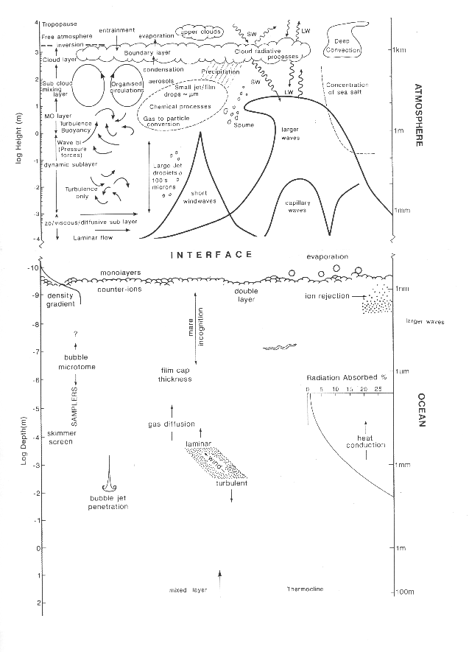

FIGURE 3 - The continental sources and atmospheric processing of iron and its relationship to marine biogeochemistry

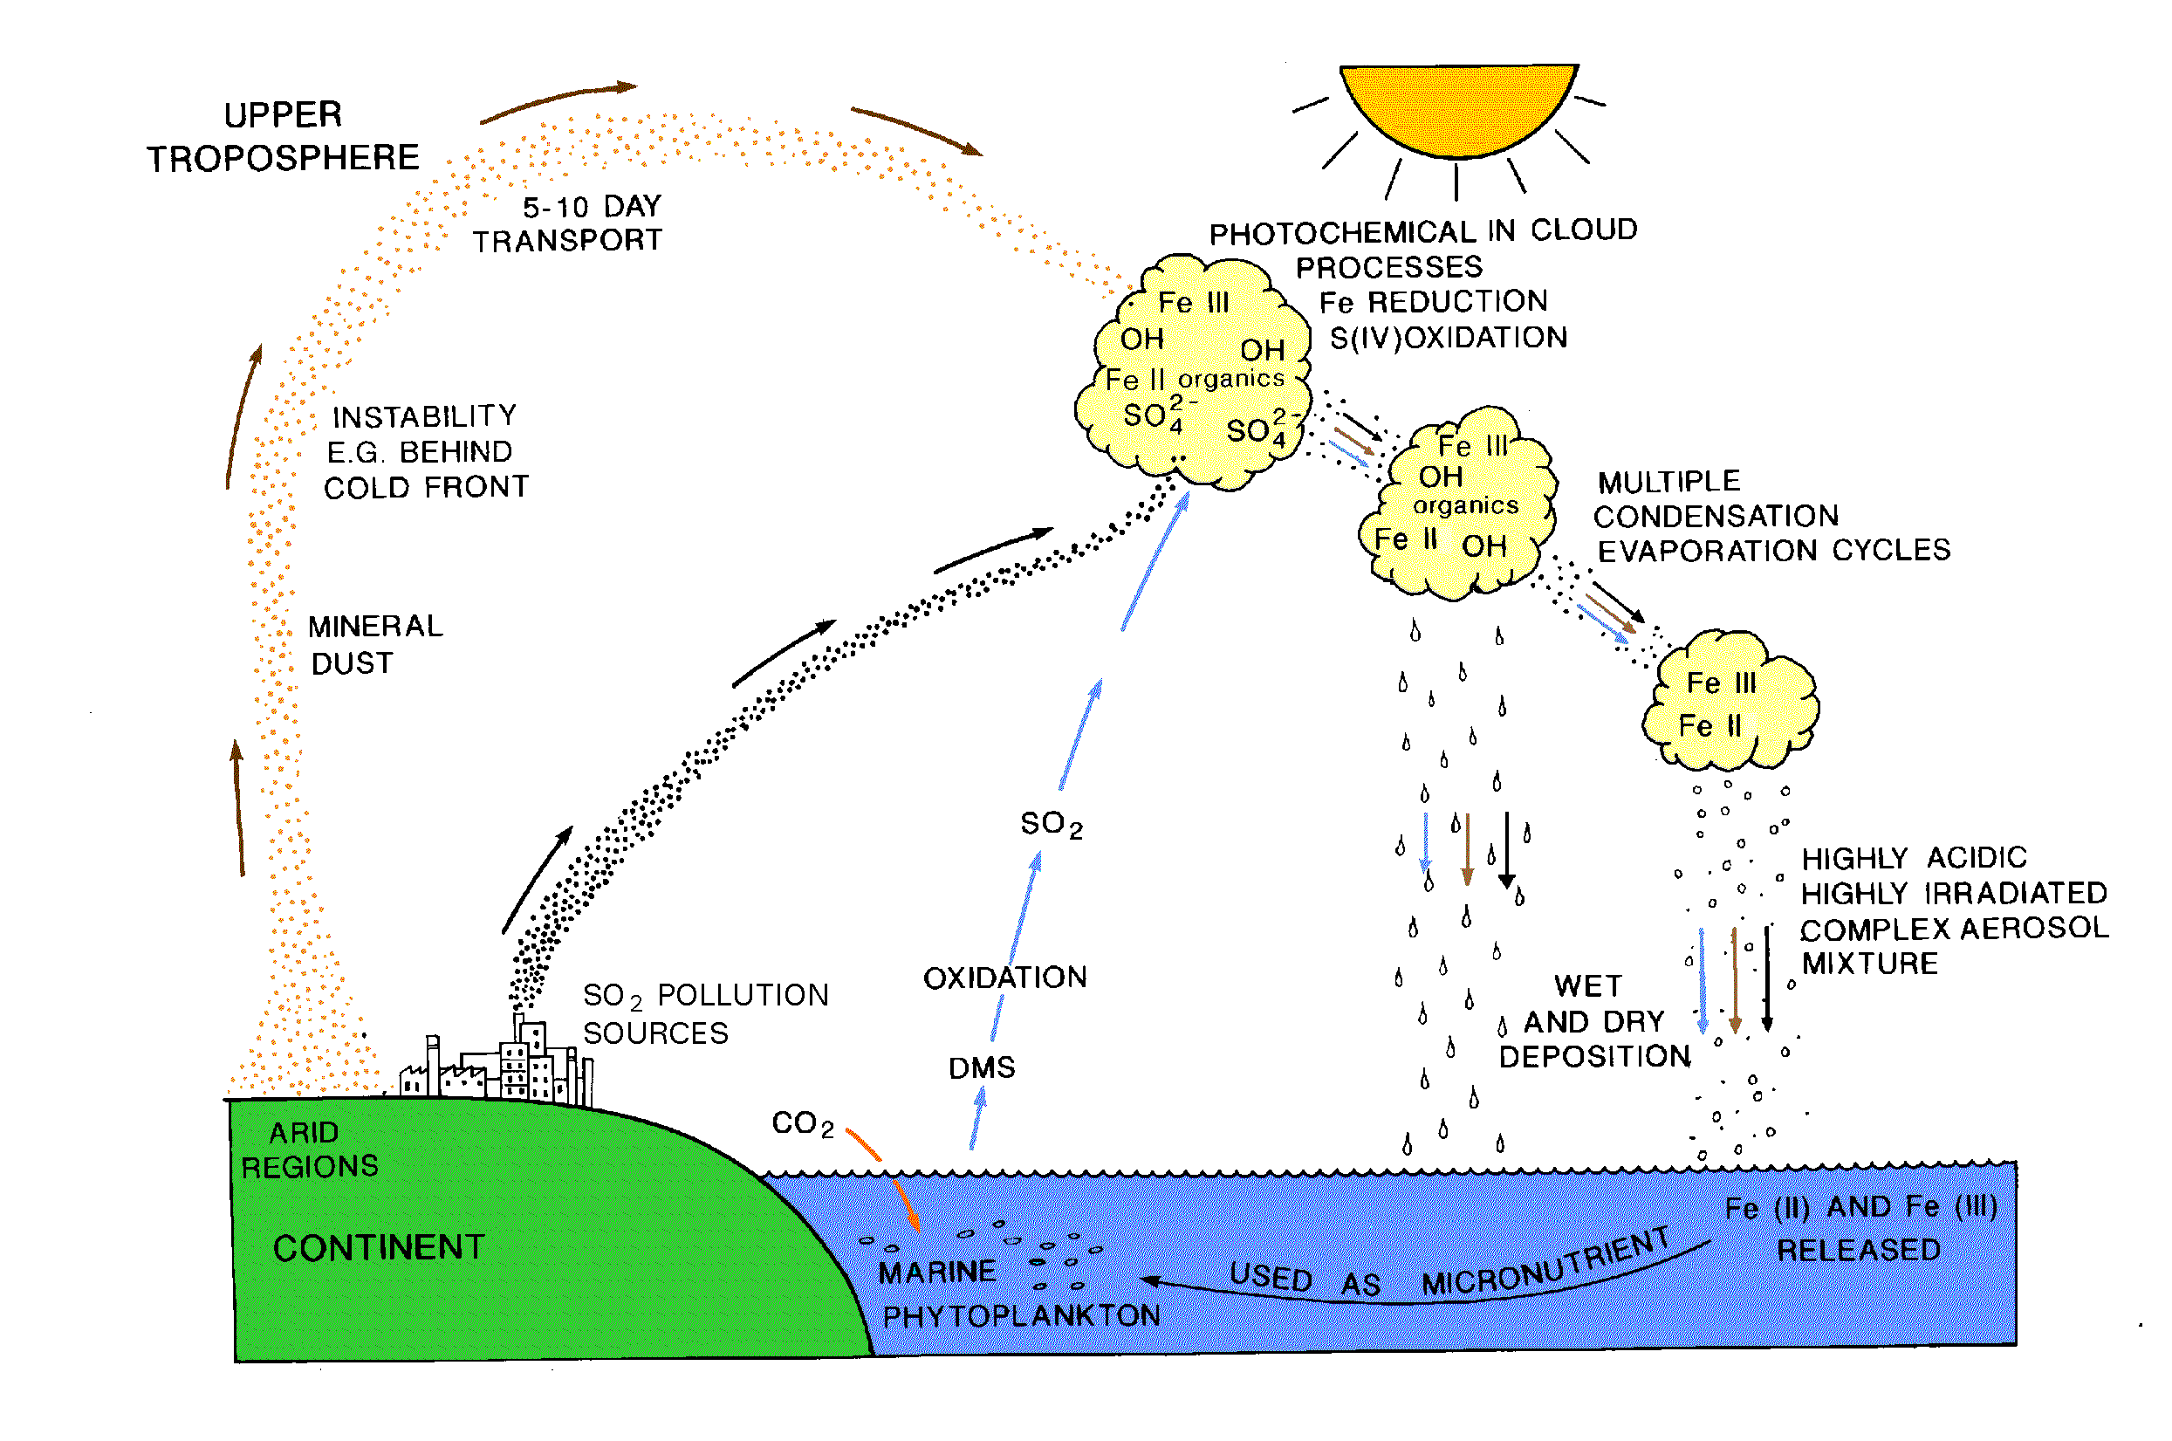

Linkages to Related Programmes and Activities
7

SOLAS development is presently sponsored by IGBP, SCOR and CACGP, with support from WCRP. Within the other activities these bodies sponsor the direct linkages for SOLAS are with IGAC and JGOFS (and any successor projects concerned with biogeochemistry of the atmospheric and oceanic reservoirs), GLOBEC, LOICZ, PAGES, GAIM and CLIVAR; its efforts will be well coordinated and, wherever appropriate, integrated with them. There is considerable potential for integration between SOLAS and the WCRP/SCOR Working Group on Air-Sea Fluxes. For remote sensing and observing systems SOLAS will work closely with CEOS, GOOS and GCOS. SOLAS will rely heavily on research in LOICZ and PAGES for input to its studies in coastal zones and the use of palaeo records. Societal impacts of SOLAS will be dealt with in collaboration with the IHDP. Some of these relationships between SOLAS and other programmes and activities are shown in Figure 4.

FIGURE 4 - Relationships between SOLAS and other programmes

SOLAS and the Global Carbon Cycle

SOLAS cannot address all issues related to the ocean’s present and future role in the global carbon cycle. Rather it will address an important subset of carbon-cycle issues that are compatible with its overall goals, domain and technical approaches. These topics can be summarised as:

- Quantification of the present-day exchange of CO₂ and carbon-related properties between the atmosphere and the surface ocean.
- Understanding of surface layer processes that can change the future air-sea flux of CO₂ with potential implications for altered sequestration of carbon within the ocean.

The emphasis within SOLAS will therefore be on providing a description of the contemporary geographical and temporal structure and variation of air-sea CO₂ flux, as well as mechanistic understanding of surface layer processes that determine this flux both now and in the future. These limited SOLAS objectives will provide a foundation for broader global carbon cycle science activities, particularly for the evaluation of, and parameterisation of processes in, the models required to predict future ocean carbon sequestration.

The Structure of the SOLAS Science Plan

SOLAS consists of 3 foci, shown in Figure 5. Under each focus there are several activities. In the main part of the Plan, the activities are stated as hypotheses. They are worded in the positive sense but, like all scientific hypotheses, are subject to disproof. Thus the outcome of research to test the SOLAS hypotheses may lead to their refutation or confirmation. Finally, a number of issues common to many of the activities of SOLAS are outlined.
9
FIGURE 5 - The structure of SOLAS

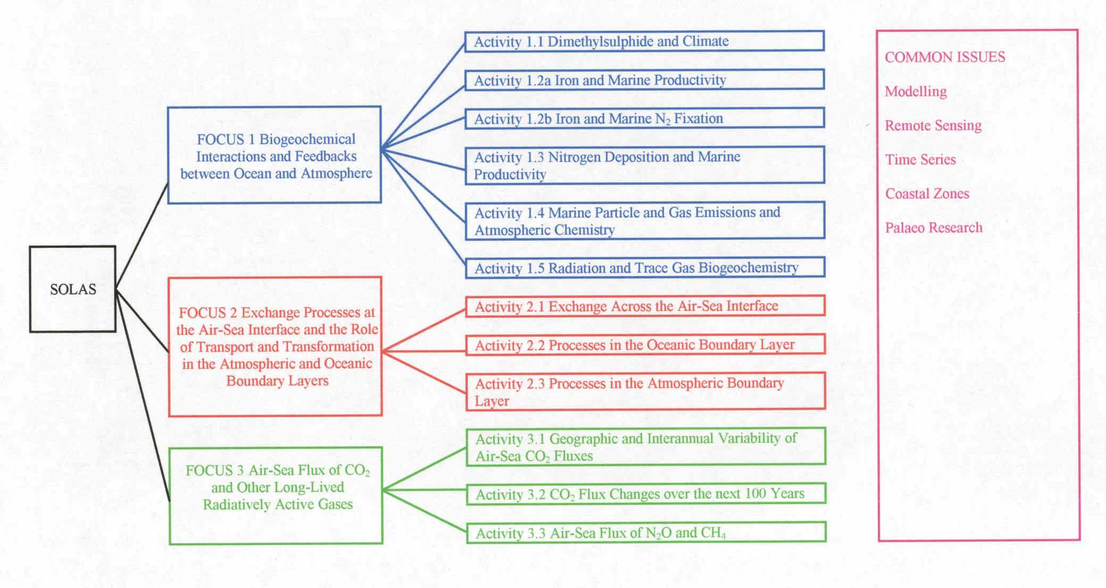

FOCUS 1 - Biogeochemical Interactions and Feedbacks Between Ocean and Atmosphere

The objective in Focus 1 is to quantify feedback mechanisms involving biogeochemical coupling across the air-sea interface, which can only be achieved by studying the ocean and atmosphere in concert. These couplings include emissions of trace gases and particles of importance in atmospheric chemistry and climate, deposition of nutrients that control marine biological activity and carbon uptake, and the production of chemically-active particles by bubble bursting.

Climate and environmental change will have significant impacts and feedbacks on biogeochemical cycling in the ocean, on atmospheric chemistry, and on chemical exchange between the ocean and atmosphere. For example, changes in climate may result in alterations in the distribution patterns of phytoplankton and associated dimethylsulphide (DMS) production and release to the atmosphere. Subsequent oxidation of DMS to sulphate aerosol in the atmosphere will affect cloud albedo and thus climate. Changes in climate can also lead to alteration in the quantity and delivery pattern of mineral aerosol and its associated nutrient iron to the ocean. In regions where iron limits primary productivity, alteration in food web structure is likely, as are changes in the release of a number of biogases from the ocean. The changes in delivery of iron to the ocean are also likely to alter nitrogen fixation by cyanobacteria, and the subsequent export of this nitrogen to the deep ocean may change the deep ocean nitrogen reservoir. Similar atmospheric inputs of different forms of nitrogen to the ocean as a result in increasing population and industrialisation will lead to increased eutrophication of coastal regions and some productivity increases and food web alterations in oligotrophic ocean areas. Climate change can also lead to changes in the fluxes of reactive particles and gases from the ocean to the atmosphere. Sea-salt particles can release gases and provide surfaces for heterogeneous chemical reactions. Many of the marine biogases are photochemically active, and changes in their emissions can lead to changes in the radiative environment, chemical cycles, acidity and oxidation capacity of the atmosphere. Finally, changes in the spectral quality and intensity of radiation in the atmosphere and ocean as a result of ozone depletion and climate-driven changes in mixed layer depth can have significant impacts on photochemical processes and cloud cover in the atmosphere and can lead to alteration of physiology and community structure as well as photochemical processes in the marine photic zone. These complex and interdependent processes can only be addressed by studying both the ocean and atmosphere and their interactions in a series of joint and coordinated efforts.

Activity 1.1 - Dimethylsulphide and Climate

Changes in dimethylsulphide (DMS) production by marine phytoplankton will have a substantial effect on climate by modifying aerosols and cloud albedo. Marine algae that produce DMS participate in a feedback loop that has the potential to stabilise climate by controlling aerosol and cloud properties. The complexity of this system makes it very hard to test as a whole, so the individual processes need to be quantified.

Introduction

In 1987 our understanding of the importance of air-sea exchange in regulating climate was dramatically changed by the publication of the CLAW hypothesis (Charlson et al., 1987, as illustrated in Figure 6). This landmark paper postulated a feedback loop involving marine phytoplankton, sulphate aerosol formation, and cloud albedo, that might stabilise the Earth’s temperature. An increase in phytoplankton would cause an increase in DMS emissions to the atmosphere and raise atmospheric DMS concentrations, thereby increasing the rate at which sulphate aerosol (non sea-salt sulphate - NSS) is formed. If this also increased the number concentration of cloud condensation nuclei (CCN), it should make clouds whiter, reflecting more sunlight back to space and cooling the Earth. Understanding this highly-coupled ocean/atmosphere system through interdisciplinary research is one of the important objectives of SOLAS.

State of Present Understanding

While some of the CLAW linkages have been demonstrated (NSS and cloudiness at Cape Grim correlate with sea water DMS, for instance), these steps have not been quantified well enough to determine whether the CLAW feedback actually exists. The palaeo record is one of the few means for testing this overall scheme, but it has yet to produce a definitive answer (Legrand et al., 1991; Saltzman et al., 1997). In addition, the role of sea-salt particles as a source of CCN is largely unknown, and it has been suggested that the concentration of sea salt was underestimated in the original CLAW paper (Blanchard and Cipriano, 1987).

Process studies in algal blooms have established a general linkage between phytoplankton and DMS levels, but they have not quantified the natural variability in DMS concentrations, especially in large oligotrophic areas. While it is clear that some taxonomic groups typically contain orders of magnitude more of the DMS precursor dimethylsulphoniopropionate (DMSP) than others, the reasons for this are not well understood. Changes in UV-B radiation that depend upon column ozone levels in the atmosphere can also affect DMS production.

The emission of DMS to the atmosphere depends on wind speed, temperature, sea water DMS concentrations, and possibly other factors that are not well understood. The two most frequently used models for estimating DMS fluxes can differ by up to a factor of two (Nightingale et al., 2000).
FIGURE 6 - Mechanism by which marine algae may influence sulphate aerosol concentrations and the albedo of clouds, possibly feeding back to stabilise climate (Andreae, 1990 after Charlson et al., 1987)

The atmospheric chemistry of DMS is still poorly known. It is clear that OH reacts with DMS by both OH addition and hydrogen-abstraction pathways, and that SO₂ and MSA are among the major products. The relative amounts reacting by each mechanism are believed to be a function of temperature, which may explain the different product distributions observed in polar and equatorial regions. However, neither laboratory nor field experiments have yet been able to quantify rate constants for the entire suite of reactions that follow OH attack (Davis et al., 1999). It is also known that NO₃ and halogen radicals can react with DMS, but the importance of these mechanisms is even less well known.

Some fraction of the DMS is oxidised homogeneously by OH (the only pathway that can cause the nucleation of new particles), while the rest may be dry deposited back to the ocean’s surface, oxidised on existing particles in clouds, or oxidised on short-lived sea salt particles. Changes may be counter-intuitive; if conditions that create higher DMS concentrations are accompanied by higher winds (and thus more airborne sea salt to consume SO₂), it is possible that less sulphate aerosol will be formed. Or, as many global-change scenarios now assume, higher winds may mean more atmospheric DMS and more NSS aerosol.

The factors controlling homogeneous nucleation have been studied extensively since 1987, and significant progress has resulted. One scenario (Raes, 1995) suggests that new particles are primarily formed in the (largely particle-free) free-troposphere (FT), after which they are entrained into the marine boundary layer and grow by condensing the products of gas-phase DMS oxidation. However, measurements near Macquarie Island found growth rates of nanoparticles to be larger than sulphuric acid condensation could explain. Do condensable organics help embryo particles grow large enough to nucleate cloud droplets?

The relationship between particle number concentration (CN, or condensation nuclei) and cloud droplet number concentration (CDN) is also poorly known. The CLAW authors postulated an increase in CCN (cloud condensation nuclei, a subset of activatable CN), but thousands of observations have failed to establish a precise relationship between CCN and CDN (Chuang et al., 1999). In part this is due to our inability to specify updraft velocities in clouds, but there are more serious problems: cloud-chamber type CCN instruments may not mimic the kinetics of activation in clouds, a cloud’s condensable water supply, or the impact of soluble gases (e.g., HNO₃, MSA, organic acids), all of which play critical roles in activation of particles to cloud droplets. This may explain why the range of observed CDN/CCN ratios spans more than an order of magnitude.

Finally, while it is well-established that clouds with more particles have a higher albedo, the optical impact of various types of clouds is still poorly constrained. Higher droplet concentrations may also change the lifetime and extent of clouds, by reducing precipitation. The existence of “anomalous absorption” in clouds is another issue that limits our ability to predict cloud albedo and its dependence on aerosols. What would the impact of these cloud changes be on phytoplankton and photochemical processes? This is the final link that closes the hypothesised CLAW feedback loop.

Major Issues That Require Resolution

 What controls the seawater concentration of DMS? Quantification is needed both for the interactions of the various types of plankton and DMS cycling and loss by biological and abiotic processes in the surface ocean, which control DMS concentrations and limit the amount of DMS that can be emitted to the atmosphere.

 How might the flux of DMS to the atmosphere vary with changing chemical and physical conditions? The factors that control the sea to air flux of DMS are known only to about a factor of two.

 What fraction of atmospheric DMS will eventually form SO₂, MSA and sulphate aerosol and what are the relative rates of their homogeneous and heterogeneous loss processes? It is particularly important to know the absolute amount and size distribution of NSS formed from SO₂.

 Will the formation of more NSS lead to the higher particle number concentrations that the CLAW hypothesis says will change cloud properties? We are far from a quantitative understanding of the relationship between sulphate formation and particle number concentration.

 What are the relationships between CN, CCN and CDN concentrations? Our current uncertainty in these relationships is at least an order of magnitude.

 What is the net radiative impact of a change in CDN? An increase in CDN may both decrease droplet size and extend cloud lifetime.

Promising Approaches

The CLAW hypothesis has directed our thinking about the importance of air-sea exchange in controlling climate for more than a decade. Progress in quantifying this potential feedback loop has been limited to a large extent by the lack of programmes enabling us to make simultaneous, integrated measurements of the many parts of the system. While it is possible to study each of the individual CLAW processes in isolation, it is not scientifically sensible to do so. The DMS flux measurements that are needed for studying atmospheric sulphur chemistry are also needed to study the processing and loss of DMS from sea water. Integrated studies of both the marine and atmospheric processes are therefore more economical and – perhaps more importantly - they allow one to confirm relationships that extend beyond either medium. For example, as a phytoplankton bloom evolves or wind speed changes, does this produce the expected changes in atmospheric DMS concentrations, sulphate aerosol concentrations, and cloud albedo?

Coupled marine biological and chemical transport models are essential tools for predicting regional and global DMS fluxes and their effects on climate. Simultaneous observations from both air and water are essential to support model tests of the feedbacks in this complex set of processes. A fundamental principal of SOLAS is that the oceanic and atmospheric disciplines should be working side-by-side to address such critical issues. For example, lagrangian studies of atmospheric sulphur species could benefit from experience gained in such experiments in the ocean using SF₆ labelled patches of water.

Predicting sea water DMS concentrations requires models of DMS-plankton relationships, which are still in their infancy due to the lack of integrated process understanding, including the interactions between phyto-, zoo-, bacterio-, and viro-plankton and the impacts of temperature, nutrient supply, light, and other (potentially-changing) environmental factors (Liss et al., 1997). Both laboratory and field studies in a variety of environments, and using lagrangian approaches involving patches of water marked with SF₆, are needed to support the development of adequate models. Detailed research on the mechanisms of sea-air exchange (the objective of Focus 2) is critical for improving the calculation of DMS fluxes to the atmosphere.

We need both laboratory kinetic work and extremely precise time-series measurements of the whole suite of atmospheric sulphur species, oxidants, intermediates, and products to quantify the processes by which some fraction of atmospheric DMS is converted to sulphate aerosol. Since many state-of-the-art instruments cannot be run in a monitoring mode, process studies are required in the simplest possible equatorial and polar regions. (“Simple” here implies both the absence of nearby anthropogenic sulphur sources and understandable boundary layer dynamics.) While models will be essential for integrating the observations, existing marine sulphur models contain so many unverified assumptions that modeling alone is unlikely to improve our understanding.

Process studies that are directed at quantifying all possible loss processes for SO₂ are critical. We need to close the sulphur budget in Lagrangian experiments (Huebert and Lenschow, 1999) that involve direct measurements of both DMS and SO₂ surface fluxes, so that we have as few unconstrained variables as possible. Doing these experiments under a variety of wind and cloud conditions will help us quantify heterogeneous loss to sea salt particles and cloud droplets. Lagrangian microphysical studies of particle formation and growth in simple environments are also needed to resolve the relationship between sulphate formation and particle number.

Extensive laboratory and field work is required to resolve the relationship between aerosol number concentrations and cloud droplet number concentrations before we can confidently model the change in CDN that will accompany a change in particle number. Focused in situ microphysical, optical, and remote satellite measurements will be needed to quantify the impact on the net radiation budget of a change in CDN. Intensive studies of natural (e.g., volcanic plumes or smoke from large fires) or intentional perturbations could help to achieve process understanding by generating data sets that can constrain our integrated models of the SO₂-to-albedo parts of this system.

Activity 1.2a - Iron and Marine Productivity

Natural and anthropogenic changes in climate and global biogeochemistry will alter the chemical character, delivery pattern and quantity of aerosols containing iron and other essential trace metals entering the oceans from the atmosphere. This may cause changes in planktonic productivity and food web structure, which, in turn, can alter carbon partitioning between atmosphere and ocean and biogas fluxes from the ocean.

Introduction

One of the most significant recent advances in oceanography was the experimental demonstration of the importance of iron supply in regulating key biogeochemical interactions and feedbacks between the ocean and atmosphere, together with the recognition that a primary transport path for iron found in the ocean is through atmospheric mineral aerosol (dust). The limiting role of iron for many classes of pelagic organisms is at first glance surprising because iron is one of the most abundant elements in the earth’s crust. However, the oxidation conditions of upper ocean seawater and the inorganic chemistry of iron result in rapid precipitation of iron, making it the rarest of the major crustal elements dissolved in surface seawater (Johnson et al., 1997). Recognition of the scarcity of iron and evaluation of its sources was dependent on advances in both analytical marine iron chemistry (Landing and Bruland, 1987) and early global syntheses of eolian dust and iron deposition rates (Duce and Tindale, 1991).

State of Present Understanding

Iron from terrestrial sources can play a role in biological activity in all pelagic regions of the world’s ocean. However, in high nutrient, low chlorophyll (HNLC) regions, such as the northeast Pacific, the equatorial Pacific and the Southern Ocean, iron availability can be the major factor regulating primary productivity (de Baar and Boyd, 2000). It is also possible that other trace metals, such as Mn, Co, and Zn, may be limiting under some circumstances in some regions. The pattern and magnitude of delivery of the dust containing the iron varies dramatically with season, vegetation and soil aridity in the source area (Mahowald et al., 1999). It also depends on natural climate variability and human land disturbance. In general, the highest atmospheric concentrations of dust over marine areas are found over the tropical North Atlantic, the northern Indian Ocean including the Arabian Sea, and the western North Pacific (Duce et al., 1991).

Accurate measurement and even estimation of dust deposition to the ocean is very difficult. Recent work suggests that using surface water dissolved aluminium is an indirect means of estimating dust deposition to the remote ocean (Measures and Vink, 2000). From a number of studies it is now clear that the major fraction of dust deposition to the ocean takes place in the Northern Hemisphere. The total input of iron to the oceans from the atmosphere has been estimated at between 15 and 100 Tg yr⁻¹. Although this may appear to be a substantial quantity, it is distributed very unevenly , with lowest deposition to ocean regions remote from land, which approximately correspond to the HLNC areas. Further, apparently only a small fraction (perhaps 0.8-2.1%, Jickells and Spokes, 2001) of the amount of iron entering is soluble in seawater. The iron is primarily bound in the aluminosilicate matrix of the mineral aerosol, and the deposited iron must be in a form, or must be transformable in the upper water column to a form, that can be utilised by the primary producers. Some studies have observed soluble Fe (II) in aerosols, and its formation is postulated to occur via photochemical reduction of Fe (III) hydroxides, probably involving organic matter, but details of the chemistry and photochemistry of iron in aerosols and cloud droplets is minimal to date (Jickells and Spokes, 2001). High ionic strength solutions, possibly low pH solutions, and alternating wet and dry cycles during cloud formation and evaporation would be common, thereby enhancing the solubilisation of iron. In addition, changes in halogen radical chemistry could alter the oxidative capacity of the marine boundary layer, thus influencing the speciation of iron. However, almost nothing is known about the fraction of iron in aerosols that dissolves when it is deposited on the surface ocean.

We currently know relatively little about the fate of dissolved iron in the surface ocean. While insoluble oxide/hydroxide-containing particles likely form with Fe(III), they may not sink rapidly out of the euphotic zone. Some iron is likely scavenged by pre-existing surfaces such as phytoplankton. The remaining dissolved iron can be measured and is found to occur in the pico- to nano-mol concentration range. These extremely low levels explain why iron can be a limiting nutrient for microorganisms (both bacteria and phytoplankton). Of the measurable iron in seawater, >99% is organically complexed with the natural organic ligands which are part of the dissolved organic material in the oceans (Rue and Bruland, 1997). However, we know little about the chemical form, sources or sinks of the ligands (Lefevre and Watson, 1999). Boye and van den Berg (2000) found that when iron was added to iron-depleted waters, Fe-binding ligands were released by Emiliania huxleyi. Various ideas have been proposed for how microorganisms acquire the iron they need, including production of cell surface-bound siderophores and photochemical production of Fe(II), both of which would enhance iron transport into the organisms (Wells et al., 1994). The ground-breaking Fast Repetition Rate Fluorometer (FRRF) analyses made in the IronEx1 and 2 studies have established that the ambient pico- and nanoplankton adjust their photochemical efficiency to iron availability within hours (Kolber et al., 1994). This line of analysis needs to continue focusing particularly on the response of individual cells and particular functional groups of phytoplankton.

In situ iron addition experiments in two of the HNLC regions have found that 1) the productivity of all of the ambient phytoplankton, including pico- and nanoplankton, was significantly increased (Martin et al., 1994), and 2) food web structure was altered significantly by an increase in the accumulation of large diatoms (Coale et al., 1996). It is the accumulation of a high biomass of these large (greater than 5μm) potentially fast-sinking phytoplankton that has the ability to draw down the mixed layer pCO₂ and, hence, alter ocean-atmosphere partitioning of carbon. Results from a purposeful iron enrichment experiment in the equatorial Pacific are shown in Figure 7. A traverse across the Fe-enriched area clearly shows the elevated SF₆, fluorescence and DMS, and corresponding drawdown of pCO₂ and nitrate within the patch.

While these pioneering iron addition experiments as well as water column analyses in HNLC regions have confirmed the low iron availability and iron impacts on productivity and food web structure, they have not probed deeply into the altered biogeochemical interactions and feedbacks, particularly exchanges with the atmosphere. However, three critical points have been well established: 1) variations in the magnitude and pattern of iron delivery have the potential to change the absolute level of primary productivity and the structure of the pelagic food web; 2) added iron results in CO₂ drawdown; 3) certain kinds of phytoplankton, such as coccolithophorids, are efficient producers of climatically active biogases such as dimethyl sulphide, resulting in important feedbacks relating to atmospheric chemistry and climate (see Focus 1, Activity 1.1). Recent modelling efforts have led to significant new insights into iron supply, cycling and demand in the ocean (e.g., see Fung et al., 2000; Archer and Johnson, 2000), but many biogeochemical issues remain unresolved.

FIGURE 7 - Traverse across iron enriched patch in FeEX II (compilation of results from various authors)
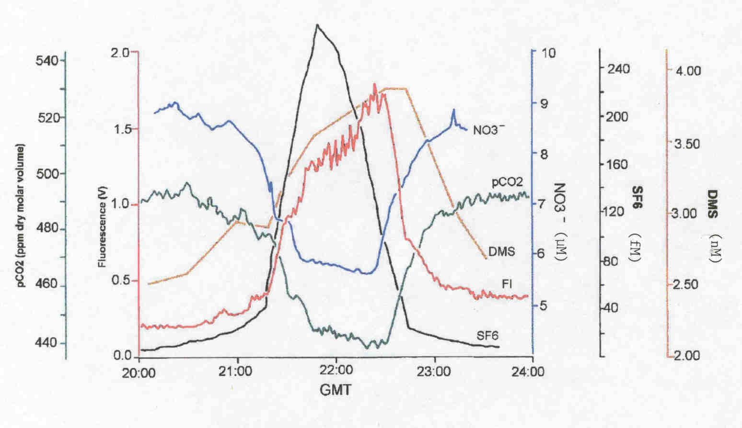

From the historical ice record, significant increases in dust delivery to the ocean took place during the last glacial maximum, and this appears to be correlated with reduced atmospheric CO₂ (Broecker and Henderson, 1998), enhanced concentration of atmospheric sulphur species, and increased ocean productivity (as measured by TOC and biomarkers in marine sediments); as shown in Figure 8 (Turner et al., 1996). It is expected that future changes in the global wind field will alter soil moisture, particle size and emission flux of mineral aerosols, and changes in desert areas will also affect the emission of dust. Future climate change would be expected to alter the deposition of atmospheric iron to the ocean, leading to significant changes of the types outlined above.
FIGURE 8 - Changes in various ice core and marine sediment parameters between the Holocene and the end of the last ice age (Turner et al., 1996). a) δ¹⁸O (a temperature proxy), Fe and MSA (an atmospheric oxidation product of DMS) from Antarctic ice cores. b) CO₂ from the Vostok ice core; TOC (total organic carbon), alkenones and dinosterol (proxies for
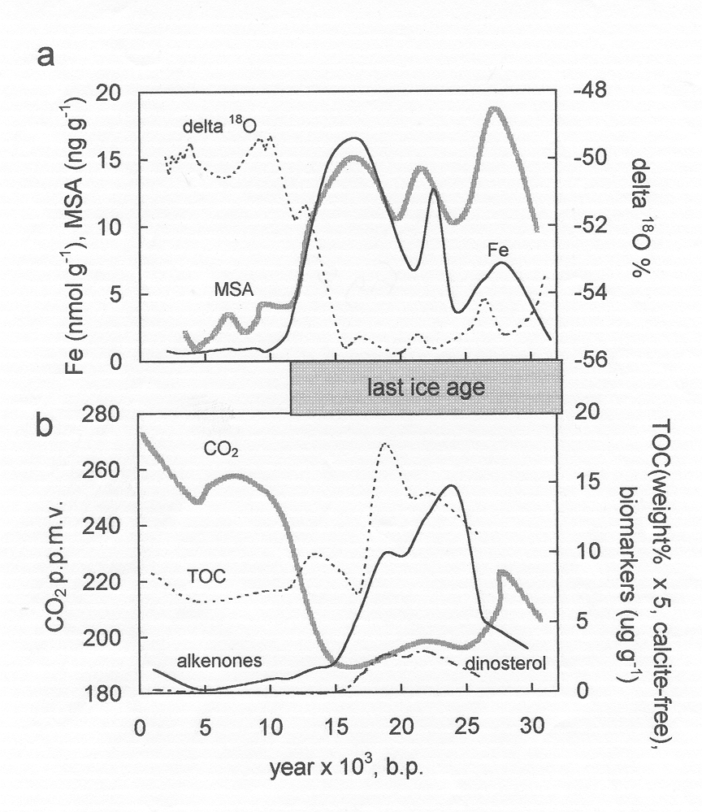
surface ocean productivity) in a sediment core from the eastern tropical Pacific

Major Issues That Require Resolution

 What is the temporal and spatial variability of the atmospheric fluxes of iron to the ocean, the chemical form of atmospheric iron delivered to the ocean, and the chemical reactions involving iron that take place in the aerosol particles and cloud droplets (e.g., photoreduction of Fe(III))? Understanding these is critical in determining the global importance of iron deposition to the ocean and its impact on oceanic biological systems.

 How would anthropogenic and natural changes in climate affect the atmospheric amount, distribution, and flux to the ocean of mineral aerosol, and thus iron? While changes in wind strength would affect the quantity of atmospheric sea salt, the effect of this as well as chlorine phase partitioning on the pH of aerosol particles and cloud droplets and thus the speciation of iron in the particles, are unknown (see Focus 1, Activity 1.4).

 What is the effect of changes in the concentration of such acidic species as nitric and sulphuric acids over the oceans on the solubilisation and speciation of atmospheric iron? These species may well increase in the future, both from anthropogenic and natural processes.

 What is the chemistry and biochemistry of iron in seawater and how it is taken up by microorganisms? How organisms satisfy their iron requirements in the face of the extremely low external concentrations of available iron must be understood before we can determine what controls marine primary production and the concomitant formation of biogeochemically important trace gases.

 What is the basic molecular biology, biochemistry and photophysiology of the uptake of iron? The fundamental process that initially responds to an increased supply of iron is hypothesised to be the quantum yield of photosynthesis (Lindley and Barber, 1998).

 How are large diatoms added to the ambient assemblage when iron is added? Understanding the reduced grazing vulnerability and/or the temperature-dependent reproductive lag in mesozooplankton and the differential photochemical efficiency and species growth rate responses of diatoms are fundamental to understanding the biogeochemical response to iron deposition.

Promising Approaches

Controlled laboratory studies, conducted both on land and at sea and involving interdisciplinary approaches can provide valuable information on the chemistry and biochemistry of iron in seawater and how it is taken up by microorganisms. However, the upper ocean inorganic and bio-inorganic chemical processes, as well as the biological responses to iron deposition, are exceedingly complex and very difficult to recreate under controlled laboratory conditions. In contrast, natural or experimental in situ iron (or dust) addition experiments realistically reproduce the target chemical and biological interactions and feedbacks, but in situ work presents logistical, as well as scientific, difficulties. However, the international biogeochemical research community has gained considerable experience with in situ experiments (Martin et al., 1994; Coale et al., 1996; Boyd et al., 2000). So much experience has been gained that SOLAS believes that in situ simulated iron deposition experiments can become the research community’s method of choice for investigating the biogeochemical consequences of varying iron availability.

Natural in situ iron deposition experiments (Young et al., 1991) may turn out to be less logistically demanding than purposeful addition approaches. In the spring of 2000 a series of exceedingly large Sahelian dust clouds were transported off North Africa, turned north and deposited thick layers of iron-rich dust as far away as Southampton in the U.K. The origin and progress of these dust events were tracked hourly by satellite (Prospero, 2000) (see cover of this Science Plan). This dramatic event passed directly over the Canary Islands. SOLAS time series research efforts based on these or other downwind islands would provide a de facto natural in situ iron deposition experiment, as would investigations of water column input of iron downstream from islands or certain continental shelf regions. Atmospheric and oceanic time series in general will be extremely useful ways to investigate these phenomena, as will transects along atmospheric and/or water column iron input gradients.

Activity 1.2b - Iron and Marine N₂ Fixation

In tropical oligotrophic ocean regions, increased aeolian iron deposition or subtle changes in mixed layer physics as a result of climate or environmental change will increase nitrogen fixation by cyanobacteria. Export of this newly fixed nitrogen to the deep ocean will increase the absolute magnitude of the deep ocean nitrogen reservoir on the decade to century time scale.

Introduction

The relative influences of phosphorus and nitrogen on oceanic primary productivity has been a controversial topic in oceanography for many years (Tyrrell, 1999). Historically, it was believed that the ultimate limitation to ocean productivity and, hence, the capacity of the ocean to take up atmospheric CO₂, was regulated by the rate at which phosphate-phosphorus dissolves from the earth’s crust. According to this geochemical dogma, phosphorus availability regulates the global rate of nitrogen fixation in the ocean (Redfield, 1958). Contemporary oceanographers challenge this idea, arguing instead that iron availability globally limits nitrogen fixation, preventing the ultimate phosphorus limitation from being realised (Falkowski et al., 1998). This controversy has important consequences for understanding the ocean’s past and future roles in regulating the concentration of atmospheric CO₂. The relative roles of phosphorus, iron, and mixed layer physics in the regulation of large scale nitrogen fixation in the tropical ocean and the feedbacks between these factors are some of the major unresolved issues in earth system science

The point is that increasing the absolute magnitude of the nitrate-nitrogen global reservoir is the most certain means of increasing the proportion of the atmospheric CO₂ that is sequestered in the ocean. An increase in the global nitrate inventory will increase the ratio of nitrogen to inorganic C in the water mixed or upwelled to the surface. When the N:C ratio is increased, the potential uptake of carbon exceeds the outgasing; therefore, each mixing or upwelling cycle will increase the downward partitioning of carbon. Thus, it is essential to have a quantitative understanding of the processes determining the magnitude of the deep-ocean reservoir of fixed-N.

State of Present Understanding

Recently several lines of evidence have suggested that nitrogen fixation in both the tropical Atlantic and Pacific has increased in the past two decades. In the North Pacific large-scale, low frequency physical changes in the mixed layer have been proposed as the causal mechanism (Karl, 1999), while in ocean regions downwind of major dust generating sites, such as the tropical Atlantic and Caribbean, increased iron deposition by dust from the African Sahel is suspected of increasing nitrogen fixation rates (Falkowski et al., 1998). An explosion of information about the molecular biology, photophysiology and distribution of oceanic N-fixers is taking place, but regional and global estimates of nitrogen fixation are primarily model-based (Gruber and Sarmiento, 1997).

A discussion of the chemical character, delivery pattern, quantity and variability of eolian iron is given above under Activity 1.2a. All of the information regarding eolian iron in that section on productivity is equally pertinent to nitrogen fixation. The sole distinguishing issue regarding HNLC productivity versus nitrogen fixation in the oligotrophic ocean is the biological response to the deposition.

Major Issues That Require Resolution

 Will changes in N-fixation that appear to be taking place in the contemporary ocean alter the deep ocean reservoir on the time scale of decades to centuries? It may be that the iron/N-fixation/global N-inventory link is significant on only the millenium time scale, in which case it may be safely ignored by models intended to predict carbon cycle processes over the next 100 years.

 Over how large an area must N-fixation be increased to alter the deep ocean reservoir of N? This question is important because the size of the oceanic N reservoir is a key factor in determining how much CO₂ is taken up by the biological pump.

 Will increased iron deposition lead quickly to the P-limitation that geochemical dogma posits, but oceanographers rarely find? This is a critical unknown.

These issues must be resolved to increase the reality of carbon cycle models.

Promising Approaches

Of particular importance in this area is the design and planning of in situ enrichment experiments in a well-stratified, oligotrophic oceanic region remote from coastal influences and in an environment of low aeolian deposition. Ideally the experiment should include both Fe and possibly P enrichment and measurement of the full suite of SOLAS biological and chemical interactions and feedbacks. There would be mutual benefit if these and similar studies were to be conducted in close collaboration with JGOFS (and successor developments which may come out of the current study in to the Future of Ocean Biogeochemistry) and GLOBEC. The major tool to detect the response of N-fixers such as Trichodesmium will be remote-sensing with SeaWIFS and similar instruments.

Testing of physical controls on N-fixation cannot at present be done with an in situ experiment, but natural climate variation, especially at the seasonal and interannual scale, offers a wealth of natural experimental possibilities. The existing time-series studies in the subtropical gyres offer ideal venues for these natural experiments.

Activity 1.3 - Nitrogen Deposition and Marine Productivity

Increasing population, industrialisation and agricultural activities will increase the atmospheric deposition of a wide variety of fixed and organic nitrogen species to both the pelagic and coastal oceans. This will cause substantial increases in eutrophication of coastal regions, and modest productivity increases and food web alteration in oligotrophic pelagic regions.

Introduction

Significant quantities of nitrogen species are delivered from the land to the ocean via the atmosphere. Much of this atmospheric nitrogen is from human-derived sources (primarily the combustion of fuels and the utilisation of fertilisers), and it is subject to future changes, both in amount and geographical distribution, depending on population and industrial growth in various regions. Delivery of atmospheric nitrogen to coastal regions in Europe and North America is estimated to have increased from 50% to 200% during the past 50 years (Paerl, 1995), leading to considerable enhancement of the coastal eutrophication in addition to that caused by riverine outflow, direct wastewater discharge and stormwater runoff.

There is also growing concern about the increasing input of human-derived nitrogen species to regions of the pelagic ocean where nitrogen is the limiting nutrient, such as the subtropical gyres of the North and South Pacific. While estimates suggest that, at present, atmospheric nitrogen accounts for only a few percent of the annual new nitrogen delivered to surface waters in these regions, the atmospheric input to the ocean is highly episodic, often coming in large pulses extending over only a few days when it can potentially play a much more important role in its production.

State of Present Understanding

Atmospheric wet and dry deposition includes several familiar biologically-active inorganic nitrogen species (nitrate, nitrite, ammonium). In addition, the atmospheric organic nitrogen deposition may be equal to or perhaps greater than the inorganic nitrogen flux to the pelagic ocean (Cornell et al., 1995). The organic nitrogen is known to be biologically active, but its sources and chemical form are not known, although agricultural activities may play an important role in its production.

While we have a rudimentary understanding of the current atmospheric deposition patterns of inorganic nitrogen to the ocean, the primary locations and relative amounts of atmospheric nitrogen inputs to the ocean may change in the future. Galloway et al. (1995) have evaluated the near-current (1990) fixed nitrogen generated from human activities such as energy production (primarily as nitrogen oxides) and fertiliser use, and the estimated fixed nitrogen that will be produced in 2020 as a result of human activities. Developed regions of the world are predicted to show relatively little increase in the fixation of nitrogen over this time period, while rapidly developing areas will contribute very significantly to increased human-derived fixed nitrogen. For example, Asia is predicted to account for ~40% of the global increase from energy-derived fixed nitrogen and ~87% of that from fertiliser! Both energy sources (nitrogen oxides, and ultimately nitrate) and fertiliser (ammonia, urea) will drive this increase.

A modeling study of deposition by Galloway et al. (1994) developed maps of the recent (1980) and expected (2020) annual deposition of the oxidised forms of nitrogen, which includes nitrate, nitrite, and nitric acid derived from combustion processes, from the atmosphere to land and ocean surfaces. Figure 9 shows the projected ratio of the estimated deposition of oxidised nitrogen in 2020 to the values for 1980. From 1.5 to 3 times, and in some limited areas up to 4 times, the present rate of deposition will occur over large areas of the coastal and pelagic ocean, and this estimate does not include possible changes in reduced nitrogen and organic nitrogen fluxes. This leads to the possibility of regional biogeochemical impacts in the coastal and pelagic oceans.

FIGURE 9 - Ratio of the estimated deposition of oxidised forms of nitrogen to ocean and land surfaces in 2020 relative to 1980 (Adapted from Galloway et al., 1994 and Watson, 1997)
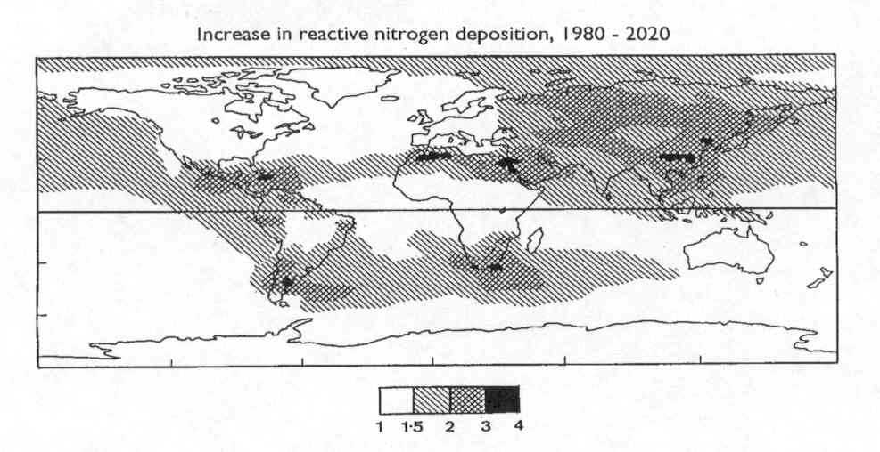

Society has set ambitious goals for reducing coastal eutrophication, but the management plans usually do not include consideration of atmospheric nitrogen deposition. Part of the reason why atmospheric nitrogen deposition is ignored in current management plans is the absence of rigorous demonstration that the additional nitrogen has deleterious impacts in these already eutrophic systems.

Of special concern in eutrophic coastal regions are increasing outbreaks and blooms of toxic phytoplankton and pathogenic bacteria, fungi and protozoans. Another alarming change in coastal waters is increased abundance of gelatinous organisms that displace the traditional crustacean grazer food webs (Mills, 1995). Eutrophic systems appear to undergo at some point late in the nutrient enrichment process a phase shift to a condition characteristic by the “invader” and gelatinous organisms.

Major Issues Requiring Resolution

 Is there a deleterious impact of atmospheric nitrogen deposition on the coastal environment? The answer to this would be a significant contribution to nearshore biogeochemistry and management of coastal inputs.

 Is the recent increase in atmospheric nitrogen deposition, as well as the coastal loading of specific organic nitrogen compounds of possible agricultural origin, involved in the increasingly common phase transitions in biological communities in eutrophic regions? By bringing to bear analytical chemistry, microbiology and conventional coastal oceanography these important basic questions about ecosystem stability and resiliency in the face of increased nutrient loading can be addressed.

 What are the impacts of changes in the geographical distribution and relative amounts of the input of atmospheric nitrogen species to oceanic oligotrophic regions on primary productivity and ecosystem structure? Responses that will need to be resolved include a) the absolute level of primary productivity; b) specific rates of photosynthesis, nutrient uptake and growth; c) species composition, diversity and resiliency to perturbation; d) production of climatically active biogases; and e) export of carbon from the upper ocean.

 What is the form, biological availability and source of the organic nitrogen entering the pelagic ocean? A significant fraction of the input of atmospheric nitrogen is apparently organically bound.

Promising Approaches

One promising research approach in a presently eutrophic coastal region could involve a series of in situ N-addition experiments similar to the successful iron addition studies. The biological response of coastal ecosystems in terms of productivity, species composition, diversity, export and yield of grazers as well as a number of biogeochemical interactions and feedbacks could be determined.

The question of the impacts on biogeochemical and ecosystem structure of episodic atmospheric nitrogen deposition in an oligotrophic pelagic region may also be addressed using the in situ nitrogen addition experimental approach. Many of the concerns and design considerations of an HNLC in situ iron addition experiment will apply to this offshore in situ nitrogen experiment. A variety of inorganic fixed nitrogen and organic nitrogen species would need to be used in these experiments. Perhaps the ideal venue for such nitrogen deposition experiments would be existing time series sites that are located in subtropical gyres. The time series projects have existing logistic infrastructure that could be deployed and the time series records would serve as excellent controls. The nitrogen deposition experiments will require much larger quantities of nitrogen to be delivered than the quantities of iron spread in the in situ iron experiments. A way round this problem may be to use mesocosm bags, which not only require less N, but also offer greater possibilities for replication of treated and control enclosures.
Activity 1.4 - Marine Particle and Gas Emissions and Atmospheric Chemistry

Changes in marine fluxes of particles and trace gases as a result of climate change will influence the radiative environment and atmospheric chemistry, including chemical cycles, acidity, and the oxidation capacity of the atmosphere.

Introduction

The oceans emit a large number of particles and gases to the atmosphere. Particles are significant for atmospheric chemistry in that they can release gases (e.g. volatile organic compounds, sulphur species, ammonia, or halogen species), provide surfaces for heterogeneous chemical reactions, and directly or indirectly change the atmospheric radiation field. Many of the gases emitted from the ocean are photochemically- and/or IR- active. Thus oceanic emissions can lead to considerable changes in the radiative environment, chemical cycles, acidity, and oxidation capacity of the atmosphere. The primary factors that control these emission are wind speed, temperature, aqueous photochemistry and biological activity, which itself is dependent on radiation- and nutrient inputs. Thus, a change in any of these factors would be expected to change emissions and their impact on the state of the atmosphere.

State of Present Understanding

Sea-salt particles are a major reactive medium in the marine boundary layer as well as a significant source of atmospheric alkalinity, organic material and precursors for volatile reactive halogens. The production of several classes of compounds (particularly the reactive halogen gases) discussed in this and other sections as well as the chemical processing and deposition of important sulphur and nitrogen species are directly tied to sea-salt cycling. Sea salt is also an important source of condensation nuclei and thus can change cloud properties including radiation effects of clouds. As a consequence sea salt can directly or indirectly lead to effective scattering of incident radiation in the marine boundary layer. Because the flux of sea-salt particles from the ocean is exponentially related to wind velocity, climatically driven changes in global wind fields will significantly alter concentrations and lifetimes of atmospheric sea salt, its associated reactant and product species, and their effects on radiative transfer.

Reactive halogens compounds (Cl, Br, and I) play major roles in the photochemical processing of air in the MBL in some, and perhaps most, marine regions. The emission of marine biogenic halogens - in particular CH₃Cl and CH₃Br - contribute to the halogen budgets of both the stratosphere and the troposphere. In addition, shorter-lived organic and inorganic halogen compounds are either emitted directly from the oceans (e.g., CH₂Br₂, CHBr₃, CH₃I), produced indirectly via photochemical transformation of precursor species, or made by chemical processes involving sea salt aerosol in the marine boundary layer (e.g., HCl, HBr, Br₂, BrCl, Cl₂, BrO, ClO, IO) (Platt and Moortgat, 1999). Heterogeneous reactions are also apparently involved in the release of reactive halogenated species (e.g., the ‘Bromine Explosion’, Wennberg, 1999).

These compounds can contribute to O₃ destruction in the troposphere. The impact of reactive halogen species such as atomic Br and BrO on tropospheric ozone is exemplified by the polar ‘Tropospheric Ozone Holes’ which occur during springtime in the Arctic and Antarctic boundary layers (e.g. Barrie and Platt 1997) (Figure 10). It is evident that halogens change FIGURE 10 - Satellite (Global Ozone Monitoring Experiment, GOME on ERS-2) observations of tropospheric BrO – ‘Clouds’ in the Arctic and Antarctica (Wagner et al., 2000). Total BrO column densities in the centre of the clouds exceed 10¹⁴ BrO molecules/cm³. The clouds are associated with total loss of boundary layer ozone, occur only in springtime, and have a typical lifetime of one- to a few days

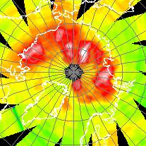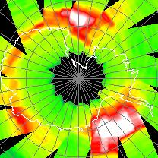
Arctic, 20.04.1997 | Antarctic, 18.09.1997
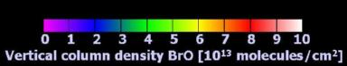

greenhouse forcing both directly (through the IR absorption of ozone) and indirectly via the change in the tropospheric oxidation capacity, which controls the lifetimes and atmospheric abundances of greenhouse gases such as CH₄ and H-CFCs.

Currently the organo-halogen species CH₃Br and CH₃Cl contribute about 25% of the equivalent chlorine to the stratosphere and, consequently, contribute significantly to the loss of stratospheric O₃ (Solomon, 1999). An increase of only 0.5 pptv (5%) in the atmospheric burden of CH₃Br (perhaps as a consequence of climatic change) would reverse the current downward trend in the atmospheric burden of O₃-depleting gases. Thus, climatically driven changes in their biogenic production, their emission fluxes, or their transport by deep convection could significantly impact stratospheric O₃.

Some halogen species are powerful oxidants. BrO and atomic Cl, for instance, may play an important role in the oxidation of DMS (Toumi 1994). Observations of the relative rates of decay of selected hydrocarbons (e.g., Singh et al., 1996) clearly show the role of chlorine atoms in the MBL. Since they are roughly one order of magnitude more reactive than OH radicals, even low levels of Cl atoms could have a large influence on the atmospheric lifetimes of many trace gases (Platt and Janssen, 1996).

Ammonia (NH₃) also has a marine source (Quinn et al., 1987). Within the atmosphere, scavenging of NH₃ (and methylamines) and subsequent reaction with H₂SO₄ to form salts affects aerosol optical properties; aerosol, cloudwater, and rainwater pH; and SO₂ oxidation rates in these condensed phases. While ammonia may also control new particle nucleation rates, its atmospheric concentrations, sources and sinks are largely unknown. This is particularly true in coastal and shelf waters where its concentration and sea to air flux could be elevated due to higher algal and bacterial activity. On the other hand, proximity to continental NH₃ sources could suppress or even reverse this flux. The balance between these effects determines the extent of recycling of N inputs with distance from land. As a consequence its role in new particle nucleation rates cannot currently be assessed.

Sulphur-containing gases emitted from the ocean include dimethylsulphide ((CH₃)₂S) and carbonylsulphide (COS), which may produce new particles after oxidation in the atmosphere. The chemistry of DMS is described in detail under Activity 1.1. Because of the longer atmospheric residence time of COS, the primary impact of its oxidation to form sulphate aerosol will be in the stratosphere.

The ocean is also a significant source of biogenic volatile organic compounds (VOCs) (e.g., Plass et al., 1992; Plass-Dülmer et al., 1993). C₂ and C₃ compounds and isoprene can be present in the marine boundary layer at concentrations high enough to react with a significant fraction of the OH and thus affect the oxidation capacity of the atmosphere. In addition, products of photochemical VOC oxidation can contribute to particle formation. A myriad of heavier organic compounds, many of biological origin and surface-active, are found in the sea surface microlayer, where they may affect air-sea gas exchange rates.

Condensed organic material is one of the least-understood components of marine aerosols, even though it may have a dramatic effect on hygroscopic growth and cloud nucleating properties (Jacobsen et al., 2000). Much of the organic material processed through the MBL is emitted from the ocean to the atmosphere in association with sea-salt aerosols by concentration from bulk seawater onto the walls of bubbles and subsequent ejection into the atmosphere during bubble bursting. Organics associated with sea salt react in the aqueous phase to produce both volatile and particulate products (Kawamura et al., 1996). Other sources of condensed organic material include primary processes that release biological aerosols (e.g., bacteria and cell fragments) to the atmosphere. Condensable organic vapours (oxidised VOCs) may participate in the nucleation of new particles as well as in their growth. Identification of these organics has been impeded both by sampling artifacts (a significant amount may be volatile) and by the large number of compounds and ill-defined humic substances that are involved.

A related phenomenon is that of ‘particle bursts’ - very rapid photochemical formation of ultra-fine particles observed in some coastal areas (O’Dowd, 1999). Although the global significance of this effect is unclear, it provides a stringent test for theories of particle formation since even ternary systems (H₂O, H₂SO₄, NH₃) appear to be unable to produce particles at a fast enough rate to explain the observations, and other condensable but undetermined species have to be invoked.

Major Issues That Require Resolution

 What are the details of the physical and chemical processing of sea-salt aerosols? Sea-salt aerosols are increasingly recognised as chemically and physically important in the marine atmosphere.

 What is the impact of the various halogen species released from the ocean and from sea-salt particles on tropospheric and stratospheric ozone? This includes both organic and inorganic species.

 What is the source of Cl atoms in the atmosphere? While the release of Cl atom precursors from sea salt has been demonstrated in the laboratory, the nature of the chlorine release process at the ocean – atmosphere interface is presently unclear.

 What are the details of the heterogeneous reactions leading to autocatalytic release of reactive halogen species in polar and other regions and how are ice algae and other biota involved? These are currently very poorly understood but critical in understanding the distribution of ozone.

 What are the atmospheric concentrations of ammonia and what are its sources and sinks? NH₃ is the dominant alkaline gas in the marine atmosphere, but we know very little about its behaviour.

 What are the fluxes of biogenic VOCs from the ocean to the atmosphere and how do they affect the oxidation capacity of the atmosphere? C₂ and C₃ compounds and isoprene may be particularly important in the atmosphere, but we do not understand their sources in the ocean.

 What are the chemical constituents of the sea surface organic microlayer, how can the microlayer be accurately sampled, and what are its impacts on organic aerosols? A large number of compounds and ill-defined humic substances are involved, and analytical technique development and laboratory work are needed.

 What are the photochemical mechanisms by which bursts of ultra-fine particles can be formed in coastal areas? Our understanding needs to be improved sufficiently for the observations to be quantitatively modelled.

 What is the distribution of precipitation over the ocean? There are large uncertainties in precipitation amounts, which limit the accuracy of wet deposition flux estimates for aerosols and some gases, leading to large uncertainties in their atmospheric lifetimes.

Promising Approaches

One reason why some of the issues above are poorly understood is that tropospheric trace gas and aerosol composition and concentration trends are not adequately characterised. In many cases this is because measurement techniques are biased (e.g., aerosol inlet losses); they are not widely available due to sophistication and cost (e.g., DOAS, LIDAR, low-level NOx); or suitable techniques are non-existent (e.g., aerosol organic speciation, direct measurement of halogen atoms, HOBr, etc.). In other cases, relatively simple and inexpensive measurement methods are available, but they are not applied widely enough. Likewise concentration fields of organo-halogen gases in the surface ocean are not adequately characterised. While significant progress has been made on the physical side (e.g., TOGA/TAO array), the development of ocean and atmospheric chemical sensors that can operate unattended for weeks to months (on buoys or RPVs) is in its infancy and needs to be expanded. An emerging technique not fully utilised to date is remote sensing from space. For instance Fig. 9 shows the power of satellite instruments to map boundary layer BrO distributions.

The air-sea gas fluxes limit the subsequent atmospheric impacts. Therefore, wherever possible direct flux measurements (including dependence on wind speed, wave state, etc.) must be included in all field programmes. Reducing the uncertainties in air-sea gas fluxes is critical for quantifying chemical impacts. The focus of air-sea gas transfer research has been on slightly soluble gases. Work should be extended to the soluble gas species such as NH₃ and SO₂. The influence of the biological production of trace gases needs to be assessed in coupled ocean-atmosphere experiments (see also Activity 1.1).

Since pH is a major controller of chemical processes in aerosol solutions, reliable characterisation of the acidity/alkalinity of aerosols will provide important constraints on the nature of the associated transformations. In addition, measuring the chemical composition of the marine aerosol including the analysis of individual particles over the entire aerosol size distribution will be essential in deconvoluting the nature of multi-phase chemical processes in the MBL.

Continental outflows should be exploited for assessing the influence of a changing chemical environment on the chemistry of the MBL and fluxes through it. Measuring the vertical profiles of O₃, CO, halogen species, VOCs, NH₃, and aerosol mass and size distributions in various regions would show the extent of the impact of emissions of these species and clarify the mechanisms by which such materials are distributed. Satellite measurements of the areal distribution of gases in the lower (marine) troposphere including O₃, halogen oxides, NO₂ and CO would allow us to test chemical transport models for these species. In the future new instruments will be deployed, and improved algorithms need to be developed to extract useful data from new and existing instruments.

Halogen release and activation processes need to be examined in the high- and mid-latitudes, in the tropics, from coastal swamps, and on ice- and sea-salt surfaces. Laboratory work is needed to determine reaction rate constants in the gas phase and in highly concentrated sea-salt solutions, e.g. activity coefficients, and solubilities of the relevant species. Detailed photochemical studies need to evaluate the relative importance of OH vs Cl and Br atoms as well as halogen oxide radicals, for the oxidising efficiency in the marine boundary layer.

Since we know very little about the concentrations of alkaline gases, NH₃ and alkylamines need to be widely measured, using techniques that have been validated in rigorous intercomparison experiments.

To properly model most of these interactions, removal rates need to be constrained by better rainfall data and improved techniques for measuring aerosol dry deposition.

Reliable thermodynamic and kinetic data for potentially important species and reactions , especially in the condensed phases, need to be determined in the laboratory.

Many of the above studies would benefit from being carried out in close collaboration with IGAC.
Activity 1.5 - Radiation and Trace Gas Biogeochemistry

Changes in the spectral quality and intensity of radiation relative to the photic zone, cloud cover and particle loading will result from processes such as stratospheric ozone depletion and climate-driven changes in oceanic mixed layer depth. These will affect marine and atmospheric trace gas biogeochemistry through both direct and indirect photochemical processes, alteration of physiology and community structure, and interactions among these processes.

Introduction

Recent publications have identified radiation-driven processes as a critical link in the understanding of trace gas exchange between the ocean and atmosphere in any future climate scenario (e.g. Zepp et al., 1998). This evaluation follows from recent findings that many photochemical and photobiological reactions are important in the natural cycling of climate-relevant trace gases (e.g., sulphur gases, organohalides, carbon gases). Despite new recognition of the climatic importance of radiation-driven biogeochemical processes, most known photo-processes are still not yet fully understood or treated in a quantitative manner. In addition, it is likely that other important photochemical and/or photobiological reactions have not yet even been identified. Consequently, regardless of changes in radiation, the impact of radiation on important biogeochemical cycles needs to be better-understood and quantitatively integrated into process models.

State of Present Understanding

Many chemical and biological processes critical to trace gas cycling in seawater and exchange with the atmosphere can be affected either directly or indirectly by solar radiation and are consequently susceptible to changing radiation fields. Changes in the intensity and/or the spectral distribution of this radiation in the surface ocean or lower atmosphere will have an effect on those trace gases controlled by photochemistry and/or biological processes.

Photochemically, the direct impacts on aquatic chemical cycles include (1) the production of certain atmospherically reactive trace gases such as COS (Zepp and Andreae, 1994; Weiss et al., 1995), CS₂ (Xie et al., 1998), CH₃I (Moore and Zafiriou, 1994), and CO (Valentine and Zepp, 1993; Najjar et al., 1995) and the photo-oxidative loss of others like DMS (Kieber et al., 1996); and (2) the loss of dissolved organic carbon from marine waters by direct photochemical conversion to CO₂ (Miller and Zepp, 1995); summed over the whole ocean, this process has been estimated to be similar in magnitude to new biological production (Mopper and Kieber, 2000; Johannessen, 2000).

Indirect photochemical impacts include: (1) the photoproduction of reduced metals as well as oxygen and organic radicals that can alter surface ocean redox conditions and the bioavailability of trace nutrients (Blough and Zepp, 1995; Miller and Kester, 1994), (2) the photo-transformation of refractory dissolved organic carbon into molecules with increased microbial availability (Moran and Zepp, 1997; Kieber, 2000), and (3) the loss of coloured dissolved organic matter (CDOM) absorbance in the UV (photochemical fading) and consequent changes in ocean optical properties that result in a deeper penetration of UV into the water column and changes in photochemical rates that rely on CDOM absorbance. (Vodacek et al., 1997; Nelson et al., 1998)

Biologically, UV radiation causes direct damage to many different organisms in the ocean with a large number of specific responses (e.g., decreased photosynthesis in phytoplankton, DNA damage in bacteria, changes in the survivability of a suite of organisms ranging from viral cells to fish larvae). Together with increased visible radiation, UV can inhibit cellular processes such as N₂ fixation, nutrient uptake, methane oxidation, and nitrification. An excellent selection of review papers on these subjects is found in deMora et al. (2000). It seems clear that since radiation impacts biological processes at many levels, changes in radiation will almost certainly affect community structure, biological pigment distribution and DOM utilisation. Altered stress due to changes in light regime, together with photochemical alteration of redox chemistry and organic carbon constituents, will likely provide a driver for changes in the community’s role in trace gas cycling and atmospheric exchange.

Understanding of the direct effects of radiation on marine biogeochemical systems (particularly photochemical reactions related to trace gas exchange and climate feedbacks) is more advanced than that of the complex indirect effects that involve coupling between biology, chemistry and physics. It may be that indirect impacts from community structure changes are more significant than known direct effects. Neither, however, is currently well quantified in relation to climate feedback and the effect of altered radiation regimes on trace gas exchange.

Major Issues That Require Resolution

 Will altered photo-dynamics of marine CDOM lead to changes in penetration depth and spectral composition of radiation? Since photo-oxidation represents the main sink for CDOM in the surface ocean, this may impact cycling of DOM, photochemical trace gas reactions, and community structure, all processes significant in trace gas production and consumption.

 Do photochemical reactions in aerosols and in the surface ocean affect the speciation of essential trace metals such as Fe, providing a link between radiation and the bioavailability of trace nutrients? Iron availability may alter other processes such as N₂ fixation. The combination of these changes could also affect trace gas cycling through altered community structure.

 Will altered temperature change carbonate chemistry as well as chemical reaction rates and biological processes related to trace gas cycles? A thermal effect could, for example, impact pCO₂, pH, carbonate dissolution, etc

 Will significant changes in radiation intensity and spectral quality alter the atmospheric photolysis rates of trace gases? This could change their air-sea gradient and affect their fluxes.

 Will radiation-driven changes in biological community structure feedback to radiation intensity and spectral quality? This could occur through changes in absorption (pigments) and scattering (particle number and size, e.g., coccoliths), thus changing direct effects.

 Will climate change and resulting changes in physical forcing (wind stress, heating) and water column structure alter the relation between radiation penetration and mixed layer depth? This would change the cumulative exposure for both biological and chemical processes and could affect the depth of trace gas production in relation to the mixed layer depth, and thus increase or decrease exchange with the atmosphere.

 Will any change in the intensity, spectral quality or distribution of incoming solar radiation have a direct effect on the production of trace gases controlled by photochemistry? Standards must be developed for the intercomparison and intercalibration of light-normalised rates; most effort should be directed at radiation measurement methodology.

 Do we have appropriate methods to quantify clouds with regard to cover, spectral effects, etc.? This is necessary to quantify the effect of climate driven changes in cloud dynamics on radiative forcing of trace gas exchange.

 Is the sea-surface microlayer (approximately the top 1mm of the ocean) a particularly active site for photochemical interactions? The microlayer contains enhanced levels of various dissolved and especially particulate material and microorganisms, and it receives solar radiation largely unaffected by passage through the water. This could make it a site for increased trace gas production/destruction (see Activity 1.4) and conversion between dissolved and particulate phases.

Promising Approaches

It is recognised that there is a large separation of time scales between climate change issues and photochemistry and photobiology measurements (decades vs. nanoseconds). Consequently, great care must be taken in assigning significance to any trace gas exchange scenario because of the disparate time scales. It is important that time scales be critically addressed for the approaches listed below.

Changes in UV and visible incoming radiation at the sea surface, due to altered stratospheric and tropospheric ozone concentrations and cloud and aerosol distributions, may affect biological and chemical processes and their rates as they relate to trace gas fluxes. Approaches include field studies under varying conditions of ozone depletion and cloud conditions as found during, e.g., seasonal studies in the polar oceans, and laboratory studies to determine fundamental photochemical and biological responses to changes in radiation, including determination of photochemical quantum yields and biological weighting functions for use in models. Methods for the measurement of CDOM absorbance at wavelengths greater than about 350 nm in the open ocean are needed.

Climate-driven changes in mixed layer depth relative to the depth of radiation penetration may alter the cumulative radiative exposure of both organisms and chemical constituents, altering reactions and rates relevant to trace gas fluxes. Potential field sites to investigate this include river plumes, areas of ice melt, time series locations spanning storm-mixing events, and longitudinal transects from coastal to open ocean regions, all of which provide various combinations of mixing and water colour while maintaining equivalent radiative forcing. Conversely, stagnant marine regions could be studied over varying radiation regimes.

Radiation-driven processing of atmospheric aerosols and subsequent reactions in surface ocean waters may alter speciation and availability of nutrients to organisms, altering reactions and rates relevant to trace gas fluxes. Aerosol chamber experiments and field collections during dust and non-dust events could provide insight into material cycling under varying radiative regimes.

Natural and anthropogenic changes in particle loading in the surface ocean may alter photochemistry and trace gas cycles through changes in light field and heterogeneous reactions. Lagrangian and transect studies that contrast river plume effects (mineral particles) with phytoplankton blooms (biological particles) may provide insight into the temporal evolution of trace gas processes and the effects of biological succession. Manipulation experiments, such as the addition of non-biological particles, to quantitatively examine effects of non-biological particles on light fields and trace gas cycles may also yield useful insights.

Because ocean colour is directly related to the spectral absorption of sunlight (the driver for radiation dependant reactions), remote sensing is emerging as an important tool to extrapolate process information to regional and global spatial scales as well as for the evaluation of long-term changes of radiatively driven processes. Consequently, there should be a full integration of new remote sensing tools (see Common Issues section) to examine the variables relevant to the approaches presented above. It is critical to make full use of these data in evaluating the impact of changes in radiation on trace gas exchange.

Other approaches and considerations that are appropriate to all activities in all foci, and especially to the above mentioned hypotheses, include the simultaneous and interactive coordination of experimental and modeling studies. Also, the use of mesocosms as controlled radiation regimes together with specific mixed layer depths, particle loads, etc. can be used to study the effect of each factor and the interactions between them on processes important in trace gas cycling.

Focus 2 - Exchange Processes at the Air-Sea Interface and the Role of Transport and Transformation in the Atmospheric and Oceanic Boundary Layers

The objective in Focus 2 is to develop a quantitative understanding of processes responsible for air-sea exchange of mass, momentum and energy to permit accurate calculation of regional and global fluxes. This requires establishing the dependence of these interfacial transfer mechanisms on physical, biological, and chemical factors within the boundary layers and the horizontal and vertical transport and transformation processes that determine these exchanges.

The primary motivation for developing an improved knowledge of mechanisms underlying air-sea exchange is that an improved understanding is essential for the interpretation of larger scale biogeochemical and physical processes and feed-backs, and hence to the development of models with credible prognostic capacity within the context of changing forcing. The enormous range of scales associated with the mechanics of air-sea exchange (from micro-meter to mega-meter scale) necessarily requires such models be idealised, in that unresolved processes will be parameterised. The critical issue is that unless the basis on which this parameterisation is predicated is complete and well founded, the models will have limited predictive capacity in the face of climate or environmental change. A primary milestone in the SOLAS programme, therefore, will be the development of a gas-exchange model founded on sound physical and biogeochemical principles, together with a comprehensive delineation of the significant factors that should be measured in order to quantitatively predict the exchange fluxes of mass, momentum, and energy across the air-sea interface. There are clearly problems with using parameterisation to describe processes which are currently poorly resolved. However, within the time frame of SOLAS the rapid increase in computational capabilities should allow greater use of nested models to provide explicit descriptions.

Activity 2.1 - Exchange Across the Air-Sea Interface

Understanding physical and biogeochemical processes near the interface is critical for predicting the air-sea exchange of gases and particles and in determining how these processes will affect and will be affected by climatic change.

Introduction

Traditionally, material transport across the air-sea interface is viewed as turbulent transfer across the two fluid boundary layers, which are separated by a viscously created liquid microlayer. The rate of turbulent transfer in the atmospheric boundary layer determines the atmospheric transport rates away from or to the interface. In turn, this is determined by surface roughness, buoyancy forces and wind speed. In the ocean transfer is also dependent on turbulence, but is poorly understood. Close to the surface this turbulence is intermittent and thought to be greatly enhanced in the presence of breaking waves. Organised circulations (Langmuir circulation, tidal currents and convective motions) are responsible for transfer to the surface layer.

Across the microscale interface, where viscous effects are important, transfer occurs by molecular or conductive transport. In situ (possibly catalysed) chemical reactions may significantly modify fluxes for some species. The nature and behaviour of this interface can be affected by the presence of surface-active chemicals produced by photochemical and biological processes. Surfactants can significantly damp waves at high wave numbers and thus affect wave slope spectra, and at low wind speeds suppress near surface turbulence. Thus the behaviour and properties of these processes need to be understood and measured for development of adequate transfer models.

It is important to correctly account for the transfer of heat and momentum, as these properties are critical to the structure and evolution of the boundary layers, and hence the transport of materials to or from the interface. Radiative transfer plays an additional role for heat transport. There are complicated feedbacks between the radiative transfer, the biology and chemistry. For example the absorption depth scale of short wave radiation depends on water transparency. At lower wind speeds the differential heating of near surface water can lead to stabilisation. Increased production leads to decreased transparency, which further decreases the scale of solar penetration and increases the magnitude of that stability. Stabilisation in turn inhibits nutrient replenishment. These conditions might be expected to favour plankton adapted to high light levels and low nutrient levels. The thermal stratification leads to higher surface temperatures, which in turn enhance the sensible and latent heat exchange. Salinity stratification also affects stability particularly at high latitudes, and evaporation can lead to salinity effects at low latitudes.

At higher wind speeds the interface is disrupted to a progressively greater extent. In the water, bubbles can be formed and penetrate some distance beneath the surface. The downward penetration and evolution of bubble plumes is controlled both by a combination of wave action, organised fluid motion (circulation cells and vortices) and turbulence, and the presence of surfactants and particles. Under increasing hydrostatic pressure, the transfer of gases across the bubble/water interface is controlled by physicochemical transport across yet another interfacial layer whose properties evolve and are modified by surfactants and micro-particles. The gaseous composition of the bubbles therefore evolves in a complex manner along their individual trajectories. Depending on sea state and other biogeochemical factors, varying fractions of the bubble population are forced into solution, whereas the remainder rise to the surface and escape. Thus bubbles represent a unique and potentially important extension to the air-sea interface, particularly for relatively insoluble gaseous species.

At lower wind speeds the transfer of heat and moisture (buoyancy fluxes) at the sea surface will strongly influence transport near the interface, and rain impacting the sea generates turbulence and entrains bubbles. In addition, the thermal anomaly at the sea surface (skin effect) associated with heat transfer can also influence gas fluxes through the temperature dependence of gas solubility.

The buoyant motion of larger bubbles further stirs the water on smaller scales and the eruption of undissolved, but possibly highly modified, bubbles through the interface is an important mechanism of sea-salt aerosol production. The presence of surfactants and other contaminants in the boundary layers of the bubbles approaching the surface plays an important role in determining the physical characteristics as well as the chemical composition of the sea-salt aerosol. Most drops are generated by bursting bubbles, but spray can also be generated directly at the sea surface, especially at very high wind speeds by “wind tearing” of wave crests. Evaporation and chemical evolution of spray not only leads to property exchanges but can also create particulates. Spray that returns to the ocean surface can scavenge gases and particles. This mechanism can play an important role in short-circuiting the path of some species. This has significant impacts on the composition of the lower atmosphere and the radiative balance (Activities 1.1 and 1.4).

State of Present Understanding

Modelling and formulation of large-scale gas exchange rates as a function of environmental conditions and forcing is at present in a highly unsatisfactory state. The models are generally highly idealised, heuristic, and incomplete. A widely used formulation incorporates a quadratic function of wind speed (Wanninkhof, 1992), but the empirical underpinning is in great need of reinforcement, particularly at the high wind speeds. Field measurements have suffered from both a high degree of uncertainty and the great challenge of direct observations near the interface at high sea states, making the evaluation or parameterisation of empirical relationships difficult. Moreover, it has become clear that although wind-speed is a primary controlling determinant, there exist many other important factors that are less easily identified and measured on large scales.

Basic surface renewal models have provided useful guidance regarding the quantitative relationship between fluxes of properties with differing molecular diffusivity and have been supported by dual tracer release experiments (Nightingale et al., 2000). Schmidt number (ratio of viscosity to diffusivity) dependence of gas-exchange rates has also been usefully determined under low to medium wind-speed conditions. It has not yet been established how well this formulation works under high wind conditions in the presence of bubbles, which may play a disproportionate role in regional or global fluxes.

Gas exchange rates have either been extrapolated from laboratory measurements or measured “directly” in the field. Laboratory measurements have proved more useful in elucidating the fundamental physicochemical mechanics of gas exchange than for direct extrapolation to environmental conditions. Studies in annular wind tunnels defining the impact of synthetic and natural surfactants on wave slope and gas exchange rates (e.g., Frew, 1997 - Figure 11) have provided useful insights into underlying processes. However, field measurements using the dual tracer technique in the IronEx II study (Figure 12) seem to contradict these findings (Nightingale, Liss and Schlosser, 2000) and more fieldwork is clearly needed. Experiments in a range of facilities generating waves and bubbles by a variety of artificial devices reveal important aspects of exchange processes (e.g. Asher et al., 1996), but extension of the findings to oceanic situations is problematic. Some experiments have measured local fluxes and have addressed small-scale variability at the sea surface. For example, Bock et al., (1999) have used a suite of instruments on a catamaran to study in situ effects of natural surfactants.

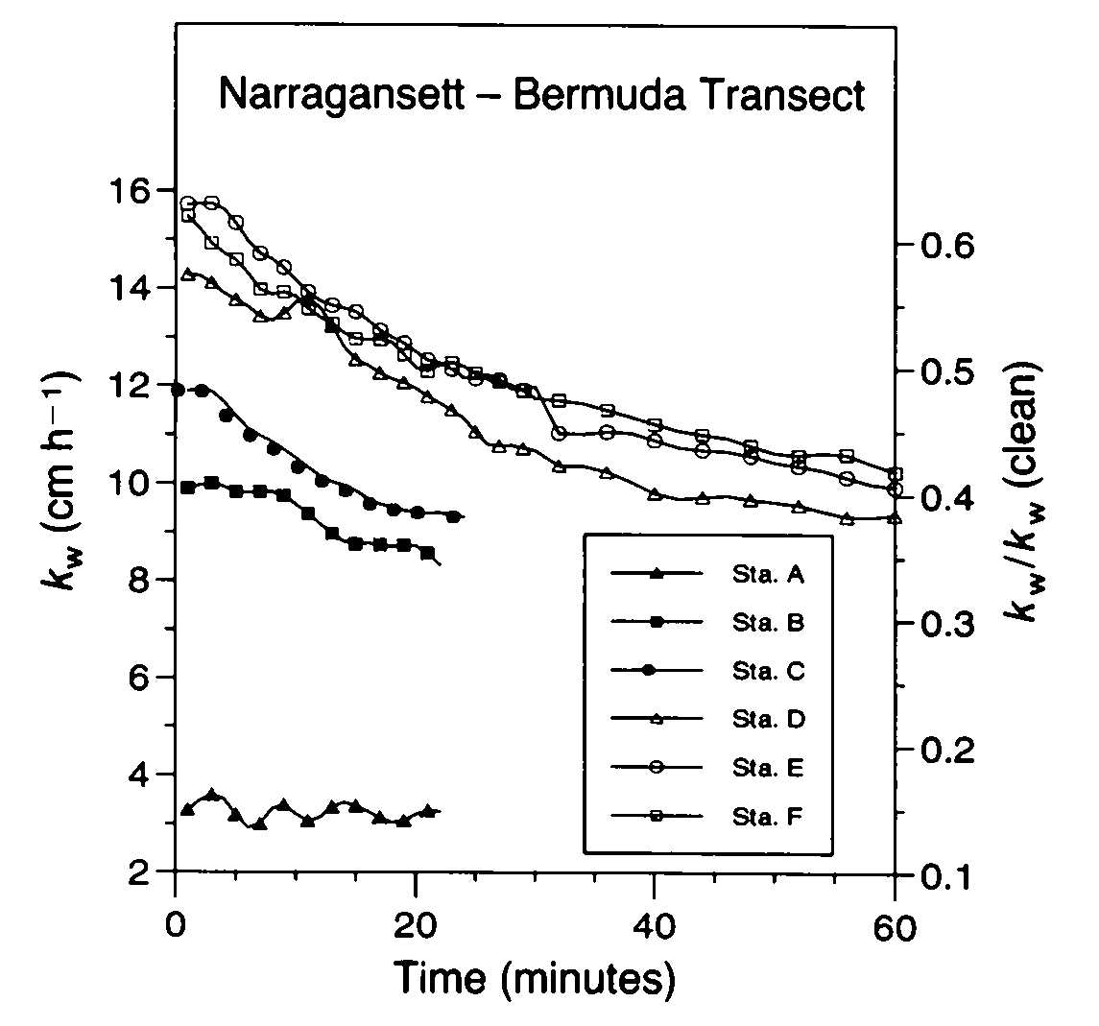
FIGURE 11 – Transfer velocity (K_{w}) as a function of time measured in an annular laboratory tank for a series of seawater samples collected on an inshore (Narragansett, RI – Sample A) to offshore (Bermuda – Sample F) transect (Frew, 1997)

FIGURE 12 – Air-sea gas transfer rates during the development of an open ocean algal bloom in IronEx II. Estimate of K₆₀₀ (red) plotted with U₁₀ from the two nearest TAO buoys (blue), chlorophyll (green) and phaeophytin (mauve); Nightingale, Liss and Schlosser (2000)

At higher wind speeds the challenge of making useful measurements of near-surface and interfacial processes increases. Lightly built floating sensors that follow the surface even at high wind speeds have been used to derive finely resolved temperature profiles, bubble size distributions and other properties. Acoustical methods have proved especially helpful in the study of wave breaking and in delineating bubble distributions. High frequency sonars allow remote detection of bubble distributions. Bubbles may then be used as tracers of the near surface flow-field, as they become organised and transported by Langmuir circulation and other coherent motions. Sonars may also be used to observe the penetration depth of bubbles while acoustic Doppler methods lead to direct measurement of the velocity field. The sound radiated by breaking surface waves allows detection of their presence, breaking intensity and motion across the ocean surface. Bubbles ‘ring’ with a high quality factor at resonance giving an acoustical signature that can be used to infer the size distribution. This fact is exploited in sensors that track changes in the size distribution with depth and time. The size distribution depends on the prior life history of the bubbles, from their formation in breaking waves, through turbulent mixing, advection and loss by buoyancy and dissolution. Measurements of bubble sizes in the context of these processes provide a sensitive diagnostic basis for exploring the detailed physics of the upper ocean boundary layer.

We still have a poor understanding of the mechanism of production of atmospheric sea-salt particles, their distribution and residence times as a function of wind speed, and their role in affecting the chemical properties of the marine atmosphere and aerosol radiative forcing.

Major Issues That Require Resolution

 What are the environmental factors that control the air-sea fluxes of mass and energy? The functional form and parameterisation of the air-sea exchange rates for gases, heat, water vapour, momentum, and sea salt aerosol generation must be determined to a level consistent with climate model objectives.

 What is the quantitative dependence of air-sea gas exchange on such factors as: wind speed, wave state, turbulence level, stratification, temperature, salinity, insolation, humidity, precipitation, ice cover, bubble population, and surfactant activity? It is evident that gas exchange rates depend on a variety of environmental factors not simply related to wind speed. This is substantiated by the fact that the observations show broad scatter about the most widely used formulation of gas exchange rates which depend on wind speed alone (Liss and Merlivat, 1986; Wanninkhof, 1992).

Promising Approaches

Field measurements of gas exchange rates have been traditionally determined by a number of geochemical mass balance techniques applied on a variety of scales. These range from local dye-release experiments, through Rn disequilibrium determinations, to global/regional scale radiocarbon uptake calculations. Comparison of these measurements remains challenging due to a mismatch of scales and scope, but a successful model of air-sea exchange must satisfy all these diverse constraints. Moreover, a well-designed observational programme should span as broad a range of space and time scales as possible to robustly calibrate and validate air-sea exchange models.

In considering the kind of research related to air-sea fluxes needed within the SOLAS context, the interacting effects of many diverse physical, chemical and biological processes appear to provide the greatest challenge. Direct measurement of air-sea fluxes of gases, for example, is very difficult, especially in the open ocean at higher wind speeds. Given this difficulty it would seem especially important that the gas transport be measured at the same time as the crucial mechanisms that mediate that change. This suggests the need for much more comprehensively integrated studies than has usually been attempted or found practical in the past. Important steps in this direction have recently been made in studies in the southern North Sea (Jacobs et al., 2000) and North Atlantic (McGillis et al., 2001 - Figure 13) in which micrometeorological and purposeful tracer approaches have been applied in tandem along with important ancillary measurements. Such experiments may be viewed as proto-SOLAS studies.

The key physical processes driving air-sea exchange include

- Near-surface turbulence in the atmosphere, relevant to aerosol deposition and gas fluxes;
- Direct production of sea spray at high wind speeds (U > 9m s⁻¹) relevant to aerosol formation;
- Production, cloud dynamics and bursting of bubbles relevant to gases and aerosols;
- Near-surface turbulence within the ocean, relevant to gas exchange;
- Organised motions, such as Langmuir cells, shallow internal waves and wave packets
- Wave spectra and mean-squared slope

FIGURE 13 - Transfer velocity (k) determined by eddy correlation in Gas-Ex 98 plotted against wind speed. Also plotted are some widely used paramterisations of k-wind and one k measurement obtained using the SF₆ - ³He dual tracer pair (McGillis et al., 2001)
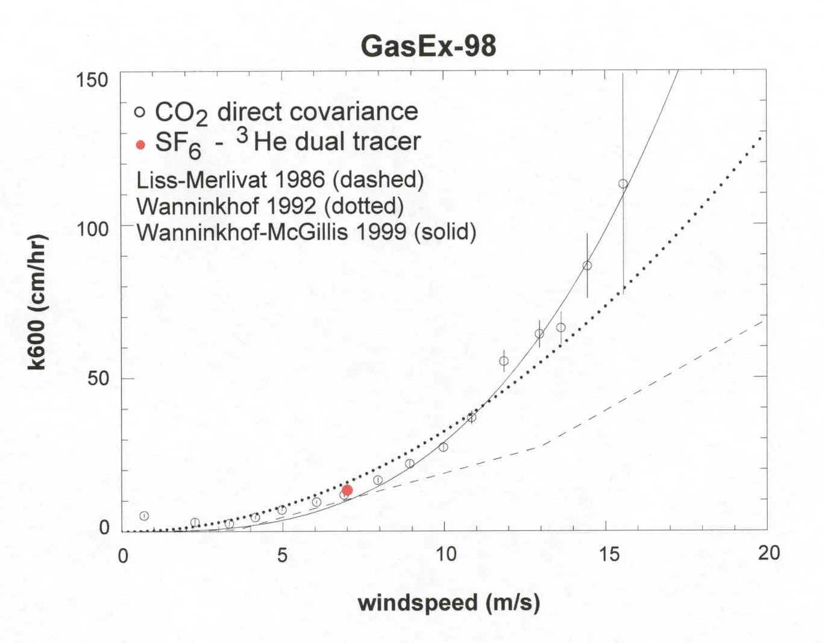

An important goal of this component of SOLAS is to learn enough about the exchange mechanisms so that the variables necessary to model the processes and to scale locally made measurements to regional and global scales will be known. This goal will require comprehensive observations and model inclusion of a wide range of variables and these should be included in planned field programmes. Potentially relevant parameters of interest include

- Wind stress (u*)
- Heat flux
- Heat transfer/thermal structure/buoyancy (T, S, light profiles)
- Directional wave field/capillary waves (optical methods, radar)
- Wave breaking (macro) (remote sensing, optical)
- Micro-breaking of waves
- Size distribution of bubbles (optical, acoustic)
- Bubble behaviour and penetration depth (optical array and acoustic (remote); increase in gas phase partial pressure
- Rain (optical methods; radar)
- Current shear (ADCP)
- Surfactants (mean square wave slope; sampling and chemical analysis)

With respect to differences across the interface of property concentration, c, the following variables are of interest:

- Near-surface vertical gradients in c (air, water)
- Lateral variability and gradients in c
- Skin effect (e.g., its effect on ΔpCO₂)
- Chemical enhancement of gradients by in situ reactions

The measurement of these properties, including gases dissolved within the water column using recording instruments that can survive storms, together with relevant oceanographic and meteorological observations, will provide the kind of data sets needed to develop a deeper understanding of the mechanisms responsible for air-sea gas transfer. Improved understanding of these mechanisms will then lead to more robust parametric representation.

Activity 2.2 - Processes in the Oceanic Boundary Layer

Understanding upper ocean boundary layer physics and biogeochemical processes is critical to predicting the air-sea exchange of gas and particles and in determining how these processes will affect and be affected by climatic change.

Introduction

The interface, which exerts a primary, short-term control over air-sea exchange, is influenced by the interaction between short time-scale processes and longer-term controls that regulate the nature of the oceanic boundary layer. Transport and transformation of properties within the oceanic boundary layer are important determinants of air-sea exchange processes on seasonal through climatic time-scales. Moreover, they exert foundational controls on the character and overall rates of biogeochemical processing within the upper layers, which in turn play a role in modifying the characteristics of the interface itself. Although the boundary layer is most conveniently defined in physical (circulation and mixing layer) or biological (euphotic zone) terms, we are also concerned with the coupling of the boundary layer to deeper layers. This coupling is important, particularly with regard to the return of remineralised nutrients and the subsequent regulation of biological productivity and trace-gas production. It is through this pathway that longer-term climate changes may have a most significant impact.

The upper ocean is intermittently mixed and restratified through the combined effects of wind and surface buoyancy flux. Mixing serves to reduce property gradients close to the air-sea interface. Horizontal and vertical transports, entrainment, upwelling and mixing of deeper water through turbulent processes combine with in situ biogeochemical transformations to set the stage for exchanges with the atmosphere. Wind mixing represents a constantly changing input of kinetic energy in space and time. Moreover the temporal response of the upper ocean to this changing input is also subject to rotational effects which introduce additional length- and time-scales. Biogeochemical transformations have a further set of distinctive time scales that are, in general, not matched to the physical scales. It is the combination and interaction of these different and interdependent processes that produce the spatially and temporally varying properties within the ocean surface layer.

It is feasible to construct an idealised and appropriately parameterised upper ocean boundary layer model that adequately mimics the behaviour of today’s ocean. However, fundamental changes in upper-ocean circulation and structure (particularly stratification) are anticipated in most future climate change scenarios. Such a simplified model will most certainly fail to account for such changes. A successful upper ocean model must correctly incorporate the relevant physical and biogeochemical processes.

State of Present Understanding

In the permanently stratified tropics, the reflux of aphotic zone remineralised nutrients to the euphotic zone must occur via turbulent mixing across the pycnocline or from wind-induced upwelling. The former is especially significant near the equator, where large shears are generated by the strong zonal currents. Tropical upwelling is driven by Ekman divergence, but is tightly coupled to ENSO/El Niño events. These processes characteristically overwhelm the ability of the phytoplankton community to utilise the refluxed nutrients, resulting in regions of abnormally high nutrient concentrations. The biological and biogeochemical characteristics of such regions may well be unique in their behaviour and response to changing forcing.

Outside the tropics, seasonal mixing plays a major role in nutrient renewal in winter. Wind mixing and surface buoyancy flux tend to dominate the stratification in spring and summer, providing constraints on the biological response. It might be expected that reduced wind mixing over the summer season would limit the nutrient input, decreasing carbon uptake and air-sea transfer of CO₂. However, in the subtropics, the summertime accumulation of photosynthetic oxygen and draw-down of CO₂, despite the clear vertical separation of the euphotic zone from the pycnocline nutrient pool below, belies this simple view. Geochemical mass budget analyses reveal that a substantial fraction of annual production may occur during this period, so that models predicated on this approach will clearly fail.

The prominent mesoscale structures visible in remote sensing imagery are a dominant characteristic of ocean variability and doubtless play a crucial role in material transport. The formation of mesoscale eddies and fronts are an inevitable consequence of how internal dynamical processes in the ocean respond to large-scale wind and buoyancy forcing. Fronts represent important boundaries between different water properties and can be associated with significant cross-isopycnal mixing and vertical motions, producing enhanced biological response. High-resolution numerical modelling of frontal structures reveals that ageostrophic motions and associated isopycnal front slumping result in substantial vertical and diapycnal exchange, which appear to support enhanced production (Mahadevan and Archer, 2000; Nurser and Zhang, 2000). Mesoscale eddies have also been strongly implicated as mechanisms for productivity enhancement by eddy heaving (McGillicuddy et al., 1999). Recent sub-mesoscale biogeochemical modelling of upper-ocean processes exhibits significant enhancement of biological production over coarser resolution models, indicating the importance of small (~ 1 km) scale motions.

Horizontal gradients in physical properties in fronts also feed back to air-sea exchange. For example, differences in surface water temperature modify the atmospheric stability and hence create a corresponding wind response, along with the local surface divergence field that modulates the wave field and resultant air-sea transport. Different cloud and fog conditions can further modify the surface buoyancy flux and photosynthetically available radiation available on either side of the front.

Transport and mixing processes in coastal regions can differ in many ways from the open ocean. Stratification will be enhanced where there is river input and may be dominated by salinity rather than temperature. Tides can greatly enhance mixing throughout the water column in shallow shelf seas. Interaction between the surface layer and the sea floor can lead to significant geochemical effects. The diversity of biological response is far greater in coastal waters. Moreover, human influence on the ocean is most extreme in coastal waters, where agricultural and other pollutants lead to profound changes in the chemistry and production by surface run-off, atmospheric inputs, or groundwater discharge. Although the areal extent of coastal waters is small relative to that of the world ocean, its importance is disproportionate because of its proximity to population centres and the magnitude of the changes that occur in these waters. Thus the mechanisms that lead to transport between coastal and offshore areas have a particular significance for modification of offshore waters, thus influencing in turn the air-sea exchange that occurs over much larger areas.
Major Issues that Require Resolution

 What are the fundamental gaps that exist in our understanding of the longer-term processes that set the biogeochemical context in the upper ocean, in particular the basic processes responsible for transporting biogeochemically important materials (nutrients, oxygen, and carbon) which are not well characterised and currently remain unquantified? Although on the periphery of the physical focus of SOLAS, the physical coupling of the euphotic zone to the middle water column is an important, climatically limiting factor in the seasonal to annual time-scale evolution of the upper ocean. In particular, regional/basin-scale models fail to adequately predict nutrient fluxes to the euphotic zone, both integrally and geographically, although more local, smaller scale, higher resolution models appear to have made progress.

Promising Approaches

The importance of very small scale processes in driving upper ocean biogeochemical activity requires the development of very high resolution numerical models, and the concomitant observational programme to design, parameterise, and test them. Numerical experimentation is an important activity, as it reveals the importance and inter-relationship of process-scales. Critical tests of model validation include not only the simulation of macroscopic behaviour and evolution, but also small-scale variability and statistics of physical properties and biogeochemically important species. A number of observational strategies need to be employed, including:

- Time-series measurement (both by repeat stations and moorings) of biogeochemically important parameters
- Physical forcing
- Diagnostic tracers
- Remote sensing for the regional/global scale integration, and studies of inter-annual and decadal scale variability
- High resolution (sub-mesoscale) numerical experimentation
- Focussed experiments to elucidate relevant processes.

Consideration should be given to the development of the next generation of sensors suitable for deployment on floats, towed devices, autonomous vehicles and moorings.

Activity 2.3 Processes in the Atmospheric Boundary Layer

Understanding atmospheric boundary layer physics and biogeochemical processes is critical in predicting the air-sea exchange of gases and particles and in determining how these processes will affect and be affected by climatic change.

Introduction

The lower atmosphere, specifically the marine boundary layer, links processes occurring at the air-sea interface to the rest of the atmosphere. If we are concerned with the vertical transport of gases and particulates it is necessary to understand the physical and chemical mechanisms involved. In general, the marine boundary layer is more difficult to observe than the terrestrial boundary layer and although there are important differences, model parameterisations often use values derived from overland measurements. Not surprisingly, the greatest observational difficulties arise at high wind speed. Gas and particulate transports may be especially important under these conditions because of the increased role of sea spray. The air-sea transports described here represent a sensitive part of the coupling between ocean and atmosphere. Changes in climate, such as temperature or wind speed, will in turn produce feedbacks through this coupling. Thus, an understanding of these processes is essential to the development of reliable predictions.

State of Present Understanding

Large-scale atmospheric circulations generate small-scale motions through shear instability, primarily due to frictional drag in the boundary layer. These smaller scale motions are described as turbulent eddies which fill the boundary layer. Their vertical motion dominates the vertical transport of momentum and scalar properties. Near the surface, turbulent viscosity varies rapidly with height. In contrast to the upper ocean boundary layer, effects due to passage of fronts and storms rarely allow an Ekman spiral to develop and convective effects, due to heat transport at the interface can effectively mix the boundary layer at mid-level, which is therefore commonly known as the mixed layer.

A useful concept for explaining boundary layer properties is Monin-Obukhov similarity theory, based on the argument that the structure of turbulent flow in the surface layer is governed by mechanical and thermal forcing. The balance between these two components results in a length scale, the MO scale L, determined by the relative strength of mechanical versus thermal forcing, with the sign determined by the direction of the buoyancy flux. The similarity hypothesis is that the turbulent characteristics, when appropriately normalised, can be expressed as a universal function depending on the parameter ζ = z/L. This scaling approach has proved successful in many atmospheric experiments and is widely accepted by the atmospheric community.

Under stable stratification (ζ > 0) vertical transfers are suppressed and the boundary layer may be very shallow (order metres). However the more common case over the ocean is that of near neutral stratification (particularly at higher wind speeds) or unstable stratification (ζ < 0). In this case the boundary layer can be considered to consist of a near surface region or wave boundary layer (order metres) where wave effects are important, a “constant flux” layer (order tens of metres), and a mixed layer (order hundreds of metres). Within the wave boundary layer, defined as that region where the total momentum flux has appreciable turbulent and wave induced components, additional scaling parameters beyond mechanical and thermal forcing at the surface are required to describe turbulent variables. Within the wave boundary layer, the vertical profile of the turbulent momentum flux can be divided into 3 components: turbulent momentum flux, viscous stress and the wave induced flux, which is just the correlation between the surface pressure field and the wave slope (form drag). At the surface the total flux is composed of wave induced flux going into ocean waves and viscous stress going directly into ocean currents.

The mixed layer may extend to the main inversion or, more typically, be capped by a layer of shallow cumulus or stratocumulus clouds. A typical overall depth for the cloud topped marine boundary layer is 1000 to 2000 m. A particular feature of the marine boundary layer (compared to that over land) is that the effects of cloud top evaporation and cloud radiative processes are of similar magnitude to the effects of the surface fluxes. Thus, the cloud layer may become decoupled from (or only intermittently coupled to) the near surface mixed layer, suppressing the vertical transfer into the cloud layer. While detailed investigation of most of these boundary layer processes is beyond the scope of SOLAS, the effect on the exchange of gases and particles must be considered.

At higher wind speeds sea spray plays an important role in air-sea transport of heat, moisture, gases and particulates. Sea spray can be formed in various ways. When a bubble reaches the surface the film breaks into small droplets with radius a few μm. Additional droplets, of radius 5-10μm are ejected from the jet formed by the collapse of the bubble cavity. A further spray producing process is the formation of spume, due to the tearing off the wave crests by the wind (Monahan et al., 1986), creating droplets that are typically greater than 20μm. Both rain drops and spume striking the surface can produce splash droplets (Andreas et al., 1995). Spume droplets account for most of the spray volume flux but are deposited more rapidly than the smaller drops typical of bubble bursting. Small droplets can be dispersed throughout the marine atmospheric boundary layer and can act as cloud condensation nuclei. Both wave-induced motion in the wave boundary layer and turbulence can prolong the residence time of sea spray. Evaporation of spray can influence humidity and temperature profiles, and by virtue of their effective increase in the ocean’s surface area can modify the transport rates of heat and moisture. Sea spray will also carry with it the enhanced concentrations of biological and chemical constituents of the air-sea interface, including gases. It therefore serves as a mechanism for transporting these properties into the marine boundary layer and ultimately into the atmosphere at larger scales.

The residence time of the droplets depends on their microphysics and the role of turbulent dispersion in the wave boundary layer. The fate of droplets in the boundary layer is somewhat analogous to bubbles near the ocean surface: dissolution decreases the size of bubbles and hence their buoyancy, while turbulence and advection can keep them in suspension. In the same way, droplets tend to fall back to the surface, but evaporation reduces their radius while turbulence can keep them suspended. There is a balance between evaporation and consequent transfer of heat and moisture, and turbulent suspension which keeps the droplet in the air long enough for the transfer to take place. Observations (Kepert et al., 1999) have shown that there is an intermediate range of droplet sizes that were actively evaporating at several tens of metres above the surface.

The problem is further complicated by feedbacks. Increased humidity due to spray evaporation inhibits further evaporation. The boundary layer transports this humidity to higher levels, replenishing the lower levels with less humid air, but the efficiency with which this occurs is limited, thus inhibiting the contribution of spray to heat and moisture transport at higher spray production levels.

Transport of the particulates within the marine boundary layer, caused by evaporation of sea spray droplets, depends on the degree of turbulence, and hence, to the extent that MO scaling applies, on ζ, the surface roughness and the wind speed. These same parameters also affect the air-sea transfer of gases. The relationship between the surface aerodynamic roughness and the sea-state is still a matter of research; it is generally considered to depend on wave age but other factors, such as the presence of swell or the mean wave slope, may have a significant effect. Thus, rather than classifying measurements only on the basis of the wind speed, it will be important in SOLAS also to determine ζ and the sea-state conditions.

Within the cloud layer, cloud condensation nuclei (CCN) derived from the sea surface modify the cloud droplet concentrations and hence the cloud albedo and the potential to form precipitation. Within the cloud layer chemical reactions occur in association with the cloud droplets. Precipitation from boundary layer clouds (as well as deep convection and higher cloud layers) acts to scavenge particulates and gases from the subcloud layers and return them to the sea.

Transfer of particulates and gases from the marine boundary layer to the free troposphere occurs at atmospheric fronts and in regions of deep convection. At atmospheric fronts the whole boundary layer may be transferred upwards into the free atmosphere. In deep convection boundary layer air may be transported to the upper troposphere and detrained at the cloud edges. Both processes tend to be accompanied by precipitation, which may remove particulates and gases.

Entrainment at the top of the marine boundary layer transfers particulates and gases from the free atmosphere into the marine boundary layer. This process is more efficient for the cloud topped boundary layer.

Significant modification of the atmospheric boundary layer occurs in coastal regions. For onshore winds, the sea state and wave breaking may be significantly modified by the shallow depth and the effects of tidal currents. Offshore winds may carry particulates and gases originating from the land out over the ocean. In this case there will be a significant change in surface roughness and ζ at the coast and an internal marine boundary layer will form within the advected terrestrial boundary layer. Such effects will be significant within the first few km of the coast with the effects of the developing sea state extending tens of km or more.

Major Issues that Require Resolution

 How can improved boundary layer parameterisations in the wave boundary layer be developed? The marine boundary layer differs from its terrestrial counterpart and the use of terrestrial measurements to infer surface fluxes over the ocean is questionable.

 What is the role of sea spray on air-sea fluxes of heat, moisture and other properties? The measurements remain too limited to draw definite conclusions, especially at higher wind speeds. We need to establish the source function for spray, which is currently uncertain by more than an order of magnitude (Andreas and DeCosmo, 1999). The most urgent requirement in this context is improved and more extensive measurements of sea spray at higher wind speeds.

 What are the uncertainties in the behaviour of the drag coefficient under strong forcing? The coefficient generally appears to increase approximately linearly with wind speed, but this relationship is very uncertain at higher winds (>15 ms⁻¹).

 What are the uncertainties in the bulk transfer coefficients parameterising exchanges of sensible and latent heat at higher wind speeds? Analytic models of the maximum potential energy of tropical cyclones (i.e. Holland, 1997) can successfully place an upper limit on the intensity of the most severe storms, but ignore the physics of air-sea transfers, parameterising these strictly in terms of sea surface temperature. The models depend on this simplified physics, but conceal the relevant processes by being tuned to the values of near surface temperature and humidity.

Promising Approaches

Increased attention to the coupled marine boundary layer and air-sea interaction will make available improved measurement and modelling approaches. Particularly valuable in this context is the eddy correlation and other micrometeorological methods for vertical turbulent transport measurements. In the past such measurements have been used for momentum, heat and water vapour, but new approaches are making it possible to measure turbulent gas transport as well (Jacobs et al., 2000; McGillis et al., 2001).

At higher wind speeds, the use of self contained air-deployed sensor technology would seem to offer interesting possibilities.

Focus 3 - Air-Sea Flux of CO₂ and Other Long-Lived Radiatively Active Gases

The air-sea CO₂ flux is a key inter-reservoir exchange within the global carbon cycle. Experimental, observational and modeling studies linking biological uptake, respiration, marine calcification and mixed-layer physics with upper ocean pCO₂ are necessary to predict changes in oceanic carbon uptake over the next century. The ocean also plays a key role in the global budgets of other long-lived radiatively gases including N₂O and to some extent CH₄. The objective in Focus 3 is to develop a quantitative understanding of the upper ocean mechanisms which create the regional, seasonal and interannual structure and variation of these fluxes in order to assess their sensitivity to future variations in environmental forcing.

The ocean acts as a major sink for anthropogenic CO₂, absorbing 35-40% of fossil-fuel CO₂ emissions (Schimel et al., 1996). The associated net flux of CO₂ across the air-sea interface is controlled by the solubility of CO₂ and the rate at which ‘older’ deep ocean waters are exposed to a contemporary atmosphere with elevated pCO₂ relative to preindustrial levels. This ‘anthropogenic’ flux is superimposed on a geographically- and temporally-varying pattern of large ‘natural’ exchanges. Natural exchanges are created by a variety of physical, biological and geochemical processes including heating and cooling of surface waters, biological uptake and export of organic carbon from the surface layer, marine biocalcification, and the upwelling of carbon-rich deep waters into the surface layer. In the preindustrial ocean, regions where the net flux of carbon was from the ocean to the atmosphere (source regions) were linked to sink regions by carbon transport carried by sinking particles and ocean circulation. The increasing pCO₂ of the atmosphere since 1750 has tended to increase the air-to-sea flux in CO₂ sink regions and decrease the flux in the source regions, leading to increased carbon storage within the ocean.

Future changes in ocean temperatures, ocean circulation, nutrient supply and other changes in biological carbon cycling associated with global change have the potential to alter the anthropogenic and/or natural components of the air-sea CO₂ flux on regional and global scales. A pre-requisite for the prediction, assessment and identification of any such change is the characterisation of the present-day air-sea CO₂ flux and the processes responsible for driving this flux and its variation.

The ocean also plays an important role in the global budget of at least two additional long-lived, radiatively active gases. Notably N₂O and CH₄ are both produced within the oceans and released to the atmosphere where they act as greenhouse gases, as well as participating actively in tropospheric and stratospheric chemical cycling. The air-sea flux of these species may be climate-sensitive although fewer field observations exist for these gases than for CO₂, and there have been far fewer process studies which can be used to assess such sensitivity.

Activity 3.1 - Geographic and Interannual Variability of Air-Sea CO₂ Fluxes

Upper ocean biogeochemical and physical processes contribute significantly to interannual variability of the growth rate of atmospheric pCO₂.

Introduction

Inverse modeling of atmospheric CO₂ data seeks to infer unknown regional and temporal distributions of carbon sources and sinks at the land- and sea-surfaces based on the measured gradients of atmospheric pCO₂ and carbon-related properties (e.g., O₂, ¹³C) using atmospheric transport models. Geographic and temporal distributions of atmospheric pCO₂ (and other carbon-related properties) arising from known fossil-fuel emissions are predicted and the magnitude and regional distribution of ocean and land surface sinks adjusted to match the measured atmospheric distributions. A major goal of such studies, driven by the Kyoto Protocol, is the characterisation of difficult-to-measure net carbon fluxes at the land surface. Such approaches suffer inevitable limitations arising from imperfect specification of atmospheric transport and mixing (e.g., Denning et al., 1999) as well as imperfect knowledge of atmospheric pCO₂ distributions. Specification of additional constraints on regional and/or global air-sea fluxes may allow improved definition of the location and magnitude of the exceedingly difficult to measure land-atmosphere fluxes (Tans et al., 1990; Fan et al., 1999). In order to develop and apply such constraints detailed information is required not only on the mean air-sea fluxes but also their variability. Specifically, inverse model of atmospheric CO₂ data will benefit from information concerning regional and temporal (seasonal to decades) variability of the air-sea flux of CO₂ and carbon-related properties.

In addition to constraining inverse models, the potential also exists to utilise observed variability in surface fluxes, particularly interannual variability, to diagnose the sensitivity of carbon fluxes to perturbations such as climate change. Presently there is controversy concerning the relative magnitude of interannual variability of land-atmosphere and ocean-atmosphere surface fluxes (Rayner and Law, 1999). If the relative oceanic and terrestrial contributions to atmospheric CO₂ variability can be resolved, then the observed sensitivity of land-atmosphere and air-sea carbon fluxes to climate perturbations will become a critical test of the ability of global carbon cycle models to predict future uptake under an altered climate.

State-of-Present Understanding

Surface water pCO₂ measurements collected over 3 decades have been extrapolated and interpolated in space and time (Takahashi et al., 1999) to estimate the global distribution of the net flux of CO₂ between the ocean and the atmosphere (Figure 14). This type of information can contribute directly to quantitative understanding of the contemporary global carbon cycle, including terrestrial biosphere processes, through the provision of constraints for use in atmospheric inversion modeling. However, despite considerable effort, surface water pCO₂ data remain sparse with respect to both geographical and, particularly, temporal coverage. At present it is necessary to collapse or ‘normalise’ all extant surface ocean data into one ‘virtual year’ in order to produce a global map. Even assuming invariant physical and biological controls on surface pCO₂, such a normalisation is non-trivial because atmospheric pCO₂ is increasing. The corresponding surface ocean pCO₂ increase may either parallel, lag-behind or even conceivably slightly exceed (Wallace, 2001) the rate of atmospheric pCO₂ increase, depending on the circulation and mixing dynamics of the specific ocean region being considered. If surface ocean pCO₂ varies significantly from year to year, then the production of such flux climatologies from sparse data becomes even more problematical.
50

FIGURE 14 - Global climatology of the annual net air-sea CO₂ flux based on interpolation of air-sea pCO₂ differences referenced to the year 1995 (Takahashi et al., 1999)

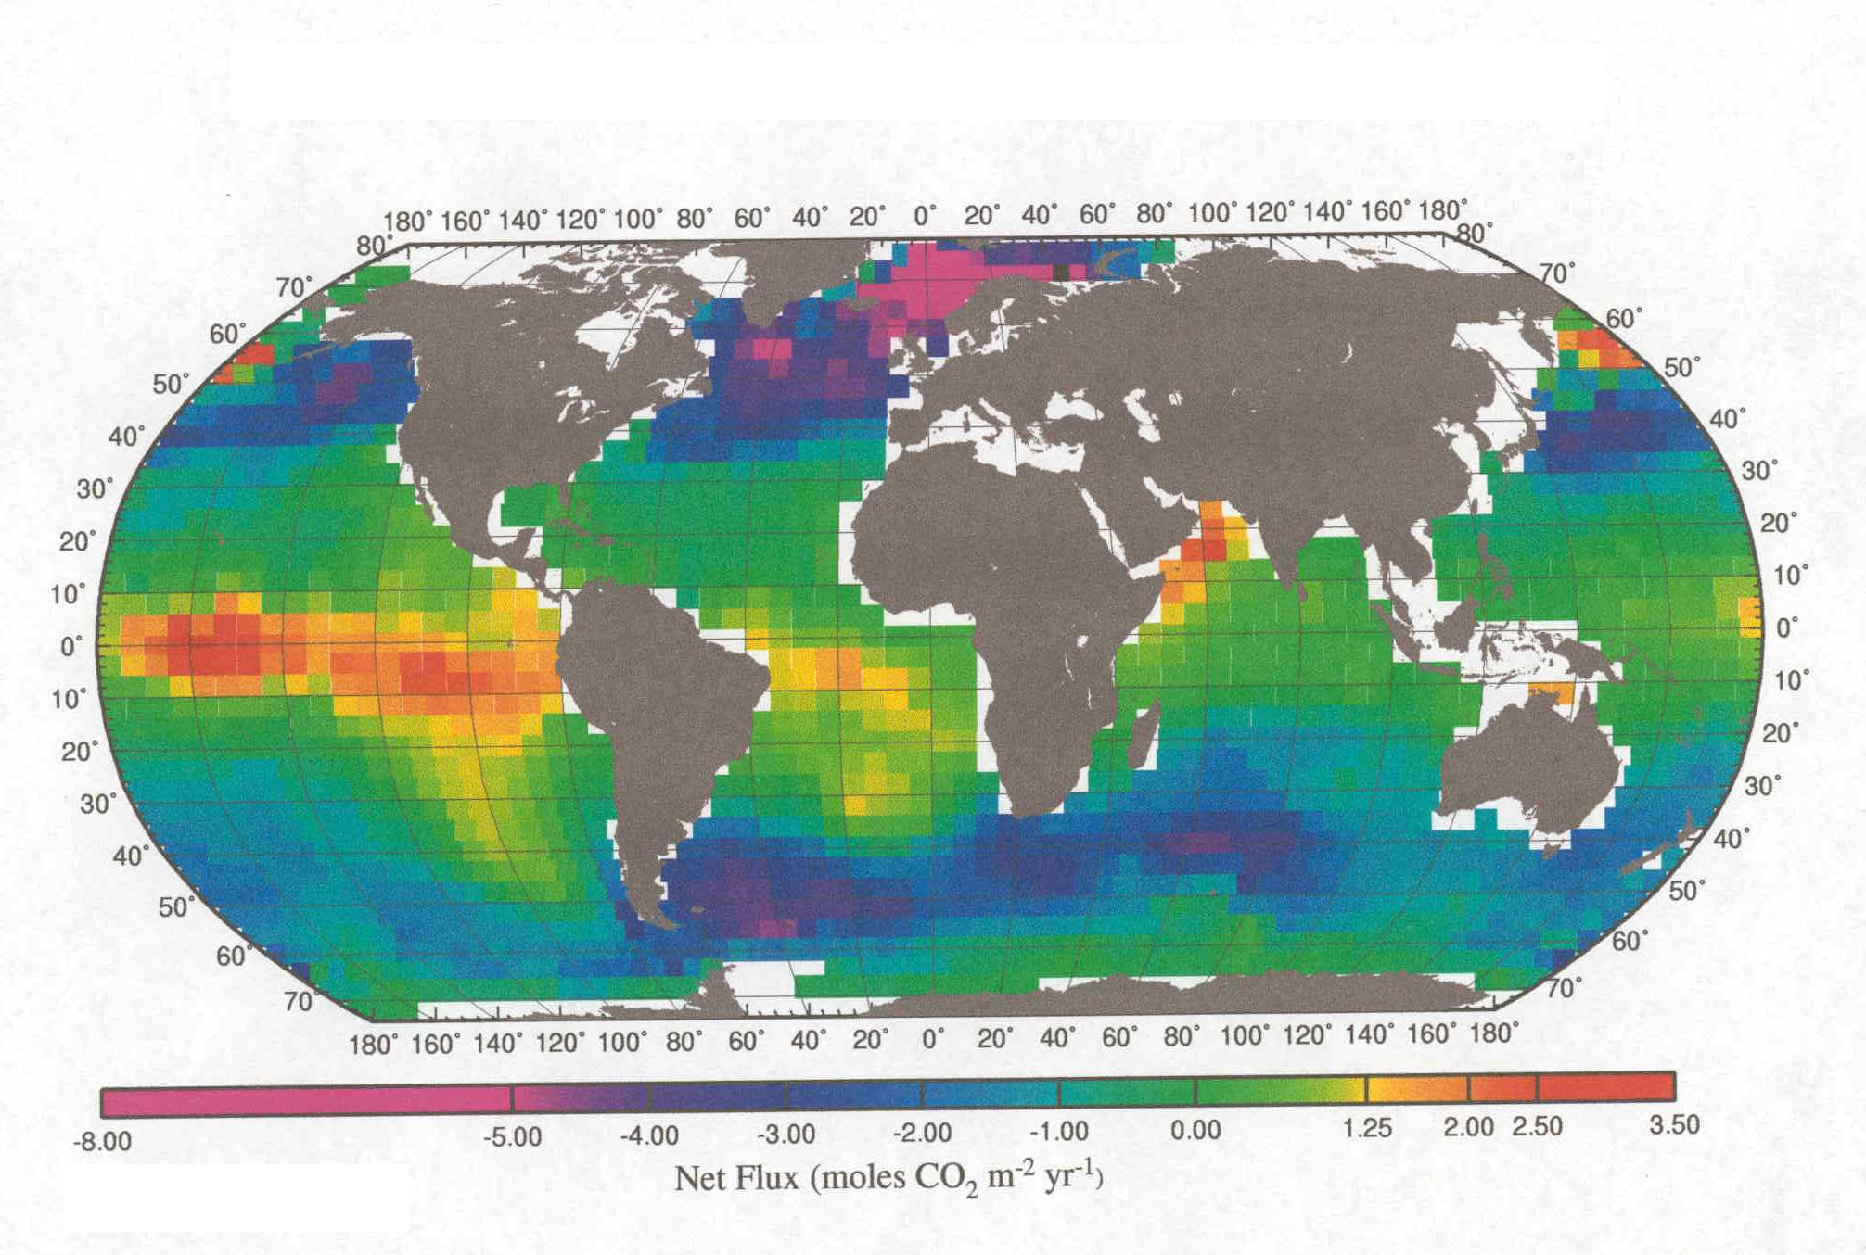

Significant interannual variability as large as ± 2 PgC yr⁻¹ has been observed in the overall rate of increase of atmospheric pCO₂ over the past 40 years. These interannual fluctuations in net CO₂ sinks and sources are comparable in magnitude to the mean accumulation rate of fossil-fuel CO₂ in the atmosphere. There is a major ongoing controversy concerning the degree to which such interannual variability is caused by ocean-atmosphere carbon flux variability, variations in the land-atmosphere flux, or both. Time-series studies in the equatorial Pacific have shown strong interannual variability of the air-sea flux of the order of 0.6 PgC yr⁻¹ (Feely et al., 1999). Studies in the Greenland Sea have also shown large year-to-year variations in air-sea CO₂ flux associated with variable climate forcing (Skjelvan et al., 1999). However, there are few other extant data sets from regions subject to large net annual air-sea fluxes with which to evaluate such flux variability directly.

Time-series of atmospheric CO₂, ¹³C and O₂/N₂ can in principle be used to separate terrestrial and oceanic source of variability of atmospheric pCO₂. Analyses of such data (Keeling et al., 1996; Francey et al., 1995; Battle et al., 2000) have apportioned this variability variously, but all such studies imply that variability of the ocean-atmosphere flux contributes very significantly. On the other hand ocean modeling studies (Le Quéré et al., 2001) and attempts to extrapolate air-sea flux variability globally (Lee et al., 1998) and regionally (Boutin et al., 1999) imply low ocean-atmosphere flux variability. Terrestrial carbon cycle models appear able to explain all observed atmospheric variability by invoking changes to terrestrial productivity only (Prentice et al., 2000). Resolving such controversies and imposing stricter constraints on carbon cycle models will require continued atmospheric time-series of such properties, as well as better understanding of the magnitude and causes of variability in the air-sea flux of CO₂ and of carbon-related properties, including O₂ and ¹³C.

Despite the impressive global picture shown in Figure 14, the sparsity of pCO₂ data which underly this picture, together with uncertainty in the gas transfer velocity (see Activity 2.1) means that net flux estimates are currently subject to uncertainties of as much as 50-75% (Takahashi et al., 1997, 1999). A major goal of SOLAS should be to reduce this level of uncertainty through better parameterisation of gas exchange (see Focus 2) and the collection of higher-resolution surface ocean and atmospheric data sets. Improvements in both global and regional flux estimates should be pursued; even in the absence of global coverage, regional flux estimates from key ocean regions can be of considerable value as constraints on inverse models.

Major Issues that Require Resolution

 What is the magnitude and temporal variability (seasonal, interannual and longer) of the air-sea CO₂ flux on regional to global scales? This information can provide a powerful constraint for carbon-cycle inverse models aimed at identifying the distribution of carbon sources and sinks, and permits critical testing of prognostic models.

 Can the key physical (e.g. SST, wind, upwelling) and biological (e.g. primary productivity, biocalcification) factors associated with such variability be assessed reliably using remote sensing? Such an assessment forms the basis for extrapolation and interpolation of limited observation-based estimates of air-sea CO₂ fluxes to larger spatial and temporal scales,

 What is the extent to which the regional magnitude and variability of observation-based estimates of air-sea CO₂ fluxes are reflected accurately by ocean carbon cycle models? Such models provide an alternative way to estimate regional and global scales air-sea fluxes and their variability.

 To what extent do atmospheric time-series data (O₂/N₂, ¹³C, pCO₂, etc) reflect observation-based estimates of air-sea CO₂ flux variability? Particularly: what scales (length, time) of variability can be evaluated from fixed-point atmospheric time series? Atmospheric time-series of carbon-related parameters record integral air-sea CO₂ flux variability over large spatial and temporal scales. These integration length- and time-scales need to be defined through comparison with observation-based flux estimates in order to guide the interpretation of time-series data and optimise measurement network design.

Promising Approaches

A concerted effort should be made to obtain data suitable for assessing geographical and temporal variability of the air-sea CO₂ flux. This is finally within reach using currently available technologies and sampling platforms. The basis for such flux estimates should be ocean-basin scale surveys of the air-sea pCO₂ difference. Platforms which provide the opportunity for long-term, large-scale measurements, such as Volunteer Observing Ships, time-series moorings, drifting buoys, etc. could provide the required spatio-temporal coverage and define scales of variability. In addition to pCO₂ data, such surveys should collect sufficient supporting physical and biological data to guide interpretation of the observed variability and permit the development of extrapolation and interpolation methods based on data assimilation modelling and/or remote sensing.

Together with improved data sets, improved estimates of the gas transfer velocity are required (see Activity 2.1) in order to determine the net air-sea flux and its variation.

Time-series measurements of atmospheric CO₂, O₂/N₂ and ¹³C provide alternative, complementary information concerning air-sea fluxes but are also affected by exchanges with the terrestrial biosphere. Such time-series tend to integrate the effects of fluxes operating over large spatial scales. In order to strengthen the interpretation of such data, regional and temporally-resolved information concerning surface water oxygen concentrations and ¹³C/¹²C ratios should also be collected and assessed.

The collection of surface ocean data from the platforms listed above also provides a unique opportunity to simultaneously improve our knowledge of the atmospheric distributions of CO₂ and related properties. The atmospheric observations made from such platforms should therefore, whenever possible, be of sufficient quality to enhance the existing atmospheric observation network.

Our understanding of the biological and physical factors underlying air-sea CO₂ flux variability has grown significantly in recent years on the basis of atmospheric and oceanic time series data. Existing oceanic time-series should be extended to include time series in locations subject to large net CO₂ fluxes, e.g. high latitude North Atlantic, Southern Ocean, equatorial Pacific and coastal environments, including coastal upwelling regions. In addition, regular meridional transits by Antarctic supply ships provide valuable opportunities to sample remote regions. Remote sensing of biogeochemical and physical properties (e.g. ocean colour) and modelling provide the tools required for interpreting such time-series observations and linking them to larger spatial and temporal scales.

With respect to modelling, at least three main classes of models are relevant and useful:

1. Data assimilation modelling offers the possibility to combine data collected from surface ocean observations, as well as remotely sensed data, and extrapolate/interpolate sparse pCO₂ observations in space and time. In principle this should provide a more comprehensive picture of the air-sea carbon flux distribution. Basic experimental, statistical and theoretical work is required to develop such approaches.

2. Inverse modelling of atmospheric observations will continue to play a major role in improving our estimates of the contribution of the ocean to variability of atmospheric CO₂. Such modelling should explore the sensitivity of inversions of atmospheric CO₂, O₂/N₂ and ¹³C data to constraints imposed by observation-based estimates of the air-sea flux.

3. Understanding concerning the processes governing the air-sea carbon flux should be incorporated into advanced coupled ocean circulation - ocean carbon cycle models. These models ultimately will permit the analysis of the effects of future forcing variability on air-sea carbon fluxes. They can be tested and refined through direct comparison with the observed scales of variability.

Activity 3.2 - CO₂ Flux Changes Over the Next 100 Years

Air-sea uptake of CO₂ will change significantly during the next century due to changes in ocean circulation and marine biogeochemistry in the surface layer.

Introduction

The ocean represents a large sink for anthropogenic CO₂ due to the partial re-equilibration of surface and interior ocean waters with the increased atmospheric pCO₂ of the post-industrial era. Most studies and models of anthropogenic CO₂ uptake have treated this anthropogenic CO₂ uptake as a ‘perturbation’ superimposed on top of a steady-state, ‘natural’ oceanic carbon distribution. With such approaches, the mechanisms and rates of the processes controlling the natural cycle of carbon in the ocean are assumed to remain unaffected by the anthropogenic carbon increase (Sarmiento et al., 1992). In the context of decadal and longer timescale climate change, the potential exists to alter the processes and/or mechanisms that are responsible for anthropogenic CO₂ uptake. For example, future changes in wind patterns and/or stratification, may strongly affect the anthropogenic component of the air-sea carbon flux (e.g., Sarmiento and Le Quéré, 1996). From current modelling studies, it is much less clear to what extent the mechanisms and rates of processes involved in the ocean’s natural carbon cycle may change as a result of future climate change or other environmental forcing.

That the natural partitioning of carbon between the atmosphere and the ocean is sensitive to climate change is clear; the record of atmospheric pCO₂ variation over glacial-interglacial periods derived from studies of ice cores shows this unequivocally. At present, although there are several competing hypotheses, there is no single agreed-upon and comprehensive explanation for such changes. Even if such an explanation were forthcoming, there are some basic limitations to the use of the past as a key to understanding what might happen in the future. For example, the potential rate of climate forcing associated with anthropogenic climate change is much more rapid and sudden than that which occurred over glacial-interglacial periods. Further, atmospheric CO₂ has already reached levels that are unprecedented over the past 15 million years. Chemically, this implies that the atmosphere-ocean system is in an unprecedented state of reduced buffer capacity. The effect of this on the climate-sensitivity of air-sea carbon partitioning cannot be straightforwardly assessed. In addition, if current climate predictions are correct, the Earth’s climate will become significantly warmer in the near future than it has been for at least the past 400,000 years. The glacial-interglacial changes of pCO₂ (peak-to-peak change of <100 ppmv) reflect transitions into climates cooler than present. There is no reliable palaeo record for the effect of a transition into a significantly warmer global climate.

The potential for future alteration of the large ‘natural’ component of the air-sea carbon flux is therefore very hard to predict or verify with our current level of understanding as it is currently represented within numerical models. Further, it is difficult to assess directly on the basis of the palaeo record.

State of Present Understanding

Factors that can potentially drive changes in the cycling of carbon between the ocean and the atmosphere can be subdivided into two categories: physico-chemically mediated and biologically mediated. The physico-chemical factors are relatively well-understood and can already be parameterised in ocean models. They include:

Warming. CO₂ is less soluble in warmer water. Global warming, if it takes place, will tend to increase surface water temperatures and progressively reduce the effectiveness of the ocean sink for CO₂.

Buffering changes. The ability of surface waters to dissolve excess CO₂ tends to decrease at higher concentrations of dissolved inorganic carbon. Future decreases in ocean buffering, associated with higher CO₂ concentrations, will inevitably and significantly decrease the effectiveness of the ocean sink (e.g. Sarmiento et al., 1995).

Sea-ice extent. Changes in sea-ice extent in the Southern Ocean have been hypothesised to have caused large changes in atmospheric pCO₂ over glacial-interglacial timescales through controls on the rate of air-sea exchange (Stephens and Keeling, 2000). A seasonal rectification of the biologically-driven air-sea carbon flux has been proposed for seasonally ice-covered regions due to the seasonal timing of biological production, gas-exchange and sea-ice cover (Yager et al., 1995). Future climate-driven changes in sea-ice extent may therefore play a role in altering air-sea fluxes.

The biologically-mediated processes have generally been viewed as having played little or no direct role, to date, in the uptake of anthropogenic CO₂. This viewpoint is derived from the observation that inorganic carbon rarely, if ever, limits the production of biomass in the ocean. Outside of high-nutrient, low chlorophyll regions, ocean carbon fixation is more typically limited by the major nutrients (nitrate and phosphate) which are supplied mainly from the deep ocean, where nutrients and inorganic carbon occur in proportions closely matched to phytoplankton growth requirements (the Redfield ratios). Constancy of these ratios severely restricts the potential for changes in biological production associated with changes in the within-ocean nutrient supply to alter atmosphere-ocean carbon partitioning. Falkowski et al. (1998) list three classes of biologically-mediated factors that could, however, alter the future air-sea flux and carbon partitioning:

- Changes of major nutrient inventories within the ocean;
- Changes in the utilisation efficiency of major nutrients at the ocean surface;
- Changes in the elemental composition of biogenic material sinking from the euphotic zone (including the organic carbon to calcium carbonate ‘rain ratio’ of material exported from the surface layer).

Some possible processes leading to changes in these factors include:

Changes in the external supply of biologically limiting nutrients (Fe, Si, N and P) could influence the strength of biological production (as discussed under Activities 1.2a, 1.2b, and 1.3) and alter surface water pCO₂. The potential for short-term control on pCO₂ and air-sea flux has been dramatically illustrated in the IronEx and SOIREE experiments (Figure 15).

Alteration of fixed nitrogen supply from internal sources and sinks as a result of in situ nitrogen fixation (or denitrification) can alter nutrient inventories, carbon export and surface water pCO₂. A relationship between nitrogen fixation and external inputs of iron has been hypothesised (Falkowski, 1997) but has not been experimentally tested. The recently suggested climate-sensitivity of nitrogen fixation in surface waters of the North Pacific sub-tropical gyre (Karl et al., 1997) leaves open the question of whether inventories of major nutrients are presently in steady-state, or are likely to remain so in the future (see Focus 1, Activity 1.2b).

FIGURE 15 - Surface water f CO₂ during SOIREE (Watson et al., 2000)
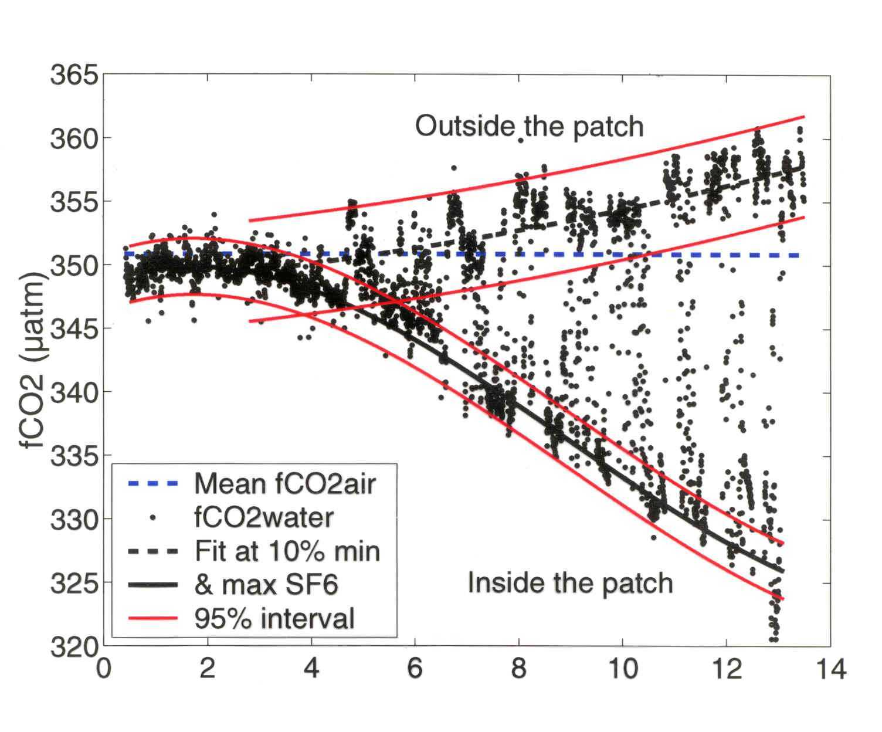

The species composition and biogeochemical nature of marine ecosystems is affected by factors including temperature, cloudiness, nutrient availability, mixed-layer physics and sea-ice extent. Future climate-related changes in such factors might alter upper ocean ecosystem structure. For example, changes in the distribution of calcareous versus siliceous planktonic organisms could have significant consequences for surface water alkalinity, pCO₂ and air-sea fluxes in the future, as they may have in the past (Archer and Meier-Reimer, 1994).

Related to this, CO₂ upon dissolution acts to reduce surface water pH. The increase of pCO₂ in surface seawater since preindustrial times implies that the global average surface water pH has already decreased by 0.12 units. A further decrease of 0.25 units will occur during the next century if atmospheric CO₂ concentration rises to 700 μatm (Figure 16). This change is comparable in magnitude to the present-day range of surface water pH (7.7 to 8.2). The potential effects on marine ecosystems are not well understood but are likely to include deleterious effects on calcite and, particularly, aragonite-forming organisms, with potential consequences for surface water alkalinity and pCO₂. Recent studies with corals and coralline macroalgae have shown that calcification rates are significantly reduced by changes of this magnitude (Gattuso et al., 1998; Langdon et al., 2000). Laboratory experiments carried out on planktonic calcifying microalgae demonstrate that biocalcification rates are very sensitive to pH changes in these organisms as well. Initial results suggest that planktonic calcification could decrease by 16-83% for an increase of surface water pCO₂ to 700-800 ppmv (Figure 17, Riebesell et al., 2000). Such changes would represent potentially important feedbacks on oceanic uptake of CO₂, as well as having significant impacts on oceanic life. Decreases in pH could also, conceivably, have more complex effects such as increased mobilisation of micronutrients with possible implications for biological productivity.

FIGURE 16 - The figure shows that the change in pH that has occurred in surface waters since the industrial revolution is of the same order as, or larger than, the natural variability of summertime pH. The pH values of surface ocean waters that are possible by the end of this century, if atmospheric pCO2 continues to increase rapidly, fall far below the present-day total range of pH variability

FIGURE 17 – Scanning electron microscope pictures of coccolithorids grown under low and high CO₂ conditions, corresponding to pCO₂ levels of about 300 ppmv (a-c) and 780-850 ppmv (d-f); Riebesell et al., 2000

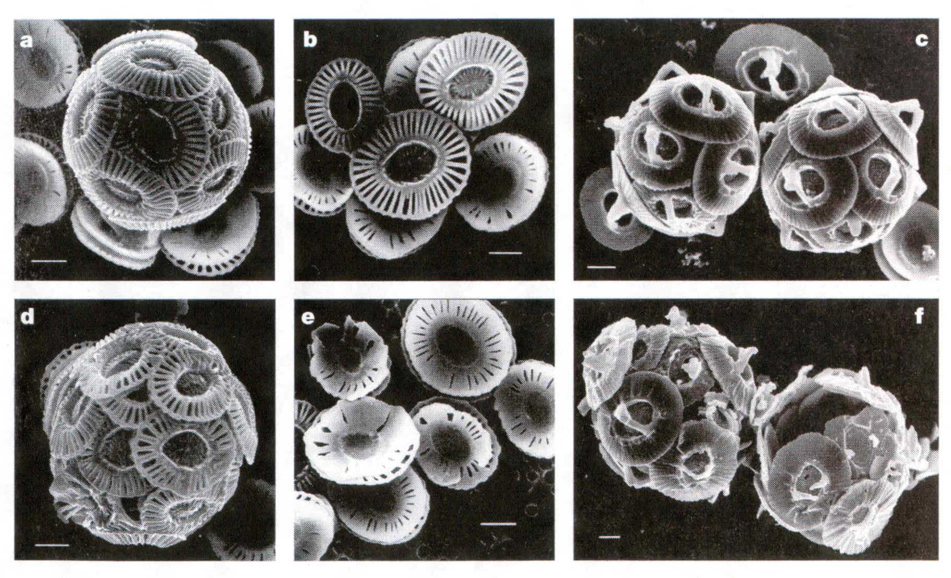

Our incomplete knowledge of present-day nutrient controls of productivity in the ocean surface layer and physical and biogeochemical controls on ecosystem structure currently severely limits our ability to predict future sensitivity of air-sea fluxes and carbon sequestration to such changes. The significance of these and other mechanisms (e.g., biocalcification changes) for control of future air-sea CO₂ fluxes cannot be reliably assessed using the current generation of numerical models owing to a lack of basic information concerning the mechanisms and processes involved.

Major Issues that Require Resolution

 What will be the effect on air-sea carbon flux and carbon export to the deep-sea of climate-related changes, including expected changes in surface ocean temperatures, salinity, ice cover, possible changes in the length of the productive season, and changes in upper-ocean stratification? Potential ocean-driven feedbacks on atmospheric CO₂ levels are at present poorly understood and quantified.

 What is the sensitivity of upper ocean carbon cycling and the air-sea carbon flux to the large changes in carbonate system speciation which will occur as atmospheric pCO₂ increases further? Significant changes in oceanic biocalcification rates appear possible based on experimental findings and may act as a negative feedback on future atmospheric CO₂ levels.

 Is the input of new macronutrients (e.g., N and P) from external or internal sources significantly affecting productivity and carbon sequestration on time scales of 100 years or more? The growing realisation of the sensitivity of oceanic macronutrient inventories to changes in external forcing (climate-change, micronutrient input) has implications for past and future atmosphere-ocean carbon partitioning that should be understood and quantified.

 If iron input to the euphotic zone were to be deliberately or inadvertently increased in HNLC regions, how much additional carbon would be fixed and how much would be sequestered for 100 years or more? A role for changes in iron input as a short-term control on surface water pCO₂ in HNLC regions has been experimentally demonstrated. Less clear presently is the extent to which short-term pCO₂ drawdown translates into increased carbon export from the upper ocean and long-term storage within the ocean interior.

Promising Approaches

These issues need to be tackled by a combination of experimental field and laboratory studies and modelling, and some possible approaches have been discussed under Focus 1. For example, with respect to the role of iron supply there is a need for improved basic understanding of the effects of iron supply on the physiology of marine organisms, species succession, etc. This can be attained through a combined programme of laboratory investigation and field Fe-fertilisation experiments (pulse or continuous) in key areas (e.g., in an oligotrophic area). The longer-term fate of carbon sequestered by Fe-fertilisation could be investigated in areas subject to otherwise constant environmental conditions but strong natural gradients of Fe input. Plumes of iron-rich waters ‘downstream’ of islands located in the deep ocean could, for example, be exploited as natural laboratories. Modeling experiments are also required to better quantify the fate of sequestered carbon. Consideration should, of course, also be given to the possibility of limitation by micronutrients other than Fe.

With respect to the supply of major nutrients, laboratory and field investigation are required into poorly understood factors such as the magnitude and controls of N-fixation, and the role of P, N and Si limitation in determining ecosystem structure, species composition, functional types and their respective C:N:P ratios. A combination of oceanic time-series studies, together with controlled perturbation experiments in the laboratory and field has the potential to advance knowledge in these important areas.

With respect to the effect of decreasing surface ocean pH, there is a need for additional physiological and experimental study of the response of key calcifying species to changes in pH. The possibility that organisms may be able to adapt to such changes in the longer-term should be investigated. At larger scales, the relationship between the production and export of organic carbon and the products of biocalcification must be much better understood. For example, mesocosm experiments could be designed to determine whether pCO₂ increases triggers systematic changes in community composition, including changes in the ratio of organic carbon production to biocalcification.

Improved understanding concerning such controls should be incorporated and evaluated in numerical models in order to assess the magnitude of possible future changes on the “rain ratio”, and the large-scale consequences of such changes for the net uptake of CO₂ by the ocean.

Activity 3.3 – Air-Sea Flux of N₂O and CH₄

The sea-to-air fluxes of N₂O and CH₄ are sensitive to climate forcing, as well as to human-induced changes in the coastal zone.

Introduction

Nitrous oxide (N₂O) significantly influences, both directly and indirectly, the Earth’s climate. In the troposphere it acts as a major greenhouse gas, and in the stratosphere it is also the major source for NO radicals, which are involved in one of the major ozone reaction cycles. Present-day as well as palaeo records of tropospheric N₂O show significant long and short term variability which is not yet fully explained (e.g., Flückiger et al., 1999).

Atmospheric methane (CH₄) is a major greenhouse gas that also plays an important role in controlling the abundance of the hydroxyl radical. Ocean surface waters are generally supersaturated with CH₄ for reasons that are still not well understood. Although in the geological past the release of CH₄ (from gas hydrates) may have played a major role in climate forcing, presently the world’s oceans appear to be a relatively modest natural source of CH₄ to the atmosphere (Lelieveld et al., 1998).

State of Present Understanding

Source estimates indicate that the world’s oceans play a major role in the global budget of atmospheric N₂O (Khalil and Rasmussen, 1992; Nevison et al., 1995, Bouwman et al., 1995). Of the global oceanic source, estuaries, coastal upwelling regions and continental shelves covering only a small part of the world’s ocean area appear to be responsible for 15-60% of the oceanic N₂O emissions (Bange et al., 1996; Seitzinger and Kroeze, 1998; Naqvi et al., 2000). Additionally, N₂O emissions from the Southern Ocean might have been considerably underestimated in previous studies, as suggested by Bouwman et al. (1995). Hence estimates of even the long-term mean N₂O source from the ocean are still considerably uncertain (in spatial and temporal terms), since measurements are rare (Bouwman et al., 1995).

The pathways of formation and consumption of N₂O in the ocean and their sensitivity to changes in environmental forcing also remain relatively poorly understood. Sources of N₂O include shallow sources (e.g., base of the euphotic zone) associated with bacterial nitrification (Dore and Karl, 1996; Dore et al., 1998), as well as generally deeper sources associated with nitrification and (in proximity to sub-oxic waters) denitrification (Codispoti et al., 1992). The two formation mechanisms may differ with respect to their sensitivity to climate perturbations. Karl (1999) has recently suggested that the effects of climate variability on the ecosystem of the north Pacific subtropical gyre might lead to enhanced N₂O emissions, thus suggesting a conceptual framework for an open ocean-atmosphere feedback mediated by the climatic relevant trace gas N₂O. The air-sea flux of N₂O from coastal waters, estuaries and marginal seas may also be climate sensitive, conceivably via changes in the nitrification and denitrification pathways.

A particularly powerful tool in resolving issues concerning the tropospheric budget of N₂O is its stable isotope composition (Kim and Craig, 1990), including, most recently, its ‘isotopomeric’ composition (i.e., the intramolecular position of ¹⁵N in the linear NNO molecule; Yoshida and Toyoda, 2000). Such tools have the potential to resolve ocean, terrestrial and stratospheric contributions to global budgets, as well as, within the ocean, to help identify the specific mechanisms responsible for N₂O production.

With respect to CH₄, less productive open ocean areas presently make a small contribution to overall oceanic emissions, whereas biologically productive regions (e.g., estuaries and coastal areas) appear responsible for approximately 75% of the total oceanic CH₄ emissions (Bange et al., 1994; Bates et al., 1996; Upstill-Goddard et al., 2000). Despite microbial CH₄ production (i.e., methanogenesis) being possible only under anoxic conditions, the results of several studies have indicated that the well-oxygenated surface layer of the open ocean can be enriched considerably with dissolved CH₄ (see overview by Bange et al., 1994). Diffusion and mixing processes could generally be excluded as CH₄ sources, and various in-situ CH₄ production mechanisms have been proposed, such as CH₄ formation during zooplankton grazing (De Angelis and Lee, 1994) or CH₄ formation in anoxic microenvironments within particles (Karl and Tilbrook, 1994). However, no mechanism is yet able to fully explain the so-called “oceanic methane paradox” of CH₄ accumulation in the fully oxygenated ocean surface layer.

In summary, basic information required to resolve the tropospheric budgets of both of these gases is lacking. Further, the controls on N₂O and CH₄ surface water concentrations remain poorly understood.

Major Issues that Require Resolution

 What are the major geographical regions responsible for these air-sea fluxes? Specific attention should focus on whether coastal environments are adequately represented in global budgets of N₂O, including whether the stable isotopic composition of N₂O in coastal waters matches that of the open ocean surface layer.

 What are the key factors determining the mean concentration (and variability) of dissolved N₂O and CH₄ in the ocean surface layer, and hence the sea-to-air flux? Specifically it will be necessary to resolve the relative roles of physico-chemical processes (e.g. solubility changes, diffusion, mixing, air-sea exchange) and biological processes (e.g., nitrification, denitrification, methanogenesis, methane oxidation). Are there additional, presently unrecognised, processes that may contribute to N₂O and CH₄ formation or consumption in the surface ocean (e.g., assimilatory nitrate reduction, N fixation)?

 After the key factors are resolved, what are their potential climate sensitivities? Such considerations will allow the possibility of, for example, significant ocean-atmosphere feedback mechanisms operating via N₂O exchanges to be assessed.

 For the coastal ocean, what are the effects of eutrophication and other human-induced changes on the emissions of N₂O and CH₄? This is an area of growing concern in highly developed coastal regions.

Promising Approaches

SOLAS should utilise a mixture of time-series studies, in-situ rate measurements and experimental investigations in order to shed light on the key factors controlling the air-sea flux of these compounds. The application of modern biological methods, including molecular biology, as well as advances in isotope geochemistry has the potential to provide considerable new insight, specifically:

Time series of N₂O and CH₄ should be collected in regions of the open ocean and the coastal zones subject to enhanced air-sea fluxes of N₂O and/or CH₄. Such time-series are required to resolve seasonal cycles and provide information concerning responses of bulk concentrations and air-sea flux to variable climatological and biological forcing. These time-series should ideally be closely linked with measurements made at atmospheric time-series sites.

Within the context of these time-series studies, process and metabolism studies should be conducted to identify and quantitatively characterise production and removal processes, including identification of the organisms and metabolisms involved. In addition to field-based process studies, controlled laboratory and mesocosm experiments can be used to evaluate the influence of specific environmental factors on trace gas production and degradation rates.

Considerable information concerning budgets and production/removal processes can be extracted from the stable isotope composition of N₂O and CH₄. Hence whenever possible, the in-situ and experimental studies should include measurements of stable isotope signatures. In the case of N₂O, the isotopomeric composition should be characterised. In support of such isotopic studies there will likely be a need for additional basic experimental characterisation of fractionation factors.

Common Issues

Modelling

All of the key hypotheses under test in SOLAS will require numerical modelling studies for their systematic evaluation and quantitative assessment. Therefore, modelling spanning the full range of spatial and temporal scales within the earth system will constitute an integral part of all SOLAS activities. Generally, SOLAS modelling activities will fall into three broad classes: (I) modelling as a key contribution to process studies, (II) modelling as a monitoring tool to integrate spatial and temporal scales, and (III) development of models and model components of SOLAS subsystems as components of earth system models.

Process modelling
Clearly every SOLAS field experiment and process study will have to be accompanied by a series of process modelling activities on a variety of spatial and temporal scales. The objective of these activities is to link individual field measurements to a more comprehensive understanding of the key processes under study. They also constitute an indispensable requisite in the planning stages of the major SOLAS field experiments, as they provide guidance in the selection of optimal measurement strategies: e.g. which variables are to be measured? Where and when are expected changes largest? What is the necessary sampling frequency and accuracy in order to discriminate between conflicting hypotheses?

Many of the key hypotheses under study in SOLAS require a substantial effort of model development beyond what is currently available. Evidently, this model development will have to be conducted in parallel with the major experimental and observational studies. Key areas in need of model development include:

- The development of more advanced ecosystem models of the marine biosphere which take into account, beyond carbon and nitrogen, the full suite of macro- and micronutrients. These models will also have to represent individual species or functional types to adequately describe the effects of competition and adaptation, as well as species specific biochemistry.
- Advanced theoretical and numerical micrometeorological and turbulence modelling studies of the physico-chemical processes governing exchanges of trace substances between the surface ocean and the marine boundary layer. Such studies will provide the basis for improved parameterisations of exchange properties as functions of more readily observable variables.
- An improved representation of the marine boundary layer atmospheric chemistry with emphasis on trace gas, aerosol and cloud droplet interactions.

Diagnostic modelling for integration and monitoring

The information gathered from individual field campaigns, from scattered time series stations or from remote sensing data has to be integrated to the regional and global scale for a quantitative assessment. This scaling-up necessitates the use of diagnostic models for the interpolation and extrapolation of key parameters over the domain of interest. Such models describe the physical environment (advective transport, mixing, radiation, etc.) as accurately as possible and are typically based on three-dimensional general circulation models of the atmosphere and/or the ocean. Using data assimilation techniques, these models are tuned to the large body of observations of the physical state of the atmosphere and the ocean. Examples include the atmospheric reanalysis products provided by several weather forecast centres, or the oceanic data assimilation systems recently implemented for improved short term climate forecasts. In SOLAS these modelling systems have to be enhanced by inclusion of biogeochemical components.

A particular example of the diagnostic modelling approach consists of the so-called “atmospheric inversions”. Thereby, using a three-dimensional model of atmospheric transport, one attempts to deduce in a statistically optimal way the spatial and temporal variations of surface trace gas fluxes from atmospheric concentration measurements at remote monitoring stations (Rayner et al., 1999; Kaminski et al., 1999). Such techniques have also been successfully applied to oceanic problems (Schlitzer, 2000).

Currently performed inversion calculations are restricted to linear or almost linear problems. However, the chemical and biological complexities of the key hypotheses under study in SOLAS include many non-linear feedbacks. Therefore, new data assimilation techniques will have to be developed in order to optimally include the measurements from the multitude of observational platforms (ship, buoy, aircraft, floats, remote sensing etc.) within a regional or global diagnostic modelling framework. As an example, early attempts to deduce from remote sensing data optimal parameter values of a simple ecosystem model embedded into the three-dimensional circulation of the tropical Atlantic have shown the power of this approach (Oschlies and Garcon, 1998).

The development and application of such diagnostic modelling systems for trace gases and aerosols under study within SOLAS will have to be linked and co-ordinated with similar activities in the programmes of the Global Climate Observing System (GCOS) and the Global Ocean Observing System (GOOS) of the WRCP.

Prognostic model development and application as components of comprehensive earth system models

A fundamental, long-term goal of earth science consists of the development of comprehensive earth system models. Such models must describe the multitude of coupled physical feedback processes in the earth system, consisting of the atmosphere, ocean, land surface and the cryosphere. This model development has begun with the very successful establishment of coupled global climate models. However, it has become more and more evident, that chemical, biological and biogeochemical processes exert a significant control on the physical climate system and vice versa. The development of comprehensive earth system models, which include these feedbacks in a realistic way, has only begun recently. Within IGBP the development of such models is primarily fostered by the IGBP-GAIM task force. However, it is expected that SOLAS modelling studies will provide significant contributions to this endeavour.
Clearly, the regional and global effects of individual feedback links studied in SOLAS, e.g. the dimethylsuphide-climate interaction (Activity 1.1), the feedbacks between radiation and trace gas biogeochemistry (Activity 1.5) or the feedbacks from ocean circulation changes on the marine carbon cycle and the air-sea fluxes of CO₂ (Activity 3.2) can only be quantitatively assessed with global climate model simulations. This necessitates a close link between the SOLAS modelling community and the global climate modelling community.

An example of such an activity is provided by the Ocean Carbon Model Intercomparison Project (OCMIP) initiated by IGBP-GAIM task force. In this project, new formulations of biogeochemical processes of the marine carbon cycle are compared in simulations with different ocean general circulation models. Through this activity observations from the major field campaigns are readily made accessible for model development and testing. Planned global change simulation experiments with ocean carbon cycle components in global climate driven models will provide the necessary tools to investigate quantitatively the climate impacts on the multitude of physical, chemical and biological processes which control the air-sea fluxes of CO₂ on the interannual, decadal and centennial time scale. As a next step, the ocean carbon cycle component will be joined with similar model representations of the terrestrial carbon cycle components within global climate models in order to provide a fully interactive global carbon cycle - climate model. It is expected that similar prognostic modelling approaches will be conducted for some of the other key elements in SOLAS (N, O, P, S, Fe).

Remote Sensing

Remote sensing data, mainly from satellite sensors, are expected to make a vital contribution to SOLAS. Satellites allow global observation of marine biogeochemical signatures (e.g. ocean colour, trace gases, and aerosols), have good temporal coverage, and with 4-5 year missions, provide observations over an extended time period. In particular, satellite observations can put field experiments into a larger scale temporal and spatial perspective. A need will be to achieve coupling between field data, satellite observation, and models. Application and further development of remote sensing techniques will be an important component of SOLAS.

The present capabilities of satellite missions relevant to SOLAS build on a number of previous missions (Table 1). The present and future applications of satellite data (Table 2) fall into a several categories: Satellites sensors allow mapping of tropospheric trace gas distributions including distributions of NO₂ (as a precursor of nitrate, which is deposited on the ocean), SO₂, BrO and possibly IO (as an indicator of halogen release), O₃ and CO. Satellite instruments are also a major source of aerosol data (mass and size distribution). While satellite instruments frequently can only measure total column amounts of atmospheric trace gases, in many cases a priori information allows attribution of a large fraction of the column to a particular part of the atmosphere, e.g. the lower troposphere in the case of SO₂ or excess BrO, and probably also for IO. While remote sensing data are certainly no panacea they can, for example, allow characterisation of atmospheric continental outflows and hence assessment of the influence of changes in chemical environment on marine boundary layer chemistry and fluxes.

Satellite data can be used to improve estimates of wet and dry deposition and gas exchange through determining the variables on which these processes depend. Thus precipitation estimates are obtained by passive microwave, infrared (cloud top temperatures), and active microwave (precipitation radar and altimetric radar) techniques. Remotely sensed sea surface parameters relevant to deposition and flux estimation include SST (infrared radiometry), wind speed (scatterometry, passive microwave, radar altimetry), water content (microwave radiometry), sea state (radar altimetry, SAR) and the radiative fluxes. The latter are obtained from top of the atmosphere radiometry combined with a radiative transfer model.

Satellite Ocean Colour sensors observe the visible radiation (400-700 nm) back-scattered from the surface layer (from 1 optical depth, 1-20 m) after selective absorption and scattering by all the constituents in the water. These are: phytoplankton pigments, (chlorophyll a and accessory pigments, mainly carotenoids), coloured dissolved material (C-DOM, of biogenic or terrestrial origin, yellow substances, gelbstoff) and suspended particles, both biogenic (phytoplankton and detritus) and inorganic, mineral material. Recent new sensors (see Table 2), OCTS, SeaWiFS, MODIS (on Terra) and MERIS (on Envisat, due 2001) have sufficient spectral and radiometric sensitivity and accuracy, to provide accurate determinations of the concentrations of all these water constituents directly, along with the diffuse attenuation coefficients, K(λ) at visible and UV wavelengths (by extrapolation). Information on phytoplankton taxa may be derived through absorption/scattering relationships. Diffuse attenuation coefficients are used in photo-chemistry dynamics. Many of the variables implicated in biogenic gas production and exchange in the surface layer can be derived from satellite observations, but relating them to the in situ processes is problematic.

Other variables can be derived by surrogate relationships, e.g. NO₃ through SST relationships, and pCO₂ through SST and/or chlorophyll relationships.

The recently launched Terra spacecraft and the sister mission Aqua carry a number of sensors which have great potential for SOLAS research (Table 2). MISR will characterise the amount and type of aerosol particles (both natural and anthropogenic), and the amounts, types, and heights of clouds. Thus MODIS, together with MISR and CERES will determine the impact of clouds and aerosols on the Earth’s energy budget. MOPITT will determine the distribution, transport, and sources and sinks of CO and methane in the troposphere, while other MODIS channels will aid estimation of aerosol and gas release from biomass burning. The complementary ESA Envisat and future EOS-Chem missions will also provide much further information on the chemical composition of the troposphere.

TABLE 1 - Different satellite instruments, coverage of their measurements, species measured and the satellite platform for past satellite missions (after Burrows, 2000)

Instrument | Name | Target Species | Platform
ATMOS | Atmospheric Trace Molecule Spectroscopy | O₃, NO_{x}, N₂O₅ ClONO₂, HCl, HF, CH₄, CFCs, etc. | Space Shuttle Spacelab-3 (1985), ATLAS-1,2 and 3 (1992,1993 and 1994)
MAPS | Measurement of Air Pollution from satellites | CO | STS-2 (1981); Space Shuttle (1984 and 1994)
POLDER | Polarisation and Directionality of the Earth’s Radiance | Polarisation, aerosols, clouds | ADEOS-1 (1996-97)
SAGE I | Stratospheric Aerosol and Gas Experiment I | O₃, NO₂, aerosols | NASA Atmospheric Explorer Mission (1979-81)
CZCS | Coastal Zone Color Scanner | ocean colour | Nimbus 7
OCTS | Ocean Color and Temperature Sensor | ocean colour | ADEOS I

TABLE 2 - As Table 1 but for present and future missions. The list is not intended to be complete, but merely to illustrate the currently available instrumentation (after Burrows, 2000)

Instrument | Name | Target Species or Parameter | Platform
JASON Altimeter | Radar altimeter, microwave sounder and tracking system | Sea surface elevation, wave height, wind speed, rainfall | JASON-1
AMI | Active Microwave Instrument | surface wind velocity, waves | ESA-ERS1,2 (1991-present)
ATSR | Along Track Scanning Radiometer | Aerosols, clouds, sea surface temperature | ESA-ERS1,2 (1991-present)
AVHRR | Advanced Very High Resolution Radiometer. Four channels on the first 4 platforms listed, five channels on the last 5 platforms | Clouds, sea surface temperature, smoke, fire, aerosols, vegetation | TIROS-N,  NOAA-6, -8, - 10;  -7, -9, -11, -12, -14  (1978- present)
CERES | Clouds and the Earths radiant Energy System | Clouds, radiative fluxes | TERRA, AQUA
EPIC, NISTAR | Earth Polychromatic Imaging Camera, NIST Advanced radiometer | Cloud cover, ozone, reflected shortwave, aerosols | Triana (Oct 2001) in L1 orbit
GEOSCIA | Geostationary Scanning Imaging Absorption Spectrometer for Atmospheric Cartography | tropospheric and stratospheric chemistry | (proposal for mounting on geostationary platform)
GeoTRACE | Geostationary Observatory for Tropospheric Air Chemistry | carbon monoxide, ozone, and nitrogen dioxide + methane, nitrous oxide, and total column ozone | 2003
GIFTS | Geostationary Imaging Fourier Transform Spectrometer | wind and vert. profiles of CO, O₃, H₂O from geostationary orbit | 2005
GOME | Global Ozone Monitoring Experiment | O₃, NO₂, H₂O BrO, OClO, SO₂, HCHO, clouds and aerosols | ESA-ERS-1 (1995-present)
MERIS | Medium Resolution Imaging Spectrometer for Passive Atmospheric Sounding | H₂O, clouds and aerosol | ESA-ENVISAT (2000)
MISR | Multi-angle Imaging Spectro-Radiometer | aerosols, clouds, land surface cover | TERRA
MIPAS | Michelson Interferometer for Passive Atmospheric Sounding | O₃, NO_{x}, N₂O₅ ClONO₂, CH₄, CFCs, etc., temperature | ESA ENVISAT (2000)
MODIS | Moderate resolution Imaging Spectroradiometer | Aerosol and ocean colour | TERRA, AQUA
MOPITT | Measurement of Pollution in the Troposphere | Total column of CO, CH₄ + CO profiles | TERRA
OMI | Ozone Monitoring Instrument | O₃, SO₂, NO₂, | EOS-CHEM (2003)
PICASSO-CENA | Pathfinder Instruments For Cloud And Aerosol Spaceborne Observations-Climatologie Etendue des Nuages et des Aerosols | Aerosol profiles (LIDAR, O₂ A-Band and IR-radiometer) | PROTEUS-bus (2003)
RA | Radar Altimeter | Sea surface elevation, wave height, wind speed, rainfall | ESA-ERS1,2 (1991-present)
SeaWinds | (microwave scatterometer) | Surface wind velocity | QUIKSCAT (June 1999 on)
SAGE II  SAGE III | Stratospheric Aerosol and Gas Experiment II  Stratospheric Aerosol and Gas Experiment III | O₃, NO₂, H₂O, aerosols  O₃, OClO, BrO, NO₂, NO₃ aerosols | NASA Earth Radiation Budget Satellite (1984 – present)  Meteor 3M (1999); Internat. Space Station (2002)
SeaWiFS |  | Aerosol, ocean colour | SeaStar, (August, 1997 on)
SCIAMACHY | Scanning Imaging Absorption Spectrometer for Atmospheric Cartography | O₃, O₂, O₂(¹Δ), O₄, NO, NO₂, N₂O, BrO, OClO CO, H₂O, SO₂, HCHO, CO, CO₂, CH₄, cloud, aerosols, p, T. | ESA-ENVISAT (2000)
SSM/I | Special Sensor Microwave/Imager | water vapour, wind speed, ice cover | DMSP (1987 to present)
T/P | T/P Altimeters and tracking systems | Sea surface elevation, wave height, wind speed, rainfall | Topex-Poseidon (August 1992 on)
TES | Tropospheric Emission Spectrometer | Various incl. HNO₃, O₃, NO, H₂O | NASA-EOS-CHEM (2003)
TMI, VIRS, PR | TRMM Microwave Imager, Visible Infrared scanner, Precipitation Radar | Water vapour, rain , sea surface temperature | TRMM
TOVS | TIROS Operational Vertical Sounder | Temperature and humidity profiles | NOAA series (1979 to present)

Time Series

A comprehensive understanding of global biogeochemical cycles is required to address contemporary scientific issues related to the atmospheric accumulation of greenhouse gases and their impact on global environmental change. Consequently, detailed in situ investigations of atmospheric composition and terrestrial and marine ecosystems are necessary prerequisites for developing a predictive capability for environmental variability and the effects of human-induced perturbations. These investigations need to address the interdisciplinary connections among the physics, chemistry and biology of each compartment. In terrestrial and marine ecosystems, it is necessary to address broad questions regarding the distribution, abundance, diversity and control of key plant, animal and microbe populations and their interactions with their habitats. In the atmosphere, key questions concern the sources, transport and transformation, and sinks of chemical species that control the lifetimes of greenhouse gases or affect ecosystem productivity. Such questions can often be addressed by time series studies which ideally should be conducted at strategic sites that are representative of large biomes or in regions that are likely to exhibit substantial interannual variability over large areas. Furthermore, these field investigations should be conducted for at least several decades, in order to distinguish natural variability from that induced by human activities. In spite of this well-recognised need, systematic, long-term, direct biogeochemical observations of the atmosphere are rather limited; for oceanic habitats they are indeed rare.

There is a clear connection between what happens in the surface ocean and what can be observed in the surface atmosphere, and vice versa. The air-sea interface has to some extent become a scientific disciplinary boundary. This is potentially limiting, given that the boundary arbitrarily divides biogeochemical and physical processes of the upper ocean and lower atmosphere. The surface layers of the atmosphere and ocean are constrained to a significant extent by limited transport across the top of the planetary boundary layer into the free troposphere and across the thermocline into the deep ocean, respectively. As such they constitute the ideal laboratory for studying the regionally-integrated impacts of energy and material exchanges.
Above the Interface

Direct time series measurements of the composition of the atmosphere are, in the main, a development of global Earth science of the last two to three decades (Keeling et al. 1996). Such observations in combination with proxy records preserved in peat bogs, soil/dust deposits, firn, ice and lake and marine sediments have established clearly the trends that are occurring in many species as well as gross budgets. They have also implicated human activities in many cases as the cause of change. Both the trends and the attribution of cause have underpinned concern and political action with respect to major issues such as ozone depletion and global warming. The observations now constitute the primary mechanism for the assessment of global and, in some cases, regional success in emission mitigation programmes.

Observations also clearly suggest that warming of the surface oceans, which may bring with it increased productivity, could be compensated for partly by enhanced reflectivity of clouds through the impact of marine emissions on cloud optical properties (Charlson et al., 1987). In addition, the surface layers of the atmosphere over the oceans are the sites of newly discovered and yet to be understood reactive chemistry (e.g., Carpenter et al., 1999; Dickerson et al., 1999; Yvon et al., 1996). Time-series data have provided only the first clues necessary to understand the diurnal, seasonal and interannual impacts of the constituents and their chemical interactions, as well as the influence of the photo environment, other physical conditions and larger-scale processes (e.g. El Niño). The simultaneous development of precision monitoring of a wide range of chemical species at time series sites, global-scale remote sensing methodologies and improved atmospheric transport modelling capabilities promises greater understanding of regional anthropogenic and natural surface exchanges and reactions of species in the lower atmosphere.

Below the Interface

Systematic, long-term biogeochemical observations of oceanic habitats have a much shorter history. A major achievement in ocean sciences during the past decade was the establishment of several long-term time-series stations. These studies were predicated on the straightforward assertion that certain processes, such as community succession, climate change, and other habitat disturbances, are long-term processes and must be studied as such (Strayer et al., 1986). Indeed there are many examples in the scientific literature where interpretations from short-term ecological studies are at odds with similar data sets collected over much longer time scales. Because it is difficult to observe slow or abrupt environmental changes directly, much less to understand the fundamental cause and effect relations of these changes, Magnuson (1990) has coined the term “the invisible present” to refer to these complex ecological interactions. As data accumulate in a long-term ecological study, new phenomena become apparent and new understanding is derived.

Time-series stations fulfill a crucial need within ocean sciences. They assess changes in the carbon and nutrient cycles on interannual and, soon, decadal time-scales. Each year, nature presents an unique set of physical forcings and biological initial conditions. Each year, the oceans respond in an unique way. By studying the variations between years we gain a greater understanding of how these ecosystem function. By using natural variability as our guide, we can gain insight into the relationship between biogeochemistry and climate, an insight that will prove invaluable as we try to predict the future fate of the carbon cycle and the climate.

Therefore, long-term measurements of ecological and physical phenomena are, arguably, the most valuable data we collect for understanding how the world works and how it changes over time, whether by natural forces or under the influence of human activities (Feller and Karl, 1996). Finally, many ecological processes are complex and involve time lags, threshold effects, and both positive and negative feedbacks. Consequently, the effects of these processes on populations and habitat variability may not easily be revealed through simple statistical analyses of observations. Effective data assimilation and modeling are clearly vital to the long-term success of these long-term, time-series programmes.

Several ocean time-series studies were started at various times during the JGOFS programme. The first two stations were the Hawaii Ocean Time-series (HOT) and the Bermuda Atlantic Time-series Study (BATS), both of which began biweekly to monthly sampling in October 1988. These two stations now have a decade of observations and a commitment to continue into the future.

The Bermuda and Hawaii time-series have provided an unique insight into the functioning of the large central gyres of the Atlantic and Pacific Oceans. These insights challenge some of the most closely held assumptions in ocean biogeochemistry and provide clues to the mechanisms through which ocean biology may influence global climate. The most significant biogeochemical features are: (1) the variations in the mechanisms of nutrient supply, especially the ecological consequences of “pulsed” nutrient delivery, and the nutrification of low latitude regions in the absence of turbulence (e.g., enhanced N₂ fixation), (2) the relationships between ocean physics and ocean biology, especially for community structure and trophic dynamics, and (3) the resultant physical and biological controls on the ocean’s carbon pump. The decoupling of production, export and remineralisation processes in time and space, and the detection of decade-scale, climate-driven ecosystem perturbations and feedbacks combine to reveal a time-varying, biogeochemical complexity that is just now becoming evident in these independent ocean time-series data sets.

An exciting proposal is to establish a combined atmosphere/ocean time series station in the remote Southern Oceans.

Coastal Zones

Coastal ecosystems are characterised by higher primary production than open ocean systems, with associated high rates of carbon burial of significance to the carbon budget. In addition, coastal seas are dominant marine sources of some trace gases globally (e.g. N₂O, COS, CH₄), and important production sites for almost all trace biogases. The coastal ocean may also be biogeochemically functionally different to the open ocean, in terms of phytoplankton groups for example, and hence extrapolation from open ocean studies to coastal systems may be inappropriate. Furthermore, coastal zones contain some unique habitats such as macroalgal beds, salt marshes, corals and mangroves which may be significant globally in terms of carbon cycling and trace gas production.

Global change effects are likely to be particularly pronounced in coastal waters due to their proximity to centres of population and concomitant societal emissions, which are major drivers of change. Altered climate and hydrological cycles will promote major physical and biogeochemical changes in coastal seas. Increased atmospheric emissions will lead to larger inputs of nutrients and contaminants to coastal areas (see Activity 1.3). Any enhanced nutrient input into coastal waters will affect the production and cycling of biogases emitted by the ocean, which can in turn affect adjacent terrestrial systems.

Thus, the coastal zone, due to its complexity and close coupling to the Earth system, is particularly sensitive to climate change, with particular consequences for climate and atmospheric chemistry, which in turn feedback on climate change. These considerations explain why research in this area has an important part to play in SOLAS.

Examples of Particular Issues

- Changes in water column microbial/phytoplankton activity due to changes in nutrient supply and physical forcing (on time scales from days to decades) will alter air-sea fluxes of climatically important trace gases, with consequent impacts on climate and atmospheric chemistry.

- Altered fluvial inputs of DOM will change the light regime and hence the photochemical production of trace gases in coastal waters.

- Climate change may destabilise methane hydrates in coastal sediments leading to enhanced emissions of CH₄ to the atmosphere.

- Increasing societal emissions of NO_{x}, NH₃ and organic N will increase primary production in coastal waters and stimulate increased incidences of algal blooms, with consequent effects for trace gas fluxes to the atmosphere.

- Changes in biogenic and anthropogenic fluxes of VOCs and reduced S and N gases to the coastal marine atmosphere will alter the oxidising capacity of the atmosphere locally and the extent and rate of particle formation.

- Altered wind fields will change sea-salt production rates and thereby the focussing of N deposition to coastal waters via the reaction of HNO₃, and possibly NH₃, with sea-salt.

- A significant increase in the very high dust loadings and deposition close to arid areas will act to strip dissolved P from the water and lead to P limitation with consequent changes in phytoplankton productivity and speciation. In contrast, in some areas increased atmospheric and fluvial P inputs will lead to increased primary production.

- Sea level and hydrological cycle changes are likely to adversely affect shallow water/inter-tidal communities (salt marshes, mangroves, seaweed beds and coral reefs) with regionally and, possibly, globally significant effects on biogas cycling and climate.

- Increasing societal emissions of contaminants to coastal areas will lead to ecosystem damage with consequent alteration in trace gas cycling and hence climate.

Difficulties and Opportunities

There are several complications in studying coastal zones which represent impediments to success, but they can also present opportunities for probing the system; some of them are listed below:

- Coastal ecosystems are extremely diverse, with behaviour of any particular system largely the result of the relationship between geomorphology and physical forcing. In LOICZ the term ‘coastal typology’ is used to describe this relationship and it is clearly important for SOLAS to interact strongly with LOICZ in this and other areas of mutual interest.

- Coastal seas are characterised by a high degree of temporal and spatial heterogeneity, plus a sensitivity to extreme events such as exceptional river discharge. These features offer some opportunities through understanding of the reasons for the heterogeneity, and extreme events can be treated as natural perturbation experiments.

- Field studies on land adjacent to the coast are attractive on logistical and financial grounds. However, it must be recognised that processes in the nearshore zone close to the study site (e.g. emissions from kelp beds, sea spray generation, seabreeze recirculation effects) can complicate the interpretation of the results.

- Gas exchange rates may be different in coastal areas compared with the open ocean, due to more limited wind fetch and the presence of enhanced levels of film-forming material.

- Climate change effects will be particularly apparent in coastal systems so the results of long-term studies will need to allow for possible major changes in several compounding variables, including sea level rise, storminess and the hydrological cycle. Steady-state assumptions will generally be inappropriate.

- Coastal seas are inherently more difficult to model than open ocean systems because of the complexities of the boundaries.

- Satellite observations will be an important component of SOLAS due to the high spatial and temporal resolution likely to be increasingly available. However, it should be recognised that there are currently considerable difficulties with interpreting satellite data for altimetry and ocean colour in coastal areas.

Research Strategies

- Due to their complexity and diversity, coastal zone research in SOLAS will require a wide range of strategies, including purposeful and natural (extreme event and system heterogeneity) perturbation experiments.

- Satellites offer a powerful tool for studying the coastal zone but they will need to be used alongside aircraft measurement campaigns (where the smaller space and time scales may be more appropriate) and ground level observational programmes.

- Coastal systems are subject to monitoring activities in many countries; these should be drawn together and fully utilised and augmented as necessary.

- Automated instrumentation, which is becoming increasingly available, offers important and cost effective contributions to SOLAS, particularly for studies in coastal areas.

- Strong interactions with LOICZ and GOOS must be developed at an early stage.

Palaeo Research

The history of the Earth has been marked by pronounced climatic change. Long-term records of materials preserved in ocean sediments, peat bogs, ice cores and other environmental archives show that these climate changes have been strongly associated with marked changes in:

- the chemical composition and particle-loading of the atmosphere
- partitioning of materials (e.g. carbon) between ocean, atmosphere and sediments
- species composition and biological activity in the oceans

These complex records contain valuable information concerning not only what the conditions on Earth were in the past, but also about marine biogeochemical processes and their climate-sensitivity, including possible biogeochemistry-climate feedbacks. Unravelling such information is the provenance of palaeo studies.

With the SOLAS goal in mind, it is clear that documentation of the history of the Earth, and its biogeochemical processes, while of obvious intellectual value and societal importance, lies largely beyond the scope of SOLAS and can be more completely addressed by other global research programmes (e.g. PAGES). However palaeo-archives can be viewed as analogous to time-series sites, extending our record of linkages between climate and biogeochemistry to much longer timescales and covering much larger amplitudes of perturbation than can be accessed by contemporary time-series measurements. In addition, palaeo-archives document the natural, pre-anthropogenic state of the earth. Hence the use of such records to reveal key
biogeochemical-physical interactions and feedbacks between the ocean and the atmosphere, or to test our understanding of such interactions, lies firmly within the scope of SOLAS.

There are two main aspects to the role of palaeo studies in SOLAS:

- how can palaeo research contribute to the attainment of the SOLAS goal?
- what can SOLAS contribute to the field of palaeo research?

The latter aspect is important to consider in the context of programme linkages and interactions between disciplines.

Palaeo research contribution to SOLAS goals

Examination and investigation of the palaeo record has the potential to contribute towards SOLAS goals in several areas, including the cycling of trace gases between the ocean and the atmosphere and the climate-sensitivity of marine ecosystem structure and biological productivity. The palaeo record is of unique value because it provides a large-scale, long timescale record of the net effect of key ocean-atmosphere interactions. Such records can complement the much shorter duration, small to regional scale, experimental approaches envisaged for SOLAS. Within certain limits, hypotheses concerning large-scale consequences of biogeochemical changes, arising from SOLAS experiments and time-series studies, can be tested against the palaeo record. Similarly, hypotheses concerning linkages between climate and large-scale biogeochemical changes, arising from examination of the palaeo record, can form the basis for experimental and mechanistic study within SOLAS. Close links between palaeo studies and SOLAS research within the contemporary environment can be envisaged for issues such as:

- the importance of deposition of atmospheric particles containing iron and other substances to the oceans for controlling past variations of ocean productivity, surface nutrient levels, oceanic nutrient inventories, and atmospheric pCO₂.

- changes of species composition, ecosystem structure and productivity in relation to climate forcing

- changes in atmosphere-ocean sulphur cycling, as well as past variability in the production of key trace gases such as N₂O, natural halocarbons, etc.

A wide variety of archives suitable for such palaeo SOLAS studies exist. Atmospheric conditions and processes are recorded in ice cores, lake sediments and peat bogs or dissolved in groundwater. Ocean surface conditions and processes are recorded in marine sediments, living and fossil corals, corraline sponges and Mn/Fe-precipitates.

Palaeo studies make use of a combination of ‘direct’ measurements of parameters of interest and ‘proxy-variable’ measurements. Proxy variables are measurable descriptors contained in palaeo archives which act as substitutes for desired (but unobservable) target parameters (see review by Wefer et al., 1999 and Table 3 below). A considerable amount of basic research is required to define and evaluate the relationship between a proxy-variable and its target parameter.

In relation to the issues mentioned above, direct observations of past atmospheric conditions are possible using ice cores for many SOLAS-relevant quantities such as dust, NO₃, CH₄, CO₂, other trace gases, sea-salt, sulphur species, etc. Proxy measurements of past climatic conditions focus on δ²H, δ¹⁸O and dD_{excess}. Proxy measurements in marine archives can be used to recover information concerning the past history of a wide variety of surface water physical and biogeochemical parameters. Such proxies (see Table 3) can allow reconstruction of past SST, nutrient levels, pCO₂, salinity, pH, provenance, and extent of nitrification.
TABLE 3 - Examples of important marine parameters and their proxies

Target Parameter | Proxy
Sea Surface Temperature | δ¹⁸O, Sr/Ca, Mg/Ca, d⁴⁴Ca, U^{k}₃₇, microfossils, etc
Nutrients | Cd/Ca, Ba/Ca, Zn/Ca, δ¹³C, δ¹⁵N, etc.
Productivity | Corg, opal, barite, microfossils
pCO₂ | δ ¹³C, organic biomarkers
Salinity | δ¹⁸O, etc.
pH | δ¹¹B, etc.
Provenance | εNd, ⁸⁷Sr/⁸⁶Sr, etc.
Nitrification | δ¹⁵N
Time, Age | ¹⁴C, U/Th

Potential SOLAS contributions to the field of palaeo research

There is a further potentially important link between SOLAS and palaeo studies. As discussed above, the inference and documentation of past conditions often relies on the identification and use of ‘proxy variables’ that are preserved in the respective archives. These proxies have to be ‘calibrated’ to the abundance, or process-rate, of interest using transfer functions that are derived from the analysis of contemporary conditions. Such proxy relationships are often highly empirical, and are potentially confounded by the dependence of the proxy variable on additional factors (Wefer et al., 1999). The mechanistic basis underlying some empirical proxy relationships is in some cases incompletely understood (e.g. the relation of the alkenone-based U^{k}₃₇ index to surface temperature, and even, possibly, the relation between δ¹⁸O and δ¹³C in carbonates to covariation of surface temperature and carbonate chemistry). Many of the proxy-relationships that are used in palaeooceanography are used to infer past conditions within the ocean’s surface layer. SOLAS, through its emphasis on interdisciplinary, biogeochemical and experimental investigations in the ocean and atmosphere boundary layers provides an ideal context within which to develop, examine, test and refine such empirical proxy-relationships. Such investigations may result in an improved mechanistic understanding of the relationship between a proxy and the parameter of interest that it records, and therefore they can increase confidence in the reconstruction of past surface ocean conditions.

REFERENCES

Andreae, M.O., 1990. Ocean-atmosphere interactions in the global biogeochemical sulfur cycle. Marine Chemistry, 30: 1-29.
Andreas, E.L. and J. DeCosmo, 1999. Sea spray production and influence on air-sea heat and moisture fluxes over the open ocean. Chapter 13 in: G. Geernaert (ed.) Air-Sea Exchange - Physics, Chemistry, and Dynamics, Kluwer Academic Publishers, 327-362.
Andreas, E.L., J.B. Edson, E.C. Monahan, M.P. Roault and S.D. Smith, 1995. The spray contribution to net evaporation from the sea: A review of recent progress. Bound.-Layer Meteor., 72: 3-52.
Archer, D. and E. Maier-Reimer, 1994. Effect of deep-sea sedimentary calcite preservation on atmospheric CO₂ concentration. Nature, 367: 260-263.
Archer, D.E. and K. Johnson, 2000. A model of the iron cycle in the ocean. Global Biogeochem. Cycles, 14: 269-280.
Asher, W.E., L.M. Karle, B.J. Higgins, P.J. Farley, E.C. Monahan and I.S. Leifer, 1996. The influence of bubble plumes on air-seawater gas transfer velocities. J. Geophys. Res., 101: 12,017-12,026.
Barrie L.A. and U. Platt, 1997. Arctic tropospheric chemistry: Overview to Tellus special issue, 49B: 450-454.
Battle, M., M. Bender, P.P. Tans, J.W.C. White, J.T. Ellis, T. Conway and R.J. Francey, 2000. Global carbon sinks and their variability, inferred from atmospheric O₂ and δ¹³C. Science, 287: 2467-2470.
Bange, H.W., U.H. Bartell, S. Rapsomanikis and M.O. Andreae, 1994. Methane in the Baltic and North Seas and a reassessment of the marine emissions of methane. Global Biogeochem. Cycles, 8: 465-480.
Bange, H.W., S. Rapsomanikis and M.O. Andreae, 1996. Nitrous oxide in coastal waters. Global Biogeochem. Cycles, 10: 197-207.
Bates, T.S., K.C. Kelly, J.E. Johnson and R.H. Gammon, 1996. A reevaluation of the open ocean source of methane to the atmosphere. J. Geophys. Res. 101: 6953-6961.
Blanchard, D.C. and R.J. Cipriano, 1987. Biological regulation of climate. Nature, 330: 526.
Blough, N.V. and R.G. Zepp, 1995. Reactive oxygen species in natural waters. In: C.S. Foote, J.S. Pacentine, A. Greenberg, and J.F. Liebman (eds.) Active Oxygen in Chemistry, Chapman and Hall, New York, 280-333.
Bock, E.J., T. Hara, N.M. Frew and W.R. McGillis, 1999. Relationship between air-sea gas transfer and short wind waves. J. Geophys. Res., 104: 25,821-25,831.
Boutin, J., J. Etcheto, Y. Dandonneau, D.C.E. Bakker, R.A. Feely, H.Y. Inoue, M. Ishii, R.D. Ling, P.D. Nightingale, N. Metzl and R. Wanninkhof, 1999. Satellite sea surface temperature: a powerful tool for interpreting in situ pCO₂ measurements in the equatorial Pacific Ocean, Tellus B, Special Issue: Fifth International Carbon Dioxide Conference, 490-508.
Bouwman, A.F., K.W. Van der Hoek and J.G.J. Olivier, 1995. Uncertainties in the global source distribution of nitrous oxide. J. Geophys. Res., 100: 2785-2800.
Boyd, P.W., A.J. Watson, C.S. Law, E.R. Abraham, et al., 2000. A mesoscale phytoplankton bloom in the polar Southern Ocean stimulated by iron fertilization. Nature, 407: 695-702.
Boye, M. and C.M.G. van den Berg, 2000. Iron availability and the release of iron-complexing ligands by Emiliania huxleyi. Marine Chemistry, 70: 277-298.
Broecker, W.S. and G.M. Henderson, 1998. The sequence of events surrounding Termination II and their implications for the cause of glacial-interglacial CO₂ changes. Paleoceanography, 13: 352-364.
Carpenter, L.J., W.T. Sturges, S.A. Penkett, P.S. Liss, B. Alicke, K. Hebestreit and U. Platt, 1999. Short-lived alkyl iodides and bromides at Mace Head, Ireland: Links to biogenic sources and halogen oxide production, J. Geophys. Res., 104: 1679-1689.
Charlson, R.J., J.E. Lovelock, M.O. Andreae and S.G. Warren, 1987. Oceanic phytoplankton, atmospheric sulfur, cloud albedo and climate. Nature, 326: 655-661.
Chuang, P.Y., R.J. Charlson and J.H. Seinfeld, 1999. Kinetic limitations on droplet formation in clouds. Nature, 390: 594-596.
Coale, K.H., K.S. Johnson, S.E. Fitzwater, R.M. Gordon, et al., 1996. A massive phytoplankton bloom induced by an ecosystem-scale iron fertilization experiment in the equatorial Pacific Ocean. Nature, 383: 495-501.
Codispoti, L.A., J.W. Elkins, T. Yoshinari, G.E. Friederich, C.M. Sakamoto and T.T. Packard, 1992. On the nitrous oxide flux from productive regions that contain low oxygen waters. In: B.N. Desai (ed.), Oceanography of the Indian Ocean, Oxford Publishing, New Dehli, 271-284.

Cornell, S., A. Rendell and T. Jickells, 1995. Atmospheric inputs of dissolved organic nitrogen to the oceans. Nature, 376: 243-246.
Davis, D., G. Chen, A. Bandy, D. Thornton, F. Eisele, L. Mauldin, D. Tanner, D. Lenschow, H. Fuelberg, B. Huebert, J. Heath, A. Clarke and D. Blake, 1999. Dimethyl sulfide oxidation in the equatorial Pacific: Comparison of model simulations with field observations for DMS, SO₂, H₂SO₄(g), MSA(g), MS, and NSS. J. Geophys. Res., 104: 5765-5784.
De Angelis, M.A. and C. Lee, 1994. Methane production during zooplankton grazing on marine phytoplankton. Limnol. Oceanogr., 39: 1298-1308.
de Baar, H.J.W. and P.M. Boyd, 2000. The role of iron in plankton ecology and carbon dioxide transfer of the global oceans. In: Hanson, R.B., H.W. Ducklow and J.G. Field (eds.) The Dynamic Ocean Carbon Cycle: A Midterm Synthesis of the Joint Global Ocean Flux Study, Chapter 4, International Geosphere Biosphere Programme Book Series, Cambridge University Press, 61-140.
deMora, S., S. Demers and M. Vernet, 2000. The Effects of UV Radiation in the Marine Environment. Cambridge University Press, Cambridge.
Denning, A.S., T. Takahashi and P. Friedlingstein, 1999. Can a strong atmospheric CO₂ rectifier effect be reconciled with a “reasonable” carbon budget? Tellus, 51B: 249-253.
Dickerson, R.R., K.P. Rhoads, T.P. Carsey, S.J. Oltmans, J.P. Burrows and P.J. Crutzen, 1999. Ozone in the remote marine boundary layer: A possible role for halogens, J. Geophys. Res., 104: 21,385-21,395.
Dore, J.E. and D.M. Karl, 1996. Nitrification in the euphotic zone as a source for nitrite, nitrate, and nitrous oxide at station ALOHA. Limnol. Oceanogr., 41: 1619-1628.
Dore, J.E., B.N. Popp, D.M. Karl and F.J. Sansone, 1998. A Large source of atmospheric nitrous oxide from subtropical North Pacific surface waters. Nature, 396: 63-66.
Duce, R.A. and N.W. Tindale, 1991. Atmospheric transport of iron and its deposition in the ocean. Limnol. Oceanogr., 36: 1715-1726.
Duce, R.A., P.S. Liss, J.T. Merrill, E.L. Atlas, et al. 1991. The atmospheric input of trace species to the world ocean. Global Biogeochem Cycles, 5: 193-259.
Falkowski, P.G. 1997. Evolution of the nitrogen cycle and its influence on the biological CO₂ pump in the ocean. Nature, 387: 272-275.
Falkowski, P.G., R.T. Barber and V. Smetacek, 1998. Biogeochemical controls and feedbacks on ocean primary production. Science, 281: 200-206.
Fan, S., M. Gloor and J. Mahlman, 1998. A large terrestrial carbon sink in North America implied by atmospheric and oceanic carbon dioxide data and models. Science, 282: 442-446.
Feely, R.A., R. Wanninkhof, T. Takahashi and P. Tans, 1999. Influence of El Niño on the equatorial Pacific contribution to atmospheric CO₂ accumulation. Nature, 398: 597-601.
Feller, R.J. and D.M. Karl, 1996. The National Association of Marine Laboratories: A connected web for studying long-term changes in U.S. coastal and marine waters. Biological Bulletin, 190: 269-277.
Flückiger, J., A. Dällenbach, T. Blunier, B. Stauffer, T.F. Stocker, D. Raynaud and J.-M. Barnola, 1999. Variations in atmospheric N₂O concentration during abrupt climatic changes. Science, 285: 227-230.
Francey, R.J., P.P. Tans and C.E. Allison, 1995. Changes in oceanic and terrestrial carbon uptake since 1982. Nature, 373: 326-330.
Frew, N. 1997. The role of organic films in air-sea gas exchange. In: P. Liss and R. Duce (eds.) The Sea Surface and Global Change, Cambridge University Press, 121-172.
Fung, I.Y., S.K. Meyn, I. Tegen, S.C. Doney, J.G. John and J.K.B. Bishop, 2000. Iron supply and demand in the upper ocean. Global Biogeochem. Cycles, 14: 281-296.
Galloway, J.N., H. Levy II and P.S. Kasibhatla, 1994. Year 2020: Consequences of population growth and development on deposition of oxidized nitrogen. Ambio, 23: 120-123.
Galloway, J.N., W.H. Schlesinger, H. Levy II, A. Michaels and J.L. Schnoor, 1995. Nitrogen fixation: Anthropogenic enhancement-environmental response. Global Biogeochem. Cycles, 9: 235-252.
Gattuso, J.-P., M. Frankignoulle, I. Bourge, S. Romaine and R.W. Buddemeier, 1998. Effect of calcium carbonate saturation of seawater on coral calcification. Glob. Planet. Change, 18: 37-46.
Gruber, N. and J. Sarmiento, 1997. Global patterns of marine N-fixation and denitrification. Global Biogeochem. Cycles, 11: 235.
Holland, G. J. 1997. The maximum potential intensity of tropical cyclones. J. Atmos. Sci., 54: 2519-2541.
Huebert, B.J. and D.H. Lenschow, 1999. What have Lagrangian experiments accomplished? IGACtivities Newsletter, 17: 4-8.
Jacobs, C., P. Nightingale, R. Upstill-Goddard, J.F. Kjeld, S. Larsen and W. Oost, 2000. Comparison of deliberate tracer techniques and eddy covariance measurements to determine the air/sea transfer velocity of CO₂ . Proceedings of the 5th Conference on Gas Transfer at Water Surfaces, Miami Beach, 5-8 June 2000.
Jacobson, M.C., H.-C. Hansson, K.J. Noone and R.J. Charlson, 2000. Organic aerosols: Review and state of the science, Reviews of Geophys., in press.
Jickells, T.D. and L.J. Spokes, 2001. Atmospheric iron inputs to the oceans. In: D. Turner and K.A. Hunter (eds.) The Biogeochemistry of Iron in Seawater, Wiley, in press.

Johannessen, S. 2000. A photochemical sink for dissolved organic carbon in the ocean. Ph.D. disseration, Dalhousie University, Halifax, NS Canada, 176pp.
Johnson, K.S., R.M. Gordon and K.H. Coale, 1997. What controls dissolved iron in the world ocean? Mar. Chem., 57: 137-161.
Kaminski T., M. Heimann and R. Giering, 1999. A coarse grid three-dimensional global inverse model of the atmospheric transport - 2. Inversion of the transport of CO₂ in the 1980s. Journal of Geophysical Research-Atmospheres, 104: 18555-18581.
Karl, D.M. 1999. A sea of change: Biogeochemical variability in the North Pacific Subtropical Gyre. Ecosystems, 2: 181-214.
Karl, D., R. Letelier, L. Tupas, J. Dore, J. Christian and D. Hebel, 1997. The role of nitrogen fixation in biogeochemical cycling in the subtropical North Pacific Ocean. Nature, 388: 533-538.
Karl, D.M. and B.D. Tilbrook, 1994. Production and transport of methane in oceanic particulate organic matter. Nature, 368: 732-734.
Kawamura, K., R. Sempere, Y. Imai, Y. Fuji and M. Hayashi, 1996. Water soluble dicarboxylic acids and related compounds in Antarctic aerosols. J. Geophys. Res. 101: 18,721-18,728.
Keeling, C.D., J.F.S. Chin and T.B. Whorf, 1996. Increased activity of northern vegetation inferred from atmospheric CO₂ measurements. Nature, 382: 146-149.
Kepert, J.D., C.W. Fairall and J-W. Bao, 1999. Modeling the interaction between the atmospheric boundary layer and evaporating sea spray droplets. Chapter 14, in: G. Geernaert (ed.) Air-Sea Exchange - Physics, Chemistry, and Dynamics, Kluwer Academic Publishers, 363-410.
Khalil, M.A.K. and R.A. Rasmussen, 1992. The global sources of nitrous oxide. J. Geophys. Res., 97: 14,651-14,660.
Kieber, D.J. 2000. Photochemical production of biological substrates. In: S. deMora, S. Demers, and M. Vernet (eds.) The effects of UV radiation in the marine environment, Cambridge University Press, Cambridge, 130-148.
Kim, K.-R. and H. Craig, 1990. Two isotope characterization of N₂O in the Pacific Ocean and constraints on its origin in deep water. Nature, 347: 58-61.
Kolber, Z.S., R.T. Barber, K.H. Coale, S.E. Fitzwater, R.M. Greene, K.S. Johnson, S. Lindley and P.G. Falkowski, 1994. Iron limitation of phytoplankton photosynthesis in the equatorial Pacific Ocean. Nature, 371: 145-149.
Landing, W. and K. Bruland, 1987. The contrasting biogeochemistry of iron and manganese in the Pacific Ocean. Geochim. Cosmochim. Acta, 51: 29-43.
Langdon, C., T. Takahashi, C. Sweeney, D. Chipman, J. Goddard, F. Marobini, H. Aceves, H. Barnett and M. Atkinson, 2000. Effect of calcium carbonate saturation state on the calcification rate of an experimental coral reef. Global Biogeochem. Cycles, 14: 639-654.
Lee, K., R. Wanninkhof, T. Takahashi, S.C. Doney and R. Feely, 1998. Low interannual variability in recent oceanic uptake of atmospheric carbon dioxide. Nature, 396: 155-159.
Lefèvre, N. and A.J. Watson, 1999. Modeling the geochemical cycle of iron in the oceans and its impacts on atmospheric CO₂ concentrations. Global Biogeochemical Cycles, 13: 727-736.
Legrand, M., C. Feniet-Saigne, E.S. Saltzmann, C. Germain, N.I. Barkov and V.N. Petrov, 1991. Ice-core record of oceanic emissions of dimethylsulphide during the last climate cycle. Nature, 350: 144-146.
Lelieveld, J., P.J. Crutzen and F.J. Dentener, 1998. Changing concentration, lifetime and climate forcing of atmospheric methane. Tellus, 50B: 128-150.
Le Quéré, C., J.C. Orr, P. Monfray, O. Aumont and G. Madec, 2001. Interannual variability of the oceanic sink of CO₂ from 1979 through 1997. Global Biogeochemical Cycles, in press.
Lindley, S.T. and R.T. Barber, 1998. Phytoplankton response to natural and artificial iron addition. Deep-Sea Research II, 45: 1135-1150.
Liss, P.S., A.D. Hatton, G. Malin, P.D. Nightingale and S.M. Turner, 1997. Marine sulphur emissions. Phil. Trans. R. Soc. Lond. B, 352: 159-169.
Liss, P.S. and L. Merlivat, 1986. Air-sea gas exchange rates: Introduction and synthesis. In: P. Buat-Menard (ed.), The Role of Air-Sea Exchange in Geochemical Cycling, Reidel, 113-127.
MacIntyre, F., 1974. Chemical fractionation and sea-surface microlayer processes. In: E.D. Goldberg (ed.) The Sea: Ideas and Observations on Progress in the Study of the Seas, Wiley, New York, 245-299.
Magnuson, J.J., 1990. Long-term ecological research and the invisible present. BioScience, 40: 495-501.
Mahadevean, A. and D. Archer, 2000. Modeling the impact of fronts and mesoscale circulation on the nutrient supply and biogeochemistry of the upper ocean. J. Geophys. Res., 105: 1209-1226.
Mahowald, N., K. Kohfeld, M. Hansson, Y. Balkanski, S.P. Harrison, I.C. Prentice, M. Schulz and H. Rodhe, 1999. Dust sources and deposition during the last glacial maximum and current climate: A comparison of model results with paleodata from ice cores and marine sediments. J. Geophys. Res., 104: 15,895-15,916.
Martin, J.H. and the IronEx Group, 1994. Testing the iron hypothesis in ecosystems of the equatorial Pacific. Nature, 371: 123-129.
McGillicuddy, D.J. Jr., Johnson, R., Siegel, D.A., Michaels, A.F., Bates, N.R. and A. Knap, 1999. Mesoscale variations of biogeochemical properties in the Sargasso Sea. J. Geophys. Res., 104: 13,381-13,394.
McGillis, W.R., J.B. Edson, J.E. Hare, and C.W. Fairall, 2001. Direct covariance of air-sea CO₂ fluxes. J. Geophys. Res., in press.
Measures, C.I. and S. Vink, 2000. On the use of dissolved aluminium in surface waters to estimate dust deposition to the ocean. Global Biogeochem. Cycles, 14: 317-327.
Miller, W.L. and D. Kester, 1994. Photochemical iron reduction and iron bioavailability in seawater. Journal of Marine Research, 52: 325-343.
Miller, W.L. and R.G. Zepp, 1995. Photochemical production of dissolved inorganic carbon from terrestrial input: Significance to the oceanic organic carbon cycle. Geophys. Res. Lett., 22: 417-420.
Mills, C.E. 1995. Medusae, siphonophores, and ctenophores as planktivorous predators in changing global ecosystems. ICES J. Mar. Sci., 52: 575-581.
Monahan, E.C., D.E. Spiel and K.L. Davidson, 1986. A model of marine aerosol generation via whitecaps and wave disruption. In: E.C. Monahan and G. Mac Niocaill (eds.), Oceanic whitecaps and their role in air-sea exchange, D. Reidel, Dordrecht, 167-164.
Moore, R.M. and O.C. Zafiriou, 1994. Photochemical production of methyl iodide in seawater. J. Geophys. Res., 99: 16,415-16,420.
Mopper, K. and D.J. Kieber, 2000. Marine photochemistry and its impact on carbon cycling. In: S. deMora, S. Demers, and M. Vernet (eds.) The effects of UV radiation in the marine environment, Cambridge University Press, Cambridge, 101-129.
Moran M.A. and R.G. Zepp, 1997. Role of photochemistry in the formation of biologically labile compounds from dissolved organic matter. Limnol. Oceanogr., 42: 1307-1316.
Najjar, R.G., D.J. Erickson, III and S. Madronich, 1995. Modeling the air-sea fluxes of gasses formed from the decomposition of dissolved organic matter: carbonyl sulfide and carbon monoxide. In: R.G. Zepp, and Ch. Sonntag (eds.) Role of nonliving organic matter in the Earth’s carbon cycle, John Wiley and Sons, New York, 107-132.
Naqvi, S.W.A., D.A. Jayakumar, P.V. Narvekar, H. Naik, V.V.S.S. Sarma, W. D’Souza, S. Joseph, and M.D. George, 2000. Increased marine production of N₂O due to intensifying anoxia on the Indian continental shelf. Nature, 408: 346-349.
Nelson, R.K., D.A. Seigel and A.F. Michaels, 1998. Seasonal dynamics of colored matter in the ocean. Nature, 386: 480-482.
Nevison, C.D., R.F. Weiss and D.J. Erickson III, 1995. Global oceanic emissions of nitrous oxide. J. Geophys. Res., 100: 15,809-15,820.
Nightingale, P.D., G. Malin, C.S. Law, A.J. Watson, P.S. Liss, M.I. Liddicoat, J. Boutin and R.C. Upstill-Goddard, 2000. In situ evaluation of air-sea gas exchange parameterizations using novel conservative and volatile tracers. Global Biogeochemical Cycles, 14: 373-387.
Nightingale, P.D., P.S. Liss and P. Schlosser, 2000. Measurements of air-sea gas transfer during an open ocean algal bloom. Geophysical Research Letters, 27: 2117-2120.
Nurser, A.J.G. and J.W. Zhang, 2000, Eddy-induced mixed layer shallowing and mix layer/thermocline exchange. J. Geophys. Res., 105: 21,851-21,868.
O’Dowd, C., et al. 1999. On the photochemical production of new particles in the coastal boundary layer. Geophys. Res. Lett., 26: 17107-17,110.
Oschlies, A. and V. Garcon, 1998. Eddy-induced enhancement of primary production in a model of the North Atlantic Ocean. Nature 394: 266-269.
Paerl, H.W. 1995. Coastal eutrophication in relation to atmospheric nitrogen deposition: Current perspectives. Ophelia, 41: 237-259.
Plass, C., R. Koppmann and J. Rudolph, 1992. Light hydrocarbons in the surface water of the mid-Atlantic. J. Atmos. Chem., 15: 235-251.
Plass-Dülmer, C., A. Khedim, R. Koppmann, F.J. Johnen, J. Rudolph and H. Kuosa, 1993. Emission of light nonmethane hydrocarbons from the Atlantic into the atmosphere. Global Biochem. Cycles, 7: 211-228.
Platt. U. and C. Janssen, 1996. Observation and role of the free radicals NO₃, ClO, BrO and IO in the Troposphere. Faraday Discuss., 100: 175-198.
Platt U. and G.K. Moortgat, 1999. Heterogeneous and homogeneous chemistry of reactive halogen compounds in the lower troposphere. J. Atm. Chem.,. 34: 1-8.
Prentice, I.C., M. Heimann and S. Sitch, 2000. The carbon balance of the terrestrial biosphere: Ecosystem models and atmospheric observations. Global Ecology and Biogeography Letters, in press.
Prospero, J.M. 2000. Global aerosol report website: http://www.nrlmry.navy.mil/aerosol/globaer_world_loop.html.
Quinn, P.K., R.J. Charlson and W.H. Zoller, 1987. Ammonia, the dominant base in the remote marine troposphere: a review. Tellus, 39B: 413-425.
Raes, F., 1995. Entrainment of free tropospheric aerosols as a regulating mechanism for cloud condensation nuclei in the remote marine boundary layer. J. Geophys. Res., 100: 2893-2903.
Rayner, P.J. and R.M. Law, 1999. The interannual variability of the global carbon cycle. Tellus, 51B: 210-212.
Rayner, P.J., I.G. Enting, F.J. Francey and R. Langenfelds, 1999. Reconstructing the recent carbon cycle from atmospheric CO₂, δC-13 and O-2/N-2 observations. Tellus 51: 213-232.
Redfield, A.C., 1958. The biological control of chemical factors in the environment. Am. Sci., 46: 205-222.
Riebesell, U., I. Zondervan, B. Rost, P.D. Tortell, R.E. Zeebe and F.M.M. Morel, 2000. Reduced calcification of marine plankton in response to increased atmospheric CO₂. Nature, 407, 364-367.
Rue, E.L. and K.W. Bruland, 1997. The role of organic complexation on ambient iron chemistry in the equatorial Pacific Ocean and the response of a mesoscale iron addition experiment. Limnol. Oceanogr., 42: 901-910.
Saltzman, E.S., P-Y. Whung and P.A. Mayewski, 1997. Methanesulfonate in the Greenland Ice Sheet Project 2 Ice Core. J. Geophys. Res., 102: 26,649-26,658.
Sarmiento, J.L. and C. Le Quéré, 1996. Oceanic carbon dioxide uptake in a model of century-scale global warming. Science, 274: 1346-1350.
Sarmiento, J.L., C. Le Quéré and S.W. Pacala, 1995. Limiting future atmospheric carbon-dioxide. Global Biogeochemical Cycles, 9: 121-137.
Sarmiento, J.L., J.C. Orr and U. Siegenthaler, 1992. A perturbation simulation of CO₂ uptake in an ocean general circulation model. Journal Geophys. Res., 97: 3621-3636.
Schlitzer R. 2000. Applying the adjoint method for biogeochemical modelling: Export of particulate organic matter in the world ocean. In: P. Kasibhatla et al. (eds.) Inverse Methords in Global Biogeochemical Cycles, 114: 107-124. American Geophysical Union.
Schimel, D., D. Alves, I. Enting, M. Heimann, F. Joos, D. Raynaud, and T. Wigley, 1996. CO₂ and the carbon cycle, In: J.T. Houghton (ed.), Climate Change 1995: The Science of Climate Change: Contribution of WGI to the Second Assessment Report of the IPCC, Cambridge University Press, Cambridge, 65-86.
Seitzinger, S.P., and C. Kroeze, 1998. Global distribution of nitrous oxide production and N inputs in freshwater and coastal marine ecosystems. Global Biogeochem. Cycles, 12: 93-113, 1998.
Singh H.B. et al. 1996. Low ozone in the marine boundary layer of the tropical Pacific Ocean: Photochemical loss, chlorine atoms and entrainment. J. Geophys. Res. 101: 1907-1918.
Skjelvan, I, T. Johannessen and L.A. Miller, 1999. Interannual variability of fCO₂ in the Greenland and Norwegian Seas. Tellus, 51B: 477-489.
Solomon, S. 1999. Stratospheric ozone depletion: A review of concepts and history. Rev. Geophys. 37: 275-316.
Stephens, B.B. and R.F. Keeling, 2000. The influence of Antarctic sea ice on glacial-interglacial CO₂ variations. Nature, 404: 171-174.
Strayer, D., J.S. Glitzenstein, C.G. Jones, J. Kolasa, G.E. Likens, M.J. McDonnell, G.G. Parker and S.T.A. Pickett, 1986. Long-term ecological studies: an illustrated account of their design, operation and importance to ecology. Occasional Publication of the Institute of Ecosystem Studies, No. 2, Mary Flagler Cary Arboretum, The New York Botanical Garden. 38 pp.
Takahashi, T., R.A. Feely, R. Weiss, R. Wanninkhof, D.W. Chipman, S.C. Sutherland, and T.T. Takahashi, 1997. Global air-sea flux of CO₂: An estimate based on measurements of sea-air pCO₂ difference. In: C.D. Keeling (ed.) NAS Colloquium volume on Carbon Dioxide and Climate Change, Proc. Natl. Acad. Sci. USA, 94, 8292-8299.
Takahashi, T., R. H. Wanninkhof, R. A. Feely, R. F. Weiss, D. W. Chipman, N. Bates, J. Olafson, C. Sabine and S. C. Sutherland, 1999. Net sea-air CO₂ flux over the global oceans: An improved estimate based on the sea-air pCO₂ difference, In: Proceedings of the 2nd International Symposium CO₂ in the Oceans, Center for Global Environmental Research, National Institute for Environmental Studies, Tsukuba, Japan, 9-15.
Tans, P.P., I.Y. Fung and T. Takahashi, 1990. Observational constraints on the global atmospheric CO₂ budget. Science, 247: 1431-1438.
Toumi R. 1994. BrO as a sink for dimethylsulphide in the marine atmosphere. Geophys. Res. Lett., 21: 117-120.
Turner, S.M., P.D. Nightingale, L.J. Spokes, M.I. Liddicoat and P.S. Liss, 1996. Increased dimethyl sulphide concentrations in sea water from in situ iron enrichment. Nature, 383: 513-516.
Tyrrell, T. 1999. The relative influences of nitrogen and phosphorus on oceanic primary production. Nature, 400: 525-511.
Upstill-Goddard, R.C., J. Barnes, T. Frost, S. Punshon and N.J.P. Owens, 2000. Methane in the southern North Sea: Low-salinity inputs, estuarine removal, and atmospheric flux, Global Biogeochem. Cycles, 14: 1205-1217.
Valentine R.L. and R.G. Zepp, 1993. Formation of carbon monoxide from the photodegradation of terrestrial dissolved organic carbon in natural waters. Environ. Sci. Technol., 27: 409-412.
Vodacek, R.L., N.V. Blough, M.D. DeGrandpre, E.T. Peltzer and R.K. Nelson, 1997. Seasonal variation of CDOM and DOC in the middle Atlantic bight: terrestrial inputs and photooxidation. Limnol. Oceanogr., 42: 674-686.
Wagner T., C. Leue, M. Wenig, K. Pfeilsticker and U. Platt, 2000. Spatial and temporal distribution of enhanced boundary layer BrO concentrations measured by the GOME instrument aboard ERS-2. J. Geophys. Res., under consideration.
Wallace, D.W.R. 2001. Storage and transport of Excess CO₂ in the Oceans: the JGOFS/WOCE Global CO₂ Survey. In: J. Church, G. Siedler and J. Gould (eds.), Ocean Circulation and Climate, Academic Press, in press.
Wanninkhof, R. 1992. Relationship between wind speed and gas exchange over the ocean. J. Geophys. Res., 97: 7373-7382.
Wanninkhof, R. and W.R. McGillis, 1999. A cubic relationship between air-sea CO₂ exchange and wind speed. Geophysical Research Letters, 26:1889-1892.
Watson, A.J. 1997. Surface Ocean-Lower Atmosphere Study (SOLAS). Global Change Newsletter, IGBP, 31, September, 9-12.
Watson, A.J., D.C.E. Bakker, A.J. Ridgwell, P.W. Boyd and C.S. Law, 2000. Effect of iron supply on Southern Ocean CO₂ uptake and implications for glacial atmospheric CO₂. Nature, 407: 730-733.
Wefer, G., W.H. Berger, J. Bijma and G. Fischer, 1999. Clues to ocean history: a brief overview of proxies. in Fischer, G. and Wefer, G (eds.), Use of Proxies in Paleoceanography: Examples from the South Atlantic. Springer-Verlag, Berlin Heidelberg, pp. 1-68.
Weiss, P.S., S.S. Andrews, J.E. Johnson and O.C. Zafiriou, 1995. Photoproduction of carbonyl sulfide in South Pacific Ocean waters as a function of irradiation wavelength. Geophys. Res. Lett., 22: 215-218.
Wells, M.L., N.M. Price and K.W. Bruland, 1994. Iron chemistry in seawater and its relationship to phytoplankton. Mar. Chem., 48: 147-182.
Wennberg P.O. 1999. Bromine explosion. Nature, 397: 299-301.
Xie, H., R. Moore and W.L. Miller, 1998. Photochemical production of carbon disulphide in seawater. J. Geophys. Res., 103: 5,635-5,645.
Yager, P.L., D.W.R. Wallace, K.M. Johnson, W.O. Smith Jr., P.J. Minnett, and J.W. Deming, 1995. The Northeast Water Polynya as an atmospheric CO₂ sink: A seasonal rectification hypothesis. J. Geophys. Res., 100: 4389-4398.
Yoshida, N. and S. Toyoda, 2000. Constraining the atmospheric N₂O budget from intramolecular site preference in N₂O isotopomers. Nature, 405: 330-334.
Young, R.M., K.L. Carder, P.R. Betzer, D.K. Costello, R.A. Duce, G.R. DiTullio, N.W. Tindale, E.A. Laws, M. Uematsu, J.T. Merrill and R.A. Feely, 1991. Atmospheric iron inputs and primary productivity: phytoplankton responses in the north Pacific. Global Biogeochem. Cycles, 5: 119-134.
Yvon, S.A., J.M.C. Plane, C.-F. Nien, D.J. Cooper and E.S. Saltzman, 1996. Interaction between nitrogen and sulfur cycles in the polluted marine boundary layer. J. Geophys. Res., 101: 1379-1386.
Zepp, R.G. and M.O. Andreae, 1994. Factors affecting the photochemical production of carbonyl sulfide in seawater. Geophys. Res. Lett., 21, 2813-2816.
Zepp, R.G., T.V. Callaghan and D.J. Erickson, 1998. Effects of enhanced solar ultraviolet radiation on biogeochemical cycles. J. Photochem. Photobiol. B: Biology, 46: 69-82.

ACRONYM LIST - (still under construction)

ADEOS-1 Advanced Earth Orbiting Satellite
AMI Active Microwave Instrument
AQUA
ATLAS 1,2,3
ATMOS Atmospheric Trace Molecule Spectroscopy
ATSR Along Track Scanning Radiometer
AVHRR Advanced Very High Resolution Radiometer
BATS Bermuda Atlantic Time-Series Study
CACGP Intergovernmental Commission on Atmospheric Chemistry and Global Pollution
CEOS Committee on Earth Observing Satellites
CERES Clouds and the Earth’s Radiant Energy System
CLAW Charlson, Lovelock, Andreae, Warren
CLIVAR Climate Variability and Prediction Research Programme
CZCS Coastal Zone Color Scanner
DOAS Differential Optical Absorption Spectrometry
ENSO El Niño Southern Oscillation
ENVISAT
EOS Earth Observing System
EOS-CHEM
EPIC Earth Polychromatic Imaging Camera
ERS1,2 European Remote Sensing Satellite
ESA European Space Agency
GAIM Global Analysis, Integration and Modelling
GCOS Global Climate Observing System
GEOSCIA Geostationary Scanning Imaging Absorption Spectrometer for Atmospheric Cartography
GeoTRACE Geostationary Observatory for Tropsopheric Air Chemistry
GIFTS Geostationary Imaging Fourier Transform Spectrometer
GLOBEC Global Ocean Ecosystem Dynamics
GOME Global Ozone Monitoring Experiment
GOOS Global Ocean Observing System
HOT Hawaii Ocean Time-Series
IGAC International Global Atmospheric Chemistry Project
IGBP International Geosphere-Biosphere Programme
IHDP International Human Dimensions Programme on Global Environmental Change
JASON-1
JGOFS Joint Global Ocean Flux Study
LIDAR Light Detection and Ranging
LOICZ Land-Ocean Interactions in the Coastal Zone
MACHY
MAPS Measurement of Air Pollution from Satellites
MERIS Medium Resolution Imaging Spectrometer for Passive Atmospheric Sounding
MIPAS Michelson Interferometer for Passive Atmospheric Sounding
MISR Multi-Angle Imaging Spectro-Radiometer
MODIFS
MODIS Moderate Resolution Imaging Spectroradiometer
MOPITT Measurement of Pollution in the Troposphere
NASA National Aeronautics and Space Administration
NIMBUS 7 Meteorological Satellite(?)
NISTAR NIST Advanced Radiometer
NOAA National Oceanic and Atmospheric Administration
OCMIP Ocean Carbon Model Intercomparison Project
OCTS Ocean Color and Temperature Sensor
OMI Ozone Monitoring Instrument
PAGES Past Global Changes
PICASSO-CENA Pathfinder Instruments for Cloud and Aerosol Spaceborne Observations-Climatologie Etendue des Nuages et des Aerosols
POLDER Polarisation and Directionality of the Earth’s Radiance
PR Precipitation Radar
PROTEUS
QUIKSCAT
RA Radar Altimeter
SAGE I Stratospheric Aerosol and Gas Experiment I
SAGE II Stratospheric Aerosol and Gas Experiment II
SAGE III Stratospheric Aerosol and Gas Experiment III
SCIA Scanning Imaging Absorption
SCOR Scientific Committee on Oceanic Research
SeaStar
SeaWIFS Sea-Viewing Wide Field of View Sensor
SeaWinds
SOIREE Southern Ocean Iron Enrichment Experiment
SOLAS Surface Ocean-Lower Atmosphere Study
SSM/I Special Sensor Microwave/Imager
STS-2
TAO Tropical Atmosphere-Ocean
TERRA
TES Tropospheric Emission Spectrometer
TIROS-N Television Infra-red Operational Satellite-N(?)
TMI
TOGA Tropical Ocean and Global Atmosphere Project
TOVS TIROS Operational Vertical Sounder
Triana
TRMM Tropical Rainfall Measuring Mission
VIRS Visible Infrared Scanner
WCRP World Climate Research Programme

