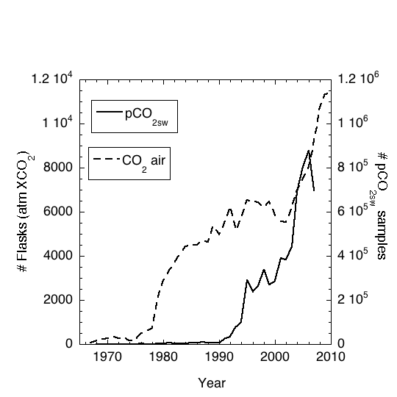

Figure 1. Tabulation of number of air CO₂ samples (dashed line, left axis) and water pCO₂ samples (solid line, right axis). The tabulations for air samples are from NOAA/ESRL/GMD (courtesy T. Conway), and from the SOCAT database. Note the hundredfold difference in the scales of the axes.

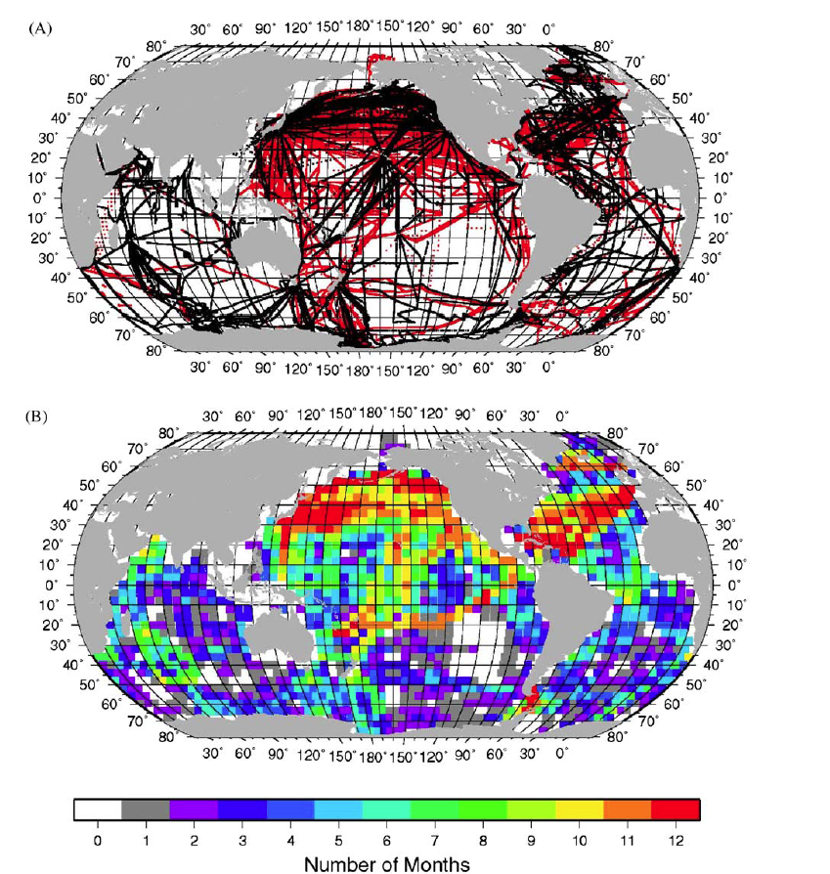

Figure 2. (a) Cruise tracks with pCO₂ measurements. The black lines indicate the tracks with measurements used in Takahashi et al. (2002) and the red lines are new measurements added to the database in T-09. (b) Number of months in each 4˚ by 5˚ box area where at least one surface water pCO₂ measurement has been made since the early 1970s. White areas are pixels that have no measurements. Reproduced from Fig. 1 in T-09.

1

Figure 3. Trend in ocean CO₂ uptake based on an ocean model ensemble. The solid line (left axis) shows the increasing annual uptake while the dashed line (right axis) gives the decreasing fraction of fossil fuel CO₂ that is absorbed from the ocean. Data are from:
http://www.tyndall.ac.uk/global-carbon-budget-2010#Jump%20to%20Data

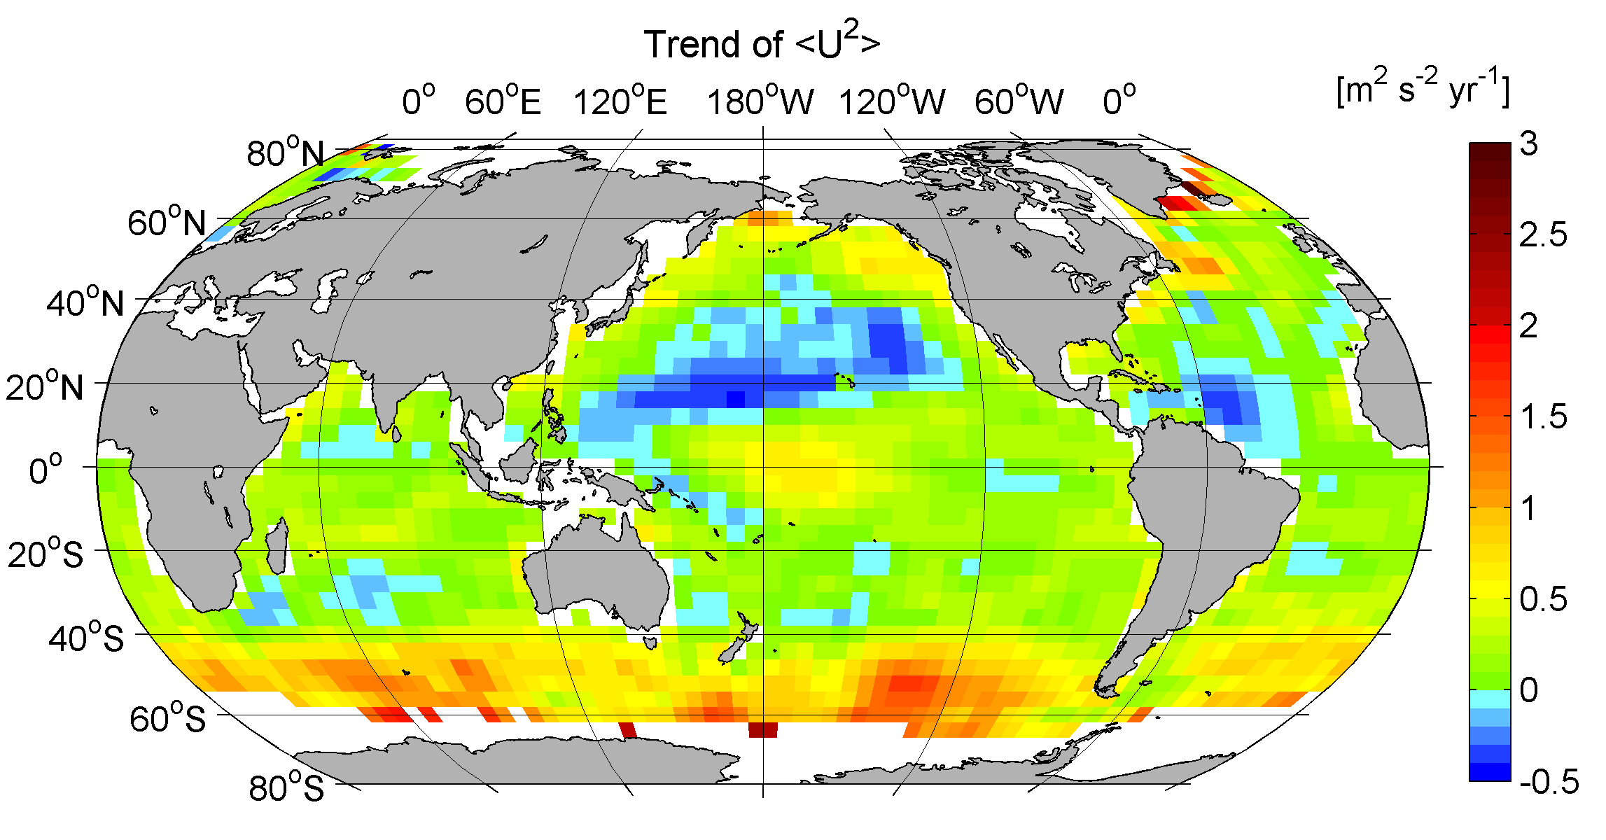

Figure 4. Global trend of the second moment of the wind <U²> for the 20-year CCMP wind product (1990-2009).

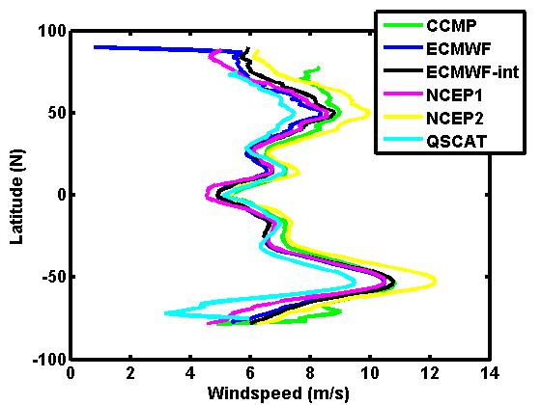

Figure 5. Comparison of several global wind products showing the zonal distribution for the year 2000. The differences of up to 2 m s⁻¹ are observed but the biases are not always consistent between high and low latitudes. CCMP = Cross Calibrated Multi-Platform winds (Atlas et al., 2011); ECWMF =European Center for Medium Weather Forecasting; NCEP = National Center for Environmental Prediction; QSCAT = QuikSCAT polar orbiting satellite with an 1800 km wide measurement swath on the earth's surface equipped with the microwave scatterometer SeaWinds. (Figure courtesy of C. Sweeney)

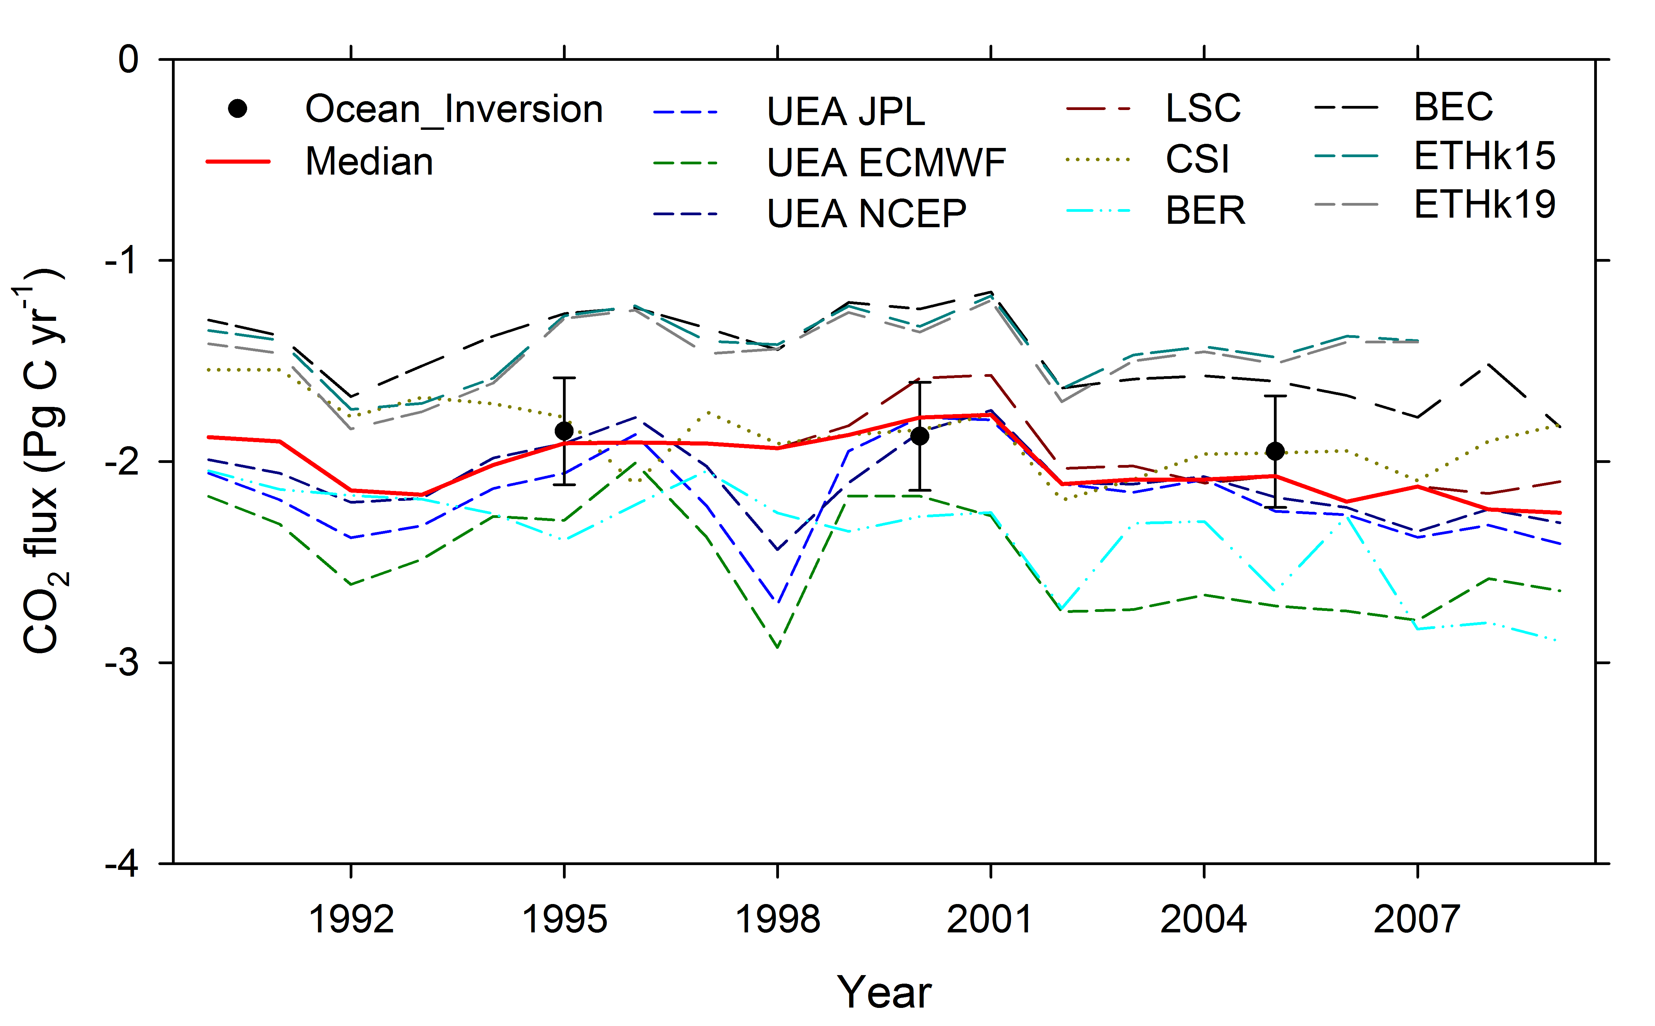

Figure 6. Summary of annual global sea air CO₂ fluxes from the ocean general circulation models, O-GCMs (lines), and ocean inversion estimate (circles with uncertainty bars). Similar line types for the O-GCMs indicate that the models have the same heritage. The median (solid red line) is the median of UEA JPL, LSC, CSI, BER, and ETHk15.

1

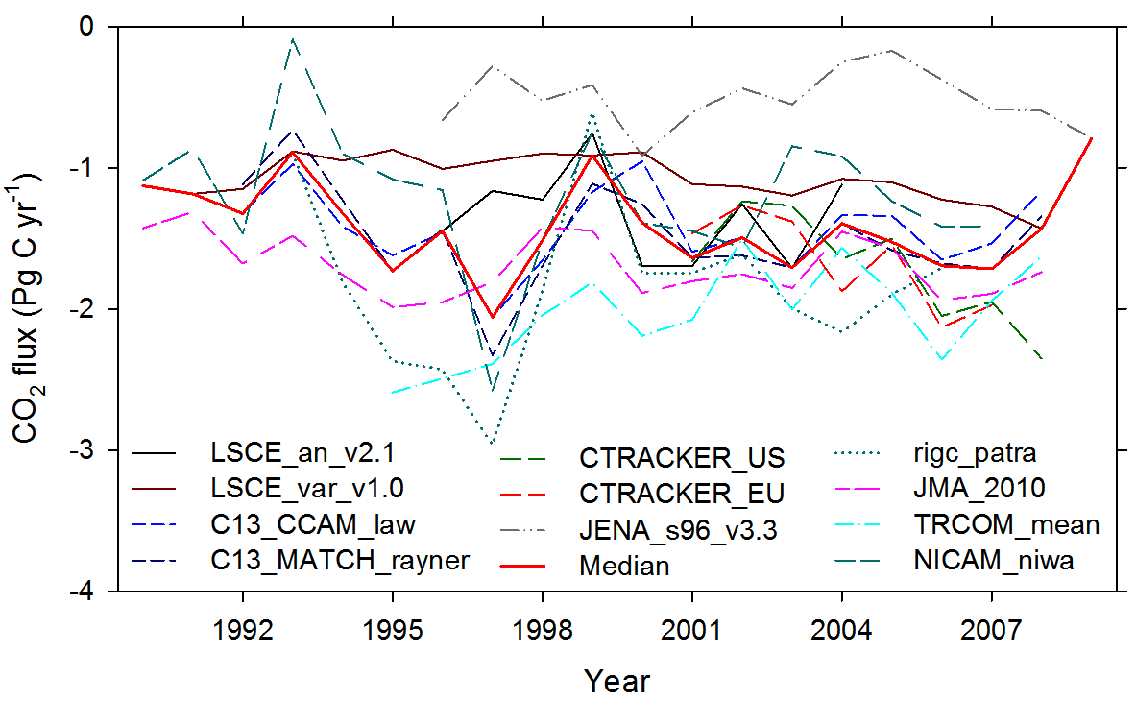

Figure 7. Summary of annual global sea air CO₂ fluxes from atmospheric inverse models. The red line is the median of all models shown.

Figure 8. Zonal distribution of: (a) square root of the second moment <U²>^{0.5} of the 20-year monthly mean CCMP wind product (thick solid line) and the standard deviation of the product (thin solid line with squares); (b) the ∆pCO₂ and the standard deviation of ∆pCO₂ of the monthly T-09 climatology; and (c) the specific flux [mol m² mo⁻¹] and standard deviation of the monthly mean flux over 20-years. The error bars of the means are the standard deviation of the 5˚ longitude bins in the particular latitude band.
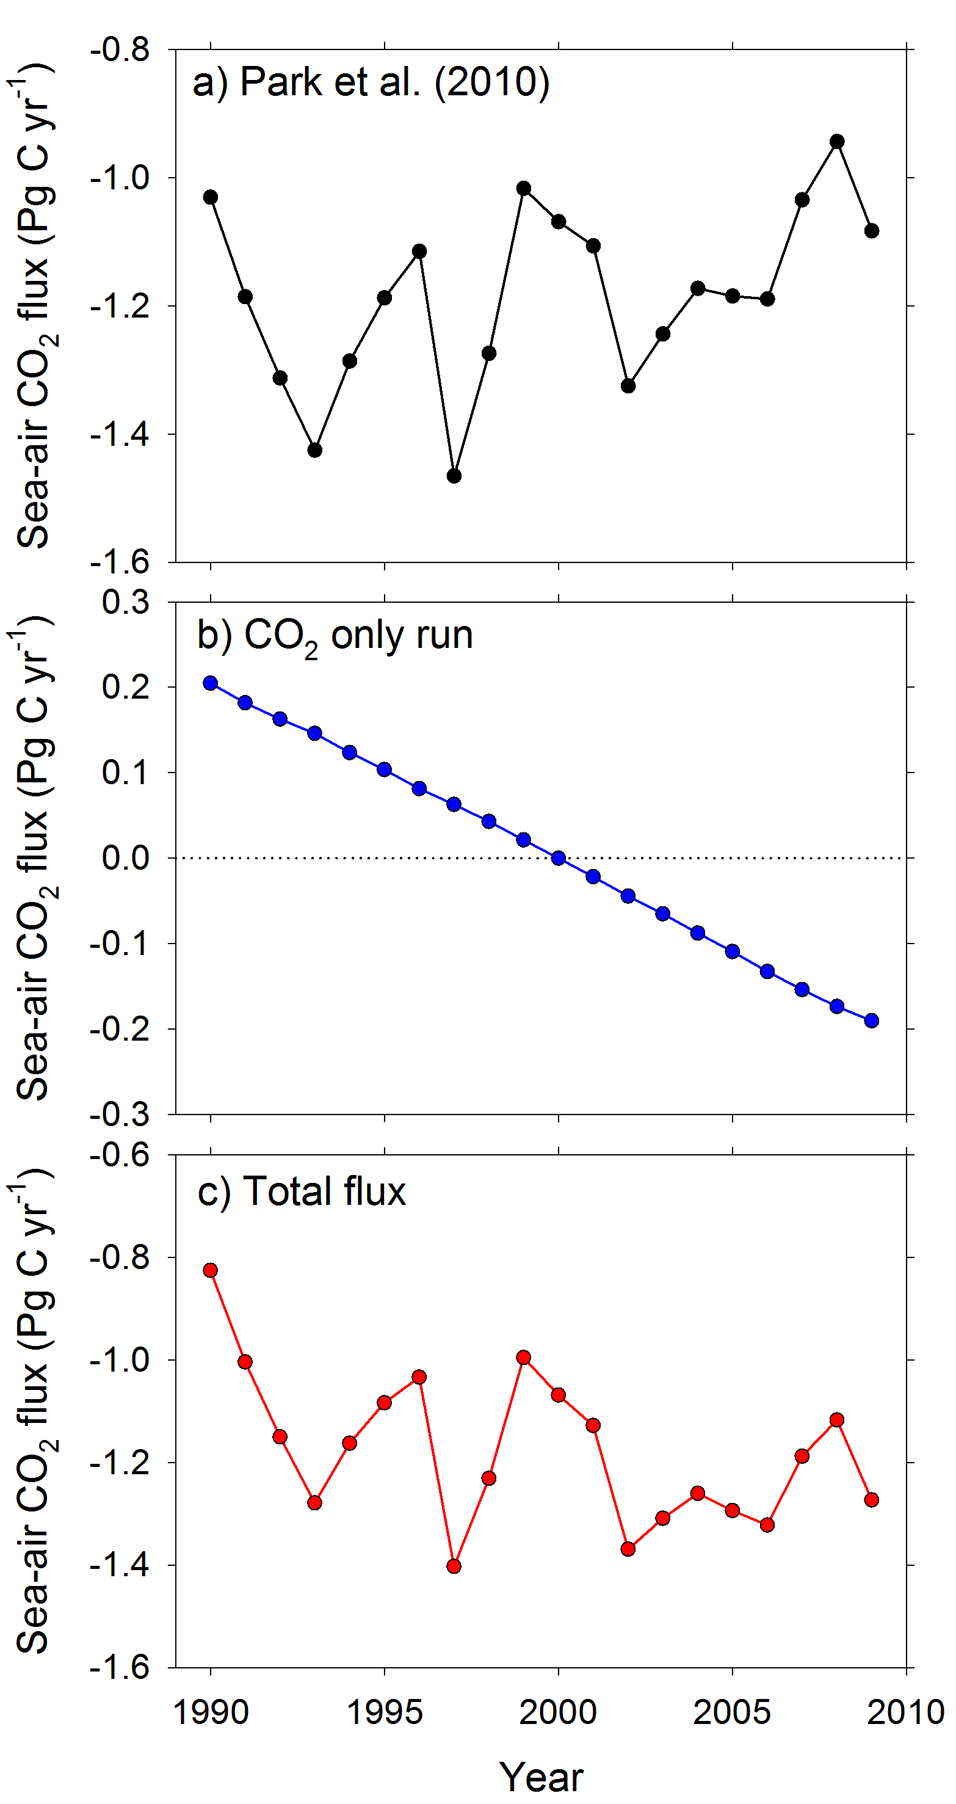

Figure 9. Global sea-air CO₂ fluxes versus time determined with the empirical approach of Park et al. (2010) (a); the global average trend of sea-air flux caused by increasing atmospheric CO₂ based on an ocean model output and normalized to year 2000 (b); the net sea-air flux based on the empirical approach and the CO₂ only run (c).

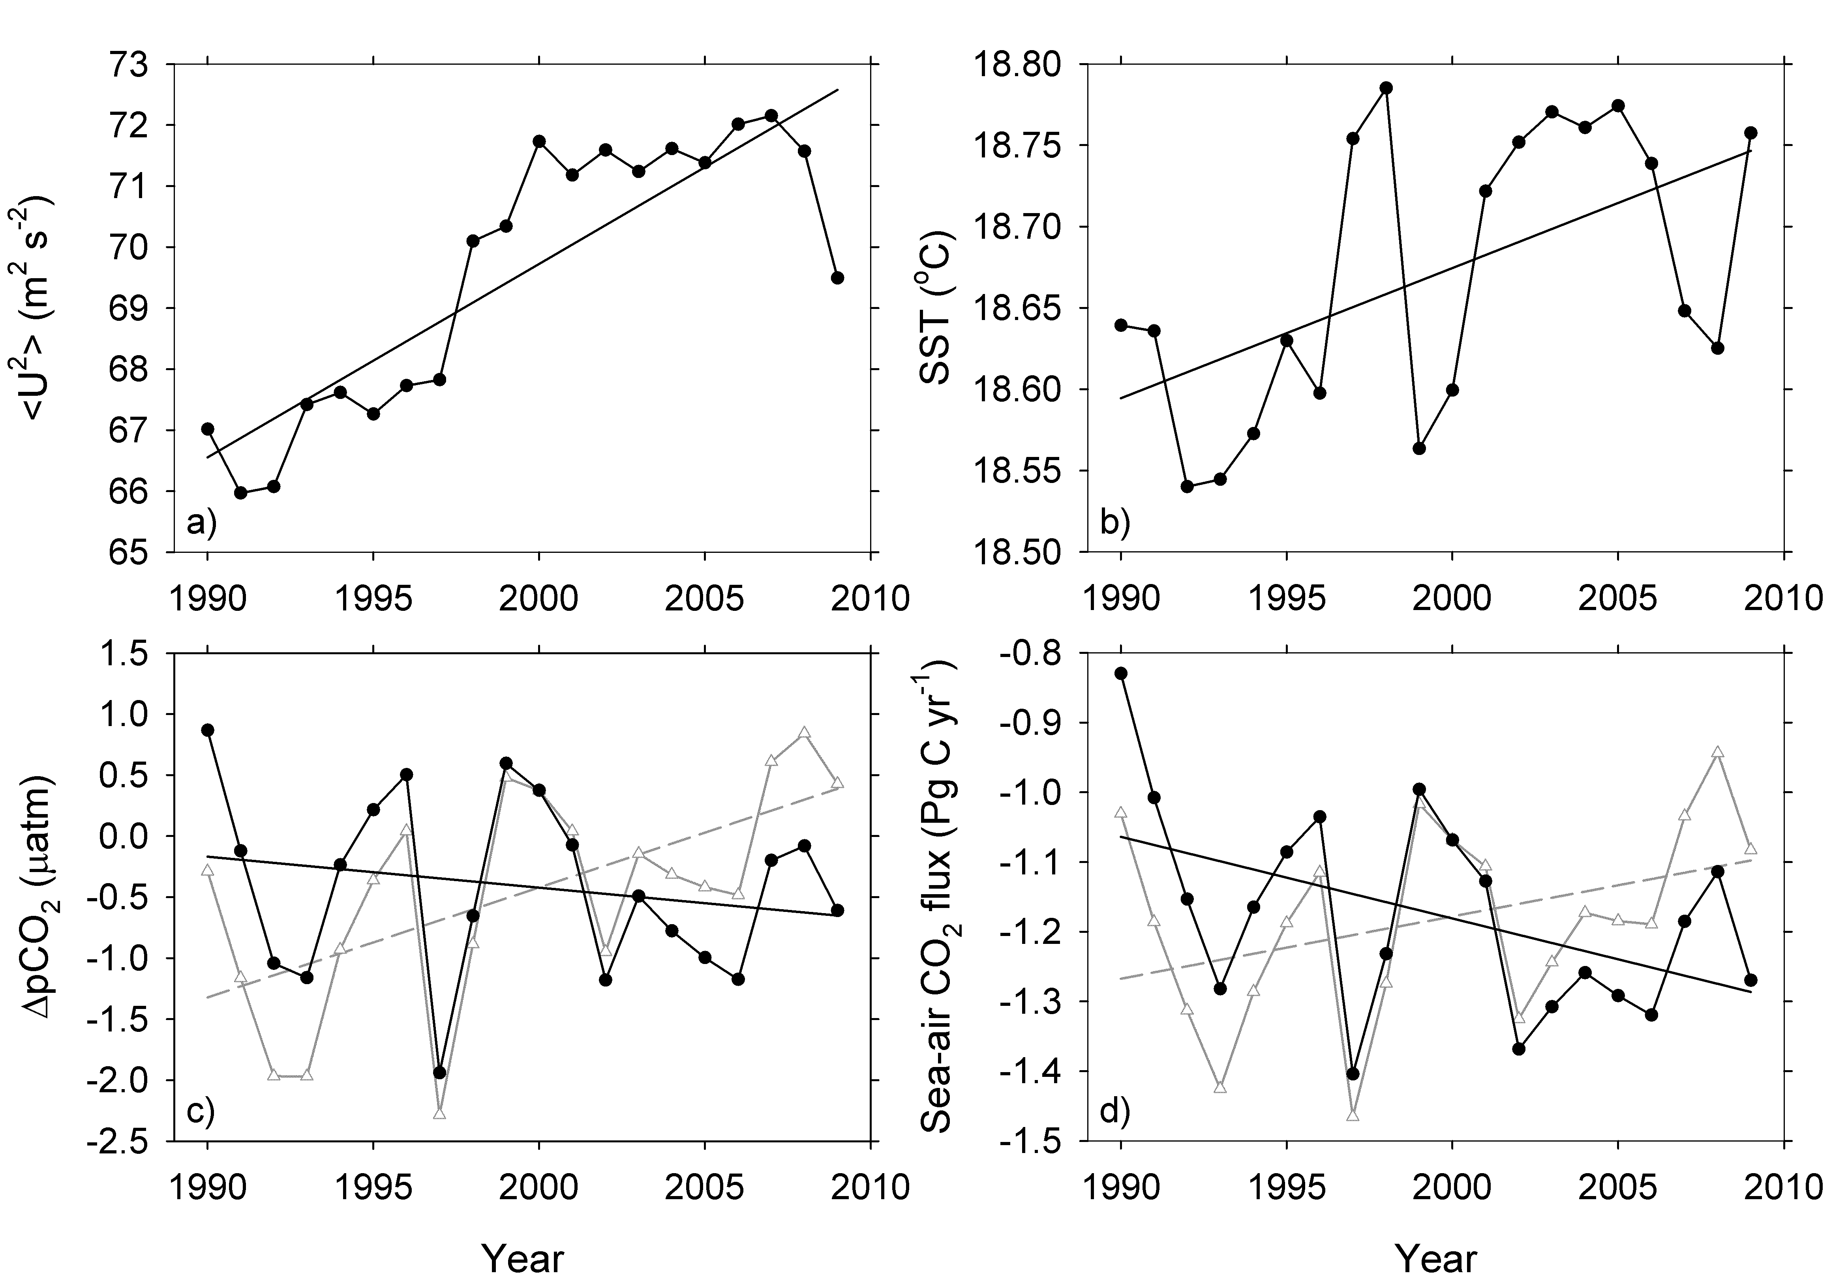

Figure 10. Global ocean change in: (a) second moment of wind; (b) SST; (c) ∆pCO₂, assuming no atmospheric CO₂ increase (gray line) and including atm CO₂ forcing (black line); and (d) sea-air CO₂ flux over the past two decades (1990-2009) without atm. CO₂ forcing (gray line) and with atmospheric CO₂ forcing (black line). The change in ∆pCO₂ is determined according to the procedures of P-10. The linear regressions (solid line) for area-weighted <U²>, SST, ∆pCO₂ and flux are 0.32± 0.04 (m s⁻¹)²; 0.008 ± 0.003 ˚C; -0.03 ± 0.03 µatm including atm CO₂ forcing ; and -0.012± 0.005 Pg C yr⁻¹ including atm CO₂ forcing, respectively.

