DRAFT December 4, 2010

Oxygen Winkler titrations by NOAA/AOML in support of Deep Water Horizon spill monitoring

Rik Wanninkhof, NOAA/AOML
Geun-Ha Park, NOAA/AOML/CIMAS
George Berberian, NOAA/AOML/CIMAS

Summary

This report details the measurement of oxygen (O₂) by the Winkler method on the ships the Nancy Foster, the Pisces, the Bigelow; the Brooks McCall and the Ocean Veritas in response to the oil spill of Deep Water Horizon 252 well. Most of the data are from near the well and were obtained from July 1, 2010 to August 30, 2010. The purpose of the measurements were to assess the accuracy of the oxygen sensors on the CTD, henceforth referred to as CTD/O₂ and to determine if the CTD/O₂ sensor provided (low) biased reading in presence of oil. Based on the analyses we believe that the O₂ analyses from CTD/O₂ and Winkler's on the ship were accurate to within 2 % (≈ 4 _{µM}ol/l, 0.1 ml, or 0.15 ml/l), with exceptions listed below. The depressions in O₂ values observed with the CTD/O₂ at depths of 1000- 1300m in the layer with diffuse oil were verified with Winkler measurements and are attributed to oxidation of the oil and associated gas.
Based on the Winkler measurements we cannot conclusively recommend adjustments to the CTD/O₂ data. A qualitative assessment suggests that the output of CTD/O₂ sensors on the Brooks McCall and Ocean Veritas agreed with each other and with the Winkler measurements to within 2%. The CTD/O₂ sensor on the Pisces appeared to read low by about 3 % compared to the Bigelow CTD/O₂ and Winkler O₂ values that agreed well with each other. The Nancy Foster had the largest dataset of Winkler O₂ values for comparison, and showed Winkler O₂ values that are about 2.6 ± 2 % higher than the CTD/O₂ values in water from 100-1000 m depth but showed larger positive deviations of up to 10 % in surface and deep water which we cannot explain.

Pre-amble

One of the core measurements in monitoring the impacts of the Deep Water Horizon deep plume were measurements of oxygen with a polarographic sensor on the Conductivity-Temperature-Depth (CTD) profiler. These CTD/O₂ measurements were performed with a SEABIRD™ model SBE-43 sensor. A common protocol for accurate oxygen measurements is to standardize the CTD/O₂ trace with discrete samples taken throughout the water column and analyzed by the Winkler technique using a from Niskin bottle/Rosette package that is lowered with the CTD. Since the initial requirements for oxygen monitoring were not too stringent and because of the haste to get the measurement campaigns executed, the Winkler calibration requirement was not instituted for all cruises. However, concerns about sensor biases in presence of oil, and to validate the measurements lead to a "scramble" to obtain measurements. This report provides the description of the O₂ Winkler analyses made shipboard and at the shore-based laboratory by the oxygen group at the Atlantic Oceanographic and Meteorological Laboratory (AOML). It includes measurements on the following ships: the Nancy Foster, the Pisces, the Bigelow; the Brooks McCall and the Ocean Veritas covering a time period from July 1, 2010 to August 30, 2010.

Introduction

Approximately 25 % of the oil released, or about 50 million gallons of oil from the wellhead of the Deep Water Horizon 252 well (DWH 252), dispersed and remained at a depth of 1100 to 1300 m. Much of this oil degraded by microbial action, which caused a decrease of oxygen at these depths. As part of the compliance monitoring, oxygen levels were determined from O₂ sensors on the CTD (CTD/O₂). The SEABIRD model SBE-43 Clark polarographic membrane type sensor provide full water column O₂ with a resolution of 1-m interval. This model sensor was used on all the ships described here. The sensors appear to faithfully reproduce small-scale (< 20 m) variations in O₂ levels but it is not clear if there are interferences and artifacts caused by the presence of oil. Moreover, to generate high quality observations from the CTD/O₂ sensor adjustments for, generally small, offsets of the sensor are required. This is commonly done by adjusting the profiles to accurate titrations with the Winkler method. Software is available from SEABIRD to perform these adjustments that empirically take into account upcast and downcast offsets due to sensor lag and hysteresis. All CTD/O₂ data were reduced using the with the same routines with the latest software package. The CTD/O₂ profiles that are provided after adjustments are the downcast values. If sufficient high quality Winkler samples are taken the final CTD/O₂ values can be adjusted for the differences between upcast CTD/O₂ profile and the discrete O₂ samples obtained on the upcast. These adjustments to the Winkler values were not performed for the CTD/O₂ data mentioned in this report.

During the initial response phase few ships monitoring the environment of the well were equipped for O₂ Winkler titrations. The oxygen group at AOML was asked to provide Winkler support in large part because of their experience in providing accurate analyses on the CLIVAR/CO₂ repeat hydrography cruises. During the June-August, 2010 timeframe the group performed Winkler O₂ measurements on the Nancy Foster (Cruise 10-13), the Ocean Veritas (Cruise #12), the Brooks/McCall (Cruise #16 &17), and supported O₂ measurements on the Bigelow and Pisces, including shore-based analyses for the latter two ships. As described below different systems, and different levels of experience of sampling and analyses personnel contributed to variations in quality of data. A summary of results is provided in Table 1. A description of operations, and pre- and post- cruise calibrations and checks for the different ships is presented for each ship.

Table 1.

Ship Cruise # samplesª # dups.^{b} Precision^{c} Winkler-CTD/O₂^{d}
µmol/l µmol/l
Nancy Foster 10-13 594 13 0.21±0.17 6.7±7.8 n=567
Ocean Veritas 12 85 0 -1.9±4.0 n=70
Brooks/McCall 16 51 3 4.26± 4 -4.1± 6.1 n=35
Brooks/McCall 17 42 -4.2±8.9 n=28
Bigelow 10-06 87 20 2.9±3.0 3.5±4.4 n=66
Pisces 88 1 0.7 12.3 n= 4

a: number of Winkler samples analyzed
b: number of duplicates taken from Niskin bottles
c: average difference of the duplicates and the standard deviation of the average difference
d: difference and standard deviation of difference between the Winkler values and the CTD/O₂ sensor value at the bottle trip depth along with the number of samples used in the comparison. All Winkler values considered questionable (QC=3) or bad (QC=4) were not used.

Nancy Foster
Operator: Andy Stefanick, AOML
Dates of O₂ sampling: July 1- July 18, 2010

The Nancy Foster completed a 2-legged cruise from Key West to Pascagoula with a stop in Tampa. The chief scientist of the cruise designated as NF10-13 was Ryan Smith. Andrew Stefanick performed oxygen analyses with assistance from Pedro Pena. The oxygen titrator was an automated system with colorometric endpoint detection (Friederich et al. 1984). Five standardization runs were perfumed using a 0.01 N potassium iodate (KIO₃) standard. Standardization was performed by titrating 2, 4, 6, 8, and 10 ml aliquots of iodate. The slope and intercept were used to quantify the thiosulfate concentration and determine the blank, respectively. Reproducibility of blank and slope (Table 2) were excellent throughout the cruise suggesting stable instrumentations and good operator protocols. The thiosulfate disperser (Methrohm) was replaced towards the end of the cruise because of a small leak in the system. The standardization curves before and after the replacement were very similar suggesting that the leak had no discernable impact on the result. Limited duplicates were measured except at the end of the cruise near the DWH-252 spill where all samples at depth were duplicated. Reproducibility of these samples was excellent.
------
Table 2. Standardization for Nancy Foster.

Date Standard name slope intercept* R²
7/4/10 nf1013a.std 25.087 -0.0003 0.9999
7/7/10 nf1013b.std 24.978 -0.0007 0.9999
7/11/10 nf1013c.std 25.118 -0.0025 0.9999
7/15/10 nf1013d.std 25.152 -0.0013 0.9999
7/18/10 nf1013e.std 24.844 0.0097 0.9999

The standardization was performed by titrating 2, 4, 6, 8,and 10 ml aliquots of iodate. The ml of aliquot versus thiosulfate titrated is plotted and the slope and intercept of the line as those given above. For standard calibration nf1013a and nf1013d the 10 ml titration value was not used and for standard nf1013c the 2 ml aliquot was not included in the linear regression.
---------
Two independent SEABIRD SBE43 oxygen sensors were used on the CTD and data was processed according to protocols outlined in SEABIRD. The two sensors yielded identical data (to better than 1 µmol/l). Pre- and post-cruise calibrations were performed at SEABIRD with one sensor showing no drift and the other a change in calibration coefficients suggesting a drift of about 1 µmol/l (@ 150 µmol/l). The comparison with the CTD/O₂ data yielded some puzzling results as shown in Figure 1. The ratio of Winkler and CTD/O₂ is about 1.03 but strong positive deviations in surface water and in deep water. No explanations for these trends are offered despite discussions and checks by SEABIRD of the data. The correspondence of the two CTD/O₂ sensors suggest that the processed values are correct. While CTD/O₂data is commonly corrected to the Winkler values we do not recommend this procedure in this instance.

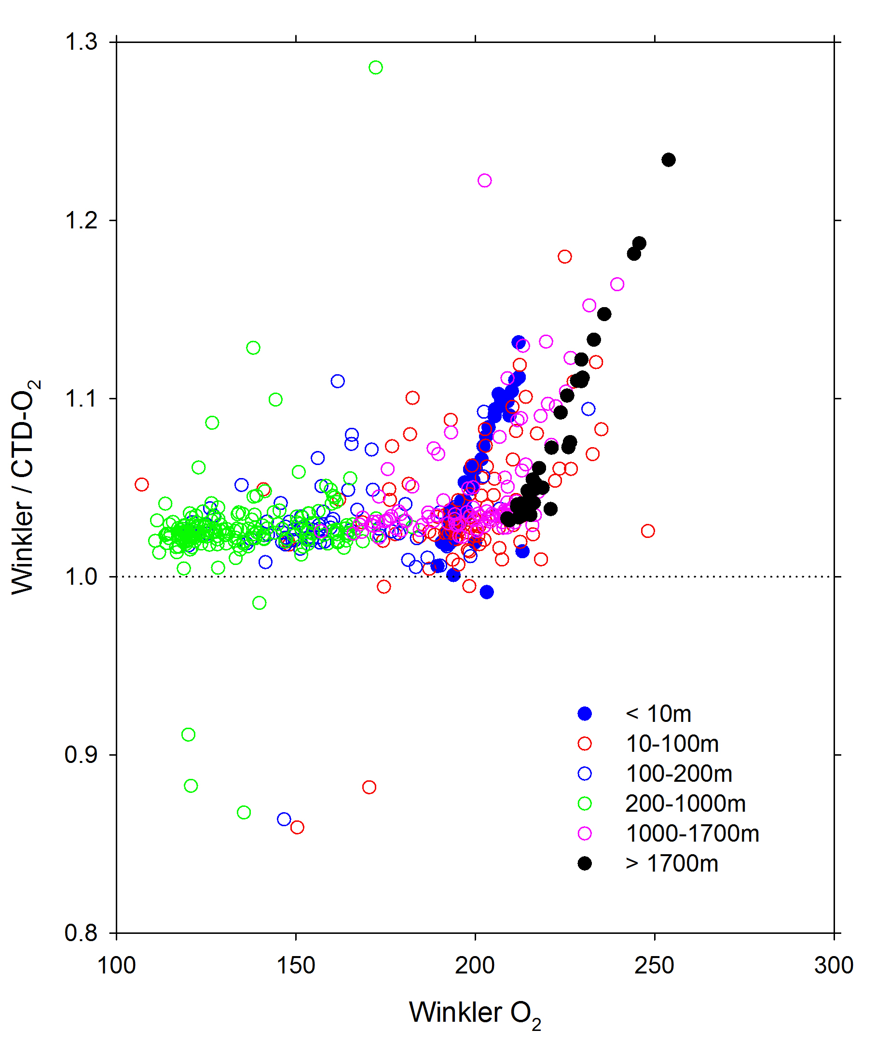

Figure 1: ratio of Winkler O₂ analyses the corresponding CTD/O₂ values for the Nancy Foster cruise 10-13. The trends at surface and at depth are unexplained.

Ocean Veritas

Operator: George Berberian AOML/CIMAS
Dates: August 1 to 2, 2010 (Cruise 12)

The Ocean Veritas and Brooks McCall operated near the MC 252 well head .
The Ocean Veritas data was obtained with an automated titrator with amperometric endpoint detection system (Langdon 2010). The system was standardized using a single aliquot of iodate. 4 standards were run on August 1. With an average endpoint for the 0.01 M solution of 701.75 ± 0.66
The data quality was satisfactory. 15 of 85 samples had a quality control flag 3 or 4, which refer to questionable or bad, respectively.
The agreement between the Winkler analyses and the CTD/O₂ (SBE-43) is -1.9 ± 4.0 µmol/l (n=70).

Brooks McCall
Operator: George Berberian AOML/CIMAS
Dates: August 4 to August 7, 2010 (Cruise 16)
August 10 to August 11, 2010 (Cruise 17)

The amperometric oxygen titrator was transferred from the Ocean Veritas to the Brooks McCall in Port Fourchon LA on August 3, 2010.
The system was standardized using a single 10 ml aliquot of potassium iodate. 6 standard run were performed on August 4 with 3 values omitted. The average endpoint for the 0.01 M KIO₃ solution for the 3 remaining standards was 703.64 ± 0.51. The three omitted values had an endpoint that was about 3 higher.
Three duplicate values were taken that had an average difference of 4.3 ± 4.0 µmol/l

For cruise 16, 16 samples were flagged questionable or bad (3 or 4) based on comparisons with CTD/O₂. For the remaining samples the agreement (Winkler O₂ - CTD/O₂) was -4.0 ± 6.1 µmol/l
4 aliquots of KIO₃ were analyzed on August 6 with 3 results omitted. The average endpoint for the 0.01 M solution for the 3 remaining standards was 701.234 ± 0.49.
For cruise 17 the system was standardized using 10 ml aliquots of potassium iodate. 8 standards were run on August 9 with the first 5 values omitted. The average endpoint for the 0.01 M solution for the 3 remaining standards was 700.64 ± 0.77. The five omitted values had an endpoint ranging from 2 to 50 higher. For cruise 17, 14 samples were flagged questionable or bad (3 or 4) based on comparisons with CTD/O₂. For the remaining samples the agreement (Winkler O₂ - CTD/O₂) was -4.2 ± 8.9 µmol/l (n=28). The entire last cast (station 172) was flagged as 4 because of a large offset between Winkler's and CTD O₂ (≈ -27 µmol/l with Winkler being lower than CTD). This is attributed to analyzing the samples too soon after adding the reagents. The ship was heading into port to avoid inclement weather and samples had to be analyzed very soon after sampling.

Bigelow
NOAA Fisheries Research Vessel Henry B. Bigelow
Cruise No. HB 10-06
Sub-surface Oil and Ecological Impacts (Gulf of Mexico)
Operators: Liza Baskin and Chris Sumner
Leg 1, July 28- August 10, 2010 Key West- Pascagoula
Leg 2, August 13 – August 22, 2010 Pascagoula – Key West
The vessel worked primarily within 10 km of the Deepwater Horizon wellhead for Leg 1.
During leg 2 work was performed in the vicinity of the wellhead but also up to 60 km from the wellhead.

An amperometric O₂ system from AOML (Langdon, 2010) was installed on the Bigelow in Key West.
Liza Baskin collected approximately 30 samples for Winkler Titrations on board. The auto-titrator was damaged on August 8 (station 33), towards the end of the first leg of cruise because it was connected to the wrong power source. Subsequent to the failure the samples were sampled and preserved (“pickled”) at sea for analysis on shore by George Berberian, AOML.
For the second leg all samples were stored and analyzed on shore. Samples were stored according to protocol, in particular a water seal was maintained on all samples, and all the samples were returned to AOML with analyses performed on the amperometric system that was used for the analyses on the Brook McCall and Ocean Veritas.
The results of duplicate analyses are presented in Table 3 and comparison with CTD values is shown in Table 4.

Standards: shore based
August 28, 2010: standard 703.0 ± 0.6
September 2, 2010: 5 standards average 704.6 ± 0.32

Comparison of CTD/O₂ with Winkler values yielded the following results:

Table 3. Winkler duplicates:
On board:
Bigelow
Key# Date Pres O₂ (µmol/l) O₂ (µmol/l) Diff (µmol/l)
Ship
211 Aug 03 64.5 213.2 211.7 1.5
408 Aug 04 504.4 123.4 124.1 0.8
607 Aug 05 403.5 125.5 125.0 0.5
903 Aug 07 1146.4 185.2 190.3 5.1
1002 Aug 07 1312.9 206.6 208.9 2.4
1105 Aug 07 1159.0 169.9 172.0 2.1
Shore
1510 Aug 07 100.4 185.8 185.5 0.3
1607 Aug 08 705.2 138.8 142.1 3.3
1701 Aug 08 1584.1 213.9 213.4 0.5
1805 Aug 08 604.1 128.2 127.3 0.9
2006 Aug 08 704.5 140.2 141.1 0.9
2106 Aug 08 807.9 154.2 154.3 0.0
2309 Aug 09 201.0 155.4 163.4 8.0

3306 Aug 15 504.7 119.1 123.0 3.8
3403 Aug 15 908.6 169.3 164.4 5.0
3503Aug 15 1109.5 190.5 191.5 1.0
4705 Aug 17 605.4 137.1 128.5 8.6
5306 Aug 18 503.9 135.4 134.2 1.3
5706 Aug 18 416.6 120.8 127.4 6.6
5807 Aug 19 403.7 128.3 128.8 0.5
av_Dif stdev count
ship 2.1 1.7 6
shore 2.9 3.0 14

Key# = stations # + Niskin position*100

Table 5. Comparison of Winkler O₂ and CTD/O₂ for the Bigelow

Key# Date CTD/O₂ O₂ Winkler Winkler- CTD/O₂
(µmol/l) (µmol/l) (µmol/l)
202 3-Aug 146.9 140.0 -7.0
211 3-Aug 213.6 213.2 -0.4
307 3-Aug 156.6 158.4 1.8
312 3-Aug 226.0 223.2 -2.7
405 4-Aug 187.9 192.9 5.0
408 4-Aug 121.5 123.4 1.9
601 5-Aug 179.7 182.6 2.9
607 5-Aug 124.8 125.5 0.7
610 5-Aug 151.4 151.1 -0.3
611 5-Aug 224.0 220.8 -3.2
703 5-Aug 156.5 157.4 0.9
705 5-Aug 130.1 130.0 -0.1
901 7-Aug 207.0 213.3 6.3
903 7-Aug 186.7 185.2 -1.5
905 7-Aug 166.3 169.1 2.8
907 7-Aug 121.9 124.1 2.1
1002 7-Aug 202.1 206.6 4.5
1005 7-Aug 186.9 190.5 3.5
1011 7-Aug 153.1 155.3 2.3
1101 7-Aug 205.5 210.4 4.9
1105 7-Aug 169.8 169.9 0.1
1108 7-Aug 153.0 157.6 4.6
1510 7-Aug 184.9 185.8 0.9
1604 8-Aug 172.6 179.4 6.8
1607 8-Aug 136.4 138.8 2.3
1612 8-Aug 198.6 200.8 2.1
1701 8-Aug 208.5 213.9 5.4
1704 8-Aug 187.7 192.8 5.1
1709 8-Aug 144.7 147.0 2.3
1711 8-Aug 206.0 205.0 -1.0
1802 8-Aug 185.9 189.0 3.1
1805 8-Aug 125.8 128.2 2.4
1812 8-Aug 198.7 201.4 2.7
2002 8-Aug 194.3 213.7 19.3
2006 8-Aug 138.2 140.2 2.0
2106 8-Aug 151.9 154.2 2.4
2112 8-Aug 198.5 200.0 1.5
2307 9-Aug 125.0 127.7 2.7
2309 9-Aug 154.1 155.4 1.3
2311 9-Aug 209.6 207.6 -2.0
2402 9-Aug 189.1 192.7 3.7
2407 9-Aug 118.8 121.7 2.9
3301 14-Aug 206.9 211.0 4.1
3306 15-Aug 117.6 119.1 1.6
3312 15-Aug 201.8 206.0 4.2
3403 15-Aug 163.2 169.3 6.2
3413 15-Aug 146.6 152.2 5.5
3414 15-Aug 184.8 185.2 0.4
3503 15-Aug 182.4 190.5 8.1
3505 15-Aug 149.3 153.8 4.4
3507 15-Aug 119.9 128.9 9.1
4705 17-Aug 125.5 137.1 11.6
4706 17-Aug 118.3 123.5 5.2
4708 17-Aug 122.7 127.4 4.7
5306 18-Aug 121.0 135.4 14.4
5309 18-Aug 137.9 150.9 13.0
5310 18-Aug 182.8 186.1 3.4
5704 18-Aug 166.9 169.7 2.8
5706 18-Aug 120.3 120.8 0.4
5708 18-Aug 120.8 129.2 8.3
5801 19-Aug 215.2 220.1 4.9
5807 19-Aug 119.1 128.3 9.2
5818 19-Aug 227.4 223.9 -3.5
6202 19-Aug 209.9 208.8 -1.1
6206 19-Aug 126.4 139.7 4.1
6211 20-Aug 230.4 235.7 5.3

Winkler-CTD
Ave_dif stdev count
all 3.4 4.2 67
ship 1.3 3.1 23
shore 4.4 4.3 44

There is no significant difference in the CTD/O₂ and Winkler values such that no adjustments are recommended to the CTD/O₂ data from the Bigelow.

Pisces
Date of O₂ sampling: August 18 - September 1, 2010
O₂ analyst on shore: George Berberian, AOML
The Pisces spent much of its time SW of the DWH wellhead.
For the Pisces O₂ was sampled and preserved by inexperienced operators. Samples were shipped from Pascagoula to Miami after the cruise. Upon arrival most samples were lacking a water seal and many samples had bubbles in the bottles. While the integrity of samples containing bubbles is compromised it was decided to run all samples. As expected samples appeared to be biased high due to likely diffusion of air into the bottles as manifested by the bubbles. In the table below the samples were differentiated based on approximate bubble diameter. The difference between Winkler and CTD/O₂ increased with bubble size indicative of ambient air diffusing into the sample (see Table 6)

Standards: shore based:
September 7 with new thiosulfate: standard 707.7 ± 0.16 N=5 blank =1.7
September 1: standard 707.3 ± 0.16 N=5 blank =1.7

Table 6. Table 5. Comparison of Winkler O₂ and CTD/O₂ for the Pisces

Ave_dif stdev count
No bubble 12.3 2.2 6
Small bubble 0.3 cm 13.1 1.6 29
Medium bubble 0.8 cm 16.0 4.6 44
Large bubble 1.3 cm 16.6 3.9 12
All 15.0 4.0 91

While the quality of samples precluded a definitive recommendation on possible offsets, a comparison of CTD/O₂ traces of the PISCES and BIGELOW at a similar sampling location suggests that the CTD/O₂ sensor on the PISCES were reading approximately 12 µmol/l low.

Equipment and standard checks.

Since biases in Burette volume and Iodate standard concentration will directly impact the determination of the results. These were checked after the field and laboratory analyses.

The Wheaton burette used to dispense the iodate standards had not changed its assigned value appreciably since the previous check:

Table 7. Pre- and post-cruise burette calibration used for standards.
Burette #ª Pre-cruise volume (ml)^{b} Post-cruise volume (ml)
AOML 3 9.953 9.965
AOML 4 9.975 9.977

a: Volume at 20 ˚C
b: The pre-cruise volume was used for all calculations of standard values. The difference in volume for AOML3 translates into a difference of 0.2 µmol/l (@ 150 µmol/l)

The potassium iodate standard (inadvertently) was left on the Pisces and was cross-calibrated with the standard prepared by Eric Quiros of Texas A&M's Geochemical and Environmental Research Group (GERG ) who operated a similar amperometirc system as used in our analyses on the Pisces during Deep Water Horizon effects monitoring in September 2010 immediate after the cruise for which the samples listed above were taken.

The calibration of the standards by Eric Quiros was as follows. Both the Texas A&M standard and that of AOML were 0.01 N potassium iodate (KIO₃):

AOML STD TAMU/GERG STD
titers in µl titers in µl.

700.37 706.13
700.24 705.75
700.16 705.59
699.00 706.12

Average 699.94 705.90
Std dev 0.63 0.27

Assessment of CTD/O₂ and Winkler values obtained during the AOML campaign.

The two objectives of the AOML sampling and analysis campaign were to:
- Estimate the overall accuracy of the CTD/O₂ signal and determine ship-to ship differences in CTD/O₂ sensor
- Determine if there were sensor artifacts due to presence of oil.

The results above suggest that the CTD/O₂ values agreed with the Winkler values to well within 14 µmol/l (≈ 0.3 ml/l or 0.4 mg/l) for all cruises. Moreover, for the stations were the CTD/O₂ showed a decrease associated with presence of oil as indicated by a fluorometer response, the Winkler results confirmed an O₂ decrease as well suggesting no CTD/O₂ artifact and that the decrease is caused by oxidation of oil.

Some graphical assessments are presented below. These provide a visualization of difference between CTD/O₂ and Winkler O₂ as well as some spot comparisons.
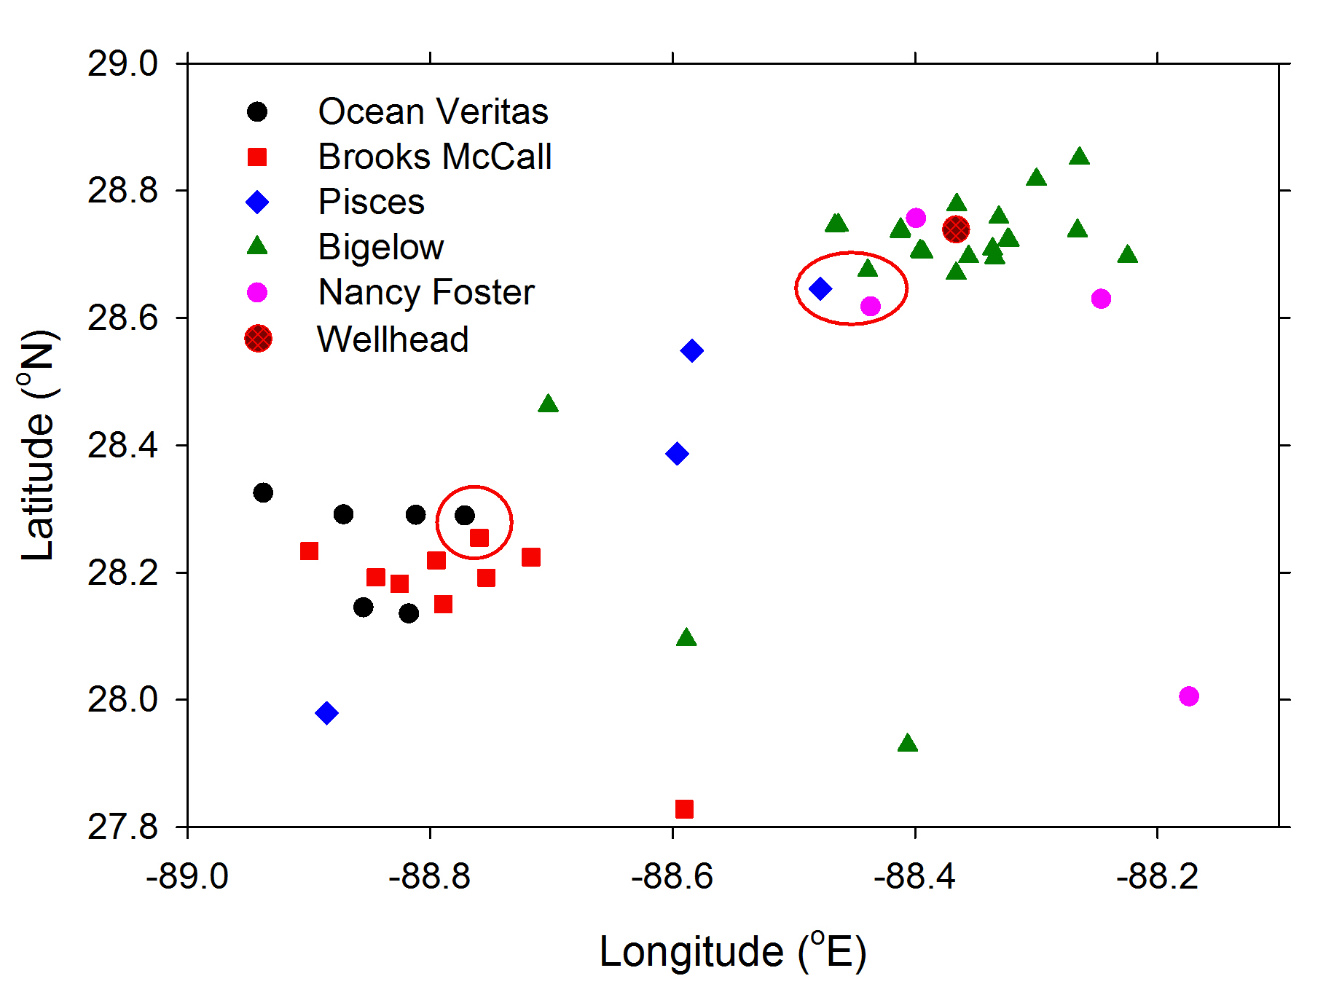

Figure 2. Distribution of stations near the wellhead of the DWH MC252 well. The circles show the stations compared in the graphs below.

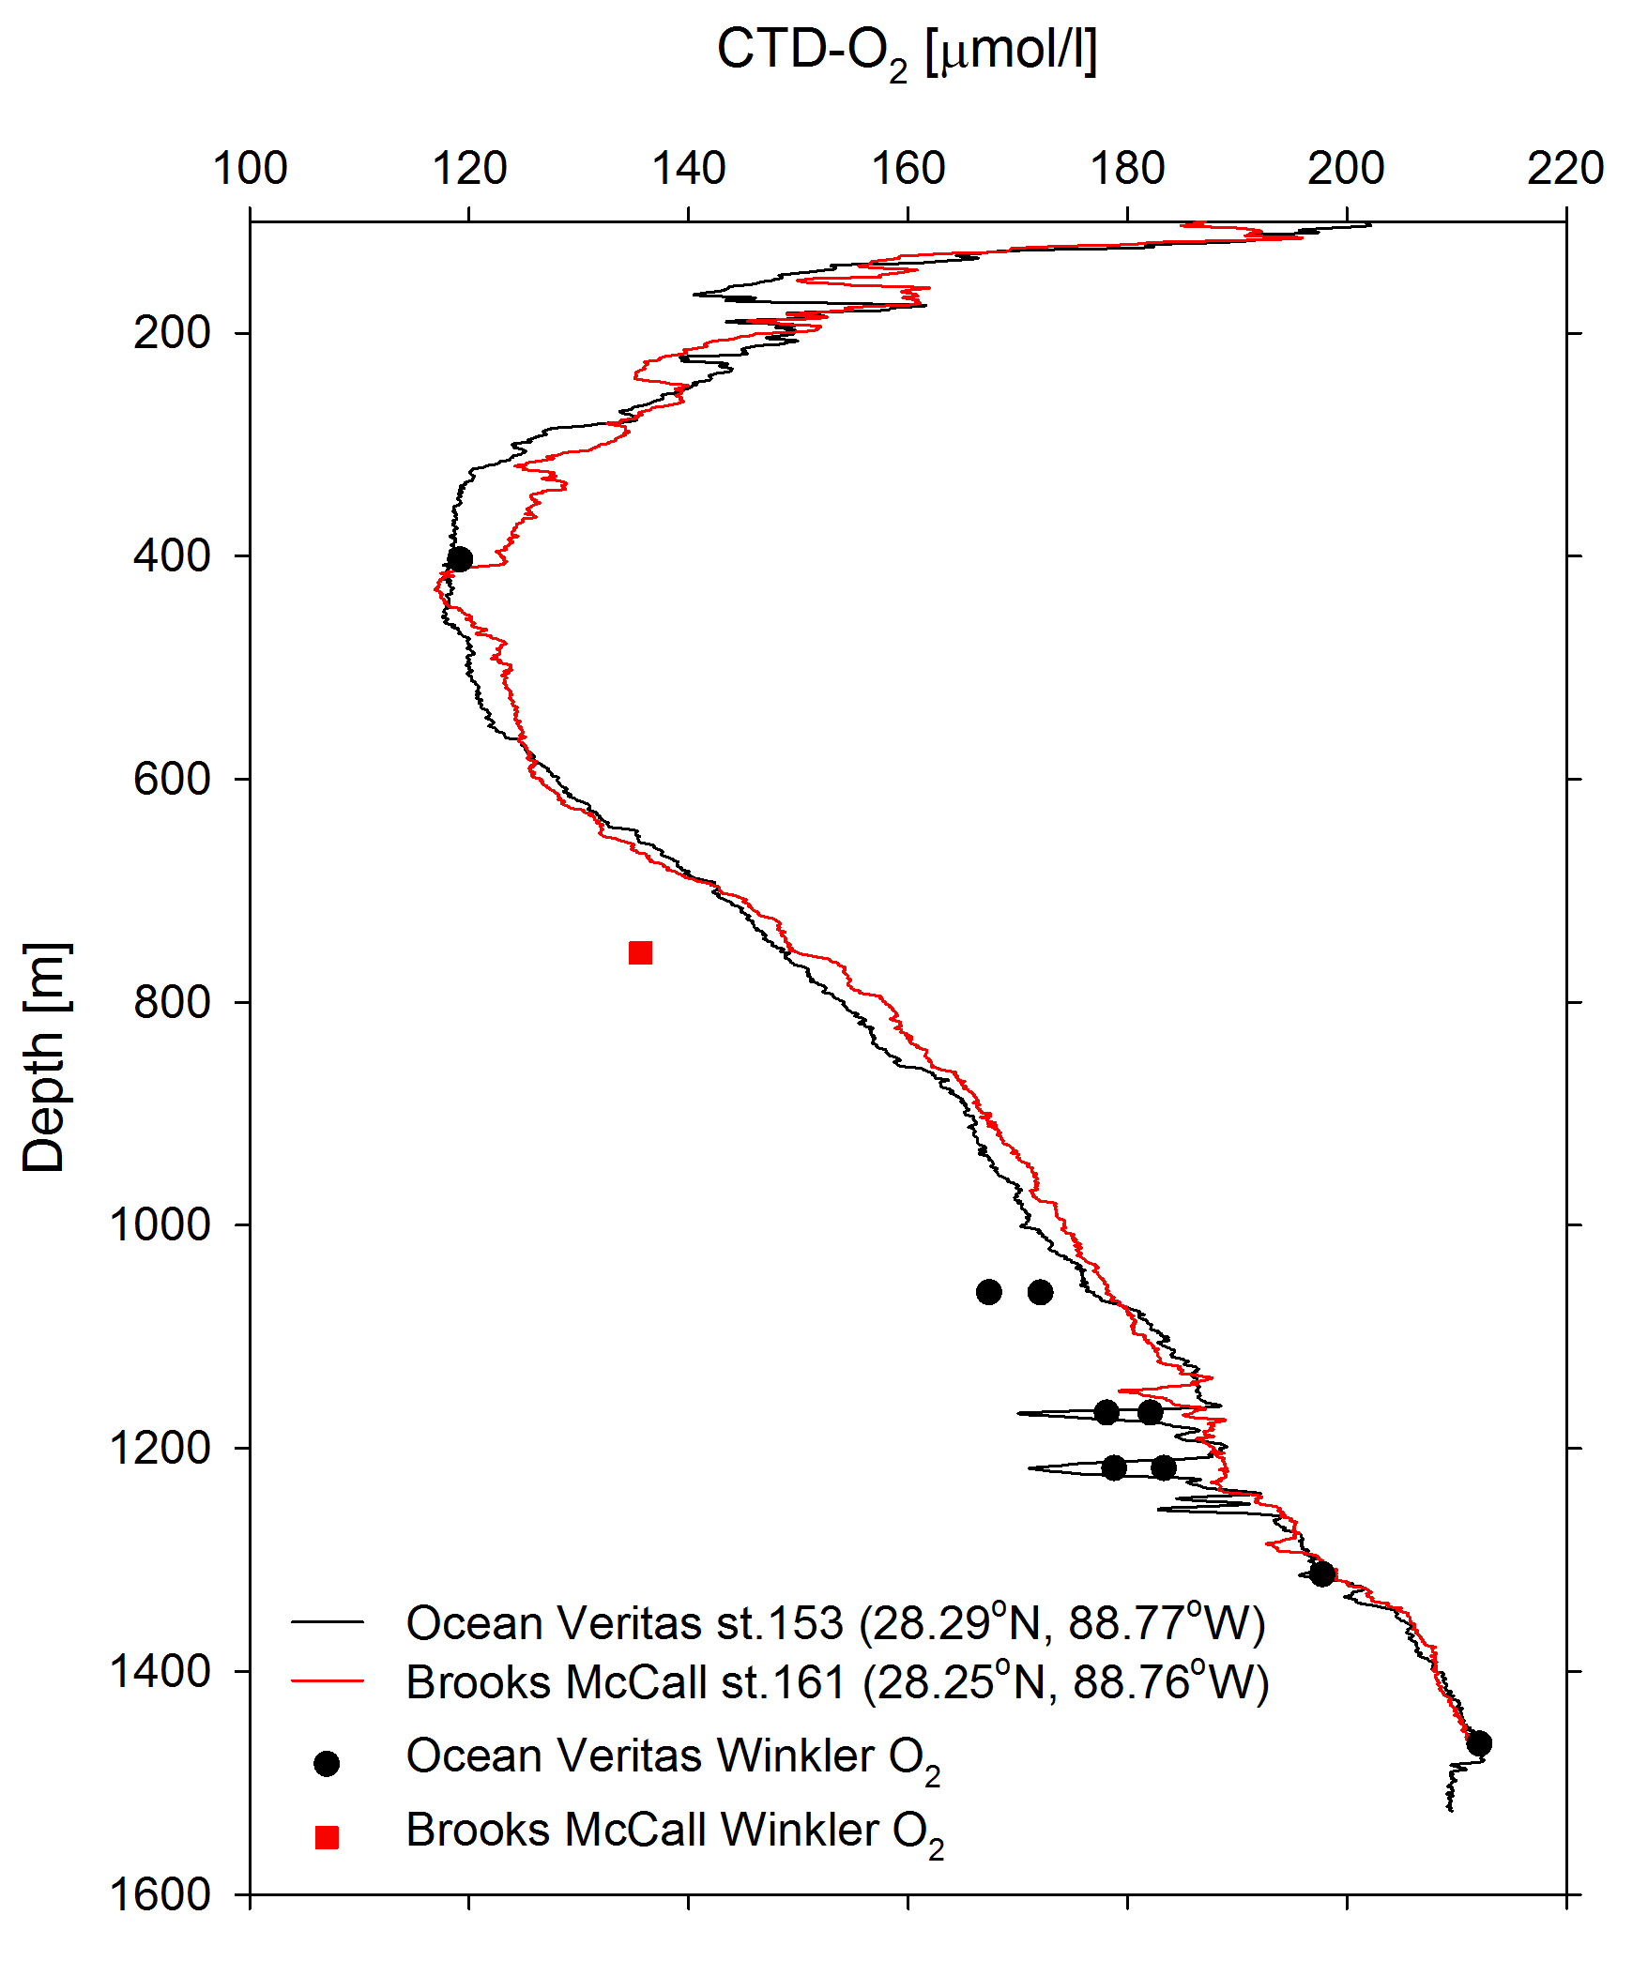

Figure 3. Comparison of CTD/O₂ and Winkler's for Ocean Veritas Station 153 occupied on and Brooks McCall Station 161 occupied on for the stations circled in Figure 2. The figure and other analyses suggest that the CTD/O₂ sensors on both ships were comparable and within 4 µmol/l (≈0.1 ml/l) from Winkler O2 analyses.

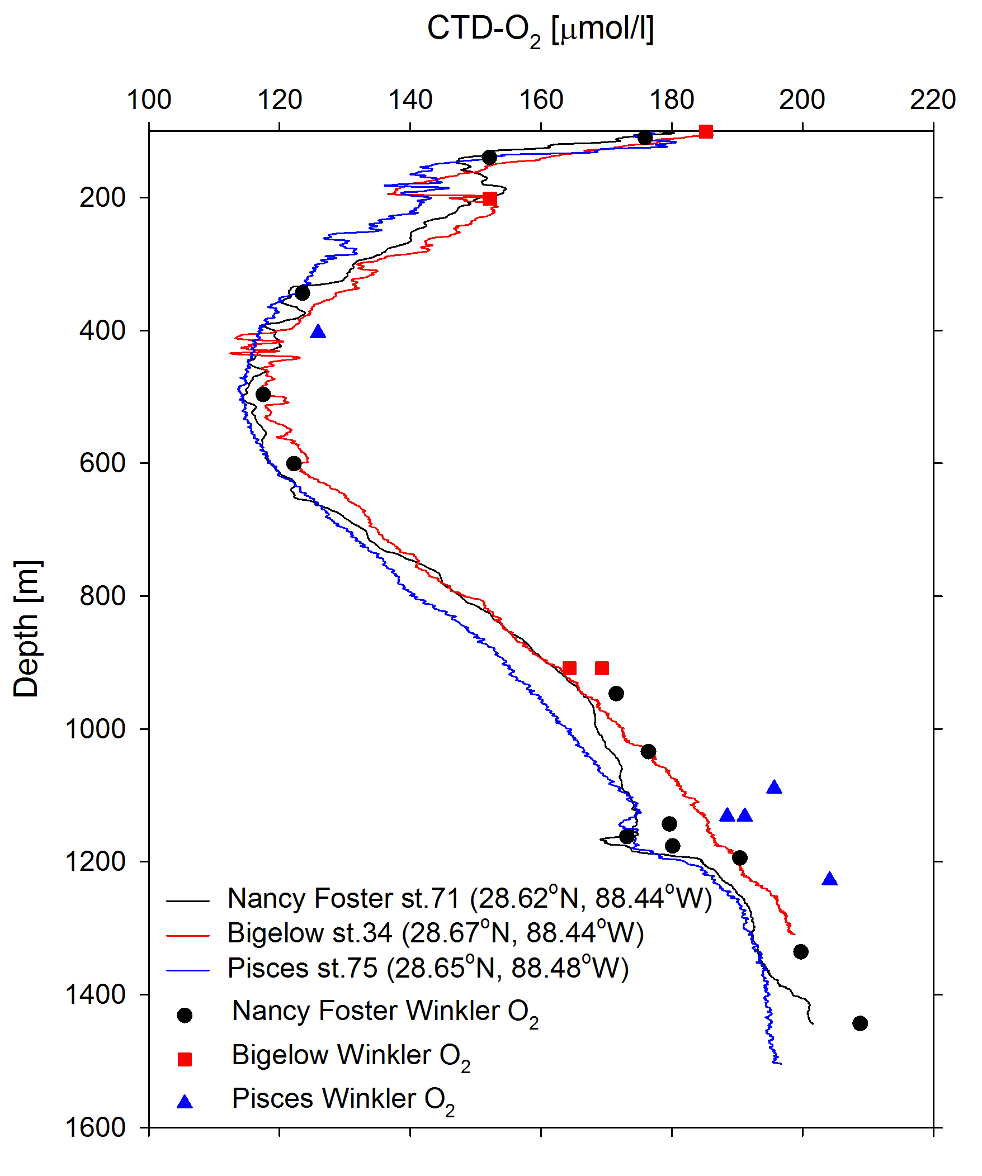
a.)
b.) c.)

Figure 4. a.) Comparison of CTD/O₂ and Winklers for Nancy Foster Station 71 occupied on July 17, 2010, the Bigelow on August 15, 2010 and Pisces on August 20, 2010. The figure and other analyses suggest that the CTD/O₂ sensors on the Pisces were reading about 7 µmol/l (≈0.2 ml/l) compared to the actual value. b.) Corresponding temperature profile. c.) Temperature profile for > 500 m to illustrate the fine scale differences in water structure. See Figure 2 for station locations (circled in upper left of Figure 2)

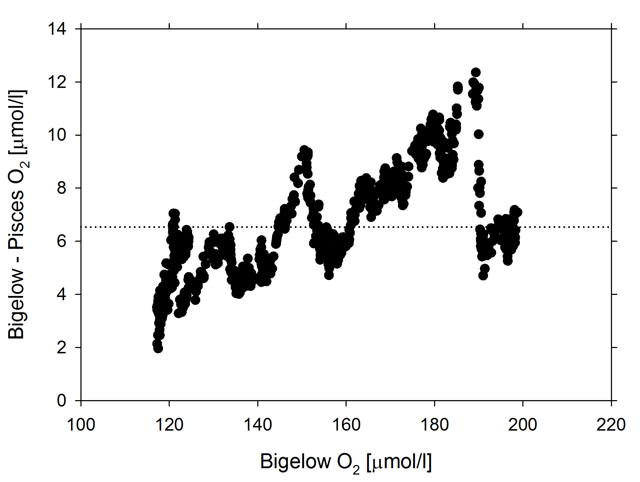

Figure 5. Comparison of CTD/O₂ for Bigelow Station 34 on August 15, 2010 and Pisces Station 75 on August 20, 2010. The figure suggests that the CTD/O₂ sensors on the Pisces were reading about 7 µmol/l (≈0.2 ml/l) too low. The depth profile is shown in figure 4

References:
Friederich, G. E., P. Sherman, and L. A. Codispoti (1984), A high precision automated Winkler titration system based on a HP-85 computer, a simple colorimeter and an inexpensive electromechanial buret, Bigelow Lab. Technical Report, 42, 24 pp.
Langdon, C. (2010), Determination of dissolved oxygen in seawater by Winkler titration using the amperometric technique, in GO-SHIP repeat hydrography manual: a collection of expert reports and guidelines edited by B. M. Sloyan and C. Sabine, IOC/IOCCP, Paris

