Empirical Sea Surface temperature-based estimates of variability
in the oceanic uptake of CO₂ over the past two decades

by

Geun-Ha Park¹, Kitack Lee¹*,
Rik Wanninkhof² and Richard A. Feely³

¹School of Environmental Science and Engineering, Pohang University of Science and Technology, Pohang, 790-784, Republic of Korea

²Atlantic Oceanographic and Meteorological Laboratory, NOAA, Miami, USA

³Pacific Marine Environmental Laboratory, NOAA, Seattle, USA

Please direct all comments to the corresponding author*

Dr. Kitack Lee

School of Environmental Science and Engineering
Pohang University of Science and Technology
San 31, Hyoja-dong, Nam-gu
Pohang, 790-784
Republic of Korea
Phone: 82-054-279-2285
Fax: 82-054-279-8299
Email: ktl@postech.ac.kr

February 3, 2006

REVISION SUBMITTED TO JOURNAL OF GEOPHYSICAL RESEARCH
Note: You should list the variability of atm CO2 growth rate as compparison?
Note:youShould compare your results with Lee 1998 in the discussion
Note:Why use 3 instead of 4 (seasonal relationships)

Note: you still use the term“diagnostic model” a lot !
ABSTRACT
In this paper, we infer the year-to-year variability of net global air-sea CO₂ fluxes from observed interannual changes in wind speed and estimated differences in CO₂ partial pressure between surface seawater (pCO_{2SW}) and the overlying atmosphere. Changes in pCO_{2SW} are estimated from changes in sea surface temperature via seasonal algorithms that relate pCO_{2SW} to sea surface temperature. Our diagnostic model yields an interannual variability of ±0.18 petagrams (1σ, Pg = 10¹⁵ grams) of carbon per year for the period 1982−2001. El Niño Southern Oscillation-induced changes in the equatorial efflux contribute approximately 70% of the global variability. Outside the equatorial Pacific, the antagonistic effects of anomalies in the gas exchange rate and pCO_{2SW} act to suppress global interannual variability. Regional flux anomalies for areas outside the equatorial Pacific are found to neither systematically reinforce nor compensate each other during times of transition from El Niño years to normal years. The interannual variability of ±0.18 Pg C yr⁻¹ obtained in the present work is at the low end of recent estimates that falls in the range of ±0.2 to ±0.5 Pg C yr⁻¹. Of the previous estimates, lower values are generally estimated from global ocean circulation-biogeochemical models, while higher values are derived from atmospheric inversion models constrained by atmospheric CO₂ observations. Comparisons of our data with two time series data sets and equatorial Pacific data suggest that our diagnostic model is not able to capture the full range of pCO_{2SW} variations; this is probably due to the inability of the empirical model to fully account for changes in surface pCO_{2SW} related to ocean biological and physical processes. The small variability in our modeled fluxes suggests that observed year-to-year variations in the rate of atmospheric CO₂ increase are primarily caused by changes in the rate of CO₂ uptake by the land biosphere.

INTRODUCTION
The burning of fossil fuel releases CO₂ into the atmosphere, about half of which is taken up by the oceans and land biosphere [Sabine et al., 2004]. The growth rate of atmospheric CO₂ shows interannual on the order of XX Pg over the past two decades variability, largely due to temporal variations in the partitioning of CO₂ between the atmosphere, the land biosphere, and the oceans. Accurate knowledge of the partitioning of CO₂ among the atmosphere, land biosphere, and ocean is needed to improve our ability to predict future atmospheric CO₂ concentrations under different fossil fuel CO₂ emission scenariosThe interannual variability of CO₂ uptake by the land biosphere and ocean remains uncertain. Studies based on variations in the concentration of atmospheric CO₂ and its ¹³CO₂/¹²CO₂, and O₂/N₂ records, in conjunction with atmospheric transport models, have attempted to distinguish the contributions to the atmospheric CO₂ anomaly from exchanges with the land biosphere and ocean [Francey et al., 1995; Keeling et al., 1995; Rayner et al., 1999; Battle et al., 2000; Peylin et al., 2005]. In these studies, the combined land biosphere and ocean uptake is calculated from the difference between total fossil-fuel CO₂ emissions and the observed increase in atmospheric CO₂ concentrations. Partitioning of carbon between the land biosphere and ocean is then determined from changes in atmospheric ¹³CO₂/¹²CO₂, which can be used as a good proxy for CO₂ uptake by the land biosphere. Note, you do not mention any N2 results, perhaps you should.
Quantifying the year-to-year variability in net air-sea CO₂ fluxes and identifying the mechanisms that cause the variability are important for several reasons. An accurate estimate of the net air-sea CO₂ flux variability places better constrains on the interannual variability of land biosphere CO₂ uptake [Rayner et al., 1999; Bousquet et al., 2000; Rödenbeck et al., 2003]. The large interannual variability (±1 to ±2 petagrams of carbon per year, Pg C yr⁻¹) of oceanic CO₂ uptake inferred from atmospheric observations in conjunction with atmospheric transport models [Francey et al., 1995; Keeling et al., 1995] implies large changes in surface ocean biology and ocean surface physics. Thus, accurate determination of the interannual variability in oceanic CO₂ uptake would provide an independent test of the ocean biogeochemical models that are used to simulate future atmospheric CO₂ concentration [Joos and Bruno, 1998], as well as provide an independent constraint on land biosphere CO₂ uptake.
During the 1990s, an average of about 5.5 Pg C yr⁻¹ was released into the atmosphere by the burning of fossil fuel [Houghton et al., 2001]. Of that 5.5 Pg C yr⁻¹, a variable fraction ranging from 1 to 5 Pg C yr⁻¹ remained in the atmosphere [Keeling and Whorf, 2000]. Studies using a stable carbon isotope and N2/O2budget approach have yielded interannual variabilities in oceanic uptake that range from ±1.5 Pg C yr⁻¹ [1σ, Francey et al., 1995; Keeling et al., 1995] to ±0.5 Pg C yr⁻¹ [1σ, Rayner et al., 1999; Battle et al., 2000]. Inverse models constrained by atmospheric CO₂ measurements spanning over the past two decades have been used to deduce year-to-year changes in the regional carbon balance of the land biosphere and oceans [Bousquet et al., 2000]. These analyses indicate that variability in the land biosphere CO₂ fluxes for 1980−1998 was twice as great as for ocean fluxes. The magnitude of the ocean flux variability proposed by Bousquet et al. [2000] is close to that inferred by Rayner et al. [1999]. These two estimates are still greater than those predicted by an ocean diagnostic model [Lee et al., 1998] and 3-D global ocean circulation-biogeochemistry models [Le Quéré et al., 2000, 2003; Obata and Kitamura, 2003; McKinley et al., 2004a]. The causes underlying these differences are not yet fully resolved. However, results obtained from atmospheric inversions using high resolution atmospheric CO₂ data [Rödenbeck et al., 2003] are in good agreement with those predicted by ocean models as to the high contribution of the Pacific Ocean to variability in the global air-sea CO₂ flux [McKinley et al., 2004b].
It is difficult to verify from ocean CO₂ data if the large interannual variability in oceanic CO₂ uptake inferred from studies based on atmospheric ¹³CO₂/¹²CO₂ data and different inverse models is accurate. This uncertainty is due to the significant temporal and spatial variability in net air-sea CO2 flux and the lack of long-term time-series observations of global scale CO₂ partial pressure in surface water (pCO_{2SW}). Reports that indicate a large interannual variability in oceanic CO₂ uptake stand in striking contrast to the results obtained by Lee et al. [1998], who utilized a monthly climatology of partial pressure difference (ΔpCO₂ = pCO_{2SW} − pCO_{2AIR}) between the atmosphere and the surface ocean, as obtained from Takahashi et al. [1997], and empirical algorithms between pCO_{2SW} and sea surface temperature (SST) to infer interannual variability in the global net air-sea CO₂ flux. The authors found a small interannual variability of less than ±0.2 Pg C yr⁻¹ (1σ). In that study, multi-year SST data were used to estimate the interannual variability in surface pCO_{2SW} because SST is one of a few parameters that are determined globally at monthly time scales over the last two decades and, more importantly, changes in SST can reasonably account for changes in pCO_{2SW} due to thermodynamic, transport, and biological effects.
The present study expands on the earlier work of Lee et al. [1998] by: (1) providing detailed descriptions of the diagnostic model originally used by Lee et al. [1998] and modifications made to this model; (2) extending the analysis period to a 20-year interval; (3) validating the assumption that the seasonal relationships between pCO_{2SW} and SST can be used to infer interannual variations in net air-sea CO₂ fluxes by comparing diagnostic modeled results with time series observations not included in the analysis of Lee et al. [1998]; (4) evaluating the effects of wind speed products and gas exchange velocities on the interannual variability; (5) assessing uncertainties in diagnostic modeled interannual variability; (6) investigating potential factors that act to bias the interannual variability; and (7) comparing results with those obtained from ocean models [Le Quéré et al., 2000, 2003; Obata and Kitamura, 2003; McKinley et al., 2004a] and from an inverse model using 20-year atmospheric CO₂ measurements obtained from the global atmospheric sampling network [Bousquet et al., 2000].

CALCULATION METHOD
The monthly mean net air-sea CO₂ flux (F_{ym}) for each latitude 4º × longitude 5º pixel for an individual year other than 1995 was estimated from the global ΔpCO₂ climatology representing 1995 (obtained from Taro Takahashi of Lamont-Doherty Earth Observatory of Columbia University, available at http://www.ldeo.columbia.edu/res/pi/CO2/carbondioxide/air_sea_flux/ fluxdata.txt), together with global records of monthly mean wind speed and SST anomalies compared with the climatology normalized to the year 1995 in the following manner:
F_{ym} = k_{ym} K₀,_{ym} {[pCO_{2SW1995m} + (∂pCO_{2SW}/∂SST)_{1995m} × ΔSST_{ym−1995m}] – pCO_{2AIR1995m}} (1)
where k is the monthly mean gas transfer velocity, K₀ is the solubility of CO₂, ym is the year and month in the time series during the period 1982−2001, and subscript 1995m refers to the month in 1995. Net air-sea CO₂ flux can be decomposed into a kinetic component (k) and a thermodynamic component (K₀ ΔpCO₂). In the present study we assume that variations in k are related to variations in the monthly mean wind speed, and that interannual variations in surface ΔpCO₂ are fully parameterized by SST variations through seasonal pCO_{2SW}/SST relationships derived for each pixel.
Measurements of the gas exchange coefficient k performed under various wind regimes in wind tunnels and in the oceans have yielded different relationships between gas exchange and wind speed [e.g., Liss and Merlivat, 1986; Wanninkhof, 1992; McGillis et al., 2001]. The effect of the temperature difference between the bulk water and surface skin on ΔpCO₂ is not considered in the present study because there is only limited data available on spatial and interannual variations in the thermal skin effect [Robertson and Watson, 1992; Van Scoy et al., 1995], and because the effect is probably significantly less than that suggested in the original work [McGillis and Wanninkhof, 2006]. Temporal and spatial variations in atmospheric CO₂ levels for 1995, pCO_{2AIR1995m}, were obtained from interpolation of extensive observations Global ViewEach component of Equation (1) is described in detail in the following sections.
The ΔpCO₂ climatology for the reference year 1995
The global ΔpCO₂ climatology for a single non-El Niño year was produced from approximately 940,000 measurements of surface water pCO_{2SW} and overlying atmospheric pCO_{2AIR} made over the 40 years since 1959 [Takahashi et al., 2002]. Because of the sparseness of measurement in time and space, the pCO_{2SW} data were normalized to the reference year 1995, and interpolated in space (4º×5º grid) and time (monthly) using the surface transport field of the Princeton/GFDL General Circulation Model [Cox, 1984]. The year 1995 was chosen because it represents the temporal midpoint of the dataset used in this study. The ΔpCO₂ climatology excluded measurements made in the equatorial Pacific (10ºN−10ºS) during El Niño events and used approximately 4 times as many pCO_{2SW} data as used in the previous climatology referenced to 1990 [Takahashi et al., 1997]; the 1990 ΔpCO₂ climatology was used in the analysis of Lee et al. [1998]. A more detailed explanation of the methods used for measuring, adjusting, and re-sampling the data can be found in Takahashi et al., [1997, 2002].
When we use the European Center for Medium-range Weather Forecasts monthly mean wind speeds and the (wind speed)² dependence of the gas exchange velocity of Wanninkhof [1992], the 1995 ΔpCO₂ climatology yields a global net air-sea CO₂ flux of 1.78 Pg C yr⁻¹, which is 0.4 Pg C yr⁻¹ greater than the global flux calculated using the 1990 climatology note, with the same wind product? . The regional and global net air-sea CO₂ fluxes estimated using the two different ΔpCO₂ climatologies agree to within ±25%. Takahashi et al. [2002] who used the NCEP 40- year average wind speed product obtained a global net air-sea CO₂ flux of X.XX Pg C yr⁻¹
Constructing surface water pCO₂ for 1995 (pCO_{2SW 1995})
Surface pCO_{2SW} values for 1995 were obtained by subtracting atmospheric pCO_{2AIR} for 1995 from the 1995 ΔpCO₂ climatology. Mole fractions of atmospheric CO₂ (X_{CO2}) corrected for dry air were obtained from the National Oceanic and Atmospheric Administration/Climate Monitoring and Diagnostics Laboratory (NOAA/CMDL) [GLOBALVIEW-CO₂, 2004] and converted to pCO_{2AIR} using the climatological sea level pressure for 1995 and the saturation vapor pressure of seawater at the appropriate SST.. We interpolated the monthly mean global sea level pressure (P_{T}) provided on a 2.5º latitude × 2.5º longitude grid [Kalnay et al., 1996] to a 4º latitude × 5º longitude grid to match the pCO_{2SW} climatology. The pCO_{2AIR} was then calculated from X_{CO2} using the following equation:
pCO_{2AIR} = [X_{CO2} × (P_{T} − P_{H2O})] (2)
where P_{H2O} (atm) is the saturation vapor pressure of seawater at the monthly mean SST of each pixel. (ln P_{H2O} = 24.4543 − 67.4509 (100/T) − 4.8489 ln (T/100) − 0.000544 S) [Weiss and Price, 1980]; T is temperature in Kelvin; and S is salinity.
Derived relationships between pCO_{2SW} and SST, (∂pCO_{2SW}/∂SST)_{1995m}
For areas outside of the central and eastern equatorial Pacific, seasonal pCO_{2SW}/SST relationships were determined for each 4º × 5º pixel from least squares linear fits of monthly climatological pCO_{2SW} and SST values for three different periods: January through April, May through August, and September through December. In much part of the world’s oceans except in the South Indian and Southern Oceans, the good correlations between pCO_{2SW} and SST (r² = 0.70 ± 0.3, number of pixels = 1314) indicate that SST accounts for approximately 70% of the total pCO_{2SW} variability. The lower correlations (r² = 0.55 ± 0.3, number of pixels = 353) are generally found in the South Indian and Southern Oceans. Note, how did you determine the good and bad correlations? Their st dev overlap! These derived relationships were then used to calculate the monthly ΔpCO₂ anomalies for each 4º × 5º pixel using SST anomalies compared with the 1995 climatology.
For the central and eastern equatorial Pacific (5ºN−10ºS and 95ºW−165ºE), we used four empirical pCO_{2SW}/SST equations derived from multiyear data that were collected from the equatorial Pacific between 1992 and 2001 [Cosca et al., 2003]. This dataset represents the warm and cool seasons of both El Niño and La Niña conditions: two equations for El Niño conditions and the other two for non-El Niño conditions.
El Niño (Jan.−June): pCO_{2SW} (±20.3) = 923.3 − 19.0 SST r² = 0.466 (3)
El Niño (July−Dec.): pCO_{2SW} (±16.6) = 794.6 − 14.7 SST r² = 0.532 (4)
Non-El Niño (Jan.−June): pCO_{2SW} (±28.8) = 1044.3 − 23.1 SST r² = 0.550 (5)
Non-El Niño (July−Dec.): pCO_{2SW} (±30.2) = 679.9 − 10.7 SST r² = 0.458 (6)
Equations (3) and (4) were used to predict pCO_{2SW} variations for El Niño conditions under which SST in the Niño 3.4 region (5ºN−5ºS and 120ºW−170ºW) at the time of data collection was 0.4ºC greater than the average, whereas Equations (5) and (6) were used for non-El Niño conditions under which SST was within 0.4ºC less than the average [Trenberth, 1997]. The two seasonal relationships derived for each El Niño year are not statistically different from the two composite pCO_{2SW}/SST correlations (equations 3 and 4) derived using all the El Niño data [Cosca et al., 2003].
During El Niño Southern Oscillation (ENSO) events, low salinity surface water with low ΔpCO₂ (due to enhanced rainfall) extends from the western equatorial Pacific to the central and eastern equatorial Pacific [Feely et al., 2002; Takahashi et al., 2003]. The eastward movement of fresh water lenses leads to a significant decrease in ΔpCO₂ in the surface waters of the central and eastern equatorial Pacific [Feely et al., 1999, 2002, 2004]. Because pCO_{2SW} data were collected during all phases of the ENSO cycle, the four pCO_{2SW}/SST relationships derived from this dataset likely account for pCO_{2SW} changes caused by ENSO-induced changes in salinity within the central and eastern equatorial Pacific. The four empirical relationships used in the present study likely account for pCO_{2SW} changes better than the single relationship -6% change in pCO_{2SW} per ºC used in earlier modeling work [Lee et al., 1998]. However, in our diagnostic modeling, the four relationships probably do not fully account for the effect of biology on pCO_{2SW} [Cosca et al., 2003; Feely et al., 2004].
Monthly mean sea surface temperature and wind speed
Monthly mean global wind speed datasets were acquired from the European Center for Medium-range Weather Forecasts (ECMWF-40 year reanalysis, hereafter referred to as ECMWF, available at http://www.ecmwf.int/products/ data/archive/index.html), and the National Centers for Environmental Prediction/Atmospheric Model Intercomparison Project II (NCEP/DOE AMIP-II Reanalysis, hereafter referred to as NCEP, available at http://www.cpc.ncep.noaa.gov/ products/ wesley/reanalysis.html) reanalysis for the period 1982−2001. The NCEP is the updated product of the NCEP/NCAR reanalysis used by Lee et al. [1998]. The NCEP wind speed products (1000 hPa) were corrected to 10 m above the sea level using a drag coefficient (1.2 × 10⁻³) under neutral boundary conditions note, explain how did you did this; the ECMWF products were measured at 10 m above the sea level. The ECMWF wind speed products were used in all calculations in the following sections.
Monthly mean SST datasets for the same analysis period, 1982−2001, are available from the NCEP/National Center for Atmospheric Research (http://www.cdc.noaa.gov/cdc/data. noaa.oisst.v2.html). These assimilated datasets are derived from in situ and satellite-derived SST and are available on a 1º latitude × 1º longitude grid. The data were further adjusted to a 4º × 5º grid to match the grid size of the ΔpCO₂ climatology data.

RESULTS AND EVALUATION OF UNCERTAINTY
Surface water pCO_{2SW} and its relationships to SST in the global oceans
The distribution of surface water pCO_{2SW} is determined by the interaction of various processes, including the mixing of different water masses in the surface mixed layer (transport effect), changes in temperature and salinity (thermodynamic effect), air-sea CO₂ exchange, photosynthesis, and the oxidation of organic matter [Poisson et al., 1993; Takahashi et al., 1993; Takahashi et al., 2002]. The relative contributions of these different processes to changes in surface water pCO_{2SW} are usually of equal magnitude, but often act in opposite directions and show significant geographic or seasonal variability. Even so, changes in SST are related to thermodynamic, transport, and biological effects on the surface water pCO_{2SW}. Many studies have found strong seasonal correlations between pCO_{2SW} and SST on a regional scale [e.g., Tans et al., 1990; Poisson et al., 1993; Takahashi et al., 1993; Inoue et al., 1995; Landrum et al., 1996; Feely et al., 1997, 2002, 2004; Bates et al., 1998; Lefèvre and Taylor, 2002; Cosca et al., 2003; Olsen et al., 2003].
Trends in the pCO_{2SW}/SST relationship in the global oceans are described in detail elsewhere [Takahashi et al., 1993] and here we highlight important general trends. Takahashi et al. [1993] suggested that for most of the world’s oceans, except the northern North Atlantic, seasonal variations in both SST and pCO_{2SW} could be reasonably approximated as sine functions within a 12-month period. Under this approximation, the pCO_{2SW}/SST relationship depends on the phase difference between the two sine functions. The four contrasting cases that are commonly found in the world’s oceans are shown in Figure 1.
In the first case, changes in pCO_{2SW} are 180 degree out of phase with SST (Figures 1a and 1b). This trend is usually found in northern high latitude oceans in which surface waters are coldest in February and warmest in September. In these high latitude waters, the total inorganic carbon concentration, C_{T} at the surface increases due to convective mixing of deep waters rich in C_{T}. In this case, the thermodynamic and transport effects are out of phase, and reductions in pCO_{2SW} due to seasonal cooling are opposed by and potentially outweighed by pCO_{2SW} increases due to vertical mixing. During springtime, phytoplankton blooms can cause rapid reductions in pCO_{2SW}. Increased springtime irradiance and stratification initiate these blooms, which occur in tandem with increases in SST. Therefore, the slope of the seasonal pCO_{2SW}/SST relationship is typically negative and depends on the peak-to-peak amplitude of pCO_{2SW} and SST (Figures 1a and 1b). This pCO_{2SW}/SST trend is also generally found in the Southern Ocean.
In the second case, changes in pCO_{2SW} are in phase with those in SST. This trend is typically found in the tropical and subtropical oceans in which the mixed layer is shallow and vertical mixing is weak. In these warm waters, limited photosynthesis occurs and hence SST is the primary factor that determines surface water pCO_{2SW}. Consequently, the pCO_{2SW}/SST relationship shows less seasonal variability; it generally falls within the range +1 to +4% per ºC (Figures 1c and 1d).
In the third case, pCO_{2SW} is out of phase with SST by less than 6 months, and the seasonal pCO_{2SW}/SST relationship generally describes an ellipse trend (Figures 1e and 1f). This trend is in particular broadly found in the northwestern North Pacific and occasionally in the tropical South Pacific [Takahashi et al., 1993]. If the observed pCO_{2SW}/SST relationship resembles a narrow ellipse such as in the subtropical gyres, then it can be approximated by a single straight line; however, if the relationship resembles a broad ellipse, three or four seasonal relationships are required to adequately represent the changes in pCO_{2SW} [Lefèvre and Taylor, 2002].
In the fourth case, pCO_{2SW} and SST are highly anticorrelated. This relationship is observed in the eastern equatorial Pacific region, in which the upwelling intensity of subsurface waters high in C_{T} affects the variability of surface pCO_{2SW} [Feely et al., 1999, 2002, 2004].
Our diagnostic model is formulated on the assumption that changes in surface pCO_{2SW} due to the influence of advection, upwelling and outcropping of water with different levels of CO₂ (transport effect), and photosynthesis and oxidation of organic matter (biological effect) can be predicted from SST variations via seasonal pCO_{2SW}/SST relationships. The thermodynamic component, which is caused by SST variations, can be approximated as a ∼4.2% increase in pCO_{2SW} per ºC increase in surface water temperature [Takahashi et al., 1993; Lee and Millero, 1995; Lee et al., 1996]. The transport and biological effects cause changes in the concentration of total inorganic carbon (C_{T}) and, to a lesser extent, total alkalinity (A_{T}). These changes in C_{T} and A_{T} in turn affect the surface water pCO_{2SW} generally in opposite direction to the SST effect [Takahashi et al., 2002]. Air-sea CO₂ fluxes usually have a smaller effect on pCO_{2SW} because of the carbonate-buffering factor and dilution due to vertical mixing in high latitude waters.
Interannual variability of global net air-sea CO₂ fluxes
Our diagnostic analysis yields a 20-year global mean net air-sea CO₂ flux of 1.70 Pg C yr⁻¹ for the period 1982−2001 (Figure 2a). Higher oceanic uptakes are inferred for the El Niño years of 1982−1983, 1987, 1992−1994, and 1997−1998, and smaller oceanic CO₂ uptakes are predicted for the years that immediately follow El Niño years. The flux variations that occur during the transition from El Niño to non-El Niño years have maximum peak-to-peak amplitude of 0.6 Pg C. Our analysis shows that the interannual variability of the global net air-sea CO₂ flux is ±0.18 Pg C yr⁻¹ (1σ) for the period 1982−2001 (Figure 2a). Interannual flux anomalies differ in magnitude or in sign across regions. The largest fraction (∼70%) of the interannual variability can be attributed to flux anomalies in the equatorial Pacific Ocean (Figure 2b). Our CO₂ efflux from the equatorial Pacific is relatively low during the peak period (from boreal fall through boreal spring) of El Niño years and high during the peak period of La Niña years. Next to the equatorial Pacific, the Southern and Subtropical Oceans are the second and third largest contributors, respectively, to global variability (Figure 3).
The diagnostic modeled global interannual variability is less than that inferred from inversions of atmospheric CO₂ combined with atmospheric transport models (see Figure 11). To identify the possible sources of this difference, we must first consider factors that may contribute to the uncertainty in our modeled variability. To estimate a robust range of uncertainty in our modeled net CO₂ fluxes, we (1) compared our results to time series observations from the equatorial Pacific, and the Bermuda Atlantic Time-series Study (BATS), and the Hawaiian Ocean Time-series (HOT) sites; (2) quantified the effect of differences in various wind speed products; (3) quantified the effect of uncertainties in the derived pCO_{2SW}/SST relationship; and (4) quantified the effect of differences in various gas exchange parameterizations. This enabled us to better define the range of uncertainty in interannual variability modeled by our model. We also identified factors that may depress the interannual variability and quantified the degree to which the interannual variability is suppressed by these factors.
Comparison with multi-year time series observations
The time series stations have monthly records of SST and pCO_{2SW} spanning 11 to 12 years that were not incorporated in the pCO_{2SW} climatology, whereas net effluxes for the equatorial Pacific were estimated from bi-annual observations from 1992 to 1998 [Feely et al., 1999, 2002, 2004]. To evaluate the accuracy of the diagnostic modeled net air-sea CO₂ fluxes, we compared our model results with time series measurements made at the BATS and HOT sites, representing the subtropical ocean, as well as measurements from the equatorial Pacific, where surface pCO_{2SW} is dominantly modulated by ENSO-related changes in upwelling intensity (Figures 4 and 5).
Equatorial Pacific (10ºN−10ºS, 80ºW−135ºE): The equatorial Pacific Ocean is the largest natural CO₂ source region for the global budget of air-sea CO₂ exchange [Tans et al., 1990; Feely et al., 1997, 1999, 2002, 2004; Takahashi et al., 1997, 2002, 2003]. During La Niña years, intense upwelling in the equatorial Pacific results in enhanced CO₂ efflux, whereas the opposite condition prevails during El Niño years. As a result, the amount of CO₂ released from the equatorial Pacific varies considerably, ranging from 0.2 to 1.0 Pg C yr⁻¹ [Feely et al., 1999, 2002]. During the El Niño Southern Oscillation (ENSO) events, low salinity surface water in the western equatorial Pacific with low ΔpCO₂ moves to the central and eastern equatorial Pacific. This eastward shift in the western warm pool contributes to the large decrease in efflux in the equatorial Pacific [Feely et al., 1999, 2002; Takahashi et al., 2003]. The ENSO events also lead to changes in the depth of the thermocline, upwelling rates, and wind speeds. Such ENSO-induced changes in ocean physics significantly affect air-sea CO₂ flux variability through surface ΔpCO₂ shifts and gas exchange rate variations [Feely et al., 2002; McKinley et al., 2004a, 2004b]. An accurate estimate of efflux variations in the equatorial Pacific is therefore essential to constrain the interannual variability in global net air-sea CO₂ fluxes.
Results obtained from our analysis agree well with estimates based on the 3-D ocean models [Le Quéré et al., 2000; Obata and Kitamura, 2003; McKinley et al., 2004a] in terms of both phase and magnitude (Figure 2b). In both the diagnostic and 3-D ocean modeling, the equatorial Pacific accounts for nearly 70% of the global variability in net air-sea CO₂ flux, and El Niño events are the dominant factor influencing the variability in equatorial CO₂ efflux. Although changes in the Southern Oscillation Index (SOI) are also closely associated with temperature, wind speed, and precipitation anomalies, the exact relationship between the CO₂ efflux anomaly and the SOI is not yet clearly understood.
Comparison of our results with measured effluxes suggests that the diagnostic model underestimate the interannual variability by as much as ∼50% (Figure 4a). The underestimation of the interannual variability in our model can be explained in part because the pCO_{2SW}/SST relationship for this region does not account for the full effect of seasonal and interannual variations in biological activity on CO₂ fluxes [Loukos et al., 2000; Feely et al., 1999, 2002; Cosca et al., 2003].
Bermuda Atlantic Time series (BATS, 31º50′N, 64º10′W): note, for the BATS and HOT sight how does the monthly SST and pCO2 compare with the climatology for SST and pCO2 from Takahashi??? Ii expect that the climatology will be depressed compared to the data at HOT and BAT and contribute to the lower dpCO2/dSSTThe BATS site represents the western North Atlantic subtropical gyre, were winter mixing of nutrients supports a short-lived springtime phytoplankton bloom [Michaels et al., 1994]. During summer and fall at this site, nutrient concentrations in the mixed layer remain below the detection limit, suggesting that rates of primary production tare significantly lower than the rate during spring. As a result, temporal and spatial distributions of surface pCO_{2SW} in this region can be predicted with relatively small error from measurements of surface temperature and seasonal pCO_{2SW}/SST relationships [Bates et al., 1998]. Note, only if the relationship is close to 4 %/C, is this so?? As part of the BATS measurement program, surface total alkalinity (A_{T}) and total inorganic carbon (C_{T}) were measured at approximately monthly intervals since the program began in 1988 [Bates, 2001]. Net air-sea CO2 fluxes for the period 1989−2001 were estimated using calculated pCO_{2SW} from A_{T} and C_{T} via the carbonate thermodynamic model suggested by Lee et al. [2000]. We find broad agreement between derived and observed seasonal pCO_{2SW}/SST relationships (Figure 5a). The observed pCO_{2SW}/SST relationships at this site show a large degree of scatter for the winter season, but are more consistent and show positive slopes for the other seasons. Gruber at al. [2002] suggested that the significant interannual variability in the wintertime pCO_{2SW}/SST relationship is due to interannual variations in the North Atlantic Oscillation index that lead to changes in the timing and intensity of wintertime convective mixing, which in return influences pCO_{2SW}/SST relationships. The 12-year average of the CO₂ fluxes (moles C m⁻²) observed at the BATS site is -1.0 ± 0.24 (1σ) mol C m⁻²yr⁻¹, which is in good agreement with our modeled flux of -1.0 ± 0.15 (1σ) for the same period (Figure 4b), although the magnitude of variability predicted by our model is ∼40% lower as determined from the percentage difference in the standard deviations ([0.24 (1σ) − 0.15 (1σ)] / 0.24 (1σ) × 100).
Hawaii Ocean Time series (HOT, 22º45′N, 158º00′W): The HOT station represents the North Pacific subtropical gyre, which is characterized by a relatively deep permanent nutricline. During winter, the mixed layer depth at this site remains shallow and is consequently nutrient-depleted throughout the year [Karl and Lukas, 1996]. Surface A_{T} and C_{T} have been measured at approximately monthly intervals. The analytical precision and accuracy of the C_{T} and A_{T} measurements have remained at ±2 μmol kg⁻¹ and ±5 μmol kg⁻¹, respectively, for the duration of this program [Dore et al., 2003]. pCO_{2SW} values were then calculated from measured A_{T} and C_{T} using the carbonate thermodynamic model suggested by Lee et al. [2000].
The surface pCO_{2SW} at the HOT site is usually lower than the overlying atmospheric pCO_{2AIR} throughout the year. This seasonal pattern is in contrast with the alternating pattern between undersaturation and oversaturation with respect to pCO_{2AIR} at the BATS site. The primary reason for these different seasonal flux patterns is the distinct differences in the net air-sea CO₂ flux and net community production observed at these two sites. Throughout the year at the HOT site, surface pCO_{2SW} decreases because net community production is largely compensated by pCO_{2SW} increase due to an oceanic uptake of CO₂; this results in only minor changes in seasonal variability in net air-sea CO₂ flux. In contrast, net air-sea CO₂ flux reinforces net community production, resulting in large seasonal variability at the BATS site [Keeling et al., 2004].
We derived seasonal pCO_{2SW}/SST relationships for individual years from measured SST and calculated pCO_{2SW} at BATS. The pCO_{2SW}/SST relationships derived from these measurements generally showed positive slopes regardless of the season and are in good agreement with those derived from climatological pCO_{2SW} and SST values for each pixel, including the HOT station (Figure 5b). The 11-year average of measured CO₂ fluxes (moles C m⁻²) at the HOT site is a sink of approximately -0.68 ± 0.24 (1σ) mol C m⁻²yr⁻¹, which is in good agreement with our modeled flux of -0.67 ± 0.18 (1σ) for the same period (Figure 4c). However, in 1998, our modeled annual net flux is approximately two times greater than the measured flux. This discrepancy is due to the inability of our model to account for a decrease in net CO₂ uptake due to the local evaporation-induced increase in salinity at the HOT site [Dore et al., 2003]. Overall, comparisons with time-series measurements indicate that the magnitude of our variability also is lower by ∼25% ([0.24 (1σ) − 0.18 (1σ)] / 0.24 (1σ) × 100).
Time series measurements of sea surface temperature over a significant part of the North Pacific subtropical gyre vary synchronously with measurements at the HOT site. Therefore, measured air-sea CO₂ flux variability at the HOT site is believed representative for the North Pacific subtropical gyre (10º−30ºN) [Brix et al., 2004]. Extrapolated variability of ±0.2 Pg C yr⁻¹ for the North Pacific subtropical gyre is larger than our modeled variability of ±0.05 Pg C yr⁻¹ and other 3-D global ocean model-based estimates of ±0.12 Pg C yr⁻¹ [Le Quéré et al., 2000] and of ±0.07 Pg C yr⁻¹ [McKinley et al., 2004a].
In summary, there is broad agreement between our modeled net fluxes and those observed at the equatorial Pacific, BATS, and HOT sites; however, our results appear to underestimate interannual variability by as much as 38% ([50% + 40% + 25%] / 3). This indicates that parameterizations of pCO_{2SW} with SST may not fully account for pCO_{2SW} changes, possibly due to climate-induced variations in ocean physics and biology. In addition, it is possible that the use of monthly averaged SST and pCO_{2SW} over a 4 by 5 grid will decrease the slope of pCO_{2SW}/SST relationship.
Dependence on wind speed product note, this section has very long sentences, try to break them up.
For the period over which both ECMWF and NCEP wind speed products are available (1982−2001), the interannual variability in net global air-sea CO₂ flux is largely independent of whether the ECMWF or NCEP wind speed product is used (Figure 6a), although ECMWF yielded a global net air-sea CO₂ flux 10% higher than NCEP. The magnitude of interannual variability of net air-sea CO₂ flux for the equatorial Pacific Ocean (10ºN−10ºS and 80ºW−135ºE) is also nearly identical when the ECMWF and NCEP wind speed products were compared (Figure 6b), although the total net efflux out of this region is ∼10% greater with the NCEP wind product. Overall, our analysis suggests that the magnitude of interannual variability in global or regional net air-sea CO₂ fluxes is not affected by the choice of commonly used wind speed products.
Dependence on gas transfer velocities
Gas transfer velocities are usually related to wind speeds to calculate air-sea CO₂ fluxes from ΔpCO₂ at regional or global scales. Several empirical parameterizations of the variation in gas exchange rate (k) with wind speed have been derived from laboratory and field studies [e.g., Liss and Merlivat, 1986; Wanninkhof, 1992; McGillis et al., 2001]. Although the parameterization of k with only wind speed is insufficient to represent various spatial scales and environmental conditions [Wanninkhof and McGillis, 1999], at present wind speed is the most readily available parameter for estimating gas exchange rate on a global scale.
We used three gas exchange parameterizations to examine the sensitivity of our modeled interannual variability to different functional forms of the gas exchange rate. Liss and Merlivat, [1986] deduced, three relationships from wind tunnel measurements which were adjusted to fit lake measurements. This parameterization is divided into three regimes: smooth surface (k = 0.17 WS₁₀ [600/Sc]^{2/3} for WS10 ≤ 3.6 m sec⁻¹), rough surface (k = (2.85 WS₁₀ – 9.65) (600/Sc)^{1/2} for 3.6 ≤ WS₁₀ ≤ 13 m sec⁻¹), and braking wave (k = (5.9 WS₁₀ – 49.3) (600/Sc)^{1/2} for WS₁₀ ≥ 13 m sec⁻¹) regimes, where Sc is the Schmidt number for CO₂ and WS₁₀ is wind speed in m s⁻¹ at 10-m height and k is in cm hr⁻¹. Second, the relationship for long-term wind proposed by Wanninkhof [1992] uses a quadratic fit to the bomb ¹⁴C inventory: k = 0.39 WS₁₀² (Sc/660)^{-1/2}. Third, a cubic relationship was proposed for: k = 3.3 + 0.026 WS₁₀³ [McGillis et al., 2001] note, this relationship is for short term wind not long term winds. This cubic relationship was derived on the basis of results obtained from a covariance flux study in the North Atlantic and is consistent with the global bomb ¹⁴C oceanic uptake constraint [Broecker et al., 1986]. The work by McGillis et al. [2001] contains a significant number of measurements at winds greater than 12 m s⁻¹.
The different functionalities of gas exchange with wind may yield different magnitudes of interannual variability. When the same wind speed and SST products were combined with the gas exchange relationships of Liss and Merlivat [1986], Wanninkhof [1992], and McGillis et al. [2001], the relationship proposed by Liss and Merlivat [1986] yielded the smallest variability of ±0.09 Pg C yr⁻¹, whereas the relationship by Wanninkhof [1992] yielded the largest variability of ±0.18 Pg C yr⁻¹ over two decades (Figure 7). However, the relative interannual flux anomalies (1σ) relative to the 20-year mean fluxes produced by the three parameterizations are nearly identical in magnitude (Figure 7).
Estimation of the robustness of interannual variability
Our method might underestimate the amplitude of interannual variability in global net air-sea CO₂ flux due to several factors. Of these factors, uncertainties in the derived seasonal pCO_{2SW}/SST relationships probably make the largest contribution to the error. Therefore, the overall uncertainty in the interannual variability of ±0.18 Pg C yr⁻¹ is estimated by assuming that uncertainty in the derived seasonal pCO_{2SW}/SST relationships is the dominant source of error. However, the lack of long-term time series observations of pCO_{2SW} on a global scale makes it difficult to estimate the true magnitudes of uncertainties in our seasonal pCO_{2SW}/SST relationships for all pixels. Therefore, we used two different scenarios to estimate the effect of uncertainties in the seasonal pCO_{2SW}/SST relationships derived from the climatological pCO_{2SW} and SST values on the air-sea net CO₂ flux variability.
For case 1, interannual variabilities in seasonal relationships observed at the BATS and HOT sites were used as the errors errors in the fit note, do not use the term “fit errors” but rather errors in the fit throughout for all pixels in the Atlantic and Pacific Oceans, respectively, except the equatorial Pacific. For the equatorial Pacific, uncertainties in Equations 3 to 6 were used to estimate the errors. For the Indian Ocean, we used average values of the errors in pCO2sw/SST fits from the Atlantic and Pacific Oceans. To model maximum possible flux variability, the seasonal relationships for all pixels were increased by the % fit errors (2σ) (e.g., 50% = 1.5 × ∂pCO_{2SW}/∂SST) for all basins given in the legend of Figure 5. This yielded an interannual net air-sea CO₂ flux variability of ±0.26 Pg C yr⁻¹ (1σ).
For case 2, the errors in fit of the derived seasonal relationships have an average of 25% uncertainty (2σ); however, they vary seasonally and geographically. Therefore, to model maximum possible flux variability, the derived seasonal relationships for all pixels except those in the equatorial Pacific Ocean were increased by varying errors in the fit (2σ) depending on season and pixel. This analysis yielded an interannual net air-sea CO₂ flux variability of ±0.24 Pg C yr⁻¹ (1σ). The average and interannual variability of net air-sea CO₂ flux obtained by the two methods is similar. We believe that our estimations via the two methods are a reasonable approximation of the upper bound of the interannual variability predicted by our method.
DISCUSSION note, perhaps also discuss the differences with the Lee et al 1998 paper here.
Potential factors that affect interannual variability
The interannual variability of ±0.18 Pg C yr⁻¹ (1σ) obtained in the present study could reflect several factors. Information concerning the relative contributions of different factors to the interannual variability would be useful in unraveling the mechanisms that regulate net air-sea CO₂ flux and its variability at various time scales. The following factors can potentially affect the interannual variability in net air-sea CO₂ flux.
Compensating or reinforcing effect of gas exchange rate and surface water pCO_{2SW} anomalies: we estimated the contributions of interannual anomalies in k and surface water pCO_{2SW} to the global net air-sea CO₂ flux variability in the following manner. For modeling the contribution of interannual pCO_{2SW} change to net air-sea CO₂ flux variability, the monthly mean net air-sea CO₂ flux (F_{ym}) for each latitude 4º × longitude 5º pixel for an individual year was estimated from monthly mean k (k_{1995m}) for 1995 and variations in pCO_{2SW} predicted from interannual anomalies in SST and seasonal pCO_{2SW}/SST relationships, as described in the following equation:
F_{ym} = k_{1995m} K₀,_{ym} {[pCO_{2SW1995m} + (∂pCO_{2SW}/∂SST)_{1995m} × ΔSST_{ym−1995m}] – pCO_{2AIR1995m}} (7)
For modeling the contribution of interannual k change to net air-sea CO₂ flux variability, we estimated the F_{ym} for each latitude 4º × longitude 5º pixel for an individual year using the global ΔpCO₂ climatology for 1995 [Takahashi et al., 2002] and variations in k predicted from interannual anomalies in wind speed, as described in the following equation:
F_{ym} = k_{ym} K₀,_{1995m} (pCO_{2SW1995m} – pCO_{2AIR1995m}) (8)
For much of the 20-year analysis period, the contribution of surface water pCO_{2SW} anomalies to the global flux variability is greater than that of k variations, except for 1984−1986, 1996, and 2000−2001 (Figure 9a). For one-third of the years in the analysis period (1982−1983, 1987, 1991−1992, 1997−1998), surface pCO_{2SW}-driven flux anomalies are compensated by flux anomalies of opposite sign caused by k variations, whereas for the remaining years the two types of flux anomalies have the same sign and thus reinforce each other (Figure 9a). The antagonistic effect of k and surface pCO_{2SW} anomalies is particularly apparent for most of the El Niño years and can potentially be an important factor in suppressing interannual variability. For the equatorial Pacific, net CO₂ efflux variability caused by pCO_{2SW} variations is much greater than that caused by k variations (Figure 9b). Surface pCO_{2SW}-driven flux anomalies are particularly significant during El Niño years. For much of the analysis period, except for 1982−1983, 1994, and 1997−1998, surface pCO_{2SW}-driven flux anomalies are reinforced by flux anomalies of opposite sign related to k variations.
Compensating or reinforcing effect of regional fluxes: another mechanism that could potentially suppress the interannual variability in global net air-sea CO₂ flux is the compensation of regional flux anomalies. To examine the effect of this mechanism on the suppression of interannual variability, we determined whether the diagnostic modeled regional flux anomalies reinforce or compensate each other during the transition from an El Niño year to the following year. We compared global net air-sea CO₂ fluxes for the strongest El Niño years (1982−1983, 1986−1987, and 1997−1998) with those for the immediately following years (Figure 10). During the transition from El Niño years to subsequent years, equatorial effluxes are significantly enhanced (blue color in Figure 10) along with slightly reduced uptakes (light blue color) in parts of the subtropical regions. However, for most regions outside of the equatorial Pacific, flux anomalies neither reinforce nor compensate each other. The interannual variability in global net air-sea CO₂ flux is depressed in part by the fact that the decrease in ENSO-induced efflux is spread over two consecutive years. Decreased efflux during the El Niño years typically persists from late fall to the subsequent spring, covering parts of two consecutive years.
Comparison with estimates from other studies note, this section is the weakest of the paper in terms of writing style not quite sure how to improve it
Our diagnostic modeled interannual variability of ±0.18 Pg C yr⁻¹ (1σ) in global net air-sea CO₂ fluxes is similar in magnitude to the previous values (1σ) of ±0.2 Pg C yr⁻¹, ±0.23 Pg C yr⁻¹, and ±0.28 Pg C yr⁻¹ inferred from 3-D global ocean circulation-biogeochemical models by Le Quéré et al. [2003], Obata and Kitamura [2003], and McKinley et al. [2004a], respectively (Figure 11). The diagnostic and 3-D ocean modeled estimates of interannual variability are also in good agreement in phase. In contrast, a study using an inverse model constrained by extensive atmospheric CO₂ concentration data yielded a global variability of ±0.5 Pg C yr⁻¹ (1σ) [Bousquet et al., 2000] (Figure 11), which is greater than the variability inferred from our work and 3-D ocean models. Bousquet et al. [2000] applied an inverse model to 20-year atmospheric CO₂ measurements and inferred year-to-year changes in the regional carbon balance of oceans and land biosphere.
The geographic and temporal structures differ as well between studies.. In the inverse analysis of Bousquet et al. [2000], northern middle and high latitudes contribute largely to the global ocean flux variability; whereas our results and 3-D ocean models, the equatorial Pacific dominates the global ocean flux variability. The interannual variability inferred from this inverse model may be overestimated, particularly in areas outside the equatorial Pacific. This is probably due to the relatively low density of atmospheric sampling stations on continents, which makes it difficult to draw a reliable boundary between ocean and land [Bousquet et al., 2000]. This raises the possibility that part of the variability due to the land biosphere is attributed to the oceans [Bousquet et al., 2000]. In recent inverse modeling works [Rödenbeck et al., 2003; McKinley et al., 2004b], spatially high resolution atmospheric data inversion was used to confine the region of influence of a sampling station to a smaller area, whereas in the conventional inversion schemes [e.g., Bousquet et al., 2000] the sphere of influence for a particular sampling station covers basin-scale regions. The revised inversion scheme with higher resolution minimizes possible errors caused biases in a priori prescribed large-scale CO₂ flux patterns [McKinley et al., 2004b]. In addition, results predicted by different atmospheric inversions are somewhat sensitive to the amount of atmospheric CO₂ concentration data used in those models [Patra et al. 2005].
For the equatorial Pacific (10ºN−10ºS and 80ºW−135ºE), our modeled efflux variability of ±0.12 Pg C yr⁻¹ is in good agreement with the variabilities of ±0.13 to ±0.17 Pg C yr⁻¹ predicted by global ocean circulation-biogeochemical models [Le Quéré et al., 2000, 2003; Obata and Kitamura, 2003; McKinley et al., 2004a; Wetzel et al., 2005] (see Figure 2b). The good agreement between our result and 3-D ocean models in this region is probably due to the fact that in both our diagnostic and 3-D ocean modeling, interannual changes in the upwelling rate and longitudinal shifts in the western Pacific warm pool dominantly control pCO_{2SW} variability in the central and eastern equatorial Pacific note, this is not strictly speaking correct. Our model only uses SST and a priori does not tell anything about shifts in warm pool an upwelling. Such an agreement in the equatorial efflux variability also results in a good agreement in the global net air-sea CO₂ flux variability predicted by the two methods, as interannual variability in the equatorial efflux contribute approximately 70% of the modeled global variability in both our results and 3-D ocean models [; Le Quéré et al., 2000; McKinley et al., 2004a, 2004b]. Our diagnostic and ocean models compare favorably with the Bousquet et al. [2000] inversions for the amplitude of the interannual variability in the equatorial pacific (see Figure 2b); however, some phasing differences between the two approaches remain unresolved.
Caveats associated with our diagnostic approach
Several factors could possibly contribute to the uncertainty in interannual variability predicted by our diagnostic model. The key assumption in our analysis is that seasonal pCO_{2SW}/SST relationships derived from monthly climatological pCO_{2SW} and SST values can be used to infer interannual variations in pCO_{2SW}. Although this assumption cannot be globally tested, there is broad agreement between derived seasonal relationships and those observed at the two key time series locations (BATS and HOT) and in the equatorial. However, at the BATS and HOT sites, the large degree of scatter in the pCO_{2SW}/SST relationships observed for the winter season indicates that inferring interannual variability in the wintertime net CO₂ flux using derived pCO_{2SW}/SST relationships is problematic. Our diagnostic model also does not fully capture pCO_{2SW} changes caused by biological events such as coccolithophore blooms, particularly in temperate and subpolar seas [Balch et al., 1991; Holligan, 1992].
Another possible reason for our model underestimating the flux variability is the use of ΔpCO₂ climatology [Takahashi et al., 2002] that is data sparse and could smooth regional flux variations because of interpolation of data in space and time. The interpolation schemes of pCO_{2SW} and SST data in space and time may also cause a mismatch between pCO_{2SW} and SST, which in turn may result in an additional error in our model-based estimates of interannual variability. Note, this could be checked at HOT and BATS
Finally, the use of monthly mean datasets in our model does not adequately account for flux variability caused by sporadic events such as storms and hurricanes [Bates et al., 1998; Bates, 2002]. The CO₂ flux due to storms is particularly significant in the temperate region of the Northern Hemisphere (10ºN−40ºN). [; Bates et al., 1998; Bates, 2002].

CONCLUSIONS
The ability to predict future atmospheric CO₂ levels in response to particular emission scenarios will aid in global environmental planning. To make such predictions, it is necessary to separate interannual CO₂ variations from long-term mean fluxes, which in turn entails determining those regions and processes that are responsible for year-to-year variations in CO₂ uptake by the ocean and land biomes. Hence in the present study we modeled interannual variability in net air-sea CO₂ fluxes and compared our diagnostic model predictions with time series measurements covering a limited range of oceanic regimes. Our approach of using SST anomalies to predict net air-sea CO₂ fluxes appears to capture much of the interannual variability of surface pCO_{2SW} and thus of oceanic CO₂ uptake. However, the use of simple pCO_{2SW}/SST relationships must be viewed as a first step in estimating interannual variability in net global air-sea CO₂ flux. In the future, the use of satellite-derived measurements of wind speed, SST, sea surface salinity, and ocean color, along with improved relationships to relate pCO_{2SW} to these measurements, should improve the accuracy of our diagnostic predictions. Furthermore, more time-series measurements in various locations of the world’s oceans are useful to check how accurately the seasonal pCO_{2SW}/SST and other predictive relationships can infer interannual variability of net air-sea CO₂ fluxes in areas other than the tropical oceans (e.g., HOT and BATS).
The diagnostic modeled flux variability for the period 1982−2001 is ±0.18 Pg C yr⁻¹, which is slightly lower in magnitude to estimates based on 3-D ocean models [Le Quéré et al., 2003; Obata and Kitamura, 2003; McKinley et al., 2004a]. The present results confirm the results of these studies that exchange rates of CO₂ with the land biosphere likely govern much of the interannual changes in atmospheric CO₂ growth rate. This conclusion supports other estimates based on ocean data and models [Feely et al., 2002; Boutin et al., 1999; Le Quéré et al., 2003; Obata and Kitamura, 2003; McKinley et al., 2004a; Wetzel et al., 2005].

ACKNOWLEDGEMENT
We thank Christoph Heinze, two anonymous reviewers, and Chris Sabine (associate editor) for constructive comments on the manuscript. This work was financially supported by the National Research Laboratory (NRL) Program of the Korea Science and Engineering Foundation and by the Korea Aerospace Research Institute. Partial support was also provided by the AEBRC at POSTECH, by the Brain Korea 21 Project, by the MOEHRD (KRF-2005-070-C00143), by the KOSEF (R01-2002-000-00549-0, 2004), by the Korea Polar Research Institute through a study on the Arctic Environmental Characteristics (PE05007), and by the NOAA/Global Carbon Cycle Program (RW and RAF)
REFERENCES
Balch, W. M., P. M. Holligen, S. G. Ackleson, and K. J. Voss (1991), Biological and optical properties of mesoscale coccolithophore blooms in the Gulf of Maine, Limnol. Oceangr., 36, 629−643.
Bates, N. R. (2001), Interannual variability of the oceanic CO₂ and biogeochemical properties in the Western North Atlantic subtropical gyre, Deep-Sea Res., Part II, 48, 1507−1528.
Bates, N. R. (2002), Interannual variability in the global uptake of CO₂, Geophys. Res. Lett., 29, doi:10.1029/2001GL013571.
Bates, N. R., T. Takahashi, D. W. Chipman, and A. H. Knap (1998), Variability of pCO₂ on diel to seasonal timescales in the Sargasso Sea near Bermuda, J. Geophys. Res., 103, 15567− 15585.
Battle, M., M. L. Bender, P. P. Tans, J. W. C. White, J. T. Ellis, T. Conway, and R. J. Francey (2000), Global carbon sinks and their variability inferred from atmospheric O₂ and δ¹³C, Science, 287, 2467−2470.
Bousquet, P., P. Peylin, P. Ciais, C. Le Quéré, P. Friedlingstein, and P. P. Tans (2000), Regional changes in carbon dioxide fluxes of land and oceans since 1980, Science, 290, 342−1346.
Boutin, J., et al. (1999), Satellite sea surface temperature: a powerful tool for interpreting in situ measurements in the equatorial Pacific Ocean, Tellus, Ser., 51B, 490−508.
Brix, H., N. Gruber, and C. D. Keeling (2004), Interannual variability of the upper ocean carbon cycle at station ALOHA near Hawaii, Global Biogeochem. Cycles, 18, GB4019, doi:10.1029/2004GB002245.
Broecker, W. S., J. R. Ledwell, T. Takahashi, R. Weiss, L. Merlivat, L. Memery, T.-H. Peng, B. Jähne, and K. O. Munnich (1986), Isotopic versus micro-meteorologic ocean CO₂ fluxes: a serious conflict, J. Geophys. Res., 91, 10517-10527.
Cox, M. D. (1984), A primitive, 3-dimensional model of the ocean, GFDL Ocean Group Tech. Rep. 1, 143 pp., Geophys. Fluid Dyn. Lab., Princeton.
Conway, T. J., P. P. Tans, L. S. Waterman, K. W. Thoning, D. R. Kitzis, K. A. Masarie, and N. Zhang (1994), Evidence for interannual variability of the carbon cycle from the national Oceanic and Atmospheric Administration/Climate Monitoring and Diagnostics Laboratory global air sampling network, J. Geophys. Res., D99, 22831−22855.
Cosca, C. E., R. A. Feely, J. Boutin, J. Etcheto, M. J. McPhaden, F. P. Chavez, and P. G. Strutton (2003), Seasonal and interannual CO₂ fluxes for the central and eastern equatorial Pacific Ocean as determined from fCO₂-SST relationships, J. Geophys. Res., 108, 3278, doi:10.1029/2000JC000677.
Dore, J. E., R. Lukas, D. W. Sadler, and D. M. Karl (2003), Climate-driven changes to the atmospheric CO₂ sink in the subtropical North Pacific Ocean, Nature, 424, 754−757.
Feely, R. A., R. Wanninkhof, C. Goyet, D. E. Archer, and T. Takahashi (1997), Variability of CO₂ distributions and air-sea fluxes in the central and eastern equatorial Pacific during the 1991-1994 El Niño, Deep-Sea Res., Part II, 44, 1851−1867.
Feely, R. A., R. Wanninkhof, T. Takahashi, and P. Tans (1999), Influence of El Niño on the equatorial Pacific contribution to atmospheric CO₂ accumulation, Nature, 398, 597−601.
Feely, R. A., et al. (2002), Seasonal and interannual variability of CO₂ in the equatorial Pacific, Deep-Sea Res., Part II, 49, 2443−2469.
Feely, R. A., R. Wanninkhof, W. McGillis, M.-E. Carr, and C. E. Cosca (2004), Effects of wind speed and gas exchange parameterizations on the air-sea CO₂ fluxes in the equatorial Pacific Ocean, J. Geophys. Res., 109, C08S03, doi:10.1029/2003JC001896.
Francey, R. J., P. P. Tans, C. E. Allison, I. G. Entintg, J. W. C. White, and M. Troller (1995), Changes in oceanic and terrestrial carbon uptake since 1982, Nature, 373, 326−330.
GLOBALVIEW-CO₂ (2004): Cooperative Atmospheric Data Integration Project – Carbon Dioxide. CD-ROM, NOAA CMDL, Boulder, Colorado [Also available on Internet via anonymous FTP to ftp.cmdl.noaa.gov, Path: ccg/co2/GLOBALVIEW].
Gruber, N., C. D. Keeling, and N. R. Bates (2002), Interannual variability in the North Atlantic Ocean carbon sink, Science, 298, 2374−2378.
Henderson-Sellers, A., and H. Zhang (1997), Tropical Cyclones and Global Climate Change (WMO/CAS/TMRP Committee on Climate Change Assessment (Project TC-2), World Meteorological Organization Rep. New York, NY.
Holligan, P. M. (1992), Do marine phytoplankton influence global climate?, in Primary Productivity and Biogeochemical Cycles in the Sea, edited by P. G. Falkowski and A. D. Woodhead, pp. 487-504, Plenum, New York.
Houghton, R. A., Y. Ding, D. J. Griggs, M. Noguer, P. J. van der Linden, and D. Xiaosu (Eds.) (2001), Climate Change 2001: The Scientific Basis, Cambridge Univ. Press, New York.
Inoue, H. Y., H. Matsueda, M. Ishii, K. Fushimi, M. Hirota, I. Asanuma, and Y. Takasugi (1995), Long-term trend of the partial pressure of carbon dioxide (pCO₂) in surface waters of the western North Pacific, 1984-1993, Tellus, 47B, 391−413.
Joos, F., and M. Bruno (1998), Long-term variability of the terrestrial and oceanic carbon sinks and the budgets of the carbon isotopes ¹³C and ¹⁴C, Global Biogeochem. Cycles, 12, 277−295.
Kalnay, E., M. et al. (1996), The NCEP/NCAR 40-year reanalysis project, Bull. Amer. Meteor. Soc., 77, 437−471.
Karl, M. D., and R. Lukas (1996), The Hawaii Ocean Time-series (HOT) program: Background, rationale, and field implementation, Deep-Sea Res., Part II, 43, 129−156.
Keeling, C. D., T. P. Whorf, M. Wahlen, and J. V. Plicht (1995), Interannual extremes in the rate of rise of atmospheric carbon dioxide since 1980, Nature, 375, 666−670.
Keeling, C. D., and T. P. Whorf (2000), in Trends: A Compendium of Data on Global Change, Carbon Dioxide Information Analysis center, Oak Ridge National Laboratory, US Department of Energy, Oak Ridge, Tennessee (at http://cdiac.ornl.gov/ndps/ndp001.html).
Keeling, C. D., H. Brix, and N. Gruber (2004), Seasonal and long-term dynamics of the upper ocean carbon cycle at Station ALOHA near Hawaii, Global Biogeochem. Cycles, 18, GB4006, doi:10.1029/2004GB002227.
Landrum, L. L., R. H. Gammon, R. A. Feely, P. P. Murphy, K. C. Kelly, C. E. Cosca, and R. F. Weiss (1996): North Pacific Ocean CO₂ disequilibrium for spring through summer,
1985–1989. J. Geophys. Res., 101, 28539–28555.
Lee, K., and F. J. Millero (1995), Thermodynamic studies of the carbonate system in seawater, Deep-Sea Res., Part I, 42, 2035−2061.
Lee, K., F. J. Millero, and D. M. Campbell (1996), The reliability of the thermodynamic constants for the dissociation of carbonic acid in seawater, Mar. Chem., 55, 233−246.
Lee, K., R. Wanninkhof, T. Takahashi, S. C. Doney, and R. A. Feely (1998), Low interannual variability in recent oceanic uptake of atmospheric carbon dioxide, Nature, 396, 155−159.
Lee, K., F. J. Millero, R. H. Byrne, R. A. Feely, and R. Wanninkhof (2000), The recommended dissociation constants for carbonic acid in seawater, Geophys. Res. Lett., 27, 229−232.
Lefèvre, N., and A. Taylor (2002), Estimating pCO₂ from sea surface temperatures in the Atlantic gyres, Deep-Sea Res., Part I, 49, 539−554.
Le Quéré, C., J. C. Orr, P. Monfray, O. Aumont, and G. Madec (2000), Interannual variability of the oceanic sink of CO₂ from 1979 through 1997, Global Biogeochem. Cycles, 14, 1247−1265.
Le Quéré, C., et al. (2003), Two decades of ocean CO₂ sink and variability, Tellus, 55B, 649−656.
Liss, P. S., and L. Merlivat (1986), Air-sea gas exchange rates: Introduction and synthesis. In The role of air-sea exchange in geochemical cycling, edited by P. Buat-Ménard, pp. 113−129, D. Reidel, Norwell, Mass..
Loukos, H., F. Vivier, P. P. Murphy, D. E. Harrison, and C. Le Quéré (2000), Interannual variability of equatorial Pacific CO₂ fluxes estimated from temperature and salinity data, Geophys. Res. Lett., 27, 1735−1738.
McGillis, W. R., and R. Wanninkhof (2006), Aqueous CO₂ gradients for air-sea flux estimates, Mar. Chem., 98, 100-108.
McGillis, W. R., J. B. Edson, J. D. Ware, J. W. H. Dacey, J. E. Hare, C. W. Fairall, and R. Wanninkhof (2001), Carbon dioxide flux techniques preformed during GasEX-98, Mar. Chem., 75, 267−280.
McKinley, G. A., M. J. Follows, and J. Marshall (2004a), Mechanisms of air-sea CO₂ flux variability in the equatorial Pacific and the North Atlantic, Global Biogeochem. Cycles, 18, GB2011, doi:10.1029/2003GB002179.
McKinley, G. A., C. Rödenbeck, M. Gloor, S. Houweling, and M. Heimann (2004b), Pacific dominance to global air-sea CO₂ flux variability: A novel atmospheric inversion agrees with ocean models, Geophys. Res. Lett., 31, L22308, doi:10.1029/2004GL021069.
Michaels, A. F., et al. (1994), Seasonal patterns of ocean biogeochemistry at the US JGOFS Bermuda Atlantic Time-series Study site, Deep-Sea Res., Part I, 41, 1013−1038.
Obata, A., and Y. Kitamura (2003), Interannual variability of the air-sea exchange of CO₂ from 1961 to 1998 simulated with a global ocean circulation-biogeochemistry model, J. Geophys. Res., 108, 3337, doi:10.1029/2001JC001088
Olsen, A., R. G. J. Bellerby, T. Johannessen, A. M. Omar, and I. Skjelvan (2003), Interannual variability in the wintertime air-sea flux of carbon dioxide in the northern North Atlantic, 1981−2001, Deep-Sea Res. Part I, 50, 1323−1338.
Patra, P. K., S. Maksyutov, M. Ishizawa, T. Nakazawa, T. Takahashi, and J. Ukita (2005), Interannual and decadal changes in the air-sea CO₂ flux from atmospheric CO₂ inverse modeling, Global Biogeochem. Cycles, 19, GB4013, doi:10.1029/2004GB002257.
Peylin, P., P. Bousquet, C. Le. Quéré, S. Sitch, P. Friedlingstein, G. McKinley, N. Gruber, P. Rayner, and P. Ciais (2005), Multiple constraints on regional CO₂ flux variations over land and oceans, Global Biogeochem. Cycles, 19, GB1011, doi:10.1029/2003GB002214.
Poisson, A., N. Metzl, C. Brunet, B. Schauer, B. Bres, D. Ruiz-Pino, and F. Louanchi (1993), Variability of sources and sinks of CO₂ in the western Indian and Southern Oceans during the year 1991, J. Geophys. Res., 98, 22759−22778.
Rayner, R., I. G. Enting, R. J. Francey, and R. Langenfelds (1999), Reconstructing the recent carbon cycle from atmospheric CO₂, δ¹³C and O₂/N₂ observations, Tellus, Ser. B, 51, 213−232.
Robertson, J. E., and A. J. Watson (1992), Thermal skin effect of the surface ocean and its implications for CO₂ uptake, Nature, 358, 738−740.
Rödenbeck, C., S. Houweling, M. Gloor, and M. Heimann (2003), CO₂ flux history 1982-2001 inferred from atmospheric data using a global inversion of atmospheric transport, Atmos. Chem. Phys., 3, 1919-1964.
Sabine, C. L., et al. (2004), The oceanic sink for anthropogenic CO₂, Science, 305, 367-371.
Takahashi, T., J. Olafsson, J. Goddard, D. W. Chipman, and S. C. Southerland (1993), Seasonal variation of CO₂ and nutrients in the high-latitude surface oceans: a comparative study, Global Biogeochem. Cycles, 7, 843−878.
Takahashi, T., R. A. Feely, R. Weiss, R. H. Wanninkhof, D. W. Chipman, S. C. Sutherland, and T. T. Takahashi (1997), Global air-sea flux of CO₂: an estimate based on measurements of sea-air pCO₂ difference, Proc. Natl. Acad. Sci. USA, 94, 8292−8299.
Takahashi, T., et al. (2002), Global sea-air CO₂ flux based on climatological surface ocean pCO₂, and seasonal biological and temperature effects, Deep-Sea Res., Part II, 49, 1601−1622.
Takahashi, T., S. C. Sutherland, R. A. Feely, and C. E. Cosca (2003), Decadal variation of the surface water PCO₂ in the western and central Equatorial Pacific, Science, 302, 852−856.
Tans, P. P., I. Y. Fung, and T. Takahashi (1990), Observational constraints on the global atmospheric CO₂ budget, Science, 247, 1431−1438.
Trenberth, K. E. (1997), The definition of El Niño, Bull. Am. Meteorol. Soc., 78, 2771−2777.
Van Scoy, K. A., K. P. Morris, J. E. Robertson, and A. J. Watson (1995), Thermal skin effect and the air-sea flux of carbon dioxide: A seasonal high-resolution estimate, Global Biogeochem. Cycles, 9, 253−262.
Wanninkhof, R. (1992), Relationship between wind speed and gas exchange over the Ocean, J. Geophys. Res., 97, 7373−7382.
Wanninkhof, R., and W. R. McGillis (1999), A cubic relationship between air-sea CO₂ exchange and wind speed, Geophys. Res. Lett., 26, 1889−1892.
Weiss, R. F., and B. A. Price (1980), Nitrous oxide solubility in water and seawater, Mar. Chem., 8, 347−359.
Wetzel, P., A. Winguth, and E. Maier-Reimer (2005), Sea-to-air CO₂ flux from 1948 to 2003: A model study, Global Biogeochem. Cycles, 19, GB2005, doi:10.1029/2004GB002339.

FIGURE CAPTIONS
Figure 1. Examples of seasonal pCO_{2SW}/SST relationships (a, c, e) and monthly variations in SST (open circles) and pCO_{2SW} (filled squares) (b, d, f) for grid cells (4º × 5º) in the present analysis. (a, b), northern high latitude oceans; (c, d), temperate and tropical oceans; and (e, f), other oceans. In a, c, and e, the January−April points are solid circles with a solid line showing the regression line used in the pCO_{2SW}/SST relationships; the May−August points are solid squares and dotted lines, and September−December points are solid triangles and dashed lines.
Figure 2. (a) Net global air-sea CO₂ fluxes in Pg C yr⁻¹ from 1982 through 2001. The dotted line is a spline fit. Negative values correspond to net oceanic CO₂ uptake. Shaded bars indicate El Niño events (when SST is greater than 0.4ºC in the Niño 3.4 region). (b) Comparisons of modeled CO₂ efflux anomalies for the equatorial Pacific (10ºN−10ºS, 80ºW−135ºE). For the period over which four independent estimates are available (1982−1997), modeled interannual variabilities obtained from Le Quéré et al. [2003], McKinley et al. [2004a], Bousquet et al. [2000], Obata and Kitamura [2003], and the present study are ±0.18 Pg C yr⁻¹, ±0.18 Pg C yr⁻¹, ±0.14 Pg C yr⁻¹, ±0.13Pg C yr⁻¹, and ±0.12 Pg C yr⁻¹, respectively.
Figure 3. Annual flux anomalies for the globe, the equatorial Pacific (EPO) (10ºN−10ºS and 80ºW−135ºE), subtropics, and high-latitude oceans (north of 40ºN or south of 40ºS).
Figure 4. Comparisons of modeled net air-sea CO₂ fluxes (filled bars) and multi-year observations (open bars). (a) In the equatorial Pacific (10ºN−10ºS, 80ºW−135ºE); (b) at the Bermuda Atlantic Time series Study (BATS) (31º50′N, 64º10′W); and (c) at the Hawaiian Ocean Time series (HOT) (22º45′N, 158º00′W).
Figure 5. Measured (open bars) and modeled (filled bars) pCO_{2SW}/SST relationships ([∂lnpCO_{2SW}/∂SST] ×100 = % pCO_{2SW} per ºC) at the BATS and HOT sites for selected years. At the BATS site, mean pCO_{2SW}/SST relationships for the three periods January−April, May−August, and September−December are 0.09 ± 0.63 (130%), 2.69 ± 0.51 (20%), and 3.23 ± 0.58 (20%), respectively. At the HOT site, those are 3.11 ± 1.76 (60%), 1.78 ± 0.83 (50%), and 2.91 ± 1.09 (40%), respectively. Values in parenthesis denote % fit errors ([1σ/slope] × 100).
Figure 6. Comparisons of annual CO₂ flux anomalies relative to 20-year mean values for (a) the globe and (b) the equatorial Pacific Ocean (10ºN−10ºS, 80ºW−135ºE). Annual fluxes were obtained using ECMWF (solid line with filled squares) and NCEP (dotted line with open triangles) wind speed products.
Figure 7. Comparisons of annual CO₂ flux anomalies relative to a 20-year mean value obtained using the gas exchange coefficients of Liss and Merlivat [1986] (dashed line), Wanninkhof [1992] (solid line with filled squares), and McGillis et al. [2001] (dotted line). The curves are spline fits of net global annual flux anomalies.
Figure 8. Global CO₂ flux anomalies from 1982−2001 for the present study and two different scenarios. The dashed and dotted lines indicate CO₂ flux anomalies for case 1 and 2, respectively, as described in the text.
Figure 9. Annual CO₂ flux anomalies caused by changes in pCO_{2SW} predicted from SST variations (filled bar) or changes in k predicted from wind speed variations (open bar) for (a) the globe and (b) the equatorial Pacific Ocean (EPO) (10ºN−10ºS, 80ºW−135ºE).
Figure 10. Differences in global net air-sea CO₂ flux in mol C m⁻² yr⁻¹ between El Niño years (July 1982−June 1983, July 1986−June 1987, July 1997−June 1998) and the following year (July 1983−June 1984, July 1987−June 1988, June 1998−June 1999). The El Niño years and the subsequent year periods were selected to maximize the flux differences. Negative values (blue to purple) represent a decrease in efflux or an increase in net oceanic CO₂ uptake, whereas positive values (yellow to red) indicate the opposite case.
Figure 11. Comparison of net global air-sea CO₂ flux anomalies from 1982−2001. Shown are the values from this study compared with those of Le Quéré et al. [2000], McKinley et al. [2004a], Obata and Kitamura [2003], and Bousquet et al. [2000].

Figure 1

Figure 2

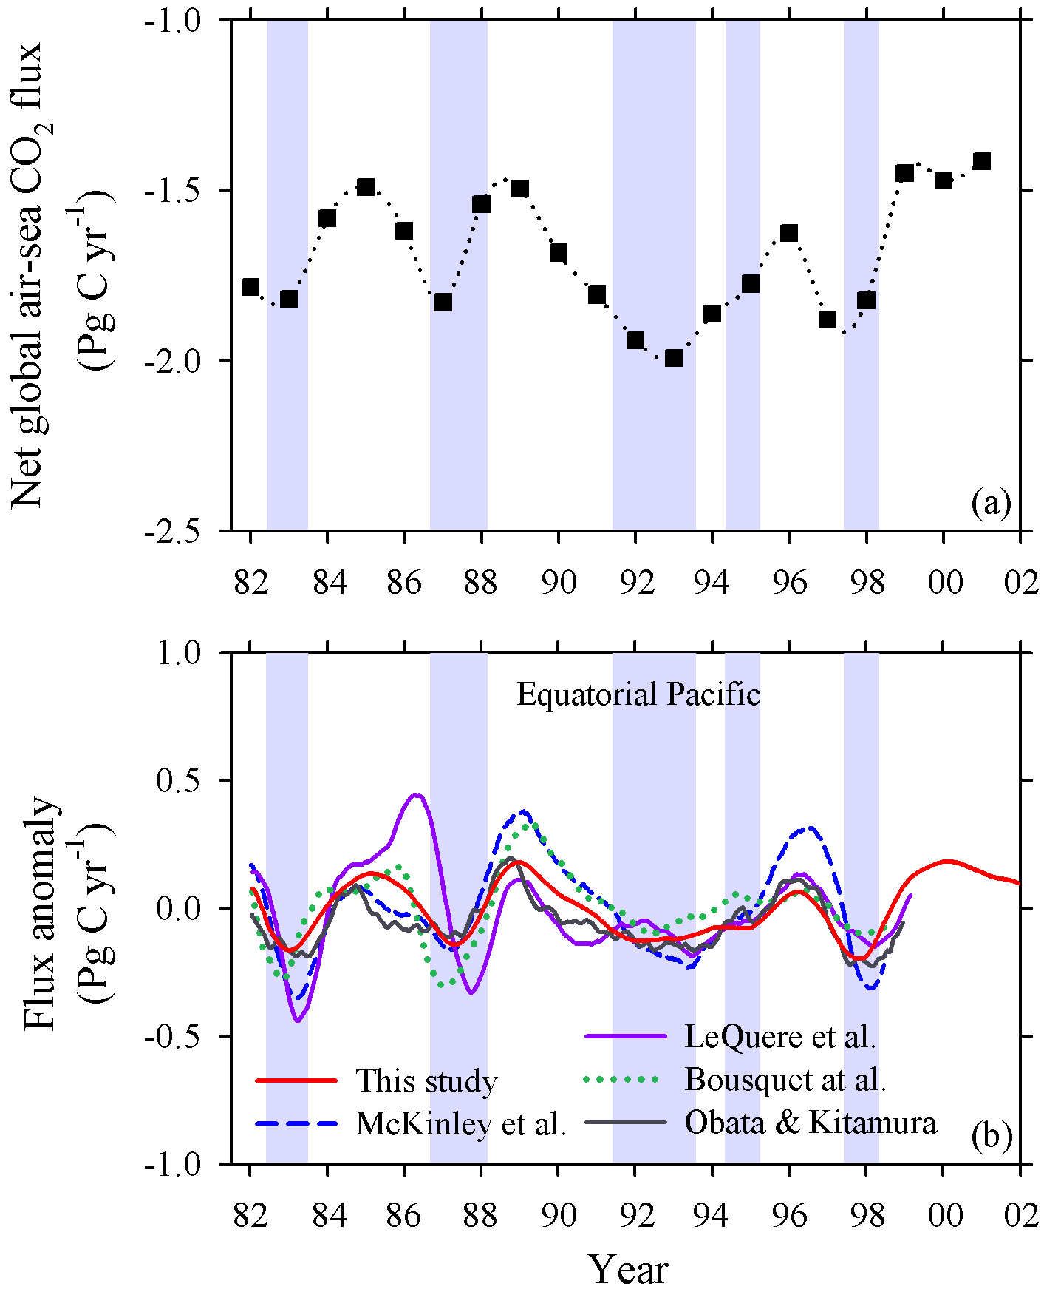

Figure 3 note combine errors bars for the regions into a single bar, it is difficult to compare the years
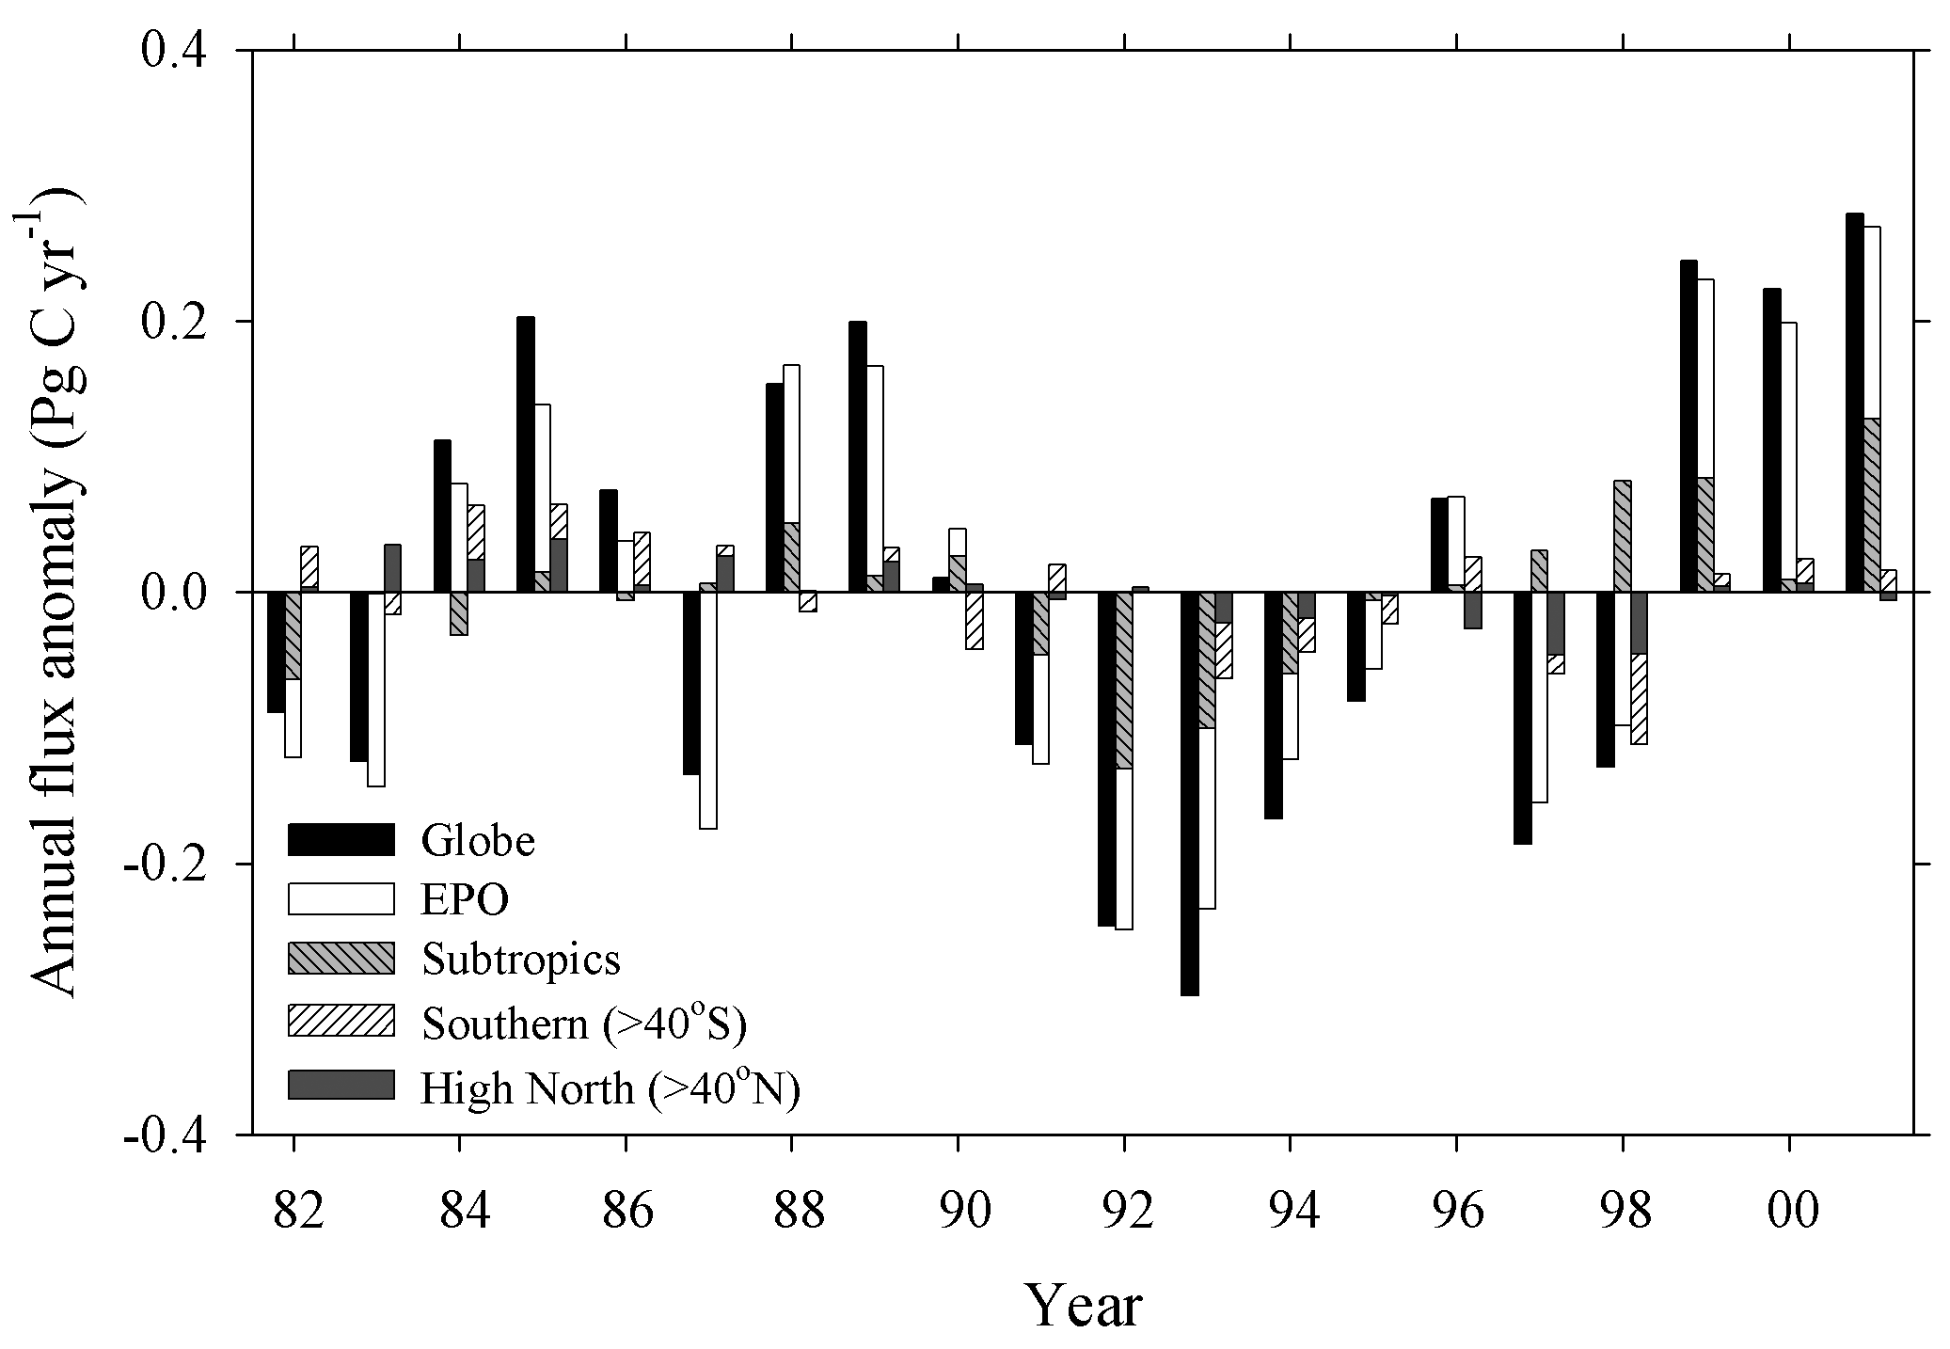

Figure 4 call the y-axis in 4a Net air-sea flux as well like panel b &c.

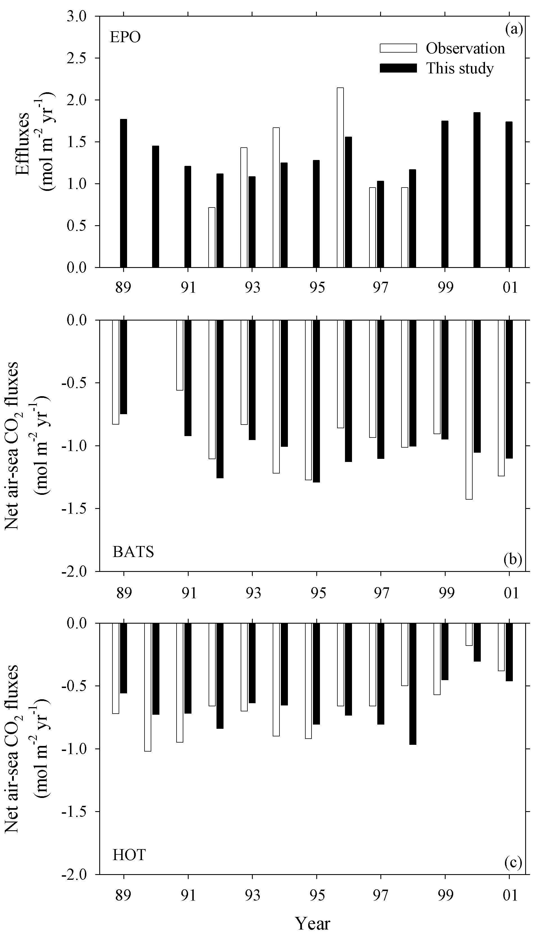

Figure 5

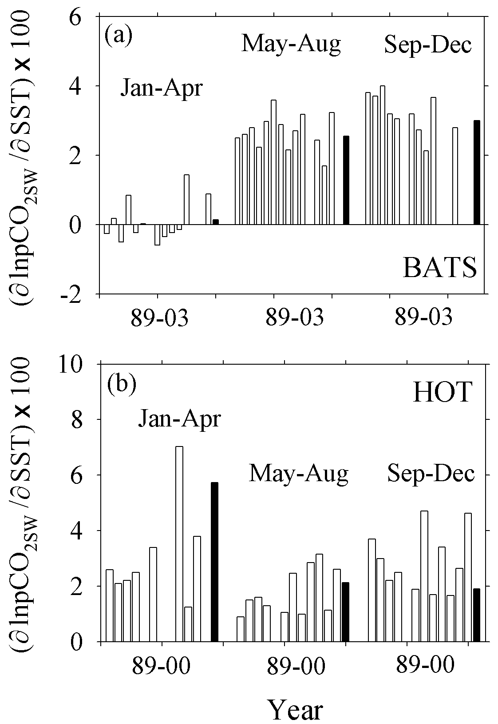

Figure 6

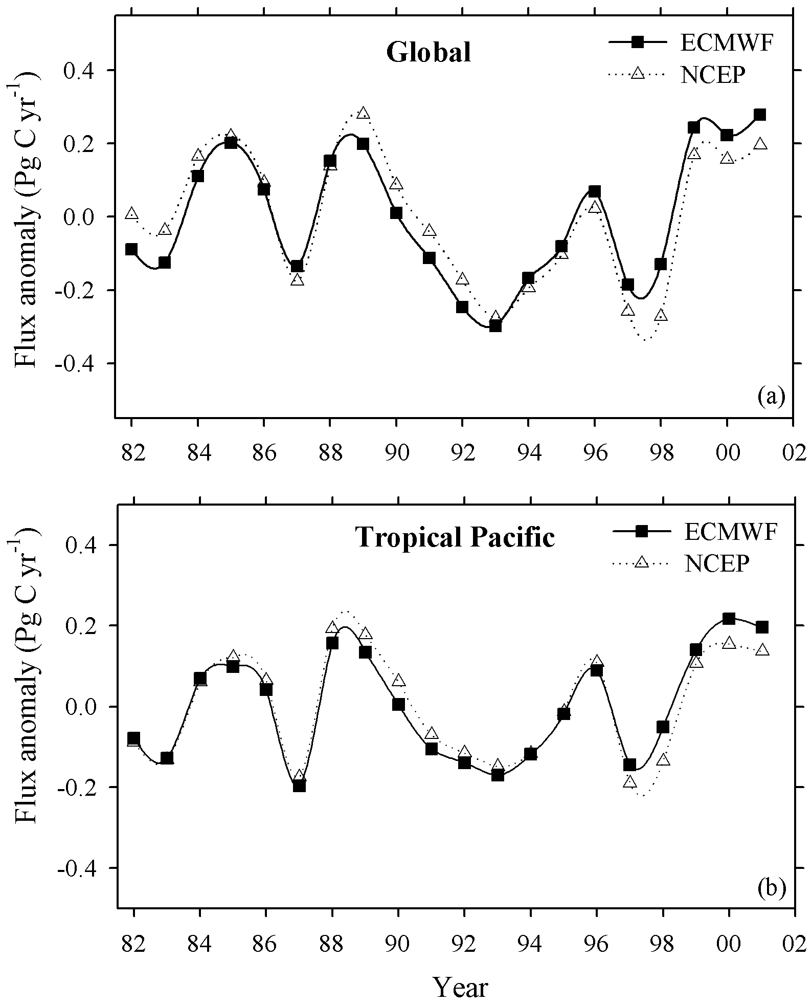

Figure 7

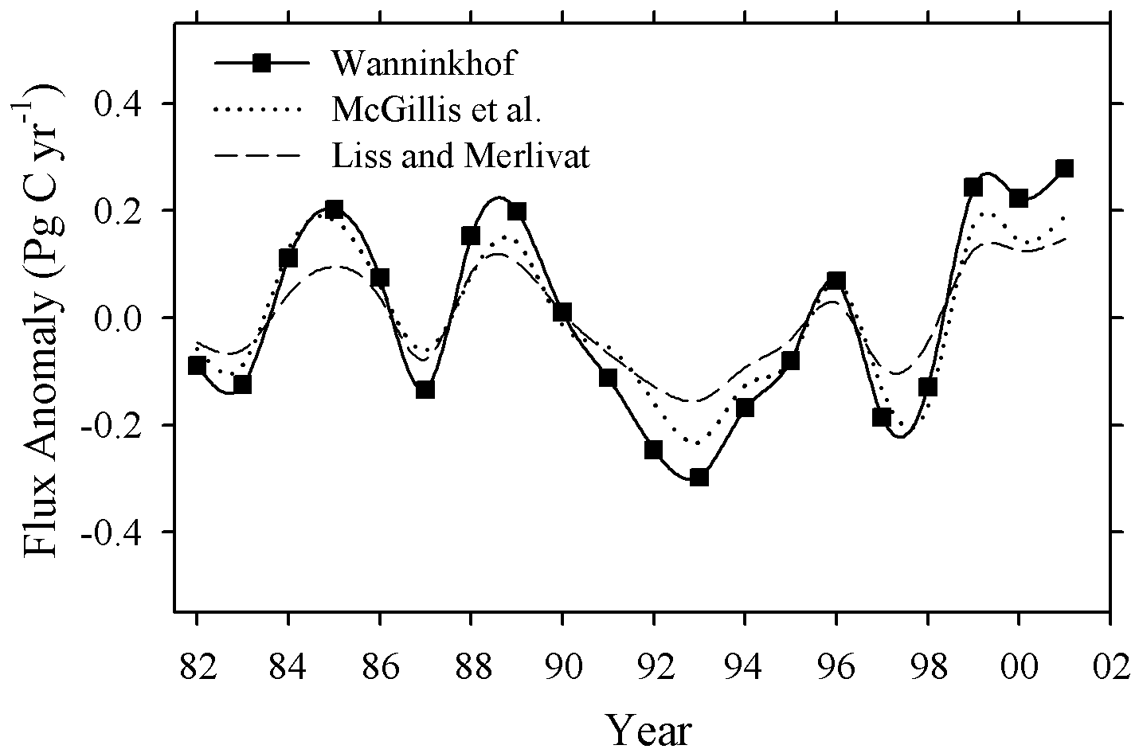

Figure 8
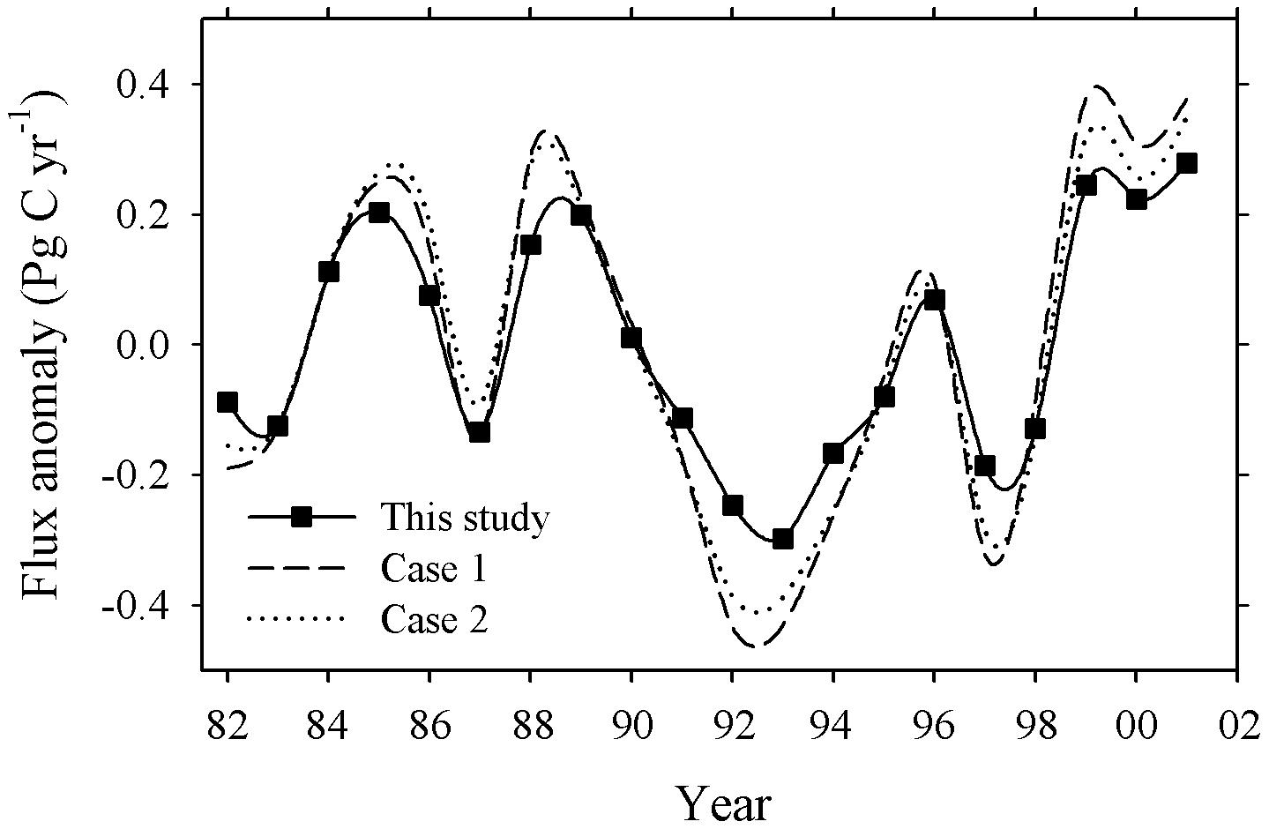

Figure 9
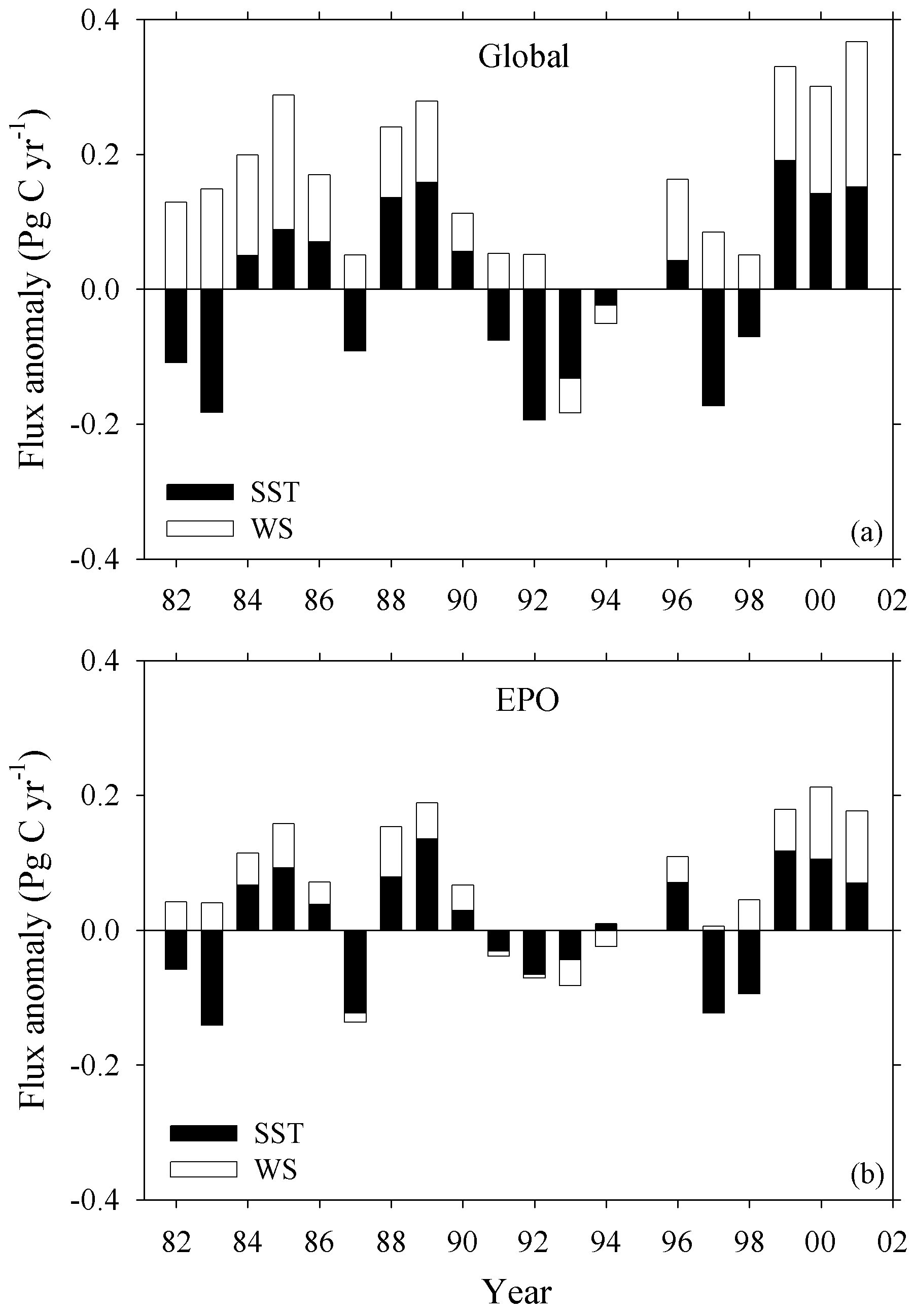

Figure 10
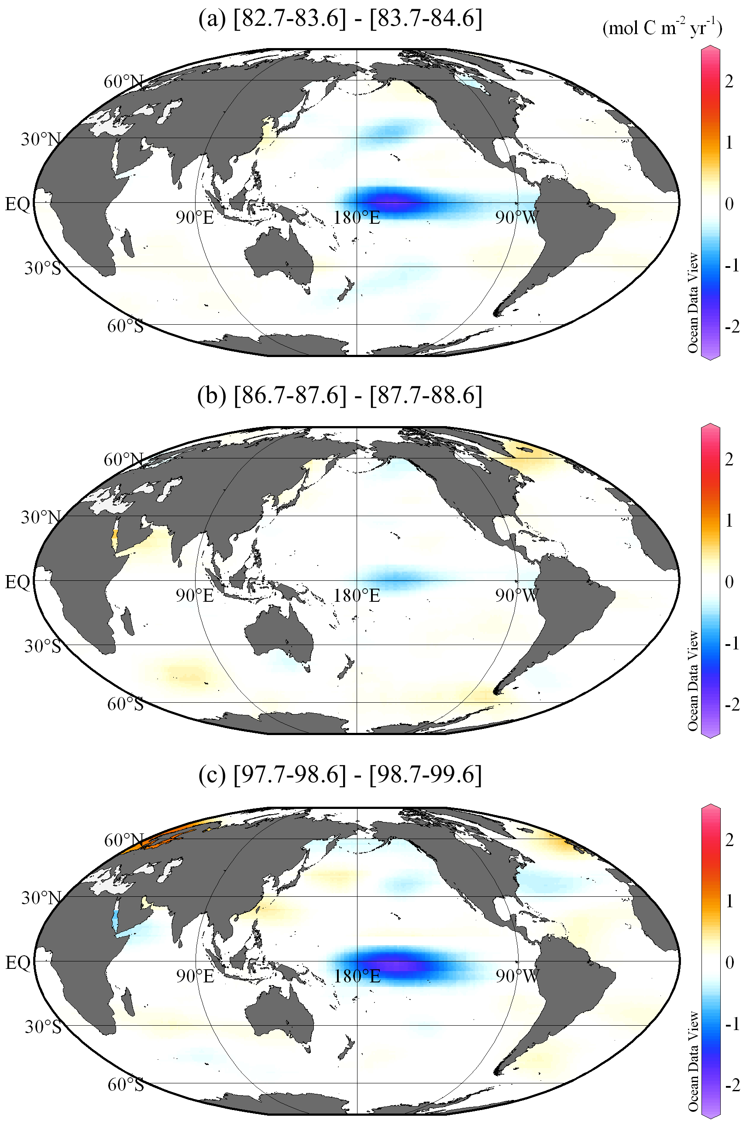

Figure 11

