Using Hyperterminal
- Start Hyperterminal: “Start --> All Programs --> Accessories --> Communications --> Hyper Terminal.
- If opened for the first time, the following window will appear. Enter any area code then “OK” twice.
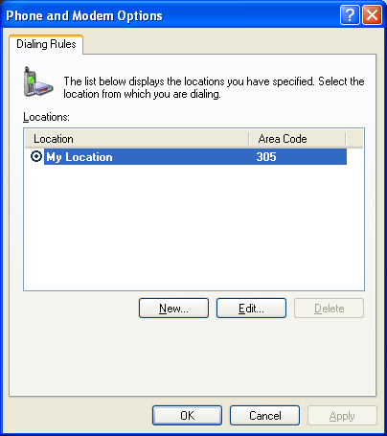
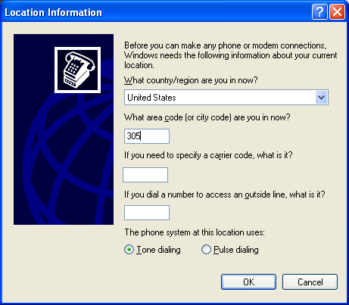

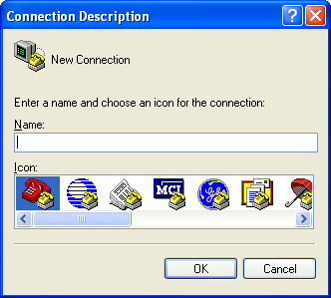
In the connection Description Window, enter any name, choose icon then “OK”.

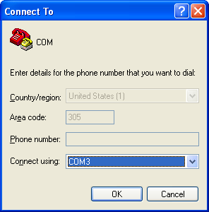

In the next window, Select the COM port you want to use in “Connect using”, then “OK”.

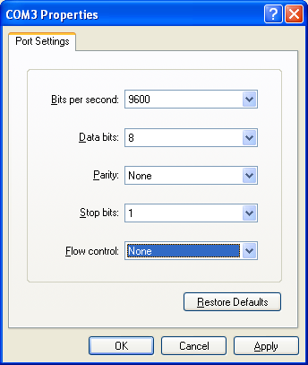
Select Baud Rate (Bits per seconds): usually 9600 but 4800 for GPS
Data bits 8 parity None Stop bits 1
Usually, flow control should be None.
Then “OK”

Communication Window.
Click on left icon to connect
Click on right icon to disconnect
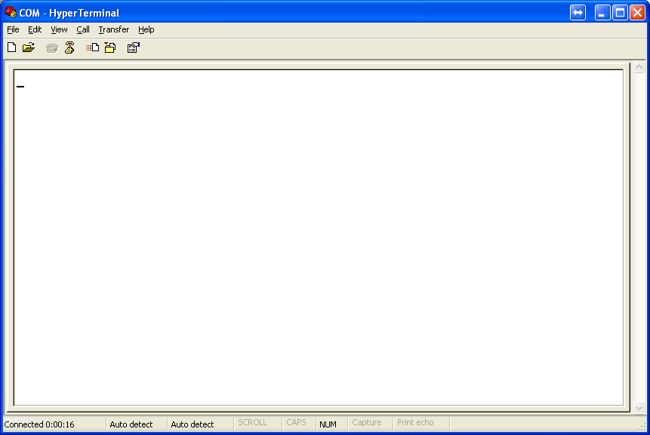
Connection time
Type commands here to send to device.
If device is broadcasting, strings will appear here
After disconnecting, click on this icon to modify Properties (COM #. Baud rate…etc)

You can save the connection as a *.ht file for quick access.

