Towards Improving High-Resolution Numerical Hurricane Forecasting: Influence of Model Horizontal Grid Resolution, Initialization, and Physics
by
Sundararaman G. Gopalakrishnan, Stanley Goldenberg¹, Thiago Quirino¹, Frank Marks, Jr.¹, Xuejin Zhang², Kao-San Yeh², Robert Atlas³ and Vijay Tallapragada⁴

NOAA/ Atlantic Oceanographic and Meteorological Laboratory/ Hurricane Research Division, Miami, FL, USA;
² University of Miami, Cooperative Institute for Marine and Atmospheric Studies,
Miami, FL, USA;
³ NOAA/Atlantic Oceanographic and Meteorological Laboratory
Miami, FL, USA;
⁴ NOAA/Environmental Modeling Center, National Centers for Environmental Predictions, Washington, DC, USA

(Submitted to Weather and Forecasting, May 5, 2011)
Abstract
This paper provides an account of the performance of an experimental version of the Hurricane Weather Research and Forecasting system (HWRFX) for 87 cases of Atlantic tropical cyclones during the 2005, 2007, and 2009 hurricane seasons. The HWRFX system was used to study the influence of model grid resolution, initial conditions, and physics. For each case, the model was run to produce 126 hours of forecast with two versions of horizontal resolution, namely, (i) a parent domain at a resolution of about 27 km with a 9 km moving nest (27:9) and (ii) a parent domain at a resolution of 9 km with a 3 km moving nest (9:3). The former was selected to be consistent with the current operational resolution, while the latter is the first step in testing the impact of finer resolutions for future versions of the operational model. The two configurations were run with initial conditions for tropical cyclones obtained from the operational Geophysical Fluid Dynamics Laboratory (GFDL) and HWRF models. Sensitivity experiments were also conducted with the physical parameterization scheme. The study shows that the 9:3 HWRFX system using the GFDL initial conditions and a system of physics similar to the operational version (HWRF) provides the best results in terms of both track and intensity prediction. Use of the HWRF initial conditions in the HWRFX model provides reasonable skill, particularly when used in cases with initially strong storms (hurricane strength). However, initially weak storms (below hurricane strength) posed special challenges for the models. For the weaker storm cases, none of the predictions from the HWRFX runs or the operational GFDL forecasts provided any consistent improvement when compared to the statistical-dynamical intensity model (Decay-SHIPS).

1. Introduction
The past decades have been marked by significant advances in operational weather prediction models such as the National Oceanic and Atmospheric Administration’s (NOAA) Global Forecast System (GFS), the NOAA/Geophysical Fluid Dynamics Laboratory’s (GFDL) regional hurricane forecasting system, the U.S. Navy Operational Global Atmospheric Prediction System (NOGAPS), the European Centre for Medium-Range Weather Forecasts (ECMWF) model, and the United Kingdom Meteorological Office model (UKMET). Such advances have contributed greatly to a steady improvement in the official tropical cyclone (TC) track forecasts issued by the NOAA/National Weather Service’s (NWS) National Hurricane Center (NHC), resulting in a substantial reduction in track forecast errors. This, in turn, has reduced warning and evacuation areas, thereby saving lives and resources (Rappaport et al. 2009).
Forecasting intensity changes is also extremely important, especially in the case of storms that rapidly intensify or weaken just prior to landfall (e.g., TCs Charley, 2004; Katrina and Wilma, 2005; Humberto, 2007; Karl, 2010). However, forecasting intensity changes in TCs is a complex and challenging multiscale problem. While cloud-resolving numerical models using a horizontal grid resolution of 1-3 km are starting to show some skill in predicting intensity changes in individual cases (Chen et al. 2011), it is not clear at this time if such high-resolution models can provide intensity guidance with fidelity. The goal is to produce consistently reliable results in the real-time (operational) venue. Lack of skill in numerical intensity forecasting is often associated with inaccurate initial conditions or limitations in modeling the physical processes within and around hurricanes. There is also debate as to what constitutes a reasonable horizontal resolution for use in forecasting hurricane intensity changes on a day-to-day basis (Gopalakrishnan et al. 2011).
The Weather Research and Forecast (WRF) system for hurricane prediction (HWRF) became operational at the National Centers for Environmental Prediction (NCEP) in 2007. This advanced hurricane prediction system was developed at the NWS/Environmental Modeling Center (EMC) to address the Nation's next generation hurricane forecast problems. In this study, an experimental version of HWRF (HWRFX) is used to explore three important factors (i.e., model grid resolution, initial conditions, and model physics) that may influence the accuracy of track and intensity forecasts and provide guidance for improvements to the operational HWRF system.

2. Background
The GFDL regional hurricane prediction system originated as a research model in the 1970s (Kurihara and Tuelya 1974; Kurihara 1975; Tuleya and Kurihara 1975, 1978, 1982). In the mid-1980s, the Hurricane Dynamics Group at GFDL began a 10-year effort to transform their research hurricane model into an operational hurricane forecasting tool for NWS. As part of that effort, several years were spent in developing a technique to insert a more realistic and model-consistent vortex into the global analysis. The initialization of hurricanes in the GFDL model, which is unique to this model and is relevant to the discussion later in this study, uses a vortex replacement strategy which consists of three major steps: (1) interpolate the global analysis fields from GFS onto the operational GFDL hurricane model grid; (2) remove the GFS vortex from the global analysis; and (3) add a high-resolution, model-consistent vortex (Kurihara et al. 1995). Since 1995, the GFDL hydrostatic hurricane prediction system has been used operationally by NHC and is regarded by NHC as one of the most skillful and reliable dynamical models for track forecasts. Since 2005, the model has demonstrated improved skill in intensity predictions, especially after the atmosphere-ocean coupled system (Ginis et al. 1999) and increases in vertical and horizontal resolution were implemented (Bender et al. 2007). A thorough summary of the modeling system and its performance is provided in Bender et al. (2007).
WRF is a general purpose, multi-institutional mesoscale modeling system. NCEP’s Non-hydrostatic Mesoscale Model (NMM; Janjic et al. 2001; Janjic 2003) is a dynamical core option within the WRF model initiative. A moving nest capability was created within the WRF-NMM system to address the hurricane problem (Gopalakrishnan et al. 2006). This dynamical capability is the backbone of the HWRF system. The high-resolution nest is capable of capturing non-hydrostatic scales of motion within the hurricane inner core and has the potential to provide improved intensity guidance. Another advancement of the HWRF system over the GFDL model is the option to use the previous forecast cycle of the model vortex (when available) as the first guess and to assimilate inner-core observations. This capability was introduced to provide more realistic initial three-dimensional structure and is a critical ingredient towards advancing TC intensity/structure prediction (Liu et al. 2006). To build on the success of the GFDL model, the physics in the initial implementation of HWRF emulated the latest version of the GFDL system (Bender et al. 2007). In addition, the HWRF system, as with the GFDL model, is coupled to a three-dimensional version of the Princeton Ocean Model (POM) modified for hurricane applications over the Atlantic basin. The HWRF system, with 27 km and 9 km parent and movable mesh grid resolutions (27:9; Fig. 1a), respectively, has been used as an operational hurricane forecasting tool at NWS since 2007. Documentation for the HWRF system (Gopalakrishnan et al. 2010) is available at the Development Testbed Center (DTC), National Center for Atmospheric Research (NCAR), in Boulder, Colorado (http://www.dtcenter.org/HurrWRF/users/docs/scientific_documents/HWRF_final_2-2_cm.pdf).
In addition to operational hurricane models, cloud-resolving models are more recently being used as research tools to help understand the hurricane intensity prediction problem. For example, in a series of explicit simulations of Hurricane Andrew (1992) using the fifth generation mesoscale model, MM5, developed by Pennsylvania State University (PSU) and NCAR at a resolution of about 6 km, several interesting features of the modeled hurricane (Liu et al. 1997, 1999; Yau et al. 2004; Zhang et al. 1999, 2000, 2001, 2002) compared well to the observed structure of hurricanes (Marks and Houze 1987; Marks et al. 1992; Willoughby 1979, 1990a, 1990b). As verified against various observations and the post-storm derived “best track” data (positions and intensities) provided by NHC, the PSU/NCAR MM5 simulations reasonably captured many of the features of the inner-core structure of the storm. In particular, the track, explosive deepening rate, minimum surface pressure preceding landfall, and strong surface winds near the shoreline were all well reproduced by these simulations (Yau et al. 2004).
Other recent research suggests that hurricane intensity forecasts could be improved with very high model resolution (grid spacing ≤ 1 km in the horizontal) that adequately simulates hurricane inner-core structures such as the eyewall and rainbands (Davis et al. 2008, 2011; Rotunno et al. 2009). For example, in an effort to demonstrate the value of a high resolution hurricane forecast, Davis et al. (2011) used the Advanced Hurricane WRF (AHW) model with two sets of 69 simulations (covering 10 Atlantic tropical cyclones) with horizontal resolutions of 12 and 1.33 km. Their statistically significant results indicated that higher resolution improved forecasts of both intensity and the hurricane's structural aspects. Using the results of Davis et al. (2011) as the basis, the authors used the AHW model to provide real-time forecasts during the 2009 season. The results were storm specific. While higher resolution improved forecasts of track and intensity, especially for some of the weaker storms like Erica and Danny, the impacts were mixed for other storms. These results raise the question of what controls the overall intensity and track predictions: resolution alone, physics, initial conditions, or all of these factors?
While operational track forecasts show substantial skill (on the order of 30-40% at 72 h) versus the CLImatology and PERsistence (CLIPER) model utilized by NHC (e.g., Gross 1999), the skill in predicting intensity change using a dynamical model has been marginal (DeMaria and Kaplan 1999; Kaplan et al. 2010). To address this lack in intensity prediction skill, with an emphasis on rapid intensification (RI) events, NOAA established the Hurricane Forecast Improvement Project (HFIP) in 2007 (available online at http://www.nrc.noaa.gov/plans_docs/HFIP_Plan_ 073108.pdf).
HWRFX is a version of the HWRF system specifically adopted and developed at the Hurricane Research Division (HRD) of the Atlantic Oceanographic and Meteorological Laboratory (AOML) to study the intensity change problem at cloud-resolving scales (about 1-3 km). This modeling system is supported by HFIP and complements the operational HWRF system. The data acquisition component, designed with Java and shell scripts, runs automatically and in parallel with the triggering mechanism. It continuously retrieves meteorological data sets required to perform the HWRFX forecasts. These data sets include the initial conditions and the 126-hour forecast data of the operational Global Forecast System (GFS), the initial conditions of the operational GFDL hurricane model, and the initial conditions of the operational HWRF model. The HWRFX model can be run with at least two suites of physics options. The first suite mimics the operational HWRF suite of physics (Gopalakrishnan et al. 2011), and the second is a suite of physics that was developed as part of the high-resolution modeling effort at NCAR. The physics options used in this work are discussed in detail later in the text. As in the case of the GFDL model developments, HWRFX can be run in both an idealized research framework (Gopalakrishnan, et al. 2011) and in real-time mode (Zhang et al. 2011). HWRFX was first used in an idealized framework to gain a fundamental understanding of the influence of horizontal grid resolution on the dynamics of hurricane vortex intensification in three dimensions (Gopalakrishnan et al. 2011). Based on a series of numerical experiments at the current operational resolution of about 9 km for the movable fine mesh and at a finer “research” resolution of about 3 km (Figs.1a and 1b), it was found that improved resolution had very little impact on the initial spin up of the vortex. However, the mature phase of the storm’s evolution exhibited significantly different behavior at 9 and 3 km, with the finer resolution significantly improving predictions of the storm’s structure.

3. HFIP High-Resolution Test Plan
The first step in the HFIP effort was to quantify the impact of increasing the horizontal grid resolution in numerical models on intensity forecasting. In early 2009, HFIP established the High Resolution Hurricane (HRH) tests. The plan for these tests was developed jointly by several segments of the community, including specialists in hurricane forecasting, numerical modeling, and forecast verification. Hurricane Specialists at NHC selected 69 cases from 10 hurricanes during the 2005 (Emily, Katrina, Ophelia, Philippe, Rita, and Wilma) and 2007 (Felix, Humberto, Ingrid, and Karen) seasons for the HRH tests. The 69 HRH cases were selected in order to examine a variety of aspects of the models’ performance for areas such as (1) the capability to simulate RI events (e.g., Katrina, Rita, Wilma, Humberto, and Karen; see Table 1 and Fig. 2), (2) the impact of vertical wind shear on intensity evolution (e.g., Katrina, Philippe, Rita, Ingrid, and Karen), (3) the effects of eyewall replacement (e.g., Emily, Rita, Wilma, and Felix), (4) the effects of oceanic heating and cooling (e.g., Ophelia), and (5) the impact of terrain interaction during landfall on track and intensity predictions (e.g., Katrina, Rita, and Wilma).
Zhang et al. (2011) used the HWRFX system to study the impact of resolution on the 69 cases. The GFDL initial conditions (of the storm vortex and immediate environment) and physics that emulate the operational system were used for this testing. The high-resolution forecasts, using a uniform resolution of 9 km with a moving nest at 3 km, demonstrated a reduction in the absolute track errors vs. the low-resolution forecasts at all forecast time intervals. Forecasts at both high- and low-resolutions showed a westward and southward bias with the exception of the low-resolution forecasts for 108 and 120 hours. However, results for the frequency of superior performance (FSP), a measure (in percent) of how often one model produces a better forecast than another, were mixed. In contrast, use of the high-resolution model reduced the absolute intensity errors in comparison to the low-resolution model, with the exception of the 84-hour forecast. The intensity biases appear to be much better balanced over the forecast period with the high-resolution model, which had a smaller negative bias than the low-resolution model prior to 60 hours but changed to a positive bias at the later forecast times. This demonstrates that the high-resolution model tends to intensify storms more than the low-resolution model. FSP results for intensity errors show that high-resolution forecasts also demonstrate general improvement over the low-resolution forecasts. However, these results did not include a significant number of forecasts for initially (at the start of the forecast) weak (i.e., below hurricane strength) storms or sheared systems.
The 2009 hurricane season was a challenging one for forecasts due, in part, to several weak and/or sheared storms (e.g., Ana, Danny, and Erica). As part of the HFIP real-time Demonstration system, HWRFX was run in real time during the 2009 season. For this study, cases from five 2009 storms (Ana, Bill, Danny, Erica, and Ida) were added to the 2005 and 2007 HRH storm sample to test the HWRFX system’s sensitivity to resolution, initial conditions, and physics. In all, 87 cases were tested (Table 1; Fig. 2). Although this is a modest number of cases compared to verification samples used for operational purposes, the sample size should be sufficient for the sensitivity tests presented here. These results will hopefully provide insights that will later be translated into improvements for operational forecasting. The 87 cases comprised a diverse sample set of initial intensities, strengthening and weakening scenarios (including a number of RI events), and track types (see Table 1 and Fig. 2) to better understand the impact of various factors upon model performance. This was also the first time that the sensitivity of a version of the HWRF model to initial conditions and physics, in addition to resolution, was examined for a comprehensive list of cases.

4. Resolution/Configuration, Vortex Initialization, and Model Physics
Figure 1 shows the two model configurations (resolutions) used in this study. The domain of simulation along the horizontal direction was set to about 50 x 50 degrees with a moving nest of about 7 x 7 degrees. There were 40 hybrid levels in the vertical with the top level set to 50 hPa. The simulations reported here were performed with two kinds of horizontal resolution, namely, (i) a parent domain and moving nest with resolutions of about 27 km and 9 km, respectively (27:9 henceforth; Fig. 1a) and (ii) a parent domain and moving nest with resolutions of 9 km and 3 km, respectively (9:3 henceforth; Fig. 1b). While the former was selected to be consistent with the current operational resolution, the latter could become the possible operational resolution in the near future. All results reported in this study used moving nests at 9-km (i.e., 27:9) or 3-km (i.e., 9:3) resolution. The model was run for 126 hours. As mentioned earlier, the HWRFX system has an option to be initialized using either the operational HWRF grib or the GFDL grib products. The WRF post-processor (WPS) was used to initialize the model with either the HWRF or the GFDL vortex initializations. The GFS forecasts were used to produce boundary conditions for all the cases reported here.
A description of the operational HWRF suite of physics was recently published as a technical document at the DTC, NCAR, in Boulder, Colorado (Gopalakrishnan et al. 2010). The HWRFX physics options used in this study were configured as close as possible to the operational HWRF system. The GFDL surface (Bender et al. 2007) and GFS boundary layer formulations (Hong and Pan 1996) were used to parameterize the flux transport and subsequent mixing in the atmosphere. The Ferrier scheme (Ferrier et al. 2002) was used to provide latent heating due to the microphysical processes in the atmosphere, and the Simplified Arakawa and Schubert scheme (SAS) was used to parameterize subgrid cumulus-cloud activity. The scheme included a term for momentum mixing (Hong and Pan 1998) that was parameterized as a drag term in the model. Cumulus parameterization in combination with the Ferrier microphysical scheme have been found to have some value in the operational NMM for scales down to about 5 km. However, the contribution to heating from SAS has diminishing returns, i.e., an increase in resolution and the grid volume in the inner core region quickly becomes saturated with the use of an explicit microphysics scheme. Consequently, the SAS convection scheme was switched off at the 3 km resolution (moving mesh) in this work consistent with Zhang et al. (2011). Finally, to keep the radiation option simple, the effect of radiation on the atmosphere was approximated with the NCAR long- and short-wave radiation scheme (Dudhia’s short wave radiation and Rapid Radiative transfer model) available in the WRF framework. Detailed descriptions of the physics options in HWRFX with appropriate references are reported in Yeh et al. (2011). Although the physics options in HWRFX were kept as close as possible to the operational HWRF physics, apart from the difference in the radiation scheme, there were several subtle but significant changes adopted in this study. We believe that it may be worthwhile to contrast these differences at least for the 27:9 version. In Table 2 we specify some main differences in physics between the 27:9 forecasts and the operational HWRF physics.
The WRF model provides an option for several combinations of physics packages (http://www.mmm.ucar.edu/wrf/users/tutorial/200707/WRF_Physics_Dudhia.pdf). In the recent past, a number of studies have reported intercomparisons between these packages for the specific case of a hurricane (e.g., Li and Pu 2009; Fierro et al. 2009) or for a range of scale-spanning problems such as warm season regional forecasts (e.g., Gallus and Bresch 2006) and hurricane forecasting (Davis et al. 2011). The “Kain–Fritsch (KF; Kain and Fritsch 1992) convective scheme, Yonsei University (YSU; Noh et al. 2003) planetary-boundary layer (PBL) scheme, and WRF-Single-Moment 5-Class Microphysics scheme (WSM5)” is a well-documented combination for hurricane applications (Davis et al. 2011). In this study, the YSU-WSM5-KF combination was used as the second option for testing. The effect of solar radiation on the atmosphere was approximated with the NCAR long- and short-wave radiation scheme available in the WRF framework for all the runs. Both physics packages in this study used the NOAH land surface scheme (Ek et al. 2003). Finally, in all the runs, sea surface temperatures (SSTs) were obtained from the GFS and held fixed during the forecasts. Table 3 presents a summary of the sensitivity experiments performed using the 87 cases in this study.
The track and intensity of a storm were determined on the basis of the position of the nest within the parent domain (Fig. 1) which, in turn, is based on the concept of dynamic pressure (Gopalakrishnan et al. 2002). At the end of every time step of the nested domain, the centroid of the dynamic pressure within this moving domain is determined. The minimum dynamic pressure determines the storm center. If the storm center is advected beyond one grid point of the parent domain (three grid points from the center of the nested domain due to the 3:1 parent-to-nest grid ratio), the nested domain is moved to a new position within the parent domain to maintain the storm near the center of the nested domain. The post-processing software reads the history output file from the moving nest, which carries the information of the minimum sea level pressure, maximum wind, radius of maximum wind, and storm location corresponding to the minimum sea level pressure of the nested domain. As with any numerical model, tracking problems sometimes occurred when the algorithm (or nested grid) lost the storm center, was affected by a storm’s proximity to the boundaries, or the nested grid algorithm jumped to a neighboring low pressure system or other storm. These cases were typically removed by screening for situations in which the storm center, as determined from the parent domain and the center determined from the nested grid, differed by more than ~200 km. Once a center position was determined to be suspect, the rest of that forecast (position and intensity) was removed from the sample. Improvements to the automated tracking algorithm are now being developed but were not available when the data for this study were compiled.

5. Results and Discussions
Given the large amount of high-resolution data, it is not feasible here to discuss our results in terms of individual cases. Therefore, only statistical verification of the runs will be presented. We report the results in terms of standard metrics such as (i) absolute track errors and (ii) intensity errors (absolute and bias). These measures provide only a partial glimpse of the high-resolution model’s potential to improve track and intensity forecasts. In addition to these standard metrics, we also examined the radius of maximum wind as a measure of structure prediction. The cumulative distribution function (CDF) of the radius of maximum wind at 10 m above the ground for all the HWRFX forecasts was compared with HRD’s H*WIND analyses (e.g., Powell et al. 1998).
Models based solely on climatology and persistence are created from statistical relationships between storm-specific information such as location, time of year, and the behavior of historical storms. For track forecasts, NHC’s operational CLImatology and PERsistence model is CLIPER5 (Neumann 1972). For intensity forecasts, it is DSHIFOR5. DSHIFOR5 (Decay-SHIFOR) is the SHIFOR5 (Statistical Hurricane Intensity FORecast) model (Jarvinen and Neumann 1979; Knaff et al. 2003) adjusted for the inland decay rate of Demaria et al. (2006). NHC and others (Aberson 1998; Franklin 2010) routinely use these models as a benchmark for establishing the “skill” of research and operational models, where CLIPER5 and DSHIFOR5 provide a “no-skill” baseline. Variations in the errors from these climatology/persistence models help to provide an indication of whether forecast situations are “easy” or “difficult.” Track forecast results in this study are shown in terms of “skill” versus CLIPER5. However, because the ultimate focus of this project is to improve intensity forecasts for dynamical models, a higher standard for the intensity forecast baseline, DSHIPS, was used. SHIPS (Statistical Hurricane Intensity Predicton Scheme) is a sophisticated statistical-dynamical model which predicts storm intensity utilizing multiple regression relationships with climatological, persistence, and numerical model predictors (DeMaria et al. 2005). DSHIPS (Decay-SHIPS) is SHIPS adjusted for the decay of storms when they move inland, according to Demaria et al. (2006), and is regarded as one of the most reliable intensity forecast models by NHC (Franklin 2010). In this study, we use CLIPER5 and DSHIPS as the basis for comparison of track and intensity predictions, respectively, from HWRFX.
5.1 Track Errors
Figure 3 provides an overview of the track error statistics. The mean track errors for all runs for the two resolutions (i.e., 27:9 and 9:3) and two initial conditions (i.e., GFDL and HWRF) are presented here, where H9hwrf and H9gfdl refer to the 27:9 results with HWRF and GFDL initial conditions, respectively, and H3hwrf and H3gfdl refer to the 9:3 results with HWRF and GFDL initial conditions, respectively (Table 3). The results are also compared with the operational GFDL model. As expected, the number of cases decreases for longer forecast intervals and, consequently, while there are 87 entries for the 12-h forecast, there are only 26 entries for the 120-h forecast. The average track errors for the various models increase almost linearly from near 60 km at 12 h to as low as 436 km (H3gfdl) and as high as 529 km (H9gfdl) at 120 h (Fig. 3a). In general, the large-scale variations that are expected to have a major influence on the TC tracks (Riehl 1954) are well captured by the HWRFX system in all four model versions. The impacts of the changes to resolution and initial conditions are better seen when the results are normalized with reference to CLIPER5 (Fig. 3b). The operational GFDL model provides the best overall skill. The H3gfdl version of HWRFX has nearly the same skill level overall as the GFDL model. Consistent with the results shown in Zhang et al. (2011), use of the GFDL initialization in the 9:3 HWRFX version (H3gfdl) produces more skillful results than the use of the GFDL initialization in the 27:9 version (H9gfdl). On the contrary, the HWRFX prediction at 27:9 resolution with the corresponding HWRF initialization (H9hwrf) is more skillful in the mid-forecast intervals compared to the 9:3 version with the HWRF initialization (H3hwrf).
5.2 Intensity Errors
Figure 4 depicts the intensity error statistics from HWRFX. The intensity forecasts show a large diversity in behavior (Fig. 4a), with H3hwrf as the outlier with the largest errors. At 12 h, the intensity error for this initialization is close to 9 m s⁻¹, whereas the same initialization with the 27:9 resolution (i.e., H9hwrf) produces an intensity error of about 7.4 m s⁻¹. When the average intensity forecast errors are shown as skill relative to DSHIPS (Fig. 4b), the dynamical models are better from at least about 36-96 h, with the exception of H3hwrf. These are encouraging results (see footnote 4) considering DSHIPS is regarded as one of the most reliable intensity forecast models [DSHIPS shows consistent skill relative to DSHIFOR5 (Franklin 2010)]. For this sample, the intensity forecast error results from the various versions of HWRFX (again with the exception of H3hwrf) are comparable or sometimes better than the results from the operational GFDL model for 36-120 h.
Considering the impact of resolution and initial conditions, for this sample there is only a marginal improvement at 12, 24, 60, and 72 h using the increased resolution (9:3) with GFDL initial conditions (i.e., H3gfdl, vs. H9gfdl). However, using the GFDL initial conditions, Zhang et al. (2011) found a more consistent improvement in forecasts with improved resolution. The change in results is likely due to the addition of the sheared and weak cases from 2009, demonstrating the lack of stationarity in verification statistics with these modest sample sizes. On the other hand, runs with the HWRF initial conditions (H9hwrf vs. H3hwrf) perform much better for the lower resolution (27:9, i.e., H9hwrf). This is likely caused by the superfluous use of a bogus vortex and an overly restricted storm structure in the operational HWRF initialization. In the operational HWRF system (used here for the initialization of H9hwrf and H3hwrf), weighted information from the first cycle was used in the subsequent cycles (Liu et al. 2006). In fact, weights from the bogus increase with weaker storms. Consequently, the subsequent cycles carry information from the bogus vortex that result in the artificial effects being amplified by the increase in resolution. In summary, the two resolutions provide more or less similar results when using the GFDL initial conditions, at least with the 36-96 hour forecasts, but the HWRF initial conditions appear to be much better suited to the coarser grid.
To further understand model behavior, the sample was stratified based on the initial intensity of each case. Figures 5a and 5b show the results in terms of skill (vs. DSHIPS) for average absolute intensity forecast errors for storms with an initial intensity (maximum sustained surface wind speed) ≥ 33.4 m s⁻¹ (i.e., hurricane strength) and for storms with an initial intensity < 33.4 m s⁻¹ (i.e., less than hurricane intensity), respectively (see Table 1). Of course, this further reduces the already modest sample size at the 12 h forecast interval to 38 cases for initially stronger storms and 49 cases for initially weaker storms, and the sample size is even smaller for the later forecast intervals. Since the results with DSHIPS for the stratified samples (not shown) demonstrate very little difference for absolute errors between the runs with initially weaker and stronger storms, the baseline used for the skill diagrams is fairly stable. Therefore, the skill differences discussed here for stratification are primarily the result of differences in the model results rather than the baseline.
A comparison between Figs. 5a and 5b demonstrates that the skill in predicting intensity for initially stronger storms far exceeds that of predicting intensity for the initially weaker storms for the given sample. In fact, with the exception of the 12- and 24-h forecast intervals for the HWRFX with GFDL initial conditions (i.e., H9gfdl and H3gfdl), the skill level for every dynamical model represented here is generally higher than 20% from 24 to at least 96 h. In contrast, the skill for initially weaker storms was negative for every model at every forecast interval with the exception of a few models showing slightly positive skill from 60-84 h. For initially strong and weak storms, the results for runs using the HWRF initialization (H9hwrf and H3hwrf) are fairly close, except for 12 and 24 h, and also for 36 h with weak storms only. For runs with GFDL initial conditions (H9gfdl and H3gfdl), the finer resolution has better skill until 72 h. However, the sample size was limited to 17 at that time and decreases to only 9 cases at 120 h. Nevertheless, for stronger storms, the HWRF initialization for the 27:9 km HWRFX modeling system generally performed better than the GFDL initialization at almost all lead times.
It should be noted that the extremely poor performance of the overall sample (Figs. 4a and 4b) of the fine grid version of HWRFX using HWRF initial conditions (H3hwrf) is mostly due to large errors from the weak storm sample (see Fig. 5a vs. 5b). In fact, H3hwrf performs well out to 72-84 h for the strong intensity cases but extremely poor relative to all of the other models depicted for the weaker cases. Overall, one would have to conclude that the GFDL initial conditions (H3gfdl) are better suited (for the cases in this study) when using the 9:3 km version, and the HWRF initial conditions (H9hwrf) are better suited when using the 27:9 km version.
With the exception of H3hwrf, the results from the various versions of HWRFX were generally comparable to the operational GFDL model (Fig. 4b). As opposed to initially strong storms, an initially weak vortex had a very dramatic influence on prediction skill (Fig. 5b). Clearly, there is a complete lack of skill at almost all lead times. Results for intensity bias statistics discussed in a subsequent section may shed light on these skill levels, at least for the initial period of forecast. Even with relatively small sample sizes, these results are striking and make physical sense in that the models would be expected to have a more difficult time initializing and maintaining an initially weaker vortex. Results for the actual absolute intensity errors for initially strong and weak storms and the full sample of cases (not shown) were also very consistent. The smallest errors are associated with initially strong storms at all forecast intervals and show that these stratified results are not biased by scaling with the DSHIPS predictions. Stratification of the track forecast errors (not shown) also yielded very similar results, with skill much higher for initially stronger storms.
5.3 Intensity Bias
Figure 6 compares the intensity bias of the models (four versions of HWRFX, GFDL, and DSHIPS). Figures 6a, 6b, and 6c show the biases for all the runs (87 cases at 12 h), initially strong storms (38 cases at 12 h), and initially weak storms (49 cases at 12 h), respectively. Several features are worth noting:
- For the complete sample (Fig. 6a), the 27:9 km runs with GFDL initialization (H9gfdl) produced noticeable negative bias at lead times through 84 h. This is primarily from the strong storm cases (Fig. 6b) through about 60 h (section 5.3 (ii)) and mainly from the weaker cases (Fig. 6c) at 84 h. The results also show a large negative bias for the 9:3 runs with GFDL initialization (H3gfdl) for the initially stronger storms (Fig. 6b) through 24 h. Yeh et al. (2011) used the GFDL initialization for HWRFX at 27:9 and studied the performance of the modeling system for the 2008 season. The study concluded that the early negative bias of the HWRFX resulted from a dynamical inconsistency due to the use of GFDL initial conditions, but the continuing negative bias was probably related to inadequate physical forcing of the given configuration (27:9). The study also suggested the need for model-consistent initial conditions for the HWRFX system. The use of initial conditions from the operational HWRF system is hence justified. In the present study, the use of HWRF initial conditions for the HWRFX runs at the same resolution (i.e., 27:9) produced an improved intensity bias and a better intensity forecast (Fig. 5b). “Downscaling” (i.e., using the operational HWRF initial conditions from the 27:9 version to drive the experimental 9:3 version: H3hwrf) produced noticeable positive bias (Fig. 6a). The positive bias, however, is almost entirely due to errors from the weak cases (Fig. 6c).
- The H9gfdl bias for strong storms was negative through at least 84 h and was especially large through at least 36 h (Fig. 6b), suggesting that a strong initial vortex invariably spins down in the first 12 hours of the forecast. It takes 24-36 hours for the vortex to recover, and this is partly reflected in the poor model skill for the same period (Fig. 5a). Intensity bias (Fig. 6b) is strongly associated (or correlated) with model performance for the strong storms (Fig. 5a) and with the other models as well. The GFDL initialization for the 9:3 km runs (H3gfdl) showed a noticeable spin down that lasted for less than 24 hours (Fig. 6b). The model consequently recovers from the initial shock to produce more skillful guidance than DSHIPS by 24 h (Fig. 5a). There is a systematic improvement (i.e., reduction) in the initial negative bias with resolution for stronger storms (Fig. 6b).
- A careful analysis of the first one hour of the simulations (not shown for brevity) indicated that the model spin down problem is only marginally effected by the initial intensity errors. For example, the initial intensity errors for the strong storms for the H9gfdl was about -4.7 ms⁻¹, H3gfdl was -3.0 ms⁻¹, H9hwrf was –2.1 m/s, H3hwrf was –2.0 ms⁻¹ and the GFDL model was the –5.6 ms⁻¹ (not shown), the corresponding initial intensity bias (Fig. 6b) shows despite huge initial intensity bias the GFDL model recovers rapidly from the initial error. However, as mentioned earlier H9gfdl and H3gfdl spins down stronger storms further indicating the need for some research and analysis on the model spin up issue.
- Despite very small initial errors (not shown), and consequently, zero-hour bias, weak cases presented special challenges for storm prediction (Fig. 6c). The HWRFX runs with HWRF initialization (H9hwrf and H3hwrf) showed substantial positive bias even at 12 hours, and the positive biases persisted through 120 h. The worst biases were seen for H3hwrf and are reflected in the very poor intensity forecasts (Fig. 5b). H9hwrf and even the GFDL model predictions also show significant initial positive bias, suggesting that these models are cyclogenic in behavior. On the contrary, DSHIPS, which showed negligible bias for the overall and strong case samples (Figs. 6a and 6b, respectively), showed negligible bias for the weak cases through 36 hours but then maintained a negative bias throughout the rest of the forecast, especially from 60-96 h. While improved initial conditions for weak and sheared storms may be of pivotal importance in improving high-resolution model forecasting, it appears that improved physics, especially for longer forecast lead times, may also be an important issue. We explore some preliminary sensitivity experiments in section 6.
5.4 Preliminary Evaluation of Structure
The radius of maximum wind (RMW) is defined as the distance between the center of a TC and its band of strongest wind. It is considered an important parameter in TC dynamics and forecasting. In a recent study using idealized initial conditions, Gopalakrishnan et al. (2011) demonstrated that changing the initial radius of maximum wind significantly altered the structure and intensity of the modeled storms. Yet, RMW is one of the parameters with large measurement uncertainties, except where aircraft reconnaissance data are available. As progress is made towards improving structure and intensity predictions with high-resolution models, the need arises to evaluate RMW from the model outputs. Recently, Zhang et al. (2011) used HRD’s H*WIND analysis to evaluate the predictions from HWRFX. The same analysis procedure is followed here. Figure 7 provides the Cumulative Distribution Function (CDF) of the RMW from the HWRFX forecasts with the probability counted in 1-km bins of RMW, compared with those from the H*WIND analysis. Excluding samples in which the storm center was located over land, 230 H*WIND analyses, along with 2653 GFDL and 2966 HWRF initialized and 2704 GFDL and 2865 HWRF initialized low- and high-resolution model samples were used, respectively, to calculate the distribution functions. Figure 7a shows that, according to the H*WIND analysis, 60% (from the 20th to 80th percentile) of the observed RMWs are distributed over 20-64 km. For the high- and low-resolution HWRFX configurations using GFDL initial conditions (H3gfdl vs. H9gfdl; Fig. 7a), 60% of the simulated RMWs are distributed over 34-93 km and over 43-104 km, respectively. This indicates that storm size is better predicted with the high-resolution forecasts than with the low-resolution forecasts. Consistent with earlier results, there is a small degradation with the use of HWRF initial conditions (Fig. 7b). However, when compared to the intensity errors produced at higher resolution using the HWRF initial conditions (H3hwrf vs. H9hwrf), there is a noticeable improvement in predictions of RMW with increased resolution, even with the HWRF initial conditions (H3hwrf).

6. Additional Sensitivity Experiments
The operational HWRF system is likely to be run at about 3 km resolution beginning with the 2012 hurricane season using the advanced, model consistent initialization procedure described in section 4. To complement the HWRF system and provide input for further improvements to that system at 3-km resolution, sensitivity experiments were performed to its high-resolution prototype (HWRFX). Specifically, model sensitivity to the model physics suite and lateral diffusion coefficient were examined.

6.1 Sensitivity to model physics
As mentioned in section 4, while the GFS-FERRIER-SAS combination for surface and boundary layer, microphysics, and cumulus convection parameterization scheme is used in the operational HWRF model, YSU-WSM5-KF is another well-researched combination and is used in the Advanced Research WRF (ARW) model. However, it remains a great challenge for the research community to reach a consensus on whether the current physics parameterizations in the operational NWP models are suitable for horizontal grid spacing of 3 km or smaller. Using the physics packages reported in Table 2, Gopalakrishnan et al. (2011) performed a series of idealized experiments with HWRFX at the current operational resolution of 9 km and 3 km, a resolution proposed to be used in NOAA operations. They found that the GFS-FERRIER-SAS combination may be extended to a higher resolution and produced realistic intensification of an isolated hurricane vortex at 3-km resolution as well. Nevertheless, Bao et al. (2011; personal communication) more recently performed a series of idealized experiments with HWRFX and found significant sensitivity of the vortex intensification process to the boundary-layer parameterization convective scheme followed by the microphysics scheme. They also found that the GFS boundary-layer scheme produced deeper inflow and larger storms. These studies are complemented here by examining the sensitivity of the TC tracks and intensity statistics for real cases (Table 1) to the model physics. In this case, the 9:3 configuration of HWRFX was run with HWRF initial conditions but with the physics options set to the YSU-WSM5-KF combination.
Figure 8 provides an overview of the track and intensity prediction skills for HWRFX. Figure 8a provides track statistics obtained from using the modified physics combination (H3Nhwrf). There is only a slight difference in results between the new combination (H3Nhwrf) and the GFS-FERRIER-SAS package (H3hwrf), except at 120 h when there is a 5-7% improvement in skill. However, the sample size is limited at the later forecast intervals. Nevertheless, YSU-WSM5-KF (H3Nhwrf) produces very noticeable improvements in the overall intensity statistics (Fig. 8b) at all forecast intervals except for 12 and 84 h. The skill significantly improves when compared to the 3-km run with HWRF initial conditions and GFS-FERRIER-SAS physics (H3hwrf), and the H3Nhwrf results are comparable with the 3-km run with GFDL initial conditions or the 9-km run with GFDL or HWRF initial conditions with GFS-FERRIER-SAS physics (see Fig. 4b). It should be noted that the GFDL model still provides the best skill in terms of commonly used skill measures for this sample. When the sample is stratified by initially weak and strong storms (Figs. 8c and 8d), the YSU-WSM5-KF combination in HWRFX (H3Nhwrf) produces modest improvements for the initially strong vortex cases (Fig. 8c) from 24-60 h. There is even an approximate 5% improvement over the GFDL predictions for those times. Between 96-120 hours, there is a significant improvement using the modified physics scheme, even showing an improvement when compared with the GFDL model results for 108 and 120 h. However, the sample size is very limited at the later forecast intervals. In the case of initially weak storms, the YSU-WSM5-KF combination produces intensity skill much better than the 3-km HWRF runs with the GFS-FERRIER-SAS combination at all forecast intervals, except for 84 h (with skill improvements on the order of 30% between 48-72 h), and the results are equivalent to the GFDL forecasts from 48-72 h. However, even with the improvement, H3Nhwrf still demonstrates no skill when compared to DSHIPS predictions (except slight skill at 72 h) for the initially weak storms. A careful re-examination of these results in terms of structure predictions should be performed to better understand the source and nature of the improvements.

6.2 Sensitivity to lateral diffusion
Apart from sensitivity to the modeled physical process discussed above, recent work by Rotunno et al. (2009) illustrates the importance of horizontal diffusion, especially in the eyewall region of hurricanes. Nevertheless, the application of lateral diffusion in atmospheric models in general and hurricane models in particular has always been a subject of debate since it is not clear to what extent one can model horizontal diffusion. At this time, diffusion along the horizontal direction is reduced to a minimum value to alleviate the numerical dicretization issue (Janjic 1990). In the HWRF/HWRFX system that uses the NMM core as the basis, lateral diffusion is formulated following the Smagorinsky type non-linear approach (Janjic 1990) where the horizontal diffusion coefficient is defined as K_h=(Smagorinsky constant*minimum grid length*diffusion strength). The Smagorinsky constant is usually set as a tunable parameter. Apart from horizontal deformation, Janjic (1990) included the diffusion strength to be a function of turbulent kinetic energy (TKE). The namelist parameter, known as COAC, is also an input parameter and is defined as 10* (Smagorinsky constant)**2. This coefficient was set to 1.6 in the parent domain and 0.7 in the nested domain in the operational HWRF and in all of the earlier experiments as well (Table 3). However, unlike the NMM system, the HWRF and HWRFX systems are operated with the GFS physics package that does not include an additional equation for the TKE. Consequently, one can expect an effective reduction in lateral diffusion with a different system of physics that does not include a TKE equation for the NMM core. The COAC was increased to 5 in the inner domain but retained at 1.6 in the outer domain (i.e., increased the lateral diffusion by a factor of roughly 3 in comparison with the parent domain which is a third of the resolution of the nested domain), and the 9:3 model configuration was re-run, still using the HWRF initial conditions. The standard option of the GFS-FERRIER-SAS physics package was used in this case.
Figure 8 also provides an overview of the sensitivity of the track and intensity statistics to changes in the lateral diffusion coefficient in the 3-km domain. An increase in lateral diffusion in the moving nest (H3Chwrf) produces only small improvements to track predictions at some forecast intervals compared to the H3hwrf results (Fig. 8a); however, it produces significant improvements to the intensity predictions at all forecast intervals (Fig. 8b). From 24-108 h, the intensity forecasts with enhanced diffusion are close to the GFDL model predictions. Figures 8c and 8d show the skill results (vs. DSHIPS) stratified by initial storm intensity. A comparison between the 3 km HWRFX predictions using HWRF initial conditions (H3hwrf) and the current set of results (H3Chwrf) illustrates that the effect of increasing lateral diffusion produces a slight improvement at most forecast times for the initially strong storms (i.e., hurricane strength). However, improvement for the initially weak storms is dramatic at all forecast times, producing results comparable to the GFDL model forecasts at some forecast intervals. It is very likely that increasing lateral diffusion eases the strong gradient in the eyewall region, especially in the case of initially weak storms and, yet, does not deter the skill on a strong initial vortex (Fig. 8c). This leads to improved skill in the overall intensity predictions with HWRF initial conditions at the 3-km resolution as measured by the current skill metrics.
Figure 9 provides the CDF of the RMW from the HWRFX forecasts with the probability counted in 1-km bins of RMW, compared with those from the H*WIND analysis. Excluding samples in which the storm center was located over land, 230 H*WIND analyses, along with 2966 data points obtained from runs with YSU-WSM5-KF combination (H3Nhwrf) and runs with changes in the lateral diffusion coefficient in the 3-km domain (H3Chwrf). The baseline from HWRFX (H3hwrf) is also provided for comparson (as in Fig. 7b). Although the increase in lateral diffusion improves the intensity statistics (Fig 8), the structure, which in this study is measured in terms of the radius of maximum wind is degraded with the GFS-FERRIER-SAS combination.
7. Summary and Conclusions
In this study, the research version of the operational HWRF system, HWRFX, was run for 5 days for 87 TC cases (Table 1) at two horizontal resolutions, namely, (i) a parent domain with a resolution of about 27 km with a 9 km moving nest (i.e., 27:9) and (ii) a parent domain at a resolution of 9 km with a moving nest at 3 km (i.e., 9:3). Two initial conditions were used for each horizontal resolution, namely, GFDL and operational HWRF initializations. As part of the sensitivity experiments, the NCAR suite of physics was used with the operational HWRF initial conditions for the fine grid model version (9:3 km). Sensitivity experiments were also performed using the 9:3 km version with HWRF initial conditions by adjusting the diffusion coefficient. This study has shown that:
- The 9:3 km runs with the HWRFX system using the GFDL initial conditions and a system of physics close to the operational version of the HWRF model (i.e., H3gfdl) provided the best overall skill in terms of both track and intensity predictions. This configuration also produced improved structure predictions, as measured in terms of probability estimates of the radius of maximum wind.
- The 27:9 km runs with the HWRFX system using the HWRF initial conditions and a system of physics close to the operational version of the HWRF model (H9hwrf) provided reasonable skill in terms of both track and intensity predictions. However, the 9:3 km version with the same configuration produced very poor results, showing that the HWRF initial conditions may need adjustment to be consistent with the finer scale version of the model. Work is currently proceeding in this area.
- In cases of initially strong storms (hurricane strength), initial spin up of the hurricane vortex in HWRFX appeared to have a major influence on the intensity bias and errors, at least during the first 36 h of the model run. In general, the model appeared to spin down the initial vortex for strong storms when using the GFDL initial conditions. Use of HWRF initial conditions for the stronger storms reduced model bias and improved skill between 0-24 hours. Nevertheless, the operational GFDL model performed better than any of the other models discussed here for the 12-h intensity forecasts for initially strong storms.
- Forecasting intensity for initially weak storms poses major issues and requires further study. Other than marginal skill at 72-84 h, none of the models, including GFDL, had any skill relative to DSHIPS for these cases. The 9:3 km runs using HWRF initialization (H3hwrf) illustrated a substantial positive bias, indicating the overly cyclogenic behavior of HWRFX for initially weaker storms. This is likely caused by the superfluous use of a bogus vortex and an overly restricted storm structure in the operational HWRF initialization. In the operational HWRF system (used here for the initialization of H9hwrf and H3hwrf), weighted information from the first cycle was used in the subsequent cycles (Liu et al. 2006). In fact, weights from the bogus increase with weaker storms. Consequently, the subsequent cycles carry information from the bogus vortex that result in the artificial effects being amplified by the increase in resolution. Increasing the lateral diffusion on the 3-km domain for runs initialized with the HWRF initial conditions substantially improved the intensity skill scores, leading to scores that equaled the GFDL forecasts. These improvements were marginal, however, when compared to the DSHIPS predictions.
- Increasing lateral diffusion on the 3 km domain runs with the operational GFS-FERRIER-SAS combination for surface and boundary layer, microphysics, and cumulus convection parameterization scheme and HWRF initial conditions had only a slight improvement in intensity skill at most forecast times for the initially strong storms (i.e., hurricane strength). Nevertheless, it had nearly the same effect on track and intensity skill as using the NCAR YSU-WSM5-KF physics combination especially for weak storms. However, with the increased lateral diffusion the structure, which in this study is measured in terms of the radius of maximum wind is slightly degraded with the GFS-FERRIER-SAS combination. A further analysis beyond the standard metrics adopted here will be the subject of a future work.

The research version of the system (HWRFX) is not identical to the operational version (HWRF) due to minor differences in the physics, domain size, methods in which the initial conditions are generated, and ocean coupling. The HWRFV3.2 is an ocean-coupled, high-resolution operational and research system currently under development. This system is a merger between HWRFX and the operational HWRF system. The current work provides a basis for further evaluation of this system. However, as the research and operational communities work together under the auspices of NOAA’s HFIP to understand the degree to which tropical cyclone intensity forecasts can be improved by increasing the horizontal grid spacing of operational numerical weather prediction (NWP) models, it remains a greater challenge for these communities to reach a consensus on vortex initialization scheme and whether the current physics parameterizations in operational NWP models are even suitable for horizontal grid spacing of 3 km or smaller. Substantial progress is being made under the HFIP on both these areas. It should be noted that the HWRF system of parameterization schemes were chosen to be consistent with the other operational models such as the GFDL and the GFS system, and perhaps part of insensitivity on tracks were due to physics best “tuned” for those hydrostatic models, as rightly mentioned by one of the reviewers of this manuscript it is well known the the HWRF system of physics is diffusive and increasing the horizontal diffusion, as carried out in the current study, may only clearly provide improvements to intensity skill scores as measured by standard metrics used at this time. However those improvements occur at the expense of structure predictions. Nevertheless, thanks largely due to the observations now available in the inner core (Zhang et al. 2010 a and b and 2011), we are in the process of evaluation of both the vertical and horizontal diffusivity in the HWRF system. In fact we find that the overly diffusive inner core is due to the vertical diffusion in the HWRF system. These findings have been tested within the idealized paradigm and needs to be evaluated for the cases under consideration. As more observations get available under the HFIP we are hoping to evaluate the horizontal diffusivity in both idealized as well as real framework. Our subsequent studies will focus on the impact of physics on weak storms at higher resolutions.
Finally, the use of high resolution numerical models for predicting Rapid Intensification (RI) episodes is in stages of infancy. Unfortunately because of the reduced sample size (Table 1) a statistical analysis of RI events may not be reasonable. In addition, track error and landfall timings may further dilute any statistical analysis of such events. Moreover, we believe that one may have to look beyond the 10-m wind to gain any insights to the modeled RI problem. In recent publications (and perhaps the only two reference to RI using advanced models) Rogers (2010) and Chen et al (2011) provide some extensive analysis of rapid intensification (RI), respectively, of Hurricanes Dennis and Wilma, 2005 . We strongly believe that an extensive work of the above sort may be required using the current data sets. Table 4 provides intensity changes as measured by 10-m wind speed produced by each of the model configurations during the observed RI events. The information provided in the table 4 may be useful for further research.
Acknowledgments:
The authors acknowledge funding from NOAA’s Hurricane Forecast Improvement Project that supported this work. The model was primarily developed at the NCEP. The first author wishes to acknowledge several of the scientists at NCEP for their help during the development of this modeling system. The authors wish to thank Gail Derr and Drs. Robert Rogers and Tomislava Vukicevic for providing useful comments on improving the original version of this manuscript.

References
Aberson, S. D., 1998: Five-day tropical cyclone track forecasts in the North Atlantic basin. Wea. Forecasting, 13, 1005-1015.

Bender, M. A., I. Ginis, R. E. Tuleya, B. Thomas, and T. Marchok, 2007: The operational GFDL coupled hurricane-ocean prediction system and a summary of its performance. Mon. Wea. Rev., 135, 3965-3989.

Chen, H., D.-L Zhang, J. Carton and R. Atlas, 2011 : On the Rapid Intensification of Hurricane Wilma (2005). Part I: Model Prediction and Structural Changes (To appear in Wea. Forecasting).

Davis, C., W. Wang, S. S. Chen, Y. Chen, K. Corbosiero, M. DeMaria, J. Dudhia, G. Holland, J. Klemp, J. Michalakes, H. Reeves, R. Rotunno, C. Snyder, and Q. Xiao, 2008: Prediction of landfalling hurricanes with the advanced hurricane WRF model. Mon. Wea. Rev., 136, 1990-2005.

Davis, C. A., W. Wang, S. Cavallo, J. M. Done, J. Dudhia, S. Fredrick, J. Michalakes, G. Caldwell, T. Engel, and R. Torn, 2011: High-resolution hurricane forecasts. Comput. Sci. Eng., 13, 22-30.

DeMaria, M., and J. Kaplan, 1999: An updated statistical hurricane intensity prediction scheme for the Atlantic and eastern North Pacific basins. Wea. Forecasting, 14, 326-337.

DeMaria, M., J. Kaplan, J. A. Knaff, M. Mainelli, and L. K. Shay, 2005: Further improvements to the Statistical Hurricane Intensity Prediction Scheme (SHIPS). Wea. Forecasting, 20, 531-543.
DeMaria, M., J. A. Knaff, and J. Kaplan, 2006: On the decay of tropical cyclone winds crossing narrow landmasses. J. Appl. Meteor., 45, 491-499.
Ek, M. B., K. E. Mitchell, Y. Lin, E. Rogers, P. Grunmann, V. Koren, G. Gayno, and J. D. Tarpley, 2003: Implementation of Noah land surface model advances in the NCEP operational mesoscale Eta model. J. Geophys. Res., 108, 8851, doi:10.1029/2002JD003296, 16 pp.
Ferrier, B. S., Y. Lin, T. Black, E. Rogers, and G. DiMego, 2002: Implementation of a new grid-scale cloud and precipitation scheme in the NCEP Eta model. Preprints, 15th Conf. on Numerical Weather Prediction, San Antonio, TX, Amer. Meteor. Soc., 280-283.

Fierro, A.O., R. F. Rogers, F. D. Marks, and D. S. Nolan, 2009: The impact of horizontal grid spacing on the microphysical and kinematic structures of strong tropical cyclones simulated with the WRF-ARW model. Mon. Wea. Rev., 137, 3717-3743.

Franklin, J. L., 2010: 2009 National Hurricane Center verification report. [Available online at http://www.nhc.noaa.gov/verification/pdfs/Verification_2009.pdf.]

Gallus, W. A. Jr., and J. F. Bresch, 2006: Comparison of impacts of WRF dynamic core, physics package, and initial conditions on warm season rainfall forecasts. Mon. Wea. Rev., 134, 2632-2641.

Ginis, I., W. Shen, and M. A. Bender, 1999: Performance evaluation of the GFDL coupled hurricane ocean prediction system in the Atlantic basin. Preprints, 23rd Conf. on Hurricanes and Tropical Meteorology, Dallas, TX, Amer. Meteor. Soc., 607–610.

Gopalakrishnan, S. G., D. P. Bacon, N. Ahmad, Z. Boybeyi, T. J. Dunn, M. S. Hall, Y. Jin, P. C. S. Lee, R. V. Madala, R. A. Sarma, M. D. Turner, and T. Wait, 2002: An operational multi-scale atmospheric model with grid adaptivity for hurricane forecasting. Mon. Wea. Rev., 130 (7), 1830-1847.

Gopalakrishnan, S. G., N. Surgi, R. Tuleya, and Z. Janjic, 2006 : NCEP's two-way-Interactive-Moving-Nest NMM-WRF modeling system for hurricane forecasting. Preprints, 27th Conf. on Hurricanes and Tropical Meteorology, Monterey, CA, Amer. Meteor. Soc., 4 pp.

Gopalakrishnan, S., Q. Liu, T. Marchok, D. Sheinin, N. Surgi, R. Tuleya, R. Yablonsky, and X. Zhang, 2010: Hurricane Weather and Research and Forecasting (HWRF) model scientific documentation. L. Bernardet, Ed., 75 pp.

Gopalakrishnan, S. G., F. D. Marks, X. Zhang, J.-W. Bao, K.-S. Yeh, and R. Atlas, 2011: The experimental HWRF system: A study on the influence of horizontal resolution on the structure and intensity changes in tropical cyclones using an idealized framework. Mon. Wea. Rev. (in press).

Gross, J. M., 1999: 1998 National Hurricane Center forecast verification. Minutes, 53rd Interdepartmental Hurricane Conf., Biloxi, MS, Office of the Federal Coordinator for Meteorological Services and Supporting Research, B24–B63. [Available from Office of the Federal Coordinator for Meteorological Services and Supporting Research, 8455 Colesville Rd., Suite 1500, Silver Spring, MD 20910.]

Hong, S.-Y., and H.-L. Pan, 1996: Nonlocal boundary layer vertical diffusion in a medium-range forecast model. Mon. Wea. Rev., 124, 2322-2339.

Hong, S.-Y., and H.-L. Pan, 1998: Convective trigger function for a mass-flux cumulus parameterization scheme. Mon. Wea. Rev., 129, 1164-1178.

Janjic, Z. I., 1990: The step–mountain coordinates: Physical package. Mon. Wea. Rev., 118, 1429–1443.

Janjic, Z. I., 2003: A non-hydrostatic model based on a new approach. Meteor. Atmos. Phys., 82, 271-285.

Janjic, Z. I., J. P. Gerrity Jr., and S. Nickovic, 2001: An alternative approach to non-hydrostatic modeling. Mon. Wea. Rev., 129 (5), 1164-1178.

Jarvinen, B. R., and C. J. Neumann, 1979: Statistical forecasts of tropical cyclone intensity for the North Atlantic basin. NOAA Tech. Memo, NWS NHC-10, 22 pp.

Kain, J. S., and J. M. Fritsch, 1992: The role of convective “trigger function” in numerical forecasts of mesoscale convective systems. Meteor. Atmos. Phys., 49, 93–106.

Kaplan, J., M. DeMaria, and J. A. Knaff, 2010: A revised tropical cyclone rapid intensification index for the Atlantic and eastern North Pacific basins. Wea. Forecasting, 25, 220-241.

Knaff, J. A., M. DeMaria, B. Sampson, and J. M. Gross, 2003: Statistical, five-day tropical cyclone intensity forecasts derived from climatology and persistence. Wea. Forecasting, 18, 80-92.

Kurihara, Y., 1975: Budget analysis of a tropical cyclone simulated in an axisymmetric numerical model. J. Atmos. Sci., 32, 25-59.

Kurihara, Y., and R. E. Tuleya, 1974: Structure of a tropical cyclone developed in a three-dimensional numerical simulation model. J. Atmos. Sci., 31 (4), 893-919.

Kurihara, Y., M. A. Bender, R. E. Tuleya, and R. J. Ross, 1995: Improvements in the GFDL hurricane prediction system. Mon. Wea. Rev., 123, 2791-2801.

Li, X., and Z. Pu, 2009: Sensitivity of numerical simulation of early rapid intensification of Hurricane Emily (2005) to cumulus parameterization schemes in different model horizontal resolutions. J. Meteor. Soc. Japan., 87, 403-421.

Liu, Q., N. Surgi, S. Lord, W.-S. Wu, S. Parrish, S. Gopalakrishnan, J. Waldrop, and J. Gamache, 2006: Hurricane initialization in HWRF model. Preprints, 27th Conf. on Hurricanes and Tropical Meteorology, Monterey, CA, Amer. Meteor. Soc., 2 pp.

Liu, Y., D.-L. Zhang, and M. K. Yau, 1997: A multiscale numerical study of Hurricane Andrew (1992). Part I: Explicit simulation and verification. Mon. Wea. Rev., 125, 3073-3093.

Liu, Y., D.-L. Zhang, and M. K. Yau, 1999: A multiscale numerical study of Hurricane Andrew (1992). Part II: Kinematics and inner-core structures. Mon. Wea. Rev., 127, 2597-2616.

Marks, F. D., and R. A. Houze, 1987: Inner core structure of Hurricane Alicia from airborne Doppler radar observations. J. Atmos. Sci., 44, 1296-1317.

Marks, F. D., R. A. Houze, and J. F. Gamache, 1992: Dual-aircraft investigation of the inner core of Hurricane Norbert. Part I: Kinematic structure. J. Atmos. Sci., 49, 919–942.

Neumann, C. B., 1972: An alternate to the HURRAN (hurricane analog) tropical cyclone forecast system. NOAA Tech. Memo, NWS SR-62, 24 pp.

Noh, Y., W. G. Cheon, S.-Y. Hong, and S. Raasch, 2003: Improvement of the K-profile model for the planetary boundary layer based on large eddy simulation data. Bound.-Layer Meteor., 107, 401–427.

Powell, M. D., S. H. Houston, L. R. Amat, and N. Morisseau-Leroy, 1998: The HRD real-time hurricane wind analysis system. J. Wind Eng. Indust. Aerodyn., 77-78, 53-64.

Rappaport, Edward N., and Coauthors, 2009: Advances and challenges at the National Hurricane Center. Wea. Forecasting, 24, 395-419.

Riehl, H., 1954: Tropical Meteorology. McGraw-Hill Book Company, 392 pp.

Rogers, R, 2010: Convective-Scale Structure and Evolution During a Cloud-Resolving Simulation of Tropical Cyclone Rapid Intensification. Journal of the Atmospheric Sciences, Vol.67, pp 44-70.

Rotunno, R., T. Chen, W. Wang, C. Davis, J. Dudhia, and G. J. Holland, 2009: Large-eddy simulation of an idealized tropical cyclone. Bull. Amer. Meteor. Soc., 90, 1783-1788.

Tuleya, R. E., and Y. Kurihara, 1975: The energy and angular momentum budgets of a three-dimensional tropical cyclone model. J. Atmos. Sci., 32, 287-301.

Tuleya, R. E., and Y. Kurihara, 1978: A numerical simulation of the landfall of tropical cyclones. J. Atmos. Sci., 35, 242-257.

Tuleya, R. E., and Y. Kurihara, 1982: A note on the sea surface temperature sensitivity of a numerical model of tropical storm genesis. Mon. Wea. Rev., 110, 2063-2069.

Willoughby, H. E., 1979: Forced secondary circulations in hurricanes. J. Geophys. Res., 84, 3173-3183.

Willoughby, H. E., 1990a: Temporal changes of the primary circulation in tropical cyclones. J. Atmos. Sci., 47, 242-264.

Willoughby, H. E., 1990b: Gradient balance in tropical cyclones. J. Atmos. Sci., 47, 265-274.

Yau, M. K., Y. Liu, D.-L. Zhang, and Yongsheng Chen, 2004: A multiscale numerical study of Hurricane Andrew (1992). Part VI: Small-scale inner-core structures and wind streaks. Mon. Wea. Rev., 132, 1410-1433.

Yeh, K.-S., X. Zhang, S. Gopalakrishnan, S. Aberson, R. Rogers, F. D. Marks, and R. Atlas, 2011: Performance of the experimental HWRF in the 2008 hurricane season. J. Natural Hazards (accepted).

Zhang, D.-L., Y. Liu, and M. K. Yau, 1999: Surface winds at landfall of Hurricane Andrew (1992) - A reply. Mon. Wea. Rev., 127, 1711-1721.

Zhang, D.-L., Y. Liu, and M.K. Yau, 2000: A multiscale numerical study of Hurricane Andrew (1992). Part III: Dynamically-induced vertical motion. Mon. Wea. Rev., 128, 3772-3788.

Zhang, D.-L., Y. Liu, and M. K. Yau, 2001: A multiscale numerical study of Hurricane Andrew (1992). Part IV: Unbalanced flows. Mon. Wea. Rev., 129, 92-107.

Zhang, D.-L., Y. Liu, and M. K. Yau, 2002: A multiscale numerical study of Hurricane Andrew (1992). Part V: Inner-core thermodynamics. Mon. Wea. Rev., 130, 2745-2763.

Zhang, J.A., F.D. Marks, Jr., M.T. Montgomery, and S. Lorsolo, 2011a: An estimation of turbulent characteristics in the low-level region of intense Hurricanes Allen (1980) and Hugo (1989). Mon. Wea. Rev., 139, 1447-1462.

Zhang, J. A., R. F. Rogers, D. S. Nolan, and F. D. Marks, 2011b: On the characteristic height scales of the hurricane boundary layer. Monthly Weather Review, in press.

Zhang, J. A. and M. Montgomery, 2011; Observational estimates of the horizontal eddy diffusivity and mixing length in the low-level region of intense hurricanes (communicated to the Journal of the Atmospheric Sciences)

Zhang, X., T. S. Quirino, S. Gopalakrishnan, K.-S. Yeh, F. D. Marks Jr., and S. B. Goldenberg, 2011: HWRFX: Improving hurricane forecasts with high resolution modeling. Comput. Sci. Eng., 13, 13-21.

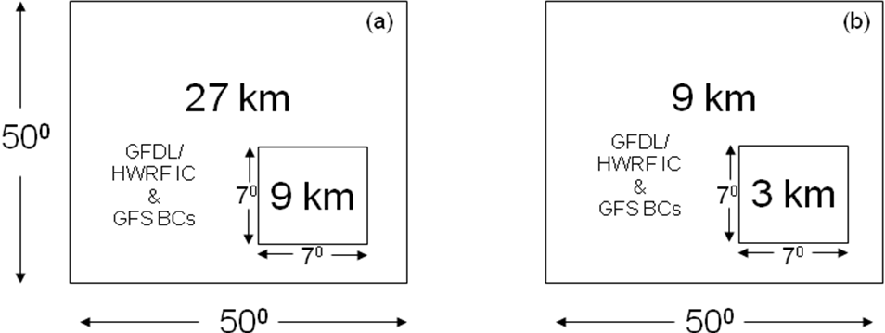

Figure 1: Versions of the two domain configurations used in this study: (a) Parent domain at a resolution of 27 km with a moving nest at 9 km and (b) parent domain at a resolution of 9 km with a moving nest at 3 km. The approximate sizes of the domains are shown as they appear in a rotated latitude-longitude grid system (i.e., without any projection to the actual latitude-longitude grid).
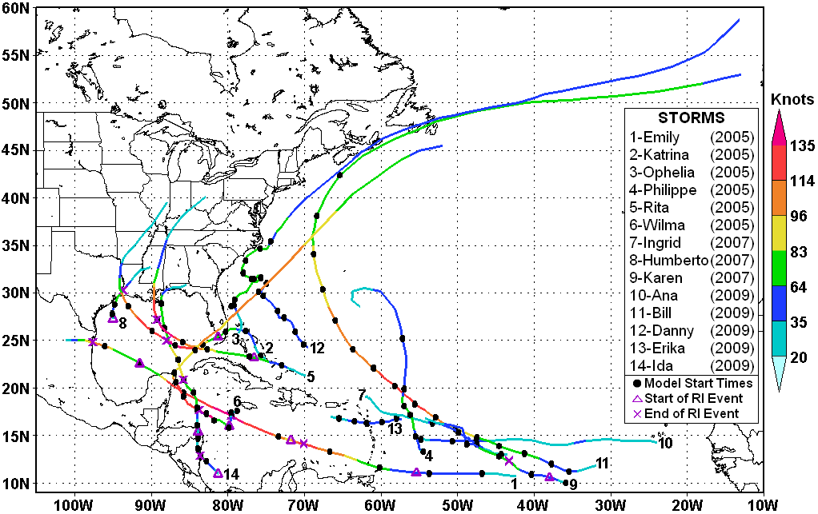
Figure 2: Actual tracks (from NHC best track data) of the 14 tropical cyclones used in this study. Model initialization times (see Table 2) for the 87 cases are indicated by solid dots. Best- track maximum surface (10 m) wind speeds are color coded (speeds on legend are in knots). Beginning and ending points of observed rapid intensification (RI) events are indicated by triangles and X’s, respectively.

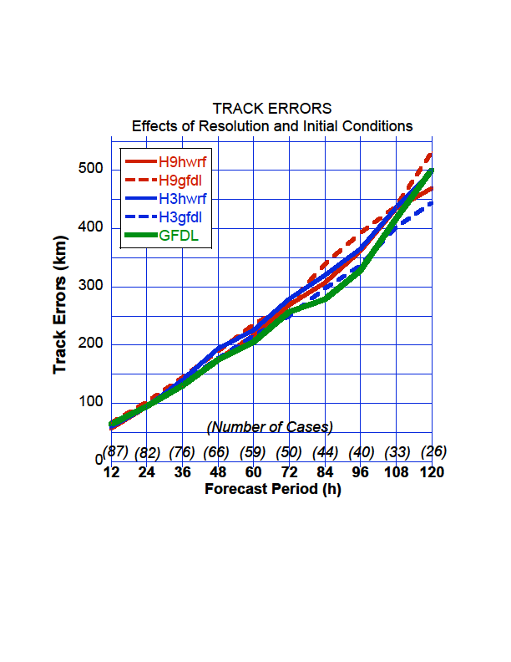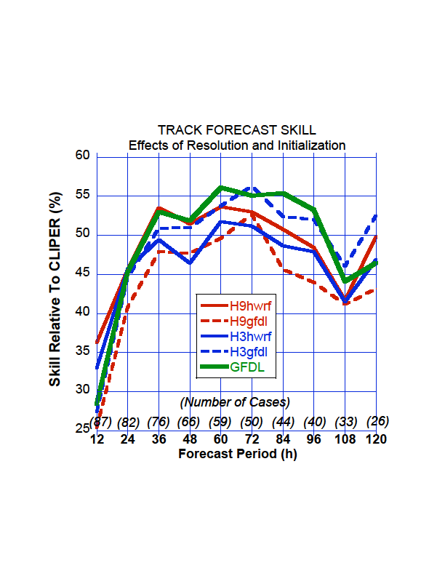
(a)
(b)

Figure 3: Verification of HWRFX track forecasts: (a) Absolute track errors and (b) skill relative to CLIPER. H9hwrf (H9gfdl) refer to results from the nested domain at 9-km resolution with HWRF (GFDL) initial conditions. H3hwrf (H3gfdl) refer to results from the nested domain at 3-km resolution with HWRF (GFDL) initial conditions.

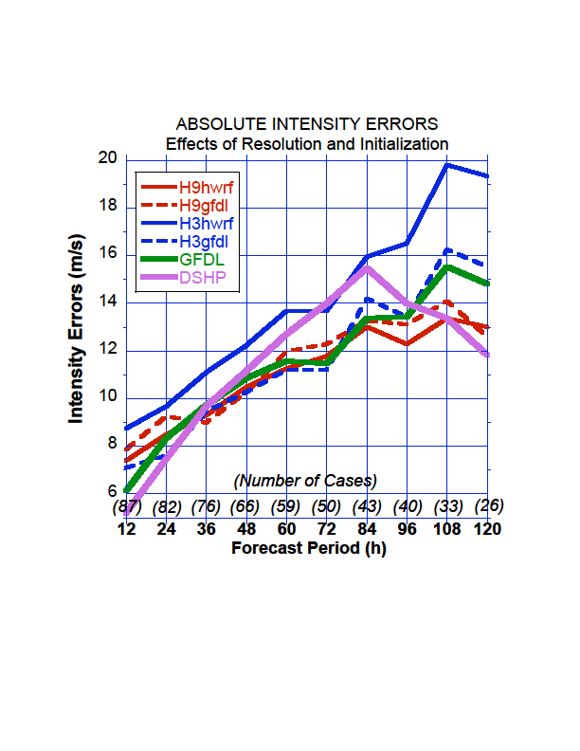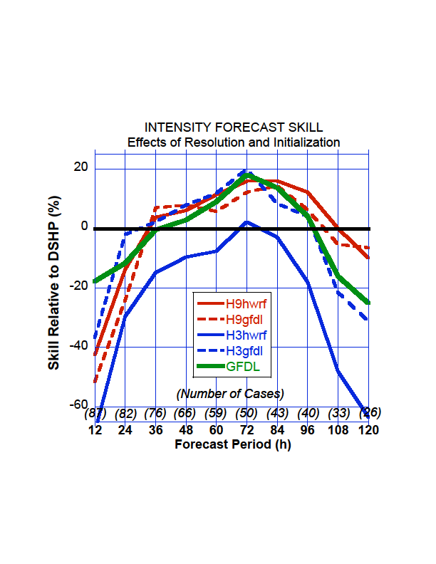
(a)
(b)
Figure 4: Verification of HWRFX intensity errors: (a) Absolute intensity errors and (b) skill relative to DSHIPS. Versions of the HWRFX models are as in Fig. 3.

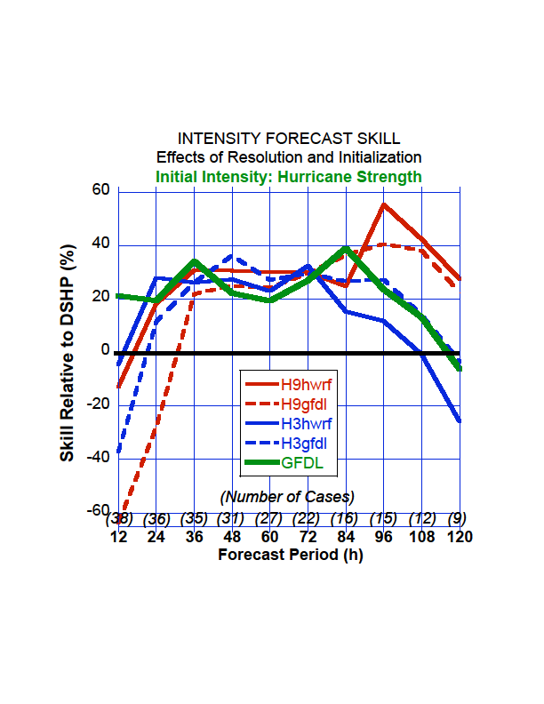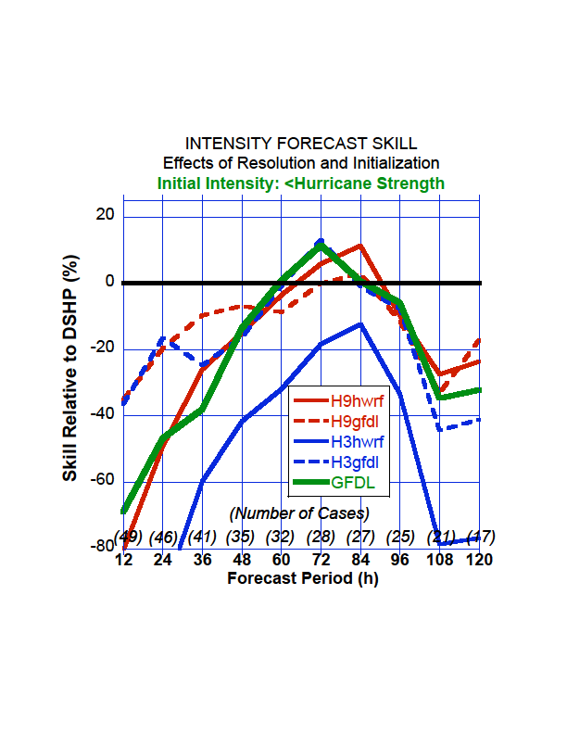
(a)
(b)

Figure 5: Skill relative to DSHIPS for (a) storms with initial intensity (maximum sustained surface wind speed) ≥ 33.4 m s⁻¹ (i.e., hurricane strength) and (b) storms with initial intensity < 33.4 m s⁻¹ (i.e., less than hurricane intensity). See Table 2 for (a) and (b) cases.
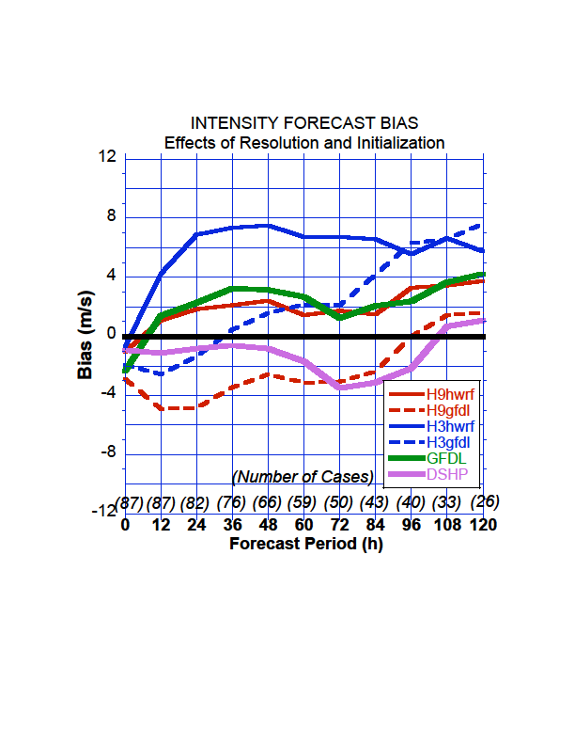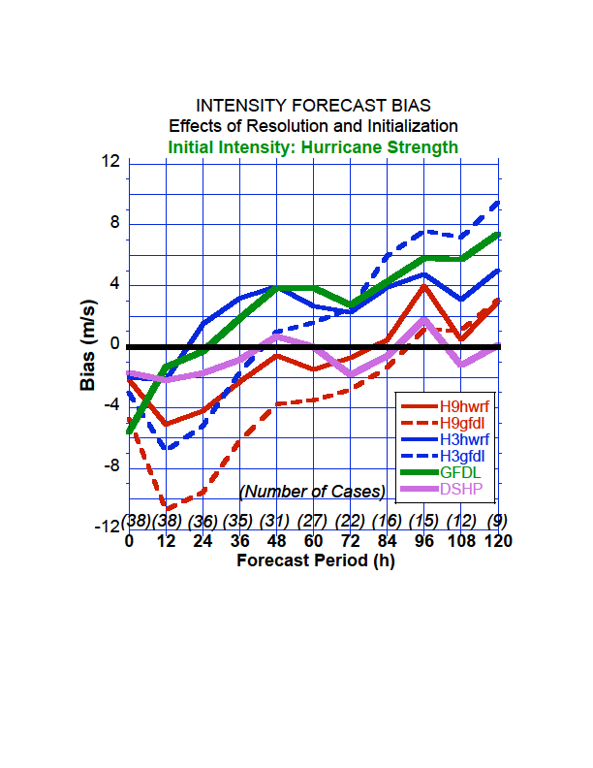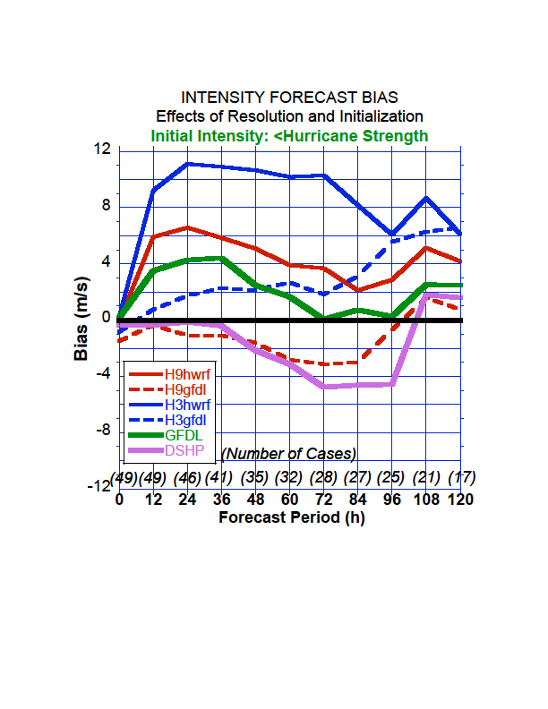
(a)
(b)
(c)

Figure 6: Intensity bias for the models (four versions of HWRFX, GFDL, and DSHIPS). Figures 6a, 6b, and 6c show biases for all the runs (87 cases at 12 h), initially strong storms (38 cases at 12 h), and initially weak storms (49 cases at 12 h), respectively.

(a)
(b)

Figure 7: Cumulative probability distribution of the radius of maximum wind at 10 m above the ground for the HWRFX forecasts, compared with the H*WIND analysis using (a) H3gfdl and H9gfdl and (b) H3gfdl and H9gfdl.

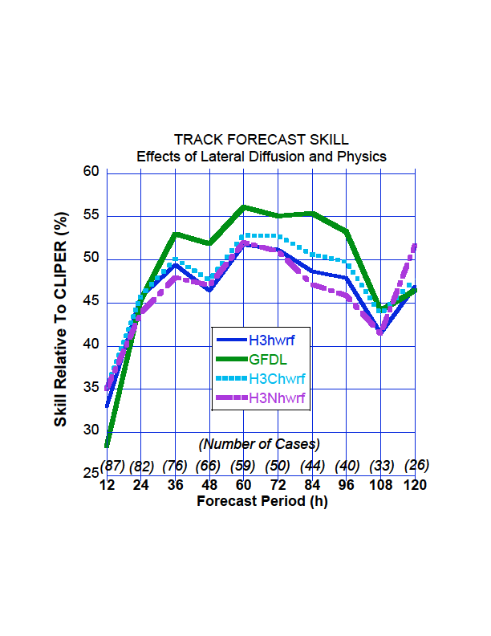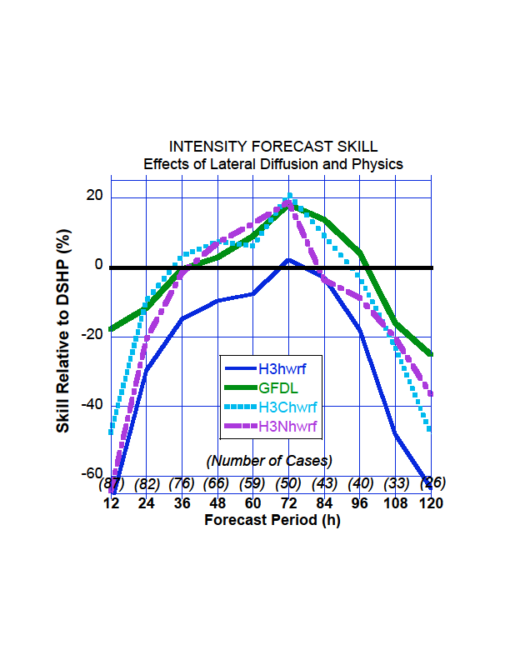
(a)
(b)
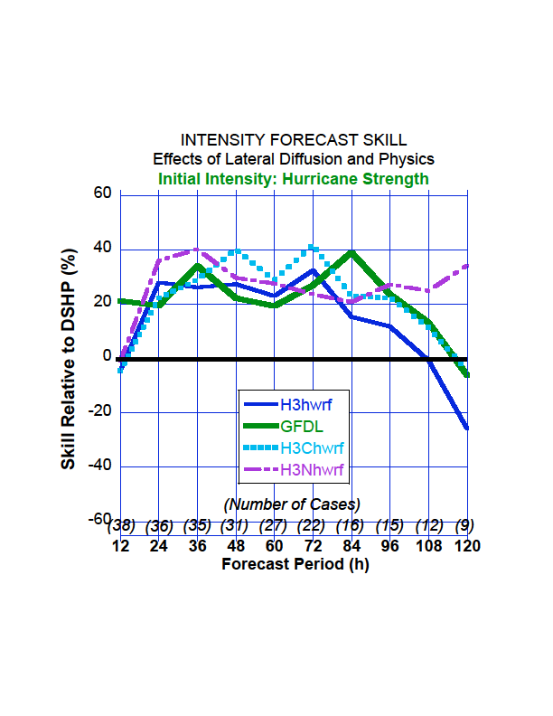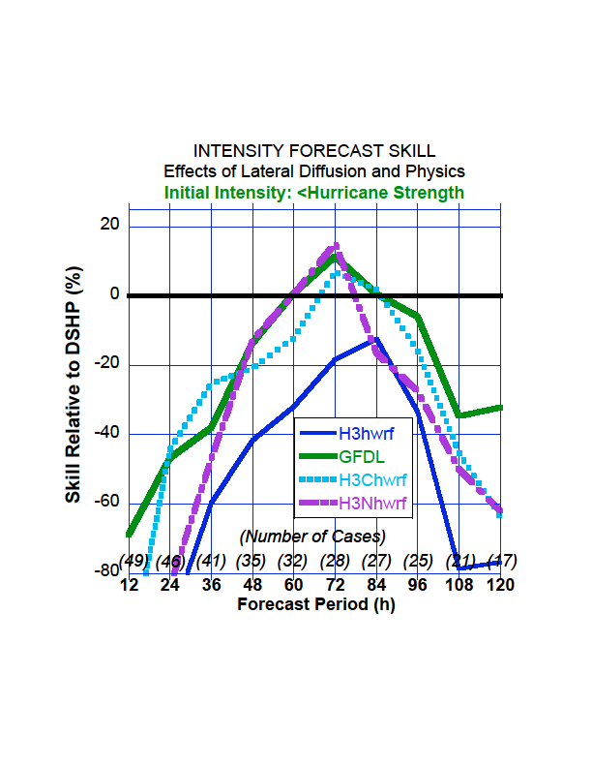
(c)
(d)

Figure 8: Verification of HWRFX (a) track errors: skill relative to CLIPER and intensity errors: skill relative to DSHIPS for (b) all storms, (c) storms with initial intensity (maximum sustained surface wind speed) ≥ 33.4 m s⁻¹ (i.e., hurricane strength), and (d) storms with initial intensity < 33.4 m s⁻¹ (i.e., less than hurricane intensity). Effect of the “YSU-WSM5-KF” physics package (H3Nhwrf) is shown in pink, and enhanced horizontal diffusion on the 3 km HWRFX runs with HWRF initial conditions (H3Chwrf) is shown in cyan.

Figure 9: CDF of the RMW from the HWRFX forecasts with the probability counted in 1-km bins of RMW, compared with those from the H*WIND analysis. Excluding samples in which the storm center was located over land, 230 H*WIND analyses, along with 2966 data points obtained from runs with YSU-WSM5-KF combination (H3Nhwrf) and runs with changes in the lateral diffusion coefficient in the 3-km domain (H3Chwrf). The baseline from HWRFX (H3hwrf) is also provided for a comparison (as in Fig. 7b)

Name | # Cases | Dates | RI Events
Emily, 2005 | 8 | 071300,071400, 071500, 071600, 071700, 071800, 071900, 072000 | 071306-071512, 071518-071700, 071900-072012
Katrina, 2005 | 6 | 082400, 082500, 082600, 082700, 082800, 082900 | 082606-082900
Ophelia, 2005 | 9 | 090712, 090812, 090912, 091012, 091212, 091312, 091412, 091512, 091612
Philippe, 2005 | 6 | 091712, 091812, 091912, 092012, 092112, 092212
Rita, 2005 | 5 | 091900, 092000, 092100, 092300, 092400 | 092000-092206
Wilma, 2005 | 7 | 101600, 101700, 101800, 101900, 102200, 102300, 102400 | 101718-101918
Humberto, 2007 | 2 | 091212, 091300 | 091206-091312
Ingrid, 2007 | 4 | 091212, 091312, 091412, 091512
Karen, 2007 | 3 | 092500, 092700, 092800 | 092512-092618
Ana, 2009 | 2 | 081512, 081600
Bill, 2009 | 15 | 081600, 081612, 081700, 081712, 081800, 081812, 081900, 081912, 082000, 082012, 082100, 082112, 082200, 082212, 082300
Danny, 2009 | 5 | 082612, 082700, 082712, 082800, 082812
Erika, 2009 | 4 | 090200, 090212, 090300, 090312
Ida, 2009 | 11 | 110500, 110512, 110600, 110612, 110700, 110712, 110800, 110812, 110900, 110912, 111000 | 110406-110512, 110618-110812

Table 1: Summary of the 87 TC cases used in this study. Cases in bold are for initial intensity (maximum surface wind speed) ≥33.4 m s⁻¹ (i.e., hurricane strength). Rapid Intensification (RI) events are defined as ≥ 15.4 m s⁻¹ (i.e., ≥30 kts) increase in maximum surface wind speed in 24 h (Kaplan et al. 2010). See Figure 2 to view the actual tracks and locations of the model initialization times and RI events.

 | Convection | Microphysics | Boundary and surface layer | Land Surface &  Ocean Coupling | Dissipative  heating | Radiation
Operational  HWRF  (WRF version 2.0) | SAS with momentum mixing | Ferrier | GFS boundary layer and GFDL hurricane model surface layer scheme (uses modification  to surface  roughness over ocean) | GFDL slab land surface &  Princeton Ocean model coupling | Switched on | GFDL  radiation scheme
HWRFX  (WRF version 3.1)  (Low resolution forecasts) | SAS without momentum mixing | Ferrier | GFS boundary layer and  GFDL hurricane  model surface layer scheme  (uses the original Charnock’s approximation for surface roughness over ocean) | NOAH LSM  &  Uncoupled/  Initially prescribed SST | Switched  off | NCAR

Table 2: List of differences between operational HWRF and HWRFX physics for the configuration at 27:9.

No. | Initial conditions | Grid configuration | Physics | Lateral diffusion coefficient in parent & nest domain | Specification
1 | HWRF | 27:9 | HWRFX | 1.6 & 0.7 | H9hwrf
2 | GFDL | 27:9 | HWRFX | 1.6 & 0.7 | H9gfdl
3 | HWRF | 9:3 | HWRFX | 1.6 & 0.7 | H3hwrf
4 | GFDL | 9:3 | HWRFX | 1.6 & 0.7 | H3gfdl
5 | HWRF | 9:3 | HWRFX | 1.6 & 5.0 | H3Chwrf
6 | GFDL | 9:3 | NCAR | 1.6 & 0.7 | H3Nhwrf

Table 3: List of experiments performed, each containing 87 cases.

Name | RI Event* | Date/  Cycle | H9  HWRF | H9  GFDL | H3  HWRF | H3  GFDL | H3  CHWRF | H3  NHWRF
Emily,2005 | 071306-071512 071518-071700 071900-072012 | 1300  1500  1900 | 35  -14  8 | 44  -15  22 | 26  -18  -1 | 45  0  41 | -1  -10  6 | 26  -33  24
Katrina,2005 | 082606-082900 | 2600 | 50 | 66 | 68 | 76 | 65 | 56
Rita, 2005 | 092000-092206 | 2000 | 44 | 18 | 54 | 50 | 43 | 51
Wilma, 2005 | 101718-101918 | 1700 | 42 | 64 | 47 | 74 | 38 | 48
Humberto, 2007 | 091206-091312 | 1212 | 15 | 2 | 24 | 6 | 15 | 26
Karen, 2007 | 092512-092618 | 2500 | 5 | 20 | 29 | 25 | 15 | 24
Ida, 2009 | 110406-110512, 110618-110812 | 0500  0600 | 12  28 | 8  16 | 22  70 | 18  43 | 18  48 | 18  45

Table 4: Intensity changes as measured by 10-m wind speed in knots produced by each of the model configurations during the observed Rapid Intensification (RI) or weakening events. These changes were measured, when data was available during the most skillful period from the model. For example for RI even between 071518-071700 in Emily, the 071400 forecasts were used

Corresponding author address: S.G. Gopalakrishnan, AOML/HRD, 4301 Rickenbacker Causeway, Miami, Florida 33149 <E-mail: gopal@noaa.gov
For this study, cases from Felix (2007) could not be included in the homogeneous sample since all of the necessary initial conditions were not available for that storm.
The “5” refers to the fact that the original CLIPER (developed in 1972) and SHIFOR (developed in 1979) models only provided forecasts out to 72 h. These forecasts were extended to 120 h (five days) in 1998 and 2003, respectively.
These comparisons are not considered completely “fair” judges of the performance of the HWRFX (or GFDL) models in the actual operational environment since the HWRFX and GFDL versions used here are considered “late” models, i.e., they are available late in the operational forecast cycle, whereas the CLIPER5 and DSHIPS are “early” models, in that they are available to the forecasters much sooner (Franklin 2010).
The model RMWs were obtained from the hourly model output of the azimuthally-averaged winds.

